 | 
COUNCIL OF  THE EUROPEAN UNION |  |  | Brussels, 2 March 2012
 | Interinstitutional File:  2011/0438 (COD) |  | 7214/12
MAP 22
MI 148
CODEC 549
INST 173
PARLNAT 127

COVER NOTE
from: | Swedish Riksdag
date of receipt: | 1 March 2012
No. Cion doc. : | 18966/11 MAP 10 MI 686 + ADD 1 + ADD 2 - COM (2011) 896
Subject: | Proposal for a Directive of the European Parliament and of the Council on public procurement  - Reasoned Opinion on the application of the Principles of Subsidiarity and Proportionality

Delegations will find attached the Opinion of the Swedish Riksdag on the above proposal.

________________________

Encl.:
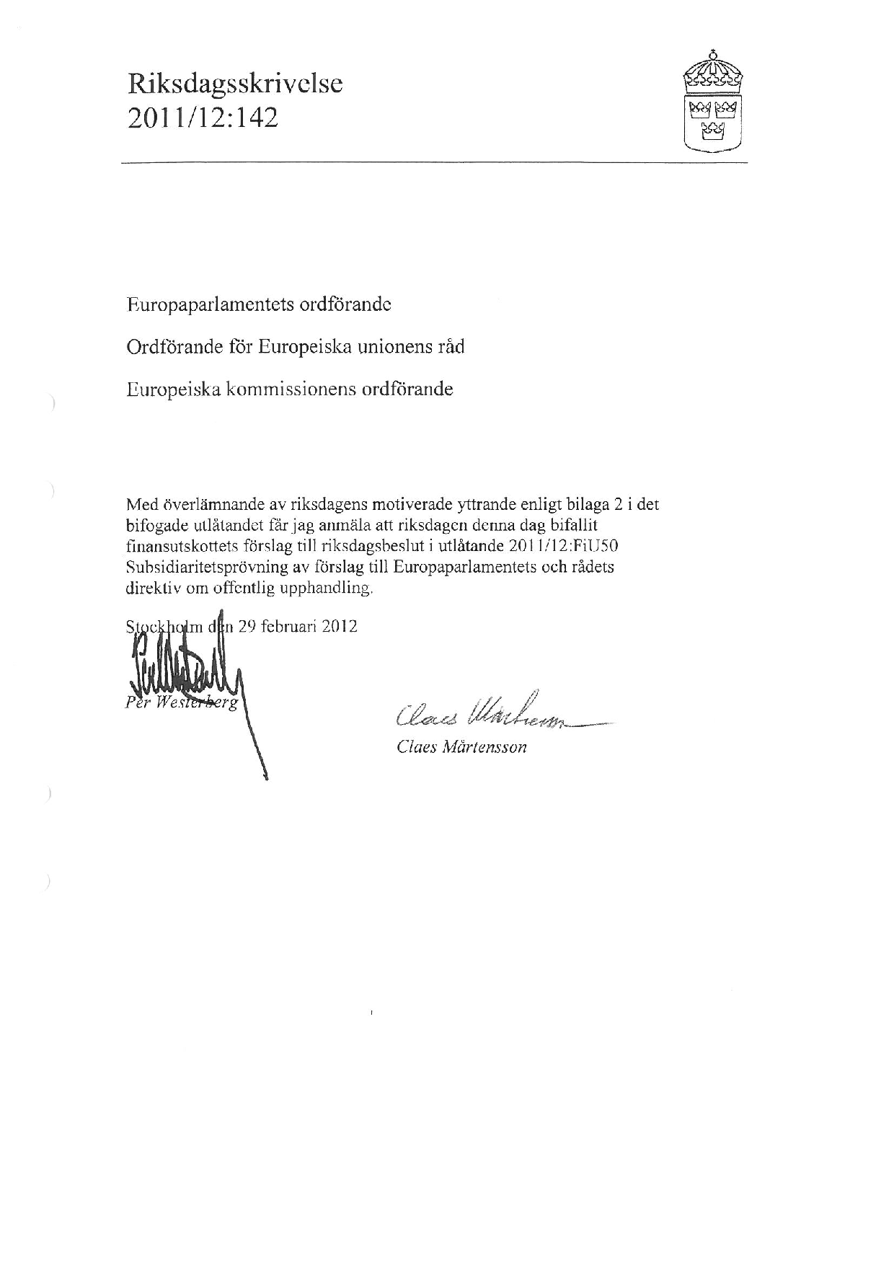
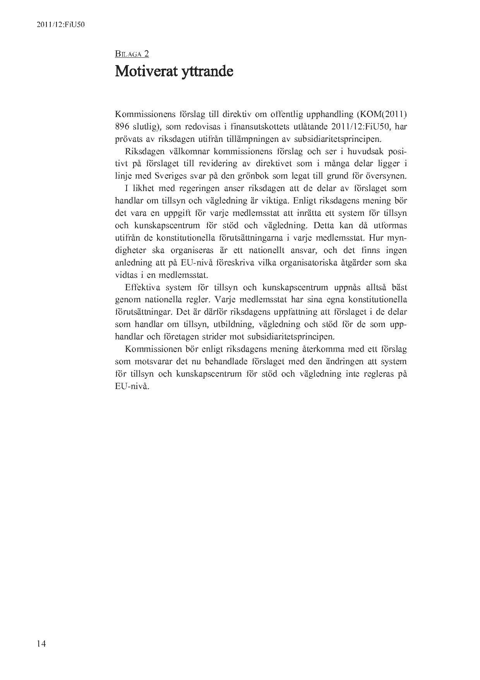

Translation may be available at the Interparliamentary EU information exchange site IPEX at the following address: http://www.ipex.eu/IPEXL-WEB/search.do.

