 | 
COUNCIL OF  THE EUROPEAN UNION |  |  | Brussels, 2 March 2012
 | Interinstitutional File:  2011/0417 (COD) |  | 7159/12
EF 53
ECOFIN 213
COMPET 123
IND 44
CODEC 538
INST 165
PARLNAT 119

COVER NOTE
from: | The President of the Portuguese Parliament
date of receipt: | 1 March 2012
to: | President of the European Union
Subject: | Proposal for a REGULATION OF THE EUROPEAN PARLIAMENT AND OF THE COUNCIL on European Venture Capital Funds [doc. 18499/11 - COM(2011)860 final]  - Opinion on the application of the Principles of Subsidiarity and Proportionality

Delegations will find attached the above mentioned opinion

________________________

Encl.

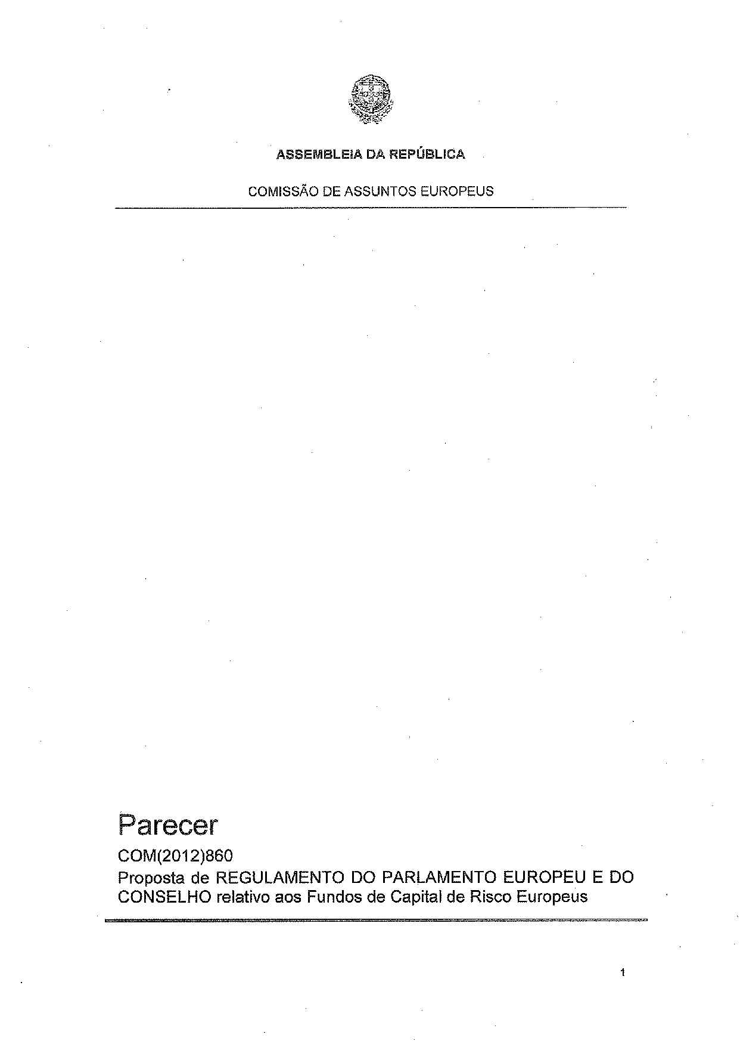
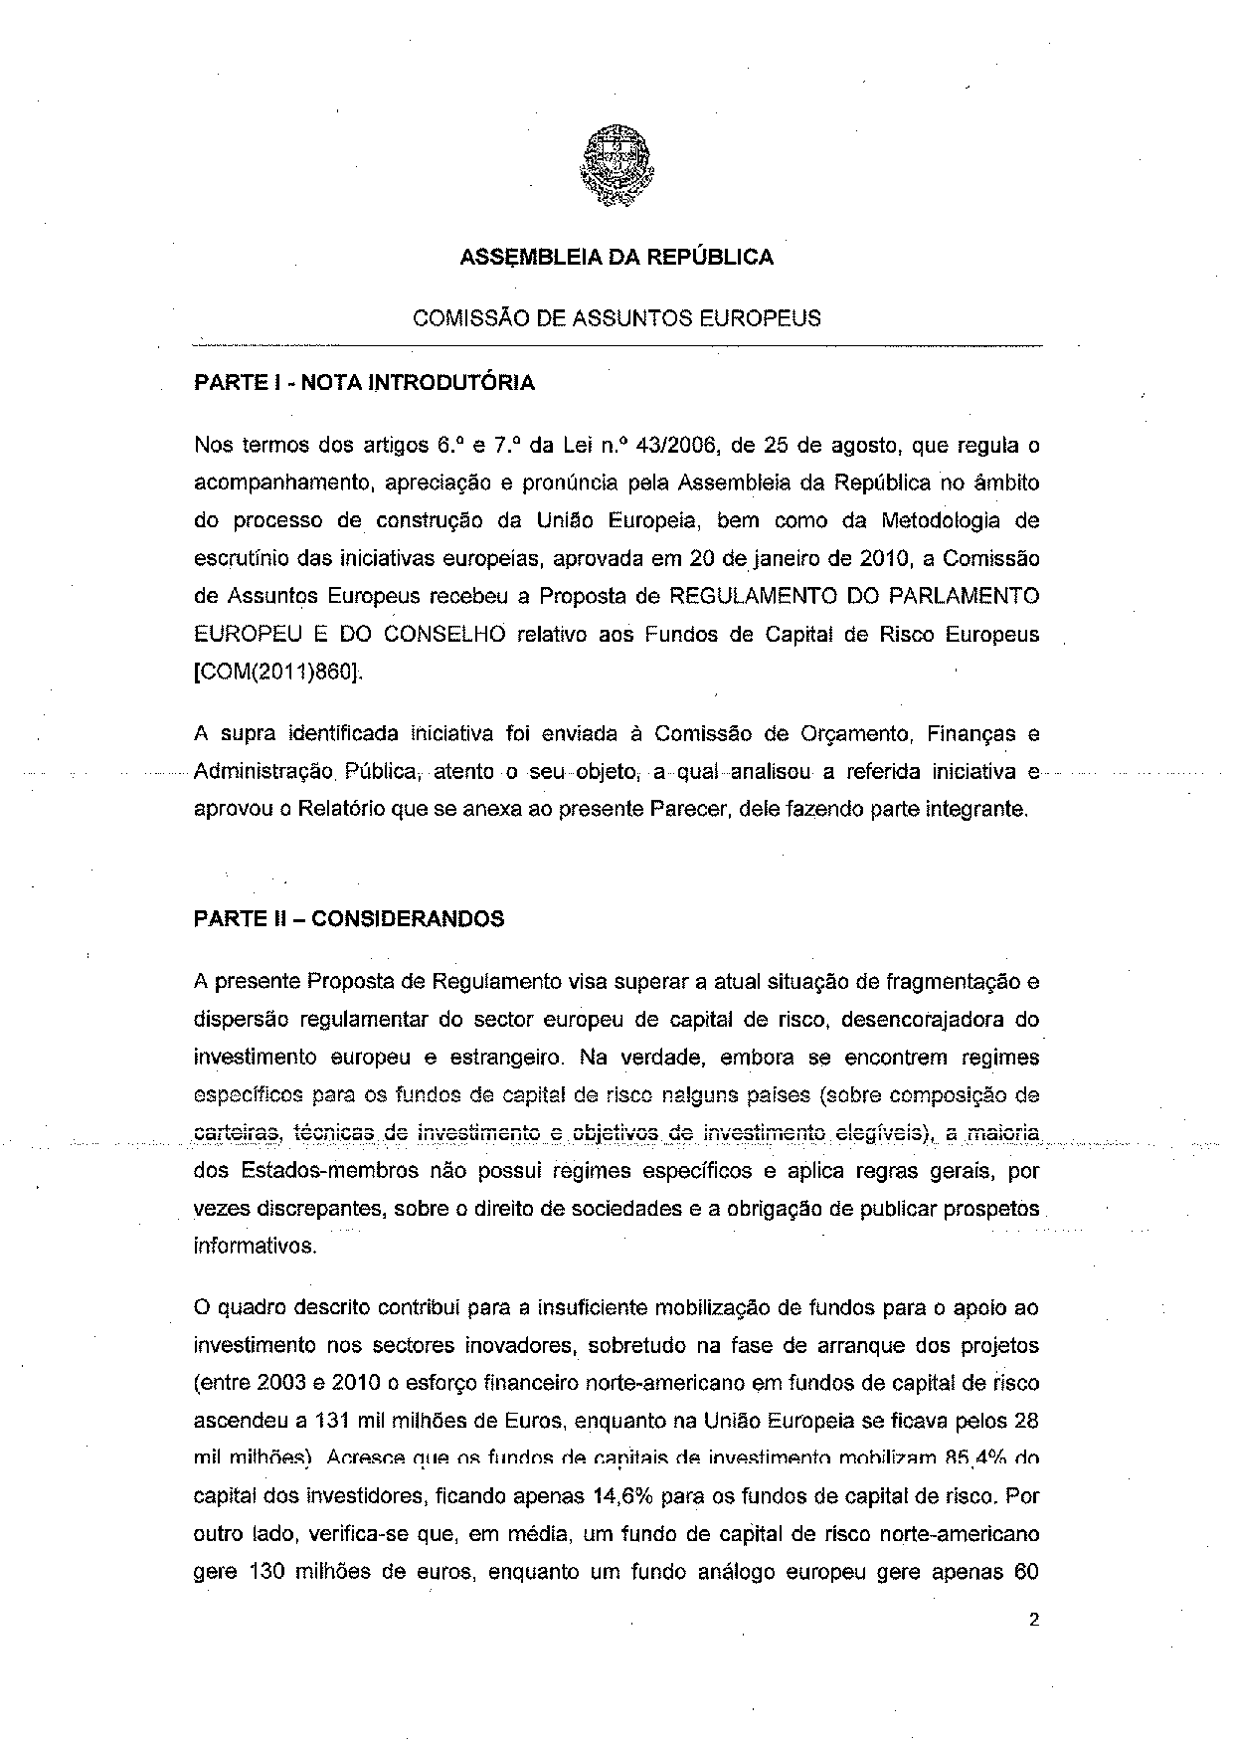
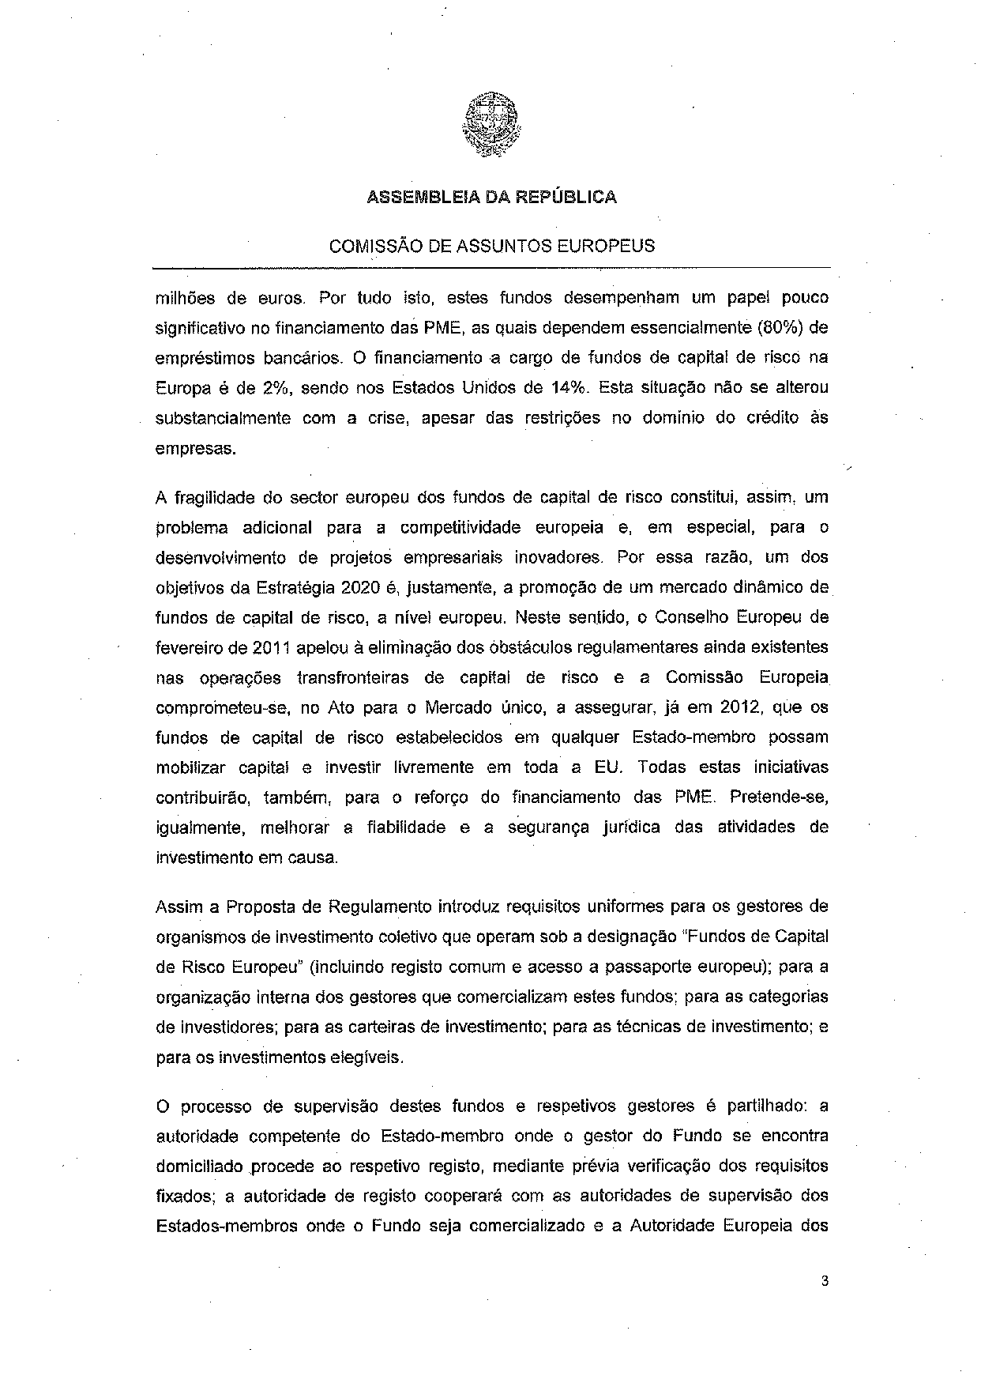
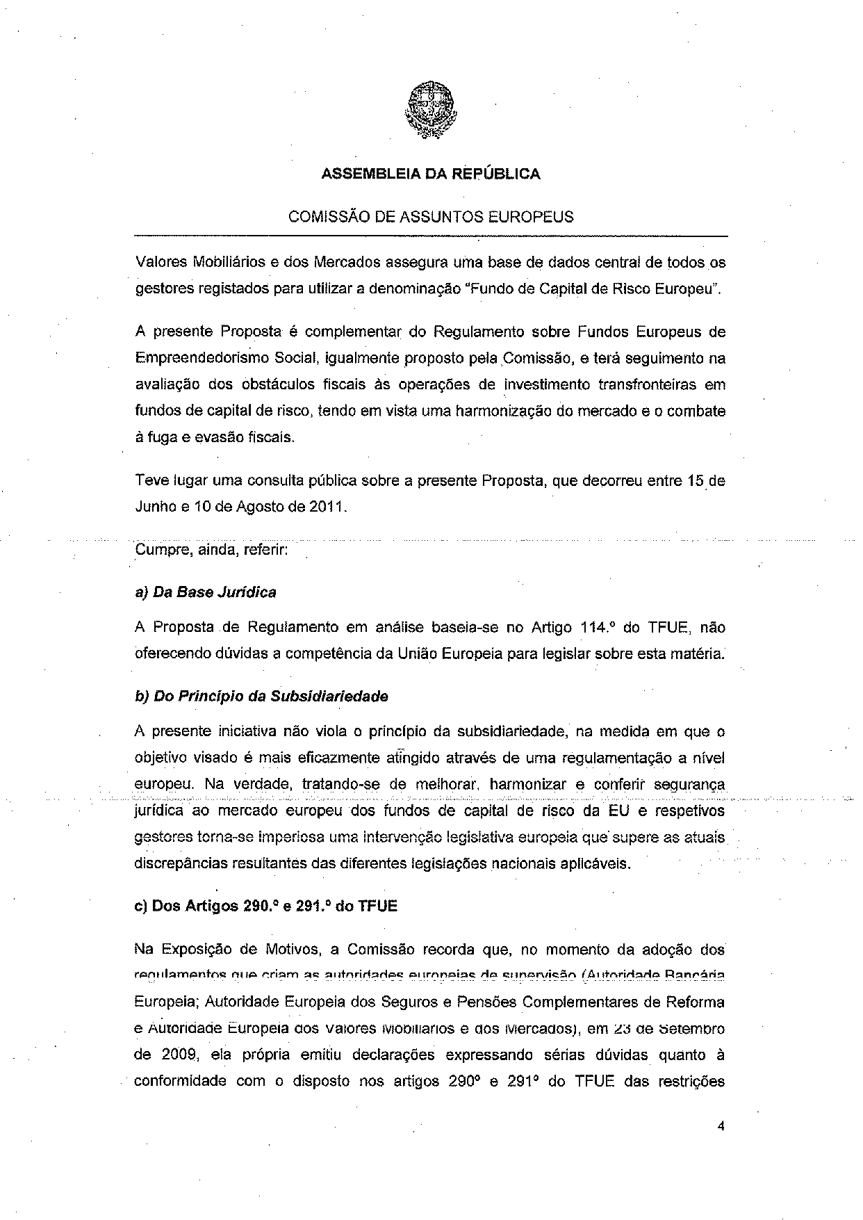
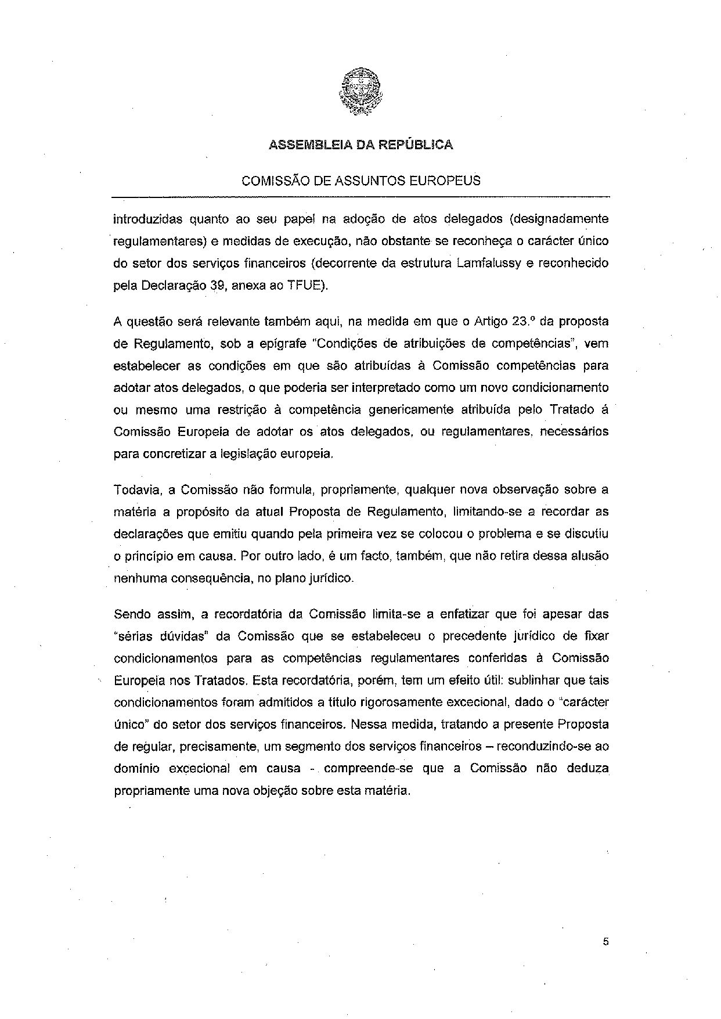
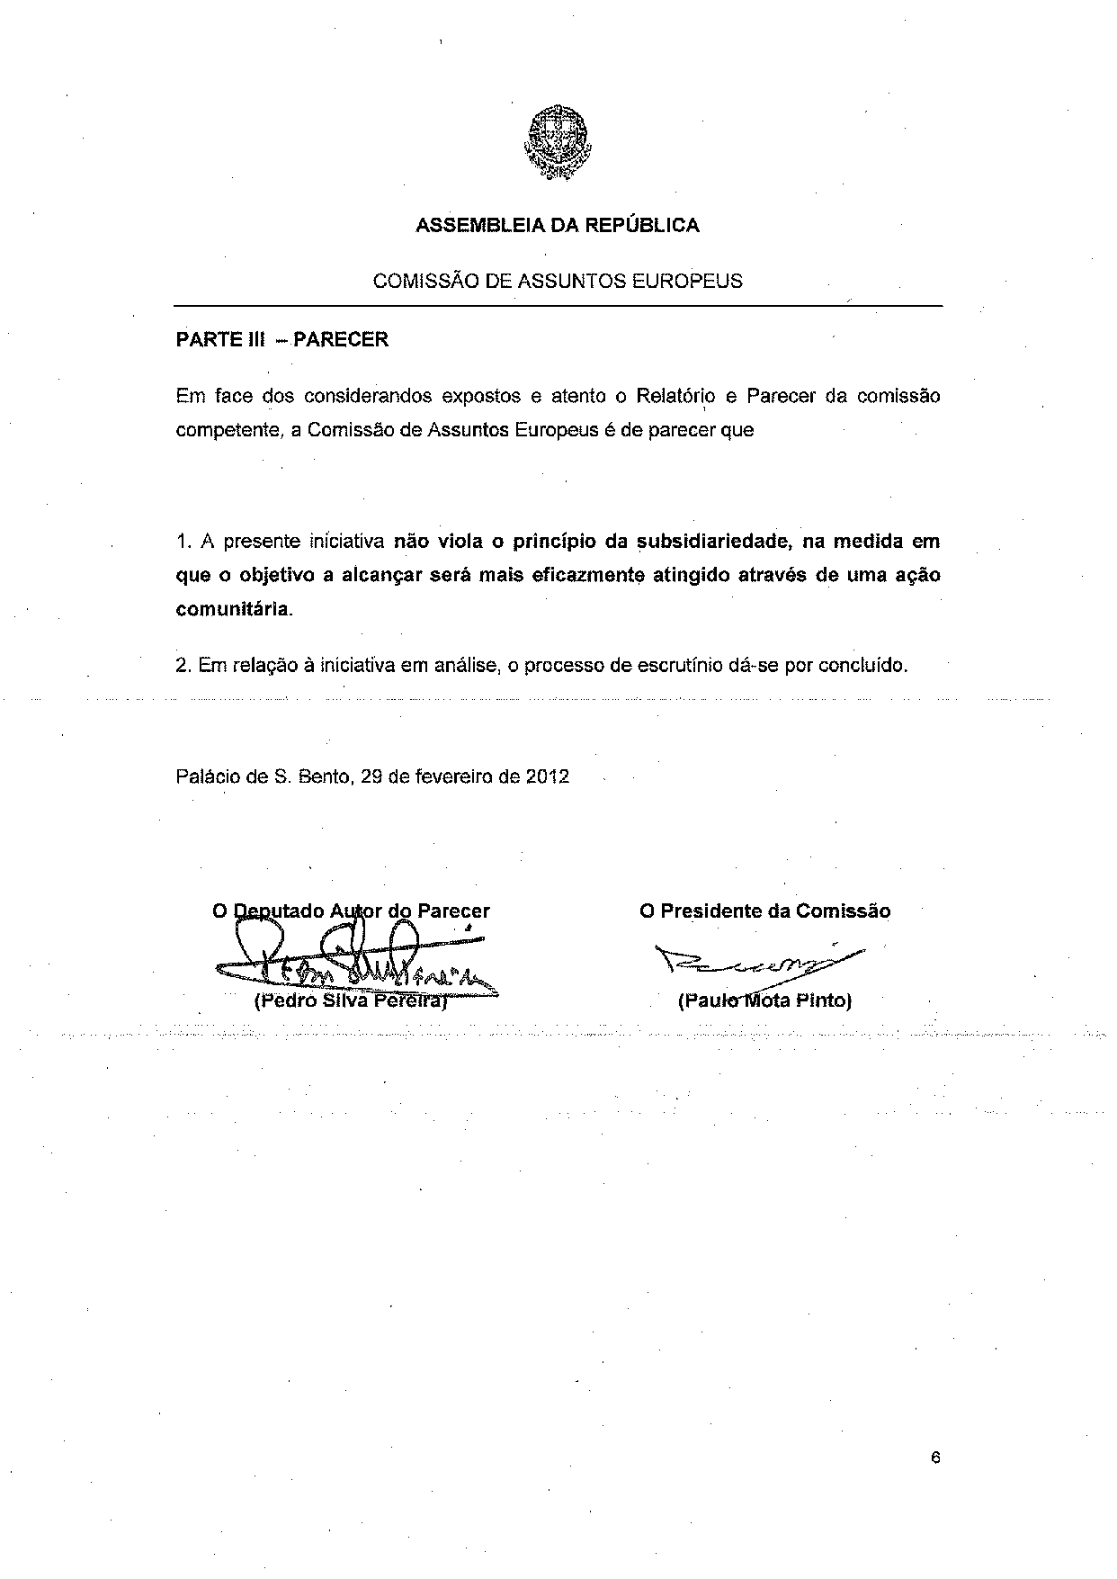

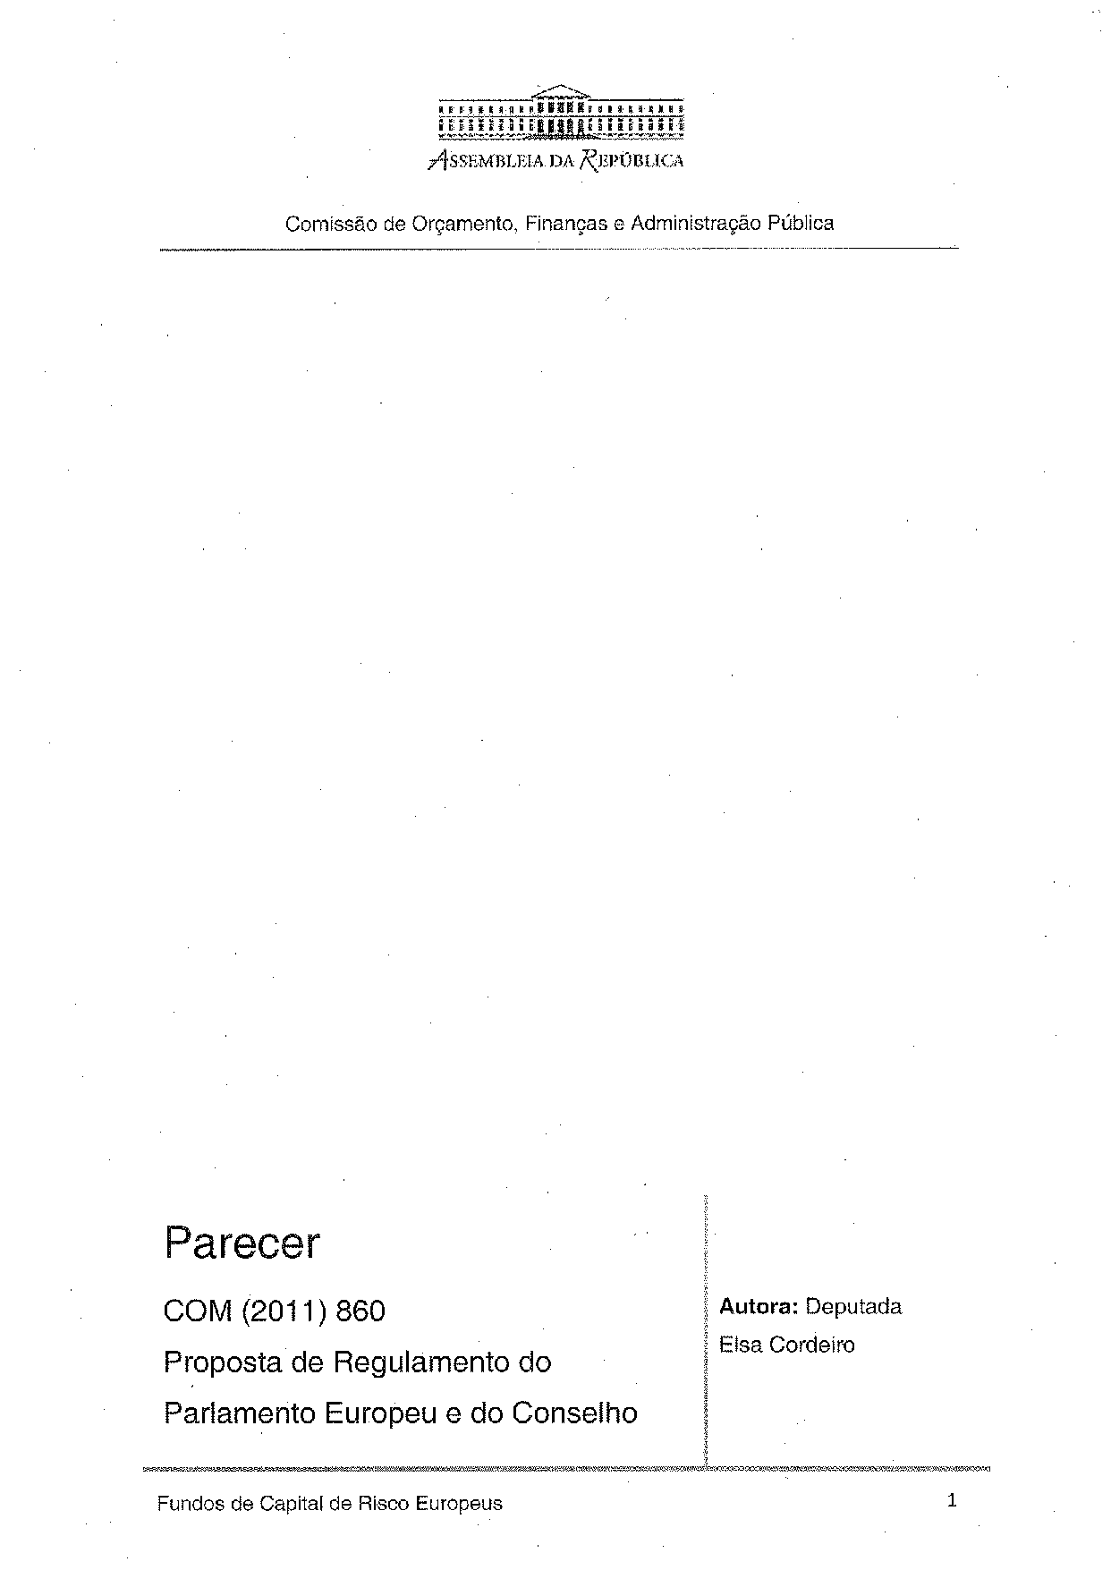
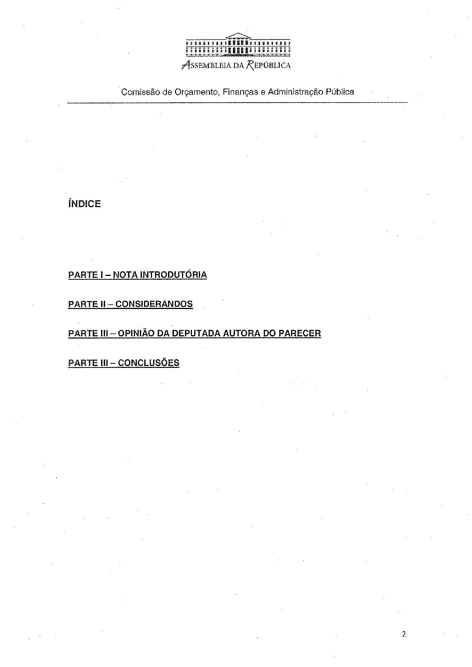
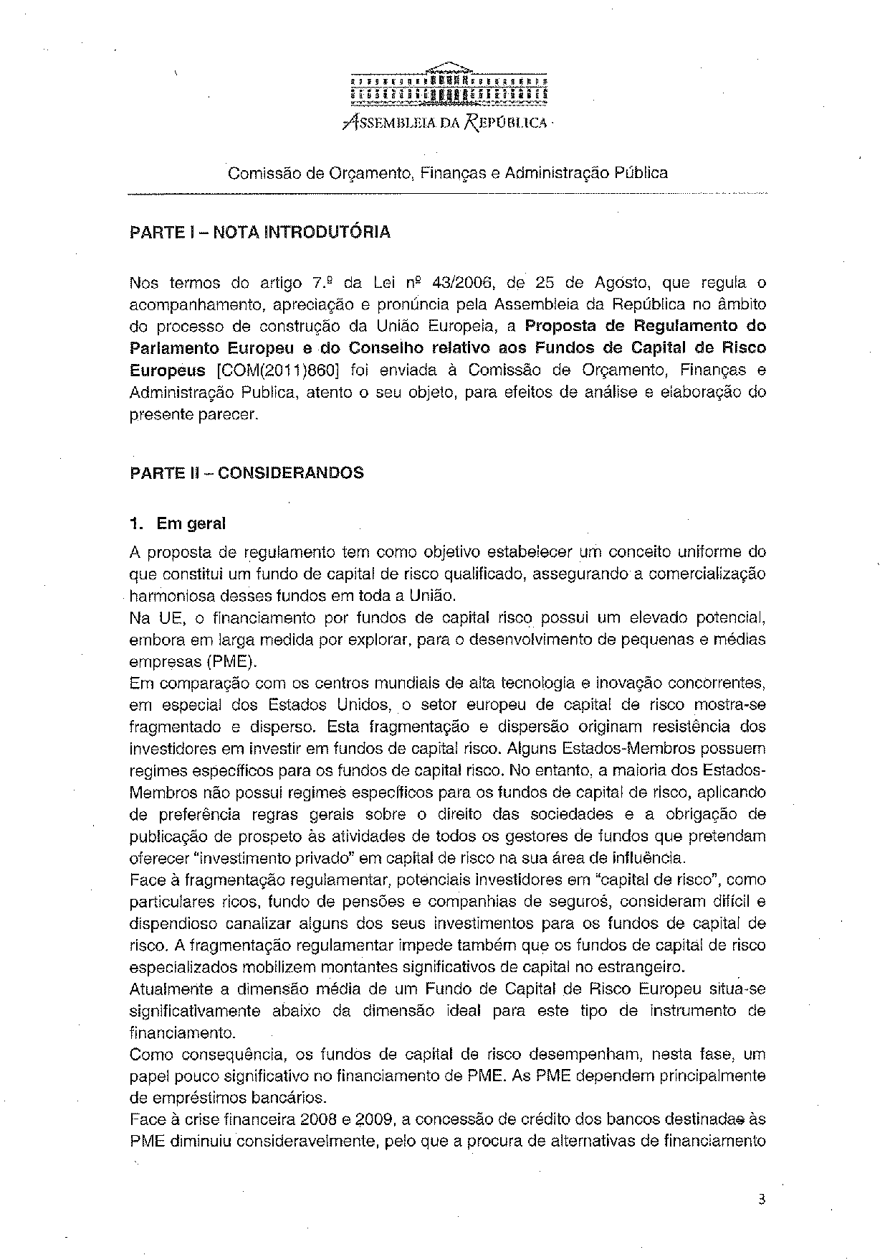
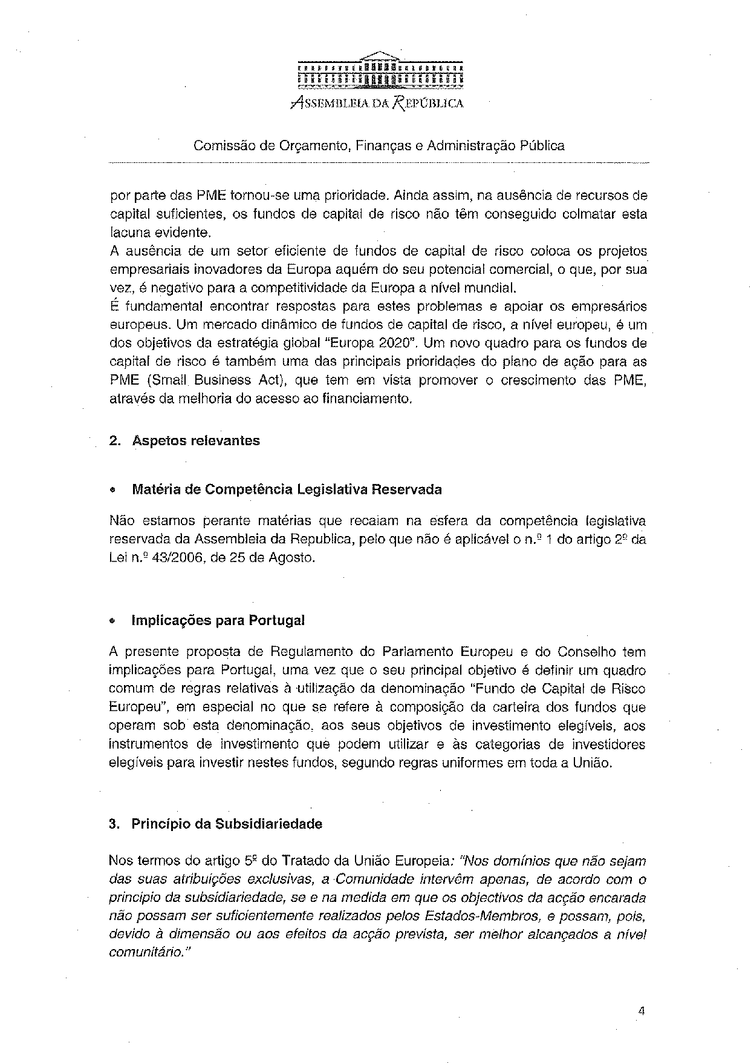
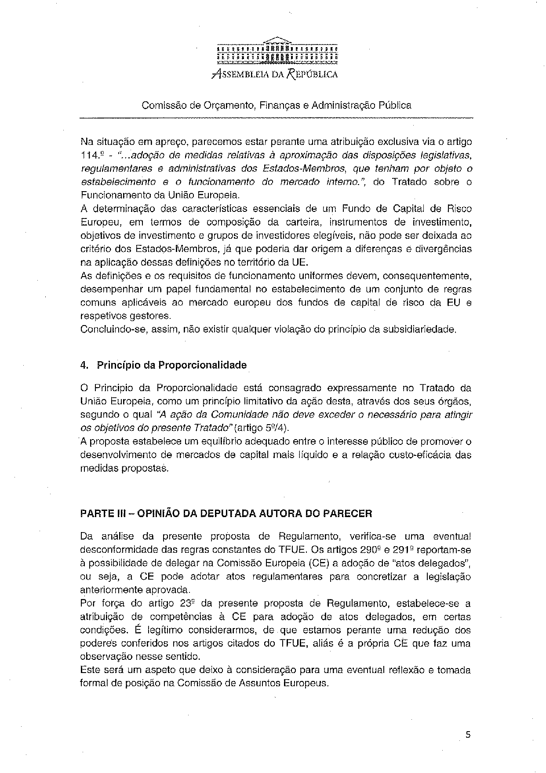
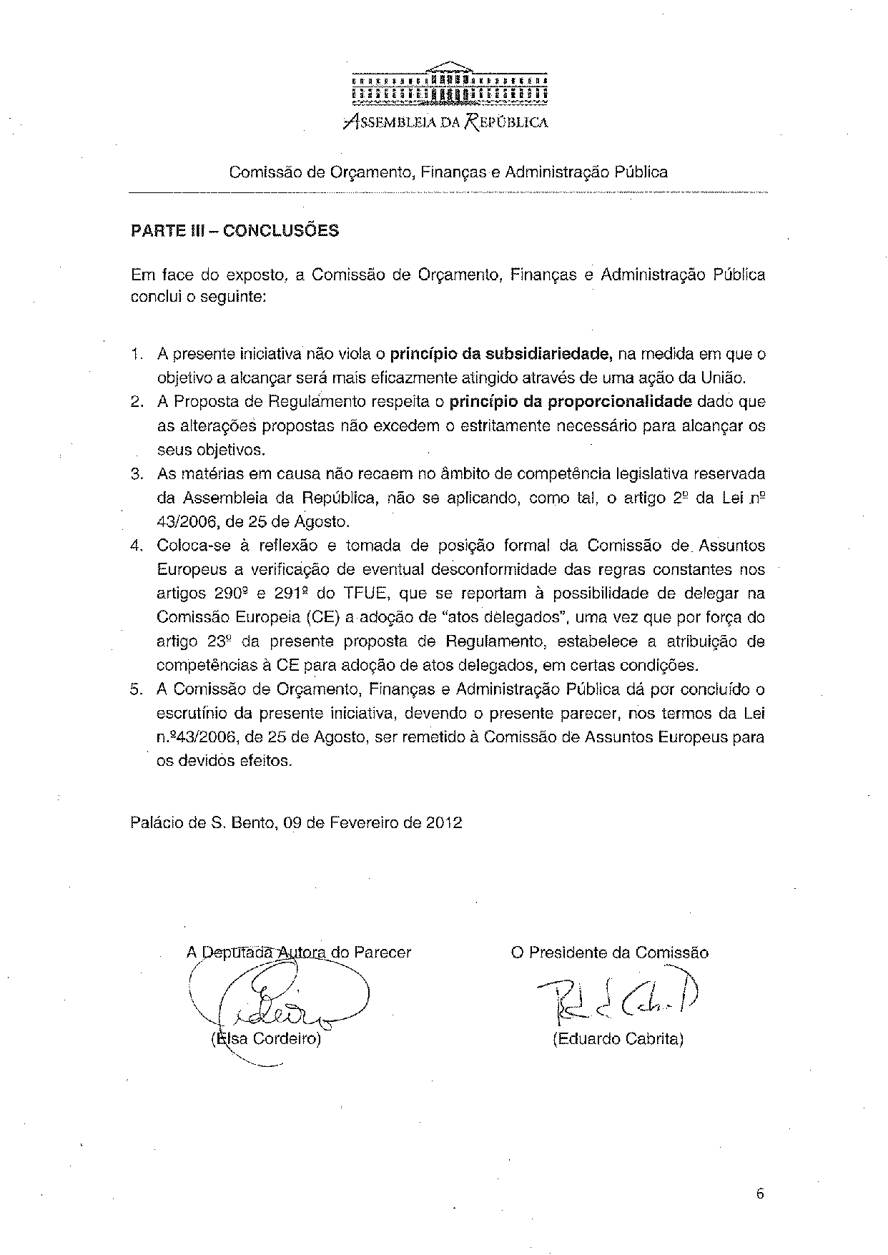

This opinion is available in English on the interparliamentary EU information exchange site (IPEX) at the following address: http://www.ipex.eu/IPEXL-WEB/search.do

