 | 
COUNCIL OF  THE EUROPEAN UNION |  |  | Brussels, 9 March 2012
 | Interinstitutional File:  2011/0459 (COD) |  | 7410/12
STATIS 22
ECOFIN 233
CODEC 591
INST 186
PARLNAT 135

COVER NOTE
from: | Italian Senate, Italy
date of receipt: | 7 March 2012
to: | Mr Uwe CORSEPIUS, Secretary-General of the Council of the European Union
No Cion doc.: | COM(2011) 928 final
Subject: | Proposal for a Regulation of the European Parliament and of the Council on the European statistical programme 2013-2017 [doc. ST 5089/12 STATIS 1 ECOFIN 6 CODEC 16 - COM(2011) 928 final]  - Opinion on the application of the Principles of Subsidiarity and Proportionality

Delegations will find attached the opinion of the Italian Senate on COM(2011) 928 final - Council ST 5089/12.

________________________

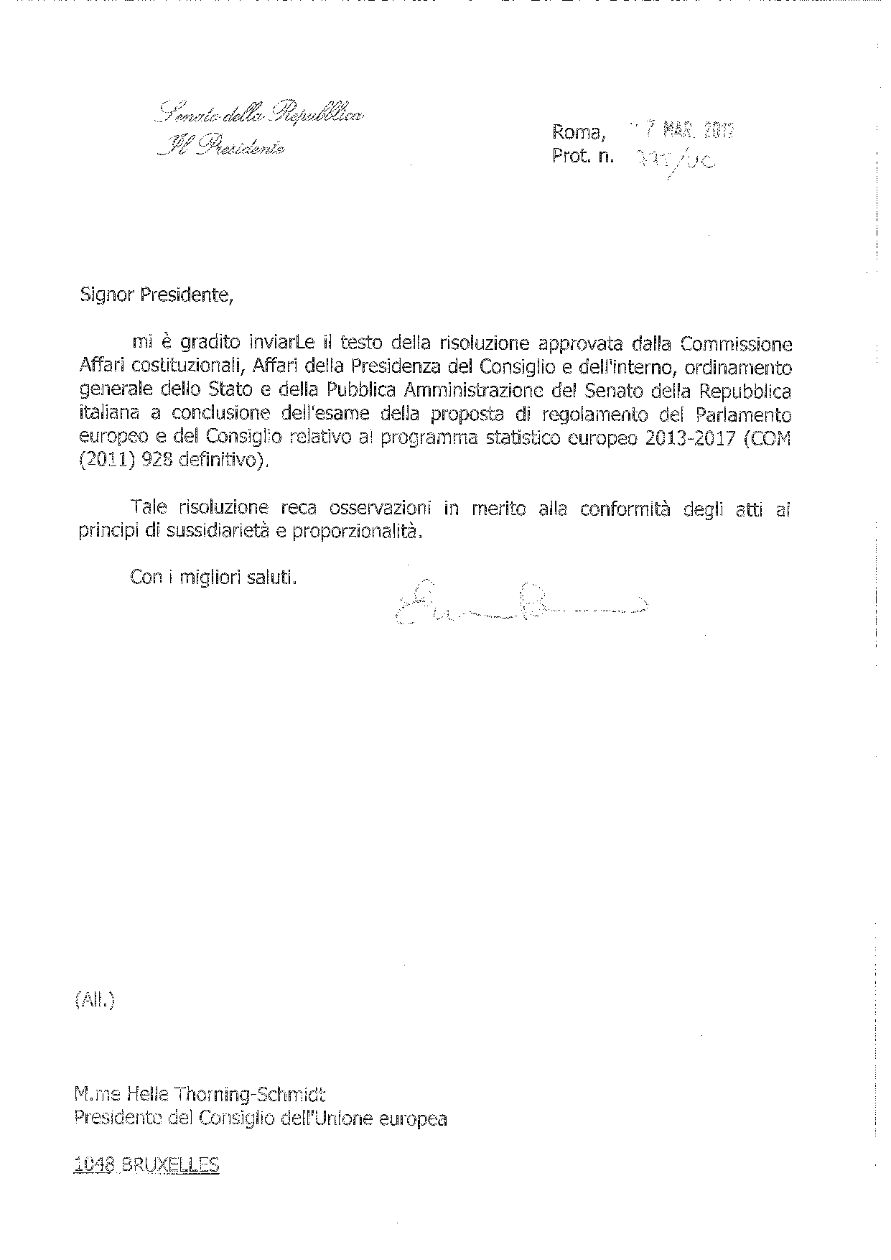

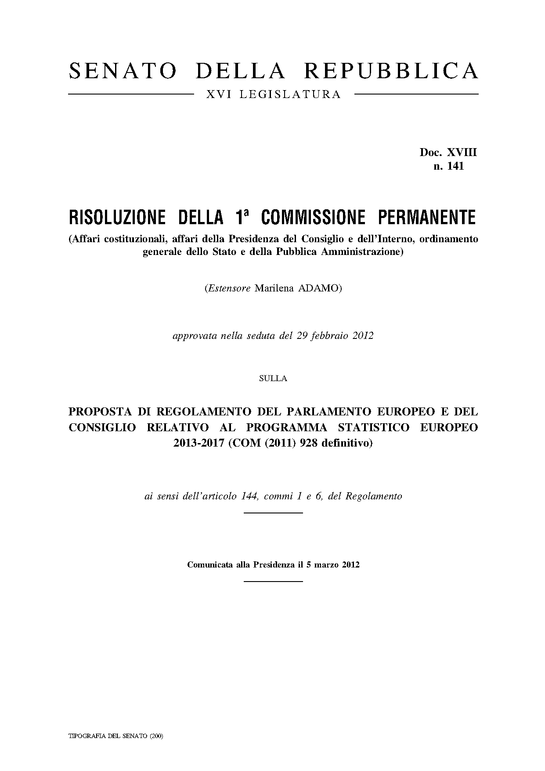
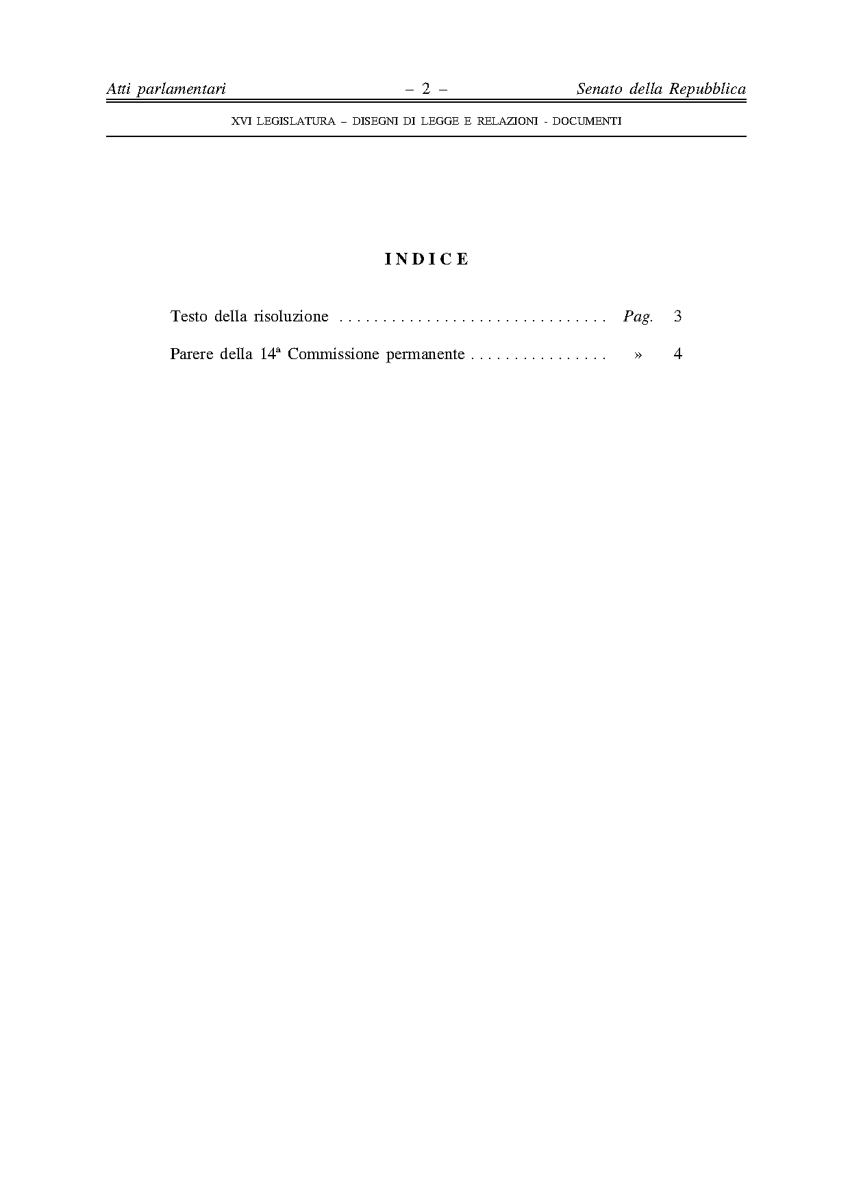
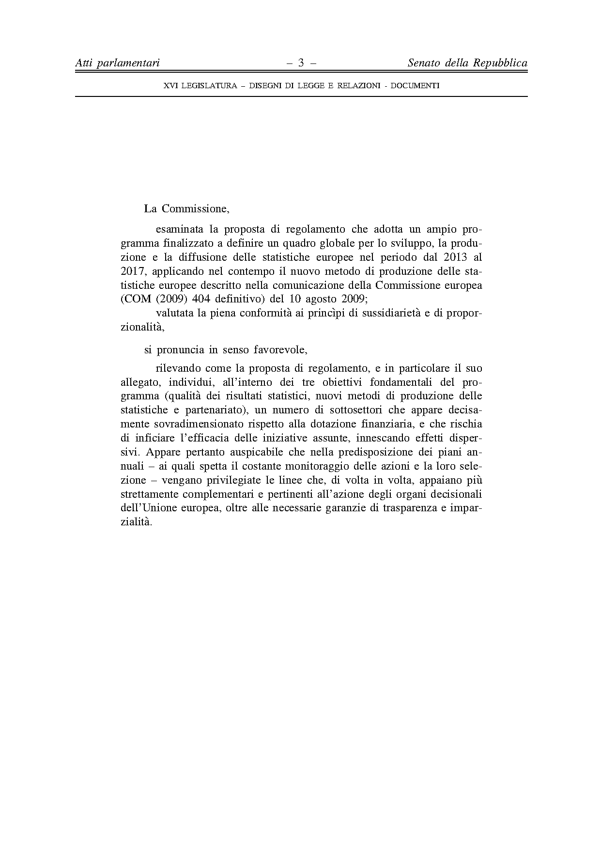
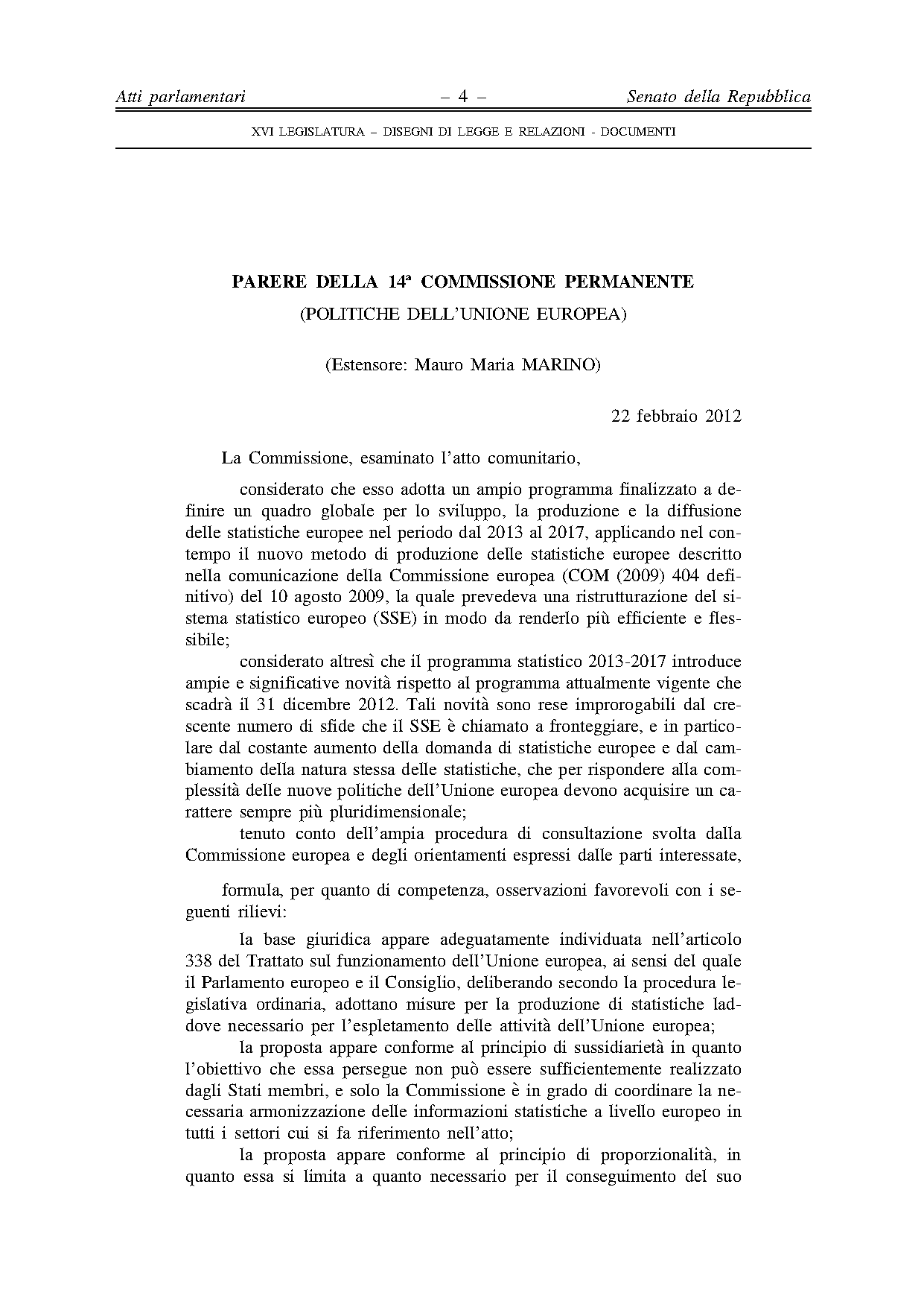
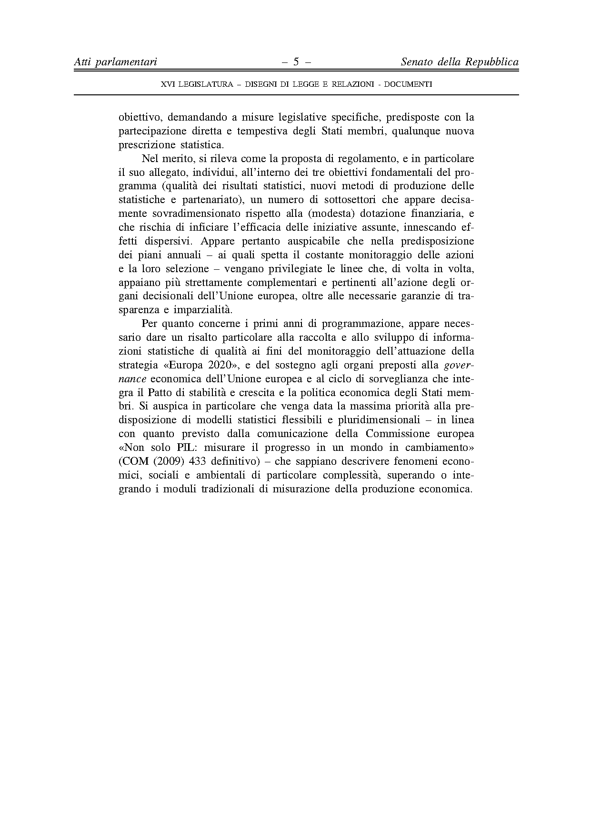

For other language versions of the opinion, reference is made to the Interparliamentary EU information exchange site IPEX at the following address: http://www.ipex.eu/IPEXL-WEB/search.do

