 | 
COUNCIL OF  THE EUROPEAN UNION |  |  | Brussels, 9 March 2012
 | Interinstitutional File:  2011/0435 (COD) |  | 7496/12
ETS 10
MI 174
COMPET 145
EDUC 61
CODEC 623
INST 194
PARLNAT 142

COVER NOTE
from: | Portuguese Parliament
date of receipt: | 9 March 2012
to: | President of the Council of the European Union
Subject: | Proposal for a Directive of The European Parliament and of The Council amending Directive 2005/36/EC on the recognition of professional qualifications and Regulation on administrative cooperation through the Internal Market Information System  = Opinion on the application of the Principles of Subsidiarity and Proportionality

Delegations will find attached the above mentioned opinion.

________________________

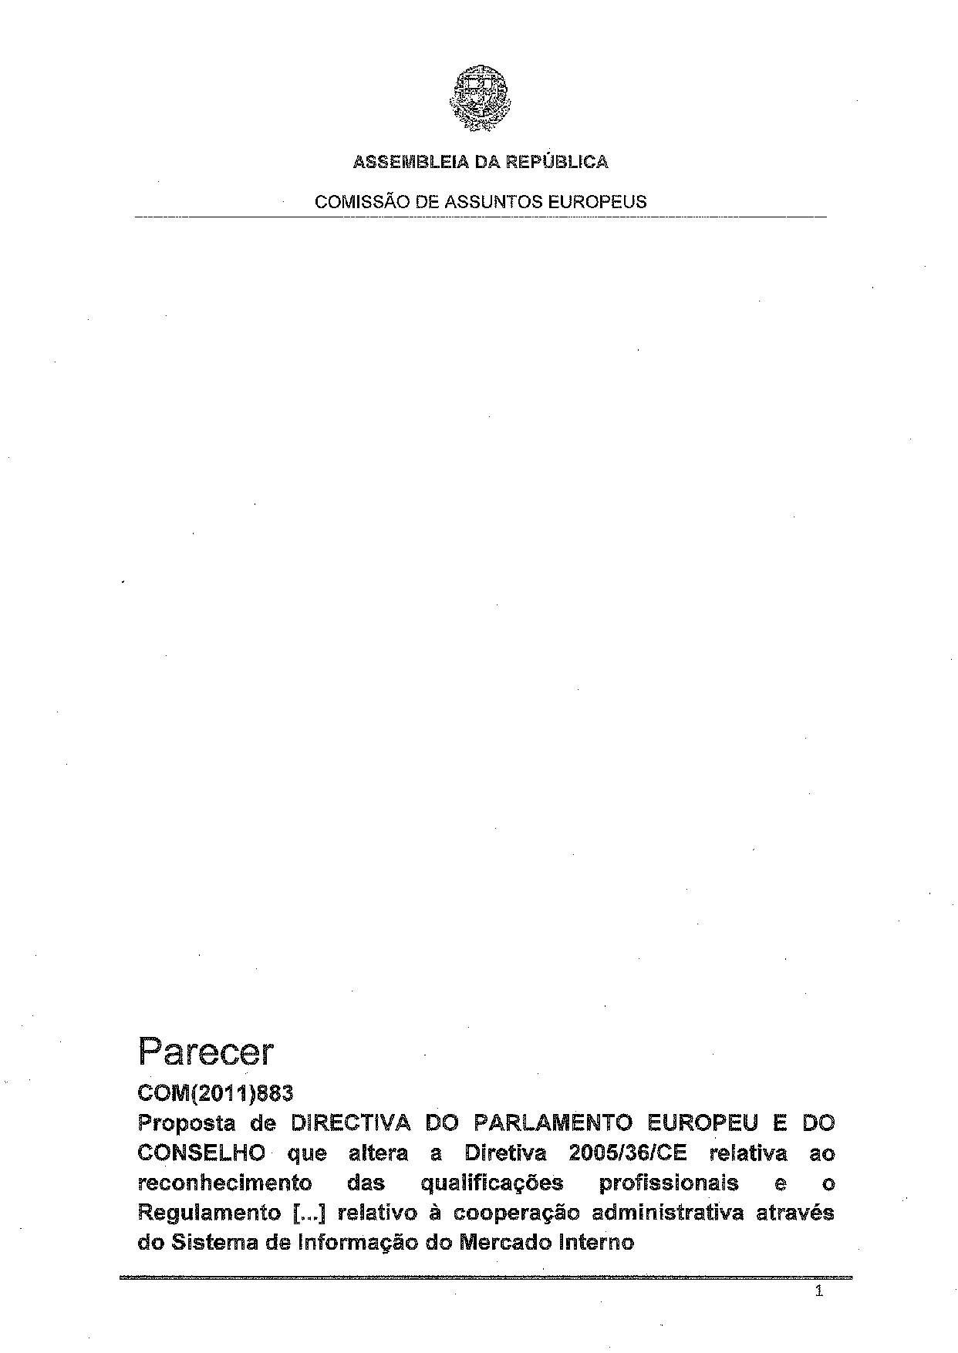
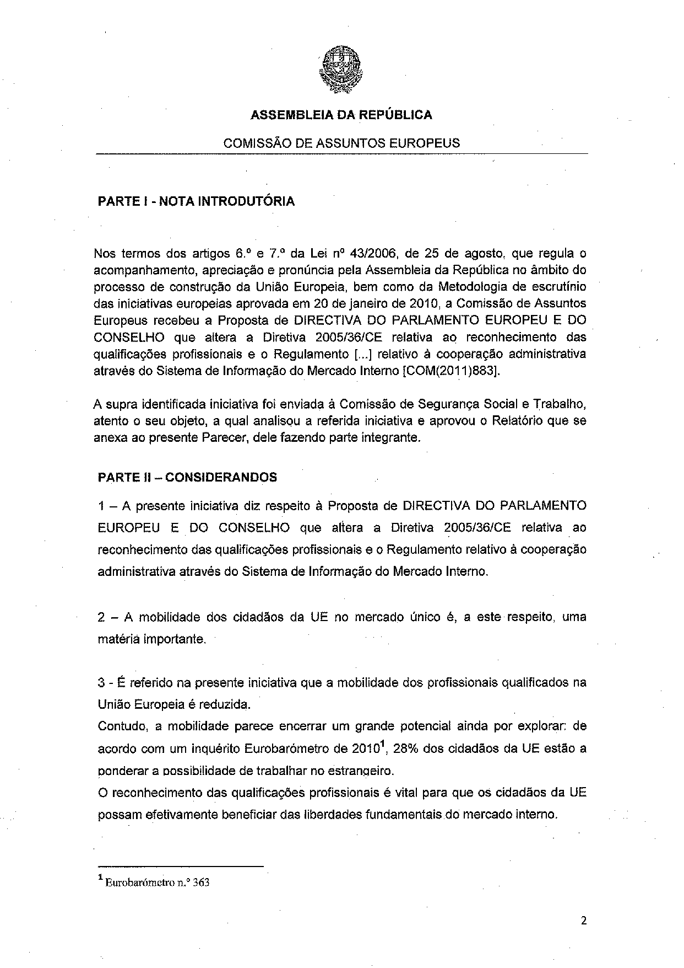
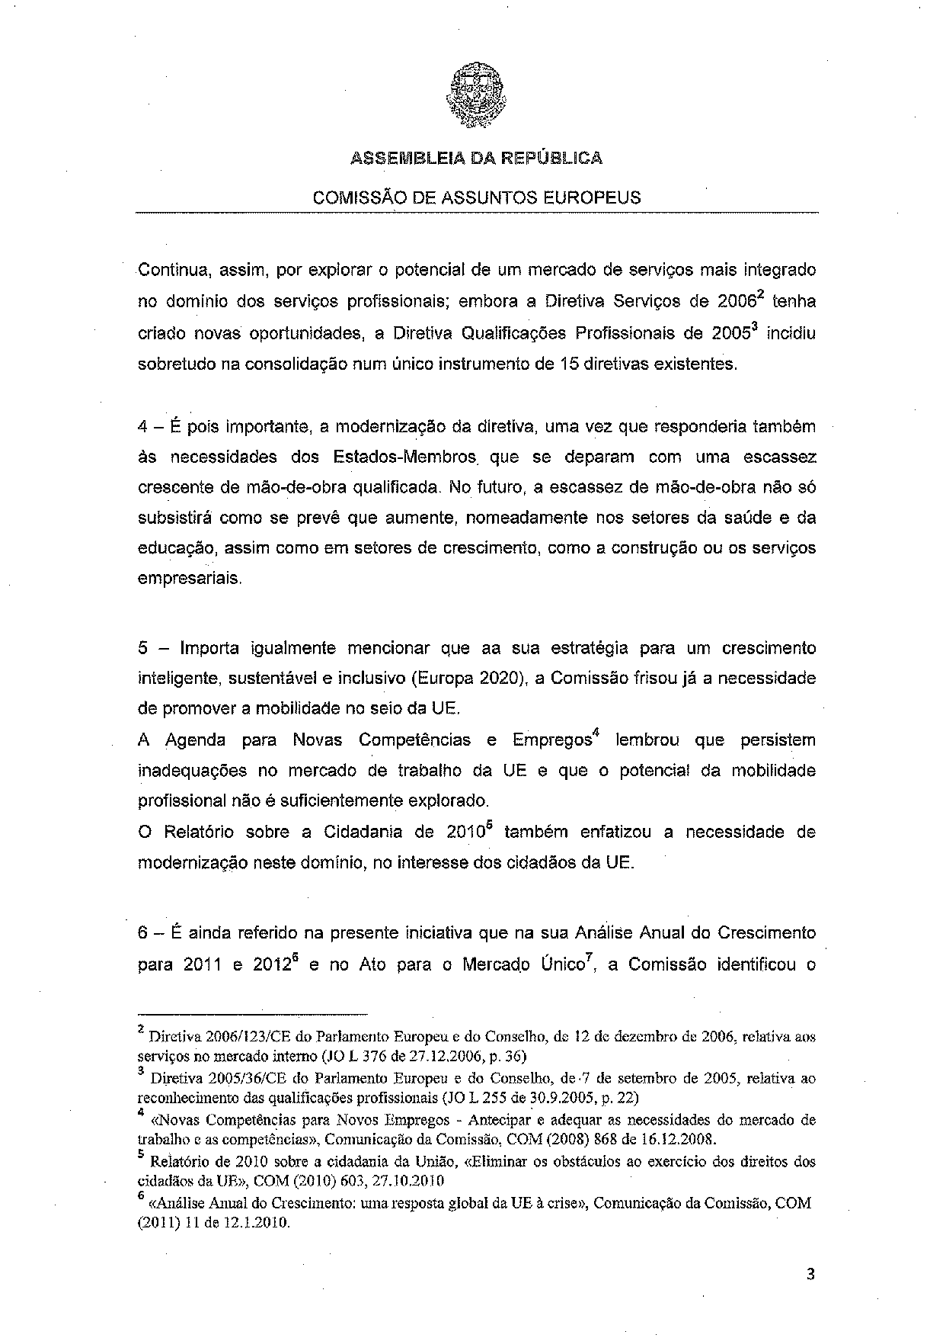
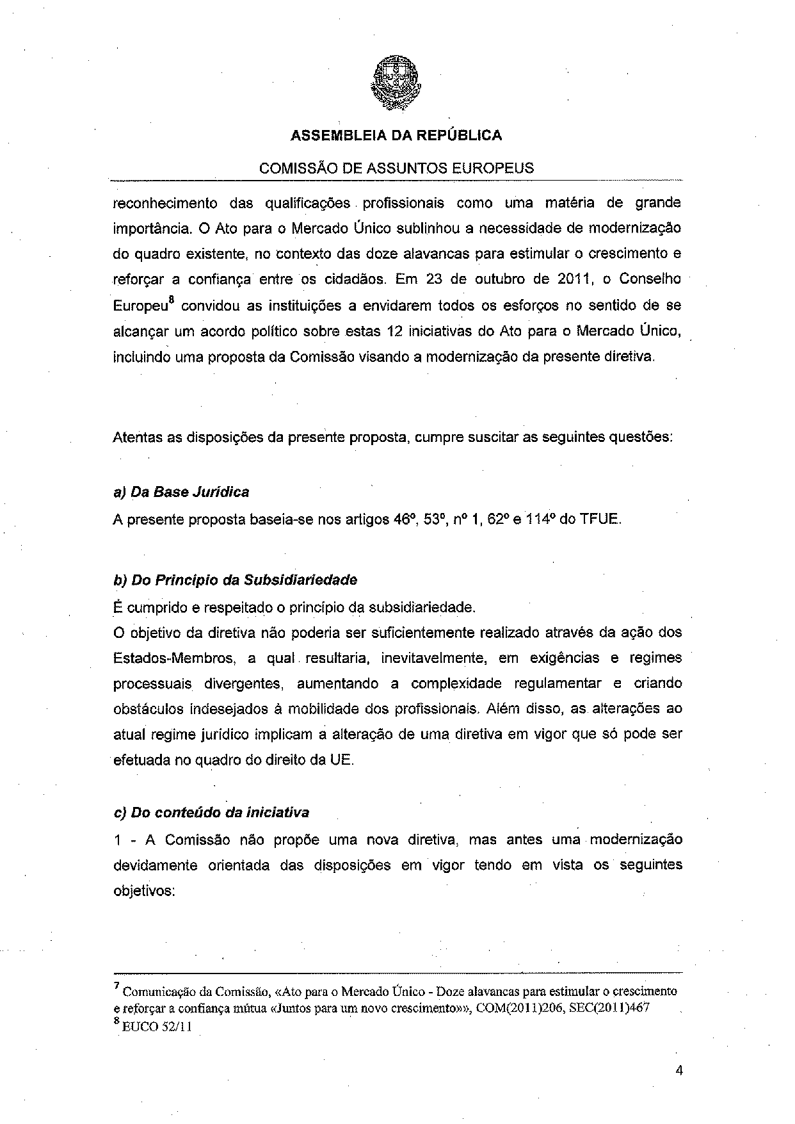
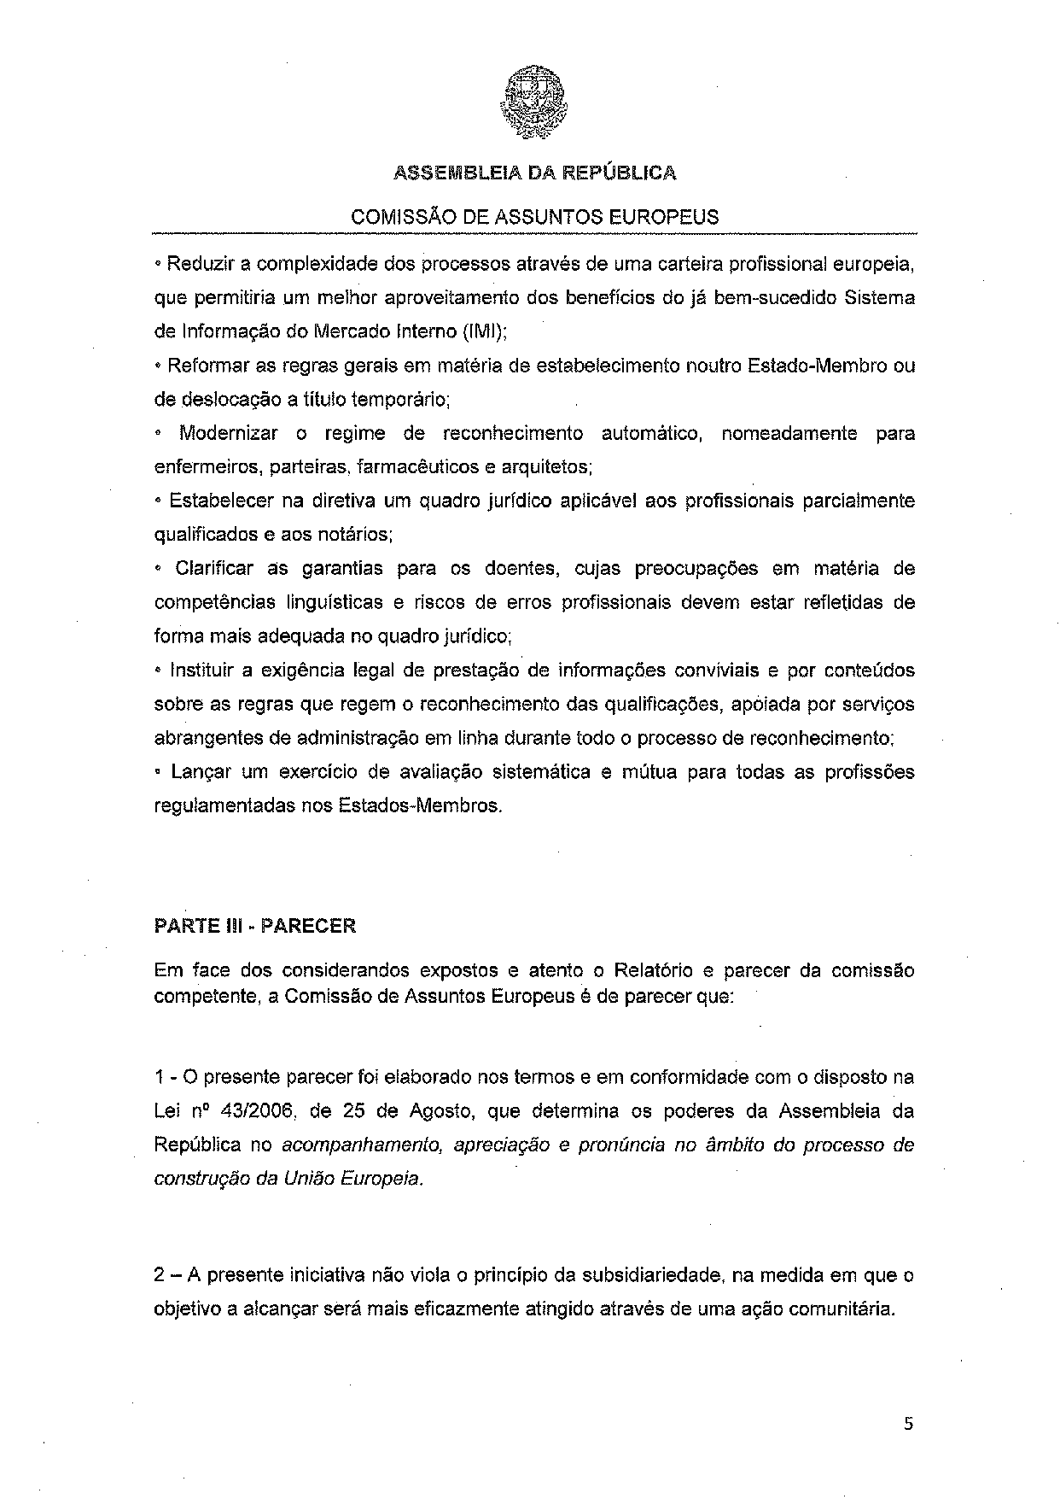
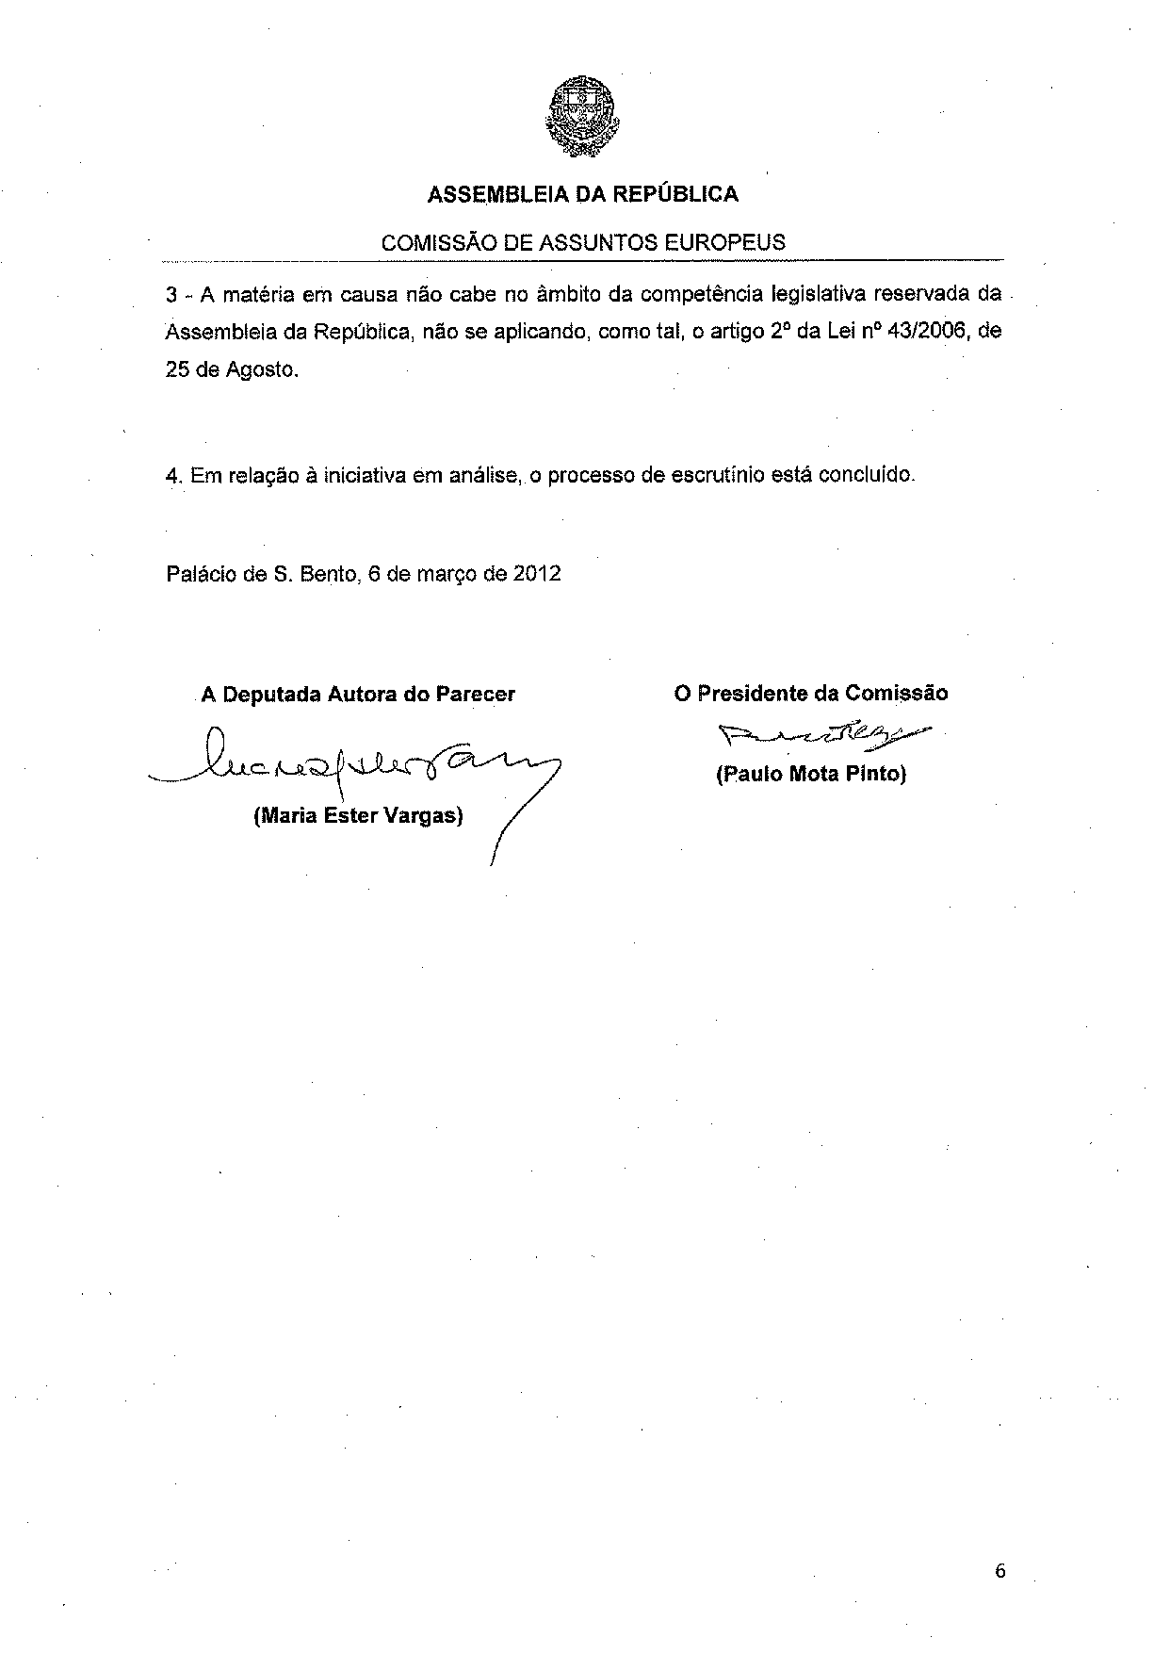

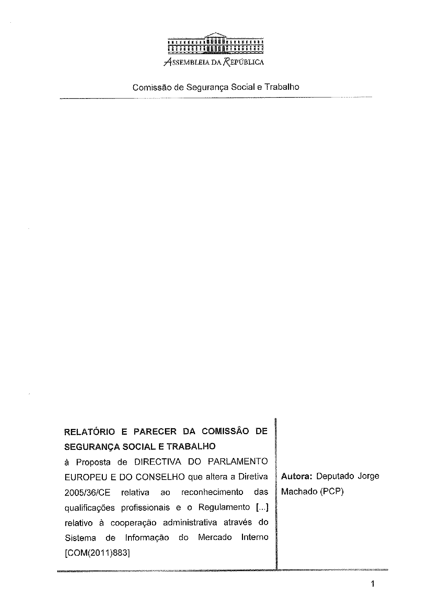
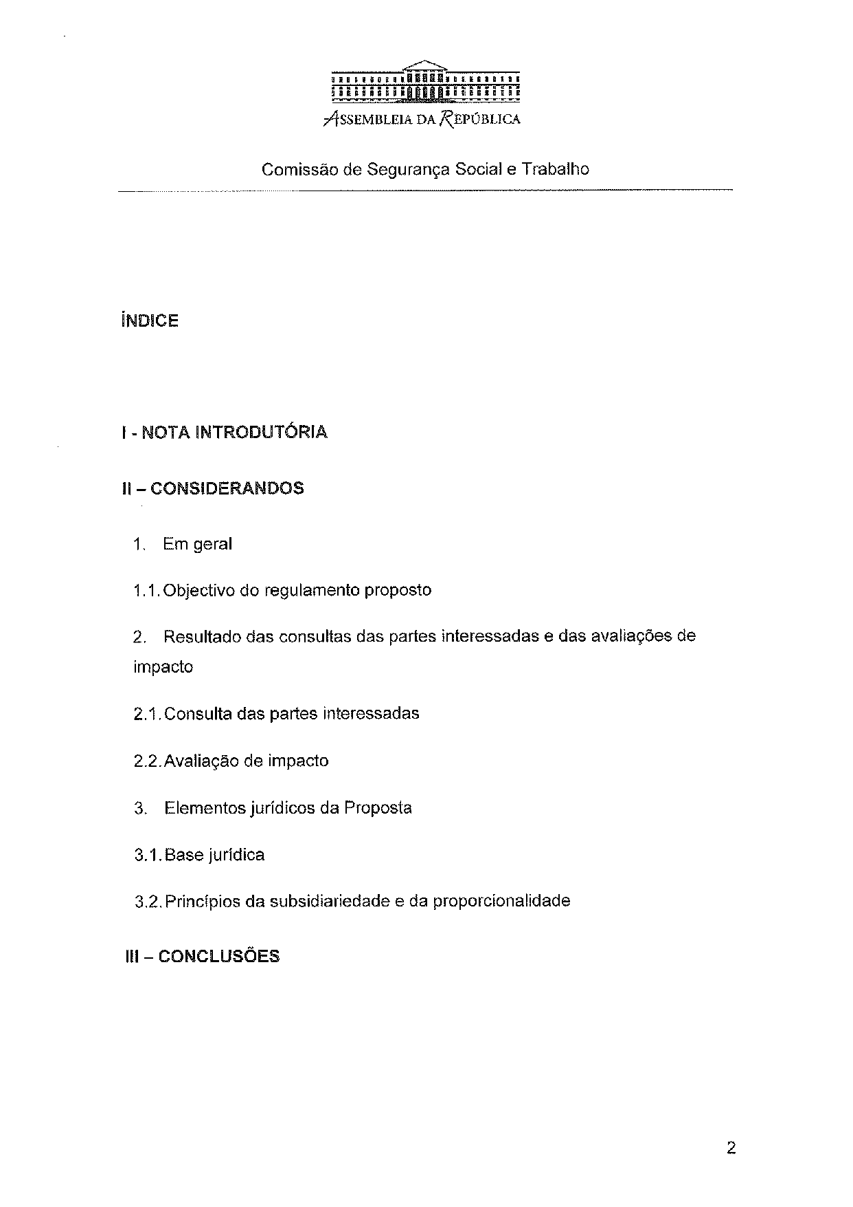
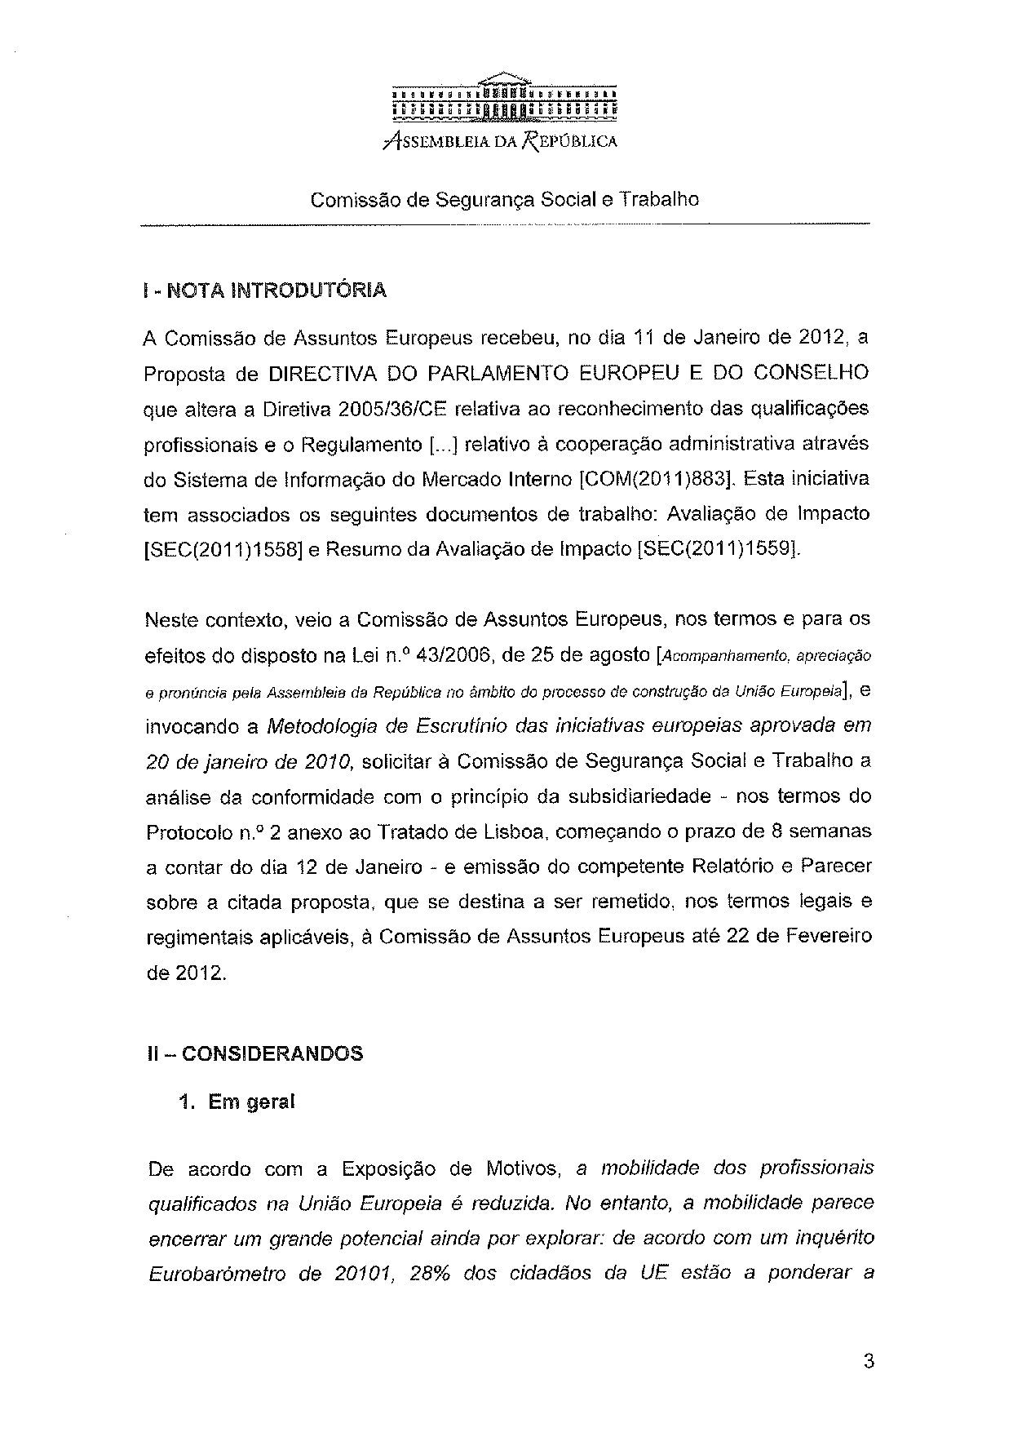
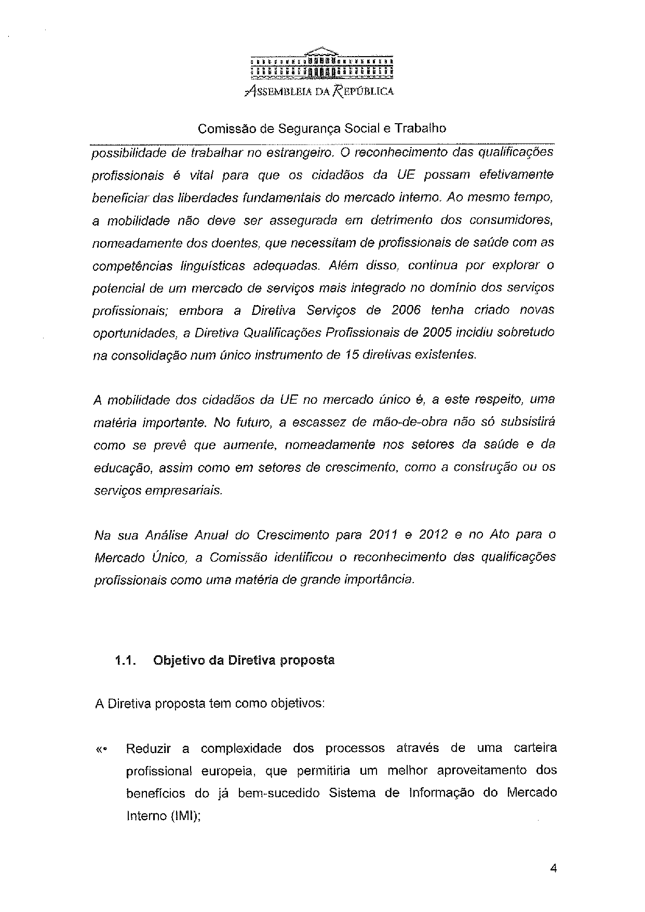
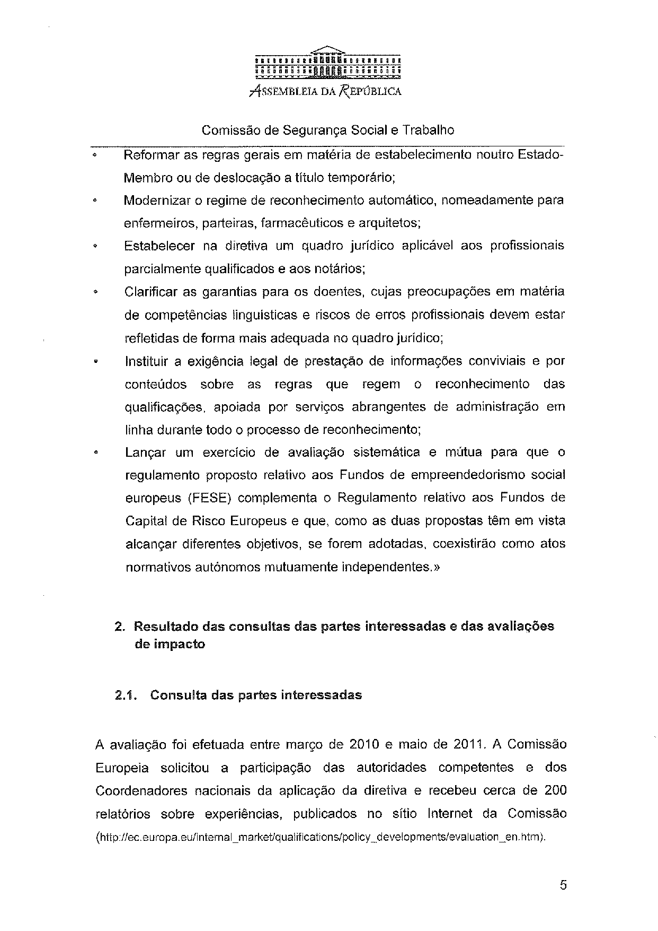
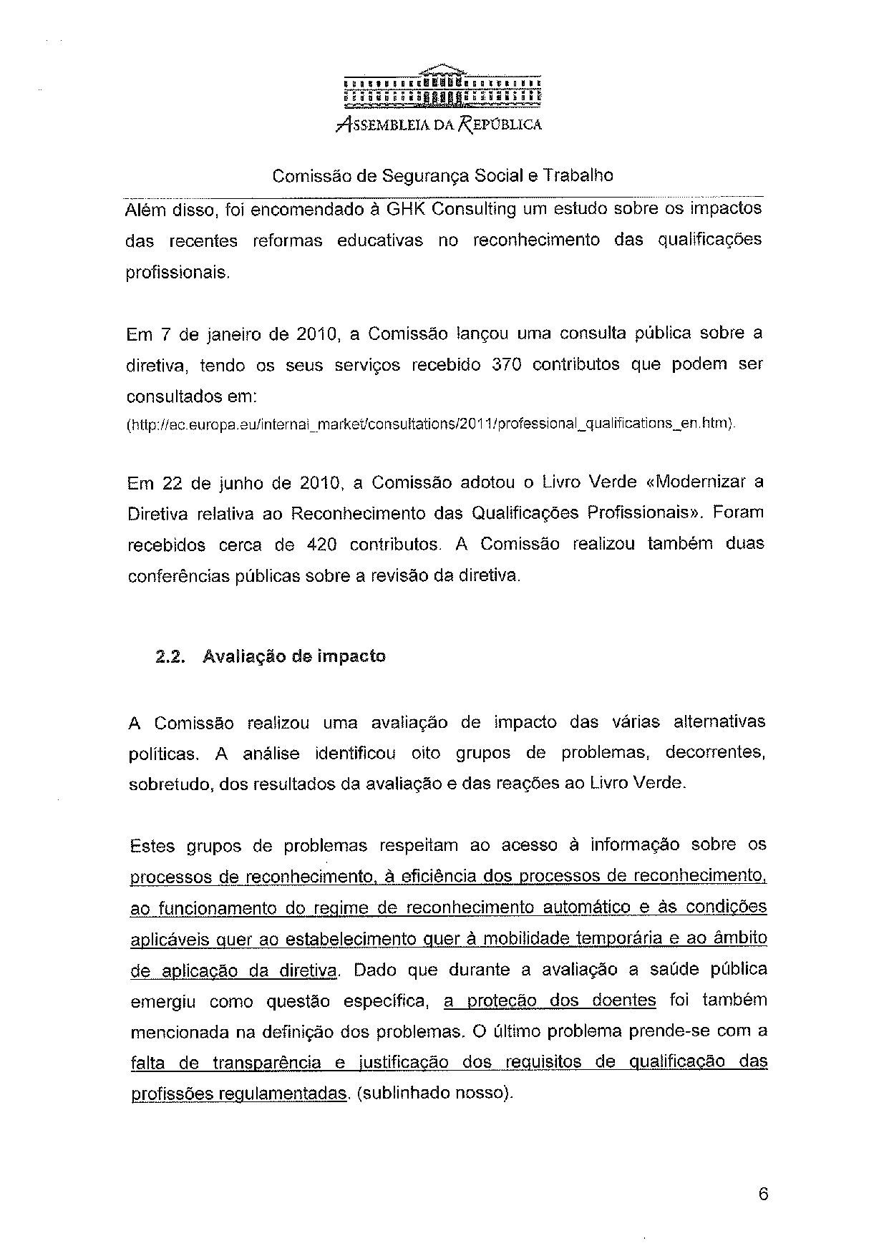
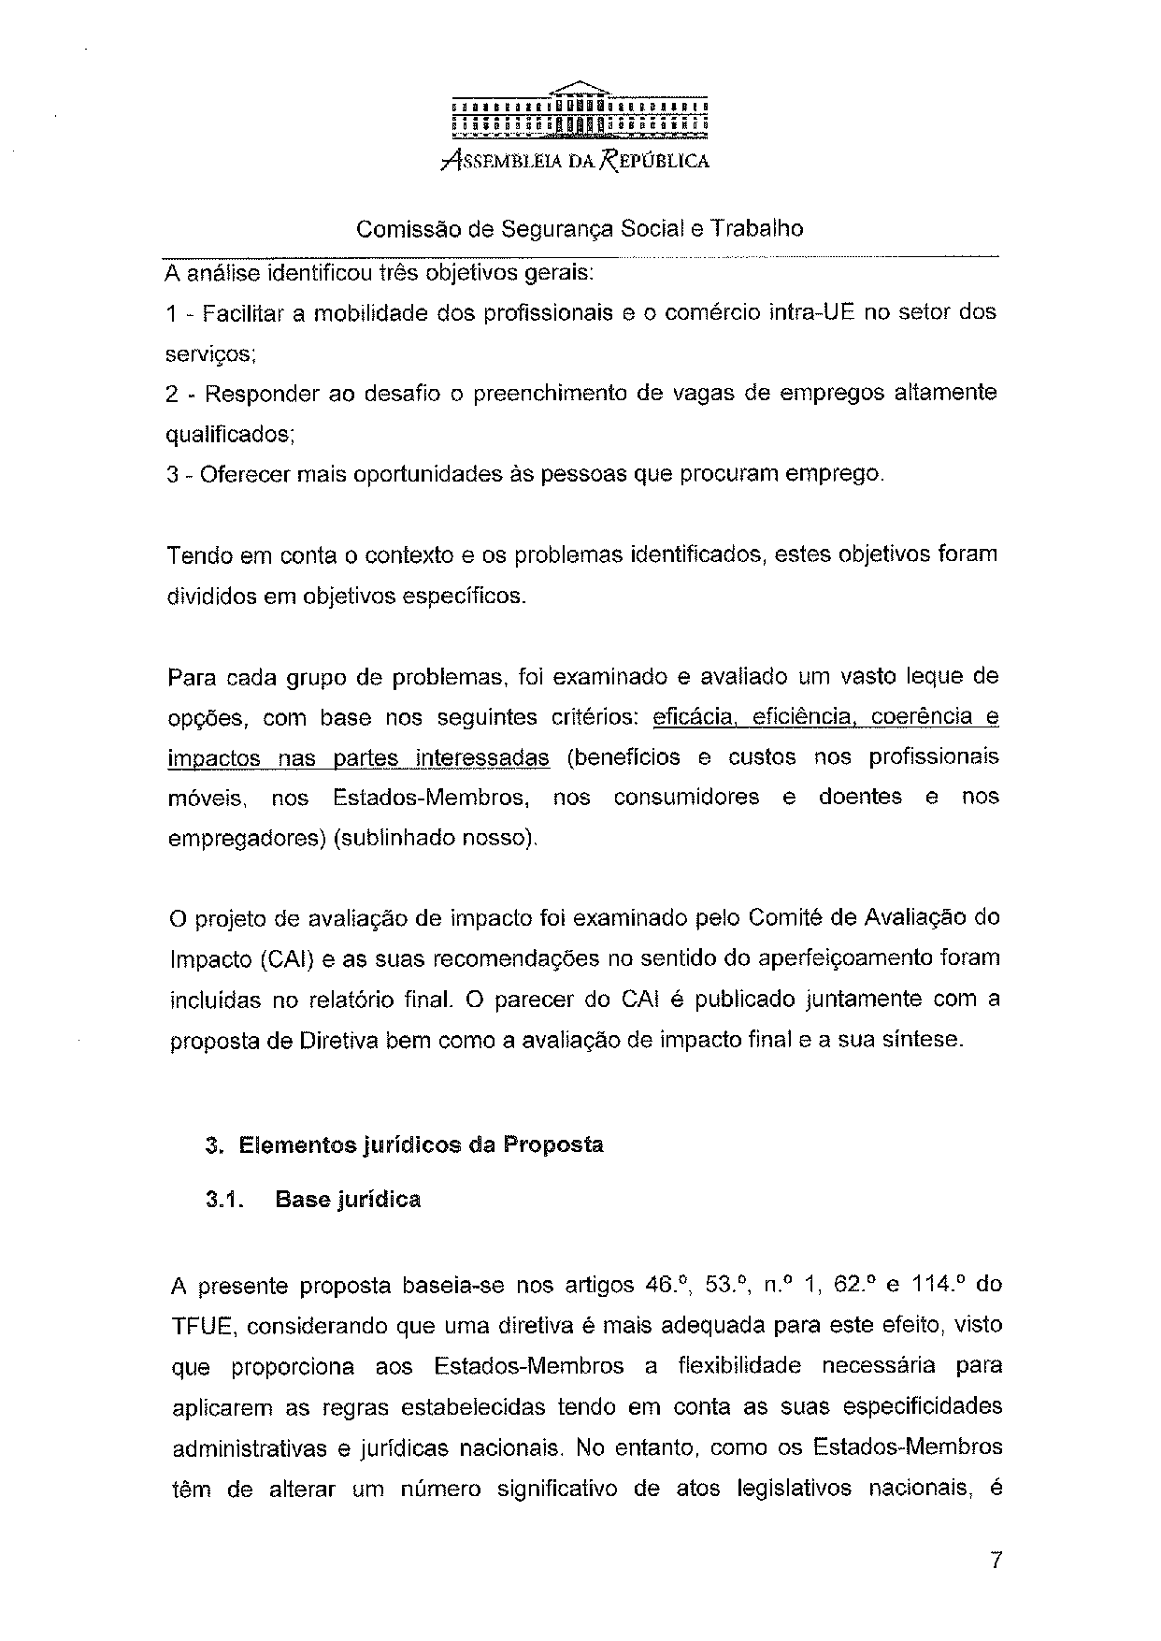
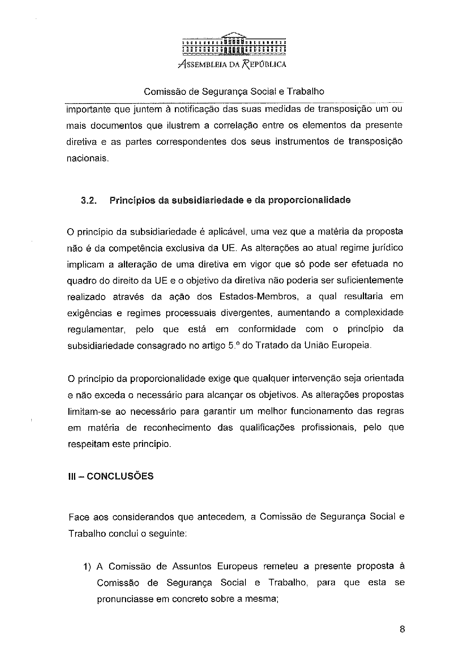
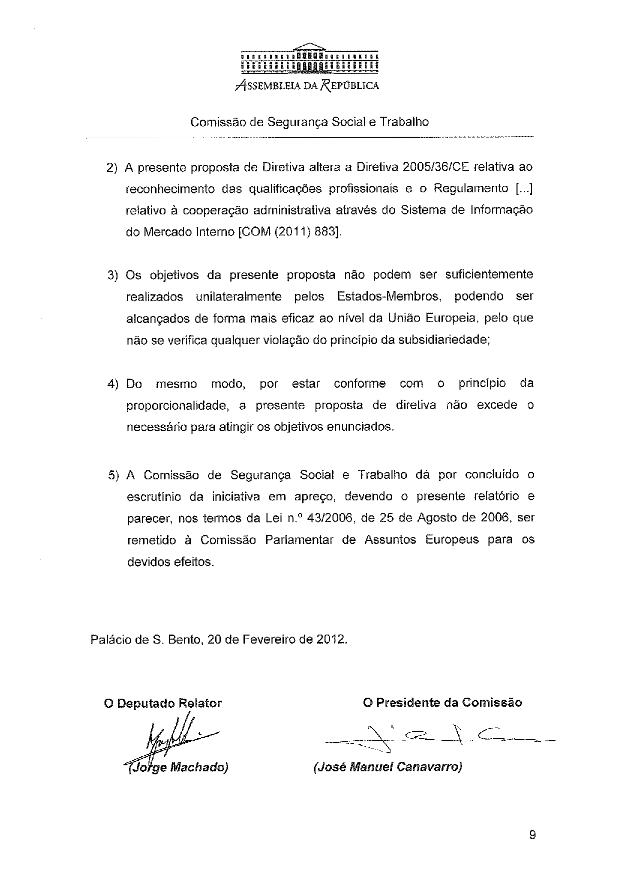
______________________________

Translations of the opinion may be available at the interparliamentary EU information exchange site IPEX at the following address: http://www.ipex.eu/IPEXL-WEB/search.do

