 | 
COUNCIL OF  THE EUROPEAN UNION |  |  | Brussels, 12 March 2012
 | Interinstitutional File:  2011/0310 (COD) |  | 7515/12
COMER 57
PESC 303
CONOP 43
ECO 33
UD 71
ATO 32
CODEC 631
INST 199
PARLNAT 147

COVER NOTE
from: | The Assembly of the Portuguese Republic
date of receipt: | 9 March 2012
to: | The Council of the European Union
No. Cion prop. | COM(2011) 704 final
Subject: | Proposal for a Regulation of the European Parliament and of the Council amending Regulation (EC) No. 428/2009 setting up a Community Regime for the control of exports, transfer, brokering and transit of dual use items  – Opinion on the application of the Principles of Subsidiarity and Proportionality

Delegations will find attached a copy of the abovementioned opinion.

_______________

Encl.:

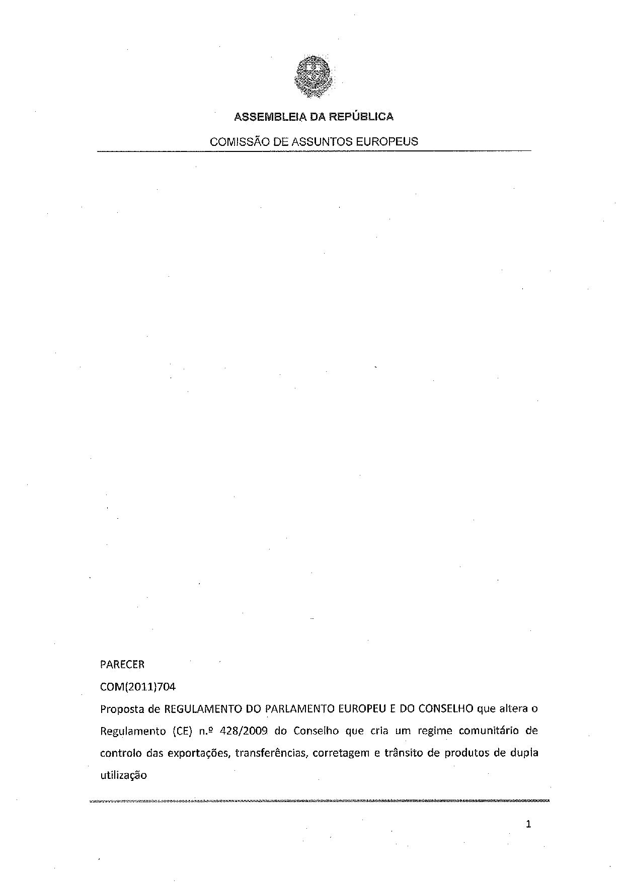

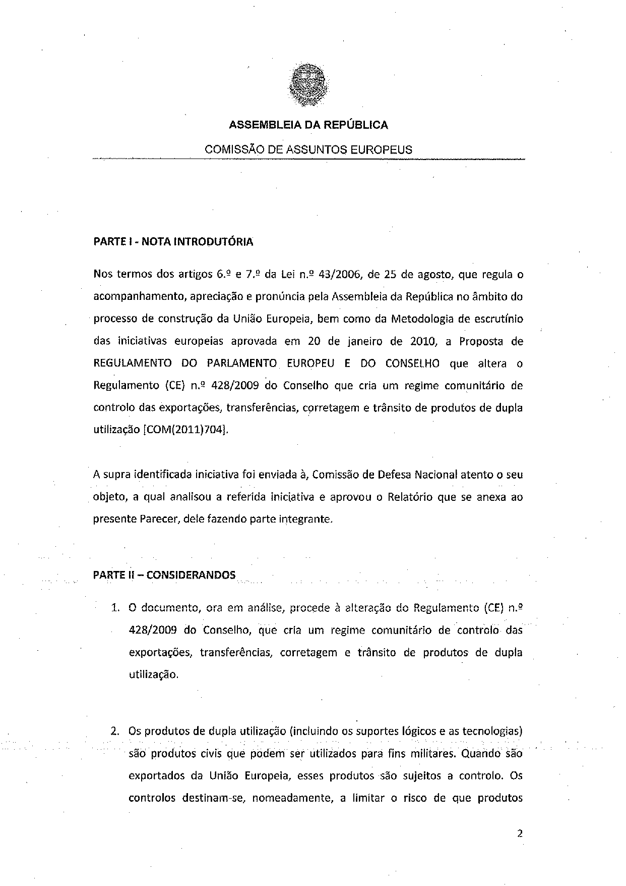

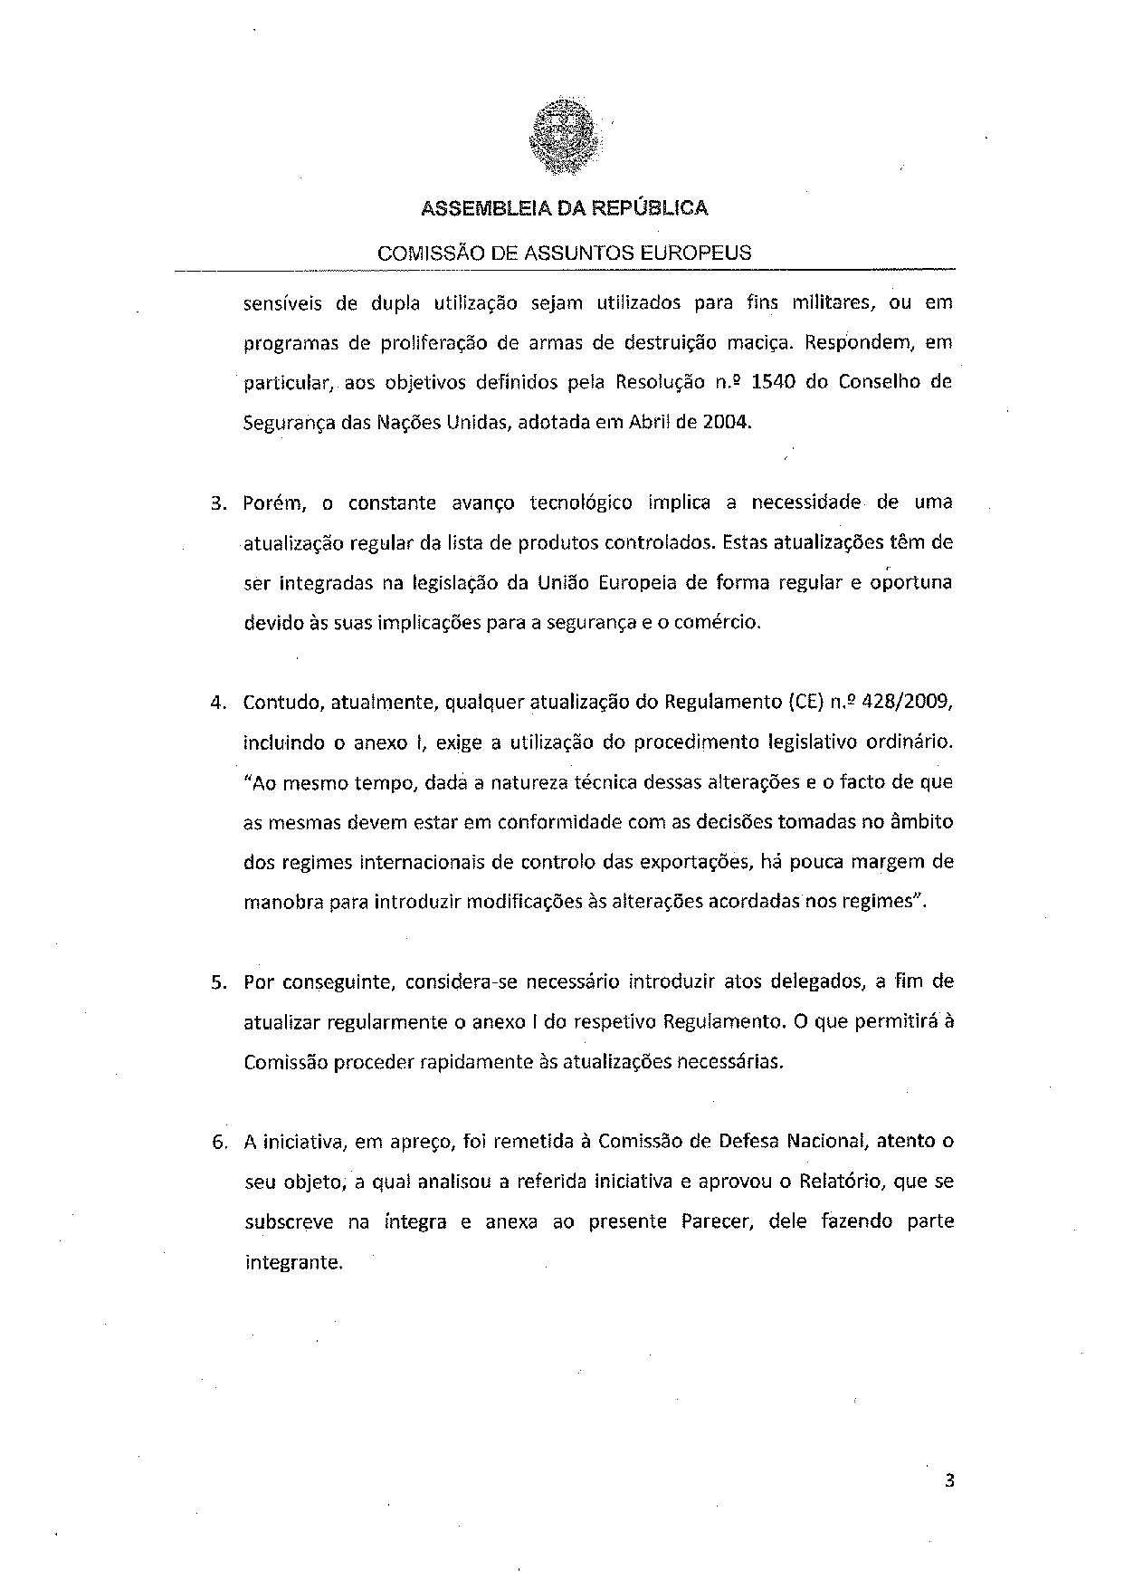

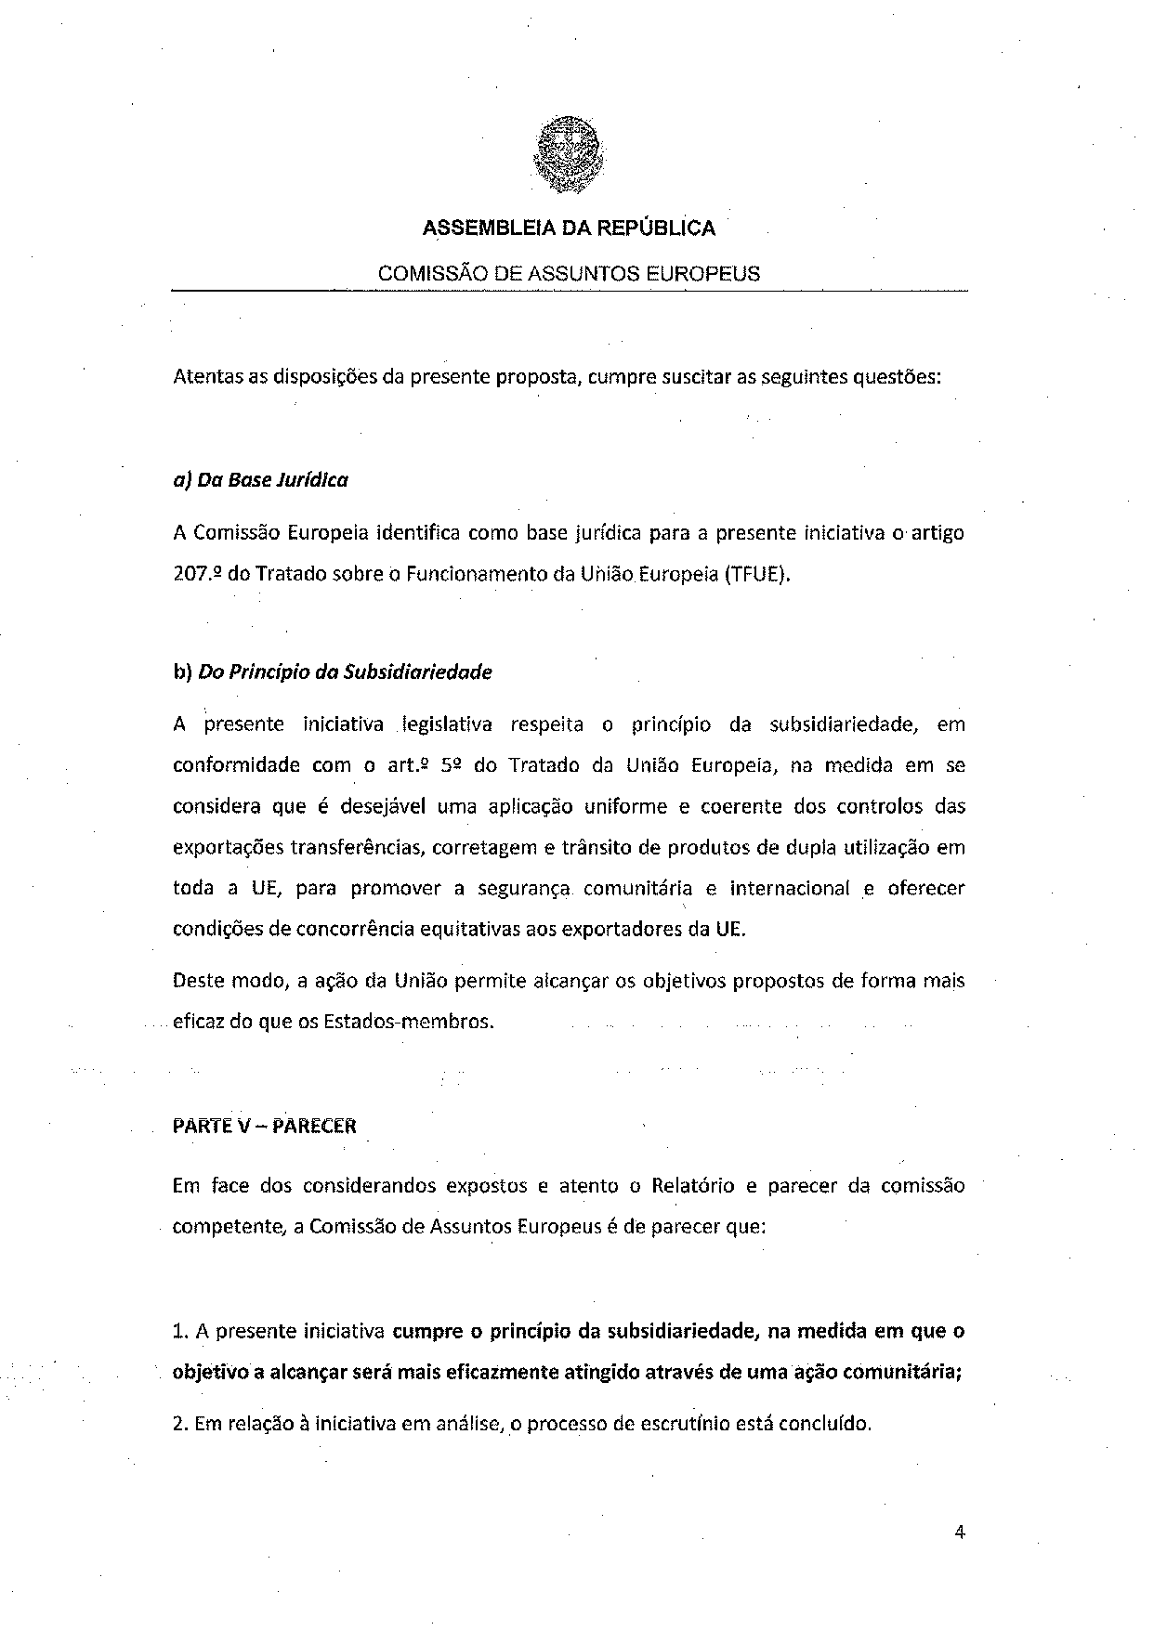

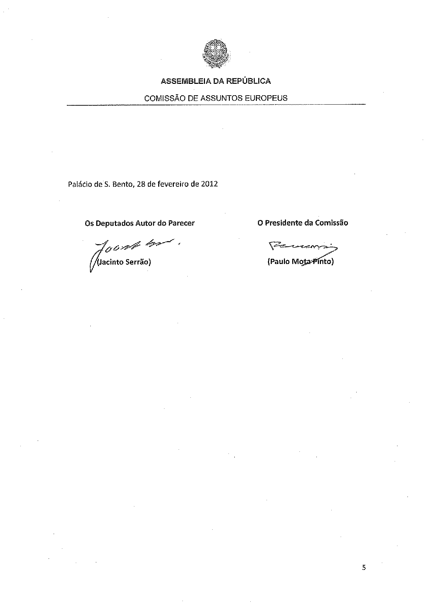

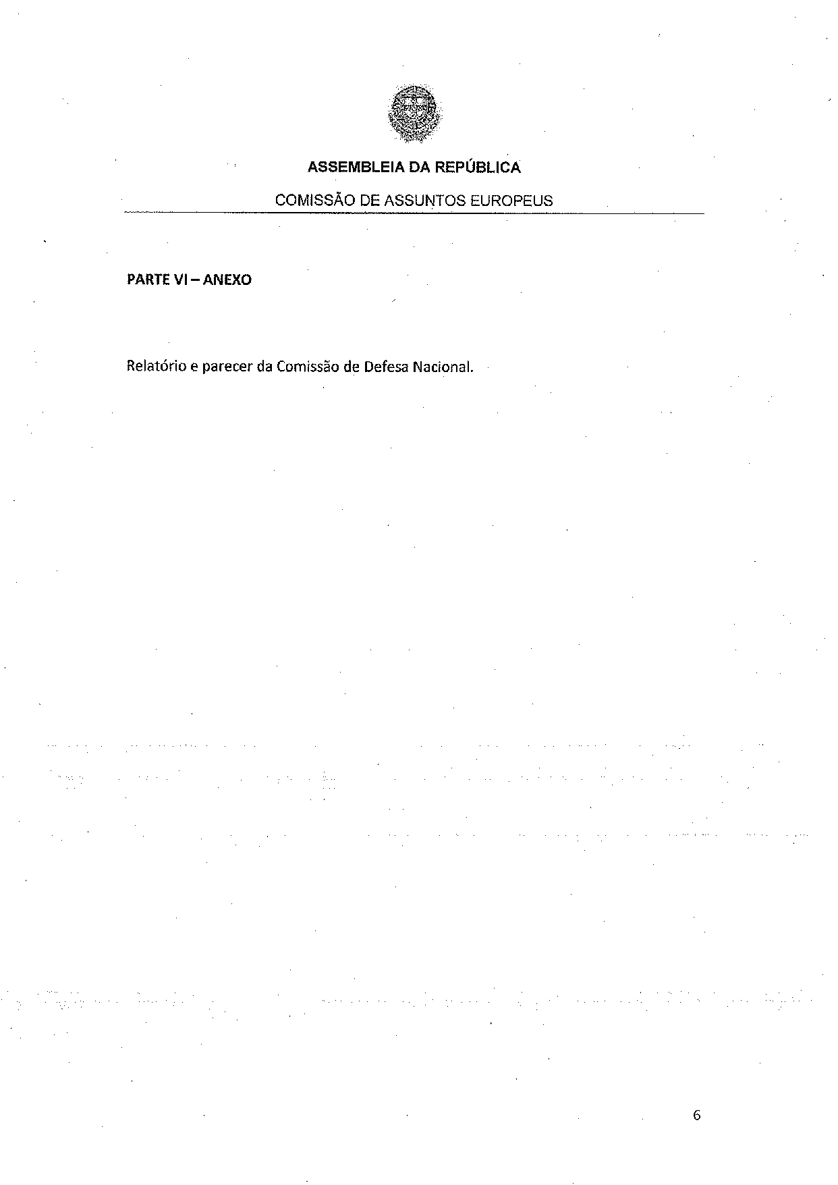

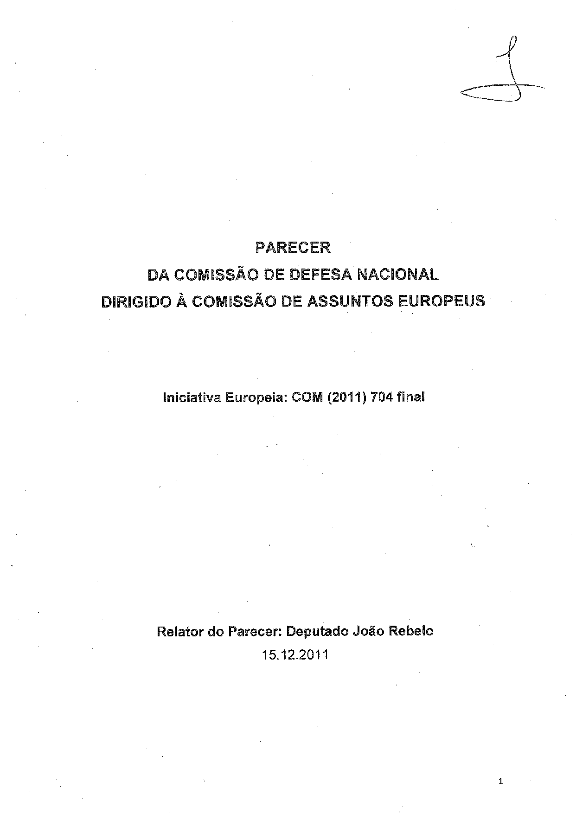

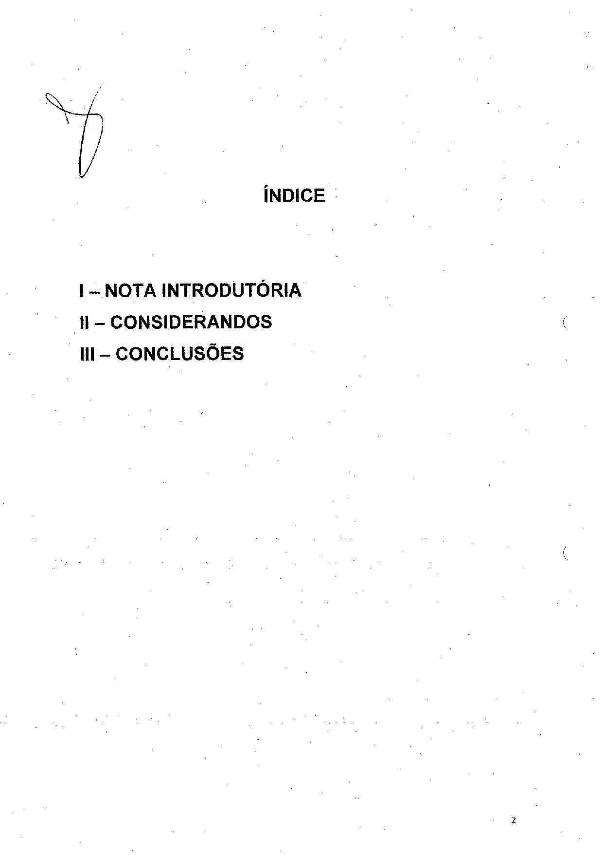

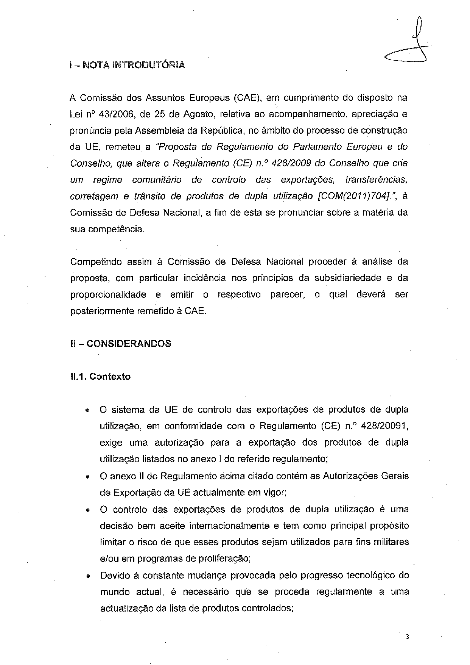

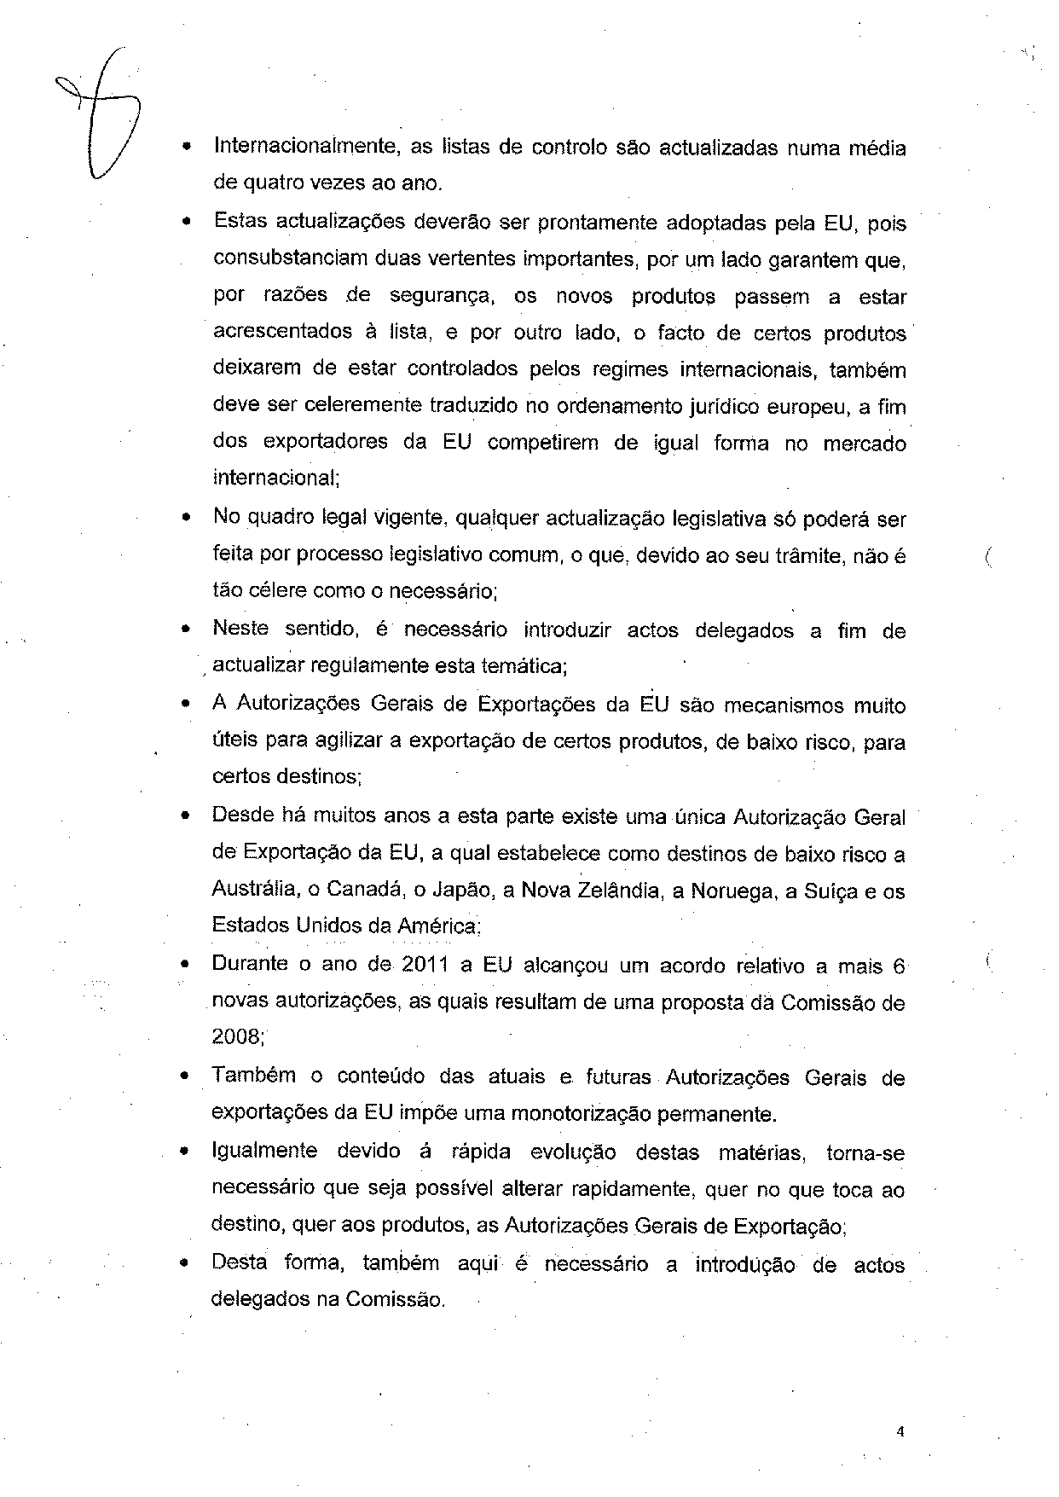

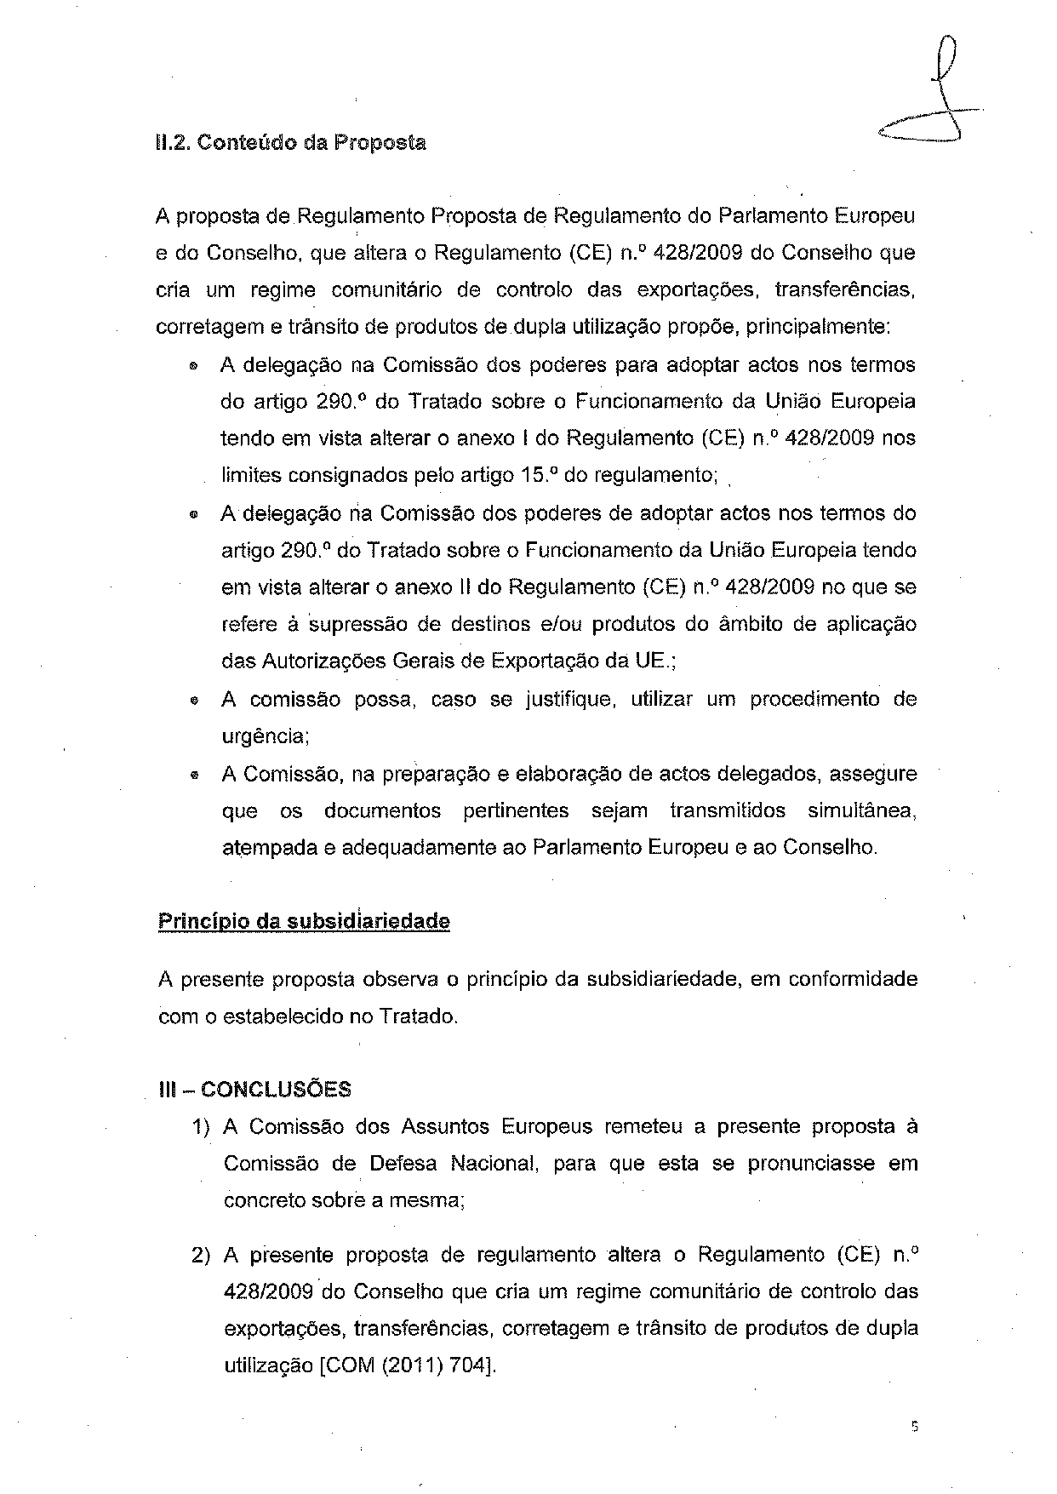

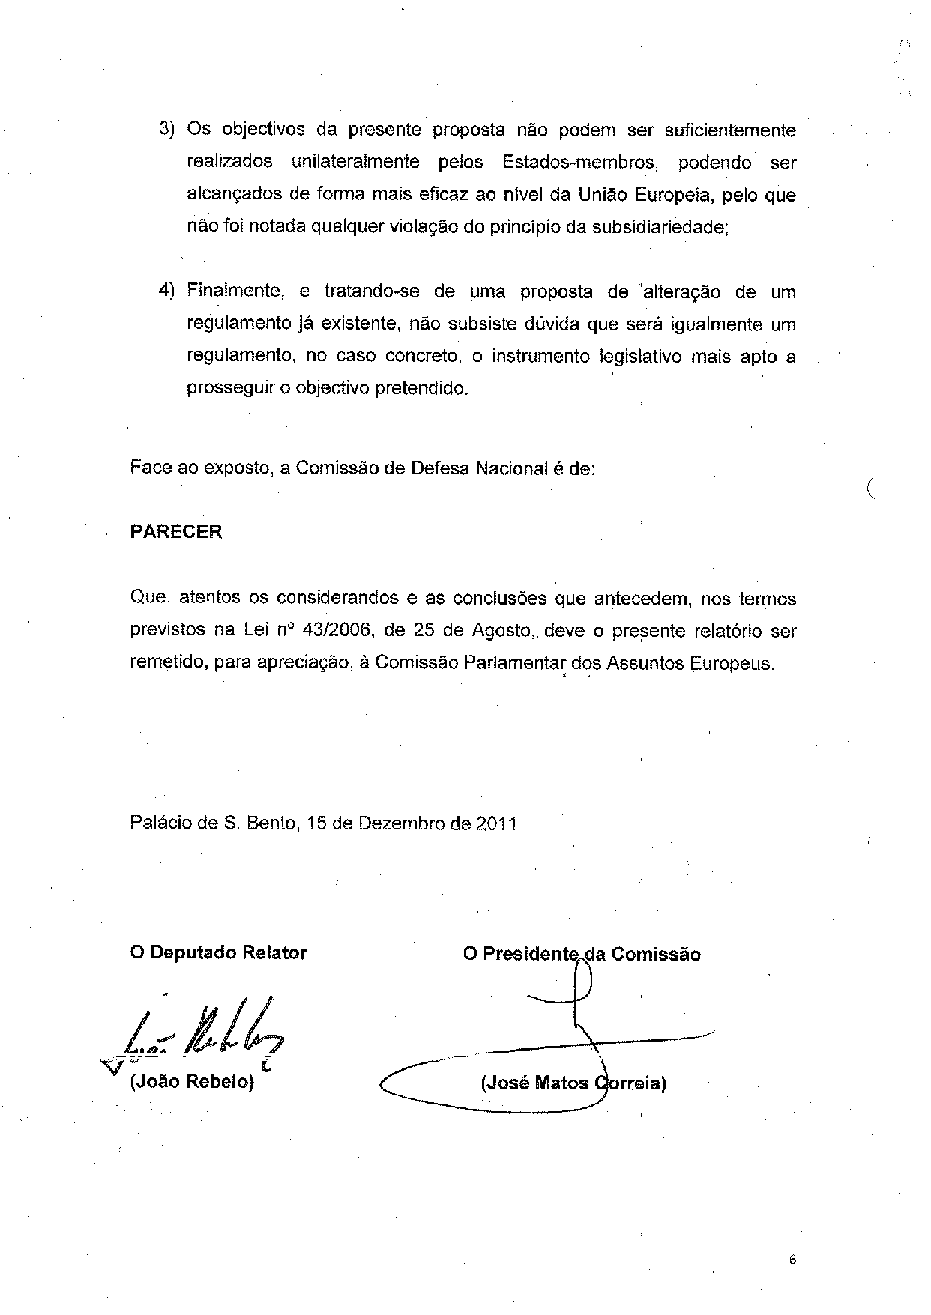

For other available language versions of the opinion, reference is made to the Interparliamentary EU information exchange Internet site (IPEX) at the following address: http://www.ipex.eu/ipex/cms/home/Documents/pid/10.

