 | 
COUNCIL OF  THE EUROPEAN UNION |  |  | Brussels, 12 March 2012
 | Interinstitutional File:  2011/0459 (COD) |  | 7480/12
STATIS 23
ECOFIN 236
CODEC 614
INST 192
PARLNAT 140

COVER NOTE
from: | Portuguese Assembleia da República, Comissão de Assuntos Europeus
date of receipt: | 8 March 2012
to: | Mr Uwe CORSEPIUS, Secretary-General of the Council of the European Union
No Cion doc.: | COM(2011) 928 final
Subject: | Proposal for a Regulation of the European Parliament and of the Council on the European statistical programme 2013-2017 [doc. ST 5089/12 STATIS 1 ECOFIN 6 CODEC 16 - COM(2011) 928 final]  - Opinion on the application of the Principles of Subsidiarity and Proportionality

Delegations will find attached the opinion of the Portuguese Parliament on COM(2011) 928 final - Council ST 5089/12.

________________________

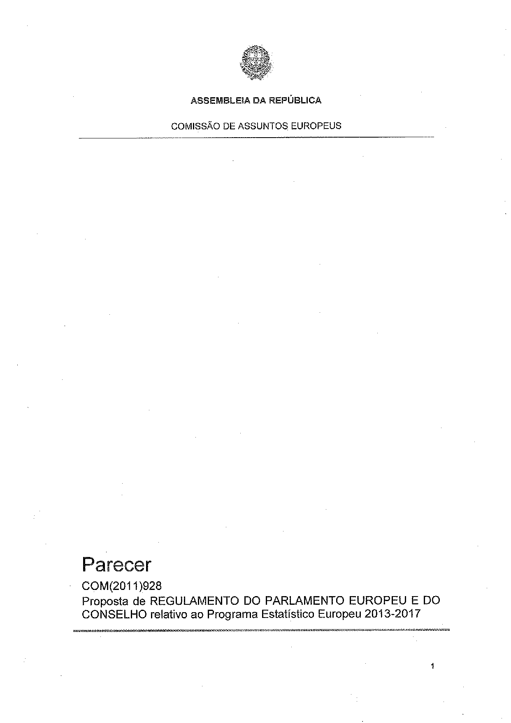
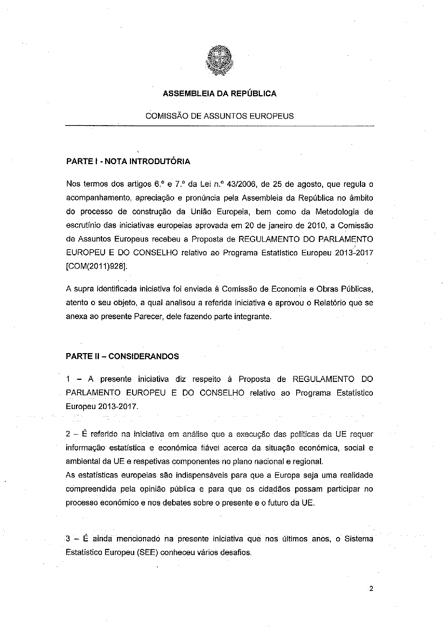
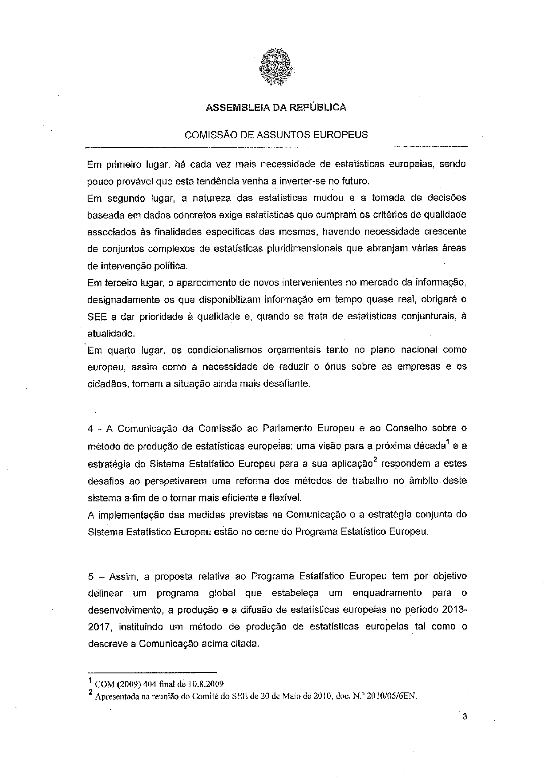
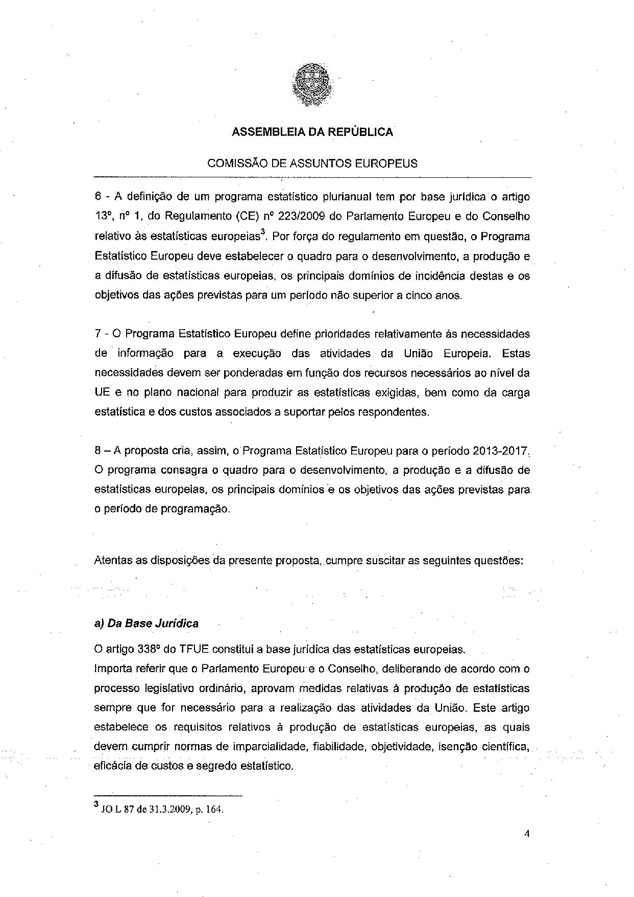
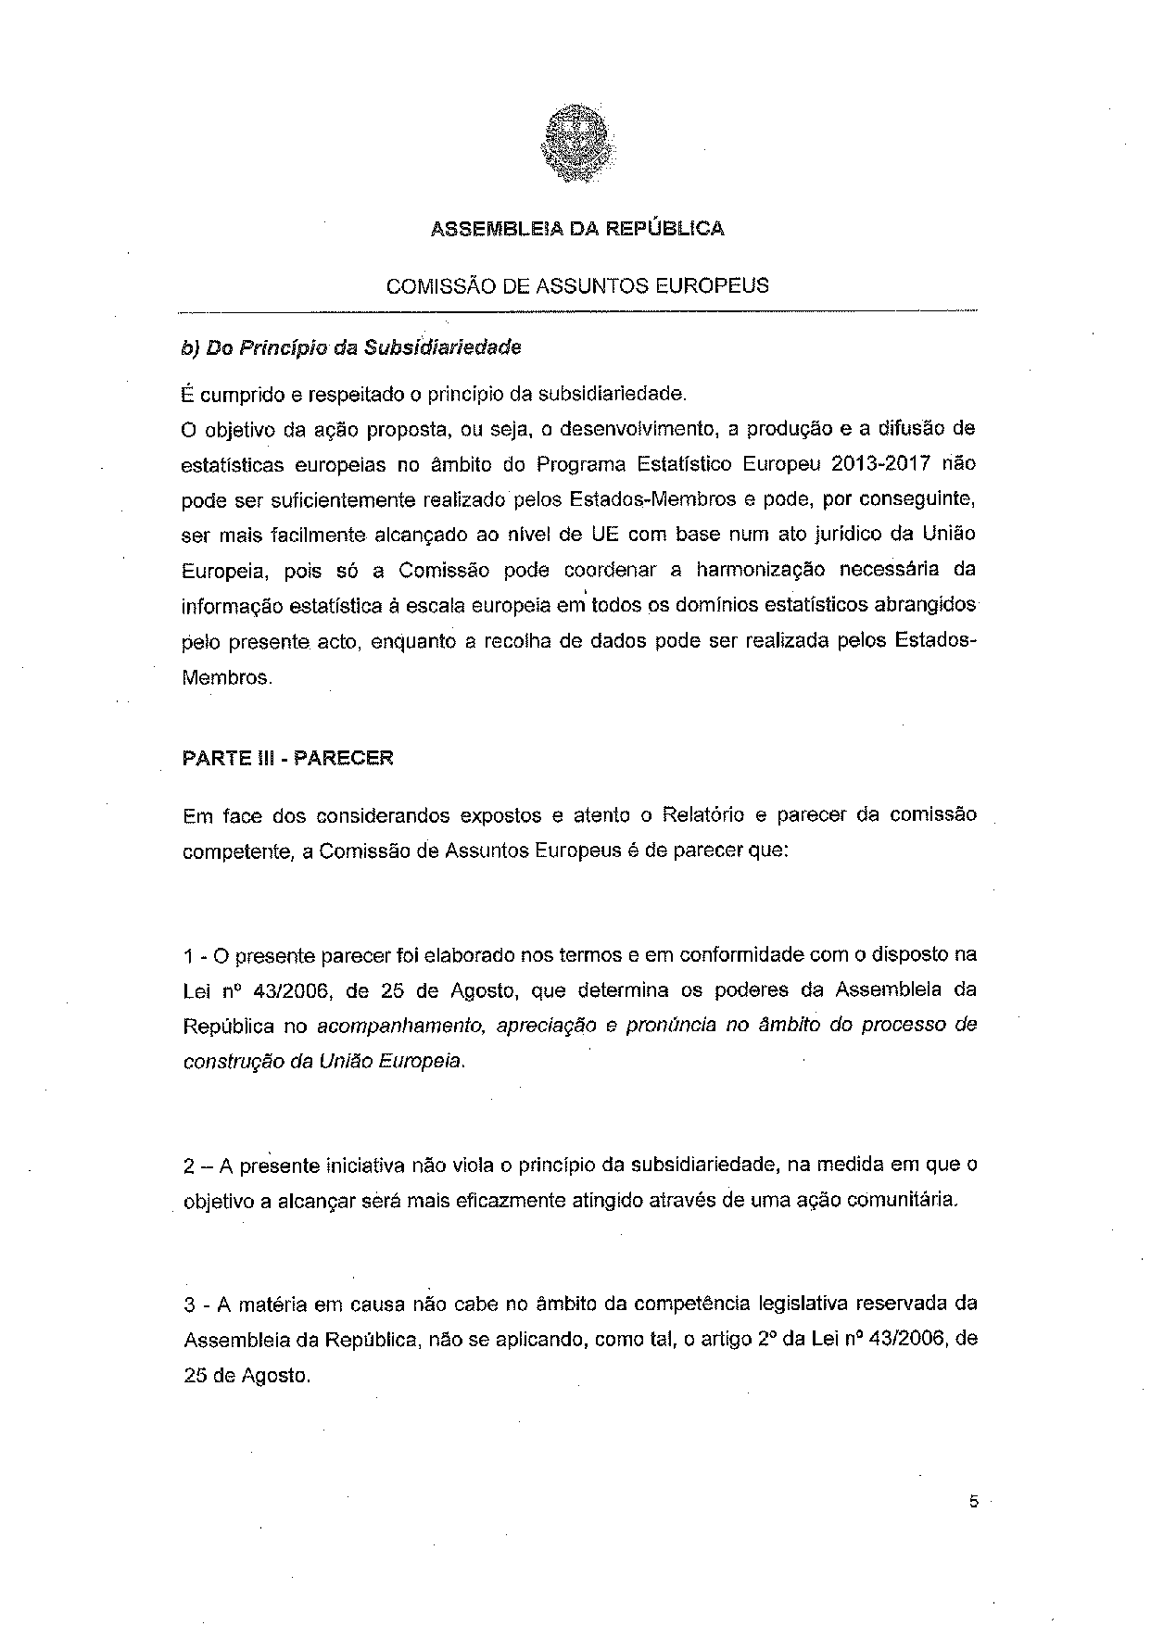
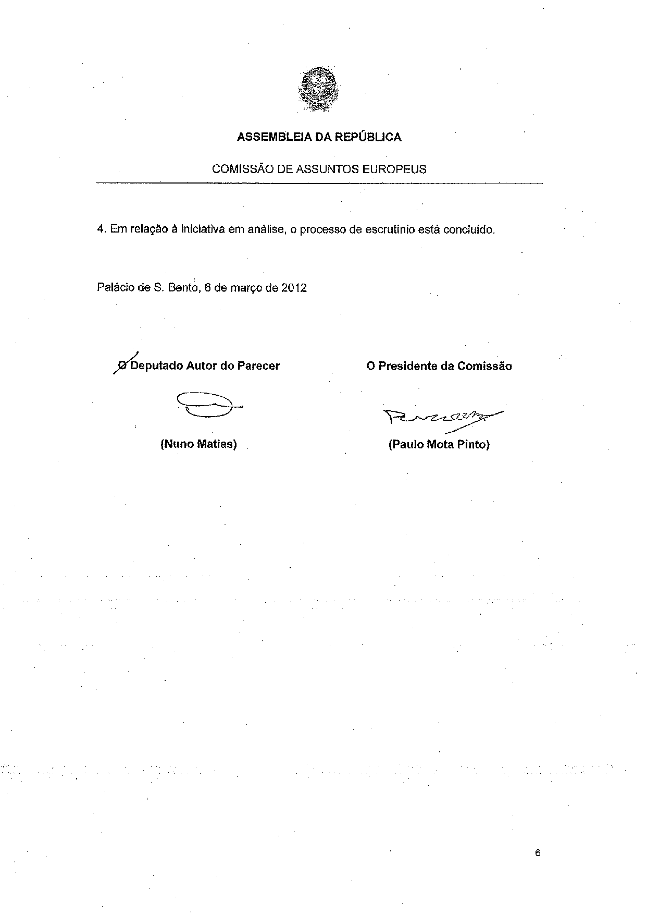

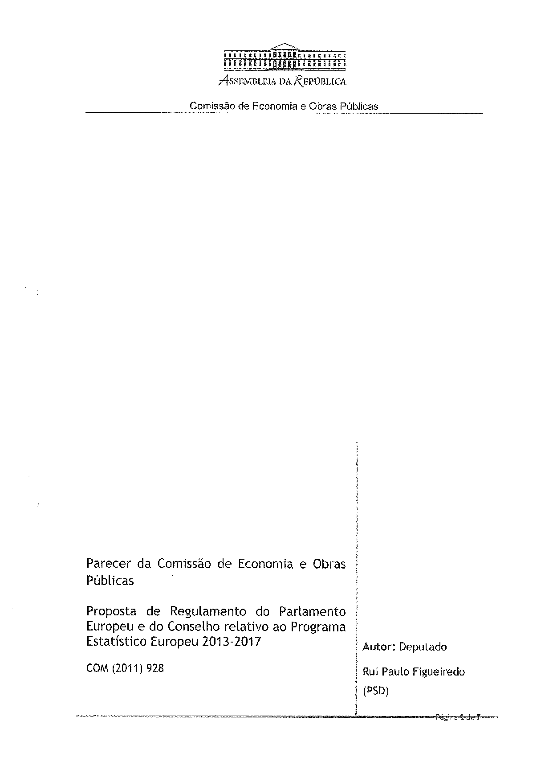
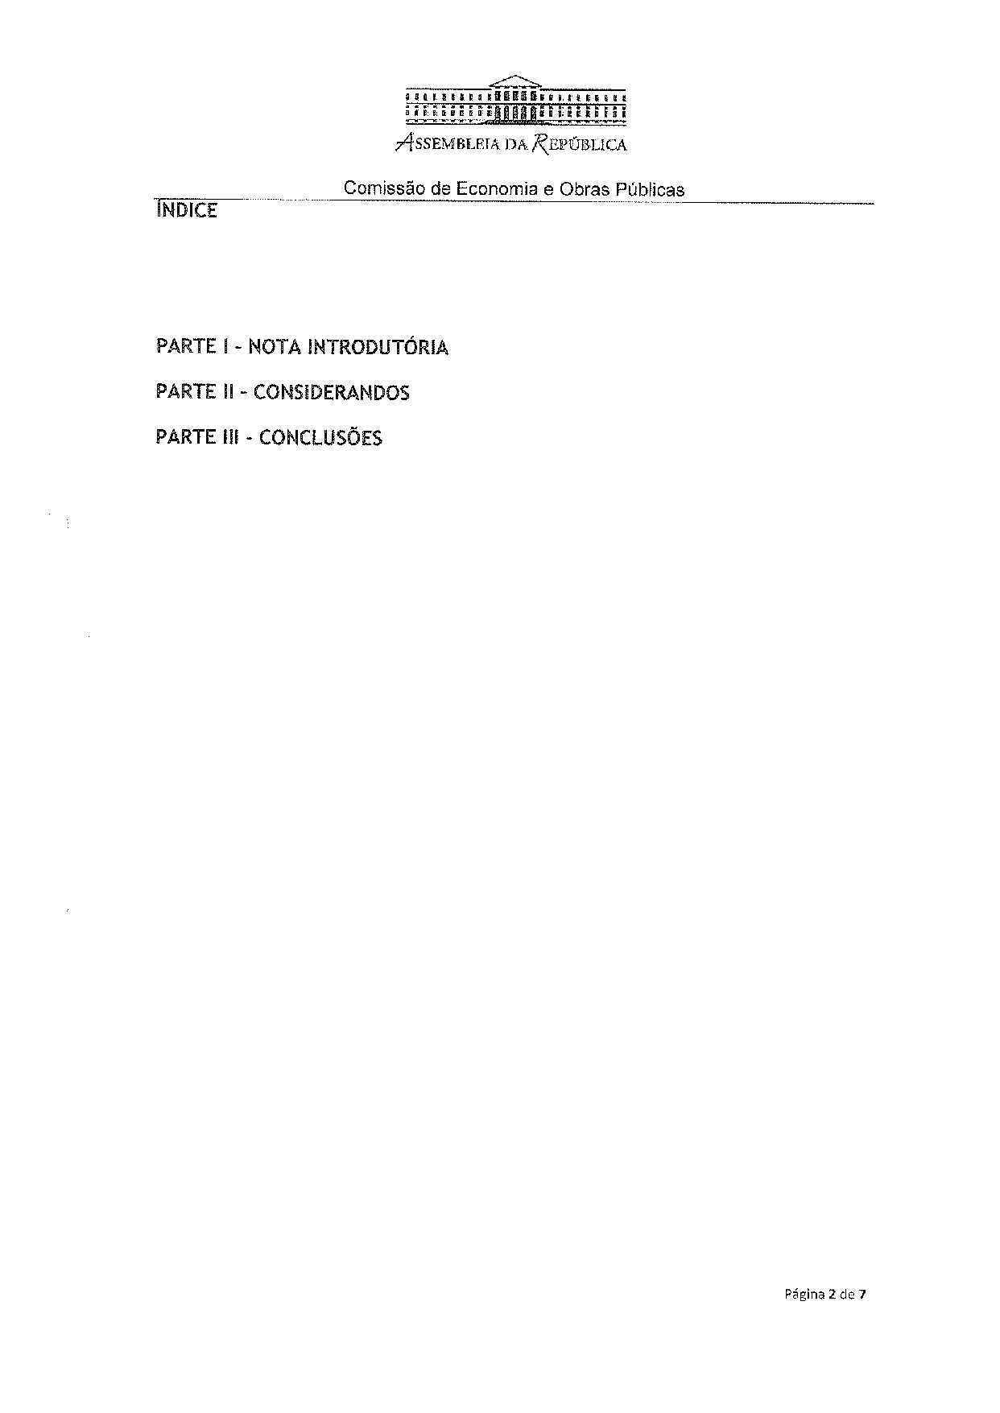
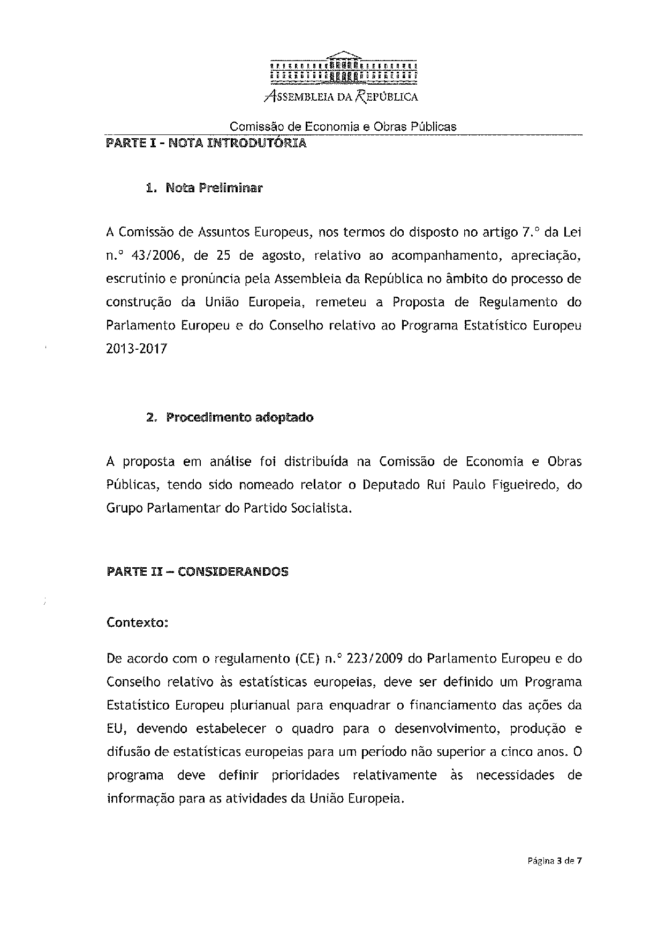
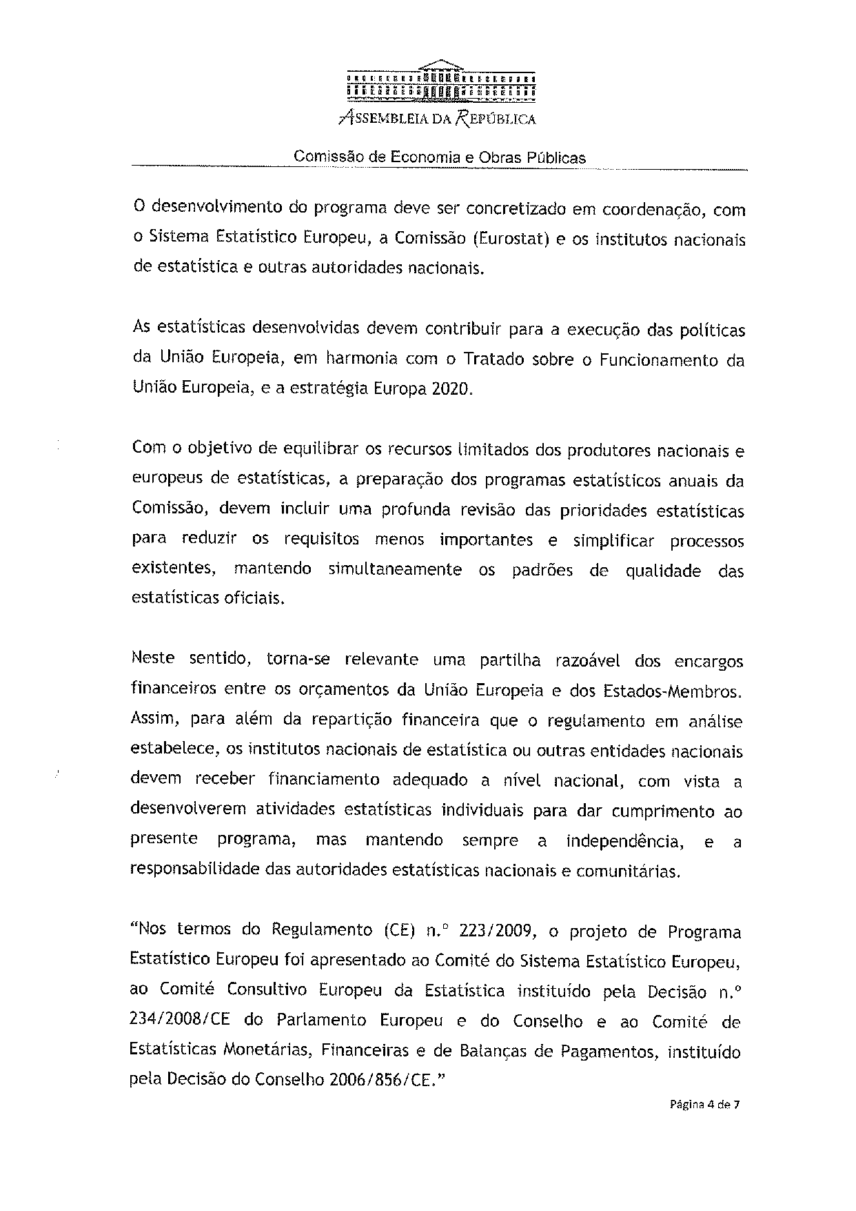
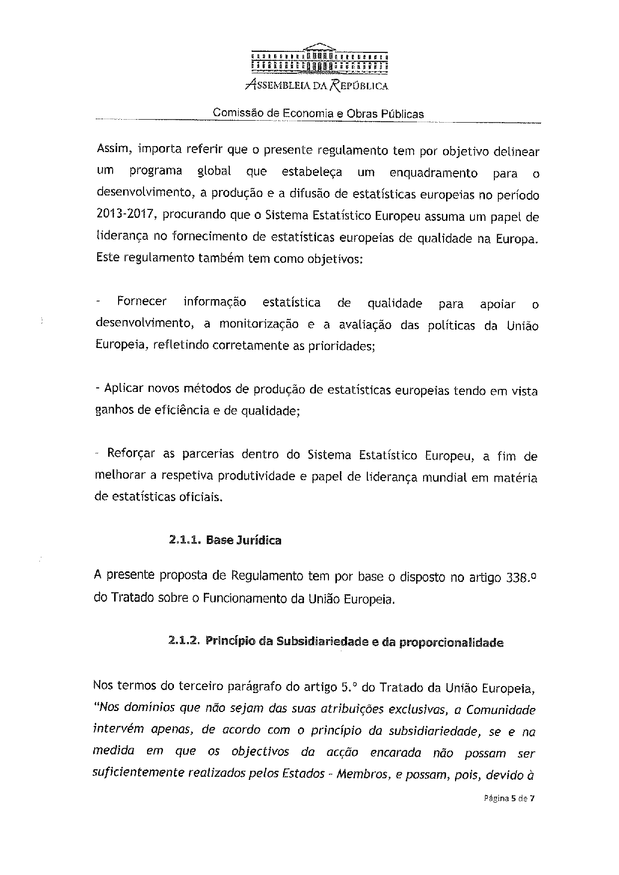
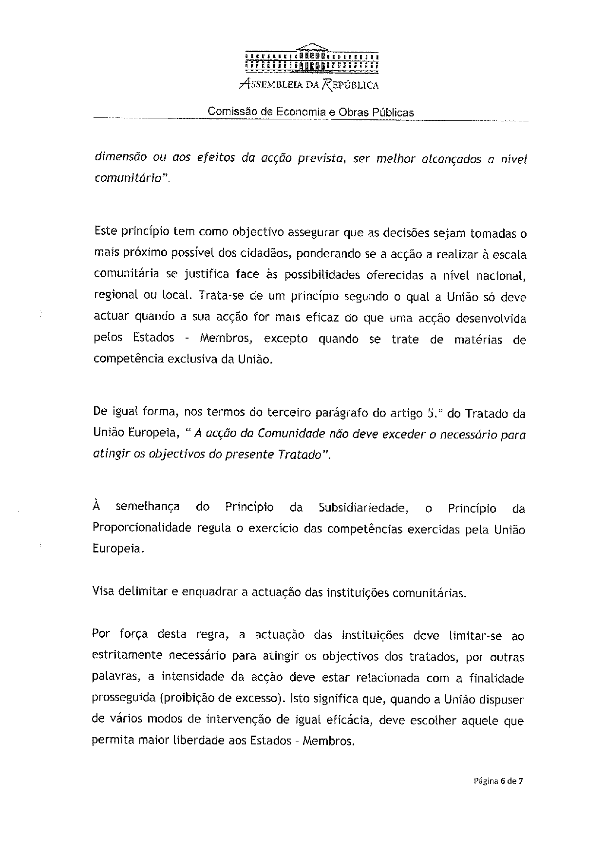
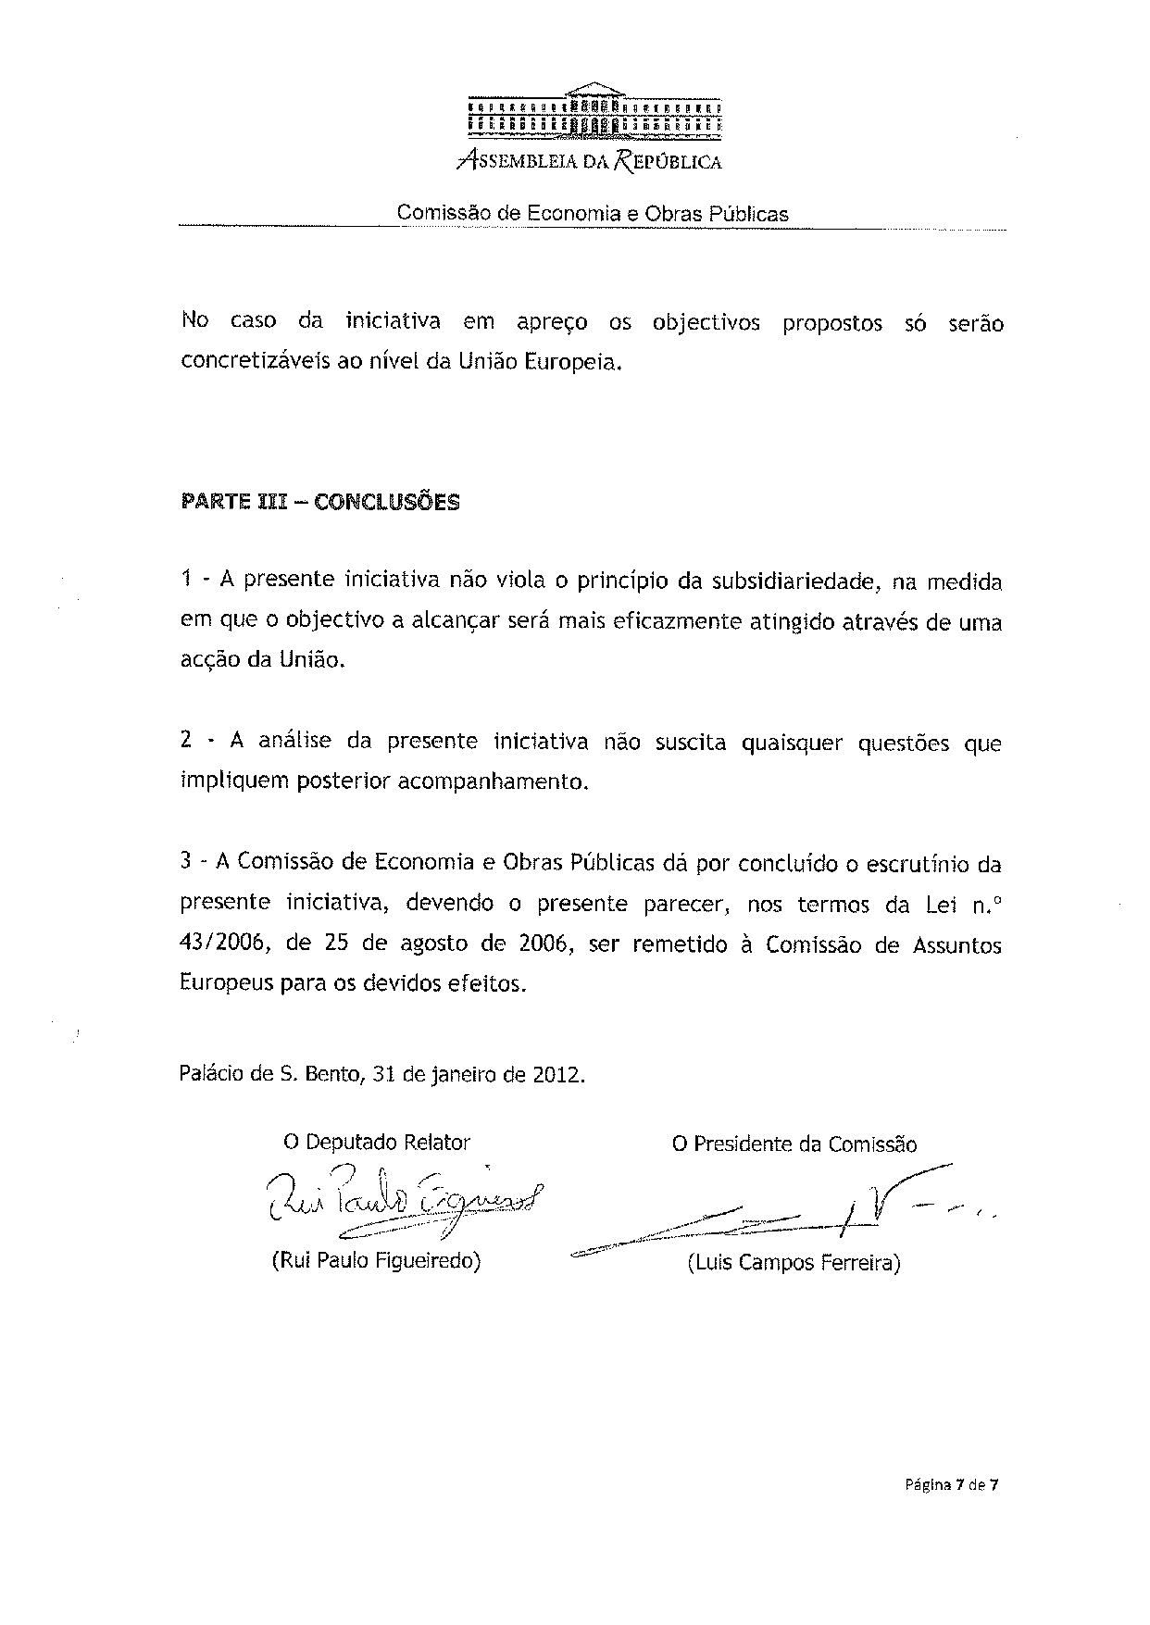

For other language versions of the opinion, reference is made to the Interparliamentary EU information exchange site IPEX at the following address: http://www.ipex.eu/IPEXL-WEB/search.do

