 | 
COUNCIL OF  THE EUROPEAN UNION |  |  | Brussels, 8 March 2012
 | Interinstitutional File:  2011/0437 (COD) |  | 7428/12
MAP 26
MI 169
CODEC 595
INST 188
PARLNAT 137

COVER NOTE
from: | Spanish Cortes Generales
date of receipt: | 7 March 2012
No. Cion doc. : | 18960/11 MAP 8 MI 684 + ADD 1 + ADD 2 - COM (2011) 897 final
Subject: | Proposal for a Directive of the European Parliament and of the Council on the award of concession contracts  - Reasoned Opinion on the application of the Principles of Subsidiarity and Proportionality

Delegations will find attached the Opinion of the Spanish Cortes Generales on the above proposal.

________________________

Encl.:
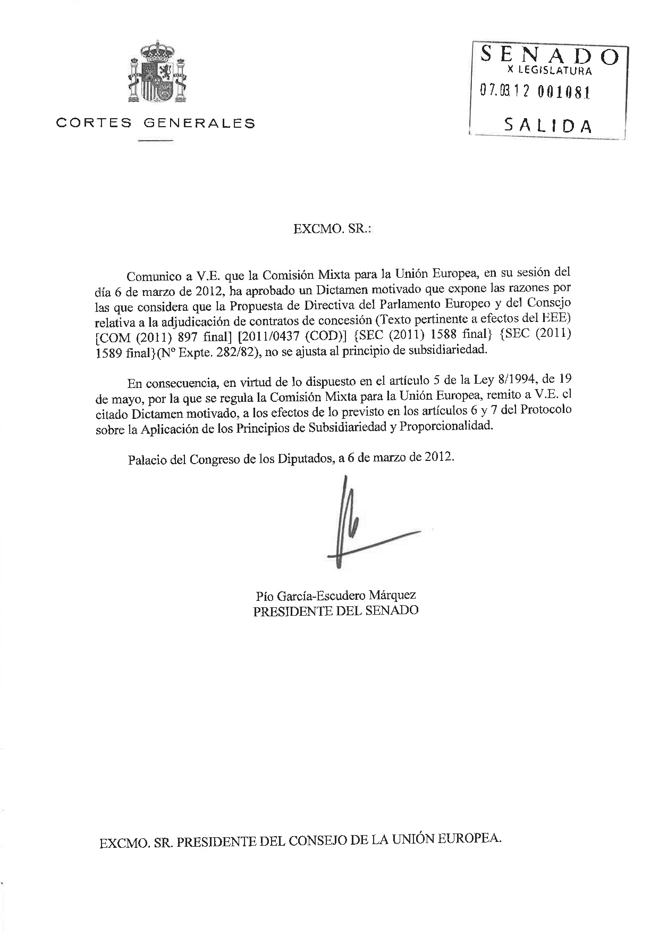

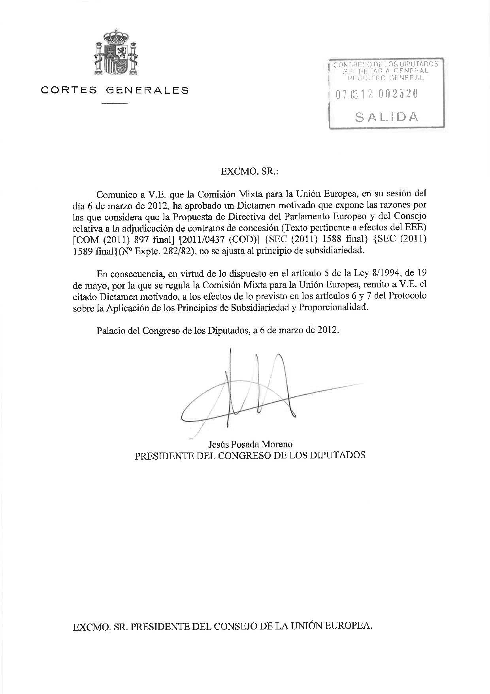
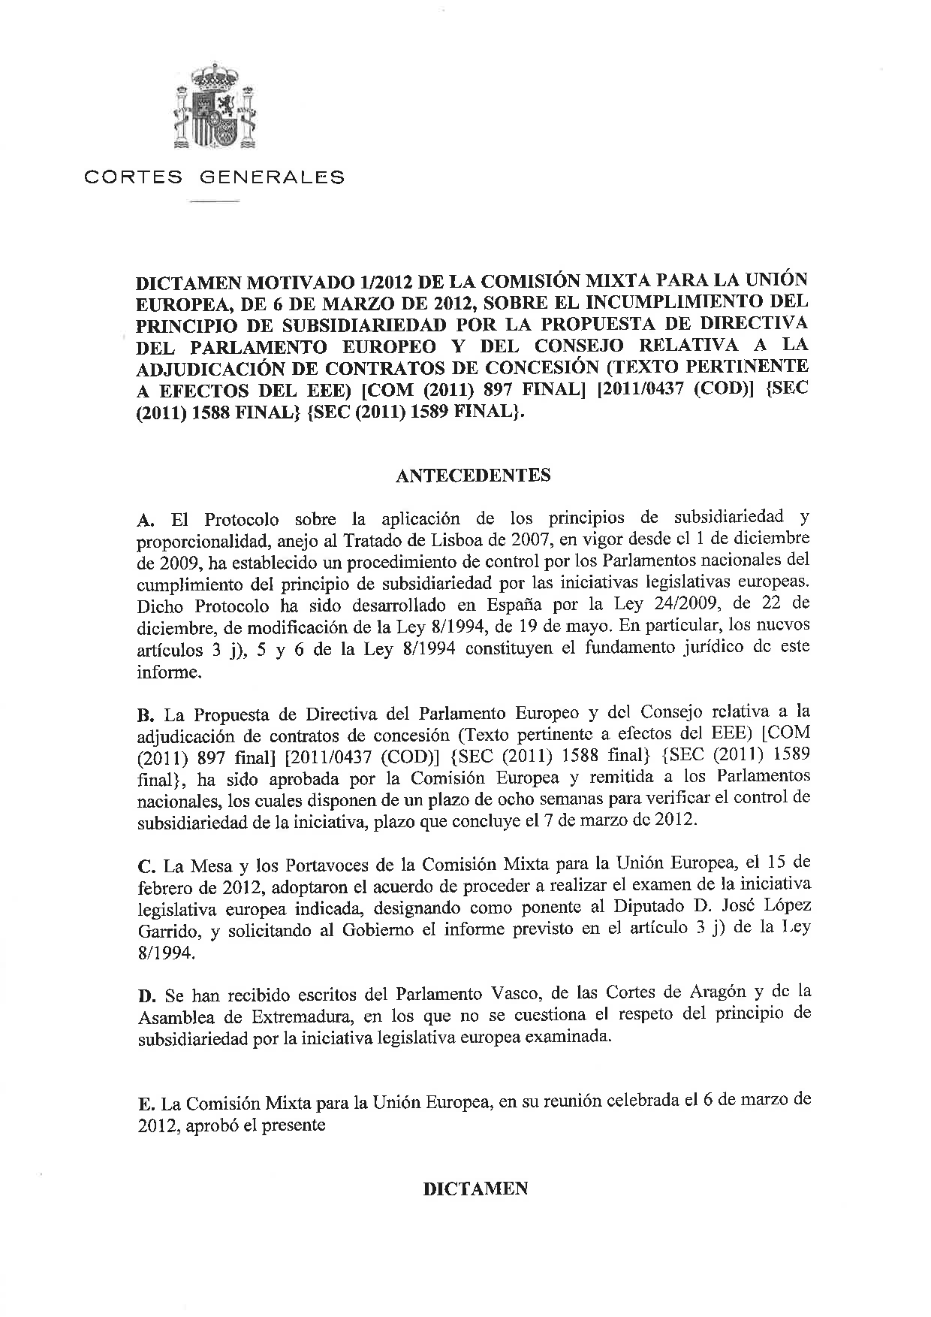
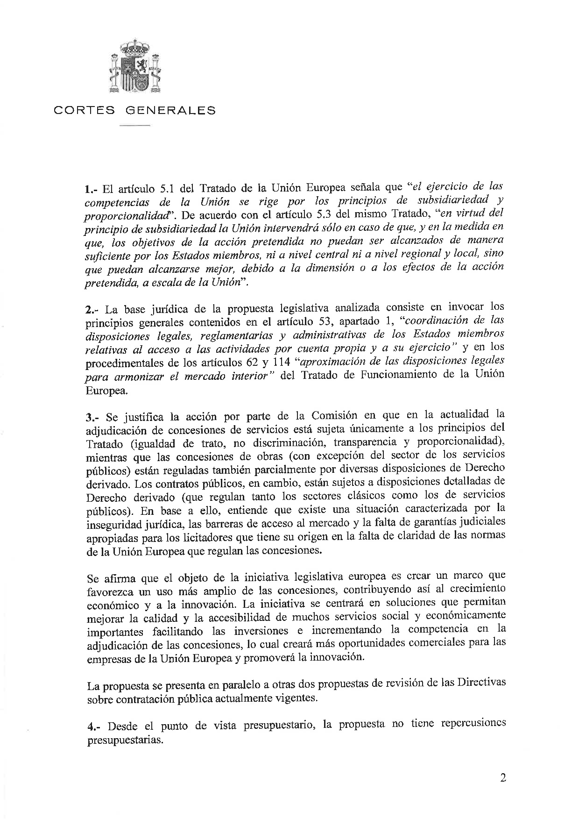
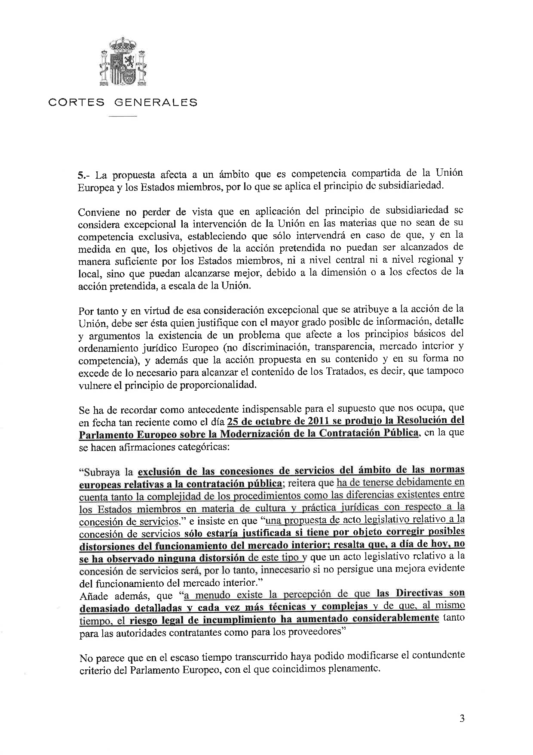
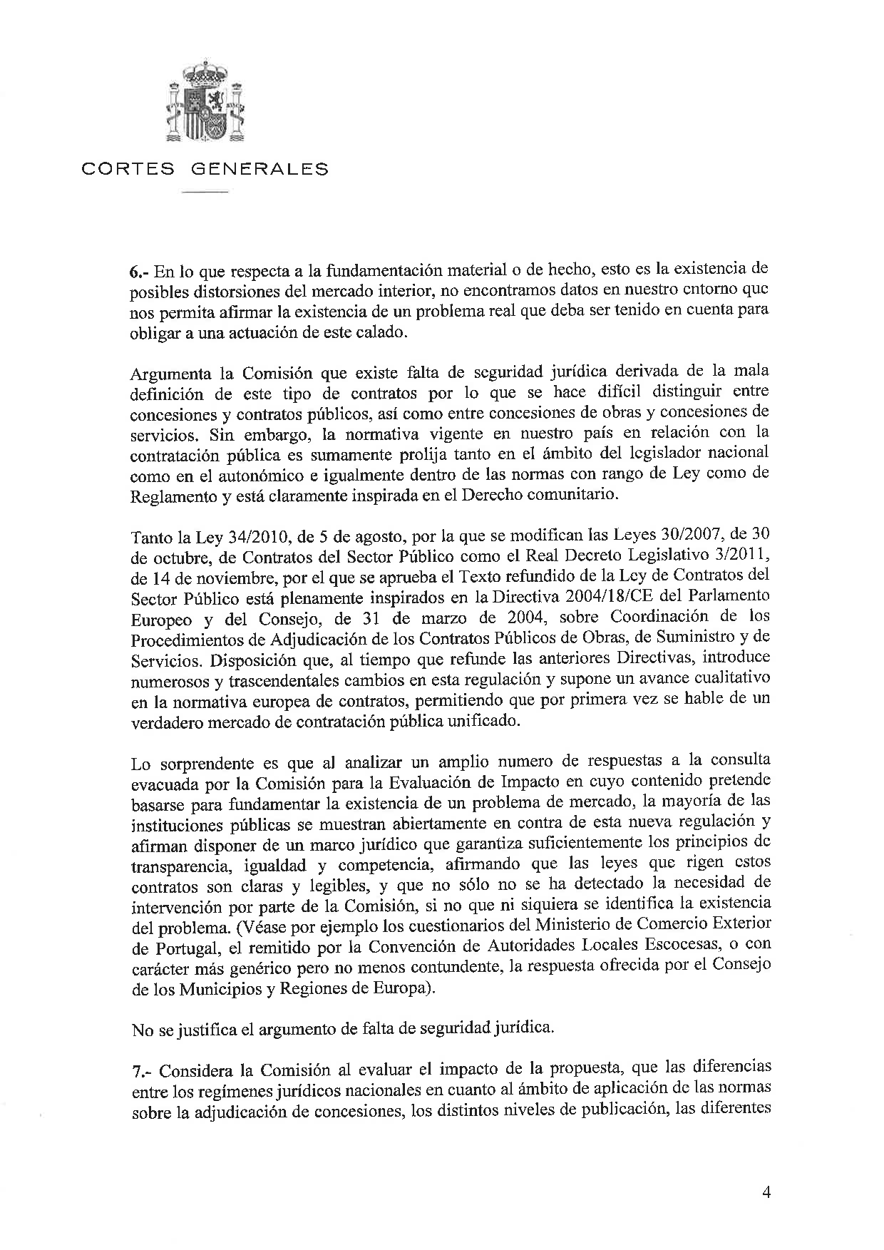
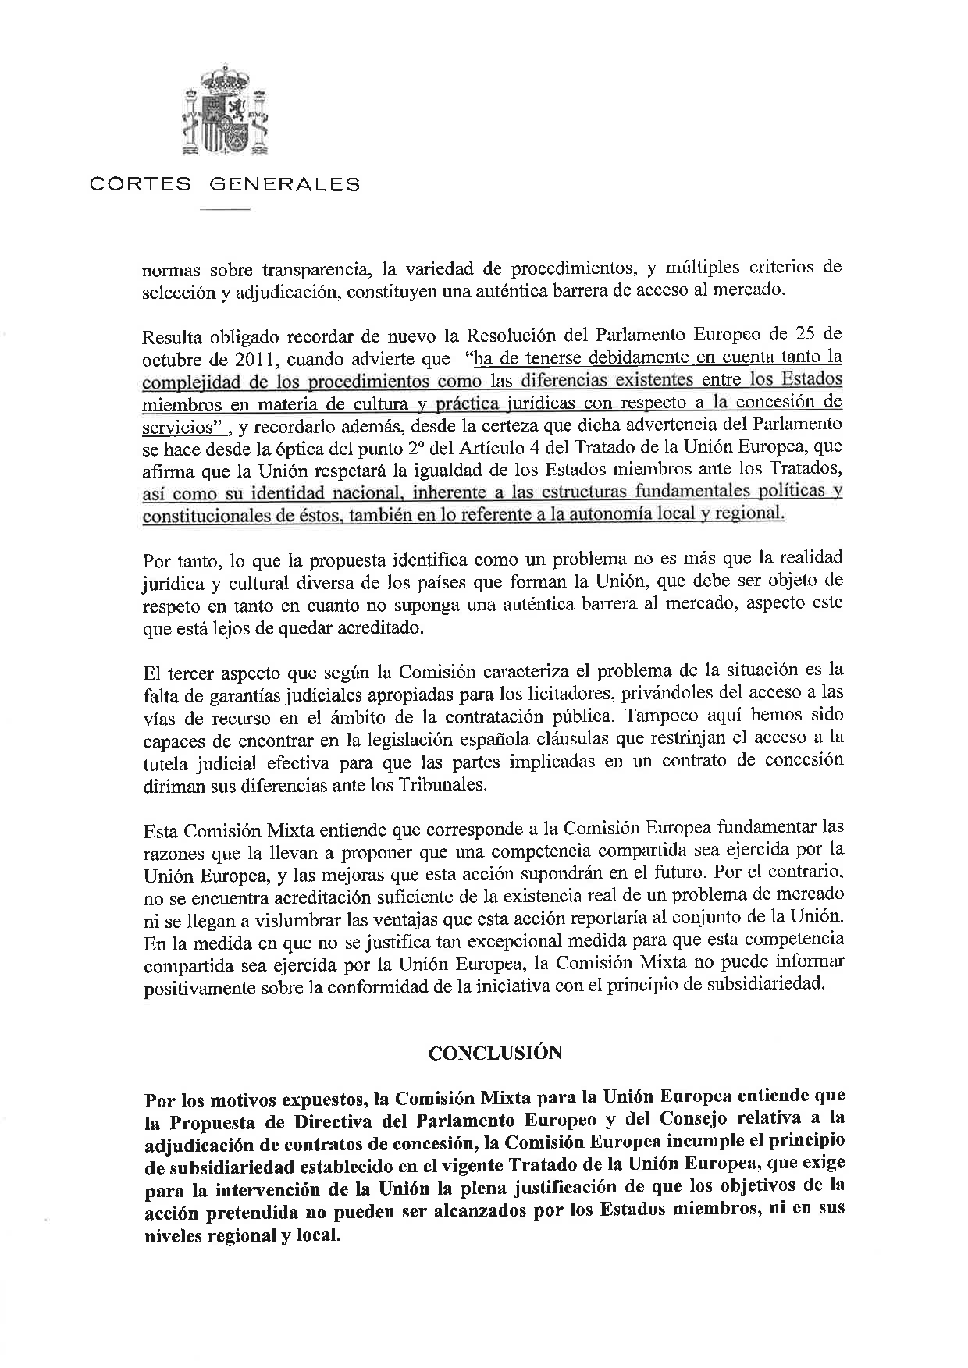

Translation may be available at the Interparliamentary EU information exchange site IPEX at the following address: http://www.ipex.eu/IPEXL-WEB/search.do.

