 | 
COUNCIL OF  THE EUROPEAN UNION |  |  | Brussels, 27 January 2012
 | Interinstitutional File:  2011/0386 (COD) |  | 5827/12
ECOFIN 73
UEM 21
CODEC 215
INST 70
PARLNAT 54

COVER NOTE
from: | Portuguese Assembleia da República, Comissão de Assuntos Europeus
date of receipt: | 26 January 2012
to: | President of the Council of the European Union
Subject: | Proposal for a Regulation of the European Parliament and of the Council on common provisions for monitoring and assessing draft budgetary plans and ensuring the correction of excessive deficit of the Member States in the euro area [doc. ST 17231/11 ECOFIN 806 UEM 336 CODEC 2113 - COM(2011) 821 final]  - Opinion on the application of the Principles of Subsidiarity and Proportionality

Delegations will find attached the above mentioned opinion.

________________________

Encl.:

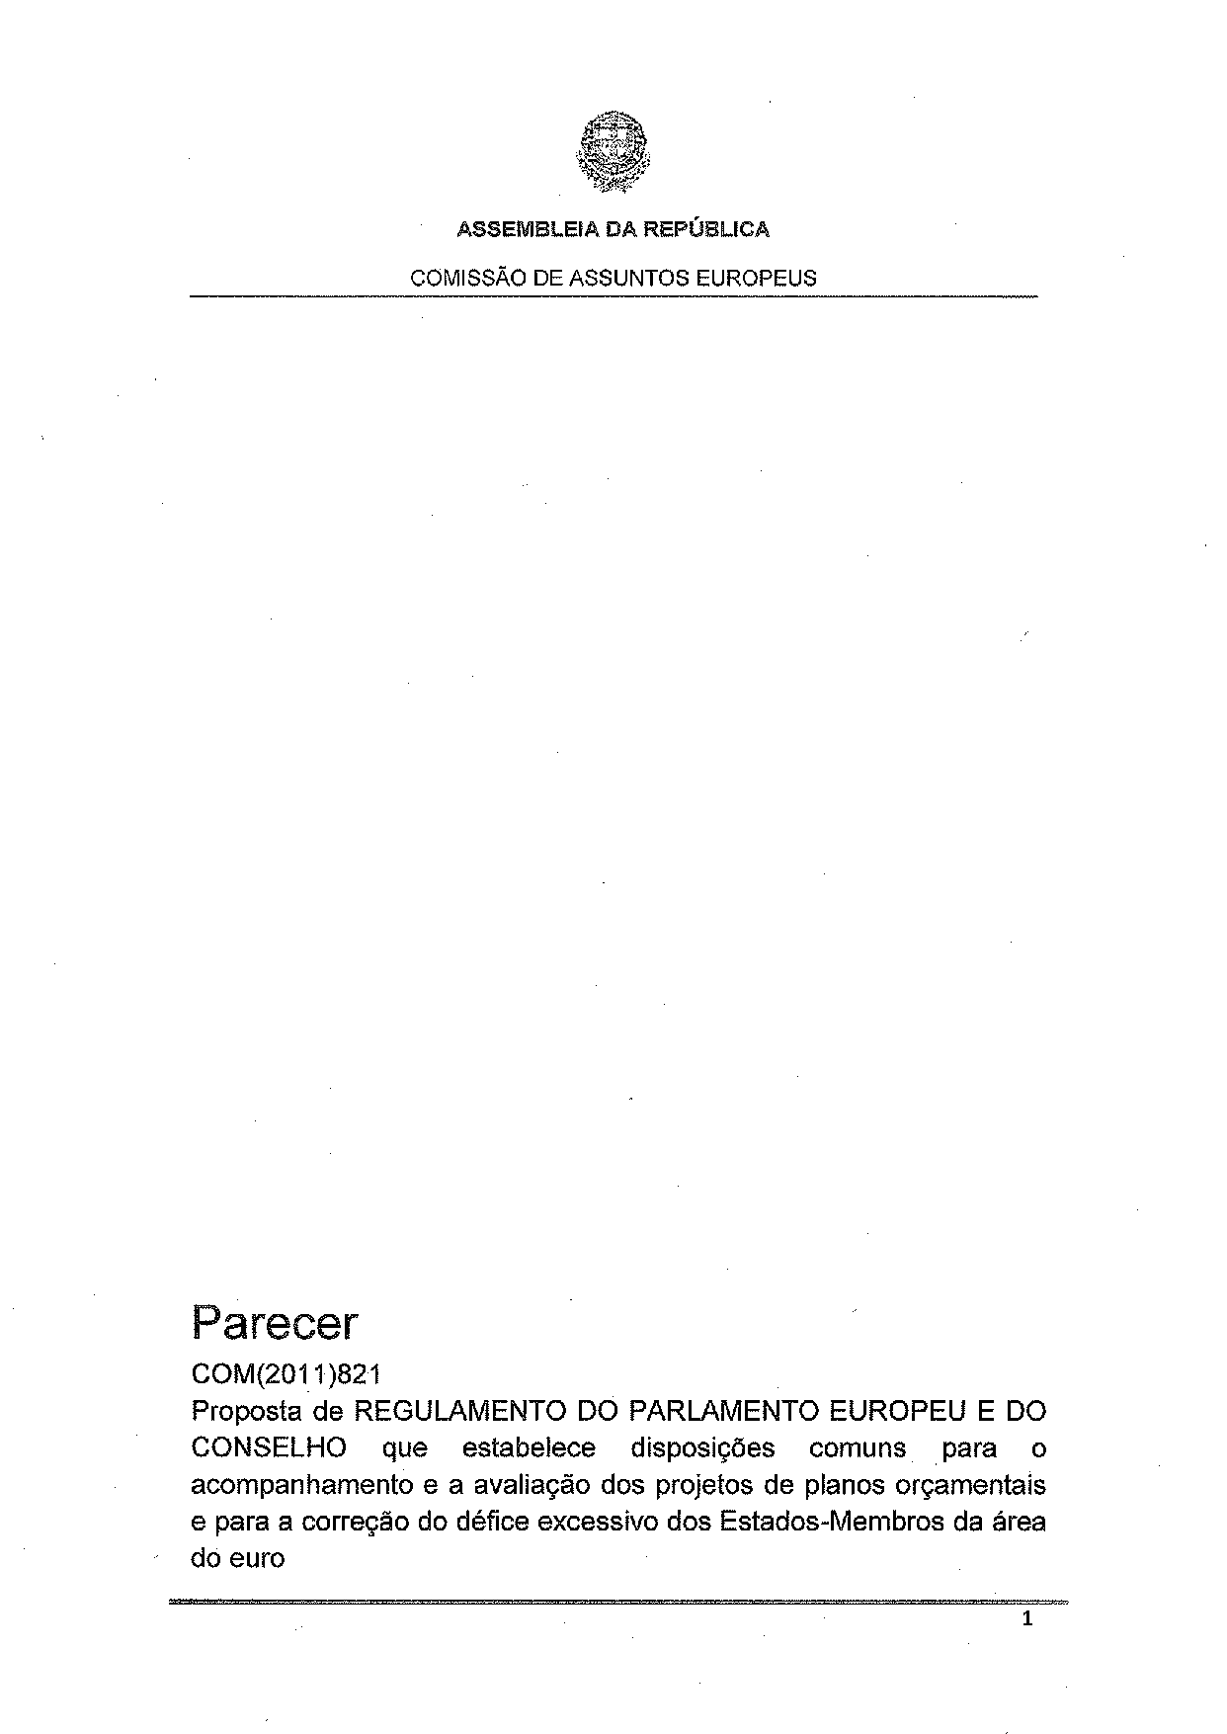
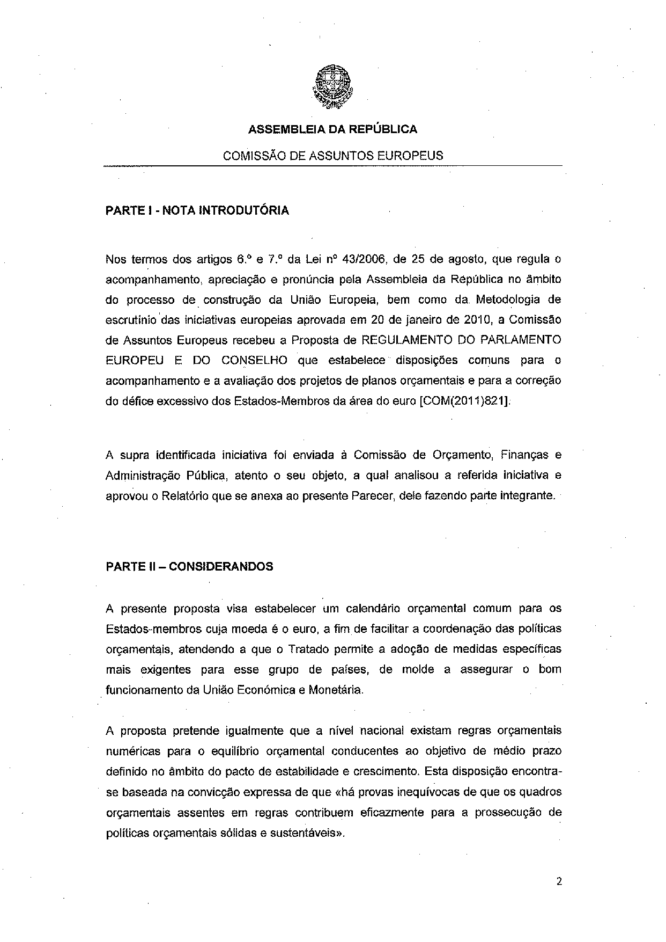
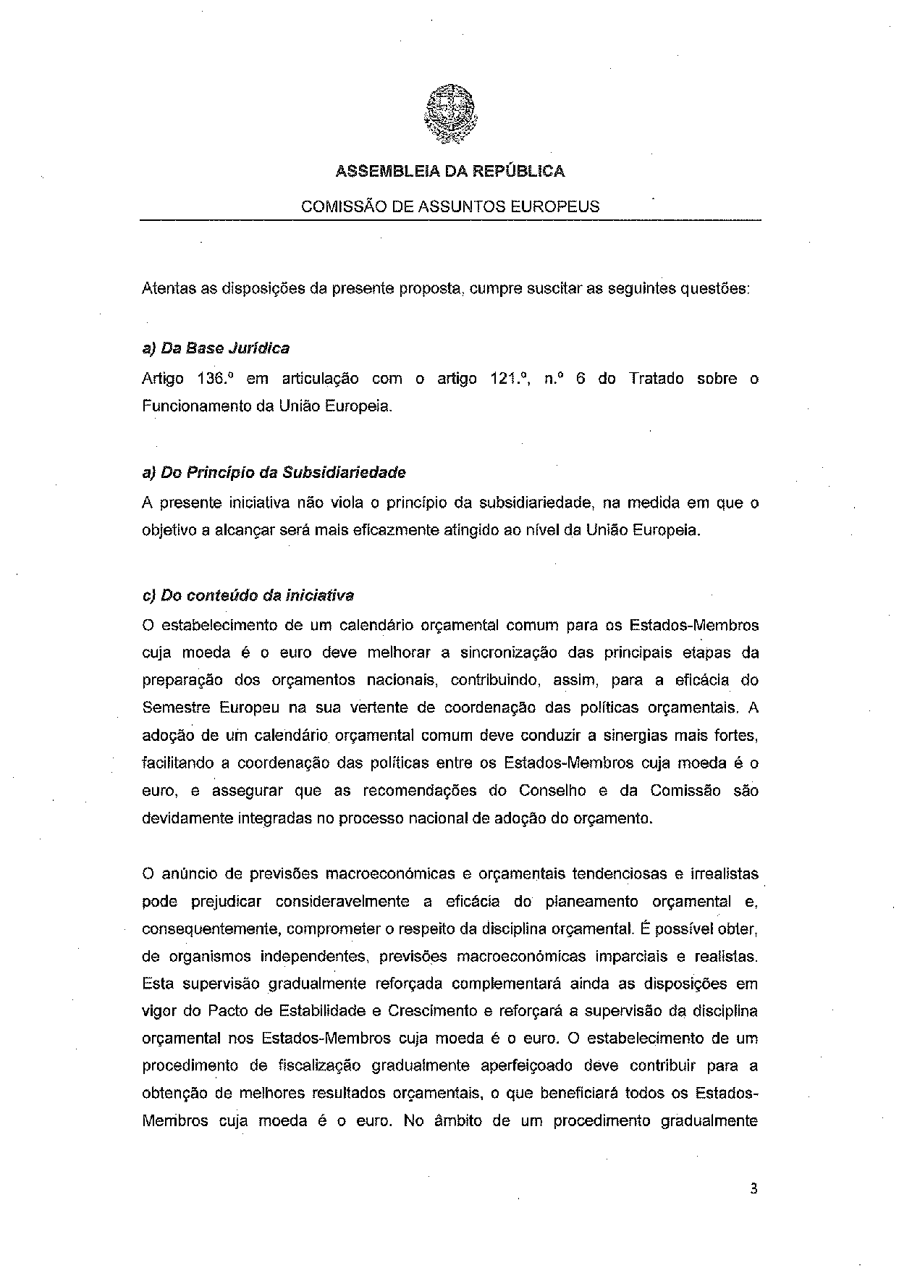
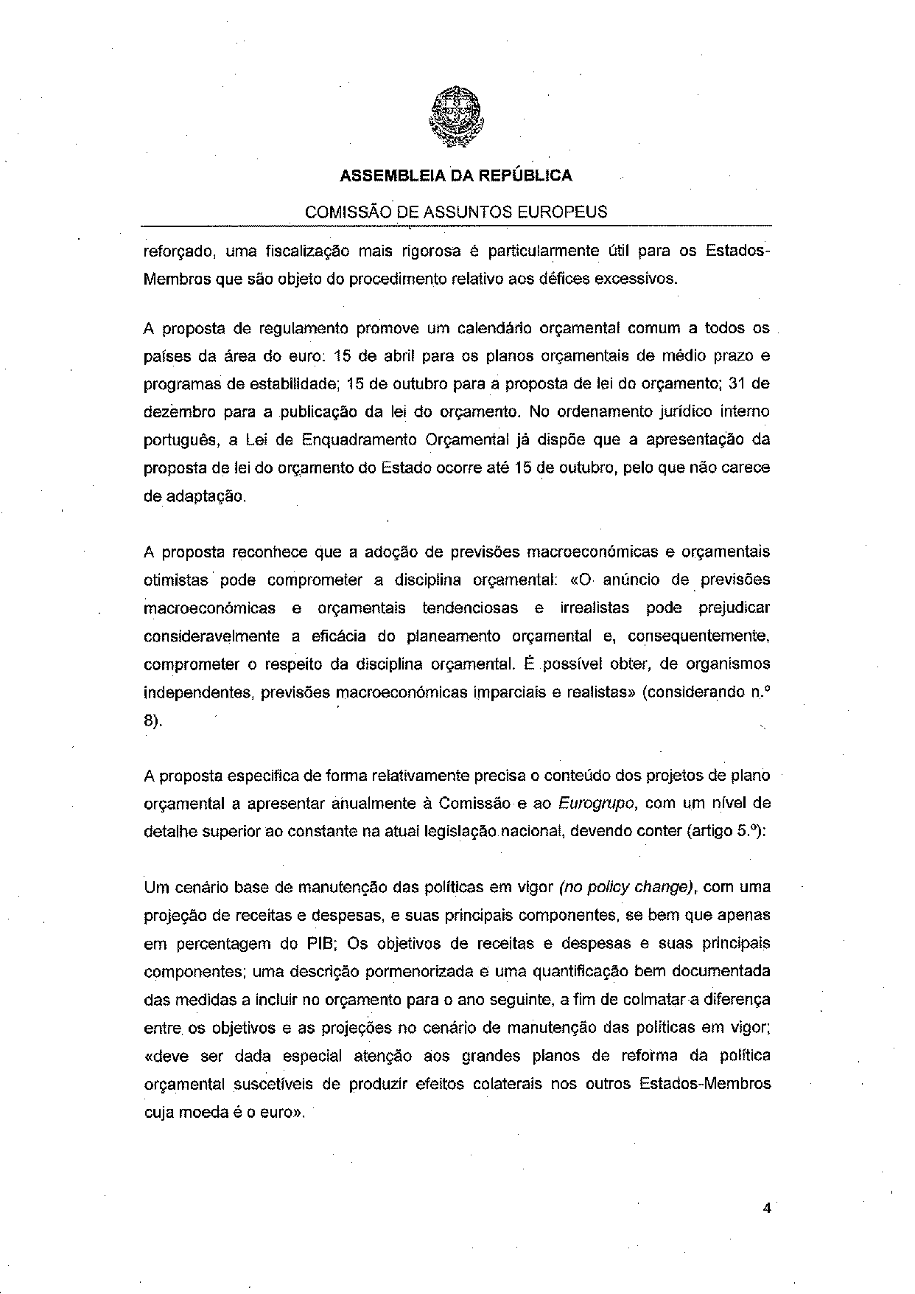
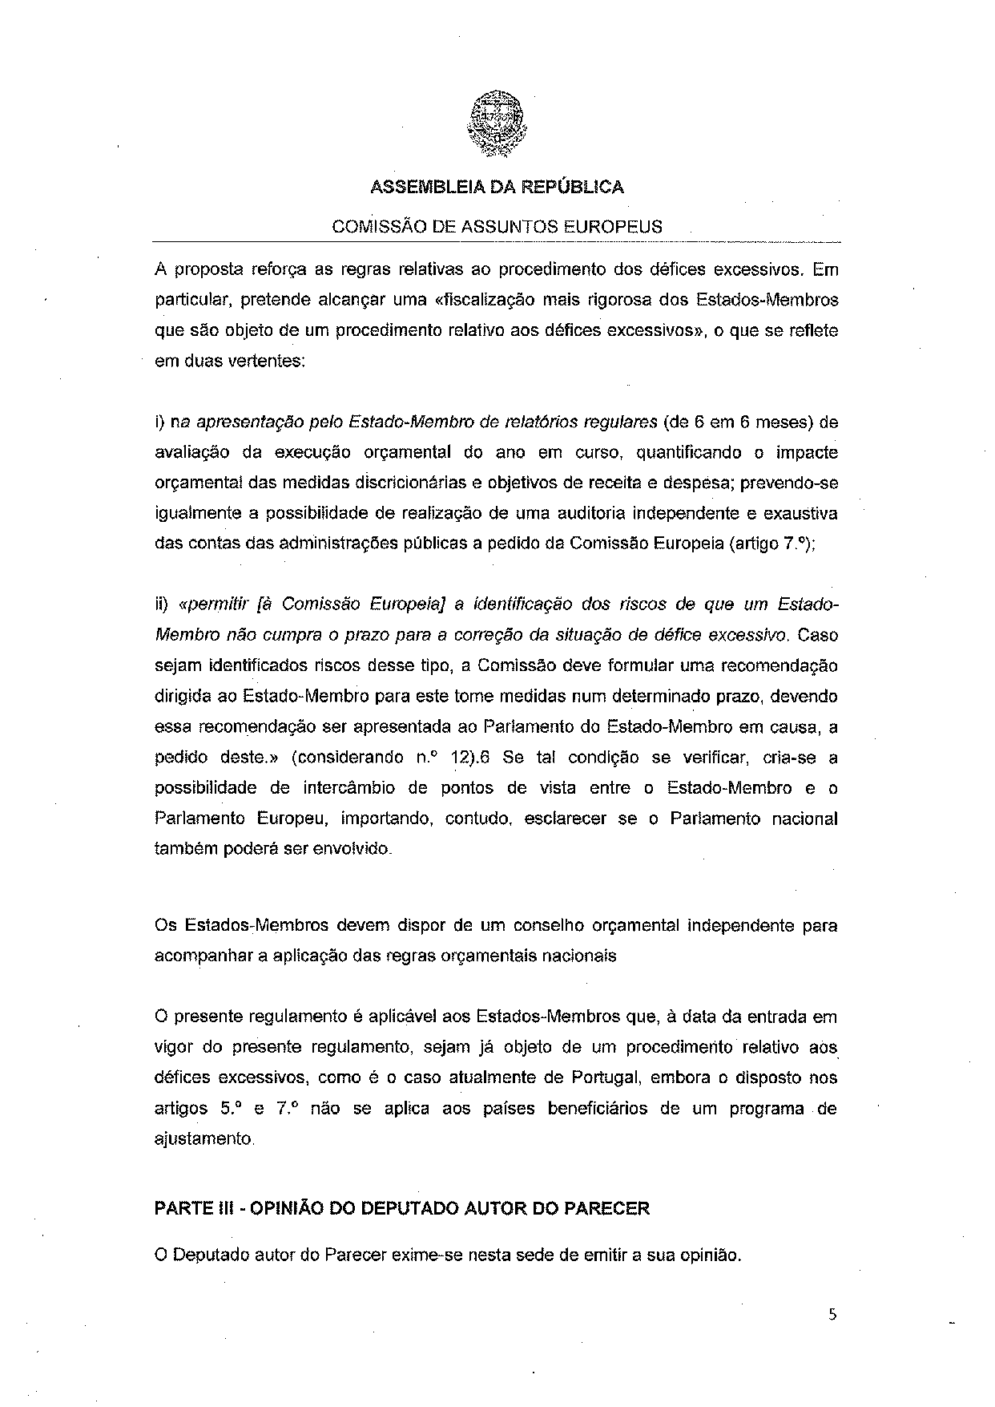
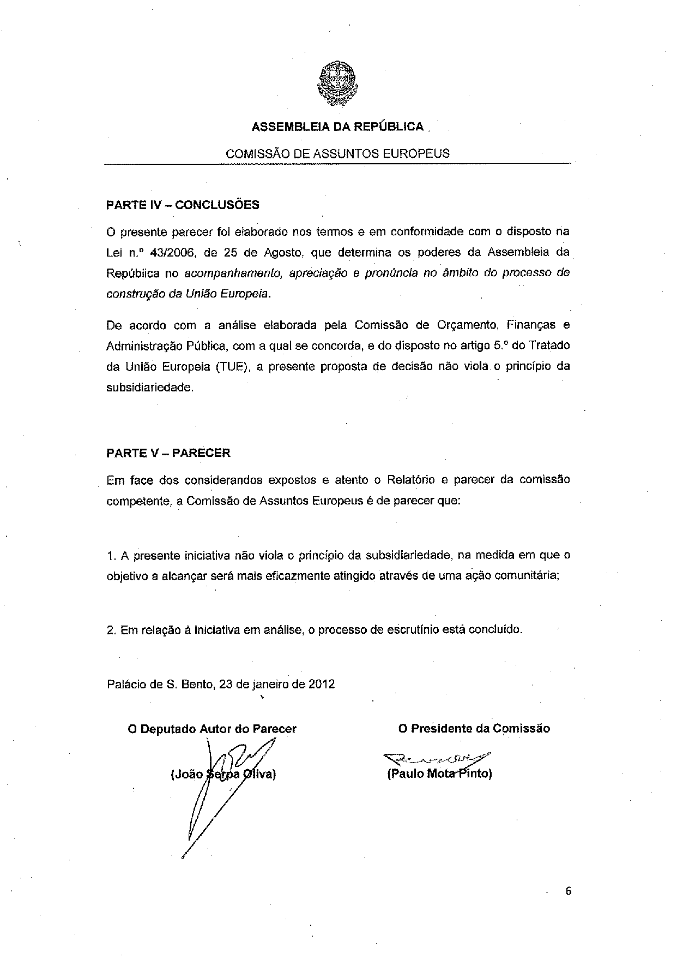

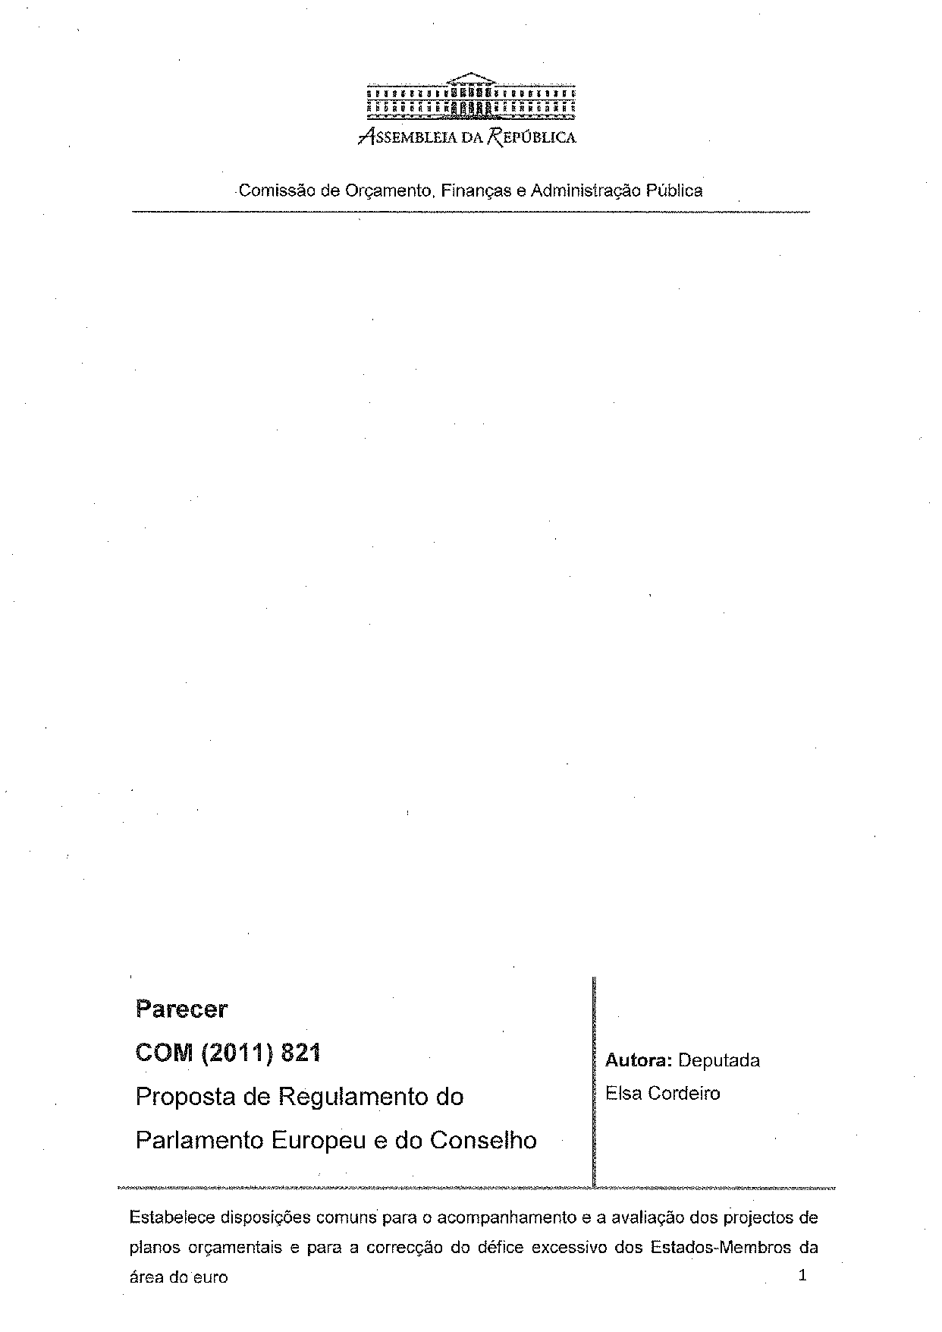
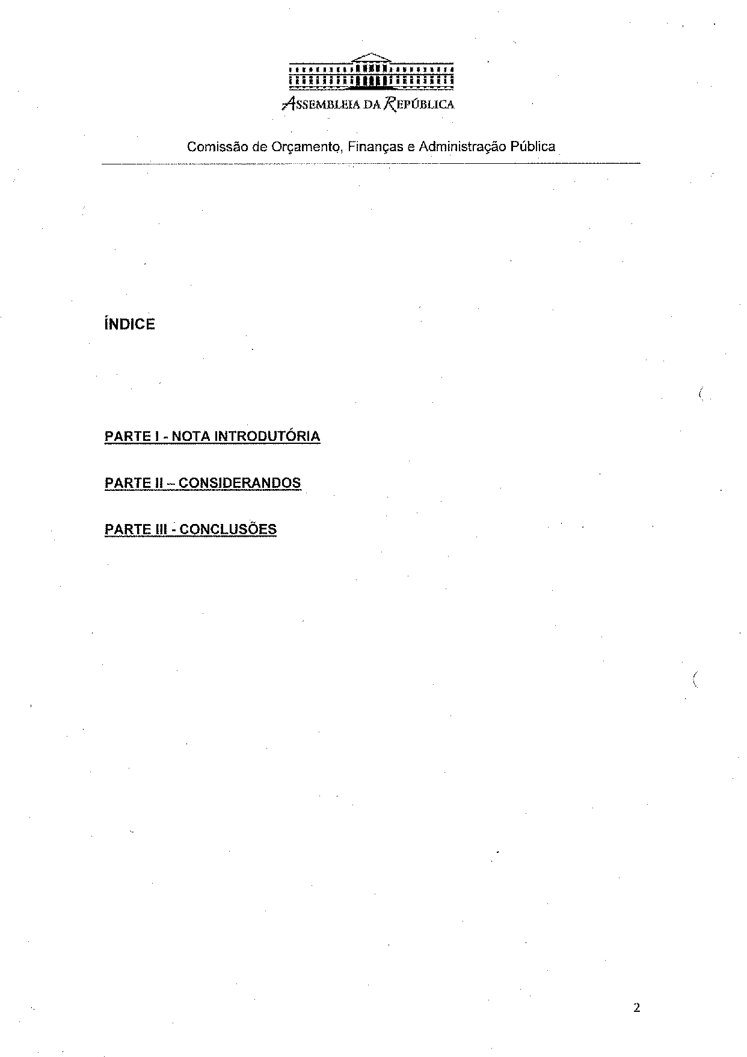
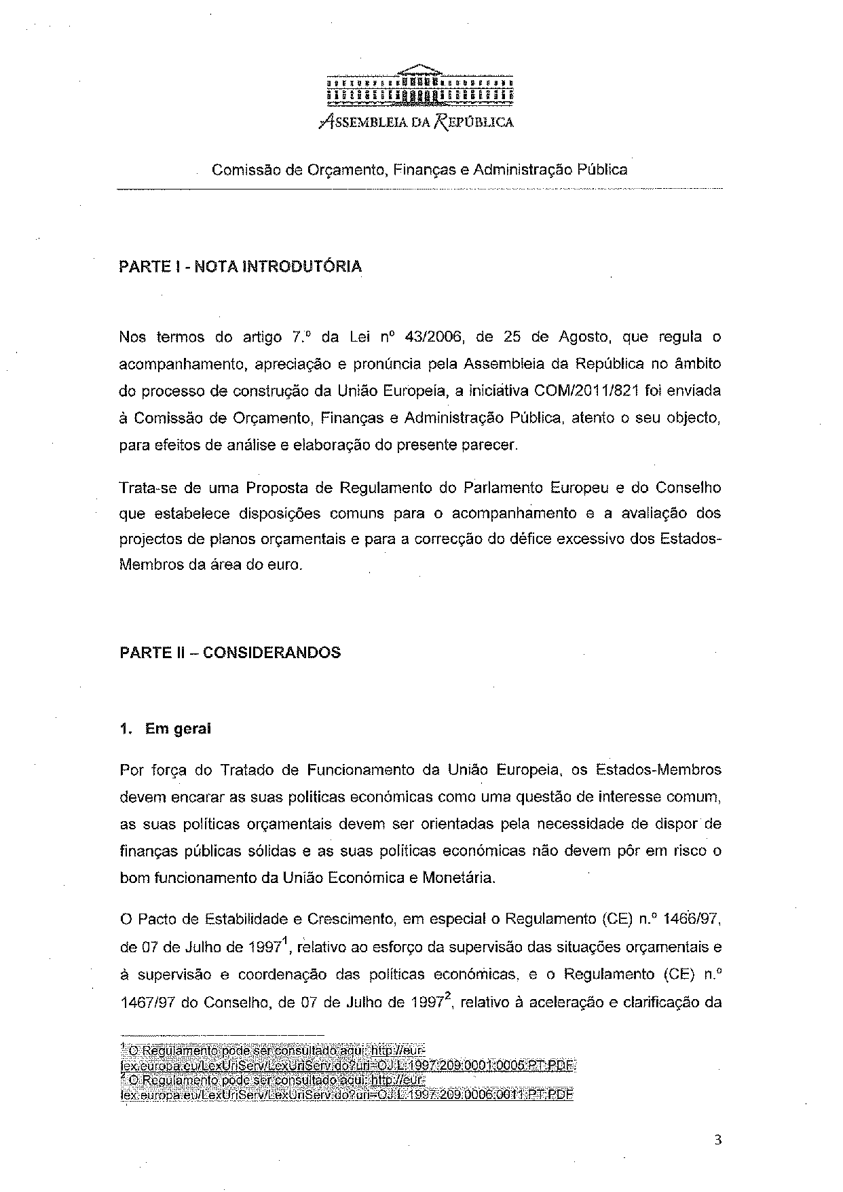
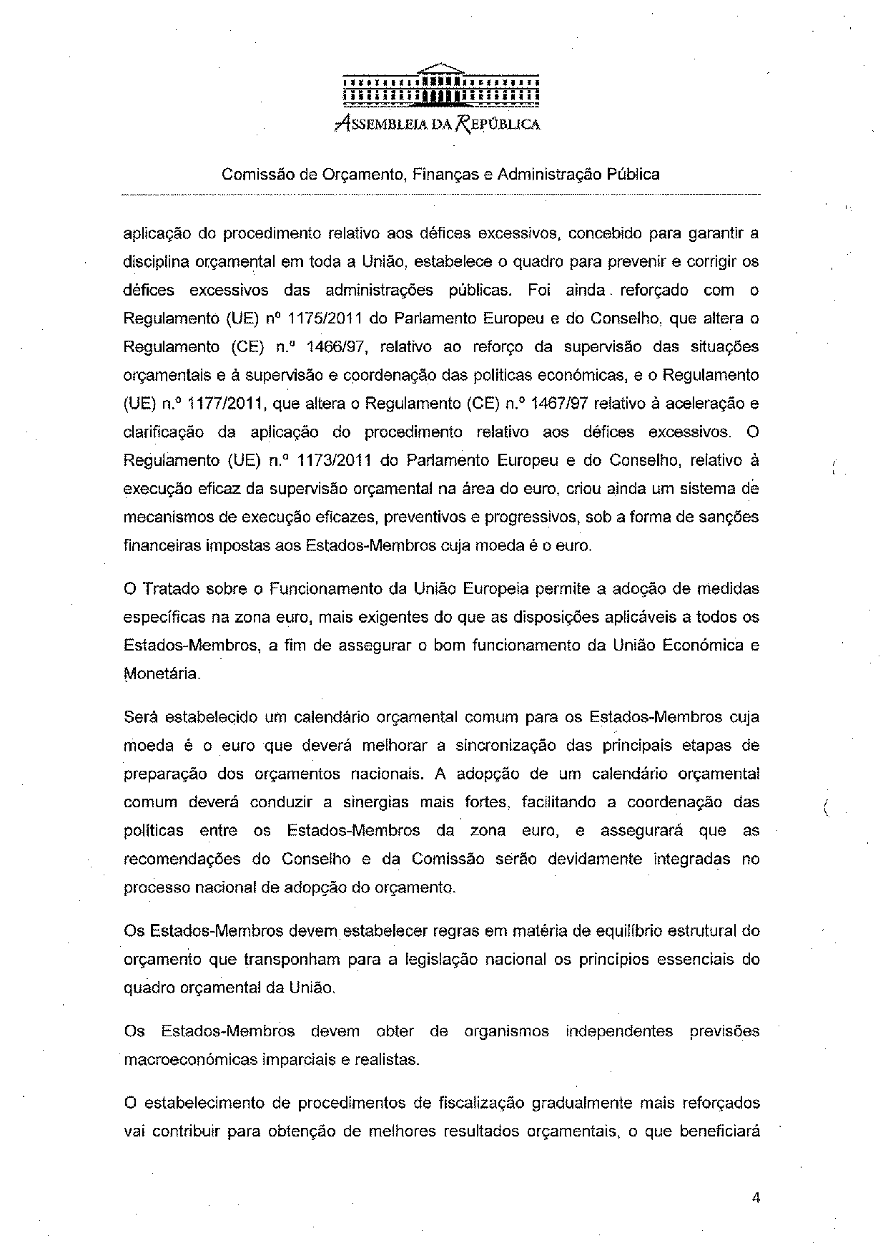
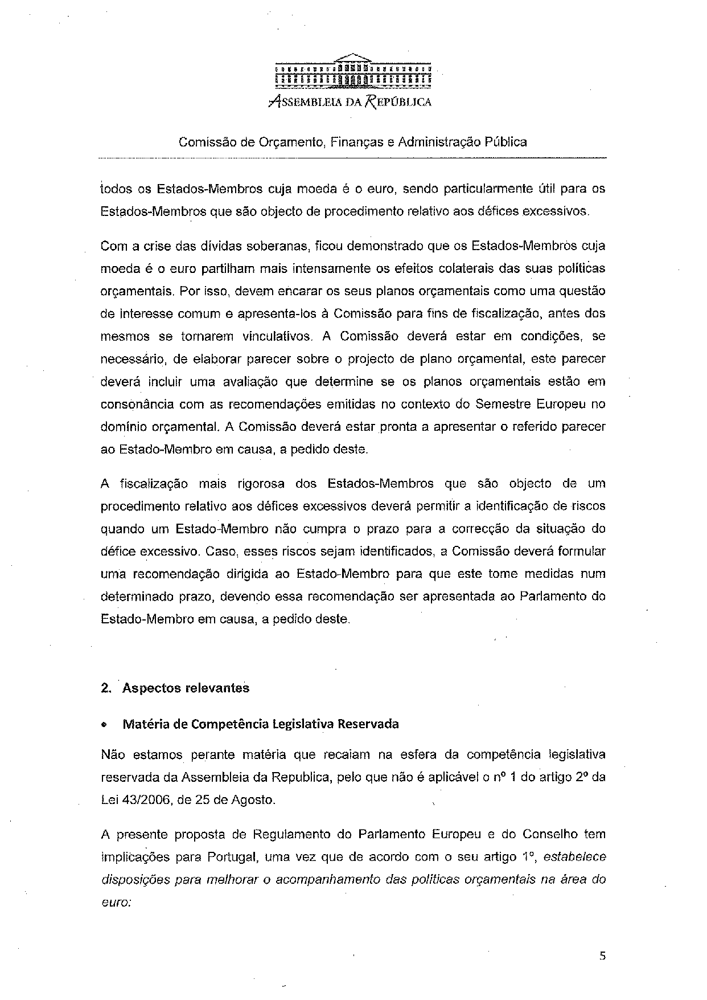
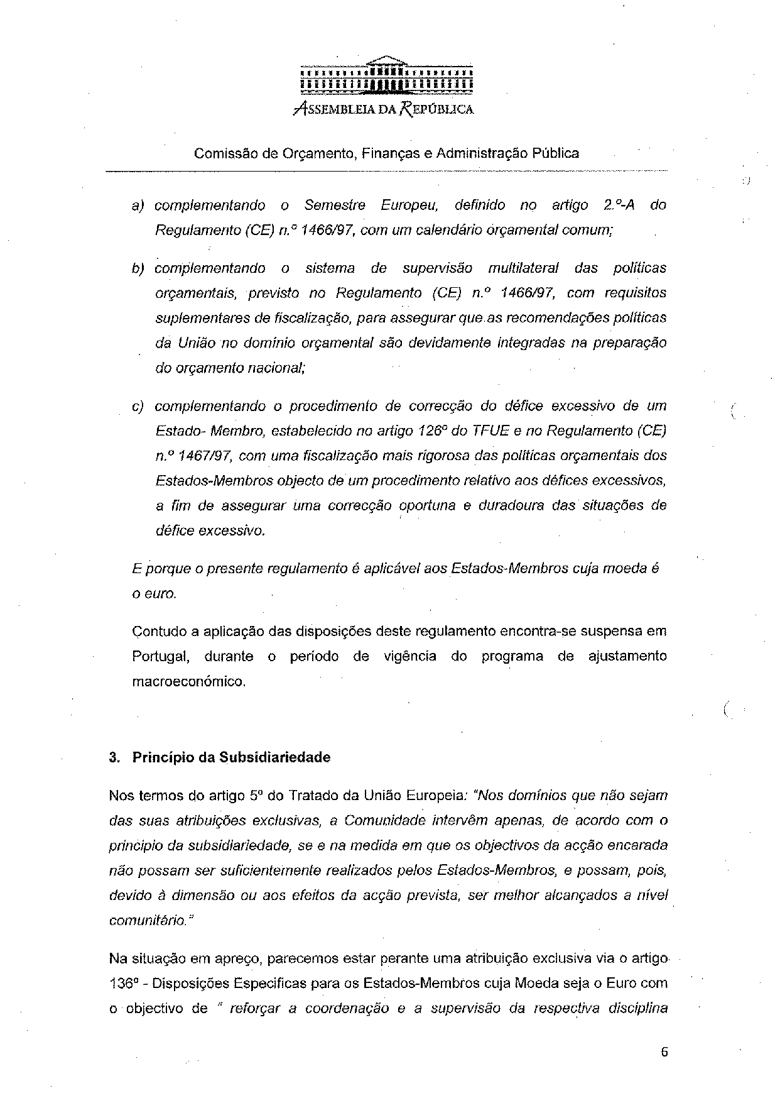
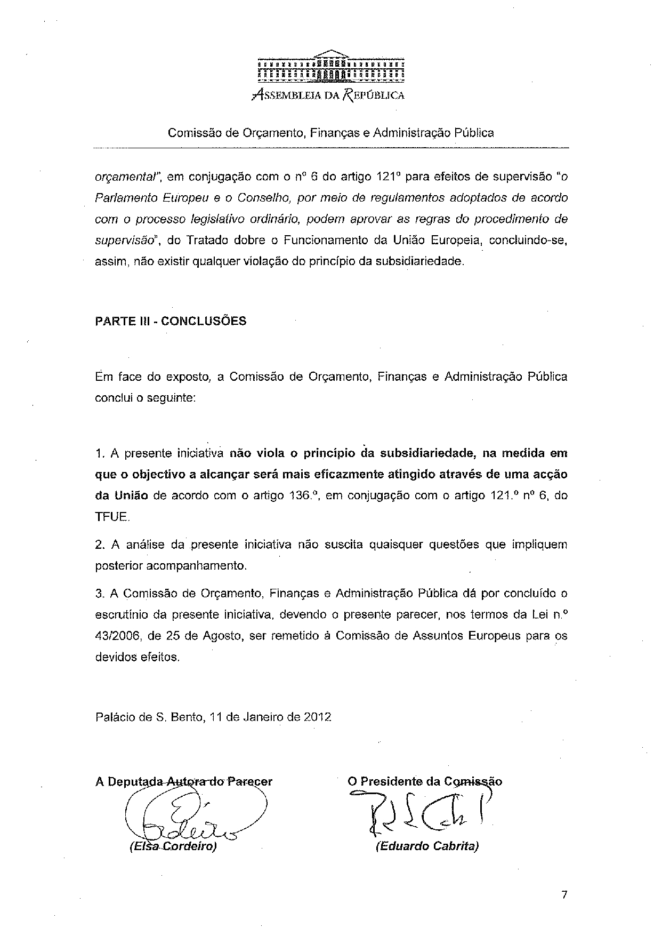

For other language versions of the opinion, reference is made to the Interparliamentary EU information exchange site IPEX at the following address: http://www.ipex.eu/IPEXL-WEB/search.do

