 | 
COUNCIL OF  THE EUROPEAN UNION |  |  | Brussels, 14 March 2012
 | Interinstitutional File:  2011/0431 (APP) |  | 7580/12
FREMP 36
JAI 178
COSCE 7
COHOM 56
INST 202
PARLNAT 149

OPINION
from: | The Italian Senate
dated: | 9 March 2012
No Cion doc.: | 18645/11 FREMP 115 JAI 954 COSCE 23 COHOM 299  COM(2011) 880 final
Subject: | Proposal for a COUNCIL DECISION establishing a Multiannual Framework  for the European Union Agency for Fundamental Rights for 2013-2017  Opinion on the application of the Principles of Subsidiarity and Proportionality

Delegations will find attached the above mentioned opinion.

________________________

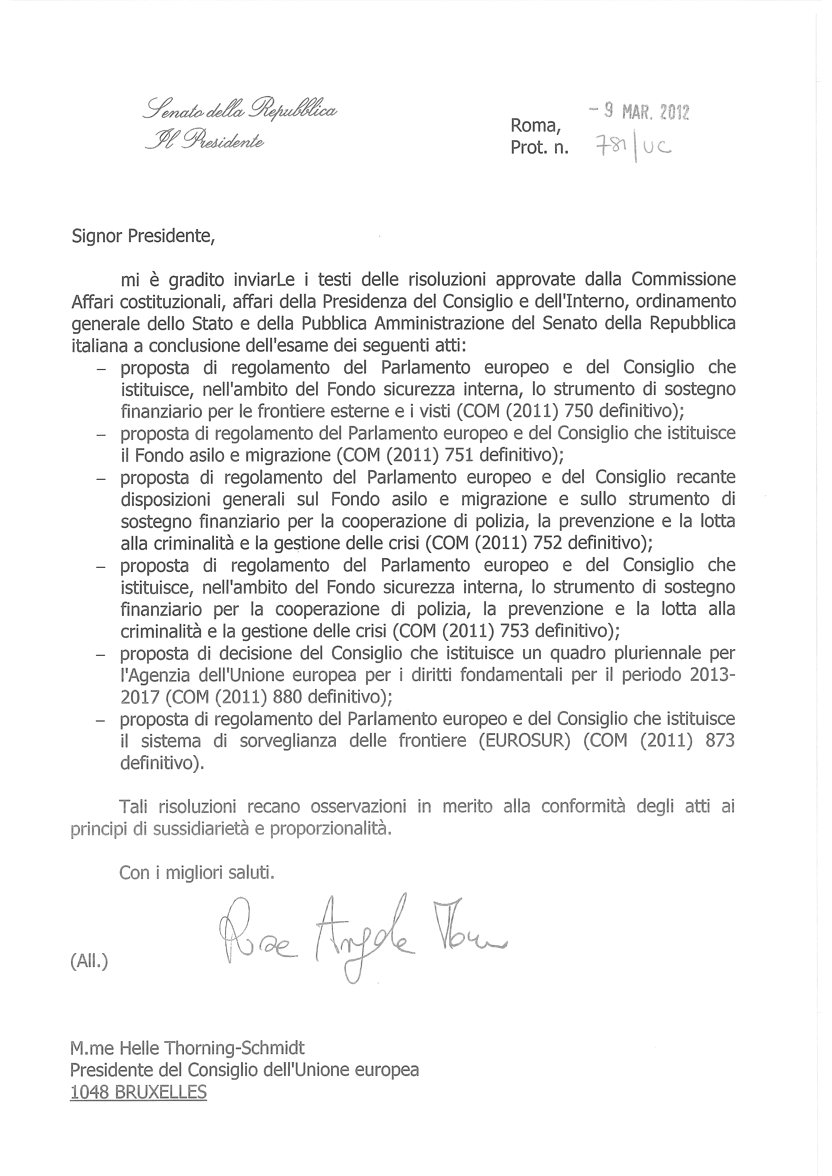
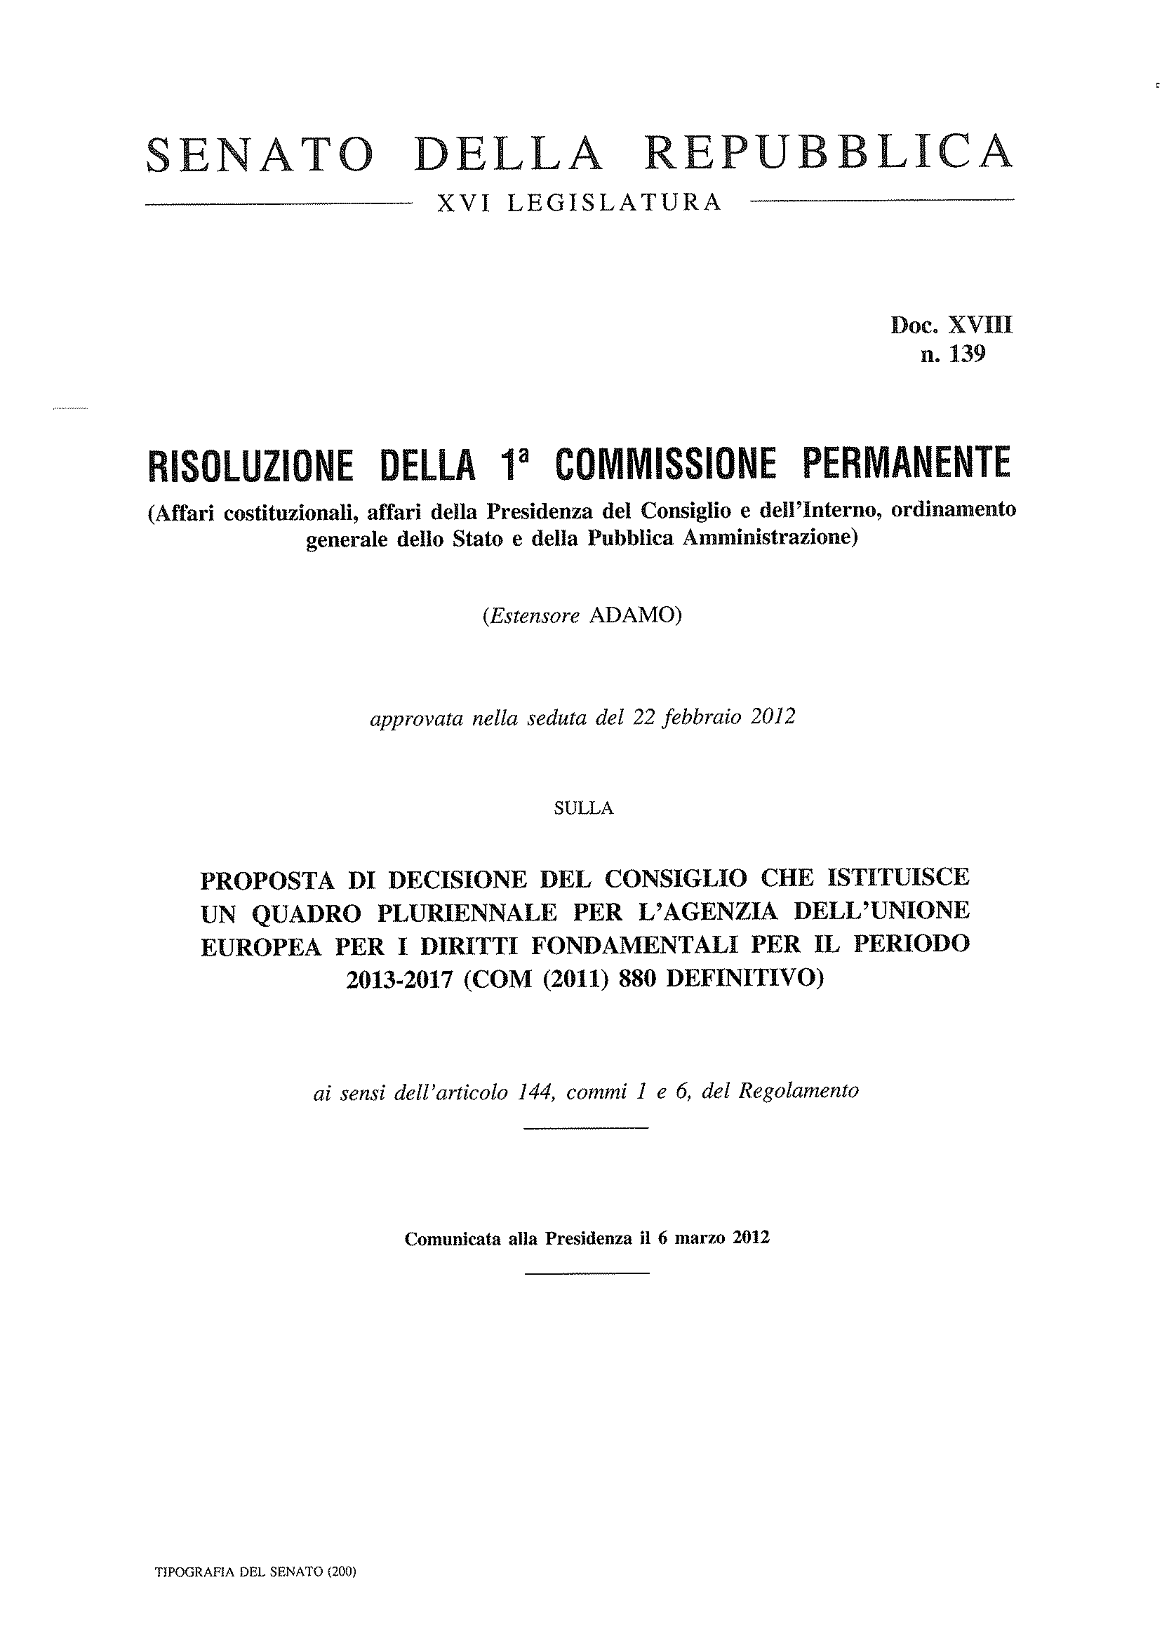
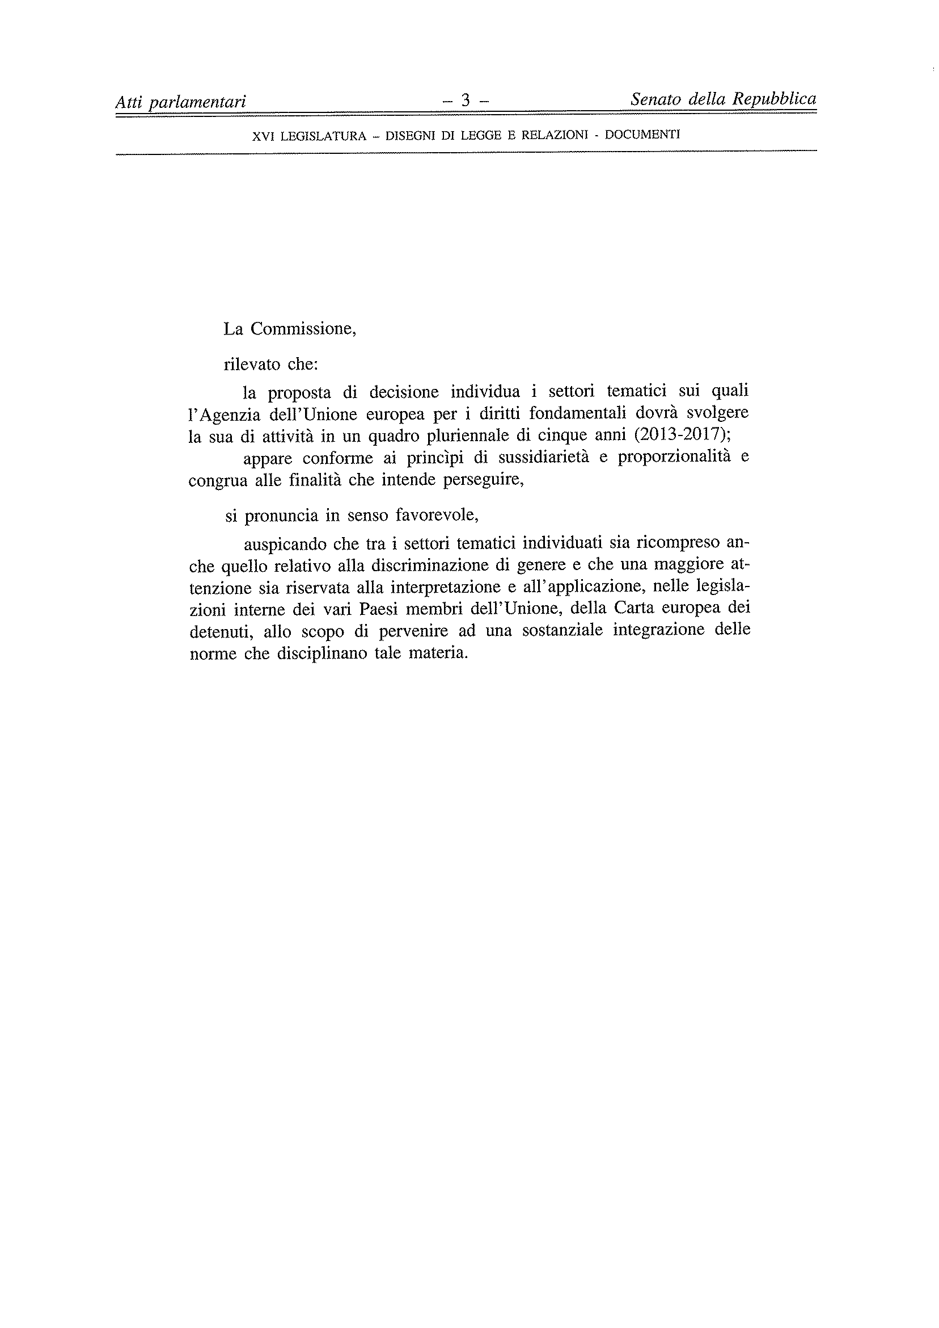
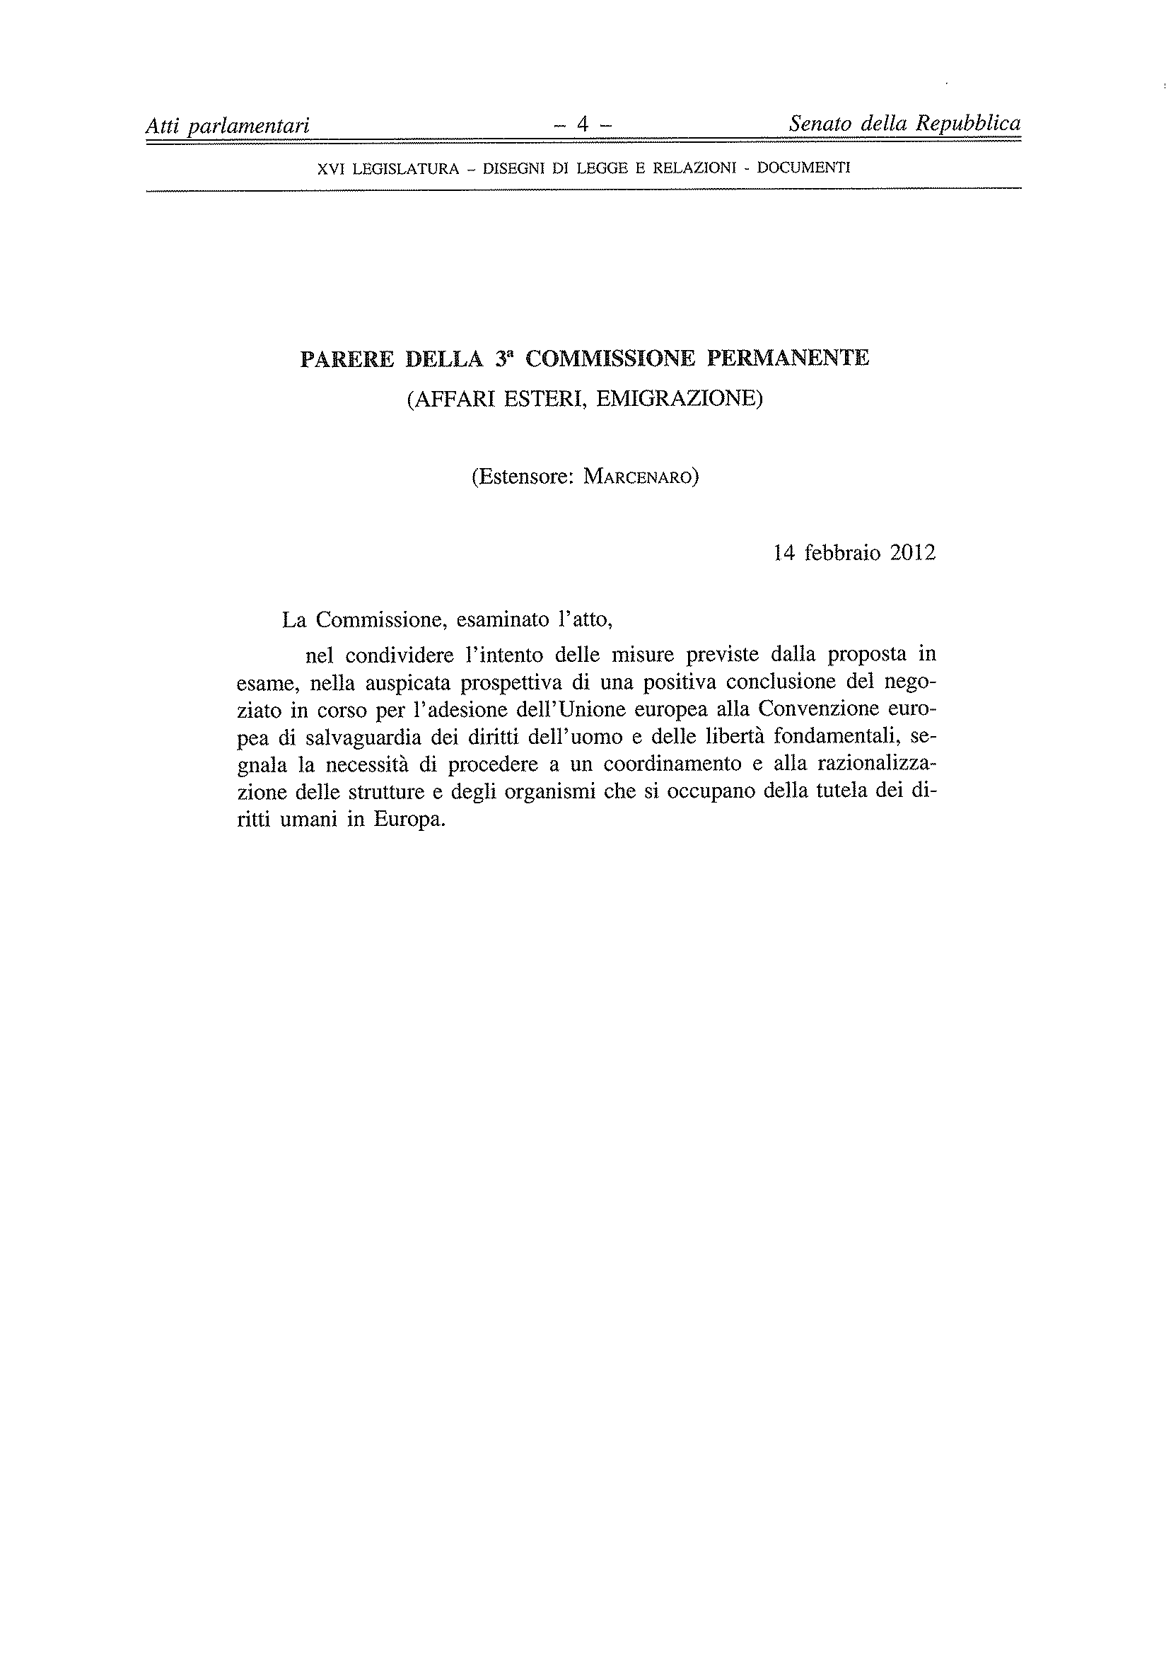
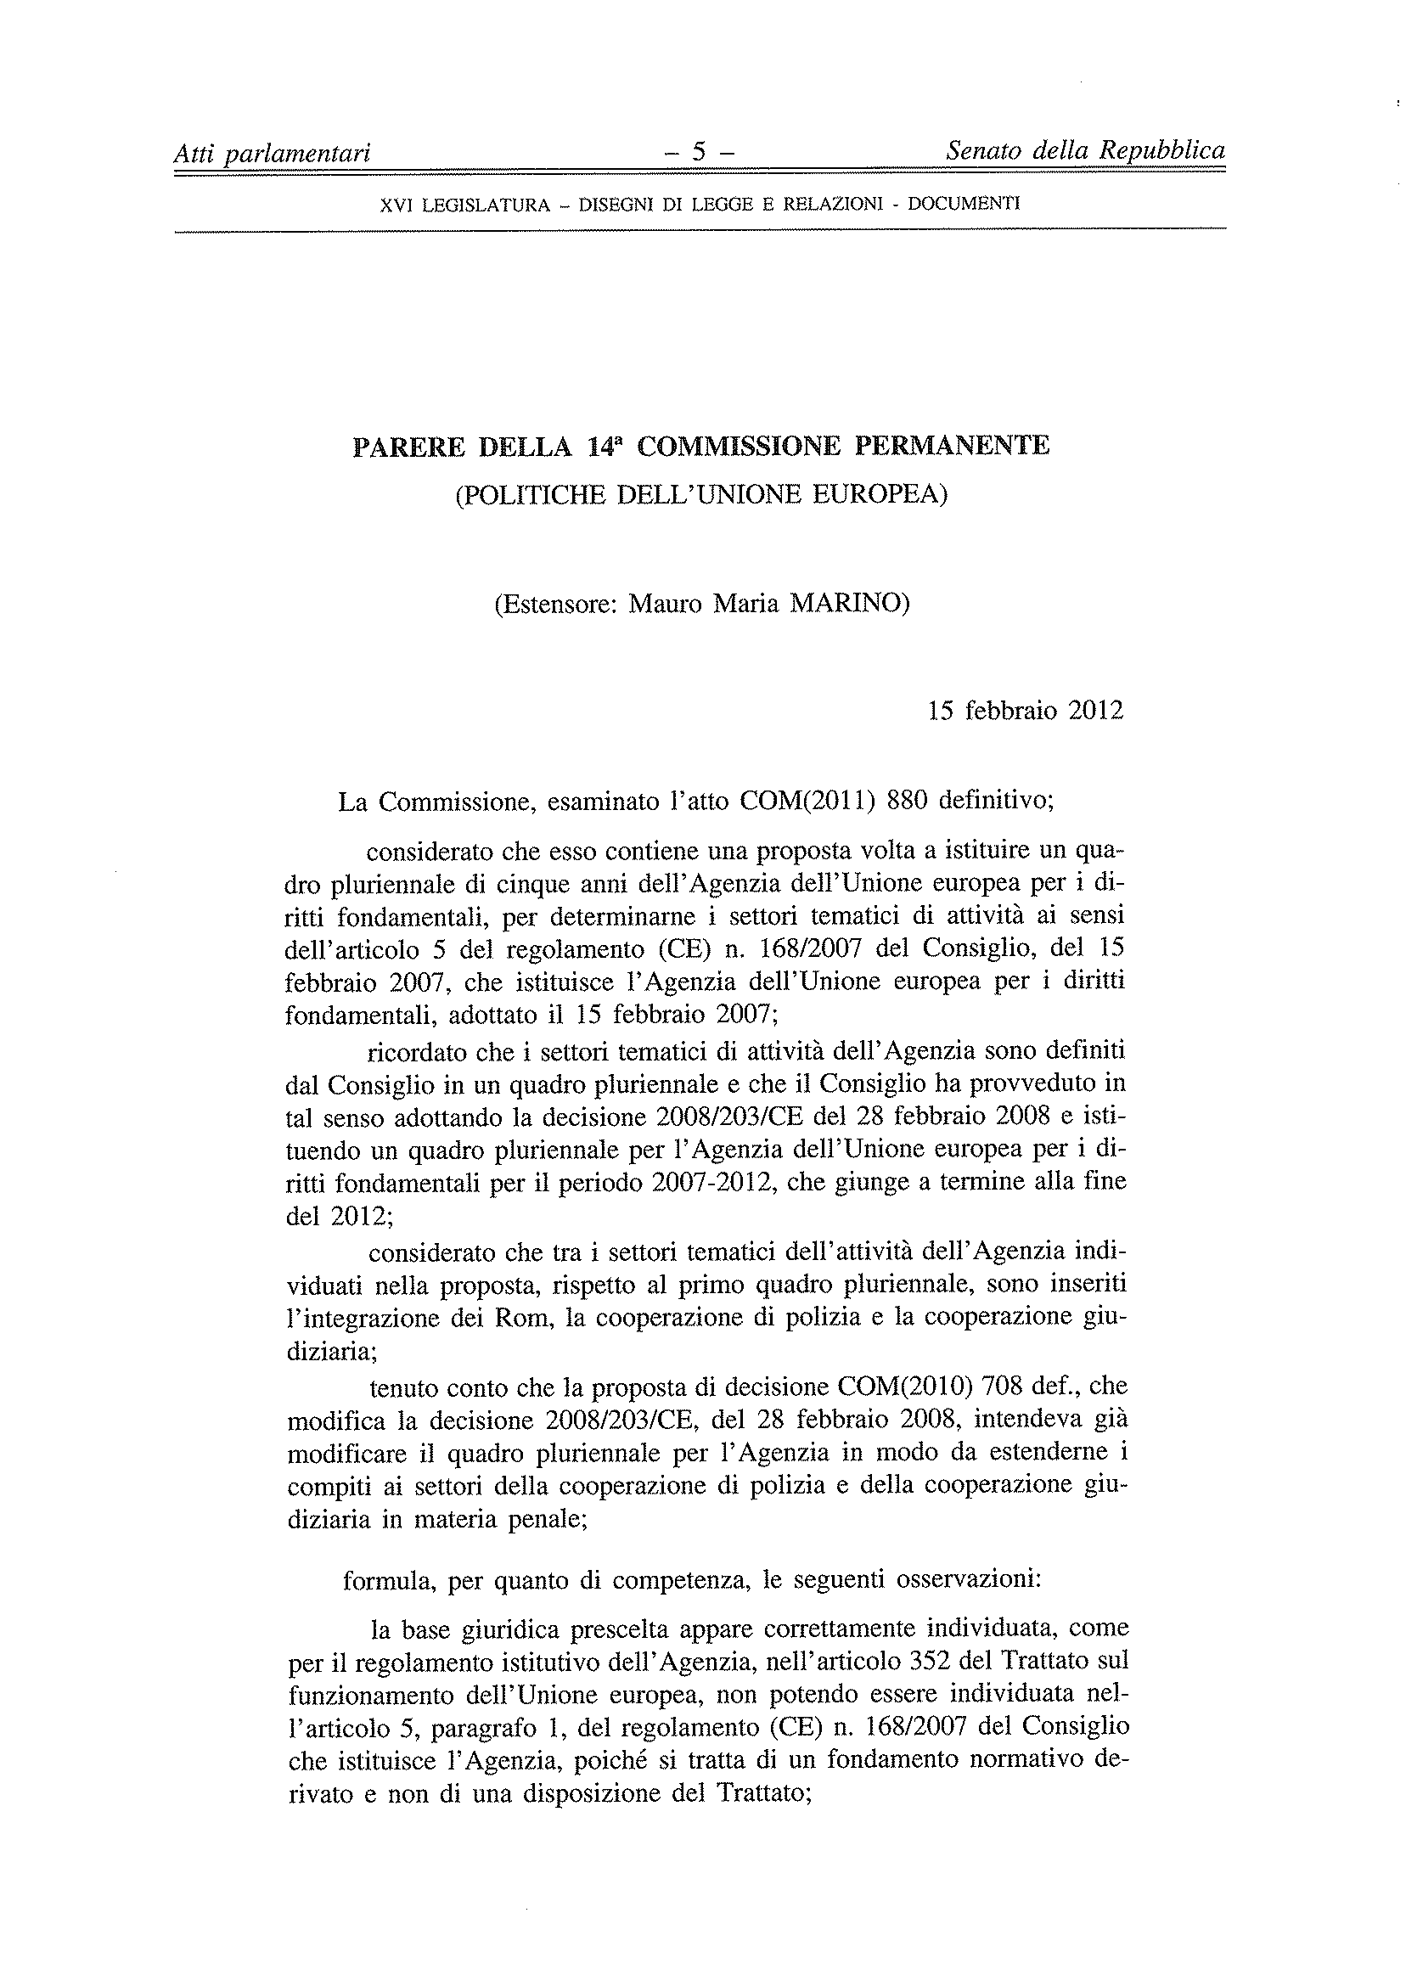
_____________

Translation(s) of the opinion may be available at the Interparliamentary EU information exchange site IPEX at the following address: http://www.ipex.eu/IPEXL-WEB/search.do

