 | 
COUNCIL OF  THE EUROPEAN UNION |  |  | Brussels, 26 January 2012
 | Interinstitutional Files:  2011/0386 (COD) |  | 5792/12
ECOFIN 68
UEM 20
CODEC 208
INST 65
PARLNAT 52

COVER NOTE
From: | The French Senate
Date of receipt: | 26 January 2012
To: | President of the Council of the European Union
Subject: | Proposal for a Regulation of the Council and of the European Parliament on common provisions for monitoring and assessing draft budgetary plans and ensuring the correction of excessive deficit of the Member States in the euro area [doc. 17231/11 ECOFIN 806 UEM 336 CODEC 2113 - COM(2011) 821 final]  - Opinion of the application of the principles of Subsidiarity and Proportionality

Delegations will find attached the above mentioned opinion.
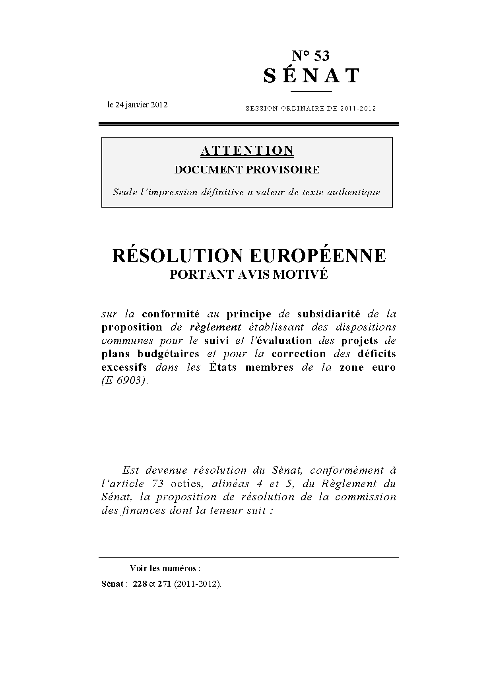
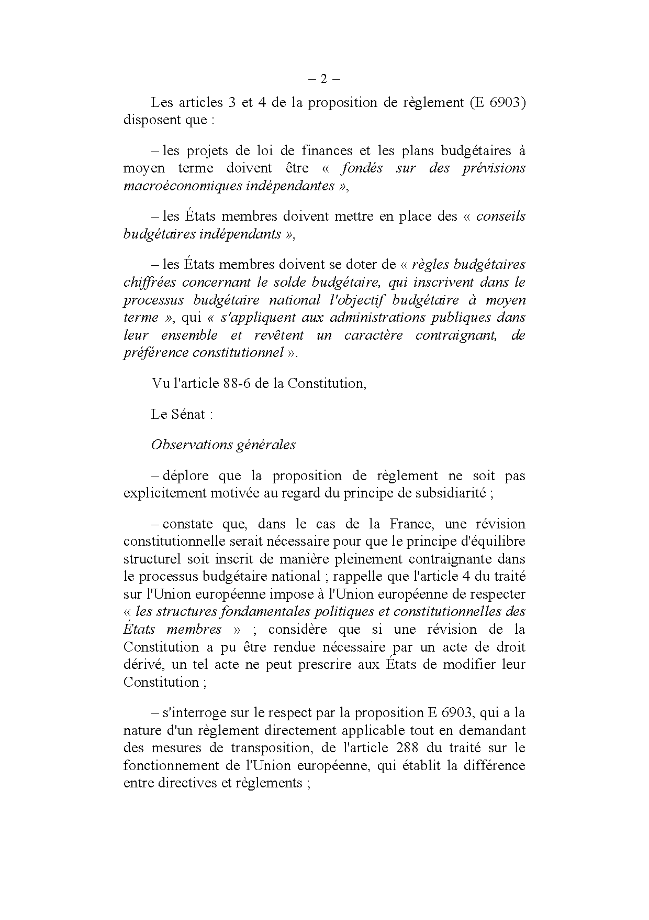
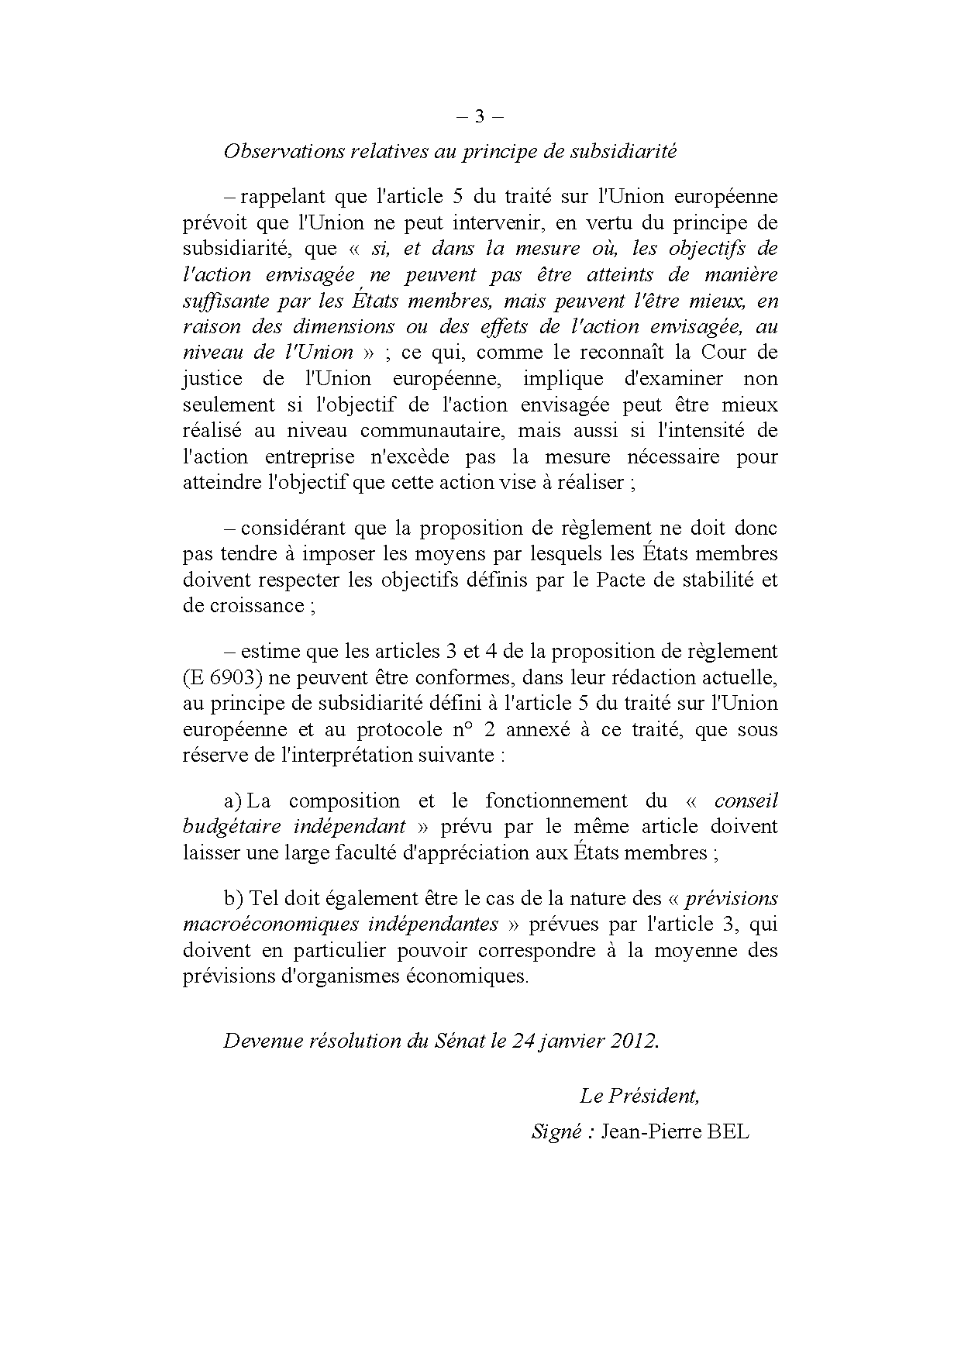

This opinion is available in English on the parliamentary EU information exchange site (IPEX) at the following address: http://www.ipex.eu/ipex/cms/home/Documents/pid/10

