 | 
COUNCIL OF  THE EUROPEAN UNION |  |  | Brussels, 15 March 2012
 | Interinstitutional Files:  2011/0315 (COD)  2011/0322 (NLE)  2011/0328 (NLE) |  | 7649/12
WTO 97
COEST 75
STIS 3
UD 73
CODEC 659
SERVICES 30
FDI 14
INST 206
PARLNAT 151

COVER NOTE
from: | the President of the Assembly of the Republic of Portugal
date of receipt: | 8 March 2012
to: | Ms Helle THORNING-SCHMIDT, President of the Council of the European Union

Subject: | Proposal for a Regulation of the European Parliament and of the Council repealing Council Regulation (EC) No 1342/2007 on administering certain restrictions on imports of certain steel products from the Russian Federation  [doc. 16770/11 WTO 403 COEST 405 STIS 24 UD 302 CODEC 1996 - COM(2011) 715 final]  Proposal for a Council Decision on the conclusion, on behalf of the European Union, of the Agreement in the form of an Exchange of Letters between the European Union and the Russian Federation relating to the administration of tariff-rate quotas applying to exports of wood from the Russian Federation to the European Union and the Protocol between the European Union and the Government of the Russian Federation on technical modalities pursuant to that Agreement  [doc. 16771/11 WTO 404 SERVICES 118 FDI 36 COEST 406 - COM(2011) 722 final]  Proposal for a Council Decision on the conclusion, on behalf of the European Union, of the Agreement in the form of an Exchange of Letters between the European Union and the Government of the Russian Federation regarding the preservation of commitments on trade in services contained in the current EU-Russia Partnership and Co-operation Agreement  [doc. 16812/11 WTO 421 SERVICES 128 COEST 423 - COM(2011) 724 final]  - Opinion on the application of the Principles of Subsidiarity and Proportionality

Delegations will find attached the above-mentioned opinion.

________________________

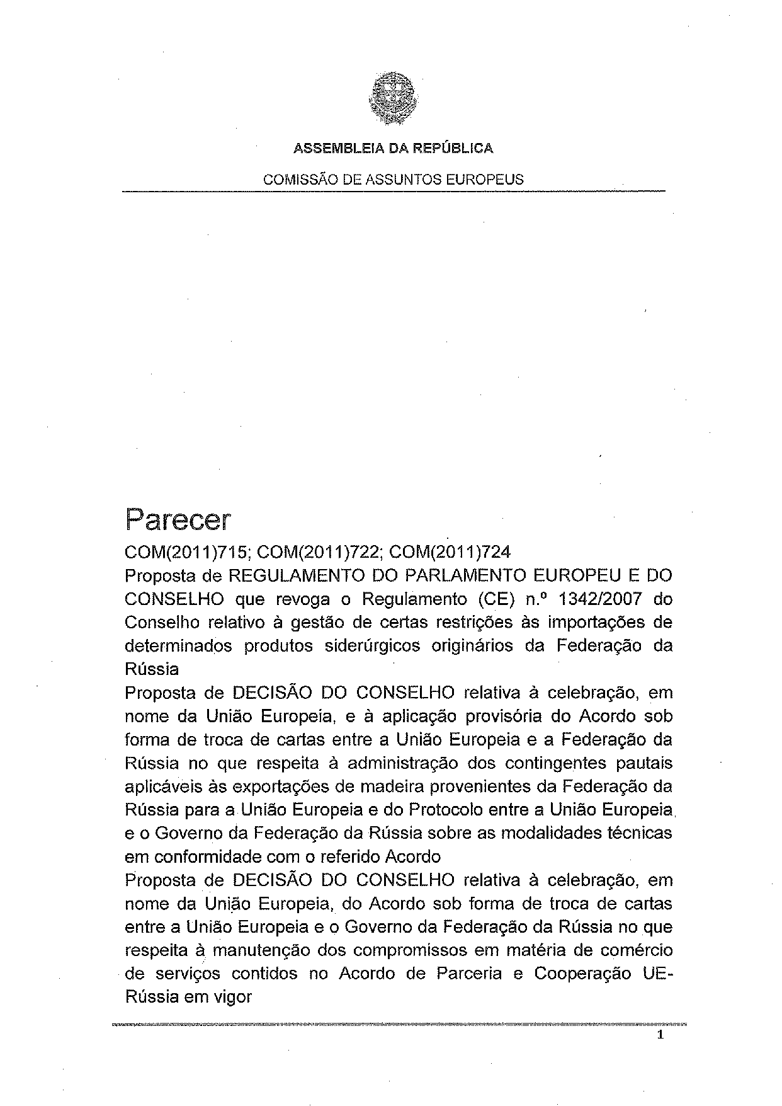
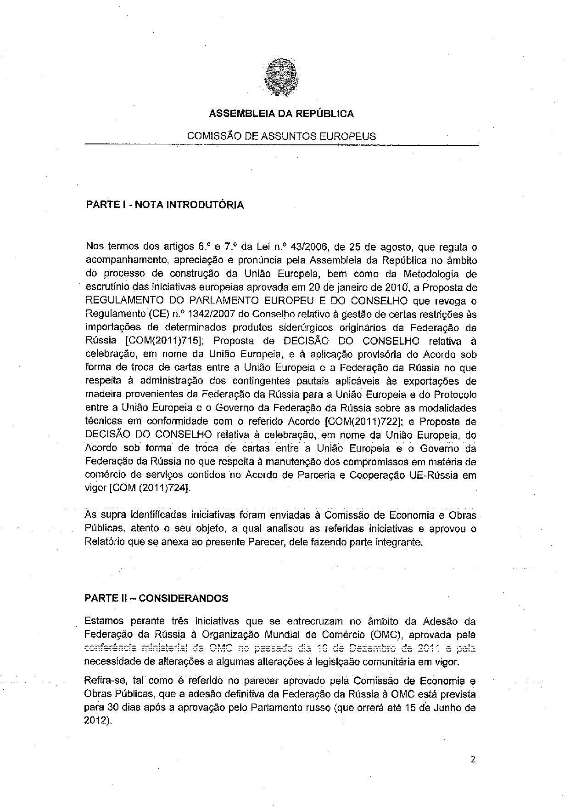
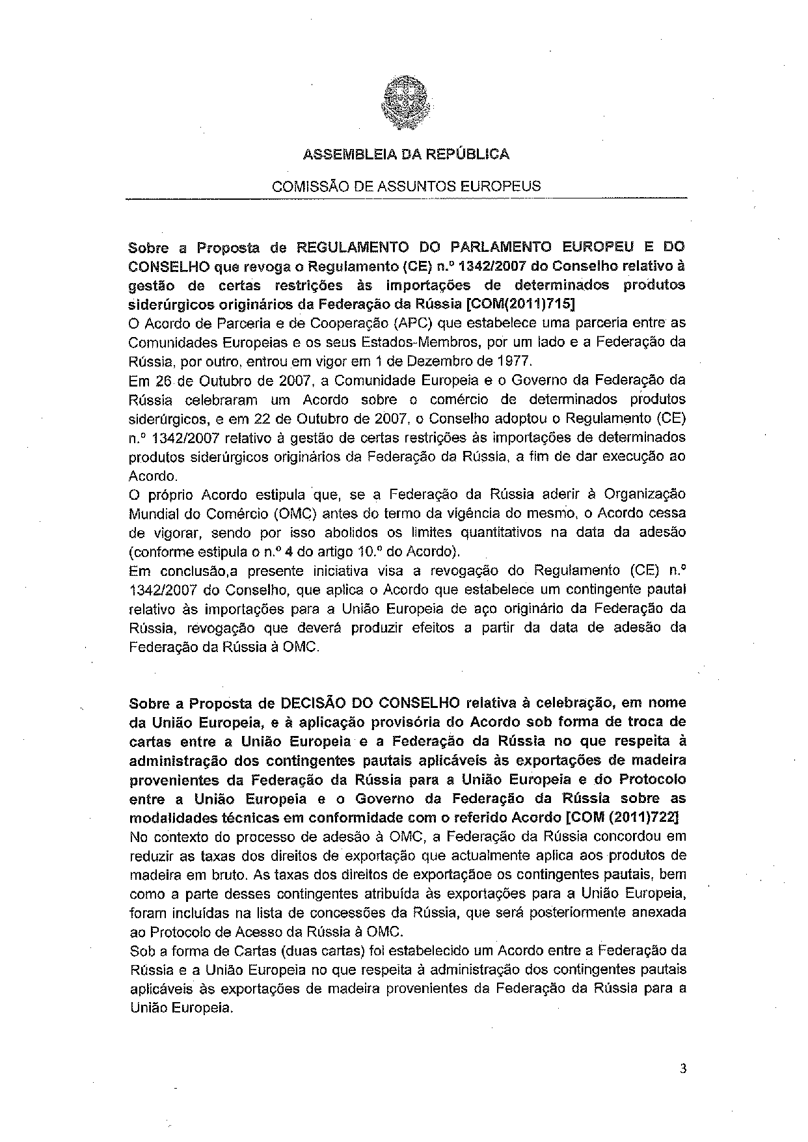
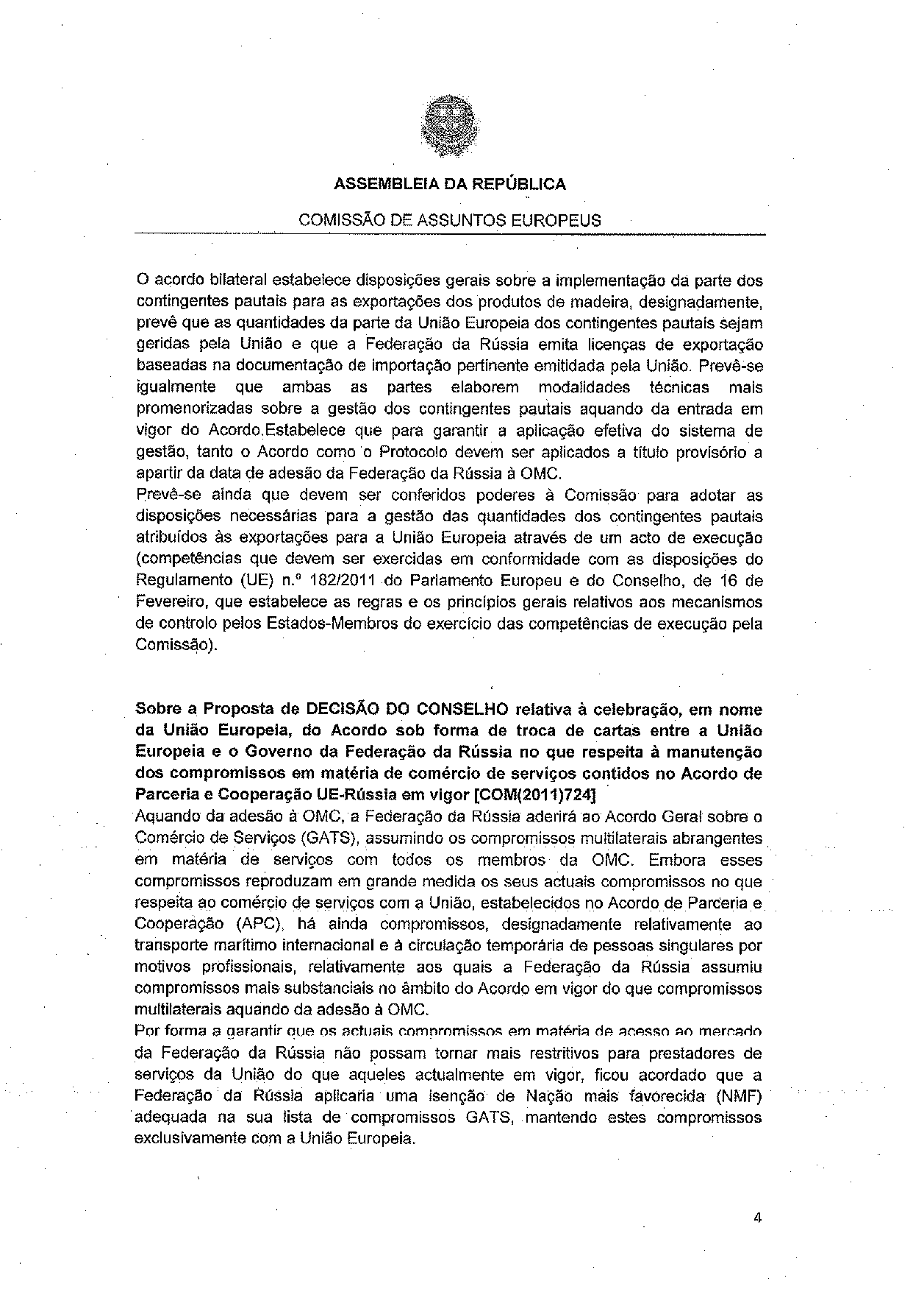
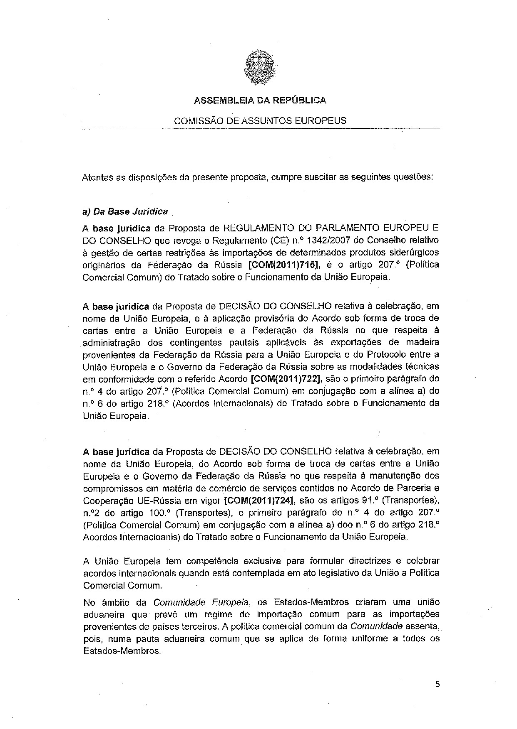
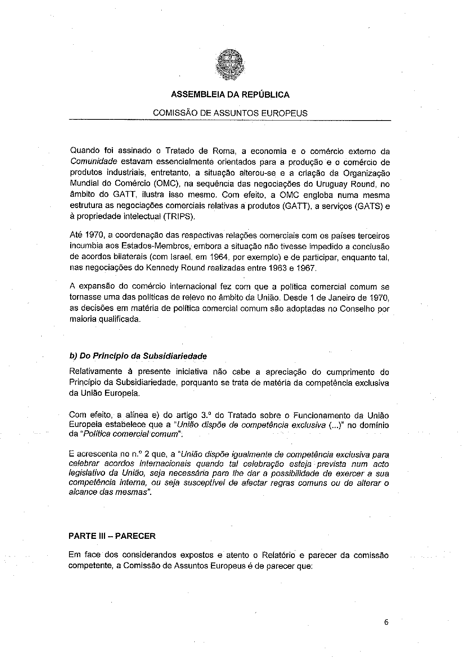
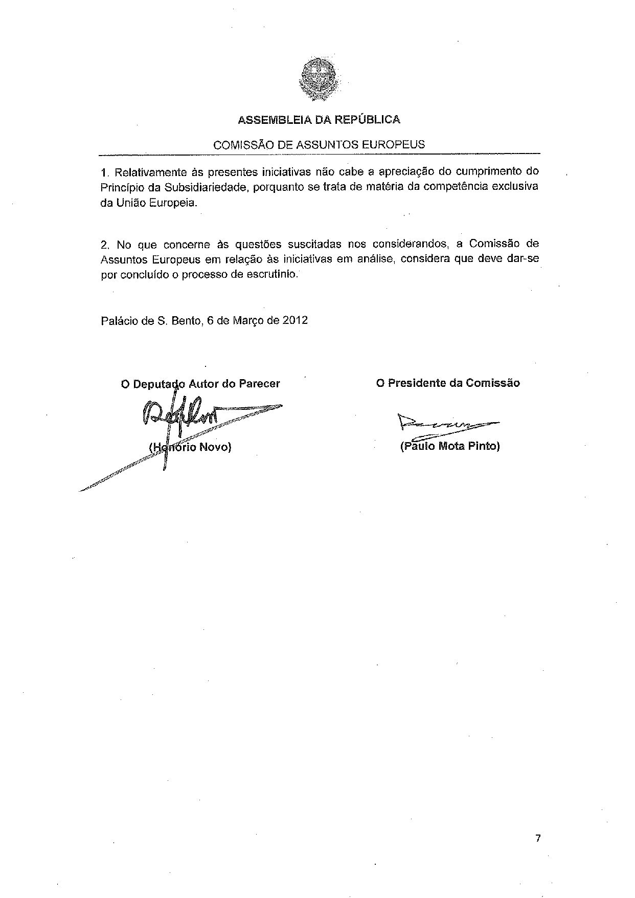

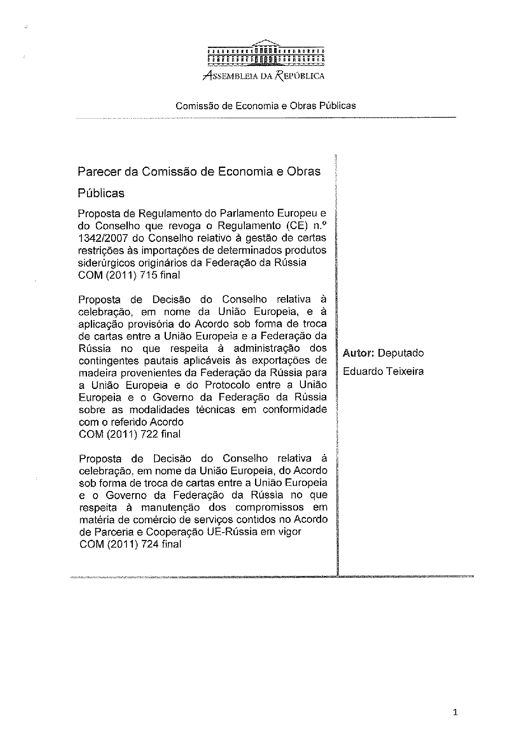
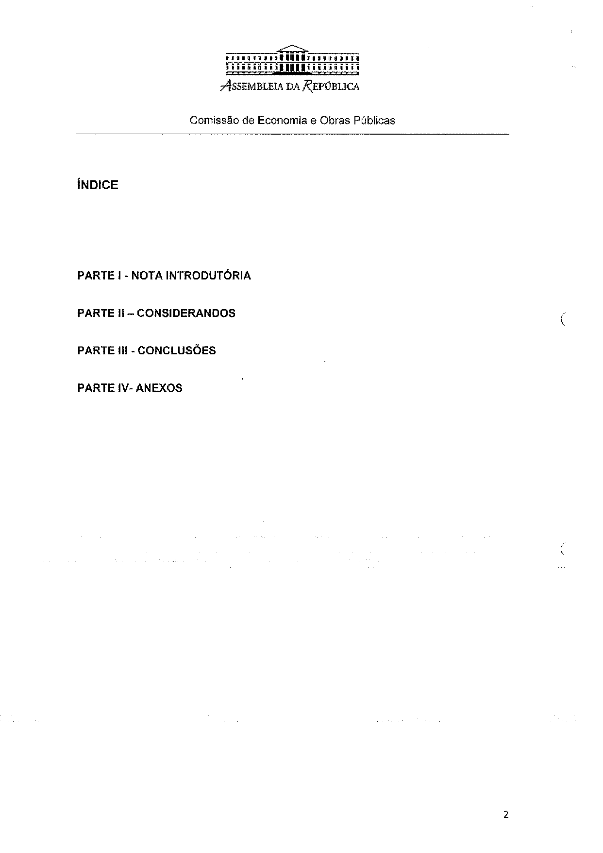
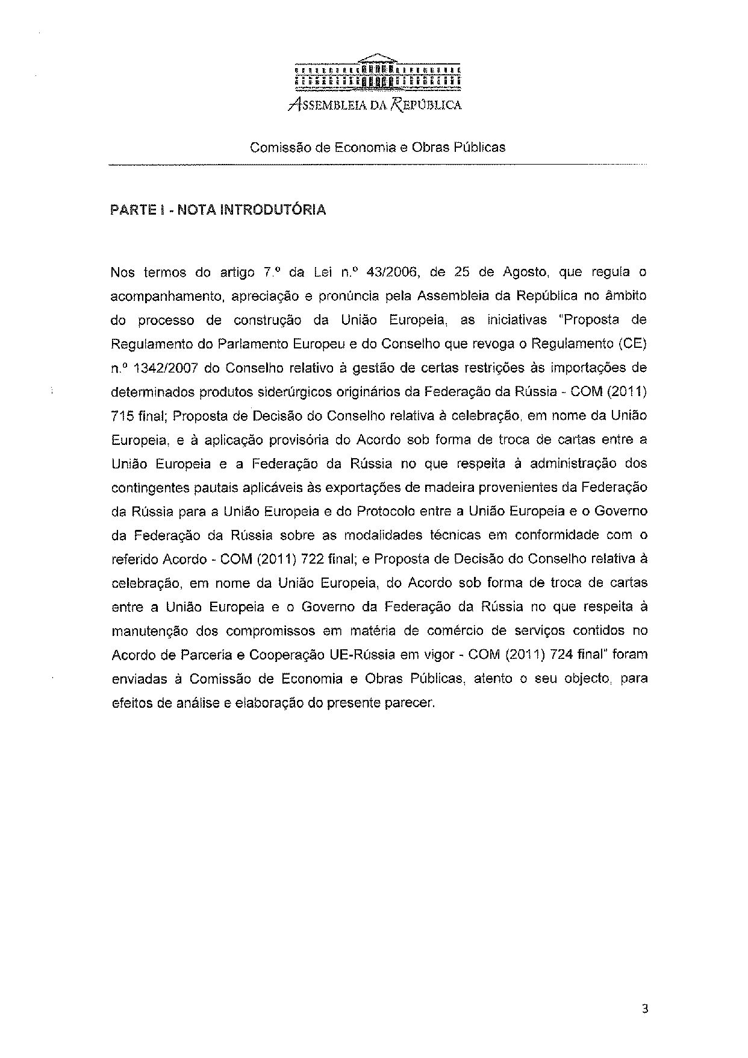
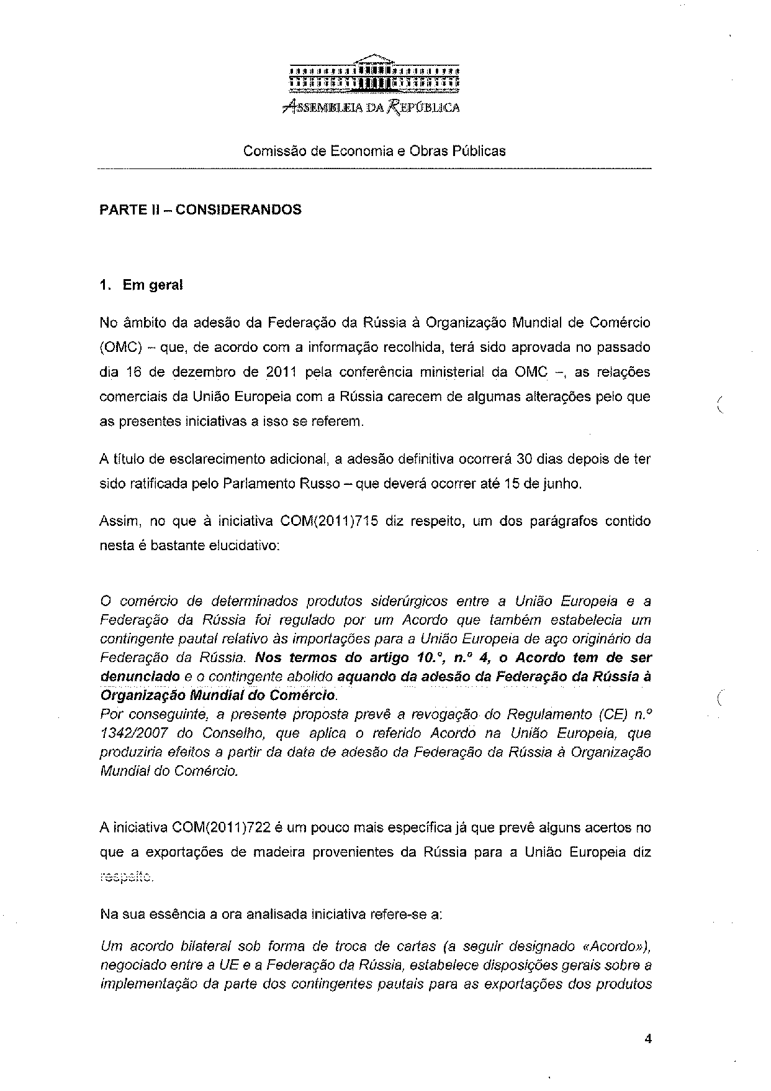
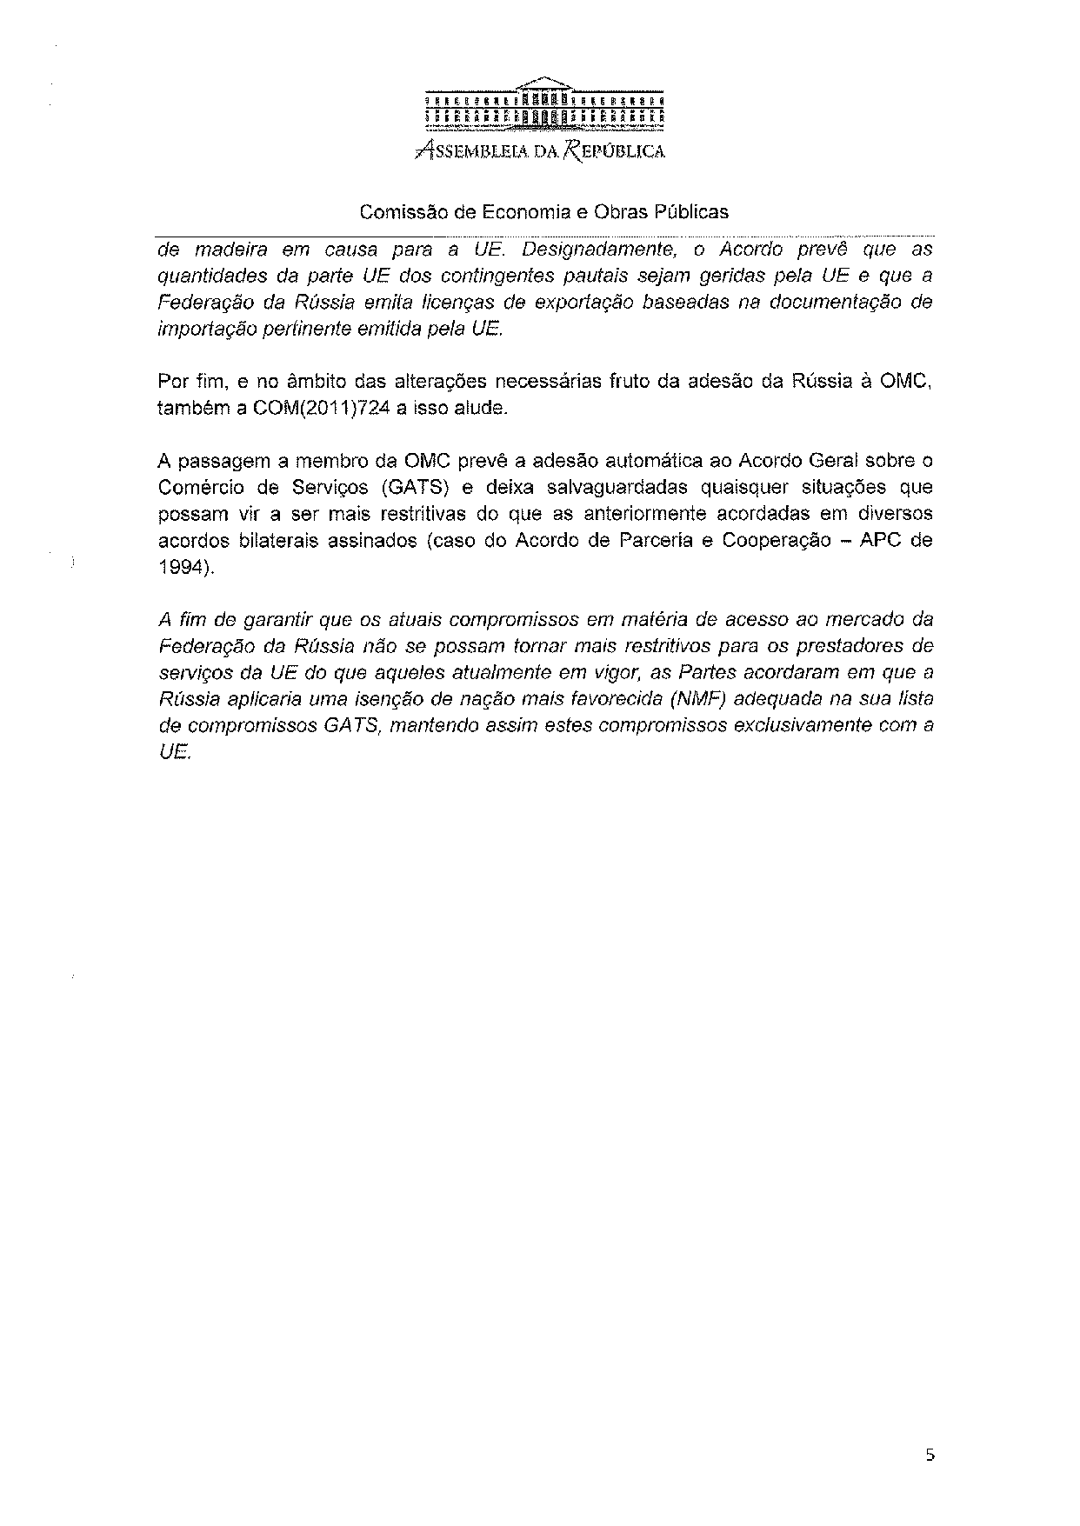
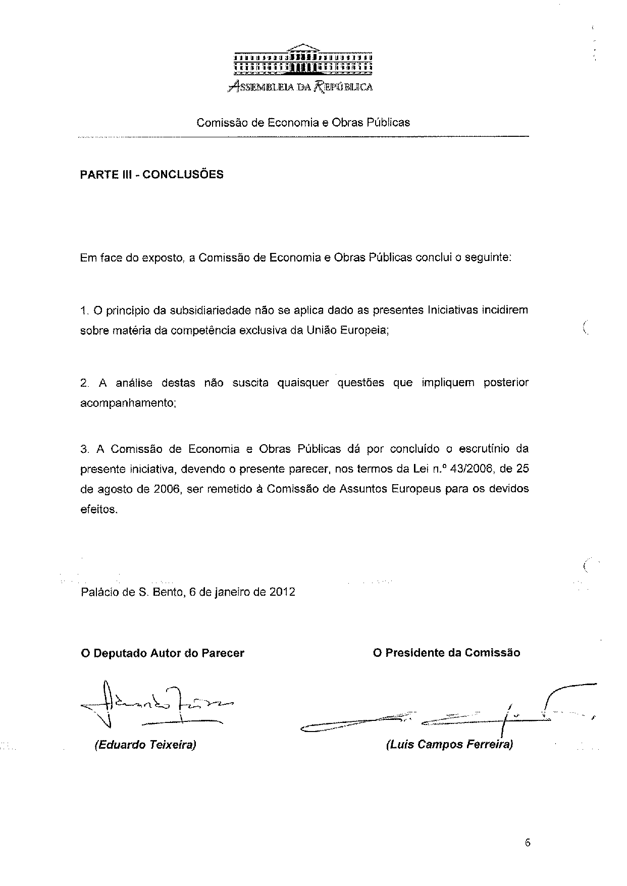

The translation of the opinion may be available at the Interparliamentary EU information exchange site IPEX, at the following address: http://www.ipex.eu/IPEXL-WEB/search.do.

