 | 
COUNCIL OF  THE EUROPEAN UNION |  |  | Brussels, 23 January 2012
 | Interinstitutional File:  2011/0242 (COD)  2011/0312 (COD) |  | 5195/12
SCHENGEN 2
FRONT 3
SCH-EVAL 4
INST 36
PARLNAT 34
COMIX 13
CODEC 67

COVER NOTE
from: | President of the Italian Chamber of Deputies
date of receipt: | 29 December 2011
to: | Mr Uwe CORSEPIUS, Secretary-General of the Council of the European Union
Subject: | - Amended proposal for a regulation of the European Parliament and of the Council on the establishment of an evaluation and monitoring mechanism to verify the application of the Schengen acquis  [doc. 14358/11 SCH-EVAL 152 SCHENGEN 27 FRONT 116 COMIX 582 CODEC 1465 - COM(2011) 559 final]  - Proposal for a Regulation of the European Parliament and of the Council amending Regulation (EC) No 562/2006 in order to provide for common rules on the temporary reintroduction of border control at internal borders in exceptional circumstances  [doc. 14359/11 FRONT 117 SCH-EVAL 153 SCHENGEN 28 COMIX 583 CODEC 1466 - COM(2011) 560 final]  - Communication from the Commission to the European Parliament, the Council, the European Economic and Social Committee and the Committee of the Regions  – Schengen governance – strengthening the area without internal border control  [doc. 14357/11 SCHEVAL 151 SCHENGEN 26 FRONT 115 COMIX 581 - COM(2011) 561 final]  – Opinion on the application of the Principles of Subsidiarity and Proportionality

Delegations will find attached a copy of the above opinion.

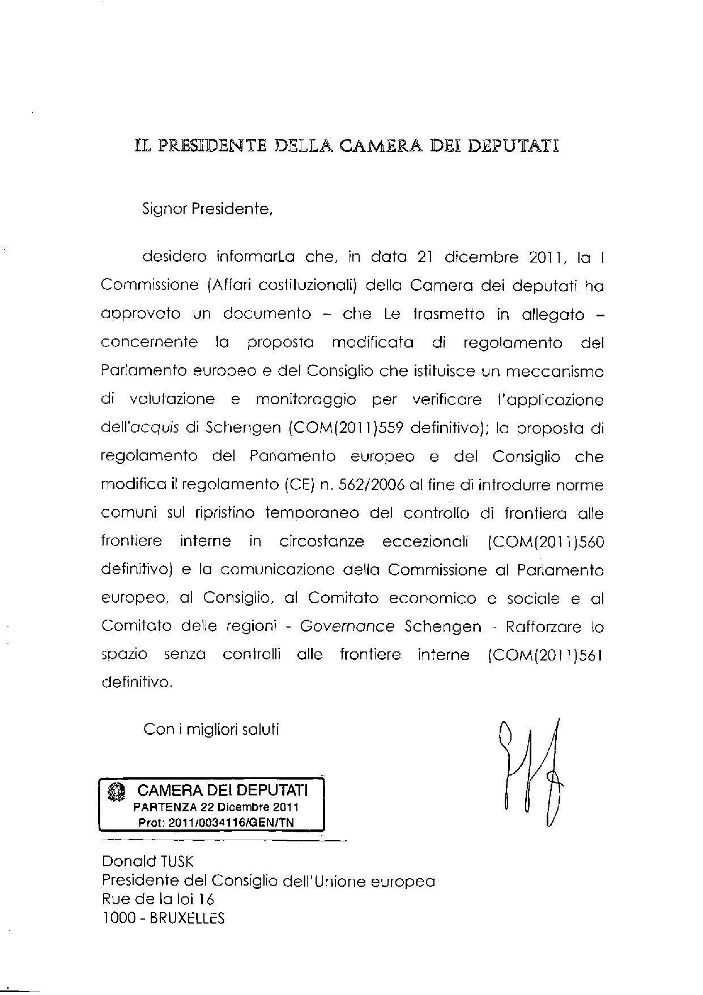

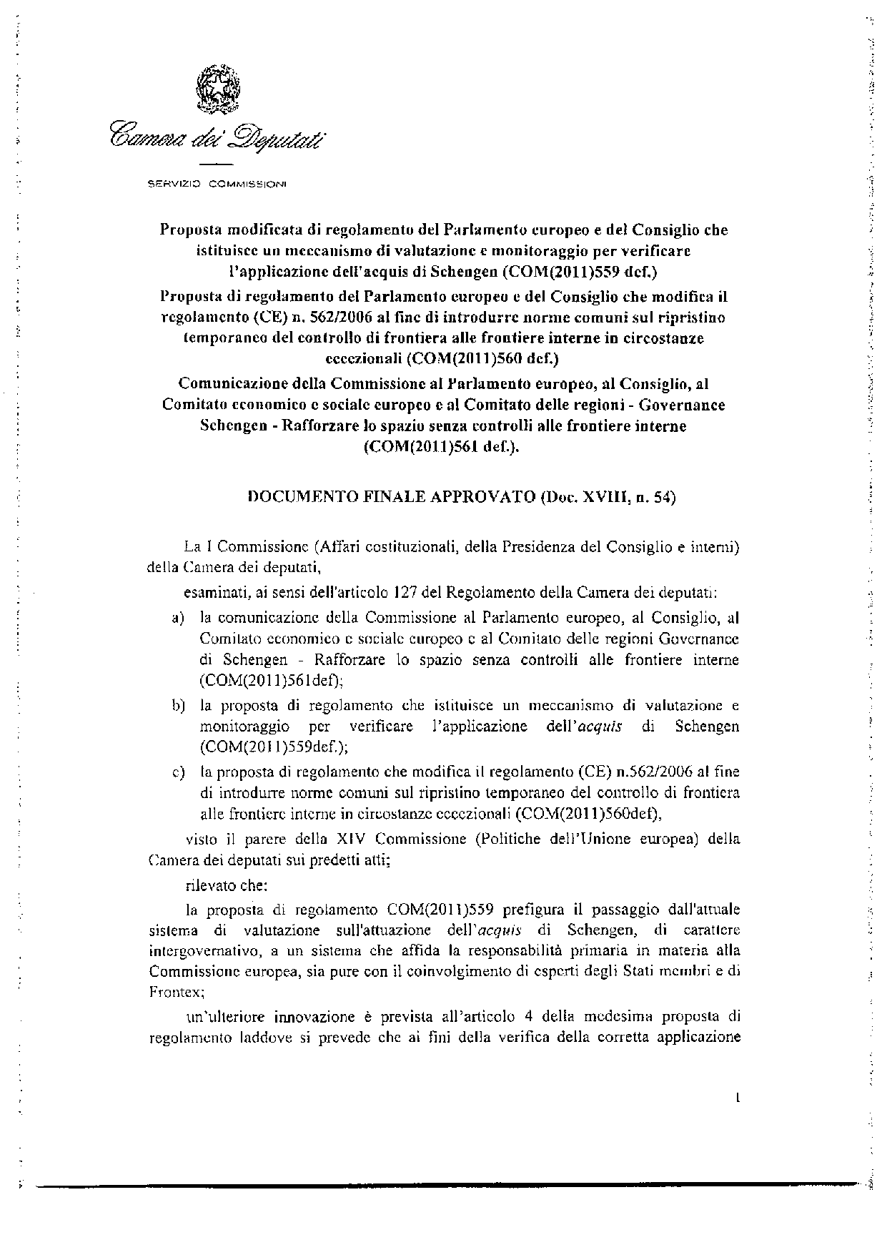

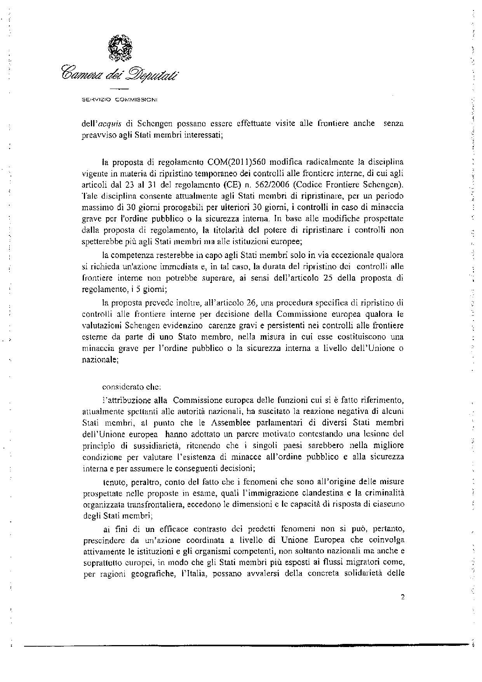
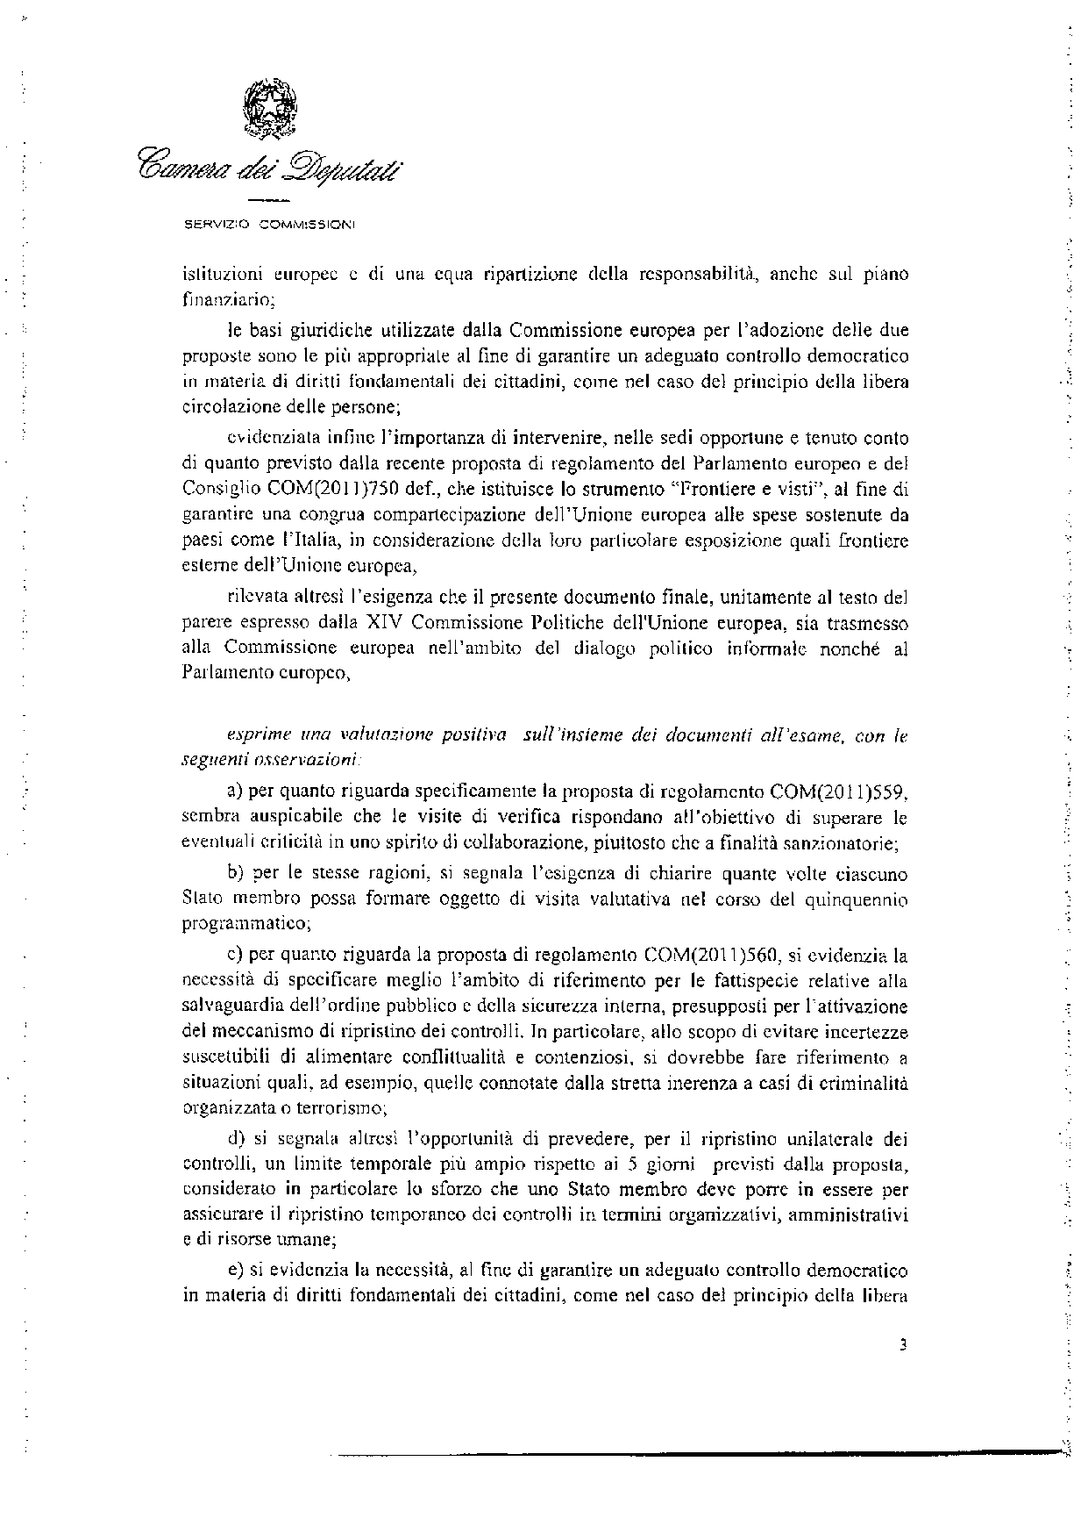
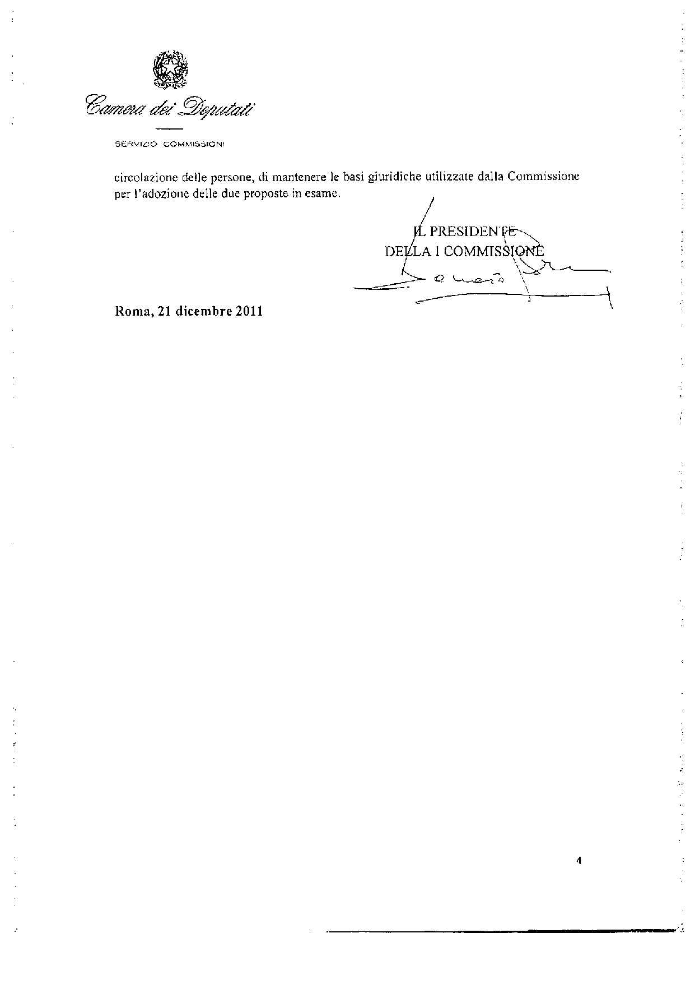
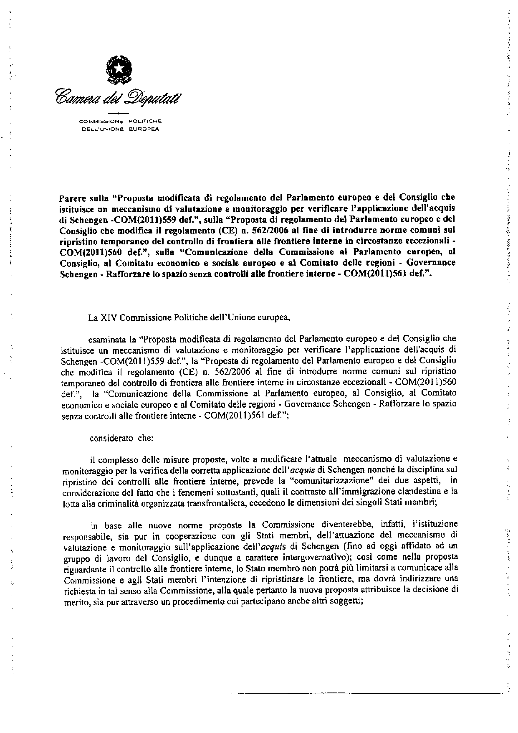
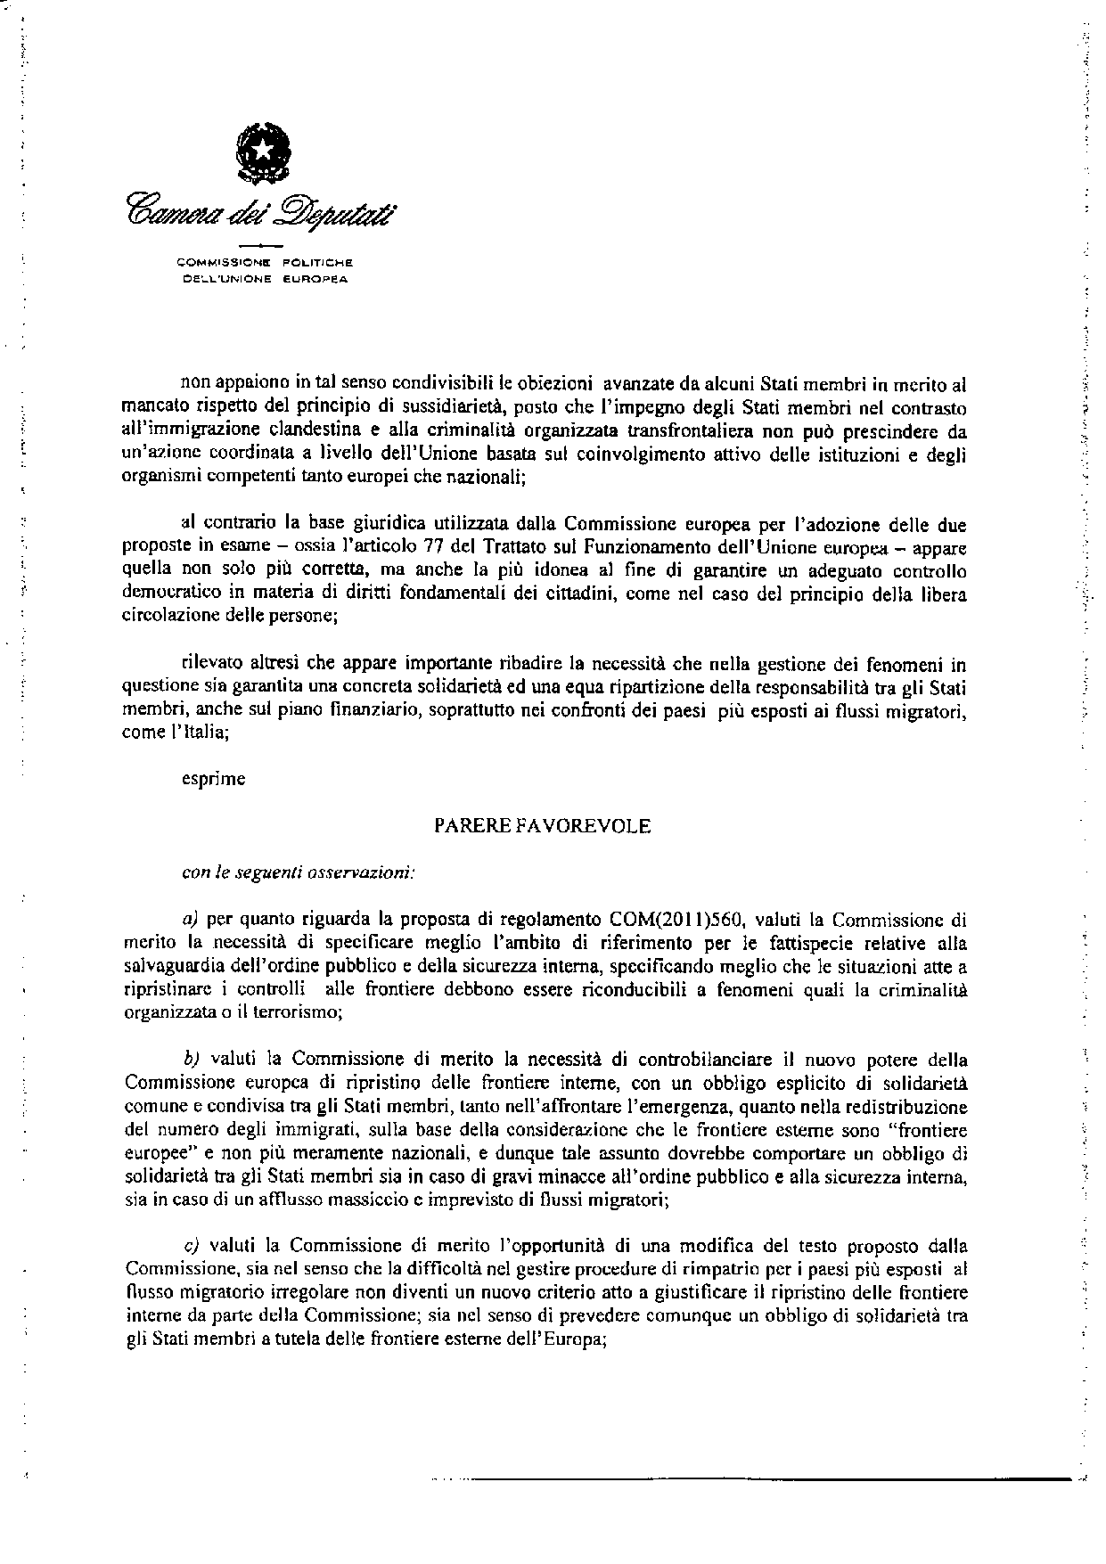


For other available language versions of the opinion, reference is made to the Interparliamentary EU information exchange Internet site (IPEX) at the following address: http://www.ipex.eu/ipex/cms/home/Documents/pid/10.

