 | 
COUNCIL OF  THE EUROPEAN UNION |  |  | Brussels, 24 January 2012
 | Interinstitutional File:  2011/0341 (COD) |  | 5667/12
FISC 12
UD 18
CODEC 185
INST 62
PARLNAT 50

COVER NOTE
from: | The Portuguese Parliament
date of receipt: | 19 January 2012
to: | The President of the Council of the European Union
Subject: | Proposal for a REGULATION OF THE EUROPEAN PARLIAMENT AND OF THE COUNCIL establishing an action programme for customs and taxation in the European Union for the period 2014-2020 (FISCUS) and repealing Decisions N°1482/2007/EC and N°624/2007/EC  [doc. 16901/11 FISC 139 UD 313 CODEC 2024 - COM(2011) 706 final]  - Opinion on the application of the Principles of Subsidiarity and Proportionality

Delegations will find attached the abovementioned opinion.

________________________

Encl.

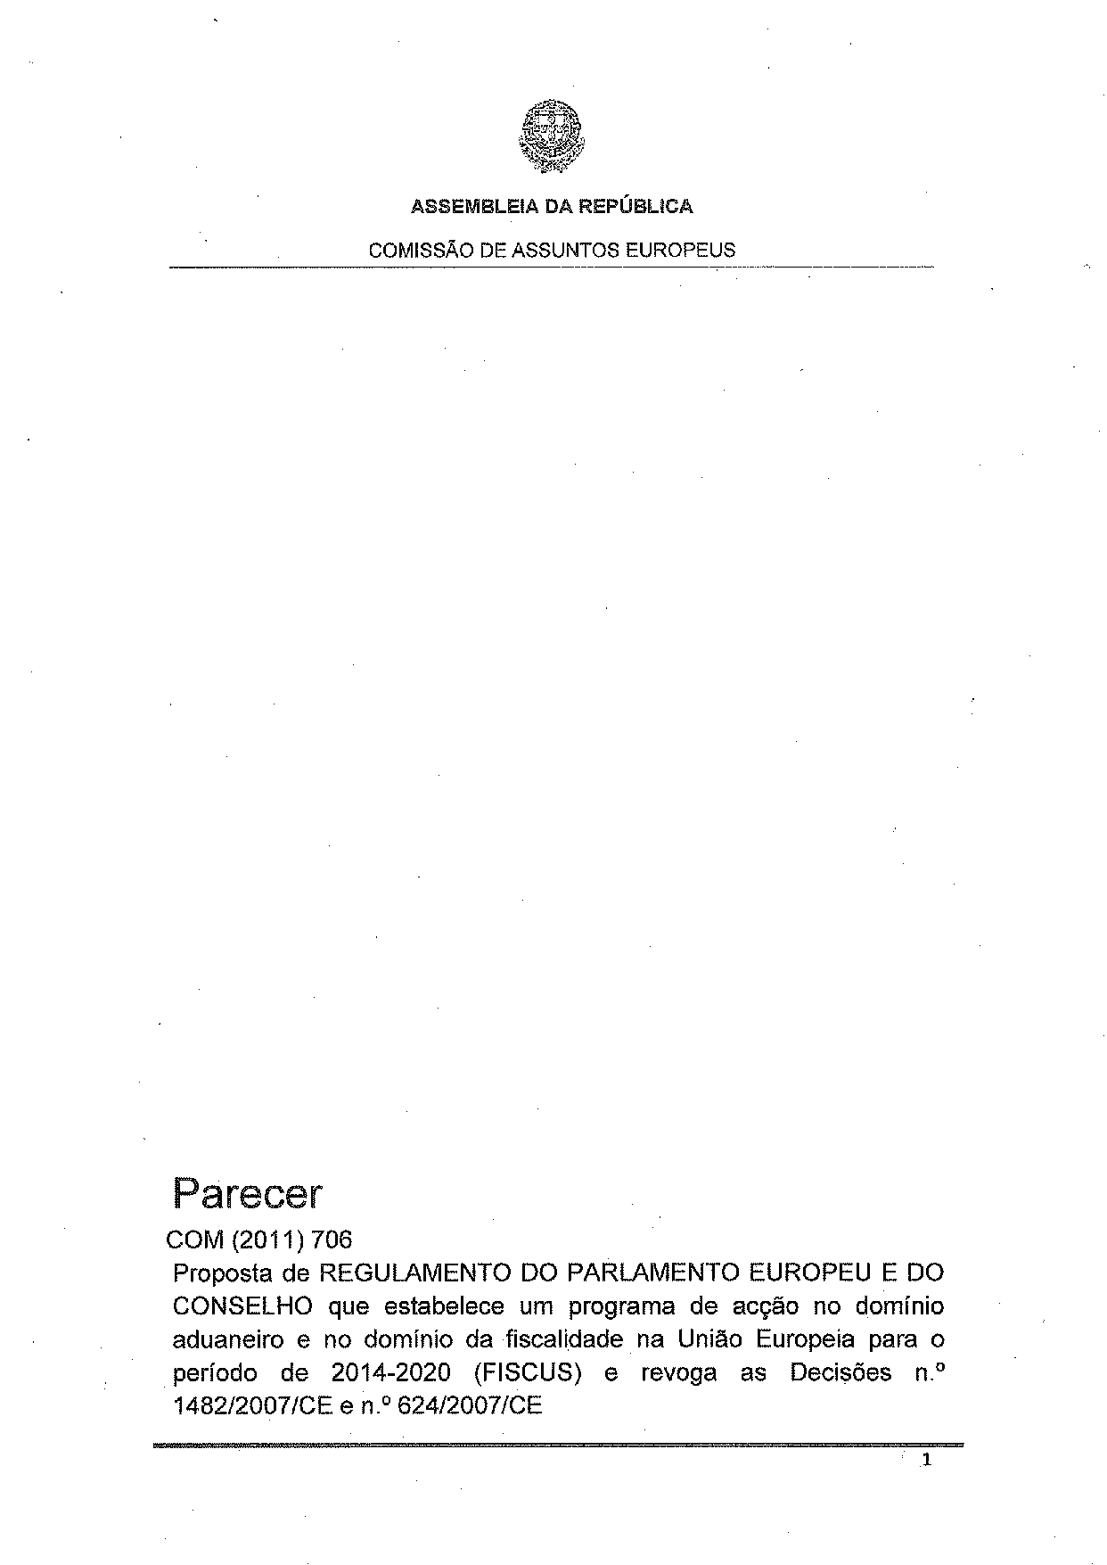

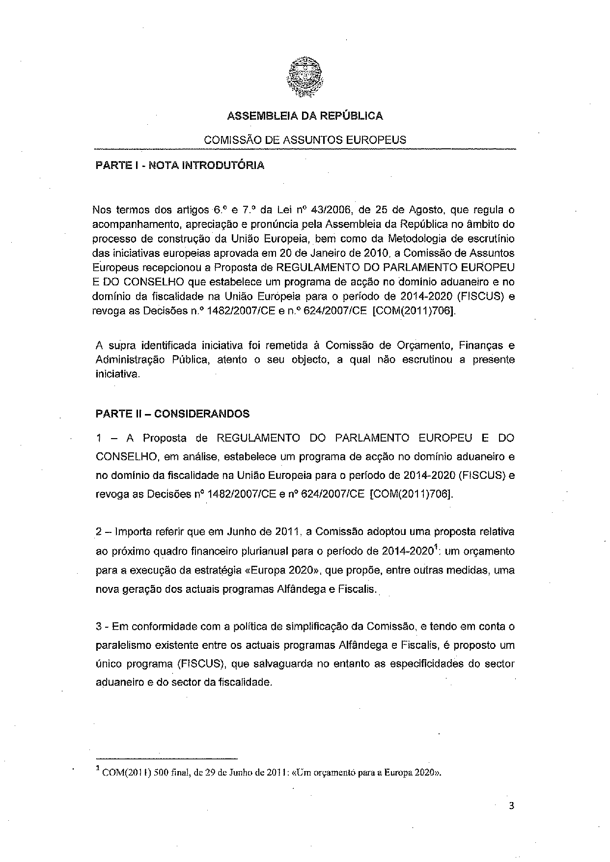

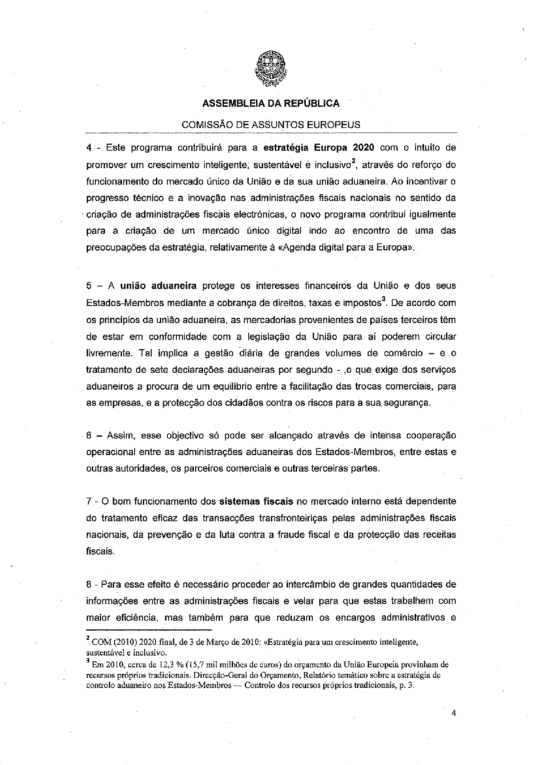

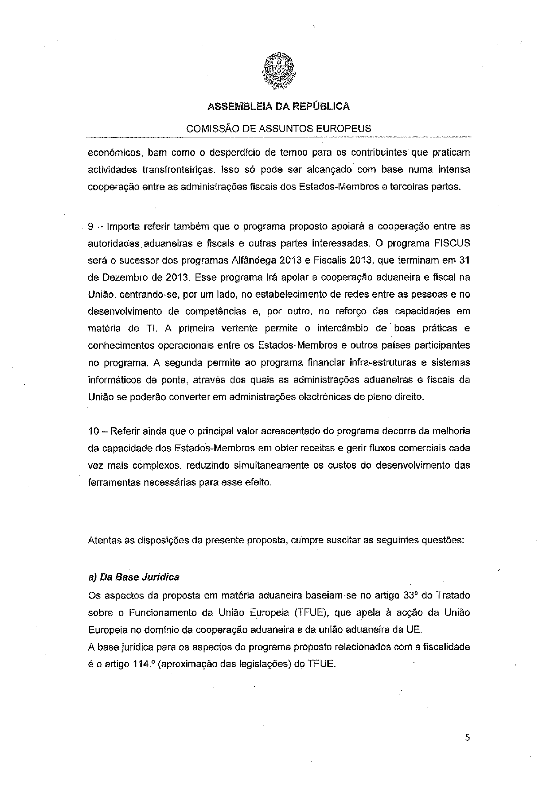

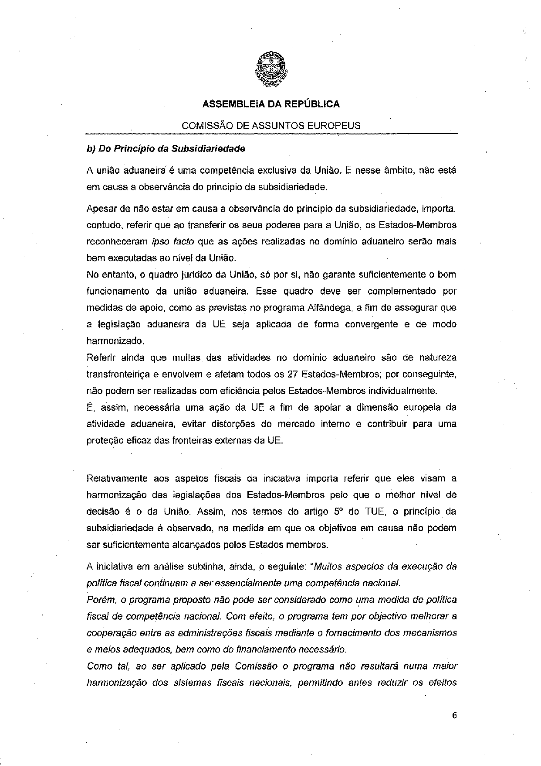

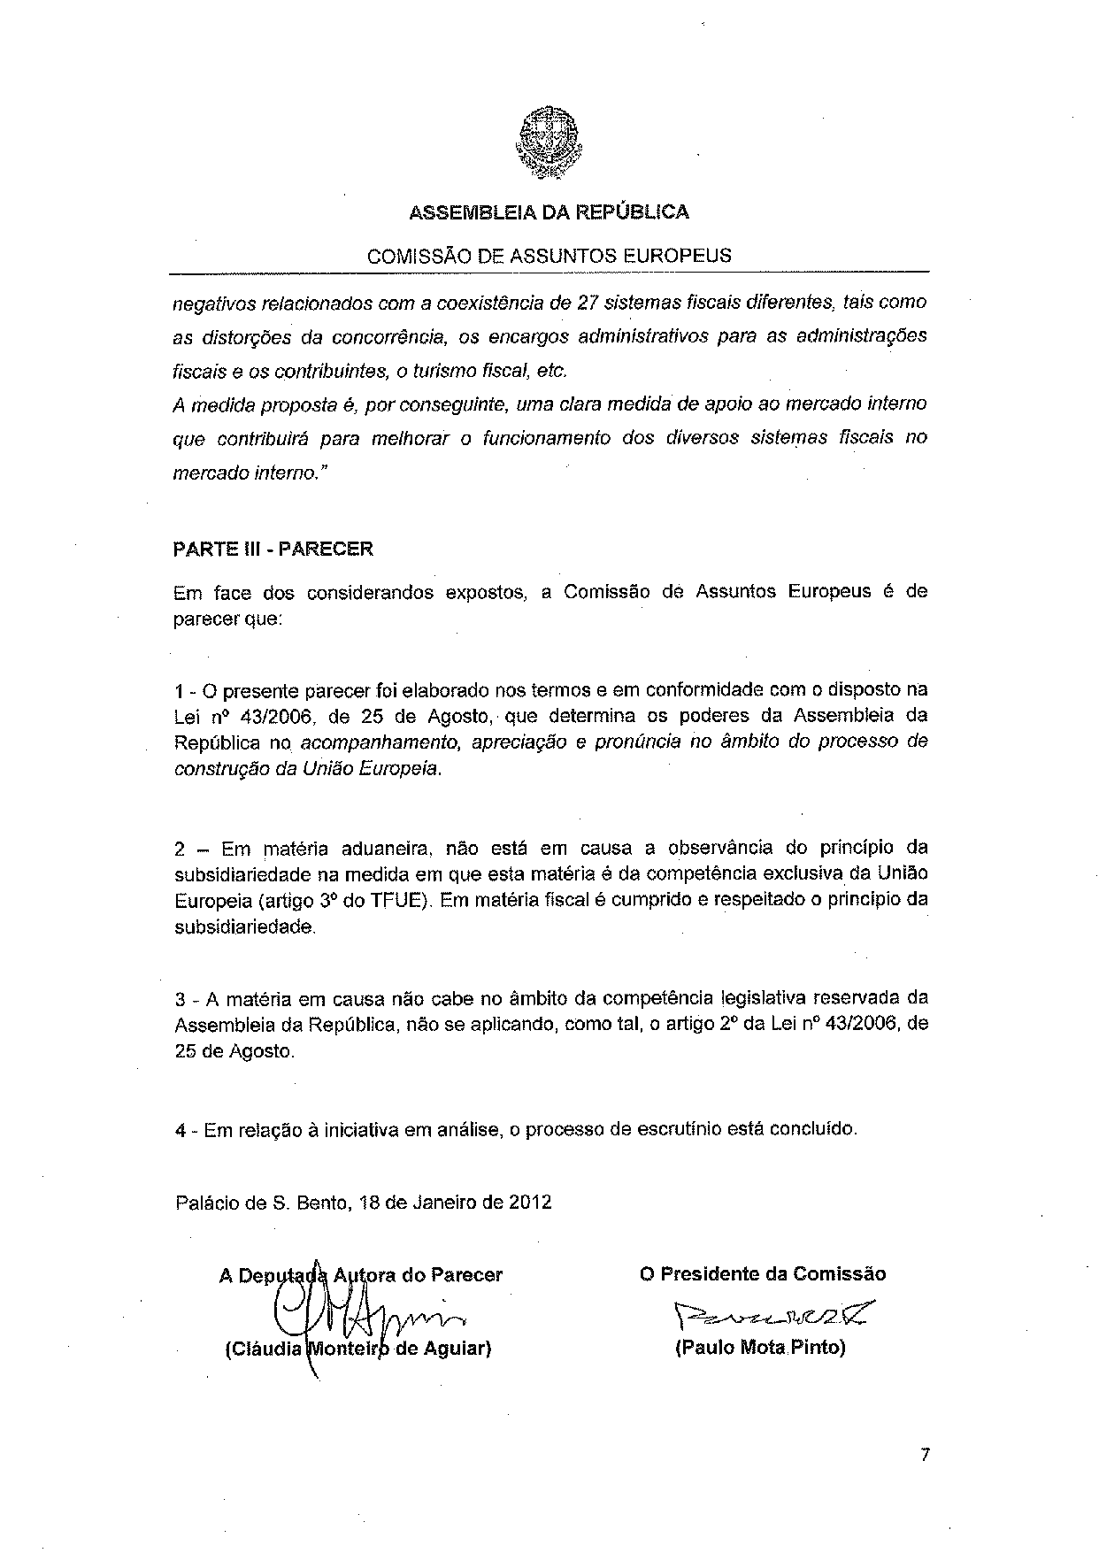

This opinion is available in English on the Interparliamentary EU information exchange site (IPEX) at the following address: http://www.ipex.eu/IPEXL-WEB/search.do

