 | 
COUNCIL OF  THE EUROPEAN UNION |  |  | Brussels, 16 March 2012
 | Interinstitutional File:  2011/0347 (NLE) |  | 7787/12
WTO 102
UD 76
RELEX 247
INST 216
PARLNAT 157

COVER NOTE
from: | the President of the Assembly of the Republic of Portugal
date of receipt: | 15 March 2012
to: | Ms Helle THORNING-SCHMIDT, President of the Council of the European Union
Subject: | Proposal for a Council Decision establishing the position to be adopted on behalf of the European Union within the World Trade Organization (WTO) as regards requests under Article IX of the Marrakesh Agreement establishing the World Trade Organization (the WTO Agreement) for granting and/or extending certain waivers  [doc. 16993/11 WTO 437 UD 318 RELEX 1195 - COM(2011) 762 final]  - Opinion on the application of the Principles of Subsidiarity and Proportionality

Delegations will find attached the above-mentioned opinion.

________________________

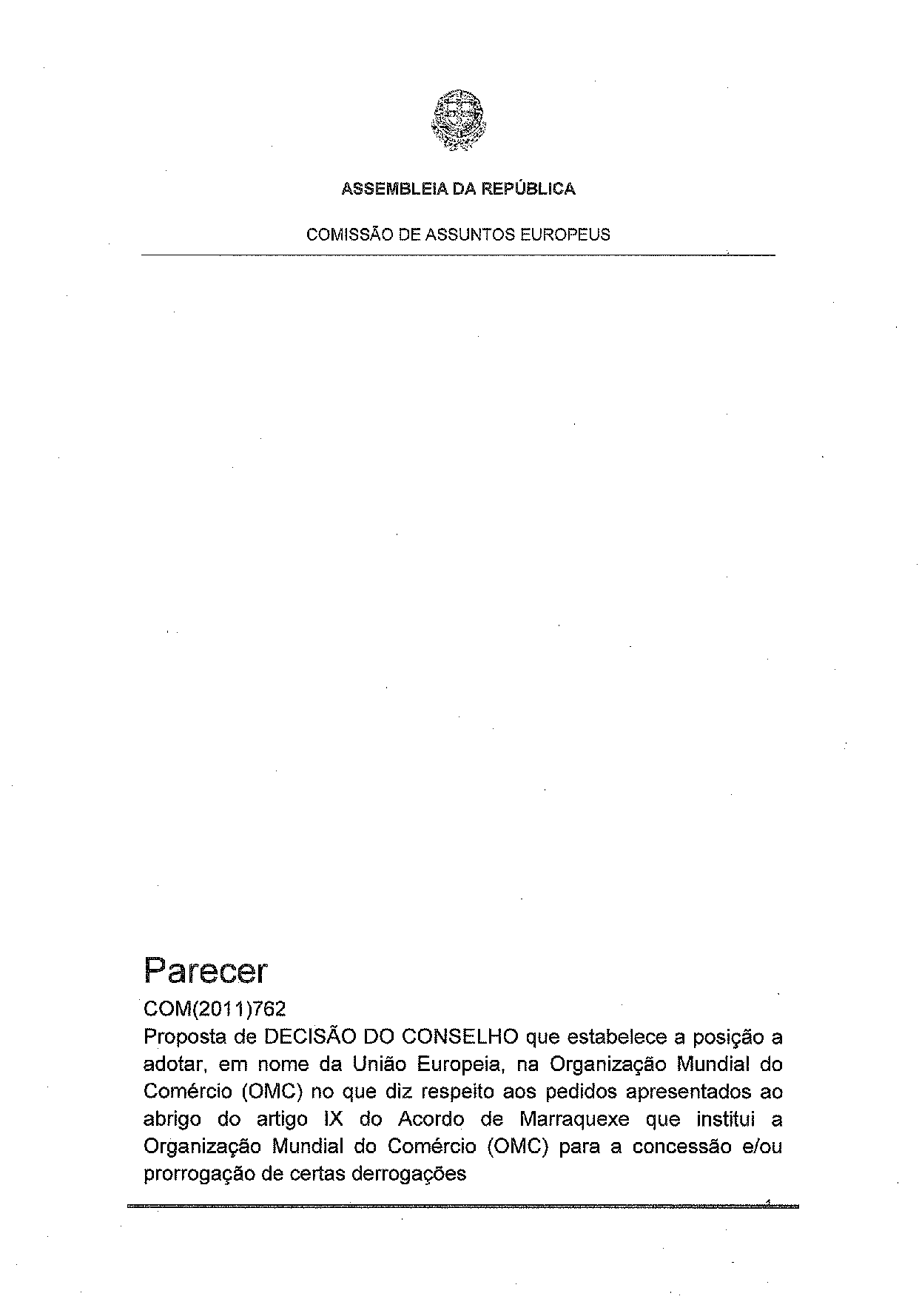
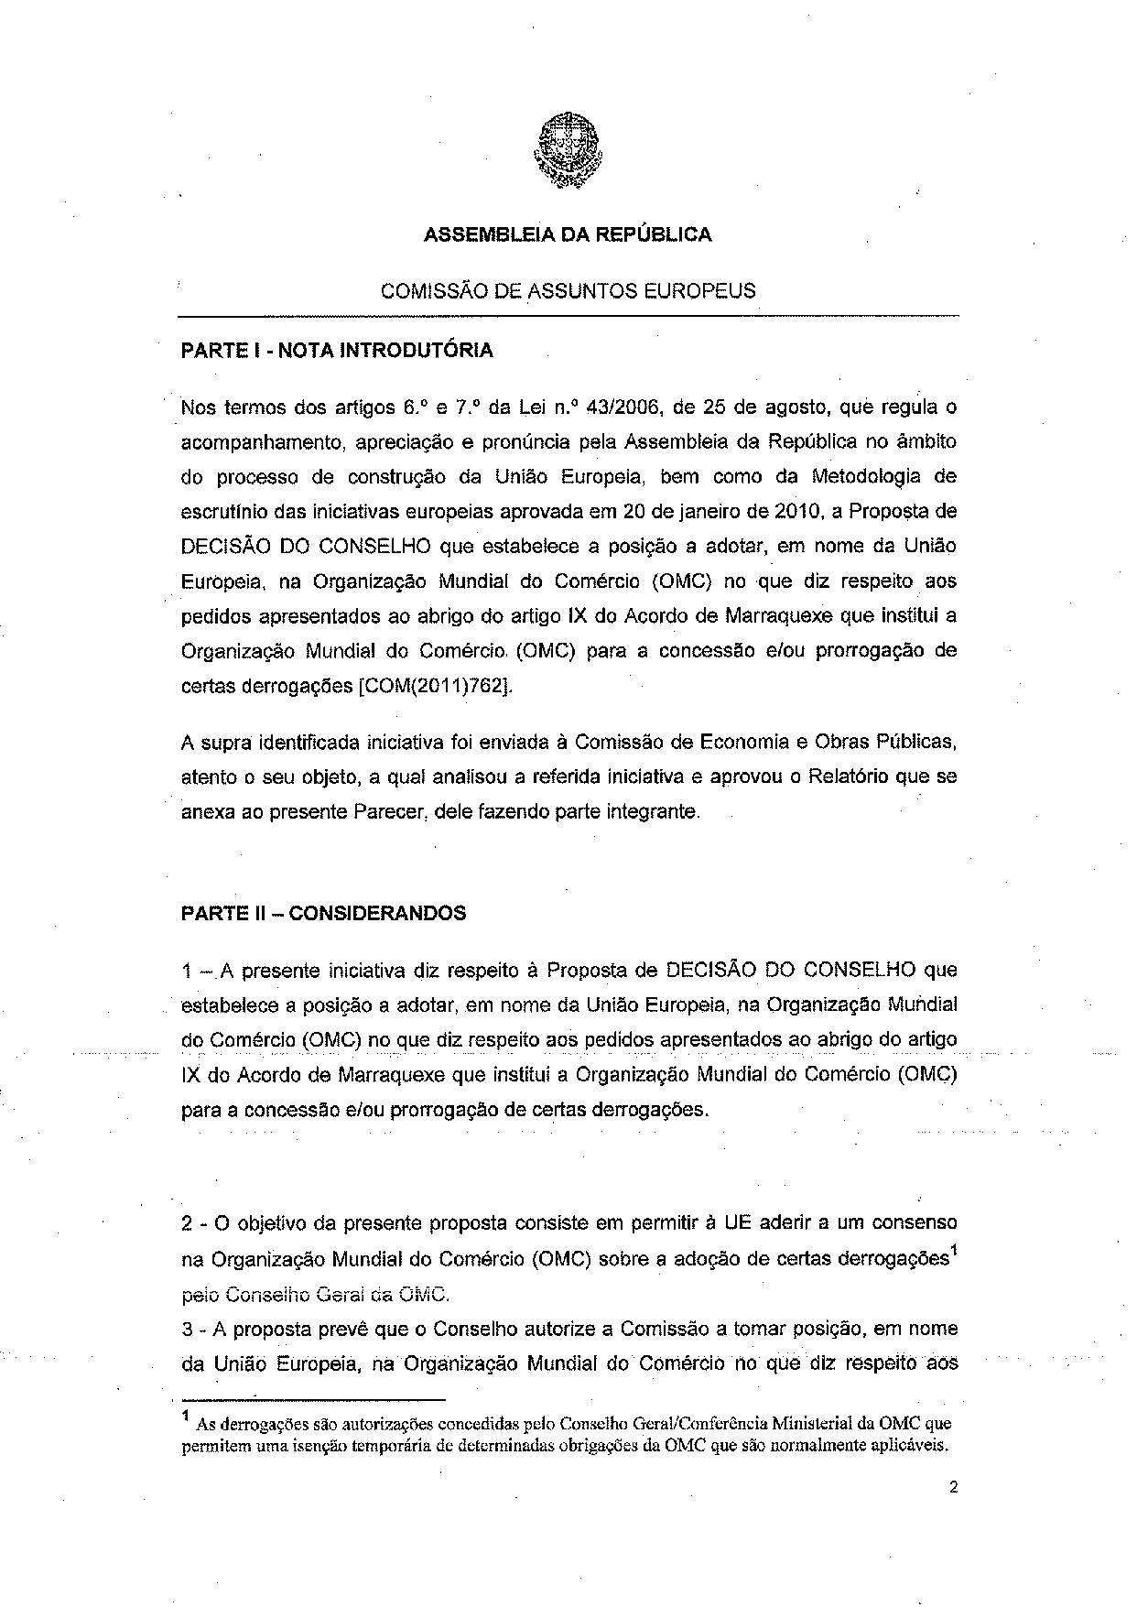
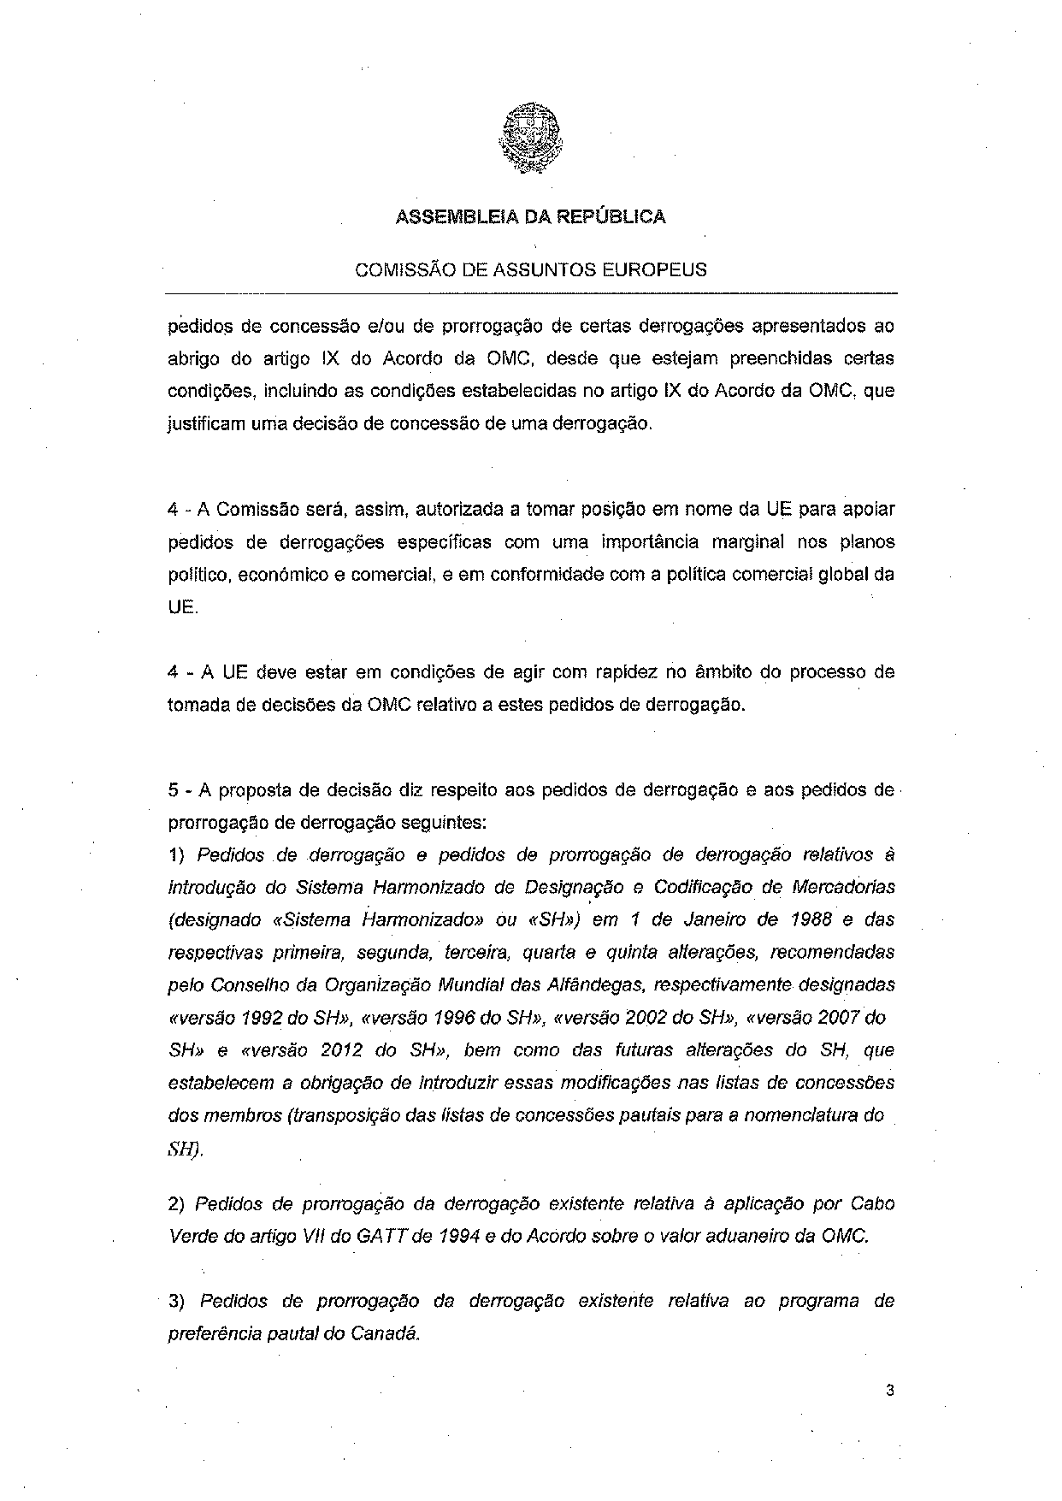
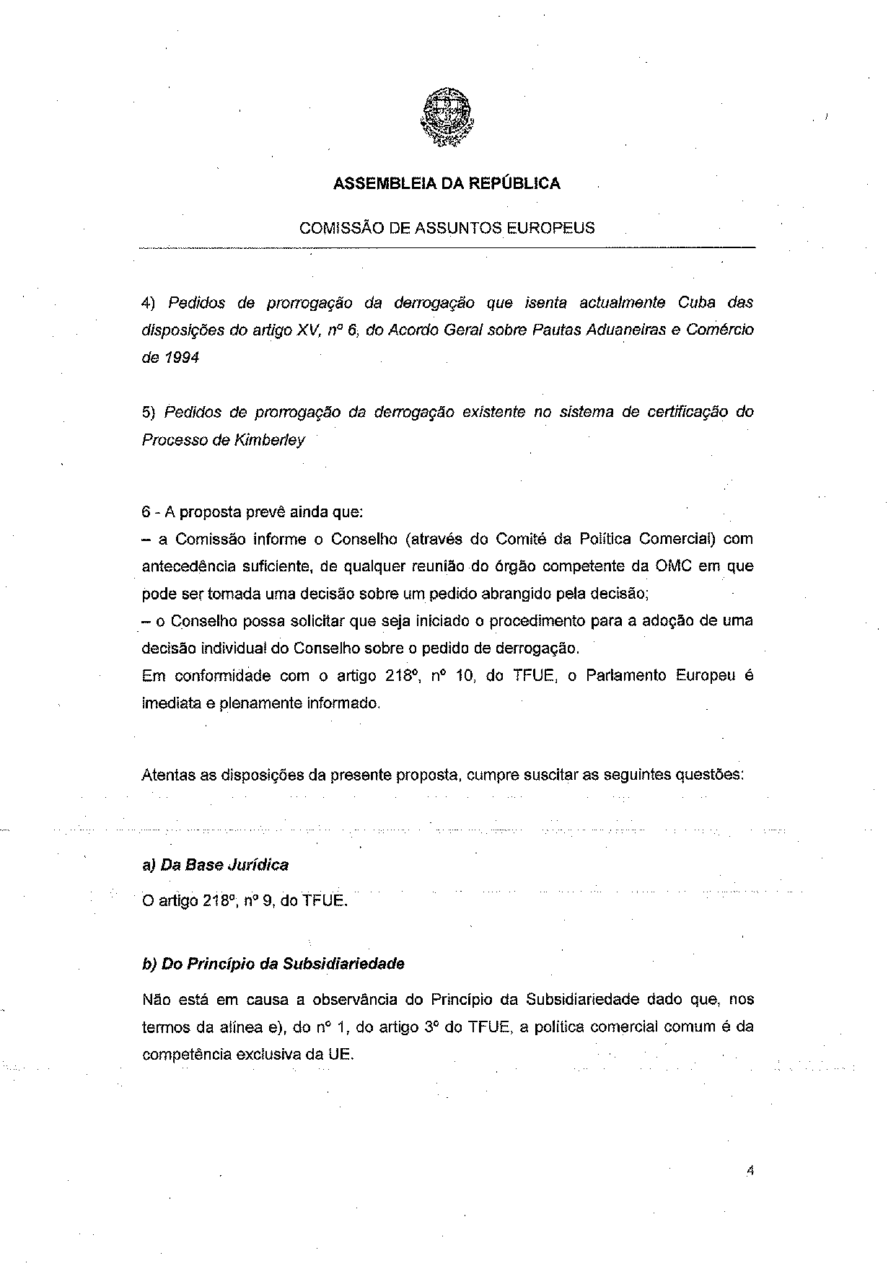
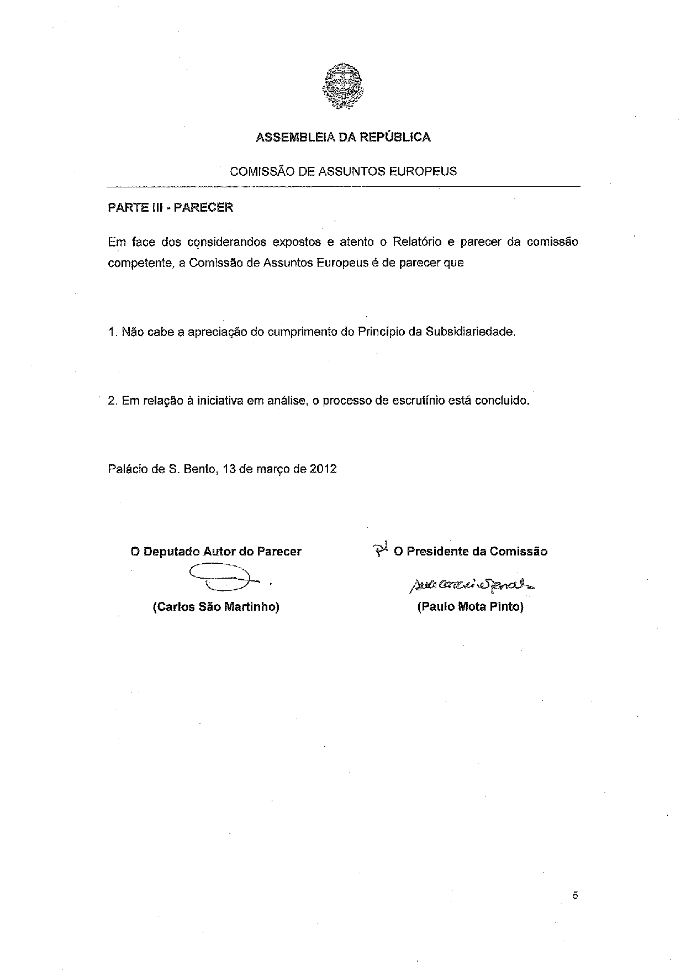
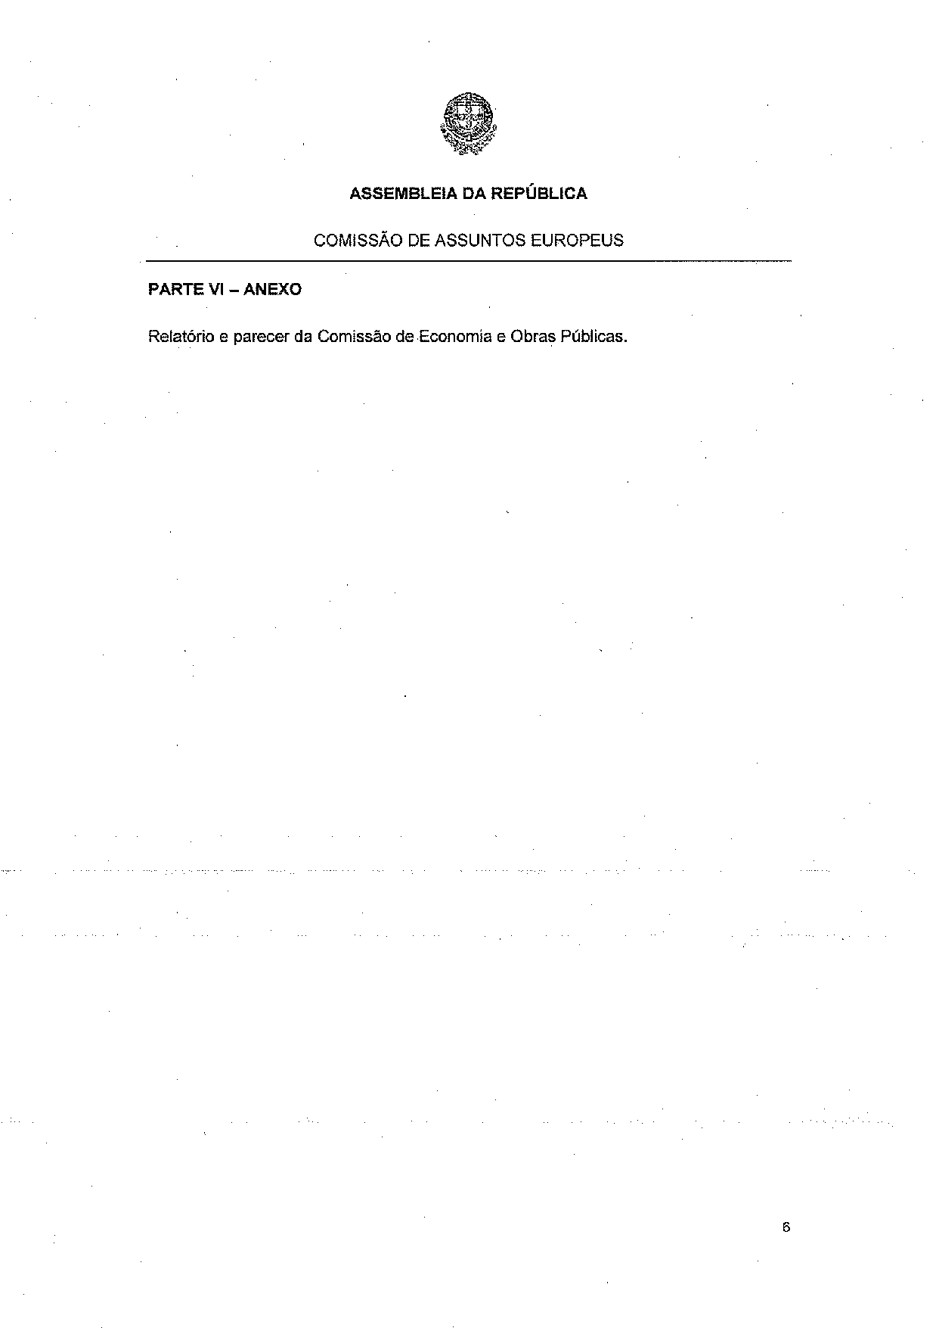
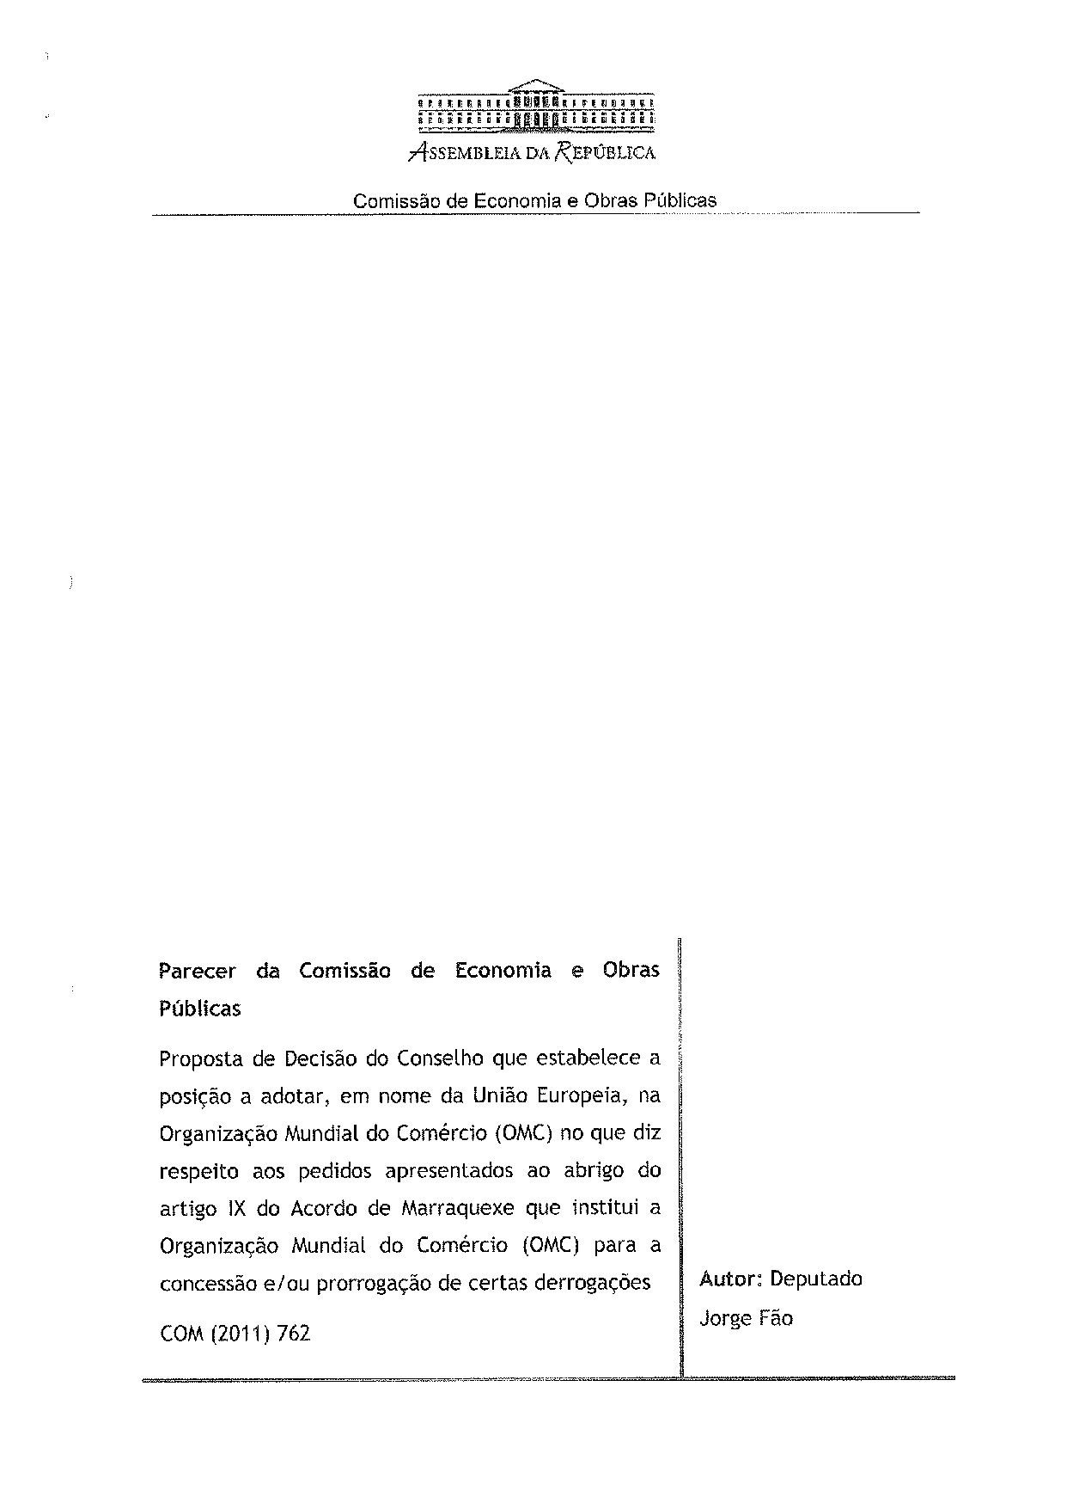
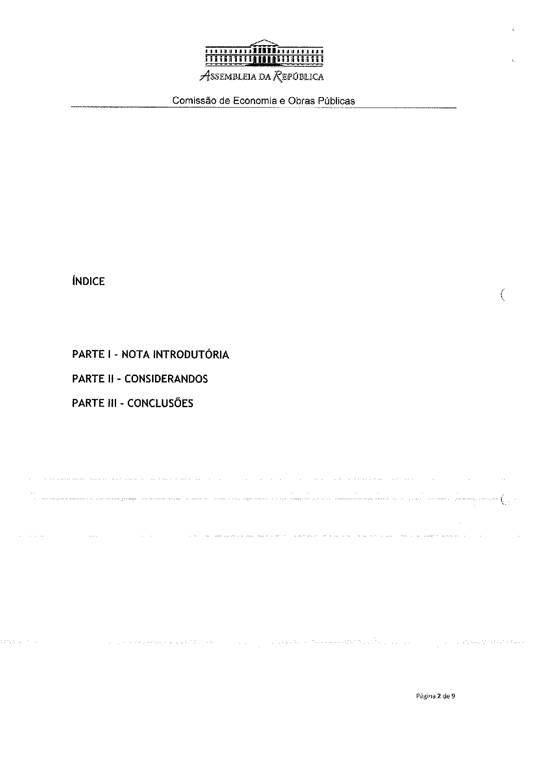
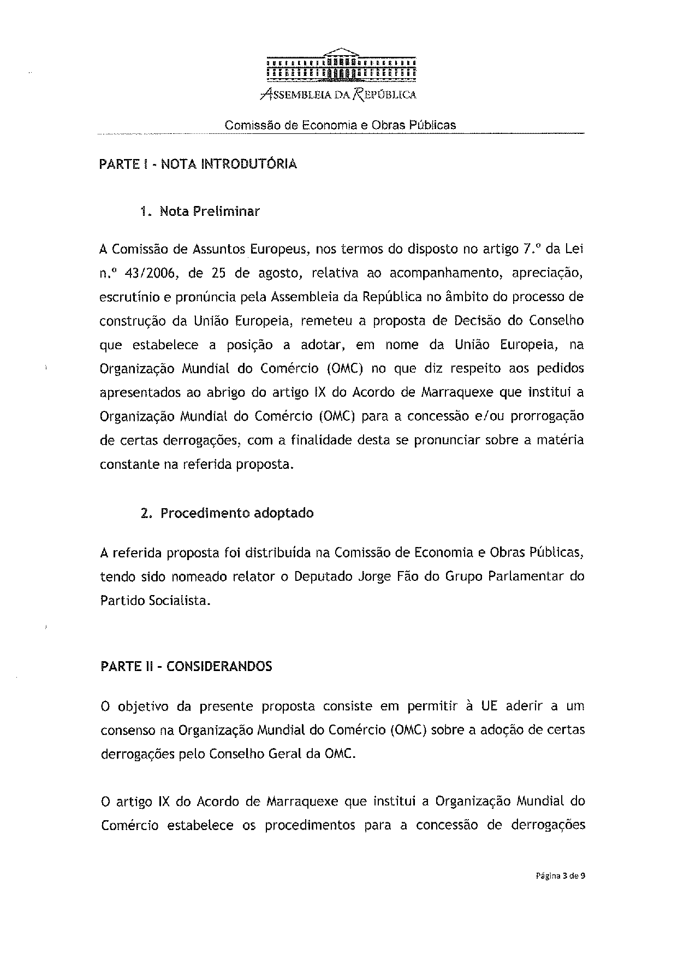
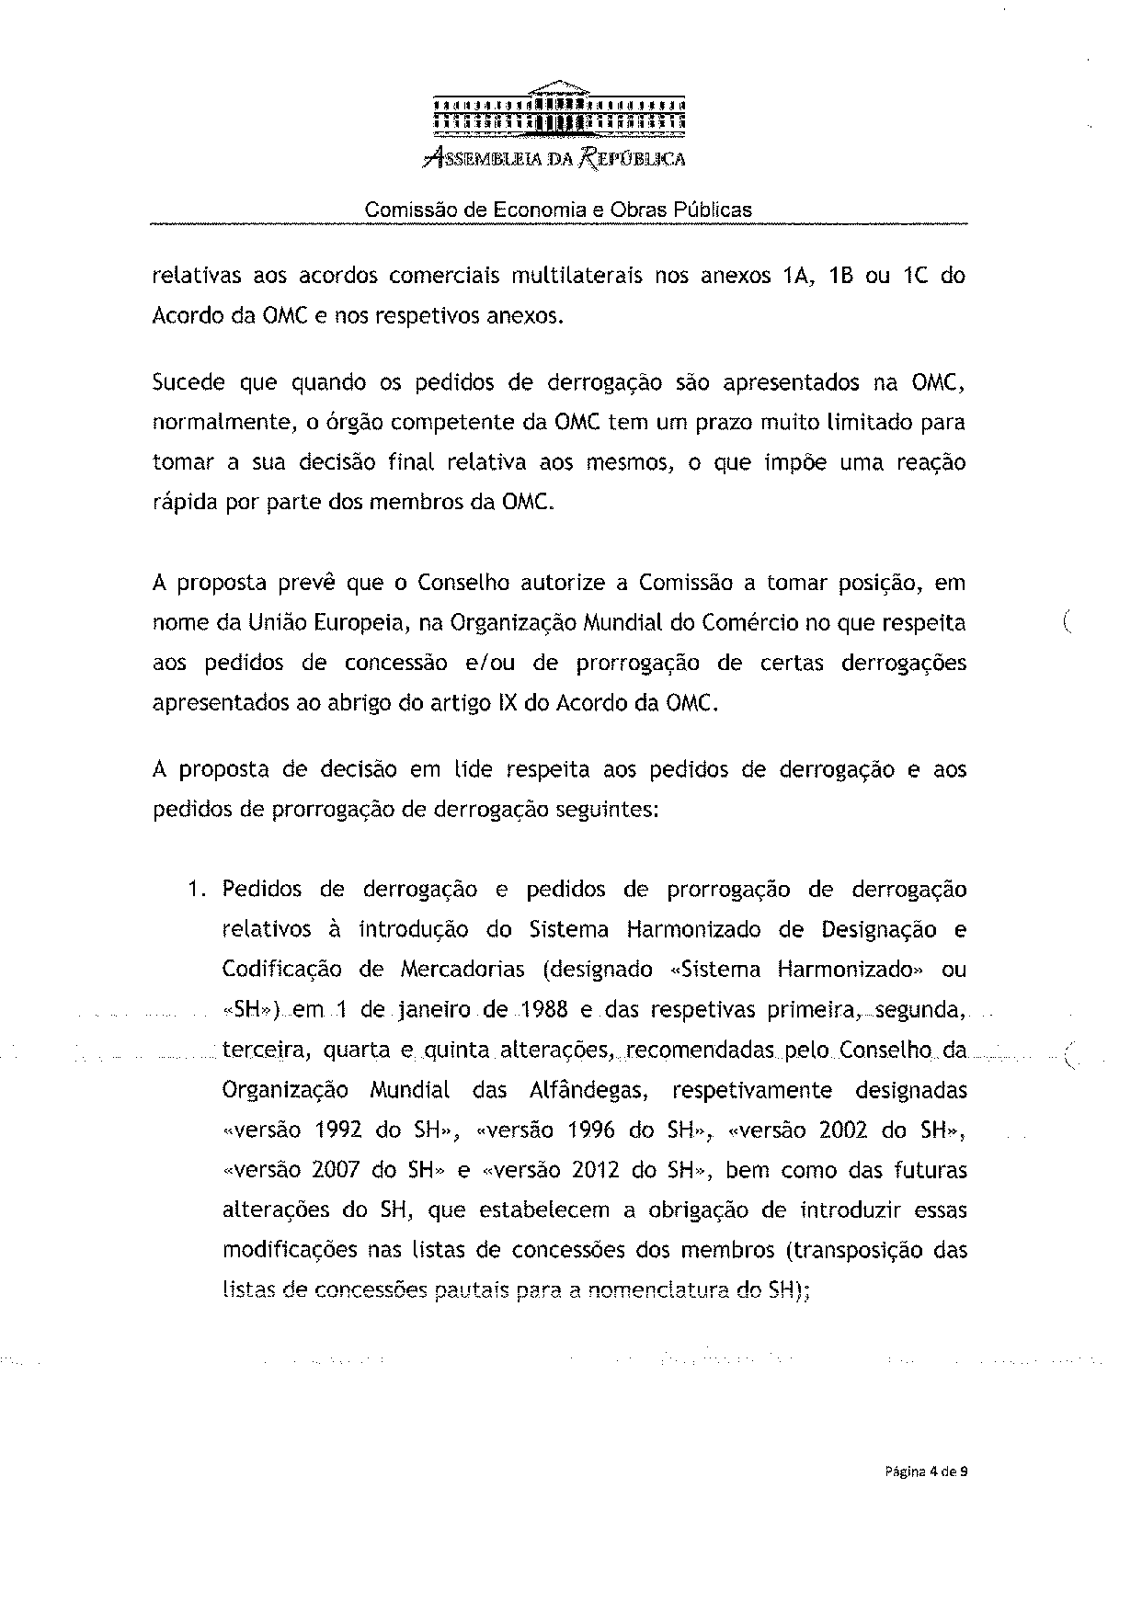
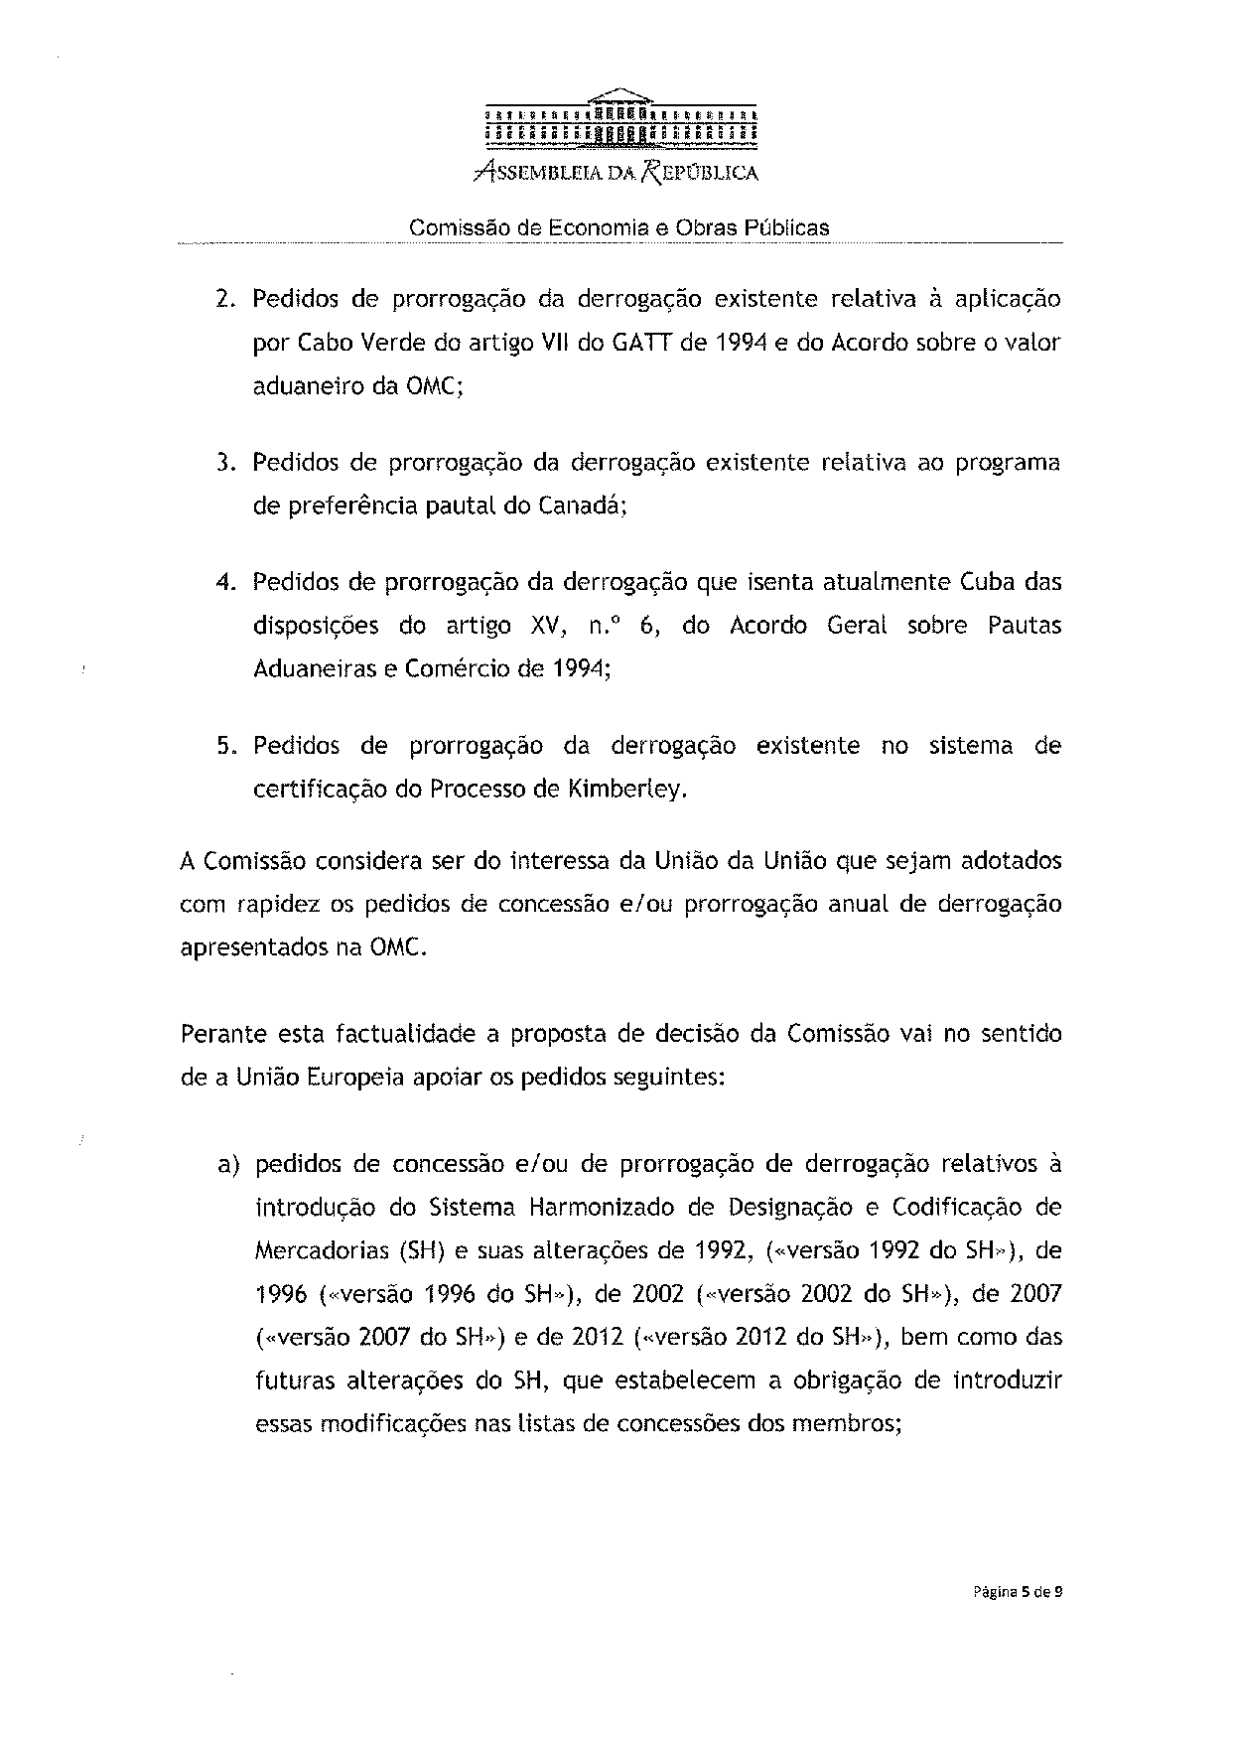
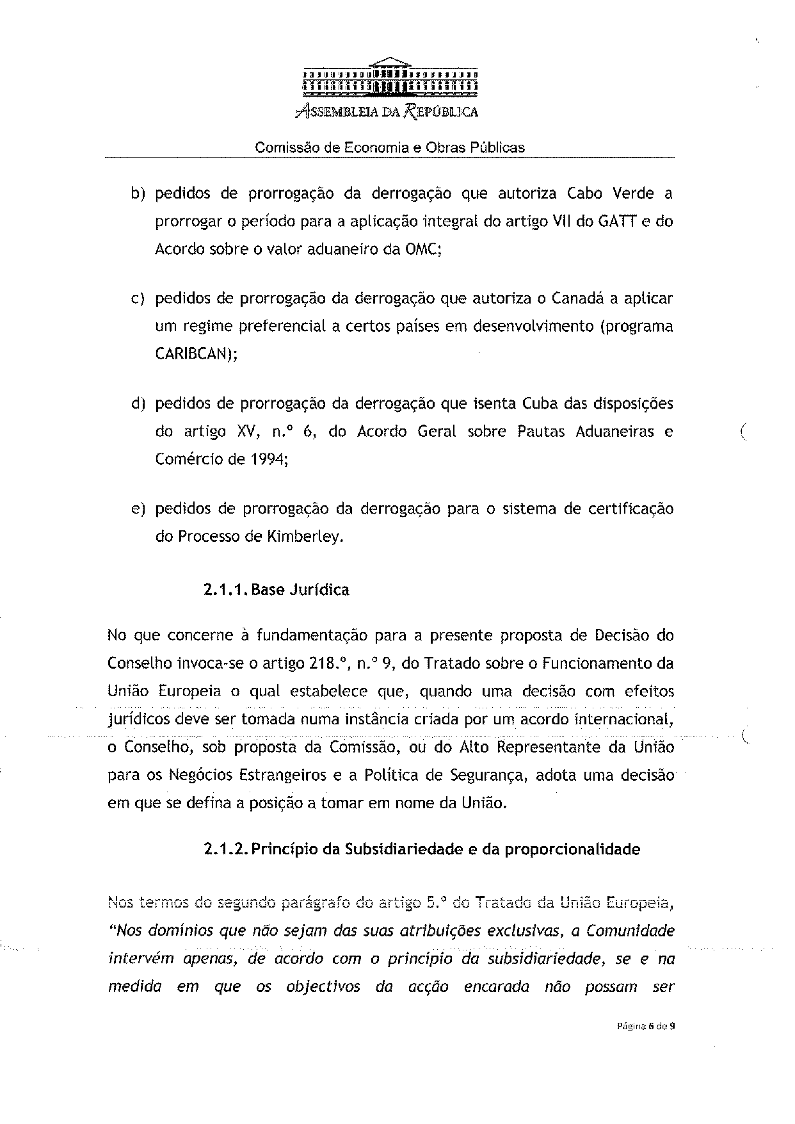
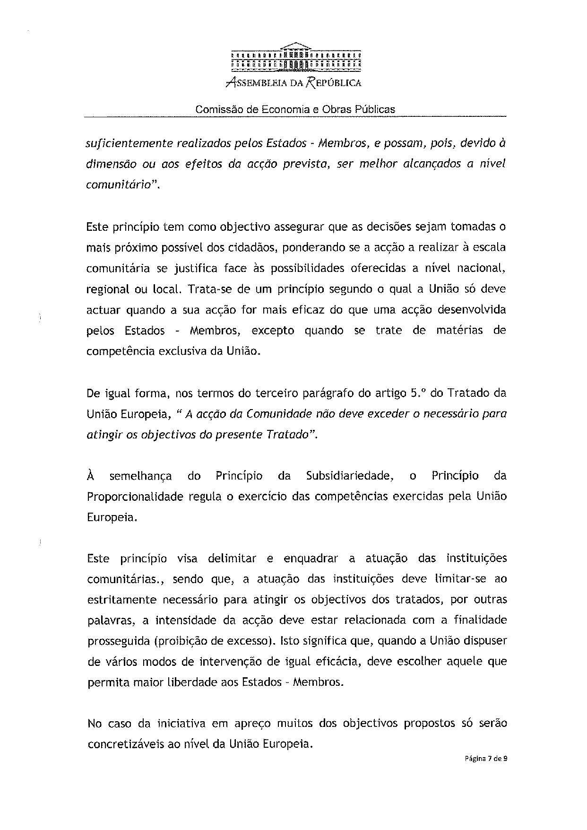
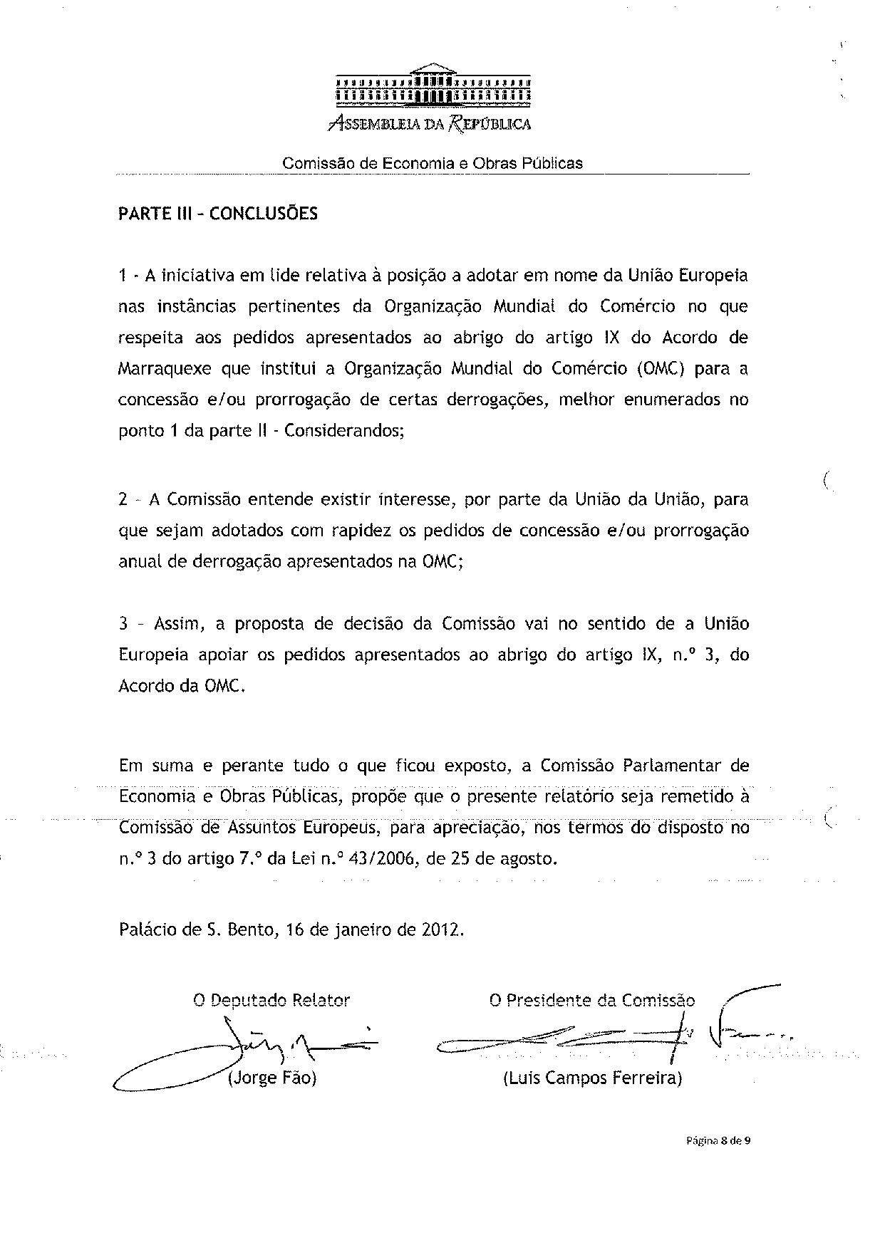

The translation of the opinion may be available at the Interparliamentary EU information exchange site IPEX, at the following address: http://www.ipex.eu/IPEXL-WEB/search.do.

