 | 
COUNCIL OF  THE EUROPEAN UNION |  |  | Brussels, 16 March 2012
 | Interinstitutional File:  2011/0330 (CNS) |  | 7811/12
FISC 41
INST 222
PARLNAT 163

COVER NOTE
from: | The President of the Italian Senate
date of receipt: | 16 March 2012
to: | The President of the Council of the European Union
Subject: | Proposal for a Council Regulation on Administrative Cooperation in the field of excise duties  [doc. 16975/11 FISC 142 - COM(2011) 730 final]  - Opinion on the application of the Principles of Subsidiarity and Proportionality

Delegations will find attached the abovementioned opinion.

________________________

Encl.

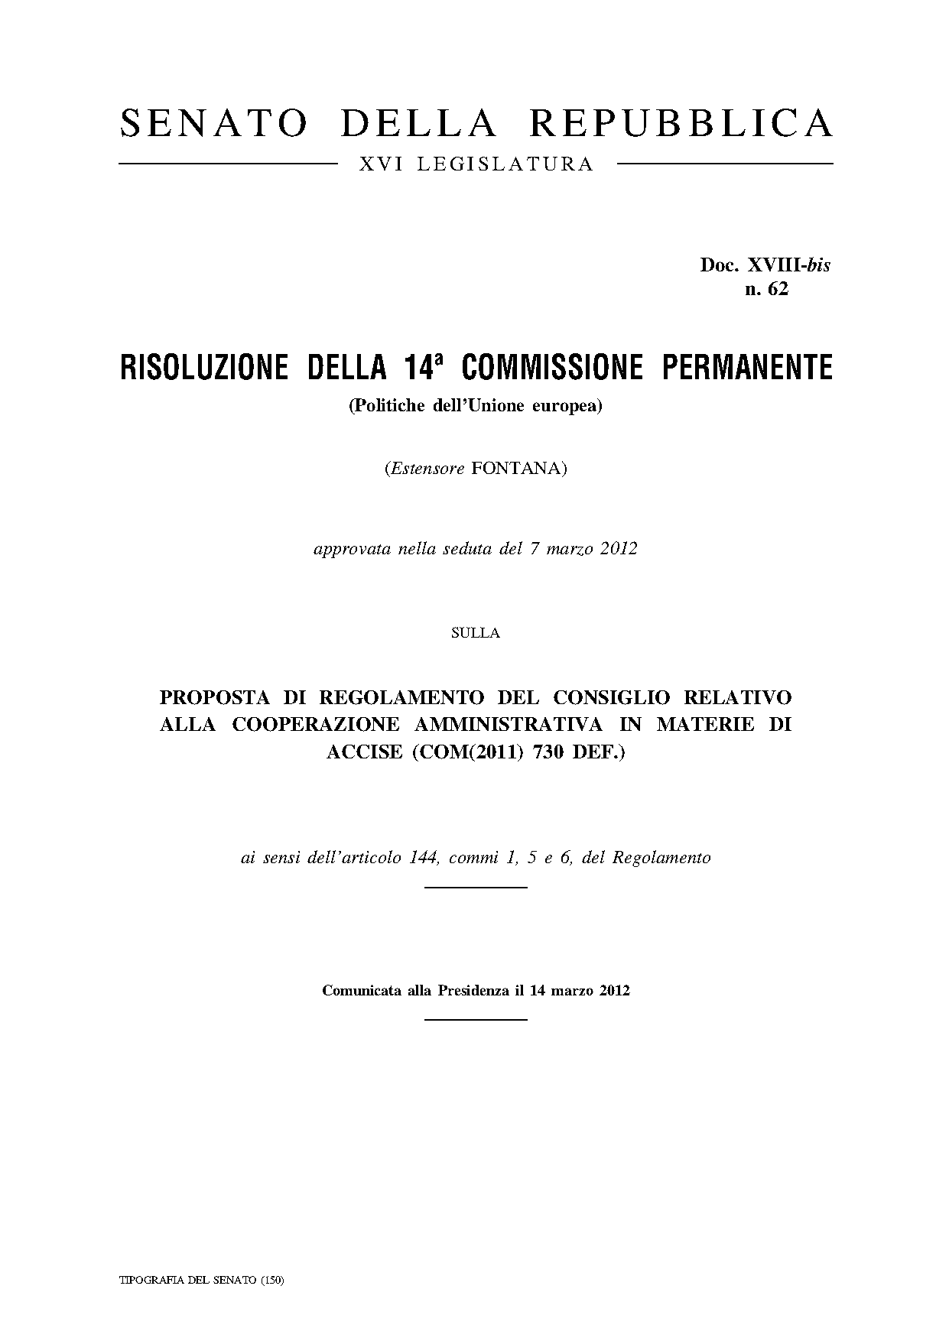

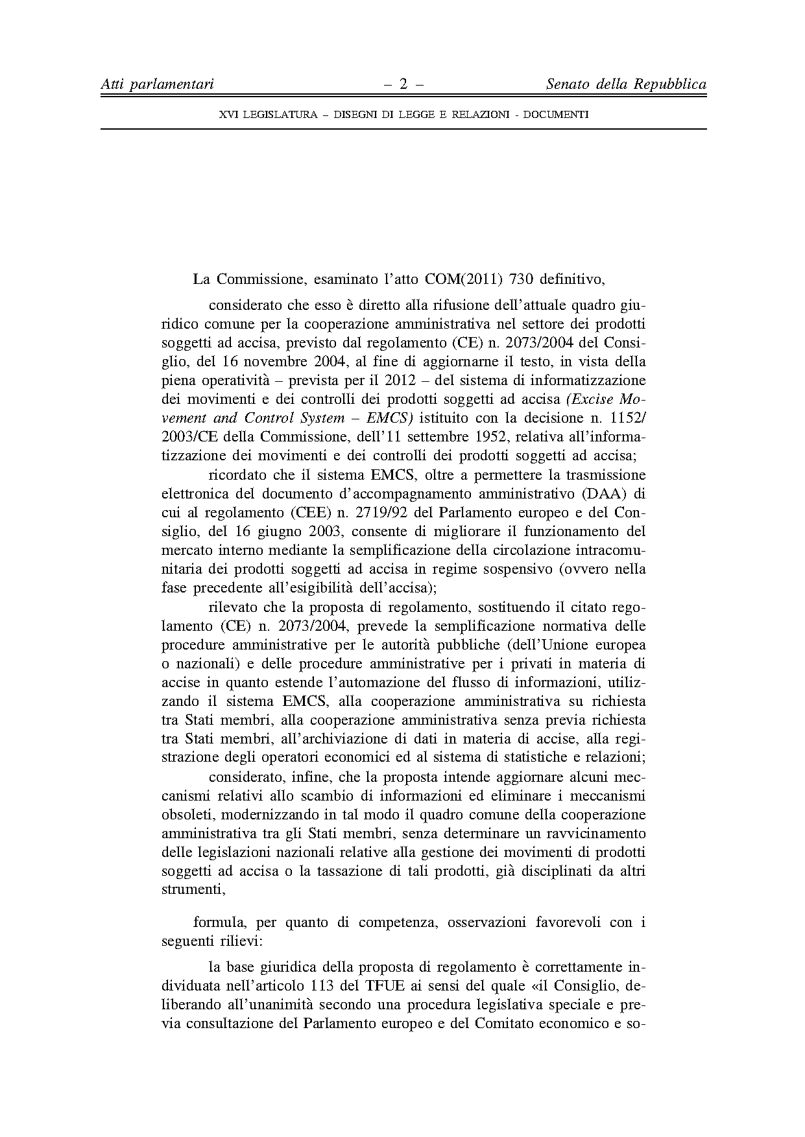

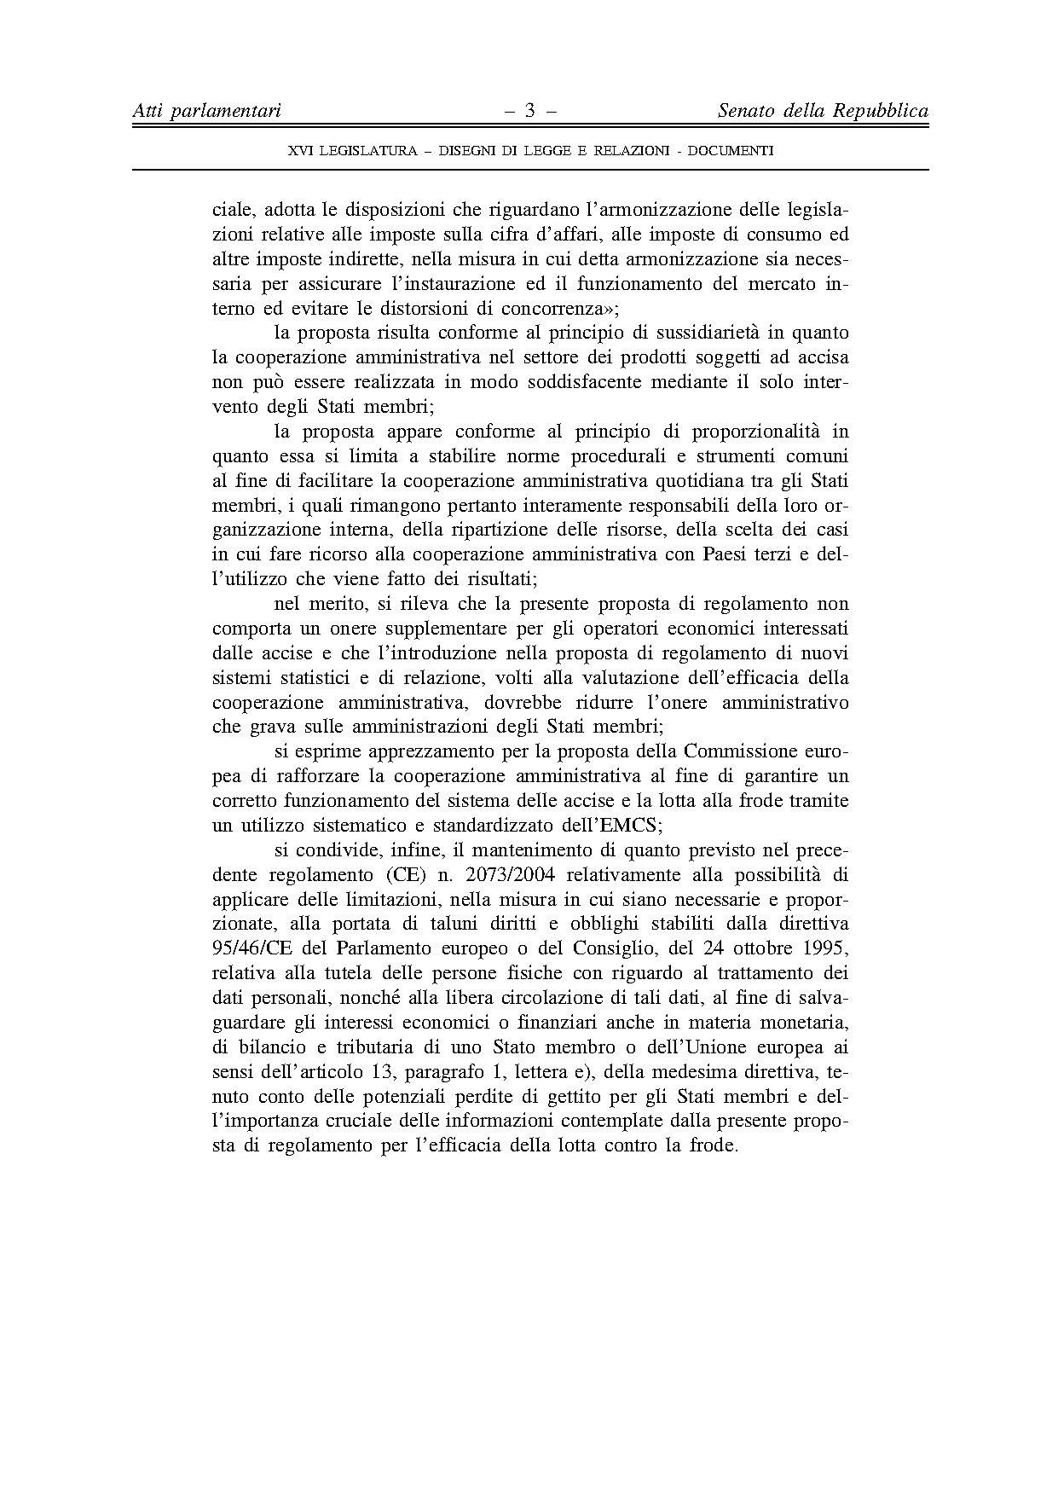

This opinion is available in English on the Interparliamentary EU information exchange site (IPEX) at the following address: http://www.ipex.eu/IPEXL-WEB/search.do

