COMMISSION STAFF WORKING DOCUMENT
IMPACT ASSESSMENT
Accompanying the document
Proposal for a
DIRECTIVE OF THE EUROPEAN PARLIAMENT AND OF THE COUNCIL
amending Directive 2006/66/EC on batteries and accumulators and waste batteries and accumulators as regards the placing on the market of portable batteries and accumulators containing cadmium intended for use in cordless power tools

Disclaimer
This report commits only the Commission's services involved in its preparation and does not prejudge the final form of any decision to be taken by the Commission.

ANNEX

Annex 16: Sensitivity analysis on collection rate 4
Annex 17: Sensitivity analysis on batteries lifespan 17
Annex 18: Sensitivity analysis on emissions of metals 27
Annex 19: Battery sales and separate collection of NiCd batteries in Germany 36
Annex 20: Environmental impacts related to the relevant battery technologies 38
Annex 21: Main raw materials used in alternative batteries for CPT 49
Sensitivity analisys on collection rate
1. Scenario definition
The four scenarios studied in this sensitivity analysis are defined as follows:
- The reference scenario corresponds to the collection rate based on cat.6 WEEE collection;
- Scenario A1 corresponds to the collection rate target defined by the batteries directive for 2012;
- Scenario A2 corresponds to the collection rate target defined by the batteries directive for 2016;
- Scenario A3 corresponds to the collection rate derived from Targeted Risk Assessment Report (TRAR).
Corresponding values are presented in the table below.

Table 21: Scenario definition for the sensitivity analysis on collection rate
 | Reference scenario | Scenario A1 | Scenario A2 | Scenario A3
Collection rate | 10% | 25% | 45% | 53%

1.1. Scenarios A1 and A2
As described in the Battery Directive, the targets for waste battery collection by 2012 and 2016 are 25% and 45% respectively.
The collection rate of the battery directive corresponds to a waste-to-sales approach: more precisely, it is defined as the ratio of the collected quantities at a given calendar year by the average sales during that calendar year and the two preceding calendar years.
The two target values are selected for scenarios A1 and A2. The use of these collection rates for the LCA has some limitations: the Batteries Directive is not specific to batteries used in CPTs, and it concerns secondary as well as primary batteries. However, it gives a complementary perspective on the definition of the collection rate.
1.2. Calculation of the collection rate for scenario A3
As previously presented, the waste-to-waste approach is an alternative approach for calculating the collection rate. The TRAR provides quantities of cadmium incorporated in NiCd portable batteries (not only in CPTs, that is) in different waste flows at EU16+Switzerland level in 2002, as shown in Figure 21.
Then, the collection rate of NiCd portable batteries, based on the cadmium content only, can be calculated with a waste-to-waste approach as follows:

Finally, we have to assume that this collection rate, valid for NiCd portable batteries, also applies for CPTs specifically.

Figure 21: Portable Ni-Cd batteries mass balance (EU16 + Switzerland, 2002) (Cadmium content)
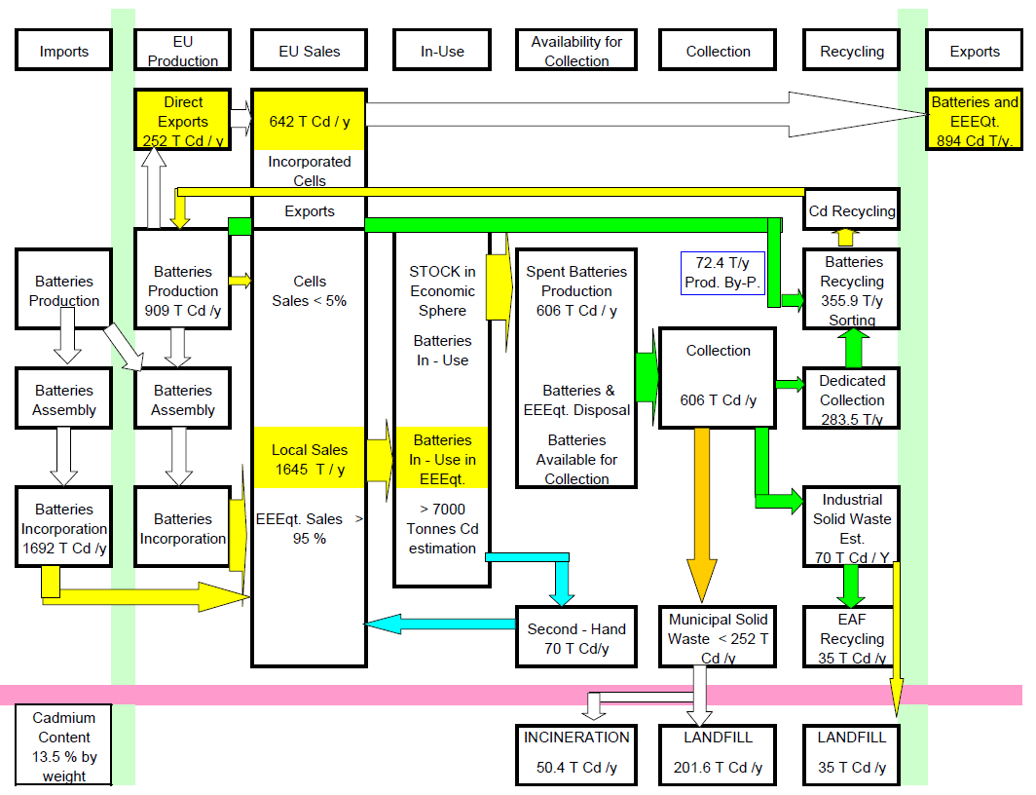

2. Results
The following figures present the relative impacts for each scenario. For each indicator, the reference (100%) corresponds to the total impact of NiCd battery for the reference scenario.
A first set of indicators is presented, which are not significantly sensitive to a variation of the collection rate, in the sense that the ranking of the batteries is not modified by an increase or decrease in the collection rate.
Figure 22: Sensitivity analysis on collection rate – results for Global Warming Potential
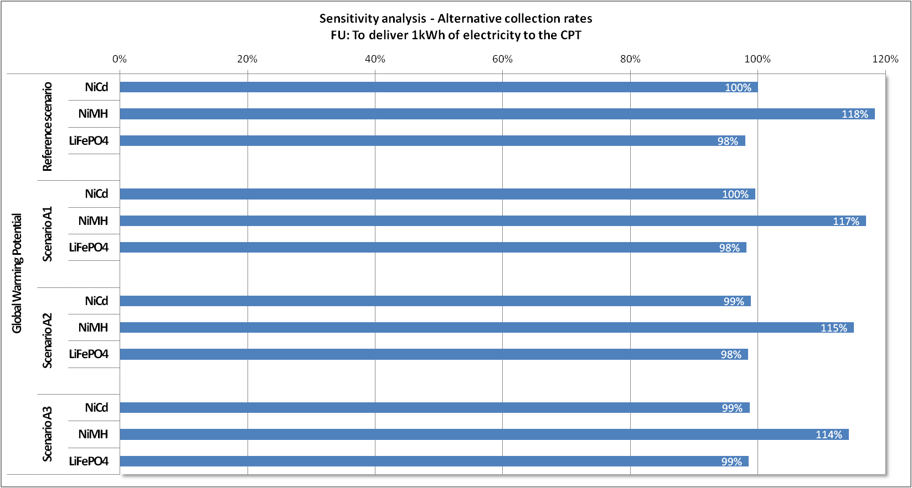
Figure 23: Sensitivity analysis on collection rate – results for Cumulative Energy Demand
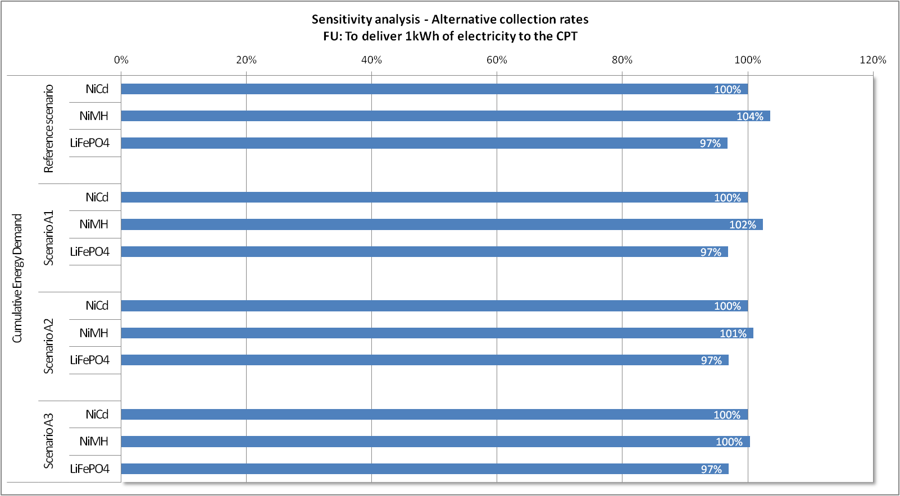
Figure 24: Sensitivity analysis on collection rate – results for Metal Depletion Potential
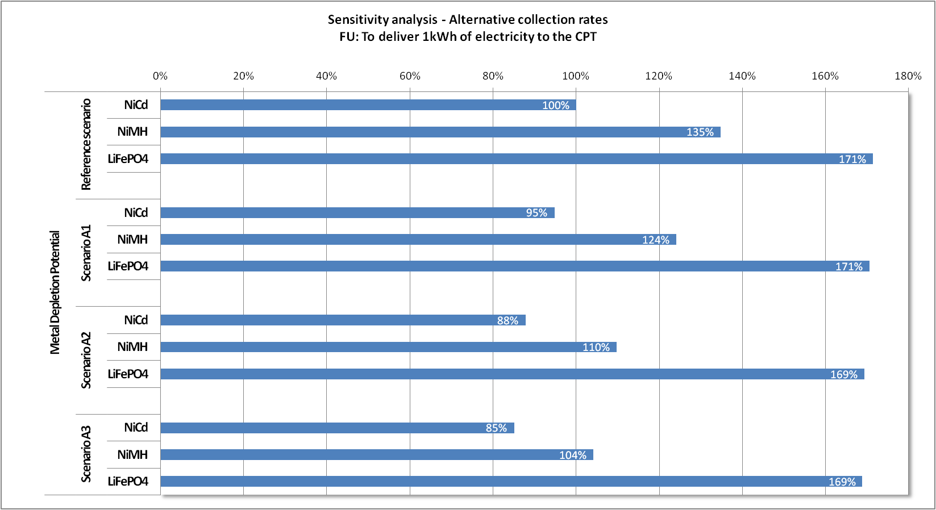
Figure 25: Sensitivity analysis on collection rate – results for Freshwater Eutrophication Potential
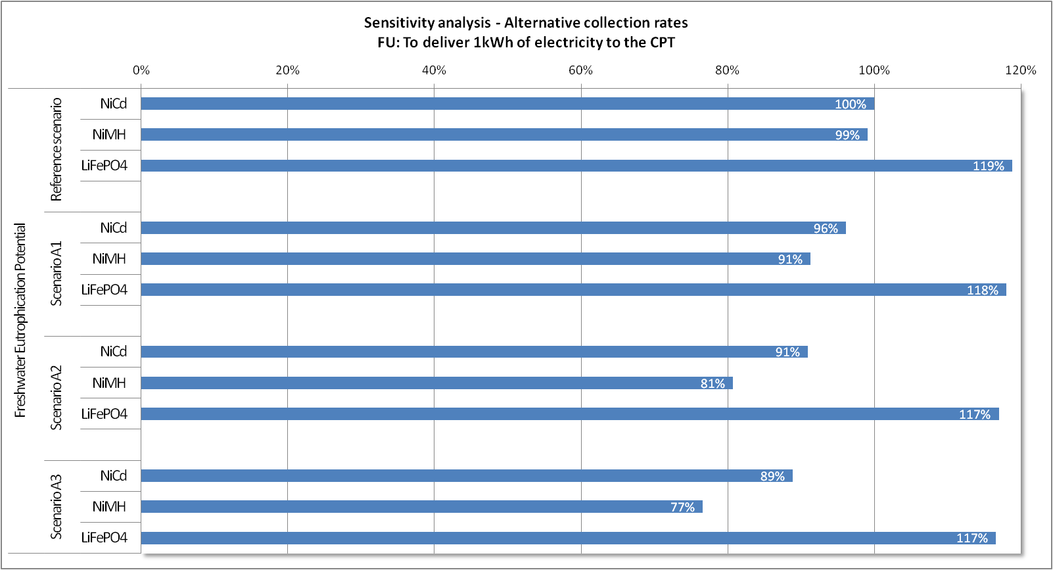

Figure 26: Sensitivity analysis on collection rate – results for toxicity indicators without LT emissions
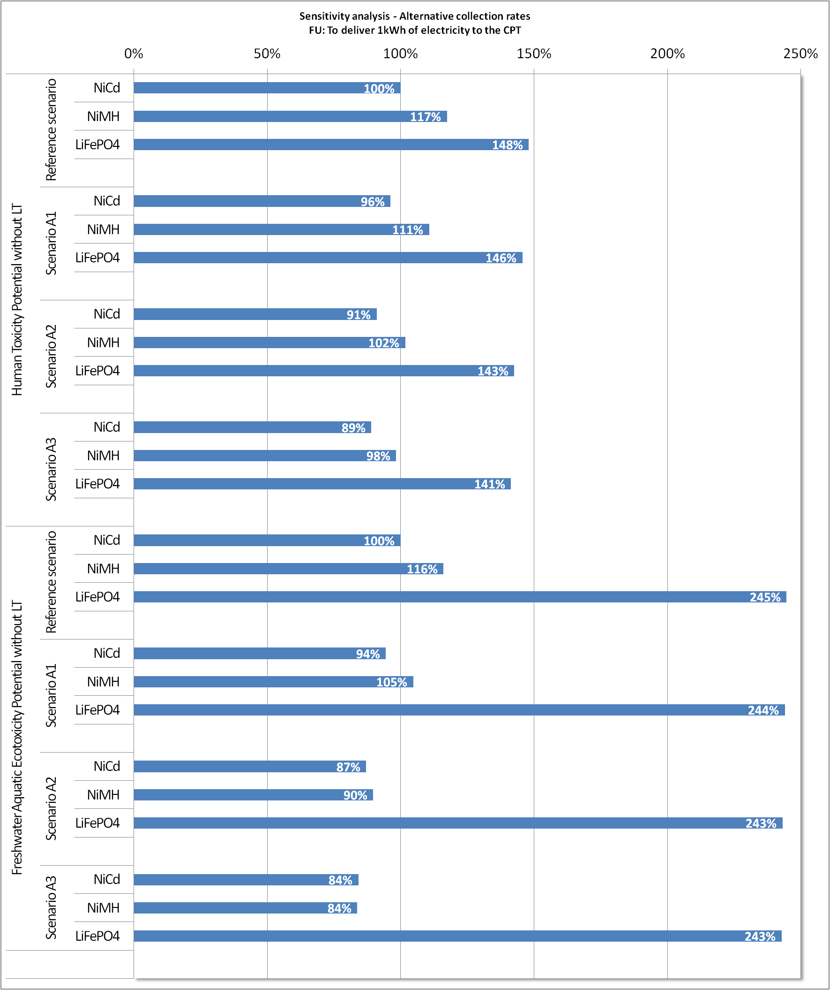

These indicators show low sensitivity to a variation of the collection rate:
- Global Warming Potential and Cumulative Energy Demand: for the three battery technologies, the main contributor for those impacts is the use phase, which is independent of the collection rate.
- Metal Depletion Potential: higher collection rates do lead to some impact reductions (due to a higher quantity of recovered metal from the recycling of the cells). However, as electronic components in the charger (and in the pack, for LiFePO4) are the main contributor to this impact, and not the cells, the benefits of the cells’ recycling are partly hidden.
- Freshwater Eutrophication: the increase of the collection rate does not influence the impact of LiFePO4 battery, while it generates limited reductions for NiCd and NiMH batteries. The ranking of the batteries does not change if the collection rate increases. However, a lower collection rate tends to even the impacts of the three batteries.
- Human toxicity and freshwater aquatic ecotoxicity potentials without long-term emissions: these indicators show low sensitivity to the variation of the collection rate. Indeed, long-term emissions essentially occur in landfills, while short-term emissions are essentially generated during production stages and during the use phase (electricity consumption). The impacts of these life-cycle stages are independent of the collection rate.

Figure 27: Sensitivity analysis on collection rate – results for Abiotic Resource Depletion Potential
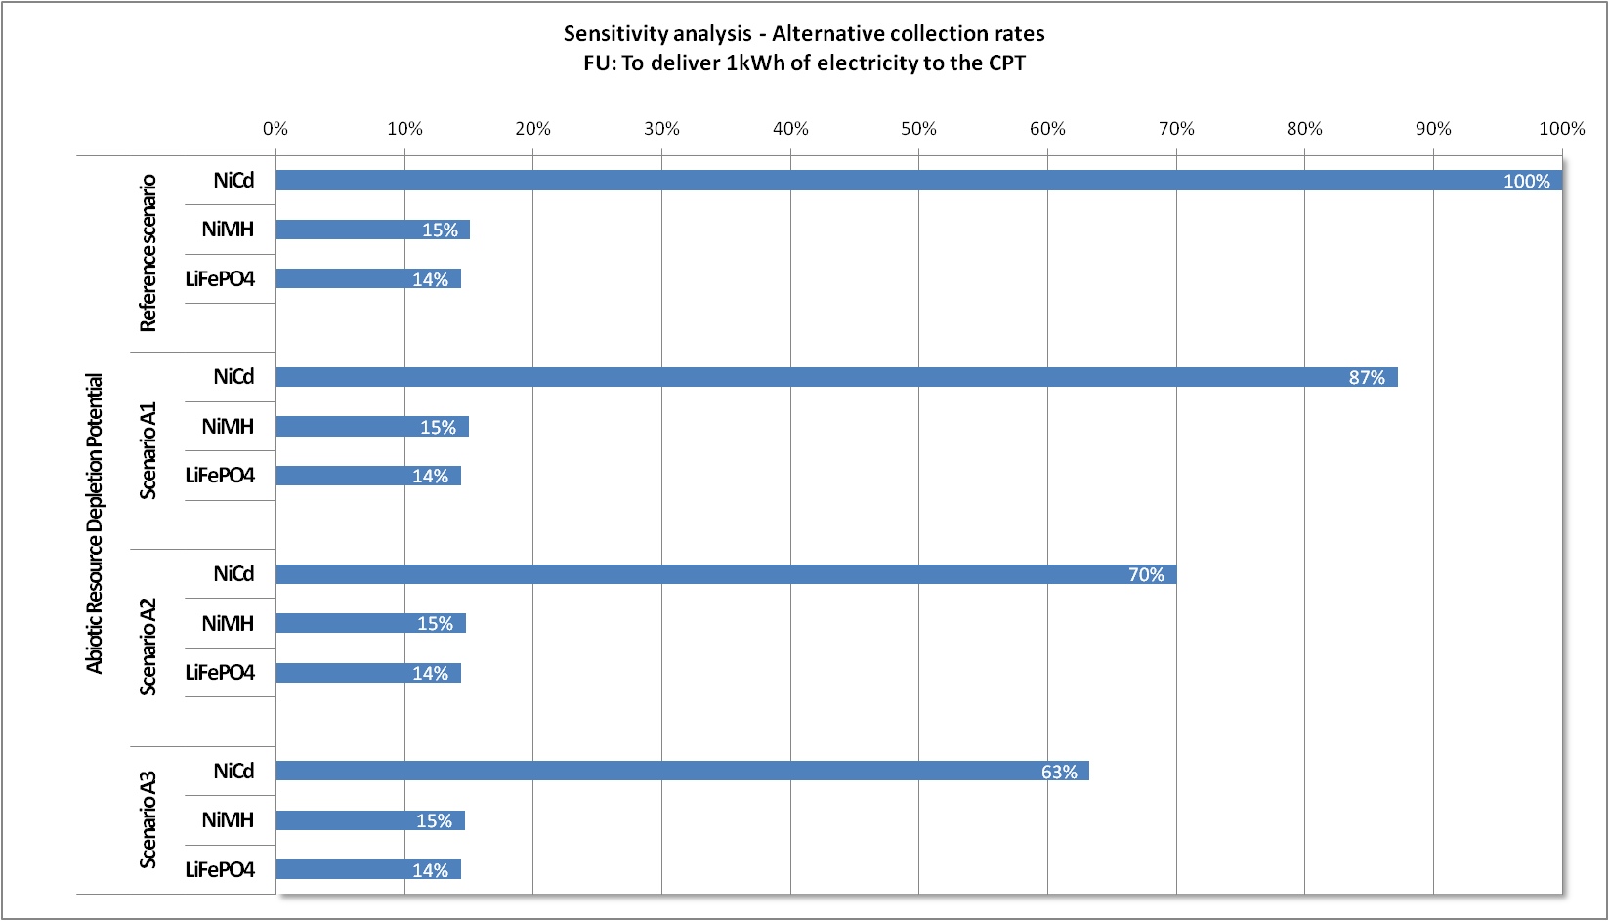

The impact of NiCd battery on Abiotic Resource Depletion reduces significantly with an increase in the collection rate, because an increased collection rate leads to higher quantities of recovered cadmium, which is the main contributor to this impact.
For LiFePO₄ and NiMH, this indicator shows low sensitivity to the variation of the collection rate, because most of the impact for these two batteries comes from the use phase, the impact of which is independent of the collection rate. However, the ranking of the batteries does not change when the collection goes from 10% to 53%.

Figure 28: Sensitivity analysis on collection rate – results for Photochemical Oxidant Formation Potential
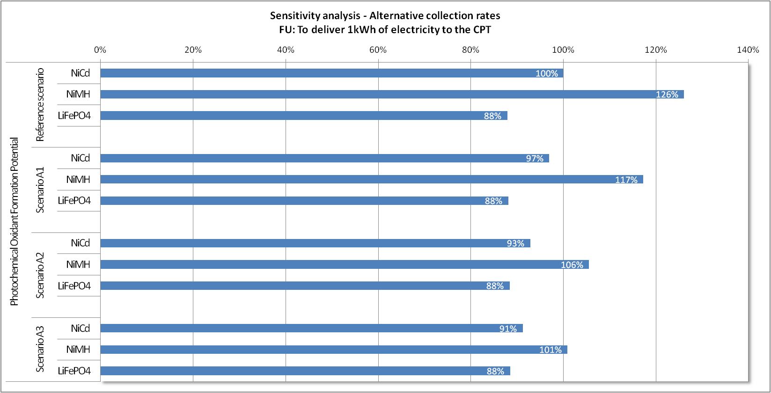

Photochemical Oxidant Formation Potential indicator shows low sensitivity to the collection rate parameter. For the NiCd and LiFePO₄, the main contributor for this impact is the use phase, which is independent of the collection rate. For NiMH, the impact comes mainly from LaNi₅ production, which is also independent of the collection rate.
However, while NiMH is the most impacting battery in the reference scenario, it shows similar impacts as the two others for higher collection rate (scenarios A2 and A3).

Figure 29: Sensitivity analysis on collection rate – results for Particulate Matter Formation Potential
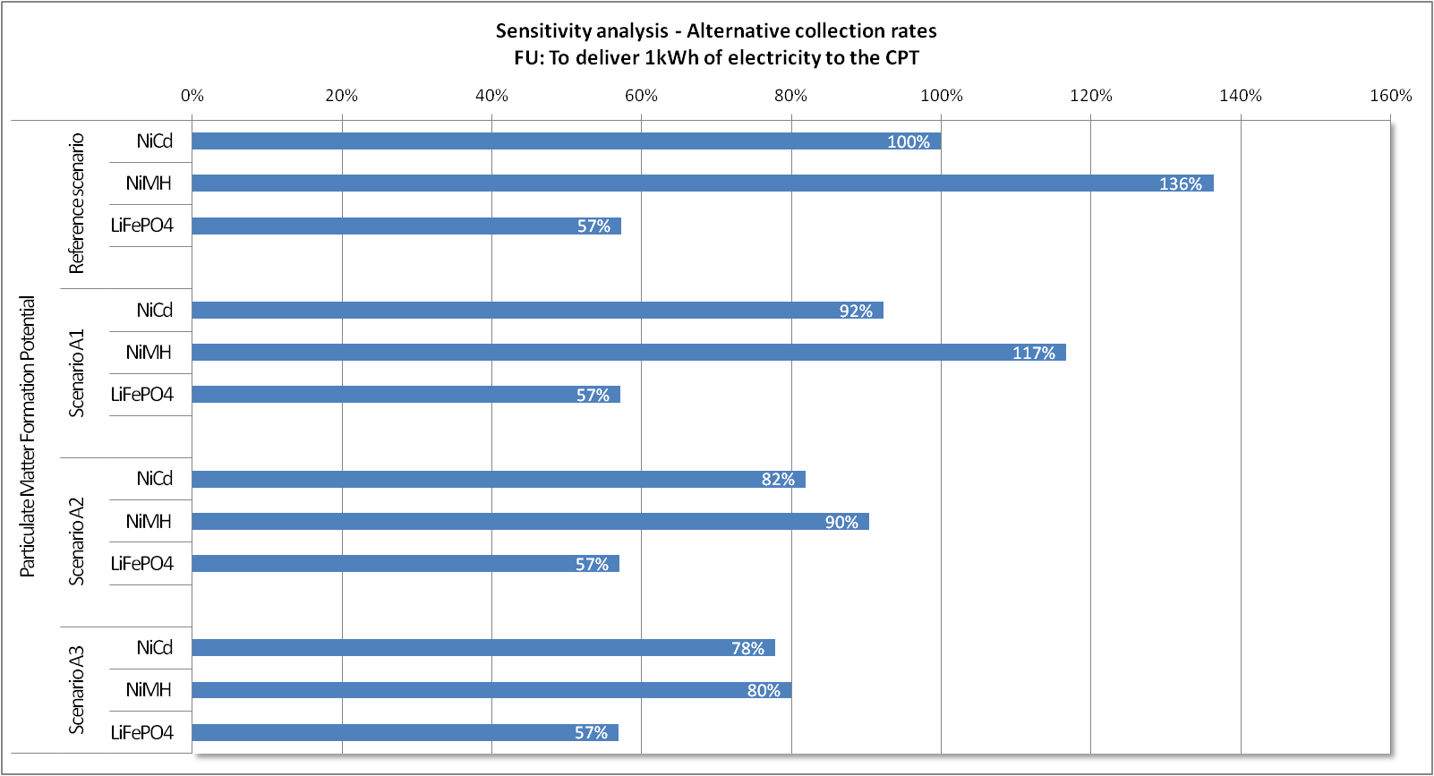

Regarding Particulate Matter Formation Potential, an increase of collection rate generates impact reductions for NiMH, and to a lesser extent for NiCd, due to the avoided nickel production and consequently the avoided emissions of SO₂ to air. LiFePO₄ battery shows no sensitivity on this indicator, because for this technology:
- Impacts are mainly generated during the use phase;
- The production of substances that are recovered here do not have a significant impact (and thus benefit when recycled instead of produced) on this indicator.
While NiMH is the most impact battery in the reference scenario, it shows similar impacts as NiCd for higher collection rates (scenarios A2 and A3).

Figure 30: Sensitivity analysis on collection rate – results for Terrestrial Acidification Potential
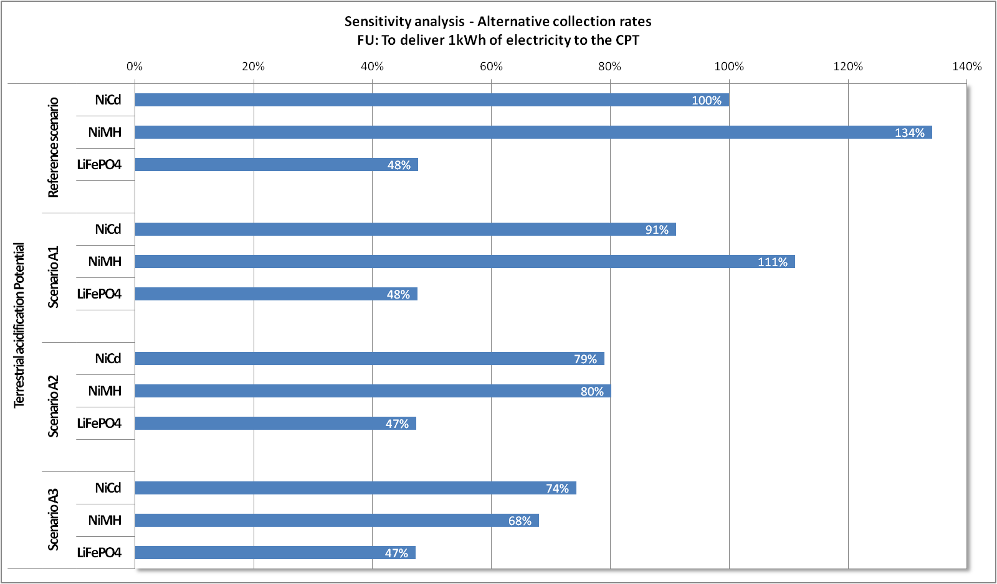
Impacts of NiCd and NiMH batteries on terrestrial acidification reduce significantly when the collection rate increases: this is mainly due to the increased quantity of recovered nickel and thus to an increase in avoided emissions of acid substances. The sensitivity is even higher for NiMH than for NiCd, because of its higher nickel content. The increased collection rate from 25% to 45% and 53% evens the impacts between NiCd and NiMH.
However, LiFePO₄ impact on terrestrial acidification shows low sensitivity to the variation of the collection rate, because for this technology:
- Impacts are mainly generated during the use phase ;
- Recovered substances during recycling do not have a significant impact (and thus benefit) on this indicator.
While NiMH is the most impacting battery in the reference scenario, it shows similar impacts as NiCd for higher collection rates (scenarios A2 and A3).

Figure 31: Sensitivity analysis on collection rate – results for toxicity indicators with long-term emissions
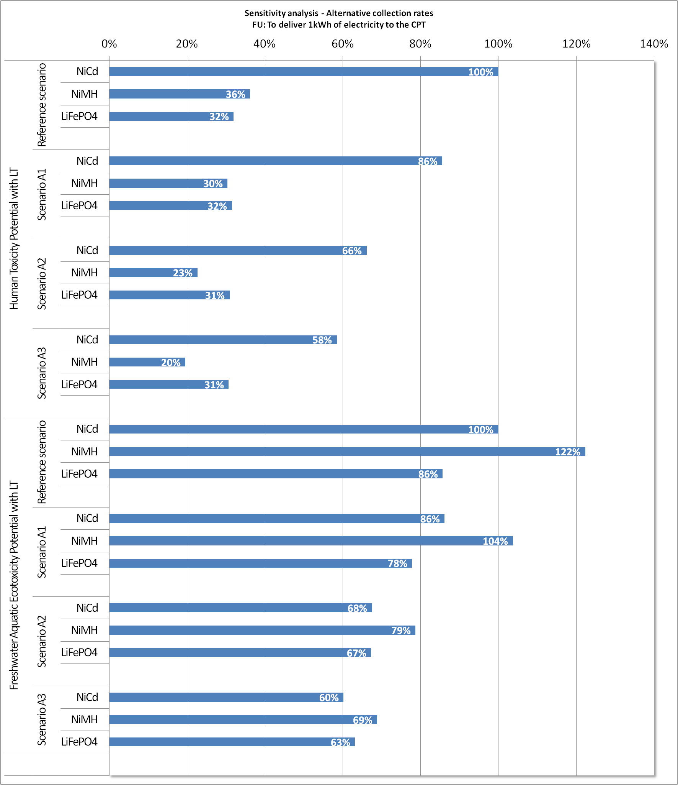

Human Toxicity Potential – with long-term emissions
For these indicators, NiCd and NiMH batteries have lower impacts for higher collection rates. This is due to the fact that an increased collection rate reduces the amount of batteries put in landfill, and thus the emissions of metals to groundwater. For Scenario A3 (53% collection rate), NiCd battery is still the most impacting battery type, but the differences with the two other types are significantly reduced. LiFePO₄ battery is not sensitive to the variation of the collection rate, because for this technology, the impact is generated at production stages (cells and charger), on which the collection rate has no influence.
The ranking of the batteries does not change with a variation of the collection rate.
Freshwater Aquatic Ecotoxicity Potential - with long-term emissions
An increase in the collection rate tends to reduce the differences between batteries. This is due to the fact that an increased collection rate reduces the amount of batteries put in landfill, and thus the potential emissions of metals to groundwater. The reduction is higher for NiMH, for which the nickel content is higher and thus the avoided emissions more important.
While NiMH is the most impacting technology in the reference scenario, it shows similar impacts as the two other battery types for higher collection rates (scenarios A2 and A3).
We now consider the intermediate situation where only 5% of the metallic content of the batteries are eventually released in the environment:

Figure 32: Sensitivity analysis on collection rate – results for toxicity indicators with 5% long-term emissions
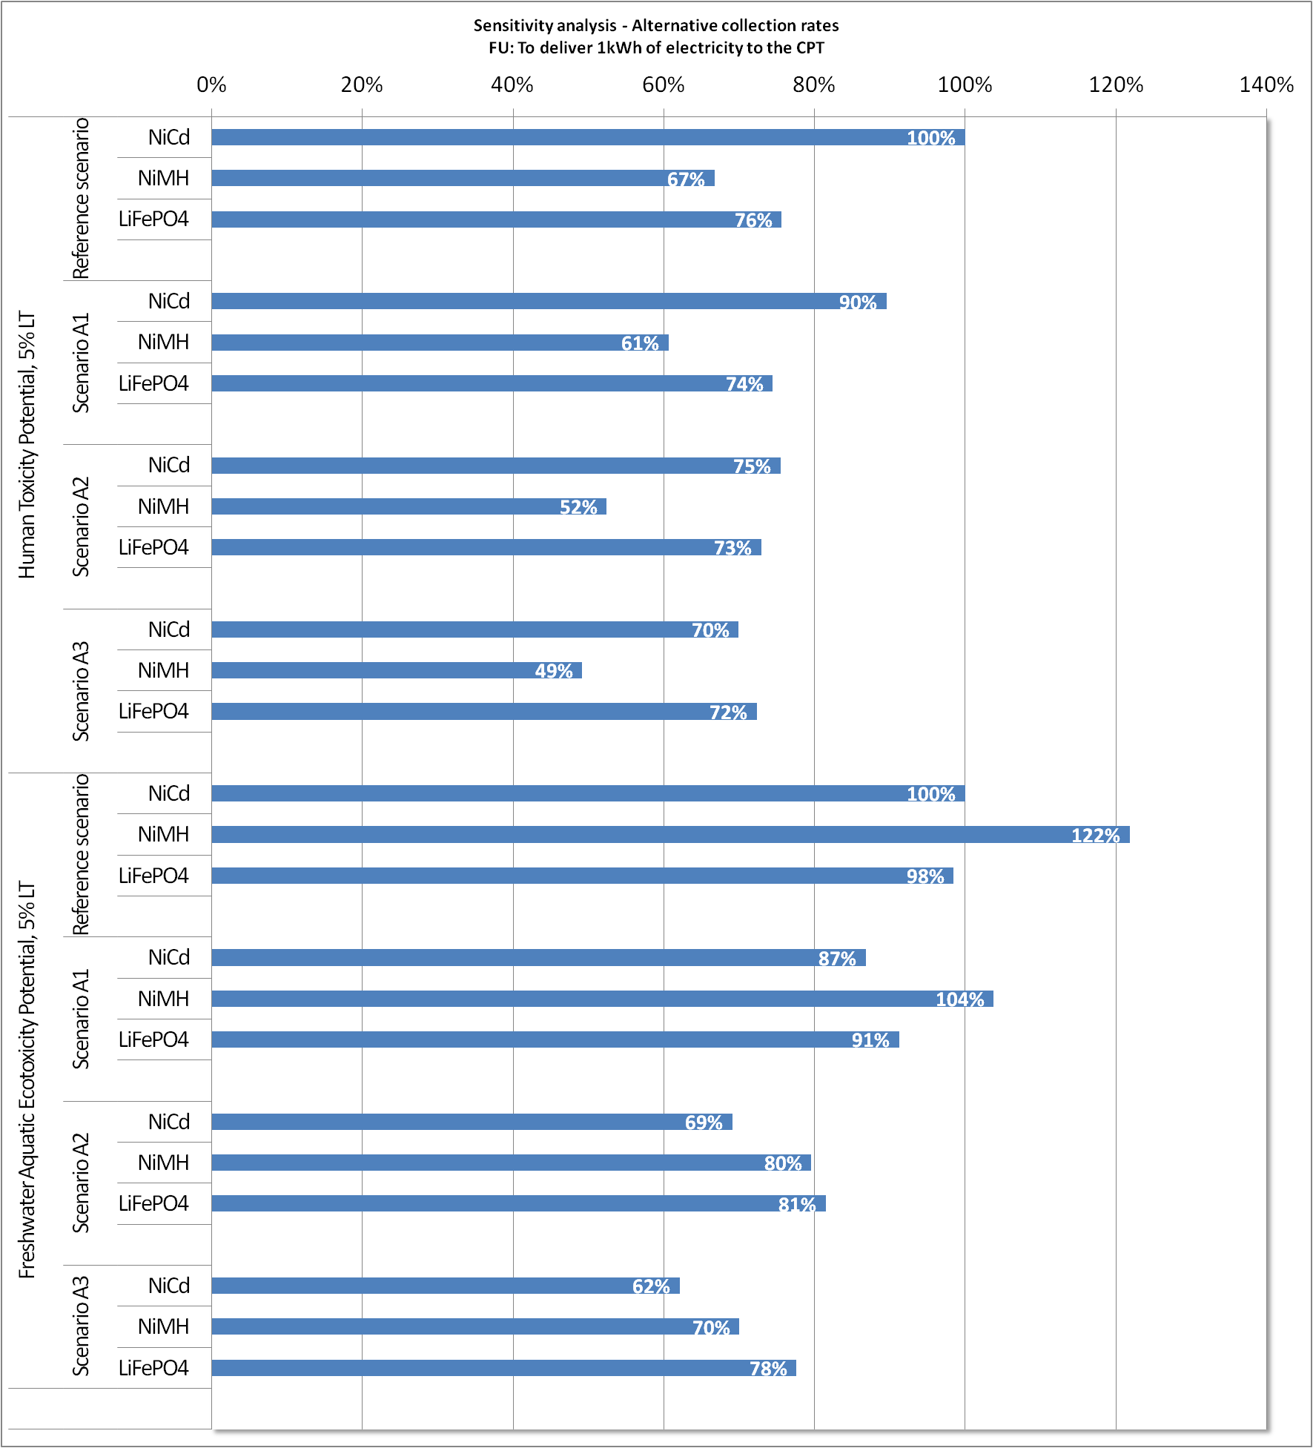

Human Toxicity Potential – with 5% long-term emissions
For NiCd and NiMH, the variation of the collection rate has a significant effect on this indicator.
However, the potential impact of LiFePO₄ on human toxicity with 5% LT emissions has a low sensitivity to a variation of the collection rate because this impact is mainly generated during production stages and thus mainly due to short-term emissions. For this indicator, LiFePO₄ shows similar impacts as NiCd for high collection rates (scenarios A2 and A3).

Freshwater Aquatic Ecotoxicity Potential – with 5% long-term emissions
In terms of sensitivity to the collection rate, similar trends can be observed for freshwater aquatic ecotoxicity potential with 5% LT emissions: for this indicator, the impact of LiFePO₄ battery has lower sensitivity to the variation of the collection rate (compared to the two other battery types). Consequently, with a 45% collection rate, LiFePO₄ has the highest potential impact on freshwater aquatic ecotoxicity potential with 5% LT emissions.
While NiMH is the most impacting battery in the reference scenario, it shows a similar impact as the two others for higher collection rates (scenarios A2 and A3).

3. Conclusions on the sensitivity analysis on collection rate
Depending on the indicator, the increase of the collection rate has a different effect on the impacts:
For the following indicators, the variation of the collection rate has only a limited influence on the results. The ranking between batteries is not impacted by a variation of the collection rate:
- Global Warming Potential;
- Cumulative Energy Demand;
- Metal Depletion Potential;
- Abiotic Resource Depletion Potential;
- Photochemical Oxidant Formation Potential;
- Particulate Matter Formation Potential;
- Freshwater Eutrophication Potential;
- Human Toxicity Potential, without long-term emissions;
- Freshwater aquatic ecotoxicity potential without long-term emissions.
Terrestrial Acidification: while NiMH is the most impacting battery in the reference scenario, it shows similar impacts as NiCd for higher collection rates (scenarios A2 and A3).
Human Toxicity Potential with 100% long-term emissions: NiCd is the most impacting battery whatever the collection rate is. While NiMH shows higher impacts than LiFePO4 in the reference scenario, this ranking is reversed for higher collection rates (scenarios A2 and A3).
Human Toxicity Potential with 5% long-term emissions: While NiCd shows higher impacts in the reference scenario, NiCd and LiFePO4 batteries have similar impacts for higher collection rates (scenarios A2 and A3).
Freshwater Aquatic Ecotoxicity Potentials with 100% and 5% long-term emissions: while NiMH is the most impacting technology in the reference scenario, it shows similar impacts as the two other battery types for higher collection rates (scenarios A1 and A2).
Sensitivity analisys on batteries lifespain

1. Scenario definition
As previously described, it was supposed in the reference scenario that the batteries were discarded when the CPT reached its end-of-life (after 165 hours of use). In some practical cases, users keep the batteries when the CPT has reached its end-of-life, and continue using them with a new CPT. Another case could be that the CPT has a longer lifetime than the battery. In this case also, the battery would be used until the end of its theoretical lifespan (800 cycles) (as suggested in the figure below).
Do these alternative cases favour one particular battery technology?
This sensitivity analysis aims at analysing in which extent comparative results vary when all three batteries are used until their theoretical lifespan.

Table 22: Scenario definition for sensitivity analysis on lifespan
Parameter |  | Reference scenario | Scenario B
Lifespan | Batteries and charger stop being used after 165 hours of use |  | Batteries and charger stop being used after 800 cycles

Figure 33: Illustration of the lifespan of the batteries and of the CPT
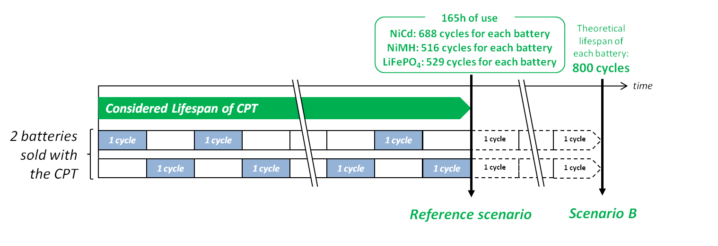

2. Results

Figure 34: Sensitivity analysis on lifespan – results for Global Warming Potential
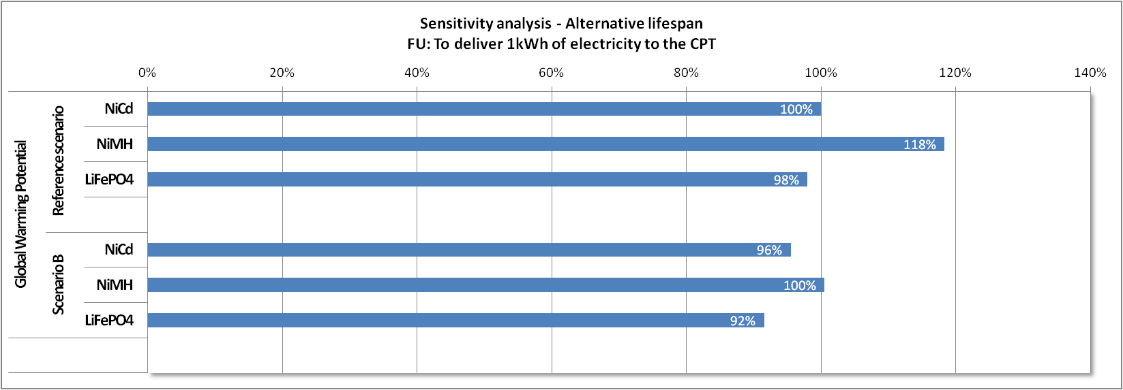

Figure 35: Sensitivity analysis on lifespan – results for Cumulative Energy Demand
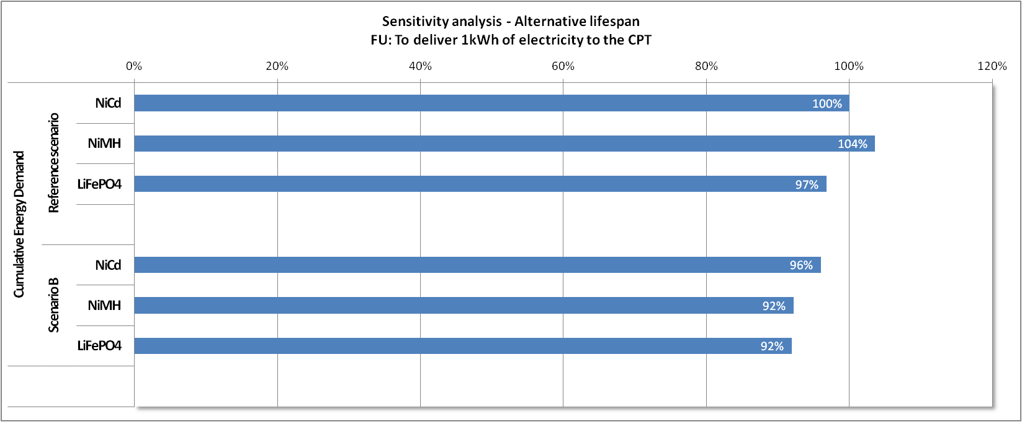

Concerning Global Warming Potential and Cumulative Energy Demand, no technology emerges as more contributing than the two other technologies, for the scenario B as for the reference scenario.

Figure 36: Sensitivity analysis on lifespan – results for Metal Depletion Potential
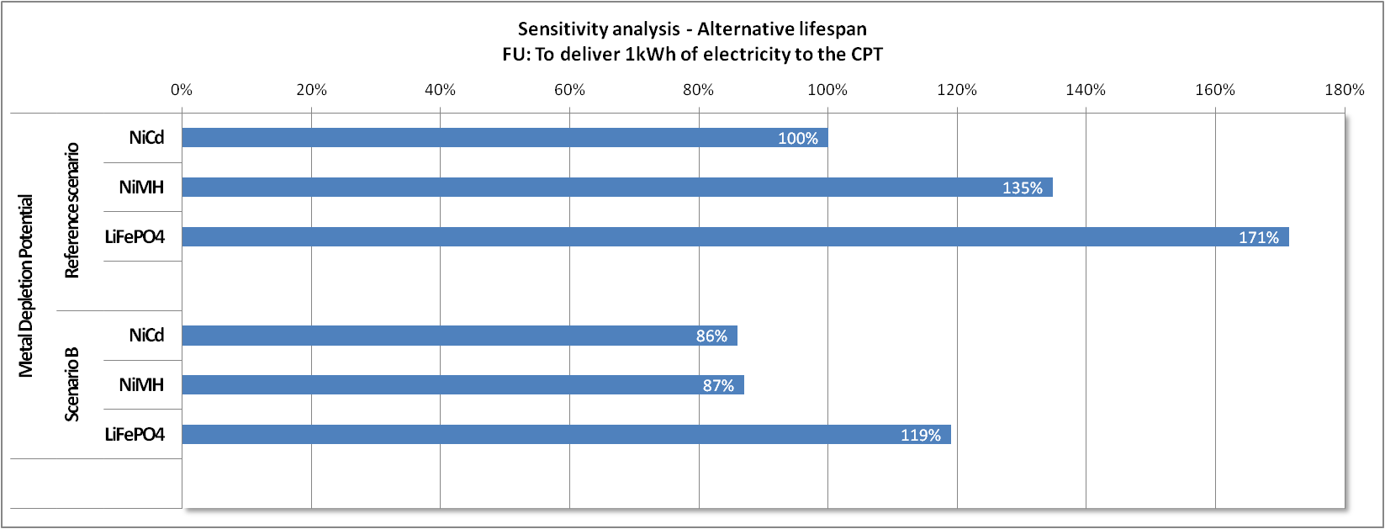

Concerning metal depletion, the extension of the lifespan generates a significant impact reduction for the three batteries. While LiFePO₄ shows higher impacts in both scenarios, the gap between the three technologies is significantly reduced when switching from the reference scenario to scenario B. Moreover, while NiMH shows higher impacts than NiCd battery in the reference scenario, both technologies show similar impacts with an extended lifespan (scenario B).
Impacts on metal depletion are mostly related to the production phase, which contribution is independent of the lifespan in absolute value.
However, a given battery provides more Functional Units (i.e. more kWh) to the CPT when its lifespan is extended. Consequently, when assessing the impacts for one Functional Unit, the impacts of production will be reduced when increasing the lifespan. This effect is intensified for NiMH, and in a lesser extent for LiFePO₄, as the relative increase of the lifespan (in terms of number of FUs) is higher for NiMH and then LiFePO₄, as shown in the following table.

Table 23: total number of FUs provided by each battery during its whole lifespan for both scenarios
Scenario | NiCd | NiMH | LiFePO₄
Reference scenario (82.5 hours of use) | 29.7 FU | 29.7 FU | 32.7 FU
Scenario B (800 cycles) | 34.6 FU | 46.1 FU | 47.1 FU
Relative increase | 16% | 55% | 44%

Figure 37: Sensitivity analysis on lifespan – results for Abiotic Resource Depletion Potential
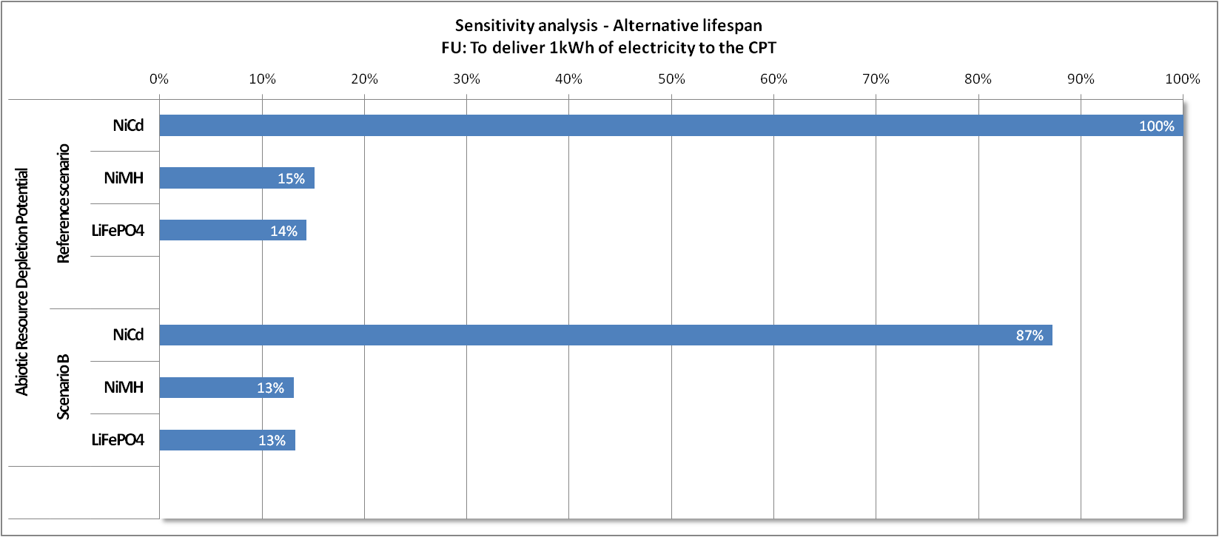

The increase of the lifespan to 800 cycles generates a reduction of the Terrestrial Acidification Potential for NiCd batteries whereas the two other chemistries are quite insensitive to a change of the lifespan for this indicator. Since for this technology and for this indicator, production impacts are higher than use phase impacts (due to the higher contribution of cells), the relative decrease of the production phase impacts is higher than for the other technologies.

Figure 38: Sensitivity analysis on lifespan – results for Photochemical Oxidant Formation Potential
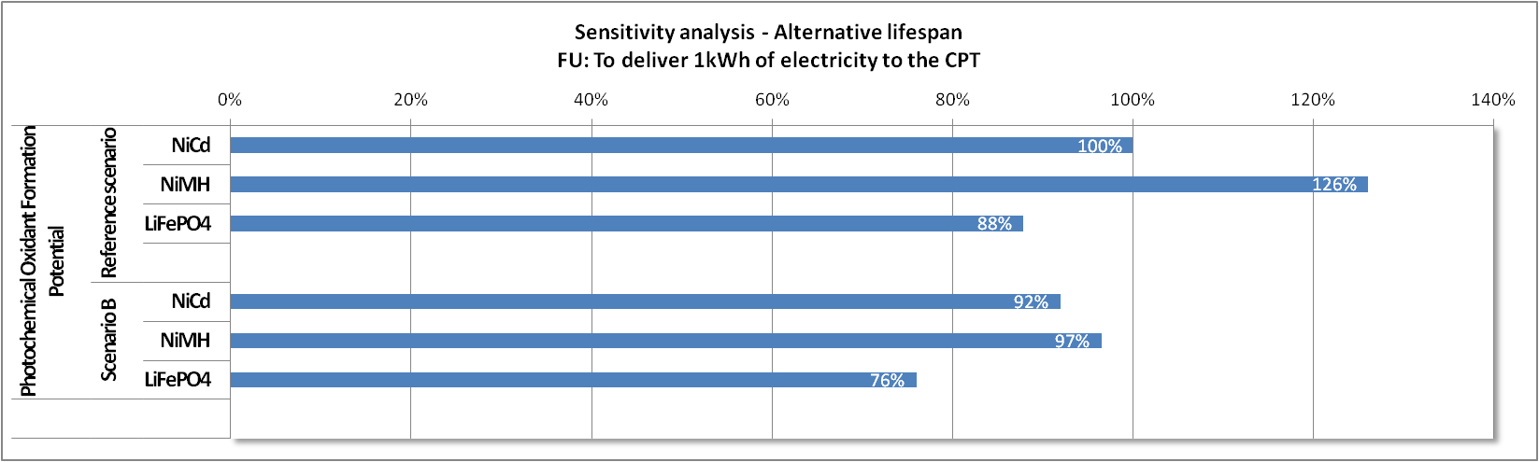

Figure 39: Sensitivity analysis on lifespan – results for Terrestrial Acidification Potential
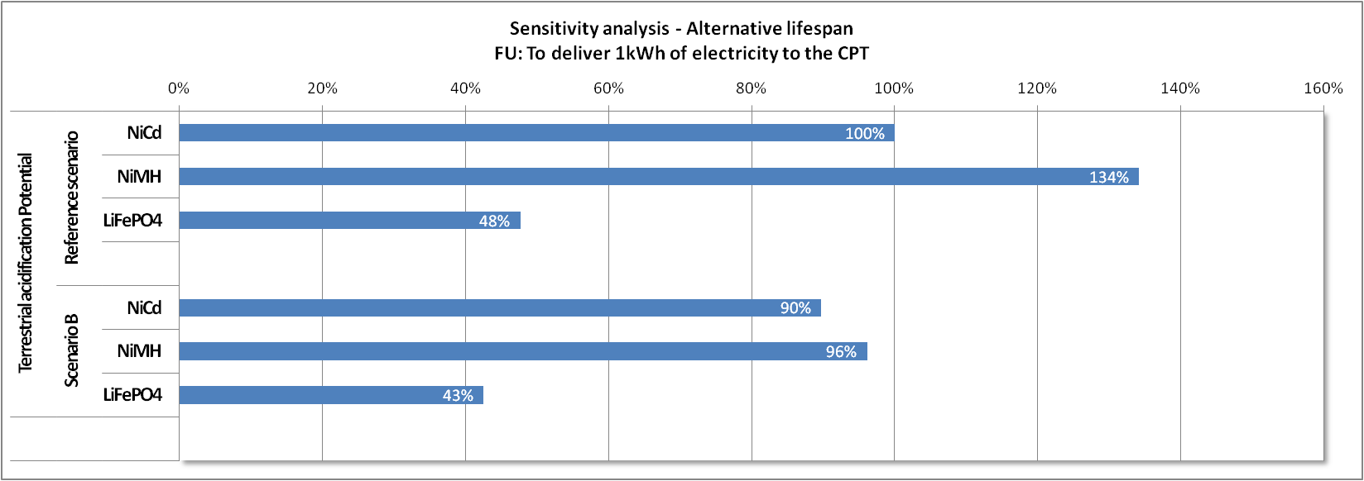

Figure 40: Sensitivity analysis on lifespan – results for Particulate Matter Formation Potential
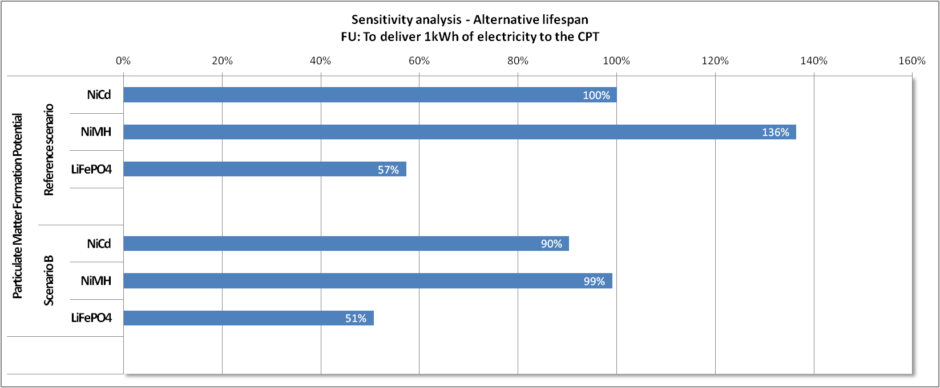

Concerning photochemical oxidant formation potential, terrestrial acidification potential and particulate matter formation potential, limited impact reductions for the three batteries can be observed when extending the lifespan.
The reduction is however significant for NiMH only, because:
- the production phase has a higher relative contribution for NiMH (due to a higher contribution of the cells);
- the relative increase of the lifespan (in terms of number of FUs) is higher for NiMH, as shown in Table 23.
While in the reference scenario NiMH is the most impacting chemistry, the difference with the other batteries is lowered in Scenario B: in this scenario, NiMH and NiCd have comparable impacts for these indicators.

Figure 41: Sensitivity analysis on lifespan – results for Freshwater Eutrophication Potential
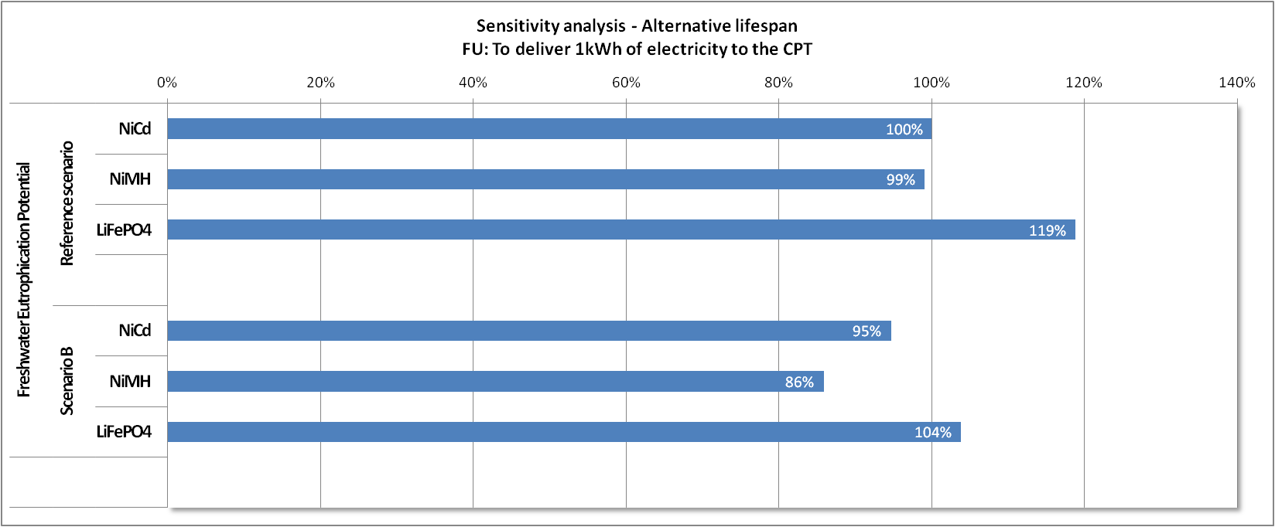

Concerning Freshwater Eutrophication Potential, limited impact reductions can be observed for the three technologies. The relative reduction is slightly higher for the LiFePO₄ battery, as for this indicator its production phase has a relative contribution that is higher than for the other battery types.
While in the reference scenario, LiFePO₄ is the most impacting battery, the difference with the other batteries is lowered in Scenario B (LiFePO₄ and NiCd have a similar impact in scenario B).

Figure 42: Sensitivity analysis on lifespan – results for toxicity indicators (with long-term emissions)
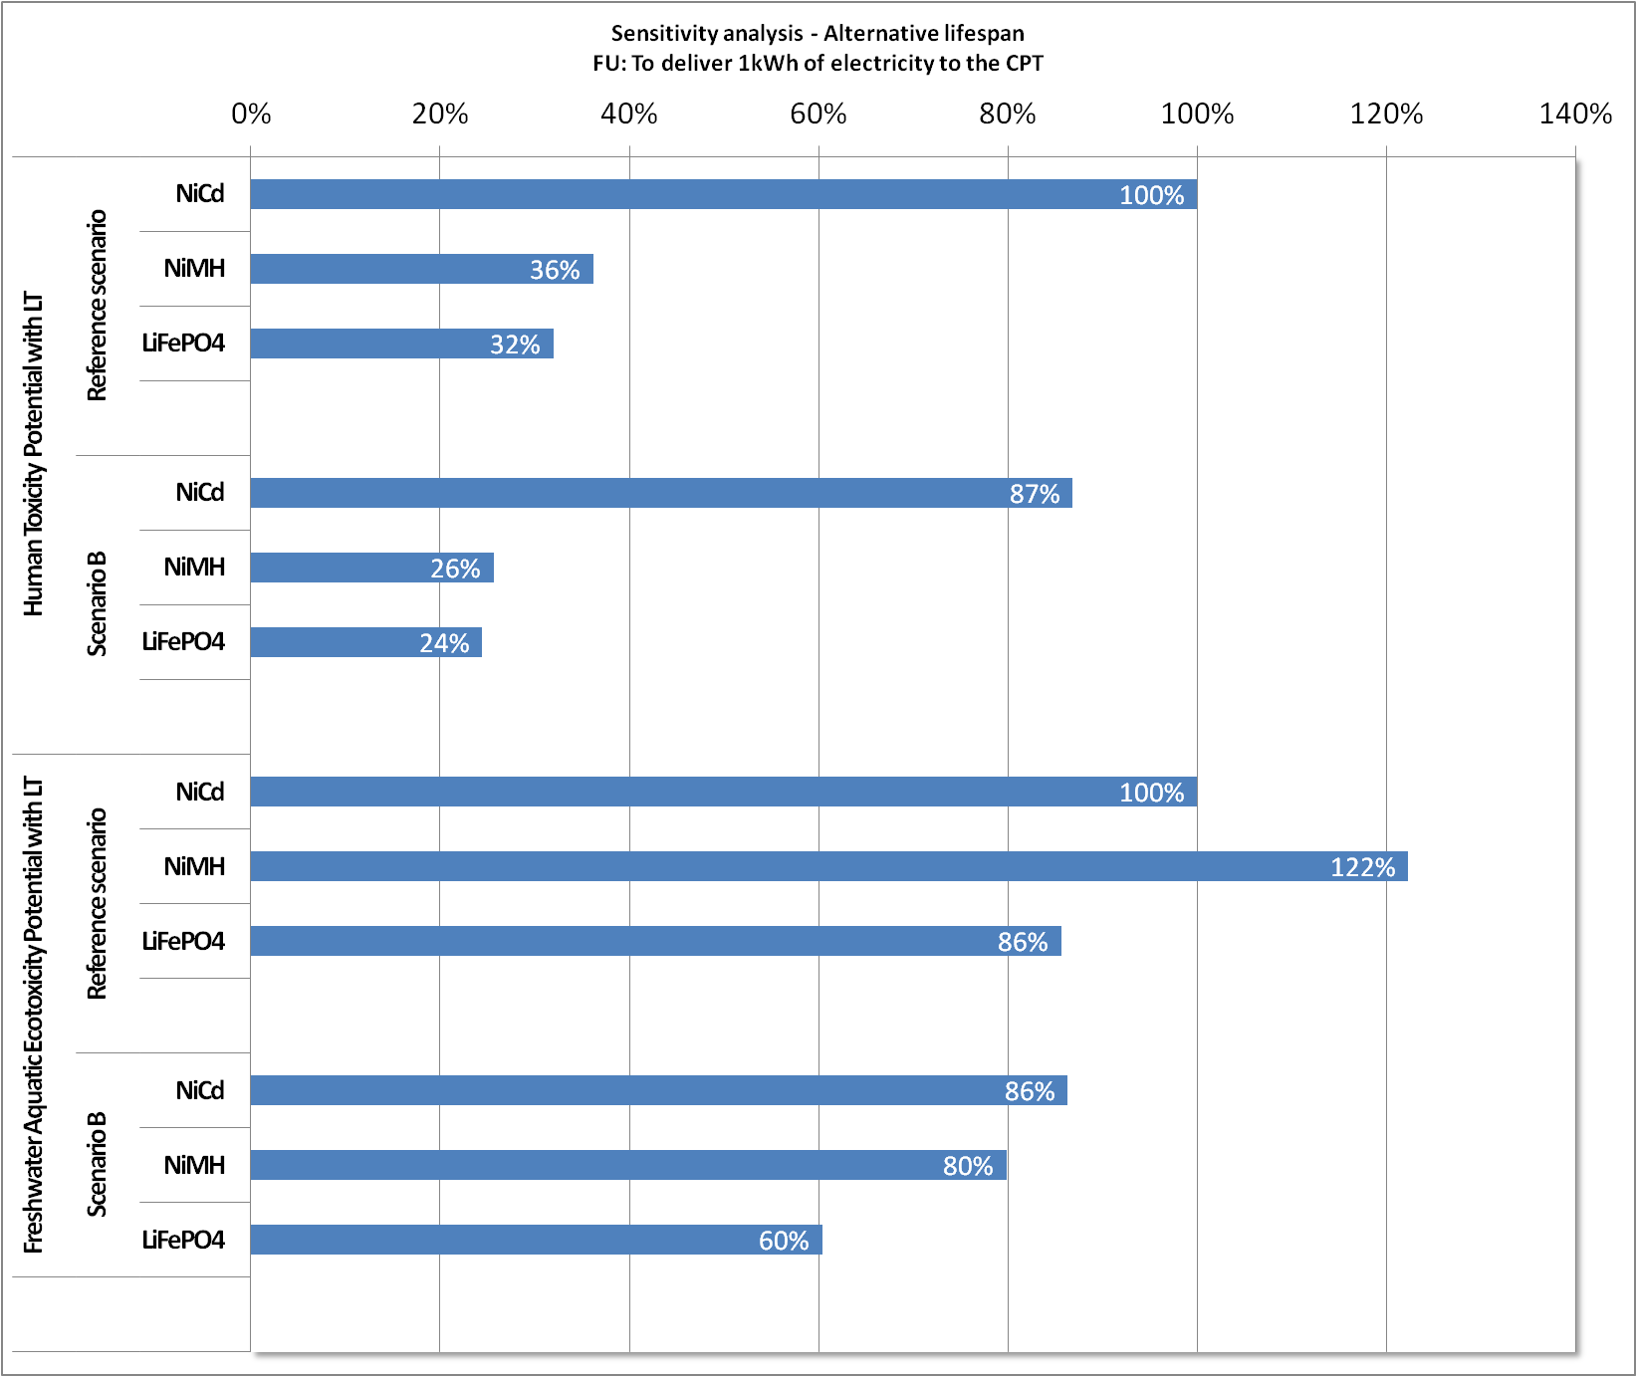

For both indicators, impact reductions can be observed for the three technologies, with more significant reductions for LiFePO₄ and NiMH. This is because the relative increase of the lifespan (in terms of number of FUs) is higher for NiMH and LiFePO₄, as shown in Table.
For Human toxicity potential: the ranking does not change between scenarios (NiCd is still the battery showing higher impacts).
For Freshwater aquatic ecotoxicity potential: In the reference scenario, NiMH shows the highest impact, the two others having similar impacts. In scenario B, LiFePO₄ has lower impacts than the NiCd battery.

Figure 43: Sensitivity analysis on lifespan – results for toxicity indicators (with 5% long-term emissions)
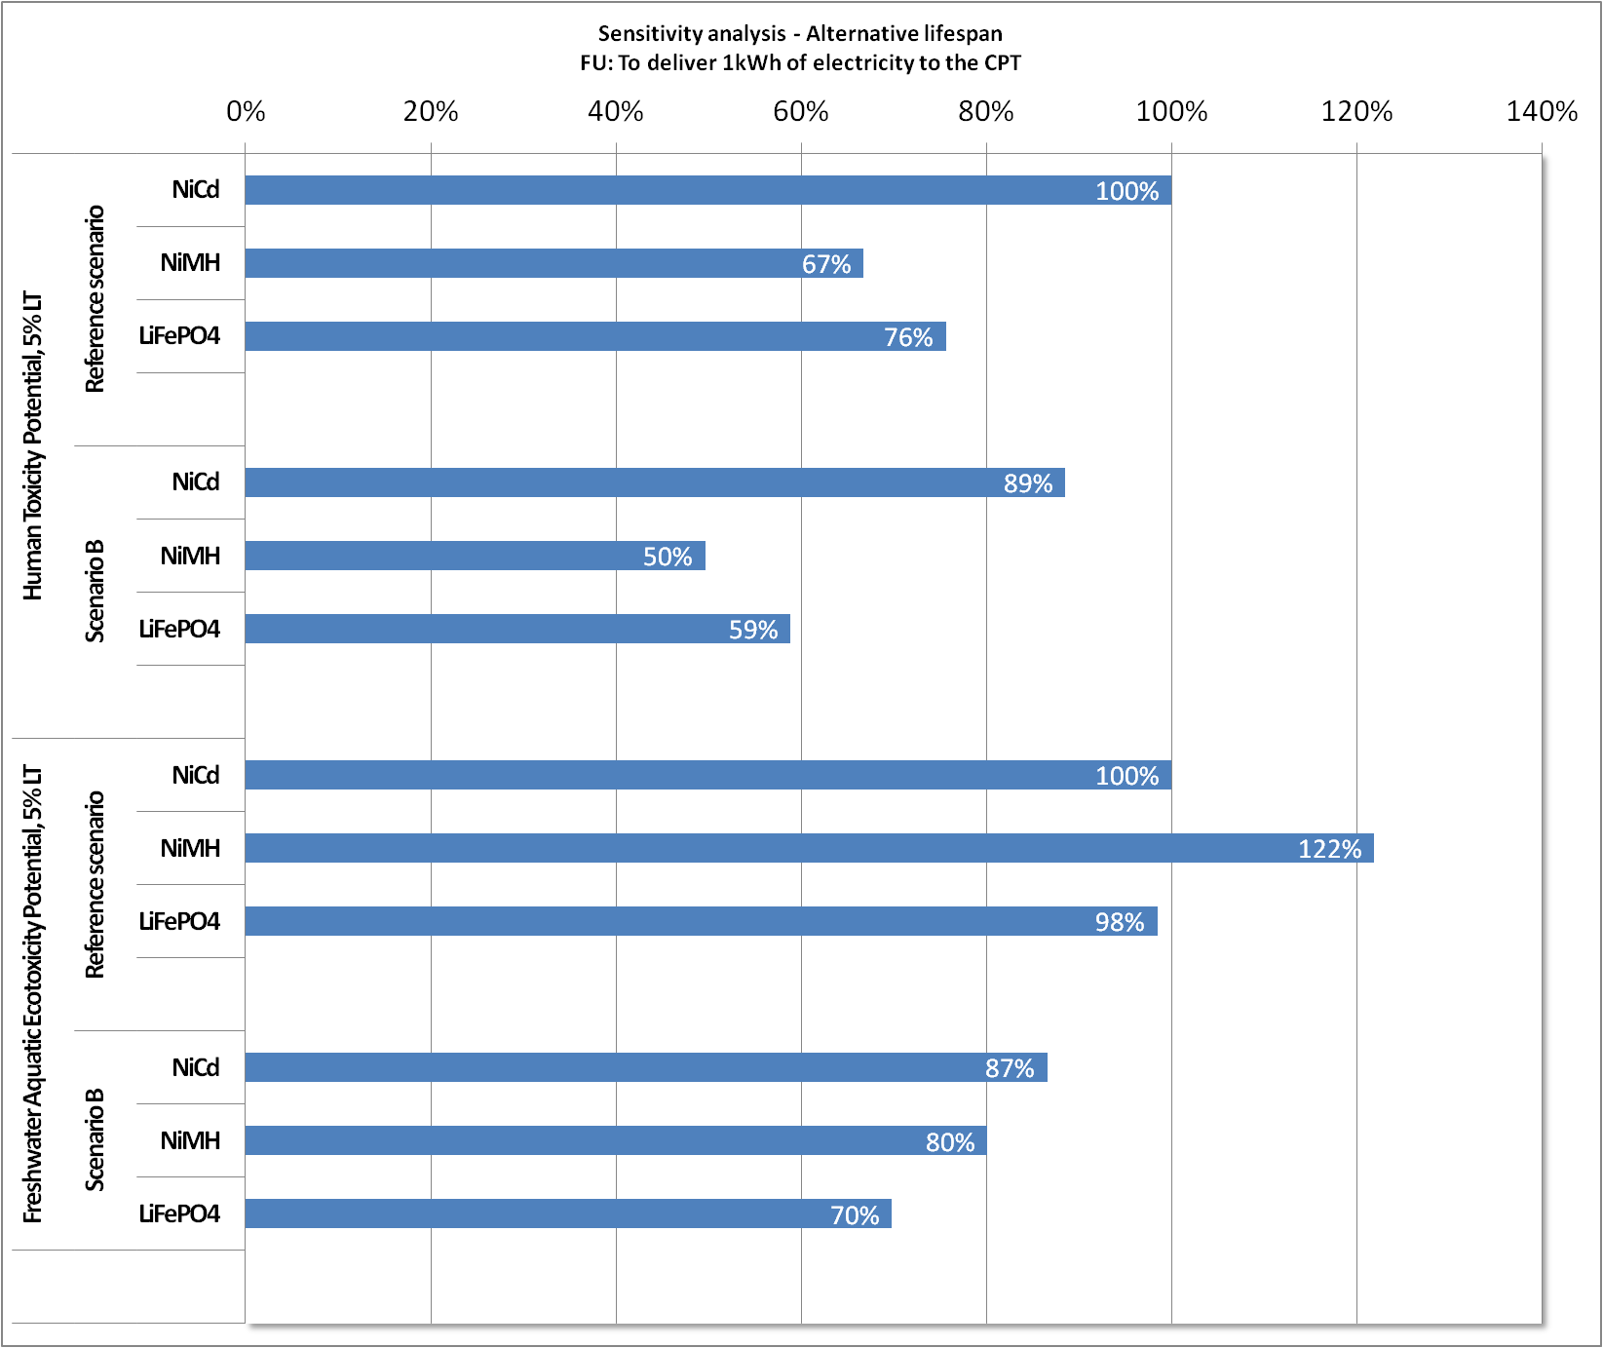

For both indicators, impact reductions can be observed for the three technologies, with more significant reductions for LiFePO₄ and NiMH. This is because the relative increase of the lifespan (in terms of number of FUs) is higher for NiMH and LiFePO₄, as shown in Table.
For Human toxicity potential: The relative ranking of batteries does not change.
For Freshwater aquatic ecotoxicity potential: While NiMH was the most impacting battery in the reference scenario, the three batteries show similar impacts in the scenario B.

Figure 44: Sensitivity analysis on lifespan – results for toxicity indicators (without long-term emissions)
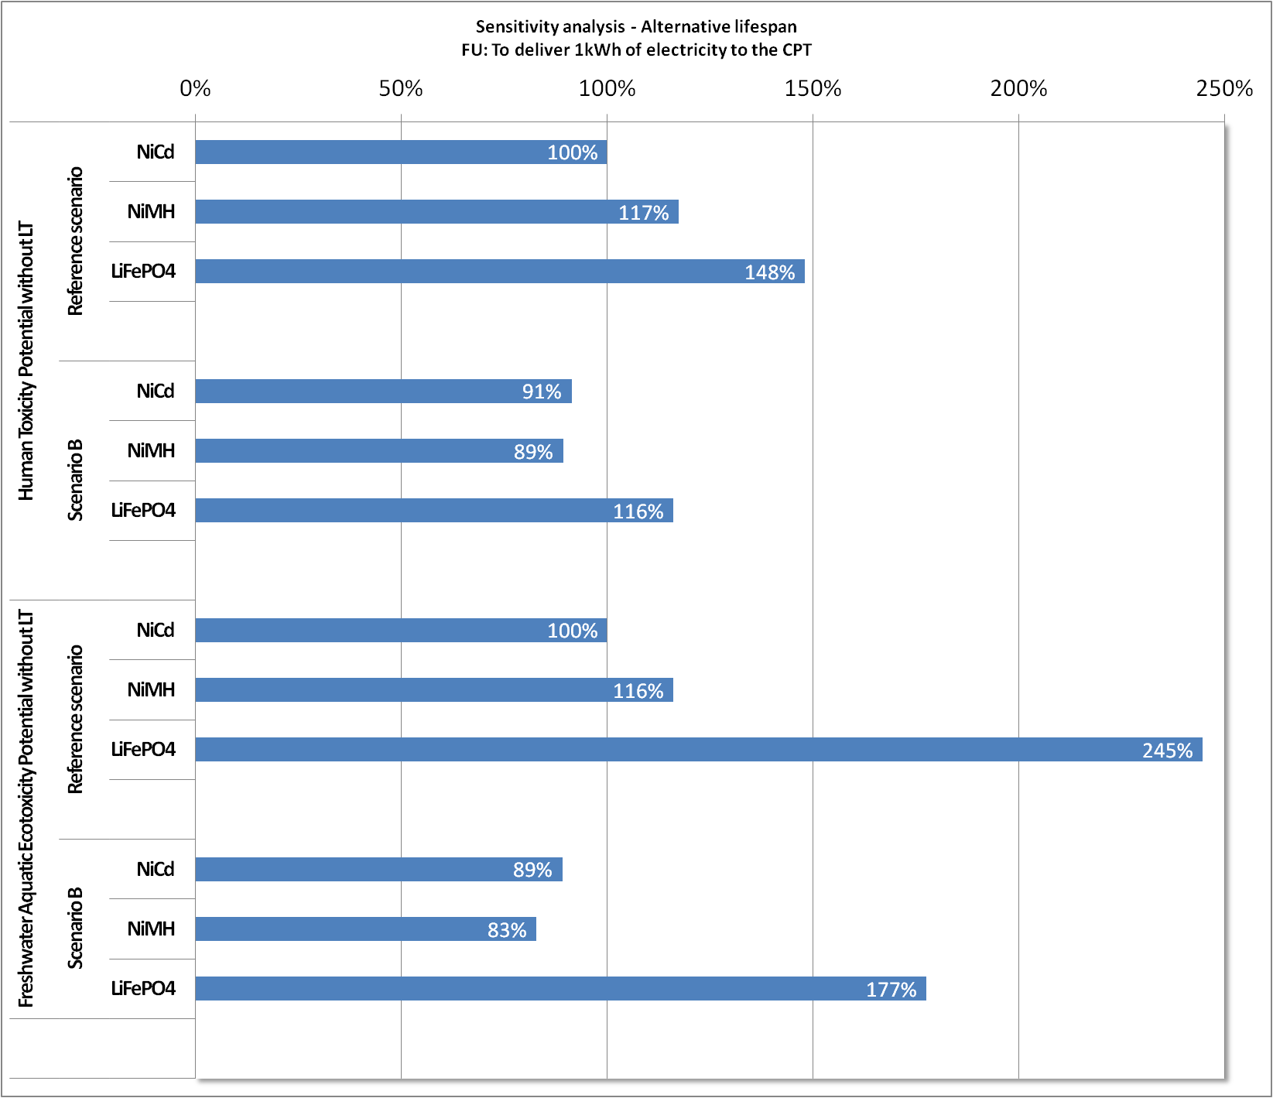

For both indicators, impact reductions can be observed for the three technologies, with more significant reductions for LiFePO₄ and NiMH, because the relative increase of the lifespan (in terms of number of FUs) is higher for NiMH and LiFePO₄, as shown in Table.
For both indicators, LiFePO₄ still shows higher impacts than the two other technologies in both scenarios.

3. Conclusion on the sensitivity analysis on lifespan
Depending on the indicator, the increase of the lifespan to 800 cycles has different effects on the impacts:
- Global Warming Potential, Cumulative Energy Demand show a low sensitivity to the increase of the lifespan.
- Abiotic Resource Depletion Potential shows impact reduction for NiCd, but this technology is still the most impacting in scenario B.
- Concerning Metal Depletion Potential, while impact reductions are observed for the three battery types, LiFePO4 is still the most impacting battery in scenario B.
- Concerning photochemical oxidant formation potential, terrestrial acidification potential and particulate matter formation potential, impact reductions are mainly observed for NiMH. While NiMH is the most impacting battery, the difference with the other batteries is lowered in Scenario B.
- Concerning Freshwater eutrophication potential, limited impact reductions are observed for the three batteries. While in the reference scenario, LiFePO4 is the most impacting battery, the difference with the other batteries is lowered in Scenario B.
- Concerning Human toxicity potential with long-term: only a limited decrease is observed, that generates no change in the ranking (NiCd is still the most impacting technology).
- Concerning Freshwater aquatic ecotoxicity potential with long-term (LT) emissions: the decrease in impacts is higher for NiMH. Thus, its impact in scenario B is similar to the impact of NiCd, while it was the most impacting battery in the reference scenario.
- For Human toxicity potential with 5% LT emission: The relative ranking of batteries does not change.
- For Freshwater aquatic ecotoxicity potential with 5% LT emissions: While NiMH was the most impacting battery in the reference scenario, the three batteries show similar impacts in the scenario B.
- For Human toxicity and freshwater aquatic ecotoxicity potentials without LT emissions: for both indicators, LiFePO4 remains the most impacting battery, while the two other technologies show similar impacts.
Sensitivity analisys on emissions of metals

1. Scenario definition

Table 24: Scenario definition for the sensitivity analysis on metal emissions
Parameter | Reference scenario | Scenario “ 0.01% emissions of metals” | Scenario “2% of emissions of metals”
% of metal emitted to air | No direct emissions are considered during the cell production step. | 0.01% are emitted during the cell production step | 2% are emitted during the cell production step
% of the metal emitted to water | No direct emissions are considered during the cell production step. | 0.01% are emitted during the cell production step | 2% are emitted during the cell production step

Direct emissions of heavy metals in air and water during cell production are not taken into account in the reference scenario, because of a lack of robust data. However, this could be an important data gap and a major limitation of the study.
Therefore, it is relevant to assess the sensitivity of the results to emissions of heavy metals in air during cell production. Alternative scenario are considered, where emissions to air and water occur for each battery type. The following emissions of metal are considered:
- For NiCd: Nickel, Cadmium and Cobalt,
- For NiMH: Nickel and Cobalt,
- For LiFePO4: Copper and Aluminium.
In order to determine a conservative order of magnitude of the quantity of emitted metals, literature data on emissions during batteries production Rantik's data were used.
Rantik's data presents quantified emissions occurring during the production of NiCd and NiMH batteries intended for use in electric vehicles (no literature source could be found for the specific application of CPTs). Based on the emitted quantities per kilogram of battery and the mass breakdown of each battery, the ratio of metal emitted has been calculated, for each type of metal.
Emissions of metals reported in Rantik's report vary significantly from one manufacturing site to another and from application to another. Therefore, 2 alternative scenarios are set, the first one being an “intermediate” scenario and the second one being the most “conservative” scenario.
1.1. Calculation of emissions for the 1st alternative scenario
Emissions to air and water during the production of NiCd batteries used in electric vehicles, derived from 0, are reported in the following table.

Table 25: Emissions to air and water during the production of NiCd batteries for EV – emissions in kg of metal / kg of metal contained in the battery
Type of emission | Specific emission | Value | Unit
Emission to air | Cadmium | 0.007% | kg / kg Cd contained in the cell
Emission to air | Cobalt | 0.008% | kg / kg Co contained in the cell
Emission to air | Nickel | 0,008% | kg / kg Ni contained in the cell
Emission to water | Cadmium | 0.010% | kg / kg Cd contained in the cell
Emission to water | Cobalt | 0.011% | kg / kg Co contained in the cell
Emission to water | Nickel | 0.011% | kg / kg Ni contained in the cell

Since the representativeness of these values to our specific case (production of cells for batteries intended for use in CPTs) may be quite poor, it was chosen to retain 0.01% as the reference value for the first alternative scenario. This value is applied to each metal listed above and for each compartment considered (air and water).
Furthermore, the equivalent quantity of emitted metal has been accounted as additional raw material input.
1.2. Calculation of emissions for the 2nd alternative scenario
Emissions during the production of NiMH batteries, derived from M. Rantik, are reported in the following table.

Table 26: Emissions to air/water/ground during the production of NiMH batteries for EV¹³⁶ - emissions in kg of metal / kg of metal contained in the battery
Type of emission | Specific emission | Value | Unit
Emission to air/water/ground | Nickel | 2.7% | kg / kg Ni contained in the cell
Emission to air/water/ground | Cobalt | 6.0% | kg / kg Co contained in the cell

If we assume equal emissions into the three compartments, the following emissions in air and water are calculated.

Table 27: Emissions to air and water during the production of NiMH batteries for EV recalculated from
Type of emission | Specific emission | Value | Unit
Emission to air | Nickel | 0.9% | kg / kg Ni contained in the cell
Emission to air | Cobalt | 2.0% | kg / kg Co contained in the cell
Emission to water | Nickel | 0.9% | kg / kg Ni contained in the cell
Emission to water | Cobalt | 2.0% | kg / kg Co contained in the cell

The maximum value for a single metal in a given compartment, i.e. 2%, is used as the reference value for the second alternative scenario. This is the most conservative choice. This value is applied to each metal listed above and for each compartment considered (air and water).
Furthermore, the equivalent quantity of emitted metal has been accounted as additional raw material input.

2. Results
In the following analysis of the results, we only focus on toxicity impacts, since all other impacts do not significantly vary when emissions of metals to air and water during the production of the cells are increased.
Figure 44: Sensitivity analysis on metal emissions during production – results for human toxicity potential with long-term emissions
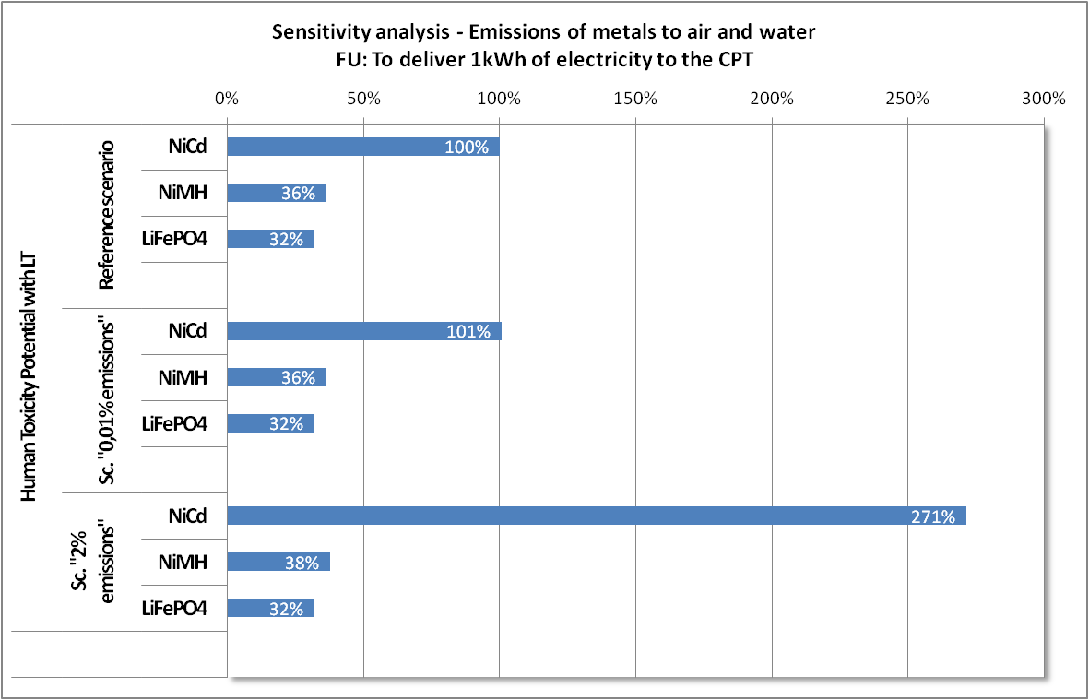

Human Toxicity Potential with long-term emissions shows no sensitivity for NiMH and LifePO4 batteries. For NiCd battery, the emission of 2% of the metal content triples the impact for this indicator.

Figure 45: Sensitivity analysis on metal emissions during production – results for Freshwater Aquatic Ecotoxicity Potential with long-term emissions
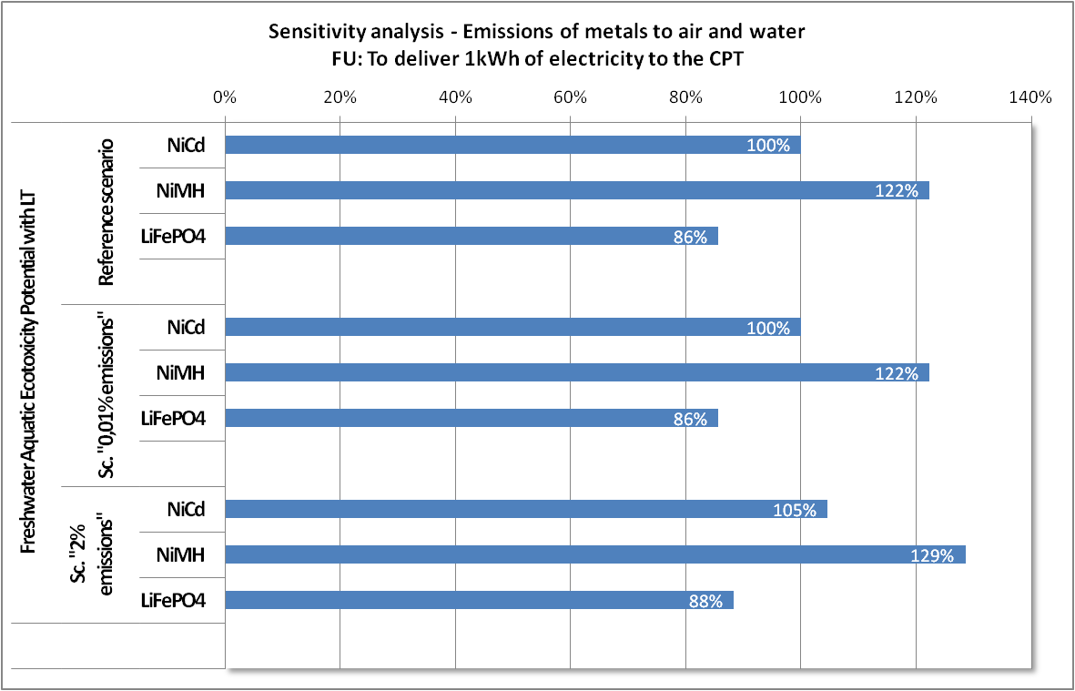

Freshwater Aquatic Ecotoxicity potential with long-term emissions shows no significant sensitivity to an increase of the emissions of metals in air and water during the production of the cells.

Figure 46: Sensitivity analysis on metal emissions during production – results for Human Toxicity Potential with 5% LT emissions
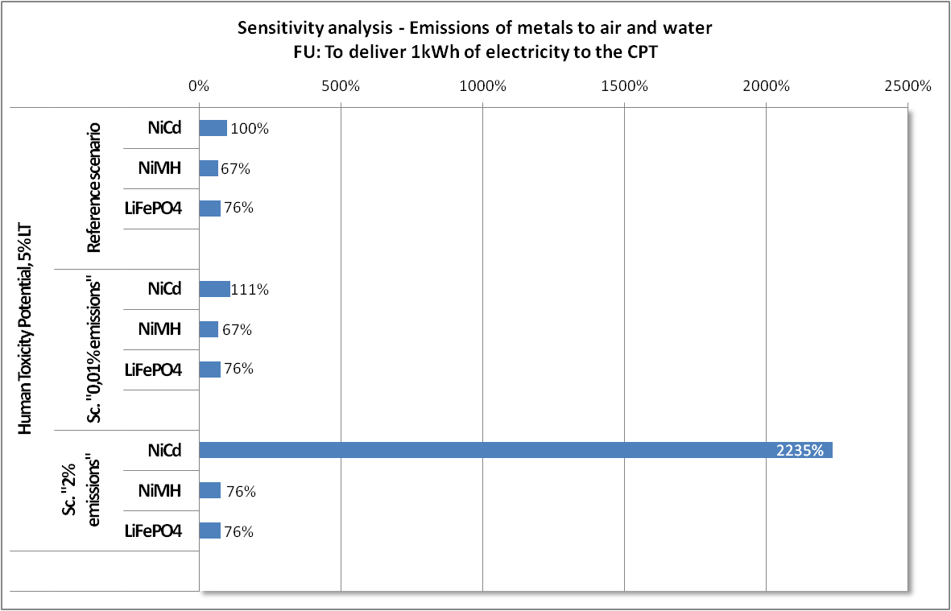

Human Toxicity Potential with 5% LT emissions shows no significant sensitivity for NiMH and LifePO₄ batteries. Concerning NiCd battery, the emission of 0.01% of the metal content generates no significant increase in the impact while the emission of 2% of the metal content increases drastically the impact (multiplied by about 22).

Figure 47: Sensitivity analysis on metal emissions during production – results for Freshwater Aquatic Ecotoxicity Potential with 5% LT emissions
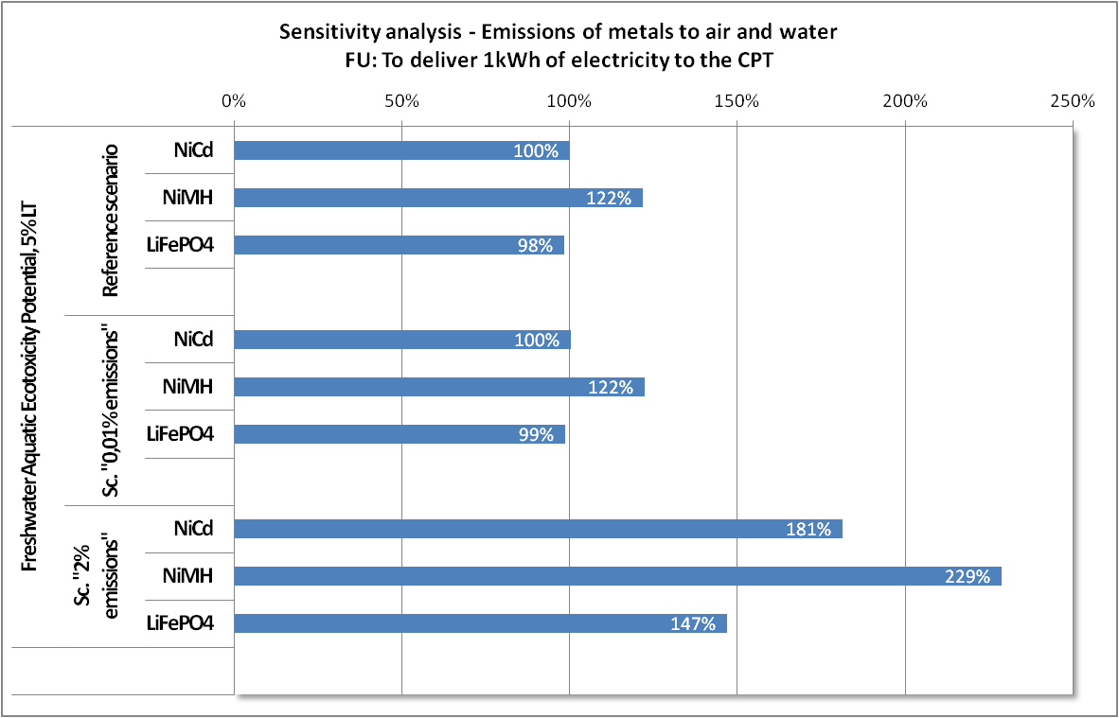

Freshwater Aquatic Ecotoxicity with 5% long-term emissions, no differences can be seen for the “0.01% scenario”. For the 2% scenario however, the overall impact of each battery increases significantly (the impact is nearly doubled for the three battery types), without any major differences in the ranking of the batteries (given the uncertainty on the model).

Figure 48: Sensitivity analysis on metal emissions during production – results for Human Toxicity Potential (without long-term emissions)
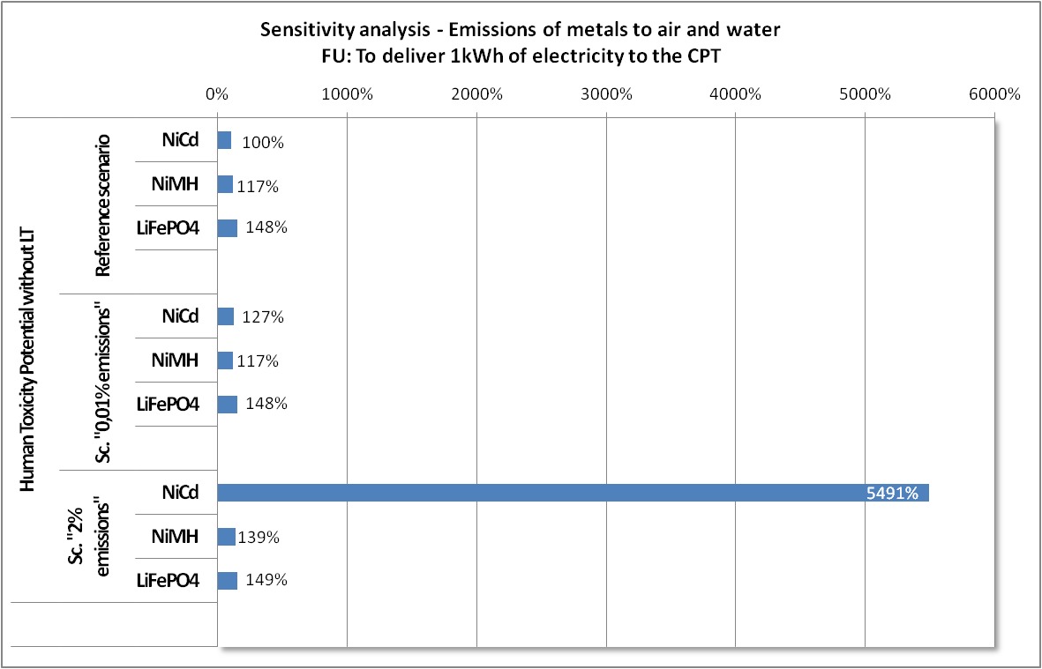

Human Toxicity Potential without long-term emissions shows no sensitivity for NiMH and LifePO₄ batteries. Concerning NiCd battery, the emission of 0.01% of the metallic content generates a 30% increase in the impact while the emission of 2% of the metallic content increases drastically the impact (multiplied by about 55).

Figure 49: Sensitivity analysis on metal emissions during production – results for Freshwater Aquatic Ecotoxicity Potential (without long-term emissions)
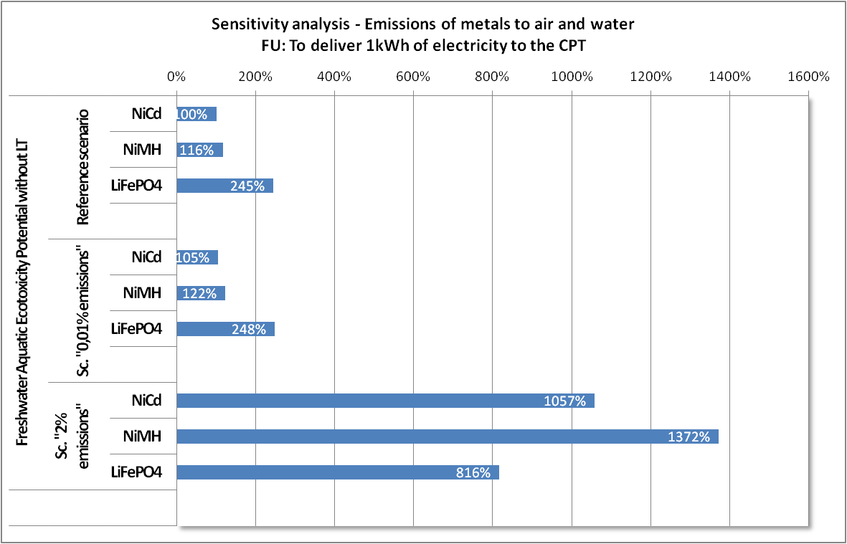

Concerning Freshwater Aquatic Ecotoxicity potential without long-term emissions, no difference can be seen for the “0.01% scenario”. For the 2% scenario however, the overall impact of each battery increases drastically.
Besides, for this scenario, the ranking of batteries is modified compared to the reference scenario: whereas in the reference scenario, LiFePO₄ is the most contributing battery and the two other batteries are equivalent, for the “conservative” scenario (emissions of 2% of the metallic content) NiMH is the most contributing battery and LiFePO₄ the less contributing one.

3. Conclusion on the sensitivity analysis on emissions of metals
Toxicity indicators, especially human toxicity indicators, are highly sensitive to the emissions of metal to the environment during the cell production, with the exception of Freshwater Aquatic Ecotoxicity potential with long-term emissions. It is reminded that all other considered indicators show no sensitivity to the emissions of metals to air and water during the production of cells.
In conclusion of the analysis, the need for accurate and representative figures on the emissions during the production of the cells is of major importance to have robust results in terms of toxicity impacts.

Battery sales and separate collection of NiCd batteries in Germany
The Batteries Directive (2006/66/EC) requires EU Member States to introduce schemes for the separate collection of waste batteries. In Germany such schemes have been implemented since 1998.,
Figure 50 shows the tonnes of batteries which were sold in each year in Germany by NiCd- NiMH- and Li-ion battery type for the period from 2001 to 2008. While in recent years in Europe the NiCd batteries are almost exclusively used in CPT, the sold NiMH and Li-ion batteries are used in many different applications.
Figure 50 : Battery sales in Germany in tonnes/year

Figure 51 shows the tonnes of NiCd batteries collected each year in the German separate battery collection systems. When comparing Figure 51 with Figure 50 it is necessary to take into account the residence time of NiCd batteries in the use phase. In Japan the average age of NiCd batteries returned to recycling plants is 7.3 years. This very well corresponds to the 7 years of average life-time of NiCd cells estimated by EPTA. Thus, when comparing the NiCd collection masses of 2007 and 2008 with sales masses of 2001 and 2002 recycling rates of 38 to 44 % are get.

Figure 51 : Separate collection of NiCd batteries in Germany in tonnes/year
In 2002 the European Commission reported that 45.5% of the portable batteries sold in the EU-15 that year went to final disposal (incineration or landfill), instead of being collected and recycled.
It has to be concluded that, in spite of very well established and montiored separate collection systems in some Member States, such as in Germany for example, the majority of NiCd batteries and thus of the contained cadmium is collected with residual household waste and possibly other waste streams, and either incinerated in municipally solid waste incineration plants, mechanical-biological treatment plants, in plants of treating non-ferrous metals separated from residual waste or directly landfilled. Thus there is some likelihood that cadmium can dissipate uncontrolled into the environment during the waste-phase of NiCd batteries.

Environmental impacts related to the relevant battery technologies

1. NiCd batteries
As shown in Table 28 it is estimated that 240 million NiCd cells were sold in Europe for cordless power tool applications in the year 2008. With a mass of 55 g/cell this gives a total mass of 13,200 tonnes of NiCd cells sold in 2008 for application in CPT in Europe.
Table 28 shows an estimation of the substance-flows caused by the total of all NiCd-cells sold for CPT in 2008 in Europe and the effect on production and reserve depletion for the contained metals. It can be seen, that 10.6 % of the world 2008 cadmium production can be refered to the NiCd batteries for CPT in Europe. About 0.45 % of the world cadmium reserves were used for that end.
Smaller shares of 0.11 % and 0.16% of the world cobalt and the world nickel production respectively were also required. The effect of the NiCd batteries on world iron, manganese and zinc production and reserves is really small.
Table 28: Materials contained in rechargeable NiCd batteries sold in Europe for CPTs in 2008 and effect on world metal production (Sources: composition = average from [EC 2003] and [ERM 2006]; production and reserves [USGS 2009])
 | Assumed share in cell in % | Mass for all 2008 NiCd cells in t | % of year 2008 worldwide metal production | % of worldwide reserves
Cadmium (Cd) | 16.7 | 2,200 | 10.6 | 0.45
Cobalt (Co) | 0.6 | 79 | 0.11 | 0.0011
Iron (Fe) and steel | 34.7 | 4,576 | 0.0004 | 0.00002
Manganese (Mn) | 0.1 | 11 | 0.0001 | 0.000002
Nickel (Ni) | 19.0 | 2,508 | 0.16 | 0.0036
Zinc (Zn) | 0.1 | 8 | 0.0001 | 0.000004
Alkali (KOH) | 2.0 | 264
Plastics | 10.0 | 1,320
Water | 5.0 | 660
Other non metals | 11.9 | 1,574
Total | 100 | 13,200

Health Effects and Environmental Effects
From the materials contained in NiCd batteries the highest health and environmental risk emanates from cadmium as this metal
- is carcinogenic,
- mutagenic,
- carries a possible risk of impaired fertility and possible risk of harm to the unborn child
- is very toxic by inhalation
- carries danger of serious damage to health by prolonged exposure through inhalation and if swallowed
- is very toxic to aquatic organisms, may cause long-term adverse effects in the aquatic environment.
Due to its relatively low melting and boiling point, respectively, it can be easily released into the environment and may accumulate there.
The next most hazardous substance in is nickel:
- for carrying limited evidence of a carcinogenic effect
- and for being toxic showing danger of serious damage to health by prolonged exposure through inhalation.
Other substances contained in NiCd batteries are hazardous to some degree:
- Cobalt is classified as harmful, it may cause sensitization by inhalation and skin contact, and it may cause long-term adverse effects in the aquatic environment [JRC 2009].
- Manganese is classified as being harmful when swallowed or inhaled [Regulation (EC) No 1272/2008].
- Alkali is corrosive, harmful if swallowed, and may cause severe burns [JRC 2009].
As NiCd-power packs are well protected, closed systems, in the use phase health and environmental risks occur only very rarely, that is when the power pack ruptures due to extreme mechanical wear, heat or an explosion of the gases produced during overcharge.
From the life-cycle perspective the phases with the highest health and environmental risks are:
- The mining phase (especially the mining of cadmium)
- The treatment of ores and production of metals phase
- The phase of waste collection
- The phase of waste treatment and recycling.

2. NiMH batteries
Table 29 gives an estimation of the mass of NiMH batteries which would be required to provide the same amount of lifetime energy as the 13,200 tonnes of NiCd batteries sold in Europe in 2008. It shows that 22,500 t of NiMH batteries would be required.

Table 29 : Estimation of the mass of NiMH- and Li-ion batteries, respectively which would be required to provide the same amount of lifetime-energy as the 13,200 tonnes of NiCd batteries sold in Europe for CPTs in 2008 (based on data from [EPTA 2009b])
Battery type | Total mass in t | kg/pack (18 V) | Number of packs | Lifetime Wh/pack | Lifetime GWh of all packs | Lifetime Wh/pack | Number of packs | kg/pack (18 V) | Total mass in t
NiCd | 13,200 | 1.015 | 13,000,000 | 34,200 | 951
NiMH |  |  |  |  | 951 | 20600 | 21,600,000 | 1.040 | 22,500
Li-ion |  |  |  |  | 951 | 21200 | 21,000,000 | 0.705 | 14,800

Table 30 shows the material streams which would be required to replace the NiCd batteries sold in 2008 in Europe for CPTs by NiMH batteries to give the same lifetime energy. It can be seen that in absolute terms considerable amounts of nickel, iron and mischmetall (lantanides or rare-earths) would be required. Relative to the world metal production, however, the mischmetalls, cobalt and lithium are the most critical metals. Here it has to be noted that only one information source specifically mentions lithium as being a component of NiMH batteries, too. So the real lithium demand caused by NiMH batteries may be considerably lower than estimated in Table 30.

Table 30 : Materials contained in the NiMH batteries which would be required to deliver the same lifetime energy as the NiCd batteries sold for CPTs in 2008 in Europe and effect on world metal production (composition = average from [EC 2003, ERM 2006, EPBA 2007, VARTA 2008], production and reserves from [USGS 2009])
 | Assumed share in cell in % | Mass for all NiMH cells necessary to replace NiCd in t | % of year 2008 worldwide metal production | % of worldwide reserves
Aluminium (Al) | 1.0 | 225 | 0.001 | <<
Cobalt (Co) | 3.7 | 830 | 1.156 | 0.012
Iron (Fe) and steel | 27.1 | 6,103 | 0.001 | 0.000
Lithium (Li) | 1.0 | 225 | 0.821 | 0.005
Manganese (Mn) | 1.5 | 332 | 0.002 | 0.000
Nickel (Ni) | 33.0 | 7,425 | 0.461 | 0.011
Zinc (Zn) | 1.7 | 375 | 0.003 | 0.000
Mischmetal alloy / lanthanides (calculated as rare earth oxides) | 10.7 | 2,400 | 1.935 | 0.003
Alkali | 5.0 | 1,125
Plastics | 7.0 | 1,575
Water | 8.0 | 1,800
Other non metals | 0.4 | 85
Total | 100.0 | 22,500

Health and Environmental Effects
NiMH batteries do not contain cadmium. Thus the highest health and environmental risks of NiMH batteries emanate from nickel.
In addition to the hazardous substances contained in NiCd batteries, NiMH batteries contain:
- Lithium which is only dangerous in its reactive metallic form (but not as lithium salt)
- Mischmetall alloy which is of low to moderate toxicity.
Some experts claim that NiMH batteries are somewhat less abuse tolerant than NiCd batteries, so that the likelihood of rupture may be somewhat higher with NiMH batteries but still low.
The critical life-cycle phases during which the highest health or environmental impacts may occur are the same as with NiCd.

3. Li-Ion Batteries
Table 29 (above) shows the estimation of which mass of Li-ion batteries would be required to deliver the same lifetime energy as all NiCd batteries sold in Europe in 2008; this would be 14,800 t.
Table 31 shows the material streams which would be required to replace the NiCd batteries sold in 2008 in Europe for CPTs by Li-ion batteries to give the same lifetime energy. The share of lithium is relatively low. However, when compared to the world production of each material, a ban of NiCd batteries in cordless power tools (CPT) would have its biggest impact on cobalt- and on lithium-production. A corresponding ban would increase the world cobalt-demand by 3.75 % and the world lithium demand by 1.57 %.
At the bottom of Table 31 it can be seen, that the fluorine contained in the LiPF₆-electrolyte and in the PVDF-membrane on the average may constitute some 5 % of the Li-ion-battery material. According to [EPBA 2007] the share of LiPF₆ on the total Li-ion cell material may lie between 1 and 15 %, the share of PVDF between 1 and 2 %, this gives a range for the fluorine share of 1.3 to 12.4 % with an average of 5.1 %. The total amount of fluorine needed to replace all NiCd batteries in CPTs in Europe thus lies at about 758 t per year.

Table 31 : Materials contained in the Li-ion batteries which would be required to deliver the same lifetime energy as the NiCd batteries sold for CPTs in Europe in 2008 and effect on world metal production (composition = average from [EC 2003, ERM 2006, EPBA 2007], production and reserves from [USGS 2009])
Material | Assumed share in cell in % | Mass for all Li-ion cells necessary to replace NiCd in t | % of year 2008 worldwide metal production | % of worldwide reserves
Aluminium (Al) | 12.5 | 1,845 | 0.005 | <<
Cobalt (Co) | 18.3 | 2,697 | 3.75 | 0.038
Copper (Cu) | 10.0 | 1,476 | 0.009 | 0.000
Iron (Fe) and steel | 18.4 | 2,720 | 0.000 | 0.000
Lithium (Li) | 2.9 | 429 | 1.57 | 0.010
Nickel (Ni) | 13.5 | 1,993 | 0.124 | 0.003
Carbon/Graphite | 13.5 | 1,993 | 0.180 | 0.002
Carbonate ester | 4.1 | 612
Lithium hexafluorophosphate (LiPF6) | 5.7 | 835
Poly(vinylidene fluoride) (PVDF) | 1.5 | 221
Total (due to doublecounting of Li > 100 %) | 100.3
Total without doublecounting of Li | 100 | 14,800
Fluorine | 5.1 | 758 | 0.027 | 0.001
Manganese (Mn) (in manganese-Li-ion cell instead of cobalt) | 12.5 | 1,845 | 0.013 | 0.000

Health and Environmental Effects
The contents of an opened Li-ion battery can cause serious chemical burns; N-methyl pyrrolidinone, ethylene carbonate, ethyl methyl carbonate, dimethyl carbonate, and biphenyl may be absorbed through the skin causing localized inflammation.
Li-ion batteries do not contain cadmium. Thus similar to the situation with NiMH, also with Li-ion batteries the most dangerous metal is nickel. However, Li-ion batteries with Lithium hexfluorophosphate (LiPF₆) contain an additional substance of major concern. Lithium hexafluorophosphate (LiPF₆) is very destructive to mucous membranes. Harmful if swallowed, inhaled, or absorbed through skin.
Lithium-hexfluorophosphate forms fluoric acid in contact with water which in turn:
- Is very toxic by inhalation, in contact with skin and if swallowed
- Causes severe burns [JRC 2009].
In addition to the substances discussed heretofore, Li-ion batteries may also contain following chemical compounds:
- Lithium cobalte oxide : CAS-Nr. 12190-79-3; Xn; R: 42/43
- Acetylene black is listed as possible carcinogens by the International Agency for Research on Cancer (IARC) [Lebensministerium 2007].
- Manganese dioxide MnO2: CAS-Nr. 1313-13-9; Xn; R20/22 - harmful by inhalation or ingestion – (limit: 25 % - Xn, sum of harmful substances)
- Lithium tetrafluoroborate LiBF4: CAS-Nr 14283-07-9; C corrosive - causes burns; R20 R21 R22 R31 R34 - harmful, if swallowed or inhaled, and in contact with skin; very destructive of mucous membranes. Toxicology not fully investigated. UN No 3260. Packing group II. Major hazard class 8
- Lithium trifluoromethanesulfonate: CAS-Nr 33454-82-9; Xi – irritant; R 36/37/38 Irritating to eyes, respiratory system and skin.
- Lithium perchlorate LiClO4: CAS-Nr 7791-03-9; strong oxidizer - contact with combustible material may cause fire; incompatible with organic materials, combustible materials, strong reducing agents; R 36/37/38 Irritating to eyes, respiratory system and skin.
- Biphenyl: CAS-Nr 92-52-4, R36/37/38-50/53; Xi, N (irritant – limit 20%); German Water Pollution Class 2
- N-Methyl-2-pyrrolidinone: CAS-Nr 872-50-4; Xi; R 36/38 [Lebensministerium 2007]
In spite of having extensive protection equipment EPTA classifies Li-ion power packs as not being abuse tolerant. Nevertheless, also with Li-ion batteries the highest health and environmental risks likely occur during the mining and recovery phase as well as during the waste collection and the waste treatment phase.

4. Consequences of a ban NiCd batteries for use in CPTs for health and environment
Table 32 directly compares the materials necessary for providing the same amount of life-time energy by either NiCd, NiMH or Li-ion batteries as can be provided by the NiCd batteries sold in Europe for CPTs in 2008.

Table 32 : Materials contained in the 13,200 tonnes of NiCd batteries sold in Europe in 2008 for use in CPTs and materials which would be necessary to replace NiCd batteries either by 22,500 tonnes of NiMH batteries or by 14,800 tonnes of Li-ion batteries [EC 2003, ERM 2006, EPBA 2007, VARTA 2008, USGS 2009]
Material | NiCd |  | NiMH |  | Li-ion
Material | Mass of all 2008 NiCd cells in t | % of year 2008 global metal production | Mass of all NiMH cells necessary to replace NiCd in t/a | % of year 2008 global metal production | Mass of all Li-ion cells necessary to replace NiCd in t/a | % of year 2008 global metal production
Aluminium (Al) | . |  | 225 | 0.00 | 1,845 | 0.00
Cadmium (Cd) | 2,200 | 10.58
Cobalt (Co) | 79 | 0.11 | 830 | 1.16 | 2,697 | 3.76
Copper (Cu) | . |  |  |  | 1,476 | 0.01
Iron (Fe) and steel | 4,576 | 0.00 | 6,103 | 0.00 | 2,720 | 0.00
Lithium (Li) | . |  | 225 | 0.82 | 429 | 1.57
Manganese (Mn) | 11 | 0.00 | 332 | 0.00
Nickel (Ni) | 2,508 | 0.16 | 7,425 | 0.46 | 1,993 | 0.12
Zinc (Zn) | 8 | 0.00 | 375 | 0.00
Mischmetal alloy / lanthanides (calculated as rare- earth oxides) | . |  | 2,400 | 1.94
Carbon/Graphite | . |  |  |  | 1,993 | 0.18
Carbonate ester | . |  |  |  | 612
Lithium hexafluorophosphate (LiPF₆) | . |  |  |  | 835
Poly(vinylidene fluoride) (PVDF) | . |  |  |  | 221
Alkali (KOH) | 264 |  | 1,125
Plastics | 1,320 |  | 1,575
Water | 660 |  | 1,800
Other non metals | 1,574 |  | 85
Total (rounded) | 13,200 |  | 22,500 |  | 14,800
of which Fluorine | . |  |  |  | 758 | 0.06

The numbers of Table 32 show:
- When only NiMH batteries replaced the NiCd batteries in European Cordless Power Tools,
- 2,200 t/year of very toxic (also and especially to aquatic organisms), accumulating and category 2 carcinogenic cadmium
would be replaced by roughly:
- 4,900 t/year of toxic and category 3 carcinogenic nickel
- 750 t/year of harmful cobalt and
- 2,400 t/year of low to moderate toxic mischmetal alloy.
- When only Li-ion batteries replaced the NiCd batteries,
- 2,200 t/year of very toxic (also and especially to aquatic organisms), accumulating and category 2 carcinogenic cadmium
would be replaced by roughly:
- 835 t/year of very toxic lithium hexafluorophosphate (or 1,600 t of fluorine) and
- 2,600 t/year of harmful cobalt.

All three technologies, NiCd batteries, NiMH batteries and Li-ion batteries contain hazardous substances. By far the most hazardous substance to health and environment, however, is the cadmium contained only in the NiCd batteries.
In 2003 a “Targeted Risk Assessment Report (TRAR) on the use of cadmium oxide in batteries” was circulated, showing the results of life cycle analysis on cadmium emissions in EU-15. Table shows that the emissions related to NiCd batteries would be small compared to the emissions from oil/coal combustion, iron and steel production or phosphate fertilizers. Thus NiCd batteries would only be responsible for 1.35 % of the atmospheric cadmium emissions, 1.51 % of the cadmium emissions into water and 0.65 % of the total emissions ([EC 2003b] cited in [Recharge 2004]).
Lacking the publication of the underlying assumptions it is not possible to evaluate the results of the TRAR shown in Table 33. It, for example, would be necessary to know, how the different behaviour of cadmium in fertilizers (release of cadmium immediately after distributing the fertiliser on the field) and in landfills (release over decades and possibly even centuries) was modelled.
In any case the picture drawn by Table 33 would very likely change dramatically:
- when taking into account also the new EU - Member States (in which the landfilling of untreated residual household waste is still common practice and thus the rate of cadmium emissions from landfills much higher) and
- when taking into account also the first steps of the NiCd-batteries’ life cycles which occur outside Europe, that is during the mining and processing of cadmium and during the preparation of the NiCd-cells in countries which do not have the environmental protection standards of the EU.
Based on the fact that 1 % of the cadmium which is brought into Austria is emitted over its lifetime, it can be estimated that the total cadmium emissions connected to NiCd batteries for CPTs over its total lifetime is also some 1 % of the cadmium contained in these batteries. This results in an amount of cadmium emissions of 22 tonnes connected to the 2,200 tonnes of cadmium brought into the European Union in 2008 by NiCd batteries for CPTs. A big share of these emissions occurs outside the European Union e.g. during processes related to mining, processing, manufacturing and transport of the cadmium.
Irrespective of these considerations, NiCd batteries used in Europe in CPTs are responsible for 10.5 % of the total cadmium which is brought into the economy worldwide intentionally. A ban of NiCd batteries in CPT would substantially reduce the amount of cadmium brought into the European economy and used in everyday products and the corresponding risk of cadmium releases to the environment.
Table 33: Annual cadmium emissions in EU-15 by source ([EC 2003b] cited in [Recharge 2004])
 | Emission per sector/process/technology | NiCd Battery contribution
 | Tonnes per year | Tonnes per year | % of total
Atmospheric emissions
Cd alloys | 0,82
Cd/CdO Production | 3,90
Non-ferous metals | 9,70
Iron & steel | 31,00
Oil/coal combustion | 54,00
Phosphate process | 0,70
Municipal solid waste incineration | 3,20 | 1,62 | 1,31
Wood/peat combustion | 1,70
Others | 19,00
NiCd batteries production and recycling | 0,05 | 0,05 | 0,04
Total atmospheric emissions | 124,07 | 1,67 | 1,35
Emissions into water
Cd plating | 0,20
Cd/CdO Production | 1,20
Non-ferous metals | 9,70
Iron & steel | 15,60
Oil/coal combustion | 0,10
Phosphate process | 9,10
Municipal solid waste incineration | 0,35 | 0,18 | 0,46
Metal mining | 1,10
Others (chemical industry, waste treatment) | 1,20
Landfill leaching | 0,55 | 0,34 | 0,87
NiCd batteries production and recycling | 0,07 | 0,07 | 0,18
Total emissions into water | 39,17 | 0,59 | 1,51
Agricultural soil emissions
Phosphate fertilizers | 231,00
Sludge from municipal sewage treatment plants | 13,60 | 0,38 | 0,16
NiCd batteries production and recycling | Not relevant
Total Agricultural soil | 244,60 | 0,38 | 0,16
Total cadmium emissions | 407,84 | 2,64 | 0,65

Current market developments let expect that the NiCd batteries would be replaced by NiMH batteries in existing cordless power tools and by Li-ion batteries in new cordless power tools. This would for some years increase the nickel- and mischmetal-alloy (rare-earth) turnover and on the long term the cobalt, lithium and fluorine turnover.
The high chemical reactivity of the Li-ion system in general and of lithium hexafluorophosphat in special is a matter of concern especially for the collection and treatment of power packs and power pack containing waste. As Li-ion cells, however, are ubiquitous due to use in information and communication technology, appropriate waste treatment systems have to be introduced anyway.
Weighing the benefits of reduced cadmium turnover against the impacts from temporarily increased nickel, mischmetal alloy, and long term cobalt, lithium and fluorine turnover, it can be concluded that a ban of NiCd batteries intended for use in cordless power tools (CPT) will be beneficial for the environment and human health.
Main raw materials used in alternative batteries for CPT
Option 1
The main raw materials used in alternative batteries (to NiCd batteries) for CPT are Cobalt, Lithium, Nickel and Rare-earth oxides.
The global market of these metals (which includes their use in CPT batteries and all other possible uses) in 2008 is presented below:
Material | Global markets in tonnes/annum
Cobalt | 71 685
Lithium | 27 440
Nickel | 1 614 130
Rare-earth oxides | 123 710

The contribution to the global consumption of above raw materials resulting from the use of batteries in CPT in EU in 2008 is presented below:
Material | Market share of Batteries used in CPTs
Cobalt | 1.71%
Lithium | 0.71%
Nickel | 0.27%
Rare-earth oxides | 0.25%

Option 2
It is estimated that over the period of 2013-2025, it will impact on an average annual basis the overall worldwide market of other metals as per following:
- Cobalt market: increase by 0.796%
- Lithium market: increase by 0.374%
- Nickel market: decrease by 0.012%
- The rare-earths market: increase by 0.124%
It is clear from above that the impact on the global demand of raw materials resulting from the withdrawal of current exemption to NiCd battery use in CPT is almost insignificant (less than 1% for all of them). It can therefore be assumed that supply of these raw materials will not be limited due to the withdrawal of current exemption to NiCd battery use in CPT in EU in 2013.
Option 3
It is estimated that over the period of 2016-2025, it will impact on an average annual basis the overall worldwide market of other metals as per following:
- Cobalt market: increase by 0.723%
- Lithium market: increase by 0.340%
- Nickel market: decrease by 0.011%
- The rare-earths market: increase by 0.113%
It is clear from above that the impact on the global demand of raw materials resulting from the withdrawal of current exemption to NiCd battery use in CPT is almost insignificant (less than 1% for all of them). It can therefore be assumed that supply of these raw materials will not be limited due to the withdrawal of current exemption to NiCd battery use in CPT in EU in 2016.

European Union Risk Assessment Report, Cadmium metal, 2007
Source: CollectNiCad, 2002a, revised July 2002, in Cadmium Risk Assessment Report, 2007
M. Rantik (1999), Life Cycle Assessment of five batteries for electric vehicles in different charging regimes, Chalmers University, KFB
M. Rantik (1999), Life Cycle Assessment of five batteries for electric vehicles in different charging regimes, Chalmers University, KFB
Calculation based on the BOM provided in [136], BIO study (2011)
Calculation based on the BOM provided in [136], BIO study (2011)
Calculation based on the BOM provided in [136], BIO study (2011)
ESWI study (2010)
See ESWI study (2010), [Recharge 2009]: Wiaux, Jean-Pol. Comments on Alternative Technologies of Portable Batteries used in Cordless Power Tools. Recharge, Brussels, October 2009.
See ESWI study (2010), [EPTA 2009 b]: EPTA - European Power Tool Association, Cooke, B., personal communication 15.10.2009.
European Commission, Commission Staff Working Paper, Directive of the European Parliament and of the Council on Batteries and Accumulators and Spent Batteries and Accumulators, Extended Impact Assessment, {COM(2003)723 final}
See ESWI study (2010), [EPTA 2009]
ESWI study (2010)
ESWI study (2010), [JRC 2009], JRC – Joint Research Centre, European Chemical Substances Information System (ESIS), European Inventory of Existing Commercial Chemical Substances, Sevilla, http://ecb.jrc.ec.europa.eu/esis/, accessed 13.10.2009.
ESWI study (2010), [JRC 2009], JRC – Joint Research Centre, European Chemical Substances Information System (ESIS), European Inventory of Existing Commercial Chemical Substances, Sevilla, http://ecb.jrc.ec.europa.eu/esis/, accessed 13.10.2009.
ESWI study (2010)
See ESWI study (2010), [VARTA 2008]
See ESWI study (2010), [EPTA 2009b]
ESWI study (2010)
See ESWI study (2010), [EPTA 2009b]
4,900 t is the difference of 7,425 t in NiMH batteries and 2,508 t in NiCd batteries
750 t is the difference of 830 t in NiMH batteries and 79 t in NiCd batteries
2,600 t is the difference of 2,697 t in Li-ion batteries and 79 t in NiCd batteries
ESWI study (2010)
ESWI study (2010)

