 | 
COUNCIL OF  THE EUROPEAN UNION |  |  | Brussels, 27 March 2012
 | Interinstitutional File:  2011/0316 (NLE) |  | 8219/12
WTO 121
COWEB 45
AGRI 189
UD 93
TDC 7
INST 242
PARLNAT 172

COVER NOTE
from: | the President of the Assembly of the Republic of Portugal
date of receipt: | 22 March 2012
to: | Ms Helle THORNING-SCHMIDT, President of the Council of the European Union
Subject: | Proposal for a Council Decision on a European Union position concerning the decision by the WTO General Council on the extension of the WTO waiver in order to implement the EU autonomous trade preferential regime for the Western Balkans  [doc. 16337/11 WTO 383 COWEB 246 AGRI 747 UD 291 TDC 20 - COM(2011) 716 final]  - Opinion on the application of the Principles of Subsidiarity and Proportionality

Delegations will find attached the above-mentioned opinion.

________________________

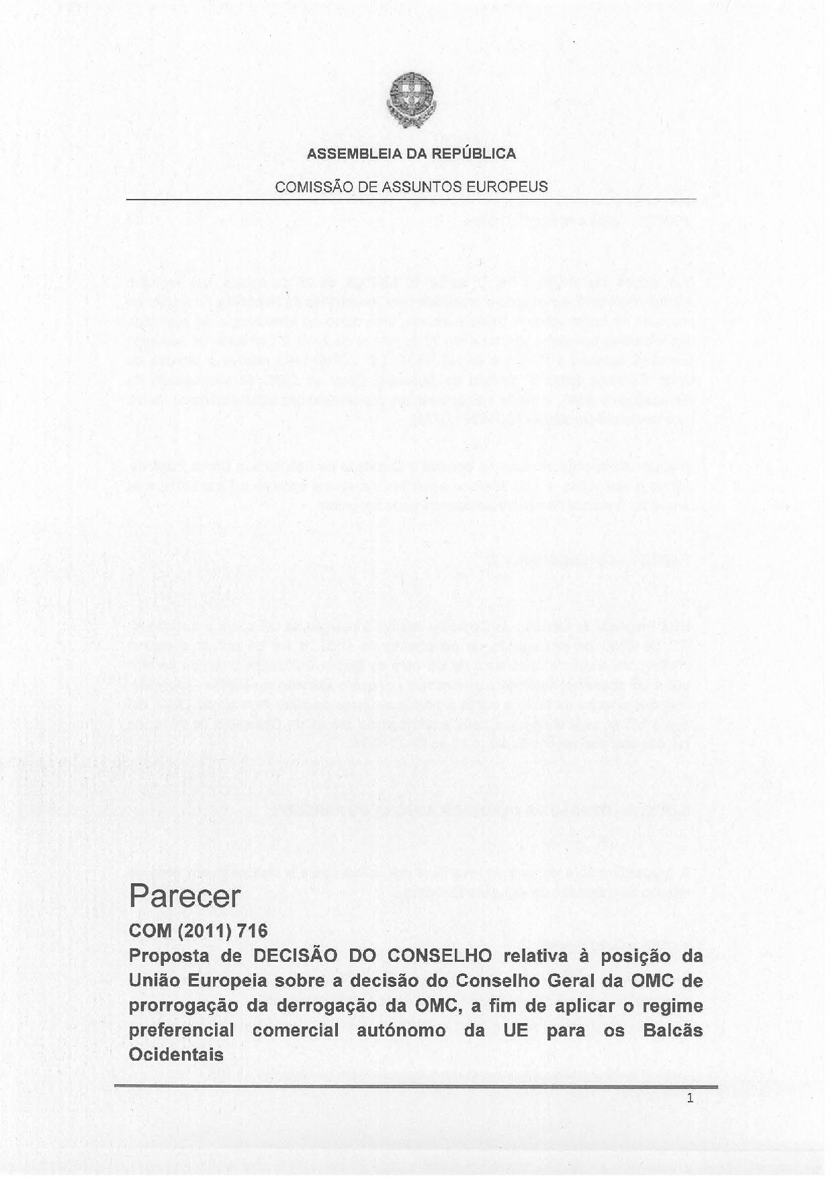
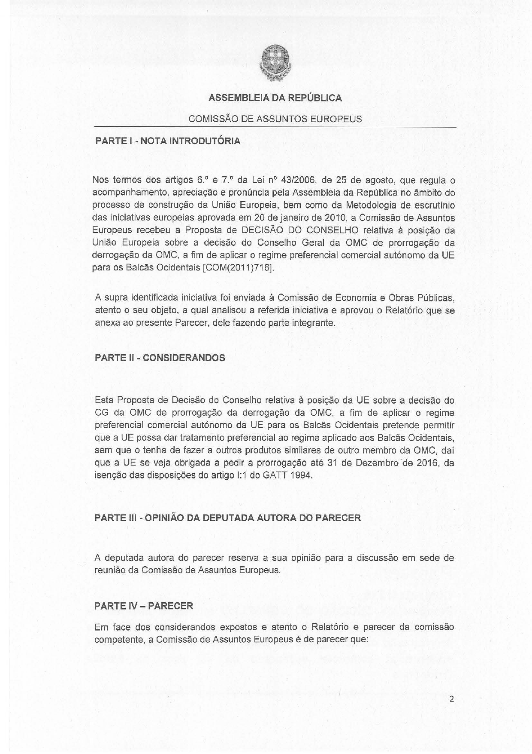
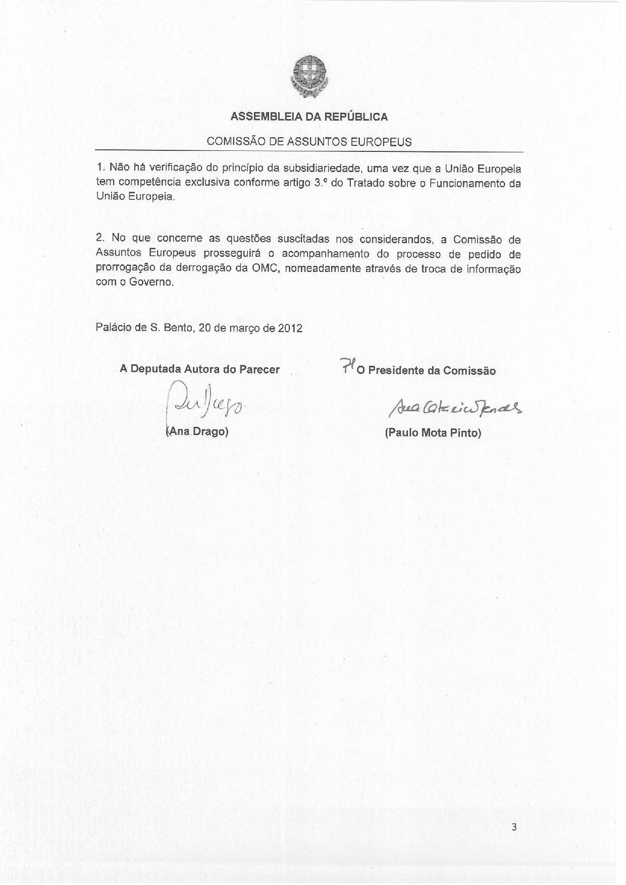
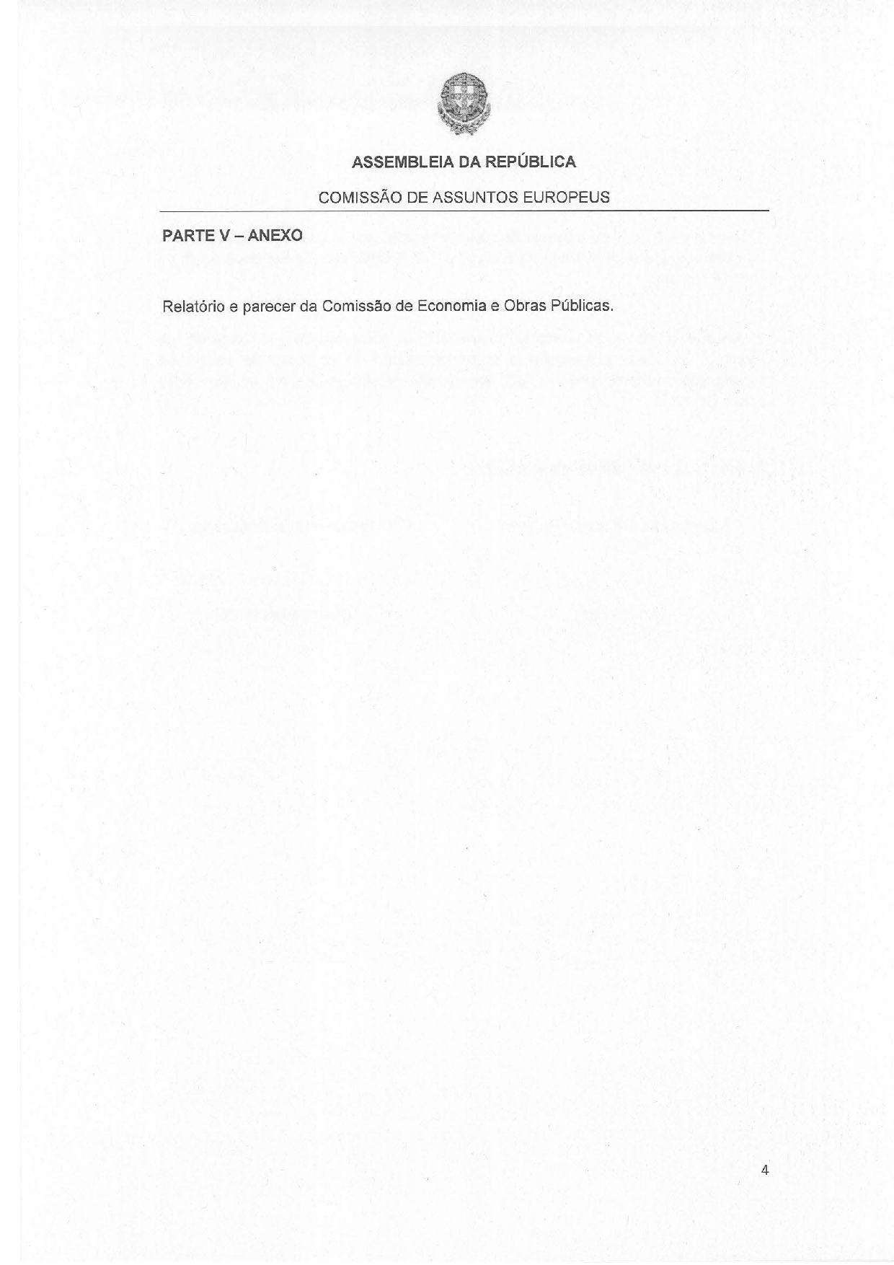
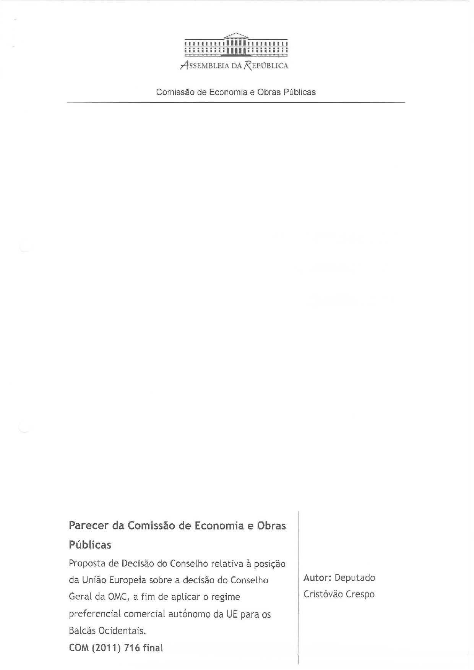
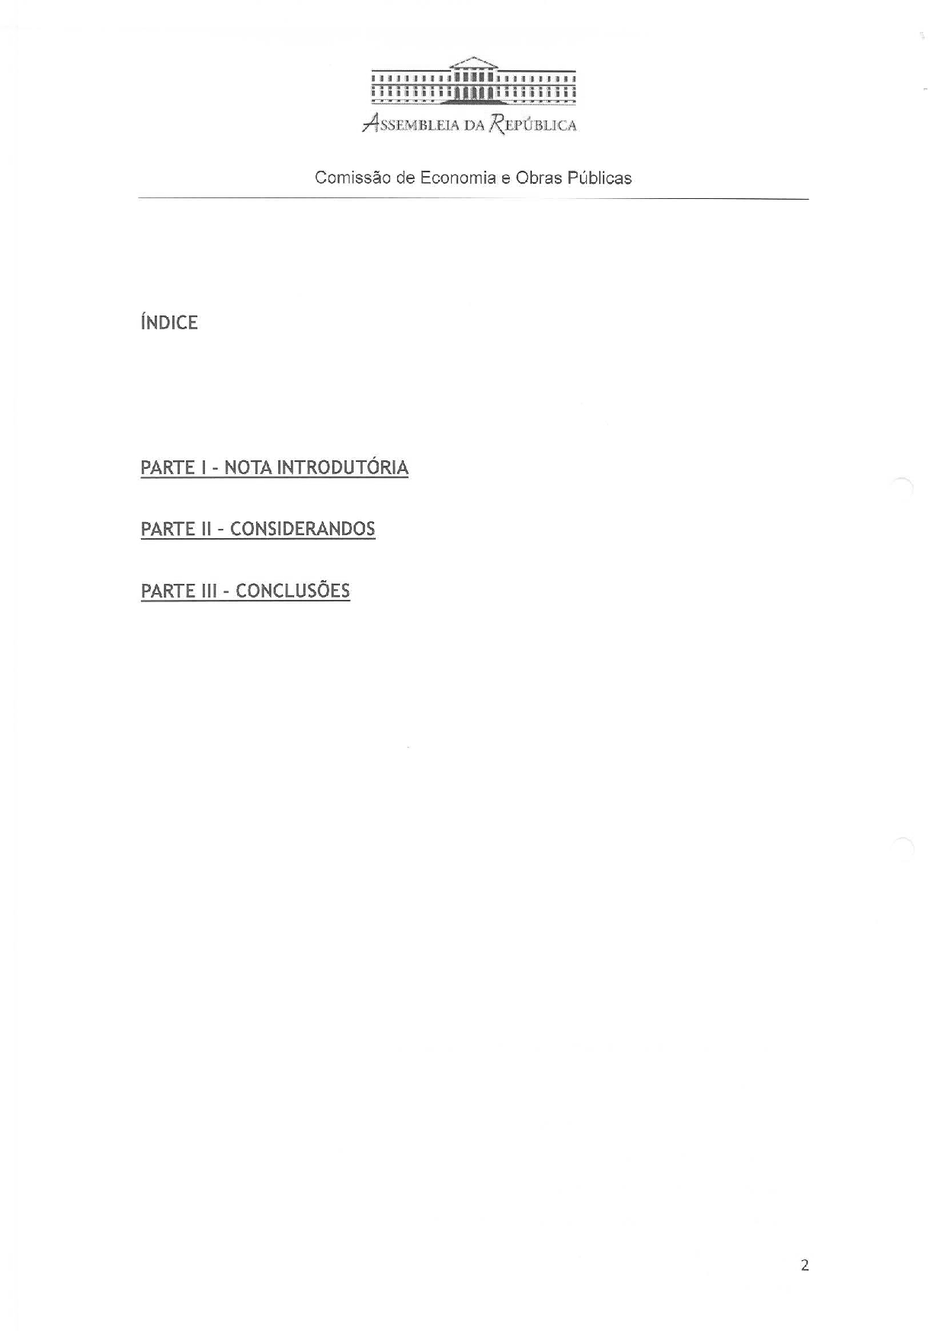
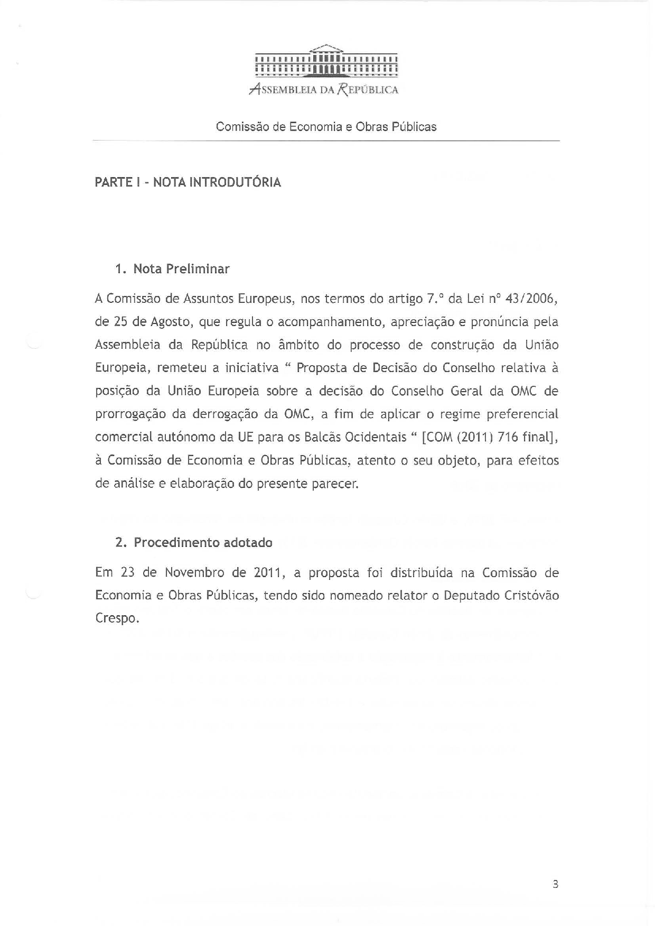
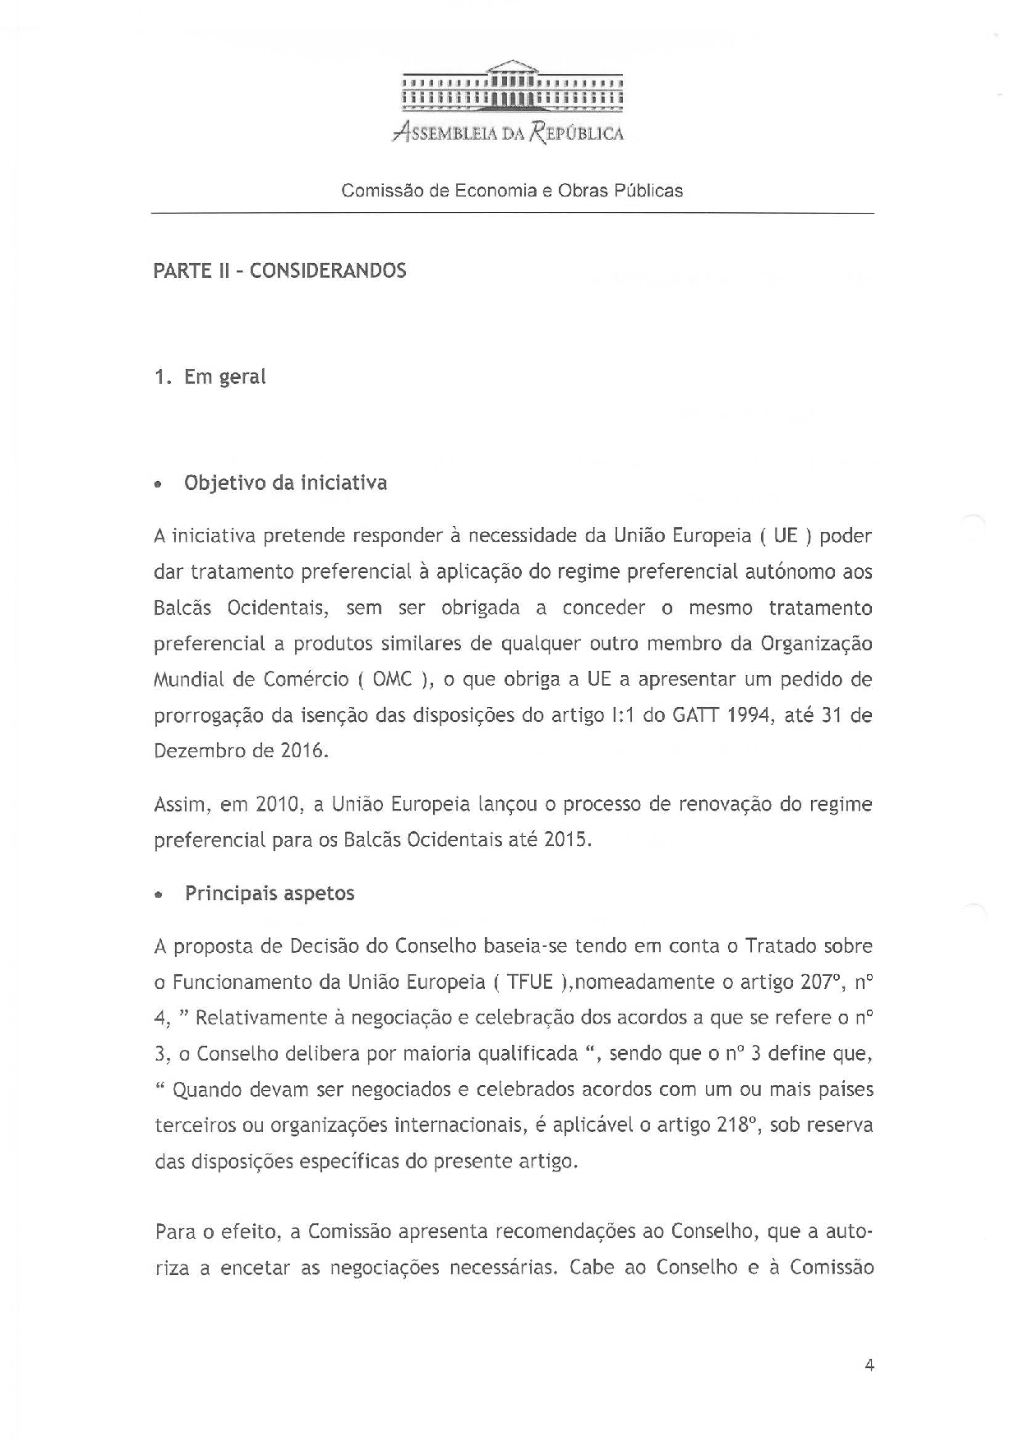
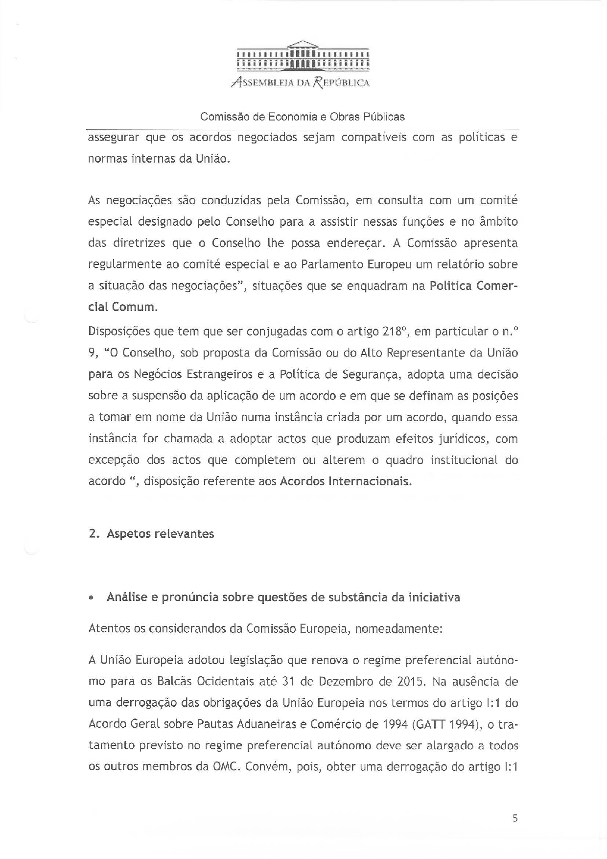
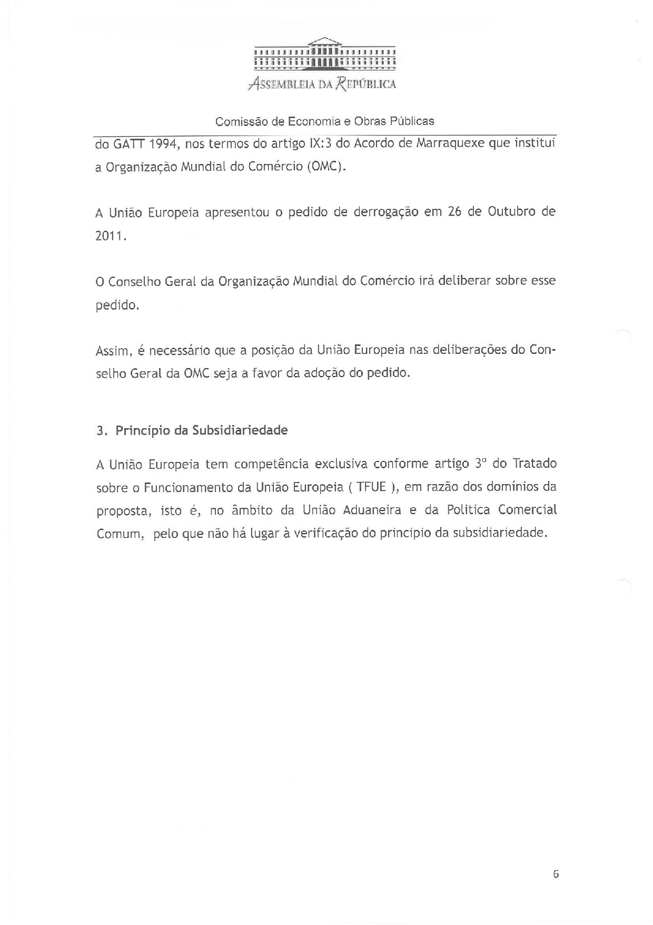
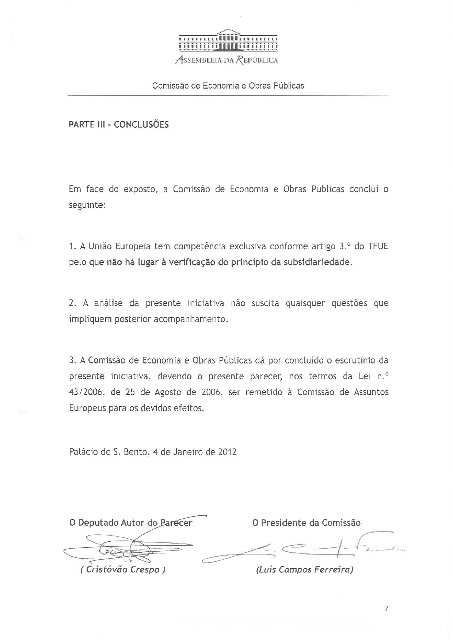

The translation of the opinion may be available at the Interparliamentary EU information exchange site IPEX, at the following address: http://www.ipex.eu/IPEXL-WEB/search.do.

