 | 
COUNCIL OF  THE EUROPEAN UNION |  |  | Brussels, 28 March 2012
 | Interinstitutional File:  2012/0003 (COD) |  | 8300/12
SOC 246
CODEC 865
INST 247
PARLNAT 175

COVER NOTE
from: | The Senate of the Italian Republic
date of receipt: | 28 March 2012
to: | Ms Helle Thorning-Schmidt, President of the Council of the European Union
Subject: | Proposal for a Directive of the European Parliament and of the Council amending Directive 2004/40/EC on minimum health and safety requirements regarding the exposure of workers to the risks arising from physical agents (electromagnetic fields) (eighteenth individual Directive within the meaning of Article 16(1) of Directive 89/391/EEC)  [doc. 5733/12 SOC 54 CODEC 197 - COM(2012) 15 final]  - Opinion on the application of the Principles of Subsidiarity and Proportionality

Delegations will find attached the above mentioned opinion.

_________________
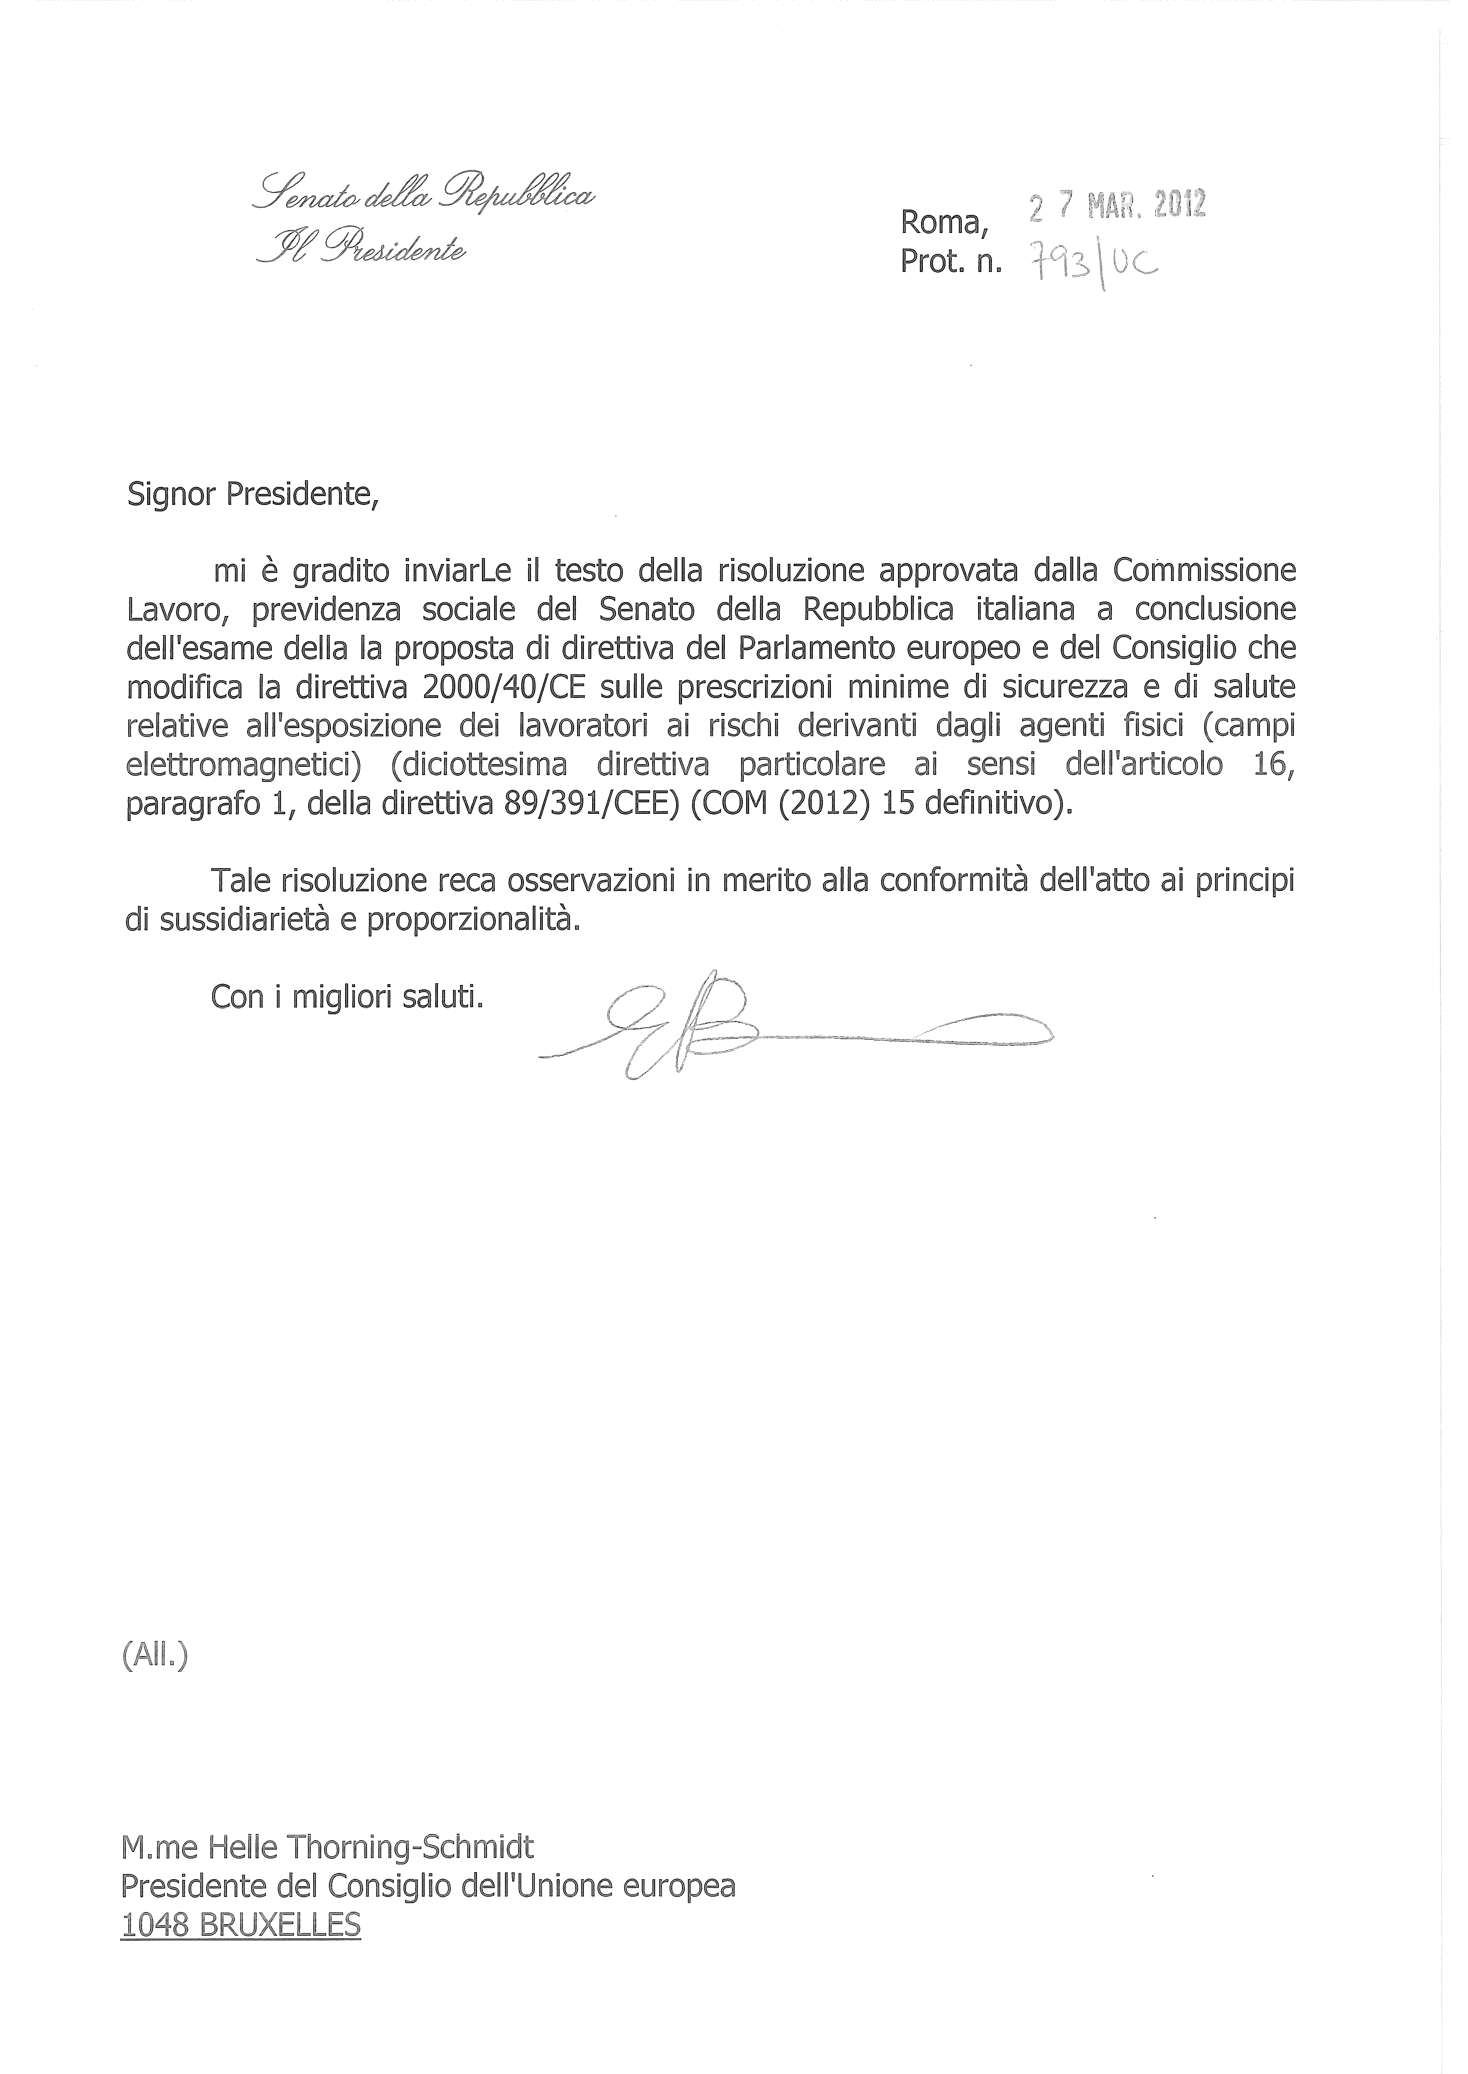

___________________

For available translations of this opinion see the interparliamentary EU information exchange site (IPEX) at the following address: http://www.ipex.eu/IPEXL-WEB/search.do

