 | 
COUNCIL OF  THE EUROPEAN UNION |  |  | Brussels, 4 May 2012
 | Interinstitutional File:  2012/0035 (COD) |  | 9384/12
PHARM 29
MI 276
SAN 90
ENT 101
CODEC 1139
INST 317
PARLNAT 216

COVER NOTE
from: | Portuguese Parliament
date of receipt: | 20 April 2012
to: | The President of the Council of the European Union
No Cion doc.: | 7315/12 PHARM 14 MI 155 SAN 48 ENT 58 CODEC 567 -  COM(2012) 84 final
Subject: | Proposal for a Directive of the European Parliament and of the Council relating to the transparency of measures regulating the prices of medicinal products for human use and their inclusion in the scope of public health insurance systems  - Opinion on the application of the Principles of Subsidiarity and Proportionality

Delegations will find attached for information a copy of the above opinion.

________________________

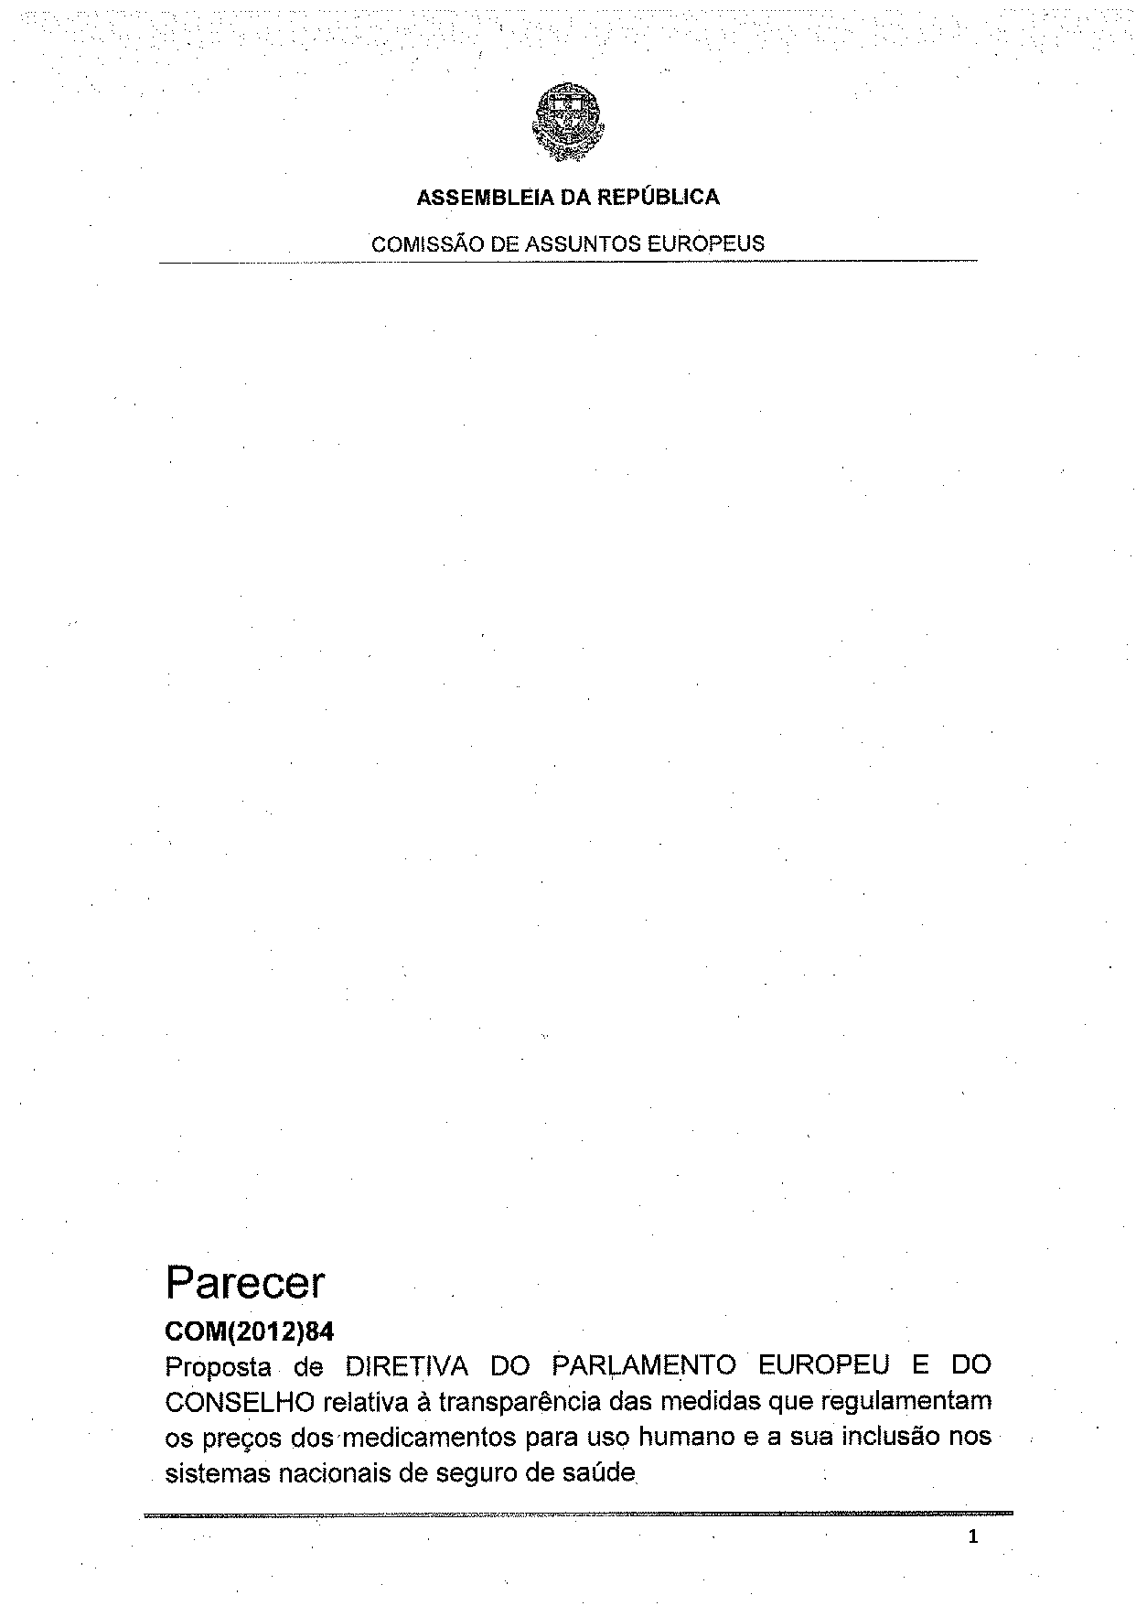
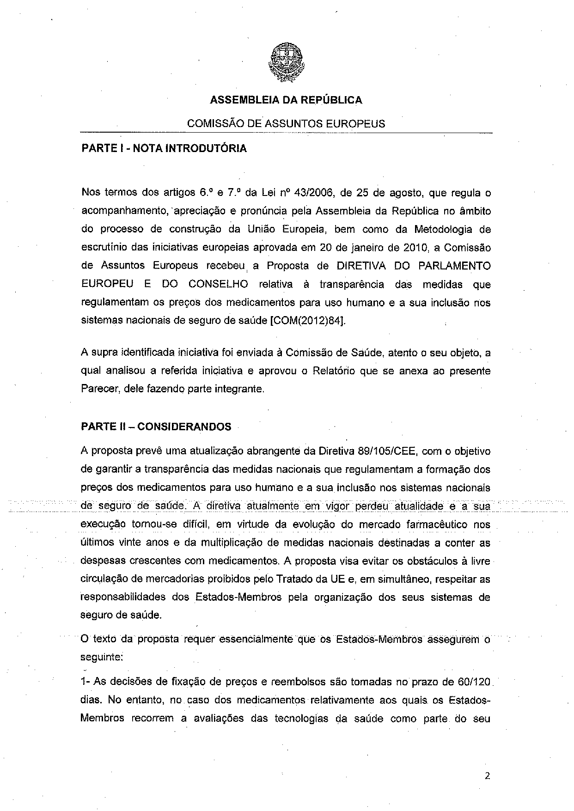
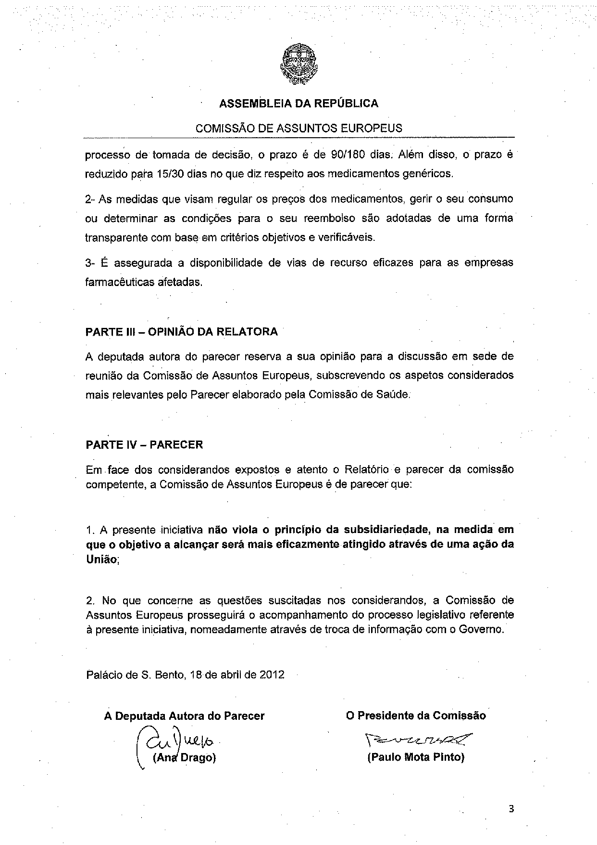

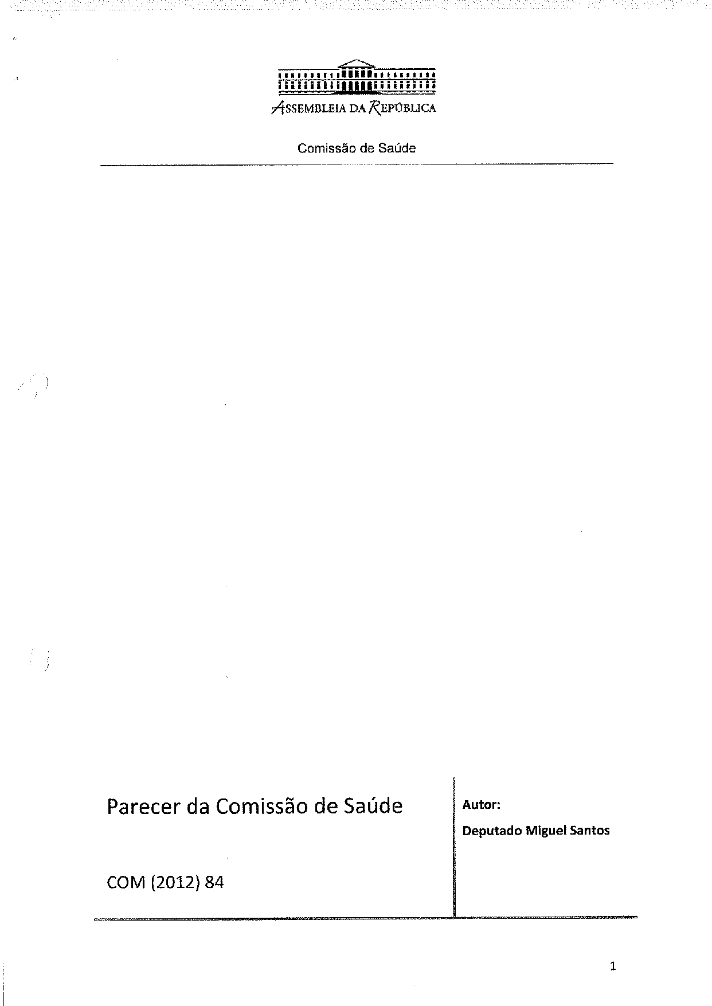
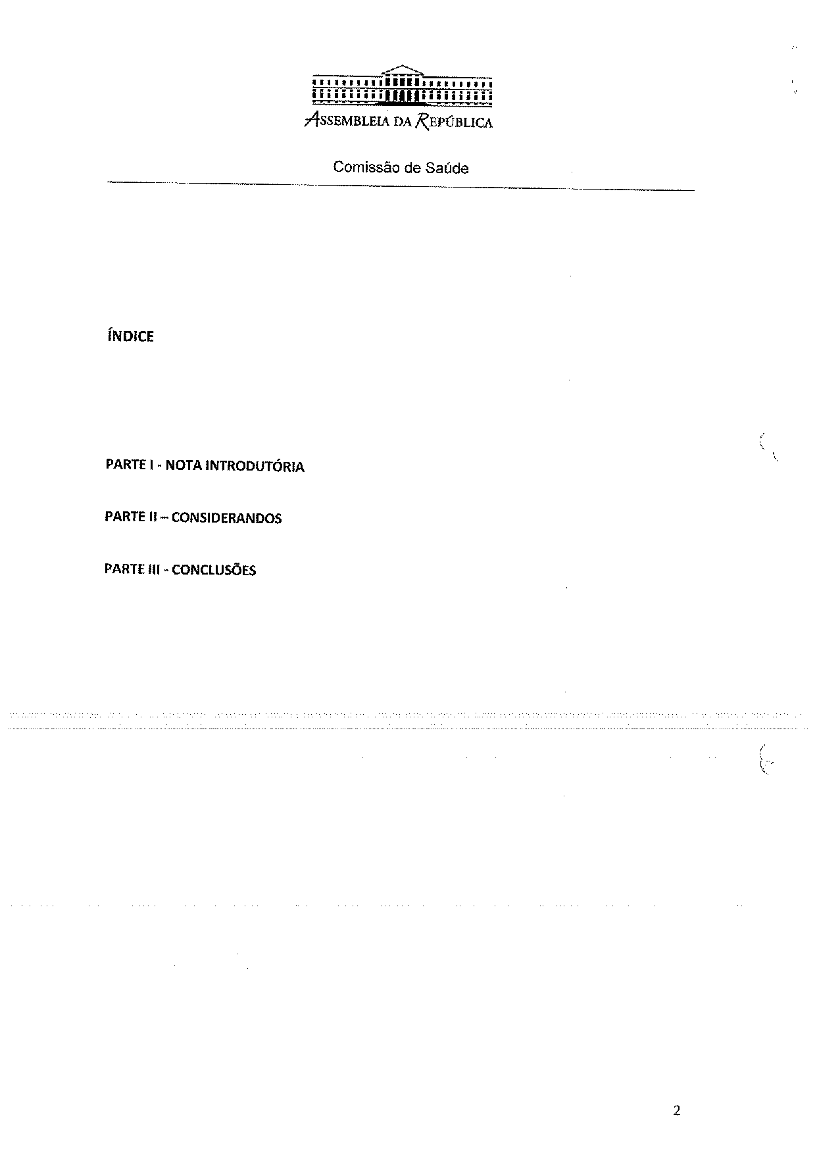
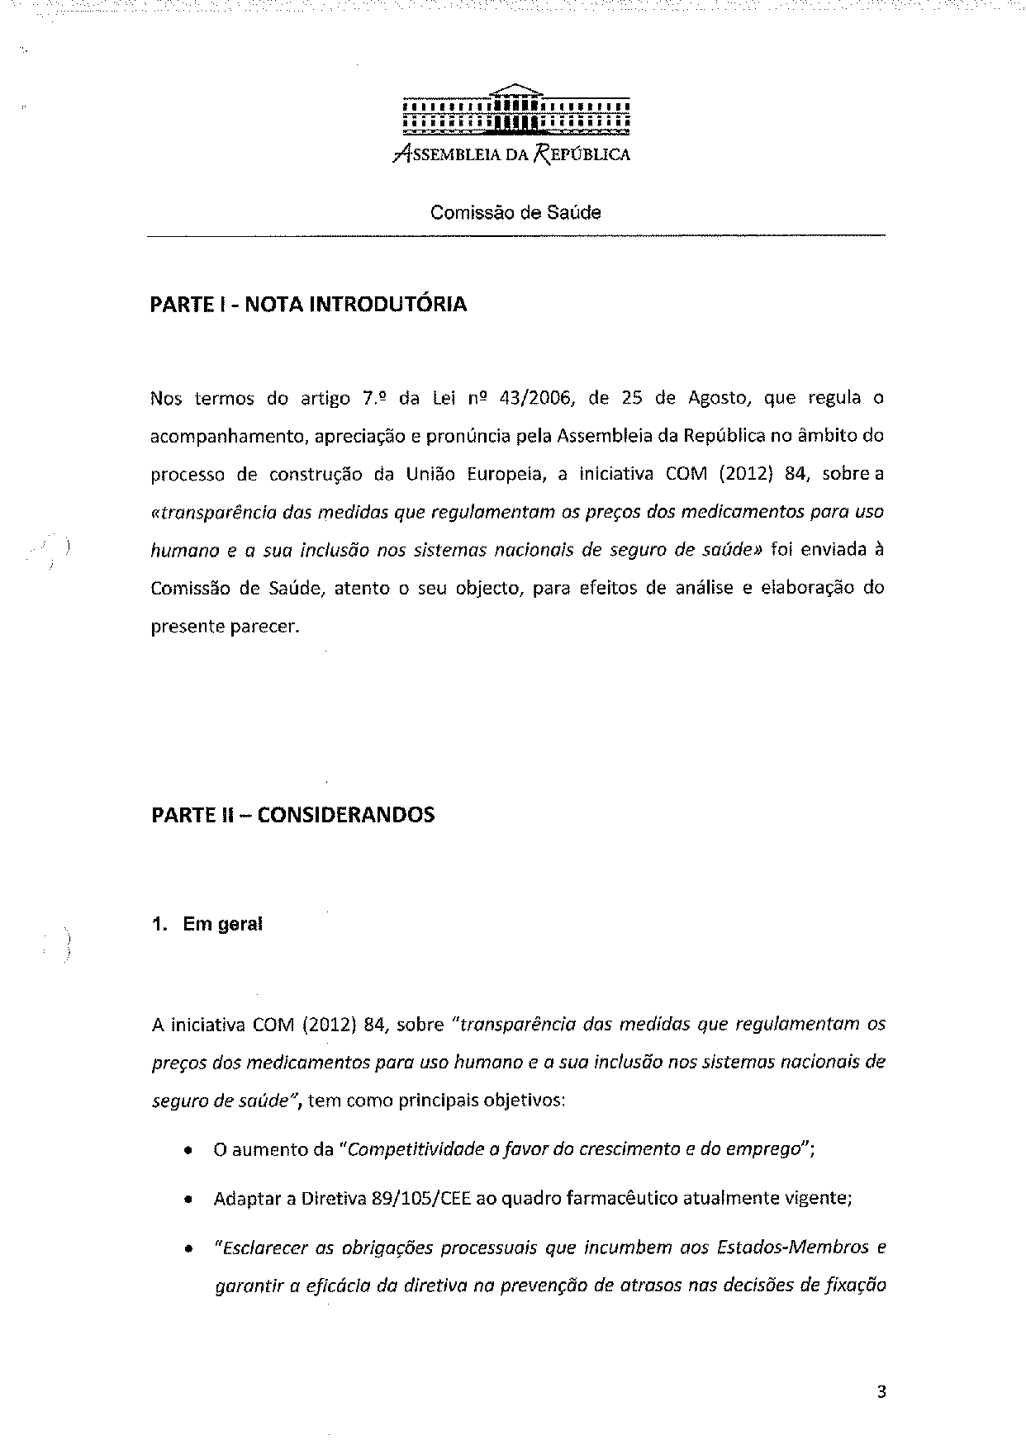
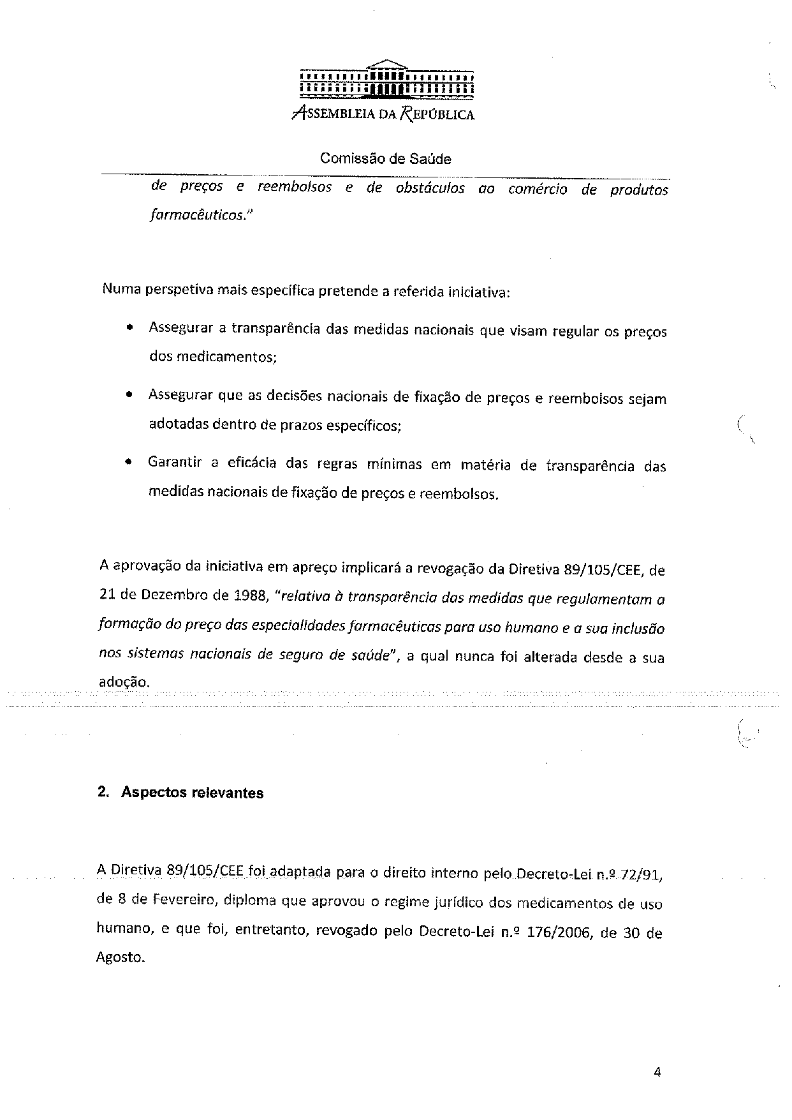
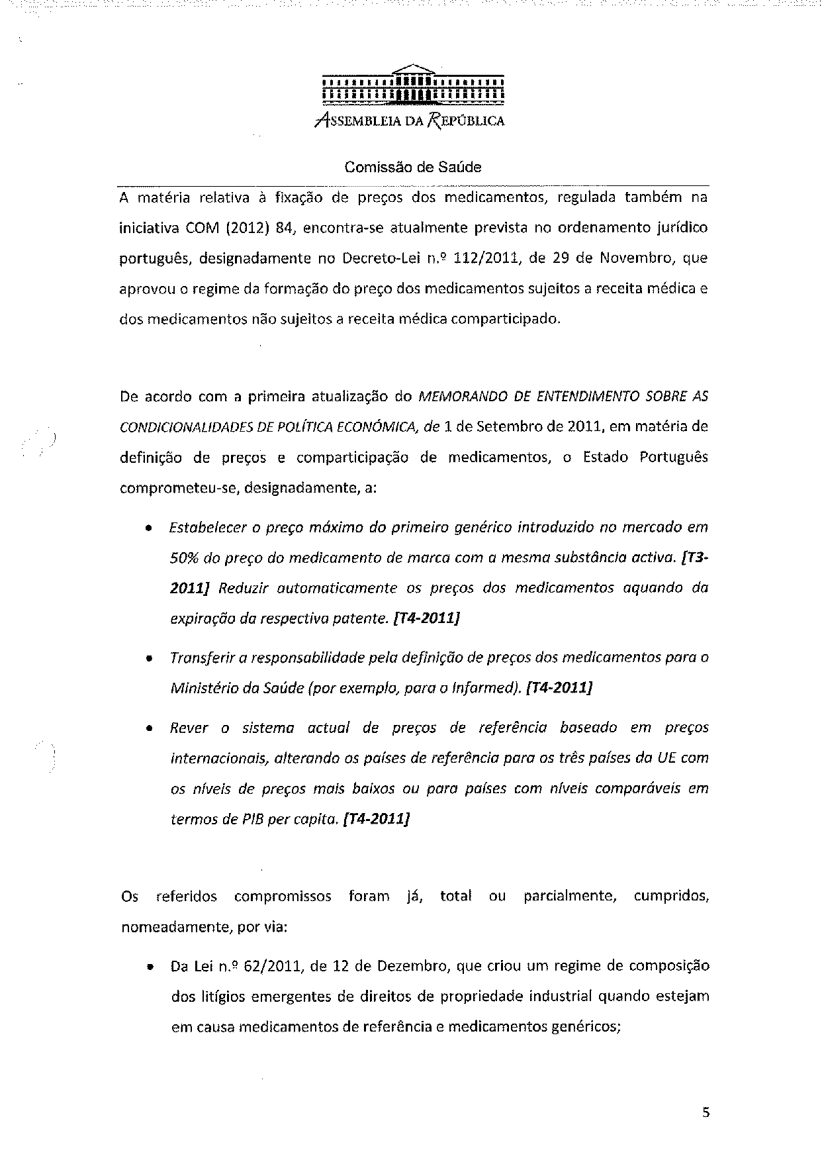
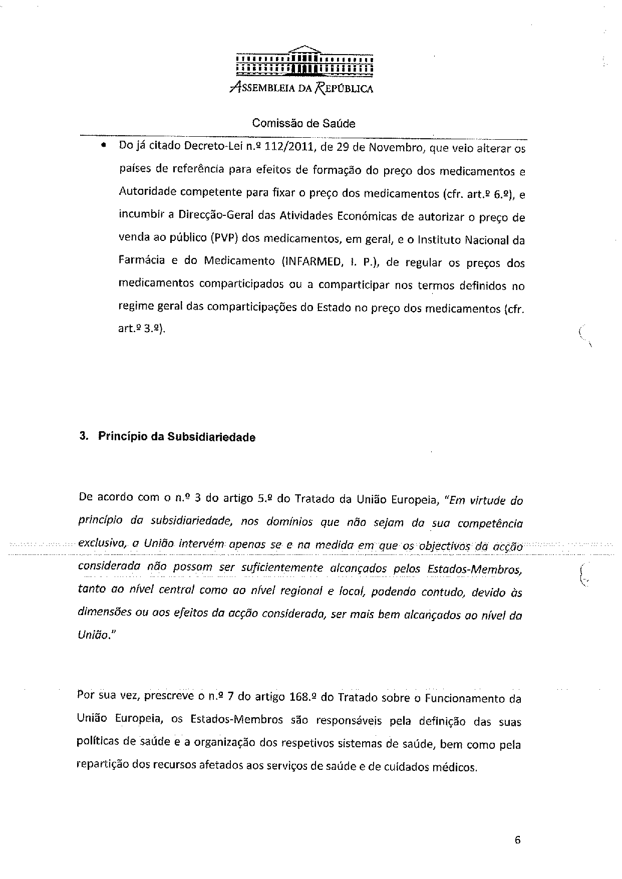
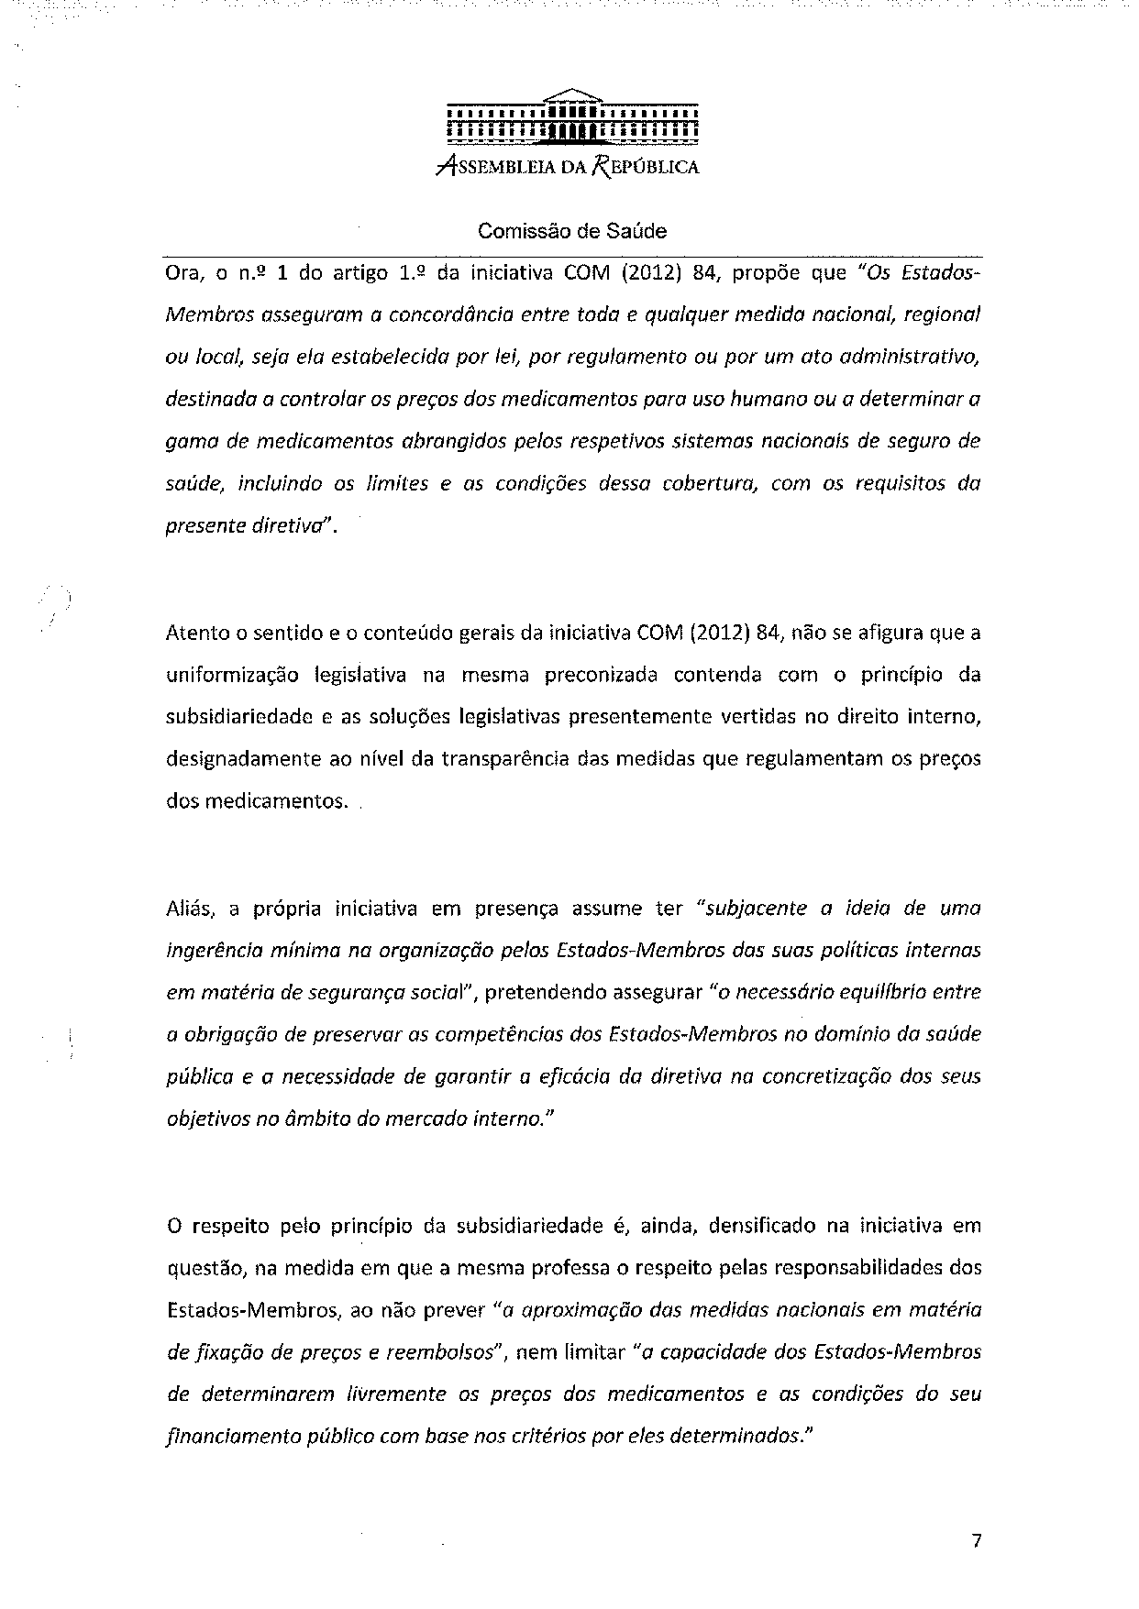
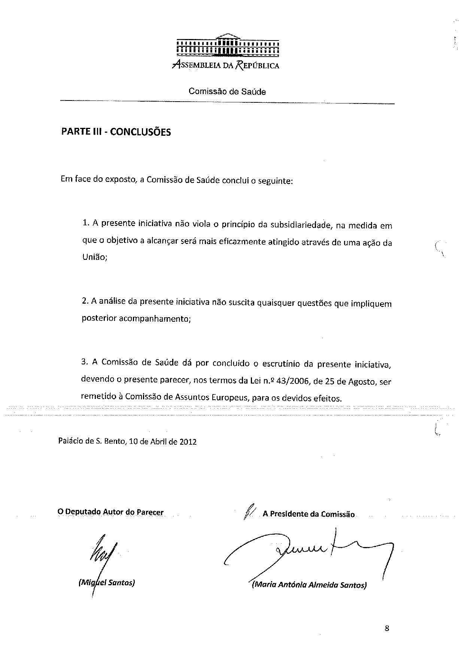

The translation can be found at the Interparliamentary EU information exchange site IPEX at the following address: http://www.ipex.eu/IPEXL-WEB/dossier/document/COM20120084FIN.do#dossier-COD20120035

