 | 
COUNCIL OF  THE EUROPEAN UNION |  |  | Brussels, 2 May 2012
 | Interinstitutional File:  2011/0360 (COD)  2011/0361 (COD) |  | 9334/12
EF 105
ECOFIN 372
CODEC 1126
INST 304
PARLNAT 209

COVER NOTE
from: | The President of the Italian Senate
date of receipt: | 26 April 2012
to: | Mr Uwe CORSEPIUS, Secretary-General of the Council of the European Union
Subject: | Proposal for a DIRECTIVE OF THE EUROPEAN PARLIAMENT AND OF THE COUNCIL amending Directive 2009/65/EC on the coordination of laws, regulations and administrative provisions relating to undertakings of collective investment in transferable securities (UCITS) and Directive 2011/61/EU on Alternative Investment Funds Managers in respect of the excessive reliance on credit ratings [doc. 17329/11 - COM(2011) 746 final]  and  Proposal for a REGULATION OF THE EUROPEAN PARLIAMENT AND OF THE COUNCIL amending Regulation (EC) No 1060/2009 on credit rating agencies [doc. 17308/11 - COM(2011) 747 final]  - Opinion on the application of the Principles of Subsidiarity and Proportionality

Delegations will find attached the above mentioned opinion.

________________________

Encl.:

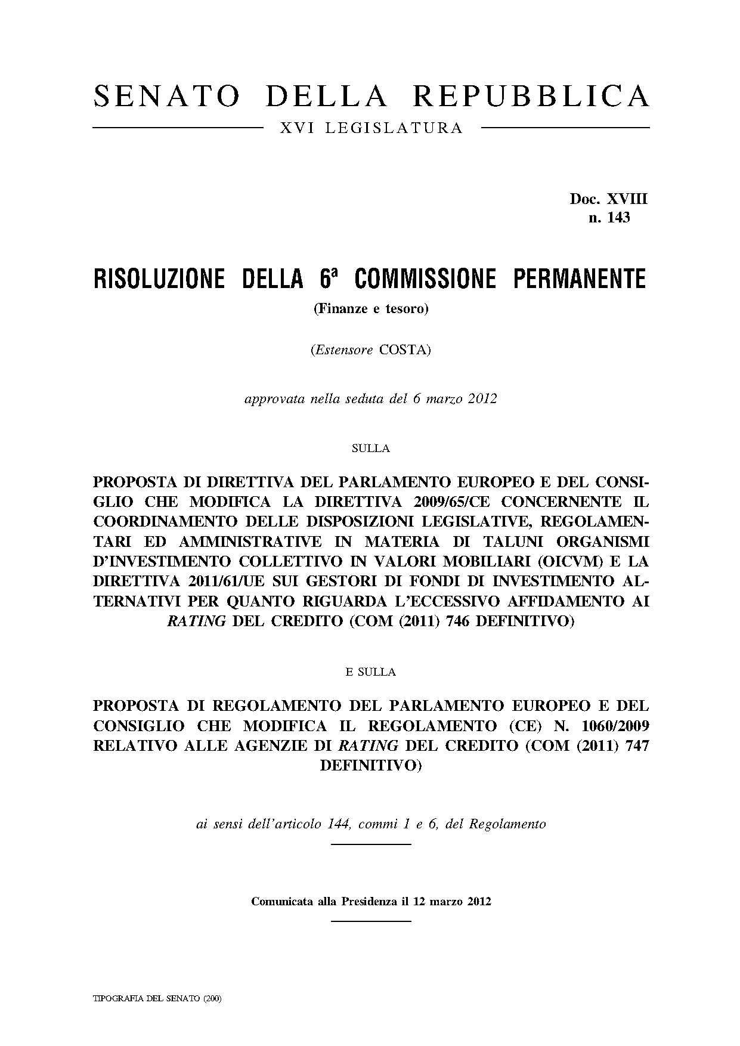
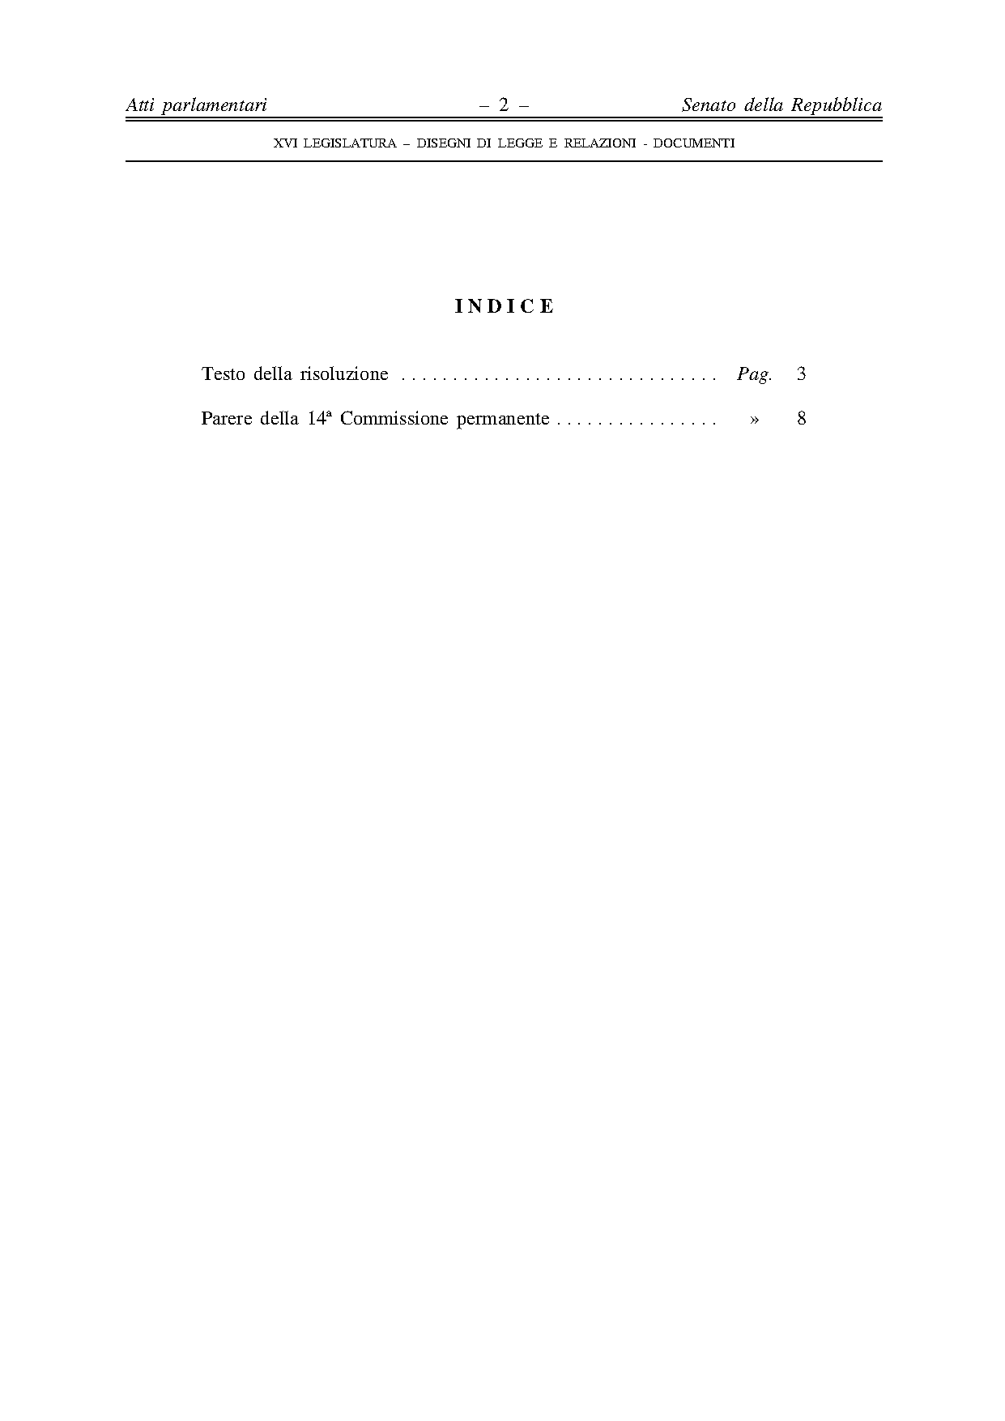
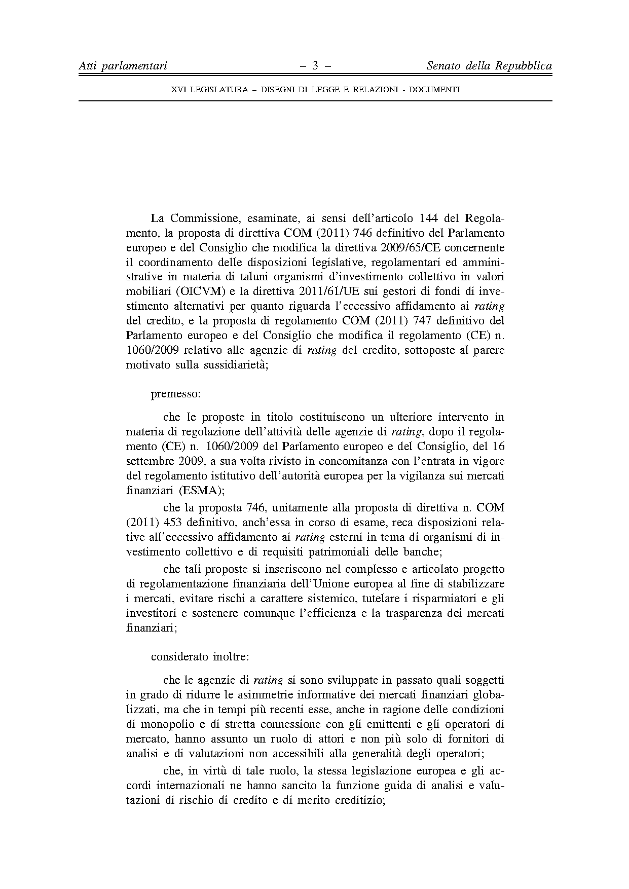
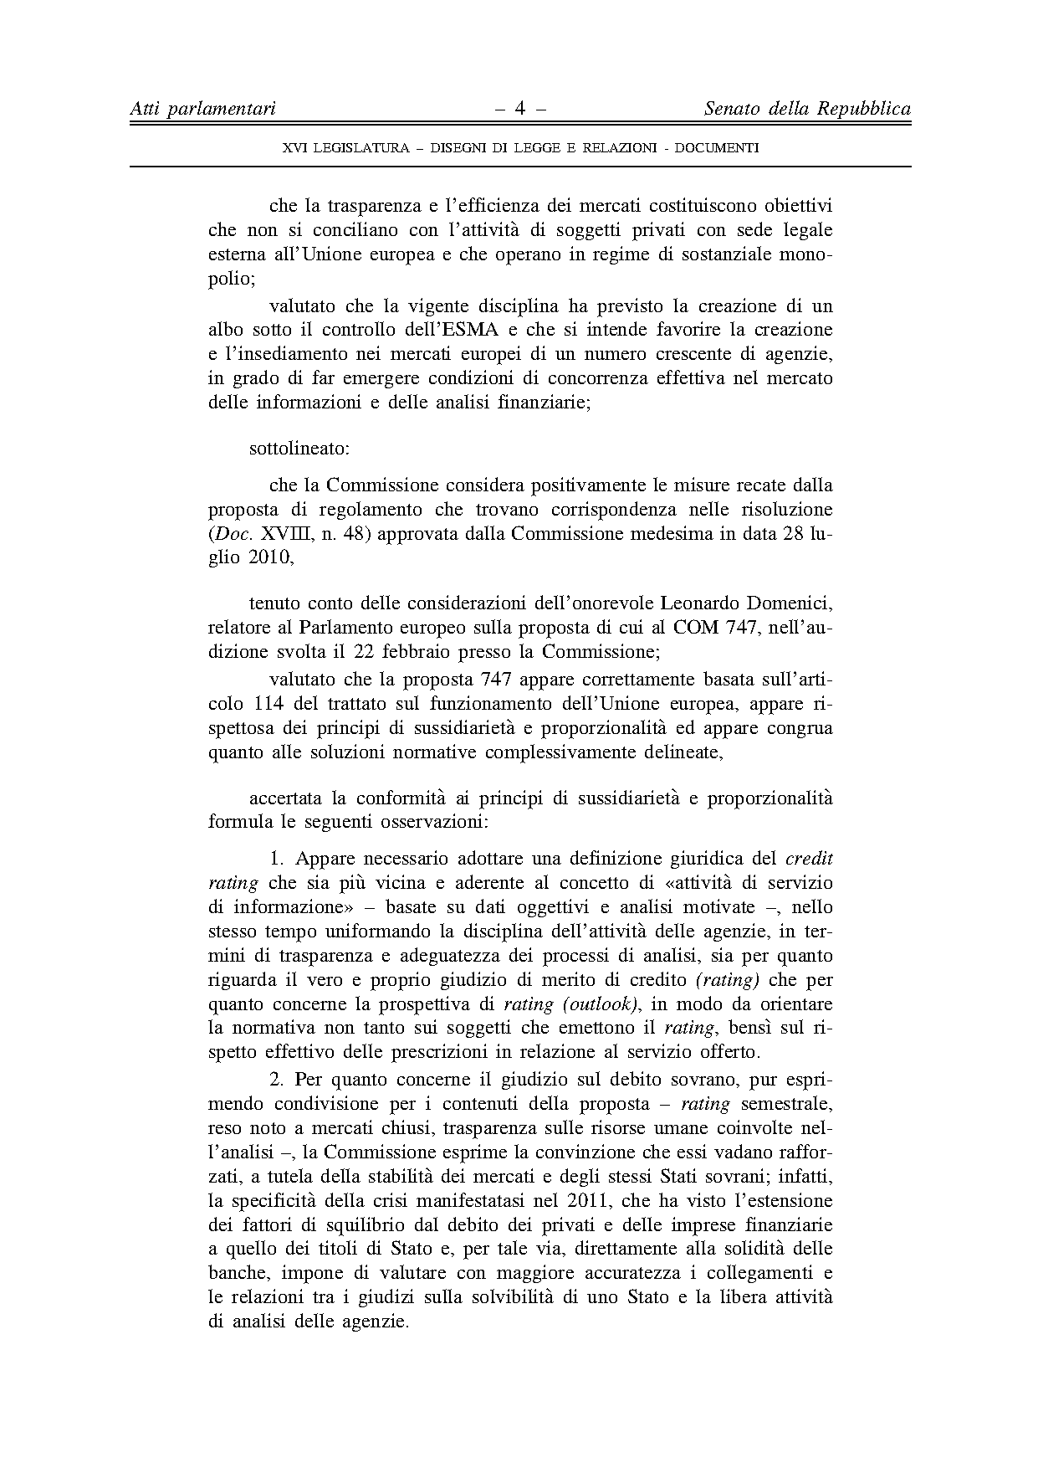
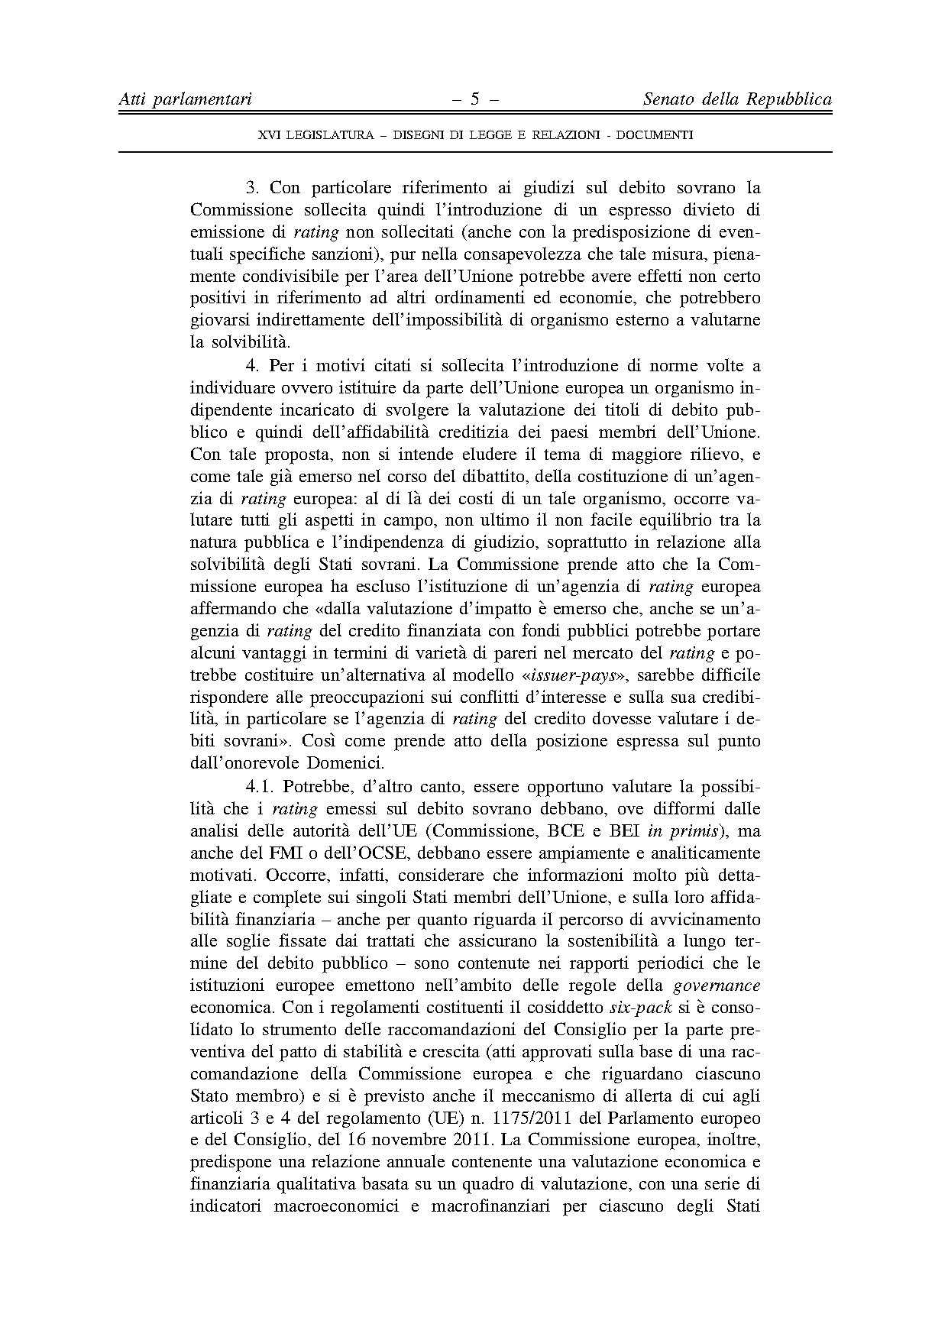
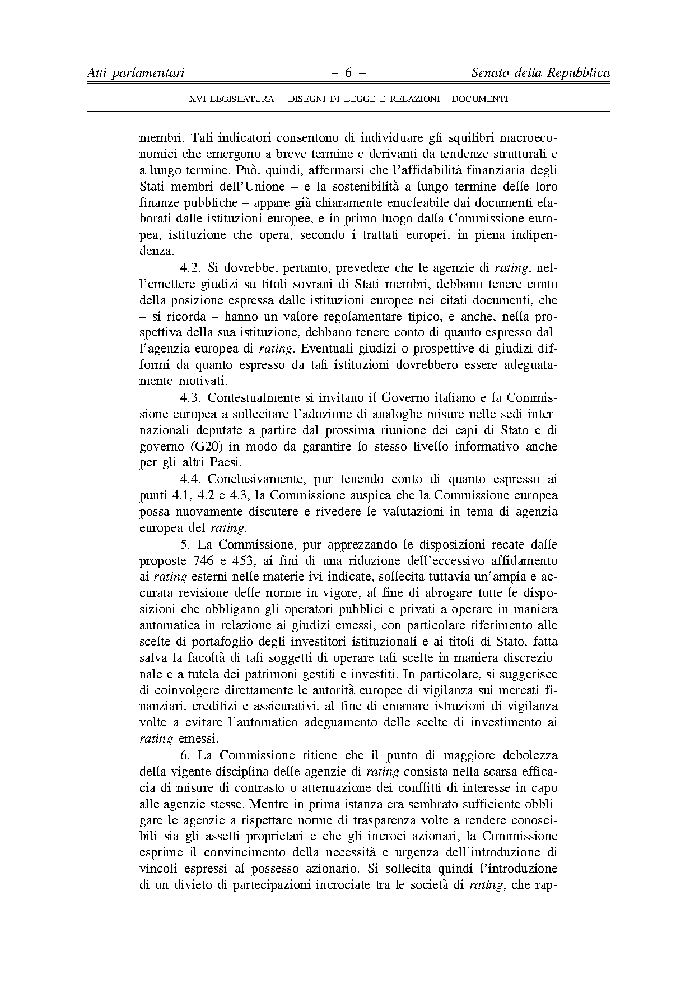
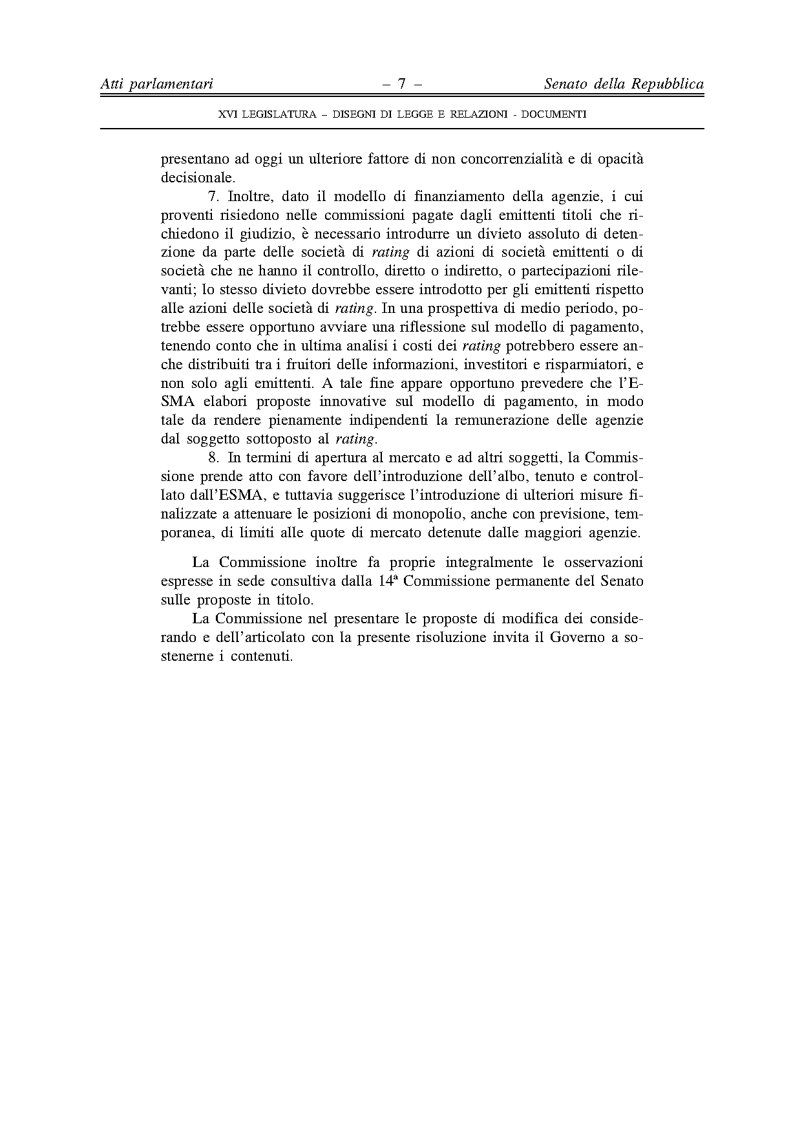
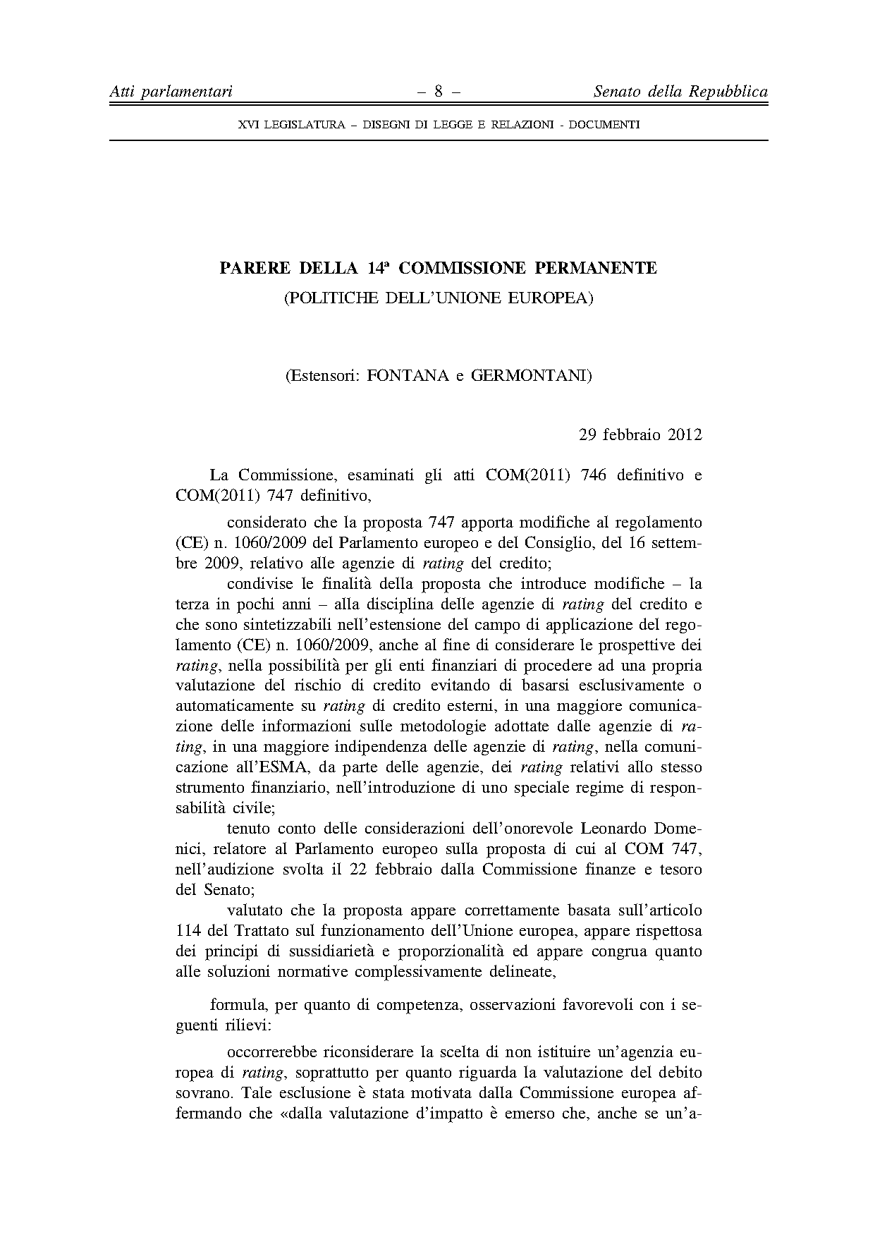
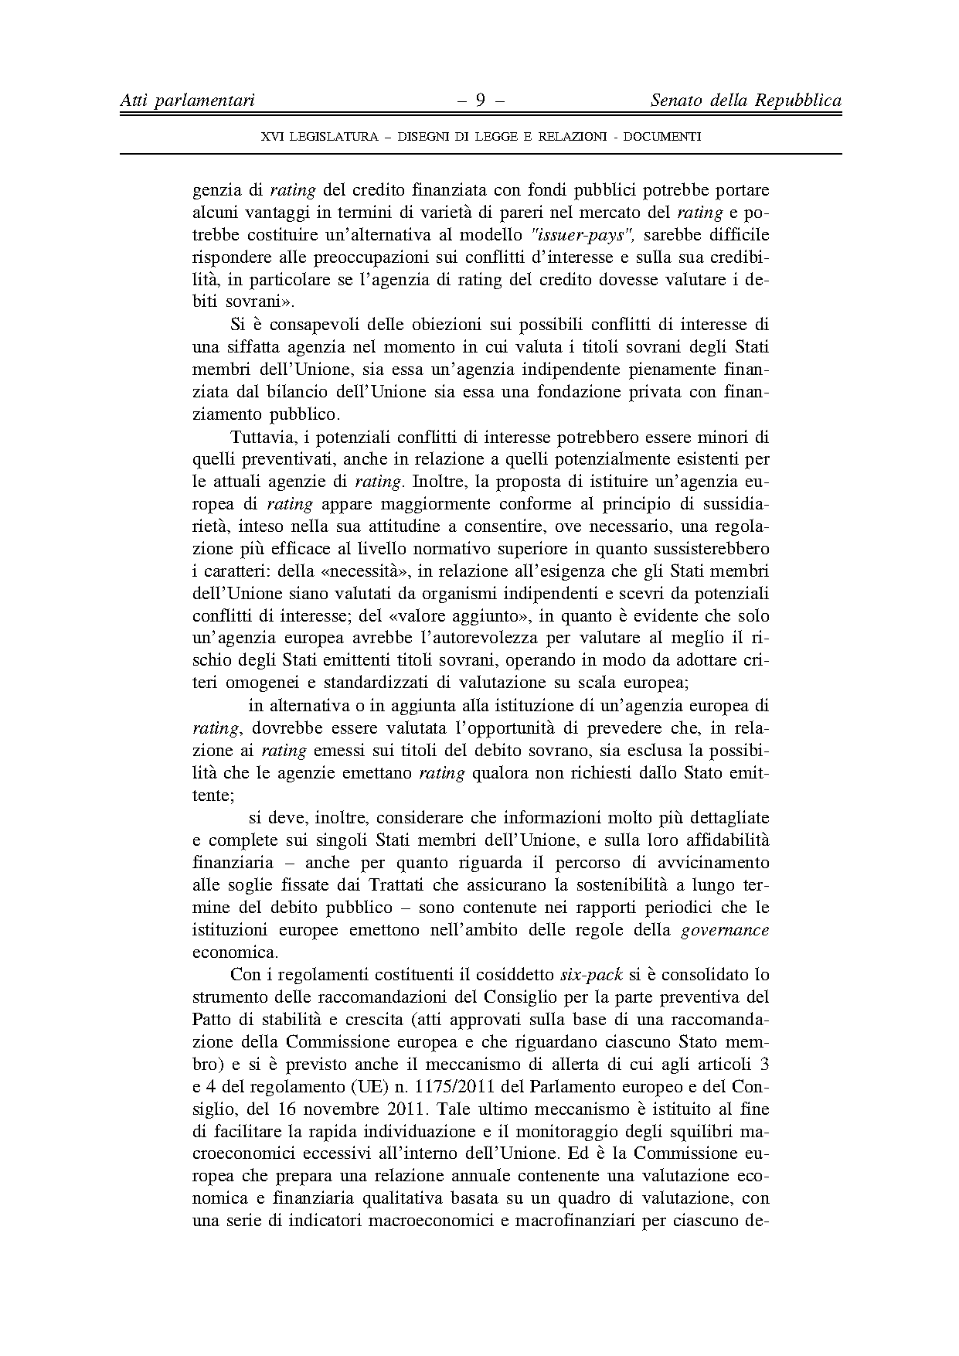
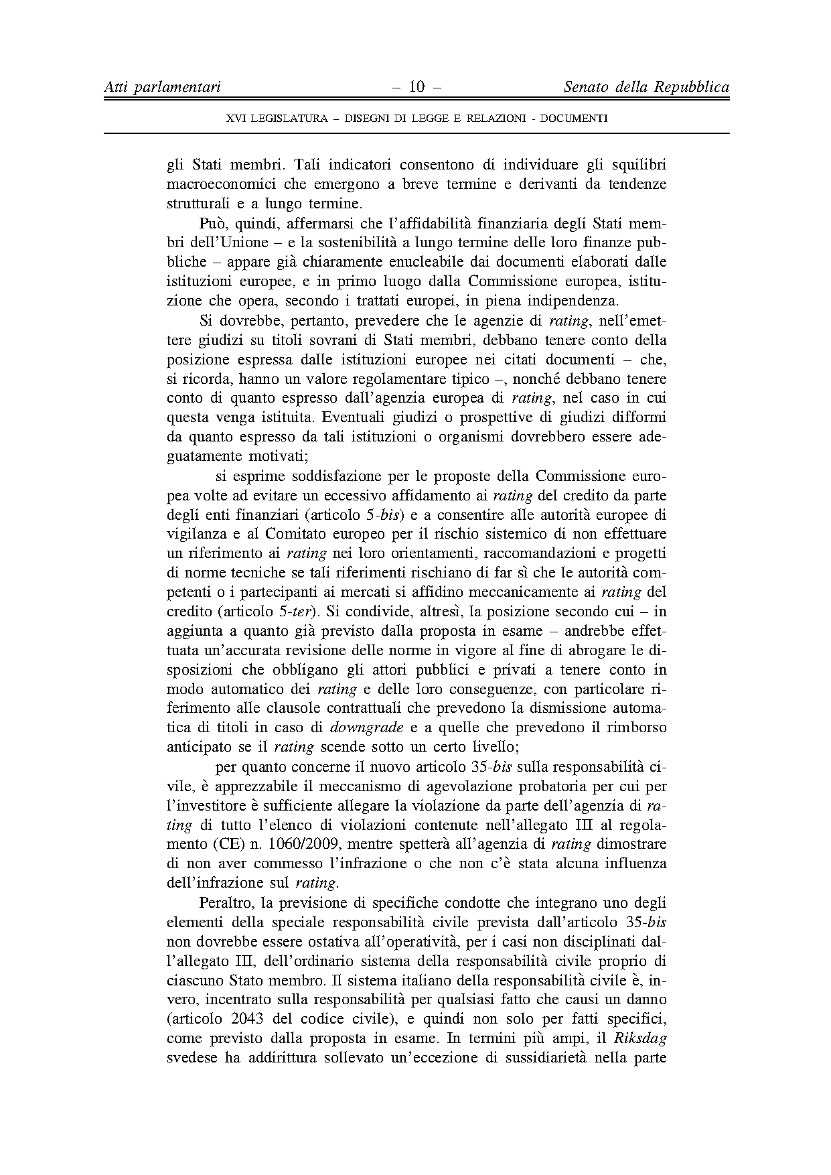
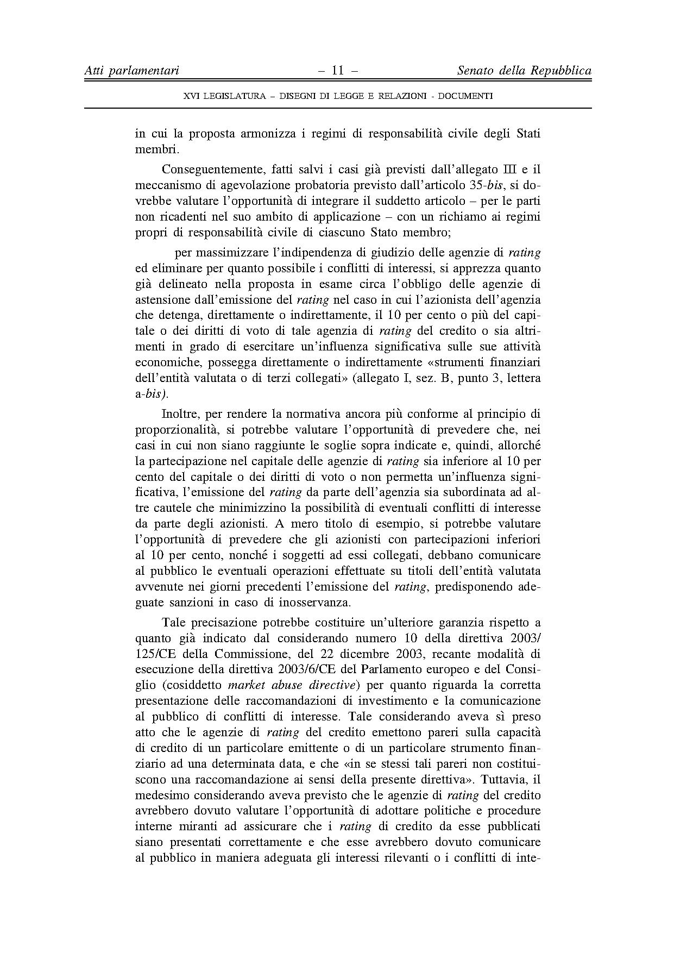
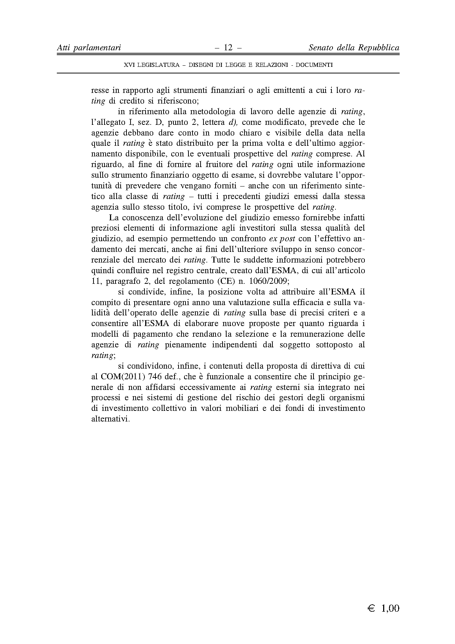

This opinion is available in English on the interparliamentary EU information exchange site (IPEX) at the following address: http://www.ipex.eu/IPEXL-WEB/search.do

