 | 
COUNCIL OF  THE EUROPEAN UNION |  |  | Brussels, 2 May 2012
 | Interinstitutional File:  2011/0261 (CNS) |  | 9469/12
FISC 62
ECOFIN 381
INST 314
PARLNAT 213

COVER NOTE
from: | The Italian Senate
date of receipt: | 26 April 2012
to: | The President of the Council of the European Union
Subject: | Proposal for a COUNCIL DIRECTIVE on a common system of financial transaction tax and amending Directive 2008/7/EC  [doc. 14942/11 FISC 121 ECOFIN 651- COM(2011) 594 final]  - Opinion on the application of the Principles of Subsidiarity and Proportionality

Delegations will find attached the abovementioned opinion.

________________________

Encl.

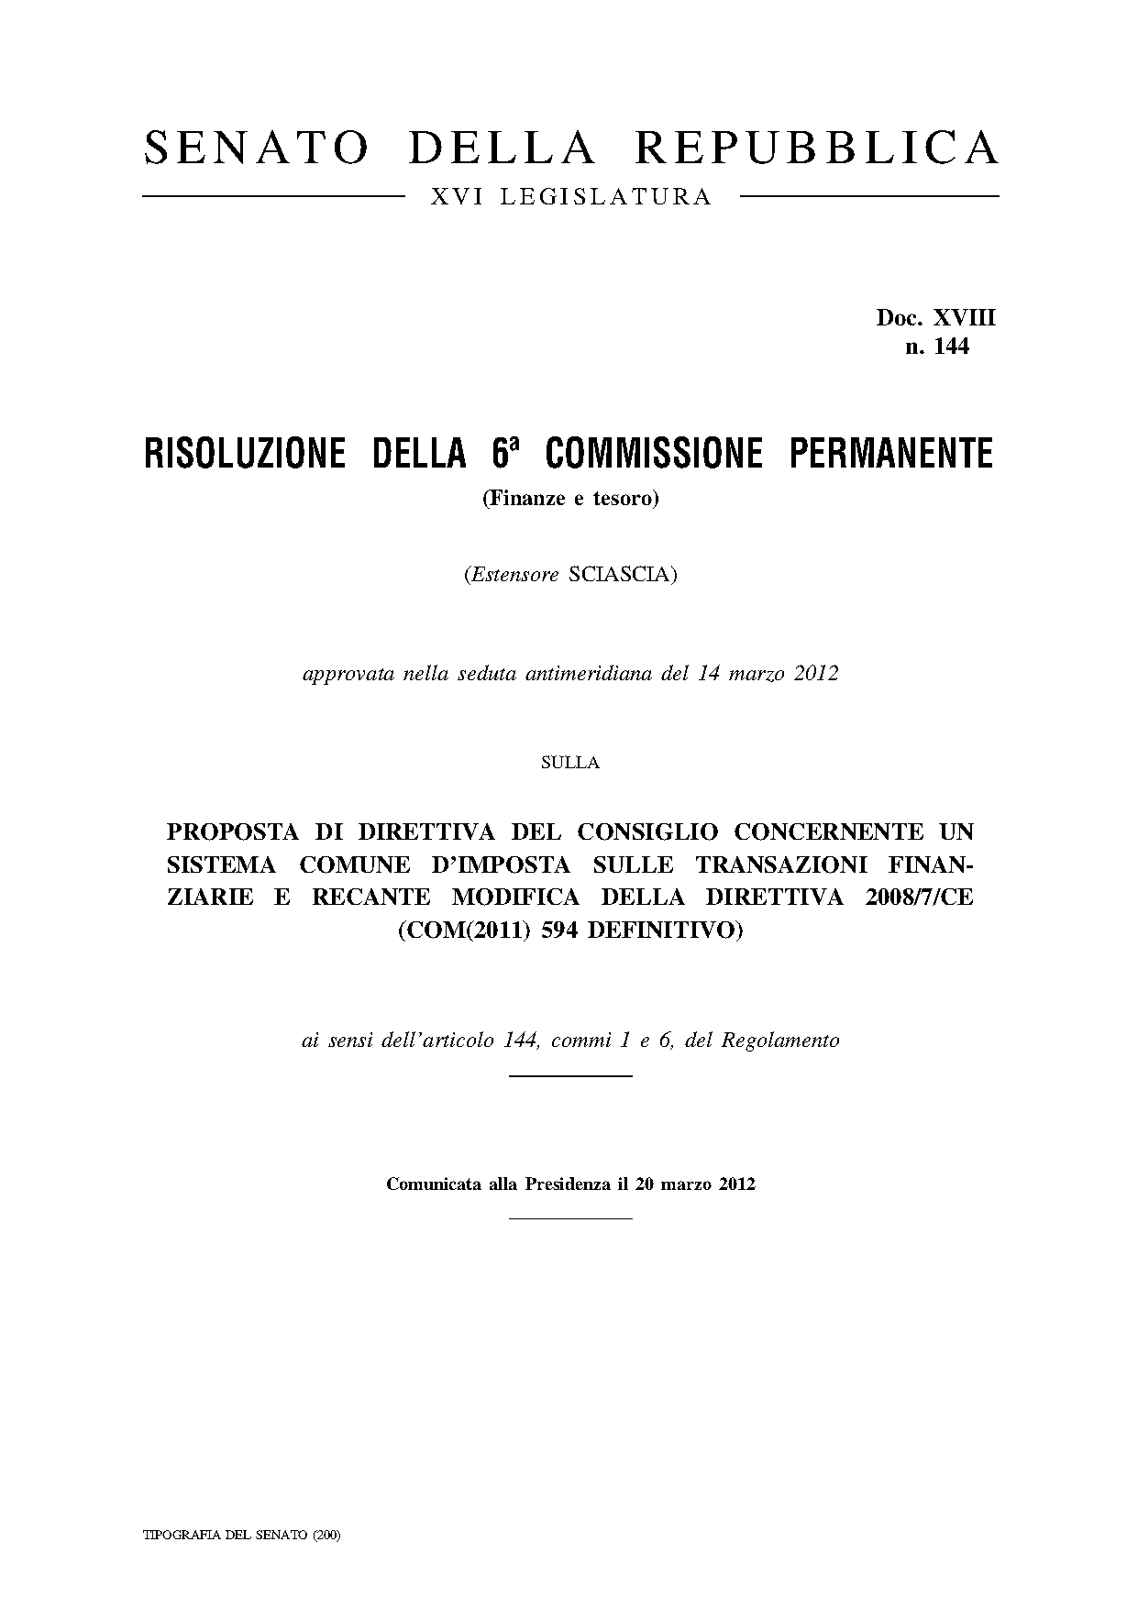

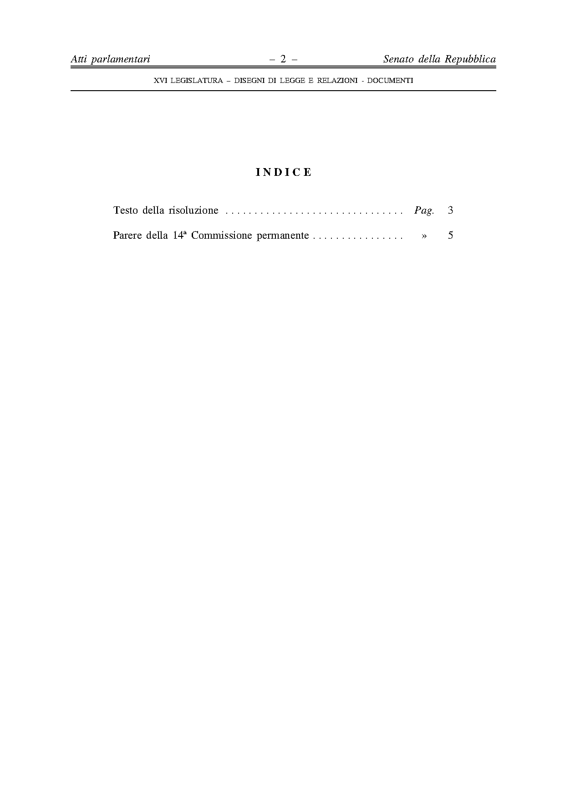

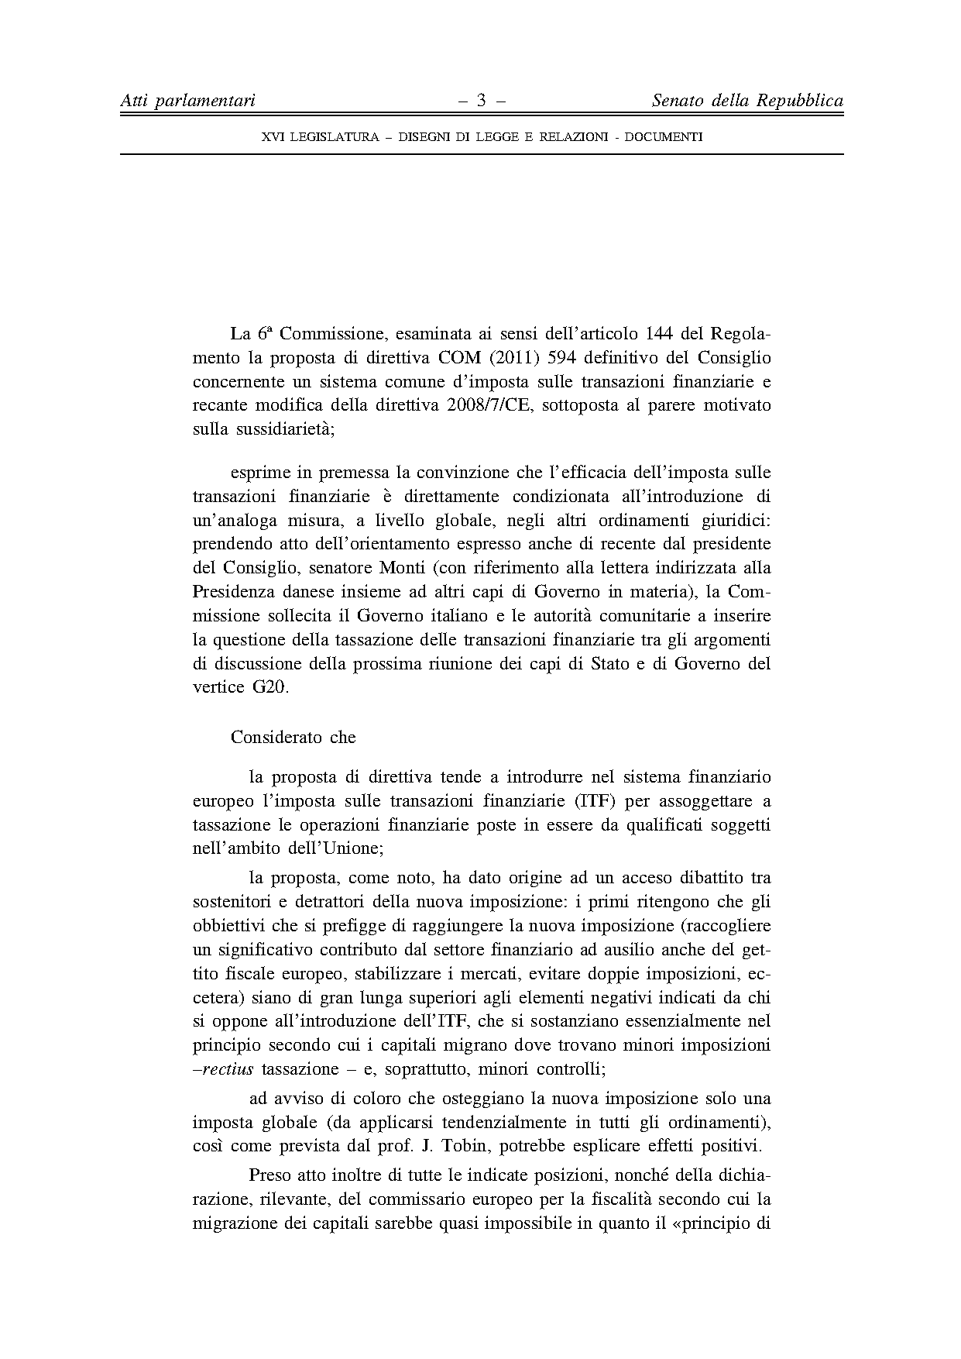

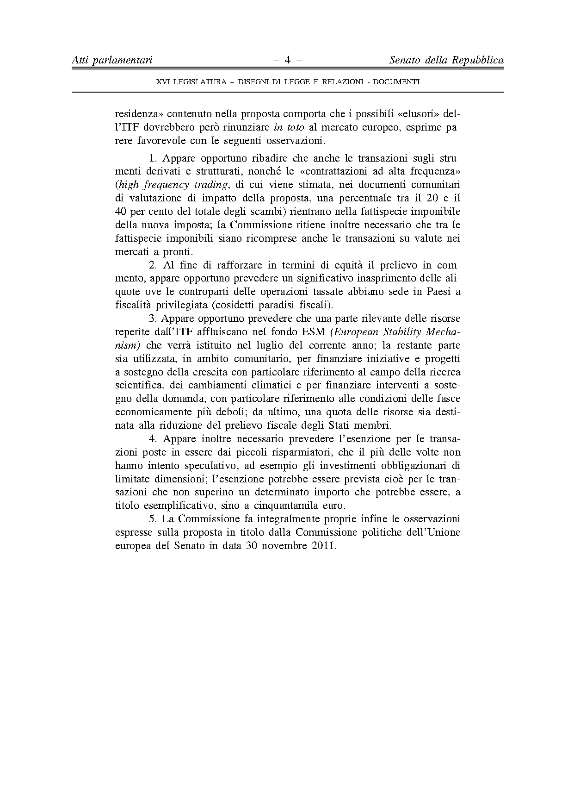

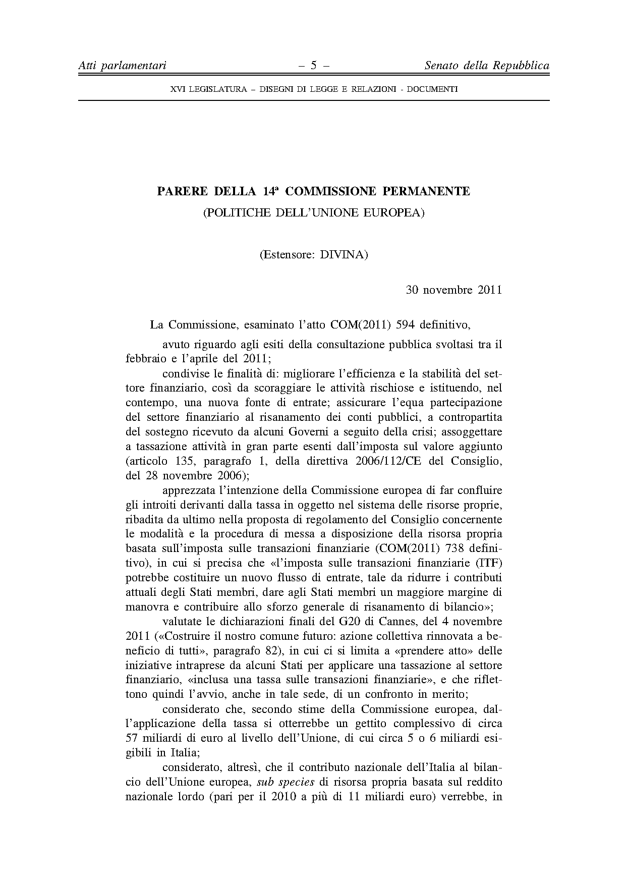

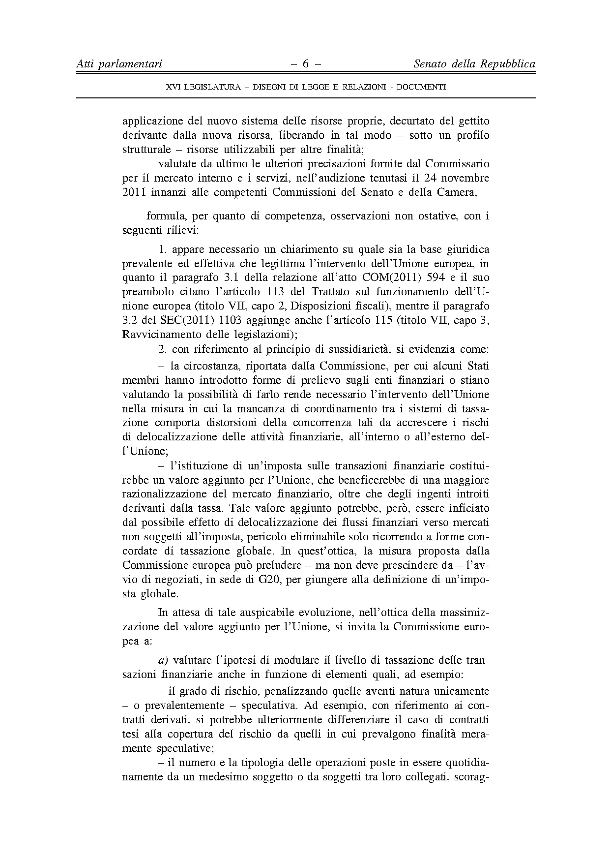

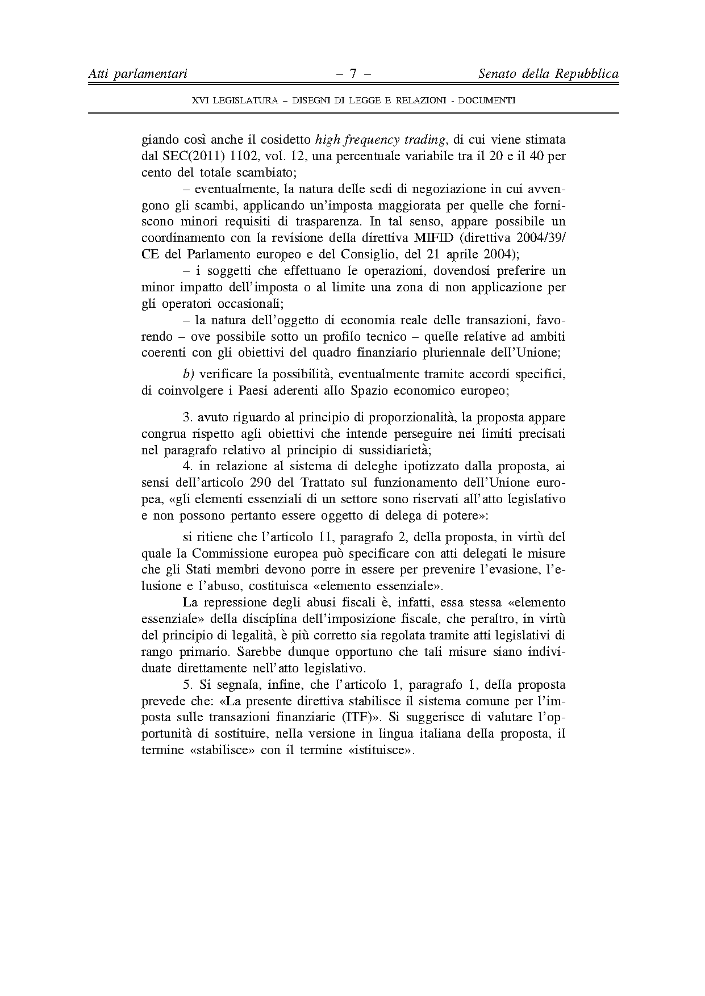

This opinion is available in English on the Interparliamentary EU information exchange site (IPEX) at the following address: http://www.ipex.eu/IPEXL-WEB/search.do

