 | 
COUNCIL OF  THE EUROPEAN UNION |  |  | Brussels, 2 May 2012
 | Interinstitutional File:  2011/0280 (COD)  2011/0281 (COD)  2011/0285 (COD)  2011/0286 (COD)  2011/0282 (COD)  2011/0288 (COD) |  | 9443/12
AGRI 276
AGRIORG 75
AGRIFIN 81
AGRISTR 57
CODEC 1155
INST 311
PARLNAT 211

COVER NOTE
from: | Italian Senate
date of receipt: | 30 April 2012
to: | President of the Council of the European Union
Subject: | Proposal for a Regulation of the European Parliament and of the Council establishing rules for direct payments to farmers under support schemes within the framework of the common agricultural policy (CAP Reform)  Proposal for a Regulation of the European Parliament and of the Council establishing a common organisation of the markets in agricultural products (Single CMO Regulation) (CAP Reform)  Proposal for a Regulation of the European Parliament and of the Council amending Council Regulation (EC) No 1234/2007 as regards the regime of the single payment scheme and support to vine-growers (CAP Reform)  Proposal for a Regulation of the European Parliament and of the Council amending Council Regulation (EC) No 73/2009 as regards the application of direct payments to farmers in respect of the year 2013 (CAP Reform)  Proposal for a Regulation of the European Parliament and of the Council on support for rural development by the European Agricultural Fund for Rural development (EAFRD) (CAP Reform)  Proposal for a Regulation of the European Parliament and of the Council on the financing, management and monitoring of the common agricultural policy  (CAP Reform)  - Opinion on the application of the Principles of Subsidiarity and Proportionality

Delegations will find attached the opinion of the Italian Senate.

_________________

ANNEX

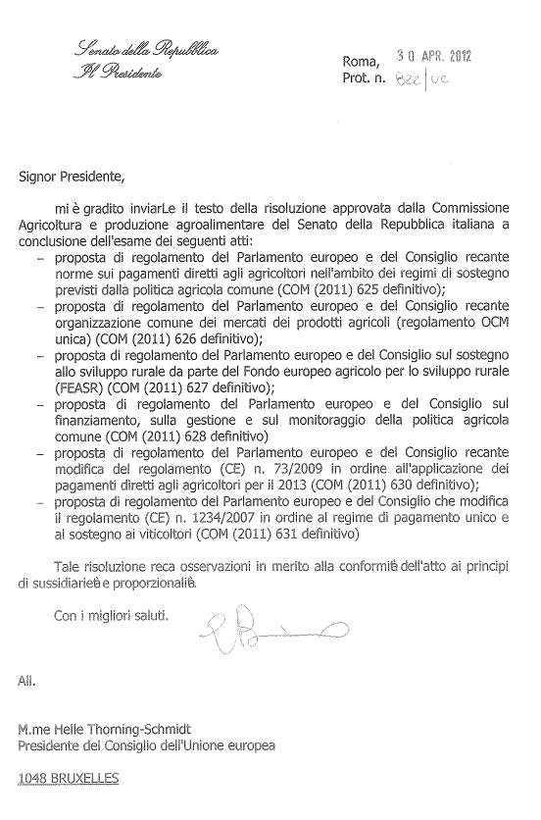

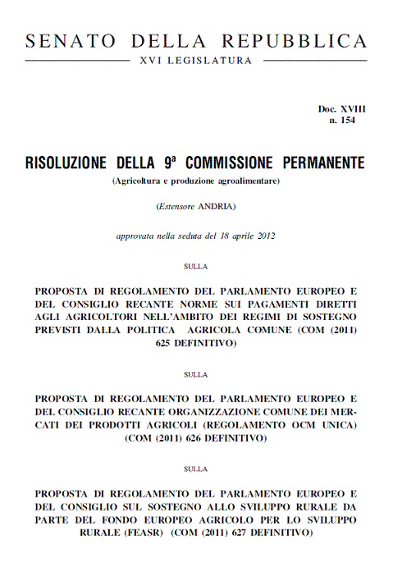

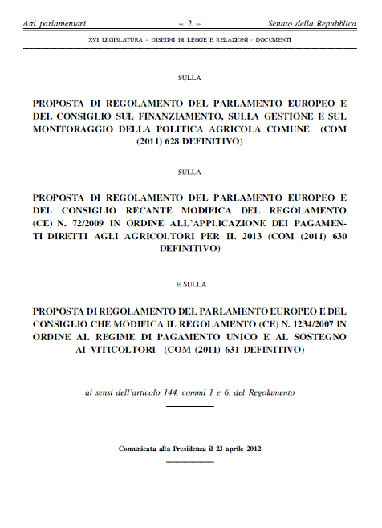

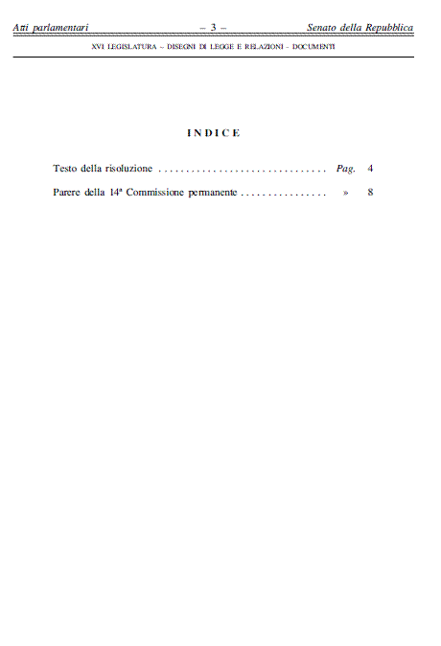

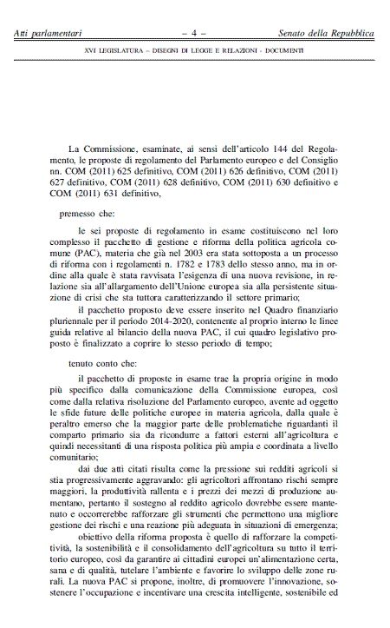

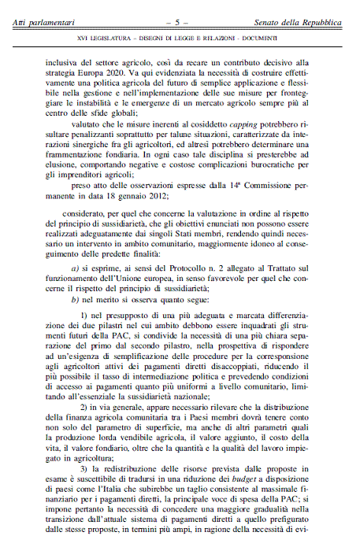

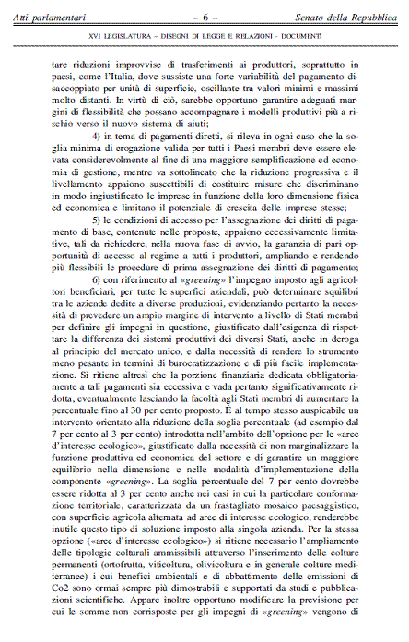

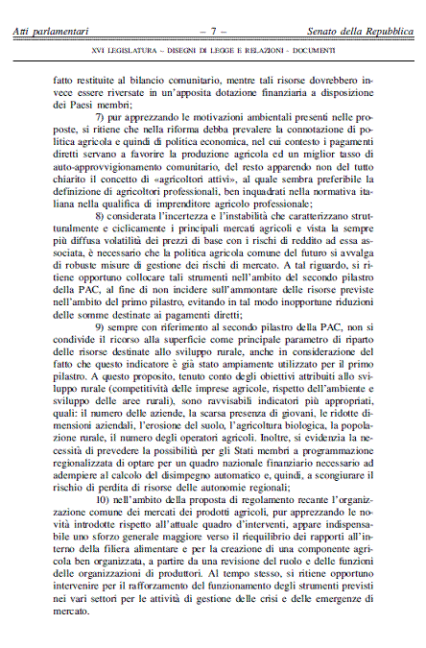

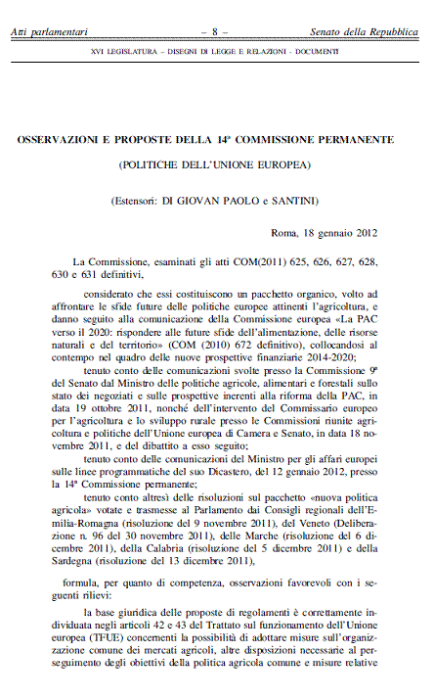

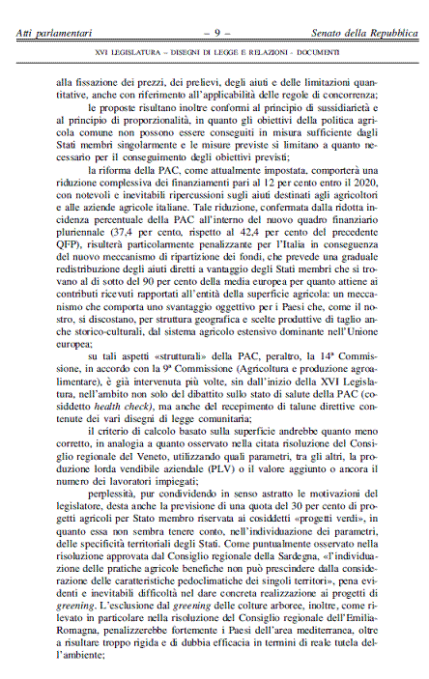

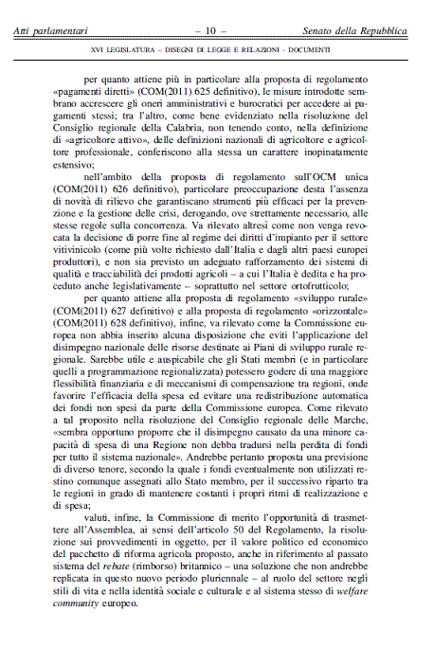

____________

The translation can be found at the Interparliamentary EU information exchange site IPEX at the following address: http://www.ipex.eu/IPEXL-WEB/search.do

