COMMUNICATION FROM THE COMMISSION TO THE EUROPEAN PARLIAMENT, THE COUNCIL, THE EUROPEAN ECONOMIC AND SOCIAL COMMITTEE AND THE COMMITTEE OF THE REGIONS
on the European Innovation Partnership on Water

1. Introduction
Floods, water scarcity and droughts have enormous environmental, social and economic impacts. Insufficient water quality levels pose threats for public health and bio-diversity and the supply of safe drinking water and sanitation still poses problems, both within Europe and outside. To sustainably manage the increasing pressures on water resources, new and innovative approaches are needed.
The European Innovation Partnerships (EIPs) as proposed in the Europe 2020 Flagship Initiative "Innovation Union" provides for a strategic approach and framework to address the weaknesses in the European research and innovation system to speed up innovations that make a significant contribution to solving societal challenges. In doing so, Europe's competitiveness should be enhanced, contributing to job creation and economic growth. EIPs are a means to pool expertise and resources on key political priorities by mobilising and linking up all relevant stakeholders across policies, sectors and borders to bring the benefits of breakthroughs and innovation to people more quickly.
The importance of innovation in the field of water management is recognized by the EU Member States. On June 21st 2011, the Council of the European Union invited the Commission to 'investigate an innovation partnership on water in close cooperation with the Member States, with a view to achieving sustainable and efficient use of water'.
The importance for Europe to engage in the sustainable management of water as a key resource is underlined in the Europe 2020 Resource efficient Europe flagship initiative. The Roadmap to a resource efficient Europe highlights the efficiency gains that can be made.
A Blueprint to safeguard Europe's waters, the water milestone on the Resource efficiency Roadmap, is being developed by the Commission. The Blueprint will present, by the end of 2012, the policy response to the challenges of the implementation issues and gaps related to the current framework of EU water resource management policy. The Blueprint and the EIP will be developed in close coordination to ensure integration of innovative approaches and innovation demand side measures in developing and realizing EU water resource management policy. Furthermore, the EIP will build on the Eco-Innovation Action Plan, which focuses on boosting innovation that results in or aims at reducing pressures on the environment and on bridging the gap between innovation and the market.

2. Seizing the innovation opportunities
Citizens, societies, agriculture and industries will increasingly need innovative solutions to meet the need of using water in a more efficient and effective way. Innovative thinking and smarter use of innovation have the potential to bring new solutions quickly and efficiently to the market while responding to the needs of end users in urban, rural and industrial areas.
Unlocking the innovation potential in the field of water management can significantly contribute to job creation, economic growth and competitiveness in Europe. A 1% increase of the rate of growth of the water industry in Europe may mean between 10,000 and 20,000 new jobs. By seizing new and significant market opportunities, Europe can increasingly position itself as a global market leader in water related innovation and technology.
There is significant potential for boosting the competitiveness and growth of the European water sector, which includes 9000 active SMEs and provides 600,000 direct jobs in water utilities aloneError: Reference source not found. This potential also exists for other water related sectors (water using industries, water technology development etc.) where innovation can create higher operational efficiencies. There is a rapidly growing world water market which is estimated to be as large as $ 1 trillion by 2020.
The European water related sectors already operate world-wide in developing innovative water solutions, but often do not capture the benefits of marketing these. Eliminating the obstacles for market breakthroughs and promoting Europe's comparative advantages in the innovation value chain will facilitate European companies to bring solutions to the market, thereby realizing their full economic potential.
Innovative solutions to water related challenges can directly support wider environmental objectives such as protecting our natural capital and ecosystems, and the biodiversity that supports these. In addition, solutions with regard to drinking water and waste water treatment are to the benefit of public health, which in turn will generate significant savings. Furthermore, solutions to improve protection of, and in, flood-prone areas will enhance public safety and prevent potential economic losses.

3. The societal challenges
Without an effective policy to stimulate innovation, Europe risks being unable to realise its potential on global markets in water related innovation and hence may have to unnecessarily acquire technology from elsewhere to deal with its water challenges.
Recent studies show that competing demands for scarce water resources may lead to an estimated 40% global water supply shortage by 2030, also affecting large parts of Europe. Competition for clean water is expected to increasingly lead to social, economic, environmental and global geo-political consequences.
Challenges with regard to water quality and quantity are significant. A substantial proportion of Europe’s freshwaters are at risk of not achieving the objectives of the EU Water Framework Directive by 2015. According to the preliminary analysis in 2009, 30% of surface waters and 38% of ground waters are at risk of not achieving good status. This has adverse effects on bio-diversity and pubic health and hampers the provision of eco-system services.
Regarding water quantity, water scarcity and droughts already affect one third of the EU territory across different latitudes. A comparison of the impacts of droughts in the EU between 1976-1990 and 1991-2006 shows a doubling in both area and population affected. In addition, over the past ten years, Europe suffered more than 175 major floods, causing deaths, the displacement of people and large economic lossesError: Reference source not found.
These challenges are projected to increase due to climate change, socio economic developments and increasing water demand in agriculture to produce food and biomass. Urbanization and rapid industrialization, combined with demographic developments have accelerated water problems, with ageing water infrastructure posing further challenges. In addition, water-energy efficiency gains and interactions will be increasingly important in the sustainable management of water.
With regard to developing countries, achieving the Millennium Development Goals in relation to sanitation and drinking water is instrumental to fight poverty and promote the economic development of millions.

4. The EU response
Protecting water resources and promoting sustainable economic growth are interlinked and call for an integrated approach. The EIP will facilitate the search for innovative solutions in support of an effective EU water policy as well as unlocking business and industry potential to innovate and gain competitive advantage. In addition to new approaches to research and technological development also new approaches to finance, ICT, governance, physical planning, institutions, management and other disciplines or the interaction between them will be needed.

4.1 EU Added Value
Knowledge and technology in the European water sector are excellent but scattered. The EIP can create a critical mass by pooling resources across sectors and borders and promote competition and level playing field conditions. Action at European level can facilitate coordination of efforts, prevention of duplication, definition of common objectives, scale-up initiatives and speed up the delivery of innovative solutions. The EIP will make best use of existing resources and recommend actions for which additional support is required. Moreover, an EU approach will provide the necessary economies of scale, to develop, implement, and foster the dissemination of innovative solutions.
Water is not confined to administrative borders. The transboundary characteristics of water management require a holistic and integrated European approach applied at the river basin level, as reflected in European water policy. Regional and international coordination is instrumental to achieve this.
Demand side measures (procurement, regulatory frameworks, standard setting, etc.) are of crucial importance to the deployment and uptake of water related innovations, and should be identified by the EIP. European regulation is a major driver for innovation and business. The EIP can facilitate innovative solutions to be adequately translated into policy developments and implementation. The procurement of water related infrastructure by public authorities and utilities has the potential to be a key driver for the development and uptake of innovative solutions. Other regulatory frameworks, such as the Eco-design directive, could be considered relevant for improving the market uptake of innovative designs which support policy objectives. Relevant standards may need to be developed or updated.
EU instruments focusing on the innovation supply side, e.g. research and development funding, need to be adequately linked to demand side actions, measures and policies which are needed to foster innovations. The EIP will combine a strong research and innovation dimension with demand side measures across political areas to shorten time to market with innovation support actions at EU and national level (i.e. reviewing regulations and proposing new rules, accelerating product approvals, fast-tracking standard settings, deploying public procurement strategies, etc.). Finally, the EIP will create cross border opportunities for industries, in particular SMEs, to find partners in developing innovative solutions throughout the entire EU.

4.2 Objectives and targets
In line with the challenges and opportunities set out above, and in view of the relevance of European level action, the EIP on Water should contribute to achieving the overall objectives of EU water policy as defined by the Water Framework Directive and the Resource Efficiency Roadmap and to overcome implementation difficulties. More precisely, the strategic objectives of the EIP are by 2020:
- To provide safe, available and affordable water for all, while ensuring sufficient water for the environment.
- To achieve the relative decoupling of the depletion of water resources from the level of economic activity in key EU sectors (including energy, farming and chemicals).
- To maintain and enhance the good status of waters in all EU river basins – in terms of quality, quantity and use, and in the context of increasing pressures on water resources.
In order to measure progress towards these strategic objectives and create an incentive for stakeholders to actively engage, targets are developed. They reflect the different areas of action embedded in the strategic objective and the EIP itself. The targets will be further elaborated in the Strategic Implementation Plan to be developed during autumn 2012 and will be closely inter-related with the Blueprint for Europe's waters planned for November 2012.
Under these conditions the EIP will aim at the following targets for 2020:
- All River Basin Management Plans implemented on time in 2015. As pressure on water continues to develop, the objectives continue to be met with the impacts of droughts and floods minimised, adapted crops, increased water retention in soils and efficient irrigation. Alternative water supply options are only relied upon when no cheaper savings opportunities exist.
- Water losses are reduced to sustainable levels across the EU, through innovation focusing on the regions where such losses are the most acute problem
- Water abstraction is below 20% of available renewable water resources in all regions.
This should lead to the following innovation and competitiveness benefits:
- The time to market of water-related innovations in Europe is shorter than in economies at a similar level of development. Europe is the global market leader in innovative solutions that effectively deal with water-related challenges.
- EU water management related eco-industries have increased their EU turn-over by 20% and their employment opportunities by 20% by 2030.
- Sustainable water management practices are brought to the global market and are integrated into EU and Member States' water-related cooperation with neighbouring and developing countries.
The EIP itself will have the following operational targets:
- By the end of 2012 to agree on a Strategic Implementation Plan.
- By 2013 to effectively function as a platform for public and private stakeholders to cooperate efficiently on developing innovative solutions for water related challenges.
- By 2013 to establish a web-based Market Place for water innovations, which allows supply and demand side actors across the EU to co-operate.
- By 2015 to show first results of actions to remove major barriers to innovation at the EU, Member State and regional levels to ensure that legislation and financial instruments support innovations.
- By 2020 to show tested solutions for 10 major water related challenges that have been successfully disseminated and scaled up.

5. Focus areas for innovation
In order to optimize the activities in addressing barriers to innovation, developing marketable solutions and designing dissemination strategies, three Work Packages are proposed: Urban Water Management, Rural Water Management and Industrial Water Management. Extensive consultations have provided broad support for this approach from stakeholders. The use of work packages is pragmatic to organize the output activities of the EIP through a coherent group of stakeholders which deal with relatively similar challenges. The following indicative description serves as a basis for the development of the work packages.
- Urban water management
Urban water management is under increasing pressure as a result of further urbanization (over 80% of the population is expected to be living in urban areas in EU countries in 2050). There is a need for an integrated approach with the urban water cycle at the core, involving all stakeholders that have an impact on, or have to deal with, water challenges. This includes professional stakeholders, as well as citizens and local governments to guarantee acceptance and uptake of innovations. Innovative solutions focussing on the relationship between water and energy, water efficiency (domestic and industrial), water quality, water infrastructure, recreation, public health and ICT-enabled user awareness will be of key importance. Work will be coordinated with the European Commission's 'Smart Cities and Communities Initiative' in the fields of energy, transport and ICT.
- Rural water management
In the rural area, biodiversity, agriculture, spatial planning and land use management influence each other and may compete with each other with regard to the available water resources. In addition, rural areas can play an important part in the prevention of floods and mitigating the effects of water scarcity and droughts. The EIP on Water will address the interface between water management at the farm level and the allocation of water resources to agriculture at the catchment and water body level and the permissible pressures on water quality. The EIP will coordinate with the EIP on agricultural productivity and sustainability which will address water quality and quantity issues at the farm level.
- Industrial water management
Innovations in industrial processes, ICT applications and new technologies for more efficient treatment will reduce costs and energy needs and decrease pollution. In industries with high water use, like energy production or the chemical industry, innovations to increase water efficiency in production processes will have positive effects on decreasing the total water footprint. The EIP on Water will focus on facilitating the possibility for industry and SME's to disseminate these innovations. Complementarities will be investigated with the EIP on Raw Materials.
A number of Transversal Themes will be defined to deal with cross-cutting issues which are relevant for the activities of two or all three work packages. They could include, for example, river basin management, climate change and water, the energy and water nexus, water governance, water related development cooperation, financial engineering or standardization.

6. Implementation of the EIP
A Strategic Implementation Plan (SIP) will form the foundation for the output of the EIP. Through a bottom-up approach, the SIP will set out the priorities for actions within the work packages and determine the transversal themes that should be addressed. The SIP will take full account of the relevant EU funding programmes and initiatives to optimise the impact of funding and contribute to the EIP objectives. The SIP will also scrutinize the targets of the EIP, taking into account the Blueprint to safeguard Europe's waters.
6.1 Output
The implementation of the EIP will lead to the following outputs:
- Innovation Sites
A first set of Innovation Sites will be launched by 2013 to identify barriers to innovation, develop, test and demonstrate concrete activities, actions, prototypes and solutions in line with the SIP, in relation to a particular water challenge. They can range from physical demonstration sites to cooperation projects or development of networks. The Innovation Sites will play a key role in the implementation of the EIP.
- Dissemination of innovative solutions
The EIP will facilitate the development of strategies to disseminate breakthroughs and innovative solutions for the major water related challenges, accelerating their market uptake.
- Addressing water innovation barriers
The development of solutions to bring innovations successfully to the market and disseminate them is hampered by a variety of barriers (regulatory, financial, standardization, technical, social, etc.). The EIP will identify major barriers to innovation. The EIP will undertake a mapping of the measures and actions needed to overcome the bottlenecks and define opportunities for speeding-up breakthroughs and innovation for every step of the value chain from research to market.
- Water innovation 'Market Place'
A web-based Market Place will be developed and established by 2013. The Market place will allow those who own the problems and those who can provide the solutions to interact regardless of their geographical location. The Market Place will be monitored through the governance structure of the EIP and will be connected to the other areas of output.
6.2 Funding
The EIP will identify how different funding programmes at EU, national and regional level as well as private sources can best interact in order to accelerate the development of innovative solutions, for example through making use of the network of eco-innovation financiers, established under the Eco-Innovation Action Plan. The EC will consider relevant support for the activities under the EIP through the 7th Framework Programme. Member States are encouraged to include relevant investments in the future programmes under the Structural Funds 2014-2020.

7. Governance
The EIP will require the participation and commitment of all relevant stakeholders representing the entire innovation value chain.
The EIP will make use of and closely coordinate with the activities and outcomes of existing European, national and regional initiatives. These include the relevant Joint Programming Initiatives, national and regional research and innovation programmes, European Technology Platforms, financial mechanisms, other EIPs and other innovation initiatives, in order to avoid duplication and promote synergies.
The governance model will allow for a bottom up approach to prioritize areas in which innovation actions can and should be pursued. At the same time, it will ensure the commitment at the highest decision making level from all involved stakeholders.
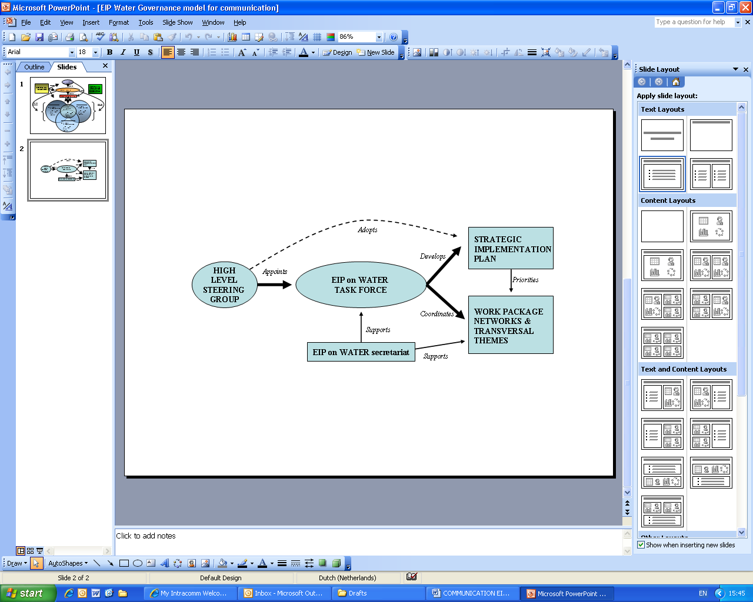

Figure 1: Visual presentation of the governance model
A High Level Steering Group (HLSG) will be established, upon invitation by the European Commission. The HLSG will be chaired by the Commissioner for the Environment and will be comprised of other European Commissioners, Member State representatives, the European Parliament and a wide variety of stakeholders. Members will be invited in their personal capacity and will represent the entire innovation value chain. The HLSG will set the mandate for the EIP and will adopt the SIP and a multi-annual roadmap for 2012-2020. The role of the HLSG during the implementation stage will be reviewed following the adoption of the SIP.
The HLSG will appoint a Task Force which will mirror the composition of the HLSG, linking the operational and decision making levels. The Task Force will be responsible for drafting the SIP, guaranteeing a bottom up approach. After the adoption of the SIP, the configuration of the Task Force can be reviewed, with the possibility of increasing the number of stakeholders to be represented during the implementation phase while maintaining effective decision making capacity. During the implementation phase of the EIP, the Task Force will be instrumental in monitoring the progress of the activities based on the targets that have been set. In addition, the Task Force will provide coordination and cross fertilisation between the activities of the EIP and will support the development of dissemination strategies.
Operational Networks will be established for each work package, consisting of all the stakeholders relevant to each work package and of the actors that participate in the Innovation Sites. In order to ensure maximal exchange of knowledge and experiences and stimulate the extension of the activities of the EIP, the networks will be open to other water related innovation activities in Europe. The signature of a Declaration of Commitment will be required for all members to the networks. The networks will be responsible for coordination between the work packages, liaising with the Innovation Sites and for facilitating the EIP output actions (finding market opportunities, addressing the various barriers to innovation, identifying funding opportunities and developing dissemination strategies). The activities of the networks will be coordinated and supervised by the Task Force.
An annual 'EIP on Water meeting' will be organized, to allow for all actors to convene and discuss the output actions of the EIP. At this meeting, the networks will gather to report on the activities, monitor developments and assess progress of the Innovation Sites. After the meeting of the work package networks, the transversal themes will come together to discuss progress and areas where future action is required. After these meetings, the Task Force will convene, where the networks and transversal themes will report and receive strategic guidance. During these meetings, the advancement towards the targets will be measured.
The European Commission will function as a driver and facilitator of the process of the EIP. An EIP secretariat will be established by the European Commission, which will support the Task Force in the development of the SIP and support the implementation phase of the EIP. After the adoption of the SIP, the European Commission will assess the Plan and propose how it will contribute to the delivery of the objectives of the EIP.

8. Next steps
The European Commission envisages the following milestones:
- Consideration of the EIP Communication by the European Parliament and the Council by May 2012.
- Establishment of the HLSG and kick off meeting before summer 2012.
- Appointment of the Task Force and establishment of the EIP secretariat by September 2012.
- Development of the SIP by the Task Force before December 2012.
- Adoption of the SIP by the HLSG in December 2012. The Commission will present this Plan to the European Parliament and Council together with its response to the Plan.
- From early 2013, start the implementation of the EIP: e.g. selection of the 1st Innovation Sites, establishment of the work package networks, implementation of demand side measures, development of the web based market place etc
- The European Commission will organize a review of EIPs during 2013 to assess progress.
- Regular reviews of progress in implementation and against the targets.

Communication COM(2010) 546 final
Council of the European Union Conclusions of 21 June 2011. (doc. 11308/11)
Resource efficient Europe, COM(2011)21 final
Roadmap to a resource efficient Europe, COM(2011) 571 final
COM(2011) 899 final
Commission Staff Working Paper Research Joint Programming Initiative on Water (doc. SEC(2011) 1250 final)
LUX Research report "Water Cultivation: The Path to Profit in Meeting Water Needs", 2008
Global Water Intelligence, 2011. Global Water Market 2011 - Meeting the world's water and wastewater needs until 2016
McKinsey & Company, 2009. Charting our Water Future: Economic frameworks to inform decision-making.
Note for Water Directors, 'Preliminary analysis of the River Basin Management Plans in 2009'. Water Directors meeting, Warsaw, 8-9 December 2011.
European Environment Agency (EEA), 2010. Water resources: quantity and flows - SOER 2010 thematic assessment.
Water related industries account for 33% of the global market for eco-industries, estimated at EUR 1.15 trillion in turnover a year in 2010. Employment in water related industries account for 22% of the total employment in eco-industries in Europe in 2010. Ecorys study on the number of jobs dependent on the Environment and Resource Efficiency improvements (February 2012).
Population Division of the Department of Economic and Social Affairs of the United Nations Secretariat, World Population Prospects: The 2006 Revision and World Urbanization Prospects: The 2007 Revision, http://esa.un.org/unup
Including through national and regional research and innovation strategies of the future EU Cohesion policy

