COMMISSION STAFF WORKING DOCUMENT
Open, dynamic and inclusive labour markets
Accompanying the document
COMMUNICATION FROM THE COMMISSION TO THE EUROPEAN PARLIAMENT, THE COUNCIL, THE EUROPEAN ECONOMIC AND SOCIAL COMMITTEE AND THE COMMITTEE OF THE REGIONS
Towards a job-rich recovery
TABLE OF CONTENTS
1. Introduction 1
2. The flexicurity framework: the EU common principles and the four components 2
3. Main approaches to flexicurity 3
4. Implementing flexicurity 4
5. Delivery of flexicurity by component during the crisis 10
6. Performance of flexicurity during the crisis 16
7. Concluding observations 21
This paper is organised as follows: after an introduction, section 2 quickly presents the different pillars of flexicurity providing both security and flexibility, section 3 outlines five country groups which share commonalities in their flexicurity approaches. Section 4 provides examples of recent labour market measures showing how flexicurity is anchored in national policy making, and how social partners are involved. To what extent flexicurity measures have been continued in the period 2008 – 2010 is discussed in section 5, with observations on labour market performance in section 6. Concluding comments in the final section of this document support the chapeau communication of the Employment Package.
Disclaimer: This document is a European Commission staff working document for information purposes. It does not represent an official position of the Commission on this issue, nor does it anticipate such a position.

1. Introduction
Since the mid-2000s, flexicurity has been developed and refined as a policy concept through common work between the European Commission, the Member States, social partners and academic experts. The Commission has defined flexicurity as “an integrated policy strategy to enhance both flexibility and security within the labour market”. The concept was developed as a comprehensive response to the challenges faced by European labour markets and societies in a context of globalisation and technological and demographic change
The flexicurity approach has provided a framework supporting the implementation of the European Employment Strategy under both the Lisbon and the Europe 2020 Strategies. The flexicurity framework was conceived in a time of relatively favourable economic conditions. The crisis and its negative employment and social impacts have heightened existing concerns and spurred criticisms of the flexicurity concept, especially from the side of the trade unions and in some academic circles. Apprehension from trade unions stems from their feeling that in times of crisis all balance has been lost as the term flexicurity has been used when only labour market flexibility has been increased, while the crisis has increased the need for employment and income security. Questions are also raised whether such a policy approach is still viable in a context of fiscal tightening: how is it possible to finance the security aspects of flexicurity? How is it possible to cope with rising demand for income support and ALMP measures? What is the role of activation measures (either train or work first) in a period of low labour demand? What is the role of social dialogue in implementing flexicurity?
It is therefore important to show the added value of the concept in a tangible form, while adapting it to the changing socio-economic context characterised inter alia by higher unemployment and tighter budgetary constraints. Furthermore, the crisis has highlighted the urgent need to pursue labour market reforms, without reducing the scope for consensus and trust between social partners - a key principle for successful flexicurity policies.
In 2010 the Commission's communication An Agenda for new skills and jobs considered that the EU common principles of flexicurity remained valid but that a comprehensive debate on strengthening the four components of flexicurity was needed to consolidate the consensus towards a new momentum in the first half of 2012. In November 2011 a Stakeholder Conference on Flexicurity was organised by the Commission bringing together representatives of Member States, social partners and European institutions. Furthermore, several surveys and studies, some of them still on-going, allow an informed assessment to be made of the implementation of flexicurity and how it could further evolve to support job creation and reduce poverty.
The purpose of this Staff Working Document is to review the implementation of flexicurity and its integration in national policies; identify concrete examples of how flexicurity policies and measures have helped weather the crisis and in what ways for the concept of flexicurity can be further useful in supporting the modernisation of European labour markets.

2. The flexicurity framework: the EU common principles and the four components
In 2007, the Commission issued a Communication ‘Towards Common Principles of Flexicurity’, which aimed to raise awareness in the Member States of the benefits of introducing flexicurity arrangements for those in work and those out of work. It did so by outlining four inter-related components of flexicurity, which comprise:
- Flexible and reliable contractual arrangements. The idea is to help ‘outsiders’, who are employed on short-term or irregular contracts or are unemployed (many of whom are women, young people and migrants) to find work and to move into stable contractual arrangements. Modern work organisation should promote work satisfaction and at the same time make enterprises more competitive. Flexicurity is also to help ‘insiders’, who are permanent employees with open-ended contracts, prepare themselves for job changes ahead of time in the case of redundancy due to economic change.
- Comprehensive lifelong learning (LLL) strategies. Lifelong learning is about ensuring that EU citizens have the opportunity to have a high quality initial education, that they complete at least their secondary education, that they develop a broad range of key skills and that they acquire new skills and upgrade existing skills throughout their working lives. It is also about ensuring that enterprises invest more in human capital and allow employees to develop their skills, as well as the recognition of all types of learning; formal, informal or non-formal.
- Effective active labour market policies (ALMPs). Active labour market policies help unemployed people back to work through job placement services and labour market programmes such as training and job creation. By implementing ALMPs such as an efficient job search support and good work incentives, jobseekers can be encouraged to find new employment. Job search courses and job clubs have been shown to be among the most effective measures to help the unemployed find a job.
- Modern social security systems. It is important for EU governments to provide adequate unemployment benefits to act as a safety net when people are changing jobs and to offer healthcare benefits in case they fall ill as well as pensions for when they retire. Childcare is another important area as it helps people to combine work and private life and thus keep them in the labour market. Maternity and parental leave should also facilitate transitions and reconciliation between working and family life.
There are eight Common Principles which provide a general framework and guidance for the implementation of integrated flexicurity strategies in the Member States.
According to these principles, flexicurity is a means to create more and better jobs, modernise labour markets and promote good work through new forms of flexibility and security. It involves the combination of the above mentioned four components. It has to be tailored to the specific circumstances of each Member State and progress should be monitored. It should promote open, responsive and inclusive labour markets in which transitions pay. Both internal (within enterprises) as well as external flexicurity are equaly important and should be promoted. Flexicurity should support gender equality, notably by allowing reconciliation between work and family (flexible working time arrangements, smooth transitions, etc.). It requires broad-based dialogue among all stakeholders and social partners should be involved in the design and implementation of flexicurity policies. Finally, it requires a cost-effective allocation of resources compatible with sound and financially sustainable public budgets.
Since 2007 the Common Principles including the four components have been the framework underpinning the labour market policies in the EU Member States, leading to a number of countries developing integrated flexicurity approaches. Under the Europe 2020 strategy, the 2010 Employment Guidelines, agreed by the Member States and adopted by the Council, urged Member States to integrate and apply the flexicurity principles in their labour market policies and recommended that measures to enhance flexibility and security should be both balanced and mutually reinforcing. The 2011 Annual Growth Survey (AGS) identified balancing security and flexibility as one of the priority measures to mobilise labour markets and create job opportunities. More recently, the 2012 AGS reiterated that the implementation of balanced flexicurity policies can help workers to move successfully between jobs and labour market situations.

3. Main approaches to flexicurity
The third common principle acknowledges that there is no one size fits-all approach to flexicurity, since they should be tailored to the specific circumstances of each Member State. The 27 Member States are characterised by very different modalities and combinations of flexibility and security elements, reflecting the diversity of European employment regimes. However, Member States may be classified into clusters based on a number of commonalities. Taking account of the existing literature, in 2006 the Commission identified, according to prevailing combinations of policies and/or institutions, five different flexicurity approaches within the European Union:
- The Anglo-Saxon system, covering the UK and Ireland, features a high degree of flexibility, relatively low security and low taxation. These countries have looser employment protection legislation, making it easier for enterprises to restructure in the face of changing economic circumstances. Countries in this grouping spend intermediate-to-low amounts on labour market policies aimed at helping the unemployed back to work. Cash transfers are primarily oriented to benefits linked to regular employment. The model is characterised by weak unions, moderate to high rates of unemployment and comparatively high disparities in wages.
- The Continental system, covering Austria, Germany, France, Luxembourg and Belgium, is characterised by intermediate-to-low flexibility, intermediate-to-high security and intermediate-to-high taxation. These countries rely extensively on insurance-based benefits and have stricter employment protection legislation. Although union membership is in decline in most countries, the unions remain strong and are regularly included in processes of decision-making and implementation. These countries tend to have higher levels of long-term unemployment than the Anglo-Saxon countries but, thanks to higher levels of redistribution via taxes and transfers, they have lower numbers of people in or at risk of poverty.
- The Nordic system, comprising Denmark, Netherlands, Sweden and Finland, is characterised by high security, intermediate-to-high flexibility and intermediate-to-high taxation. These countries have Europe’s highest levels of social protection expenditure and universal welfare provision. The strictness of employment protection legislation tends to be low, but accompanied by extensive active labour market policies and generous social assistance. They see comparatively high levels of employment, low long-term unemployment rates, high job turnover and a much higher sense of security among the population than in other European countries. Social partners tend to play an important role in decision-making.
- The Mediterranean system, covering Spain, Italy, Portugal, Greece, Cyprus and Malta, features low flexibility, relatively low security, and no clear pattern of taxation. These countries generally have strict employment protection legislation for workers on open-ended contracts, while a growing number of people with part-time and/or fixed-term contracts (especially women, ethnic minorities and the young) enjoy very little if any employment security at all. The social protection expenditure of these countries tends to be concentrated on old-age pensions, with low coverage of unemployment benefits. Countries in this system reveal high levels of unemployment and a wider incidence of poverty and social exclusion.
- The Eastern European system, covering the Baltic States, Poland, Hungary, Czech Republic, Slovakia, Slovenia, Romania and Bulgaria are characterised by low levels of employment security, intermediate-to-high flexibility and intermediate-to-high taxation. With lower levels of employment protection legislation than the Mediterranean system, the provision of social assistance in these countries is also weaker. The countries in this system tend to have high long-term unemployment rates, with unemployment particularly high among young and older workers.
These clusters – relying on a modelisation - present a simplification of the variety of the EU labour markets and empirical evidence supports them less than when they were identified. They can nevertheless be helpful in analysing further the implementation of flexicurity during the recent years and what concrete measures have been developed to help weather the crisis.

4. Implementing flexicurity
One of the criticisms addressed to flexicurity has been that it is a complex concept, too abstract and that is subject to a certain ambiguity. It is therefore important to identify tangible ways in which flexicurity has taken form.
Several studies, some of them still on-going, have identified a large number of concrete labour market policy measures considered flexicurity practices. The research of EUROFOUND identifies more than 230 public and social partner based instruments, a high share of which were either initiated or amended in the course of the crisis, pointing to the validity of flexicurity in times of economic hardship. Some initiatives were innovative and creative. However, more information is still needed regarding the effectiveness of the measures.
Each of those policy measures or instruments can provide various forms of security and various forms of flexibility. Striking the right balance between flexibility and security dimensions determines the perception that stakeholders have of the implementation of flexicurity. Measures combining external flexibility and employment security seem to be most prevalent. In general, measures combining these flexicurity dimensions include those that aim at replacing traditional job protection by measures enhancing the employability of outsiders of the labour market while easing hiring and lay-off procedures and costs for the employers, backed up by active labour market policies. This back-up tends to be government programmes to help unemployed find a fixed term or permanent job by (temporarily) offering subsidies to employers or reducing their social security contributions, while ensuring compliance with state aid rules.
In a second big group of measures, external flexibility is combined with job security. These measures often contain elements to facilitate hiring and laying off, which is combined with incentives for employees to maintain their existing jobs. Most of these measures are related to new regulations on types of employment contracts in terms of their duration. Prominent examples are legal regulations obliging companies to provide workers with an open ended contract after repeated use of fixed-term contracts or after a certain period of time has elapsed (see box for examples combining various forms of security and flexibility).
Various forms of flexibility and security
External flexibility and job security
Measures combining external flexibility and job security are often aimed at preventing abuse arising from the use of successive fixed-term contracts, for example by requiring objective reasons justifying the renewal of such contracts, maximum duration or maximum number of repeats (see also the Council directive on fixed term work). In the Netherlands this has been made operational by labour laws dictating a maximum of either three fixed-term contracts or three years of use. After this has elapsed the fixed-term labour contract will by law be considered as open-ended with the according degree of employment protection.
Labour pool companies make possible the combination of external flexibility with specific job security in several Member States including Germany, France, Belgium, The Netherlands, Sweden or Finland. The commonality of these measures is that a pool organisation composed of several employers usually from the same activity branch and/or located in the same area is voluntarily formed. This pool hires workers, trains them and sends them to the companies during their period of activity peaks. Throughout this cycle, workers keep on being employed and paid by the pool company as such, guaranteeing them a permanent income, even in times of inactivity. In most of the examples, such initiatives are partly or fully subsidised by the national or regional administration. In Belgium, the employees in the pool are entitled to indefinite contracts offered by the pool organisation. In some cases, however, the pool is used only as a platform for exchange of information and good practices and for short-term employee mobility.
External flexibility and employment security
Creating a secure framework for labour market transitions can help workers by providing employment security while delivering flexibility to firms. To this end, in 2011 France introduced regulation called career security contract (CSP) which offers workers, who lose their jobs in economic redundancies, 80% of previous wages. This protection holds for a period of up to maximum one year. Participating in this CSP, which is voluntary to the employee, means laid off workers will need to enlist in an intensified 'return to work' programme. Workers will have to accept the first job offer made to them. Actual take-up rates of the new CSP so far have been low as workers feared that needing to accept any first job offer could mean moving across the country.
At a regional level, the Austrian Work Placement Foundations (Implacement Arbeitsstiftung) have proven to be good examples to remedy structural problems in the labour market. There are currently 45 placement foundations in Austria. These foundations target fast growing sectors where there is relatively little labour supply and aim to match the enterprises’ personnel needs with unemployed people, trained and qualified in accordance with their specific needs. They offer training and a comprehensive service package including career guidance, job search, and work experience programmes that can last up to three years (four in case of jobseekers that are above 50 years of age). The participating companies report their demand to the local public employment office which looks for suitable candidates from the pool of registered unemployed candidates. During the training, the participants receive financial support amounting to the unemployment benefit from the public employment service. As a final step, the trainees are employed in the company.
Overall, work placement foundations provide firms with the skilled labour that they are seeking, specifically trained for their needs. During the training period, the company does not have any wage or related costs and saves costs for training and HR administration. In return, employers give job-seekers the opportunity to gain qualifications that hold out the promise of employment at the end of the training process. Work foundations promote greater occupational, remunerative and regional mobility. This is also a good example where a support measure can be implemented without tremendous cost burden for one single stakeholder as several stakeholders share the financial burden of the measure.
In Spain the labour market reform approved in September 2010, inspired by the reforms in the severance pay reforms in Austria, has foreseen the creation of a worker's capital fund that will enter into force in 2012. Instead of paying the total amount of severance pay at dismissal, employers would pay regularly an amount equal to a certain number of day's wages per year into this fund. The employee may benefit from this fund in the event of dismissal, geographical mobility, for training purposes, or in the case of retirement. The money is kept in the worker's account in the case that the worker changes employer voluntarily. As a transitional arrangement, until the creation of the Capital Fund, part of the severance payment of dismissal of permanent contracts (eight days per year of service) will be funded through recourse to the government Fondo de Garantía Salarial, FOGASA, created in 1985.
External flexibility and income security
In Estonia, the first policy document to tie together the four major elements of flexicurity was the explanatory note to the new Employment Contracts Act (in 2008). As the unemployment insurance came into force in 2002 and labour market services were reformed in 2006, the 2008 act dealt mostly with individual labour relations. The original act i.e. the one accepted by social partners, addressed also the security of workers during unemployment with a more generous unemployment insurance benefits system but these changes were cancelled as a crisis measure. In addition, the Act also increased the opportunities for lifelong learning.
Internal flexibility and job (and income) security
In Germany, Working time accounts were widely exploited by German companies between summer 2008 and autumn 2009 to combat the adverse impact of the economic crisis and may have been an alternative to the use of short-time work in the adjustment process during the 2008-2009 recession. If employees work fewer hours than their contractual obligation, working time accounts ensure that this debt will be balanced later; in this case, firms give a credit to their employees (full salary), and they receive a compensation once demand improves (in the form of labour). It is estimated that about one third of the companies in Germany with more than 20 employees have used working time accounts to maintain employment levels during the crisis. In 2009, the reduction in working hours that was due to working-time accounts was about half of the size of the reduction that was due to short-time work. About half of the firms that used short-time work also used working time accounts, whereas it is estimated that one in ten firms that used working time accounts also made use of short-time work. The use of working time accounts provides for the adaptation of labour to production needs. Its use is previous to the possibility of using short-time work. In case of working-time accounts, the State doesn't pay any compensation. As well as the introduction of short-time working, the use of flexible working time accounts is said to be one reason why adverse effects on employment were avoided at both the company and the macroeconomic level.
In Italy the Solidary Contract (Contratto di Solidarietà), modified in 2009, made use of company-level arrangements based on the principle of solidarity among current employees who reduce, all at the same extent, their working hours in order to avoid dismissals or to allow the recruitment of new employees. The company-level agreement grants a reduction of working hours (maximum 60%), corresponding to an equal reduction in wage. This income loss is compensated by public employment services. In 2009, the government increased the annual amount paid into the fund for job-security agreements to € 40 million. Consequently, for the period of 2009-2011, the wage supplement has been raised to 80% of the wage reduction. The job security agreements can last for an initial period of maximum 24 months, which can be extended for 24 further months (36 months for Southern Italy). At the end of the maximum period, a new job-security agreement for the same units can be agreed following an at least 12 months production resume period. The agreements create a win-win-win situation for employees, employers and unemployed. As the reduction in pay of employees is not reflected in their social security contributions (this difference is also financed by the national government), incumbent employees enjoy reduced working times with minimal income loss while new jobs are created for the unemployed. Employers deciding to use job security agreements benefit from a reduction of the amount of social security contributions to be paid for the workers using the scheme. One drawback of the scheme is reported to be the complexity of related procedures.
Social partners have found ways in collective bargaining to support both flexibility and security at the same time. In Germany, sectoral employers have the power to oppose increases in minimum wages if they can argue increased levels would be harming employment in their sectors; in specific cases they can opt out of the bargaining agreement which has been reached collectively and which still holds in other dimensions. Operating this way, firms or sectors have the flexibility to better follow labour productivity developments in their wages, avoiding employment threatening 'gaps' between wages and productivity. The way it is organised, employment in these firms is protected.
Functional flexibility and employment security
Skillnets in Ireland funds and facilitates training through 60 networks of private sector companies, in a range of sectors and regions. Each network delivers training that is relevant to both member company and specific industry needs (see www.skillnets.ie). This is an example where lifelong learning and human capital accumulation is used to ensure employment security. Skillnets is a state funded, enterprise-led support body dedicated to the promotion and facilitation of training and upskilling as key elements in sustaining Ireland's competitiveness. The organization supports and funds networks of enterprises to engage in training under the Training Networks Program (TNP). These networks, now referred to as 'Skillnets', are led and managed by the enterprises themselves to design, manage and deliver specific training programs across a broad range of industry and service sectors nationwide. Since 1999, Skillnets has facilitated over 60,000 Irish enterprises, in over 350 networks to improve the range, scope and quality of training and allowed over 275,000 employees to upskill and meet their work related training needs.
94% of companies funded by Skillnets are classified as SMEs. In a 2010 survey with member companies, more than four out of five companies (82%) agreed that Skillnets training helped them to fill skill gaps whilst 68% agreed that it improved productivity. A high proportion of companies reported that Skillnets training helped to achieve market developments such as enhancements to products and services (70%). 84% agreed that Skillnets training represents good value for money and 89% agreed that they would recommend to other companies to join a Skillnet network.
Though most of the measures have been taken by governments, social partners have also themselves taken initiatives or have been involved in the government actions. In fact, one of the important aspects highlighted in the initial Commission Communication on flexicurity, and re-iterated subsequently, is the importance of the involvement of social partner organisations in giving shape to flexicurity policies and their implementation.
In the first phase of the crisis, the contribution of the social partners to implement internal flexicurity was considerable. The short time work arrangements and collective bargaining opening clauses, are some direct examples (see also section 5). These efforts have cushioned the shock of the recession, controlled wage costs thus protected the competitiveness of firms and as a consequence avoided a steeper decline in employment. The involvement of all relevant stakeholders in the design and implementation of flexicurity policies can be seen as an important precondition for reforms leading to a win-win situation delivering both security and flexibility. However, those involved should not allow the current short term focus, induced by the economic crisis, to eclipse the long term view needed to observe and steer the process of structural reforms in the flexicurity approach.
The findings of the project implemented by the European cross-industry social partners between 2010/2011 on the Implementation of the Flexicurity Concept in the EU concludes that the level of social partners' involvement has depended very much on existing traditions of social dialogue and social partner involvement and cultures of labour relations. As a result, the integration of social partners in the decision making process and shaping reforms ranges from strong to weak.
Flexicurity measures initiated by social partners
In Finland, in response to the recent economic crisis, Tripartite Flexicurity Committees (Kolmikantainen joustoturva-työryhmä) have been formed at a sectoral or company level, which can be considered as a pioneering measure that is explicitly labelled as flexicurity. These working groups try to identify the needs for amendments in the existing labour market support system and potential new tools necessary to cope with the economic crisis and changing working environment. In doing so, a relatively strong emphasis is put on the need to address these challenges in the flexicurity spirit (ETUC, BusinessEurope, UEAPME and CEEP, 2011).
Recently, social partners in Spain reached an Agreement for employment and collective bargaining for the years 2012-2014 that has been able to improve the internal flexibility in terms of working-time, functional flexibility and to link wages to the situation and results of firms, and in particular productivity. This much improves long term employment security for workers because viability of firms is ensured by preventing wage-productivity gaps which could eventually lead to bankruptcies and termination of business activities.
The Employers’ Associations for the Bavarian Metalworking and Electrical Industries and IG Metal in Germany initiated an action programme called Employment Bridge Bavaria (Beschäftigungsbrücke Bayern) to ensure employability and vocational training for young skilled workers and engineers. Young skilled workers and engineers are hired therefore by a special company which posts these people to other companies. Hereby, the targeted young people are encouraged to opt for a technical training. The programme, expected to last until 2012, is funded by the regional government of Bavaria and involved social partners together (Source: ETUC, Business Europe, UEAPME and CEEP, 2011).
Central to flexicurity policies is their integrated nature; all parties relevant to labour market functioning do, or at least should, take part in agreeing and implementing policies, but also many thematic policy areas are included, ranging from labour law to unemployment benefits and training. This integrated nature means that views from all stakeholders on all topics should be included in policy reforms. This implies that economy-wide agreements can take a long time to materialize but if and when achieved, substantial economy-wide gains can be generated. Certainly the added pressure of the current economic crisis has diverted focus away from structured approaches to more ad-hoc measures vis-à-vis labour market outcomes. The text box below reports on a number of Member States showing a comprehensive approach to flexicurity.
In order to help Member States, at EU level, a common language has been developed, in terms of flexicurity pillars (ALMP, lifelong learning, contractual arrangements and modern social security), common goals have been articulated concerning improving labour market functioning and fighting segmentation and common instruments have been identified in terms of various types of securities and flexibilities.
Comprehensive flexicurity strategies
Denmark demonstrated in the 1990s how an integrated policy approach can lead to favorable labour market outcomes. In the fifteen years leading up to 2008 Denmark reduced its unemployment rate by almost three quarters – from 9 to 2.5% – adding considerably to employment security. Of course, part of this was due to positive macro economic trends which helped job creation and reduced unemployment but active labour market policies (ALMPs) and the benefits system saw clear reforms. Furthermore, wage bargaining and income taxation were reformed in support of job creation. Benefits were made more difficult to access through stricter eligibility criteria while benefits themselves were shorted in time and job-seeking requirements were installed taking away passive elements which had been present in the system. ALMPs changed their focus to more human capital investments.
In Estonia, different opinions emerged linked to the coherence between the four components of flexicurity: government representatives argued that all components are taken into account in the policy making process and that the connections between them are thoroughly analysed whereas the social partner perspective was that the four components of flexicurity have been dealt with rather separately and that this is a serious shortcoming. In 2008, the explanatory note to the new Employment Contracts act tied together the four major flexicurity elements.
In Poland, on-going reforms refer to all four components of flexicurity. Reforms were taken first in the areas of lifelong learning and effective active labour market policies, subsequently complemented with measures relating to flexible and reliable contractual arrangements and modern social security systems. The 2009 report on the implementation of the NRP discusses significant issues related to the implementation of an integrated model of flexicurity.
In Austria, flexicurity is seen as an overarching strategy. This is exemplified by the fact that some measures alternately appear as related to different flexicurity components in the 2011 NRP ; for example the training guarantees can be listed as a lifelong learning or active labour market policy measure and the social security coverage for self-employed and freelancers is mentioned under contractual arrangements and social security measures. It is in the areas of lifelong learning and social security modernisation that there has been the greatest renewed policy emphasis as a result of the EU flexicurity strategy. Although efforts and expenditure may have focused (particularly in the crisis years) on ALMP measures, there is arguably greater policy stability in this area, whereas responses to the policy challenges in the field of LLL and social security took longer to develop, and are in some cases (e.g. the lifelong learning strategy) not yet finalised and in need of further work. Flexicurity considerations feature highly in collective bargaining and because of the strong interlinkages of social partners in policy making the focus here has been rather similar.
Since mid-2010, also Spain has performed a considerable reform effort, aimed at reducing labour market segmentation and increasing flexibility at company level, improving the functioning of active labour market policies, enhancing the adjustment of wages to local conditions. Major steps include the reform of employment protection legislation passed in June 2010, the overhaul of active labour market policies in February 2011, the reform of collective bargaining system with a view to de-centralise wage setting in June 2011, and the pension reform passed in July 2011 to extend the statutory retirement age and increase the contribution period. Most recently, on 10 February 2012, the Spanish government presented to Parliament new labour market measures which include changes to employment protection legislation, the collective bargaining system, internal flexibility, job incentives and labour market intermediation services. The Social partners have also reached a wage moderation agreement until 2014 that includes agreed ways to implement internal flexibility.
In the context of its adjustment programme, Portugal is passing a major reform package, agreed with all the employers' organisations and only one of the trade unions, touching upon the employment protection legislation, working time arrangements and the wage-setting system. A draft law will also thoroughly revise the unemployment insurance system, while action on streamlining and strengthening active labour market policies and education policies is taking place with a view to speeding up transition to employment, and facilitateing job matching.

5. Delivery of flexicurity by component during the crisis
Flexible and reliable contractual arrangements
One of the more cited outcomes of the crisis in policy terms has been the key role played by internal flexibility instruments to help weather the crisis. A good number of them have tried to achieve increased income security and job security.
The short time work arrangements (STWAs) are the clearest and best documented instrument used to support labour demand and protecting jobs. In one way or another 20 Member States made use of these arrangements where government subsidies were given to either firm or worker to compensate for loss of income resulting from a temporary reduction in working time in response to crisis-induced reductions in output, all of this intended to maintain existing job relations and skills. Some of these arrangements were phased out in 2011 because of the need for more austerity in public finances. Specifically considering crisis induced measures, it is found that many of these include job security.
Evaluation studies from OECD and those initiated by the European Commission show that as a result many jobs were saved. Estimates range around a million jobs saved. Possible downsides to using these STWAs are the fiscal costs (although these have to be considered against unemployment and social benefits saved) and the presumption that the reductions in firm output are temporary after which they will resume their pre-crisis levels. In this sense using STWAs could obstruct necessary changes to the economy's production structure that may prove necessary in the longer term. Properly targeting this measure, thereby avoiding jobs get subsidised which would have survived anyway even without subsidies (avoiding deadweight losses), is another challenge in designing these arrangements. Some experts have also pointed to the fact that STWA have coexisted with external flexibility for non-permanent forms of work and that it has made visible the dualism of the labour market.
These problems can be minimised by including a number of criteria for a public contribution to STWA: firms being required to prove the economic necessity of using STWAs; firm-level social partners having to agree to the use of these arrangements; provisions that the cost of absorbing the productivity loss should be shared roughly equally by workers, firms and government; temporary character of fiscal support for the use of STWAs; subsidies should be paid back by the firm if after use workers still get dismissed; and finally, the time not worked should be used for training activities.
Successful experiences with the use of working-time accounts, e.g. in Germany, show that there is a possibility to use firm-based instruments that help foster flexibility in the use of labour, helping firms to be more competitive, and at the same time being an instrument of resilience and job security in terms of temporal dampening of demand. These experiences are now being also introduced in other Member States (e.g. Portugal).
However, the crisis has also increased concerns about growing labour market segmentation resulting from the rise in the use of (involuntary) fixed term employment and successive fixed-term contracts in some Member States, which – rather than acting as a stepping stone – can trap workers for many years in precarious employment. This leads not only to low job security, reduced access to training and reduced opportunities for career advancement and wage progression, but also has an impact on wider opportunities, for example access to a mortgage, saving for a pension or making long-term decisions about family formation.
One of the major reasons for segmentation is the inadequate dovetailing of regulations of the various contractual forms: disparities in employment protection rights for permanent and fixed term contracts have been identified as a, if not the, key source of segmentation. During the crisis, a number of Member States started reviewing their labour laws to reduce protection for permanent contracts with a view to making hiring more attractive. The latter has been particularly the case in some countries of the Mediterranean and Eastern European groups.
Reducing labour market segmentation - Single open ended contract
The economic crisis has put into spotlight the issue of labour market segmentation. Job losses were concentrated to a large extent on workers with fixed term contracts. As one round of fixed term contracts was finished, it was followed for many workers by unemployment rather than another fixed term contract.
In 2011 the Commission proposed to address the issue through the introduction at Member State level of a “single open ended contract” to encourage employers to hire workers on a more permanent basis. No specific contract examples have been proposed but only a general direction. Ideally, a single open ended contract would provide flexibility to employers while preventing segmentation. All workers would be protected by such a contract against lay-off at will, by forms of legal and/or monetary protection – clarity about this protection would be available from day one of the contract. Furthermore, these protection rights would build up continuously with job tenure until a maximum, and there would be no ex-ante time limits specified in the contract.
The issue has been debated at length in some Member States though as such it has not been adopted in any. However the debate has succeeded in focusing attention on the problem and has triggered at debate on the ways to improve the design of contractual arrangements to address the segmentation problem.
Active labour market policies
Active labour market policies are a key component of flexicurity in facilitating transitions from an unemployment situation towards a job. The crisis has challenged the use of ALMPs because of the severe increase in the numbers unemployed and the decrease in labour demand may cast doubts on the effectiveness of measures. Furthermore, the limits in the availability of funds due to fiscal consolidation have raised an additional challenge just when the demand for such funds has risen with increased numbers of unemployed.
Overall, spending on ALMPs as a proportion of GDP has increased across the EU as a result of greater use of existing schemes as well as newly introduced active labour market policies. An analysis of this indicator for the five flexicurity clusters shows the Nordic and Continental clusters devoted the highest proportion of GDP to ALMP, with an average 0.8% and 0.7% of GDP spent on these measures respectively. These are the two flexicurity clusters with spending above the EU average (0.6%). In 2009 the other three flexicurity clusters (the Eastern European, Southern, and Anglo Saxon clusters) each spent substantially less with an average of 0.3% of GDP on ALMP measures. A major source for ALMP funding during the crisis has been the European Social Fund, which for some Member States provided a significant contribution to limited national budget allocations, in particular for training measures, including in the context of short-time work arrangements.
Before the crisis, between 2005 and 2008, expenditure on ALMP remained rather stable for the EU, as well as among the Continental and Eastern European clusters. The Nordic cluster experienced a decline in expenditure between 2006 and 2008 (consistent with falling rates of unemployment). Such a decline was also evidenced in the Anglo-Saxon and Southern clusters between 2005 and 2006. All clusters experienced a rise in ALMP expenditure between 2008 and 2009 as a result of the economic crisis and subsequent rises in unemployment. The lowest rates of increase during this period can be found in Anglo-Saxon and Southern clusters which traditionally place less emphasis on ALMP spending. Figure 1 illustrates these findings.
Figure 1. Spending on active labour market policies (as % of GDP)
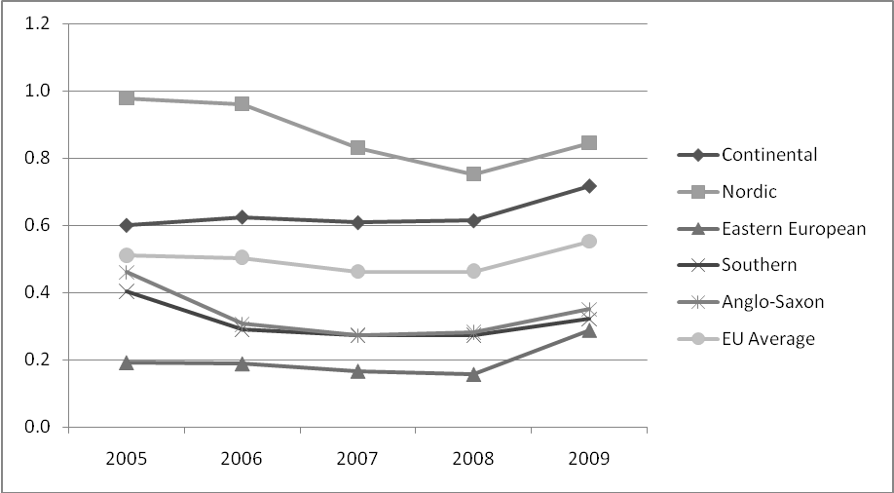
Source: Eurostat
Within ALMPs, the trend has been towards a stronger use of hiring subsidies. There has also been a strengthening of the conditionality of unemployment benefits to the participation in ALMPs. In some cases, even some income-support benefits provided after the exhaustion of unemployment benefits now require some kind of participation in activation measures.
Modern social security systems
The modernisation of social security systems is of particular relevance to the flexicurity agenda. One obvious link is that improvements or expansions in social insurance systems (for example to extend unemployment benefit durations) can serve to balance potential liberalisation in contractual arrangements by providing greater income security during transitions.
Social insurance systems can be adapted to the economic cycle to build up greater reserves to provide additional income support in times of higher unemployment (and therefore more difficult transitions). Beyond that, passive measures including income support have an important role to play as automatic stabilisers during recession, but if badly designed, can also affect incentives to work and go against the notion of “making work pay” (especially if coinciding with high tax wedge on low-paid labour).
Between 2005 and 2009 the Continental and Nordic clusters were responsible for the highest proportions of GDP spent on such measures (each spending 1.5% of GDP by 2009, compared to an EU average of 1.4% - see figure 2). The Anglo-Saxon cluster also reached this figure by 2009, following a rapid increase from a low level since 2008 (largely as a result of the crisis and rising unemployment). In common with most other flexicurity clusters, the Continental and Nordic clusters saw a consistent reduction in the proportion of GDP spent in these areas between 2005 and 2008, followed by a significant increase in 2009. This is consistent with declining rates of unemployment (and indeed declining early retirement) during these earlier years and increases in unemployment following the crisis, necessitating higher income maintenance payments. Figure 2 summarises the figures which reflect developments in numbers of income support users as well as crisis induced support schemes.
Figure 2. Expenditure on income support and early retirement (as % GDP)
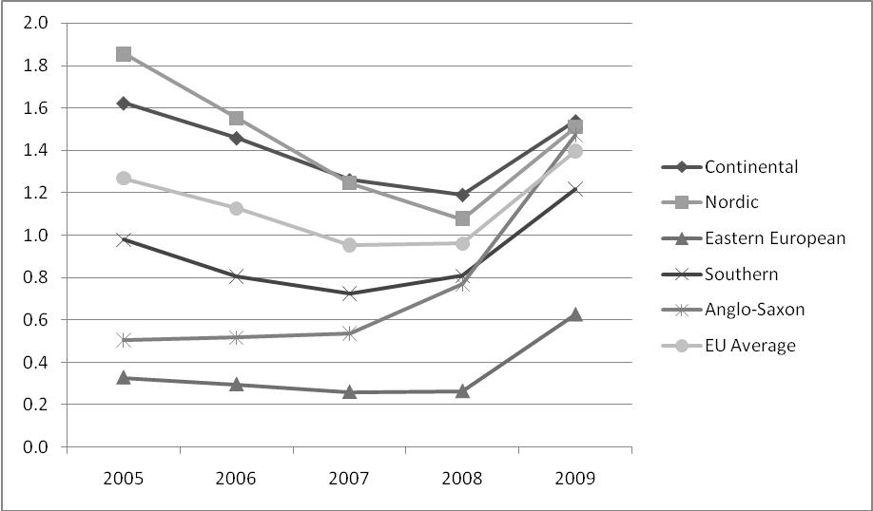
Source: Eurostat
Increasing conditionality of unemployment and other benefits is intended to make the unemployed and inactive groups more pro-active in their efforts to seek work or retrain, with sanctions applied in case of non-compliance. However, whether such effects are achieved depends on there being adequate provision of effective active labour market measures and training opportunities to support those who cannot find work and, ultimately, on adequate demand in the labour market to give people a chance of finding work after participating in ALMP measures. However, ALMP budgets have mostly not grown to reflect the increase in the number of unemployed. Moreover, conditionality also risks that the most vulnerable groups, who need the most support, are de-motivated and put off trying to find work and fall back to inactivity. There needs to be flexibility in the approach, individualised support for those that need it, and adequate fall-back systems to avoid long-term exclusion.
Although some groups do very well out of atypical employment arrangements (e.g. successful entrepreneurs, high-skilled freelance workers, etc.), many people who are self-employed, in part-time or fixed term contracts continue to be inadequately covered by social protection as well as often being rewarded unfavourably (levels of pay, holiday rights, etc.) compared to people in full-time permanent contracts doing the same or similar jobs.
The Hartz reforms undertaken during the 2000s in Germany were an example of strengthening benefit conditionality. At the core of the Hartz reforms was the introduction of a so-called 'mutual responsibilities approach in social security'. This meant the social security system would be aimed more at stimulating a return to work (more employment security) while income security continued to be available. In this approach, on the one hand PES organisations provide unemployment benefits when needed combined with increased frequencies of face-to-face contact, strengthened follow-up and generally becoming more accountable for their results, while on the other hand, jobseekers receiving benefits need to show clear job-search efforts, which are monitored, and sanctions may be used for non-compliance. Furthermore, benefit durations were made time-limited and conditionality was introduced linking training and job search effort more directly to receiving benefits. Evaluations show that jobseekers found jobs quicker and PES offices delivered more targeted and efficient services at the same or lower costs.
Lifelong learning
In addition to a good macro economic situation, employment security is to a large extent generated by ensuring continued human capital accumulation throughout workers' careers. Relying only on initial education undergone before the beginning of one's working life is insufficient in modern European economies with constantly changing technological production processes. Whether education and training activities are of a nature specific to the firm or sector influences firm incentives to make the required investments. Some of the short time work arrangements have used training participation as a criterion. Typically, this sort of training activities has been firm-specific.
The economic crisis seems to not have had a major impact on education and training participation rates among employed persons (see figure 3). During the 2008-2010 period, worker participation in training or education per flexicurity country group have remained more or less constant (Anglo-Saxon, Mediterranean and Central European) or continued to grow (Nordic). In the Continental group an increase in participation has been registered in 2009, most likely related to the participation in short time work arrangements which contained training requirements. Again, the ESF proved to be an important funding instrument in the Member States for such activities.
Considering levels, clearly workers in the Nordic, and to a somewhat lesser degree the Anglo-Saxon group, obtain a considerable portion of their employment security from high levels of human capital accumulation through education and training participation. For the other country groups, employment security via education and training seems to play a lesser role.
Figure 3. Participation in education and training among employed persons
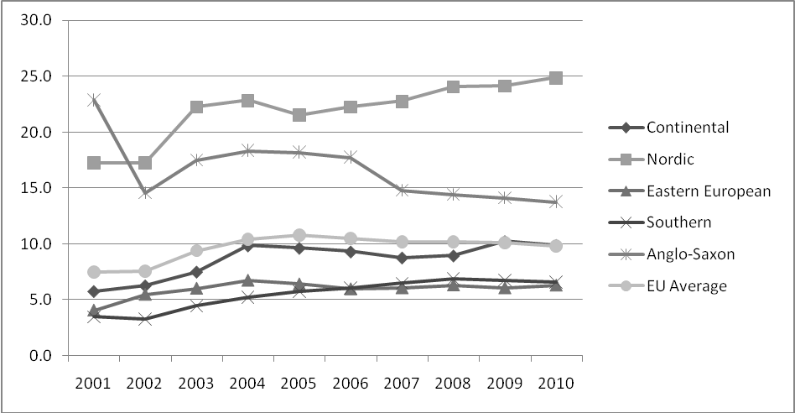
Source: Eurostat

6. Performance of flexicurity during the crisis
Flexicurity was intended to help create more and better jobs. It is therefore important to see how the various flexicurity regimes have weathered the crisis and how flexicurity policies have helped in terms of better labour market outcomes, such as employment, unemployment, segmentation, income protection and polarisation. This section discusses these themes in turn.
From an aggregated perspective the crisis has had a varied impact on Member States' labour markets. The various country groups replicate also this disparity in the way the crisis has manifested itself in terms of employment, unemployment and segmentation.
If we examine unemployment, between April 2008 and December 2011, the EU-level unemployment rate increased by 4 pp to a historic high of 9.9%. Considering the big drop in GDP and general economic activity, this rise in unemployment is moderate compared to other parts of the developed world; the US for example witnessed a stronger initial increase in unemployment even though GDP reductions were similar to those in the EU.
Figure 4. Unemployment impact of crisis various over countries
Within the EU, looking at the flexicurity country groups, some patterns emerge in the labour market performance over the crisis period. The countries in the Nordic and Continental countries groups have seen smaller unemployment increases, while Central/Eastern Europe witnessed EU-average levels of unemployment growth during the crisis and the Mediterranean countries experienced large (PT) to very large unemployment increases (EL, ES), see Figure 4. There are some exceptions to the above pattern with DK and the Baltic states with unemployment growth above their respective country group average, and IT below.
Another important aspect is how unemployment is turning into long-term unemployment. Previous to the crisis there was a general trend towards the reduction of long-term unemployment rates. This trend has been generally reversed, but it can be noted that the increase has been particularly steep in the case of the Anglo-Saxon cluster and that Nordic and Continental countries have seen a slower increase in the long-term unemployment rate than the other groups of countries. This would appear to show that they are still more successful in supporting transitions back to the labour market.
Figure 5. Long-term unemployment rates (2001-2010)
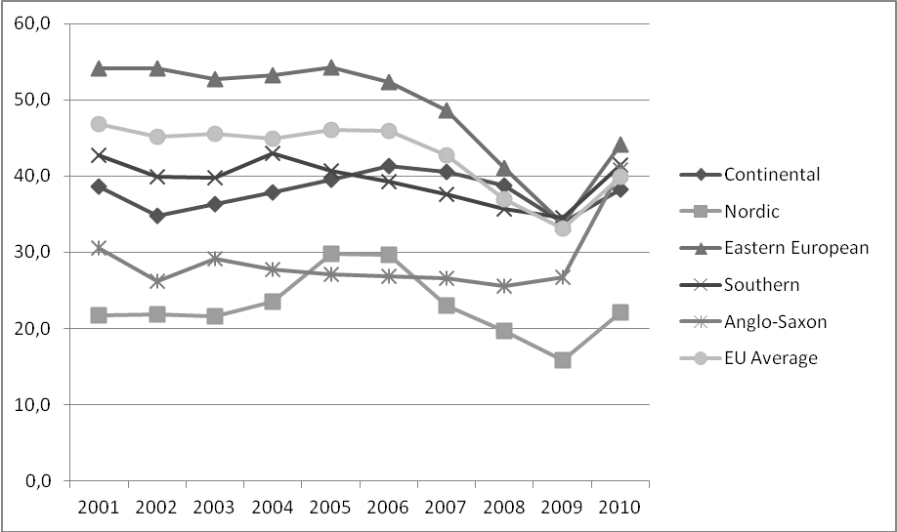
Source: Eurostat
The crisis has triggered a reduction in the EU employment rate from 2007-2010 of 2.9 pp. After the crisis period 2008–2010 the Nordic and Continental groups show the highest employment rates. The higher unemployment rates in DK pushed Nordic employment rates down but they are still at the highest level compared to other groups in the EU. The Continental group is the only group which managed to increase its employment rates over this period.
Figure 6. Employment rates for flexicurity clusters (age group 15-64 years old)
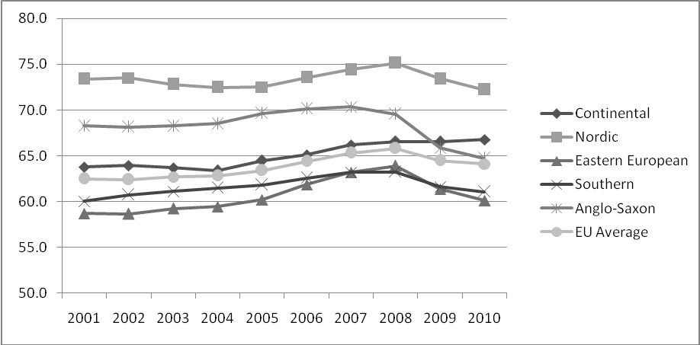
Source: Eurostat
Analysing labour market segmentation is difficult as it can not be observed directly. The numbers of workers in fixed term contracts in some cases can provide a useful but often only partial insight into the issue, since a fixed term contract is not necessarily an unfavourable contract for every worker. He or she may switch easily to a permanent contract after a fixed term contract, using it as a stepping stone, or it may well match his or her preferences. Still, labour market segmentation can be caused by repetitive use or over-use of fixed term contracts, so that it causes scarring effects, repeated unemployment spells between contract periods and a generally unbalanced development of work and private life. Using involuntary fixed term as an indicator work does provide a better insight regarding segmentation and over-use of fixed term contracts as people are increasingly likely to want to work in a permanent job, especially after they have done a series of fixed-term contracts leaving them to experience the downside of repeated fixed-term contract use.
Southern and Eastern European clusters are characterised by high levels of involuntary fixed term workers (between 70-80%, see figure 7), suggesting segmented labour markets. Workers are trying but not finding access to permanent employment. Nordic and Continental countries have lower levels of workers with involuntary fixed term contracts and these two groups showed an improvement since 2009.
Figure 7. Proportion of those in fixed term employment that ‘could not find permanent job’
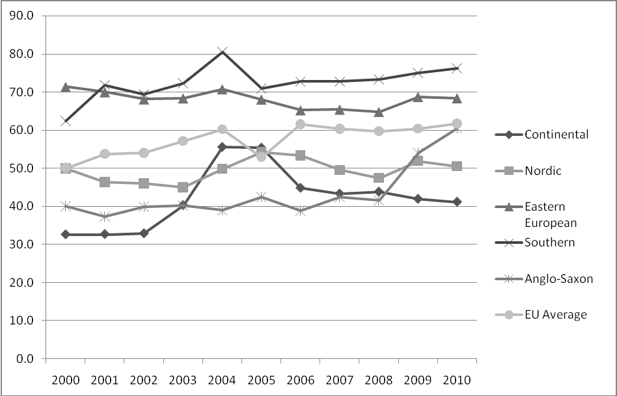
Source: Eurostat
When we look at income protection, mainly delivered through unemployment benefits, we see that the crisis has put social security schemes under stress, and has revealed strong variation across the EU in their capacity to provide adequate income support (i.e. acting as automatic stabilizers) and to cover the new unemployed.
Table 1 below illustrates for selected countries the extent to which gross disposable incomes of households (GDHI) have been sustained in the first and second phases of the crisis. It shows that it is mainly in the Continental and the Nordic countries, and the Czech Republic that incomes were well sustained during both periods, despite important initial economic shocks – as indicated by severe drops in GDP. Elsewhere the picture is mixed. In some countries (UK, Spain, Portugal), automatic stabilizers played their smoothing role in the first phase running 2007-2009, but this effect was not continued in the period 2009-2011.
Table 1. Economic shocks and effects on gross disposable household incomes, selected countries
 |  | 2007-9 |  | 2009-11
 |  | GDP | GDHI | GDP | GDHI
Anglo-Saxon | United Kingdom | -5,4 | 1,9 | 2,4 | -1,1
Continental | Austria | -2,5 | -0,5 | 5,3 | -0,8
Continental | Germany | -4,1 | 0,4 | 6,7 | 1,6
Continental | France | -2,8 | 1,7 | 3,1 | 1,3
Continental | Belgium | -1,9 | 5,2 | 4,5 | 0,1
Nordic | Denmark | -6,3 | -0,8 | 3,0 | 5,9
Nordic | Netherlands | -1,8 | -0,6 | 3,5 | -1,0
Nordic | Finland | -7,3 | 3,9 | 6,8 | 1,1
Nordic | Sweden | -5,8 | 5,1 | 9,8 | 5,1
Mediterranean | Spain | -2,9 | 5,1 | 0,7 | -6,2
Mediterranean | Greece | -3,4 | -2,7 | -8,8 | -12,4
Mediterranean | Italy | -6,1 | -2,5 | 2,1 | -1,0
Mediterranean | Portugal | -2,5 | 4,9 | -0,5 | -3,5
Eastern and Central European | Estonia | -17,4 | -6,2 | 10,4 | -1,9
Eastern and Central European | Latvia | -20,4 | -15,5 | 4,1 | -3,3
Eastern and Central European | Hungary | -6,0 | -5,6 | 2,7 | :
Eastern and Central European | Slovenia | -4,7 | 2,2 | 2,4 | -0,3
Eastern and Central European | Czech Republic | -1,7 | 3,5 | 4,6 | 0,9
Eastern and Central European | Poland | 6,8 | 8,1 | 8,1 | 5,8
Figures represent percentage change in given periods. Source: National Accounts
Furthermore, the crisis revealed strong variations in the capacity of unemployment benefit schemes to absorb the shock and to allow for adjustments in terms of benefit duration and conditionality. In some countries, tight conditionality combined with short durations had the effect of pushing people from unemployment benefits towards social assistance schemes as employment opportunities contracted. In other countries, recent data indicates that there is an increasing gap between the number of unemployed and the number of benefit recipients (over all types of schemes), indicating that an increasing number of people are not covered at all.
A final dimension worth considering in performance of flexicurity is the effects the crisis has had on the jobs structure. Jobs are structured in terms of occupations, like managers, machine operators and crafts workers, and in terms of economic sectors, like financial services, construction or manufacturing. Jobs, or occupation and sector pairs, have shown a clear pattern of polarisation over the economic crisis; jobs in the middle earnings quintiles have been terminated very clearly while jobs both in the lowest highest quintiles have seen no changes or even growth, see figure 8.
At country level, it seems Mediterranean countries including CY, ES, EL and PT show stronger patterns of polarisation, while Nordic (SE, FI, NL) and Continental groups (AT, BE, DE, LU) show less polarisation and more upgrading in job structures, i.e. job growth in higher earnings quintiles and job losses in lower quintiles.
Figure 8. Changes in numbers of jobs by wage quintiles, 2008Q2 – 2010Q2, in thousands
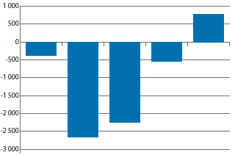

7. Concluding observations
The experience of recent years has confirmed flexicurity as a framework and a tool to understand and implement employment policy-making and to identify good and bad practices. It continues to be a useful concept within the employment agenda, supporting Europe's effort to build open, dynamic and inclusive labour markets. The following points stand out:
- Labour market segmentation remains a serious concern and the wide variety of the employment impacts from similar declines in economic activity shows that segmentation matters. Employment losses were far more serious in more segmented labour markets and also largely concentrated on the young which tended to have the greatest share of fixed term contracts.
- There is evidence that countries that reformed their systems - for example by shifting the emphasis from protection in the job to improving unemployment insurance - offered better employment protection and facilitated labour market adjustment. Similarly, those countries that allowed workers at the lower end to combine income support with the taking up of jobs - notably if efforts were made to facilitate further positive transitions to avoid that people were stuck in low productivity job – saw better outcomes.
- During the crisis, internal flexibility (or internal flexicurity) - through the use of short time work arrangements, working time accounts, use of temporary opt-out clauses, as well as other forms of managing labour market adjustment through investment in training of employed workers - has proved itself to be just as important as external flexibility.
- Countries with the best experience before, during, and successfully exiting the crisis, are indeed those that balance flexibility in adjustment to the crisis related shocks and structural change with employment security measures. Among those are Member States in the Nordic and Continental groups. However the Nordic group has seen rapidly rising unemployment and rather jobless recoveries and the Continental group rather divergent experiences, possibly so extensive that they no longer really form a coherent cluster.
- Flexicurity is both about structural reforms and social investments. What is important at this juncture is to agree on the need to undertake and implement the labour market reforms that can help put back Europe on the path to recovery and growth. In some cases the favourable impacts of reforms may take several years to see their full impacts and implications. The reforms in unemployment benefits show the importance of doing it as part of implementing an integrated policy package; a comprehensive approach delivers stronger labour market results than individual measures would.
- Discussions with Member States and the November Stakeholder conference have provided important inputs when considering the future for flexicurity. Through the work of the Employment Committee a common body of concepts, in terms of flexicurity pillars (ALMP, lifelong learning, contractual arrangements and modern social security) and common principles has been developed, feeding into the implementation of the Europe 2020 strategy
- The current analysis shows that there is a high number of measures which include multi-stakeholder cooperation and which are characterised by an explicit definition of the flexibility and security dimensions - leading to an agreed upon and accepted combination of the two. Furthermore, the new perspective on the benefits of internal flexibility instruments places a renewed onus on a reinforced social dialogue at all levels, including firm level, that contributes to the design, implementation and monitoring of flexicurity.
- The concept of flexicurity translates into concrete policies and practices. Ongoing initiatives in the field can be described with their expected effectiveness in terms of jobs and income security, and not necessarily at great (public) costs. Central to these examples is a renewed balance between various forms of flexibility combined with appropriate forms of security. Because not all can be delivered by national stakeholders, some flexicurity measures and mutual risk management can be generated by new partnerships between local governments, social partners, networks of firms (notably SME's) and communities.

An expert group on Flexicurity was set up by the Commission to elaborate proposals.
Add reference to 2007 flexicurity communication
COM(2010)682 final
Guideline 7 urges Member States to integrate the flexicurity principles endorsed by the European Council into their labour market policies and apply them; the Guideline also makes explicit reference to the four components of flexicurity
COM(2011) 11 final
COM(2011) 815 final
Employment in Europe 2006, Chapter 2 'Flexibility and security in the EU labour market', DG Employment, European Commission
There is an extensive literature trying to map different flexicurity models, most of which have drawn comparable conclusions, though the number of clusters and their composition may vary. The clusters were defined mainly on the basis of commonalities in labour market rules, institutions and practices, rather than on the basis of labour market outcomes, which have been in some cases different for different countries within the same cluster. Also, in some cases, the nature or intensity of reforms undertaken since 2006 by different countries within the same clusters has differed (as also illustrated by country examples throughout this document) and the cluster analysis does not aim to be a perfect substitute for a country-by-country analysis.
Measuring the impact of flexicurity policies on the EU labour market, Final Report, June 2011, by Institute for Advanced Studies Vienna; Social Partners and flexicurity in contemporary labour markets, Synthesis report, May 2011, by E. Voss, A. Dornelas, A.Wild and A. Kwiatkiewicz. Evaluation of the first phase of flexicurity (2007-2010): Interim Report, by GHK, 10 February 2012; The second phase of flexicurity: an analysis of practices and policies in the Member States (forthcoming), October 2011, by EUROFOUND
Council Directive 1999/70/EC concerning the framework agreement on fixed-term work concluded by ETUC, UNICE and CEEP.
The Commission is currently evaluating the functioning of the Council Directive on fixed-term work.
For more information see http://www.erc-online.eu/content/default.asp?PageID=514
OECD, Hijzen and Venn, 'The role of short time work schemes during the 2008-9 recession', OECD Working paper 115, 2011
Research voor Beleid Panteia, 'Short time working arrangements during the crisis and lessons to learn', draft version December 2011
http://ec.europa.eu/social/main.jsp?catId=113&langId=en&pubId=6176&type=2&furtherPubs=yes

