 | 
COUNCIL OF  THE EUROPEAN UNION |  |  | Brussels, 25 May 2012
 |  |  | 10430/12
ECOFIN 440
UEM 112
SOC 417
PARLNAT 255

COVER NOTE
from: | Portuguese Assembleia da República, Comissão de Assuntos Europeus
date of receipt: | 23 May 2012
to: | President of the Council of the European Union
Subject: | Report from the Commission  Alert Mechanism Report  - Report prepared in accordance with Articles 3 and 4 on the Regulation of the prevention and correction of the macroeconomic imbalances  [doc. ST 6360/12 ECOFIN 133 UEM 31 SOC 115 - COM(2012) 68 final]  - Opinion on the application of the Principles of Subsidiarity and Proportionality

Delegations will find attached the above mentioned opinion.

________________________

Encl.:

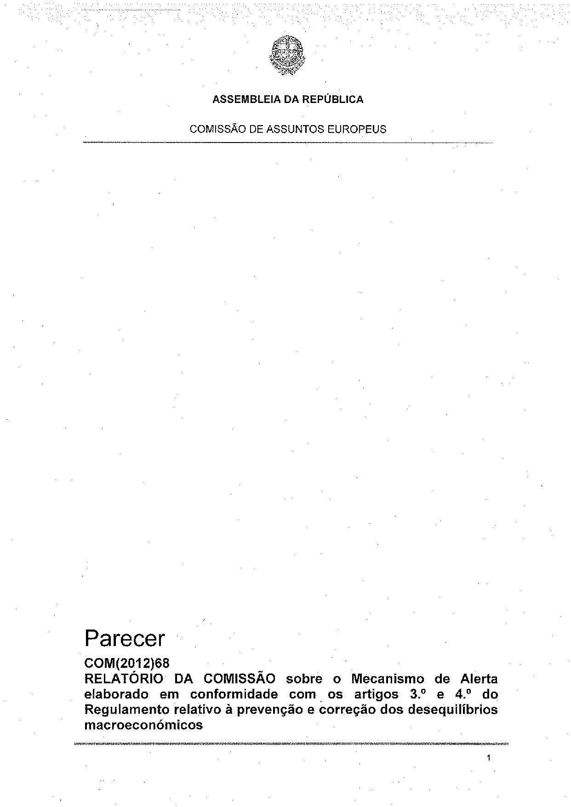
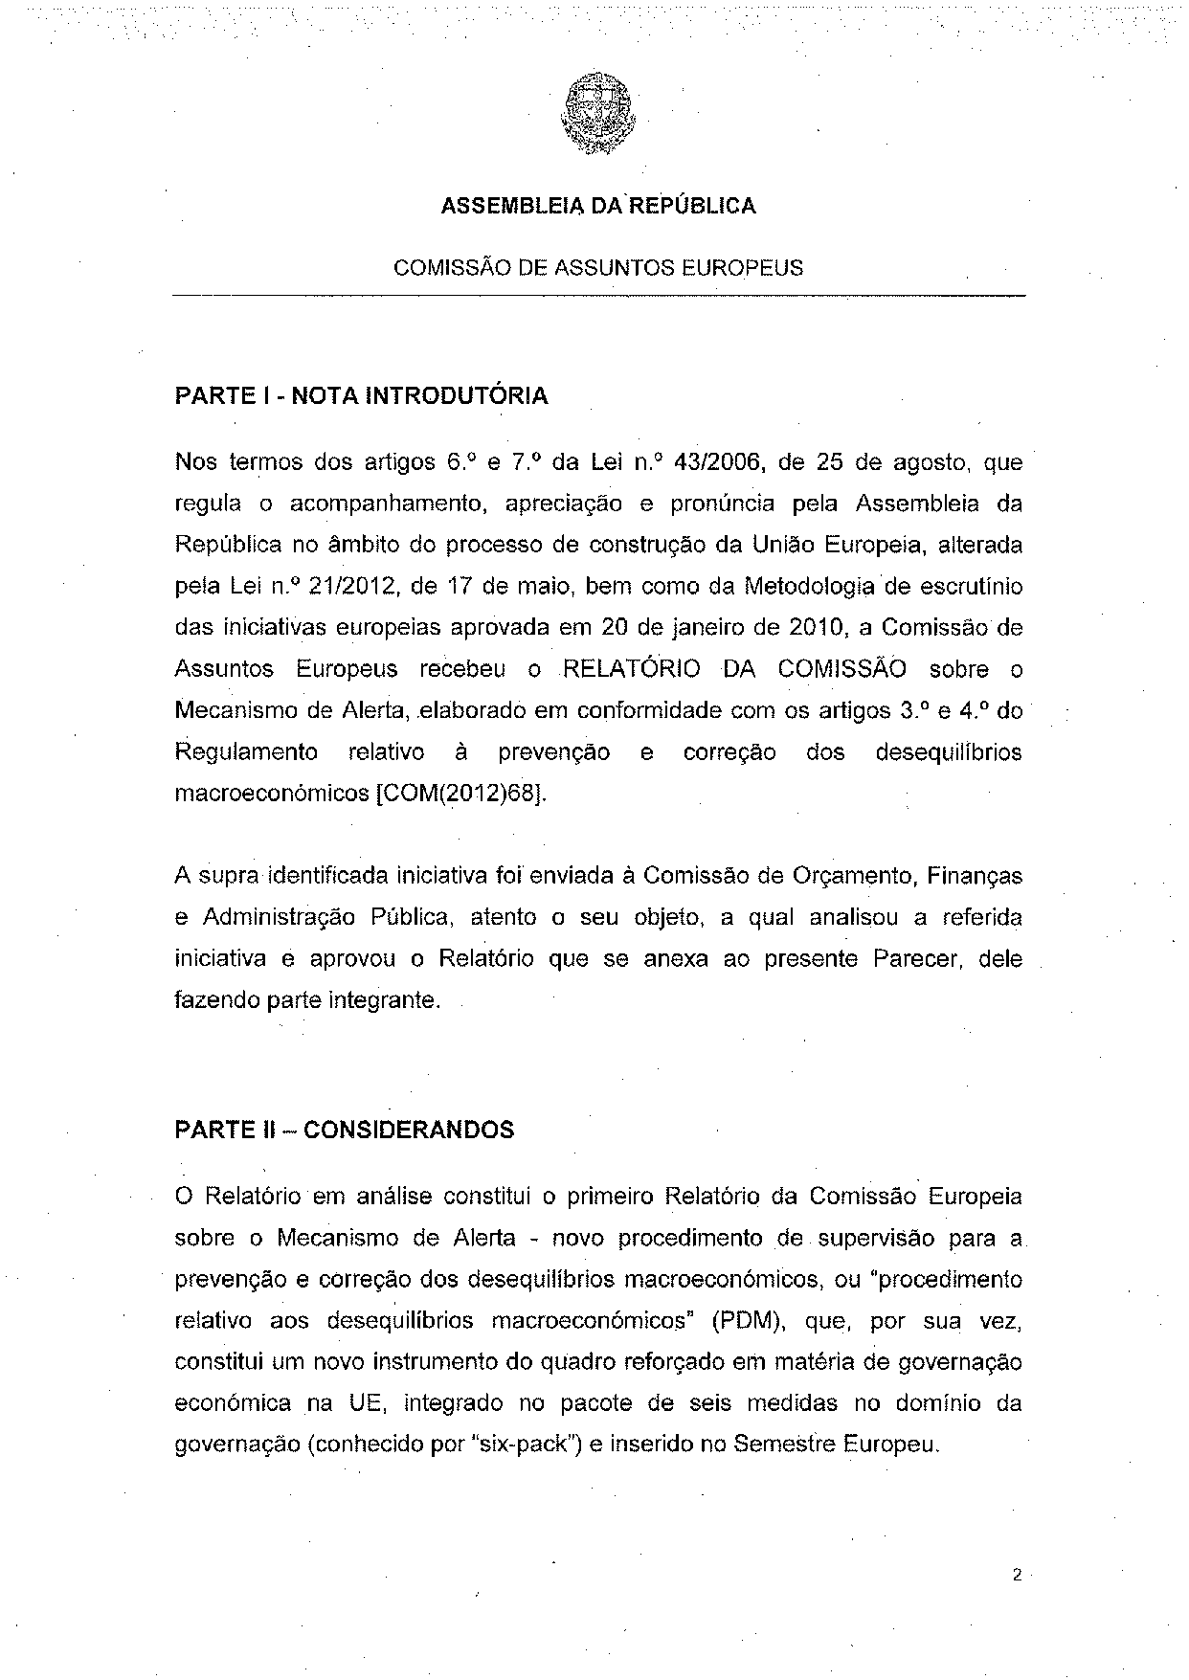
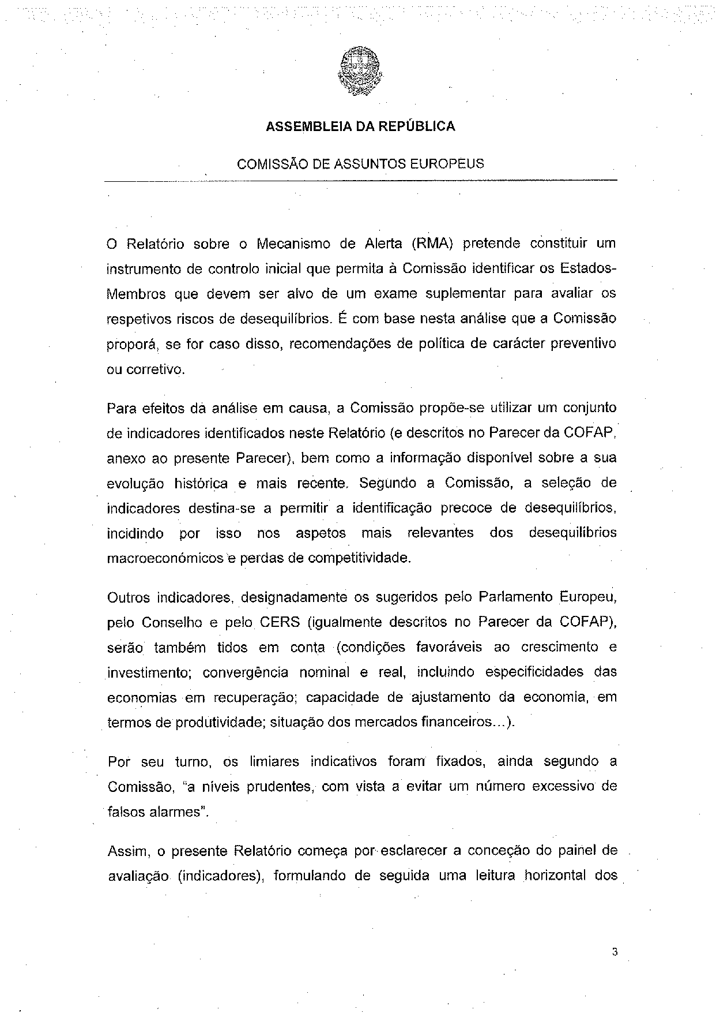
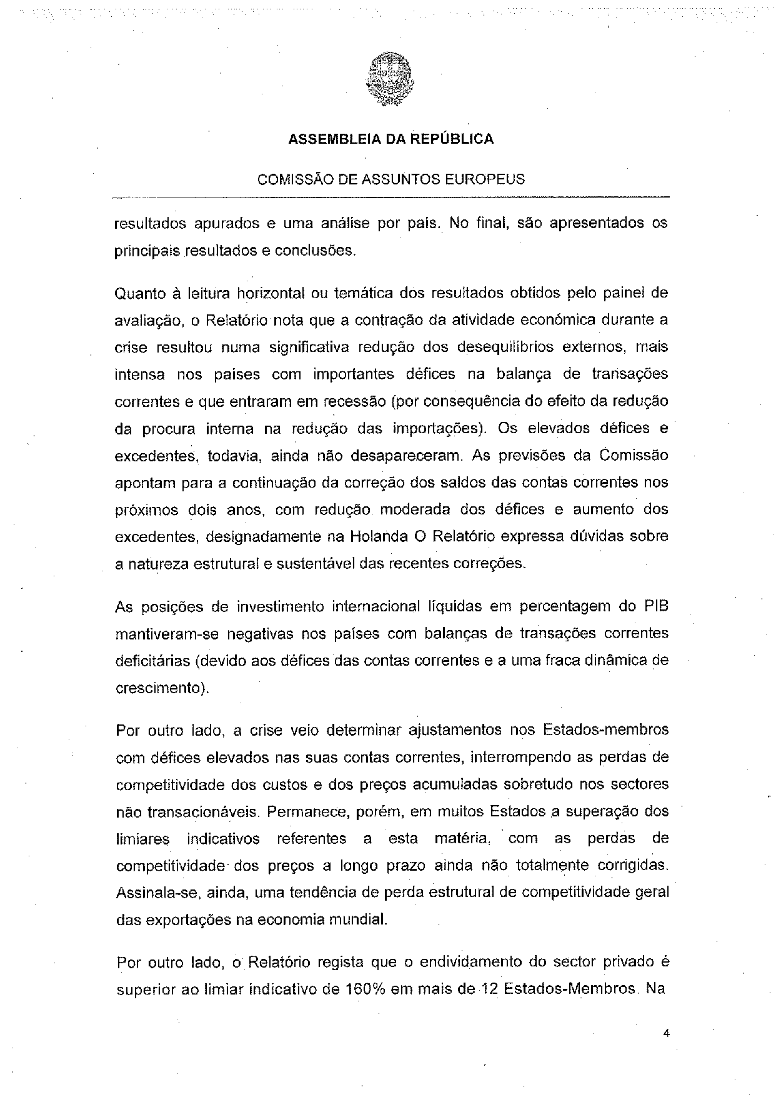
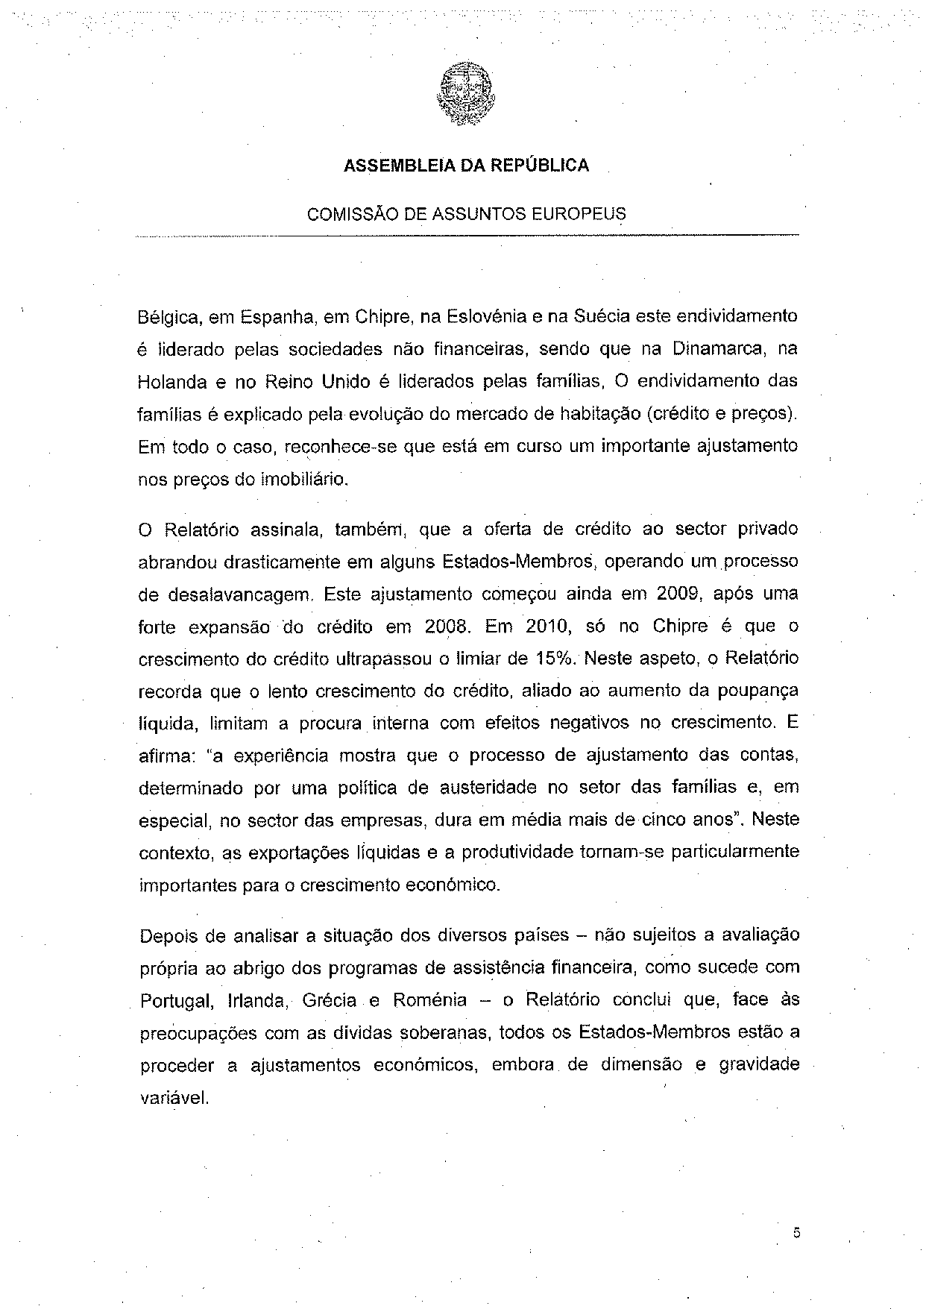
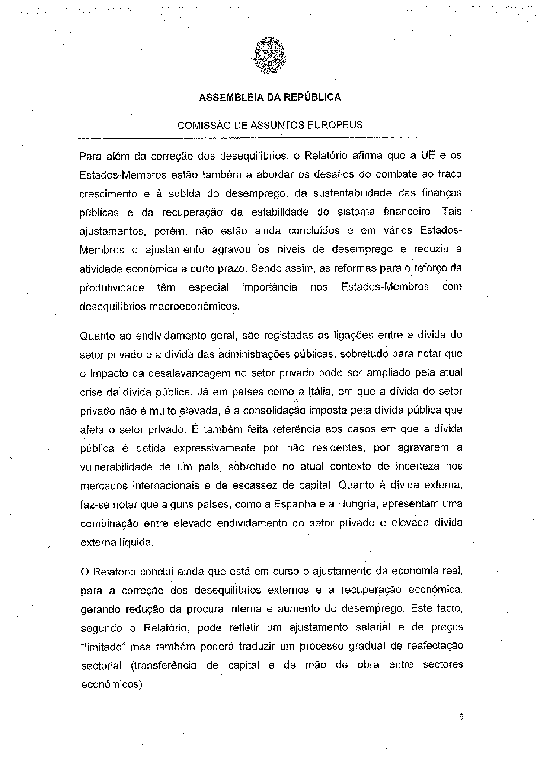
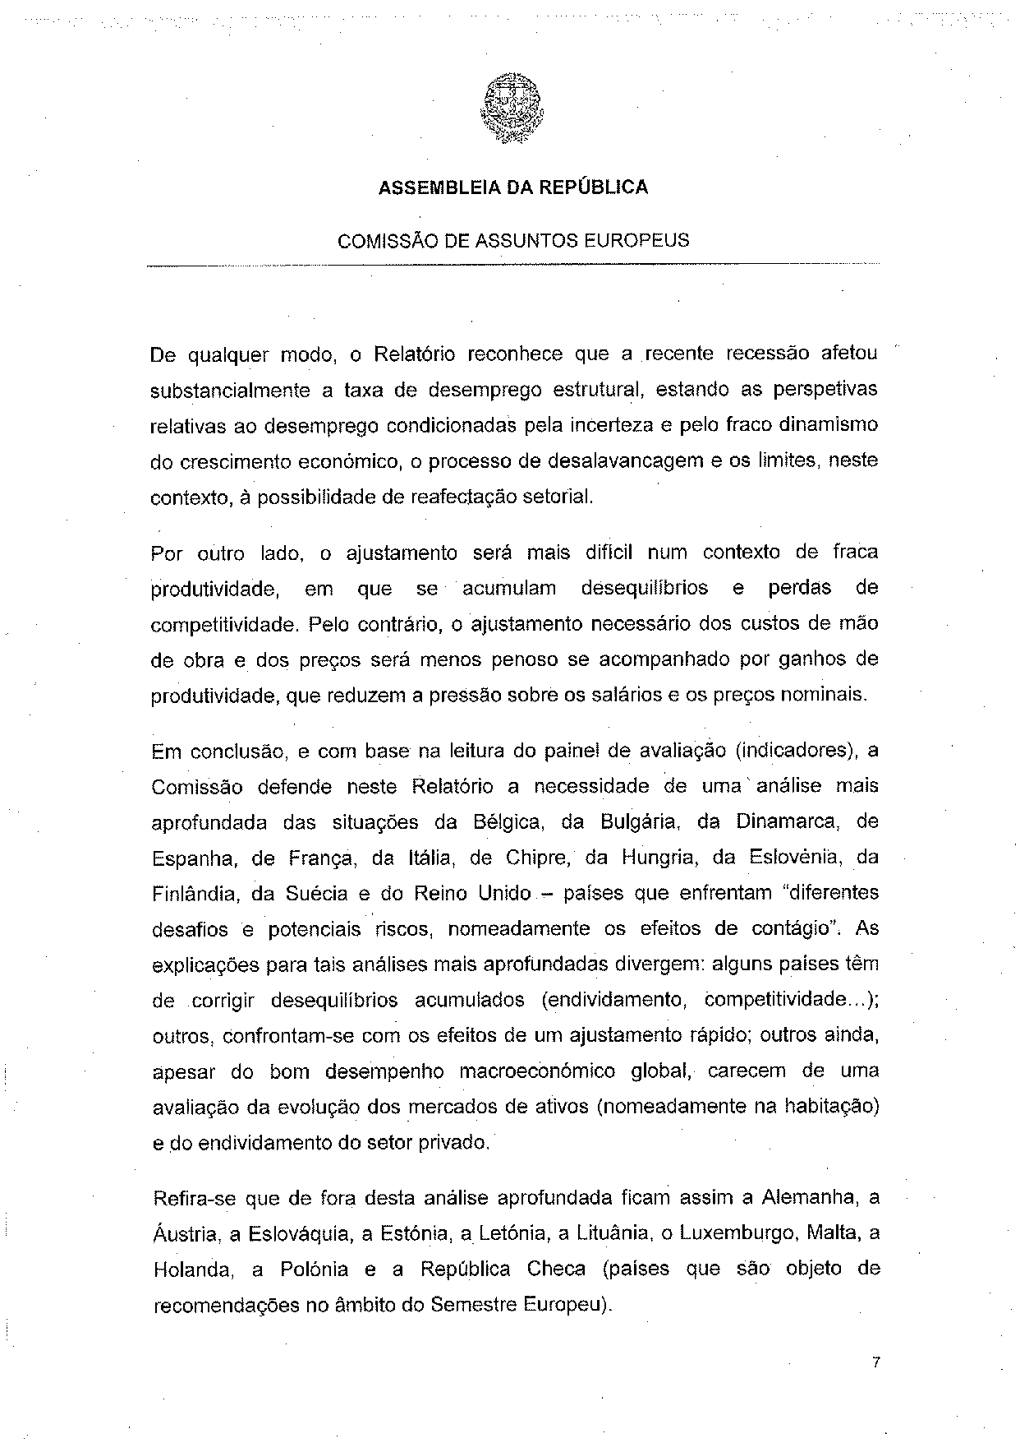
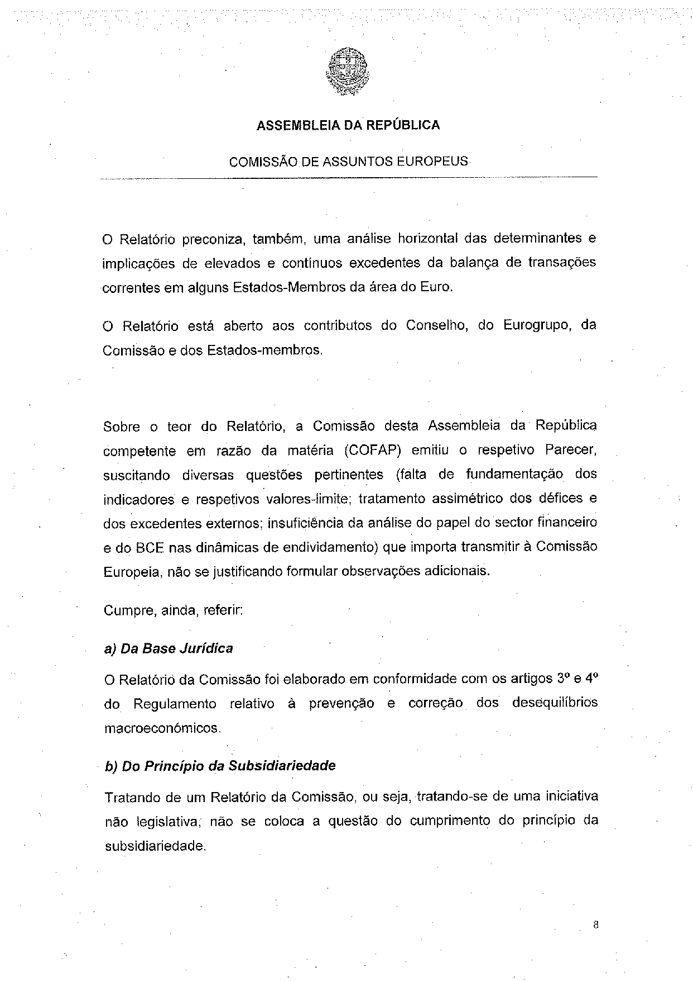
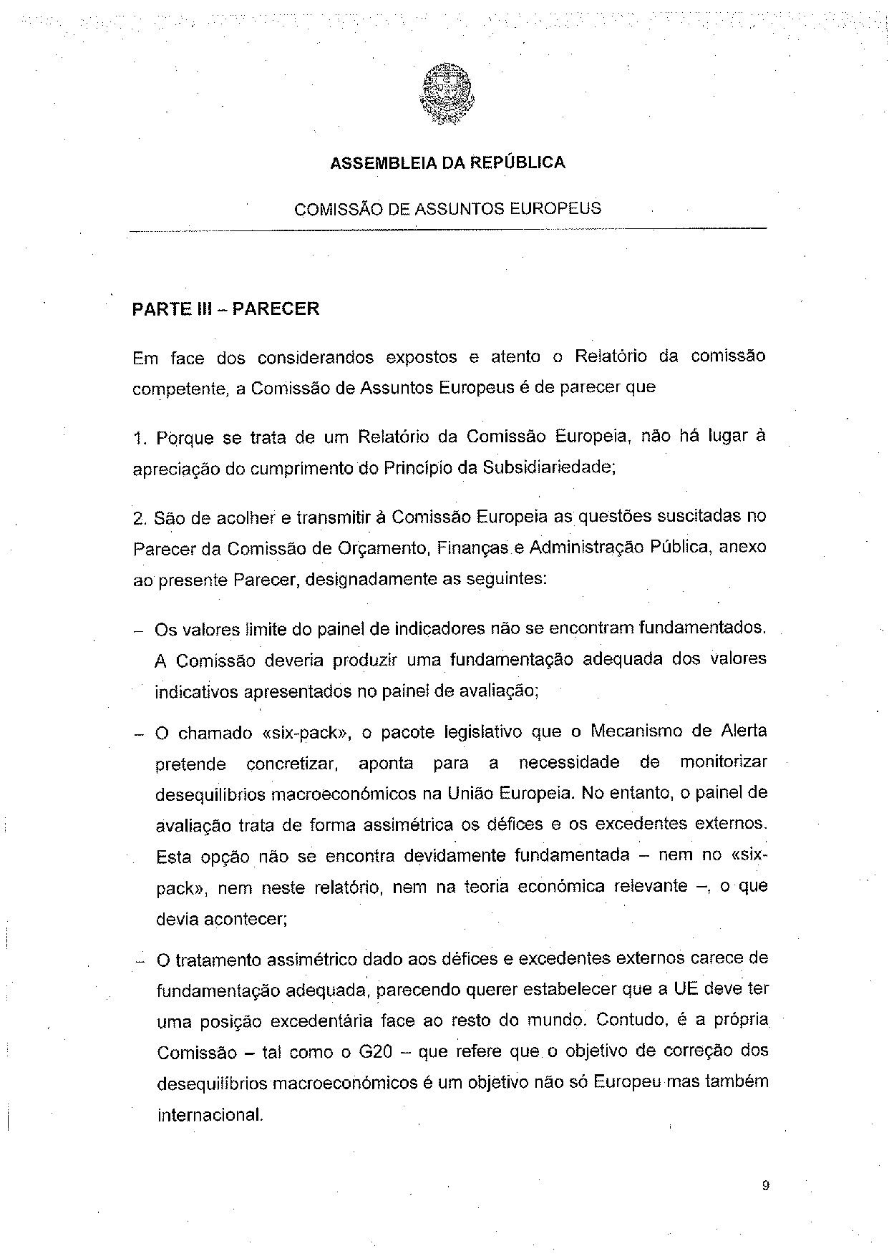
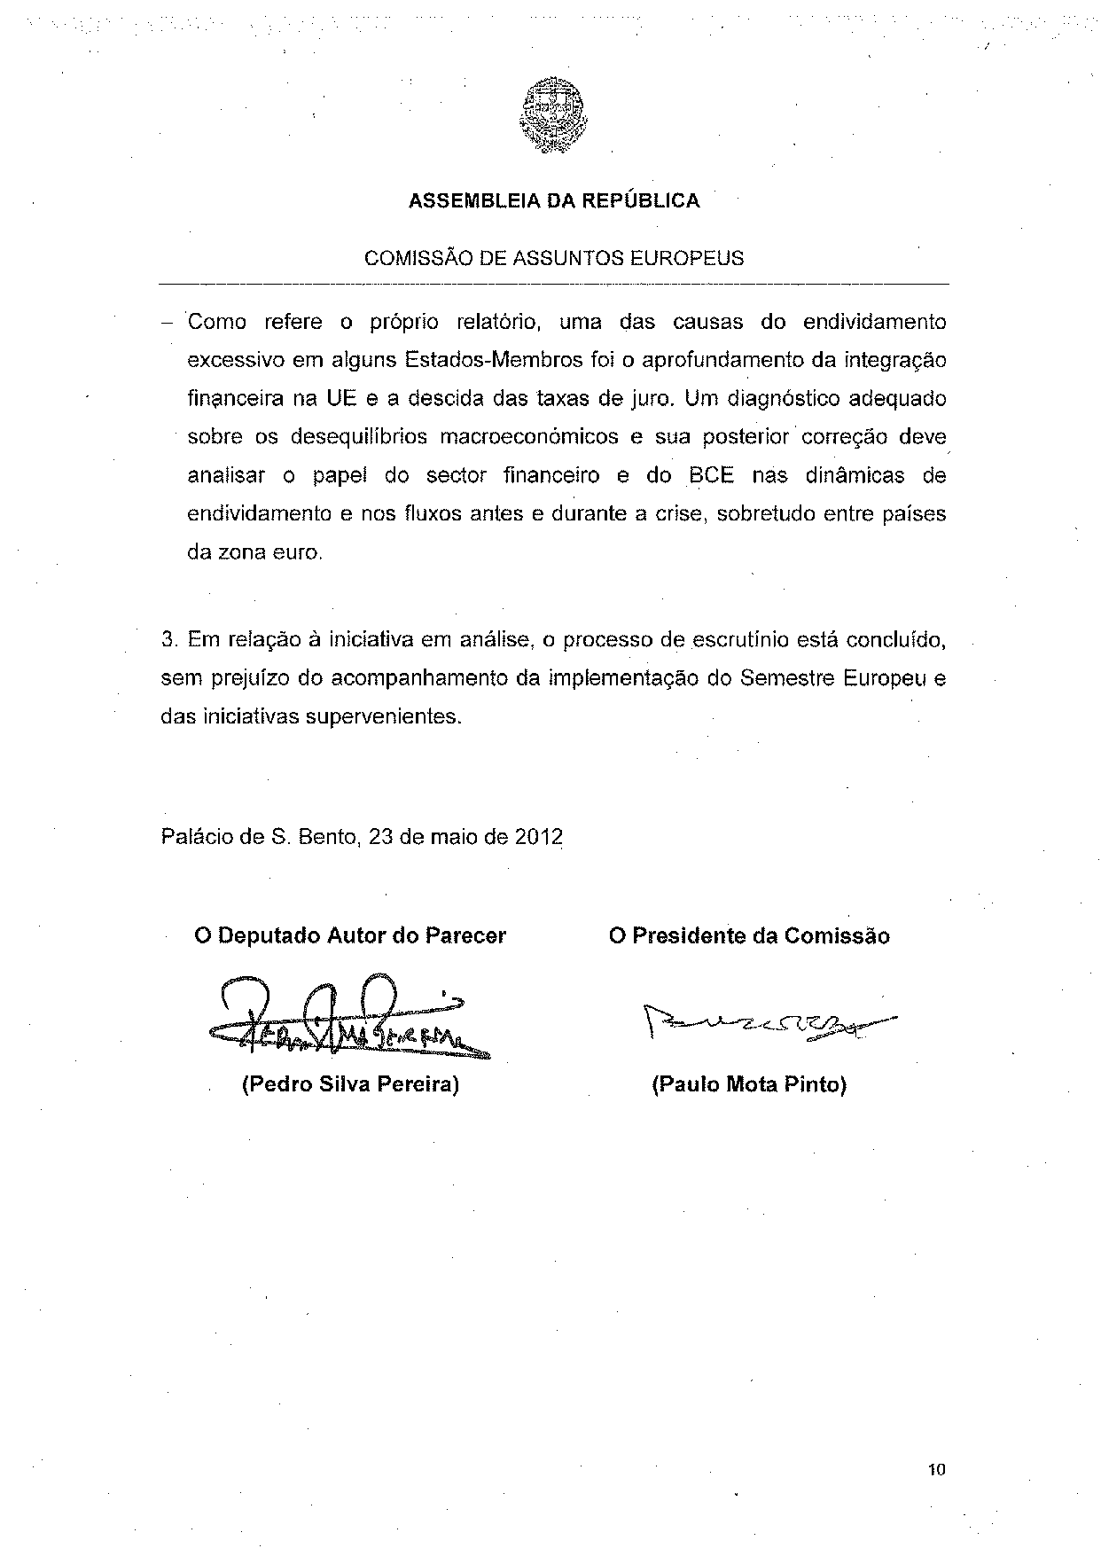
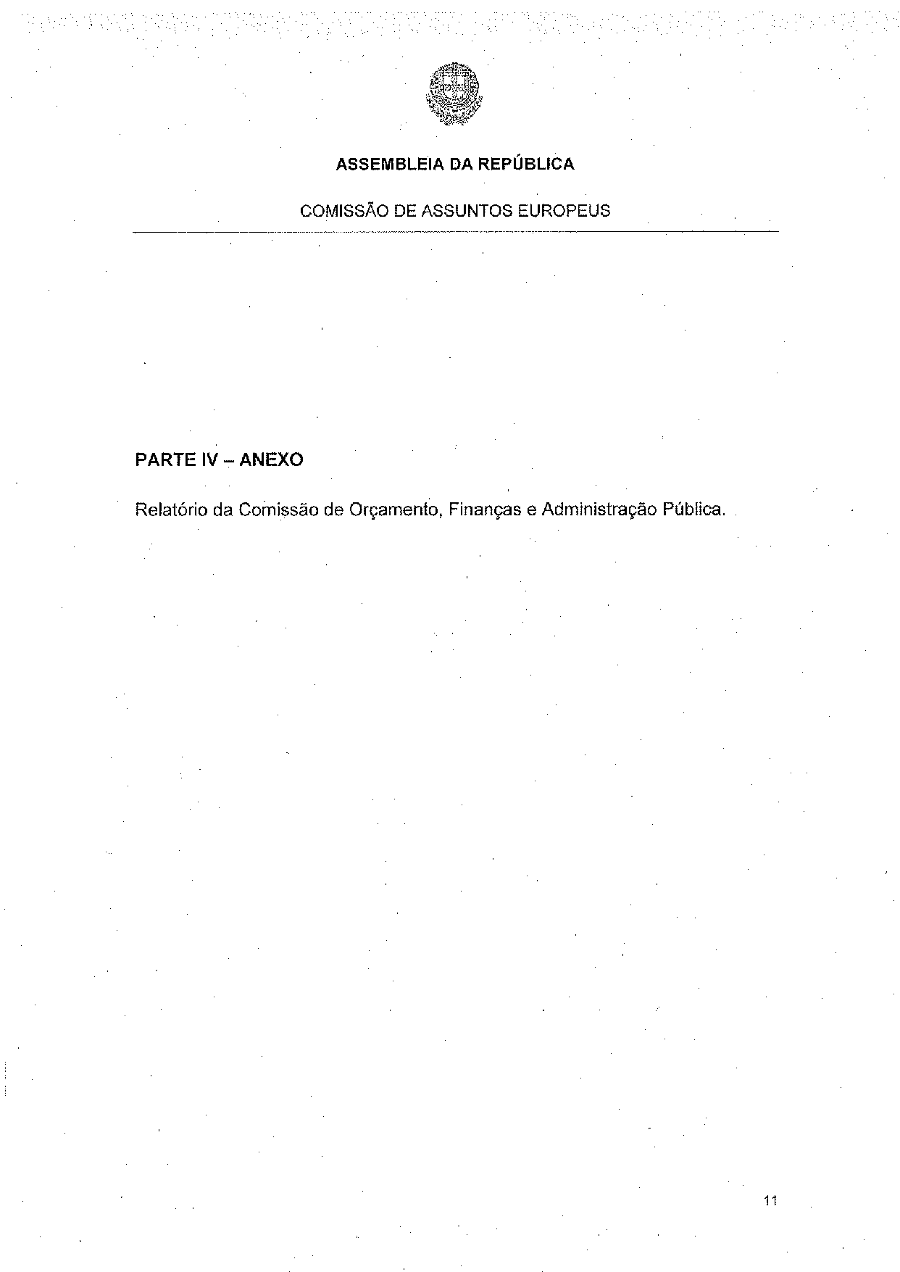
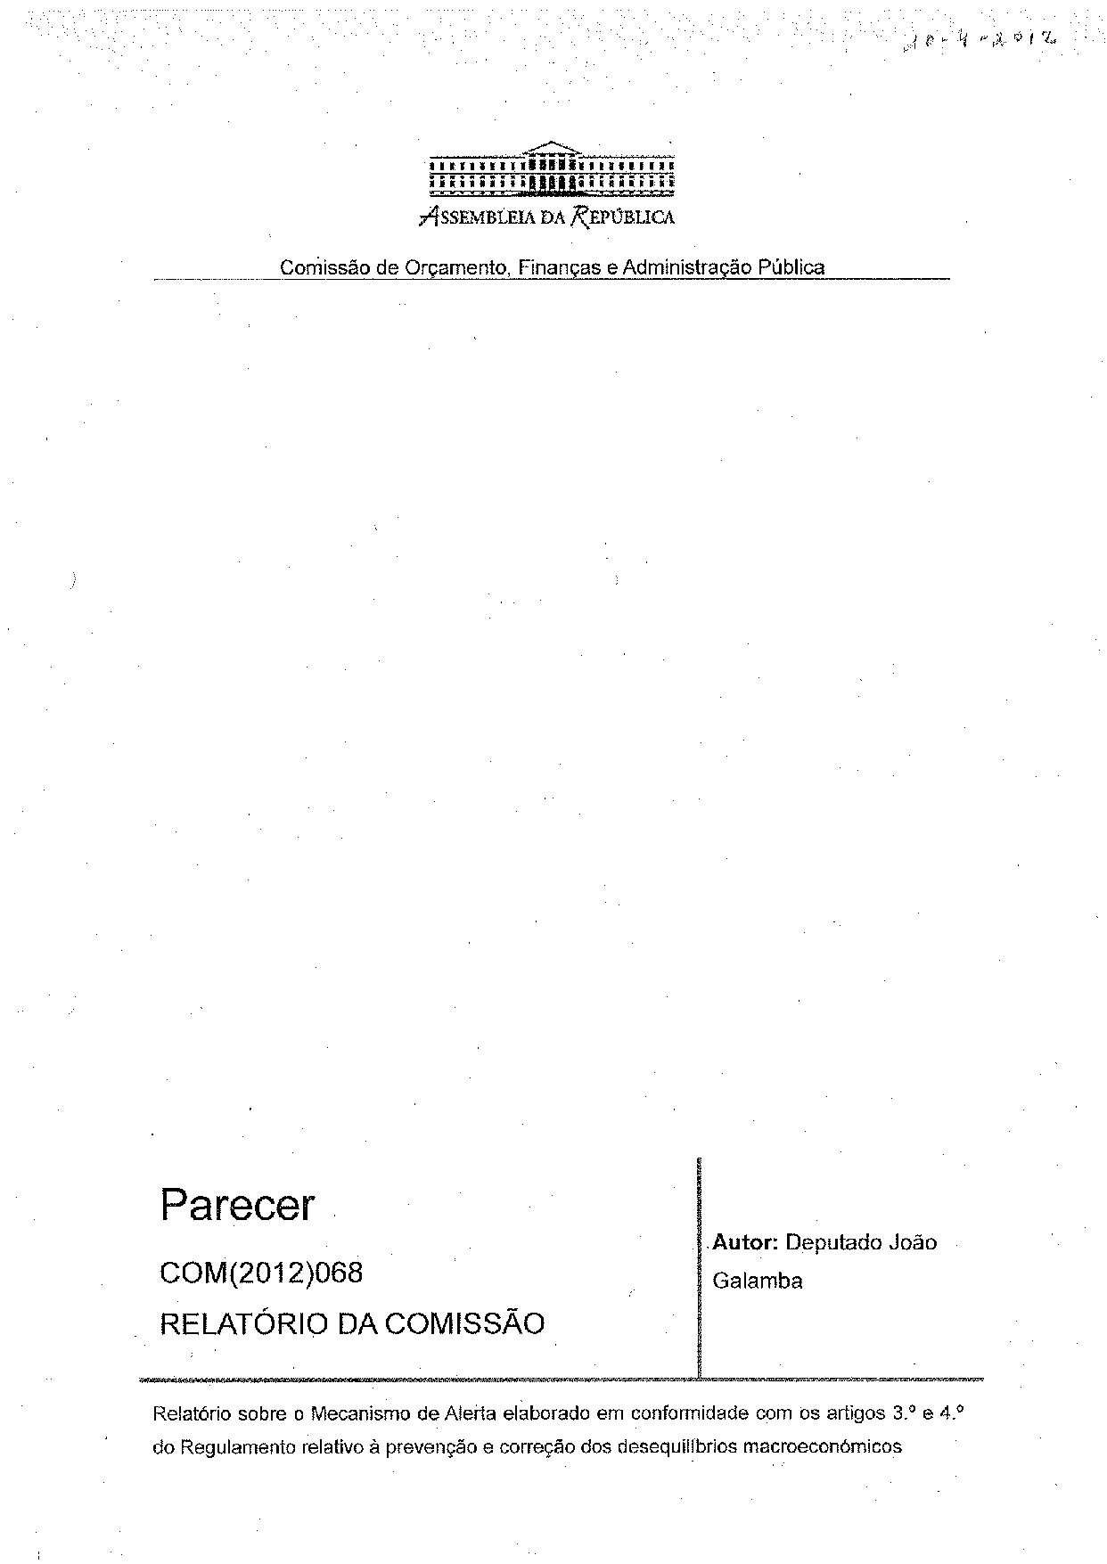
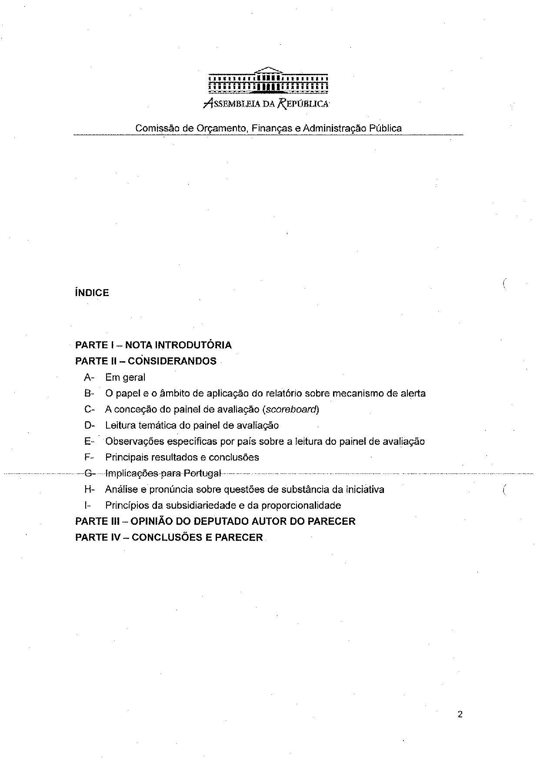
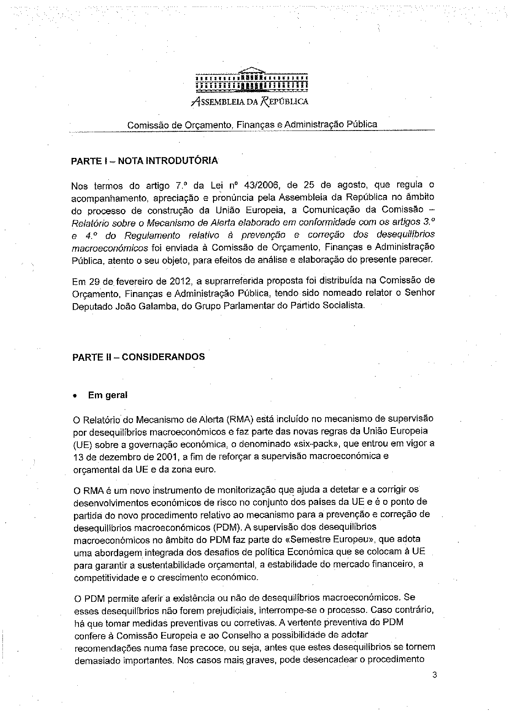
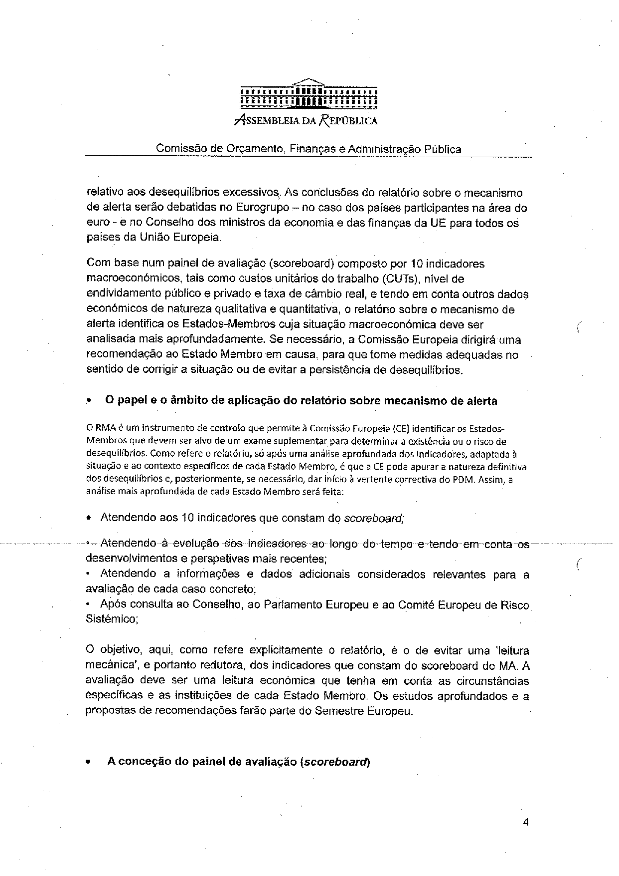
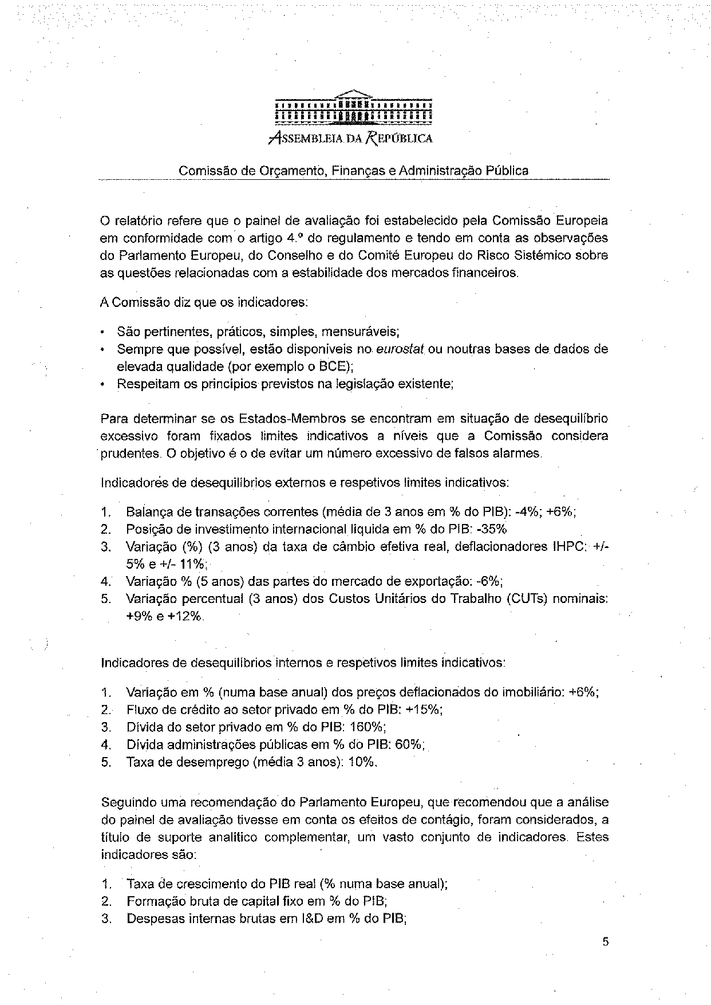
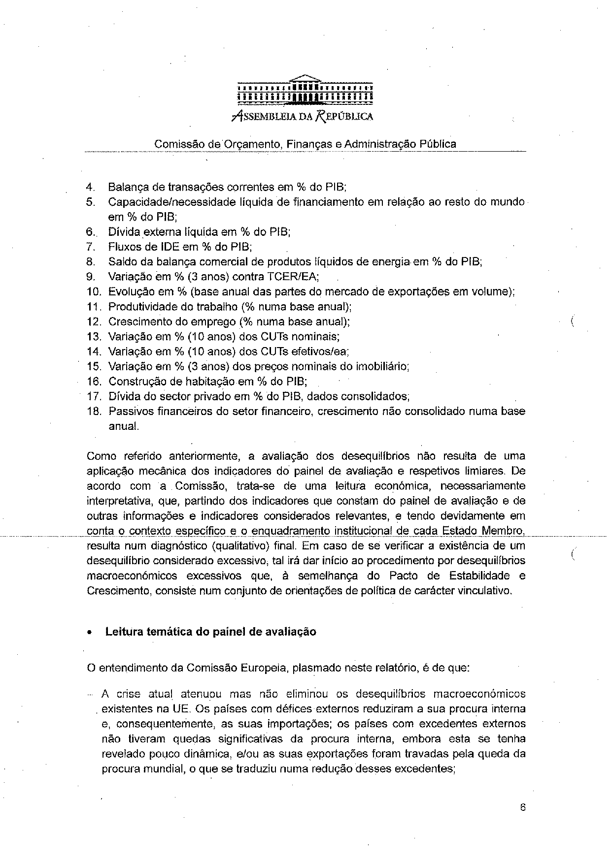
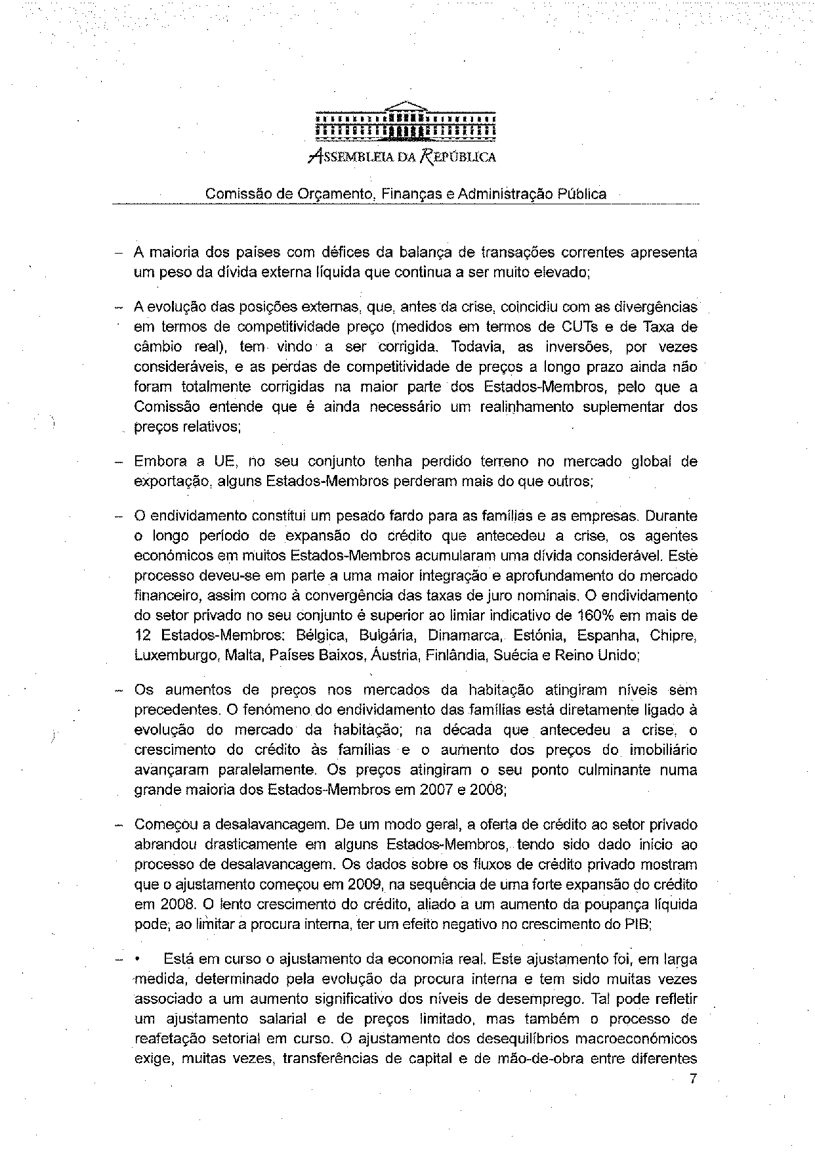
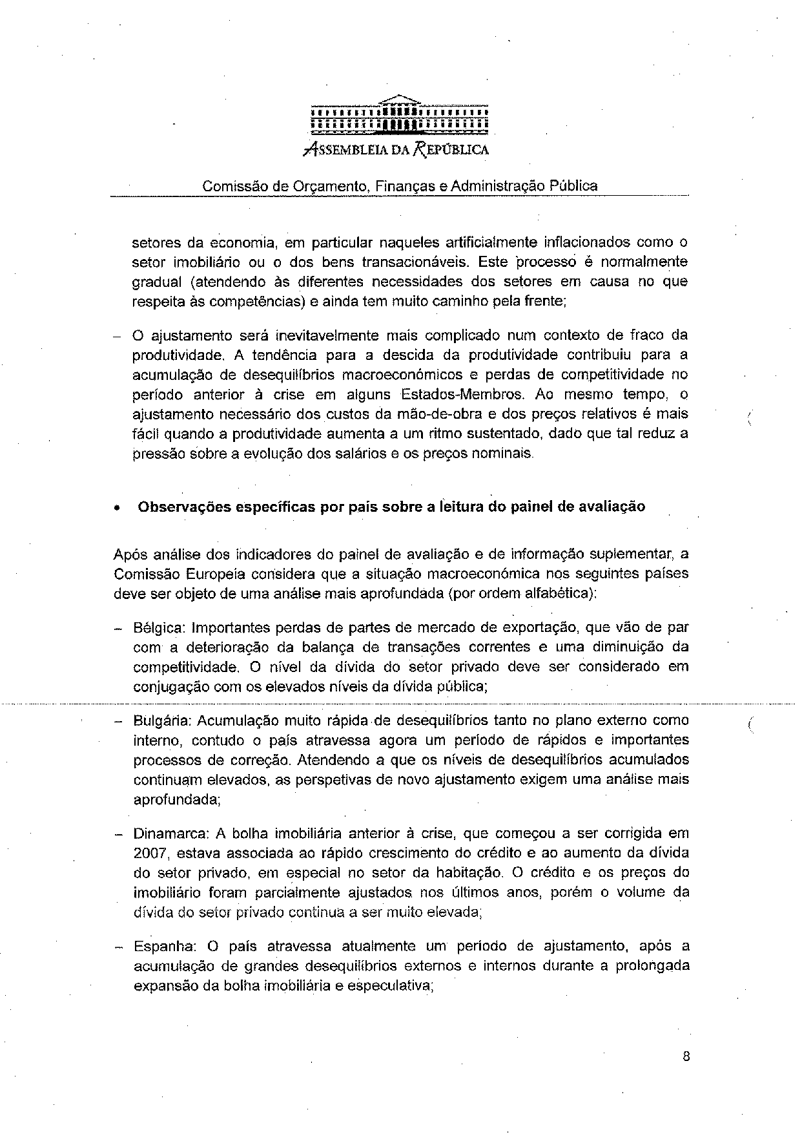
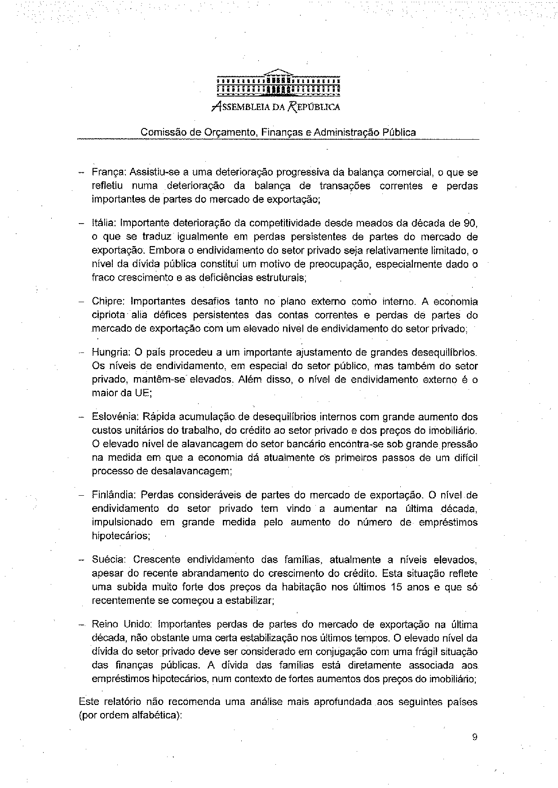
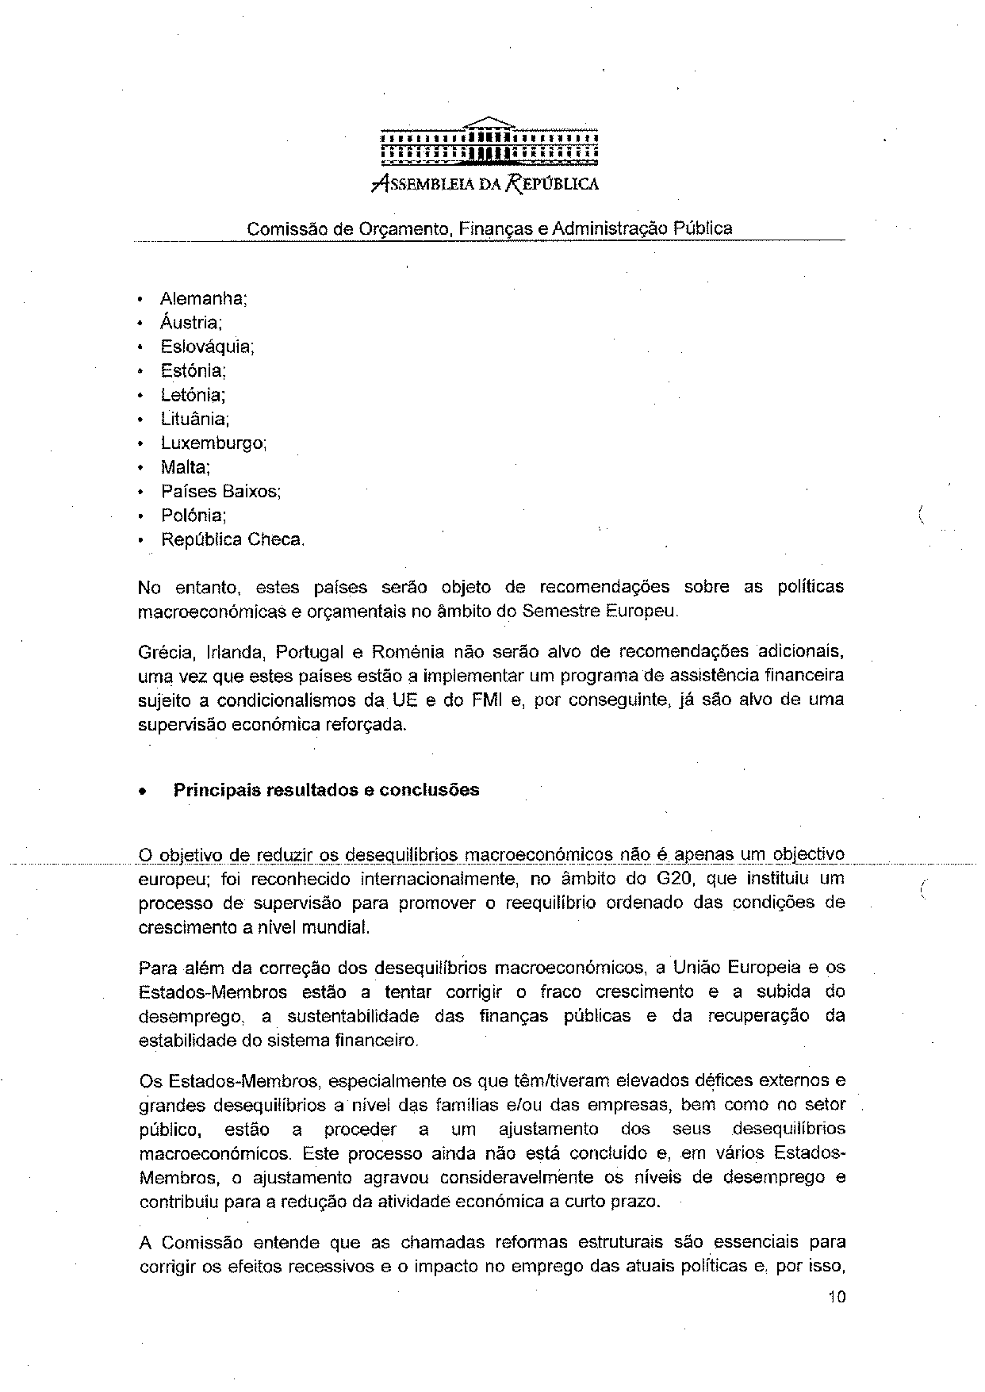
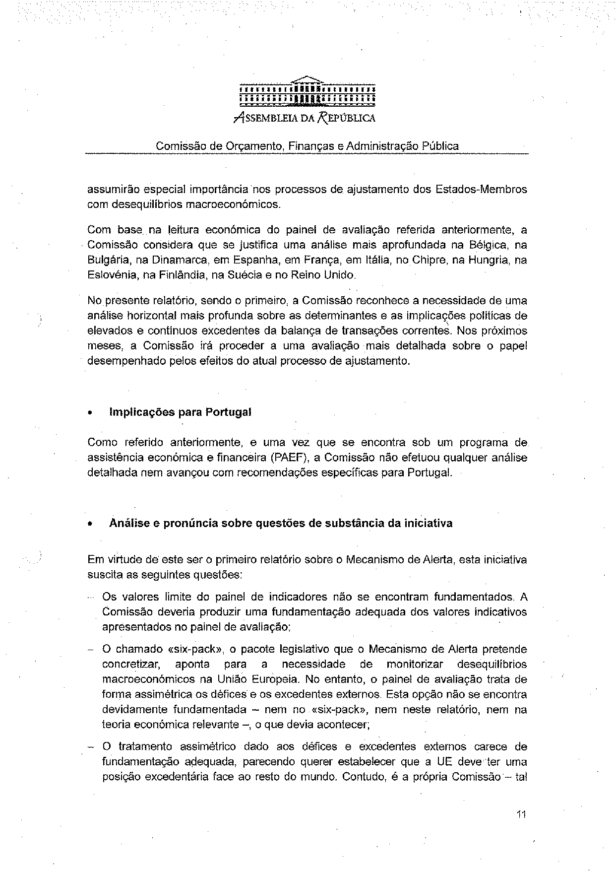
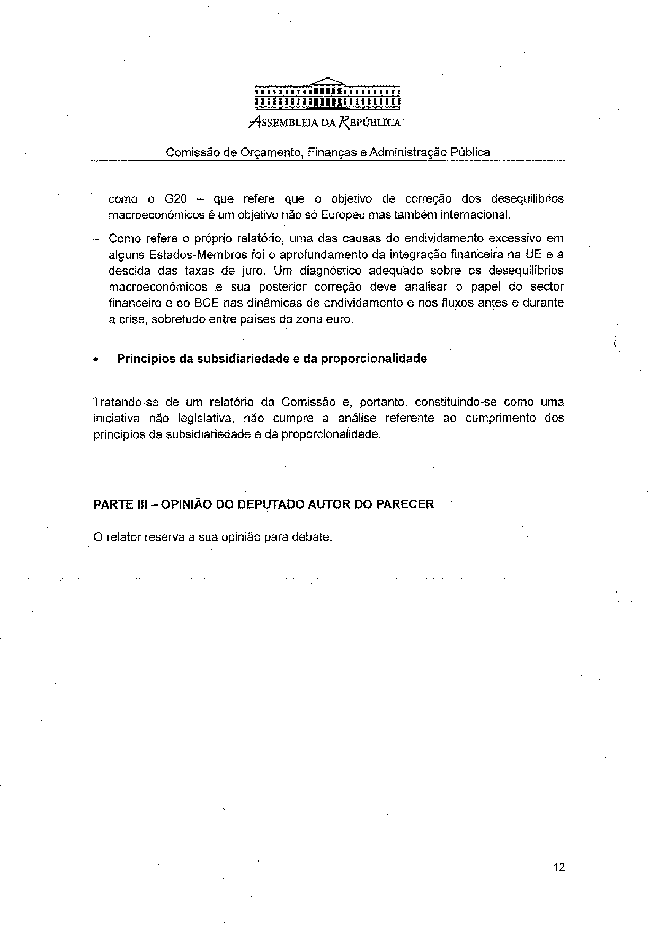
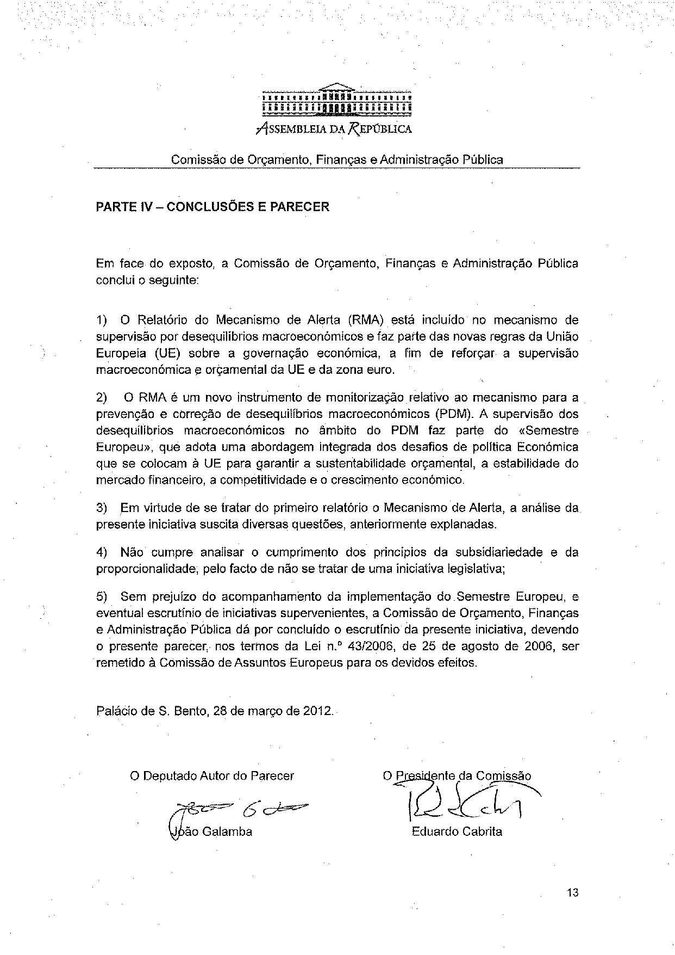

For other language versions of the opinion, reference is made to the Interparliamentary EU information exchange site IPEX at the following address: http://www.ipex.eu/IPEXL-WEB/search.do

