 | 
COUNCIL OF  THE EUROPEAN UNION |  |  | Brussels, 22 May 2012
 | Interinstitutional File:  2011/0369 (COD) |  | 10161/12
JAI 342
CADREFIN 263
DROIPEN 62
COPEN 120
CATS 35
JUSTCIV 193
EJUSTICE 43
JURINFO 23
CORDROGUE 35
CODEC 1372
INST 356
PARLNAT 247

OPINION
from: | The Italian Parliament
date of receipt: | 17 May 2012
to: | Council
Subject: | Proposal for a  REGULATION OF THE EUROPEAN PARLIAMENT AND OF THE COUNCIL  establishing for the period 2014 to 2020 the Justice Programme  Doc. 17278/11 JAI 849 CADREFIN 144 DROIPEN 142 COPEN 334 CATS 122 JUSTCIV 324 EJUSTICE 90 JURINFO 62 CORDROGUE 81 CODEC 2129  [COM(2011) 759 final]  - Opinion on the application of the Principles of Subsidiarity and Proportionality

Delegations will find attached the above mentioned opinion.

_____________

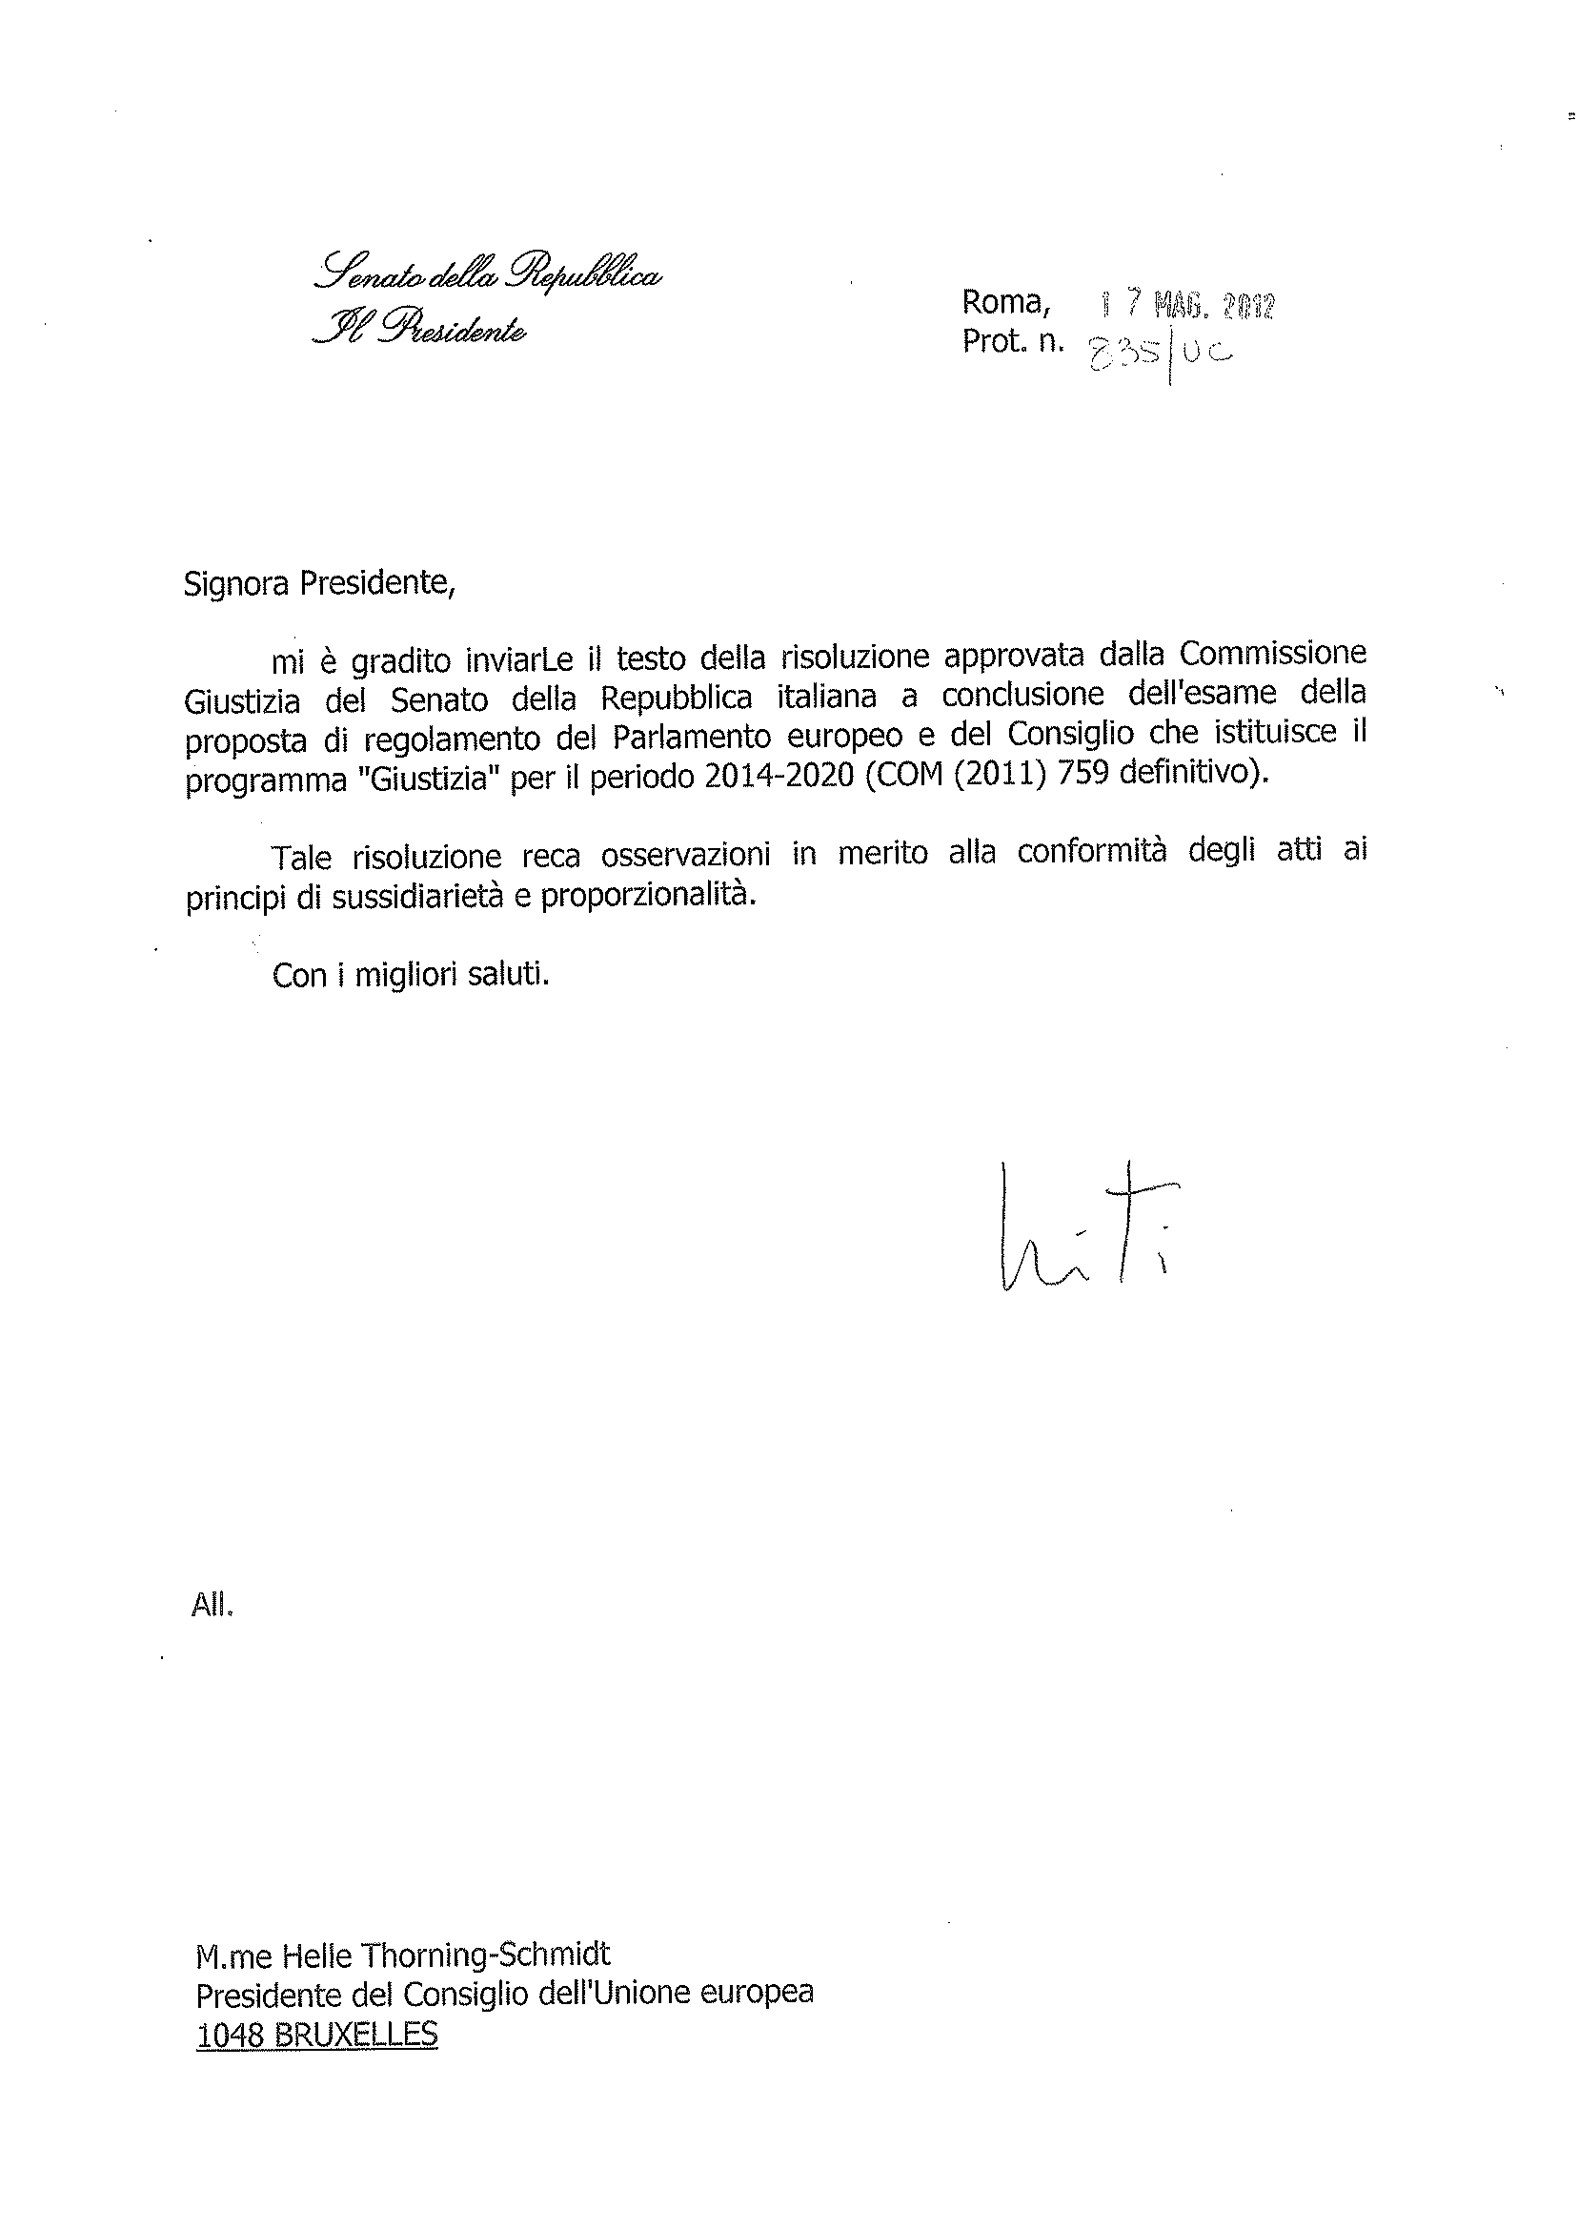
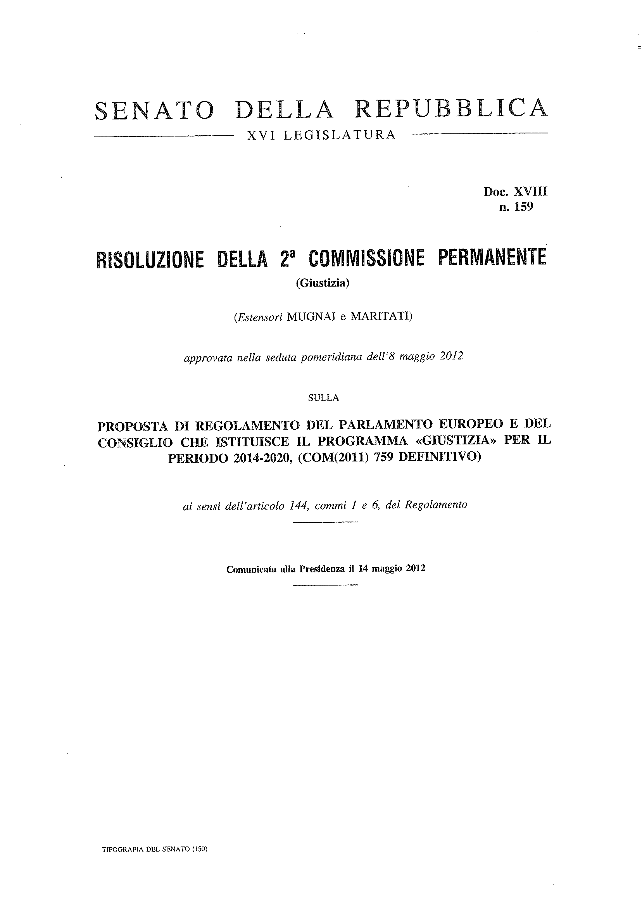

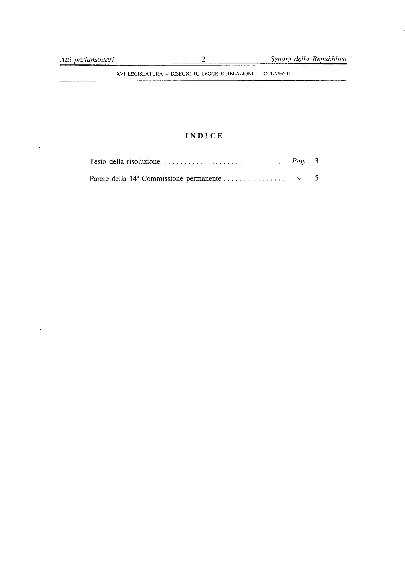

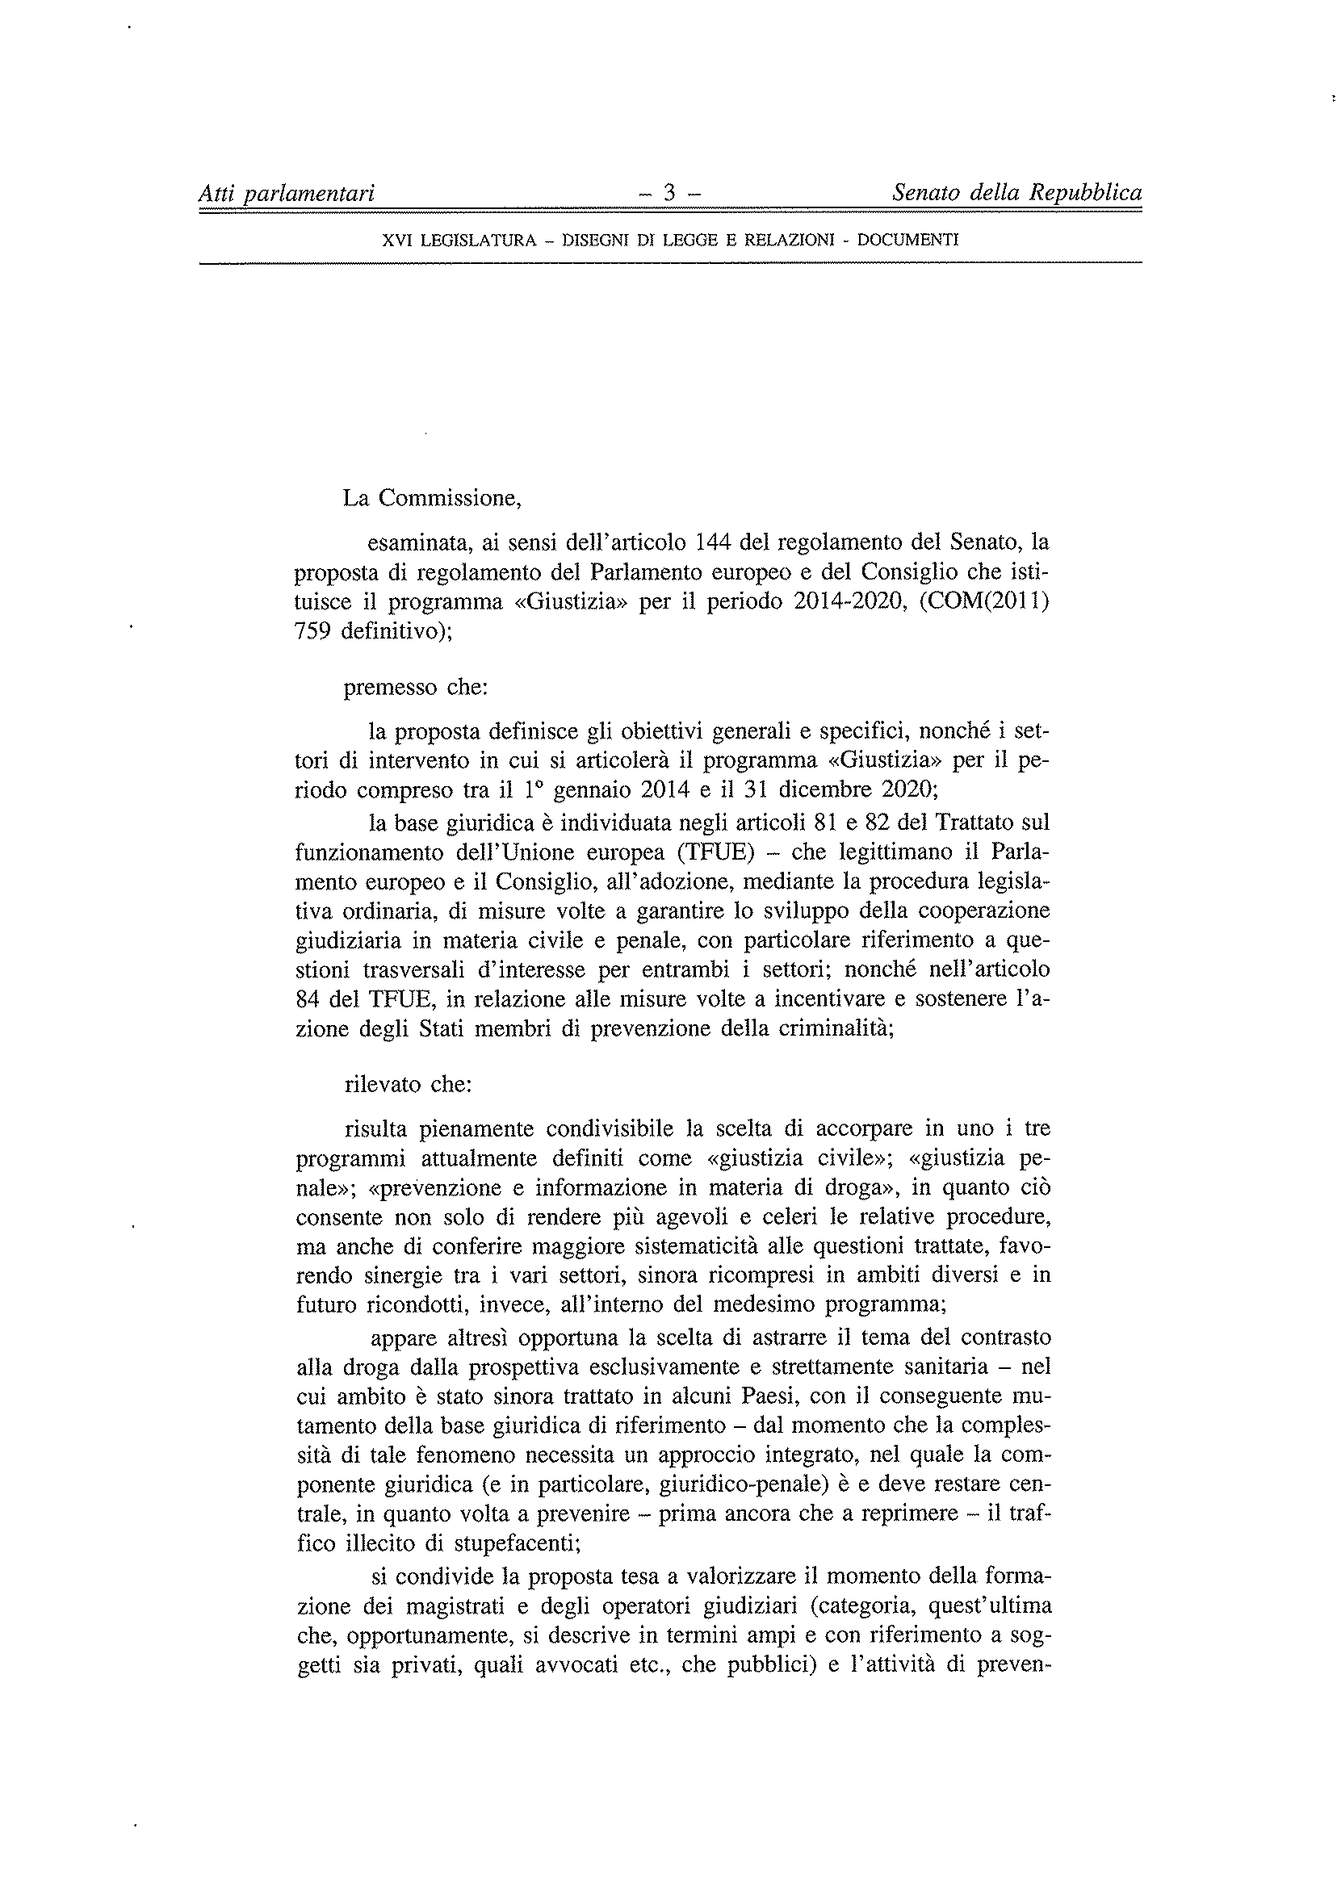

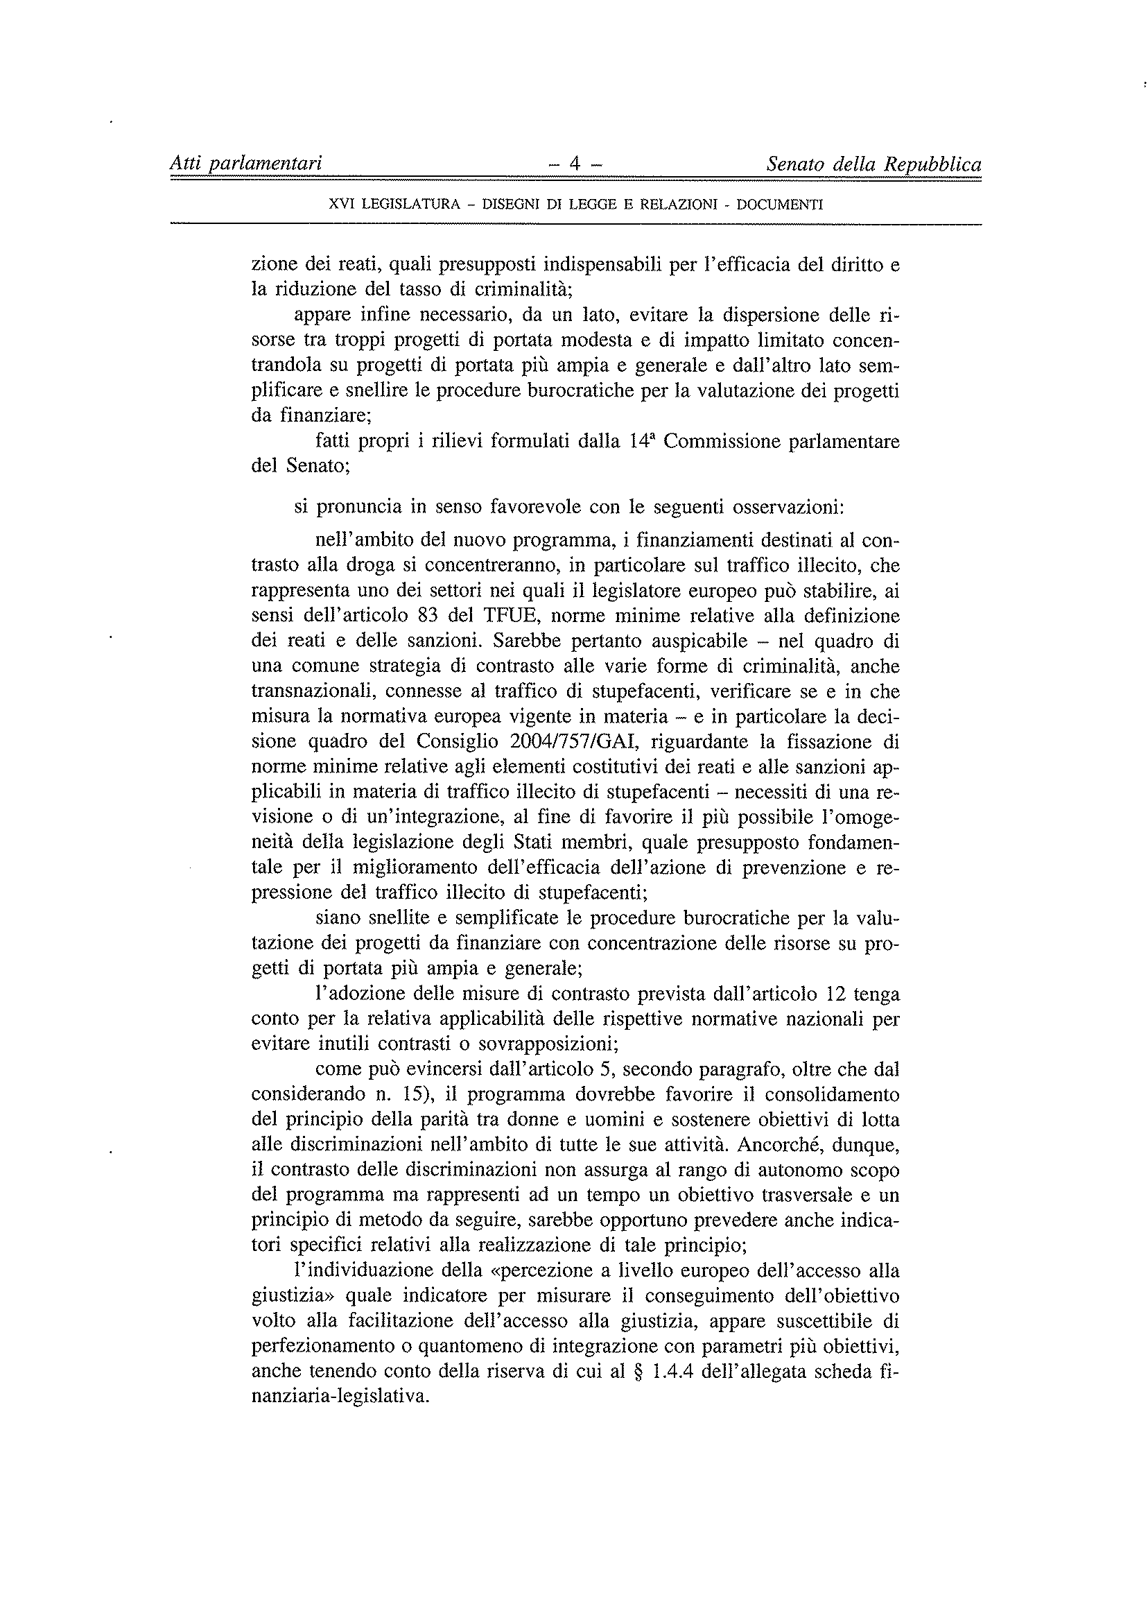

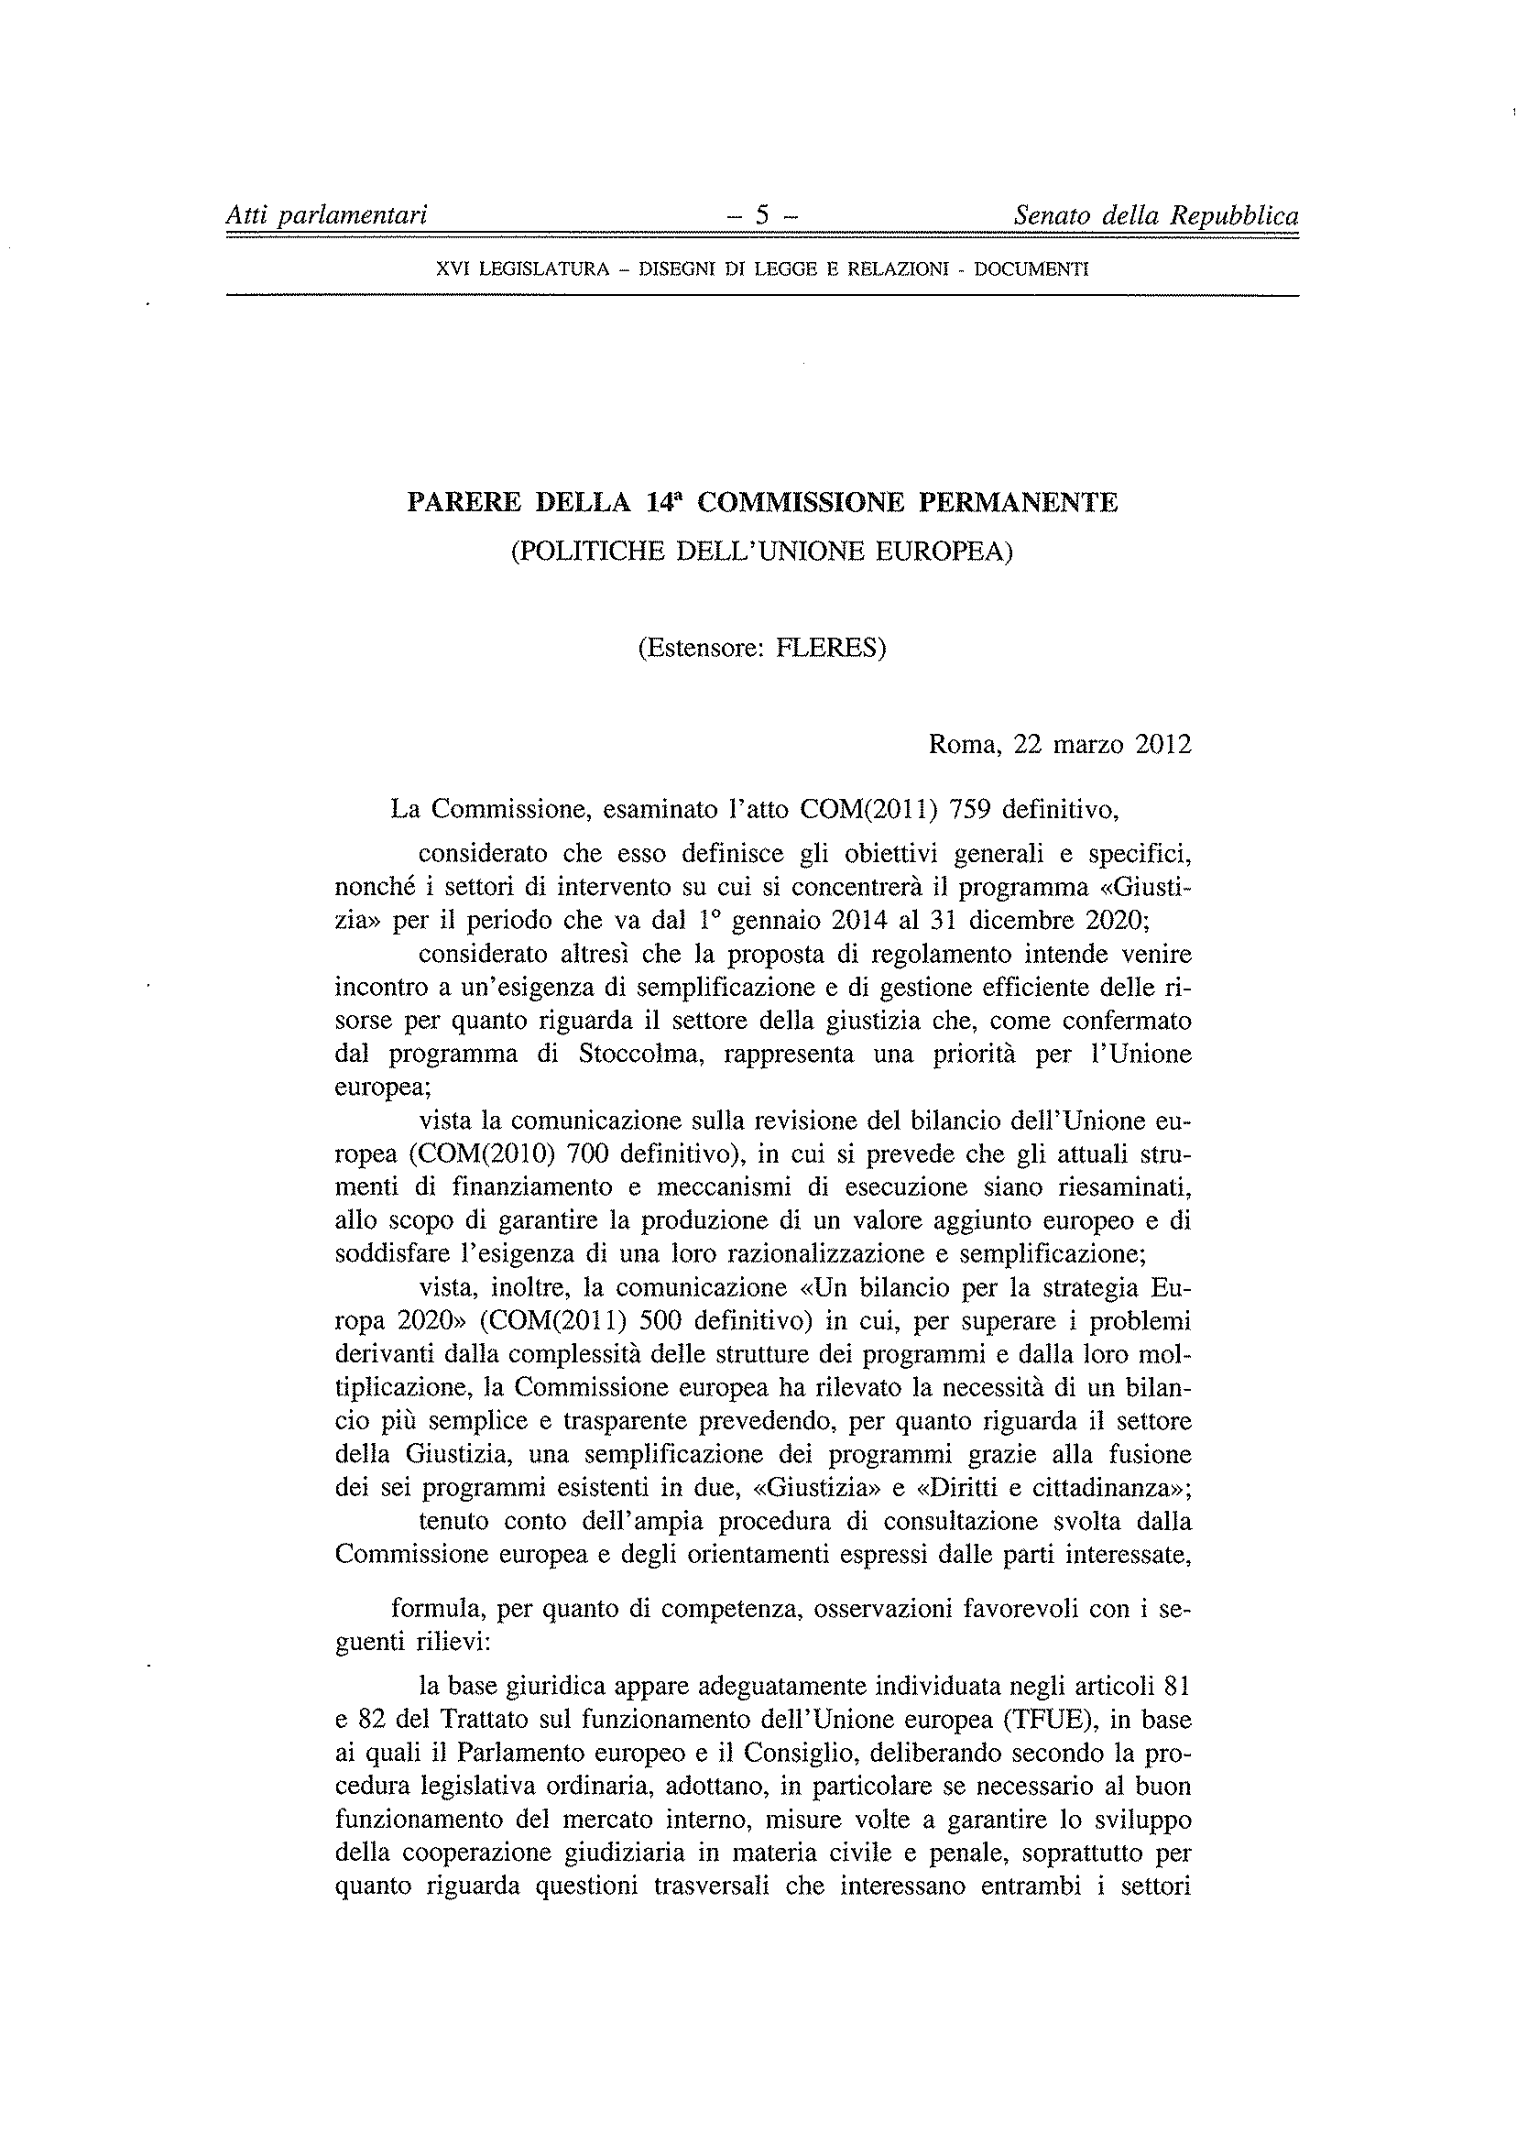
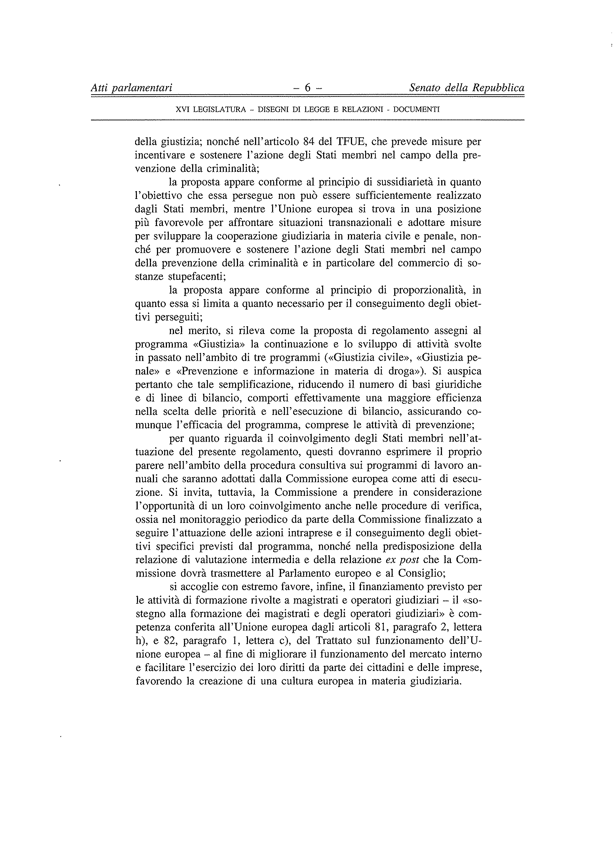________________

Translation(s) of the opinion may be available at the Interparliamentary EU information exchange site IPEX at the following address: http://www.ipex.eu/IPEXL-WEB/search.do

