 | 
COUNCIL OF  THE EUROPEAN UNION |  |  | Brussels, 21 May 2012
 | Interinstitutional File:  2012/0064 (APP) |  | 10169/12
SOC 391
MI 357
COMPET 297
INST 358
PARLNAT 249

COVER NOTE
from: | The Sejm of the Republic of Poland
date of receipt: | 18 May 2012
to: | Ms Helle Thorning-Schmidt, President of the Council of the European Union
Subject: | Proposal for a Council Regulation on the exercise of the right to take collective action within the context of the freedom of establishment and the freedom to provide services  [doc. 8042/12 SOC 226 MI 194 COMPET 169 - COM(2012) 130 final]  - Opinion on the application of the Principles of Subsidiarity and Proportionality

Delegations will find attached the above mentioned opinion.

____________________

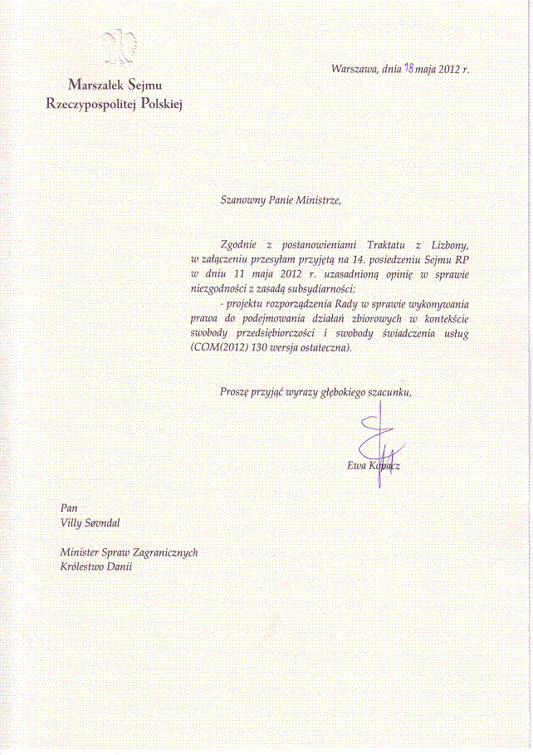
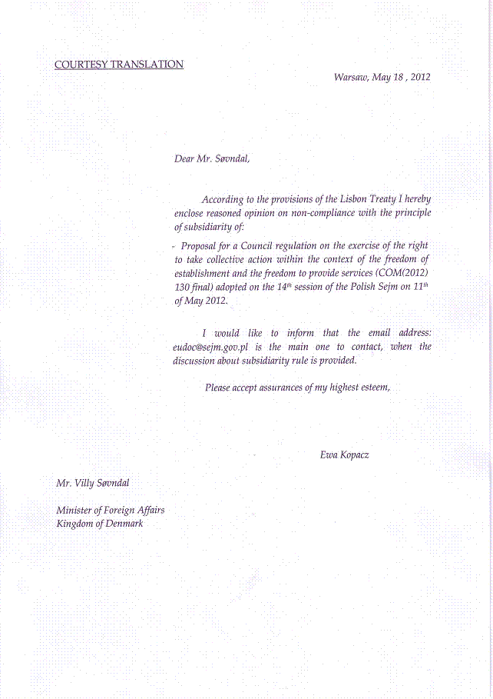
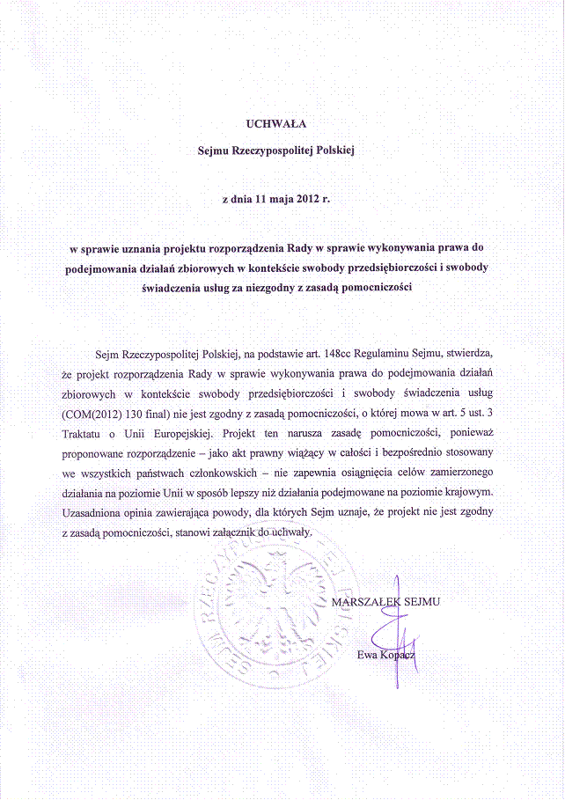
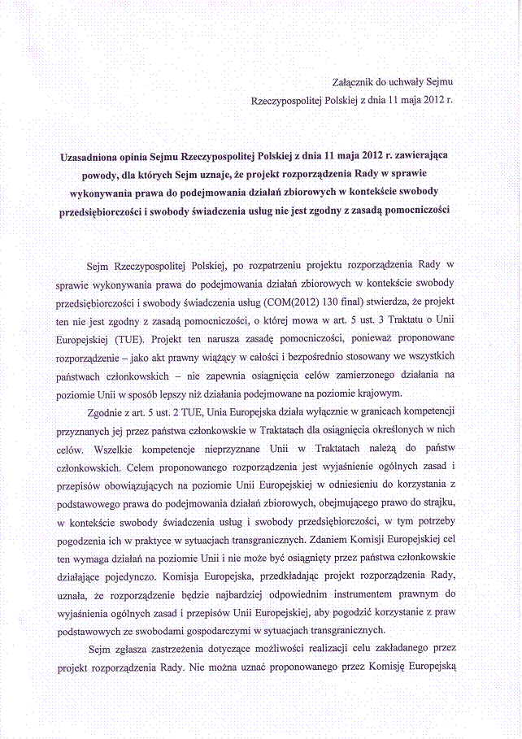
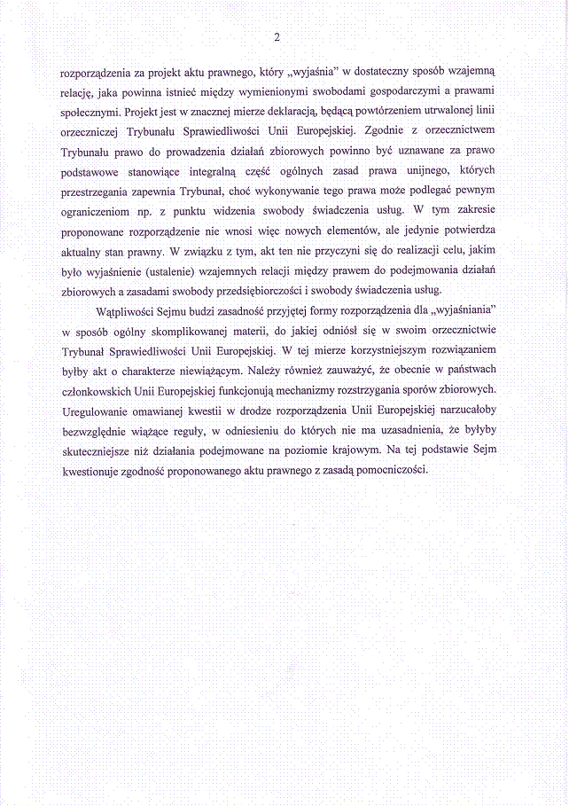
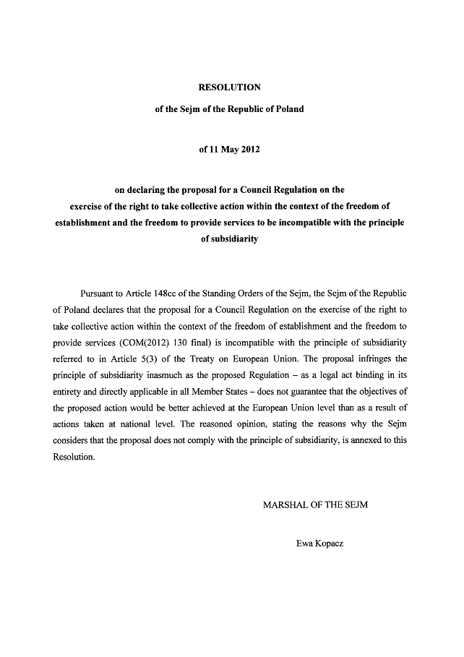
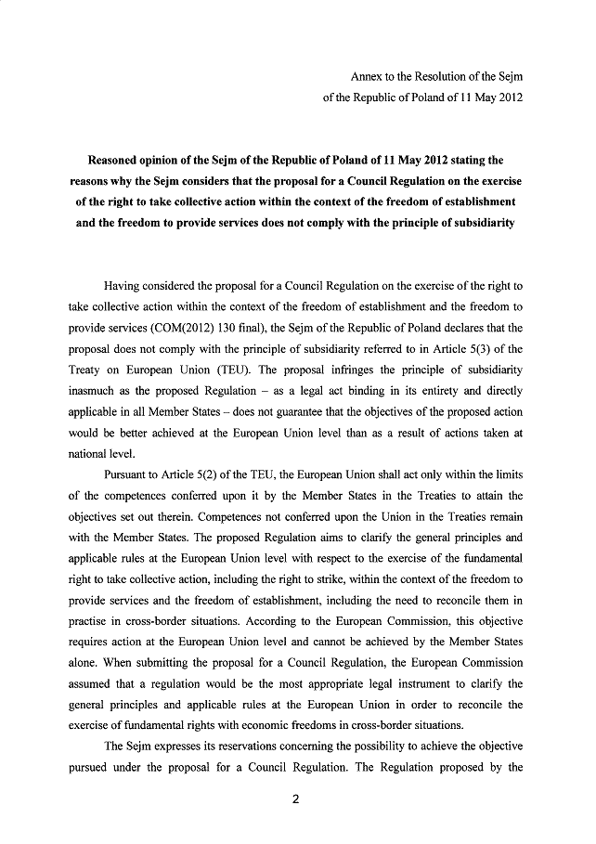
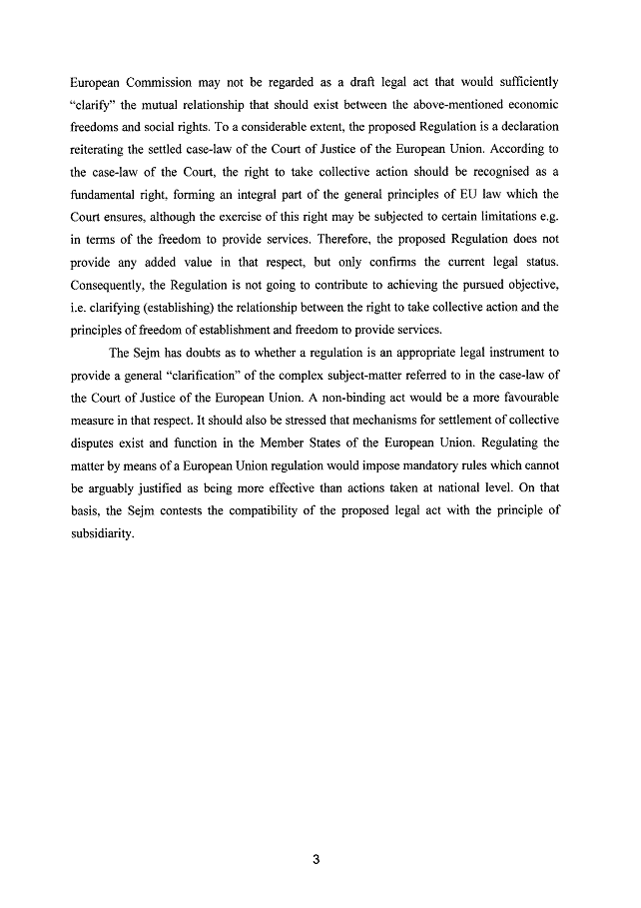_________________

For available translations of this opinion see the interparliamentary EU information exchange site (IPEX) at the following address: http://www.ipex.eu/IPEXL-WEB/search.do

