 | 
COUNCIL OF  THE EUROPEAN UNION |  |  | Brussels, 16 May 2012
 | Interinstitutional File:  2012/0008 (NLE) |  | 9964/12
WTO 181
COMER 103
ASIE 47
UD 140
INST 341
PARLNAT 234

COVER NOTE
from: | the President of the Assembly of the Republic of Portugal
date of receipt: | 10 May 2012
to: | Ms Helle THORNING-SCHMIDT, President of the Council of the European Union
Subject: | Proposal for a Council Decision establishing the position to be taken by the European Union within the General Council of the World Trade Organization on the request for a WTO waiver on additional autonomous trade preferences granted by the European Union to Pakistan  [doc. 5910/12 WTO 29 COMER 16 ASIE 7 UD 25 - COM(2012) 24 final]  - Opinion on the application of the Principles of Subsidiarity and Proportionality

Delegations will find attached the above-mentioned opinion.

________________________

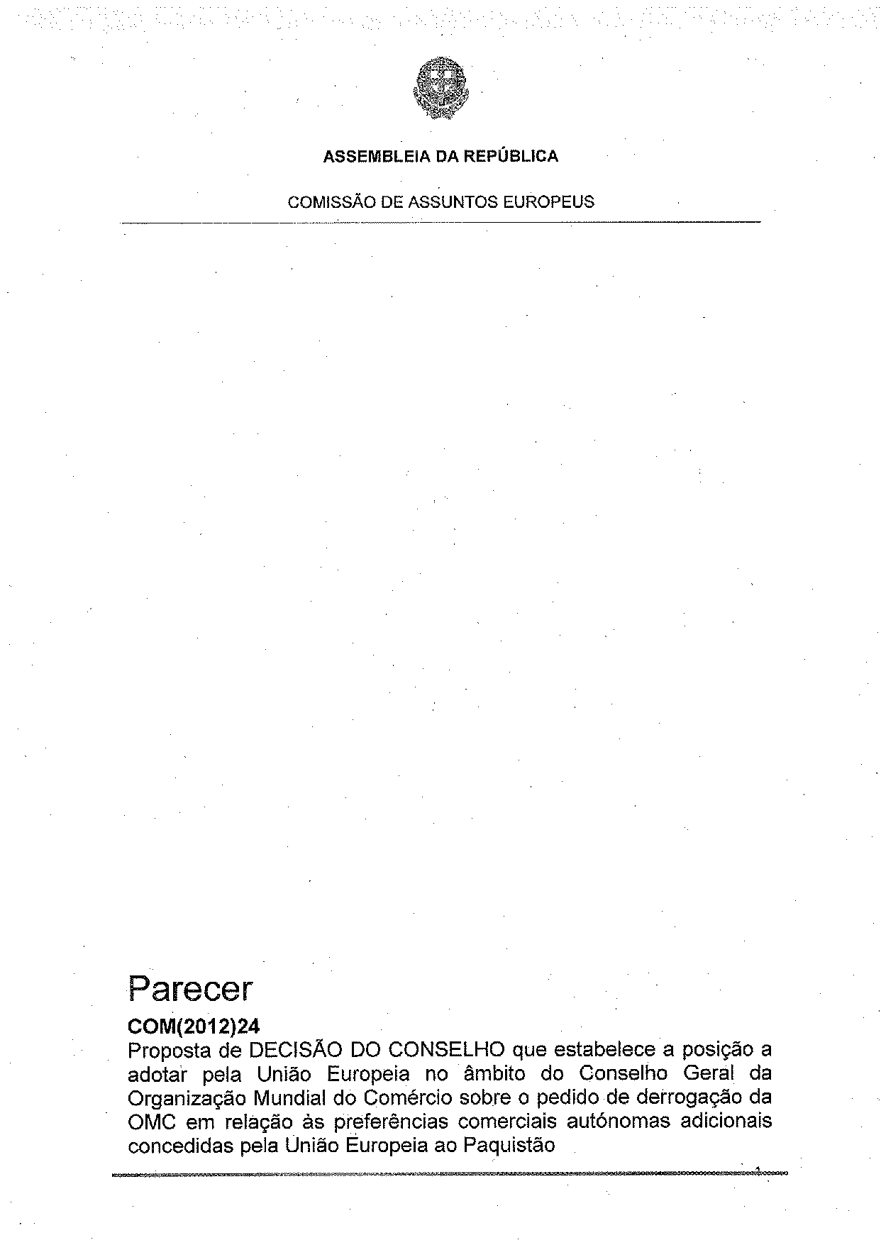
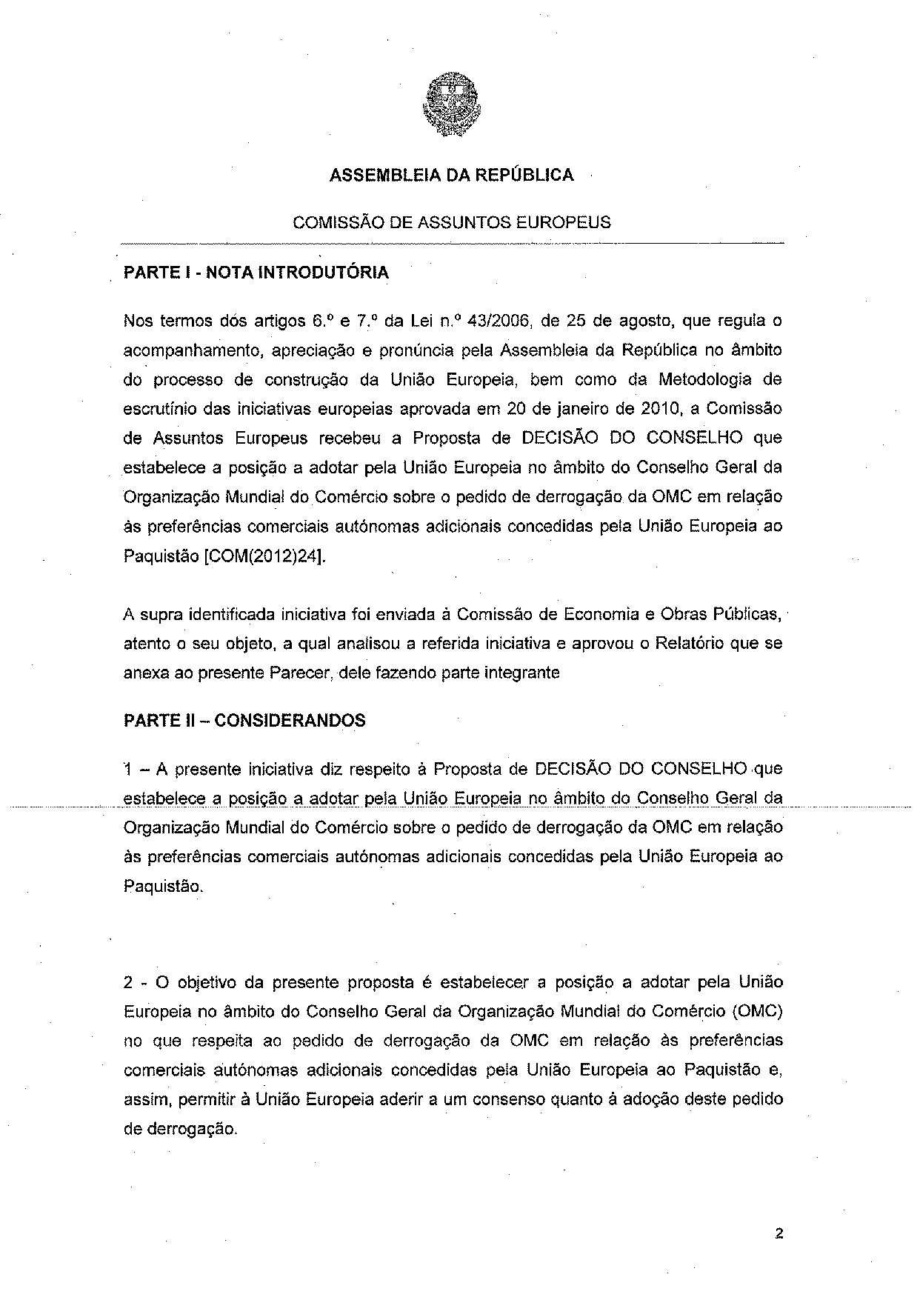
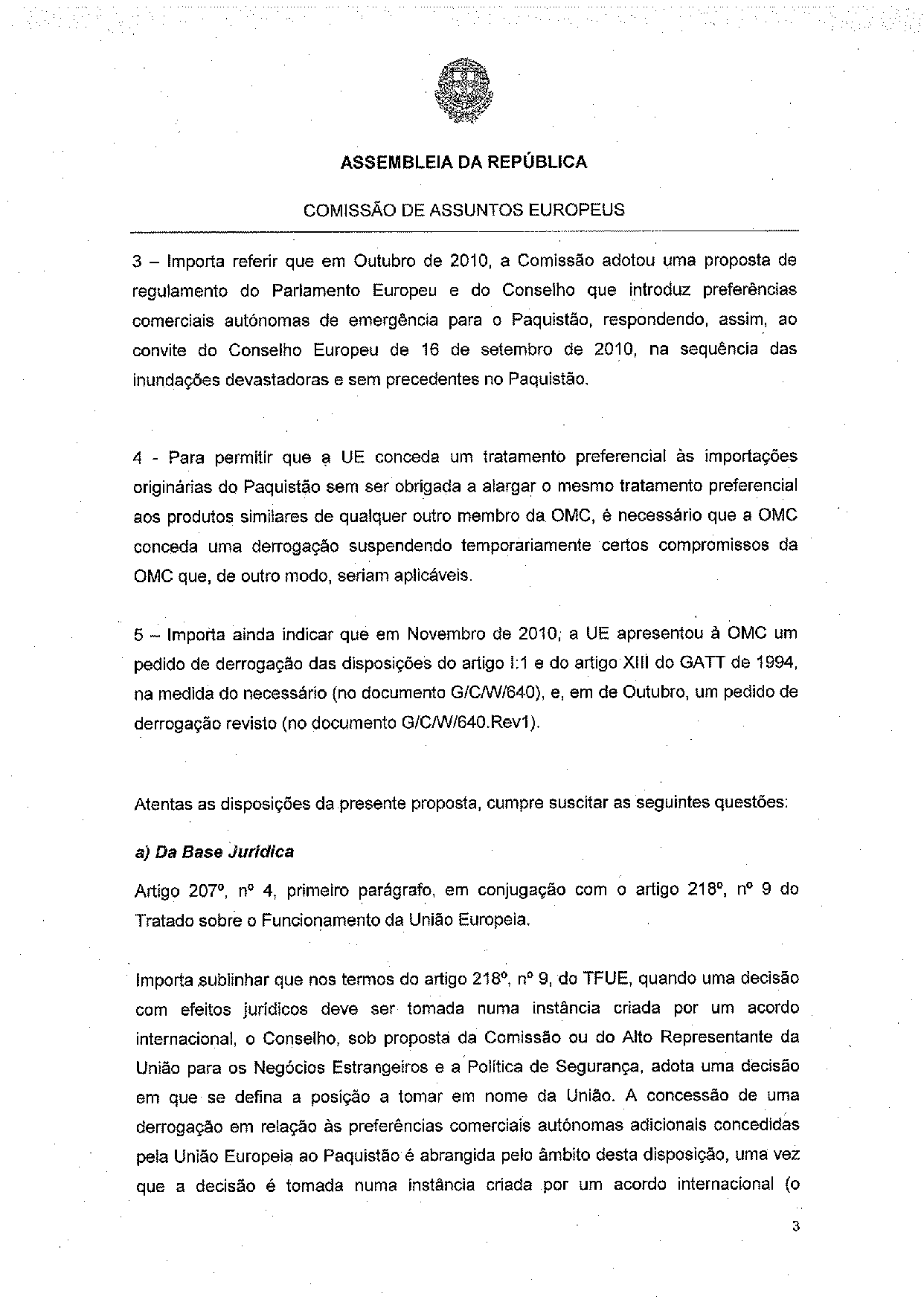
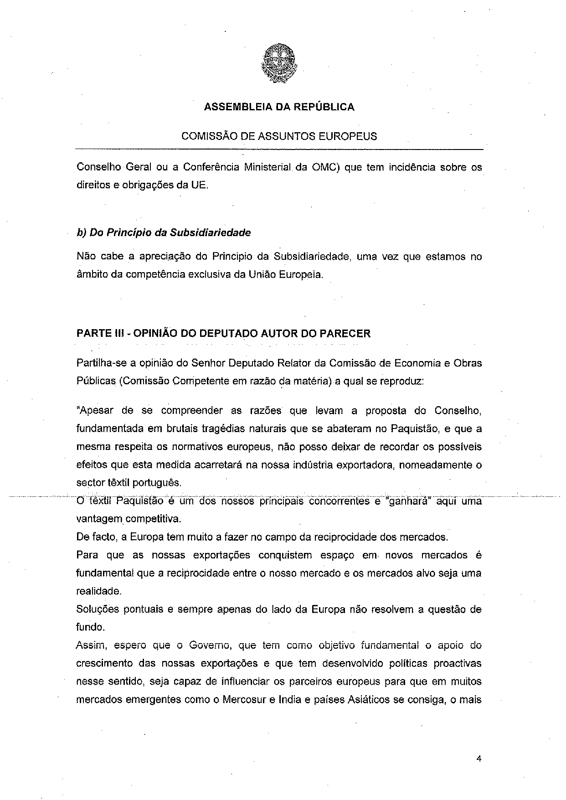
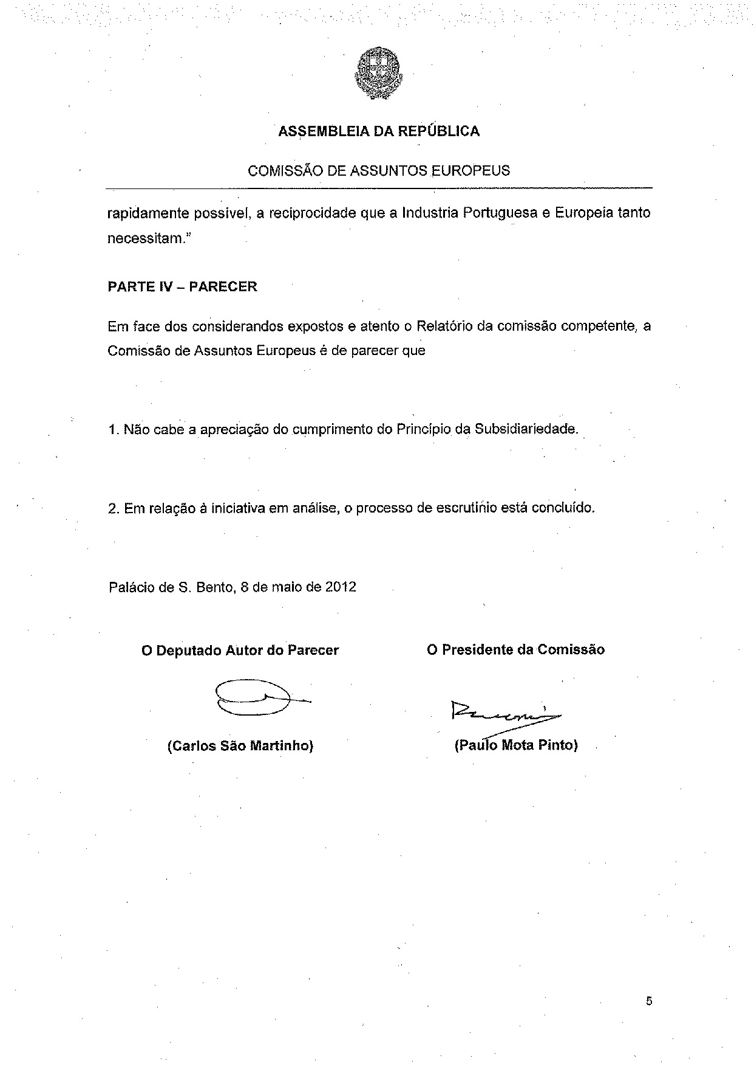
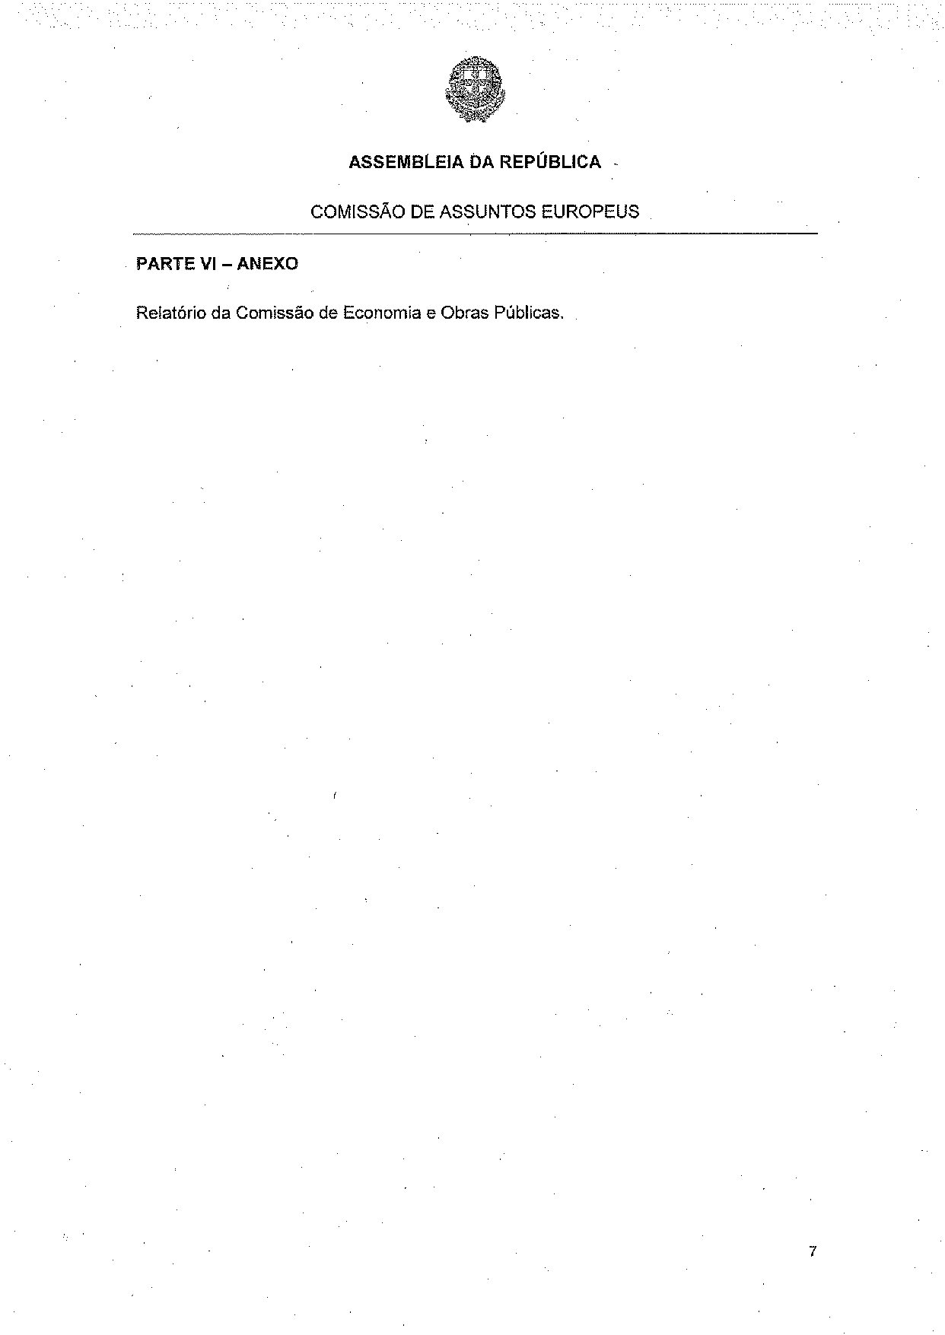
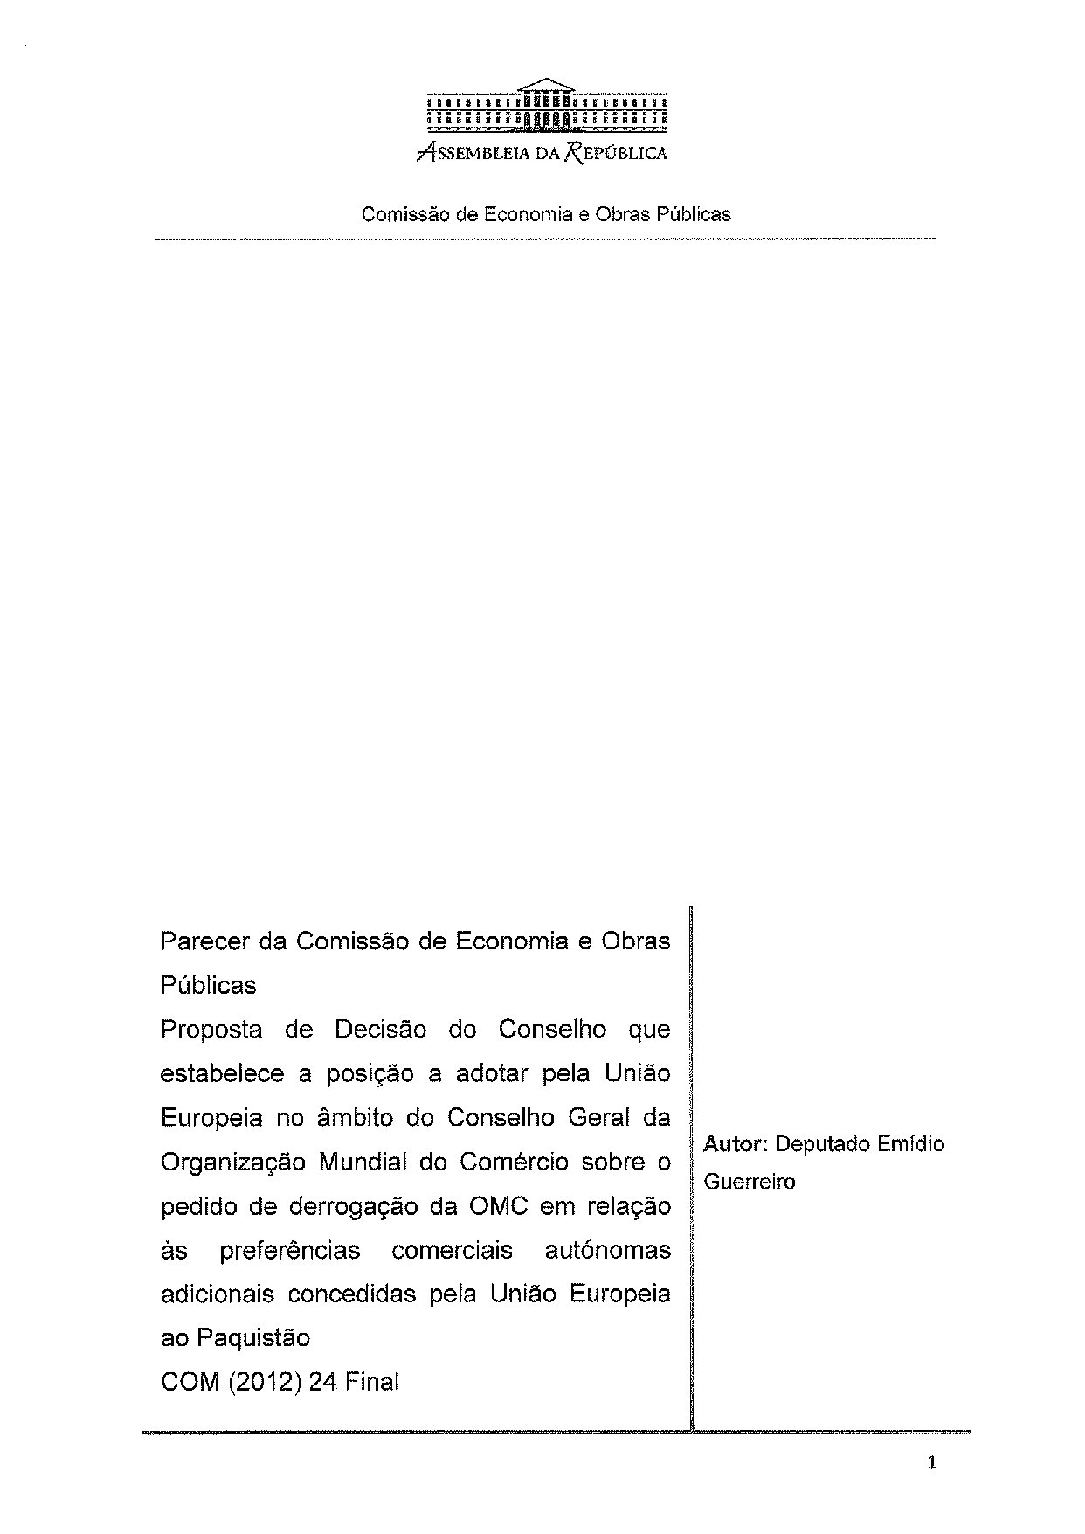
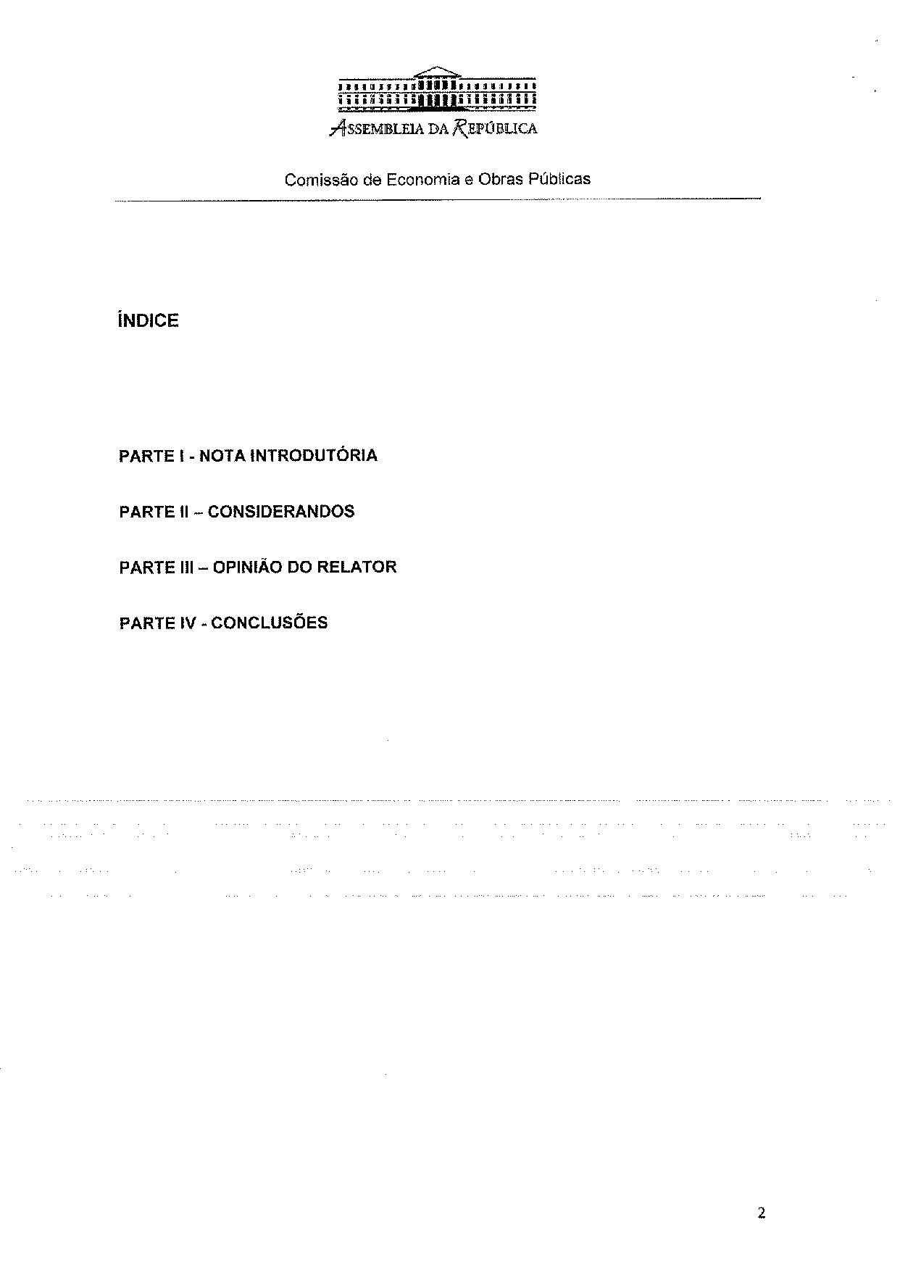
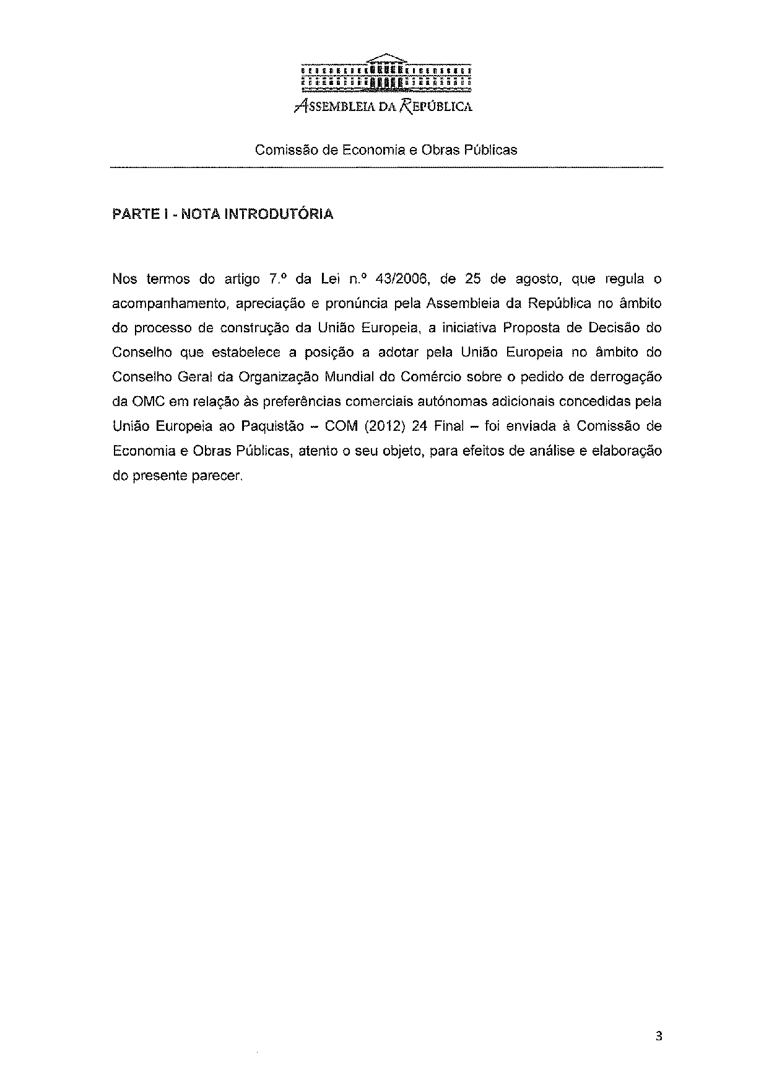
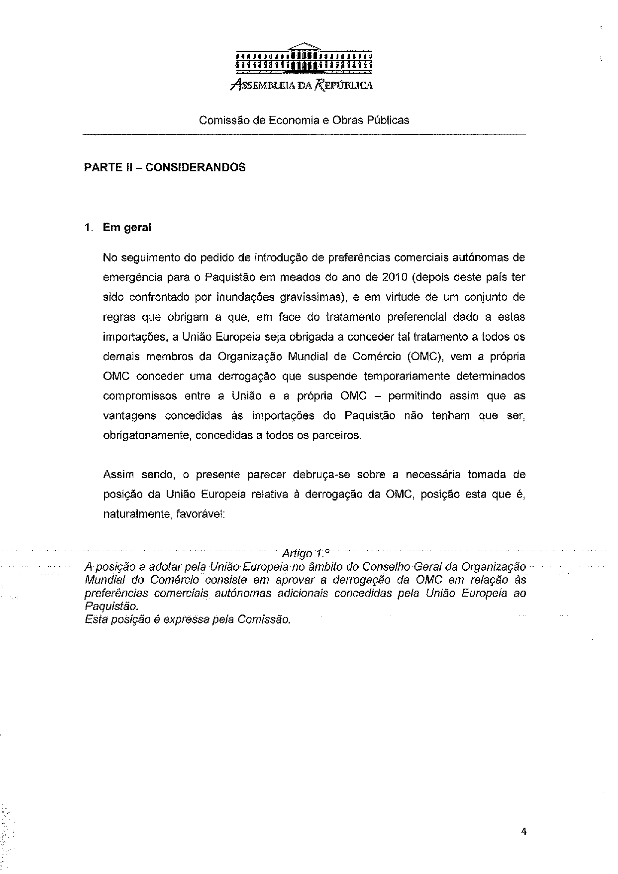
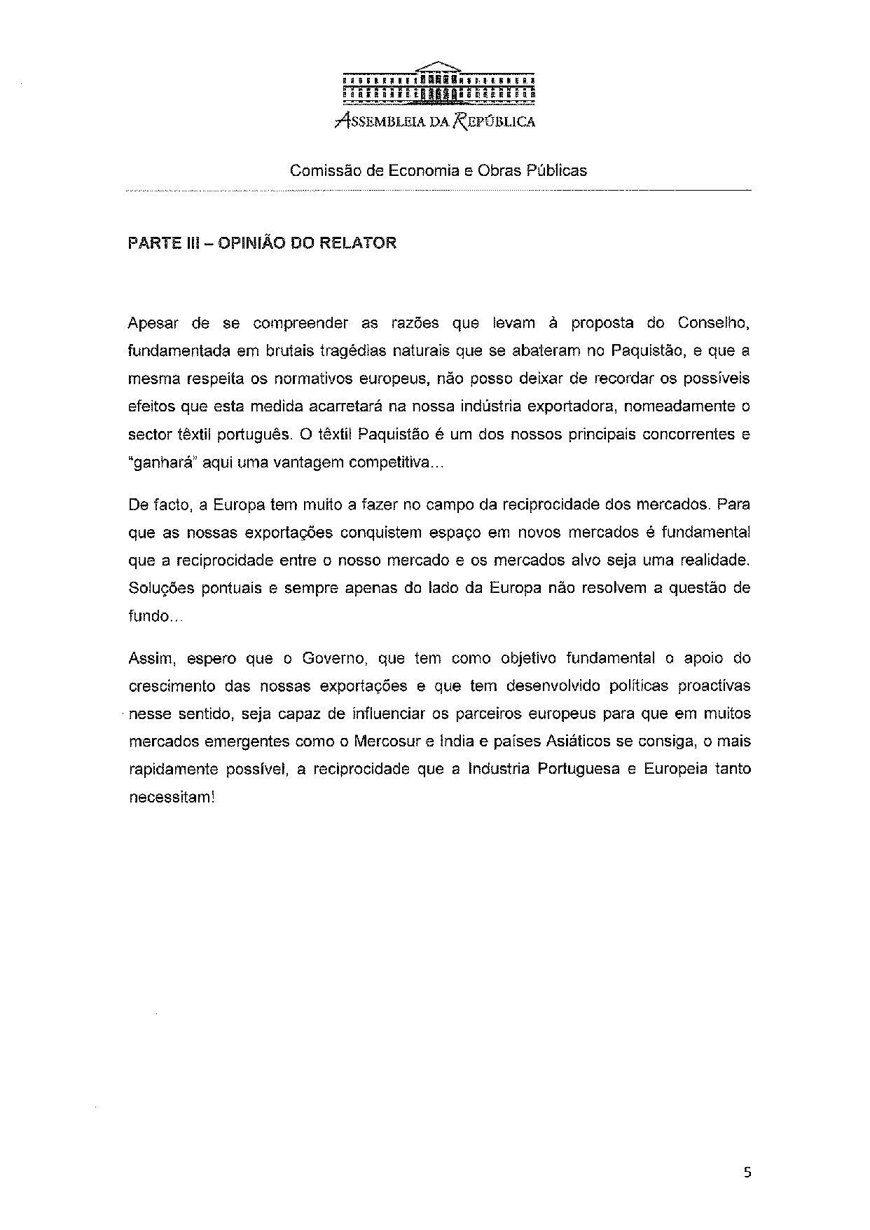
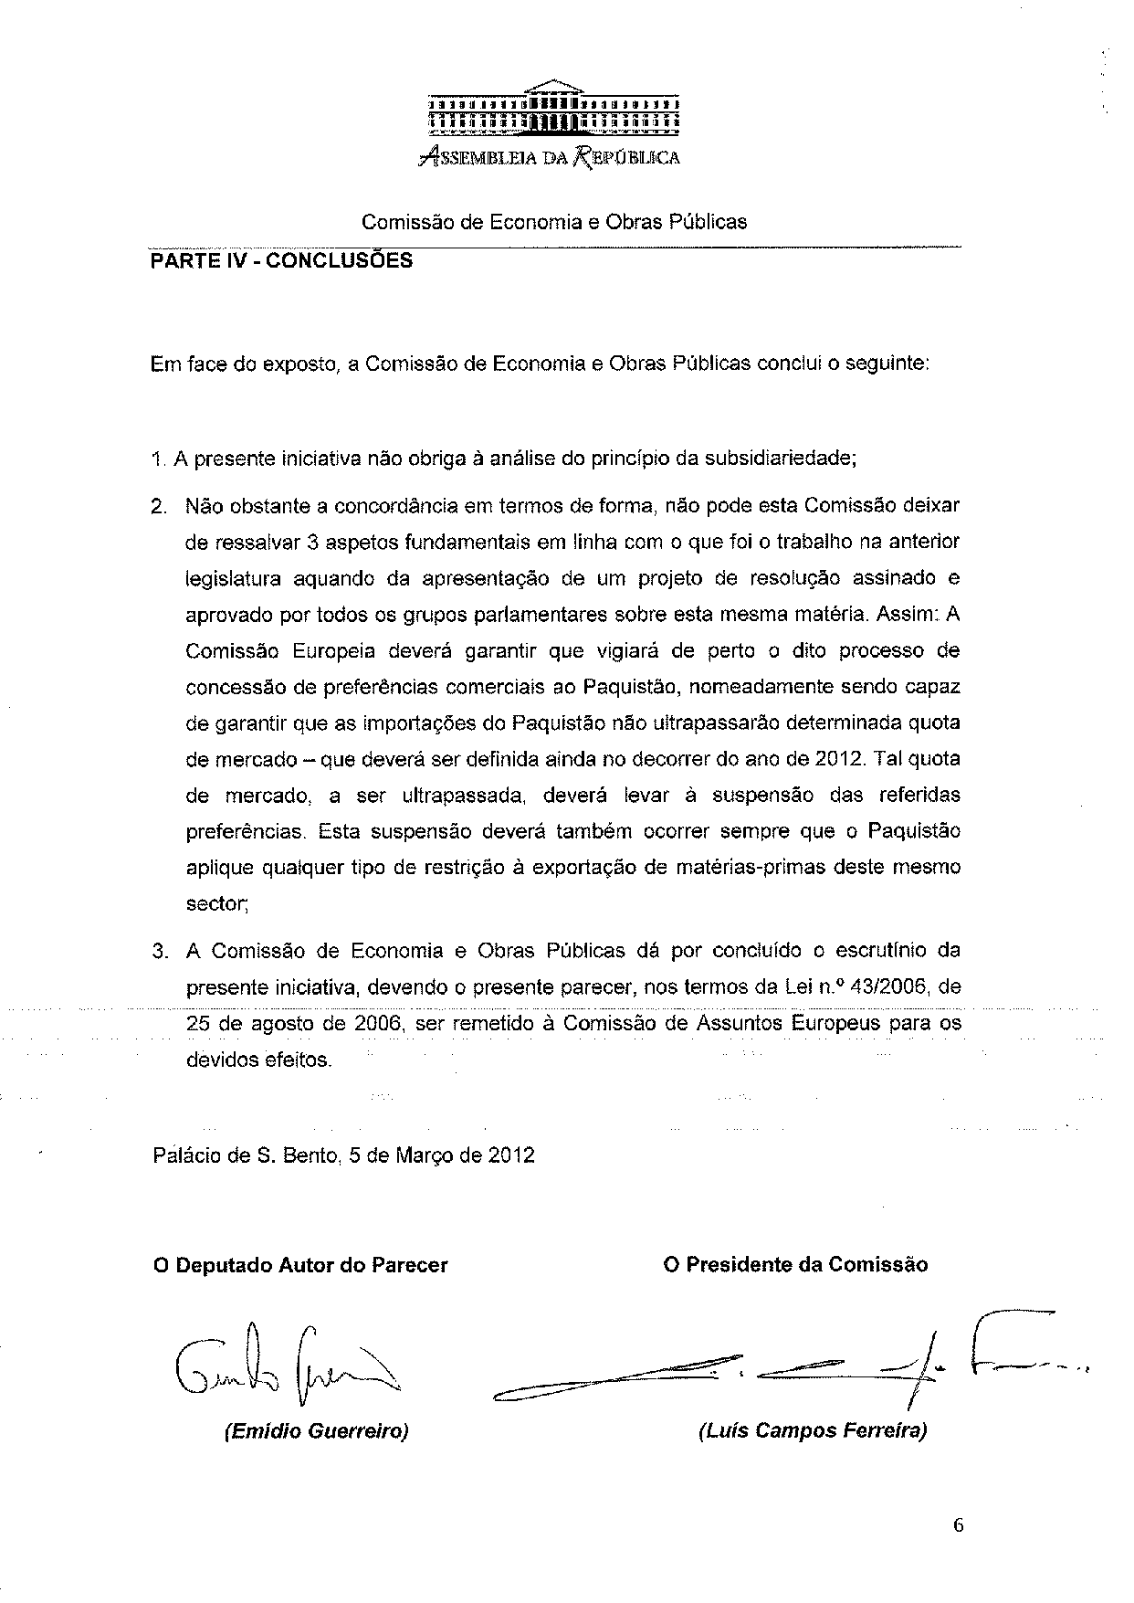

The translation of the opinion may be available at the Interparliamentary EU Information Exchange site IPEX, at the following address: http://www.ipex.eu/IPEXL-WEB/search.do.

