ANNEX VIII (D) WORLDWIDE TRENDS IN NUMBER OF MONITORED WORKERS AND IN COLLECTIVE EFFECTIVE DOSES AND EFFECTIVE DOSES TO MONITORED WORKERS (UNSCEAR Report 2008)
ANNEX VIII (E)

EXPOSURE TO IONISING RADIATION FOR WORKERS IN NORM INDUSTRIES (case study)

FRANCE, Bilan 2008 de la surveillance de travailleurs exposés aux rayonnements ionisants en France (Institute de Radioprotection et de Sûreté Nucléaire)

ANNEX IX RADON

(A) Annual Averaged Indoor Radon Concentration

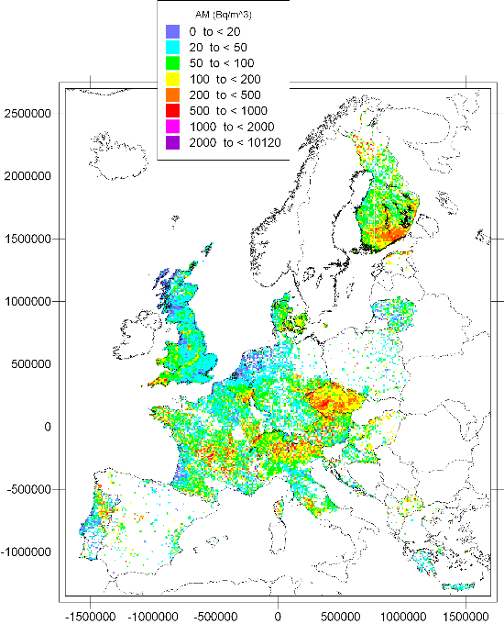
ANNEX IX (B)
Radon in Dwellings

 | Finland | Sweden | United Kingdom
Housing stock | 1 700 000 | 4 500 000 | 27 000 000
Average radon concentrations | 96 | 108 | 20
Estimated number of dwellings at or above 200 Bq/m³ | 200 000 | 450 000 | 100 000
Percentage of dwellings at or above 200 Bq/m³ | 12 | 10 | < 1

ANNEX X

(A) Graded Approach to Regulatory Control

The concept of a graded approach to regulatory control was developed some ten years ago by NEA’s Committee on Radiation Protection and Public Health (CRPPH). CRPPH advocated that, in addition to the concept of optimisation of radiation protection, the efficiency of regulatory control could benefit from a similar approach. Hence regulatory authorities would concentrate their supervision on those situations which represent a higher risk of exposure and on those where regulatory intervention is instrumental in reducing overall exposures. The BSS Directive from 1996 already gives indication that as an exception to the rule MS may specify that practices shall not require authorisation in cases where "a limited risk of exposure does not necessitate the examination of individual cases and the practice is undertaken in accordance with conditions laid down in national legislation". This opportunity given by the Directive has been used to little extend, because the requirement is very vague. Given that proper implementation of the graded approach would reduce the administrative burden to the businesses, it is important to clarify and enforce the use of this concept.

In this respect it is necessary to improve the requirements on regulatory control, on the one hand by making the list of practices submitted to authorisation more precise, and on the other hand introducing list of practices that can be submitted to lighter regimes like registration (a two-tier approach replacing the current concept of "prior authorisation" (Article 4 of the BSS). Article 3 of the BSS Directive 96/29 requires all practices to report the conduct of a practice involving ionising radiation or radioactive substances. Practices may be exempted from the requirement to report if certain values, called exemption levels, are not exceeded. There are exemption values for the total activity as well as for activity concentrations. These exemption values are laid down in the Directive (on the basis of a European study published in our radiation protection series: RP65) and uniformly transposed in national legislation. The Euratom values were also incorporated in the International Basic Safety Standards of 1996. Later, IAEA adopted a Safety Guide (RS-G-1.7) laying down a different set of radionuclide-specific values (in general lower than those in RP65). As part of the graded approach it is envisaged to make explicit provision for exemption of specific practices, for specific radionuclides, as long as the exemption criteria laid down in the Directive are complied with (essentially that doses should be lower than 1% of the dose limit). The current Directive, again, does not rule out this possibility but it is very vague ("MS's may exempt further practices …").

A second important aspect of the “graded approach” relates to the release of materials arising from within a regulated practice. In the absence of any criteria all such materials should be regarded as radioactive waste. Taking into account the huge volume of materials arising from the dismantling of decommissioned nuclear power plants, this would be at a tremendous cost and there would be a shortage of disposal sites. Most of this material has in fact no or very little radioactivity, so it could be cleared from regulatory control. The concept of "clearance", for materials with no or very little contamination, for instance steel or building rubble, is very important in this context. In the current BSS Directive the application of the concept of clearance was left to national authorities, being merely required to take Community guidance into account (as was later published in the Radiation Protection Series). Harmonisation of clearance levels for materials resulting from dismantling has therefore become a crucial issue, both within the EU as internationally. In the international guidance (IAEA RS-G_1.7) and draft new standards it is envisaged to use the same set of values both for clearance and exemption (with the lower numbers taken from RS-G_1.7). This approach could be incorporated in the Euratom BSS as well.

Recommendations for radon in dwellings in the Nordic countries, 2009, see Nordic radiation protection authorities' websites, e.g. www.ssm.se
Recommendations for radon in dwellings in the Nordic countries, 2009
Radon and Public Health, Report prepared by the Subgroup on Radon Epidemiology of the independent Advisory Group on Ionising Radiation. Advisory Group to Health and Protection Agency, UK, 2009

