 | 
COUNCIL OF  THE EUROPEAN UNION |  |  | Brussels, 7 June 2012
 | Interinstitutional File:  2011/0417(COD) |  | 11035/12
EF 135
ECOFIN 550
COMPET 406
IND 105
CODEC 1591
INST 402
PARLNAT 267

COVER NOTE
from: | The President of the Italian Senate
date of receipt: | 4 June 2012
to: | President of the European Union
Subject: | Proposal for a REGULATION OF THE EUROPEAN PARLIAMENT AND OF THE COUNCIL on European Venture Capital Funds  [doc. ST 18499/11 EF 173 ECOFIN 883 COMPET 615 IND 177 CODEC 2401 - COM(2011) 860 final]  - Opinion on the application of the Principles of Subsidiarity and Proportionality

Delegations will find attached the above mentioned opinion.

________________________

Encl.:
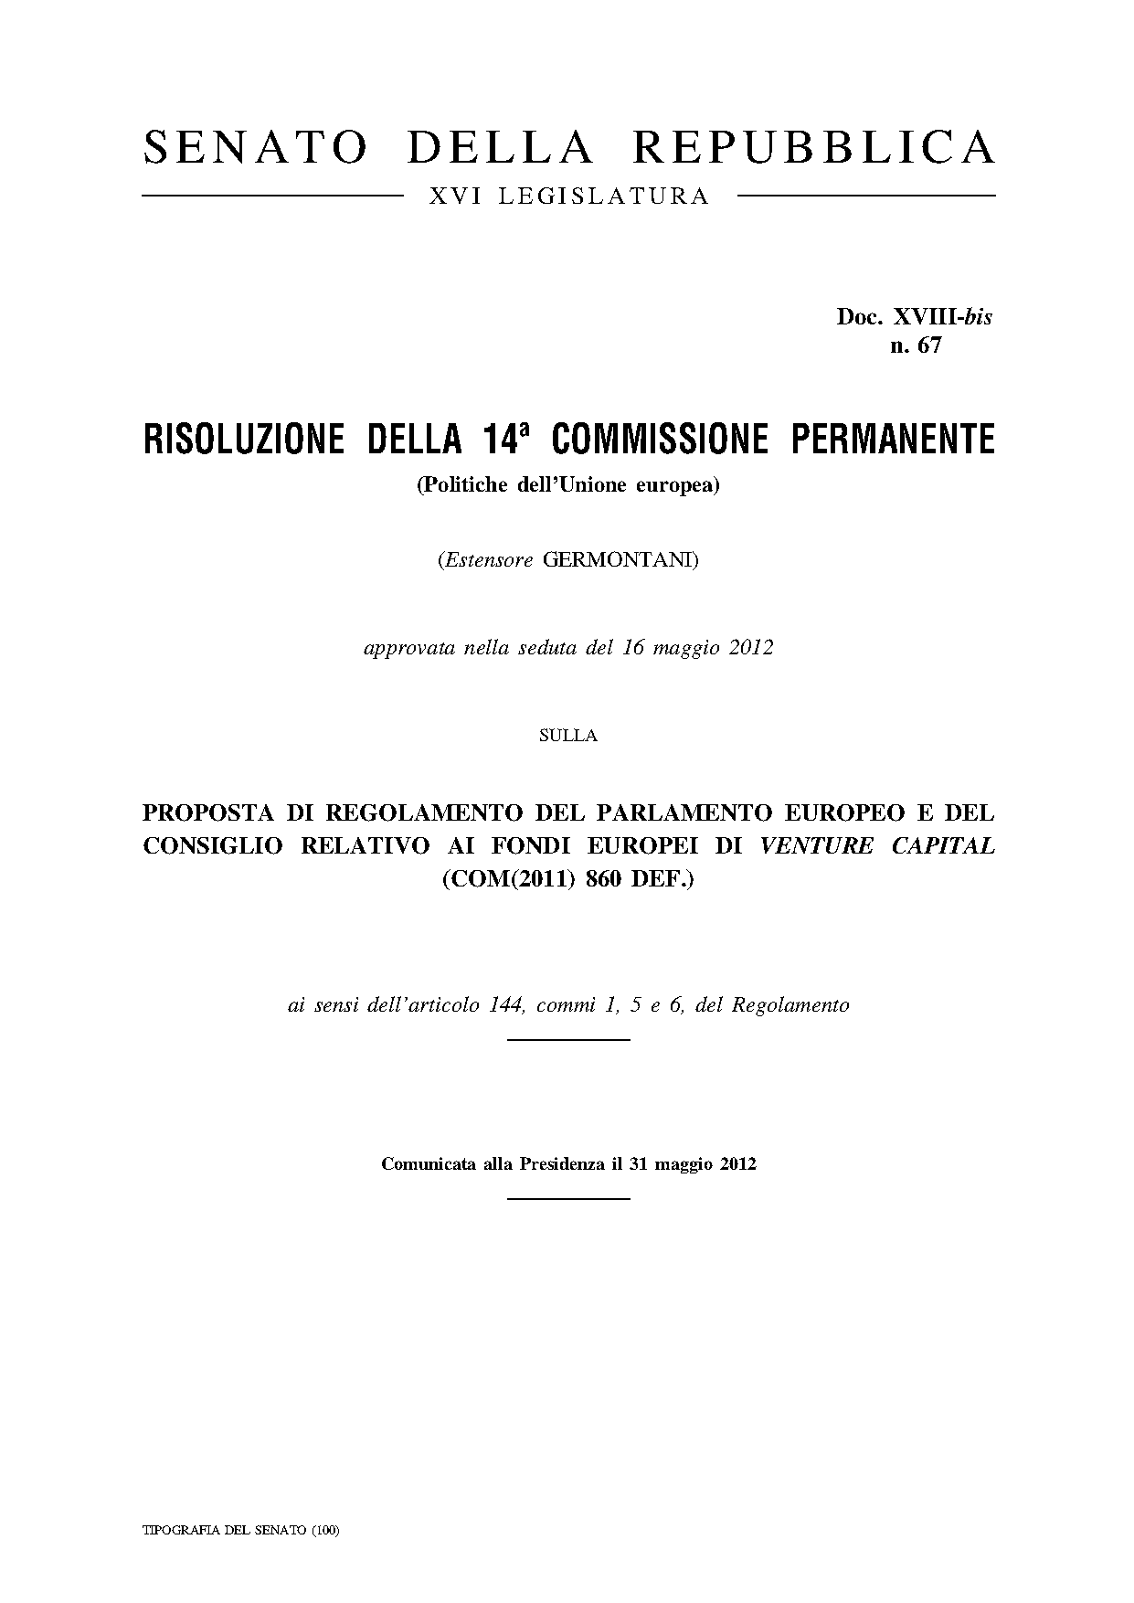
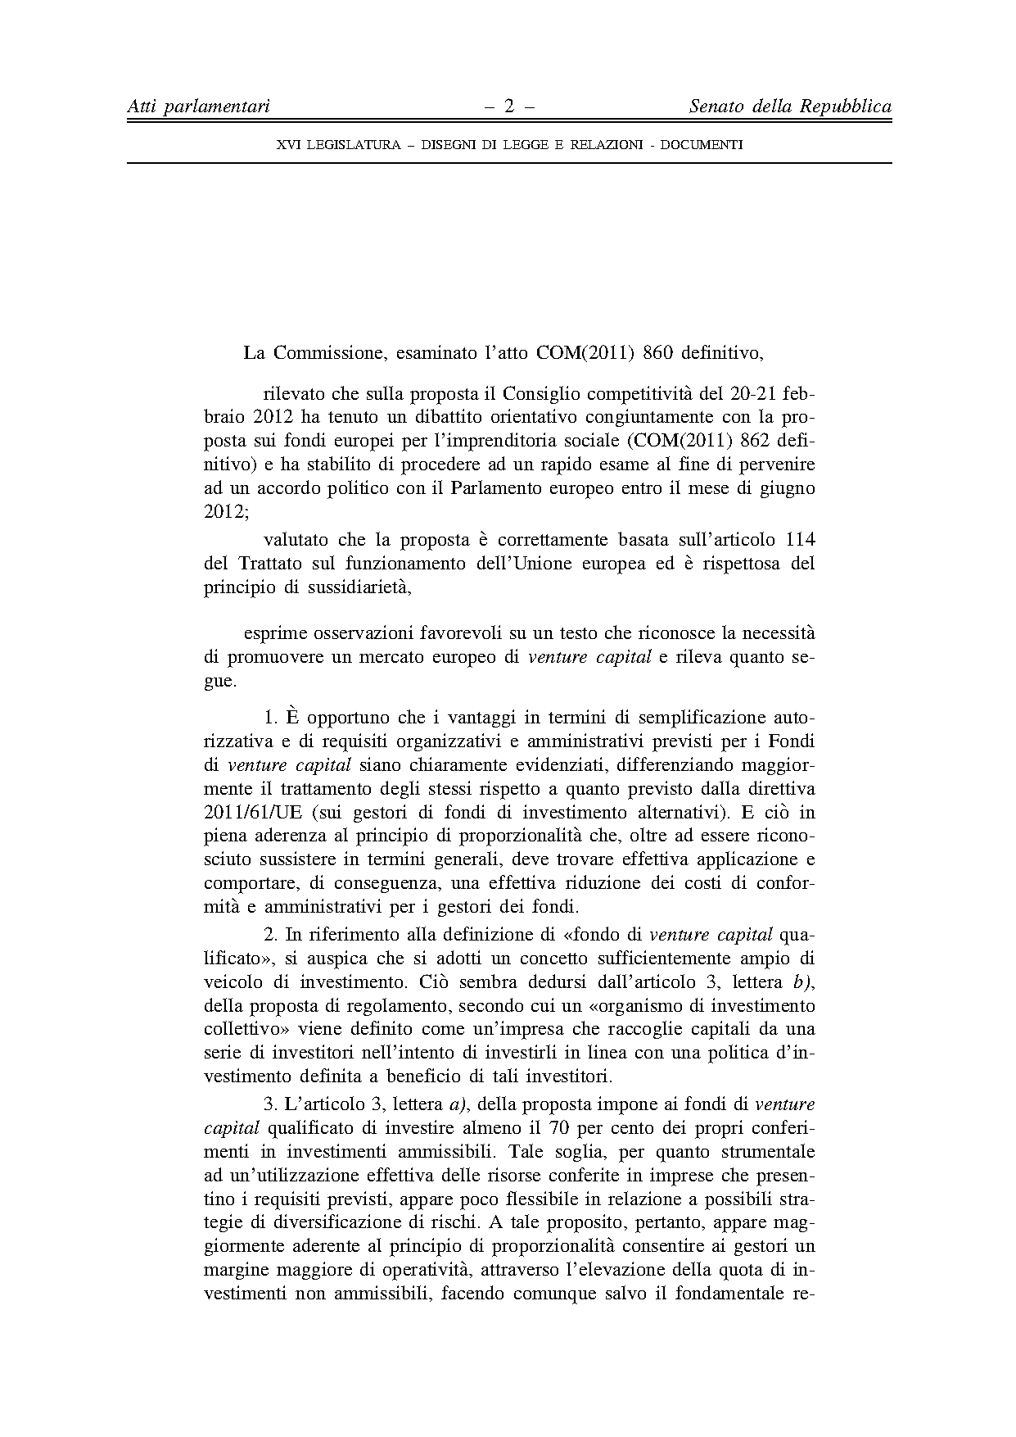
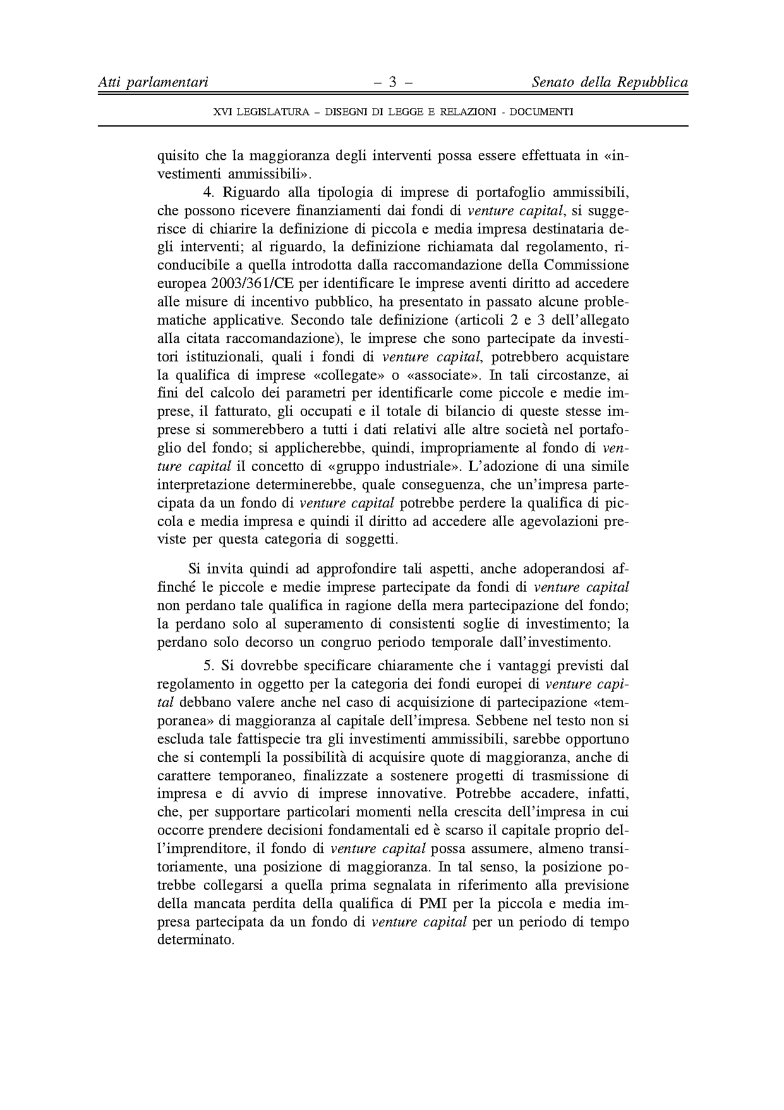


For other language versions of the opinion, reference is made to the Interparliamentary EU information exchange site IPEX at the following address: http://www.ipex.eu/IPEXL-WEB/search.do

