 | 
COUNCIL OF  THE EUROPEAN UNION |  |  | Brussels, 4 June 2012
 | Interinstitutional File:  2012/0019 (COD) |  | 10853/12
ANTIDUMPING 45
COMER 132
WTO 215
CODEC 1545
INST 387
PARLNAT 260

COVER NOTE
from: | the President of the Assembly of the Republic of Portugal
date of receipt: | 23 May 2012
to: | Ms Helle THORNING-SCHMIDT, President of the Council of the European Union
Subject: | Proposal for a Regulation of the European Parliament and of the Council amending Council Regulation (EC) No 1225/2009 of 30 November 2009 on protection against dumped imports from countries not members of the European Community  [doc. 6356/12 ANTIDUMPING 6 COMER 28 WTO 42 CODEC 340 - COM(2012) 41 final]  - Opinion on the application of the Principles of Subsidiarity and Proportionality

Delegations will find attached the above-mentioned opinion.

________________________

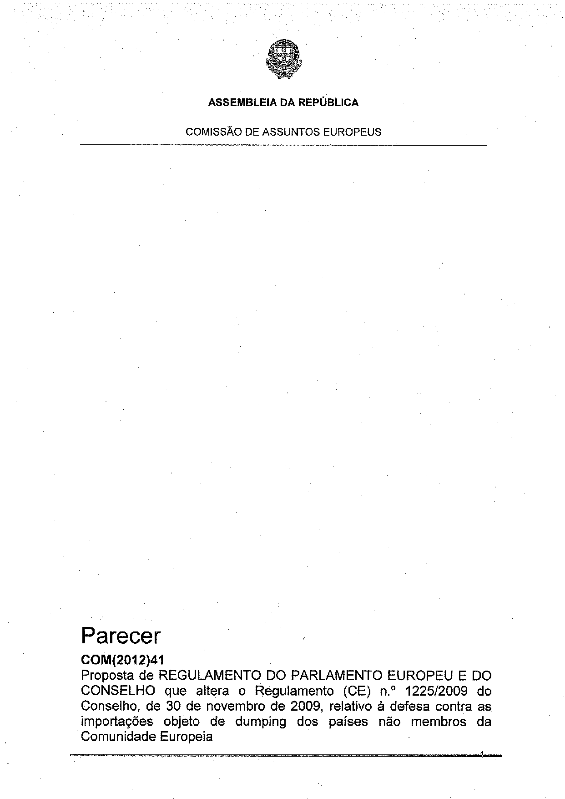
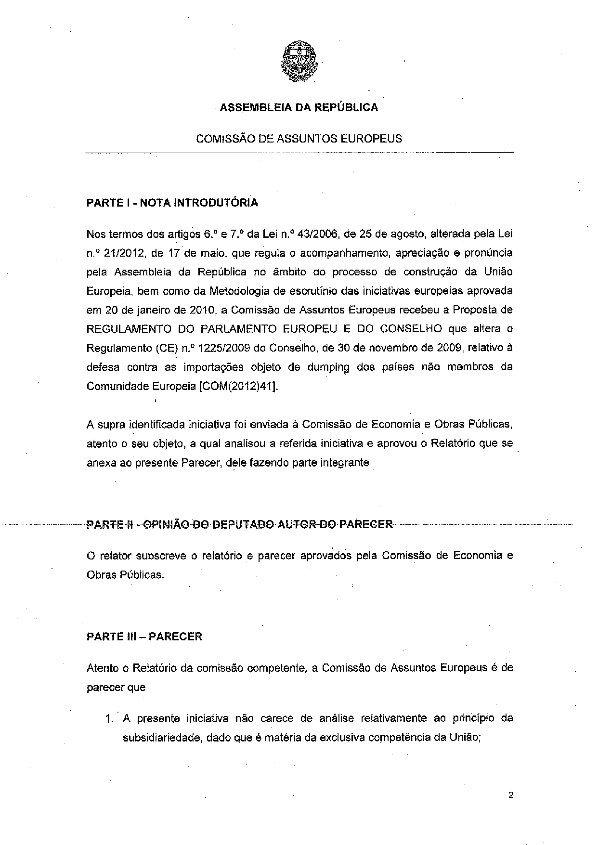
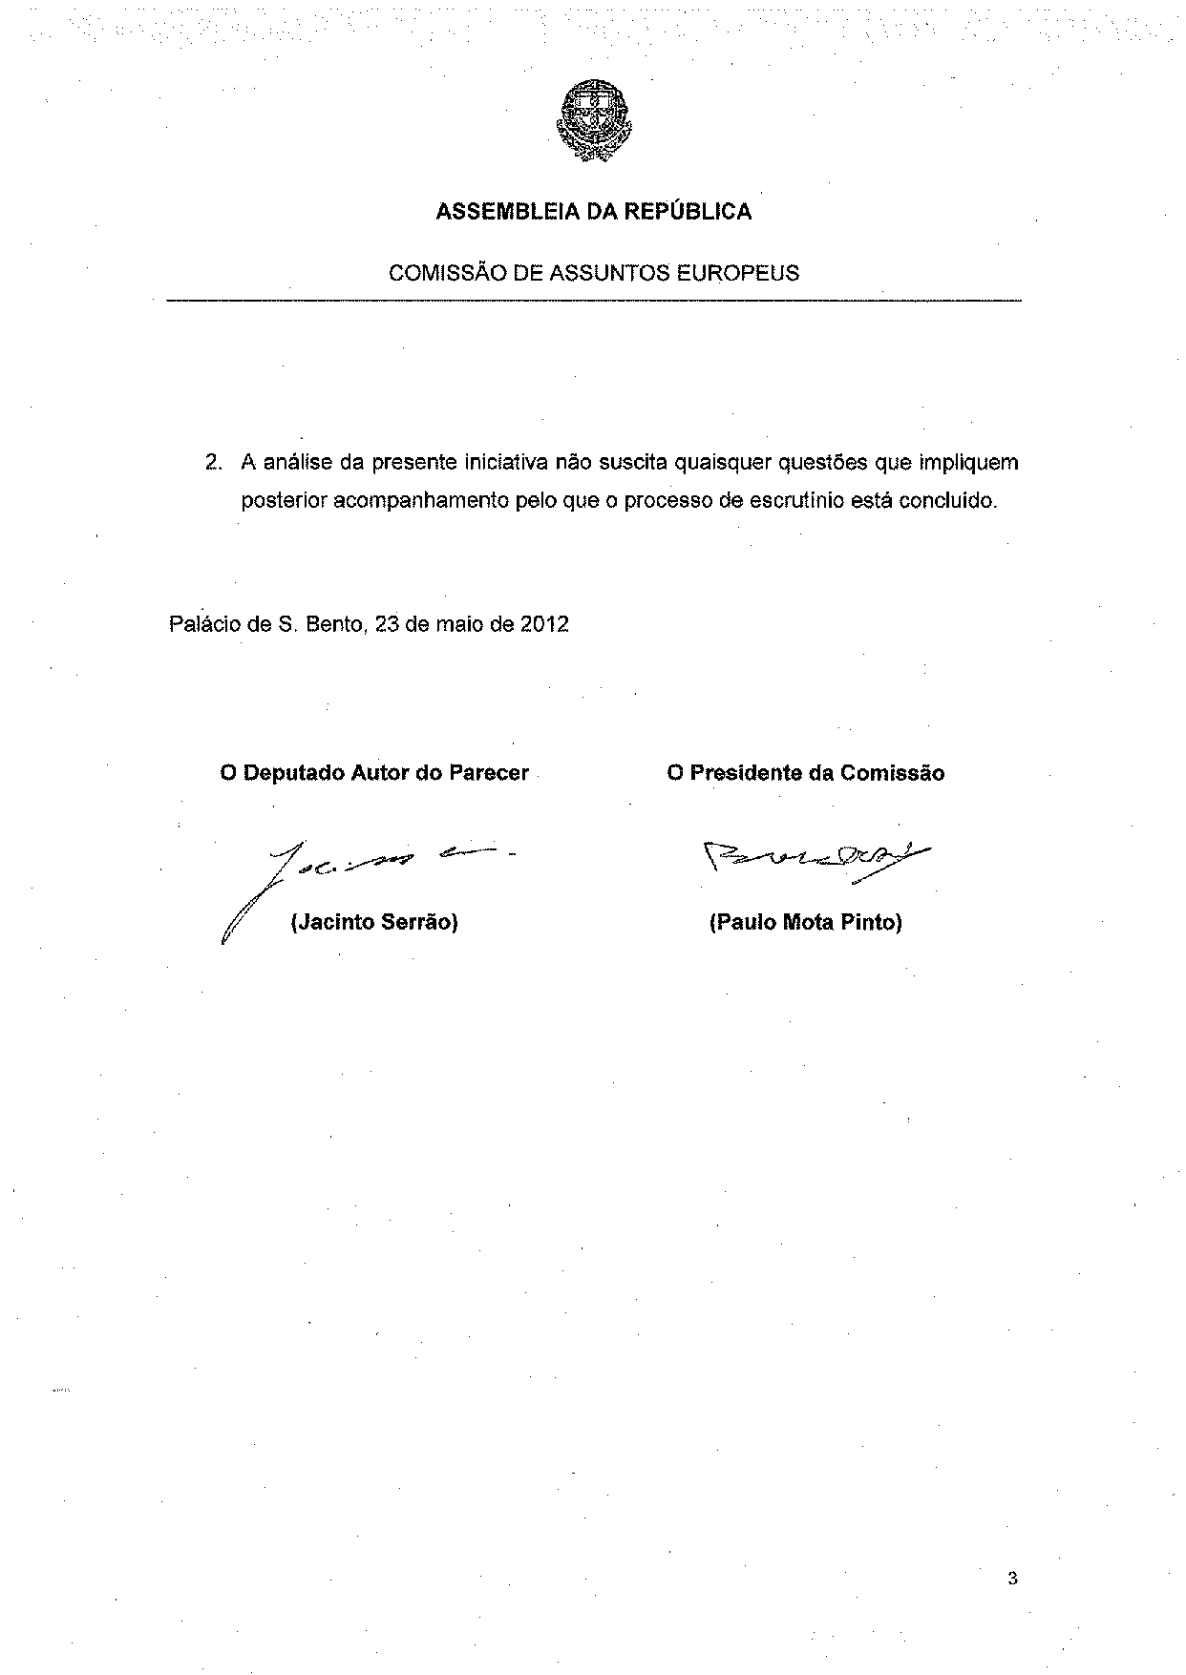
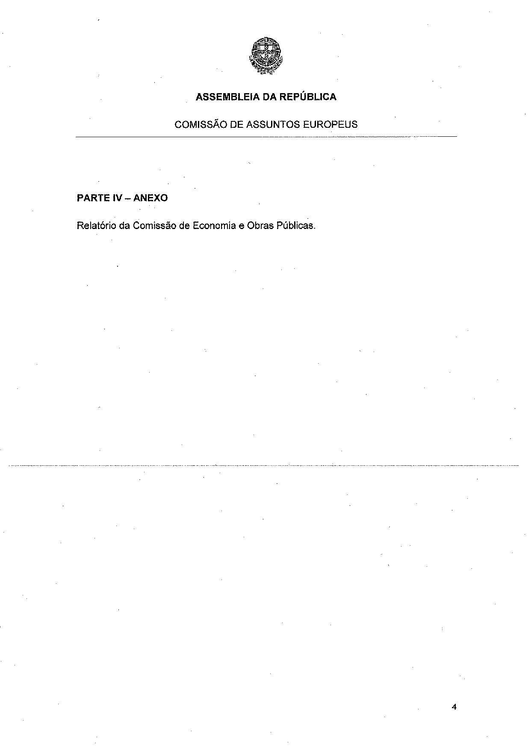
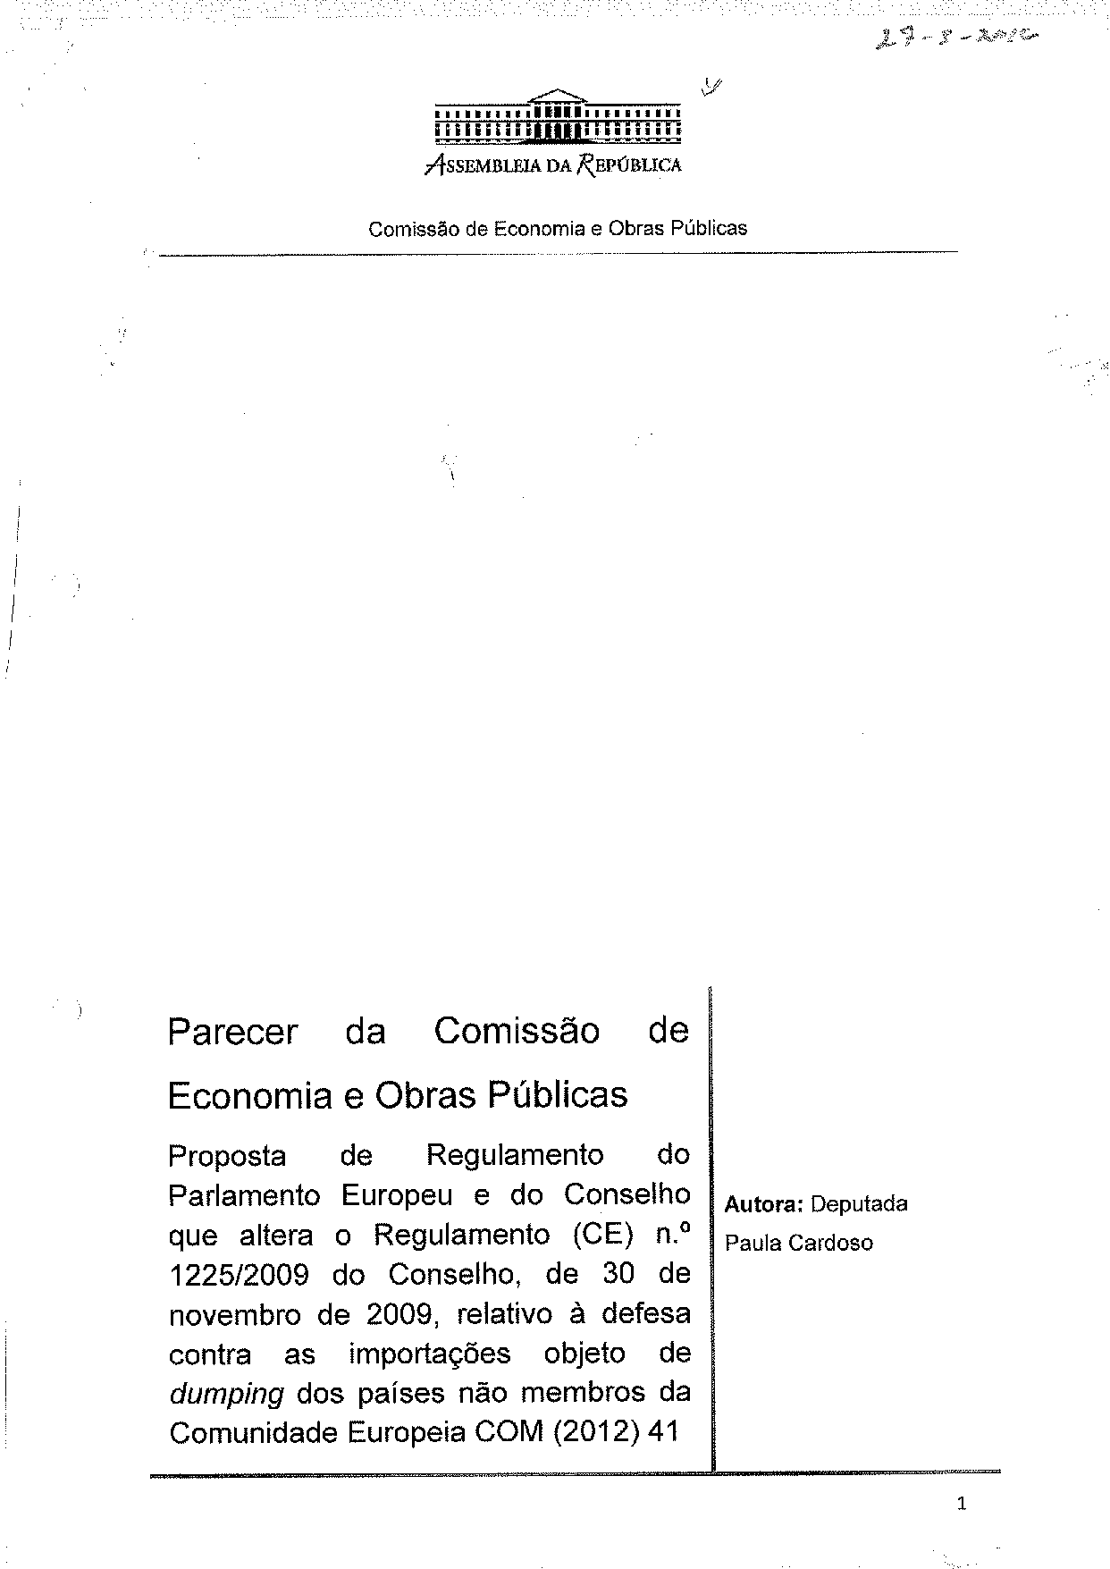
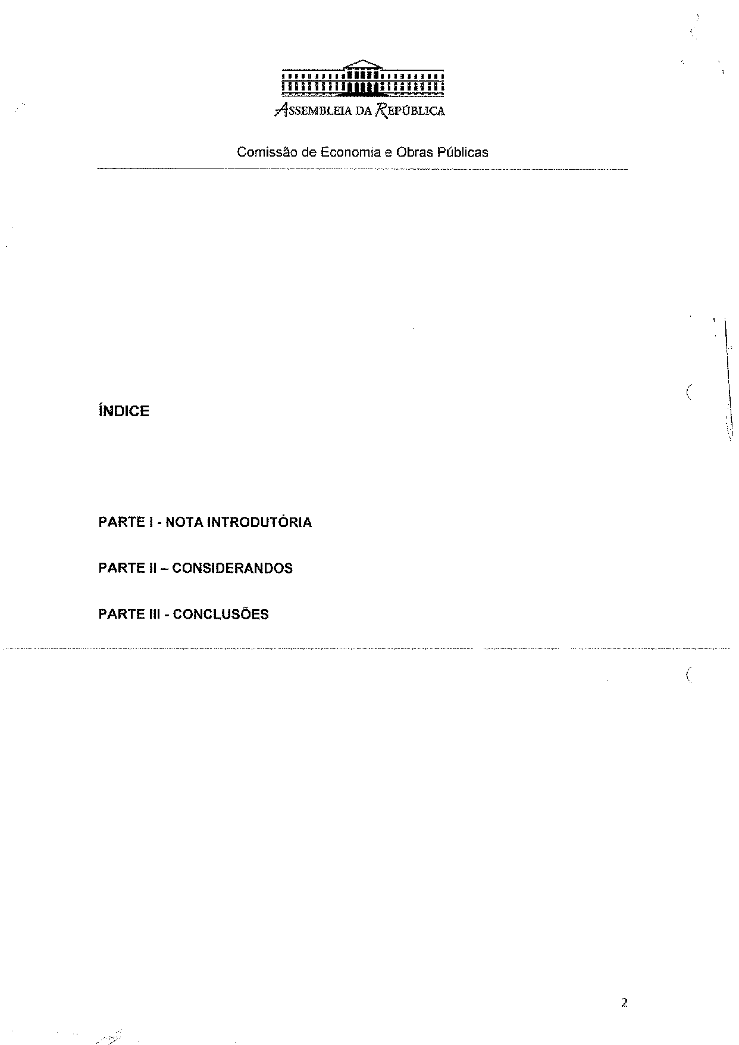
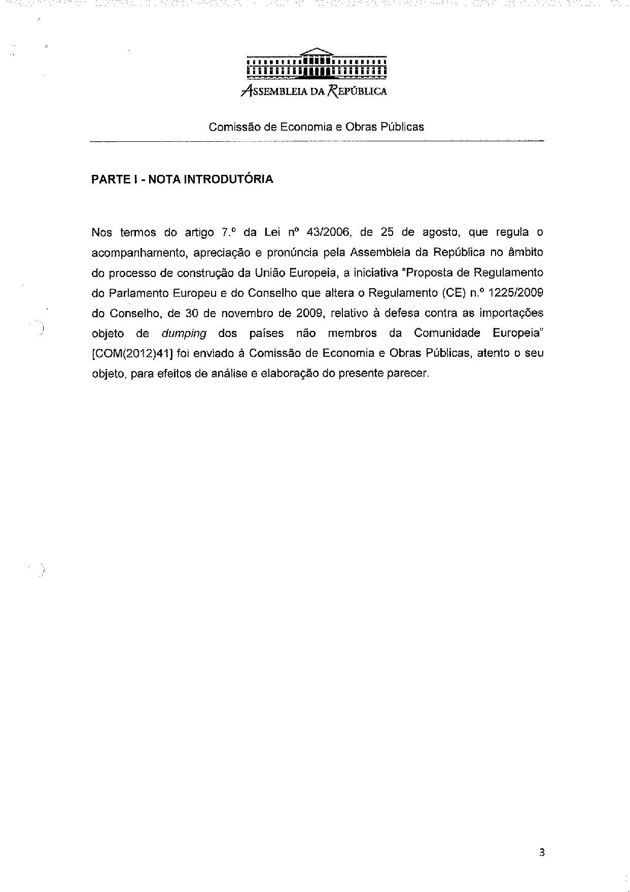
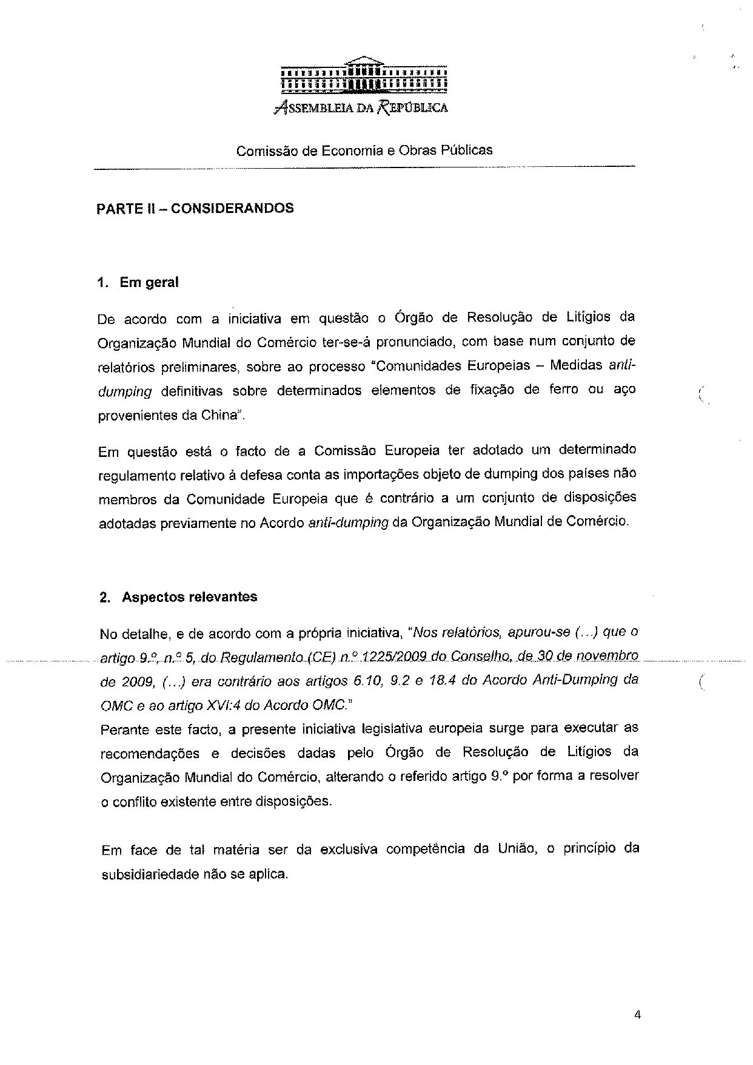
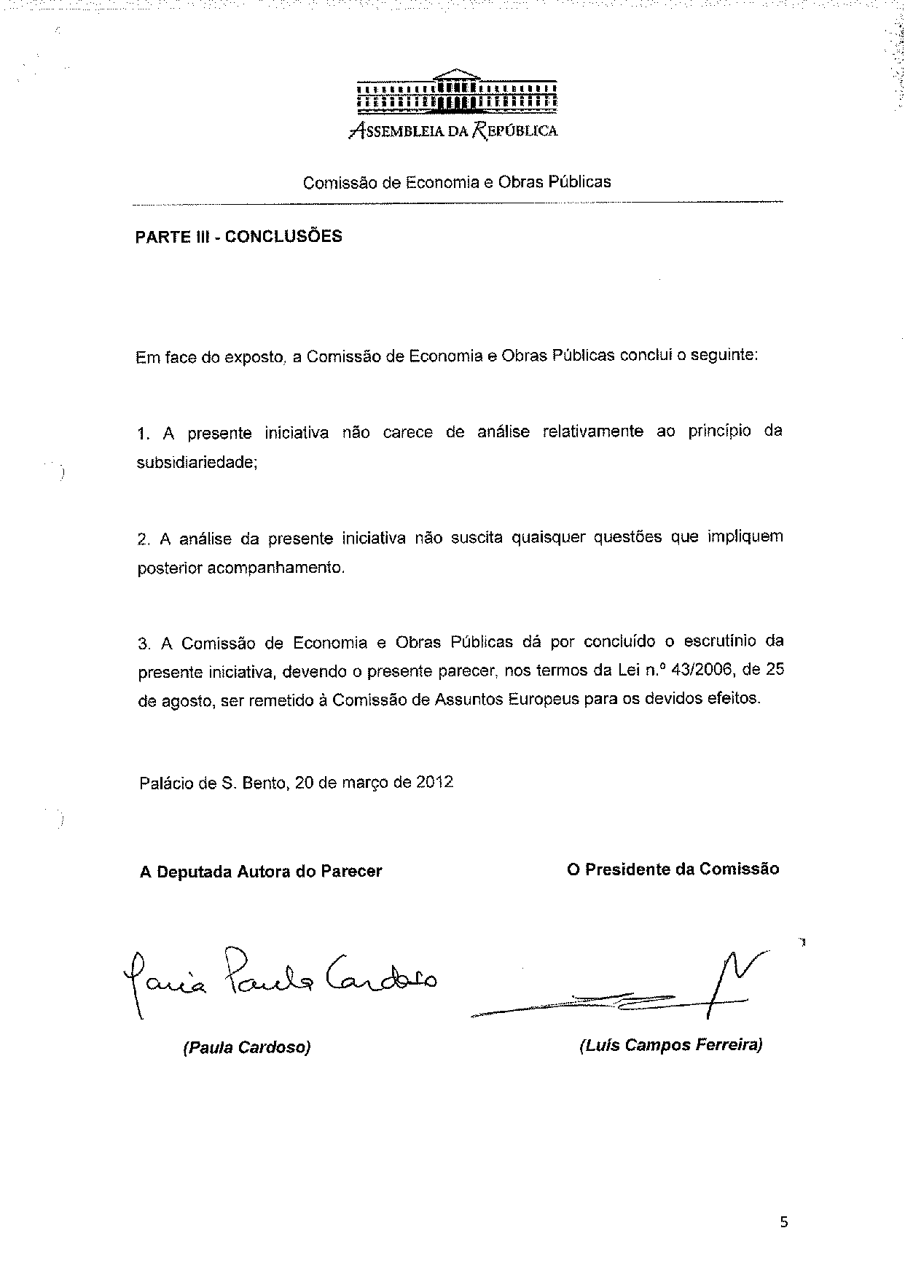

The translation of the opinion may be available at the Interparliamentary EU Information Exchange site IPEX, at the following address: http://www.ipex.eu/IPEXL-WEB/search.do.

