 | 
COUNCIL OF  THE EUROPEAN UNION |  |  | Brussels, 11 June 2012
 | Interinstitutional File:  2011/0202(COD)  2011/0203(COD) |  | 11136/12
EF 137
ECOFIN 563
CODEC 1622
INST 403
PARLNAT 268

COVER NOTE
from: | The President of the Italian Senate
date of receipt: | 4 June 2012
to: | President of the European Union
Subject: | Proposal for a Regulation of the European Parliament and of the Council on prudential requirements for credit institutions and investment firms [doc. ST 13284/11 EF 112 ECOFIN 531 CODEC 1284 - COM(2011) 452 final - Part I + ADD1 Part II + ADD2 Part III + ADD3 Part IV + ADD4 Part V]  Proposal for a Directive of the European Parliament and of the Council on the access to the activity of credit institutions and the prudential supervision of credit institutions and investment firms and amending Directive 2002/87/EC of the European Parliament and of the Council on the supplementary supervision of credit institutions, insurance undertakings and investment firms in a financial conglomerate [doc. ST 13285/11 EF 113 ECOFIN 532 CODEC 1285 - COM(2011) 453 final]  - Opinion on the application of the Principles of Subsidiarity and Proportionality

Delegations will find attached the above mentioned opinions.
________________________

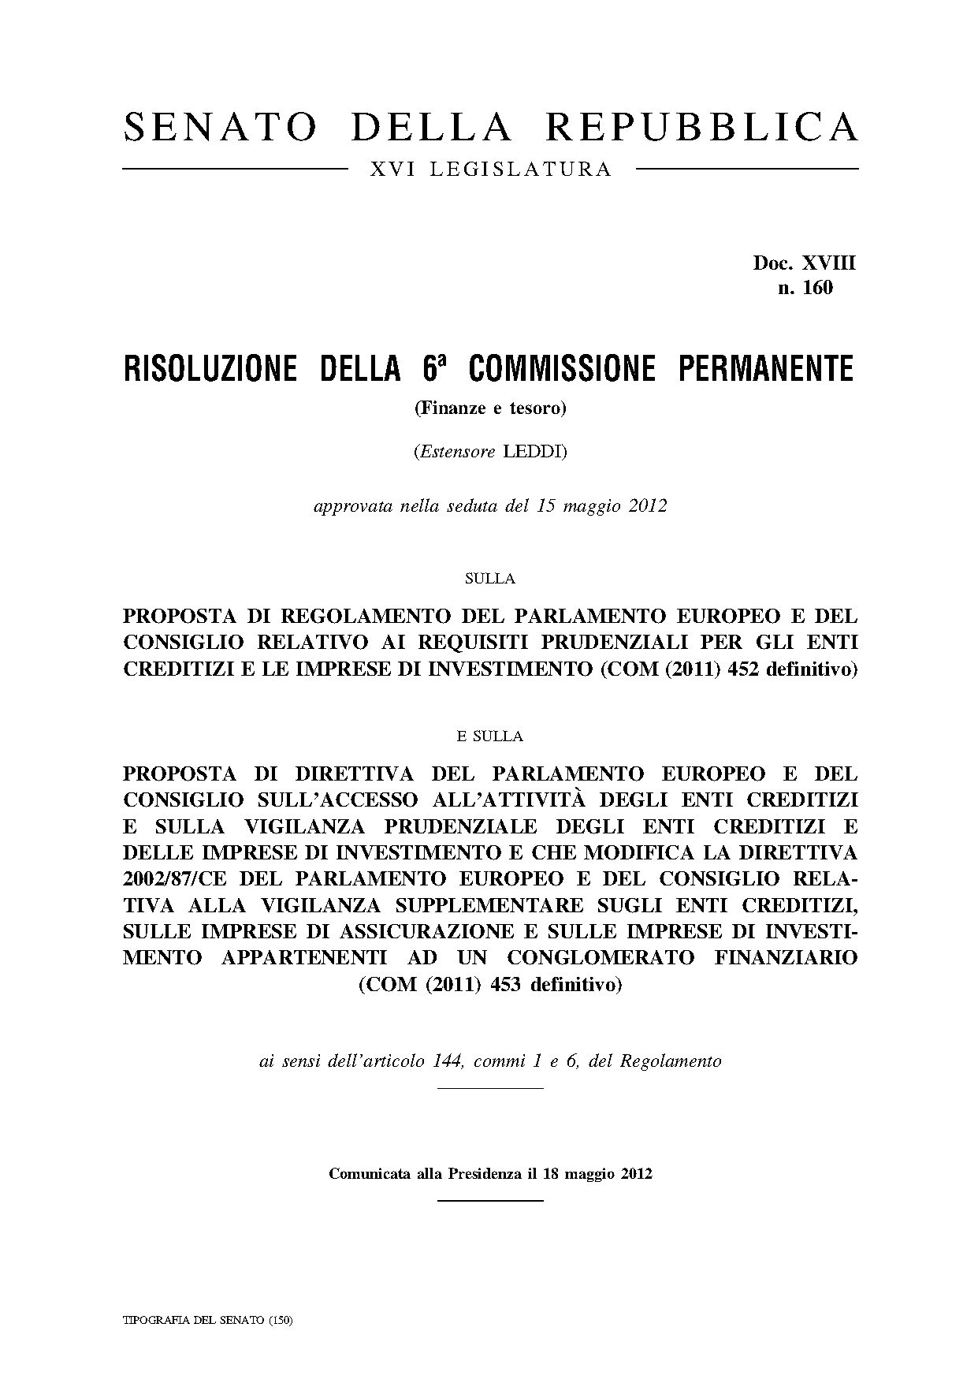
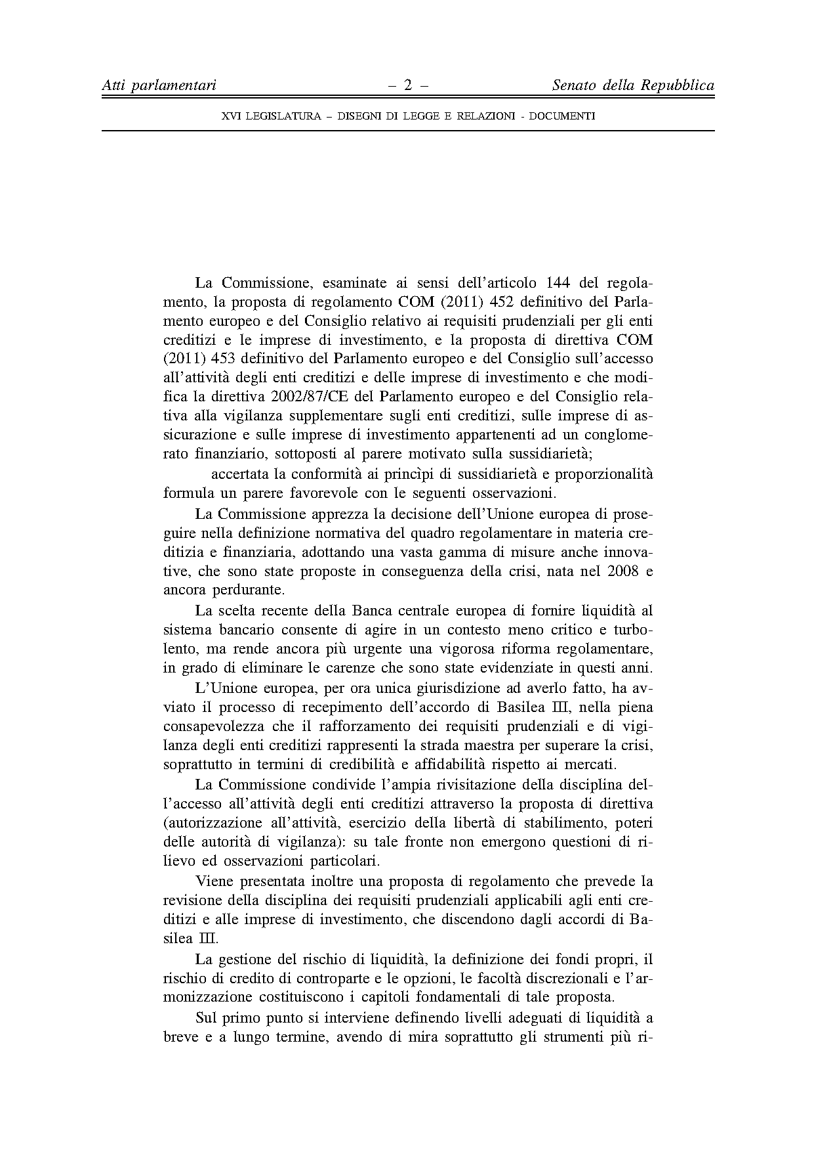
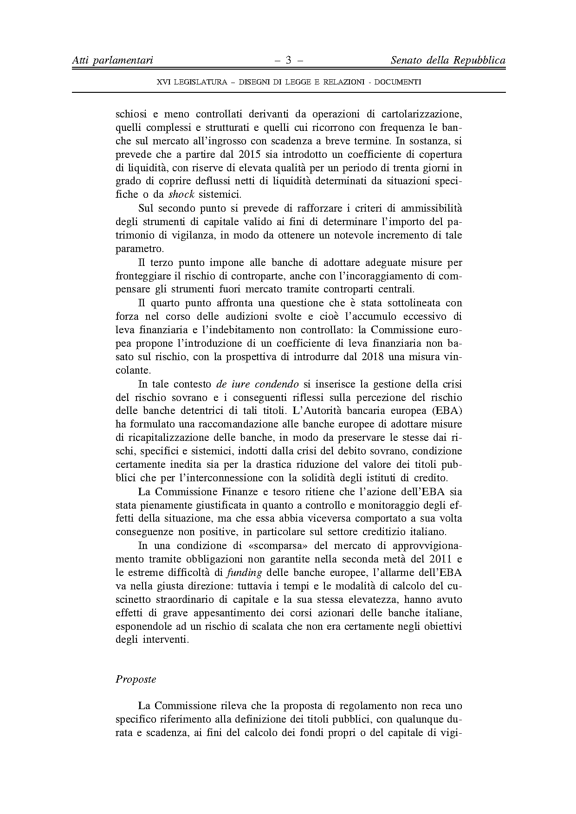
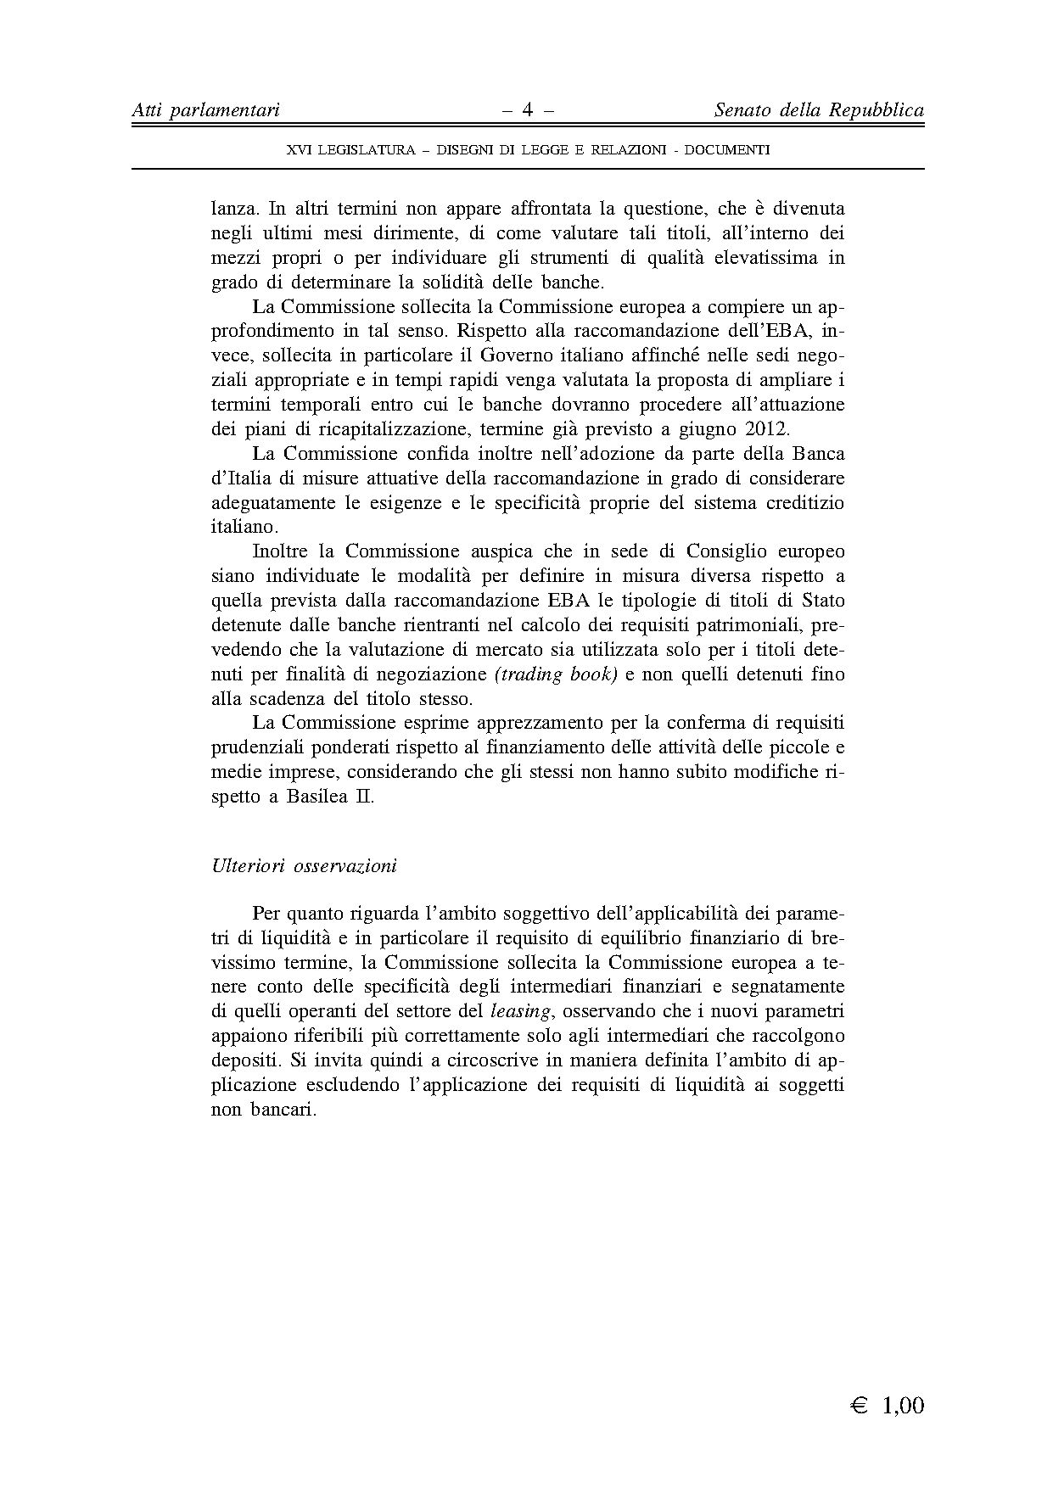

For other language versions of the opinion, reference is made to the Interparliamentary EU information exchange site IPEX at the following address: http://www.ipex.eu/IPEXL-WEB/search.do

