1. Executive Summary
Over the last year the crisis in the euro area went through its most acute phase to date. At its centre was a dangerous feedback loop between sovereigns, the banking system and the deteriorating economic outlook. As banks in Europe hold large amounts of domestic sovereign debt, concerns about the sustainability of sovereign debt spilled over to the banking sector. In turn, banks’ limited capacity to absorb losses added to the sovereign risk as governments were perceived as ultimate backstops for ailing financial institutions. Finally, feeble growth prospects – weakened further by private and public deleveraging – increased the concerns about debt sustainability and banks' profitability, led to higher debt refinancing costs and endangered debt sustainability in a self-fulfilling way.
This intense phase of the crisis showed the strength of cross-border spillovers in the euro area. The sovereign debt problems in the euro area started in 2010 as an isolated case. The crisis has since then spread to other vulnerable Member States revealing or compounding various home-grown problems, including built-up macro-economic imbalances or weaknesses in the banking sector. Finally even Member States that had been regarded as financially sound became affected and the crisis became system-wide in the second half of 2011. This reveals the strength of spillovers in the euro area – due to close economic and financial links and common policy frameworks – and is a call against complacency for those seemingly unaffected.
Determined policy actions to break the negative feedback loops and strengthen policy frameworks helped to contain the crisis. The Roadmap to stability and growth adopted by the Commission in October 2012 set out a comprehensive plan to respond to the crisis, which guided policy makers in their reform efforts. In particular, the second Greek adjustment programme has been agreed on the basis of an orderly restructuring of government debt. Other vulnerable Member States, in particular those under the EU/IMF adjustment programmes, have started bold policy reforms. Consolidation in the whole euro area has progressed broadly as planned even if additional measures are necessary in some cases. These national efforts have been paralleled by actions at the European level: EU-level initiatives with greatest growth potential have been accelerated; the size and scope of financial stability mechanisms has been strengthened; banks have strengthened their capital base in a coordinated exercise led by the European Banking Authority; the European Central Bank has taken measures to alleviate funding stress in the banking sector. Finally, far reaching governance reforms were agreed on, aiming at closer monitoring and surveillance of fiscal and economic policies.
A continuous and consistent policy effort to address the looming challenges is necessary. The above policy measures led to some tentative improvement in the first months of 2012, but volatility increased again recently due to adverse macroeconomic developments, persistent concerns about the banking system and intensified policy uncertainty in some Member States. This shows that markets remain exceptionally tense and vigilant and confidence is still weak. This is also a reminder that any improvement of the situation hinges crucially on maintaining an appropriate policy response at the national and the euro-area level. Therefore it is of paramount importance to continue with reform efforts to address the medium- and longer-term challenges of the euro area, in particular to:
  - revive growth already in the short term and increase growth potential, notably by strengthening market integration and liberalisation with the aim in particular to unlock private savings for productive investment and to improve competitiveness.
  - reduce the high debt burden in the public and private sector in a well-coordinated manner across countries and across sectors in a way that does not excessively constrain economic growth; in particular:
    - reduce the high public debt in the context of credible medium-term fiscal consolidation strategies, which strike the right balance between the need for consolidation, reform and growth;
    - reduce of large imbalances among euro area countries via broad structural reforms increasing adjustment capacity and appropriately differentiated fiscal policies;
  - continue financial repair in particular to ensure a sound banking sector, able to provide healthy financing to the economy.
Strong spillovers and interconnectedness in the euro area demand robust economic governance and close economic surveillance. The bold reforms in economic governance of the euro area enacted so far and in the pipeline go a long way in meeting the requirements of strong governance and surveillance in a monetary union and laying strong foundations for a stable and sound euro area. Nevertheless, further steps are necessary in the medium term to complete the architecture of the EMU.

2. Economic Situation and Outlook
The economic situation in the euro area deteriorated significantly over the last year. After contracting at the end of 2011 euro area GDP stabilised at the beginning of 2012. The loss of confidence due to the intensifying sovereign debt crisis, the oil price increases and the decelerating of world output growth have been weighing on growth.
While the risk of acute problems in the banking system has been eased by prompt policy action at the end of 2011, economic prospects remain sluggish. The European Commission spring forecast sees GDP as almost flat (-0.3%) in 2012, while a moderate expansion is forecast for 2013 (1.0%). This subdued recovery is predicated on a return of confidence and thus on the assumption that the crisis is contained and the financial-market situation normalises. Indeed, escalation of the crisis remains the largest downside risk, which could re-ignite the vicious feedback loop between the financial sector and the real economy and significantly reduce growth prospects.
Growth differences among the euro area Member States are expected to persist. There have been visible growth differences among the euro area countries since the outbreak of the global economic and financial crisis. These are expected to continue in the forecast horizon as Member States suffering from the legacy of internal and external imbalances are likely to register a much later and more protracted transition to a recovery than countries with lower structural impediments (see also Section 3.2).

3. Main Economic Challenges and Policy Responses
The euro area faces a number of intertwined challenges. They are discussed below under two main headings reflecting relevant policy areas and policy instruments. Section 3.1. discusses challenges related to financial and fiscal policies in the euro area, section 3.2. discusses challenges stemming from low growth and large macroeconomic imbalances. Each section contains an assessment of policy actions in the euro area, with a focus on the response to the recommendations that were addressed to the euro area Member States in 2011.

3.1. Restoring and maintaining stability

3.1.1. Financial stability
The financial sector worldwide and in Europe was hard hit during the crisis. The general reassessment of risk during the global economic and financial crisis triggered large falls in asset prices and eroded the capital base of Europe's banks, some of which had to be rescued by national public authorities. Against a background of economic recession exerting increasing pressure on public finances, these rescue operations, were in some cases big enough to undermine the sustainability of the sovereigns concerned. This – together with the revision of public finance figures in Greece – severely undermined the confidence in sovereign bonds in many euro area Member States. The prices of sovereign bonds of countries which were regarded as vulnerable declined and further reduced the capital of banks, which had invested heavily in these bonds before the crisis (Graph 1). This interdependence between weak banks and weak sovereigns in the context of slowing growth has created a very dangerous feedback loop. The aggravating crisis significantly undermined investors' confidence in the quality of banks’ balance sheets and hindered their access to funding. The crisis became system-wide in the second half of 2011 when financial stress spread onto other euro area sovereign markets, reflecting the strong spillovers existing in the single currency area (Graphs 2 and 3).
Graph 1. Programme countries' sovereign spreads
10 year maturity, difference to Germany
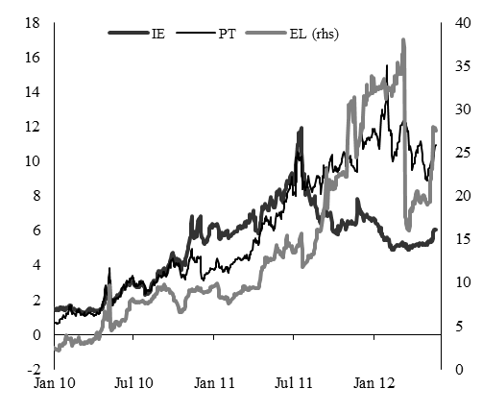
Source: Reuters Ecowin
Graph 2. Selected Member States' sovereign spreads  10-year maturity, difference to Germany | Graph 3. Financial price indicators for euro area corporations
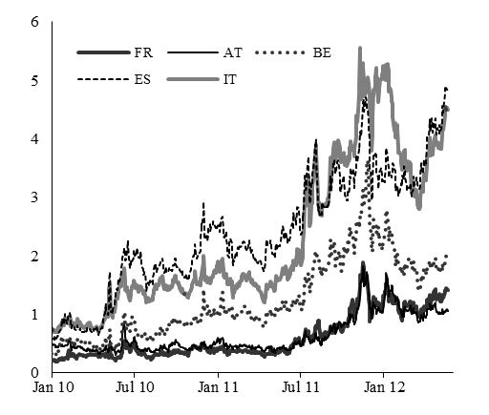 | 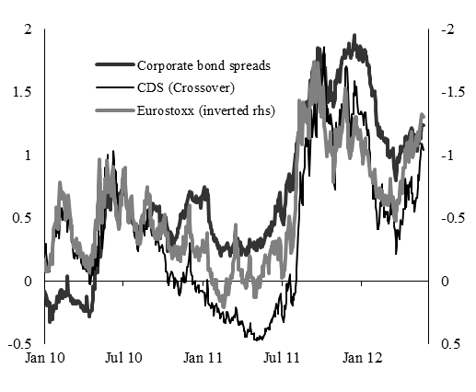
Source: Reuters Ecowin | Note: Expressed in standard deviations derived from daily averages 2005-2011.  Source: Reuters Ecowin
Policy measures introduced in the second half of 2011 and at the beginning of 2012 helped to rebuild market confidence in the early months of 2012, but the improvement proved temporary. In particular, the 3-year Very Long Term Refinancing Operations (VLTRO) carried out by the ECB filled acute refinancing gaps for euro area banks by guaranteeing banks access to medium-term funding at low cost. Also, to reassure markets about the banks’ ability to withstand shocks and maintain adequate capital, the October 2011 European Council agreed on an EU-wide recapitalisation plan coordinated by the European Banking Authority (EBA). The overall positive implementation of EU/IMF financial assistance programmes for Portugal and Ireland also contributed to improved market sentiment as did the ambitious reform programmes in other vulnerable countries. Other policy actions, such as the agreement on the second Greek adjustment programme, further strengthening of the firewalls and the reinforcement of fiscal governance also improved the sentiment towards euro area economies. Unfortunately, the improvement in sentiment proved only temporary and investors' confidence deteriorated again, which shows how fragile financial markets remain and that a failure to continue implementing appropriate policies can quickly turn market sentiment.
While further deleveraging in the banking sector is necessary to restore investor confidence, the challenge is to ensure that it does not unduly constrain the flow of credit to the economy. Recent funding strains and continuous pressure to increase capital have raised concerns that banks could excessively reduce credit supply (Graph 6). As bank credit is a major source of funding for the real economy in the euro area, in particular for the small and medium-sized enterprises, a credit crunch would have severe repercussions for growth and employment and could eventually impair growth potential if sustained over a prolonged period. To counter this risk, national supervisors have been requested to ensure that banks’ plans to strengthen capital ratio lead to an appropriate increase of capital rather than to excessive deleveraging and lending disruptions. At this stage, there is no clear-cut evidence that the deleveraging process has become excessive or disorderly with disruptive consequences on the real economy. Nevertheless, the heterogeneity across Member States is large and the aggregate picture may hide different situations at country level.
The run-down of problematic assets, accumulated before the crisis, is essential to restore the flow of credit to the economy. The continuing low interest-rate environment coupled with banks' reluctance to recognise losses or foreclose properties could increase the propensity of banks to forebear on loans or other problematic assets. Delaying loss recognition, could constrain lending to more creditworthy borrowers, reduce potentially productive investment and exert negative effect on growth.. Therefore correct and transparent risk recognition and timely restructuring is necessary to ensure the health of both the banking system and the economy.
Graph 4: Bank lending to the private non-financial sector in the euro area
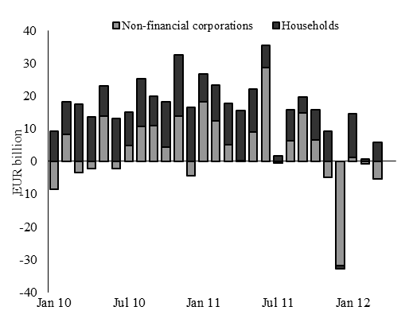
Note: monthly flows adjusted for sales and securitisation; seasonally adjusted.
Source: ECB
The ECB extraordinary liquidity measures have given the banks a breathing space. The VLTROs have alleviated acute funding strains in the banking sector and which will allow banks to provide lending to the economy, once economic conditions improve. However, the high returns offered by some sovereign bonds have encouraged some banks to further invest in domestic government debt, thus increasing interconnectedness between banks and sovereigns. Thus, it is of paramount importance that the window of opportunity offered by the VLTROs is used by banks to proceed with financial repair and restructuring of balance sheets, while maintaining credit flow to the economy, so that a more resilient banking sector is in place when the VLTROs come to maturity.
Financial sector restructuring has continued over the last 12 months in the euro area. Following last year’s recommendation to the euro area countries to improve the functioning and stability of the financial system, many Member States pursued the restructuring of their financial sector (CY, DE, ES, EL, IE, PT) and strengthened their supervisory framework (BE). Nevertheless, the measures sometimes lack ambition or a comprehensive approach (DE, SI).
The crisis has slowed the financial integration process and ambitious steps to accelerate and deepen financial integration may be needed. Already before the crisis, it was acknowledged that the EU model of cross-border banking was not stable under the existing institutional setting, in particular with respect to supervision and management of banking crises. This has proved particularly damaging in the context of the monetary union, due to closer financial and real linkages and the inter-linkages with the sovereign. Although banks have broadly maintained their cross-border presence so far, there are signs of declining cross-border activities and banks retrenching behind national borders. As part of their balance sheets restructuring banks have started to divest non-core assets, which often include foreign assets, although the pattern of the divestments is not clear-cut. To counter this trend of financial dis-integration more coordination at European level is required in supervision and crisis management frameworks. More specifically, a closer integration among the euro area countries in supervisory structures and practices, in cross-border crisis management and burden sharing, towards a "banking union" would be an important complement to the current structure of EMU. In the same vein, to sever the link between banks and the sovereigns, direct recapitalisation by the ESM might be envisaged.

3.1.2. Fiscal policy
Since the outbreak of the crisis public debt has increased substantially in the euro area. While the levels and trajectories of debt differed substantially across euro area Member States before the crisis, the increase since its outbreak was universal. This has been to the largest extent due to the significant role public finances played to support the economy and the financial sector during the global economic and financial crisis. However, insufficient efforts to reduce debt during good economic times before the crisis have also made some countries more vulnerable to economic shocks. Since the onset of the crisis in 2007, government debt levels across the euro-area have increased by more than 20 percentage points and reached 88% of GDP in 2011, with large differences across Member States. It is fair to point out, however, that although the euro-area is at the epicentre of the sovereign debt crisis, the overall increases and levels of government debt-to-GDP ratios are actually higher in both the US and Japan (Graph 5).
A combination of factors makes the reduction of high public debt an acute challenge per se and in particular in the context of the euro area monetary union. First, risk aversion on sovereign debt markets have increased markedly, probably over-correcting the subdued levels prevailing before, as investors have reassessed the prospects of sovereign debt sustainability in face of increased debt levels and a depressed growth outlook. This has led to a surge in financing costs for some governments, which in turn endanger debt sustainability in these Member States already in the medium term. Second, the crisis has revealed very large spillovers between euro-area sovereigns that increase the risks of developing systemic crises, i.e. a situation when developments in the euro area as a whole play larger role in investors' perception of a Member country than the developments in the country concerned. And third, budgetary costs stemming from ageing populations have implications for fiscal sustainability in the longer term. The sizeable magnitude of the fiscal adjustment required to bring down currently high debt-to-GDP ratios in most Member States calls for a durable and sustained fiscal consolidation strategy.
Fiscal consolidation has been ongoing in the euro area and the Member States have undertaken significant consolidation efforts. The headline government deficit in the euro area has fallen by 2.1 pp. to 4.1% of GDP in 2011. Government debt, however, continued rising and reached 87.2% of GDP. As the reduction in the headline deficit-to-GDP ratio took place in the context of slowing output growth, it amounts to significant consolidation effort. Indeed, the cyclically adjusted budget balance improved by 1 pp. and reached 3.4% of GDP in 2011. This shows that the euro area Member States have broadly achieved the structural consolidation efforts planned in the 2011 updates of their Stability Programmes.
Stability Programmes show that the consolidation is expected to continue. According to the plans set out in the Stability Programmes, fiscal deficit in the euro area will decline to around 3% of GDP in 2012 and further to less than 1% of GDP in 2015. The gross public debt is planned to still increase, however, and exceed 90% in 2012, before falling around 85% in 2015, but large differences in debt levels are expected to persist over the programme horizon.
While euro area Member States have to restore sustainability in their public finances, there are short-term growth effects of fiscal consolidation. In general, fiscal consolidations entail short-term contractionary effects on economic activity. These effects are likely to be larger now – in a post-financial crisis recession – than during a usual cyclical slowdown. This is because a larger share of household and firms are now credit constrained and are more sensitive to changes in current income and profits rather than to interest rates. Moreover, the already accommodative stance of monetary policy and the impairment of the transmission mechanism due to problems in the banking sector limit the scope for any offsetting stimulus from this source.
Graph 5. Development in government debt and deficit in the euro area, US and Japan
2007-2013 (% of GDP)
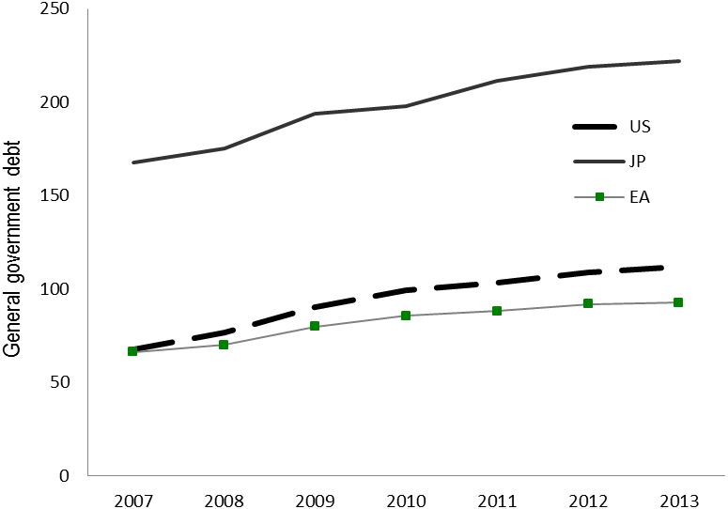
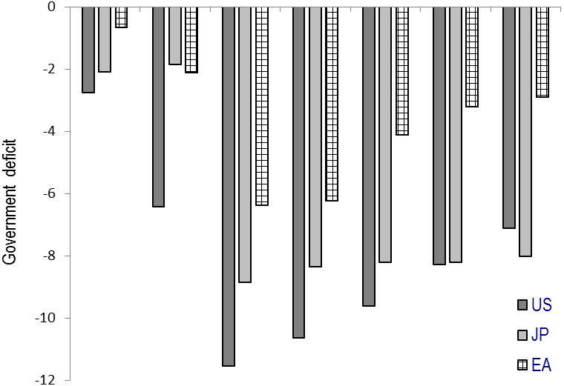
Source: Commission Services
The main challenge for fiscal policy is to pursue fiscal consolidation in a growth friendly manner. Credible medium-term growth-friendly consolidation programmes are of utmost importance to simultaneously reduce the high debt levels and to mitigate potential negative growth effects of consolidation. Credibility of consolidation is one of key factors here: short-term adverse growth effects are typically found to be smaller for consolidation efforts which are perceived to be permanent. There are four dimensions of growth-friendly nature of consolidation: (i) differentiation of the pace across countries, (ii) strong attention to the composition of consolidation, including a clear focus on curbing age-related spending, and (iii) accompanying reform of budgetary institutions.
- The size of fiscal challenge differs among the euro area Member States and calls for differentiated speed of consolidation.
The Stability and Growth Pact provides a flexible and rule-based framework to guide the differentiated pace of consolidation. The application of the EU fiscal rules is based on economic analysis and legal provisions, together with an overall assessment of the structural sustainability of public finances. The framework allows for objectively-based differentiation between Member States according to their fiscal space and macroeconomic conditions (Graph 6). The assessment of the budgetary measures taken by the Member States, in particular in structural terms, is central to the implementation of the rules.
The strategy of fiscal exit from the extraordinary measures adopted to cushion the effect of the crisis reflects the flexibility embedded in EU fiscal rules. Specifically, Member States which face high and potentially rising risk premia do not have much room for manoeuvre to deviate from their nominal fiscal targets, even if macroeconomic conditions turn out worse than expected. However, other Member States are in a position to fully let their automatic stabilisers play along the structural adjustment path.
Graph 6. Government deficit and debt in 2011, euro area Member States (% of GDP)
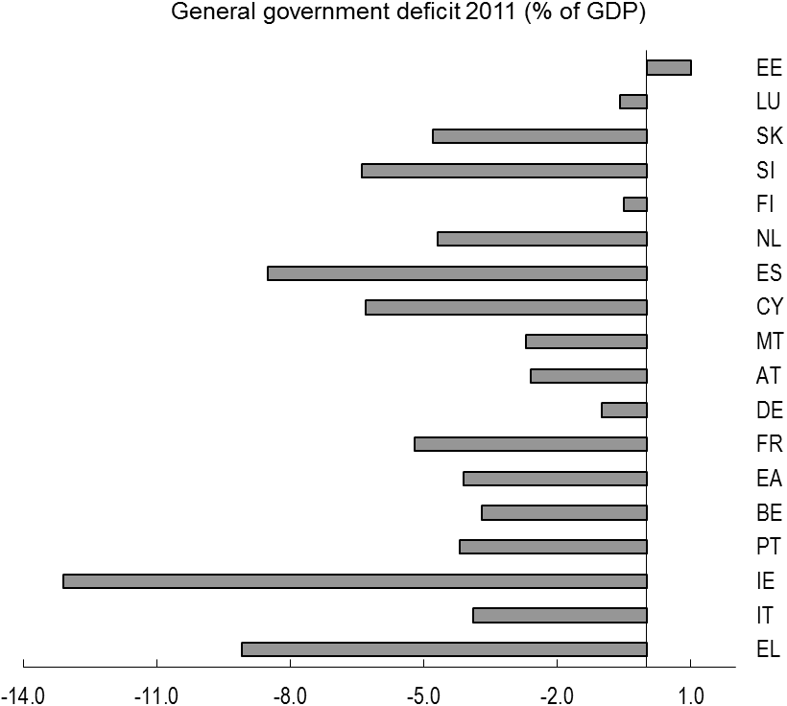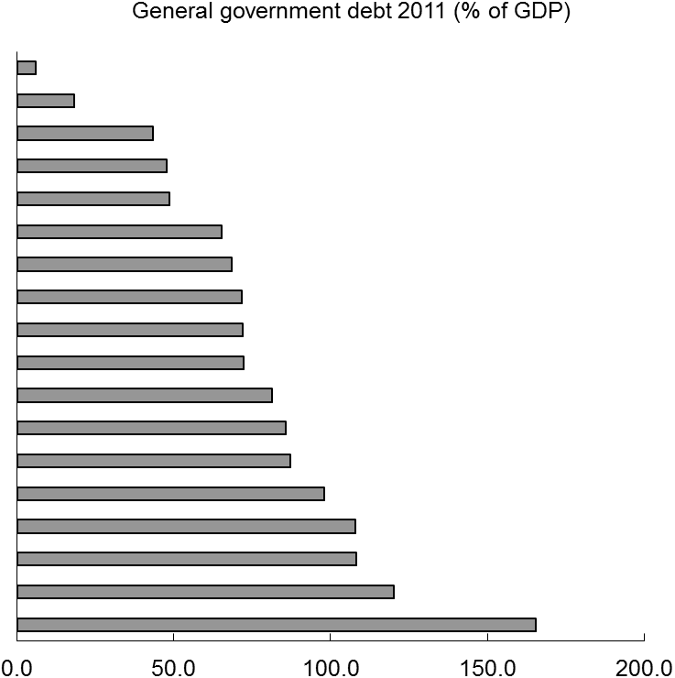
Source: Commission Services
- The composition of fiscal consolidation is critical to minimise the negative effects on growth.
Expenditure retrenchment can have important signalling effect. Due to the inherent difficulties in implementing expenditure-based consolidation strategies, their adoption is instrumental in signalling the commitment to cut fiscal deficits. Thus, spending retrenchment is a precondition to underpin credibility and prevent risk premia from rising further. However, a growth-friendly consolidation also requires prioritising growth-supporting public expenditure so as not to undermine the already weak growth potential of the euro area economy. Public investment has particular importance in this respect as investment expenditure increase growth via domestic demand already in the short term, while have a positive effect on the supply side in the long term. Especially in some Member States, which face extraordinarily low interest rates there is a case for adopting policies to promote productive investment, as it is very likely that its private and social returns would exceed the funding costs. However, it is also important to pay particular attention to the efficiency and effectiveness of the expenditure programmes.
However, as the size of the required fiscal adjustment is significant, part of it might have to come from the revenue side in many Member States. This is particularly relevant in Member States where large consolidation needs are combined with some room for potential tax revenue increases or where there is a need to restore tax bases eroded by the crisis. There are several ways to increase tax revenue which do not involve outright tax hikes. Improving tax compliance and administration should be the first lever to use. Where this is not sufficient or where tax compliance is already high, broadening of the tax base should be considered. Moreover, improving compliance and broadening the tax bases are valuable aims of tax policy per se as they increase the efficiency of taxation and reduce economic distortions. As a last option, increasing tax rates or introducing new taxes might be unavoidable in some cases. In such cases it is necessary to pay utmost attention to minimising the possible negative effects on growth by focusing on the least detrimental taxes such as consumption taxes or recurrent property taxes.
Appropriate tax policies can also contribute to growth and competitiveness and reduce imbalances in the economy. Tax policy should generally focus on growth-friendly changes in the structure and design of existing tax systems. In particular, an increase in the tax burden on labour and capital has more detrimental effects on growth and competitiveness than is the case with other types of taxes, such as on consumption, property and environmental taxes. This is particularly relevant for some euro area Member States, which need to significantly improve their competitiveness. The potential distributional impact of tax changes also needs to be carefully assessed. Any reduction in the tax burden on labour should be centred on the most vulnerable labour market groups, given that these often face particularly high disincentives to work and suffer from relatively high labour costs. With particular relevance for the euro area, tax reforms should also address the incentives to build up debt, embedded in corporate income tax systems and the housing taxation.
The composition of consolidation has not always been growth-friendly. Although consolidation efforts have been generally expenditure-based, only a few Member States have safeguarded growth-enhancing items, such as R&D (IT) or education (DE). Others (PT, IT) prioritised capital expenditure, notably by enhancing the use of EU structural funds. In several Member States, the efficiency of public spending has been improved (EE, FI). Measures on the revenue side have also been frequent. A number of Member States have opted for tax increases. These sometimes improved the structure of taxation shifting the tax burden away from labour (IT). More often the changes did not go in the right direction, as the tax burden on labour (AT, ES, FR) or on capital (ES) has increased, even if other, less growth-harmful options have not been fully exploited. There were also measures reducing distortions in property taxation (PT) or increases in consumption taxation (FR), but no shift towards environmental taxes have been recorded.
Tackling the budgetary implications of ageing population is key for public finance sustainability. Due to the negative impact of the crisis on growth, the age-related expenditure is now expected to be a larger burden for public finances. On the basis of current policies, the ratio of age-related public expenditure to GDP is projected to increase by 4¾ percentage points by 2060. There are however large differences across countries with Belgium, Cyprus, Luxembourg, Malta, the Netherlands, Slovenia and Slovakia facing particular challenges. Pensions represent a very large and rising share of public expenditure in the euro area: more than 12% of GDP today and projected to rise to 14% in 2060. In Member States that face highest pension costs, but also in others, reforms in pensions, health and long-term care would improve the long-term sustainability of public finances, underpin the credibility of the current consolidation efforts and help to strengthen investor confidence.
Progress has been made with respect to pension reforms, but health care reforms are lagging behind. The looming challenge of ageing population has over the last decade prompted the majority of Member States to adapt pension systems with the aim of putting them on a more sustainable footing. This trend has continued over the last year. The recent pension reforms in some euro area Member States notably Greece, Italy and Spain are having visible positive budgetary impacts. However, further reforms are in many cases necessary. Less progress has been made in the area of health care systems, where the challenge is to balance the need for universal health care and long-term care with an increasing demand related to ageing population, technological development and growing patient expectations in all age categories. Sound reforms are thus needed to achieve both a more efficient use of limited public resources and the provision of high quality health care.
- Reforms of national budgetary frameworks can make an important contribution to consolidation and alleviate growth-consolidation trade-offs.
Improving national budget processes by drawing on identified best practices would improve fiscal policy-making on a lasting basis. Moreover, credible budgetary frameworks, oriented towards ensuring fiscal sustainability, can create more room for short-term stabilisation role of public finances. If markets' expectations are firmly anchored in a credible medium-term path, i.e. if investors trust policy makers will reduce deficits in the medium-term, they will be less sensitive to the short-term fluctuation of fiscal aggregates, leaving more room for stabilisation policies. To anchor the expectations, the role of national fiscal frameworks and EU surveillance is crucial.
Visible progress has been achieved in improving fiscal frameworks. Most countries have embarked on ambitious reforms of major structural elements of their fiscal frameworks, putting in place new or tighter fiscal rules (in some cases at constitutional level), strengthening multi-annual planning and setting up fiscal councils. These efforts should be pursued to provide tangible deliverables strengthening the budgetary process. In particular the transposition of the Directive on requirements for budgetary frameworks by the end of 2012 – as committed by euro area Heads of State and Governments – and the swift implementation of the fiscal compact would send an unambiguous message that the euro area is putting in place the appropriate mechanisms to achieve a credible and lasting fiscal consolidation process.
Budgetary discipline and solidarity in the euro area could also be fostered by the common issuance of sovereign debt instruments. Creating a new market segment based on common issuance would address the current shortage of investor demand for the sovereign bonds of many euro-area Member States. In dependence of their design, such an instrument would provide participating Member States with more secure access to refinancing at a generally lower rate through a lower liquidity premium and less market volatility. A number of suggestions in this direction have been brought forward, including the issuance of mutualised bonds combined with a debt redemption fund as suggested by the German Council of Economic Advisers, different options of Stability Bonds as outlined in the Commission's Green Paper or the common issuance of short-term debt securities (E-Bills). Even if common issuance were not to play a role in managing the sovereign debt crisis, such an instrument would contribute to efficient financial integration by facilitating the transmission of monetary policy and making available high-quality collateral that can be more easily used on a cross-border basis. However, the net effects of common issuance will be positive only if the potential disincentives for fiscal discipline can be controlled. The successful application of the new economic governance framework already in force and in the process of being put in place may be a significant step towards fulfilling the preconditions for common issuance. The Commission will come forward with proposals following the analysis of the results of the consultation undertaken on its Green Paper.

3.2. Adjusting imbalances and enhancing growth

3.2.1. Adjusting internal imbalances in the euro area
One of the salient features of the first decade of the euro area’s existence was the gradual accumulation of macroeconomic imbalances. Their most visible manifestation was the increasing divergence in external positions. Some Member States saw their current account deficit rise to very high levels while others accumulated substantial current account surpluses (Graph 7).
The mounting current account deficits and surpluses were a counterpart to large capital flows across the euro area countries. Capital inflows benefited mostly those Member States where the real returns on investment appeared the highest. While these capital flows partially reflected sound catching-up processes, particularly in the initial period, they also reflected a generalised mis-pricing of credit risk and were ultimately to result in a misallocation of resources within the recipient economies and became a significant ingredient of unsustainable macroeconomic trends. Part of the capital flows was channelled into unproductive uses and fuelled domestic demand booms, which were associated with excessive credit expansions and raising debt in the private and/or public sectors and housing bubbles in some euro area countries (Graph 8).
Graph 7. Decomposition of current account developments in the euro area | Graph 8. External and internal imbalances before the crisis
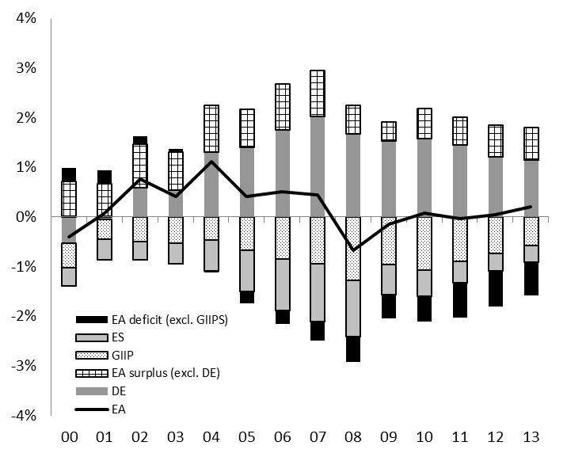
Source: Commission Services | Source: Commission Services  Note: Average private credit (transactions) as % GDP and average current account over 2000-2007.
The past divergence in external positions within the euro area was mainly due to diverging developments in the private sector (Graphs 9 and 10). A look at the sectoral net lending/borrowing in surplus and deficit countries in the euro area shows that the key driver of the growing divergences in external positions prior to the onset of the crisis was the non-financial private sector. Although government sector balances were somewhat more negative in deficit countries than in surplus countries, their contribution to overall imbalances was generally more limited compared to the private sector. However, the developments in the rest of the private sector were documenting growing divergences: while in surplus countries the financial balance of the private sector on average improved, in deficit countries it progressively deteriorated up to 2007. The household sectors in both surplus and deficit countries were on average net lenders over the whole period, while the net lending position was much weaker in the latter and, moreover, deteriorating in the run up to the crisis. The non-financial corporations were net borrowers in deficit countries while they turned into net lenders in surplus countries. The advent of the crisis has set in motion important consolidation of private balance sheets – both of households and non-financial corporations. This consolidation does not necessarily affect only deficit countries but also those with current account surpluses.
Graph 9: Net lending/borrowing as % of GDP by sector –  euro area "surplus" countries | Graph 10: Net lending/borrowing as % of GDP by sector –  euro area "deficit" countries
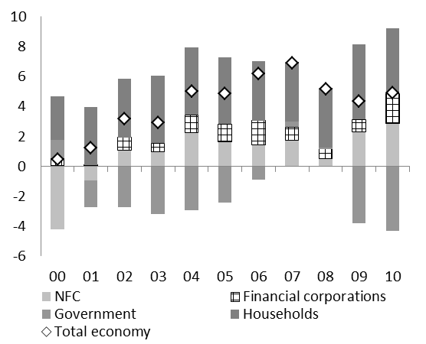 | 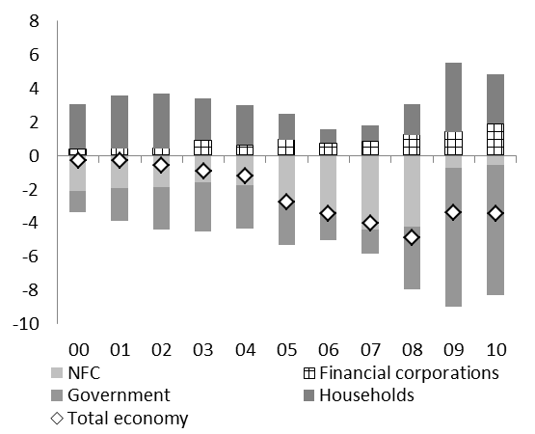
Source: Eurostat  Note: Surplus countries are BE, DE, LU, NL, AT, FI (based on average external position in the period 2000-2010). | Source: Eurostat  Note: Deficit countries are EE, IE, EL, ES, FR, IT, CY, MT, PT, SI, SK (based on average external position in the period 2000-2010).
The onset of the crisis triggered a reversal in the previous trends and current account imbalances in the euro area have been significantly reduced since. Currently, the dispersion of current account imbalances has dropped significantly compared to the peak. The gaps between actual current account balances and their 'norms' determined by fundamental factors have shrunk substantially (Graph 11). In the years preceding the crisis, a majority of countries recorded current account balances which were below what could be expected on the basis of the underlying fundamentals. As the largest adjustment so far took place on the side of current account deficit countries, the average current account gap approached zero and turned positive thereafter. While to a large extent the reduction in deficits was linked to depressed domestic demand and imports, deficit countries have also started improving their export performance. According to the Commission spring forecast their export markets shares are forecast to improve more than those of the surplus countries.
Although to a lesser extent, some rebalancing is taking place on the surplus side as well. Since 2007 all surplus countries have noticeably reduced their surpluses. Particularly, in Germany the composition of growth has changed visibly over the recent past. Domestic demand became the main driving force behind output growth and in 2011 has been growing by almost 2 pp. faster than in the euro area as a whole. Also unit labour costs accelerated faster in 2011 than on average in the euro area and recent wage negotiations also point further in this direction. According to Commission spring forecast these trends are expected to continue in the forecast horizon.

Graph 11. Developments in current account 'gaps' in the euro area | Graph 12. Actual current account (CA) balance and IIP-stabilising CA (2012-2020)
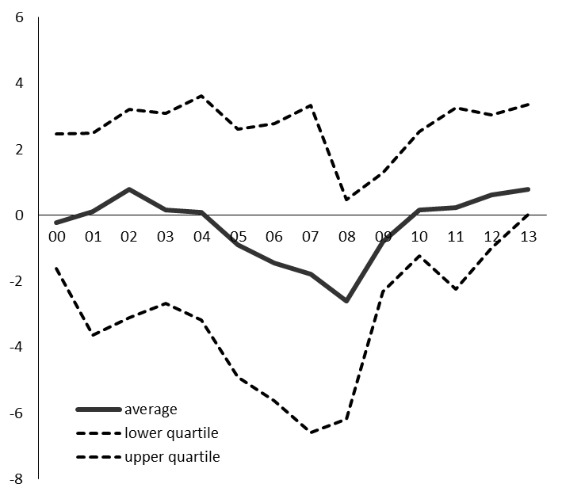
Source: European Commission  Note: Current account 'gaps' show the difference between actual current accounts and 'norms' based on the approach by Salto and Turrini (2010). | Source: European Commission  Note: The current account stabilising international investment position (IIP-stabilising CA) shows the CA balance necessary to keep the net IIP-to-GDP ratio constant given the growth projections for 2012-2020.
On the way forward, a key issue is whether the recorded narrowing of imbalances is structural or will be reversed once cyclical conditions improve. There are indications that at least part of the observed rebalancing is of a more structural nature and therefore likely to be relatively persistent. To the extent the recent corrections reflect reassessment of income expectations and risk premia rather than purely cyclical drops in output, they could prove sustainable. Given the high level of external liabilities in most deficit countries, market pressure for rebalancing should remain high in the years to come and a reversal of the balance sheet adjustment appears unlikely. Also, fiscal consolidation needs are generally larger in deficit than in surplus countries, so the public sector is likely to contribute to rebalancing in the longer term. Finally, the adjustment in many deficit countries is accompanied by changes in relative prices which is a precondition for the required reallocation of resources within the economies.
Even if the adjustment on the deficit side has been large, there are indications that it has not been complete in those countries which had the highest current account deficit. While there has often been a radical adjustment in flows, some of these countries still feature very high levels of external liabilities as showed by the net international investment positions (NIIP) as a share of GDP. Given the high level of net liabilities and weak growth dynamics, there is a need for further improvements in current accounts, particularly in trade balances, to bring the NIIP-to-GDP ratios on a declining trend (Graph 10). Given the growth prospects over the coming decade, external indebtedness in Greece, France, Italy, Cyprus, Malta and Portugal would continue increasing if current account deficits stayed at the current level. This does not necessarily jeopardise external sustainability in countries with relatively favourable external positions such as France but would be an additional drag for countries with already high levels of external debt.
Graph 13. Euro area Member States' sectoral Net Financial Assets, (% of GDP), 2010
Source: Commission Services
Note: Net financial asset (NFA) positions are defined as financial assets less financial liabilities. The NFA positions represent the national accounting counterpart of the net international investment position (NIIP) and allow exploring savings-investment balances in a sectoral perspective. The graph depicts the situation in the euro area countries by looking at three dimensions: (1) the ratio between the NFA position of households to that of firms ("coverage ratio"), which gives an indication to what extent domestic private savings are sufficient to finance the needs of firms. The light colour indicates full coverage and the dark colour reflects less than full coverage. A priori it is expected that firms are on average net investors (negative NFA) and that households are net savers (positive NFA) while financial corporations are, on average, intermediaries (balanced NFA position); (2) the government NFA gives an indication of the role of the public sector in complementing/supplementing a potential savings gap in the private sector (a negative sign indicates net general government liabilities); (3) the NFA of the economy as a whole to the rest of the world links the internal position with the economies external needs/capacities (a negative sign means net external liabilities). Surplus countries are in circles.
The required improvement in current accounts to stabilise or reduce external indebtedness often implies even more ambitious improvements in trade balances. This is due to the negative net investment income payments which these countries need to pay, i.e. interest payments on foreign loans, dividends on foreign investment or other factor payments. As the income balances are primarily linked to the stock of external liabilities, they are rather persistent. So far, much of the adjustment in deficit countries took place via changes in trade balances which in turn were mostly driven by drops in imports induced by contractions in domestic demand. To regain sustainability of external positions, countries like Greece, Spain, Cyprus or Portugal need to turn their trade deficits (including net transfers) into surpluses in order to compensate for the relatively high negative income balances. This will inter alia require important improvements in their competitiveness to recoup the losses registered before the crisis. Ensuring that wage developments contribute to regaining labour cost competitiveness and implementing measures that tackle nominal rigidities in product markets is crucial in this respect. To avoid increasing unemployment, the measures supporting price and cost adjustments need to be complemented by reforms facilitating reallocation of resources across firms and sectors. Primarily, labour and capital will have to be channelled from non-tradable activities, which expanded before the crisis, to the export sector. Labour market reforms in line with the principle of flexicurity are particularly relevant for that purpose. The large stock of debt in the deficit countries also underlines the importance of external financing conditions for these Member States, as the large stocks of external liabilities make them more sensitive to changes in financing costs. Structural reforms addressing the problems underlying the imbalances, together with progress in restoring the sustainability of public finances, will help rebuild the confidence in financial markets and keep the costs of financing of existing liabilities at viable levels.
Unlike current account deficits, large and sustained current account surpluses do not raise concerns about the sustainability of external debt or financing capacity for the countries concerned. Persistent surpluses can be justified if they are the result of the exogenous factors, such as the availability of natural resources, competitiveness of enterprises or come from the structural features of the economy that determine saving and investment, e.g. countries with an ageing population may find it opportune to save today (i.e. run current account surpluses) to avoid a drop in consumption in the future. Nevertheless, it is possible that large and persistent current account surpluses can be caused by less benign factors, related to the functioning of markets, e.g. the way the financial sector allocates resources, or policies that constrain domestic demand and investment opportunities. When the latter is the case, reforms that help strengthen domestic demand and growth potential would be welfare enhancing for the Member State concerned. The reductions in excess domestic savings over investment could, moreover, benefit other euro area countries, where no exchange rate exist to respond to persistent current account imbalances, though the strength of such growth spillovers is surrounded by significant uncertainty.
Moreover, a closer look at the surplus economies reveals significant heterogeneity of the sector composition of their external positions and hence the potential for external rebalancing. A first investigation of the euro area "surplus" economies shows that they are rather diverse as regards the relative situations of the different sectors in the economy (Graph 13):
- As regards the general government sector, Finland and Luxembourg had in 2010 overall positive financial position, i.e. their public sectors held larger amount of assets than liabilities. This is because of both relatively low stock of liabilities and a large stock of funded assets, stemming mainly from the investment of employment pension schemes. In the case of Austria, Germany and the Netherlands these countries had net public liabilities positions (net "public debtors" in Graph 13), derived essentially from the large stock of gross liabilities (Graph 14).
- Austria stands out of the group of surplus countries as it shows overall net liabilities with respect to the rest of the world (although they appear very limited) despite the past accumulation of current account surpluses.
- Looking at the situation in the private sector, a similar grouping of countries emerges. The private sectors in Austria, Germany and the Netherlands are the main providers of financing in these economies. In Austria and Germany, households are saving enough to compensate for firms' borrowing, which partially (in the case of Austria) or fully compensates for their net public liabilities. In the Netherlands, the household savings rate is virtually zero and firms provide financing for the rest of the economy (positive net lending). This coverage ratio (see the note in Graph 13) is partial for Finland and Luxembourg.
The sectoral differences among the surplus countries will shape the rebalancing pattern in the coming years. These differences in the financial positions of the different sectors and the potential interlinkages between the sectors can have an impact of deleveraging on external positions. In particular, the interplay between the savings-investment balances of the public and the private sector via existing deleveraging pressures will influence the external position in the coming years:
- In surplus Member States with net government liabilities, fiscal consolidation can be expected to contribute to negative feedback effects on growth and upward pressures on the external position. Graph 14 shows gross debt (non-consolidated) of the general government, which, in 2011, stood above 75% of GDP for Germany, Austria and the Netherlands (upper panel) and was mainly accumulated over the previous 4 years (lower panel).
Graph 14. Gross debt in the euro area countries: sector decomposition
Source: Commission Services
Note: The government debt data in the graph consist of securities other than shares (F3) and loans (F4) and are reported on a non-consolidated basis for consistency with the data for private sectors and so differ with the data reported in the context of the EU fiscal surveillance. Upper panel: levels in 2011 (% of GDP); bottom panel: change over 2007-2010 and 2010-2011, percentage points of GDP. 2011 data is calculated on the basis of the first three quarters and is not available for Ireland and Luxembourg.
- The likely impact of public consolidation on the economy and on the external balance will depend on its interplay with private deleveraging pressures. On the one hand, countries with a modest level of private indebtedness (Graph 14, upper panel) have room for increases in domestic consumption and investment, compensating the public consolidation effect, as is the case for Germany, which went through a prolonged deleveraging phase in the decade before the crisis. This is particularly important when current account surpluses are driven by anaemic private demand and when sluggish domestic consumption and investment reflect weaknesses in the functioning of specific sectors in the economy such as services markets. In these circumstances, current accounts surpluses can be the counterpart of lower-than-necessary living standards of the domestic population. Structural reforms that address these weaknesses will be instrumental in releasing the constrained domestic demand and make the economies more competitive. On the other hand, countries with a debt overhang in the private sector, like the Netherlands, are likely to witness complementary deleveraging forces to those of the public sector, reinforcing their effects on growth and their upward bias on the external position.
- Finally, "public savers" with net government assets might feel lesser deleveraging pressures, as the general government provides a buffer for potential balance sheet repair in the private sector.
There are additional issues related to surplus countries that require further investigation. For instance, it is interesting to note that in some surplus countries the international investment position has not improved in spite of substantial and sustained current account surpluses. This may partially be due to valuation effects linked to exchange rate movements, and differences in the composition and valuation of foreign assets and liabilities, but can also indicate that the capital exports have been channeled to unprofitable investments and raise questions about the efficiency of the financial sector in channelling resources to most productive uses. For instance, the cummulated current account surpluses since 2000 in Germany, the Netherlands or Austria are significantly above the change in the net international investment position over the same period, although it is necessary to point out that the period was characterised by a global mispricing of risk. (Graph 15).
Graph 15. Net lending/borrowing and the international investment position (IIP)
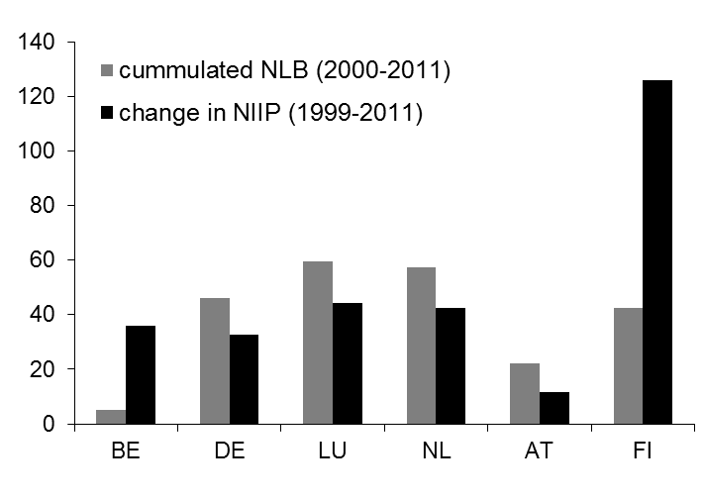
Source: Commission services
As the above analysis shows, the nature, strength and direction of interlinkages between deficits and surpluses in the euro area require thorough investigation to shed light on the way surplus countries could contribute to the overall rebalancing. The Commission intends to publish a dedicated study on this issue in the autumn of 2012.

3.2.2. Structural reforms to boost growth and adjustment capacity
Entrenched growth divergences, in particular if linked to a high debt burden, creates problems in the context of a monetary union. The Commission's spring economic forecast shows continuous growth divergence, with Member States with ongoing adjustment lagging behind. However, the adjustment is likely to continue beyond the horizon of the current forecast, creating risk of entrenched growth divergence. This is problematic in a monetary union and in particular so if the slow-growth countries are highly indebted as slow-growth countries experience higher real interest rates, which aggravates the debt problem further.
The growth weakness caused by deleveraging only adds to long-standing problems of low potential growth in the euro area. The euro area's growth potential was already relatively weak before the crisis, with the crisis putting an additional, significant, strain on trends. Over the medium term, potential growth rates of 0.8% are expected, compared with rates of around 2¼ % at the beginning of 2000s. This downward revision represents a significant deterioration in euro area’s economic performance over a relatively short period of time. The main contributor to this downward revision has been a strong downward pressure on total factor productivity growth, which can be to a large extent explained by declining growth rates of human and knowledge capital.
Therefore, the euro area as a whole faces a double challenge of rebalancing and strengthening growth in the medium and long term. Growth need to be revived already in the medium term as without growth deleveraging and rebalancing would be much more difficult to achieve. At the same time, it is necessary to carefully manage the process of deleveraging in various sectors in order to control its negative impact on growth and avoid negative feedbacks. While the challenges and hence the urgency of action is greater in the deficit countries, it is necessary to bear in mind the risks for the whole euro area, which stem from continuing growth divergence and persisting imbalances.
Structural reforms that increase contestability and flexibility of markets can enhance growth and facilitate adjustment. In some countries private savings have built up and investment has been held back by high regulatory barriers in some sectors. There is therefore potential to unlock saving overhang and induce investment and hence growth by liberalisation policies that aim at facilitating entry and exit to and from closed sectors. More contestable markets improve adjustment capacity i.e. facilitate reallocation of production factors across sectors – in particular from non-tradable to tradable sectors – and improve price and non-price competitiveness. To that end, while respecting the need for fiscal consolidation, productive public expenditure need to be prioritised. The reforms of the wage setting mechanism could improve the adjustment of wages to better reflect productivity developments and enhance the scope for real wage adjustment. Changes in the employment protection legislation could contribute to a faster reallocation of resources across sectors, thereby sustaining the adjustment in countries with large current account deficits. Lower tax burden on labour and

Euro Plus Pact – assessment of the implementation of the commitments
In early 2011, euro area Member States, as well as Bulgaria, Denmark, Latvia, Lithuania, Poland and Romania agreed on the Euro Plus Pact. In the context of the Pact, Member States have committed to reforms in the four areas: fostering competitiveness, fostering employment, enhancing the sustainability of public finances and reinforcing financial stability. They have recognised that pragmatic coordination of tax policies is a necessary element of stronger economic policy coordination, and have committed to engage in structured discussions on tax policy issues. The reform commitments of the participating Member States are reflected in their Stability or Convergence Programmes and National Reform Programmes.
In 2011, Member States took up many commitments in the policy areas identified in the Pact. However, the implementation of the commitments varied considerably across the Member States and policy areas. Only a few Member States met all their commitments. In many cases the government had made the relevant legislative proposals, while the adoption of legislation was delayed, e.g. due to discussion in the national Parliament of with social partners.
Most progress was made on reforms to foster competitiveness and in particular to improve business environment. Member States simplified the administrative requirements for businesses and introduced new services. Most Member States met their commitments to promote education and innovation, e.g. to ensure additional funding for universities and research institutes. Less progress was made to enhance competition in services and to revise wage setting mechanisms, either in the private or public sector.
Member States also introduced reforms to increase labour participation and to lower labour taxes. Fewer measures were taken to improve life-long learning and reduce undeclared work.
Member States delivered on their commitments to strengthen the sustainability of public finances and put forward legislative proposals on pension systems and national fiscal rules. In many cases, however, the adoption of new legislation has been delayed and thee implementation postponed. Member States that had targeted certain deficit or debt levels generally managed to meet their commitments.
Financial sector reforms were somewhat mixed, with only a few Member States increasing the efficiency of the regulation and supervision of the financial sector. Member States also safeguarded financial stability by taking measures to diversify the structure of the economy.
March 2012 European Council invited Member States to include in their National Reform Programmes and Stability or Convergence Programmes further commitments, focused on a small number of essential, timely and measurable reforms to achieve the objectives of the Pact. Several Member States answered to this invitation and presented new commitments.
The new commitments are relevant for achieving the objectives of the Pact. Most of them are timely and measurable, with clear objectives to be implemented within the next 12 months. In many cases, Member States have also indicated expected costs and benefits of their measures. However, the measures often refer to already ongoing projects.
As indicated in the Pact, the Commission will continue monitoring the implementation of the commitments in the framework of the European semester. The Commission will report on the progress in its Staff Working Documents on country assessment next spring.
effective active labour market policies and employment policies can boost job creation, in particular in light of the risks of building up of long-term unemployment.
In the current context of low growth, fiscal challenges and social tensions there is a need to sustain the reform momentum. While pursuing growth-friendly consolidation and prioritising items such as investments in skills, reforms that (i) show positive growth impact already in the short- to medium term and which (ii) do not involve large fiscal costs should be given priority. Most regulatory reforms fulfil these criteria: opening up over-regulated sectors does not involve fiscal costs. The same holds for reforms to improve business environment and for most reforms in the labour market, such as reforms to wage bargaining or employment protection systems as well as providing better incentives to work. The effects on productivity resulting from such reforms can be enhanced by accompanying active labour market and skills policies. In a similar vein, pension reforms have a double positive effect on public finances and on growth as they reduce implicit public liabilities and enhance sustainability while increasing labour supply, even though the effects are visible only beyond the short term. Additionally, in the context of the specific challenges they face, euro area Member States should be vanguards in implementation of some EU-wide tools, such as the Single Market and the Services Directive. While bearing limited fiscal costs, political costs of these reforms should not be underestimated. This is an argument for an appropriate distribution of the reform burden across the population, including addressing the poverty implications, rather than abandoning the reforms, bearing in mind that the crisis has disproportionately affected those who had already been in a vulnerable situation.
Common monetary policy and strong cross-border spillovers give a case for stronger coordination of structural reforms in the euro area. Structural reforms are crucial in a monetary union, where due to the lack of monetary policy tool at the national level and the fixed intra-area exchange rates most of the adjustment has to take place via markets. Moreover, in face of strong spillover effects in the euro area, strong coordination – e.g. in the form of ex ante discussion of major policy plans, which could have large spill-over effects – is necessary to properly account for increased reform externalities.
Graph 16. Change in responsiveness to OECD's Going for Growth recommendations
OECD's euro area countries
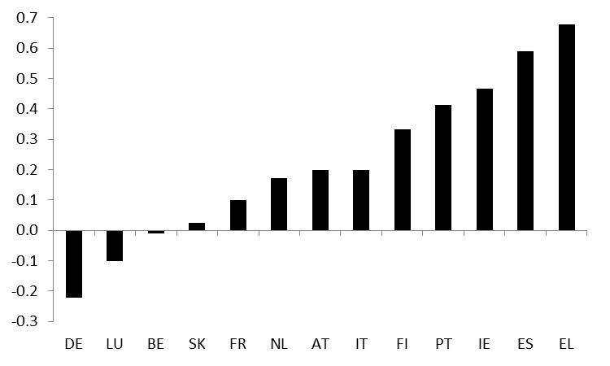
Source: OECD
Over the last 12 months, progress with structural reforms in the euro area has been correlated with the intensity of market pressure (Graph 16). Programme countries and some vulnerable countries introduced ambitious reforms, in particular in labour markets, financial markets, professional service sectors, network industries and their overall frameworks for competition. However, in other countries the pace of reform was sluggish. In a number of countries (BE, CY, ES, IT, EL, IE, LU), recently enacted or adopted labour market reforms, including in wage setting mechanisms, represent important steps toward an enhanced and more balanced labour market adjustment to shocks. The major on-going or planned reform processes will have to be translated into legislation, implemented successfully, and followed up with additional measures if necessary. However, as a result of tax changes, the tax burden on labour has recently increased in several euro area Member States (AT, ES, FR). A few euro area Member States have increased R&D (IT) or education expenditure (DE), while it has not been a common trend. Only few Member States enacted reforms to increase competition in the retail sector (IT, IE) or to remove unjustified restrictions on professional services (IT, IE, PT, EL), while in other Member States, for which recommendations in these areas were issued last year, reforms stalled or lacked ambition.
Implementation of the single market and the services directive has been relatively good, if uneven. Importantly, progress has been made in the implementation of the Services Directive. In general, euro area Member States with high levels of barriers to a single market for services before the Directive was adopted have cut their barriers significantly. Some (ES, SK) seem to have made particularly good progress, but others (AT, MT) have clearly been less diligent.

4. Strengthening policy coordination in the euro area

4.1. The crisis highlighted weaknesses in euro area governance
Economic flexibility has long been recognised as a crucial adjustment channel in EMU. The original architecture of EMU combined a single, supranational monetary policy with national economic policies coordinated at the EU level. Historically, there was no close precedent for this construction by which to judge its design merits. Academic literature on optimum currency areas suggested that the extent to which the region was prone to asymmetric macroeconomic shocks and the extent to which it could absorb these through economic flexibility would be two critical factors in determining its durability. Economic flexibility of individual Member States has generally remained low since the launch of the euro, while the crisis has shown that a monetary union can at times place even stronger demands on adjustment capacity than originally thought.
Markets failed to induce sufficient discipline during the first ten years of EMU. At a global level, nominal interest rates fell and country-specific risk premia virtually evaporated, encouraging greater risk taking. In the euro area, this trend was amplified first by the elimination of currency risk among the Member States. Secondly, the ECB fixes policy interest rates which in nominal terms are the same for the whole euro area, while inflation differences between Members remained considerable. This entailed large differences in real interest rates, which in turn fuelled capital inflows driving asset price bubbles and exaggerating the strength of macroeconomic performance.
Weaknesses in macroeconomic surveillance and enforcement at both the Member State and the EU level meant that the misallocation of resources and consequent macro-financial imbalances were not detected early enough and adequately addressed by policymakers. Apparent strong macroeconomic performance across the euro area prior to the crisis hid the underlying structural problems in public finances and macro-economic fundamentals. The SGP was met with lax implementation at the Council level. Furthermore, the analysis, design and conduct of economic policy remained compartmentalised and did not adequately take into account the interaction between fiscal issues and wider macro-economic imbalances (asset price bubbles, competitiveness and external borrowing developments). Surveillance did not sufficiently cover non -fiscal issues, which allowed macroeconomic imbalances to develop unchecked.
The dynamics of switching from a 'good' equilibrium to a 'bad' one during the crisis gained further strength due to the cross-country spillovers. Investors appeared to infer from sovereign funding difficulties in one economy that countries economically and financially connected to it would eventually receive an equivalent tightening of sovereign bond market access. In the early stages of the crisis, these cross-border contagion effects were magnified by the lack of appropriate financial backstops. Not all of the observed negative spillovers were purely speculative or confidence-based, however. Strong trade linkages in the euro area spread the negative growth impact of falling aggregate demand in one country to trading partners via lower imports. Moreover, deeper financial integration in the euro area since the start of EMU meant a greater exposure of Member States to each other, implying that a deterioration in one Member State also pushed up risks for partner economies in the euro area.

4.2. The reform of economic governance in the euro area
Since the crisis erupted, the EU and the euro area have engaged in a comprehensive strengthening of its economic governance. The reforms introduced and those in the pipeline address the identified weaknesses in economic policy surveillance through the integration of surveillance across policy areas; a better timing of policy guidance to achieve an impact on national policy formulation; stronger incentives, and a widening of surveillance to cover macro-economic imbalances. Enforcement mechanisms have been introduced specifically for the euro area.
The European Semester integrates the surveillance of the economic policies covered by the Europe 2020 strategy, as well as the preventive parts of the Stability and Growth Pact and the Macroeconomic Imbalances Procedure, and provides policy guidance to Member States before they finalise their budgets and economic reform plans. The new approach of integrated surveillance embodied in the European Semester ensures a more holistic assessment across macro-economic, structural and employment policies. It has led inter alia to a more systematic assessment of the risks to the fiscal policy path arising from the build-up of macro-economic imbalances, such as housing bubbles or excessive credit growth. It also provides a framework for reinforced coordination and multilateral surveillance of employment and social policies.
The surveillance and coordination of fiscal policies have been radically strengthened. The "six-pack" of legislation on economic governance has reinforced both the preventive and the corrective arm of the SGP. It defines quantitatively the meaning of a "significant deviation" from the MTO or the adjustment path towards it and operationalises the debt criterion of the Excessive Deficit Procedure through a numerical benchmark. A central innovation is the use of reverse-qualified-majority voting in Council decisions on most sanctions. Finally, the six pack also sets minimum requirements for all main aspects of fiscal frameworks at national level.
Further strengthening of fiscal surveillance is in the pipeline. The proposed Regulation on common provisions for monitoring and assessing draft budgetary plans and ensuring the correction of excessive deficit of the Member States in the euro area complements the six-pack. It aims at better synchronising key steps in preparation of national budgets and at ensuring minim quality standards in national budgetary processes. The proposal also strengthens further ex-ante fiscal surveillance and ensures an appropriate integration of EU policy recommendations in the national budgetary preparations. The Treaty on Stability, Coordination and Governance in the Economic and Monetary Union (TSCG), signed by the euro area Member States together with eight other Member States, contains commitments to further strengthen fiscal and economic surveillance. In particular, in TSCG contracting parties committed to lay down in national legislation rules of balanced budgets in structural terms, complemented by an automatic correction mechanism in case of a significant deviation.
The Macroeconomic Imbalances Procedure has introduced systematic economic surveillance in all areas that could potentially lead to harmful imbalances. It will reduce the risk of a build-up of macro-economic imbalances by systematic monitoring and preventive recommendations. Where larger risks are observed, the enforcement of policy recommendations is strengthened by the possibility of sanctions in case of non-compliance. In its first Alert Mechanism Report, the Commission identified seven euro area Member States (along with five non-euro area Member States) which may be affected by harmful macroeconomic imbalances, such as deteriorating positions of competitiveness, a high level of indebtedness or corrections of asset price bubbles. These Member States have been subject to in-depth reviews (IDR), which investigated the nature of the imbalances in greater detail.
The in-depth reviews confirmed that seven euro area Member States face macroeconomic imbalances which call for policy action. The analysis identified macroeconomic imbalances in seven euro area countries, which are, however, not excessive in nature. The IDRs confirmed that adjustment is proceeding, which is evident from reductions in current account deficits, retrenchment in credit flows, or corrections in housing prices. The accumulated stocks of imbalances, nevertheless, pose a formidable challenge for many euro area Member States. The levels of external, private and public indebtedness imply a pressing need for deleveraging which is likely to have an adverse impact on growth in the years to come. The results underline the broad variety of situations in which these euro area Member States find themselves and the need for a country-specific approach.
The new EU financial supervisory framework has already been instrumental in addressing the fragmented landscape of national supervision. A new supervisory architecture in the EU became operational in January 2011. Its central innovation is the establishment of the European Systemic Risk Board to provide a comprehensive European view on macro-prudential risk analysis. It enhances the effectiveness of early warning mechanisms by improving the interaction between micro-and macro-prudential analysis and by allowing for risk assessments to be translated into action by the relevant authorities. By creating three European Supervisory Authorities, the reform has also brought about better co-ordination between national supervisors, including binding decisions requiring them to take action where necessary and a clearer focus on working towards a common rulebook by developing technical standards in the areas defined in legislation. The new setup also helps ensure more complete exchange of information and views at an earlier stage.
The establishment of robust euro-area financial stability mechanisms has also implied an important step forward in euro-area governance. The creation of the European Financial Stability Facility (EFSF) and the European Financial Stabilisation Mechanism (EFSM) in May 2010 closed this important gap in the institutional setup of the euro area. However, both these elements of the European safety net are temporary in nature and a permanent European Stability Mechanism (ESM) will be established on 1 July 2012. At the end of March 2012, the combined ceiling of ESM and EFSF lending capacity was raised to EUR 700 bn, which together with the funds provided by EFSM and the Greek Loan Facility, implies an overall lending capacity of EUR 800 bn.
Effective decision making arrangements are crucial for an efficient implementation of the strengthened surveillance framework for the euro area. The Eurogroup and the Euro Summit have special responsibility in this regard. The euro area summit in October 2011 already took some first decisions to enhance the decision-making structure in the Eurogroup: some of these have already been implemented, including the organisation of regular euro area summits under a permanent President, and the creation of Permanent chairmanship for the Eurogroup Working Group.
In the future, additional reforms to economic governance may be considered to complete the institutional structure of EMU. The changes made so far have in some cases touched on issues traditionally tied to national sovereignty. In some instances, they appear to have exhausted the scope of action possible under the Treaty on the Functioning of the EU. Nevertheless, the question remains as to whether stronger coordination of economic policies will be sufficient or whether there needs to be progress towards closer integration of economic policy making. The crisis experience has underlined the importance of this issue. Over the medium term, the momentum for further integration in the monetary union may increase, particularly if the success of the governance changes made recently enhances confidence and mutual trust among euro area partners.

COM(2011) 669 final
For more information see e.g. Quarterly Report on the Euro Area, No. 1/2009, European Commission; European Economy No. 1/ 2010, Surveillance of intra-euro area competitiveness and imbalances, European Commission.
Also, the net lending/borrowing positions of the financial sector were relatively small and broadly similar, reflecting the intermediation role of financial institutions.
Although there is no indication that the financial systems of countries with persistent current account surpluses are structurally worse in allocating capital than the financial systems of countries with persistent current account deficits.
Even reforms of the Stability and Growth Pact in 2005, which were designed to take better into account cyclical conditions, suffered from conceptual difficulties in adequately distinguishing trend growth from the cycle.
COM(2012) 68 final of 14.2.2012
SEC(2012) 150-161
The European Banking Authority, the European Insurance and Occupational Pensions Authority and the European Securities Markets Authority

