 | 
COUNCIL OF  THE EUROPEAN UNION |  |  | Brussels, 20 June 2012
 | Interinstitutional File:  2012/0084 (COD) |  | 11679/12
STATIS 56
ECOFIN 627
CODEC 1732
INST 423
PARLNAT 277

COVER NOTE
from: | Portuguese Parliament, Portugal
date of receipt: | 14 June 2012
to: | Mr Uwe CORSEPIUS, Secretary-General of the Council of the European Union
Subject: | Proposal for a Regulation of the European Parliament and of the Council amending Regulation (EC) No. 223/2009 on European Statistics [doc. ST 9122/12 STATIS 29 ECOFIN 354 CODEC 1071 - COM(2012) 167 final]  - Opinion on the application of the Principles of Subsidiarity and Proportionality

Delegations will find attached the opinion of the Portuguese Parliament on COM(2012) 167 final - Council ST 9122/12.

________________________

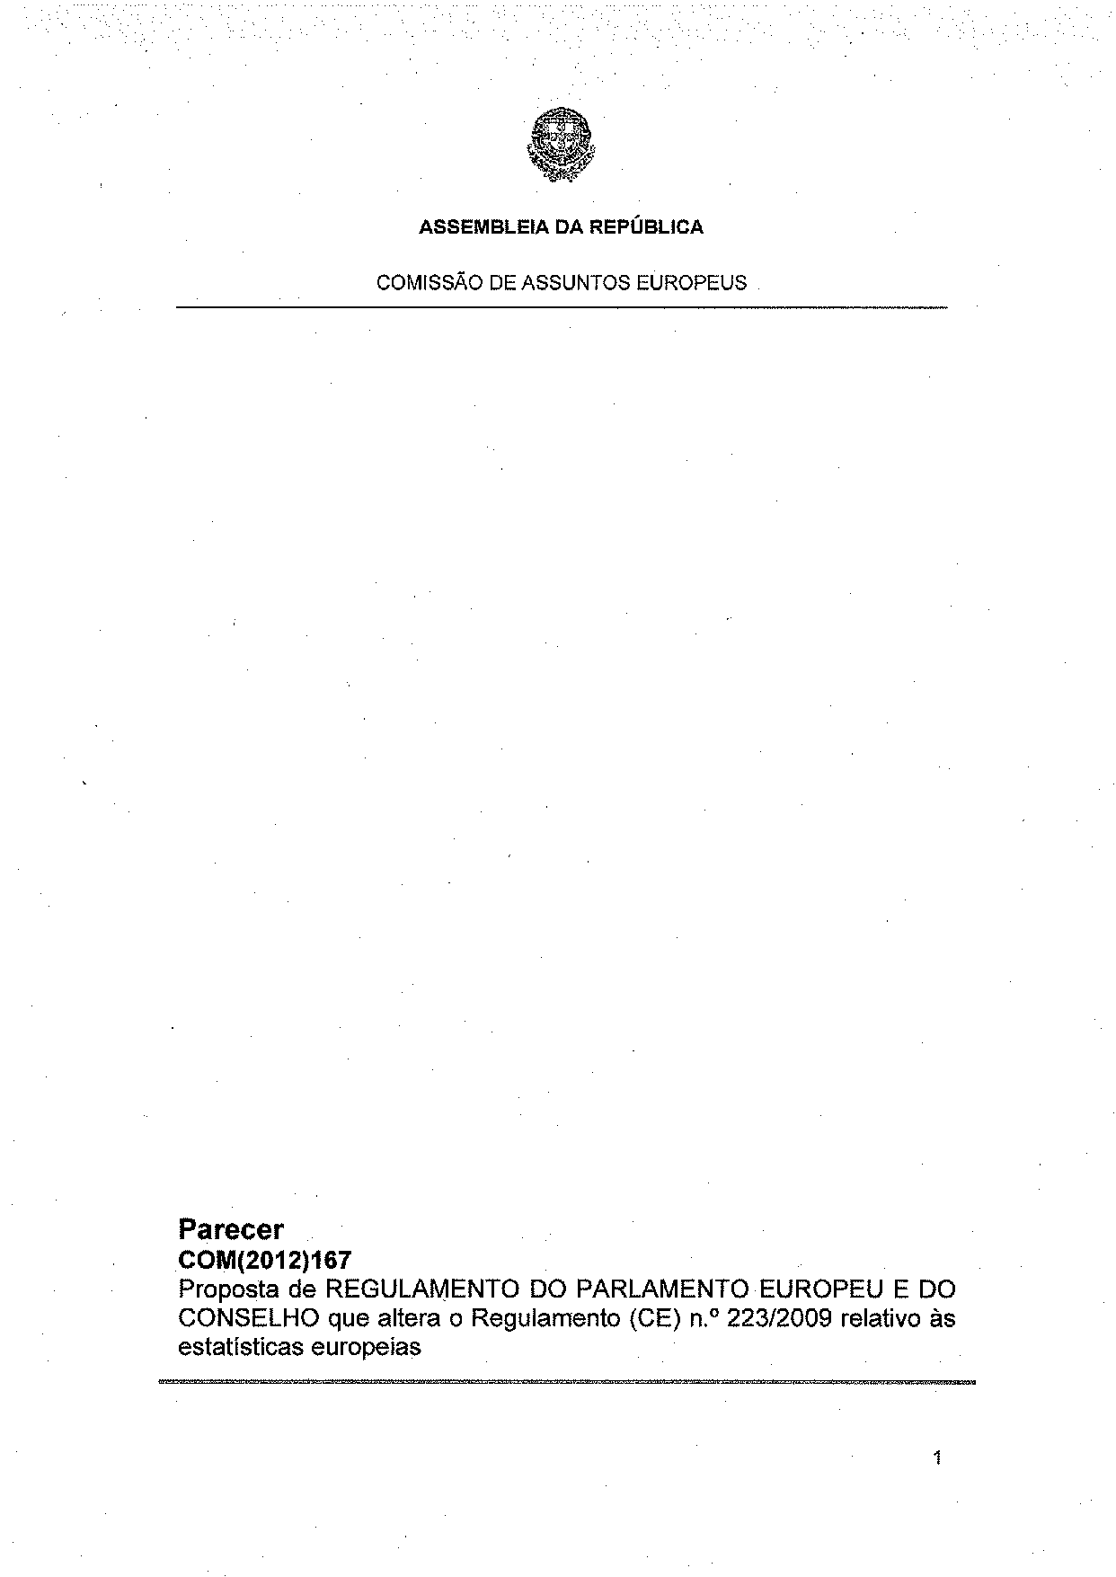
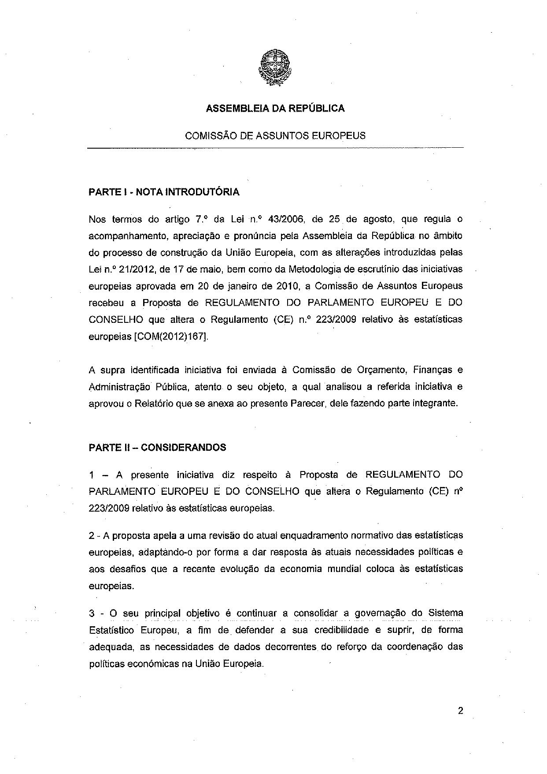
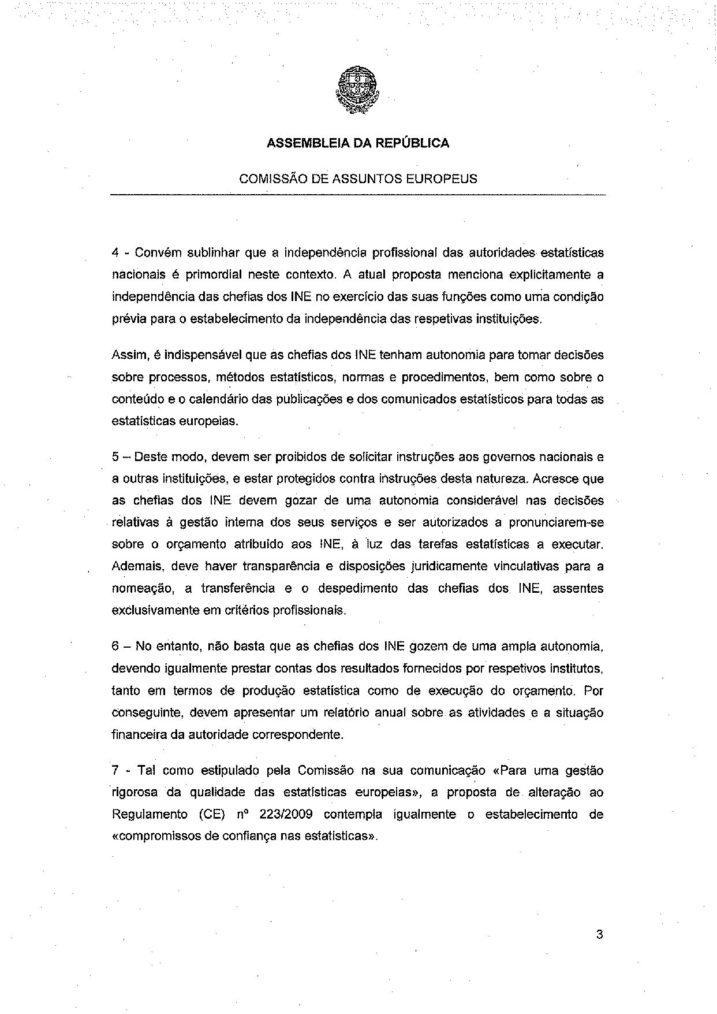
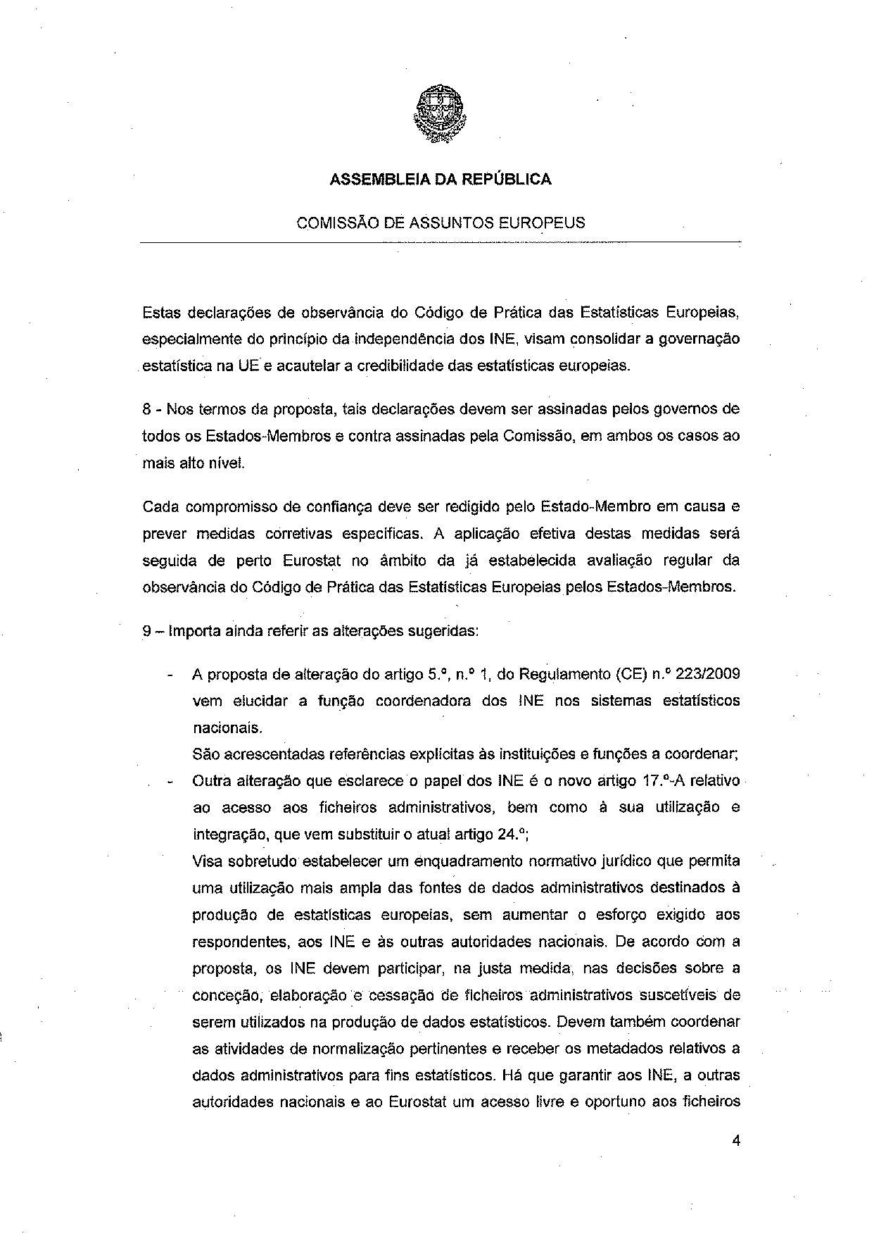
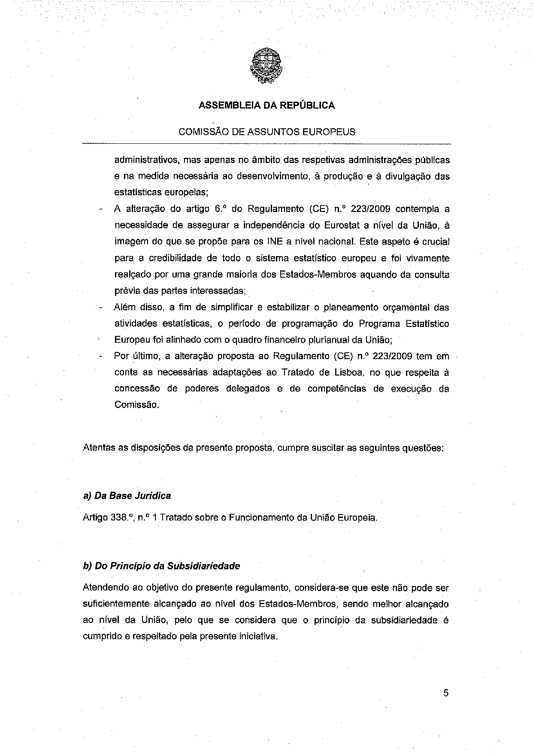
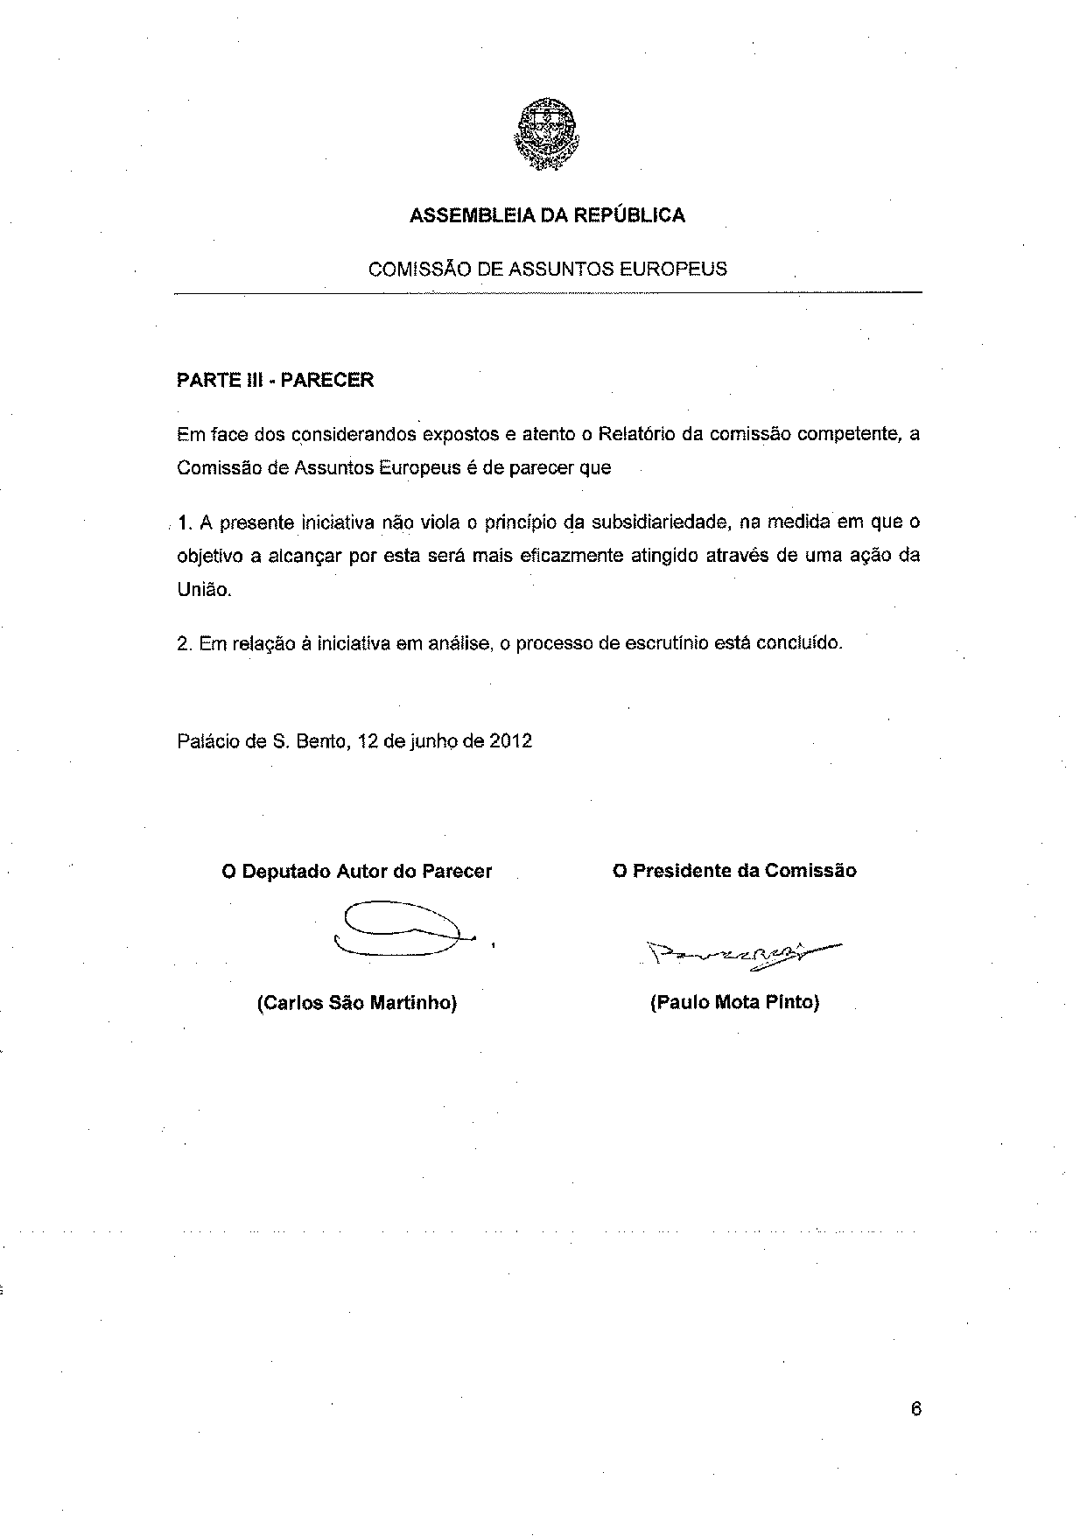
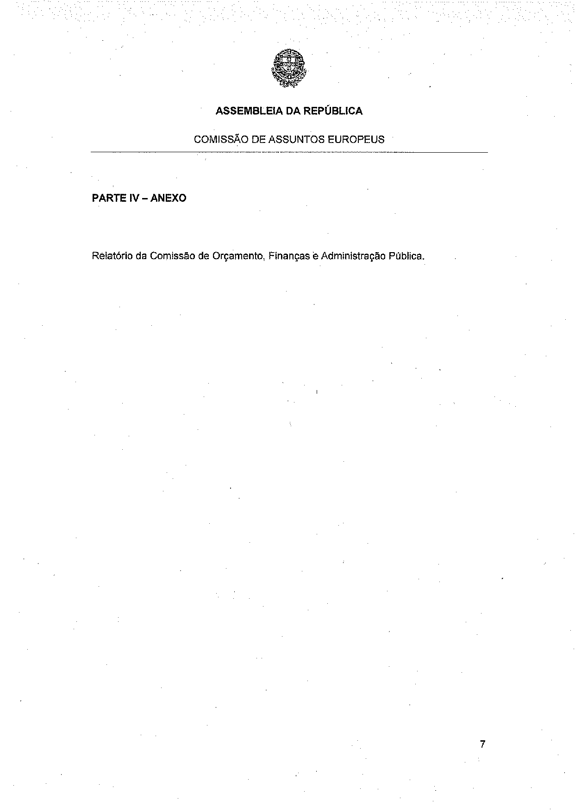
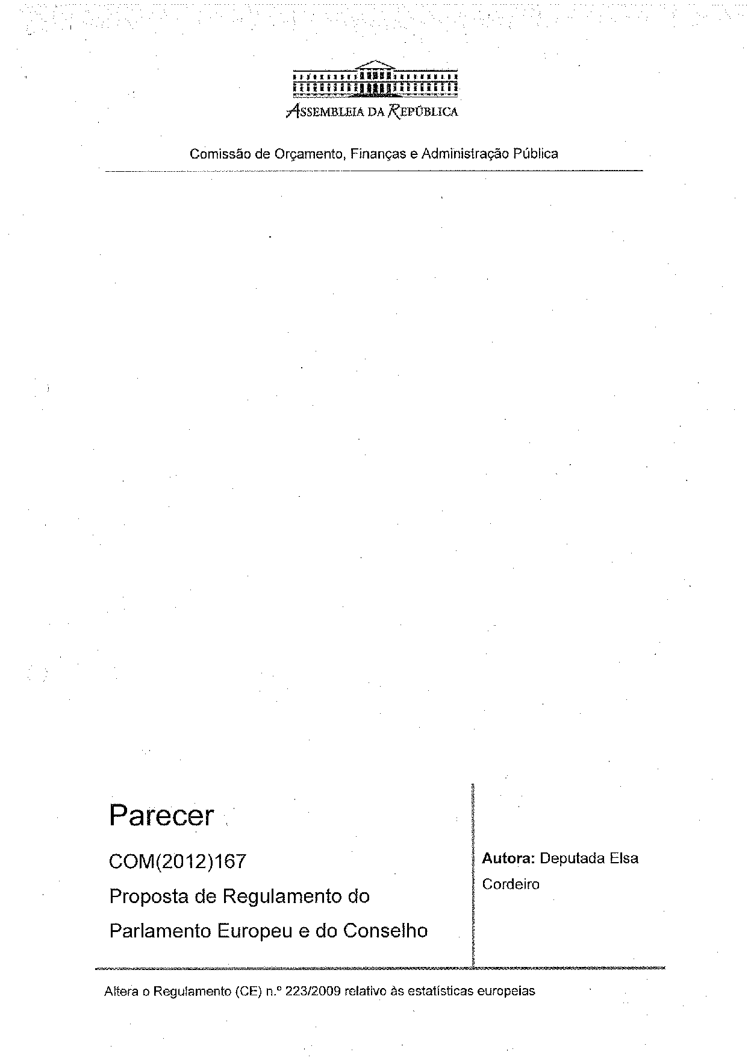
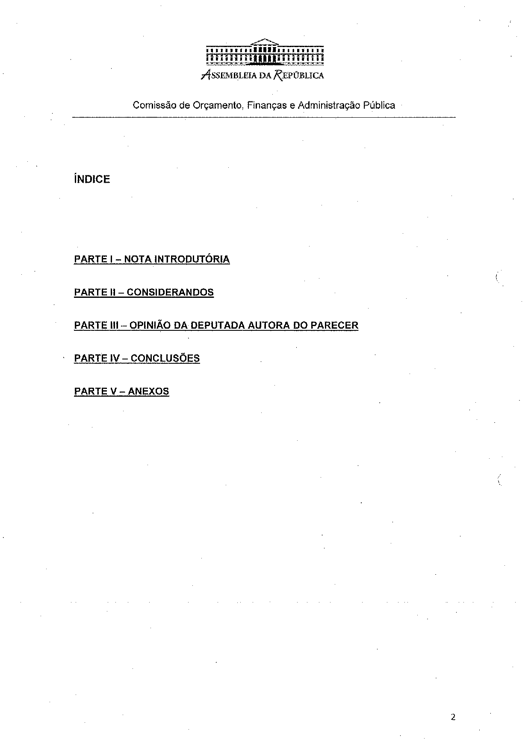
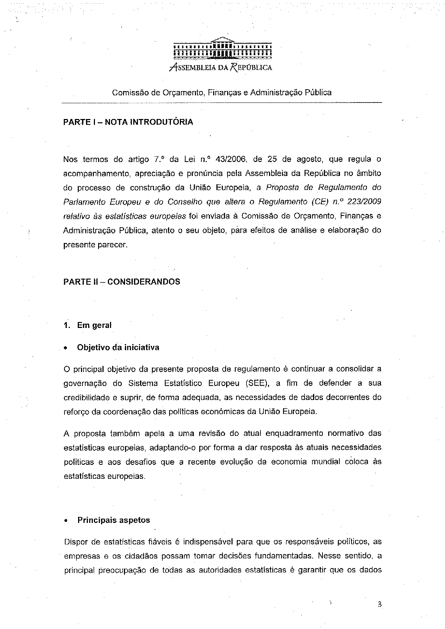
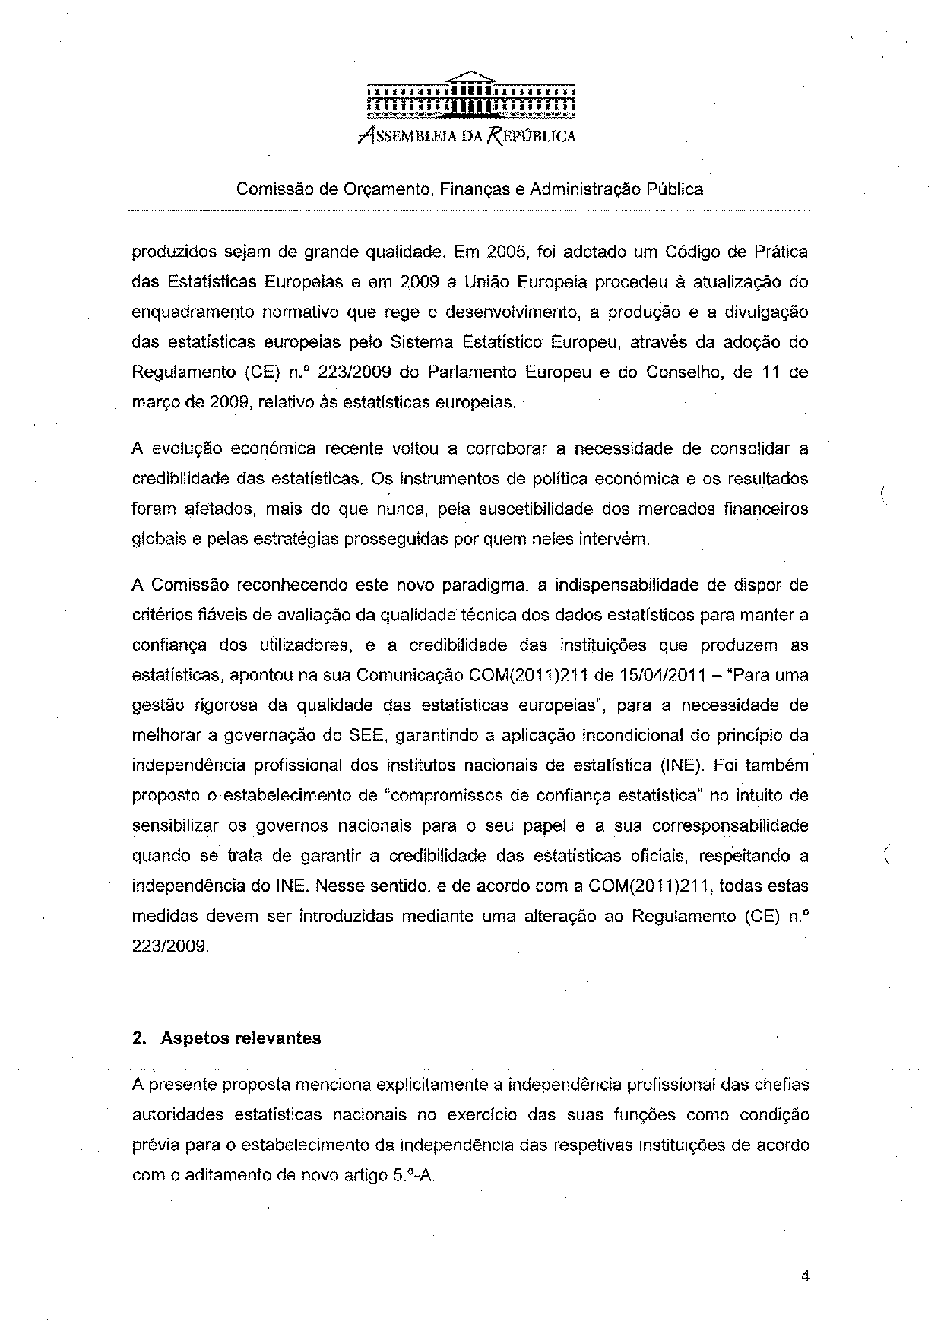
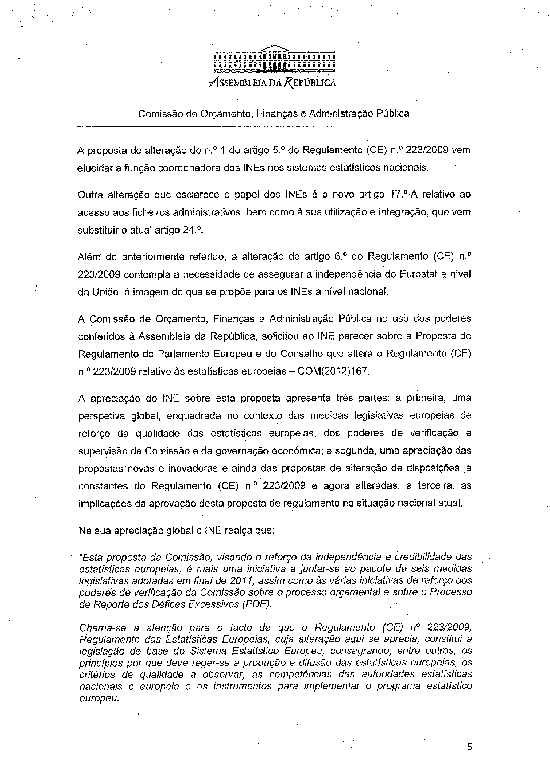
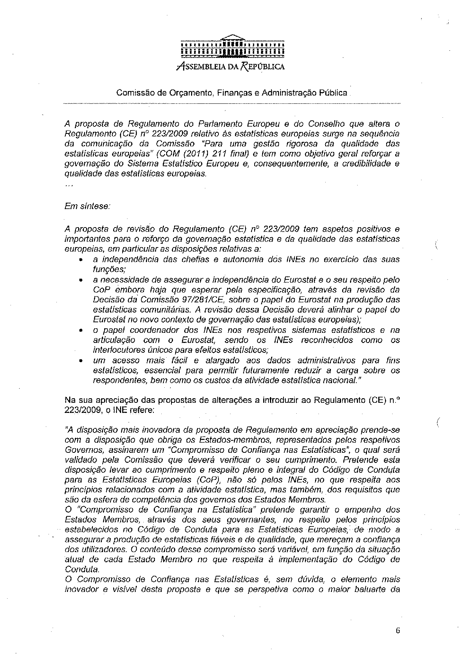
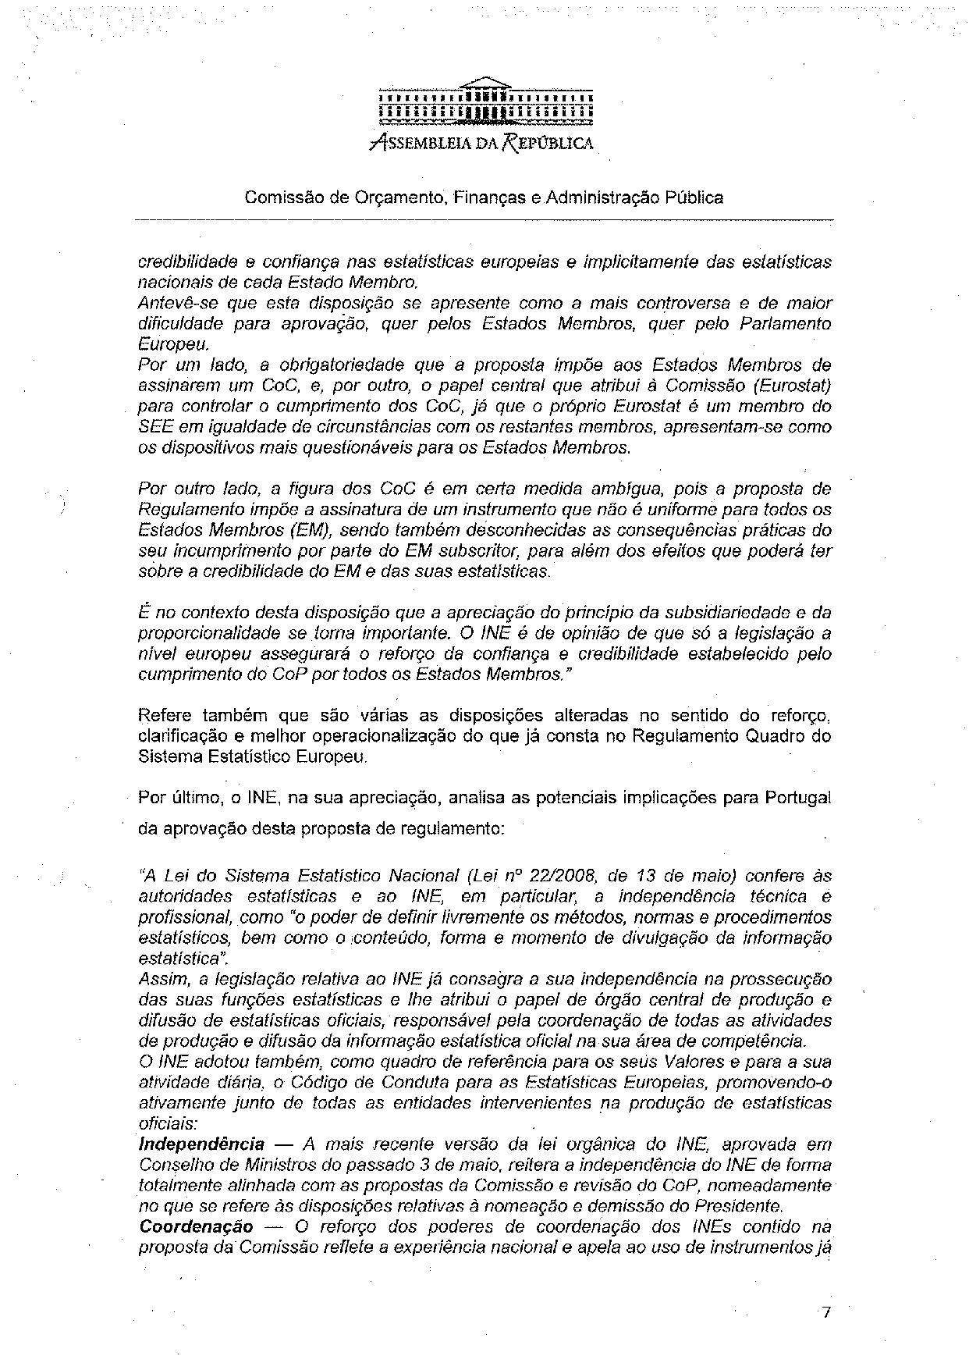
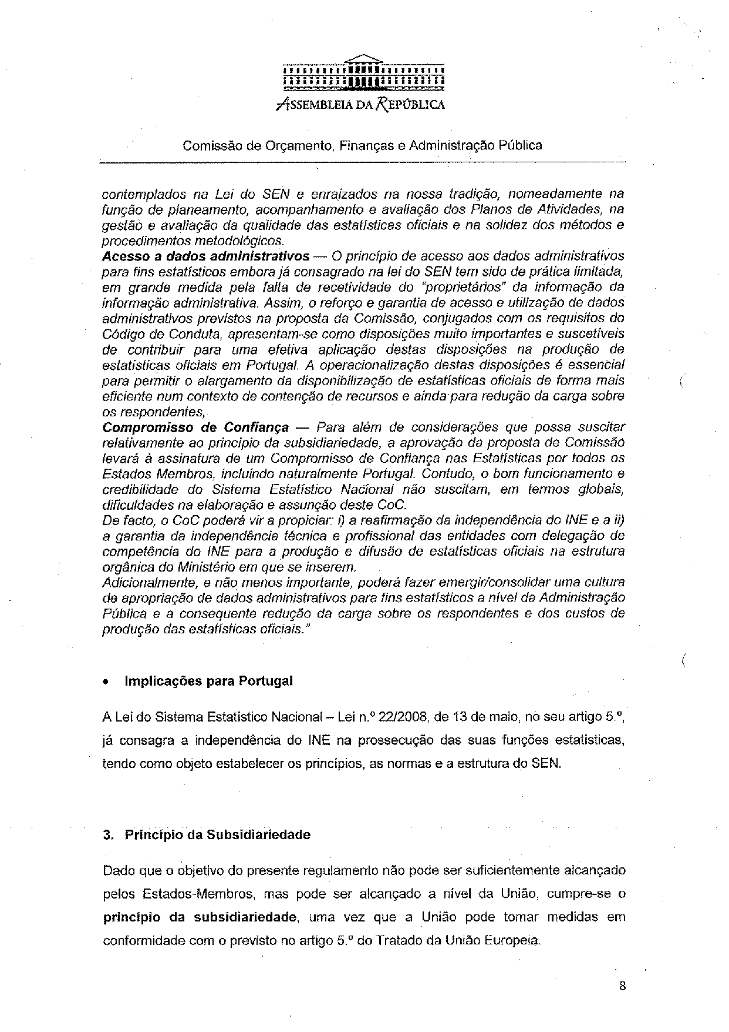
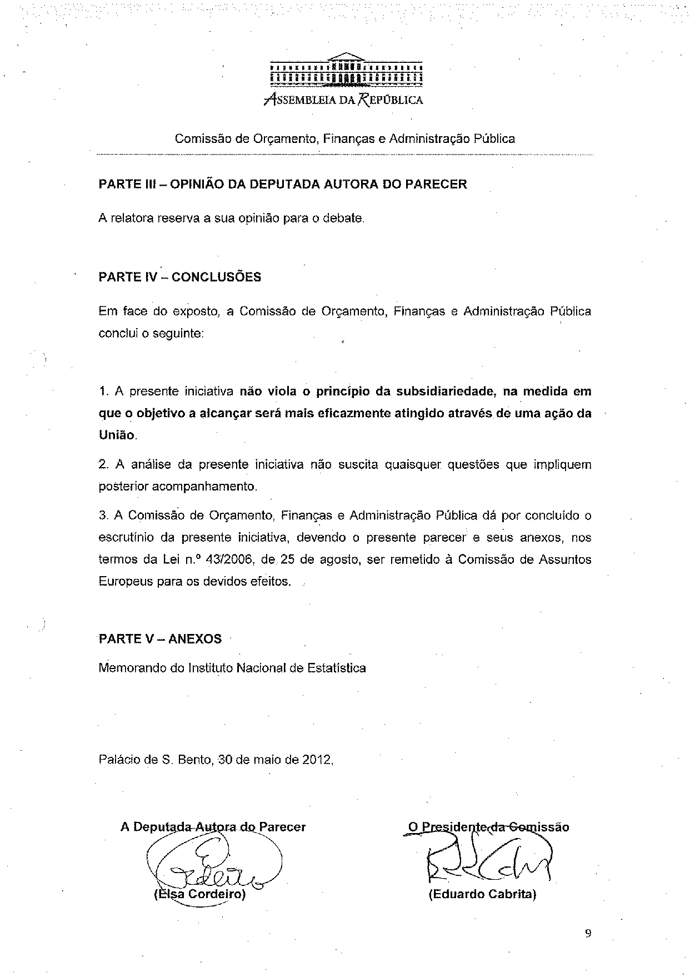
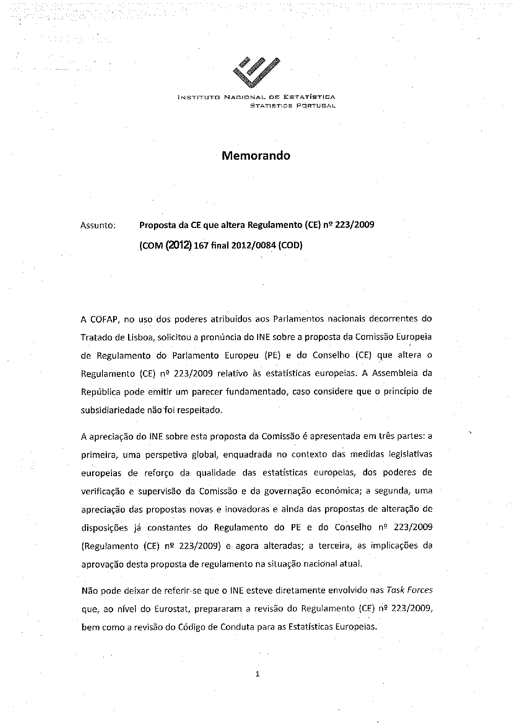
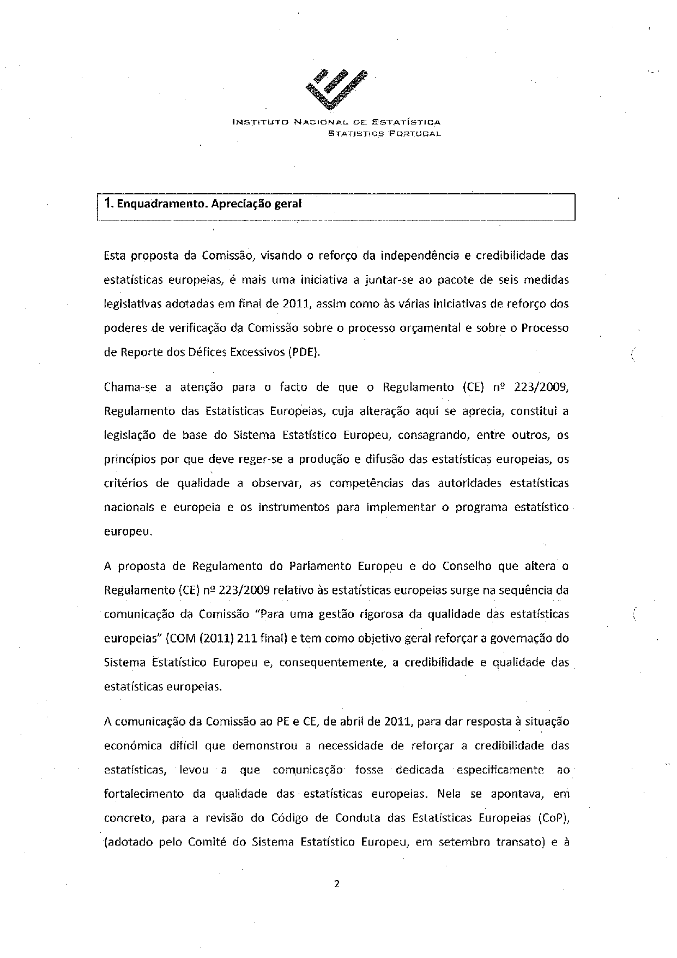
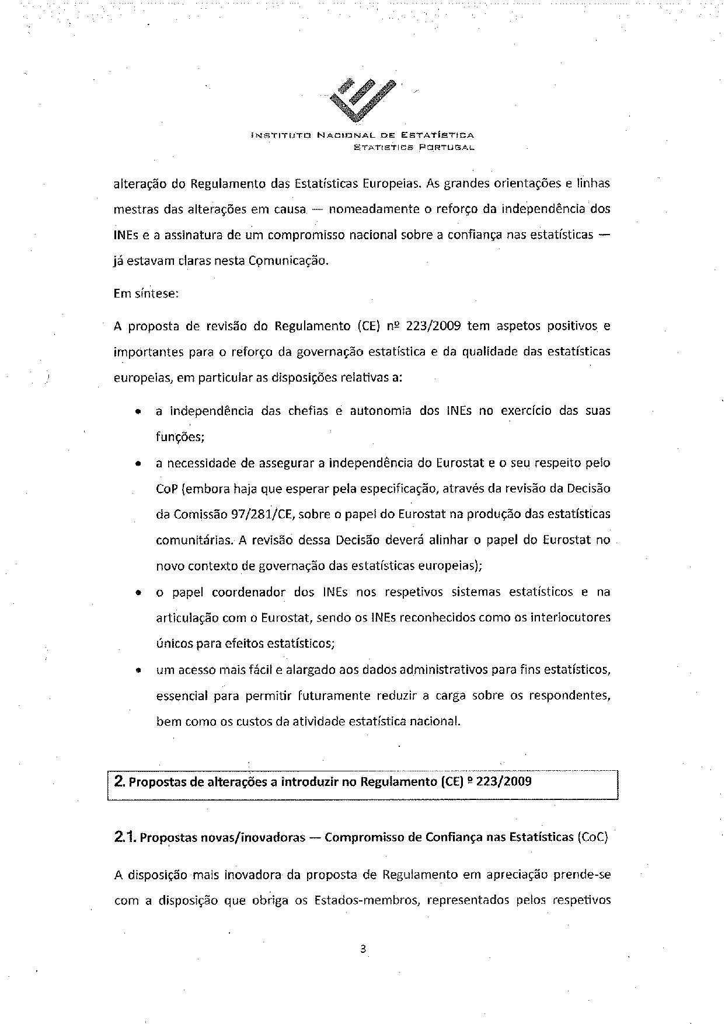
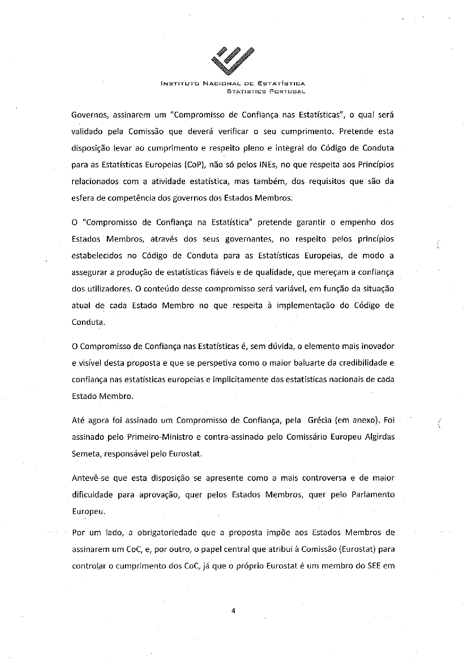
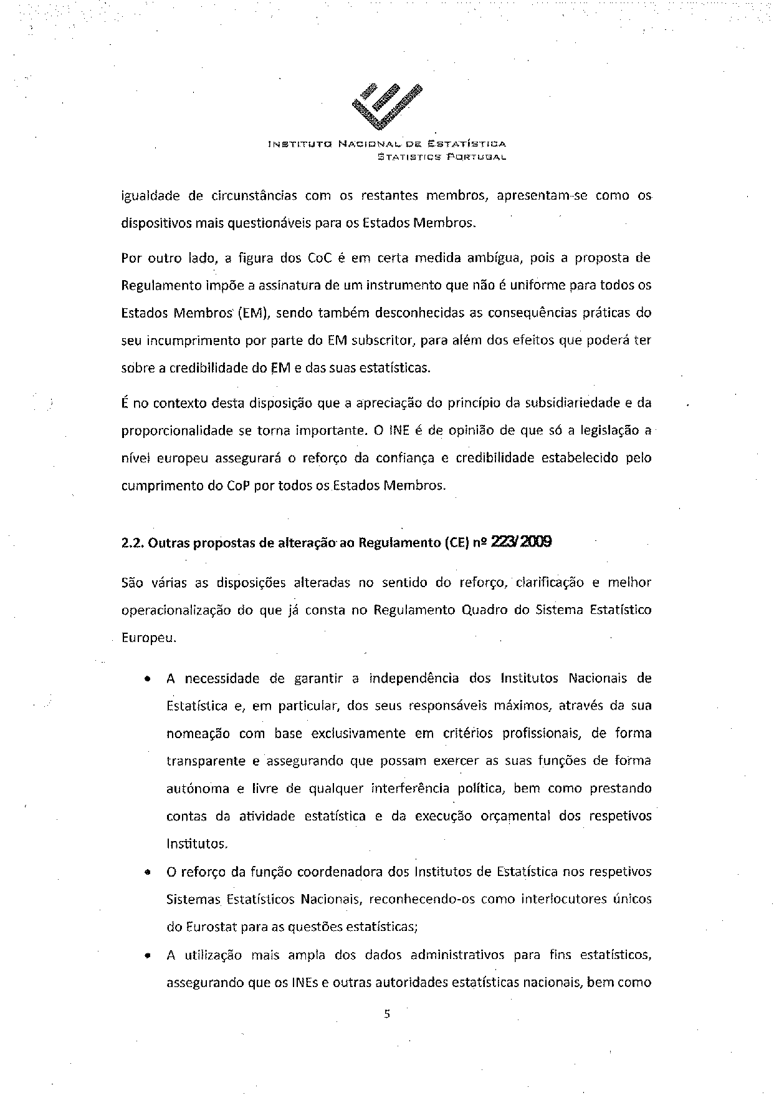
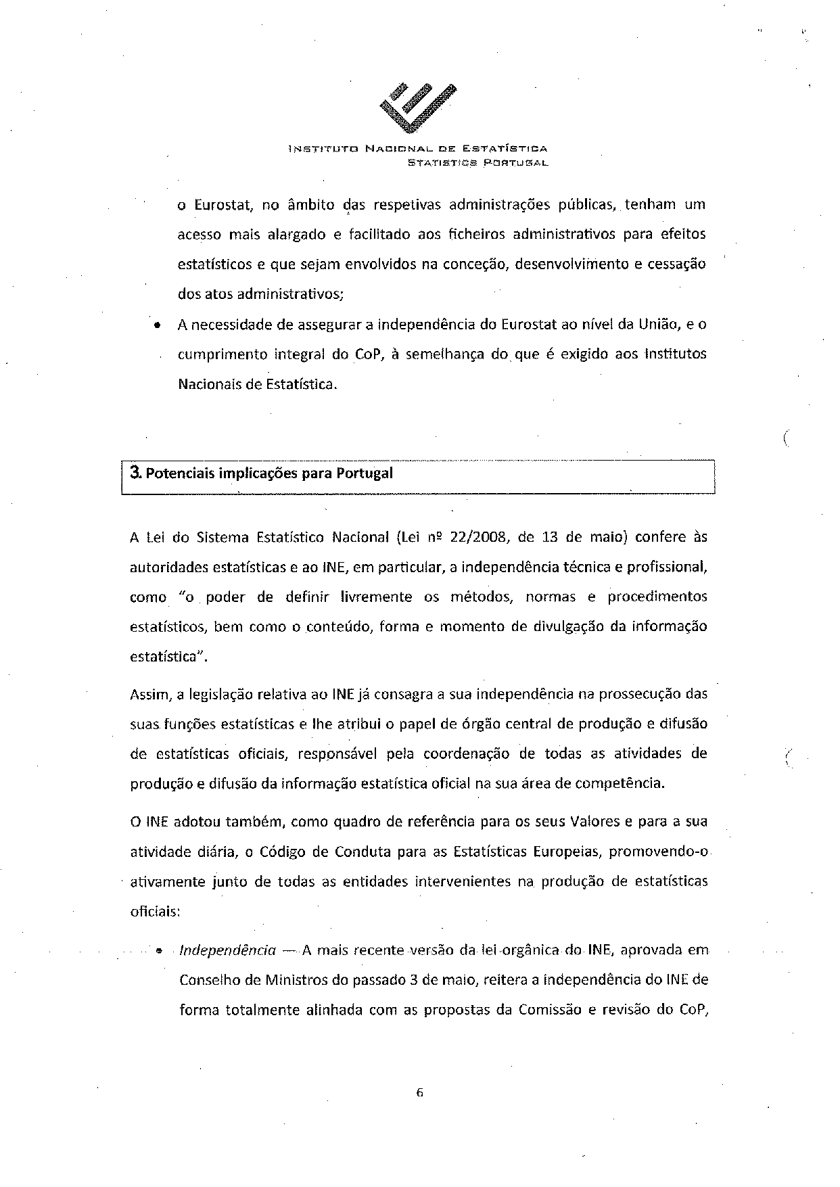
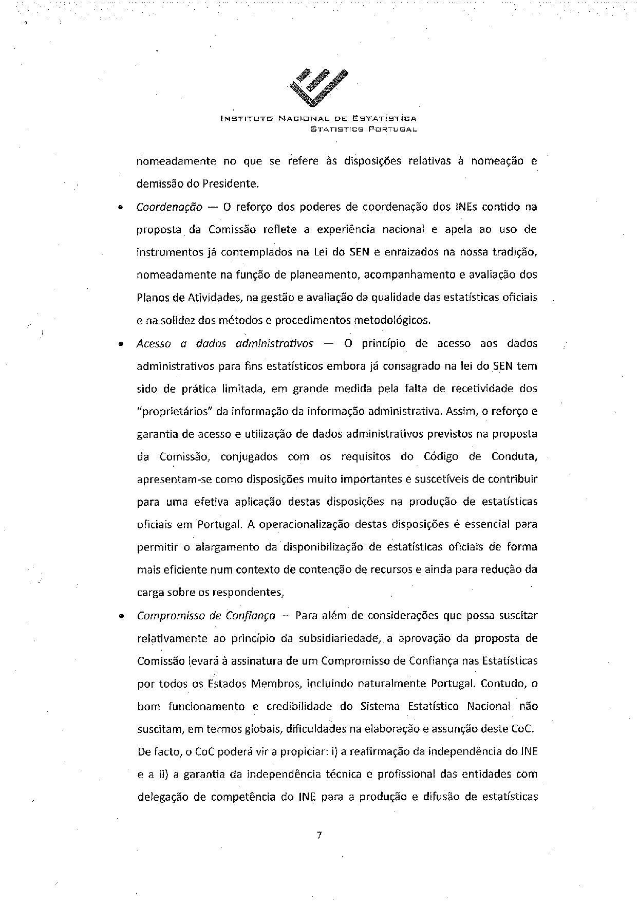
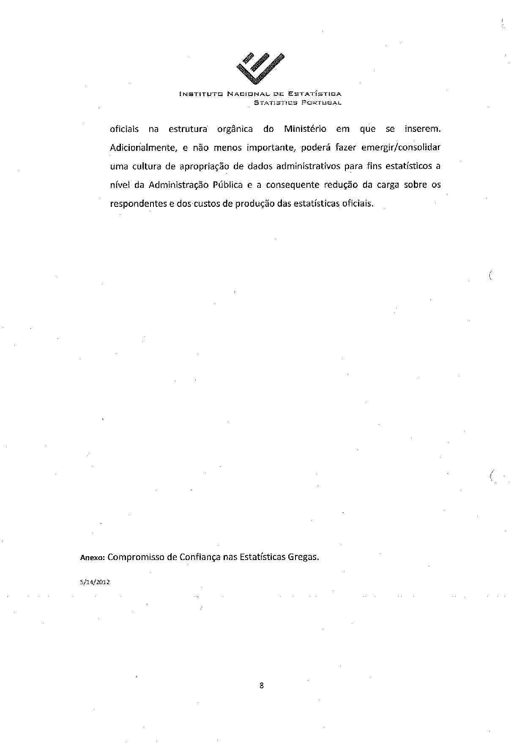
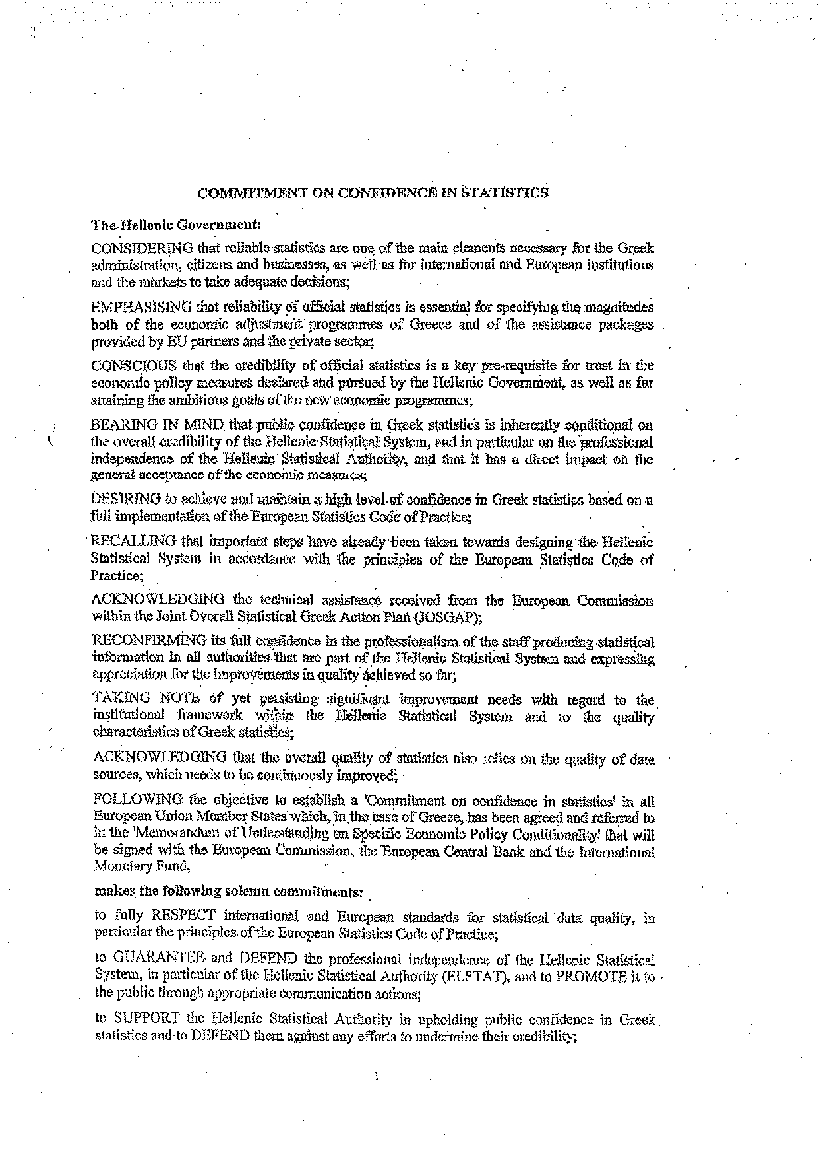
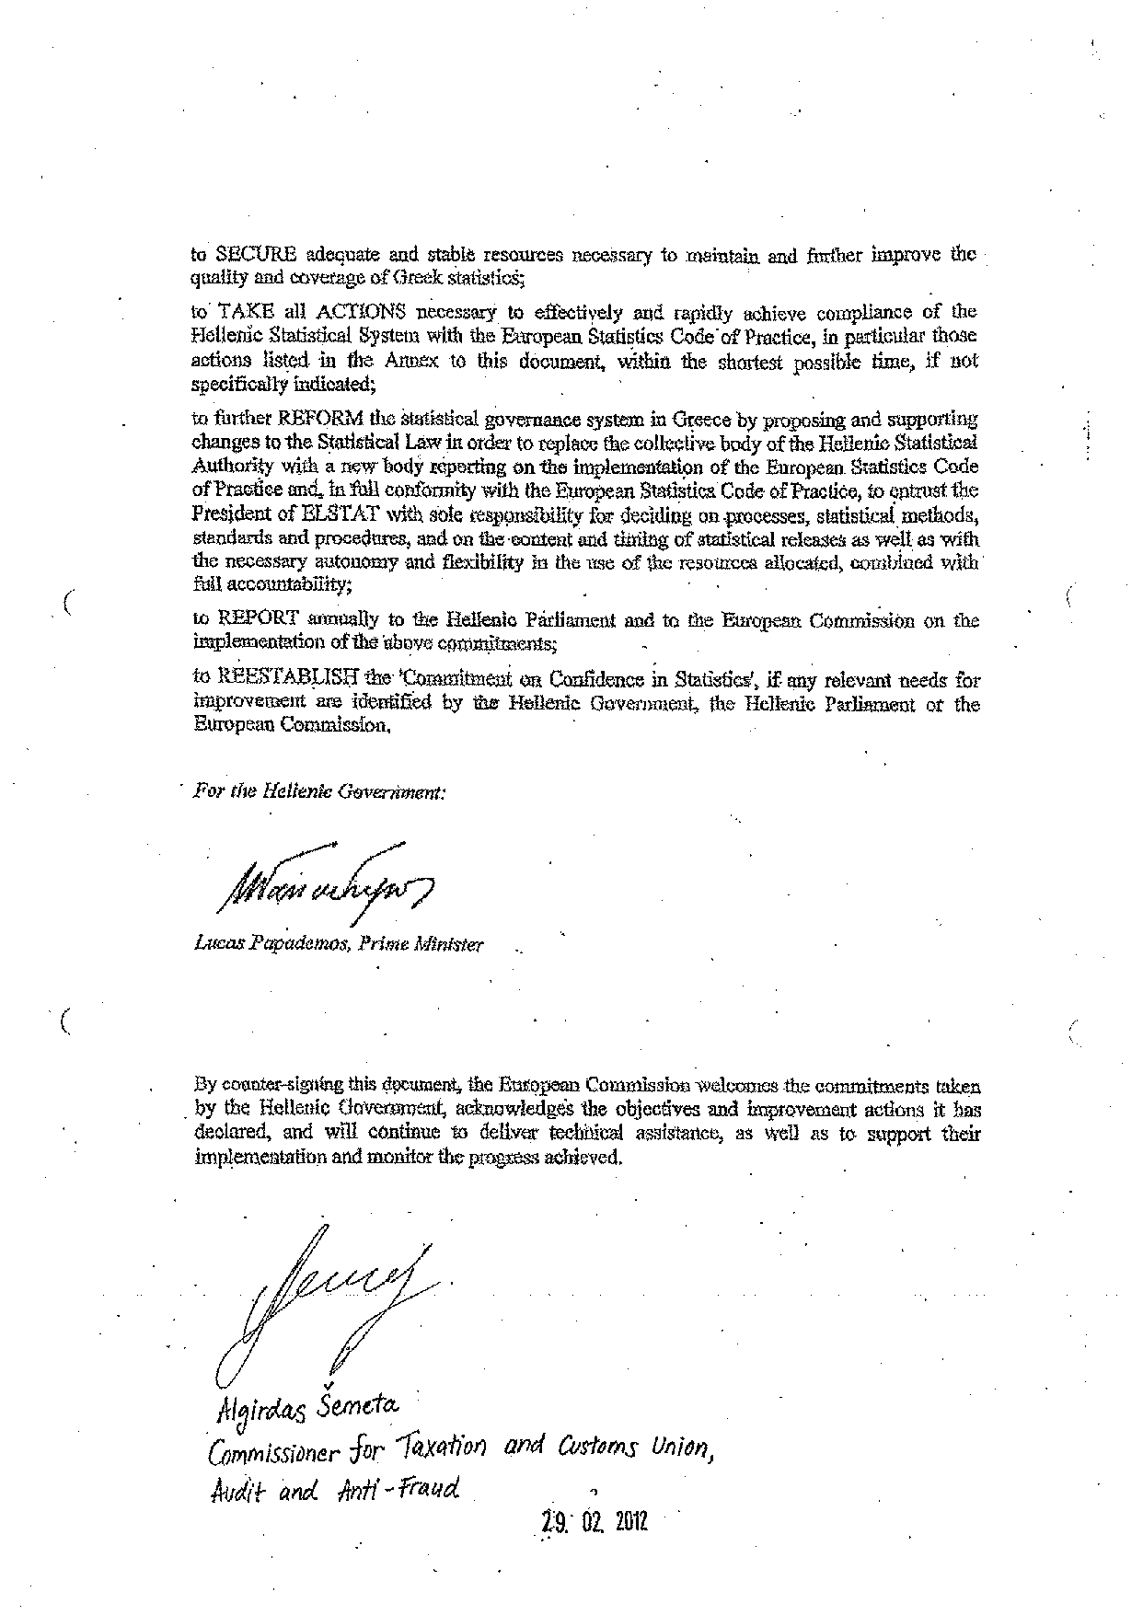
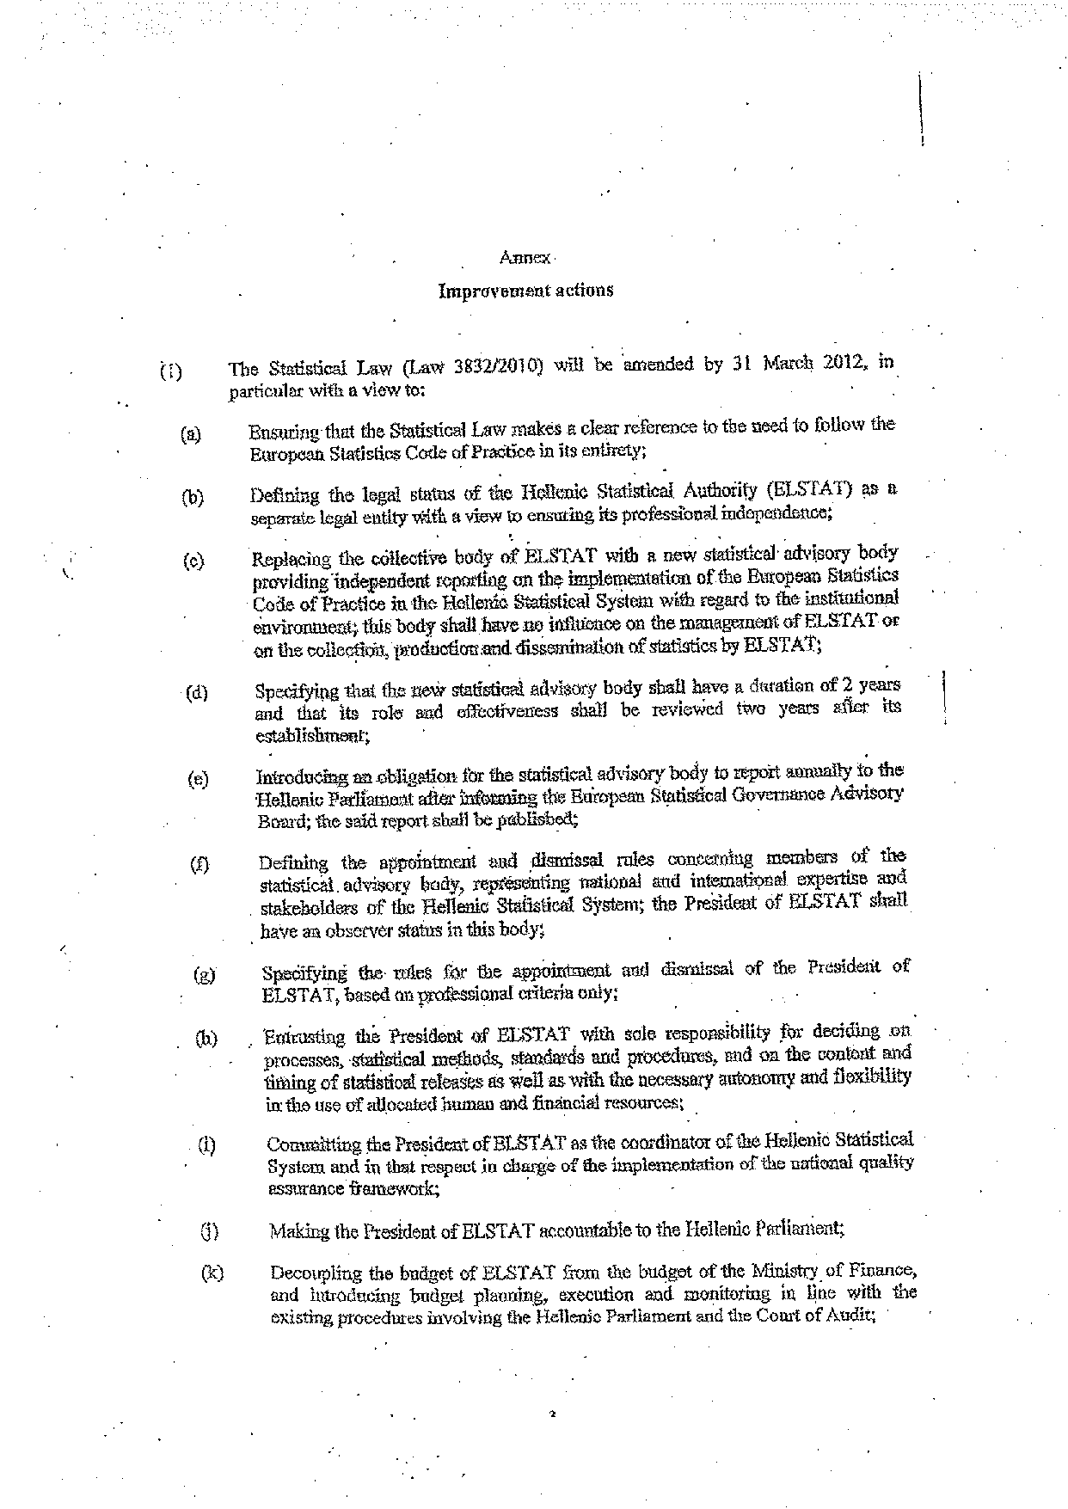
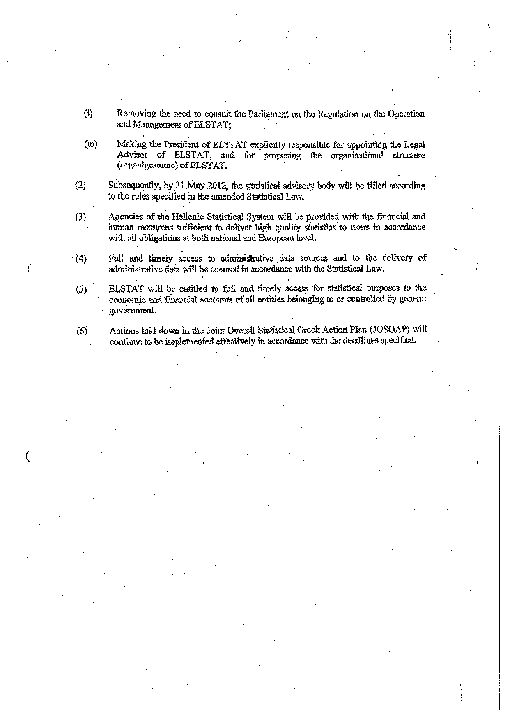

For other language versions of the opinion, reference is made to the Interparliamentary EU information exchange site IPEX at the following address: http://www.ipex.eu/IPEXL-WEB/search.do

