 | 
COUNCIL OF  THE EUROPEAN UNION |  |  | Brussels, 27 June 2012
 | Interinstitutional File:  2012/0022 (APP) |  | 11943/12
DRS 96
SOC 620
INST 442
PARLNAT 287

COVER NOTE
from: | Italian Senate
date of receipt: | 25 June 2012
No. Cion prop.: | 6580/12 DRS 28 SOC 125 + ADD 1 + ADD 2 - COM(2012) 35 final
Subject: | Proposal for a Council Regulation on the Statute for a European Foundation (FE)  - Opinion on the application of the Principles of Subsidiarity and Proportionality

Delegations will find attached the Opinion of the Italian Senate on the above proposal.

________________________

Encl.:

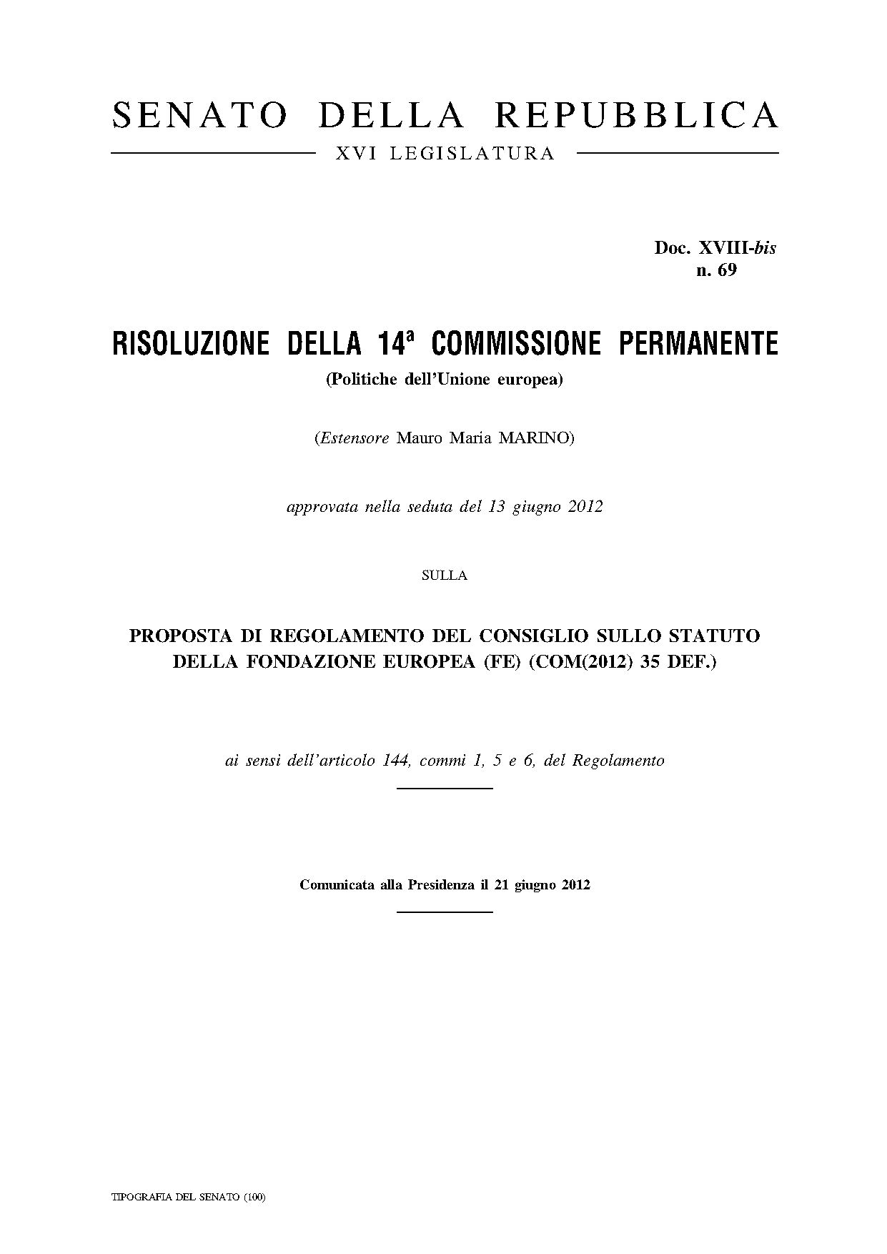

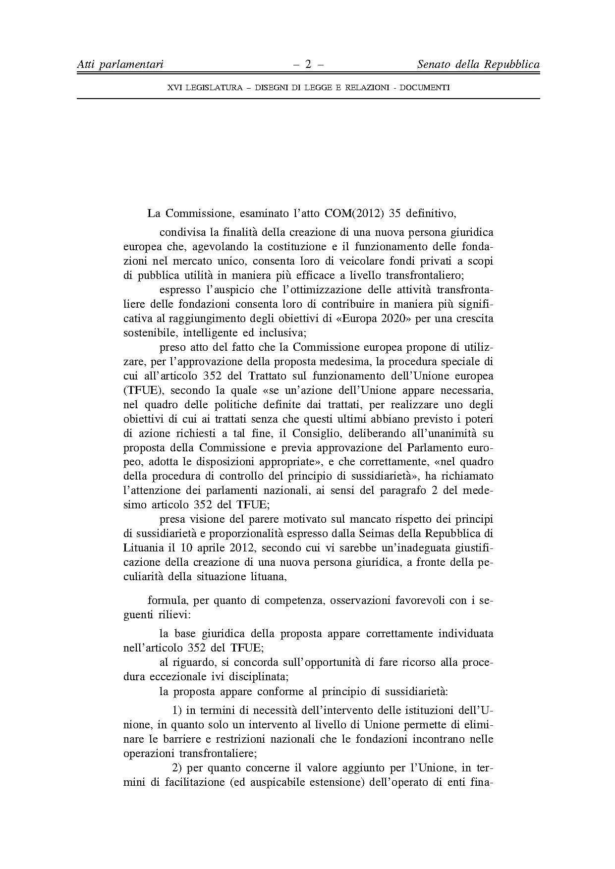

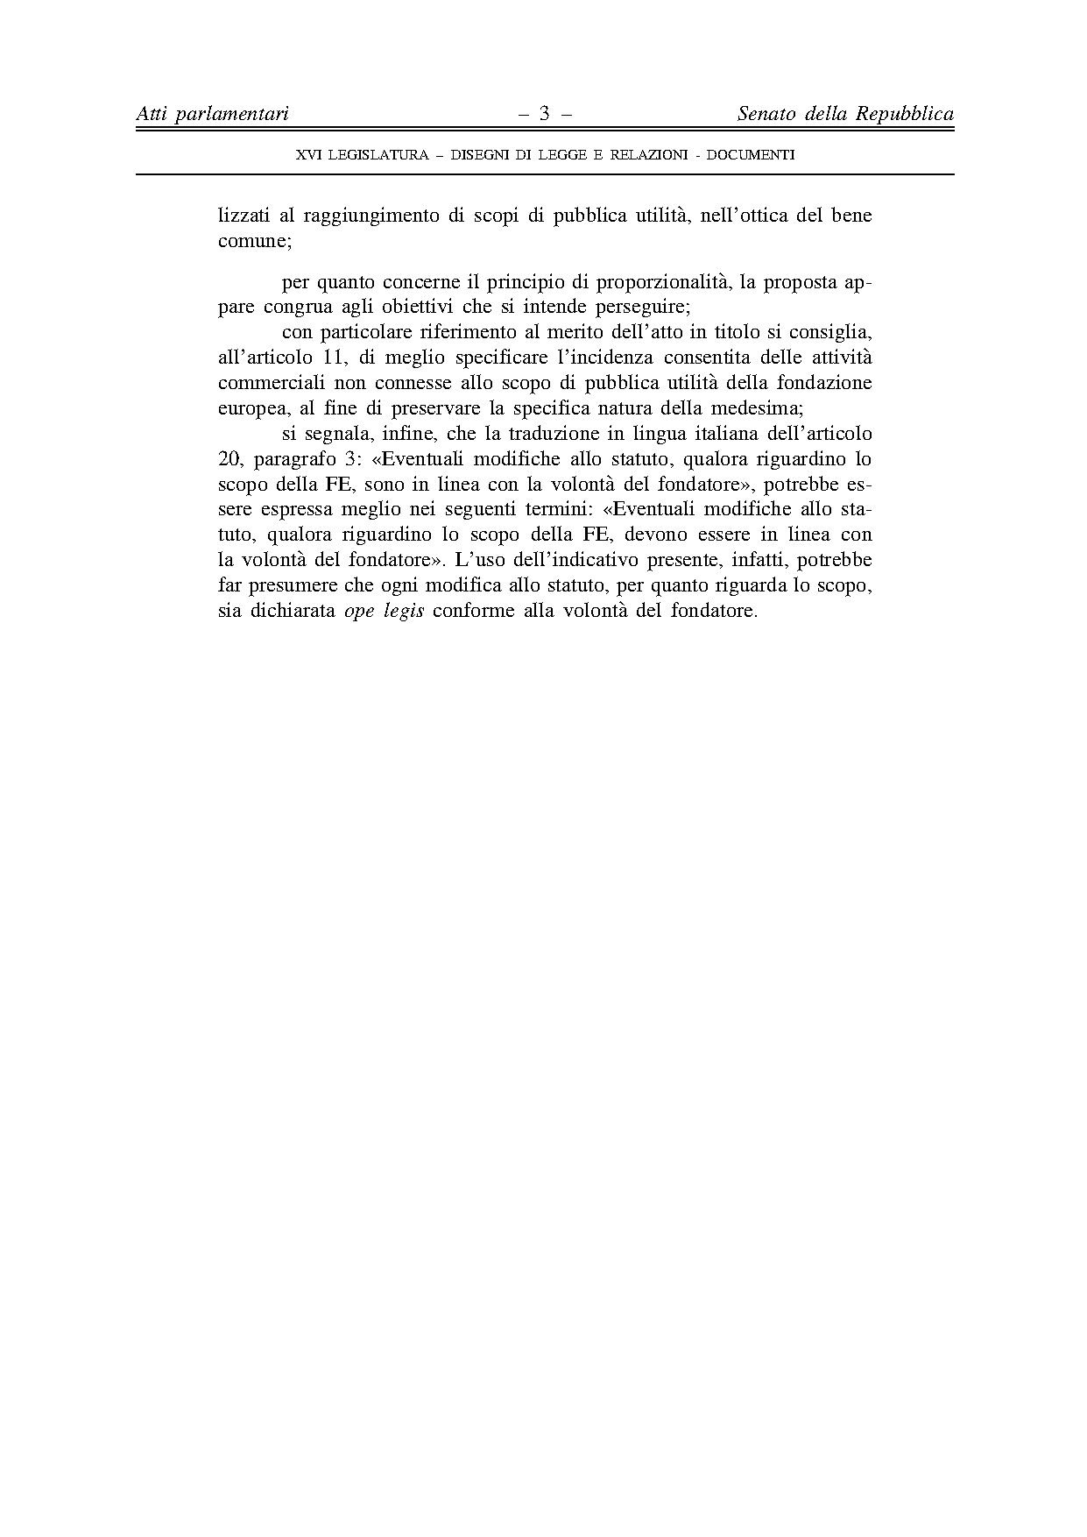

Translation(s) may be available at the Interparliamentary EU information exchange site IPEX at the following address: http://www.ipex.eu/IPEXL-WEB/search.do.

