 | 
COUNCIL OF  THE EUROPEAN UNION |  |  | Brussels, 26 June 2012
 | Interinstitutional File:  2012/0060 (COD) |  | 11919/12
COMER 163
WTO 245
MAP 48
MI 456
CODEC 1779
INST 437
PARLNAT 284

COVER NOTE
from: | the President of the Assembly of the Republic of Portugal
date of receipt: | 14 June 2012
to: | Ms Helle THORNING-SCHMIDT, President of the Council of the European Union
Subject: | Proposal for a Regulation of the European Parliament and of the Council on the access of third-country goods and services to the Union’s internal market in public procurement and procedures supporting negotiations on access of Union goods and services to the public procurement markets of third countries  [doc. 8257/12 COMER 74 WTO 124 MAP 33 MI 211 CODEC 851 - COM(2012) 124 final]  - Opinion on the application of the Principles of Subsidiarity and Proportionality

Delegations will find attached the above-mentioned opinion.

________________________

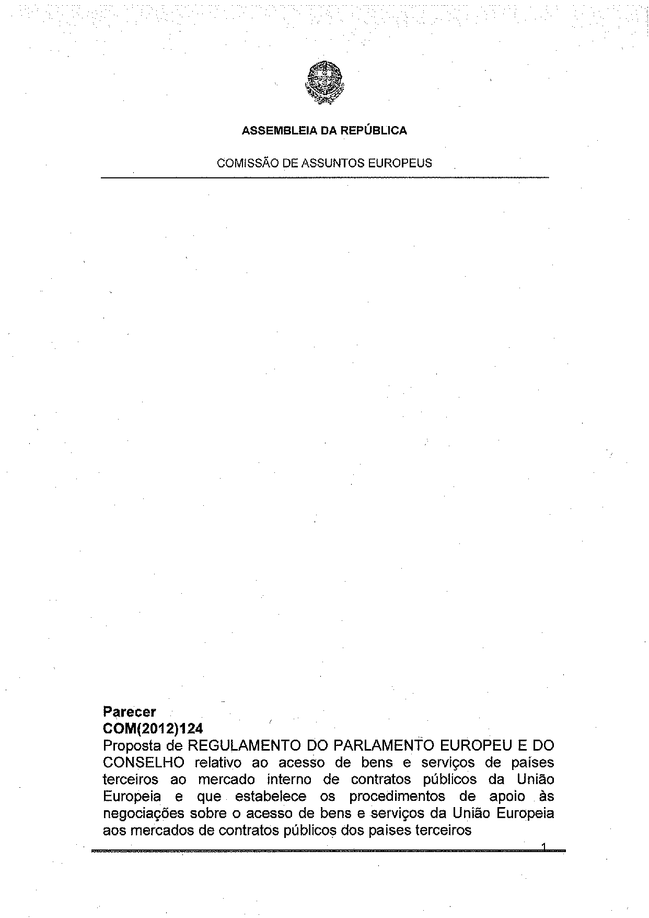
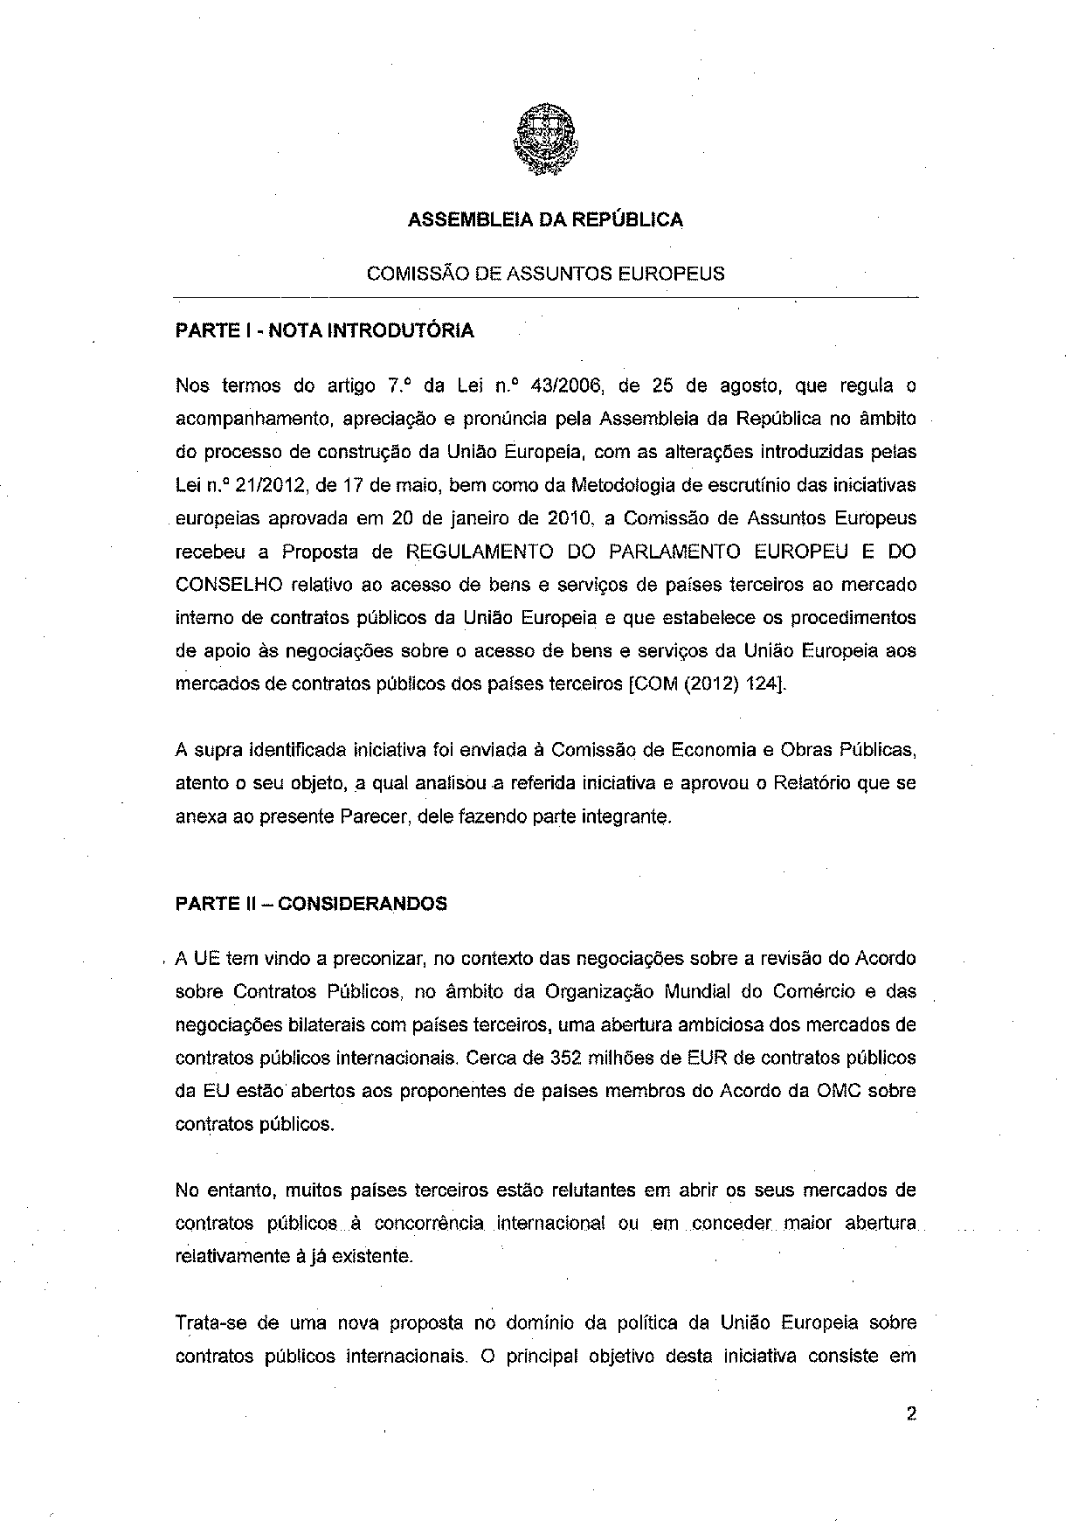
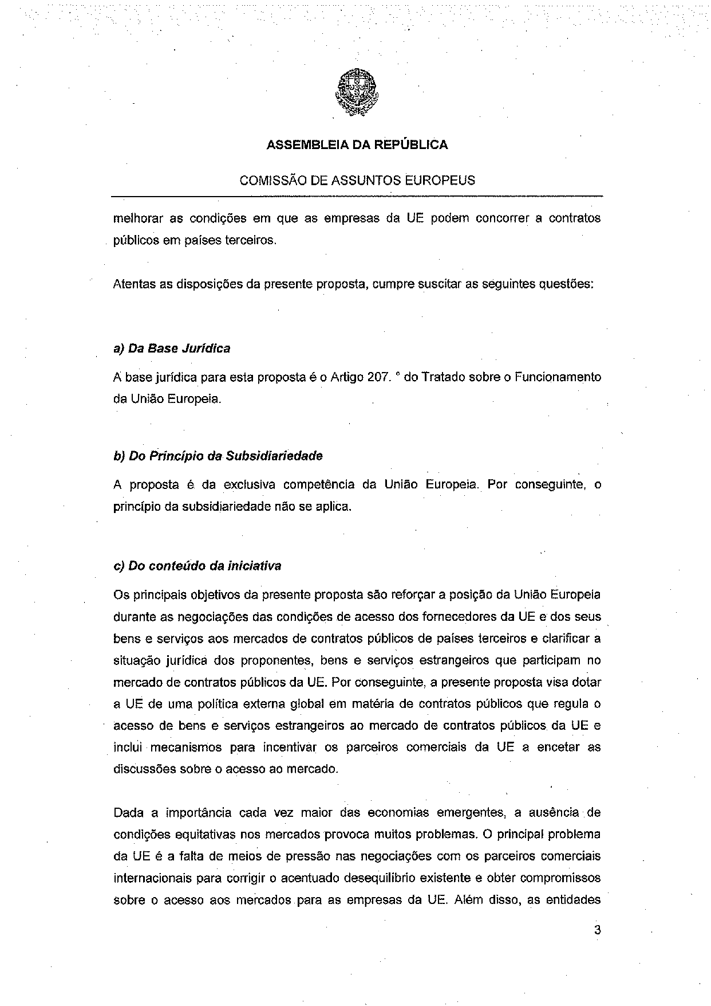
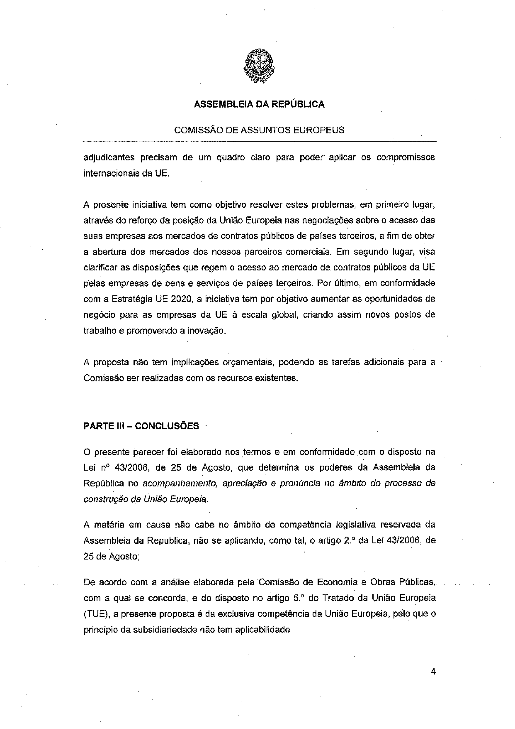
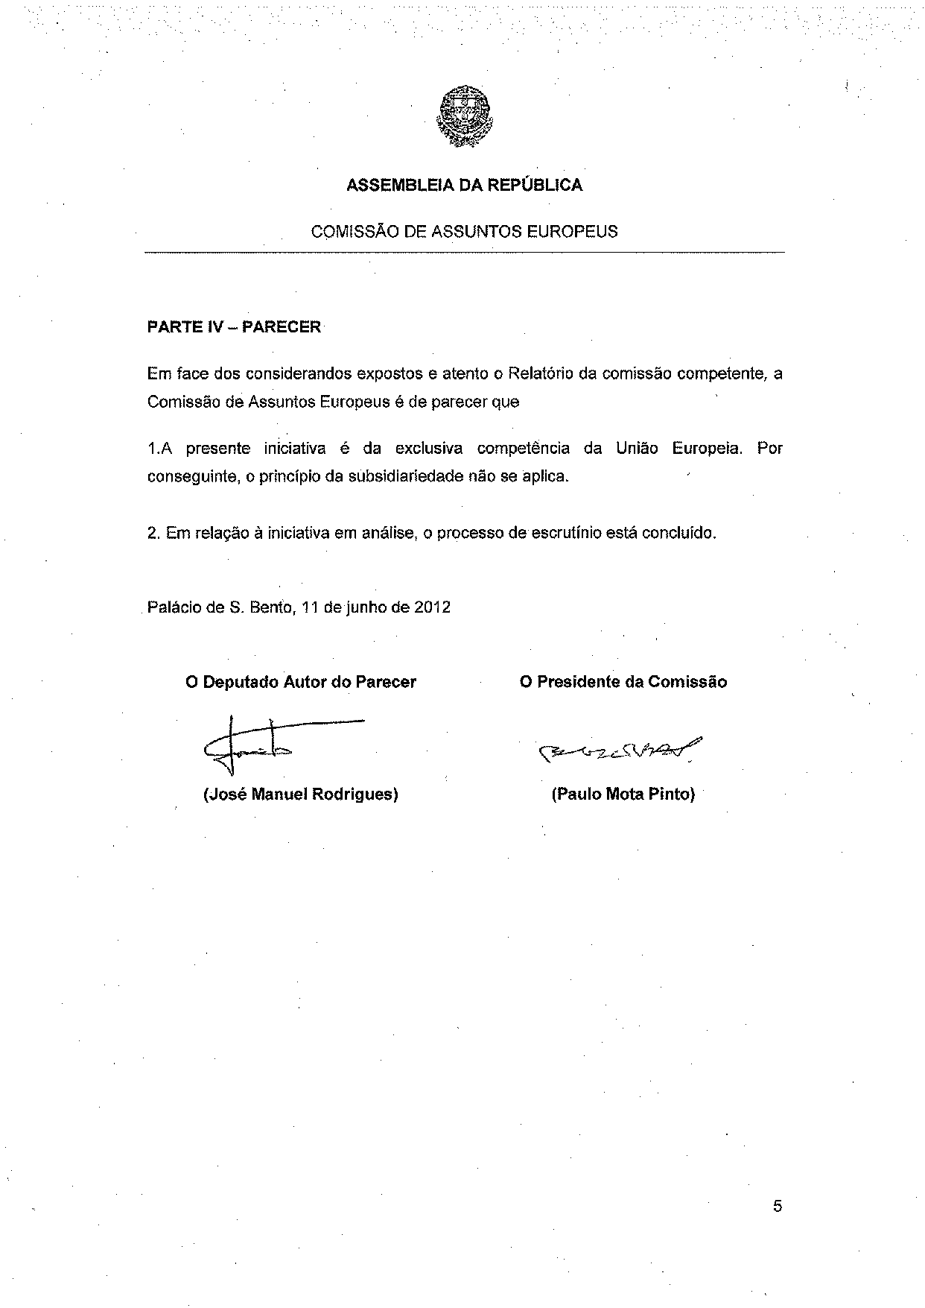
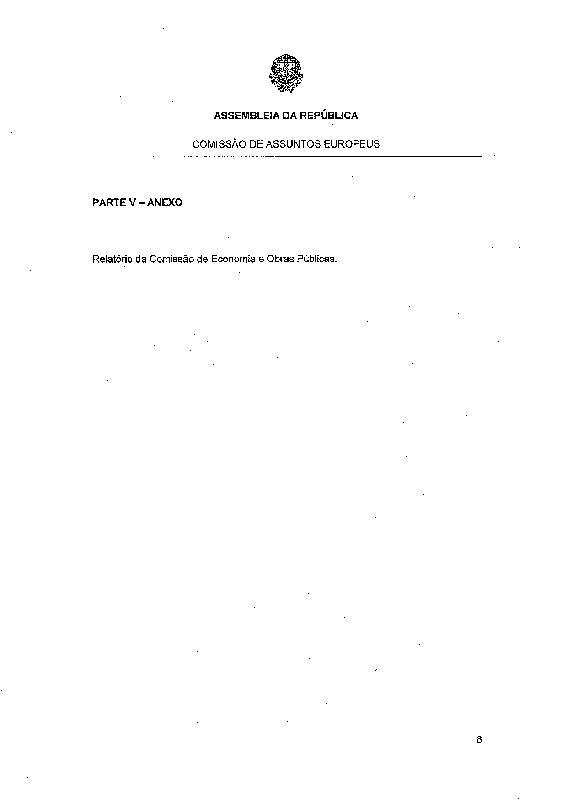
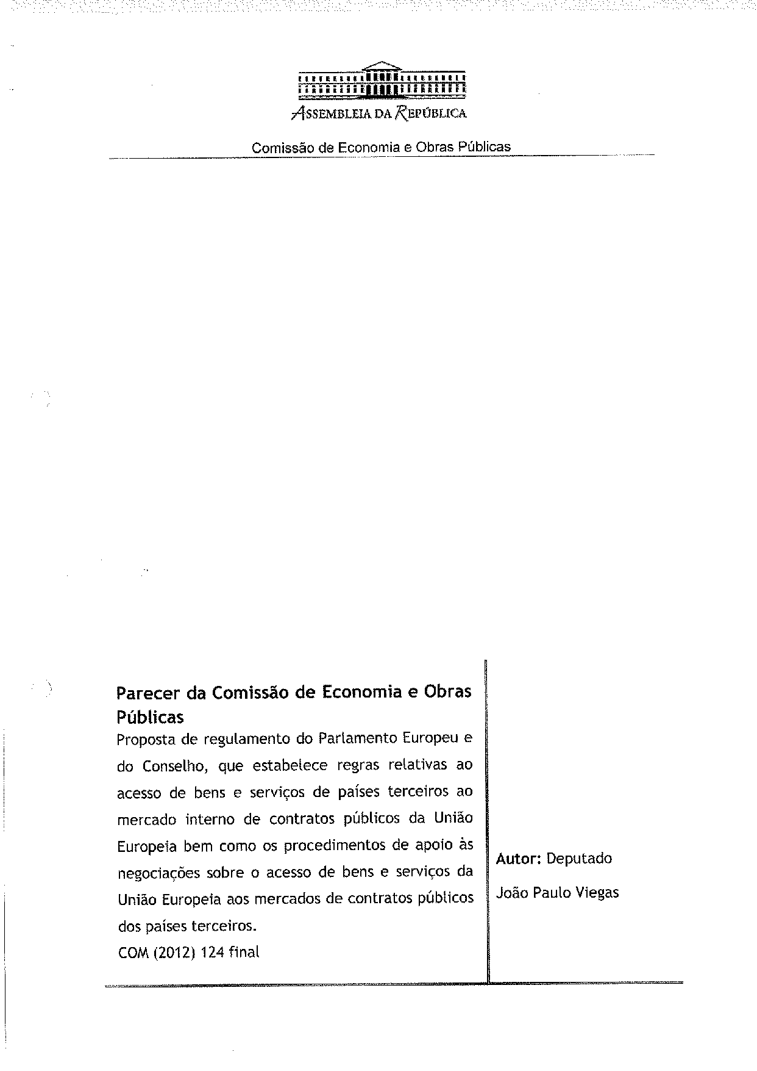
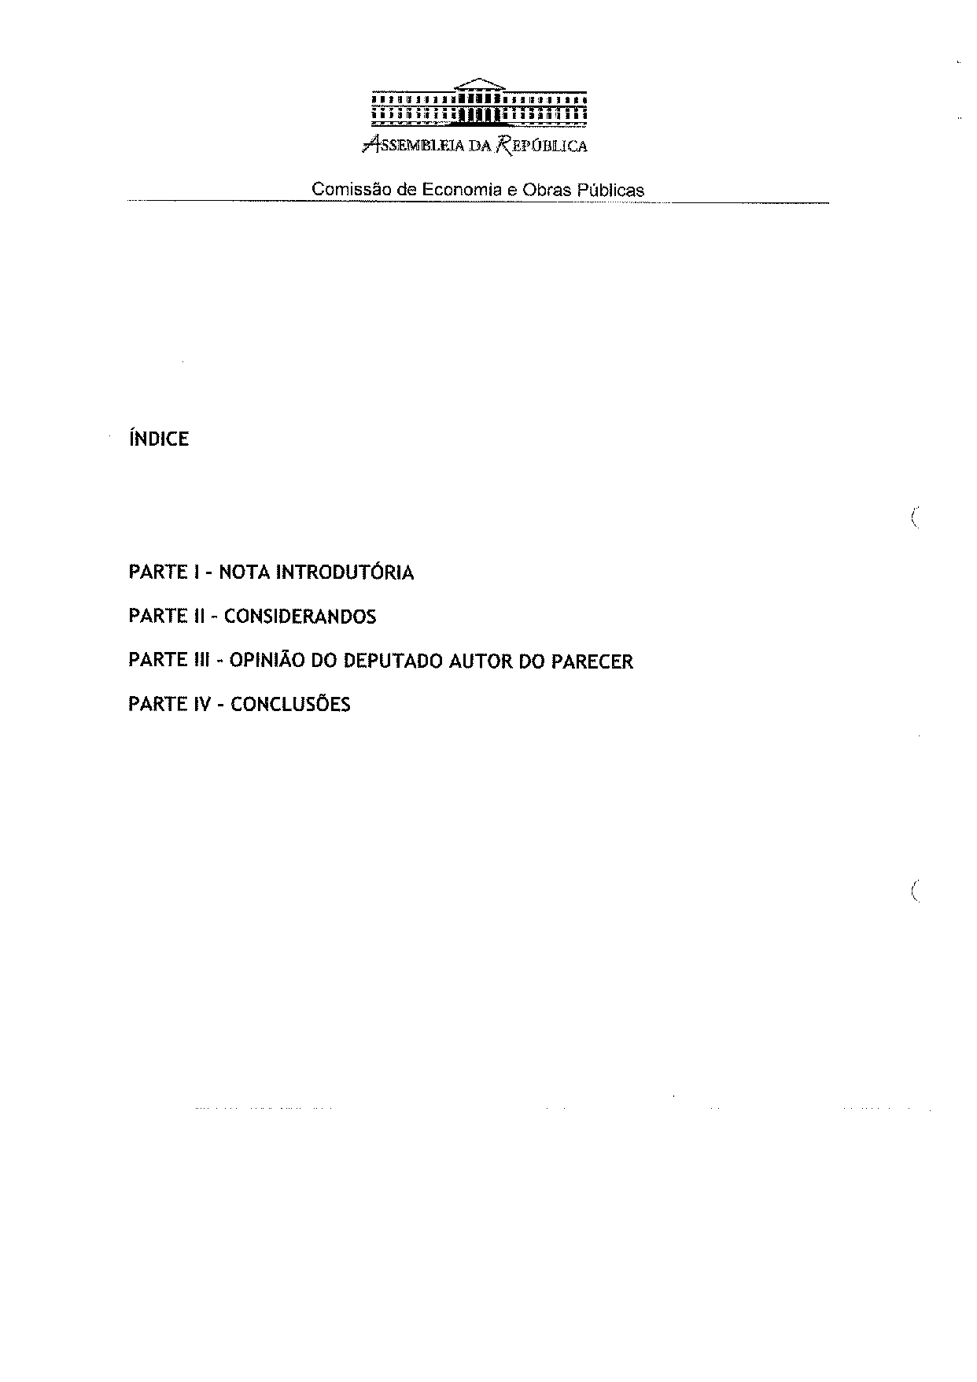
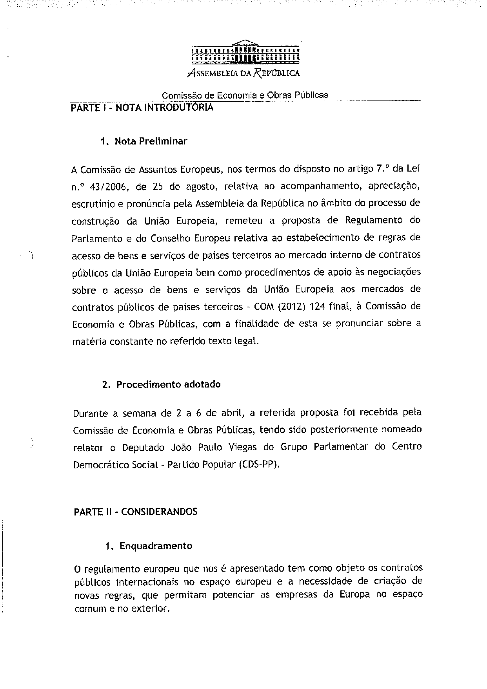
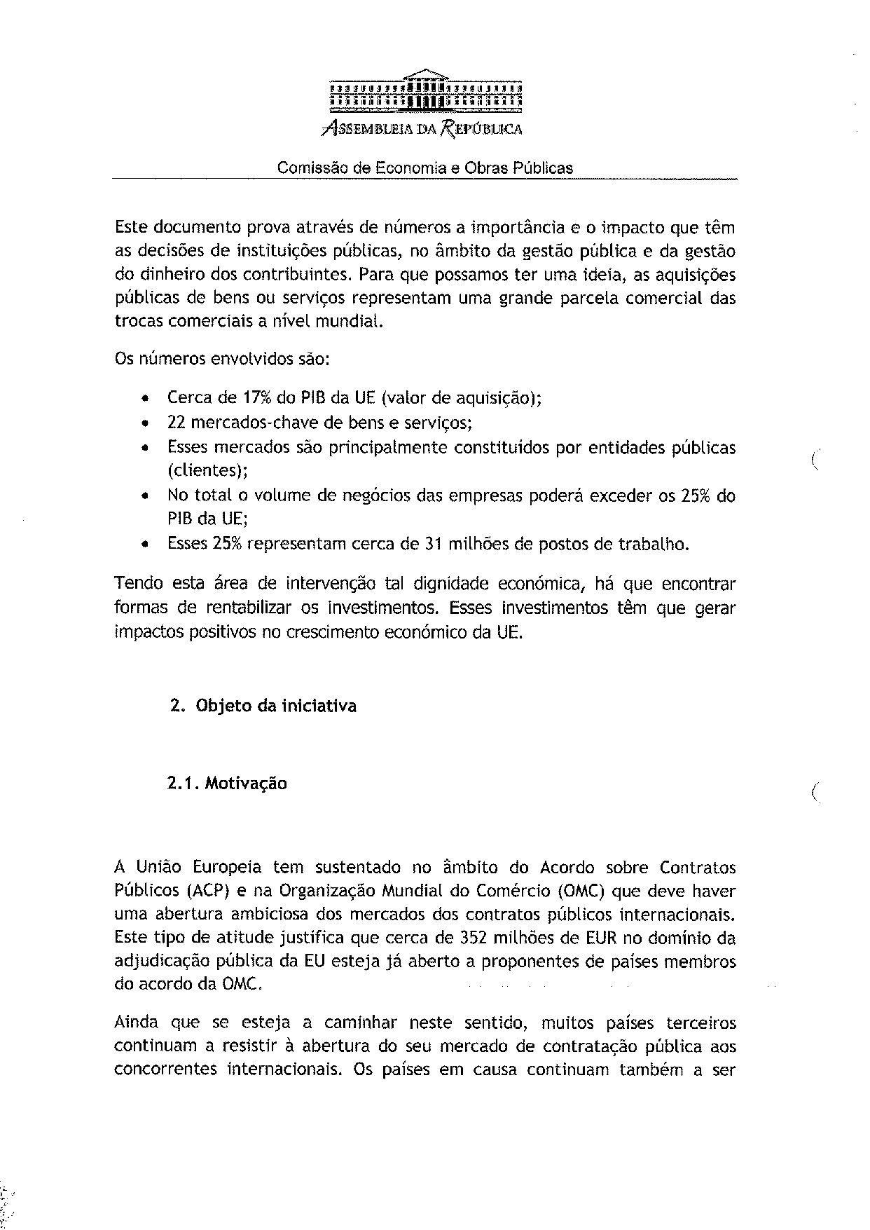
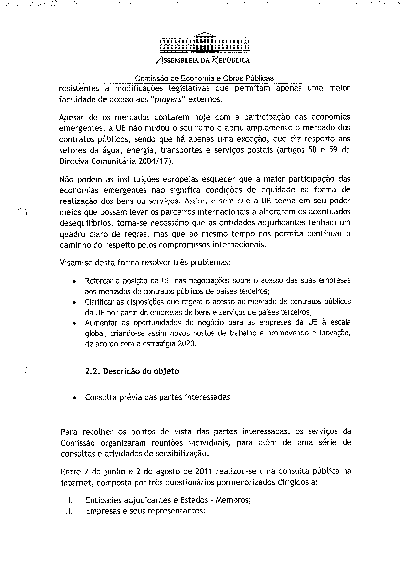
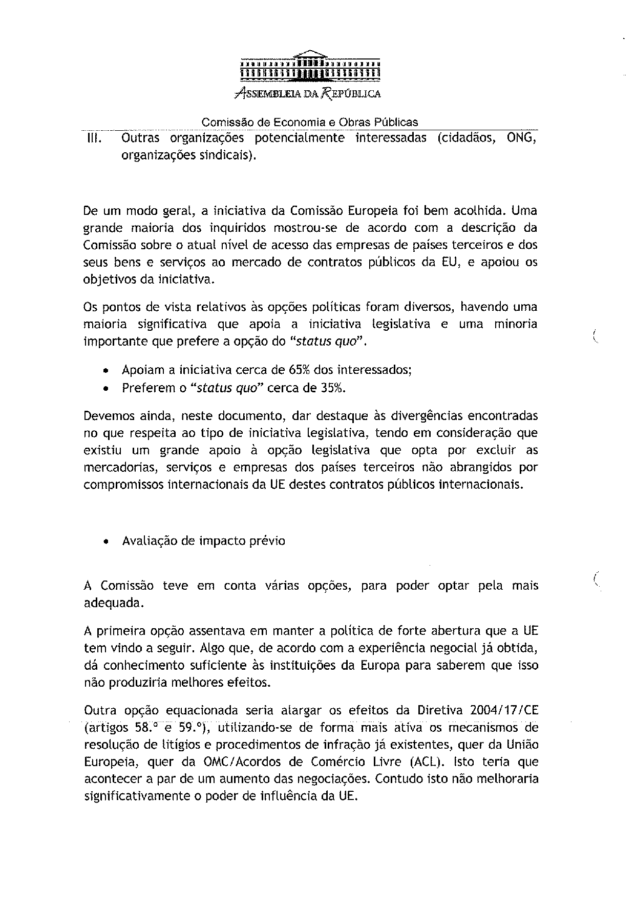
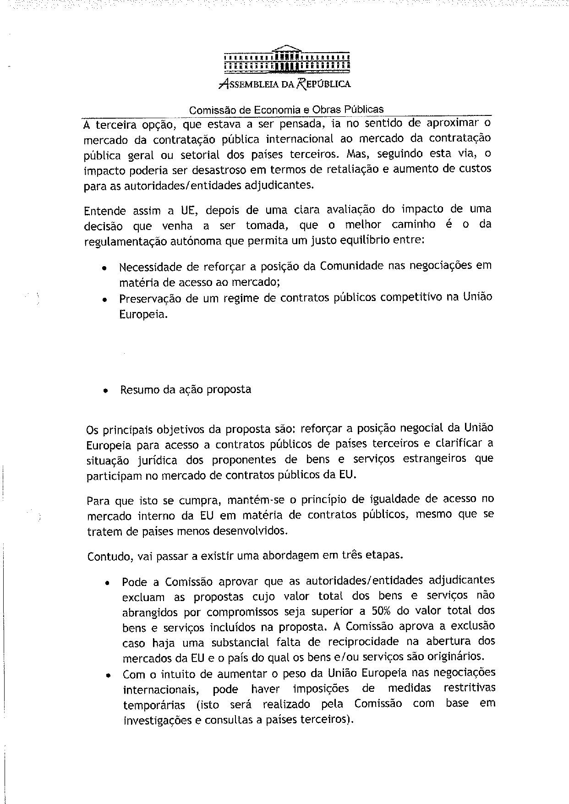
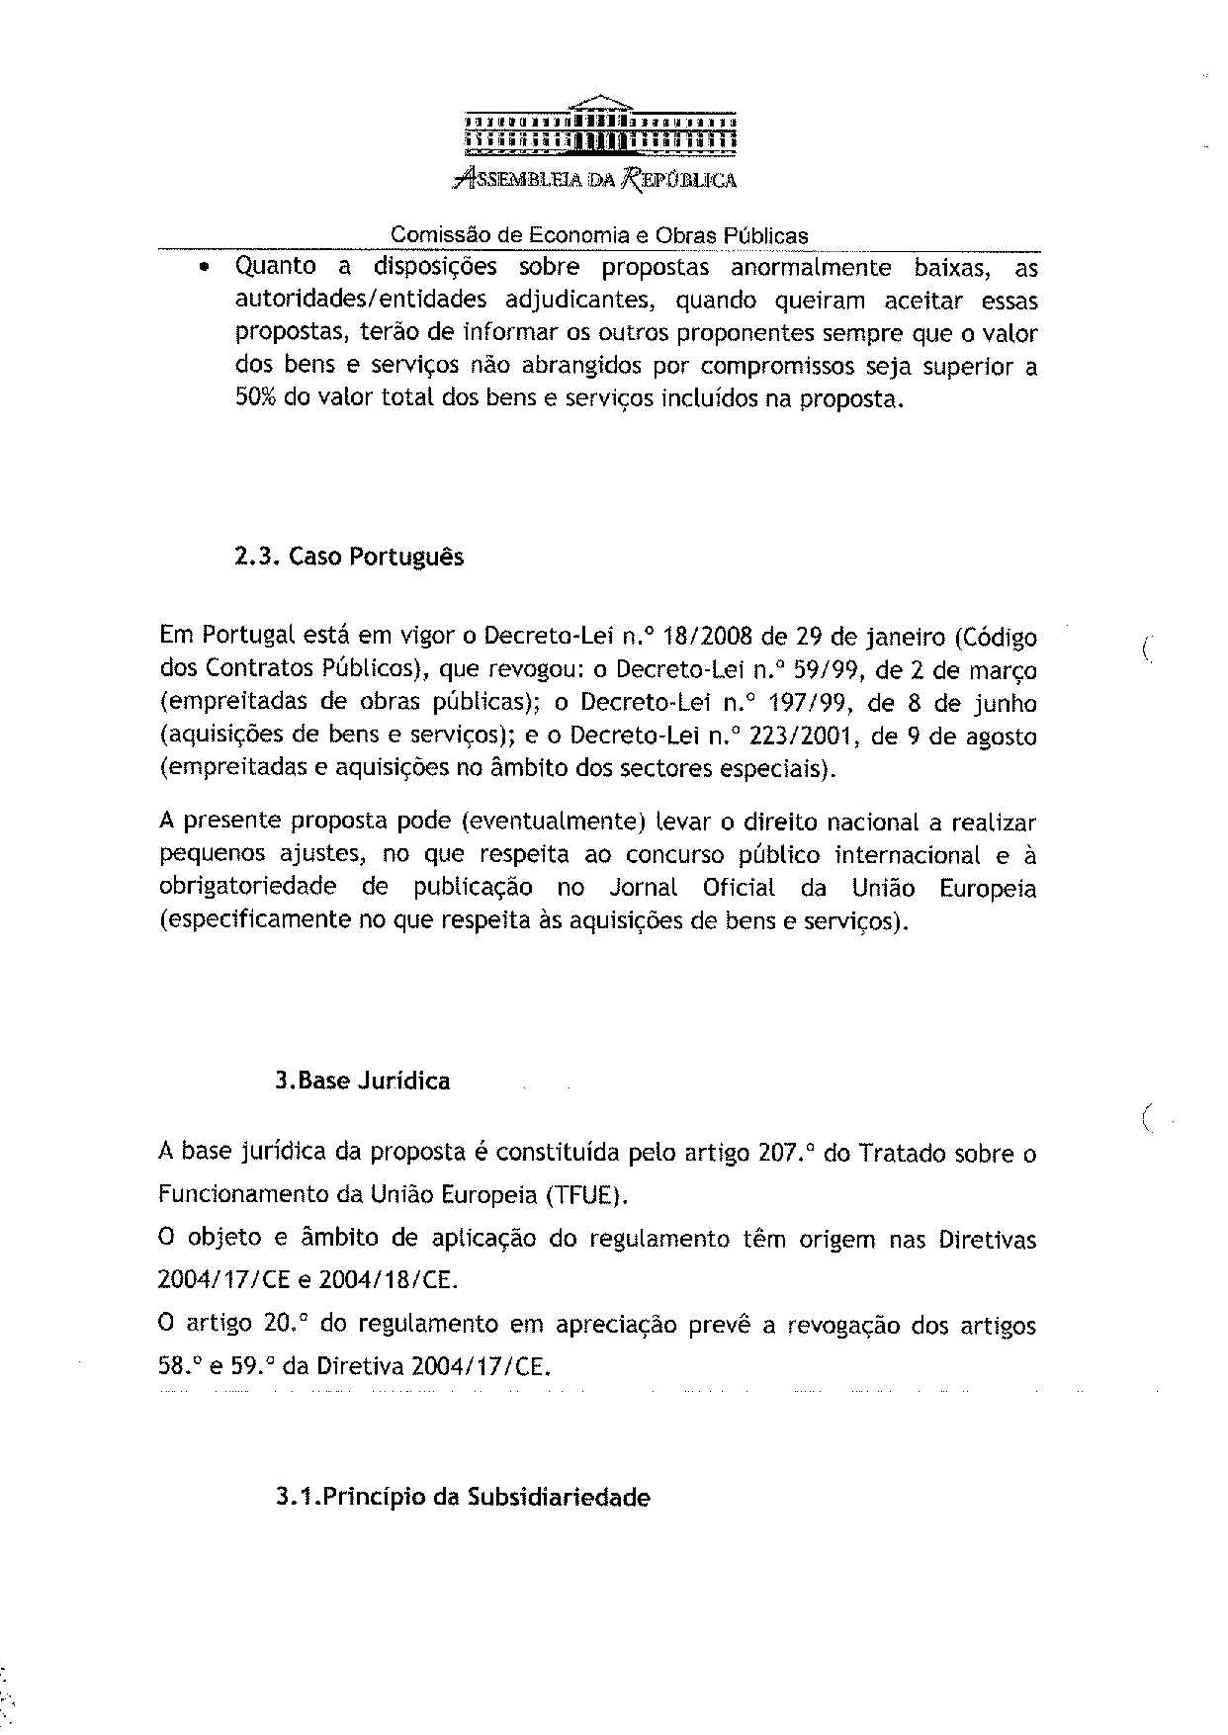
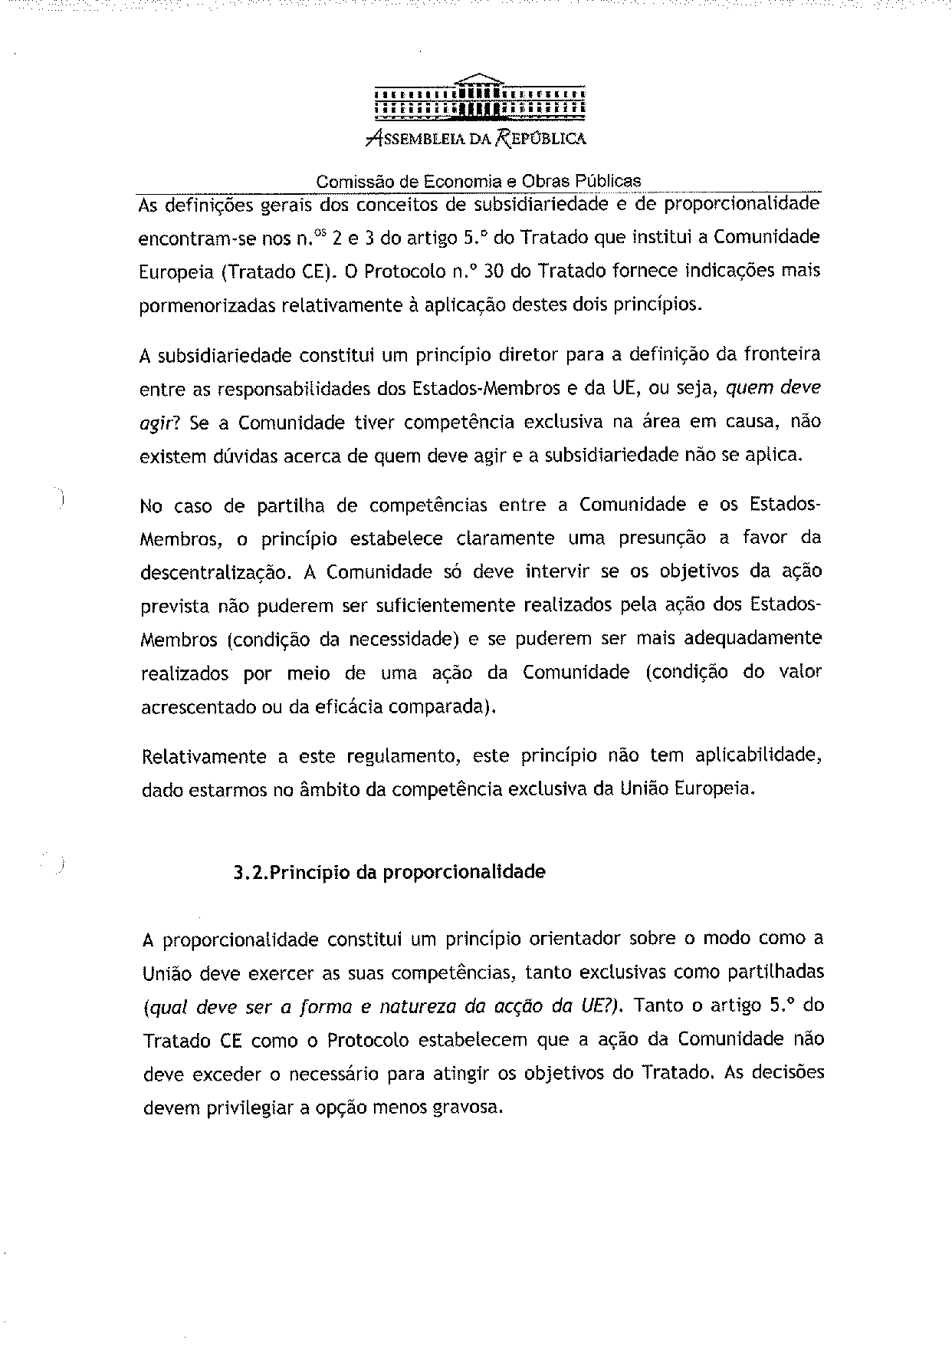
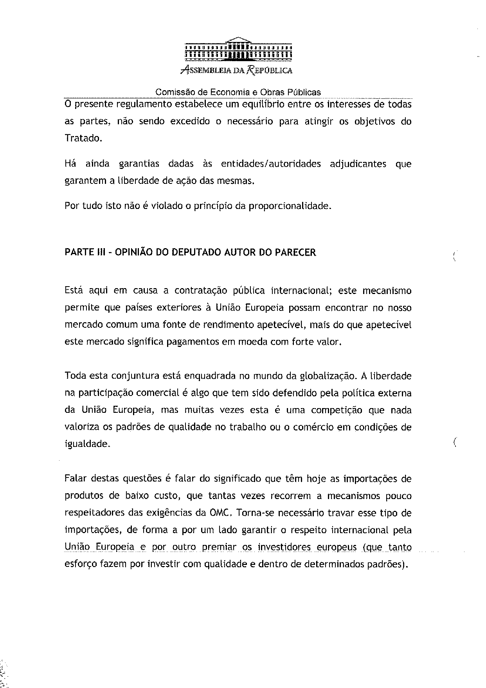
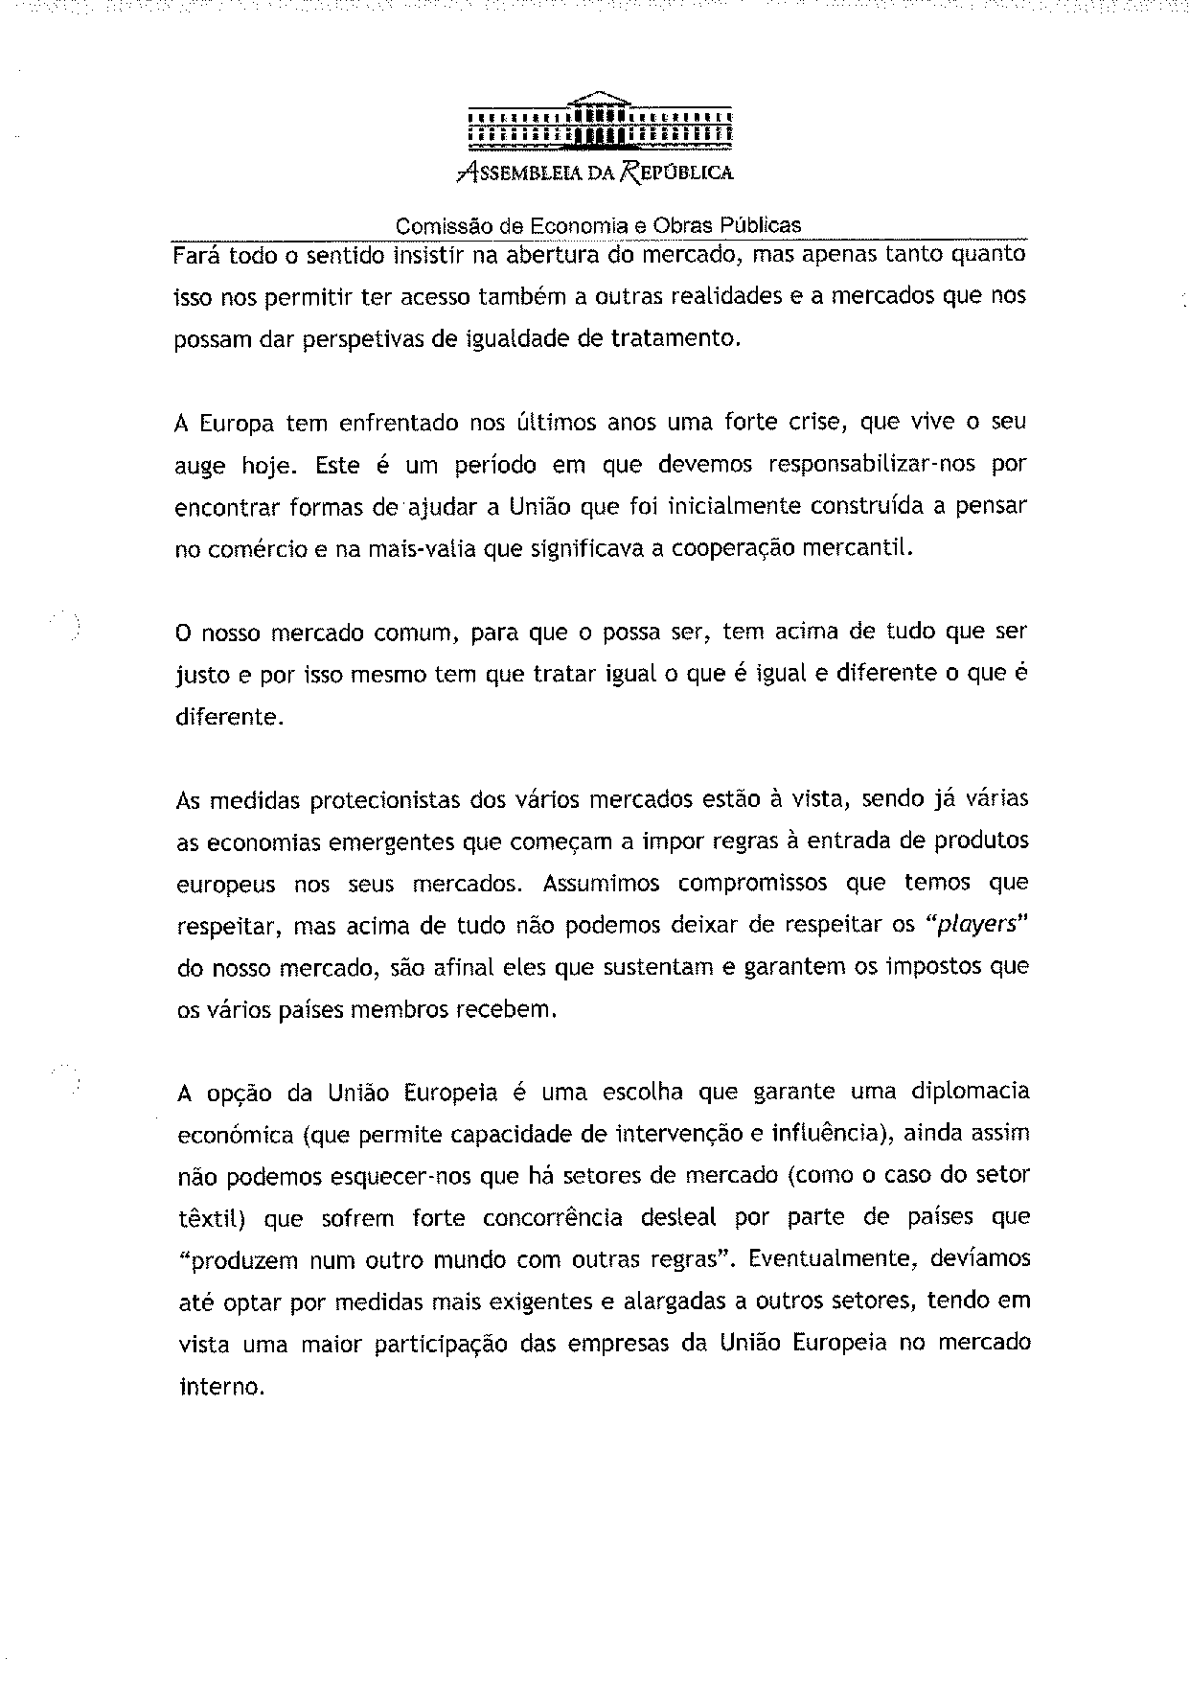
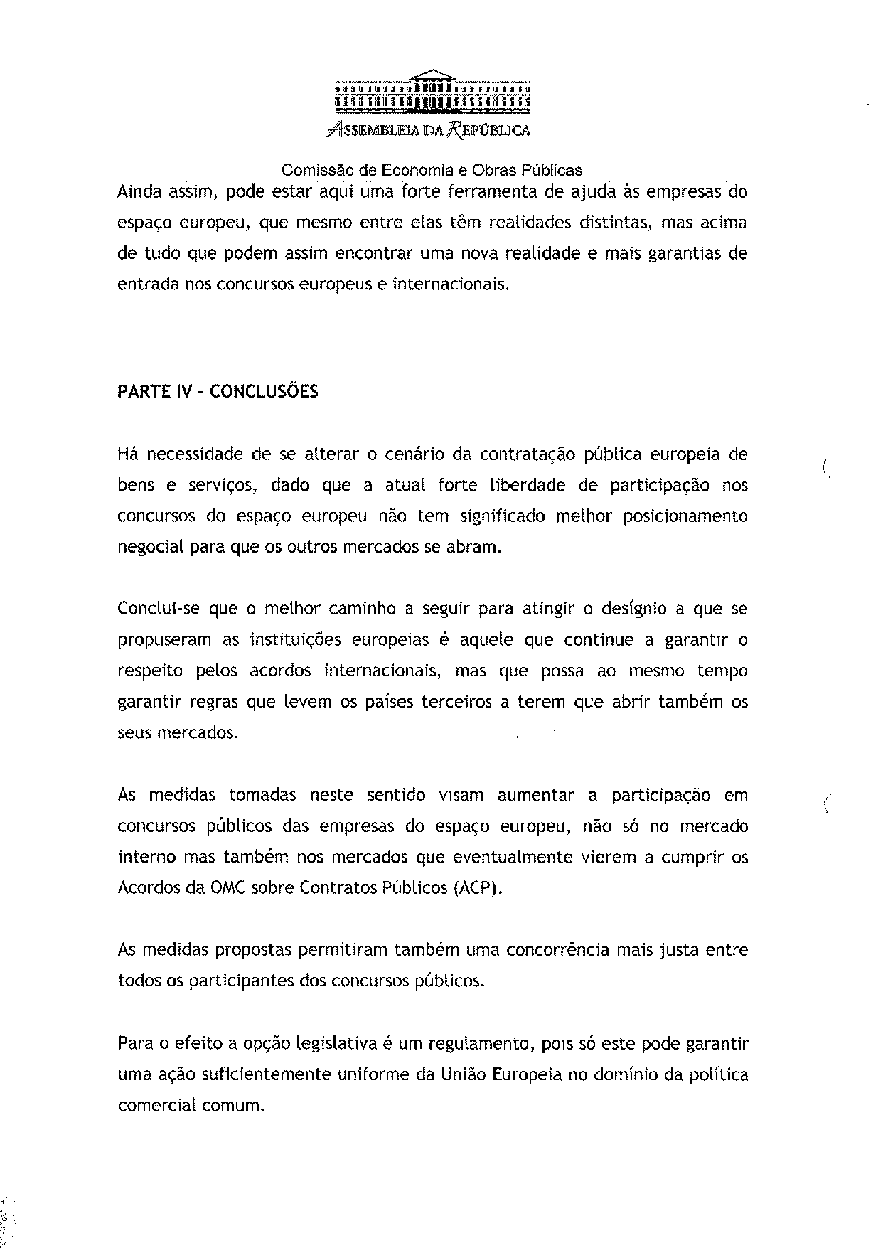
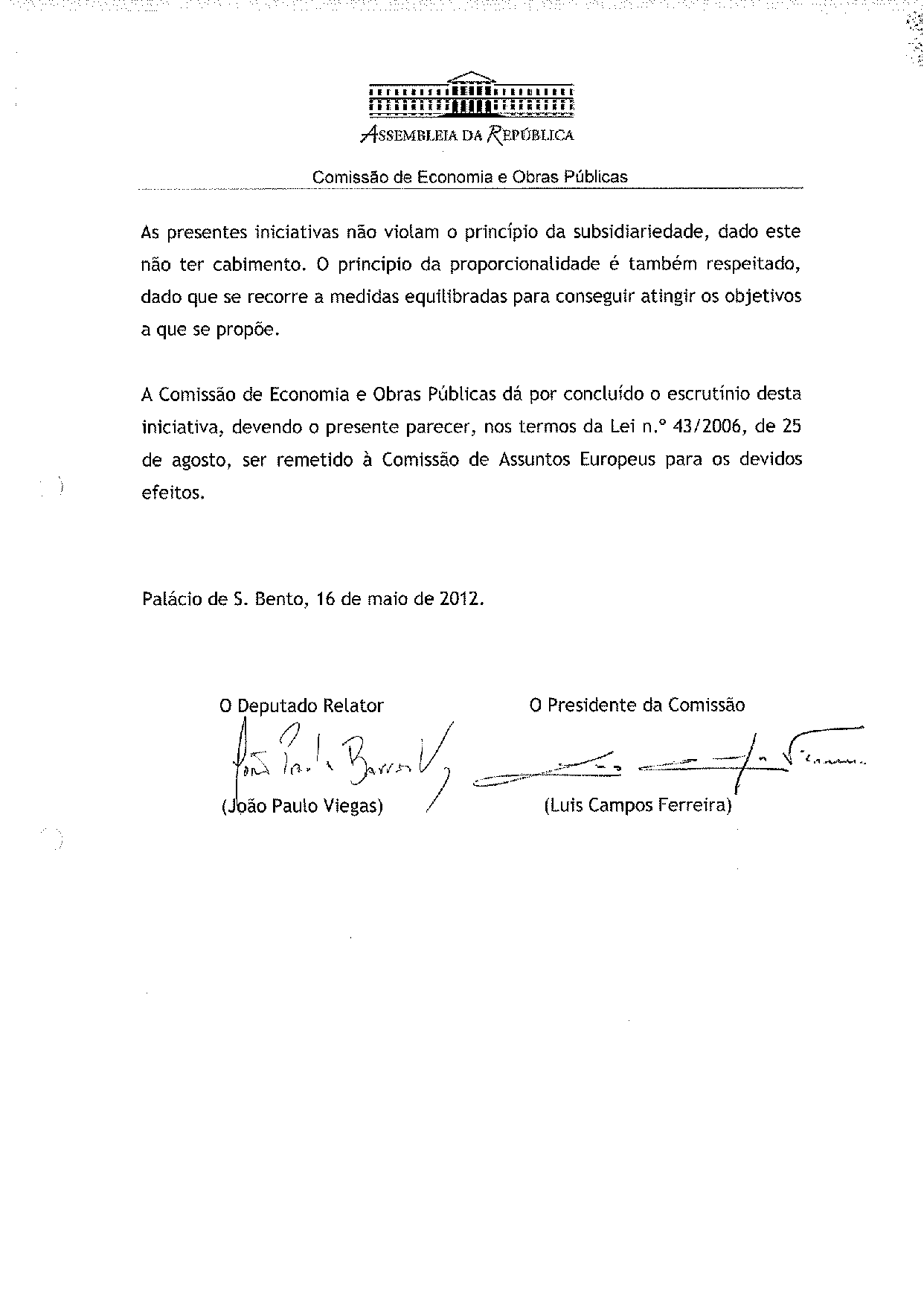

The translation of the opinion may be available at the Interparliamentary EU Information Exchange site IPEX, at the following address: http://www.ipex.eu/IPEXL-WEB/search.do.

