 | 
COUNCIL OF  THE EUROPEAN UNION |  |  | Brussels, 21 June 2012
 | Interinstitutional File:  2012/0054 (COD) |  | 11621/12
WTO 230
AGRI 434
UD 175
CODEC 1720
INST 421
PARLNAT 275

COVER NOTE
from: | the President of the Assembly of the Republic of Portugal
date of receipt: | 6 June 2012
to: | Ms Helle THORNING-SCHMIDT, President of the Council of the European Union
Subject: | Proposal for a Regulation of the European Parliament and of the Council concerning the implementation of the Agreements concluded by the EU following negotiations in the framework of Article XXVIII of GATT 1994, amending and supplementing Annex I to Regulation (EEC) No 2658/87 on the tariff and statistical nomenclature and on the Common Customs Tariff  [doc. 7886/12 WTO 113 AGRI 163 UD 85 CODEC 728 - COM(2012) 115 final]  - Opinion on the application of the Principles of Subsidiarity and Proportionality

Delegations will find attached the above-mentioned opinion.

________________________

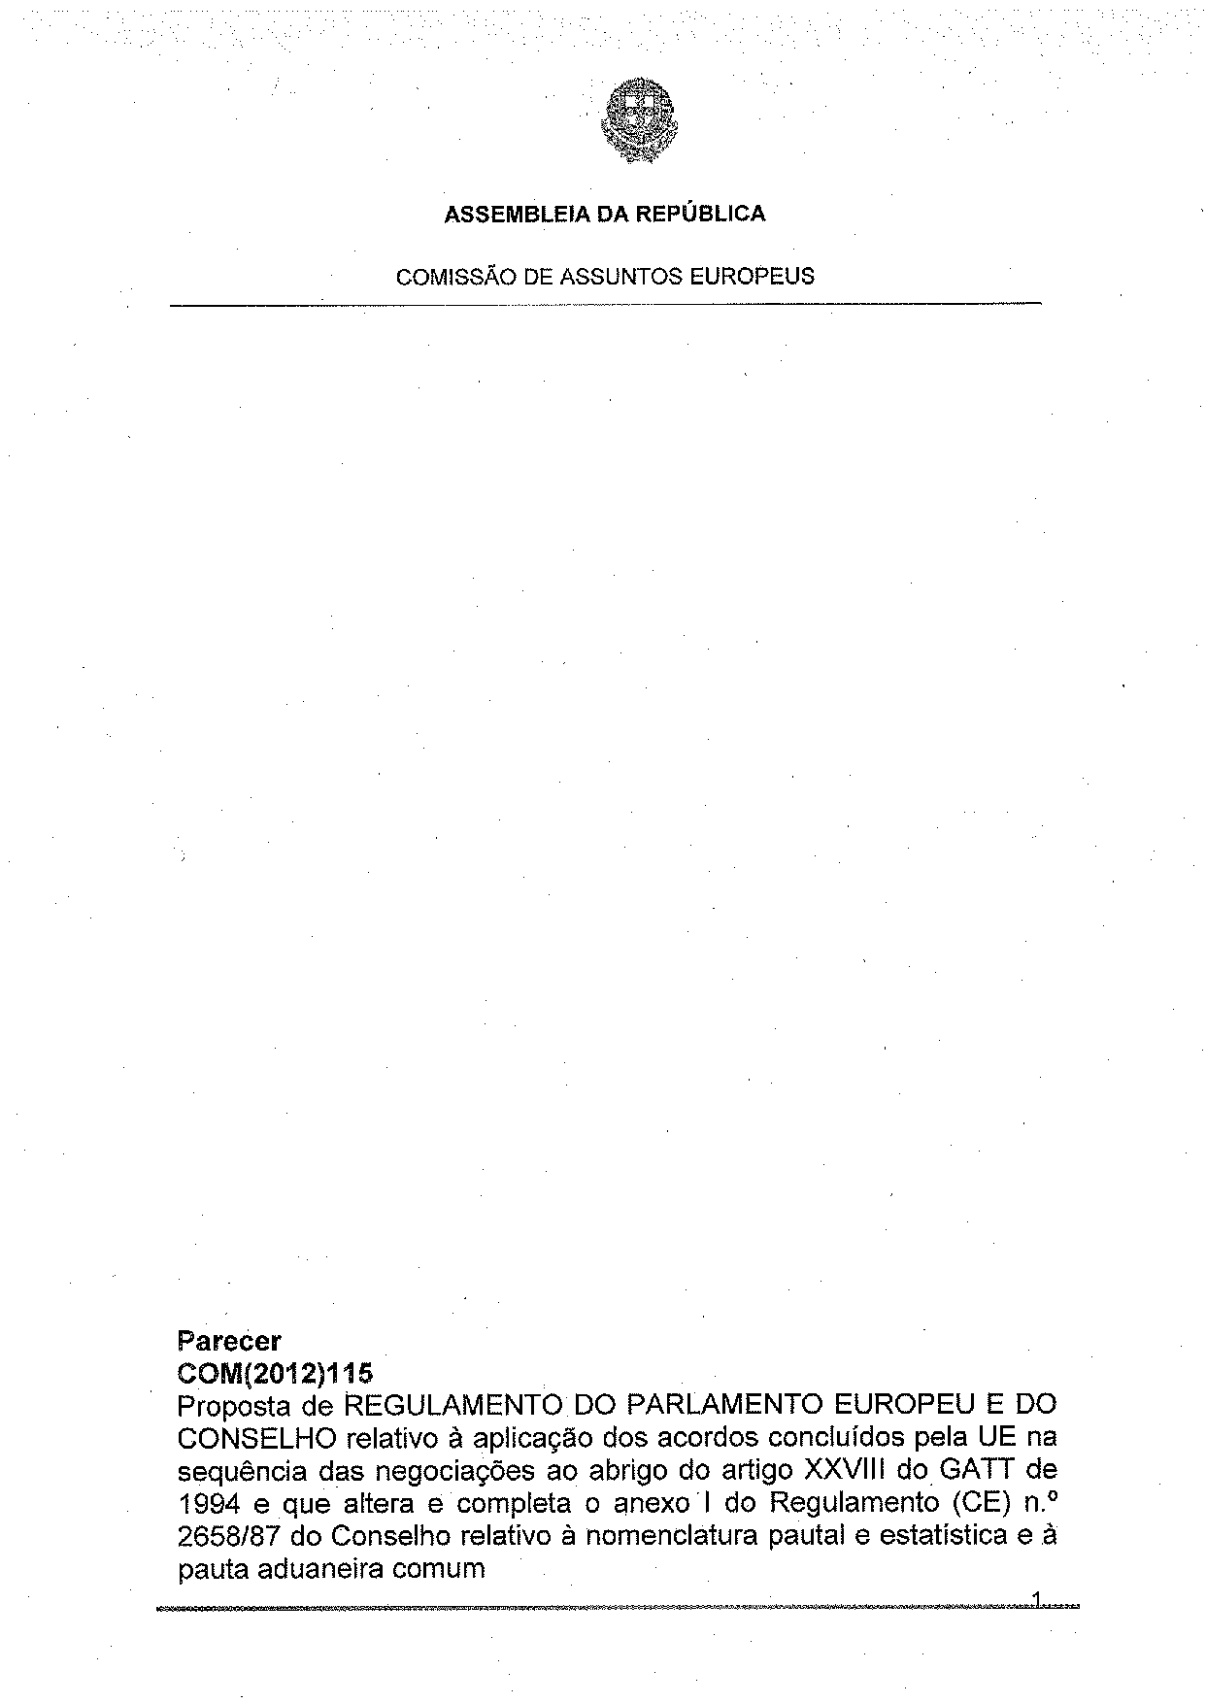
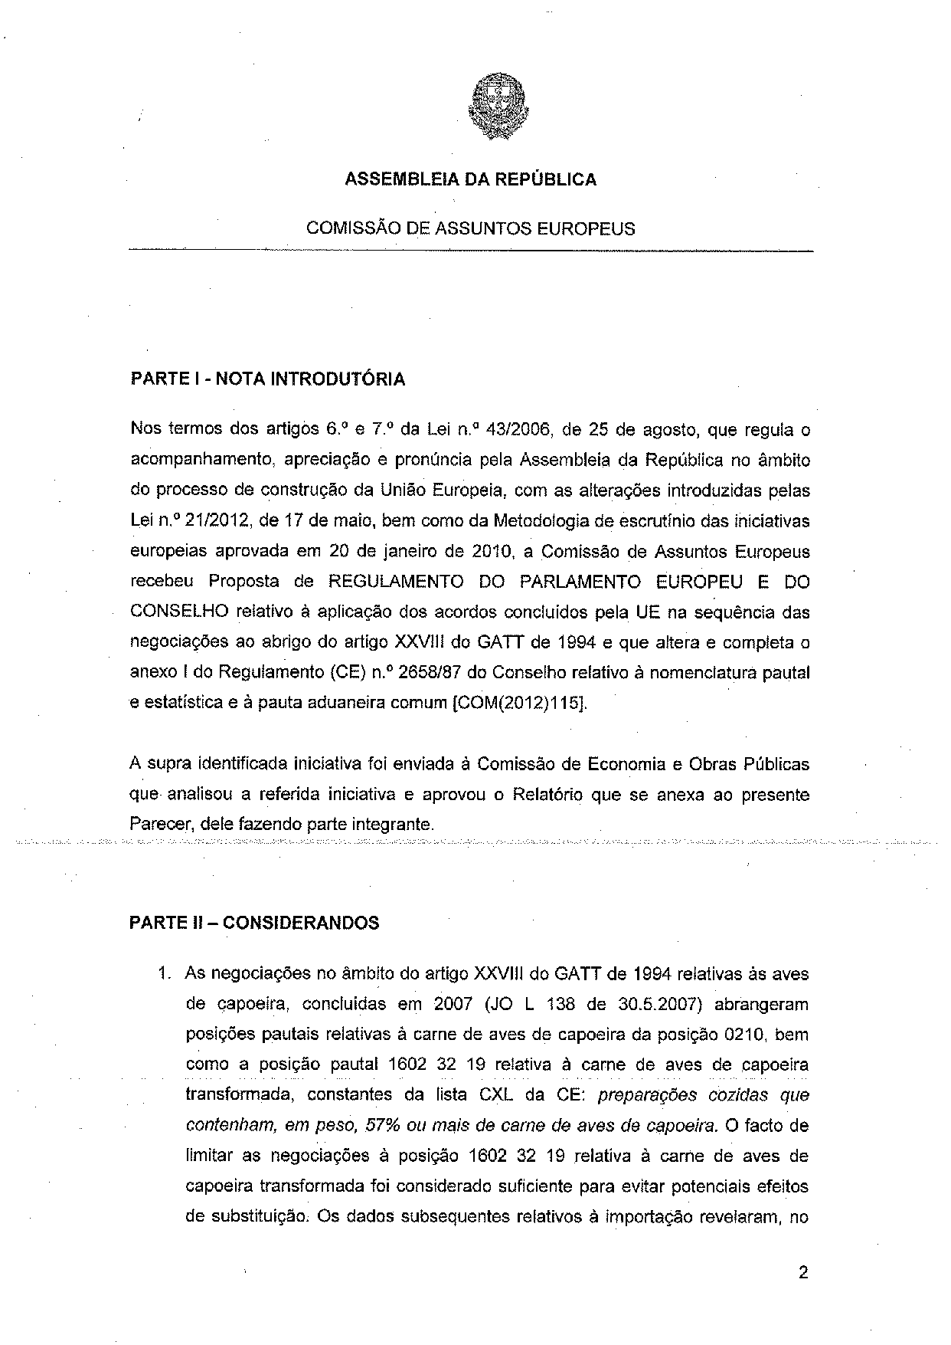
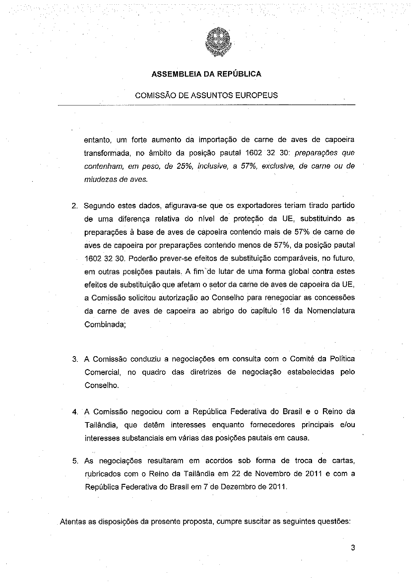
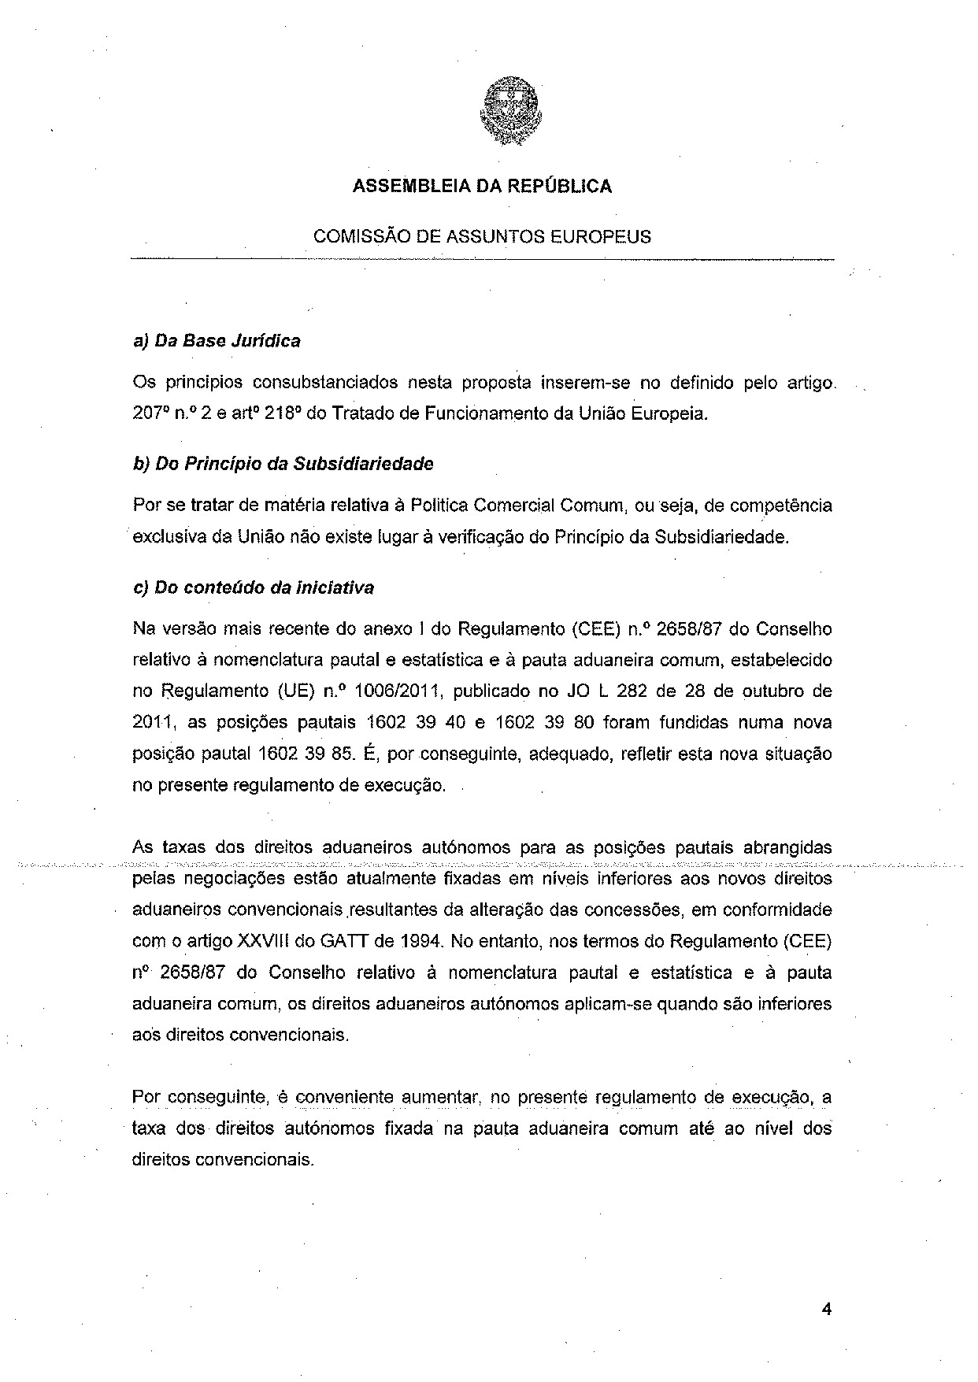
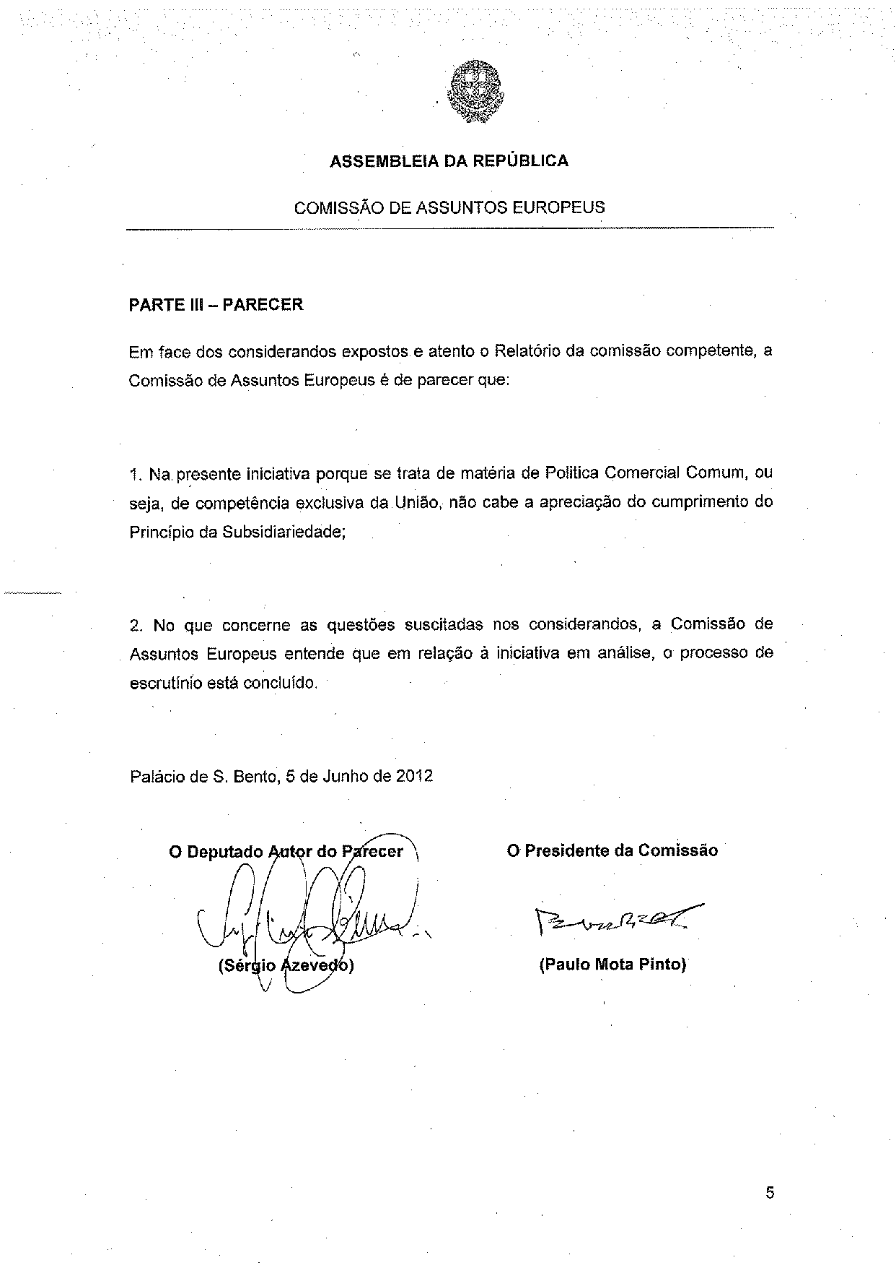

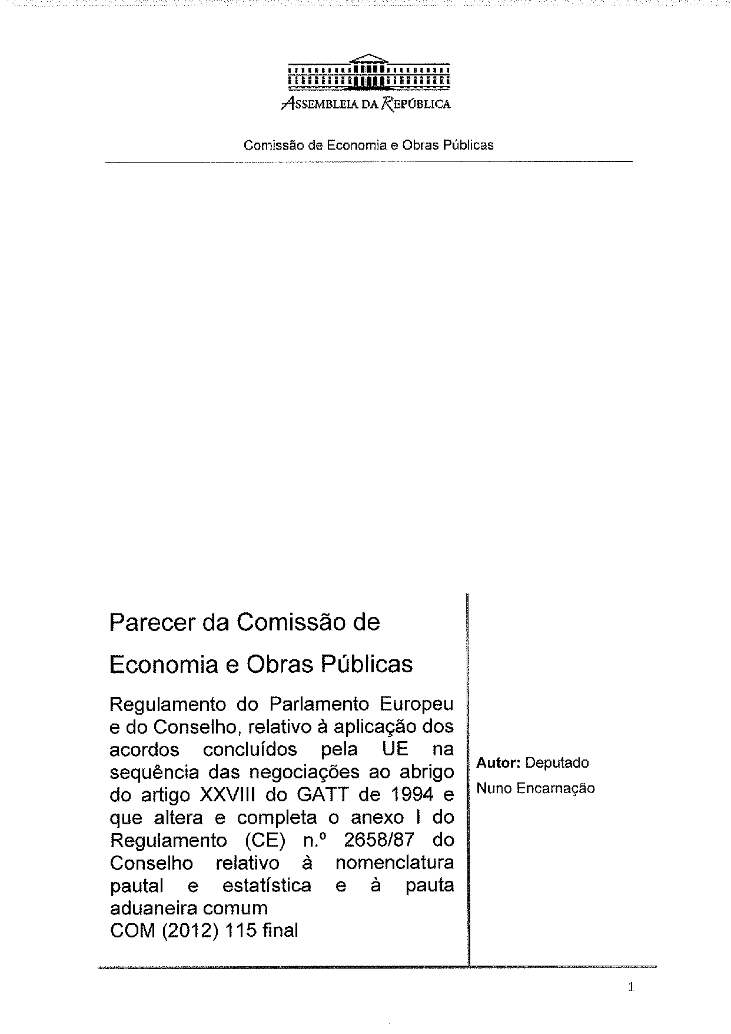
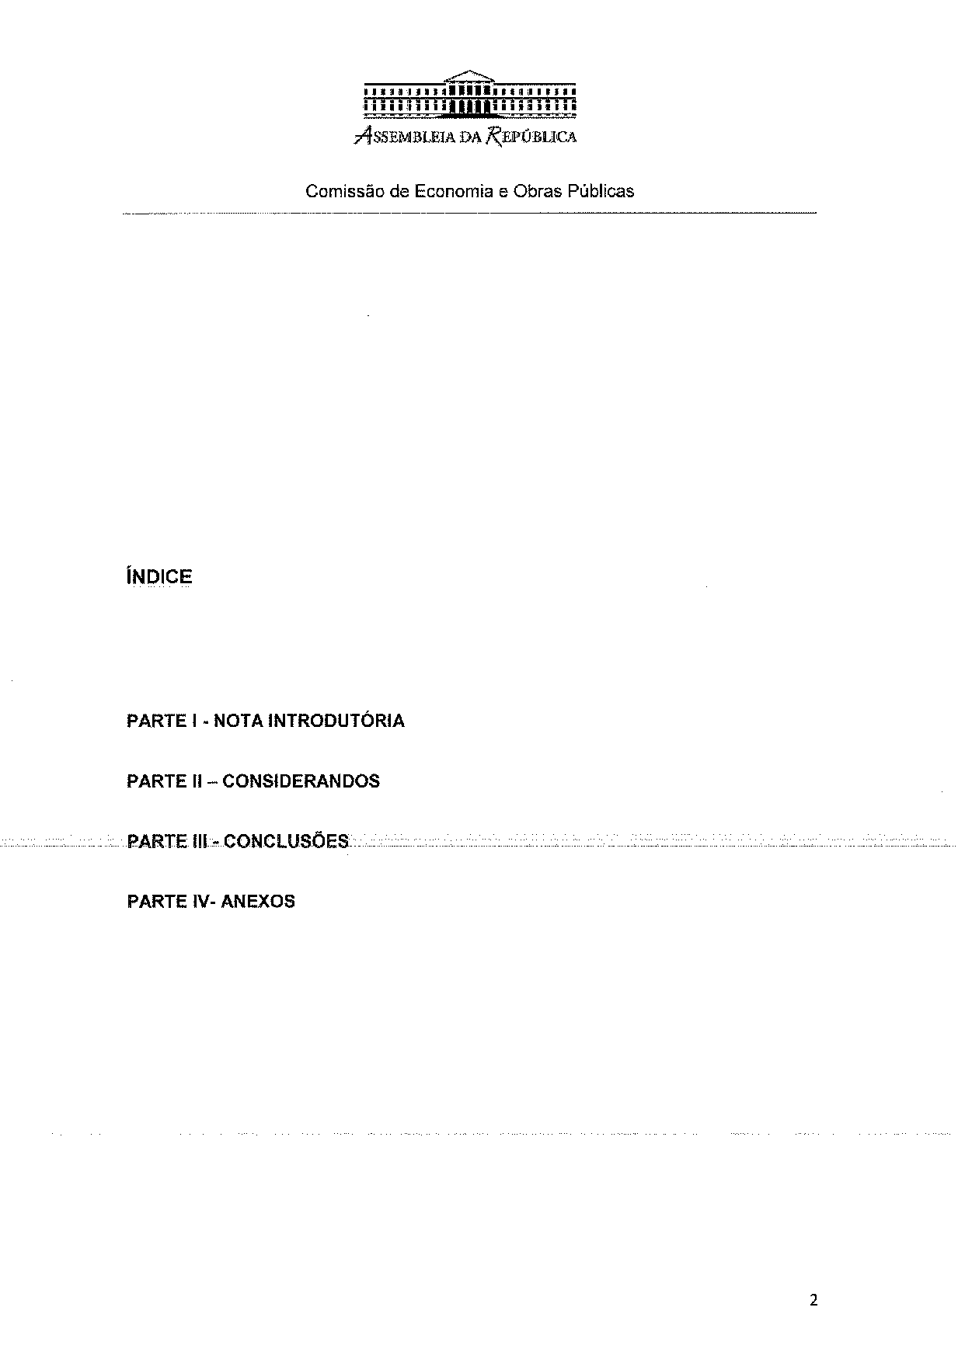
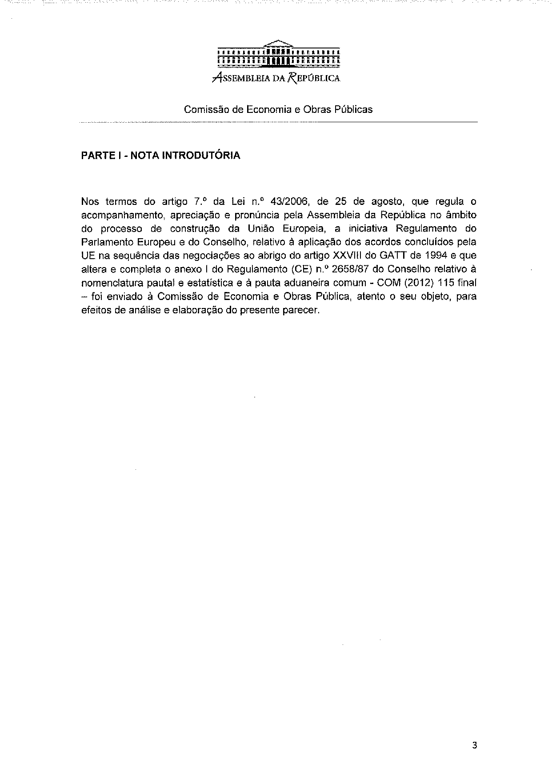
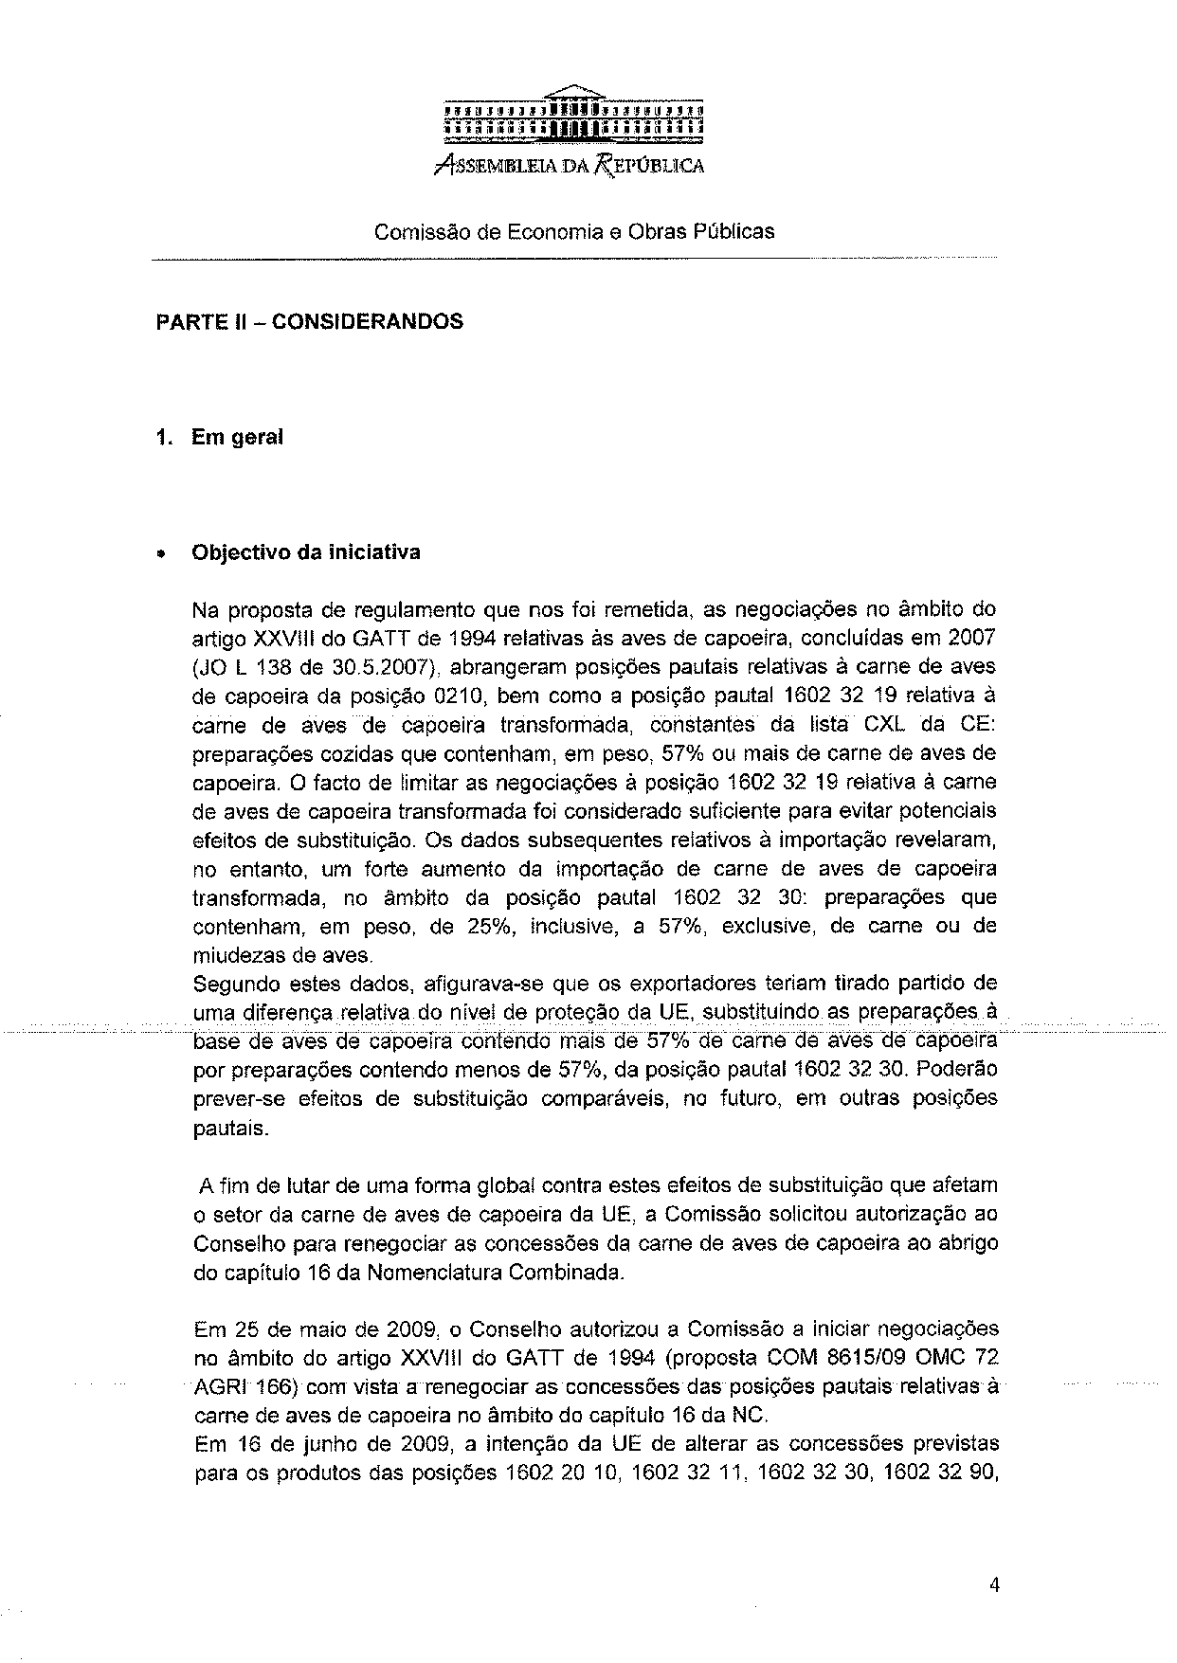
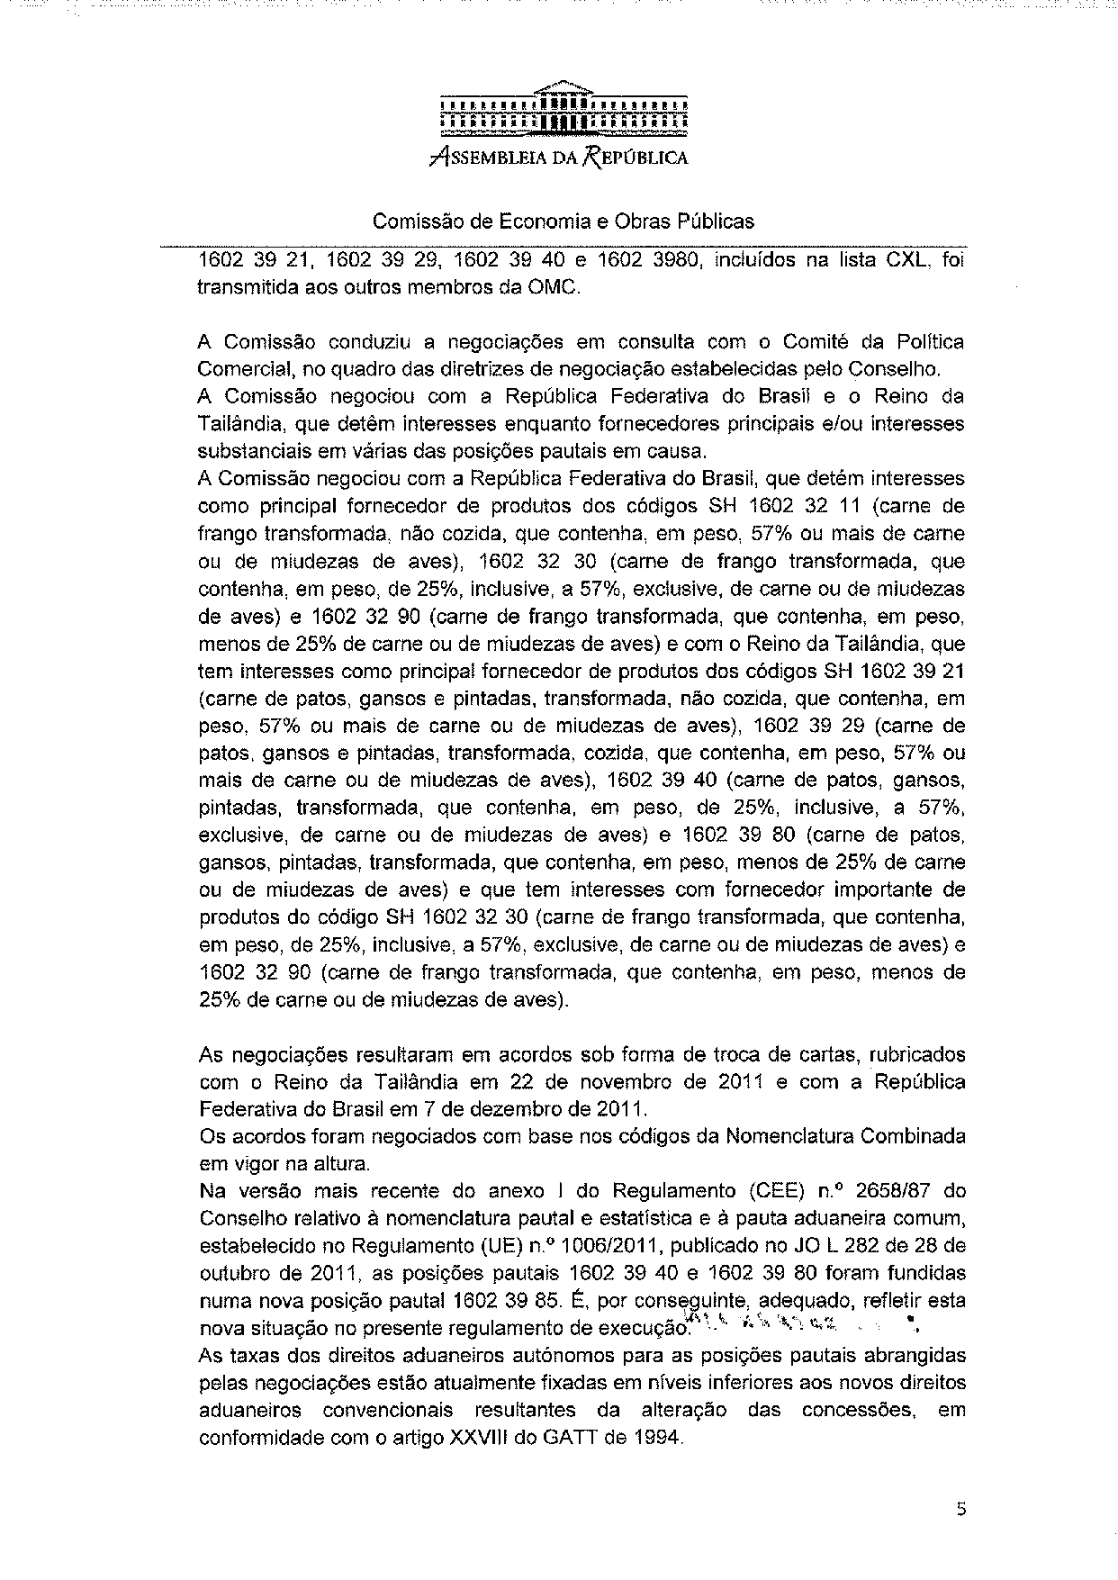
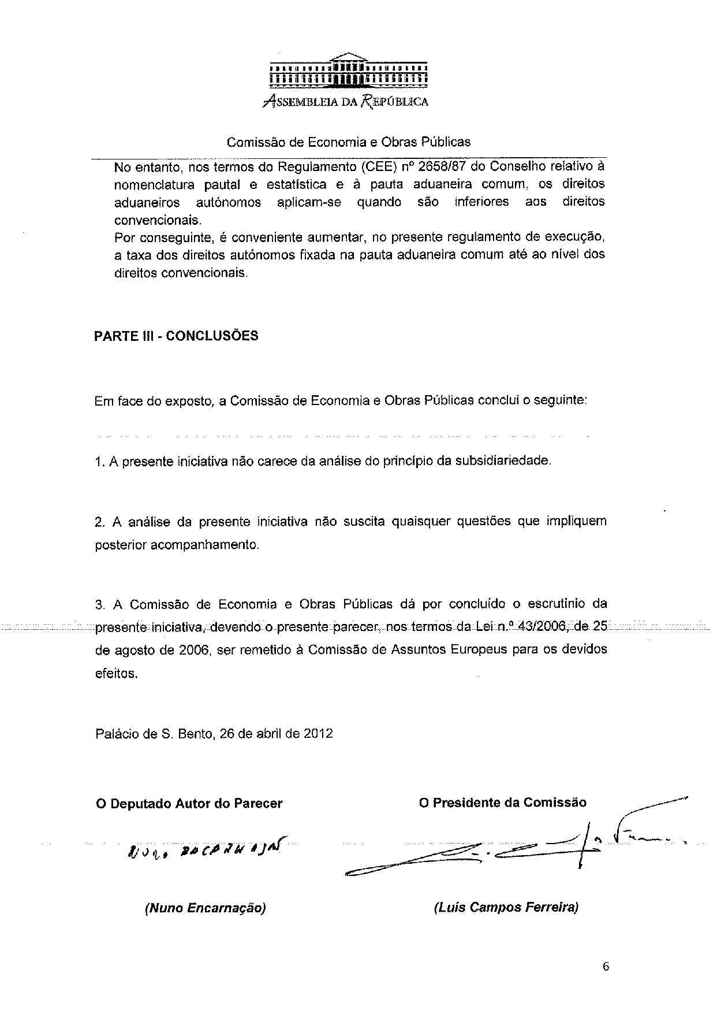

The translation of the opinion may be available at the Interparliamentary EU Information Exchange site IPEX, at the following address: http://www.ipex.eu/IPEXL-WEB/search.do.

