 | 
COUNCIL OF  THE EUROPEAN UNION |  |  | Brussels, 21 June 2012
 | Interinstitutional File:  2012/0077 (COD) |  | 11709/12
PECHE 242
CODEC 1737
INST 424
PARLNAT 278

COVER NOTE
from: | Assembly of the Republic of Portugal
date of receipt: | 14 June 2012
to: | Mr Uwe CORSEPIUS, Secretary-General of the Council of the European Union
Subject: | Proposal for a Regulation of the European Parliament and of the Council amending Council Regulation (EC) No 1098/2007 of 18 September 2007 establishing a multi-annual plan for the cod stocks in the Baltic Sea and the fisheries exploiting those stocks  [doc. 8558/12 PECHE 112 CODEC 931 - COM(2012) 155 final]  - Opinion on the application of the Principles of Subsidiarity and Proportionality

Delegations will find attached the above document.

________________________

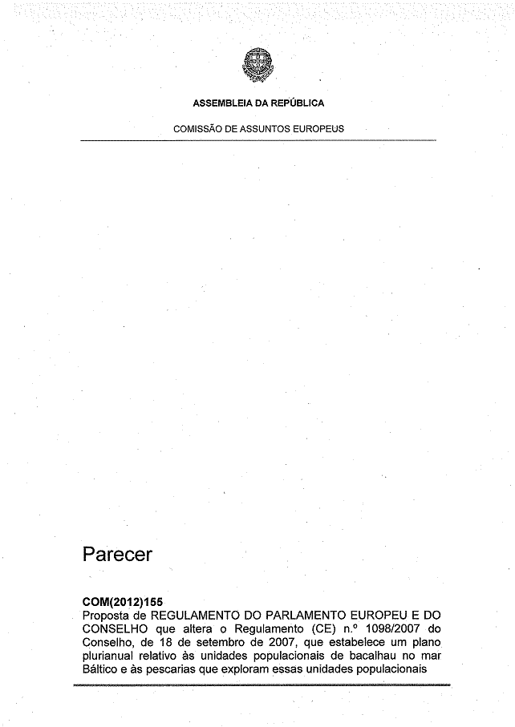
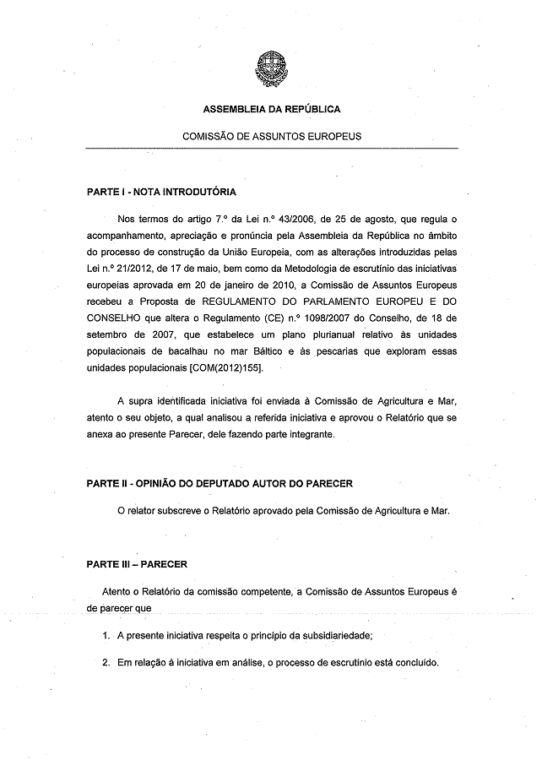
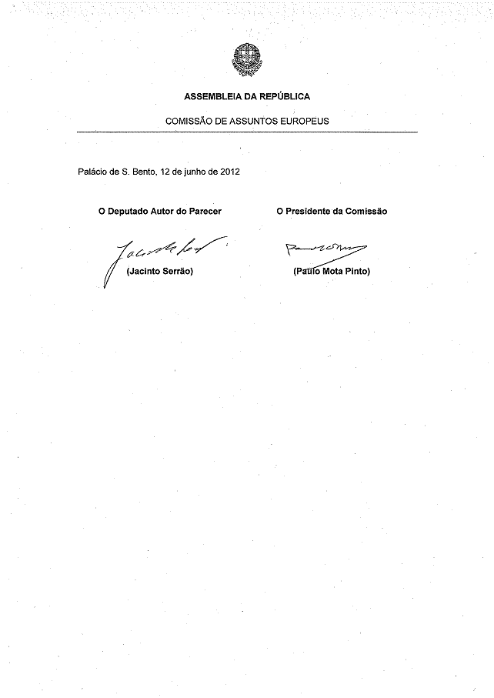
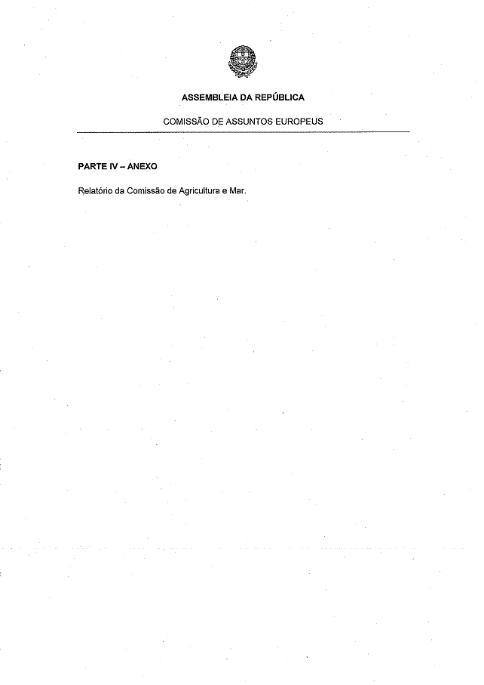
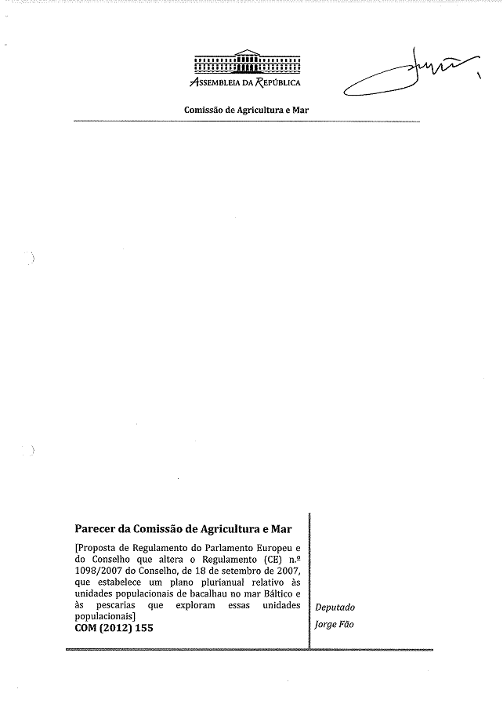
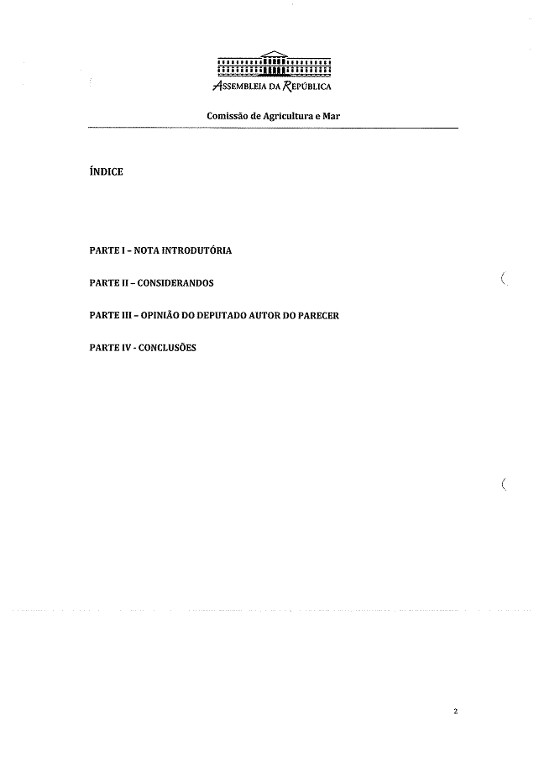
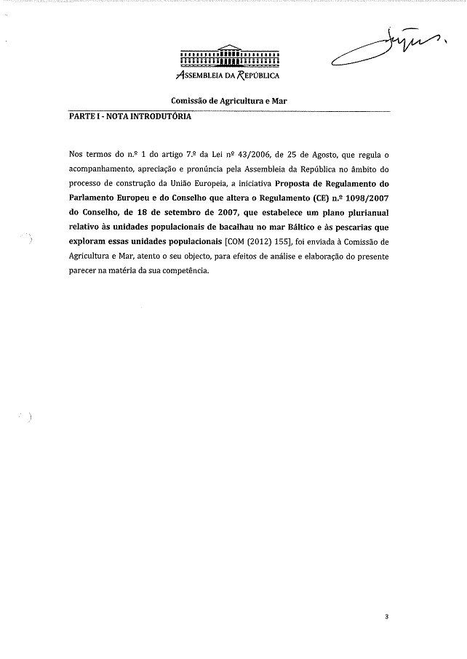
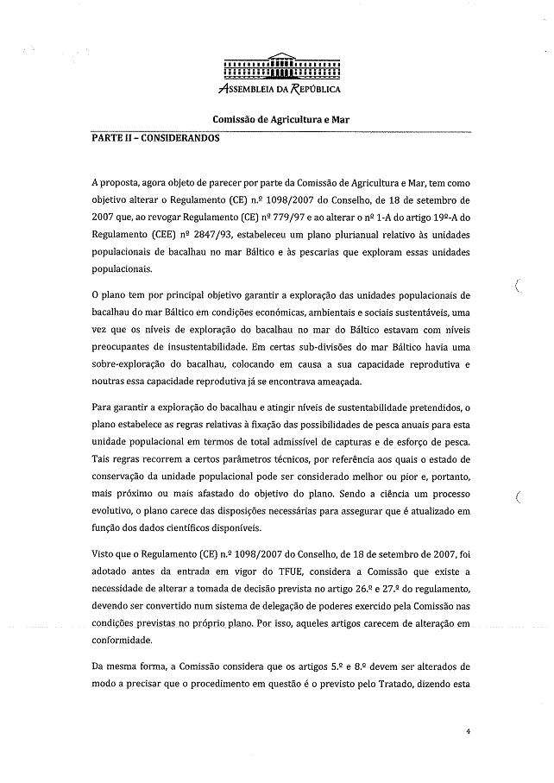
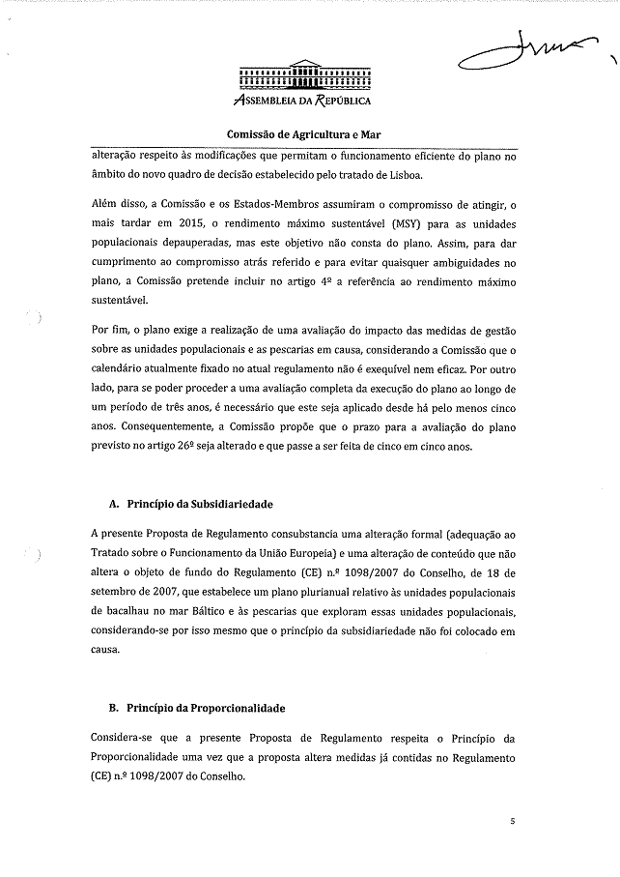
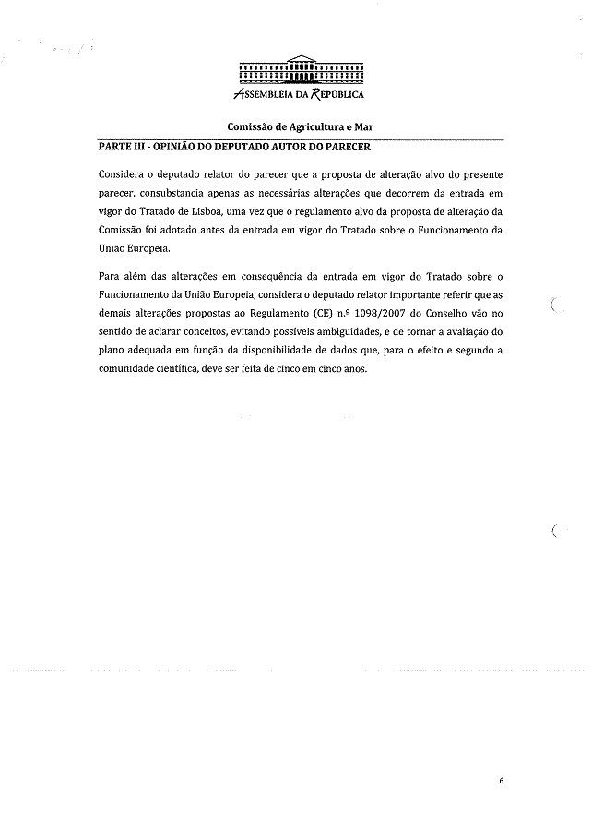
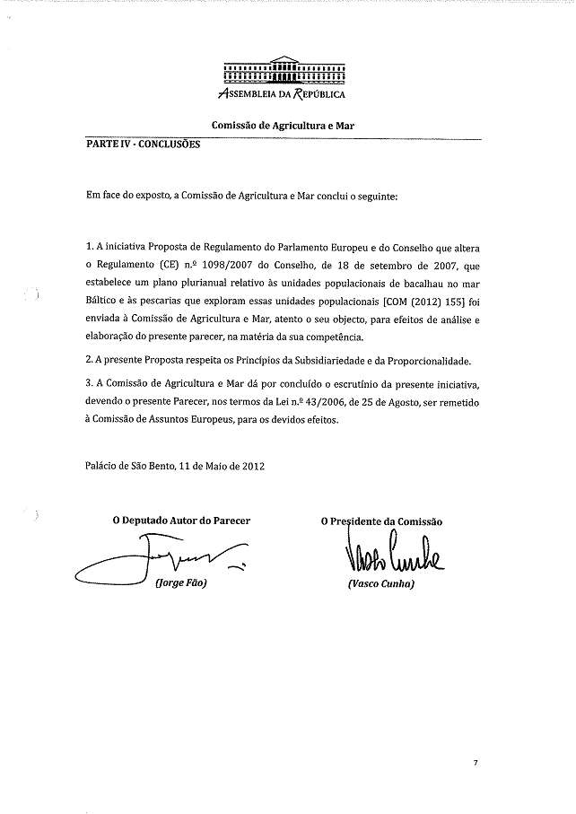__________________

Translation of this opinion may be available on the Interparliamentary EU Information Exchange site IPEX at the following address: http://www.ipex.eu/IPEXL-WEB/search.do

