 | 
COUNCIL OF  THE EUROPEAN UNION |  |  | Brussels, 14 May 2012
 | Interinstitutional File:  2012/0029 (COD) |  | 9966/12
EF 117
ECOFIN 409
CODEC 1313
INST 342
PARLNAT 235

COVER NOTE
from: | The President of the Portuguese Parliament
date of receipt: | 3 May 2012
to: | President of the European Union
Subject: | Proposal for a REGULATION OF THE EUROPEAN PARLIAMENT AND OF THE COUNCIL on improving securities settlement in the European Union and on central securities depositories (CSDs) and amending Directive 98/26/EC [doc. 7619/12 - COM(2012) 73 final]  - Opinions on the application of the Principles of Subsidiarity and Proportionality

Delegations will find attached the above mentioned opinion.

________________________

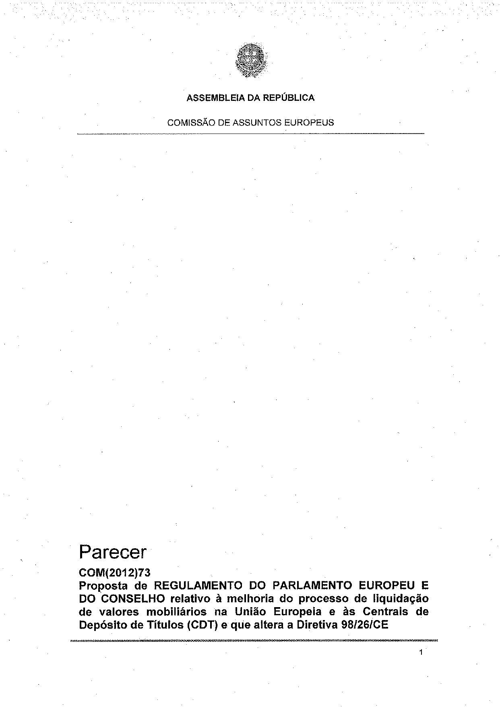
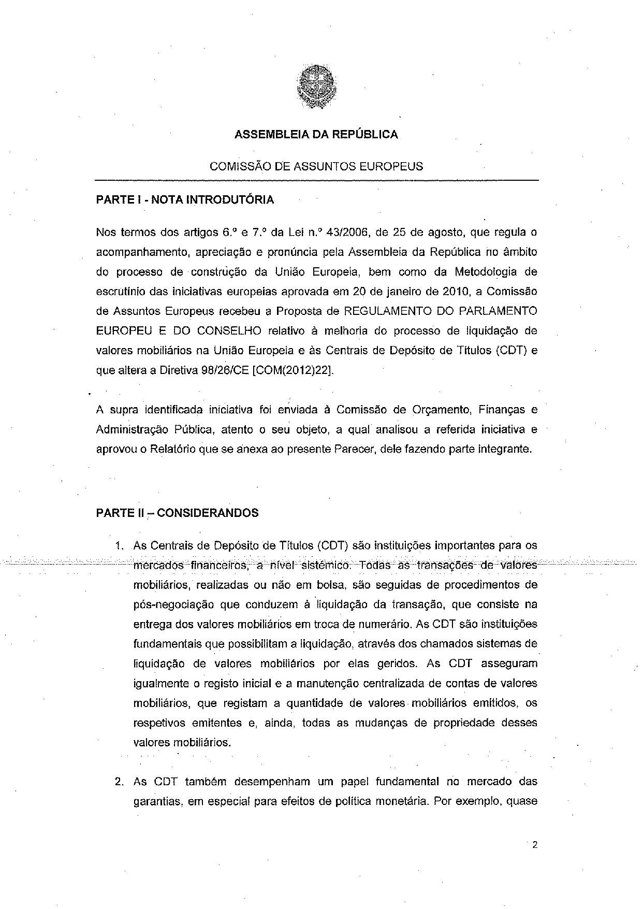
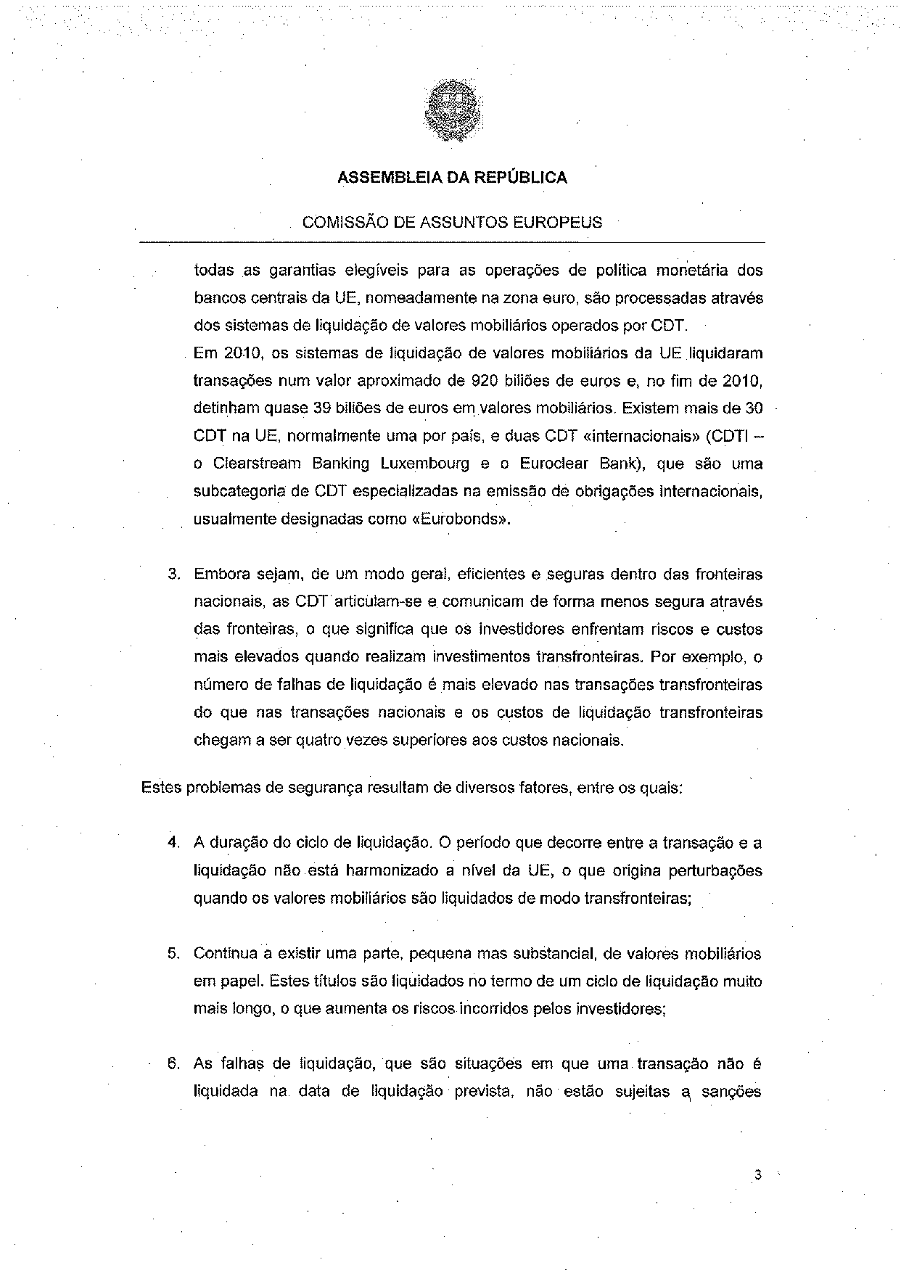
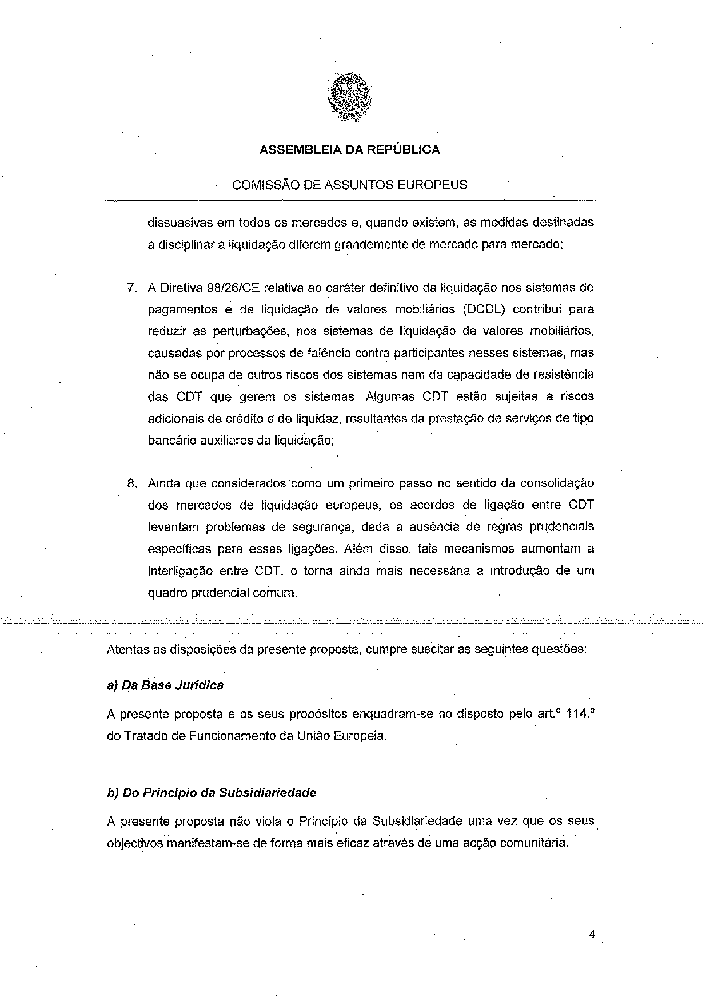
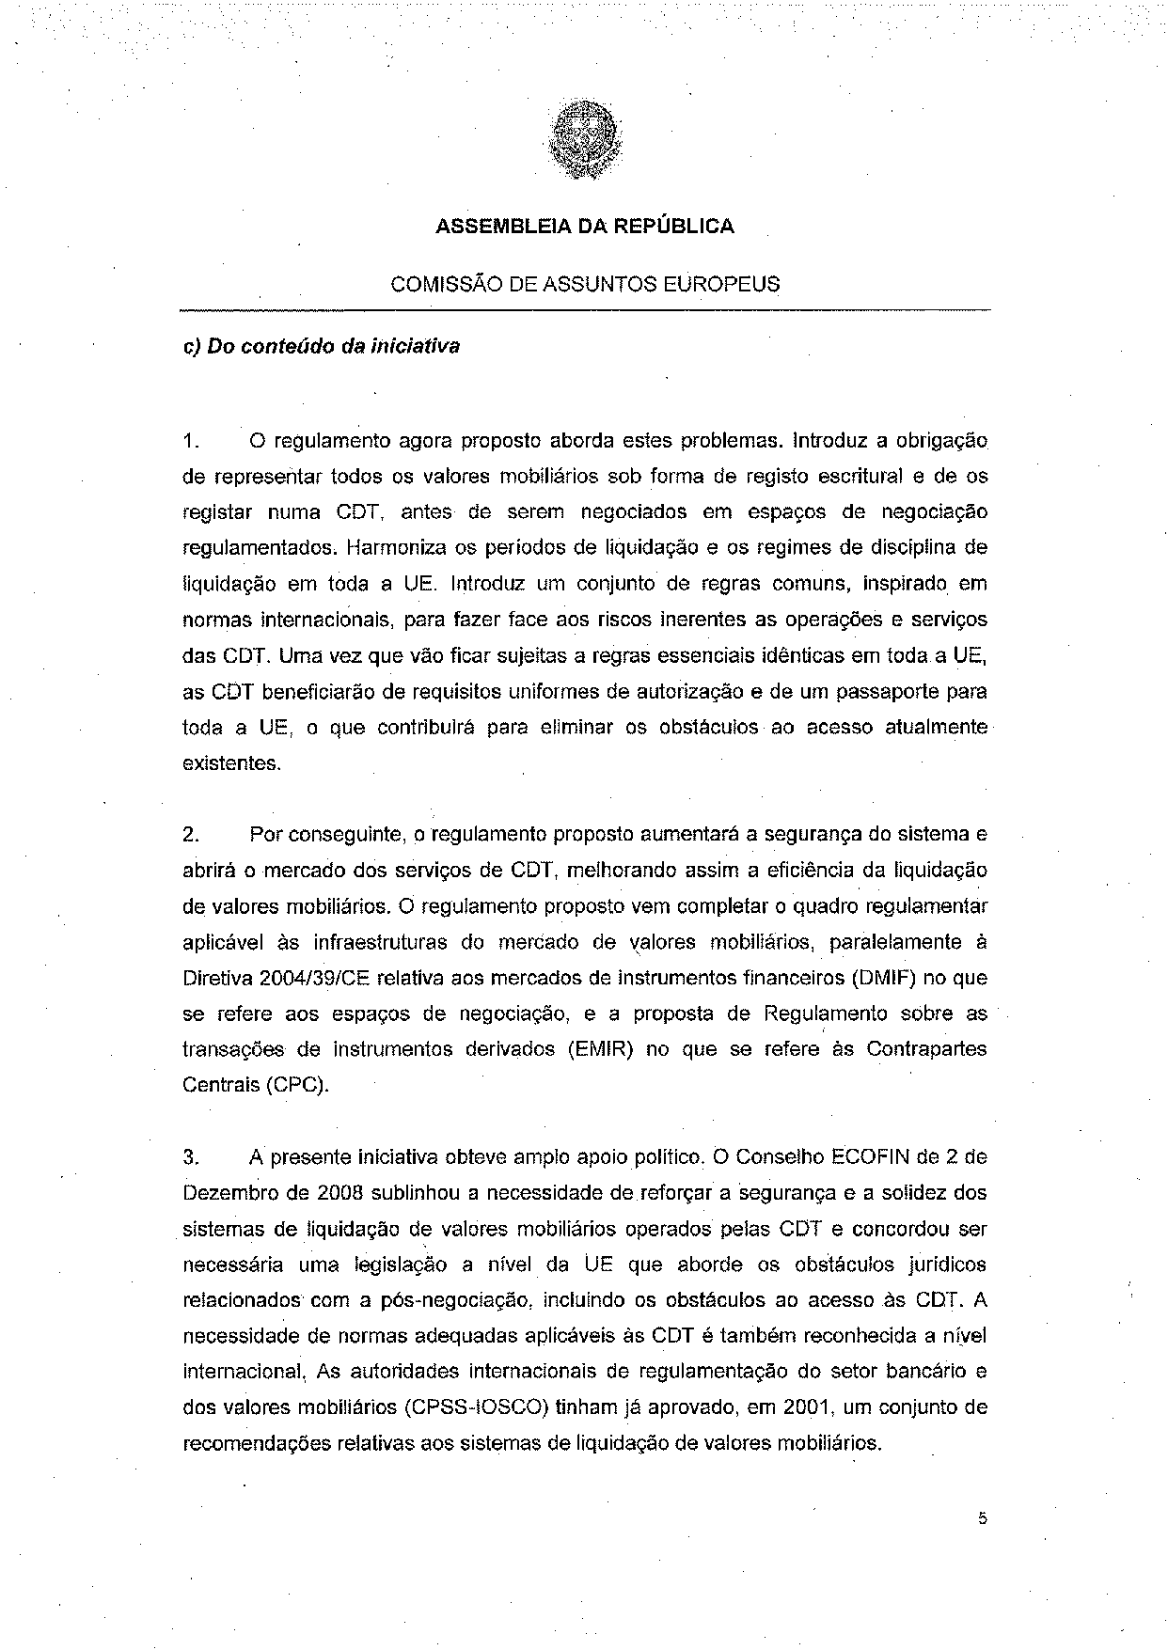
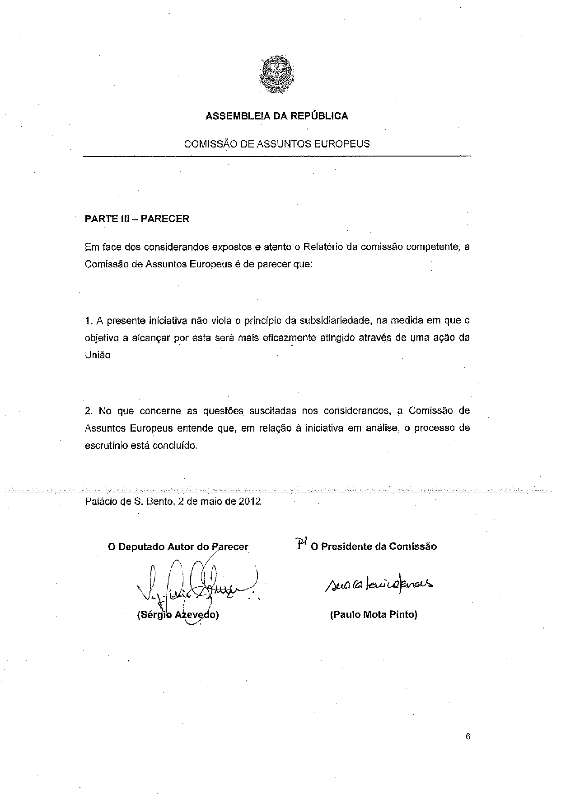
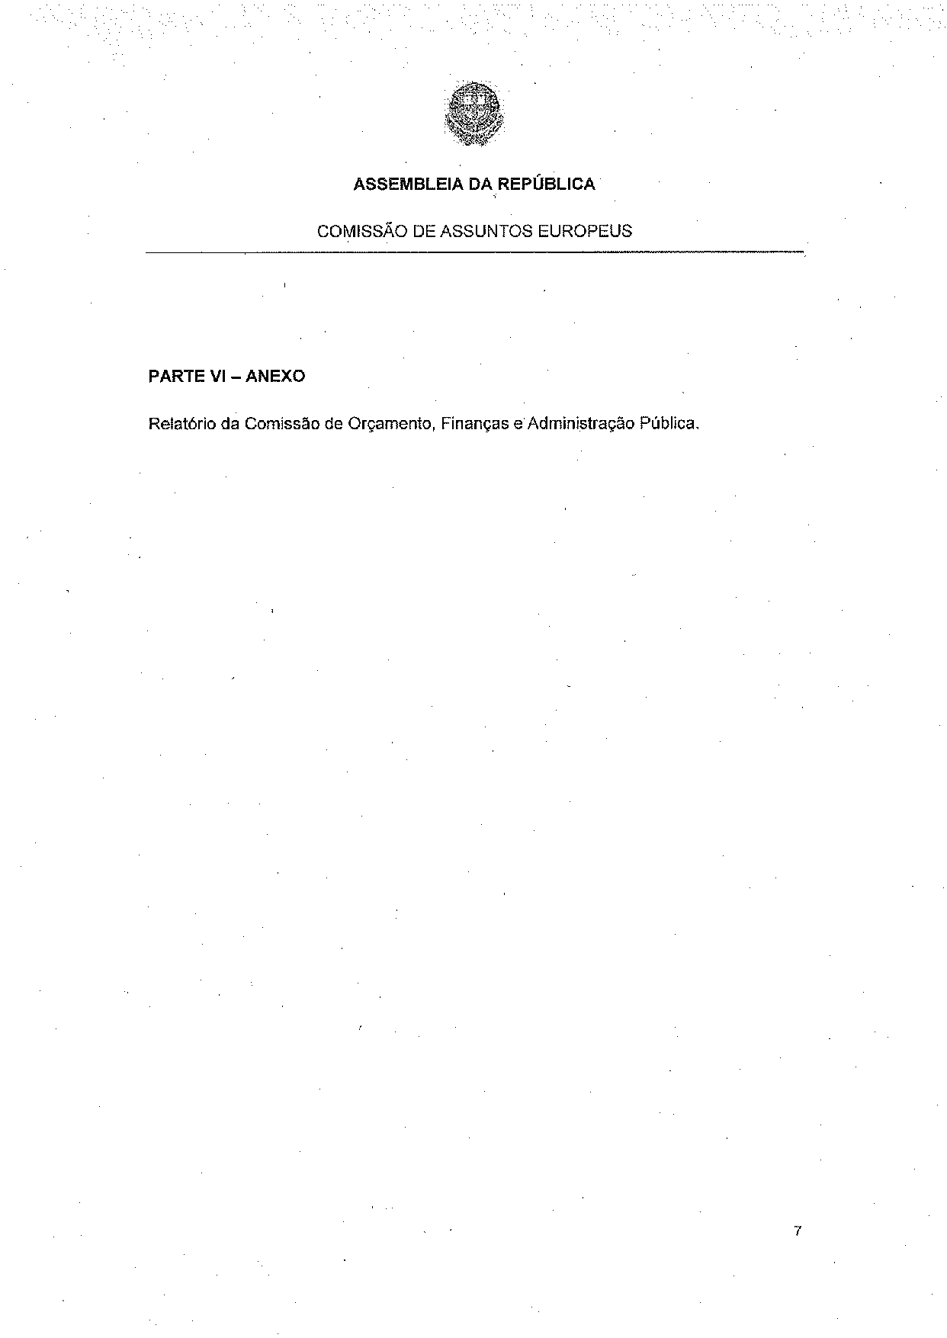

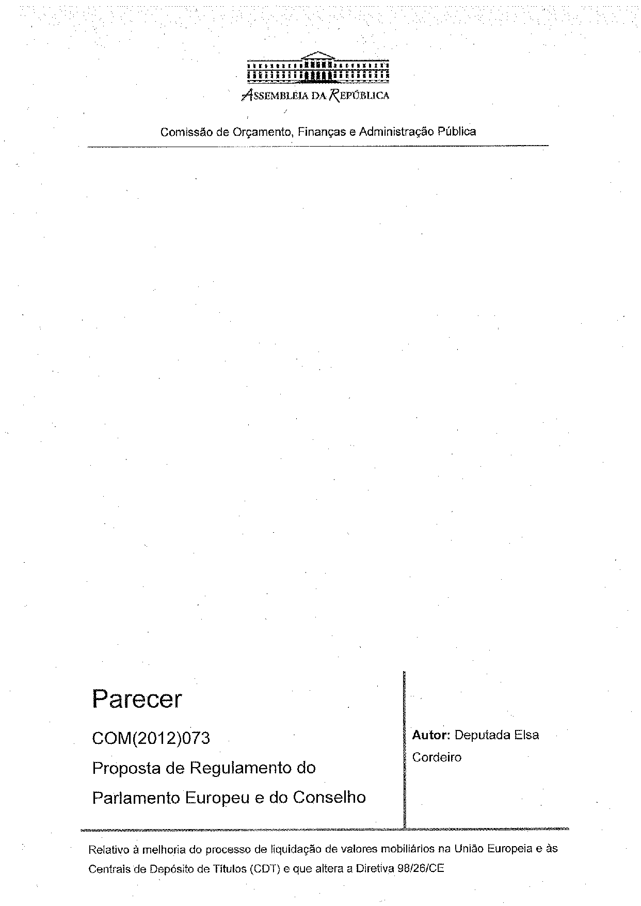
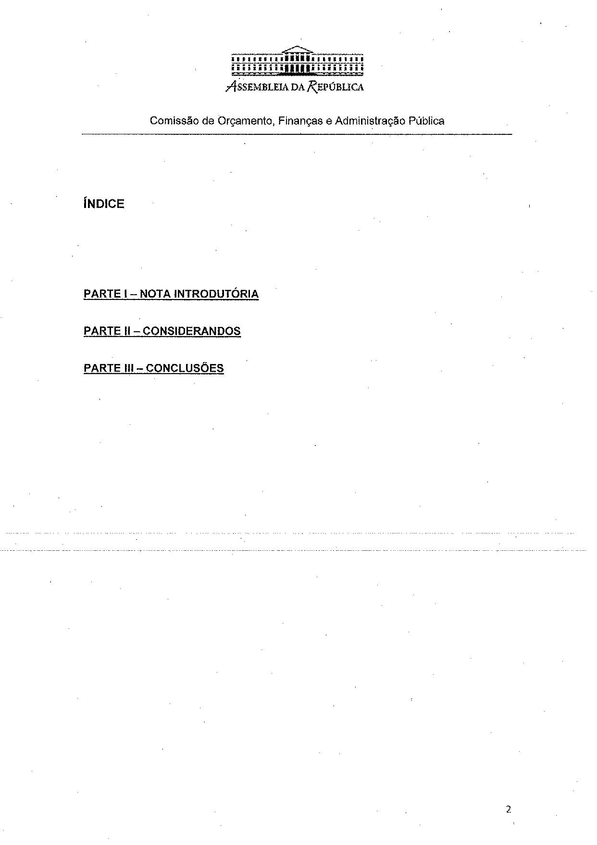
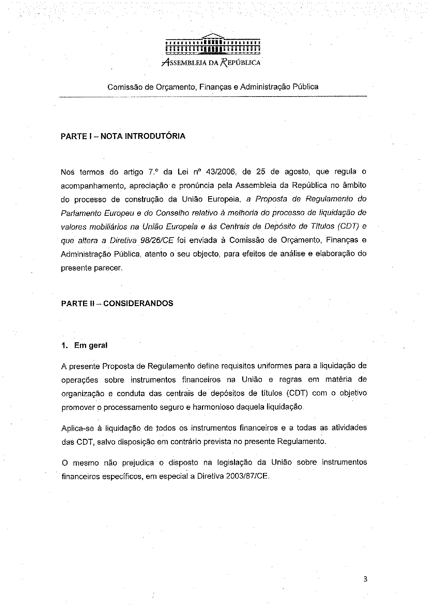
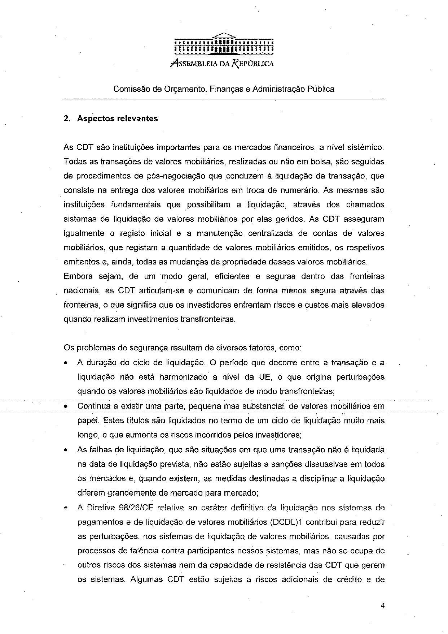
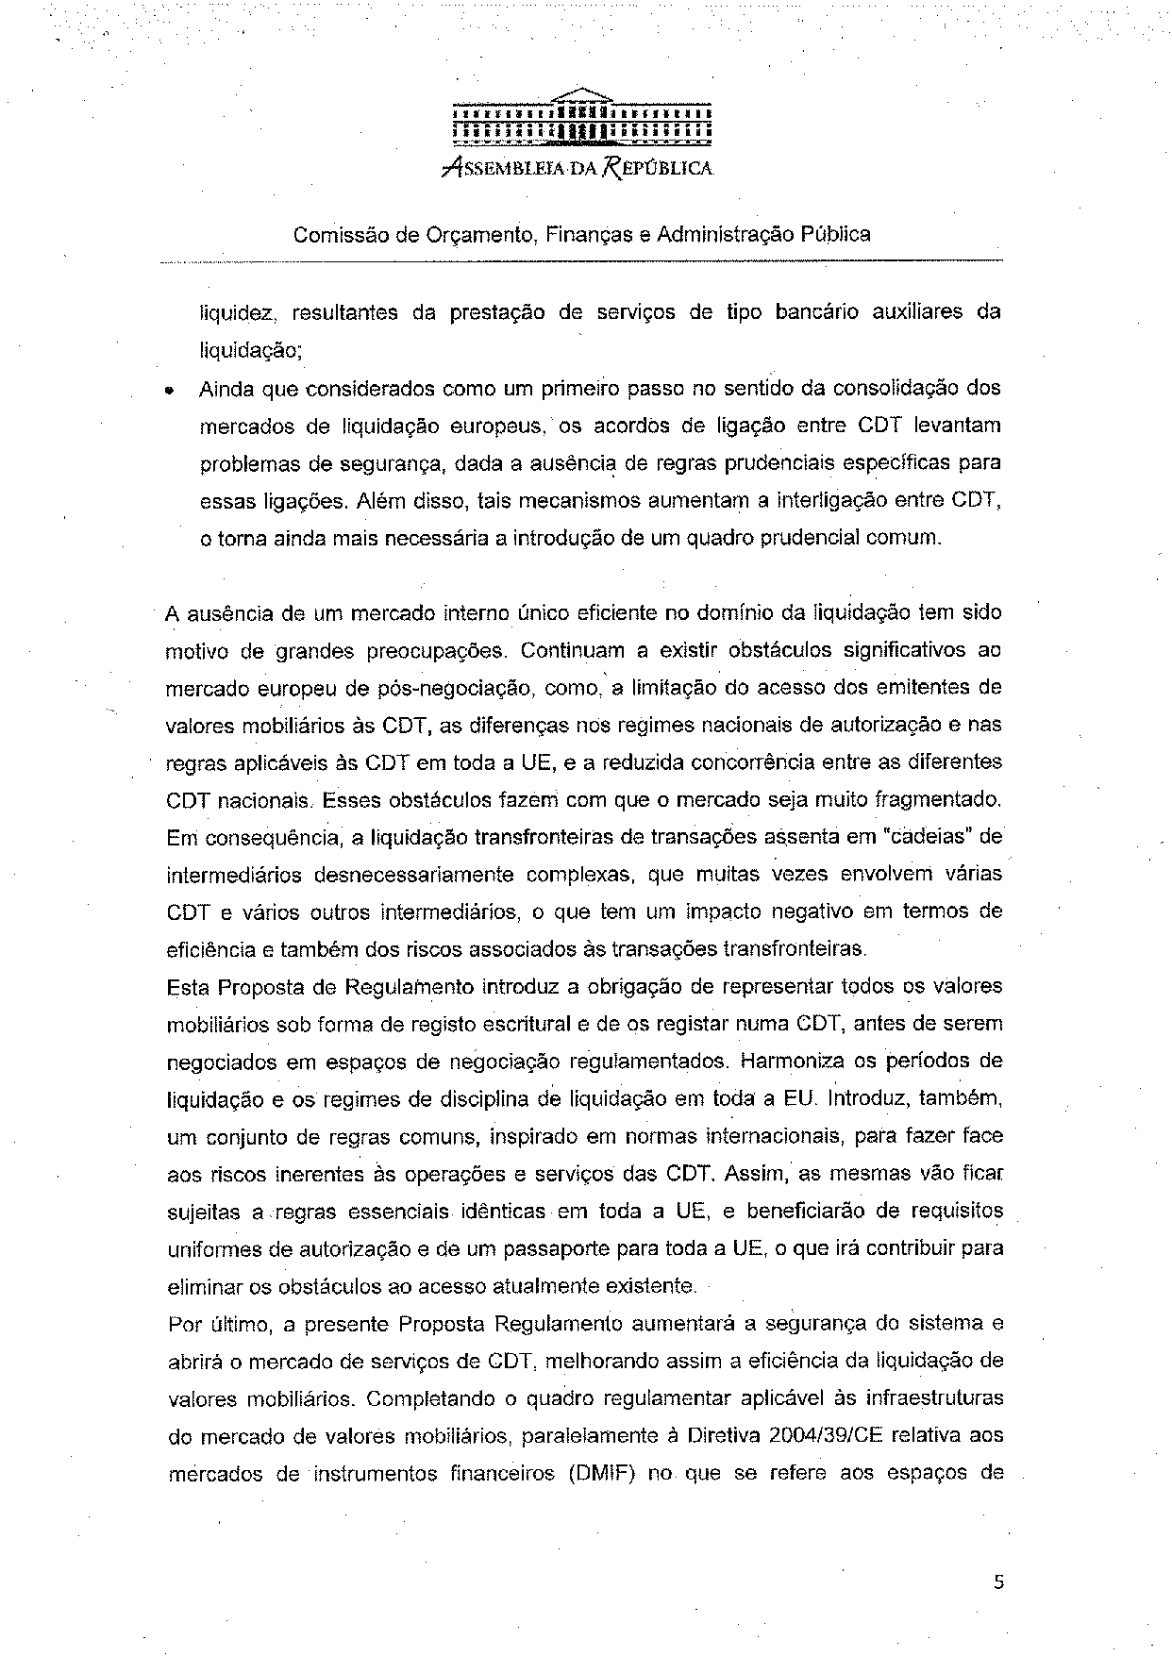
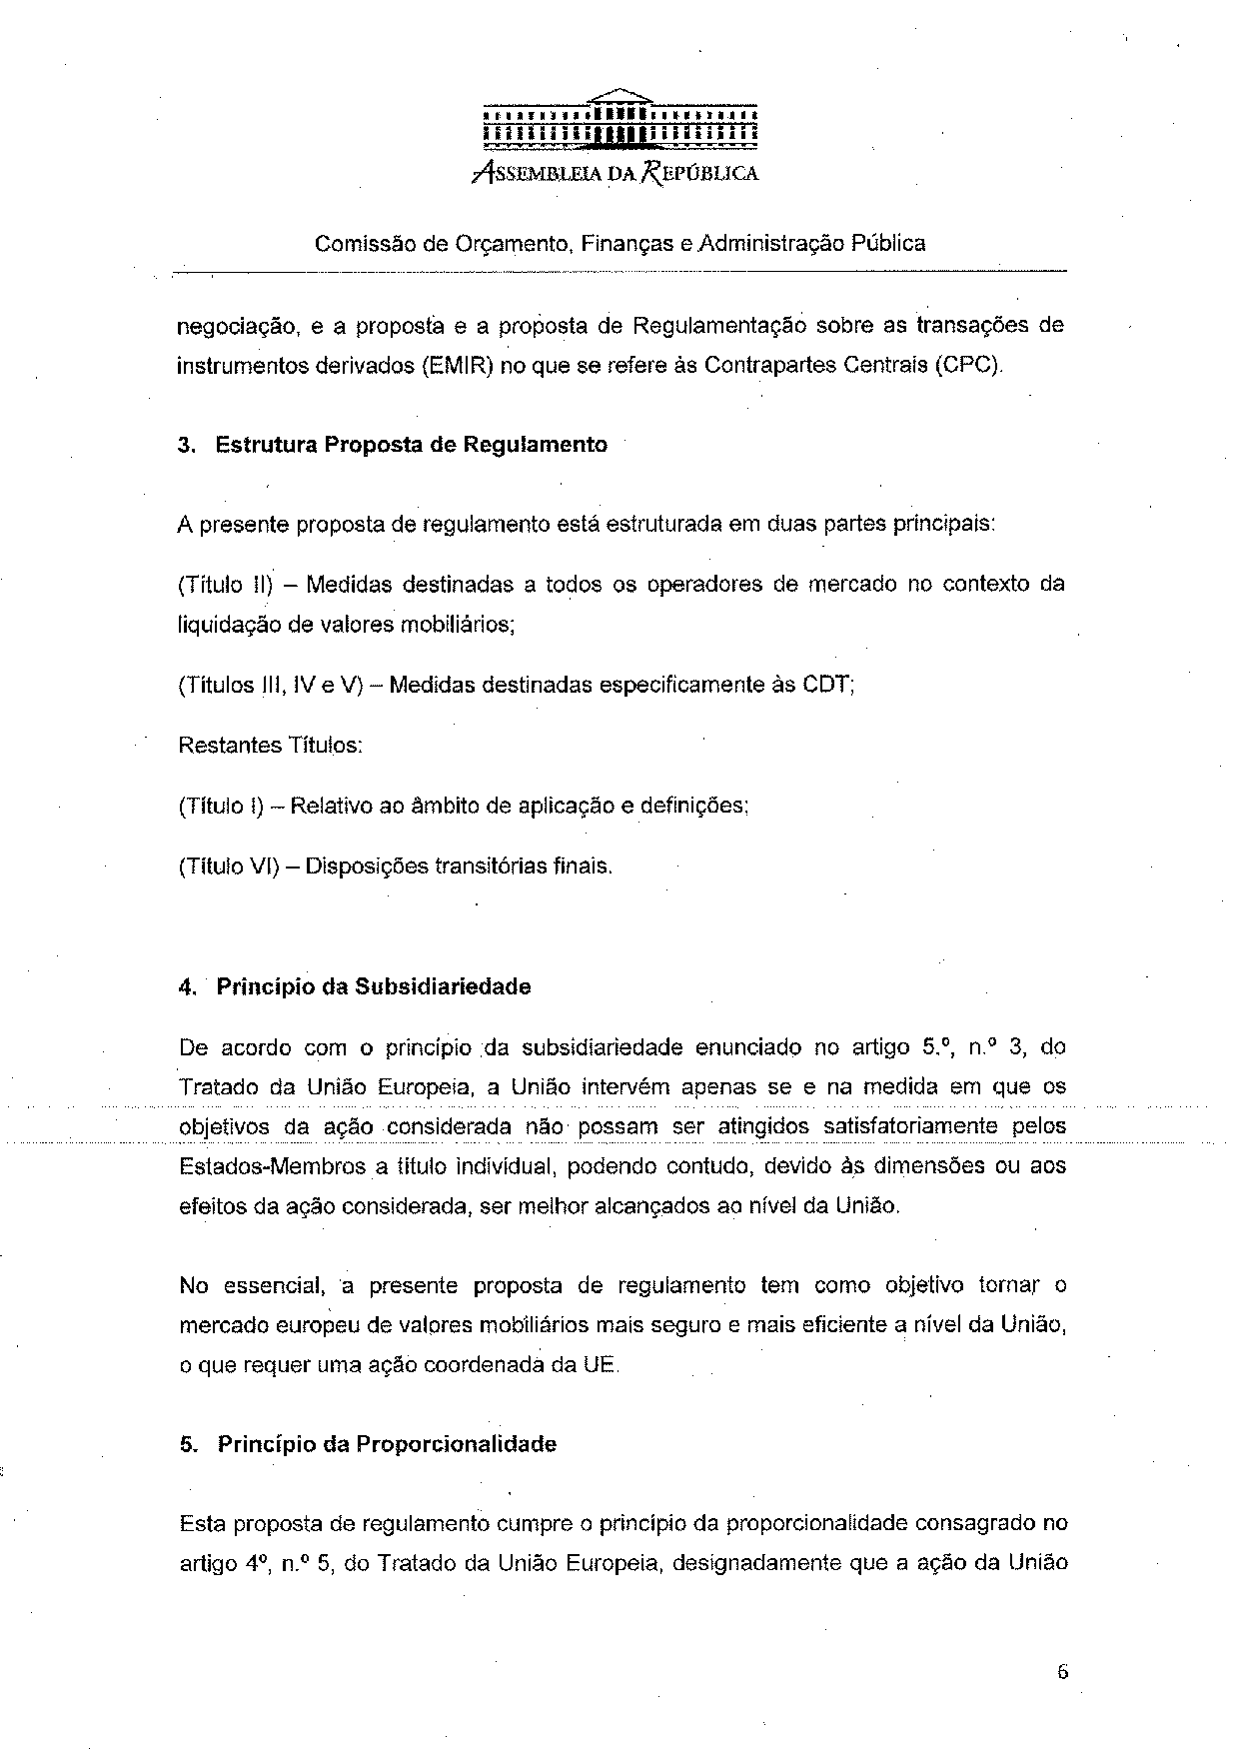
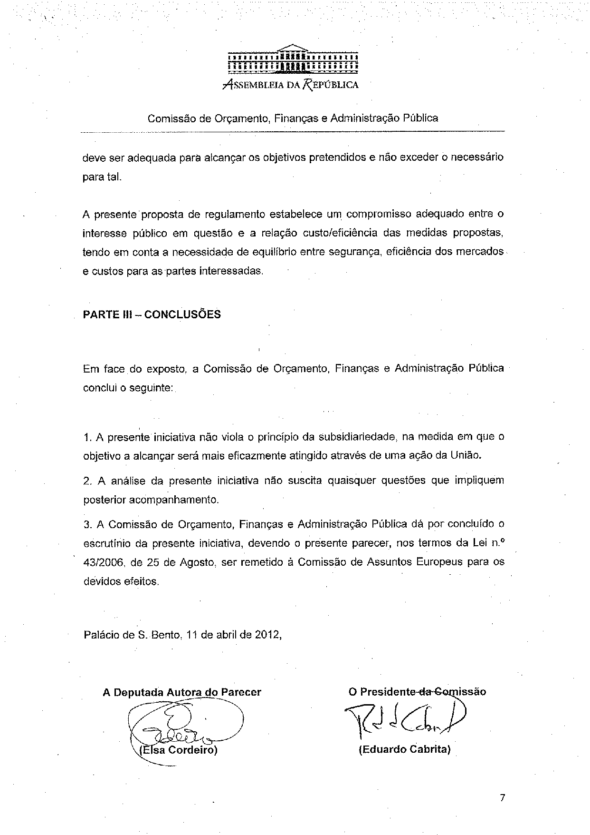

This opinion is available in English on the interparliamentary EU information exchange site (IPEX) at the following address: http://www.ipex.eu/IPEXL-WEB/search.do

