TABLE OF CONTENTS
1. Introduction 3
2. The key stages in the developing partnership between the European Union and the Outermost Regions 3
3. Recent socio-economic trends in the outermost regions 5
4. The new challenges: Europe 2020 and the outermost regions 6
5. Results of the study on "Growth Factors in the outermost regions" 9
6. Results of the study on demographic and migration trends in the outermost regions 13
6.1. Current situation of the OR 13
6.2. The impact of demographic trends by 2020 and 2030 17
6.3. Risks and opportunities: from handicaps to strong points 20
6.4. Main recommendations to face demographic challenges in the OR 22
7. Annexes 23
ANNEX I: Maps 23
ANNEX II: Statistics on the socio-economic and geographical profiles of the OR (Source: Eurostat) 28
ANNEX III: EU funds for the OR for the 2007-2013 period 30
ANNEX IV: Regional Europe 2020 indicators 31
ANNEX V: Regional GDP and unemployment in the OR 32
ANNEX VI: Examples of Innovative and Research Projects in Outermost Regions 33

1. Introduction
This document is a European Commission staff working document for information purposes. It does not represent an official position of the Commission on this issue, nor does it anticipate such a position. This Staff Working Document is a background to the Communication on "The outermost regions of the European Union: towards a partnership for smart, sustainable and inclusive growth". Its objective is to provide supplementary information and analysis on the issues raised in the main body of the Communication.

2. The key stages in the developing partnership between the European Union and the Outermost Regions
Since 1999, the EU has formally recognised the geographical and economic specificity of the outermost regions (OR): remoteness, insularity, small size, difficult topography and climate, and economic dependence on a small number of products. These specific characteristics constitute serious obstacles to economic growth. Over the years, the EU has adopted different programmes and measures in an effort to offset the negative economic impact of these obstacles in order to ensure that the OR can share in the benefits of the single market. In particular, over the period since 2004, the Commission has been seeking to set EU actions in favour of the OR within a strategic framework.
In 2004, the Commission defined the key axes of a strategic approach which had three main strands: accessibility and reduction of the effects of the other constraints; improving economic competitiveness; and promoting regional integration with their neighbouring regions and territories.
In September 2007, the Commission recognised the need "to continue the effort to adapt EU policies and for specific support whenever necessary". The Communication also launched a public debate on the future of the European strategy for the OR and referred, inter alia, to four themes with long-term implications and critical to the OR (climate change, demographic change and migration management, agriculture, and maritime policy).
In October 2008, the Commission drew the conclusions from the public debate and proposed a new paradigm vis-à-vis the OR: that of making the most of their unique characteristics. It identified certain sectors with growth potential and high added-value and gave examples of concrete actions and projects. In addition, and to develop the new paradigm, the Commission proposed to ensure that better use should be made of the existing EU instruments and put forward a series of measures for the 2007-2013 programming period, in the fields of climate change, demographic change and migration management, agriculture, maritime policy, strengthening partnership and other horizontal issues. Among the latter, it proposed to organise a bi-annual forum for the "outermost Europe" and to launch an important fact-finding study on the factors for growth in the OR (see Section 5).
Reflecting the partnership approach, the OR themselves have contributed constructively to the reflection on ways to improve economic performance and to break with the legacy of the past. In a memorandum adopted in 2009, the OR proposed a review of the actions undertaken since 1999 in favour of the OR, taking into account their development within a changing European and global context. A year later, in May 2010, the commitment to contribute to the establishment of objectives and priorities within the framework of the Europe 2020 Strategy and for the post-2013 period, led to the signature of a joint memorandum on the part of the national authorities of Spain, France, Portugal together with their OR. Meanwhile, the annual Conferences of the Presidents of the OR, also attended by representatives of the three Member States, the Commission, the European Parliament and the Member State holding the rotating EU presidency, have resulted in official joint declarations by the Presidents addressed to the European institutions.
In June 2010, the Council, in inviting the Commission to bring forward a communication on the OR, asked, firstly, for appropriate account to be taken of the needs and opportunities presented by the OR in its review of EU policies and, secondly, for work to continue on specific measures for these regions where appropriate, to reinforce partnership and to systematically evaluate the effects of the EU policies on the OR, in particular when carrying out impact assessment studies.
In October 2011, Mr Pedro Solbes, delivered a report entitled "Europe's Outermost Regions and the single market: the EU's influence in the world". Mr Solbes put forward a series of recommendations on ways to integrate the OR into the single market by making better use of their assets and to attain the objectives of the EU 2020 Strategy.
Finally, the MEPs from the OR in the European Parliament (EP) have also contributed to this debate and submitted to President Barroso in July 2010 the "common platform" of the Conference of the MEPs from the OR. In addition, the most recent contribution on the EU strategy on the OR under Europe 2020 came in the form of an own initiative opinion of the European Parliament adopted on 18 April 2012 on the "The role of Cohesion Policy in the outermost regions of the European Union in the context of EU 2020".

3. Recent socio-economic trends in the outermost regions
With regard to overall economic performance in the OR, this has been generally disappointing over recent years against a background of the wider European and global economic recession, although there are important differences between individual regions. As the Union entered the recession in 2009 with a contraction of 4.3% in levels of GDP, the national economies of Spain, France and Portugal contracted, respectively, by 3.7%, 2.7% and 2.9%. In 2009, the contraction was strongest in the Canary Islands (-4%), followed by Madeira (-3.6%). The contraction in the Azores compared to the other OR was less marked in 2009 with growth of -1%. There are no growth figures available for the French OR.
In the OR as a whole, average GDP per inhabitant in 2009 was no higher than the 2006 figure relative to the EU (see Annex V). In three OR, it even fell compared to the EU average. With the exception of Madeira, GDP per head in all the other OR lies below the figure for the whole of the respective Member State. In a few cases, the gaps appear to be widening. In one case, French Guiana, average GDP per head is no higher relative to the EU average in 2009 than in 2000.
At least some of the OR have potential opportunities arising from their proximity to countries that have not had the same depth of recession as the EU as a whole. However, these opportunities appear to be underexploited. For example, foreign trade for the French OR located in the Caribbean, situated close to the emerging countries of South America, remains weak (less than 8%). This can at least partly be explained by the difficulty of competing with producers in neighbouring countries, where salary costs, as well as social protection and other employment costs are often lower. Furthermore, the EU has been determined to resist short-termism and has insisted on maintaining the same high standards in terms of social and environmental rules in the OR as in the rest of the EU, but which do not apply in third countries. In general, between 2008 and 2009, the crisis caused a fall in imports and exports for the OR. The situation is slightly different in the Canary Islands, where the economy is more open to foreign trade, and also in the Azores and Madeira.
With regard to the labour market, since 2000 employment rates for the age group 20 to 64 years have generally increased in the OR. In 2009 and 2010, however, some experienced a rapid reduction of employment. In the Canary Islands, the employment rate fell from 67% in 2007 to 55% in 2010. This is a drop of 12 % points compared to a drop of 7 % points at national level in Spain. During this period, the unemployment rate in the Canary Islands almost tripled between 2007 (10%) and 2010 (29%). Youth unemployment increased from 22% in 2007 to 52% in 2010. Female unemployment rose from 13% to 28% and long term unemployment went from only 2% to 12% between 2007 and 2010 (see Annex V).
In the French OR, the effects of the crisis on the labour market were relatively muted. In Guadeloupe and Reunion, the employment rate dropped by 1 % point between 2007 and 2010, while in Martinique and French Guiana it increased by almost 1 % point. Unemployment rates in the French OR remain high, but did not change substantially between 2007 and 2010. The only exception is Reunion, where unemployment increased by 5 % points to 29% between 2007 and 2010 becoming the European region with the highest unemployment rate. Female unemployment rates are about 1 % point above the total unemployment rate and only increased in Reunion between 2007 and 2010. Youth unemployment is very high in the French OR (between 42% and 59%), compared to 23% for all of France. In Martinique and Reunion, the youth unemployment rate respectively increased by 14% and 7 % between 2007 and 2010.
In the Azores and Madeira, employment rates are high (70% and 72%) and barely changed between 2007 and 2010. Unemployment rates in 2010 were around 7%, which are lower than in Portugal as a whole (11%), although the figures for 2011 are likely to increase and be similar to those in mainland. Youth unemployment was around 17% in 2010, also lower than the national figure of 22%. Female unemployment rates in 2010 were between 6% and 7% well below the national figure of 12%.

4. The new challenges: Europe 2020 and the outermost regions
The Europe 2020 strategy for smart, sustainable and inclusive growth contains five headline targets to be achieved by the EU as a whole, which are quantified through a number of indicators. This limited set of EU-level targets is translated into national targets in each EU country, reflecting different situations and circumstances. While not regional as such, the targets have been analysed on a regional basis by the Commission in the Seventh Progress Report on economic, social and territorial cohesion ("The urban and regional dimension of Europe 2020"). The aim is not that all regions should reach all the national or the EU targets but that significant progress should be made in that direction.
In assessing the position of the OR against the EU 2020 targets, and indeed for any region in the EU, the immediate constraint is that of the absence of certain statistical data below national level.
As shown in the Seventh Progress Report, with regard to certain indicators, some of the OR feature among the ten EU regions most distant from their respective national 2020 targets. In this vein, the above mentioned study on demographic and migratory trends in the OR suggests that the Europe 2020 objectives are probably unrealistic for most of the OR within the timeframe, for example, in terms of improvements in schooling performances or employment rates. The same can be said for environmental targets (except as regards renewable electricity production in some OR).
Most of the OR are behind the EU averages in a range of social and economic indicators. This is notably the case for education standards, employment rates, GDP per capita (except for Madeira and the Canary Islands), levels of health care and environmental protection with a tendency for the OR to be more sensitive to the impact of the economic crisis than the Member States to which they belong.
On all three of the targets related to smart growth, the available data for Spanish and Portuguese OR show that they have a low score, considerably lower than for their respective country. R&D expenditure is only around 0.5% of GDP, which is probably linked to the lower shares of manufacturing in their economies. The share of population aged 30 to 34 with a tertiary education is some ten percentage points below the national average in the Canary Islands and the Azores, while in Madeira it is only slight below the Portuguese average. The early school leavers' rate is much higher in the Azores (49%) and Madeira (41%) than the (already high) rate for Portugal 32%, which makes the target of reducing it to 10% by 2020 seem particularly daunting. For these three indicators no data for regions in France are available.
The employment rate is well below the national 2020 target in the Canary Islands (55% compared to 74%) and the four French OR (between 50% and 55% compared to 75%). In the Azores and Madeira, however, employment rates are quite high (70% and 72%) and close to the national average (71%) and target (75%).
The Europe 2020 strategy also aims to reduce poverty and exclusion. At-risk-of-poverty-or-exclusion rates are unfortunately not available for the French OR. Nevertheless, it is likely that, where household income is only between 50% and 65% of the French average household income, poverty and exclusion rates are much higher than in mainland France.
The Canary Islands have a household income which is 86% of the Spanish average. The at-risk-of-poverty rate is 31%, considerably higher than the Spanish average of 21% in 2010. The at-risk-of-poverty-or-exclusion rate is also higher than in the rest of Spain (35%) compared to 25% in 2010.
The two Portuguese OR offer a contrast. The Azores had the same average disposable household income as all of Portugal in 2008. But it has a higher at-risk-of-poverty rate of 25% compared to 19% for all of Portugal in 2005. Madeira's disposable household income was 7% higher than that of Portugal as a whole in 2008. It had a lower at-risk-of-poverty rate of 17% compared to 19% in 2005. So while the Azores have a higher share, Madeira has a lower share of poor people. However, these figures do not take into account regional differences in cost of living.
Over the next few decades, considerable efforts need to be expended to improve the social and economic cohesion of these regions. Education and employment creation through new investments are the key domains. These are of prime importance because education shapes opportunities for access to employment for young people arriving on the labour market and increased numbers of jobs is the only solution to maintaining effective dependency ratios at a socially affordable level.
Job creation is a real priority. The recommendations of the European Commission to national governments in its communication called "Towards a job-rich recovery" published on 19 April 2012, concern also the ORs issues. This proposal focuses on the demand-side of job creation, setting out ways to encourage hiring by reducing taxes on labour or supporting business start-ups more. It also identifies the areas with the biggest job potential for the future: the green economy, health services and ICT.

5. Results of the study on "Growth Factors in the outermost regions"
A study entitled "Growth Factors in the OR" was launched by the Commission in 2009 to identify opportunities for economic growth in these remote territories of the EU. Its main objectives were: 1) to deepen the understanding of the process of economic development in the OR; 2) to identify strategies to improve competitiveness and reduce dependency on imports and external public transfers; and 3) to identify flagship projects in line with Europe 2020.
The final report of the study points out that, despite their common structural constraints (remoteness, small-scale economies, low specialization, much higher living standards than their respective geographic neighbours, large flow of transfers from mainland, private and public consumption as main determinant of growth, insufficient private investments in competitive sectors, lack of qualified manpower and of specialised skills, lack of regional integration, etc.), the OR also have considerable endogenous potential such as in their exceptional biodiversity and marine ecosystems with potential for producing renewable energy, in advanced agro-environmental research and in climate change research.
Traditional and emerging sectors
In recent years, official development strategies have begun to change, going beyond the old models of the past.
Analysis on the ground (interviews with stakeholders and examination of official documents) demonstrates that new fields of development are being pursued, focusing on the potential of each region. At their current stage, which is an initial stage, these new fields cannot offset structural imbalances, particularly in terms of employment. However, the new approach, focusing on the strengths of the OR, can be seen as the most effective way of producing a model of growth that is less dependent and more competitive, provided that the OR succeed in developing these new fields in a competitive way.
A strategy such as this leads to a development model that is similar in all the OR with comparable potential, which could lead to synergies and complementarities which are currently not apparent in any specific way.
The current transition phase is based on a mix of old and new sectors, in which modern agriculture, tourism and private services are gradually increasing their competitiveness and gaining access to wider regional markets. In addition, the OR aim to develop new sectors in industry and advanced services (e.g. financial services, technology transfer, etc.). With this end in view, significant public investment has been made in research and knowledge.
In economic terms, the concept of growth potential is connected to untapped resources, both human and/or natural, upon which a region’s production process can rely, developing new technologies and skills or a new form of organising production factors. This definition fits well with the strategy needed in order to put the potential of the OR to good use. The mix of endogenous resources, new technologies and the way that factors are organised may give rise to a competitive advantage in the production of certain goods and services.
Potential growth in the OR may derive both from restructuring the traditional sectors of tourism, agriculture and fisheries and from new specialisations resulting from the application of research and innovation to old and new sectors. New skills, requiring high abilities, and well-focused, market-oriented applied research are necessary to sustain the process.
Traditional sectors
In the majority of the OR, a high proportion of the workforce is employed in agriculture, thus maintaining their unique environmental and cultural landscape and ensuring that the local food market is supplied as well as, to varying degrees, providing exports. Given the access and isolation problems, agriculture cannot be neglected if the OR wish to lessen their dependence on imports and preserve the landscape. Production and employment in agriculture are, however, on the decline and can only be strengthened through product differentiation and specialisation. This can be achieved with the support of the current investment in RTDI, by using new techniques and discoveries to expand the variety and quality of products and to strengthen integration and competitiveness within the agri-food manufacturing chain.
Besides, the European Commission stressed "the extreme richness of biodiversity and cultural heritage, the particular geology and location of these regions providing Europe with opportunities to push back the boundaries of our knowledge, helping to find new ways ahead to deal with the key challenges facing us such as globalization and climate change".
This strategy to develop the regional potential linked to climate, environment and local know-how is pursued by most OR, with differing results and impact on regional revenue. Specific opportunities have emerged from alternative uses for sugar cane, the production of new varieties of fruit and vegetables, livestock, fish farming, etc. These developments can be enhanced by more focused and more market-oriented research and by forms of clustering and networking designed to mobilise private-sector operators, who, in general, remain weak. The current balance between the support of existing production and the speeding up of changes in product types should be carefully considered by the authorities responsible for agricultural and fisheries policy.
Tourism has significant potential in most OR and in some of them is a key sector for employment and external trade. It is based on an exceptional natural and cultural environment. The conflict between tourism and the preservation of the environment in coastal areas and greenbelt areas needs to be handled properly by the regions as a precondition for making tourism development sustainable in the long term and allowing a real growth in alternative tourism products. Although tourism is well-developed in most cases, its products are still traditional and suffer from increasing external competition; its potential is based on product differentiation to adapt better to demand segmentation, in contrast to standard mass tourism products. This should increase quality and profitability and should allow the range of tourism products offered by the OR to occupy new niches. At present, areas of specialisation such as eco-tourism, social, cultural or wellnesstourism are still in the process of being developed. The restructuring of the range of tourism services on offer gives an opportunity to invest in new, smaller and more flexible establishments for hosting tourists, which are also more environmentally sustainable. In this respect, ad hoc vocational training is vital in most OR to ensure that products are differentiated and that their quality is upgraded.
Emerging sectors
A host of new sectors and products may emerge from the application of RTDI to the development of the biodiversity which is a feature of the natural environment in the OR, from forest to marine eco-systems. A list of applications is envisaged by local authorities in the sphere of health, natural medicine and cosmetics, and many other sectors, such as food, energy or materials for eco-construction and wood.
Many dimensions of the green economy can be developed to make the most of the exceptional natural environment and marine biodiversity of the OR. The development of competitive advantages in the area of the green economy is the most promising prospect in terms of growth and employment opportunities; it is also the most demanding in terms of the conditions that need to be met, ranging from the availability of scientific and technological skills to the presence of RTDI targeted at the market, and the local exploitation of innovation through spin-offs from research. On the whole, these conditions have not yet been met and current regional RTDI policies fall short of extending the research value chain to reach business applications, or to create a critical mass for developing new products and services. This difficulty is, however, common to most of the EU’s convergence regions, particularly those which do not have a knowledge-based industry able to lead the process. Policies of this kind are still too young and it will only be possible to perceive their results in the medium term, if the above conditions are met, and if the obstacles are overcome by fine-tuned initiatives. Regional policies need to focus human and material resources, make them more market-oriented, and not spread them over too many potential fields, preventing the emergence of the necessary critical mass.
The OR have had serious problems in ensuring a regular supply of fossil fuels, and are penalised by high provision costs, due to difficulties in access and distribution. During recent years, the development of renewable energies has been pursued and favourable natural and environmental conditions exist for developing various sources of renewable energy, through wind power, solar and photovoltaic energy. In addition, in some OR there is a growing expertise in RTDI that can be drawn upon. Island status and small size encourage a wide-scale development of small plants, which could aim to satisfy a much greater share of demand, given the higher cost of traditional sources and their unreliability. Currently, a number of experimental plants and good practices may lay the foundations for a more organised and better planned development of the renewable energies that would be worth pursuing at regional level.
Currently, environmental services dealing with water and waste are a problem, because these issues have not yet been resolved in a satisfactory way in most OR, despite efforts to do so. Significant investments are needed to meet needs and provide the opportunity to create local skills and equipment that can be exported at regional level, provided that this is cost-effective.
In the majority of the OR, maritime services and port activities can be developed in relation to cruise tourism and sailing tourism, ship maintenance and transit services. To make these developments financially sustainable they need to have a significant positive impact on the provision of local products and services. Most of these developments draw upon the geostrategic position of the islands in the Caribbean sea, in the Atlantic and in the southern Indian Ocean; however, they need to be supported, in most cases, by large investments which, if not properly accompanied or preceded by the appropriate feasibility and market studies, are in danger of ending up as under-utilised infrastructure and imposing a high opportunity cost, thus preventing the regions involved from investing in other infrastructure that may perhaps be more useful.
At the same time, personal care services (health, medical and social care) are well developed and supported by skills and research. Their potential for growth in the OR is basically linked to the opportunity to export these services and the skills developed on the local market. The geographical regions where the OR are located have a much lower standard of such services, and this creates opportunities.
The geopolitical location of the OR and especially of the French OR and the Canary Islands allows for the development of geostrategic investments to exploit their proximity to key markets in the Caribbean, Latin America, West Africa and the Indian Ocean. This potential needs to be developed through an initial phase of regional cooperation involving local stakeholders, firms and all private-sector operators; once this cooperation provides concrete opportunities to exploit the “gateway” function of the OR (production and external trade), external policies will need to take these opportunities into account.
In conclusion, the potential of these sectors and products, and the conditions for their development briefly described above, allow a positive view of the future, provided that the policy choices resulting from them are followed by consistent, systematic implementation in the medium and long term, with a good balance between a radical improvement of the traditional sectors and the creation of a sufficient space for new products and sectors to grow.
Finding this balance is probably the most delicate part of the strategy, because resistance and obstacles to change are likely to arise and the policy carried out needs to ensure that change does actually take place, and does so with sufficient speed. To that end, aspirations for change must be shared by the local stakeholders and by the social groups most closely involved, through the creation of appropriate partnerships. Currently, the new sectors are starting to emerge in different ways in the economies of the OR, but they have not yet reached any significant economic size and are not represented in a comprehensive set of “flagship projects” in which the local public and private stakeholders could invest their energies.
In brief, the analysis demonstrates that the OR cannot be considered as a uniform whole. Disadvantages can be dealt with satisfactorily with appropriate policy approaches. Minimising disadvantages is therefore not only desirable but also possible.
Flagship projects
The study has identified some flagship projects whose implementation would contribute to sustainable growth. Many of these flagship projects relate to the need for urgent interventions, mainly public, to realign the basic infrastructure of the OR to the level of that in the EU: transport, waste management and processing, tourism, education, etc.
However, the list of projects reveals common features and needs:
- Supporting economic diversification, through activities linked to innovation, and the structuring of key sectors (both traditional and emerging).
- The wish to base future economic growth on local natural resources and assets (including agriculture, the sea and biodiversity).
- The inclusion of environmental and energy concerns, in particular the need to ensure a greater self-sufficiency in energy through the development of renewable energies and the promotion of energy efficiency.
- The rebuilding of the tourism strategy in regions that are already tourist-oriented (the Canary Islands, Madeira, Guadeloupe, Martinique) and a greater emphasis on the tourism sector in the other outermost regions (Azores, French Guiana, Réunion), against the backdrop of the economic crisis, which has a negative effect on the attractiveness of the OR.

6. Results of the study on demographic and migration trends in the outermost regions

A study entitled "Demographic and migration trends in the OR: impact on economic, social and territorial cohesion" was launched by the Commission in 2009 to contribute to enhancing knowledge of these phenomena by providing a tool able to offer for each OR: In more concrete terms, this study should (a) take stock of demographic change and migration (demographic situation, education, employment, economy, health, life conditions, environment and natural resources); (b) analyse the impact of demographic and migration trends, in the short and medium-term, on the economic, social and territorial cohesion; and (c) highlight the main demographic trends and their impact on the economic and social cohesion of these territories, in particular, the threats and opportunities posed by these phenomena, taking into account their specific constraints.

6.1. Current situation of the OR

Demographic trends

The OR are a very heterogeneous group and share similar characteristics with their mainland countries. The natural growth of the population compared to the EU average is below in Portugal and Madeira and only higher in Azores, Spain and the Canary Islands. In contrast, natural growth in France and the French OR is higher than the UE average because of higher fertility levels. The migratory flows have a strong effect on the shape of the age pyramids of the OR. The Spanish and Portuguese OR have become immigration destinations but the economic crisis deeply affected migration. Meanwhile, Martinique, Guadeloupe, and Reunion Island receive only moderate number of international migrants in contrast to French Guiana, and periodically St Martin, where the crisis has so far relatively little the effect.

The flows of irregular migration had considerably decreased prior to the crisis and are currently low scale in Canaries. In French Guiana, St Martin (and, to a lesser extent, Guadeloupe), irregular migration seems less dependent on the economic climate and continues at a significant level.

As regards the OR’ ‘internal’ migration within countries or the EU, the French OR experience much higher ‘pendular’ migration with their mainland metropolises than the other OR. However, numbers of EU migrants, mostly retirees from Northern EU states, are higher in East Atlantic OR.

The migration balance is slightly negative in the French Antilles, but it is highly positive in St Martin and French Guiana. It is somewhat positive in Azores and Madeira and it has recently witnessed a steep decline in the Canaries, due to above mentioned factors.
Ageing is one of the major problems facing the French Antilles and the eastern Atlantic OR. In contrast, the main challenge facing French Guiana and St Martin is population growth. Meanwhile Reunion Island faces both ageing and population growth, but at more moderate levels.

These population dynamics, and the structural changes the OR experience, have important consequences in several socio-economic domains: increasing needs in education services and job creations for populations experiencing rapid growth in the numbers of young people; the possible drop in the economically active population and rises in health costs for ageing population.

Education

In socio-economic terms, the eastern Atlantic OR appear more similar to the continent than the French OR to mainland France. In comparison to the continent, a far higher proportion of young people do not complete their secondary education and skill levels are lower.

Illiteracy, failure or school dropout reflects a relative inadequacy of the education system, both in quantitative and qualitative terms. The intergenerational reproduction of poverty has an impact on the cultural environment and thus on the relationship to education. Education and the acquisition of skills remain severe problems in the OR. Despite the immigration of skilled people from the continent or from other parts of the EU, the proportion of young adults (30- 34) with higher education diplomas is lower than in the mainland states, partly owing to the sizeable emigration of educated native-born.

Migration therefore has a highly selective influence on the skill levels of the working population in the OR. The most skilled leave the French OR whereas a majority of young people with few skills and less potential for finding employment remain in the region. This double selective process partly explains the high level of unemployment, the social exclusion of a high proportion of young people and the continuing need for training.

Employment

The low education level of a sizeable section of the OR populations has repercussions on their opportunities within the labour market. In turn, this has an impact on the economic development of these regions. The situation has worsened since the 2008 crisis.

Whilst employment remains higher in the Azores and Madeira than in Portugal or than the EU average, in the Canaries, in relation to Spain the economic crisis set off a fall in employment. As a result, unemployment levels in the Canaries are almost at the level of those in the French OR, with rates of about 50% amongst the young active population. Despite a recent increase, unemployment remains at moderate levels in Azores and Madeira.

In 2010, apart from the Azores and Madeira, employment rates amongst the economically active population (20-64) were much lower than the EU average. The deficit in female employment rates is particularly strong in French Guiana, the Azores, Reunion Island and the Canaries shows show that it is possible to increase female employment.

Reducing unemployment and the exclusion of young people from the labour market would be a means to increasing employment levels. Furthermore integrating young people into the labour market improves their personal social status and prevents them to fall further in ‘social rupture’ and violence. Employment structure in the OR, with its heavy reliance on the service sector, does not provide many opportunities for less-skilled people.

What is at stake with the ageing of the population here is the future increase of effective dependency ratios, the burden falling on the actively occupied population. Such dependency ratios constitute a direct threat to the funding of social policies in the OR in a context in which social policy is decreasingly funded by central state.

Economy

Until 2000-2001, the GDP per inhabitant in the OR grew rapidly, with average rates of around 6%. (even 8% in the Azores and 11% in Madeira). French Guiana has been an exception, with far lower rates, not due to lower economic growth but to faster population growth than in the other OR.

Economic growth slowed in all the regions after 2002, levelling off at around 4% annually until 2007 (but at 6.6% in Madeira). This growth, higher than in mainland states, reduced the gap between OR and the continent. From 2008 onwards, the crisis reversed the trend, except in the Azores and Madeira, and the difference between the EU and the OR started to increase again.

The productivity is lower in the OR, especially in the French OR, economic convergence towards the EU averages is far from being achieved, apart from in Madeira, and is being further hampered by the financial and economic crisis.

The economies of the OR are focused on the service sector, which represent over 80% of added values. In French Guiana and the Azores, this is slightly lower, at 75%. Whilst tourism plays an important role in the economies of Madeira and the Canary Islands, with a rate of 4 tourists per inhabitant per year, the sector is little developed yet in the other OR. Agriculture and the food industry are the primary export sector in the OR. They count for 50% of exports on average, 70% for the Azores and Reunion Island, but only 15% for the Canaries. The low added value of these exports means that they cannot counterbalance imports.

There is a deficit in trade balance in all the OR, with coverage rates scarcely above 50% in the Azores and Madeira, 22% in the Canary Islands and 10% or less in the French OR. Exports are principally directed to the continent and the proportion directed to neighbouring states remains minimal due to the fact that these are usually developing countries.

Households and housing

Growth in the number of households has been greater than that of the overall population. This growth is linked to ageing and to the numbers of young people leaving the parental home. The result is a decrease in household size.

Whilst economic growth over the last two decades has helped in reducing the quantity of poor housing in the OR, there still remain a substantial proportion of dwellings lacking in the basic utilities (electricity, running water, sewage system).

The proportion of social housing units is below or similar in mainland. However, the demand from eligible households is higher, owing to greater levels of poverty. Thus entitlements to public housing outweigh available stock. This is for example the case for single parent families in all OR (except for Azores), more frequent in the French Antilles and French Guiana. These households are proportionately more dependent on social assistance than others. Such living conditions have repercussions on children’s education and often lead to intergenerational reproduction of social exclusion.

Health

The life expectancy at birth is less in the OR than on the continent, except for Martinique. Infant and maternal mortality rates are higher in the French OR than in mainland France.
Mortality caused by cardiovascular diseases, respiratory diseases, digestive problems and tumours is far higher in the Azores, Madeira and Reunion Island than on the continent. Endocrinal and metabolic diseases are a major problem, the rates of mortality as a result of these diseases being at least twice as high in all the OR as on the continent.

These findings are a cause for concern, since cardiovascular and endocrinal diseases are chronic diseases, linked to life style and environment. Furthermore, the cost to the health system is high and preventative health measures are in their early stages in the OR. In the French OR, the extension of these ‘lifestyle diseases’ is taking place in parallel to the continuing prevalence of infectious diseases.

The eastern Atlantic OR and Reunion Island are less affected than the continent by the HIV virus, the French Antilles, and French Guiana and St Martin especially, have high rates of HIV infection. Migrant groups are particularly affected. Alcoholism is more often a cause of mortality in OR than in the continent, notably in the French OR, and especially in Reunion; however, it remains a minor cause of death in the Canaries. Similarly, in the French Caribbean OR (French Antilles and French Guiana), traffic accidents are a higher cause of mortality than on the mainland, but this is not so for the Canaries and Madeira.
Part of the excess mortality in the OR can be attributed to the lower education levels. In the French OR, unemployment and social exclusion combine with this, as people delay consulting a doctor until their illness is at an advanced stage. All the OR populations would benefit from wider information campaigns on lifestyle-related diseases and risk behaviours and from health promotion measures. To this end, the capacity of public health actors need to be strengthened.

Only the eastern Atlantic regions have similar health resources to those on the continent as regards hospital beds, as well as for the numbers of nurses per inhabitant. The situation is worse in the French OR. Demographic growth means that it will be difficult to catch up with the national levels.

Environment – energy

Energy consumption (fuel and electricity) per inhabitant has rapidly grown in the OR during the last two decades owing to the ‘catching up’ process. Economic growth in general has contributed to this.

The OR are highly dependent on outside energy sources. This is the case for virtually all fuel supplies but less so for electricity, as some is produced locally from renewable sources: hydraulic, geothermal, wind power and solar. This policy development to renewable energy opens the way for new technology such as wave power. The aim is to move towards greater autonomy in relation to energy. In some OR, the EU 2020 objective of 20% of energy from renewable sources has already been surpassed as regards electricity production: 70% of French Guiana’s electricity is generated from renewable sources, 33% for Reunion Island and 28% for the Azores. But the likelihood that similar progress can be made for fuel in sufficient quantities is slim. There is an insufficient land area for the production of bio-fuel. Production of bio-fuel from seaweed is still at the experimental stage.

Provision of water does not present major problems. There are other problems such as water loss within the distribution networks; or contamination at times of heavy tropical storms. Furthermore, there is still no comprehensive collecting system of wastewater. Recycling, transformation of organic waste into compost and energy recycling (Madeira and Martinique, notably) are becoming more common. Lastly, tropical environments often fall victim to natural disasters. Islands will be increasingly vulnerable to rising sea levels.

6.2. The impact of demographic trends by 2020 and 2030

Demography

Until 2020, the populations of the Antilles and Eastern Atlantic OR will grow moderately (3%). This growth will slow over subsequent years and even come to a halt or even decline in the Canary Islands and in Madeira. In contrast, growth will continue at a high level in Reunion Island and particularly in St Martin and French Guiana, with respectively 11%, 28% and 39% more inhabitants in 2020 than in 2010.

The population of the OR is characterized by a demographic ageing, with a slow drop of the proportion of young people and a rapidly increasing older population. The French Antilles will be the first regions to be concerned by the process. By 2020, 20% of their population will be aged 65 or over and the proportion will reach 28% by 2030. In the eastern Atlantic, the proportion will be approximately 15% in 2020 and 20% in 2030. By 2020, senior citizens will outnumber the young age groups in the French Antilles, the Canaries and Madeira, Azores joining the group by 2025. The age structures announce the continued growth of health spending linked to population ageing. French Guiana and St Martin will experience the opposite. The rapid growth of the population will result in a wide-based age pyramid, indicating that there will be an increase in perinatal health needs and in education. Reunion Island will combine both sets of specific needs.

Education

All the OR will continue to have sizeable education needs in order to increase skill levels. There is a general need to improve the quality of education at all level, to reduce illiteracy and falling behind at school. A real effort must be made to ensure that post-secondary studies available locally, outside the university system.

In Portugal, compulsory education will have to be extended to the secondary level in order to increase skill levels. In particular in French Guiana, Reunion island and St Martin the growth in the number children will bring a challenge to the objective to provide universal compulsory education.

Employment

The ageing populations of the OR will affect the active population. It will result in a drop in numbers of economically active people in the Canaries and the French Antilles and from 2020 in the Portuguese OR. The economically active population thus will be smaller and older in age.

The EU 2020 objective for an employment rate of 75% among the 20-64 year olds can only be met if there are sufficient jobs. In the Canaries, the economy must return to its pre-crisis level in order to achieve this objective. In the French OR, given the weak employment rates, the first stage could be to aim for the current EU average (69%) by 2020. It would be necessary to bring unemployment levels down to a structural minimum of 3% for the current EU average to be met in the French Antilles. For the same thing to happen in Reunion Island and French Guiana, unemployment would have to be totally absorbed. Only the Azores, and perhaps Madeira, seem in a position to achieve the EU 2020 objective, but this is only if austerity policies do not reduce employment.

Ageing population and the weakness of employment rates in the French OR and in the Canary Islands will result in a worsening of effective dependency ratios. In the absence of any increase in employment by 2030, the French OR will have almost three dependant people for one in work. Such levels are incompatible with the drawing up of social policy measures. Employment growth therefore is vital in the French OR, and of reasonable importance in the Canary Islands.

Households – housing

Over the next two decades, household growth will continue to outweigh population growth. Household heads will be older. Those aged 65 years or more will increase in all the OR and particularly in the French Antilles (from 25% in 2010 to 43% in 2030). In the Canaries, the Azores and Madeira, the proportion will reach 30%.

Ageing and also divorce will accelerate the increase in the proportion of female-headed households. Such changes will accentuate the need for social assistance and also for training from women heading single parent households, who have particular difficulties in finding work.

Continued growth in the number of households will have an impact on the demand for housing. The growth in the number of housing units will be accompanied by a rise in energy consumption and in household waste treatment. Demand for new housing offers an invitation to developing employment opportunities in two sectors, construction and environment, with the so-called ‘green housing’. Above all, it is an opportunity to give a new impulse to economic activities, trades and services.

Health

Future trends in health costs will be principally determined by the ageing population. The population aged 85 years and over will grow more quickly than 75 years and over group in French Antilles and in the eastern Atlantic. In the other OR overall population increase is expected. In general, health costs will rise due to overall ageing. All the regions suffer from a lack of medical personnel. This is one of the major challenges facing the OR. Increased investments in the training of medical personnel, in particular to help them to adapt to technogical changes (telemedicine, eHealth) and to ageing, will be crucial, and could be supported from the European Social Fund.

Demographic changes could also allow some economies of scale. Recourse to modern techniques such as telemedicine, which will need considerable investment, appears as a major solution to combat unequal access to health care in the OR. Telemedicine represents a particularly useful solution in archipelagos and areas where the population is highly dispersed or insufficiently numerous to permit the presence of specialists. At the same time, investments in community-based care centres or hospitals may be necessary. For instance, to compensate for the shortage of medium- and long-stay hospital beds, a problem that specifically concerns the French OR, increased investments are required to reduce the need for patient transfers to mainland France.

Environment – energy

Islands environments are fragile. Their limited size means that large areas of their territory and coastlines rapidly can become polluted. Environmental protection, including that of sea life, is required so that the population can enjoy a healthy habitat, the biodiversity be maintained and so that the OR can be attractive tourist destinations. There is a need for greater efforts towards sustainable agricultural practices, sewage treatment and disposal of household and industrial waste.

Population and household growth will result in increased energy demands. In past years, the main difficultly has been in maintaining the proportion of energy from renewable sources in the face of increasing demand. Investment has been made periodically to increase the use of renewable sources, (ie: geothermal power stations or the recycling of bagasse).

The demand for fuel could rapidly be decreased through the development of hybrid or electrically powered vehicles.
Environmental conservation also calls for more efficient sewage and waste disposal systems. Improvement of the networks will need considerable investment. Urbanization programmes, counteracting the dispersal of the habitat, would facilitate such improvements.

6.3. Risks and opportunities: from handicaps to strong points

Cohesion

The demographic advantage of young age structures that the outermost regions hold over continental Europe is fast diminishing (except Reunion Island, St Martin and French Guiana). The dependency ratios will increase.

Most of the regions are behind the EU average as regards social and economic indicators. This is notably the case for education standards, employment, the GDP (except for Madeira), health care and environmental protection. OR need a sustained effort in all domains in order to aim for better social equality and economic development. The effect of the economic crisis has been stronger than in the continent. The EU 2020 objectives are thus out of reach for most of the OR, be it in terms of schooling performances or employment, environmental targets (except for electricity production in some OR).

Over the next few decades, considerable efforts must be done in the key domains (education and employment). Education shapes opportunities to access to employment for young people. Increased numbers of jobs is the only solution to maintain effective dependency ratios at a socially affordable level. Education is thus a priority target for investment.

There are significant differences between the various sections of the population in terms of skill levels and access to employment. Furthermore single parent families have very vulnerable economic circumstances.

The analysis has revealed that the French OR, particular French Guiana and, to a lesser extent, Reunion Island, are faced with a greater challenge to improve social and economic cohesion than the other OR.

Risks and opportunities

The major problems in most of the regions are linked to ageing. French Guiana and St Martin – have to face the opposite challenge of rapid population increase. Reunion Island is in the unusual position of being faced by both challenges at the same time. These three OR are the last European regions to be experiencing high fertility whilst beginning to feel the effects of ageing.

Theoretically, demographic ageing implies that spending must be directed more towards the older groups rather than toward the young. This will be more complicated to achieve in the OR because of the need to invest more in education and to increase the number of jobs.

The challenges mentioned above can be considered as opportunity on which to base new initiatives, rather than risks. For example: ageing presents an opportunity to set up less costly management of dependant persons; housing demand should encourage activity in the building industry, use of new environmentally friendly technologies and new types of skill; public transport should be developed to ease youth’s access to training and to reduce the isolation of the elderly. Numerous jobs can be created in the environmental protection sector. The demand for energy opens the way for creating new highly qualified jobs in the renewable energy sector. Demographic change can also allow economies of scale. However, some regions will find it difficult to catch up in terms of service provision and infrastructure. In the regions with highly dispersed population, telemedicine, small-scale and local production of energy, through solar or wind power are very good options.

The OR should take advantage of these various challenges to position themselves as regions of excellence and contribute to the development of new technologies in partnership with the continent or with neighbouring states or regions. They can become laboratories for testing techniques and their specific application in tropical environments. The same logic can be applied to the prevention of natural risks, as well as to the production of high added-value products from agriculture or farm-fishing. These products and know-how could be exportable to developing countries and emergent countries in their geographical region.

However, it is unlikely that the OR will ever achieve true independence in relation to food or energy supplies, owing to their limited surface areas and resources. It is preferable in this instance to talk of ‘food security’ or ‘energy security’ by encouraging as far as possible the development of local production combined with more diversification and the safeguarding of supplies at the regional level (regional connections or agreements).

In the field of research and innovation (ie: biodiversity of renewable energy, etc), partnerships must be established with teams on the continent and international research centres, especially those located in neighbouring states, in order to achieve the status of ‘regions of excellence’. The same is applied for the commercialization of the results of these innovations. Individually, the OR do not have the sufficient capacity and resources to achieve this.

The OR must be placed at the centre of regional cooperation policies in order to meet these challenges. These regions should have the means to improve their trade links with neighbouring countries, and have access to European funding in their regional partnerships. They also need legislation, adapted to the local context of small enterprises that can help small businesses participate in the research and development sector.

Finally, it is necessary to improve the availability of statistical data to assist in planning and management of initiatives.

6.4. Main recommendations to face demographic challenges in the OR
- Training schemes to assist access to employment;
- Investment in the research and development the domains of food and energy security;
- Development of health care services (to the elderly, in relation to chronic diseases and in promoting good health and preventing diseases);
- Integration of immigrants (for long term internal social cohesion).

7. Annexes

ANNEX I: Maps

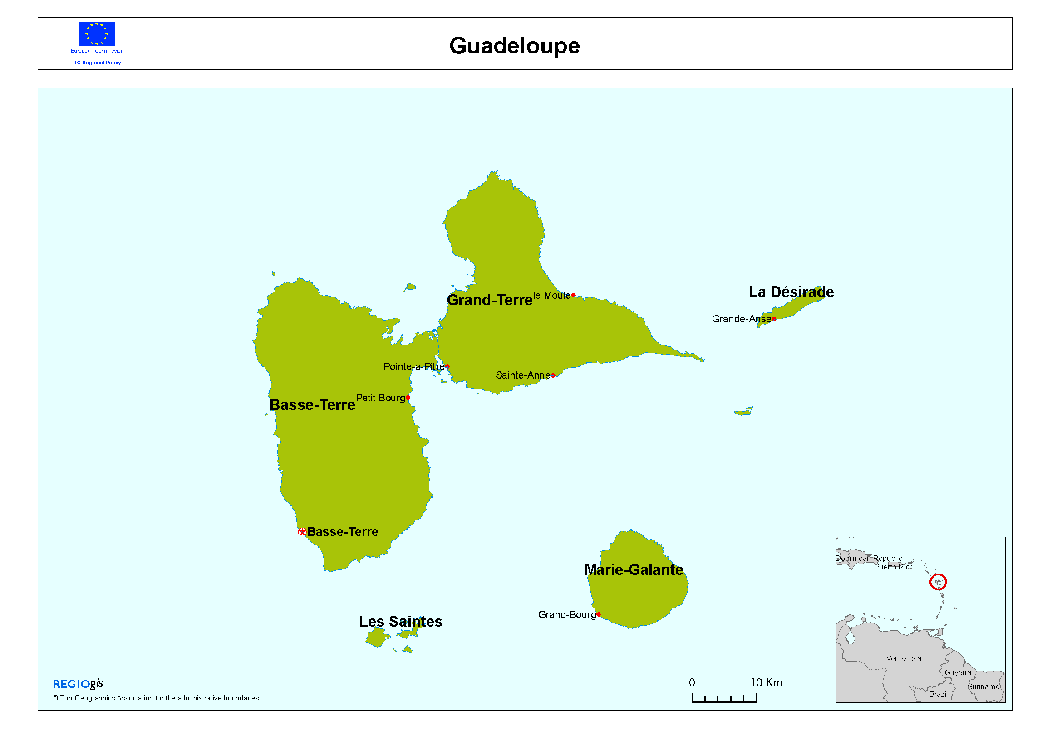
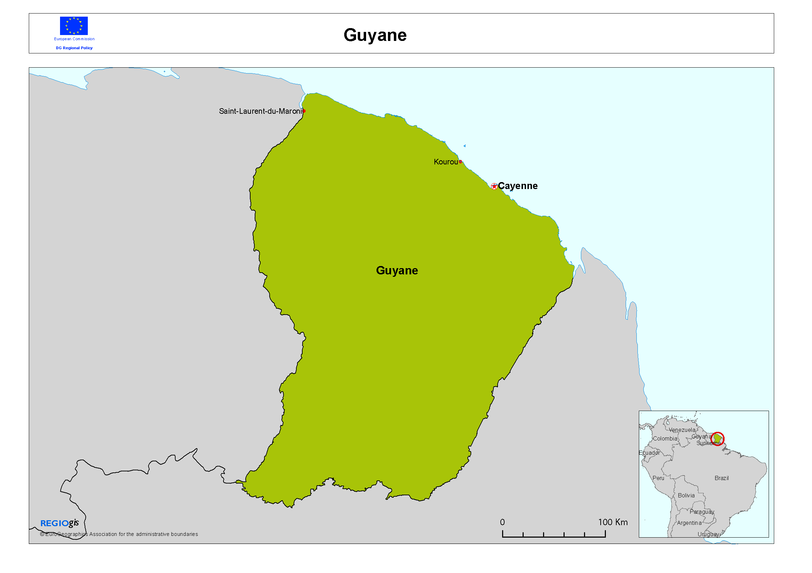

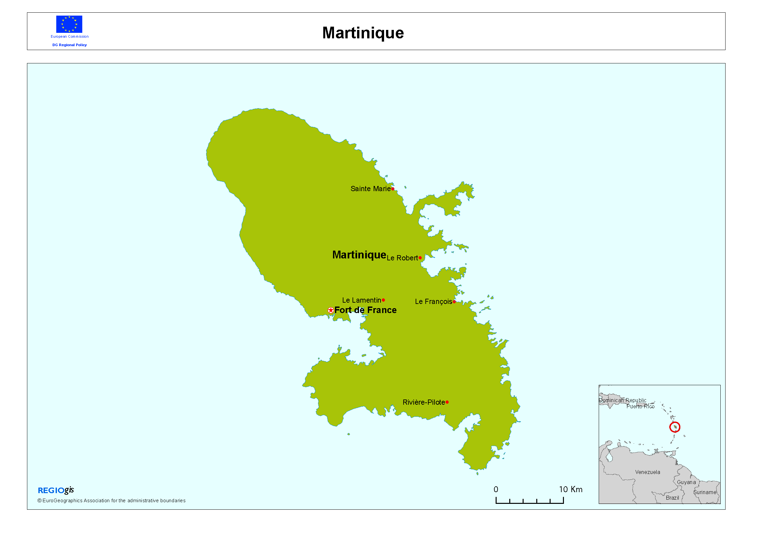
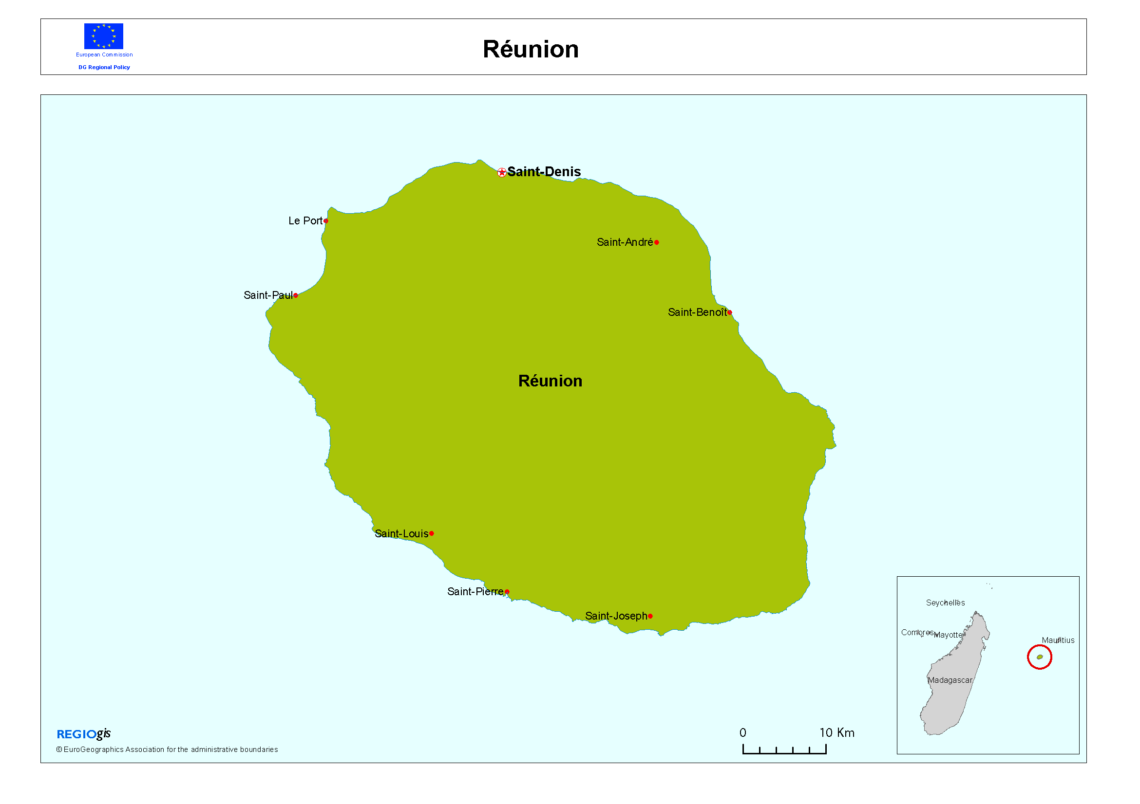

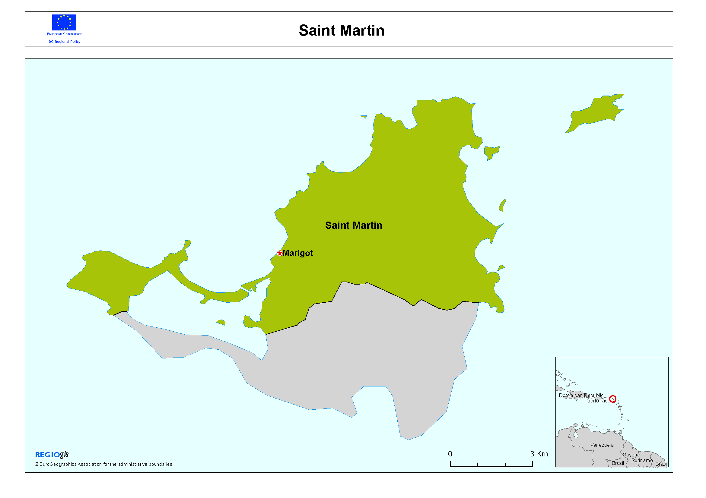
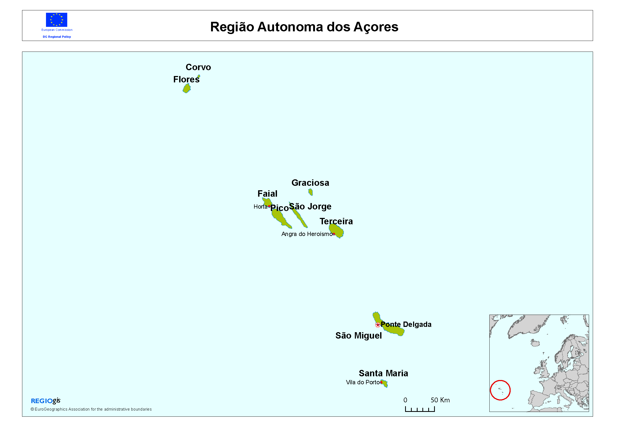

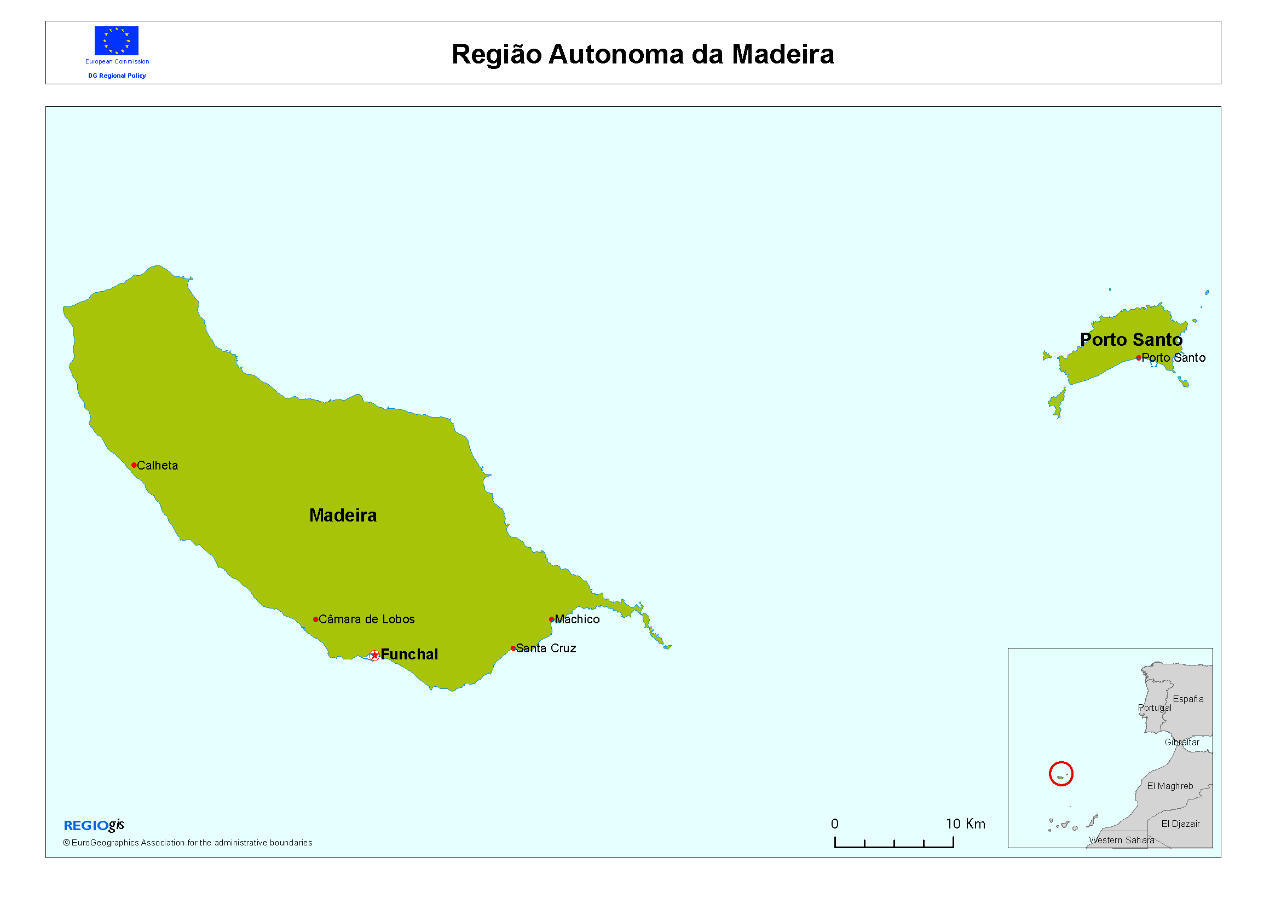

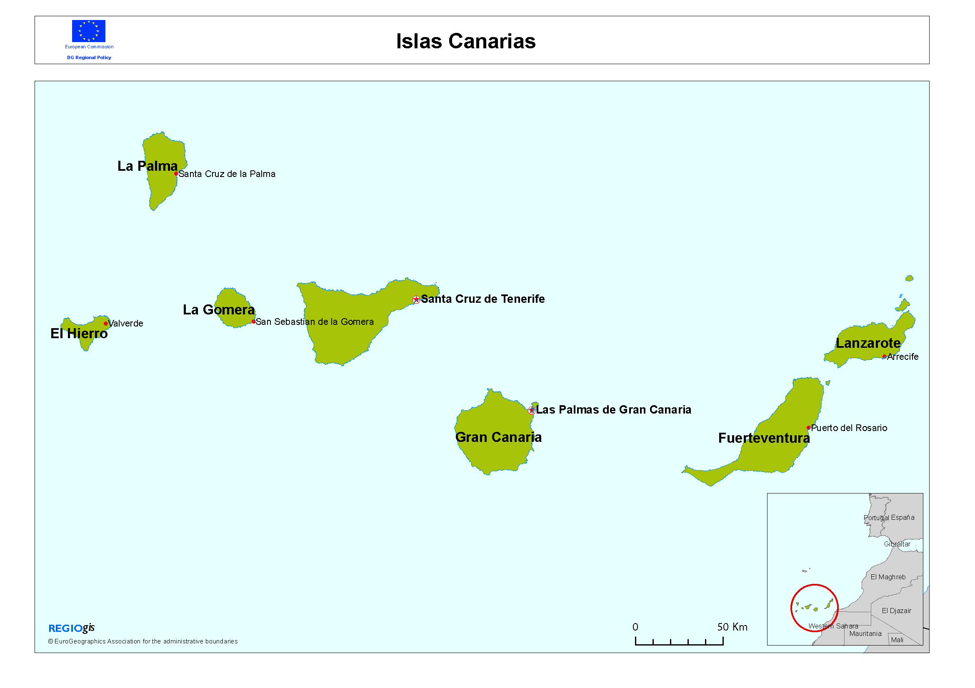

ANNEX II: Statistics on the socio-economic and geographical profiles of the OR (Source: Eurostat)

Region | DEMOGRAPHY |  |  |  | EDUCATION |  |  | GEOGRAPHY
Region | Population 2009 (1000) | Population density 2009 (inhab/km²) | % population aged: 2010 (*French regions 2009) |  | Educational attainment 25-64 (% of total), 2010 (*French regions 2009) |  |  | Distance from the capital of MS  (km) |  | Distance from mainland  (km) | Area (Km²)
 |  |  | <15 | 15-64 |  | 65+ | Lower secondary | Tertiary |  | Distance from mainland  (km) | Area (Km²)
EU27 | 500 334,6 | 116,3 | 15.6 | 67.2 |  | 17.2 | 27.3 | 25.9 |  |  | 4 324 782
Spain | 45 929,5 | 91.1 | 14.9 | 68.2 |  | 16.8 | 47.4 | 30.7 |  |  | 504 782
Canary Islands | 2 086 | 280.1 | 15.4 | 71.6 |  | 13.0 | 52.2 | 23.8 | 2 000 | 250 | 7 447
France | 64 495,8 | 101.9 | 18.5* | 65.0* |  | 16.5* | 29.2 | 29.0 |  |  | 545 965
Guadeloupe | 450,7 | 264.7 | 22.0* | 64.6* |  | 13.4* | 48.6* | 18.5* | 6 800 | 560 | 1628
Martinique | 398,9 | 353,6 | 20.0* | 65.4* |  | 14.6* | 47.4* | 18.8* | 6 850 | 410 | 108
French Guiana | 228,8 | 2.7 | 35.1* | 60.9* |  | 4.0* | 52.1* | 17.7* | 7 500 | n a | 83 846
Reunion | 826,7 | 330.2 | 25.6* | 66.1* |  | 8.3* | 51.5* | 16.9* | 9 400 | 1 700 | 2 510
Portugal | 10 632,5 | 115.4 | 15.2 | 66.9 |  | 17.9 | 68.1 | 15.4 |  |  | 92 072
Azores | 245,1 | 105.5 | 18.5 | 69.0 |  | 12.5 | 78.4 | 9.9 | 1 500 | 1 450 | 2 322
Madeira | 247,3 | 298.7 | 17.4 | 69.6 |  | 13.0 | 72.8 | 13.0 | 1 000 | 660 | 795

ANNEX III: EU funds for the OR for the 2007-2013 period
(the amounts in the table are expressed in thousand euros)
 | European Regional Development Fund | European Social Fund | European Agricultural Fund for Rural Development
The Azores | 966.300 | 190.000 | 274.000
Canary Islands | 1.019.300 | 117.300 | 154.000
Guadeloupe | 542.700 | 185.200 | 142.000
French Guiana | 305.100 | 100.000 | 76.500
Madeira | 320.500 | 125.400 | 179.000
Martinique | 417.100 | 97.800 | 103.200
Réunion | 1.014.300 | 516.900 | 329.400
Total | 4.585.300 | 1.332.600 | 1.258.100

*Saint-Martin has become an OR since 1 December 2009. Despite this new status of outermost region, it is currently not foreseen at Eurostat to collect data for Saint-Martin. Saint-Martin being an overseas collectivity, it is anticipated it will continue to belong to NUTS level 3 region Guadeloupe (FR910). NUTS level 3 corresponds to French administrative level of "départment" and is the lowest territorial level for regional data collection. Only in case France will attribute the status of "département" to Saint Martin, the creation of a new NUTS level 3 region will be possible and the corresponding data collection initiated.

ANNEX IV: Regional Europe 2020 indicators

ANNEX V: Regional GDP and unemployment in the OR

ANNEX VI: Examples of Innovative and Research Projects in Outermost Regions

Innovative and Research Projects in Outermost Regions

CANARY ISLANDS
Field | Name of the Project – Description
Renewable  Energy | HydroHybrid – Project*  Fostering the use of hydrogen as an energy source is the main objective of the project. This will also increase the use of renewable energy in the transport sector. Projects such as Hydrohybrid have made the Canary Islands an international focal point in this field.
Renewable  Energy | El Hierro 100%*  This project consists of 3 different programmes that have to be developed and implemented:  1. 100% Renewable Energy Sources for the Electricity Supply Programme  2. Energy Saving Programme  3. Transport Programme (conversion from fossil fuels to clean transport).  During the first phase, the programme aims to meet 70-80% of the electricity demand of the island by means of several activities. The most innovative one will consist of the implementation of a Wind-Hydro Power Station (WHPS), with the target of covering and achieving 30% direct wind penetration into the grid.
ICT | SIVR: En Route Passenger Information System*  Public authorities, a public transport company and local high-tech companies in Gran Canaria developed a prototype of an En Route Passenger Information System. The physical output of the project allows passive consultation and active planning of intra-island travel and provides a terminal for on-the-ground transport company staff. The software developed contains the nucleus of an inter-modal inter-island traffic information system.
Astrophysics & Spatial | Instituto de Astrofísica*  The Instituto de Astrofísica de Canarias is a Spanish research centre located in La Palma and Tenerife in order to take advantage of the archipelago's clear skies. The observatories and the Instituto de Astrofísica (Astrophysics Institute) together constitute the Observatorio Norte Europeo (European Northern Observatory).
Research | Instituto Canario de Ciencias Marinas (ICCM)*  The 2007-2013 ERDF Operational Programme contains provisions for co-financing improvements to the ICCM's research infrastructure. It will provide the basis for accessing and applying the results of the marine R+D+i carried out in the Canary Islands.  TROPOS "Modular Multi-use Deep Water Offshore Platform Harnessing and Servicing Mediterranean, Subtropical and Tropical Marine and Maritime Resources  This project is funded under the call FP7-OCEAN-2011 for a total EU contribution of 4,8 M€ and coordinated by PLOCAN/Canary Island: The Oceanic Platform of the Canary Islands (PLOCAN) is a Spanish multipurpose technical-scientific service infrastructure composed of a set of large facilities that provide support for research, technological development and innovation in the ocean. The aim of PLOCAN is to build an infrastructure to promote marine science and technology of excellence and facilitate access to ocean areas while always safeguarding the environment. PLOCAN is a joint initiative of the Government of the Autonomous Region of the Canary Islands and the Spanish National Government (Ministry of Science and Innovation).

AZORES
Field | Name of the Project – Description
Renewable
Energy

Renewable  Energy | Geothermal Company (Power Plant)*  The Azores enjoy privileged access to an inexhaustible energy source in the interior of the Earth: geothermal energy. These very high temperature geothermal fields are found only under certain geological conditions. Given the reliance of these islands on imported energy and the high cost of infrastructures - including for electricity - due to their geographical isolation and dispersed population, volcanic energy was a natural response to the needs of the Azores in this sector and the prospecting started in 1973.  The two geothermal power plants built in Pico Vermelho and Ribeira Grande (São Miguel island), with the co-financing of the ERDF, have demonstrated that volcanoes are a source of endogenous energy for the Azores. The safe and clean energy they are providing can lead to a self-sufficient supply while constributing to the preservation of Azores major asset – its environment.  Currently, geothermal energy is the greatest source of renewable energy in the Azores, accounting, in 2011, for 22.1% of the electricity production of a total production of renewable sources of 30%.
Astrophysics & Spatial | Satellite tracker at Santa Maria*  The object of this project was to install a satellite tracking station at Santa Maria. It is used by the European Space Agency (ESA) as well as for Atmospheric Radiation Measurement.  The Santa Maria S-band station, also known as 'Montes das Flores' (Hill of Flowers), is located 5 kms from the town of Vila do Porto on the Portuguese island of Santa Maria. Santa Maria is one of the first ESTRACK stations with launcher tracking capability and is used to receive real-time telemetry from launches originating from European Space Agency - ESA's spaceport in Kourou, French Guiana. It is capable of tracking Ariane 5, and will be used to track the launch of ESA's Automated Transfer vehicle (ATV) in early 2008.  SMA's tracking services may also support Project CleanSeaNet, managed by the European Maritime Safety Agency (EMSA) and providing satellite detection of oil slicks, and Project MARISS (MARitime Security Service), part of the European Union's Global Monitoring for Environment and Security (GMES) programme and supported by ESA.  The station is operated locally under contract by a consortium comprising industrial partners EDISOFT/SEGMA/GlobalEDA of Portugal/Azores on behalf of ESA.
Environment | Requalification of the Lakes of Furnas and Sete Cidades*  The projects of requalification of the margins of the Lakes of Furnas and Sete Cidades aim at the implementation of these lakes Basin Management Plans, considered as determinant instruments of a sustainable development, namely in what regards rules and use measurement, occupation and soil transformation capable to manage the areas of these plans in a dynamic ant integrated manner.  These were though as a way to create grounds and stable means that allow preserving, safeguarding, defending and, mostly, remembering the natural and primordial habitats of the region’s ecosystems that time and human occupation modify.
ICT | Global Entrepreneurship Monitor - GEM Açores*  GEM’s purpose is to analyze the relation between the level of entrepreneurship and the level of economic growth in several countries will, simultaneously, determining the conditions that foster or hinder entrepreneurship dynamics in each region or country.  The GEM Açores project will carry out this analysis for the Azores while integration the archipelago in the biggest and more reliable entrepreneurship study worldwide.
Agriculture, Fisheries and Food | Culture of Azores Pineapple*  Pineapple production in the Azores dates back to 1864, when it was brought from Brazil. Ananas comosus L. Merr is a monocotyledon from the Bromeliaceae family and the only CAM plant (succulent) with agronomical interest. It is originally produced in open-air fields in tropical areas. For it to be cultivated in the Azores, production was adjusted to a confined environment inside a glass greenhouse, where higher temperature and higher relative air humidity can be reached. Additionally, the Azorean pineapple is produced using biological means of production, without application of chemicals – namely flower induction is achieved via smoke application, in contrast to hormone (ethylene) application in open-air fields in tropical countries. Furthermore of being an agronomical product of interest, pineapple is also a touristic symbol of the azorean islands and is therefore, a culture to be preserved, for all its historical and cultural value.  Nevertheless, market globalization has brought large quantities of pineapple produced in tropical countries to our local and national markets at a cheaper price. Facing such competition, the Azorean pineapple production has been lowering progressively over the past 20 years. It is thus necessary to find improved techniques and use more cost-effective ways to produce a high quality product to meet consumer’s demands and face competition.  The project, “Research, Development and Application of Technologies and Practices promoting Competitiveness and Production Quality”, is set to offer pineapple producers improved technologies and culture practices based on acquired scientific knowledge, aiming at an increased production and higher fruit quality.  Interfruta*  The promotion of fruit-growing and viticulture in the perspective of protection and integrated production in the Macaronesia archipelagos is a project that aims at:  - Research to obtain the production data on apple-trees;  - Research on production and test new ways of production of banana-growing with less environmental impact;  - Study of chestnut-trees and the phytosanitory problems associated to this production;  - Foster the knowledge of vineyards culture and development of prevision models for diseases that limit this culture;  - Study of the Mediterranean fruit fly and of the possibility of spreading sterilized flies to fight it;  - Creation of network with phytosanitory database to the diagnostic of Macaronesia;  - Location of bioactive plants.  Regional Laboratory of Enology*  The aim of this project is to adopt analytical technics and the use of new equipment that would allow increasing the knowledge of the several vine products of the Azores, namely at the level of their physic-chemical features and organoleptic qualities.  The project also entails making available services in the domains of information, monitoring and analysis, as a fundamental tool for the certification of the Azores quality wines.
Biodiversity and Climate Change | CLIMAAT*  This project aims to identify the specific needs and requirements on detailed climatic information, weather and sea state forecasting with implications on the territory and resources management, economy, infrastructures and safety by the means of providing operational data in real time.  The strategic rationale of this project is the necessity of adequate planning and considering climate as a resource prone to change that requires mitigation and adaptation.  The particularity of climate and weather mechanisms of the islands, that distinguish them from continents; the specific needs of new methodologies to fit the requirements and scale of application to the different sectors of applied meteorology and climatology (environment, agriculture, hydrology, tourism, transports, fisheries, safety), side by side with a very good location for climatic and meteorological studies in the middle of an open space of utmost importance for the global climate are the grounds for this project.  Installation and Development of the Azores Centre of Seismic and Volcanic Emergency Operations*  This project aims at the preparation of an Emergency Operations Center (EOC) to monitor earthquakes, volcanic activity and geological phenomena in the Azores, thus contributing to optimize the analysis of the gathered information and support the decision-making process of the civil protection authorities.
Research | Scientific Re-equipping of Accredited R&D Units*  The aim of this project is to enhance the Azores' scientific and technological capabilities by the renewal and updating of scientific equipment in duly certified R&D units. The ROV (Remote Operated Vehicle) will provide the opportunity to conduct many research projects in coastal areas, along the underwater island slopes and on the seamounts. It can also be used to prospect underwater heritage, monitor sunken vessels, verify and monitor underwater building work or port structures, verify deep sea cables and other equipment and scientific moorings and to compile images for the study of marine geology. For the Department of Oceanography, this project represents a qualitative leap forwards for marine research of the University of Azores, as it enables work to be carried out at depths at which little until now has been known.  CORAL FISH*  This project is an assessment of the interaction between corals, fish and fisheries, in order to develop monitoring and predictive modelling tools for ecosystem based management in the deep waters of Europe and beyond.  It aims to support the implementation of an ecosystem-based management approach in the deep-sea studying the interaction between cold-water coral habitat, fish and fisheries, namely:  - Integrate fish and fisheries into coral ecosystem models to better understand coral fish-carrying capacity;  - Evaluate the distribution of deep water fishing effort to identify areas of potential interaction an impact upon coral habitat;  - Construct bio-economic models to assess management effects on corals and fisheries to provide policy options;  - To identify areas likely to contains vulnerable habitat and provide the EU with the tools to address the conservation issues raised by UNGA resolution.  Research Submarine*  The submarine “LULA 1000” will allow for the discovery of the underwater world of the Azorean islands, to a depth of some 1.000 meters, and will the used in several scientific projects and of gathering of information with the participation of national and international partners in areas such as:  - Study of cold-water coral;  - Habitat mapping while elaborating high resolution acoustic maps;  - Production of photo mosaics;  - Study of hydrothermal springs and volcanism;  - Inventories of habitats and populations in the seamounts  - Study of depth squids;  - Gathering of samples of deep-sea organisms for genetic analysis
Research | .  The Institute for Technological Innovation of the Azores (INOVA)*  INOVA is a non-profit association established in 1988. Its mission is to contribute to the diversification and modernization of business network of the Autonomous Region of the Azores, through the development of new products and processes and the introduction of new technologies. The association promotes the scientific research and technological development activities. These activities are directed towards the provision of services in the field of innovation and the support of modern technologies

MADEIRA
Field | Name of the Project - Description
Renewable Energy | Socorridos Multipurpose System*  The Socorridos hydroelectric power station has been developed to optimised water production for locals and for irrigation, as well to tale advantage of renewable energy sources. It aims to reach three objectives simultaneously: to supply water to Funchal and to Câmara de Lobos, to regularize irrigation volumes in agriculture and to produce electric energy.
Renewable Energy | Calheta Hydroelectric System*  This project has, as its central aim, a strong focus on promoting renewable energy, the use of cleaner fuels, the efficient use of energy and the reduction of greenhouse gases emissions. The Calheta III project, following this development model, will ensure not only sustainability of the regional electricity system, but also, overcome the recommendations and targets of the European Union, regarding the environment protection.
Renewable Energy | ISLE-PACT – Pact for Sustainability Energy*  A Pact between islands of EU is terms of energy and preparation of Actions Plans for Sustainable Energy.  Co-Financed by the European Commission / Directorate General for Energy.
Renewable Energy | ENNEREG (Regions paving the way for a Sustainable Energy Europe)*  ENNEREG aims to establish and inspire a network of regions throughout Europe – Regions 202020 - to produce regional Sustainable Energy Action Plans (SEAPs) and implement Sustainable Energy Projects (SEPs).  European project supported by the Intelligent Energy – Europe programme
ICT | Toureg-Research Driven Cluster for Tourism Sector*  By getting together Small and Medium Sized Enterprises (SMEs) with Tour Agents and Hotel Groups, the intention on an initial stage is to collect a situation status, which will lead to establishing strategies aiming globally to fulfil the needs the sector may evidence. In global terms, the project is directed to improving competitiveness in companies belonging to that services sector, especially those connected to Tourism, by establishing a platform to generate and transmit knowledge based on technological innovation and research in the Tourism domain.  European project supported by the FP7
ICT | IN-TRACK - Insular regions knowledge tracker*  This project has built on the special characteristics, strengths and constraints of four insular European regions – Crete (Greece), the Canary Islands (Spain), Sicily (Italy) and Madeira (Portugal) - to supply a tailor-made methodology based on regional foresight methods. It has promoted the formulation of knowledge-based regional policies, ensuring the support of local actors and stakeholders.  European project supported by the FP7 (Regions of Knowledge).
ICT | BrainBridges*  Collaborative technologies and environments enhancing the seamless creativity process, leveraging the full European potential*  Brain Bridges will result in a European Strategies coordinated in the area of Collaborative Working Environments (CWE) and supportive technologies. To achieve that, the project goal is to join together the National Research organizations and the key-industries in this area.  European project supported by the FP7
Astrophysics & Spatial | Portuguese archipelago in touch with space*  This high-tech project will consist in the installation of a satellite tracking centre in Madeira, enabling the region to both track satellite movements and supply related services. The project focuses on two space communication business sectors: controlling geostationary satellites; and marketing capabilities and satellite telecommunication services.
Biodiversity and Climate Change | Solid Waste Evaluation Unit*  Included in the strategy defined in the Regional Solid Waste Management Strategy Plan, the project of solid waste management facility of Madeira consist of the installation of the necessary infrastructures and equipment for an adequate integration and optimization of the activities of waste collection and transport, selective collection and recycling, valorisation, treatment and final disposal
Biodiversity and Climate Change | BIOBASE – Base de Dados da Biodiversidade do Arquipélago da Madeira*  The goal is to update the database of the biodiversity in the Autonomous Region of Madeira.  FEDER Operational Programme “Intervir+”.
Biodiversity and Climate Change | Life - Ilhéus do Porto Santo*  This project aims the recovery of the terrestrial habitats of those spaces, conserving the local fauna and the flora.  Co-financed by Life+ Nature.  Coordinator:
Biodiversity and Climate Change | Bioclimac - Biotechnology and conservation to face climatic alterations*  The goal of this project is to survey the effect of the climatic alterations on the germinative capacity of the seeds and the genetic variety of the archipelagos of the Macaronésia.  PCT MAC 2007-2013.
Biodiversity and Climate Change | CIVITAS MIMOSA - Eco friendly buses*  This Project involves the use of electric busses in Funchal. Project selected as finalist in Regio Stars 2010 awards. The objectives of the project were:  - to increase the total number of passengers  - to improve satisfaction of the users  - to build up evaluation models  - to increase the efficiency of the public transport system  - to promote a positive attitudinal shift towards alternative transport modes - biking, walking, car sharing – by making them more attractive.
Innovation in Agriculture, Fisheries and Food | CABMEDMAC - Battle of the Mediterranean fly*  The project is dedicated to study modalities of pest control the Mediterranean Fruit Fly (Ceratitis capitata Wiedemann), contributing to a better understanding of fruit flies in Macaronesia. Project partners are Azores, Madeira and Cape Verde.
Innovation in Agriculture, Fisheries and Food | Diversifying live feed diets for rearing marine fish larvae in semi-intensive systems*  Species diversification is a major concern for the sustainable development of aquaculture in Mediterranean regions that relies essentially on sea bream and sea bass.  The aim of this project is to improve current methodologies and live feeds used in aquaculture of rearing marine fish larvae that until now are unable to be cultivated or present very low survival, as red porgy Pagrus pagrus and dusky grouper, Epinephelus marginatus. To reach our objective we will develop a variant of the mesocosm technique, where different trophic levels and nutrient of the proposed prey items will be controlled. The production of juvenles of these species would comply the European Community regulation for organic aquaculture production.
Innovation in Agriculture, Fisheries and Food | Project for pelagic species production*  The almaco jack (Seriola dumerilli, S. fasciata or S. rivoliana) and the trevally (Pseudocaranx dentex) fand present aquaculture potential. The objectives of this project are: a) the capture of adults and their maintenance under artificial conditions; b) gonad maturation studies and if required hormonal induction; c) development of larvae culture techniques and transference of juveniles, employing the mesocosm technique; d) to supply the local maricultures.
Innovation in Agriculture, Fisheries and Food | The MARPROF Project*  Setting the Basis for the Management and Gastronomic Valorization of the Deep-water Fishery Resources from the Macaronesia  The main objective of this project, co-financed by FEDER, is to research non-traditional deep-water marine resources and assess their potential commercial interest thus leading to the possible development of new fishing opportunities. To accomplish its goals this project conducts fishing surveys covering fishing grounds around the Macaronesian archipelagos. It will also extend the inventory of the marine biodiversity in this area and create a new body of knowledge essential to the biological and fisheries management and hopefully to the development of new fisheries, based on sustainable exploitation. During the project a study of the food quality of the deep-water resources found will be carried out through the realization of nutritional and organoleptic analysis. Innovative recipes will be prepared by professional cuisine chefs. Eventually, all information gathered during the project will be used for the delivery of a gastronomic guide available to the consumers.
Innovation in Agriculture, Fisheries and Food | “Promoção do consumo de produtos agro-alimentares da Região Autónoma da Madeira”*  Co-financed by Operacional Programme “Intervir +”
Research | Solid Waste Treatment Station of Meia Serra*  The Project “Solid Waste Treatment Station of Meia Serra” consolidated the implementation of an adapted waste management solution, based on the construction of valuations installations, treatment and final destination facilities.  Co-financed by Cohesion Fund.
Research | CETACEOS MADEIRA II*  It’s a project for the application of actions of observation of the statute of conservation of the species of cetaceous that occur in waters off-Shore of the Archipelago of the Madeira.  Co-financed by the Programme LIFE +
Research | SOST–MAC - Cooperação e Sinergias em Acções Sustentáveis em Espaços Naturais Protegidos da Macaronésia*  Aims to put in place various actions and experiences that integrate and harmonize the partner-tourist activity in the natural protected areas, without compromising its conservation  PCT MAC.
Research | - LIFE Eco compatível*  Contributes to support the social-economic and biodiversity.  Co-financed by the Programme LIFE +

MARTINIQUE
Field | Name of the Project - Description
Renewable Energy | ECODOM - Bioclimatic Habitat*  The objective of the ECODOM experimental operation is reducing the energy needs of individual and communities :  - by limiting the use of air conditioning;  - by acting on solar thermal loads, natural ventilation;  - by promoting the production of hot water by using solar equipment.
Renewable Energy | Energy from the sea*  EDF and the Regional Council are planning to establish a prototype of Ocean Thermal Energy plant in Martinique to produce 10 MW by exploiting the thermal energy from the sea, with the aim of developing non-intermittent energy. The resource is abundant, stable and available 24/7 throughout the year. Although it is based on an experimental technology.
Renewable Energy | Geothermal energy*  The Caribbean Dominica Power Plant project (under consideration), the first project of energy cooperation in the Caribbean, could be installed in the Dominica. It would share energy production with Martinique and Guadeloupe through submarine cables. It would save the emission of 80,000 tonnes of CO₂ per year, equivalent to 32,000 cars.
Innovation in Agriculture, Fisheries and Food | Regional food hub Martinique*  The PARM (Pôle Agroalimentaire Régional Martinique) is a technical and scientific tool created at the initiative of the Regional Council to ensure the missions of research, development, assistance and advice to professionals throughout the food industry.
Innovation in Agriculture, Fisheries and Food | Testing centers in irrigated agriculture*  The objective of the project is to develop sustainable farming systems and techniques. Furthermore implementing other projects enhancing the diversification.
Innovation in Agriculture, Fisheries and Food | ŒnoFWI: guava wine*  Production and commercialization of tropical fruit wines. The flagship product is the guava wine. The artisanal production of Enology French West Indies will reach an industrial scale by the end of 2011, maintaining a premium positioning. This wine at 11° alcohol and composed of 50% fruit, has the particularity to be very aromatic. The Technopole advises entrepreneurs in search of European subsidies and defining their marketing strategy.
Research | TRAMIL*  TRAMIL is a program of applied research for traditional popular medicine in the Caribbean. It aims to validate scientifically the traditional uses of medicinal plants for primary health care. It aspires to be the reference interdisciplinary program in the detection, validation and diffusion of the uses of medicinal plants that impact on public health.
Research | PRAM – Agro-environmental Research Pole of Martinique*  The PRAM is a tool for the rural development of Martinique and the West Indies. It is composed by the Research Institute for Agriculture and Environment (Cemagref), the International cooperation Center in Agronomical Research for Development (Cirad) and the Research Institute for Development (IRD). Its mission is to develop fundamental and applied research, technical support, training, information and regional cooperation.
Innovation in agricultural transformation | FIB and CO*  FiBandCO gives a second life to banana plant trunks. Using a completely innovative technology and thanks to an eco-responsible process, they develop a natural product rich in fibres. In the heart of plantations, FIBandCo transforms unexploited resources resulting from the cultivation of bananas, to produce a quality, top of the range material.
Innovation in EcoTourism | KAY FLO*  KayFlo is an environment-friendly project of tourist accommodation on the water around Martinique. The 20 Kayflo units will be designed and built in a shipyard in Martinique.  10 KayFlo will form a floating hotel village and 10 others will be anchored at several sites around Martinique. The project will create a new type of tourism product and create at least 5 to 8 jobs.
Recycling Industry | SIDREP*  Creation of a transformation and recycling plastic factory. This structure will transform terephtalic polyethylen bottles into granulated of plastic of two qualities. The first will be used for the manufacturing of new bottles, the second will take the shape of gross products sold on the worldwide market and intended for the manufacturing of non-food containers
Scientific Research | GENOMIQUE APPLIQUEE*  Feasibility study on the development of the industry applied to genomics. This first study aims to contribute to the knowledge of the Caribbean genome. This will lead to provide more detailed knowledge of certain and genetic diseases, and complete the provision of health care.
Biodiversity and Climate Change | A new "living laboratory"*  Network of 40 "plots" of intensive monitoring and measurement that will provide a living laboratory. It will allow to detect long-term changes in the functioning of a wide variety of forest ecosystems. It will provide a better understanding of the reasons for these changes. The French National Forestry Office, in Martinique, was given a mission of expertise and advice aimed at the identification and protection of wildlife and natural habitats within this project.

GUADELOUPE
Field | Name of the Project - Description
Renewable Energy | The PRERURE*  The Regional Plan for Renewable Energies and Rational Use of Energy (PRERURE) aims to define the Region's objectives in the field of development of renewable energy and energy efficiency in the long term. It will provide the operational action programs for the short, medium and long term.
Renewable Energy | Thermal regulation : Guadeloupe case study*  Regional council of Guadeloupe asked for the support of CSTB (scientific and technical building center) to design a specific building thermal regulation adapted to tropical environment. The aim is to foster green building, ie low energies consumption building, competitive integrated hot water solar systems in tropical weather conditions and highly exposed to natural hazards, like earthquake or hurricane.  The regulation should address all kind of building, commercial, individual houses, and so on.  CSTB works from the national French regulation, in a step by step process, starting from a global approach of the building to specific issues like some national certification. The global approach is already fulfilled. Indeed, the regulation has been approved in may 2011. Then an easy understandable excel sheet has been released. It is the ever first and innovative work done on this subject.
Renewable Energy | Geothermal energy in the Caribbean*  Regional Council of Guadeloupe is the project leader of Interreg IV Caribbean area « Caribbean Goethermy ». One of the goals of the project is to design a methodology to develop industrial geothermal project in a sustainable way, taking into account local people interests and environmental concerns.  The methodology will be used for the Dominic project which aims at producing 120MW.  The second goal of the project is to ease the financing of the early steps of a geothermal project, mainly the exploration of geothermal wheels. A study will look after how to create a warranty fund, as existed one in Mediterranean sea or in Africa.
Innovation in Agriculture, Fisheries and Food | Pharmaceutical industry*  The Phytobôkaz Laboratory is located in the heart of the diverse and rich vegetation of the Commune of Gourbeyre and produces nutritional and phytocosmetics supplements.
Innovation in Agriculture, Fisheries and Food | Fisheries Informations System*  Fishery is one of the main economic activities of the territory. But over fishing may lead to exhaustion of the stock. Thank to several studies and surveys, the partners (French research institute on marine topics, regional council of Guadeloupe, regional council of fisheries and sea, and others) identify the way of fishing, the kind of boat, the number of trip, the kind of fish catch and when, and so on. The aim of the project is to better monitor the fisheries activities in order to promote a more sustainable and competitive fishery. The data gathering trough the different studies will also lead to further research projects on marine ecosystems and sustainable used of marine resources.
Innovation in Agriculture, Fisheries and Food | Agro-transfer Project - research and development interface project*  This initiative allows supporting innovative projects created by at least two cooperating partners who could develop new markets. All projects should demonstrate their collaborative nature and innovativeness.
Innovation in Agriculture, Fisheries and Food | RESPEG network*  High potential molecule can be found in traditional medicinal herbs and local biodiversity to ease diseases or to develop cosmetics products and so on. The aim of the network is to gather producers of traditional medicinal herbs, research centers and companies in order to develop high innovative products. Research will lead to optimize the crops in a sustainable way, it will also focus on screening the interesting molecule and the sustainable way to extract them
Research | Guademerged*  The objective of the project is:  - to increase the scientific and technical potential of Guadeloupe in the field of emerging and vector-borne diseases,  - to develop strategic partnerships and collaborative networks in this field  - to increase international visibility of Guadeloupe0s research in this area.
Research | Project "NET-BIOME"*  It is a network of tropical and subtropical biodiversity research in Outermost regions to support sustainable development. ERA-NET initiative, leading partner: La Reunion.
Research | Agroecotrop*  Developed by INRA (national research institute on agronomy), the project aims at designing a sustainable farm with low inputs, either energy, fertilizers, pesticides, food. In a holistic approach, research looks for complementary between some animal breeding output and the need of some crops as well as some interactions between different crops in order to reduce and halt the use of pesticides and chemical fertilizers. By the end, some crops associated with some local herbs will be suggested to the farmer, as some way to valorise the output of each activity of the farm. Indeed, production of methanol due to animal breeding output will be study. The first results on the economic sustainability of this kind of farms are very positive.
Research | Technical support to foster participation to EU framework program*  Research team in Guadeloupe are far from the EU. Despite the excellence of the research developed, they are poorly known by European teams. Further, it is quite difficult to apply to EU framework program. Therefore, in order to foster the integration to the EER, a technical support is proposed to local research teams who would like to be part of an EU framework programme project or apply as a leader for a EU framework programme. Initiated by the regional council of Guadeloupe, the aim is to develop internal capacities at local level on EU framework programme in order to benefit from these financial tools and to reinforce the local research excellence.
ICT | Regional submarine cable network*  The project will provide high-speed connectivity in the Caribbean by the installation of a new regional submarine cable network in Pointe-à-Pitre, Guadeloupe This network deployment is part of a larger project to provide the region with the most advanced telecom infrastructures linking Guadeloupe and the Caribbean countries, while creating value-added services for residential and business users. The project will provide a cost-efficient broadband access and connectivity to the region".
ICT | Live management of the highway network trough ICT*  In order to reduce traffic jam, low carbon hydroxide emission and car crashed, Route de Guadeloupe, a public organisation, deploys a large network of data collection stations. Further thank to some specific sensors set up with Météo France and the research institute on geology and soil (BRGM), Route de Guadeloupe may send a early warning about potential landslide. All these stations and sensors are connected to an interactive innovative ICT network. Data are gathered to headquarter. Drivers may know on time how it is going on the highway.
Foster innovation | Marin cluster*  This cluster gathers local organisations involved in the marine field activities (tourism, transportation, fisheries, training, research ...). It aims at promoting and enhancing the sustainable development of those activities. Therefore some studies and collaborative projects will be launched to foster them.
Foster innovation | Training on creativity*  Local companies will attend training on creativity in order to help them to overcome common problems they have to face with and to develop innovative project. Small group will work on common problems in order to acquire creative solving method. Each participant will implement the methodology in its company, with the support of the trainer. This project is developed by the regional council of Guadeloupe in partnership with the French government department linked to innovation.
Foster innovation | PURE AVENIR*  It's a project that facilitates the development of strategic cooperation between regions (Guadeloupe, Martinique, Réunion and Corse) in the field of sustainable energy and energetic efficiency.
Foster innovation | Synergîle*  It's created in November 2007 in order to create synergies around innovative projects with focus on two strategic paths: Materials and construction in tropical zone at risk and renewable energies non broadcasting of CO2.

FRENCH GUIANA
Field | Name of the Project - Description
ICT | Guiane Broadband*  This project involves the installation of high-speed broadband connections covering the whole of the region. Over 85 km of optic fibre have been laid, linking the capital Cayenne to Kourou, where the greatest concentration of the region’s 221 500 inhabitants reside.
Astrophysics & Spatial | SEAS *  (Surveillance de l'Environnement Amazonien assistée par Satellite)  This project aims to monitor by satellite the Amazon forest environment
Biodiversity and Climate Change | Guyafor*  Guyafor is a network of forest devices permanently installed in French Guiana, where scientific partners are conducting research activities to provide an estimate of the amount of carbon stored in forests of Guiana
Biodiversity and Climate Change | Centre Européen de Biodiversité – CEBio*  This research and development centre, which includes laboratories and other installations, is also a resort with a conference and business center.
Biodiversity and Climate Change | CARPAGG - Carbon pastures of Guiana and greenhouse gas emissions*  Grassland systems in Guiana, as in many other farming areas in the world, meet environmental and productive functions (particular in terms of carbon) that the project will study. Guiana is particularly concerned by this mechanism for storing carbon. The project will help the establishment and management of grassland systems capable of reconciling sustainable production objectives (ensuring the expected development of the cattle) and environment(reduce impacts, maximize services ).
Biodiversity and Climate Change | La Maison de la Forêt et des Bois de Guyane (M.F.B.G.)*  MFBG has a multidisciplinary structure and supports the forest and wood industry. Its objective is to contribute to the coordinated development of all sectors of the industry, to the prosperity of its businesses and to the implementation of standardized and eco-certified products

RÉUNION
Field | Name of the Project - Description
Renewable Energy | Solar Power*  This project consists of a photovoltaic power plant already generating enough electricity to cover the annual consumption of 850 households. The aim is to become totally energy self sufficient by 2025.
Biodiversity and Climate Change | GERRI*  This integrated project aims at making Reunion Island the first territory in the world where all environmental friendly innovations in terms of transport, energy production, storage and use, town planning and construction are integrated into society by 2030.
Innovation in Agriculture, Fisheries and Food | La Canne à sucre – eRcane*  eRcane is a research centre, that aims to improve the production of plant varieties of sugar with the objective to give added value to the sugar cane, not only as food but also as biofuel. eRcane is an Economic Interest Grouping, integrated by Sucrière de La Réunion (Quartier français Group) and Sucrerie de Bois Rouge (Téréos Group).
Innovation in Agriculture, Fisheries and Food | Run Sea Science*  This project wishes to improve and develop the research capacities and capabilities of Réunion. This is being achieved in the field of sea sciences by improving regional S & T potential, enhancing human and material resources and developing strategic partnerships and scientific dissemination.
Research | Cyclotron Réunion Océan Indien (CYROI)*  In the health sector, the Réunion Indian Ocean Cyclotron (CYROI) — a technology platform which combines a radiopharmaceutical production unit and technical research and support centres — is available to researchers and young innovative enterprises. Its research areas concern metabolic, infectious and emerging diseases and the promotion of land and marine biodiversity. The Centre for Research and Scientific Monitoring of Infectious Diseases in the Indian Ocean (CRVOI) is also linked to it.

COM(2012) 287 final, of 20.06.2012.
Numerous European initiatives take account of the specific nature of these regions, particularly in the areas of competition (for example, aid authorised in the areas of transport, energy, etc.), taxation (for example, dock dues in the French OR, the "Arbitrio sobre las importaciones y entrega de mercancías" (AIEM) tax in the Canary Islands, and the reduced rate of excise duty on rum produced in these regions, on local beer in Madeira and on certain liqueurs produced and consumed in Madeira and the Azores), customs policy, agriculture, research, trade or transport, in order to try and offset the handicaps specific to the remote nature of these regions.
Since the latest EU enlargements, the OR as a whole are no longer part of the group of poorest regions. However, in relation to the EU average, and in terms of GDP per capita, most of the OR remain among the least prosperous regions of the EU (see Section 3).
Commission Communication: "A stronger partnership for the outermost regions", COM(2004) 343, 26.5.2004); (Commission Communication “on a stronger partnership for the outermost regions: assessment and prospects”, COM(2004) 543, 6.8.2004.
Commission Communication "Strategy for the Outermost Regions: Achievements and Future Prospects" COM (2007)507 final, 12 September 2007.
COM (2008) 642 final, 17.10.2008.
Study launched in March 2012 on climate change and the OR. Specific contract within CLIMA framework contract DG CLIMA.A.4/FRA/2011/0027.
"Demographic and migration trends in the OR: impact on economic, social and territorial cohesion", of May 2012, by the "Institut National d'Études Démographiques" (INED). http://ec.europa.eu/regional_policy/activity/outermost/publications_en.cfm
The first forum took place on 27/28 May 2010. The second is scheduled on 2-3 July 2012.
Joint memorandum of the OR: ‘The Outermost Regions up to 2020’ (Las Palmas de Gran Canaria, 14 October 2009). The OR have also issued several joint contributions on different topics launched by the Commission: the Green Paper on the TEN-T (2009), the public consultation launched by the Communication from the Commission "A sustainable future for transport: Towards an integrated, technology-led and user friendly system" (2009); the public consultation on the Commission’s working document on the future Europe 2020 strategy (2010); the consultation on the new European energy strategy for 2011-2020 (2010); the public consultation "Towards a single market Act" (2011).
"A renewed vision of the EU strategy for the OR", Las Palmas de Gran Canaria, 7 May 2010.
The last Conference (the 17th) took place in November 2011 in Martinique and resulted in a declaration focused on cohesion policy, agriculture, fisheries, R&I, energy, the single market and the "Solbes" report, state aids, impact on international agreements and the renewed EU strategy for the OR.
3023rd FOREIGN AFFAIRS Council meeting, 14 June 2010.
In late 2010, in the course of re-launching the single market, Commissioner Mr Barnier asked former Minister of Agriculture and of Economy and Finance of Spain and former European Commissioner, Pedro Solbes Mira, to undertake a study on the place of the OR within the single market. This report is available at: http://ec.europa.eu/internal_market/outermost_regions/index_en.htm .
The eight MEPs from the OR are gathered in the "Conference of the MEPs from the OR of the European Parliament". The "common platform" underlines the importance of taking into account the specificities of the OR both in the external and internal EU policies and, where necessary, of making the necessary adaptations.
Procedure reference 2011/2195(INI). The MEP rapporteur was Nuno Teixeira.
1) Employment (75% of the 20-64 year-olds to be employed); 2) R&D/innovation (3% of the EU's GDP - public and private combined - to be invested in R&D/innovation); 3) Climate change/energy (greenhouse gas emissions 20% (or even 30%, if the conditions are right) lower than 1990; 20% of energy from renewables; 20% increase in energy efficiency); 4) Education (reducing school drop-out rates below 10% and at least 40% of 30-34–year-olds completing third level education); 5) poverty / social exclusion (at least 20 million fewer people in or at risk of poverty and social exclusion).
This report measures the distance of cities and regions to the national 2020 targets proposed in the national reform programmes. This distance to target depends on the disparities with the country, the ambition of the NRP and expected speed of change. http://ec.europa.eu/regional_policy/sources/docoffic/official/reports/interim7/interim7_en.pdf
For some regions, the distance to the target is simply too great. Furthermore, for some issues it is not realistic or desirable that all regions reach the same target. For example, R&D is highly concentrated in part due to benefits of clustering research.
See Annex IV.
In tertiary education (the Azores), in early school leavers (the Azores and Madeira), in employment rate (Reunion, French Guiana and Guadeloupe), unemployment rate (Reunion, Canary Islands, Guadeloupe and Martinique), and risk of poverty or exclusion (Canary Islands).
http://ec.europa.eu/news/employment/120419_en.htm
Study carried out by Ismeri Europa, in cooperation with ITD.eu Europe, commissioned by the European Commission in 2009 (Contract No 2009.CE.16.0.AT.101) and delivered in March 2011. See: http://ec.europa.eu/regional_policy/sources/docgener/studies/pdf/rup_growth/rup_growth_sum_en.pdf
Summary of the section of the study on added value sectors (traditional and emerging) and flagship projects.
Video-presentation of the European Commission on EU action to support its Outermost Regions, published on 19 March 2012.
Carried out by the "Institut National d'Études Démographiques" (INED), commissioned by the Commission in 2009, and delivered in May 2012.
Most recent available data validated by Eurostat.
Most recent available data validated by Eurostat.
This is not an exhaustive list, only some examples. Projects co-financed by the EU funds are marked with *.

