TABLE OF CONTENTS
1. Introduction 3
2. Background 4
2.1. Developments in 2011 4
2.2. MFA Framework Regulation 5
3. Macro-financial assistance operations in 2011 6
3.1. Overview 6
3.2. Individual operations in the beneficiary countries in 2011 6
3.2.1. Western Balkans 6
3.2.1.1. Bosnia and Herzegovina 6
3.2.1.2. Serbia 7
3.2.2. Eastern Neighbourhood Countries 7
3.2.2.1. Armenia 7
3.2.2.2. Georgia 8
3.2.2.3. The Republic of Moldova 9
3.2.2.4. Ukraine 9
3.2.3. Central Asia 10
3.2.3.1. The Kyrgyz Republic 10
4. Ensuring a proper use of MFA funds: operational assessments, PEFA and Ex-post evaluations 11
4.1. Operational assessments 11
4.2. Public Expenditure and Financial Accountability assessments 11
4.3. Ex-post evaluations 12
5. Requests for assistance and future Commission proposals; budgetary situation 12
REPORT FROM THE COMMISSION TO THE COUNCIL AND THE EUROPEAN PARLIAMENT
on the implementation of macro-financial assistance to third countries in 2011

1. Introduction
The report provides a general overview of the implementation of the EU's macro-financial assistance (MFA) to third countries in 2011. It describes the overall context in which MFA operations were approved and implemented, includes information on the most recent operations in the countries neighbouring the EU, provides a short outlook on possible future operations and their budgetary impact and presents general statistics on the various MFA operations carried over the last ten years.
MFA, as part of the EU's external assistance framework, is an instrument designed for countries close to the EU, addressing exceptional external financing needs in the form of balance of payment support. Its objective is to strengthen macroeconomic and financial stability in candidate and potential candidate countries and in countries in the European neighbourhood, while encouraging the implementation of appropriate structural reforms. It complements and is conditional to the existence of an adjustment and reform programme with the IMF. MFA takes either the form of loans, for which the Commission borrows the necessary funds in capital markets and on-lends them to the beneficiary country, and/or, in specific circumstances, grants, financed by the EU budget.
The year 2011 was characterised by the continuous implementation of existing MFA operations, while no new MFA operation was approved by the Council and Parliament. Crucially, in July 2011 the Commission proposed a new Framework Regulation on MFA and discussions were launched in the Council and the Parliament. The outcome of these discussions will be important for the future of MFA as a strategic emergency instrument helping to stabilise the economies of countries close to the EU. A decision on the Framework Regulation by the co-legislators is expected for the second half of 2012 or 2013.
The report also contains a section on the operational assessments, Public Expenditure and Financial Accountability (PEFA) studies and ex-post evaluations conducted in countries receiving MFA. In 2011, the Commission finalised, with the support of consultants, two operational assessments and conducted two PEFA studies in countries with MFA programmes. The Commission also launched three ex-post evaluations of completed MFA operations.
Finally, the report provides information on new requests for MFA and possible new Commission MFA proposals in the pipeline, including their budgetary implications.
This report is prepared in accordance with the Council and joint Council and Parliament decisions regarding MFA operations. It follows the reports presented in the previous years. It is accompanied by a Commission Staff Working Document (SWD(2012) 181 final) providing more detailed information on and analysis of the macroeconomic context and implementation of individual MFA operations.

2. Background

2.1. Developments in 2011
The global economic and financial crisis of 2008-2009, which affected profoundly the emerging economies of the European Union's neighbourhood, resulted in a surge of requests for financial support from the EU, including in the form of MFA. Four such programmes in favour of Bosnia and Herzegovina, Serbia, Armenia and Georgia were decided by the EU Council of Ministers at the end of 2009 and the earlier approved MFA for Kosovo* was extended by one year in 2009. In 2010, two more programmes, in favour of Ukraine and the Republic of Moldova, were decided by the EU legislators – this time, following the entry into force of the Lisbon treaty, jointly by the Council and the Parliament. The operations for Georgia and Kosovo were finalised in 2010. In 2011 and early 2012, the Commission completed the implementation of the programmes for Serbia, Armenia and Moldova and continued the preparations for the implementation of the programmes for Bosnia and Herzegovina and Ukraine.
The overall economic situation in 2010 and, to some extent, in the first half of 2011, improved considerably and eased somewhat the pressure on the balance of payments position for MFA eligible countries. Therefore, in 2011 only two new proposals were adopted by the Commission, namely for Georgia in January 2011 and for the Kyrgyz Republic in December 2011. These proposals have since been under consideration by the Parliament and the Council. However, the decision-making process has been delayed due to a difference of views between the co-legislators on the legally appropriate procedure under which the Member States committee should be consulted on the Memorandum of Understanding of the MFA programme.
In the second half of 2011, triggered by the sovereign debt crisis, the conditions in the global financial markets became markedly more difficult. In addition, the Arab Spring and the resulting political and economic upheavals in the Arab Mediterranean partner countries put heightened pressure on the budgets and the external positions in these economies. These developments are expected to lead to an increased demand for MFA in 2012. A first case has been the renewed request by the Egyptian Government in February 2012 to initiate a MFA operation for EUR 500 million. The Commission is in the process of estimating, in liaison with the IMF, Egypt's residual external financing needs with a view to the possible adoption of a proposal for a MFA to this country.

2.2. MFA Framework Regulation
As early as 2003, the European Parliament identified the lengthy decision-making process – decisions on individual MFA operations were taken on a case-by-case basis by the Council, after consultation of the Parliament – as one of the main shortcomings of MFA. Also, the Parliament stressed the need for a transparent legal basis for the instrument of MFA as a whole. Since the entry into force of the Lisbon Treaty on 1 December 2009, legislative decisions on individual MFA operations have been taken by the Parliament and the Council under the ordinary legislative procedure (co-decision), resulting in a rather lengthy decision-making process. This has increased the calls for streamlining the procedure for adopting MFA decisions. As it has been highlighted by the financial and debt crisis, dealing effectively with macroeconomic and financial emergency situations requires a crisis response instrument that can be deployed quickly and efficiently.
Responding to these developments, the Commission adopted a proposal for the Framework Regulation on 4 July 2011. The main objectives of the proposal are: (i) to make macro-financial assistance more effective through a swifter and more efficient decision-making process; (ii) to align the decision-making process with that of other instruments, mainly related to external relations; (iii) to formalise the rules governing the instrument and give the European Parliament co-ownership of them; and (iv) to update and simplify some of the rules.
The main features of the proposal are: (i) decisions granting macro-financial assistance would be taken by the Commission through an implementing act under the control of a Member States committee; (ii) the Genval criteria, which were laid down in various Council Conclusions and were also supported by the European Parliament Resolution of 2002, would be reaffirmed in a regulation and would therefore become legally binding; (iii) some of the criteria would be updated or clarified, in particular those relating to the threshold for MFA operations with respect to the residual financing gap, the geographical eligibility (in order to formally recognise the existence of the EU Neighbourhood policy in the MFA context) and the choice between grants and loans in MFA operations.
Discussions were conducted both in the Council and the Parliament. The Council finalised its first conclusions in December 2011 (in a so-called "general approach"). The Parliament commissioned a study on the effectiveness of MFA and, in the beginning of 2012, discussed a report on the Commission proposal in the International Trade Committee. It is expected that the decision on the proposal will be taken in the second half of 2012 or in 2013.

3. Macro-financial assistance operations in 2011

3.1. Overview
In 2011, the MFA operation for Serbia adopted in 2009 was completed. In July 2011, the first tranche of the assistance, a EUR 100 million loan, was disbursed to the Serbian authorities, closing this MFA operation, as the second tranche of the same amount was cancelled due to Serbia's lower external financing needs and its decision not to draw fully on programmed IMF disbursements. Regarding the MFA to Armenia, the Memorandum of Understanding was signed in February 2011 and the first tranche – a EUR 14 million grant and a EUR 26 million loan – was disbursed in July 2011. The disbursement of the second tranche – a EUR 21 million grant and a EUR 39 million loan – was agreed in December. The grant part was effectively disbursed on 27 December 2011, while the loan part was paid on 9 February 2012.
With respect to the MFA to Moldova, the Commission released the second tranche (a EUR 20 million grant) in September 2011. The release of the third tranche could not take place before the end of 2011, as originally foreseen, since several conditions had not been met. The tranche was eventually disbursed in early April 2012. The implementation of the MFA to Ukraine, approved in 2010, which, together with the funds available from a previous operation approved in 2002, amounts to EUR 610 million in loans, was further delayed due to the lack of agreement with the Ukrainian authorities on certain conditions of the Memorandum of Understanding. The first tranche of the MFA operation for Bosnia and Herzegovina, approved in 2009 (amounting to up to EUR 100 million in loans), was not disbursed in 2011 due to non-compliance with one of the first tranche conditions.
In 2011, the Commission submitted two formal proposals for new MFA operations to the co-legislators: the proposal to extend MFA to Georgia for EUR 23 million in grants and EUR 23 million in loans, adopted on 13 January 2011; and the proposal to extend an exceptional MFA to the Kyrgyz Republic for EUR 15 million in grants and EUR 15 million in loans, adopted on 20 December 2011. These proposals have since been under consideration by the European Parliament and the Council. However, the decision by the co-legislators on the MFA Georgia has been delayed due to the above mentioned contentious legal issue.

3.2. Individual operations in the beneficiary countries in 2011

3.2.1. Western Balkans

3.2.1.1. Bosnia and Herzegovina
A MFA to Bosnia and Herzegovina of up to EUR 100 million, in the form of loans, was approved by the EU Council in 2009 (Council Decision 2009/891/EC of 30 November 2009). The relevant Memorandum of Understanding (MoU) and Loan Agreement were signed in November 2010, while – partly because of the lengthy government formation after the October 2010 general elections – the Loan Agreement was ratified by the Bosnian Presidency only in August 2011. No MFA funds were disbursed during 2011, as not all the conditions attached to the first tranche and agreed in the MoU were fulfilled. In addition, the IMF Stand-By Arrangement has effectively been non-functional since October 2010. Still, some progress was achieved on the fulfilment of MFA policy conditions in the area of public financial management. As soon as the IMF programme becomes functional again and all policy conditions as laid down in the MoU are fulfilled, the disbursement of the MFA could be carried out.
In 2011, following the marginal (0.7%) growth in 2010, the economy's expansion accelerated slightly to an estimated 1.6%, driven by rising exports and slightly increasing domestic demand. Some further fiscal consolidation took place in 2011, despite a persistent weak quality of public finances. External imbalances have been on the rise again, with the current account deficit reaching 8.7% of GDP.

3.2.1.2. Serbia
A MFA loan facility of up to EUR 200 million was made available to Serbia under the Council Decision 2009/892/EC, in view of the adverse effects of the global crisis. The objective of this assistance was to complement the resources from International Financial Institutions in helping the government address the external financing gap. In light of Serbia's gradual economic recovery, lower foreign financing needs and the scaling down of the IMF assistance by half, the European Commission decided to disburse only half of the available MFA amount, i.e. EUR 100 million. The transfer of funds took place on 12 July 2011, completing this MFA operation. The MFA conditionality supported an overhaul of the public finance management, notably through the establishment of quantitative fiscal rules and new provisions regarding Public Internal Financial Control.
In 2011, the economic recovery continued, with GDP growth of 1.6%, fuelled by a surge in investments. However, towards the end of the year growth came under pressure owing to the difficult global economic environment. In the face of slowing export growth, the current account deficit widened to around 9.5% of GDP. Moreover, the budgetary deficit approached 5% of GDP, which was higher than initially targeted, largely due to revenue shortfalls.

3.2.2. Eastern Neighbourhood Countries

3.2.2.1. Armenia
In late 2010, the Commission and the Armenian authorities agreed on the conditions for the MFA programme of EUR 100 million (EUR 35 million in grants and EUR 65 million in loans) decided back in November 2009. The Memorandum of Understanding and the Loan and Grant Agreements were signed in February 2011 and ratified by the Armenian authorities in May 2011. The first instalment, amounting to EUR 40 million, was released in June 2011, while the release of the second instalment, amounting to EUR 60 million took place in December 2011 for the grant element and February 2012 for the loan element.
In 2011, the Armenian economy continued to recover; real GDP grew by 4.6%, driven by an increase in remittances and exports. However, the inflow of investments weakened. Despite a reduction of the current account deficit from 14.7% of GDP in 2010 to 10.9% of GDP in 2011, a large part of the external financing needs had to be financed by the external partners. In 2011, Armenia started to implement its new three year (2011-2013) economic stabilisation programme, supported, inter alia, by the IMF under the Extended Fund Facility (EFF) and the concessional Extended Credit Facility (ECF) for a total amount of EUR 278 million. In December 2011, the Executive Board of the IMF completed its third review of Armenia’s economic performance under the programme, which enabled the authorities to draw an additional SDR 36.2 million (about EUR 42 million). The MFA conditionality was helpful in advancing reforms in the areas of public debt, pensions, tax and customs administration, public financial management and taxation policy.

3.2.2.2. Georgia
The comprehensive EU package of up to EUR 500 million to support Georgia's economic recovery, pledged at the October 2008 International Donor Conference in Brussels, in the aftermath of the August 2008 conflict with Russia, included two potential MFA operations, amounting to EUR 46 million each. The first part was successfully implemented during 2009-2010. For the second part, the Commission adopted a proposal for further MFA to Georgia on 13 January 2011.
The European Parliament's plenary voted on the proposal on 10 May 2011 and adopted a legislative resolution with some amendments that primarily aimed at reflecting the entry into force of the new "comitology" regulation in March 2011. Since the adoption by the European Parliament of its position, the inter-institutional discussions between the Council and the Parliament have not been successful. While the Parliament favors the use of the advisory procedure for the Committee of the Member States on the Memorandum of Understanding, as originally proposed by the Commission, the Council argues that, as a matter of principle, the examination procedure should apply.
Real GDP grew by 6.3% in 2010 and by 7% in 2011, but is expected to slightly decelerate in 2012 due to the difficult global economic environment. The IMF Stand-By Arrangement ran from September 2008 to June 2011. It contributed to fiscal consolidation, progress with structural reforms and return to growth. Starting from July 2010, the authorities treated the arrangement as precautionary and did not request the last installments. Despite the improvement experienced since 2009, Georgia's balance-of-payments position remains vulnerable, with the current account deficit remaining large (equivalent to 11.7% of GDP in 2011), FDI inflows remaining significantly below their pre-2008 conflict levels and substantial external debt service obligations being foreseen for 2013-2014). The authorities agreed in March 2012 on a new two-year programme with the IMF, which will be of a precautionary nature. While the existence of a disbursing IMF programme is a precondition for the activation of the EU MFA operation, there is a probability that IMF funds could still be used over the duration of the programme, given the difficult international financial environment.

3.2.2.3. The Republic of Moldova
On 20 October 2010, the European Parliament and the Council adopted a decision on the provision to the Republic of Moldova of a MFA amounting to EUR 90 million, in grants, to be disbursed in three tranches in 2010 and 2011 (Decision No 938/2010/EU). The assistance was extended in the context of an economic programme supported by a three-year EFF-ECF financing arrangement approved by the IMF Executive Board in January 2010. Following the agreement on the MoU, the Commission disbursed already in December 2010 the first tranche of EUR 40 million. The second tranche of EUR 20 million was disbursed in September 2011, after the Commission had assessed compliance with the conditionality in June. The payment of the third MFA tranche could not be made until the end of the 2011, as originally planned, because progress in complying with the conditions of the third tranche had been deemed as insufficient. However, following additional progress in the implementation of reforms by the Moldovan authorities, a new assessment made by the Commission in February 2012 found that compliance with the conditionality reached a satisfactory level, which allowed the Commission to disburse the third and last MFA tranche of EUR 30 million in April 2012.
The economy recovered after the severe economic downturn in 2009 and rebounded strongly in both 2010 and 2011. However, the deterioration of the external economic environment led to a slowdown in economic activity in the fourth quarter of 2011; the slowdown is likely to continue in 2012. The IMF programme remained on track and the international donor support, including the EU MFA, was an important factor in maintaining macroeconomic stability and supporting the government's reform agenda. Moldova undertook an ambitious fiscal consolidation by reducing the budget deficit from 6.3% of GDP in 2009 to 2.4% of GDP in 2011 and it is set to be further reduced to 0.9% of GDP in 2012, mainly by cutting public spending. The MFA conditionality was helpful in advancing reforms in the areas of budget preparation and execution, optimisation of public finances and public debt management, financial stability and financial sector reform, public procurement and central bank legislation.

3.2.2.4. Ukraine
The EU’s co-legislators adopted a Decision in July 2010 to provide EUR 500 million of MFA to Ukraine (Decision 388/2010/EU of 7 July 2010). Together with the EUR 110 million that remained available under the MFA Decision of 2002 (Council Decision 2002/639/EC of 12 July 2002), this would allow for a potential MFA operation of up to EUR 610 million. However, the negotiations on the policy conditions related to the disbursement of this assistance, which include measures in the areas of public finance management (PFM), tax and customs administration, energy sector reform and financial sector regulation have not yet been concluded. While there has been progress in converging towards a Memorandum of Understanding (MoU) that will be acceptable to both parties, disagreement on some key issues, including the remit of the Accounting Chamber of Ukraine (the country's supreme audit institution), could not be overcome. In the absence of a signed Memorandum of Understanding and Loan Agreement, no disbursements were made in 2011.
In 2011, Ukraine's economic recovery continued, with a relatively strong growth performance and inflation largely under control. However, since mid-2011, balance of payments trends have clearly deteriorated, obliging the National Bank of Ukraine to spend USD 6.2 billion of its reserves between August and December to defend the exchange rate. The USD 15 billion IMF programme went off-track in 2011 due to disagreements over the budget and lack of progress in important structural reforms agreed under the Stand-By Arrangement, including the adjustment of gas and heating tariffs. Delays in the adjustment of energy tariffs pose significant risks for the fiscal outlook as well. As no disbursements of official external financial support were made in 2011 and banks decreased their risk exposure, access to international capital markets has become more difficult. At the same time, progress with structural reforms has been slow. While the public procurement and gas laws passed in 2010 and the legislation on pension reform adopted in 2011 were all steps in the right direction, implementation has been in some cases weak, or, in the case of public procurement, the law was subsequently watered down by amendments. Progress with PFM reform has been particularly disappointing and Ukraine's business environment remained weak, as reflected in a significant downgrading in 2011 of the country's positions in the World Bank's Doing Business ranking and the Transparency International Corruption Index.

3.2.3. Central Asia

3.2.3.1. The Kyrgyz Republic
On 20 December 2011, the Commission submitted to the European Parliament and to the Council a proposal for a MFA to the Kyrgyz Republic on an exceptional basis. In 2010, the Kyrgyz Republic had experienced a sharp drop of economic growth and a worsening of the external position, due to external shocks and internal political and ethnic conflicts, which had led to a sizable external financing gap. In an international donor conference in July 2010, the EU pledged to support the recovery after the end of the ethnic conflict. In June 2011, the IMF agreed with the Kyrgyz authorities on a three-year programme, to be supported by an ECF arrangement. However, the external position remained vulnerable and the existence of a considerable residual external financing gap for 2011-2013 was confirmed by the IMF and the Commission. In addition, the exceptional MFA operation, i.e. outside the normal geographical scope of MFA, was justified by the strength of the pro-democratic political and economic reform momentum in the country and by its position in a region of economic and political importance for the EU. The proposal is being discussed by the Parliament and Council in the context of the legislative co-decision procedure.
In 2011, economic growth recovered to 5.7% from the sharp slowdown in 2009 and 2010 and the balance of payments deficit eased to an estimated 3.1% of GDP helped by strong remittances and the high price of gold exports. However, the difficult global economic environment started to have a negative impact on remittances and exports in the last months of 2011. Inflation was brought down from over 20% (year-on-year) in mid-2011 to 5.7% by the end of 2011. The Government managed to reach its fiscal targets for 2011. The Kyrgyz authorities also met all targets of the IMF ECF programme agreed for the end of 2011.

4. Ensuring a proper use of MFA funds: operational assessments, PEFA and Ex-post evaluations

4.1. Operational assessments
In line with the requirements of the EU Financial Regulation to perform inspections before disbursing funds to recipient countries, the Commission, with the help of external consultants, carries out operational assessments (OAs) to obtain reasonable assurances on the functioning of administrative procedures and financial circuits of the recipient countries.
The OAs focus on PFM systems, in particular on the procedures and the organisation of the ministries of finance and central banks and, more specifically, on the management of accounts receiving EU funds. In addition, special attention is given to how external audit institutions work, their independence, their work programmes and the effectiveness of their controls. In the most recent OAs, an analysis of existing procedures in the procurement agencies was also undertaken.
In 2011, the Commission finalised the OA in Georgia. The main conclusions of this OA are reported in the accompanying Commission Staff Working Document (SWD(2012) 181 final).

4.2. Public Expenditure and Financial Accountability assessments
The Commission is seeking complementarity with the other diagnostic tools in the area of PFM in countries benefitting from donor support. In this context, the Public Expenditure and Financial Accountability (PEFA) programme, founded in 2001 as a multi-donor partnership and involving, inter alia, the European Commission, the World Bank and the IMF, is a particularly suitable framework.
In recent years, PEFA studies have been completed for a number of countries receiving, or potentially eligible for, MFA: Armenia (2008), Belarus (2009), Georgia (2008), Kosovo (2009), the Kyrgyz Republic (2009), the Republic of Moldova (2008), Morocco (2009) and Serbia (2010). The Commission co-authored, together with the World Bank, the PEFA studies of Georgia and Morocco and contributed directly to several other studies.
In 2011, the Commission contributed to a PEFA assessment of Ukraine, in cooperation with the World Bank (the Bank was the lead agency), and conducted, also in cooperation with the World Bank (this time as a lead agency), a PEFA assessment of Moldova.
The finding of these PEFA studies will complement the latest OAs of the financial procedures in these two countries. They will be useful in supporting the implementation of ongoing MFA operations, notably with a view to the monitoring of conditions on PFM.

4.3. Ex-post evaluations
To assess the impact of MFA and in line with the Financial Regulation, the Commission conducts ex-post evaluations of MFA programmes. The conclusions of these evaluations are taken into account in strengthening MFA management practices. The main objectives of the ex-post evaluations are: to analyse the economic impact of the MFA on the economy of the recipient country and, in particular on the sustainability of its external position; and, to assess the added value of the EU intervention.
In 2011, two new ex-post evaluations were launched to evaluate the recently completed MFA operations with Lebanon and Georgia. In the beginning of 2012, an ex-post evaluation for the MFA with Kosovo was initiated.

5. Requests for assistance and future Commission proposals; budgetary situation
The majority of MFA operations implemented in 2011 was completed in 2011 or in early 2012 (Serbia, Armenia, the Republic of Moldova). The two remaining programmes (the operations with Ukraine and Bosnia and Herzegovina) are expected to be implemented in 2012 and 2013, subject to good progress with regard to the policy conditionalities. The new programme for Georgia, still under consideration by the co-legislators, is expected to be approved in mid-2012. Similarly, the proposed MFA for the Kyrgyz Republic could be approved in the second half of 2012.
The current pipeline of MFA operations for 2012-2013 includes a possible programme for Kosovo. After the expiration of the previous programme in 2010, a new operation would respond to the conditional pledge made by the EU at the June 2008 donor conference on Kosovo, for an amount of up to EUR 100 million.
In addition, a new operation could be anticipated for Armenia. It would follow the recently completed programme and would be aimed at helping the country cover the residual external financing gap foreseen for 2013, complementing the resources made available by the IMF under the existing ECF/EFF financing arrangement.
Given the short-term financing needs in some of the Southern Neighbourhood countries undergoing political changes, it is no surprise that, in February 2012, the EU receveived a request for MFA from Egypt. The amount being requested is EUR 500 million, of which a small part could be disbursed in the form of a grant to take into account Egypt's relatively low per capita income. The MFA would complement the funds to be made available by the IMF and other donors to help strengthen Egypt's balance of payments during a period of challenging political transition. The Commission is in the process of estimating, in liaison with the IMF, Egypt's residual external financing needs with a view to the possible adoption of an MFA proposal to this country.
The prospect of activating the instrument of MFA for some of the Mediterranean countries was explicitly confirmed in the joint Communication by the Commission and the High Representative of the EU for Foreign Affairs and Security Policy "A Partnership for Democracy and Shared Prosperity with the Southern Mediterranean" adopted on 8 March 2011.
Table 1 below provides an overview of commitments and payments of MFA grants for 2011 and 2012 (indicative). The forecast for 2012 is of a very preliminary nature and will depend on various factors which are outside of the control of the Commission. The pipeline of grant operations for 2012 is broadly consistent with the budgetary ceilings for 2012, taking into account that some of the planned operations will only be financially committed in 2013. With regard to loans, the total outstanding amount for MFA lending operations was equal to EUR 569.8 million at the end of 2011. This sum is covered by the Guarantee Fund for external actions, which is maintained at 9% of the outstanding amount. The Fund covers not only MFA loans, but also Euratom loans and EIB loans to third countries and is provisioned from the EU Budget. For MFA lending operations, this would correspond to about EUR 51 million as part of the Guarantee Fund at the end of 2011.
Table 1: MFA commitments and payments in 2011-2012 in EUR
Table 2: MFA amounts authorised by year during 2002-2011 in EUR million
Chart 2a: MFA amounts authorised by year during 2002-2011 in EUR million
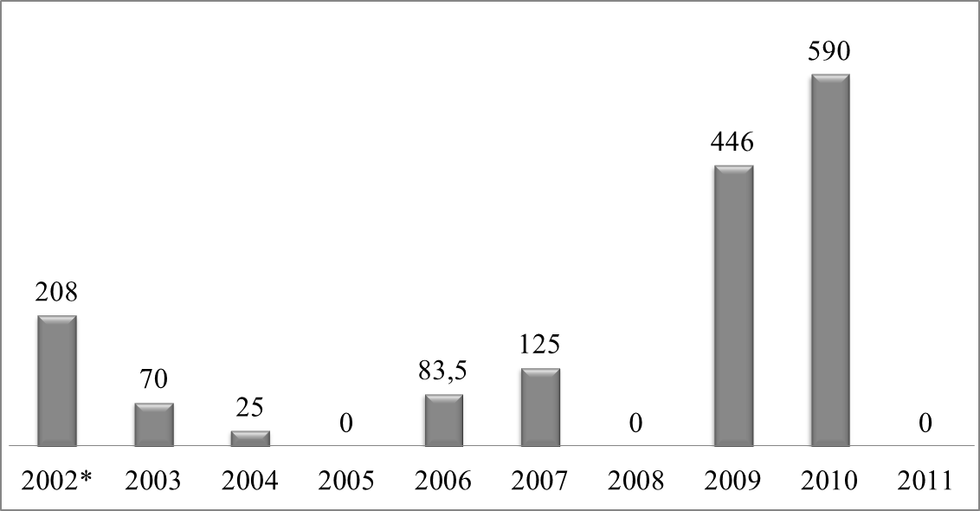
Chart 2b: MFA amounts authorised by regions in 2002-2011
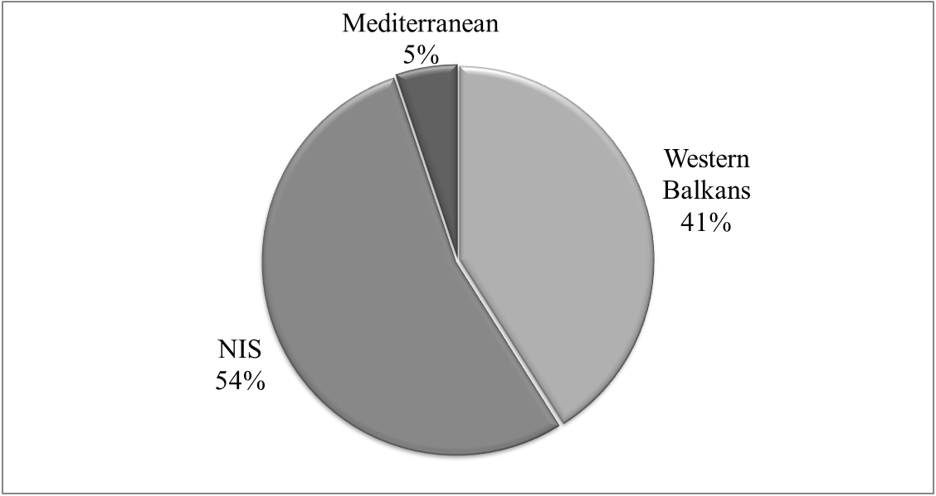
Table 3: MFA amounts disbursed by year during 2002-2011 in EUR million
Chart 3a: MFA amounts disbursed by year during 2002-2011 in EUR million
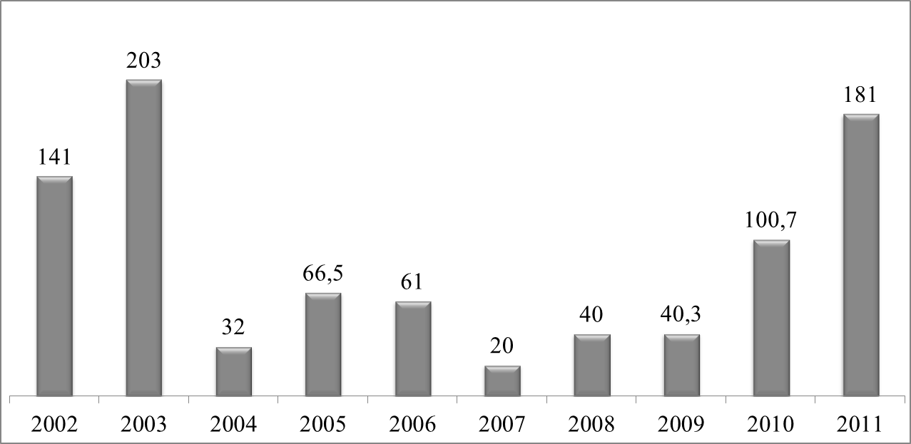
Chart 3b: MFA amounts disbursed by regions in 2002-2011
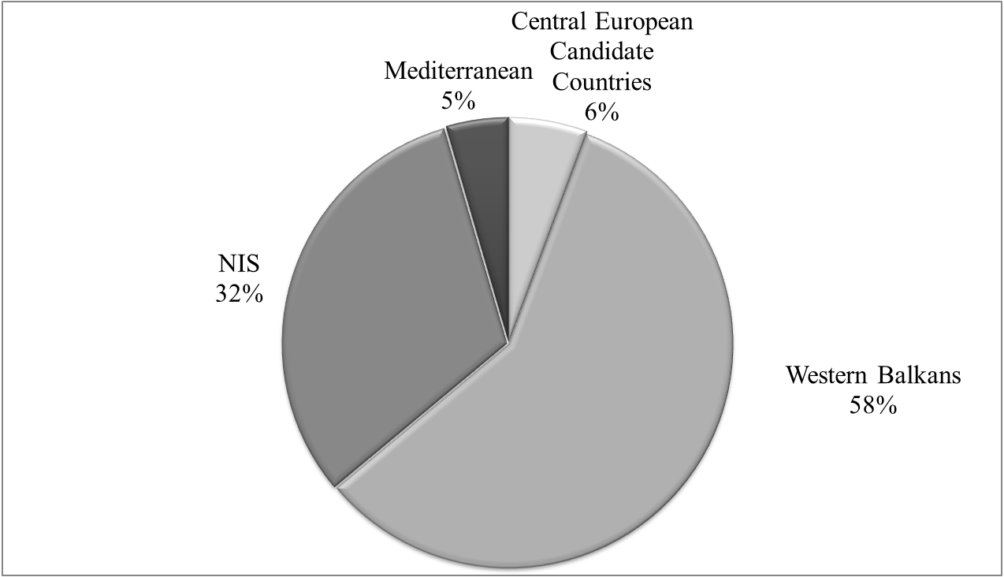

* This designation is without prejudice to positions on status, and in line with UNSCR 1244 and the ICJ Opinion on the Kosovo Declaration of Independence.
For background information on recent economic developments in the Southern neighbours, see also "The EU's neighbouring economies: coping with new challenges", Occasional Papers no. 86 / November 2011, DG ECFIN, European Commission (http://ec.europa.eu/economy_finance/publications/occasional_paper/2011/index_en.htm )
Commission proposal for a regulation of the European Parliament and of the Council lying down general provisions for Macro-Financial Assistance to third countries - COM(2011) 865 final, 4.7.2011.
Regulation (EC) No 182/2011 of the European Parliament and of the Council of 16 February 2011.
Insufficient progress with PFM, together with uncertainties over the macroeconomic framework (including the off-track status of the IMF programme), led the European Commission to delay the disbursement of budgetary support operations at the end of 2011.
For more information, please see the Report from the Commission to the European Parliament and the Council on guarantees covered by the general budget (issued semi-annually).

