The following charts from the ECB report illustrate the development of corporate credit ratings and GDP growth in the euro zone (EU 17) and in the European Union (EU27), which show a correlation of the two over time.
Chart 1: Credit ratings and GDP growth in EU17 | Chart 2: Credit ratings and GDP growth in EU27
Although the data sample is much shorter, similar tendencies are observable for securitisation rating changes.
Chart 3: Credit Ratings for Securitisation Products
The cyclicality evident in these graphs implies that capital requirements which are linked to external ratings would follow a clear cyclical pattern at the level of individual exposures. This could contribute to pro-cyclicality of credit and business cycles, where rating downgrades for certain assets may induce a relevant de-leveraging process. However, the cyclicality of overall MRC for SA banks may be mitigated by dynamic adjustments to banks’ portfolio composition.
Chart 4 and Chart 5 summarise qualitative survey results from the Eurosystem’s quarterly Bank Lending Survey (BLS).
Chart 4: Regulatory impact on banks’ risk weighted assets and capital
Impact of Basel III and other regulatory requirements on banks’ risk-weighted assets and capital position (net percentages of banks)
Note: The net percentages are defined as the difference between the sum of the percentages for “increase considerably” and “increase somewhat” and the sum of the percentages for “decreased somewhat” and “decreased considerably". Replies for 2011H1 refer to the July 2011 BLS; July 2011 BLS replies for 2011H2 correspond to expectation; replies for 2012H1 refer to January 2012 expectations.

Chart 5: Regulatory impact on banks’ credit standards
Contribution of Basel III and other regulatory requirements on the tightening of credit standards (net percentages of banks)
Note: The net percentages are defined as the difference between the sum of the percentages for contributing “considerably” or “somewhat” to tightening credit standards and the sum of the percentages for contributing “somewhat” and “considerably" to an easing of credit standards.
Chart 4 shows shedding of risk weighted assets, weighted toward riskier loans, and an improvement in banks' capital position, in the last six months significantly due to share issuance. This suggests that exogenous non-cyclical factors have impacted notably on banks' capital position.
Chart 5 shows that for the first half of 2012 banks expect a further increase in the net tightening of credit standards due to regulatory pressures. Compared with the second half of 2011, the exacerbated effects on bank lending policy are anticipated to primarily affect large firms and the financing of house purchase.
The ECB notes that several empirical studies have found that changes in credit standards significantly impact on lending with a lag of 2-3 quarters. As Chart 5 suggests anticipated regulatory requirements have led to tightened standards, this could be another link between the MCR and the volume of loans provided to the non-financial sector.
Chart 6: Tightening in credit standards on loans to enterprises and banks’ capital position as contributing factor (net percentages) | Chart 7: Factors contributing to tightening in credit standards on loans to enterprises (net percentages)
Sources: Eurosystem’s Bank Lending Survey (BLS). – Notes: The net percentage refers to the difference between the sum of the percentages for “tightened considerably” and “tightened somewhat” and the sum of the percentages for “eased somewhat” and “eased considerably”. The net percentages for the questions related to the factors are defined as the difference between the percentage of banks reporting that the given factor contributed to a tightening and to an easing. | Sources: Eurosystem’s Bank lending survey and ECB calculations. – Notes: The “perception-of-risk” factor refers to the “industry and firm-specific outlook”, the “expectations regarding general economic activity”, and the “risk on collateral demanded”; the “competition” factor refers to competition from “other banks”, “non-banks” and “market financing” respectively; the “balance-sheet-constraints” factor refers to “costs related to banks capital position”, “banks’ ability to access market financing” and “banks’ liquidity position”. Net percentages reported for three groups of contributing factors are simple averages of underlying factors listed above.
Chart 6 shows the link between banks' capital position and credit standards on loans to enterprises. Chart 7 shows that during the financial crisis banks’ balance sheet constraints have gained relative importance, while perception of risk is the main driver behind tightened standards.
Table 1: EU banking assets
Source: ECB paper "EU Banking Structures" Sept 2010

Across the EU 27, non-home bank assets account for just over a quarter of the total. This quarter is mostly EU subsidiaries (12%) and EU branches (7.7%) with third country branch and subsidiary assets being mostly located in the UK. In the UK, 24.1% of assets are from third country branches and subsidiaries, which would include e.g. US firms operating in London, and 27.4% from the EU.
Chart 8: Composition of EU 27 banking assets
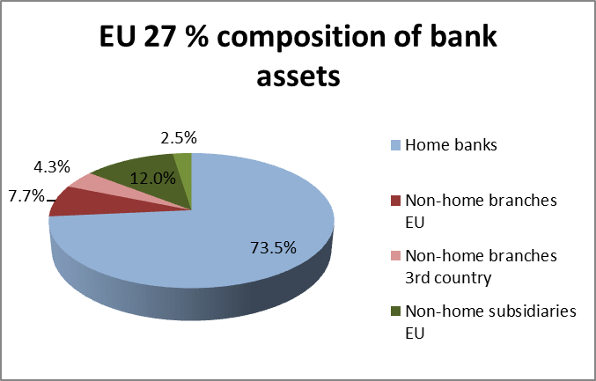
The situation is reversed when we consider only the group of ten new central and eastern Europe MS. Non-home bank assets account for about three-quarters (72%) of the total banking assets located in the CEE 10, while they contribute 2.1% of total EU 27 banking assets. In LT, BU, CZ, EE and SK, over 80% of banking assets are non-home. The CEE are clearly vulnerable to repatriation of capital to banks' home MS, which might occur if capital requirements are raised by home supervisors. The single rule book with 'constrained discretion' for home supervisors to set higher capital requirements on their firms is therefore a key measure to mitigate pro-cyclical effects of asymmetric deleveraging in "host" countries such as the CEE 10.

Chart 9: Composition of CEE 10 banking assets
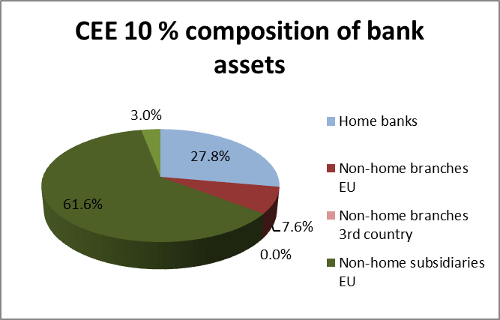
Nevertheless, there are factors that may diminish the potential impact of euro area banks' deleveraging on Eastern Europe. First, only a third of all euro area banks' lending to the region is accounted for by cross-border claims. The rest is in the form of locally incorporated operations, which tend to be much more stable. Second, banks located in the euro area hold only about a tenth of their total international claims on emerging Europe in the form of tradable debt instruments. As a result, it would be relatively difficult for them to quickly dispose of most of their claims on the region without incurring high costs.
Chart 10: Macroeconomic Assessment Group model study results
The chart (taken from page 2 of the MAG 2010 report) shows the estimated effects of a 1 percentage point increase in target capital ratio.

The MAG exercise calculated the impact of a 1 percentage point increase in target capital ratio on the basis of a two-year and a four-year transition period. While the magnitude of the overall impact is similar in these two cases, as illustrated in the Chart above, the time pattern of the GDP effects is different. Assuming that banks adjust their capital ratio within a year (rather than through two consecutive years), the impact on GDP may be more pronounced in the short run.
Chart 11: Total CCB capital add-on in RWA in the European Union
The sum of all CCB RWA capital add-on would have added up to a total sum of circa 290bn euro for all countries in the EU in the peak of the CCB requirement in 2007. This would have provided European banks with a sizeable cushion of additional Tier 1 capital to absorb a shock like the Lehman collapse, assuming a total release of the CCBs in all EU countries. This would most probably have reduced the need for government intervention and the involvement of taxpayer money in bank recapitalisation and, ultimately, would have mitigated the de-leveraging pressure on banks as well.

For euro area-based evidence see e.g. De Bondt et al. (2010), Ciccarelli et al. (2010) and Hempell and Kok Sørensen (2010). For US-based evidence, see e.g. Lown and Morgan (2006) and Berger and Udell (2004).
The term 'banks’ balance sheet constraints' captures various factors in the BLS, including 'costs related to banks capital position', 'banks’ ability to access market financing' and 'banks’ liquidity position'.

