 | 
COUNCIL OF  THE EUROPEAN UNION |  |  | Brussels, 13 July 2012
 | Interinstitutional File:  2012/0110 (COD) |  | 12615/12
EF 173
ECOFIN 709
SURE 11
CODEC 1914
INST 469
PARLNAT 296

COVER NOTE
from: | The Portuguese Parliament
date of receipt: | 12 July 2012
to: | President of the European Union
Subject: | Proposal for a Directive 2009/138/EC on the taking-up and pursuit of the business of Insurance and Reinsurance (Solvency II) as regards the dates of its transposition and application and the date of repeal of certain Directives  [doc. ST 10230/12 EF 123 ECOFIN 431 SURE 3 CODEC 1395 - COM(2012) 217 final]  - Opinion on the application of the Principles of Subsidiarity and Proportionality

Delegations will find attached the abovementioned opinion.

________________________

Encl.:
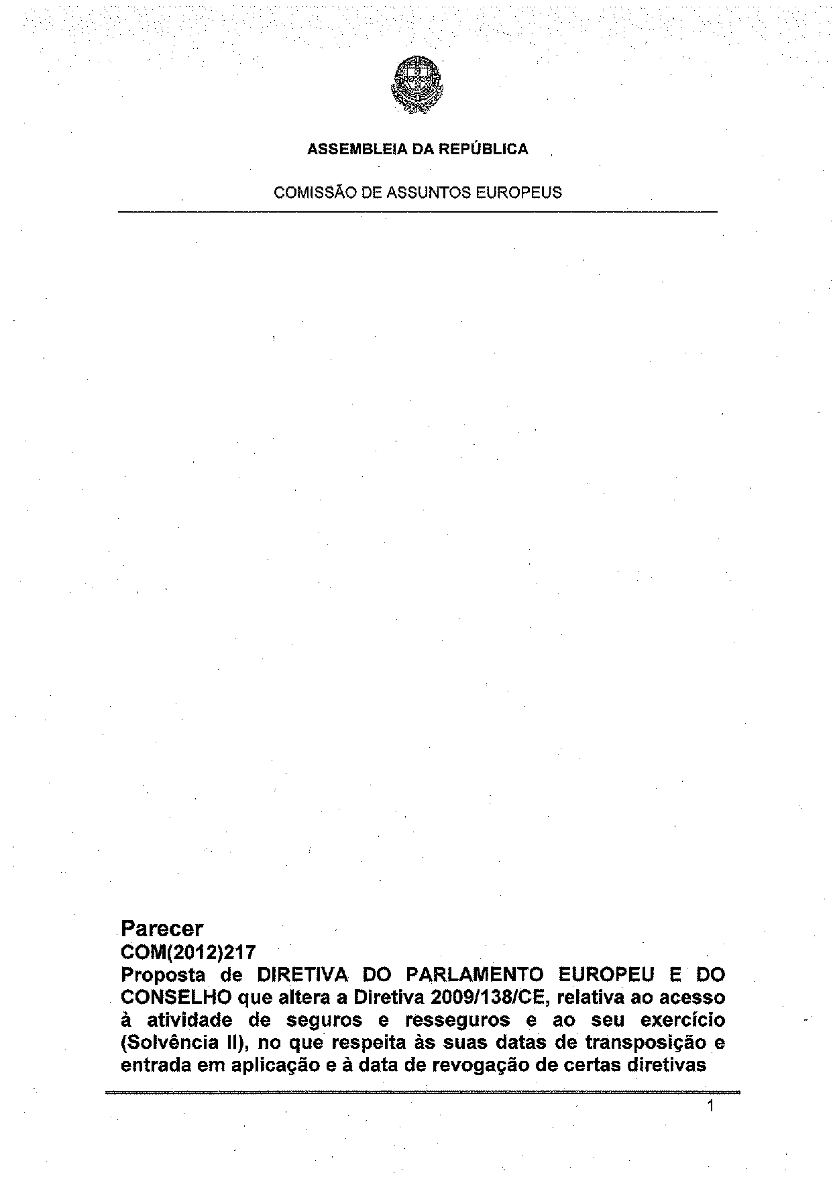
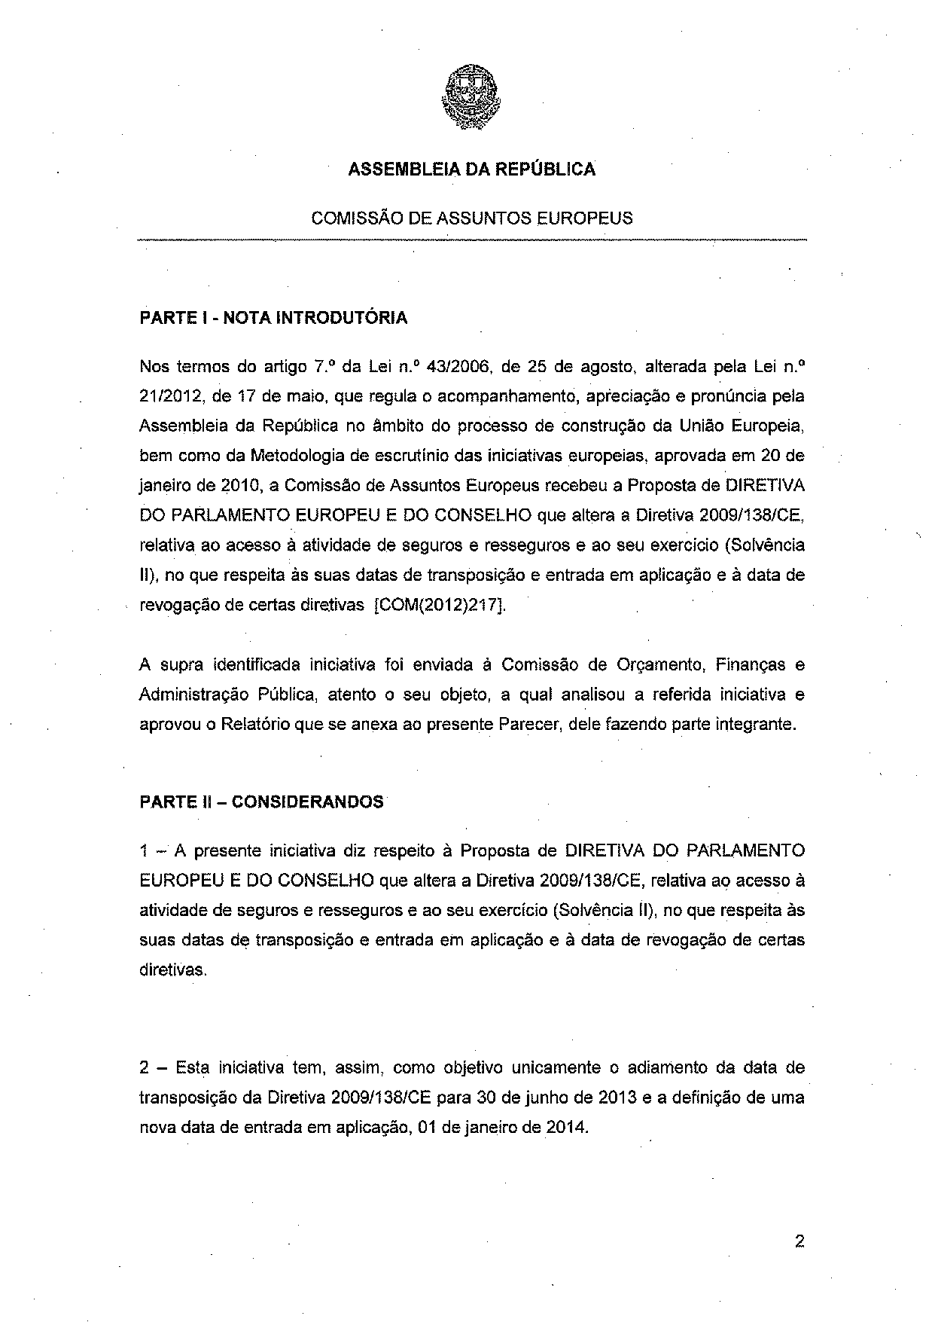
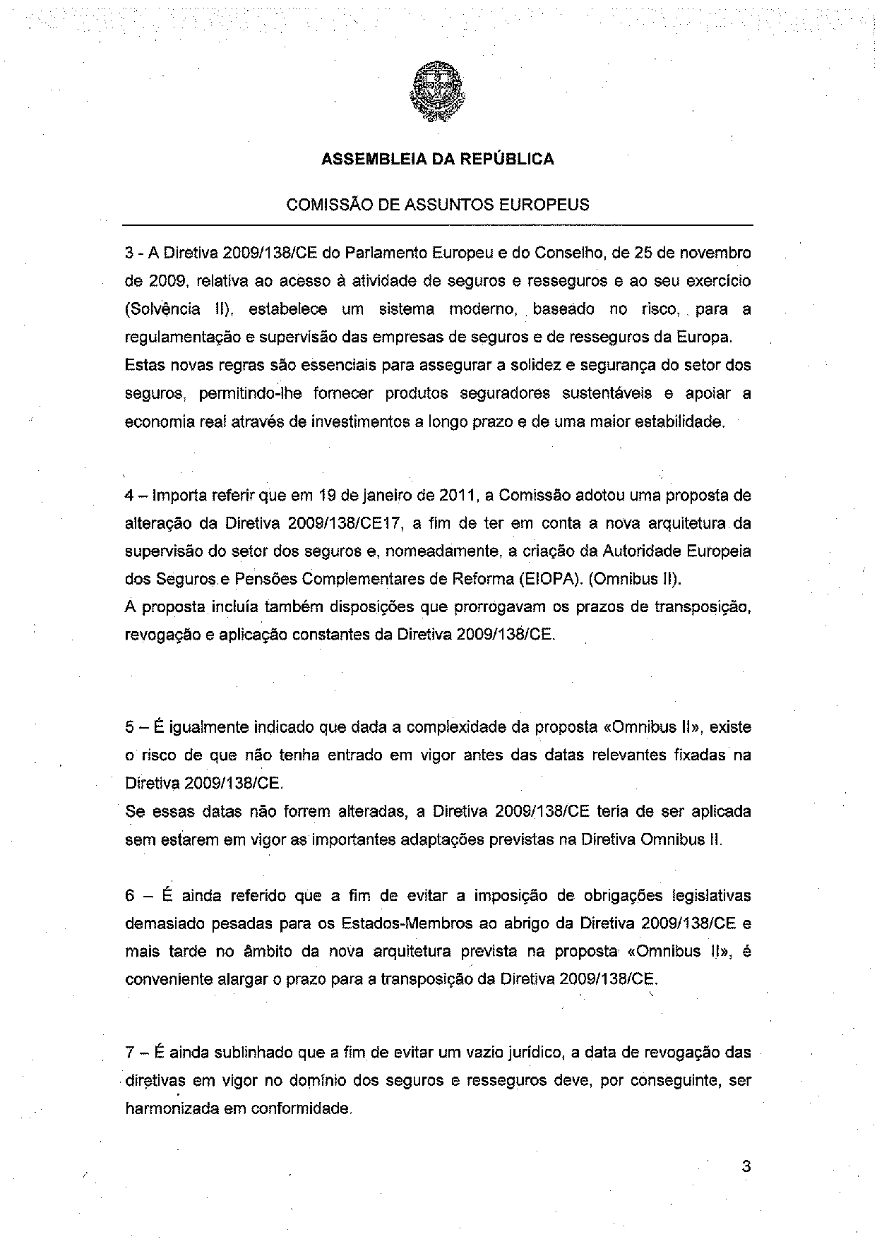
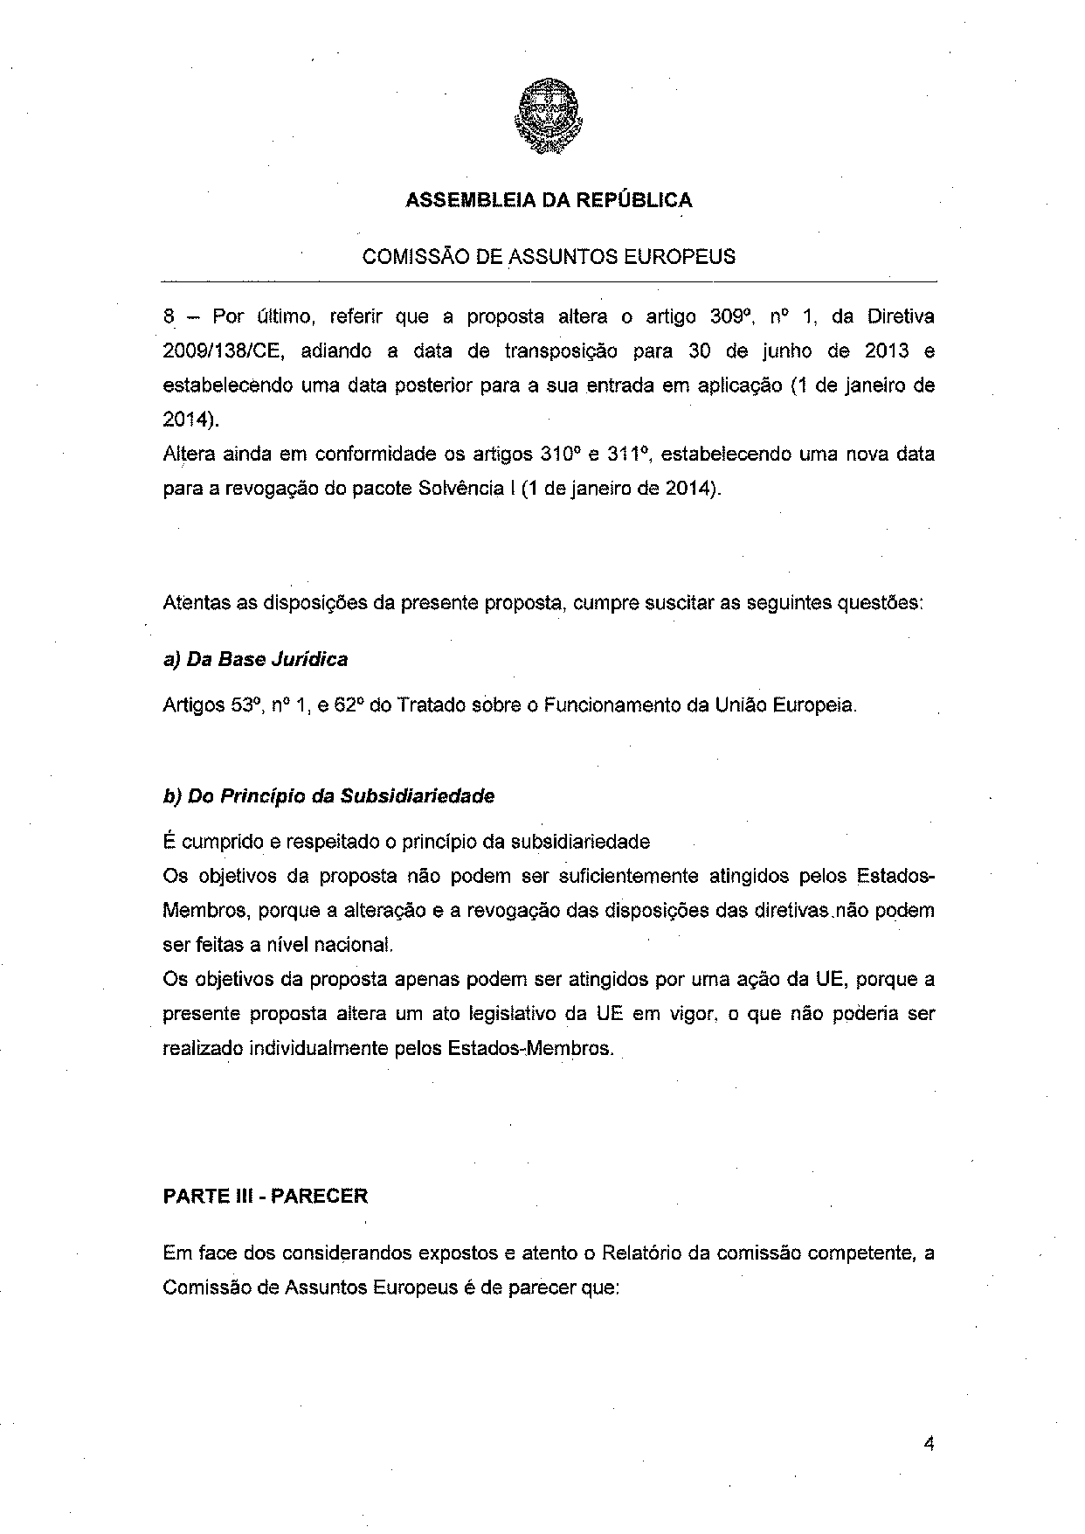
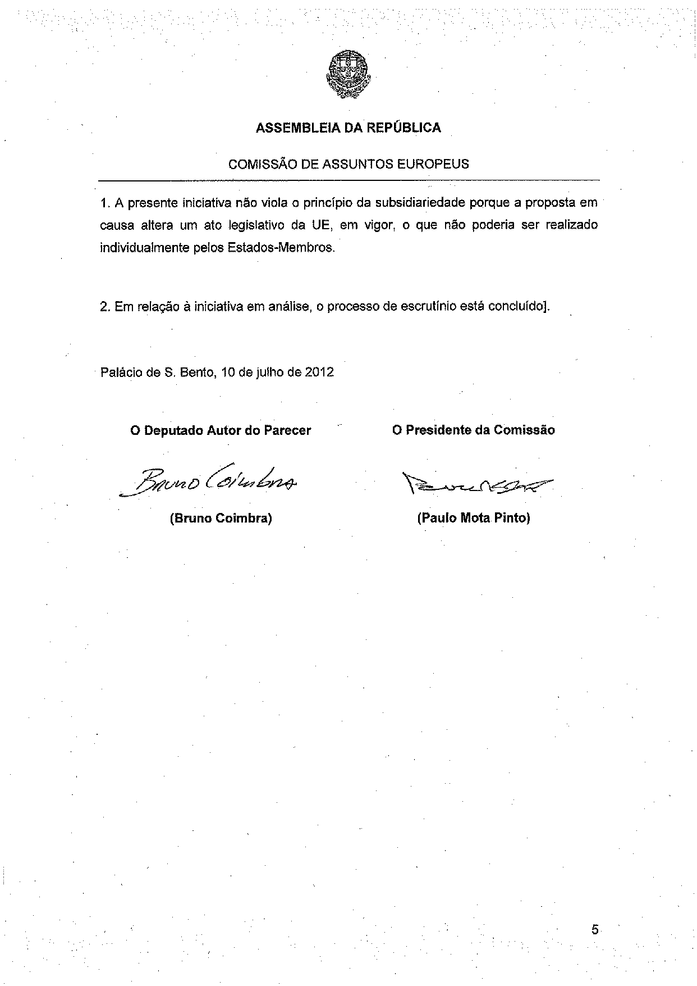

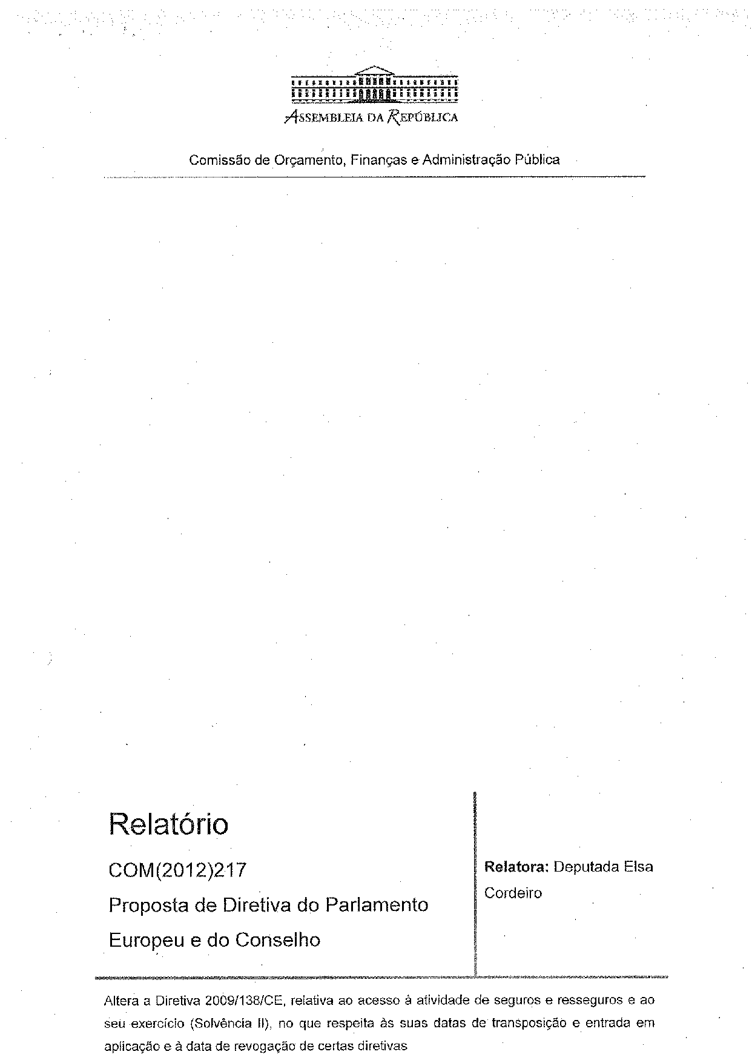
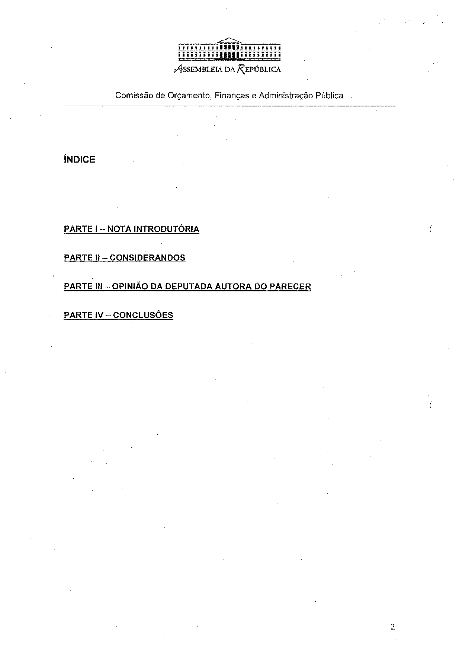
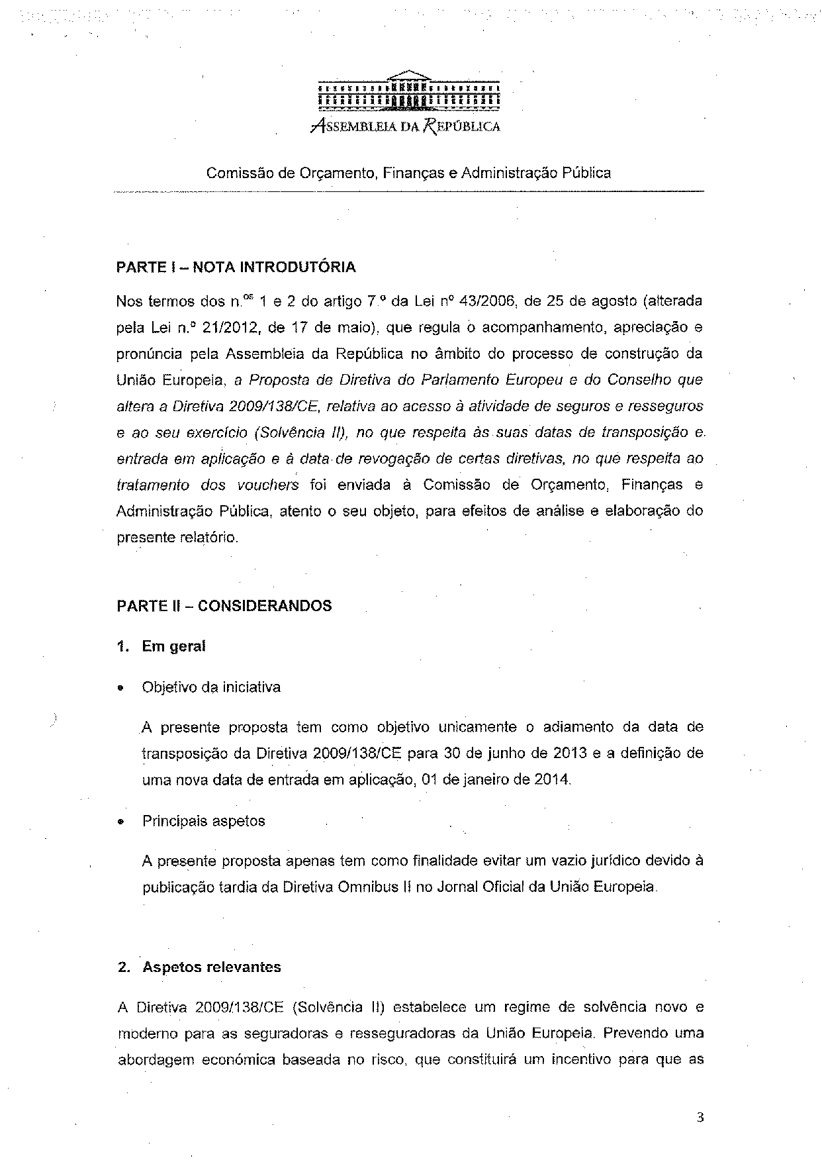
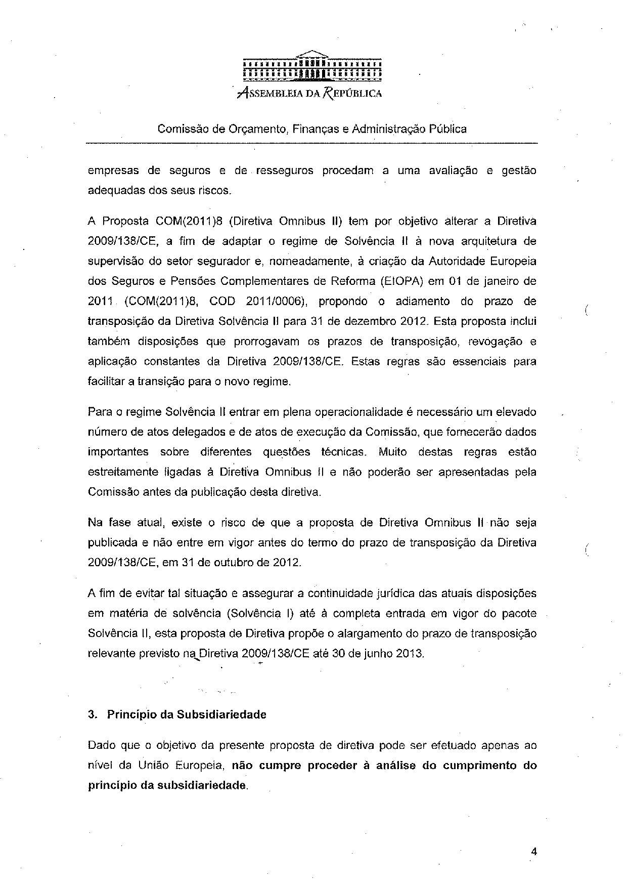
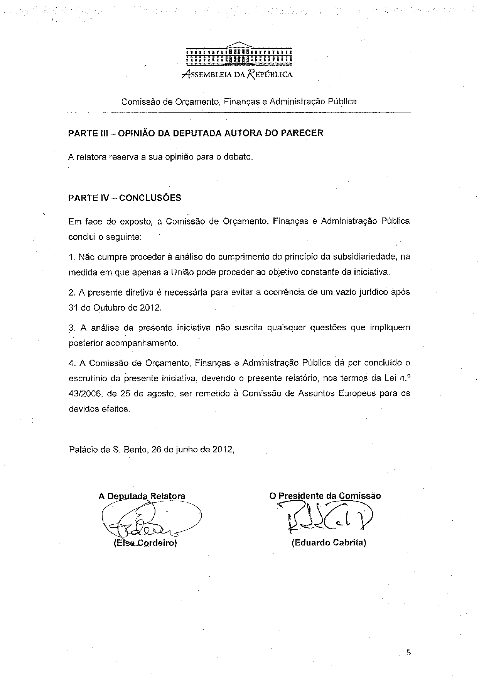

For other language versions of the opinion, reference is made to the Interparliamentary EU information exchange site IPEX at the following address: http://www.ipex.eu/IPEXL- WEB/search.do

