 | 
COUNCIL OF  THE EUROPEAN UNION |  |  | Brussels, 9 July 2012
 |  |  | 12217/12
UEM 254
ECOFIN 674
SOC 633
COMPET 482
ENV 599
EDUC 238
RECH 312
ENER 339
INST 452
PARLNAT 289

COVER NOTE
from: | The President of the Portuguese Parliament
date of receipt: | 4 July 2012
to: | The President of the Council of the European Union
Subject: | Communication from Commission to the European Parliament, the Council, the European Council, the European Central Bank, the European Economic and Social Committee, the Committee of the Regions and the European Investment Bank  Actions for Stability, Growth and Jobs  [doc . 10834/12 UEM 147 ECOFIN 497 SOC 479 COMPET 371 ENV 459 EDUC 156 RECH 212 ENER 240- COM(2012) 299 final]  - Opinion on the Application of the principles of Subsidiarity and Proportionality

Delegations will find attached the above mentioned opinion.

________________________

Encl.:

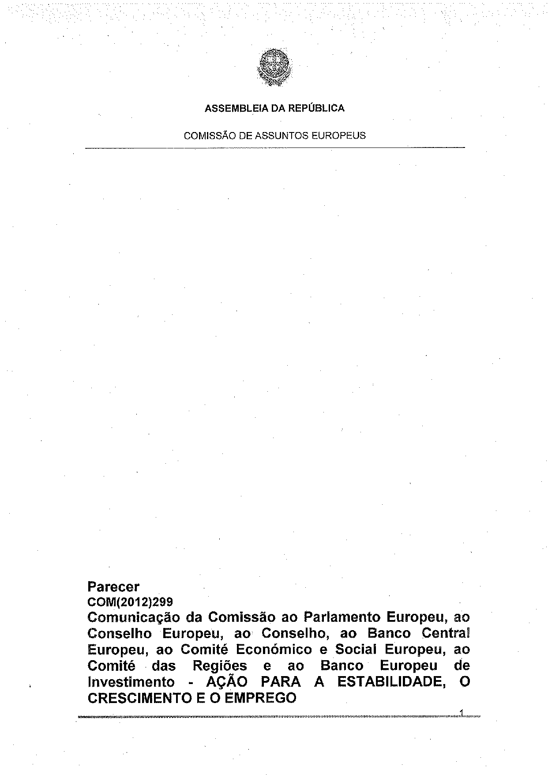
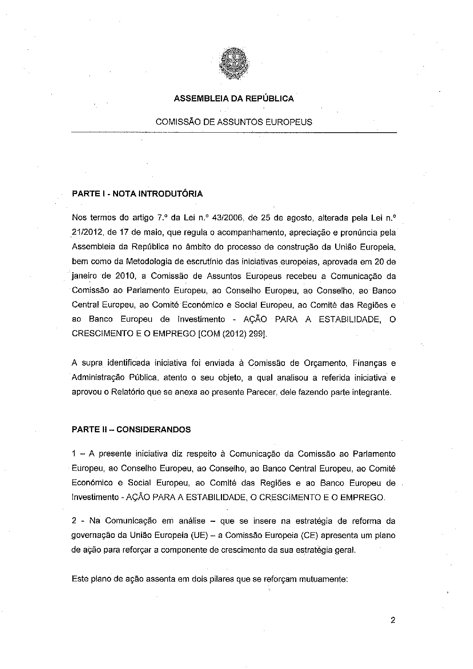
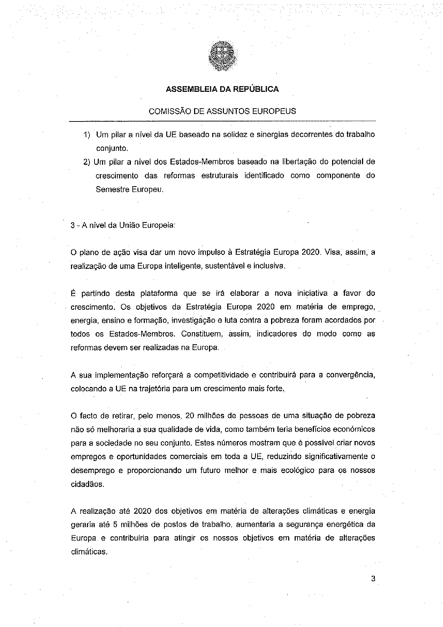
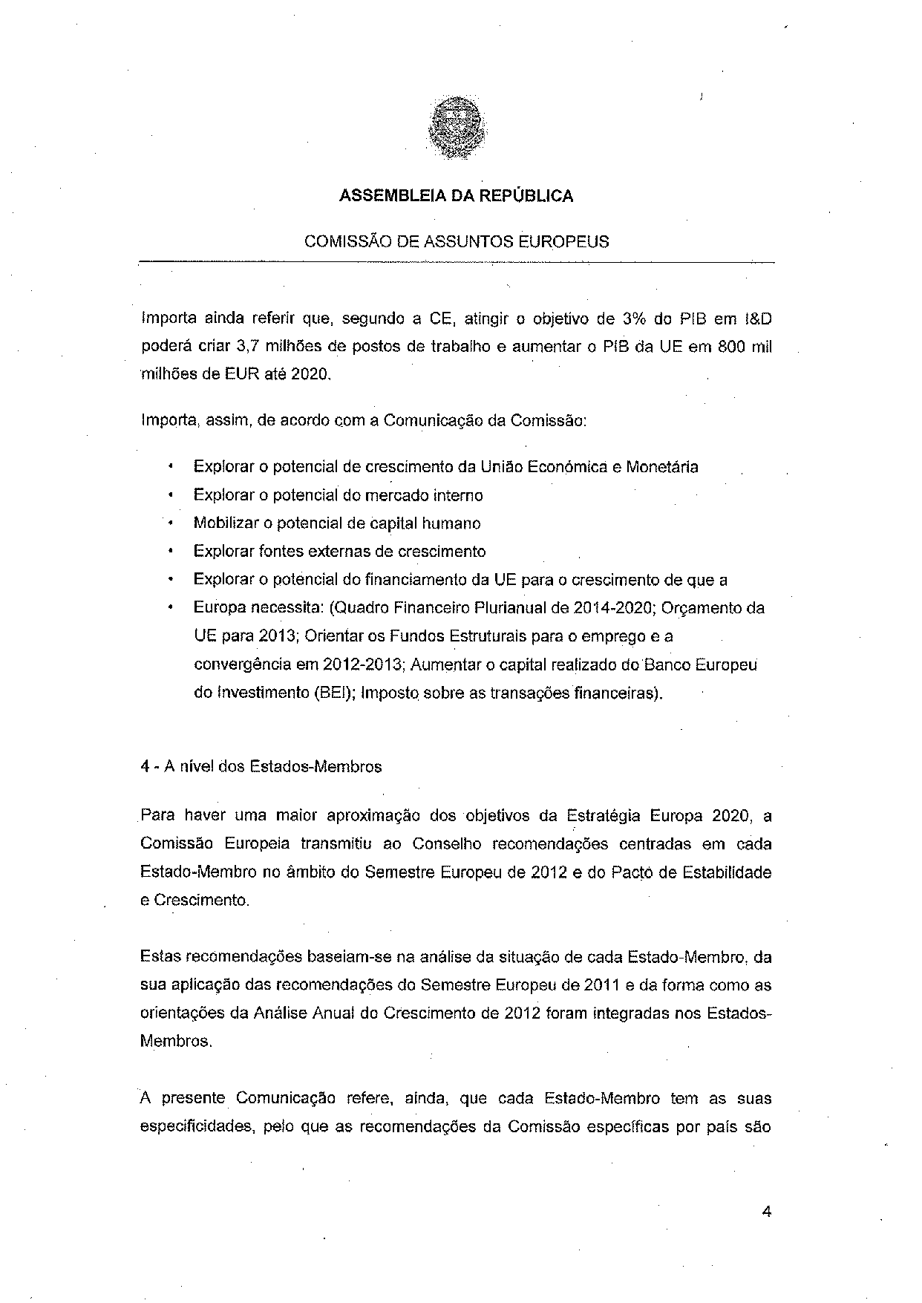
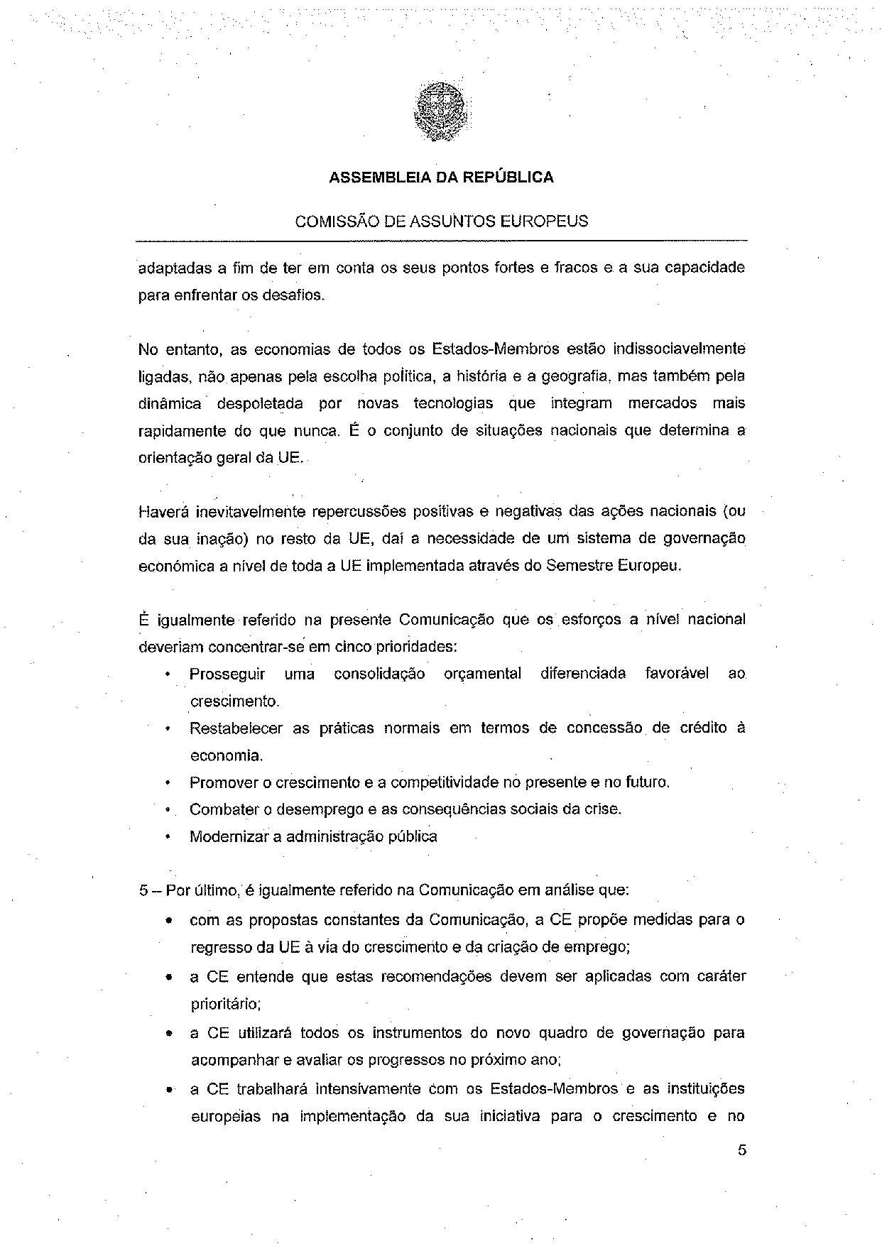
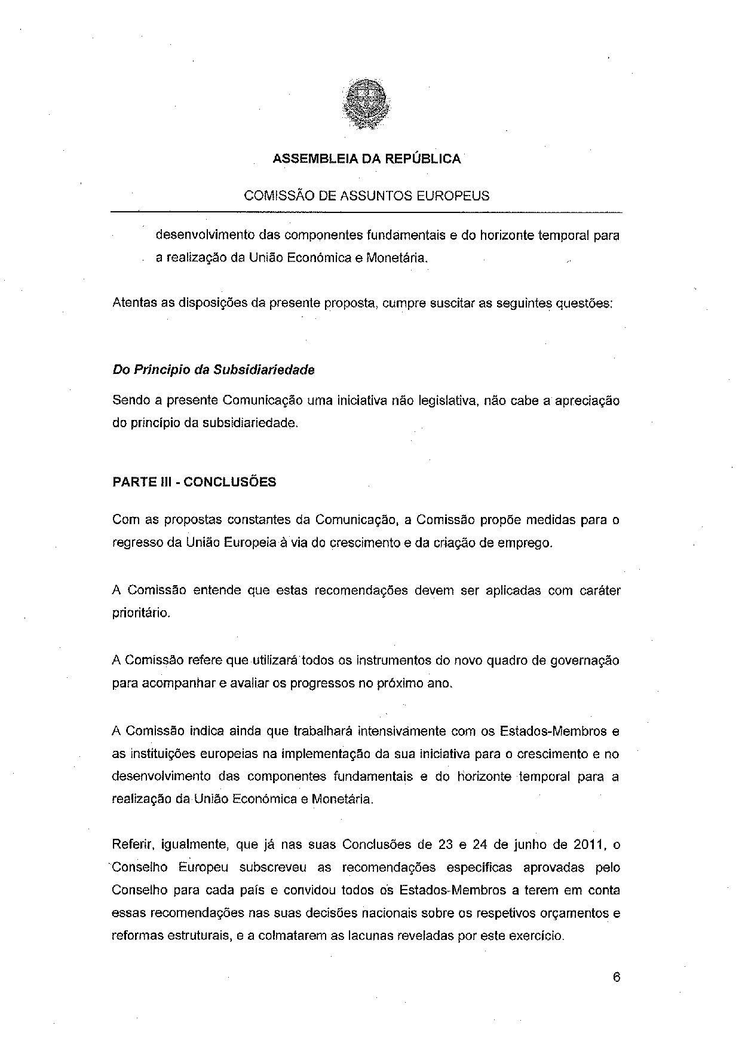
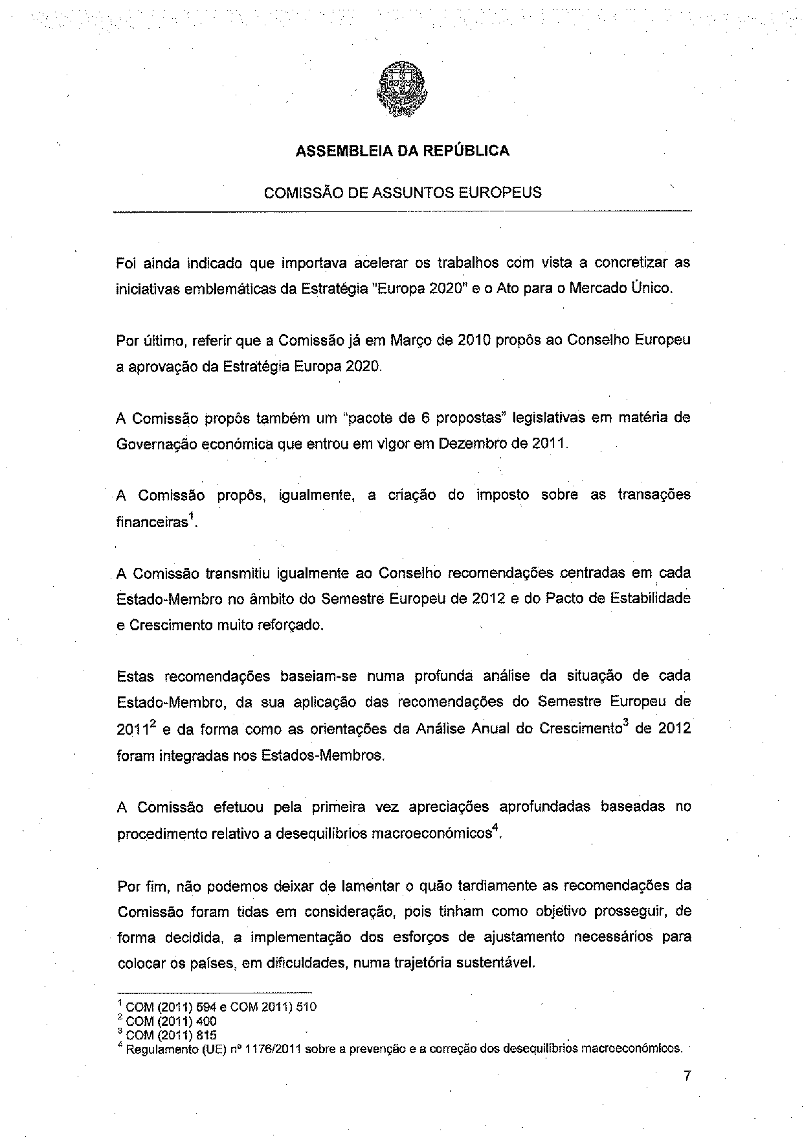
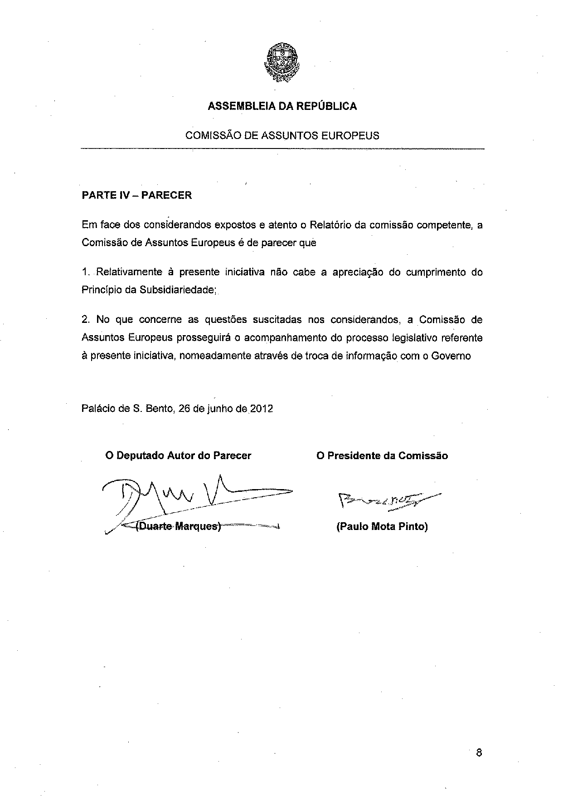

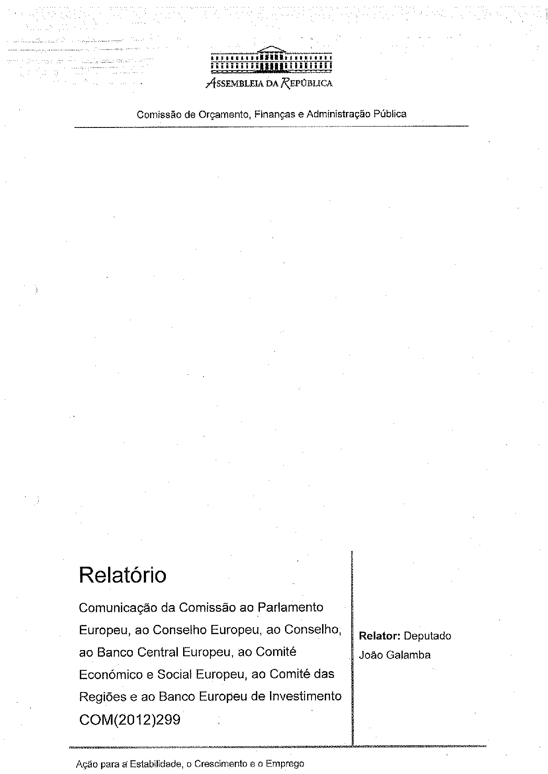
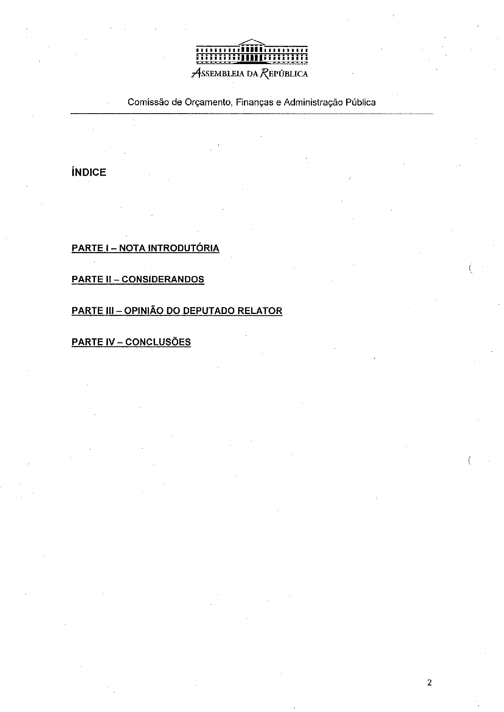
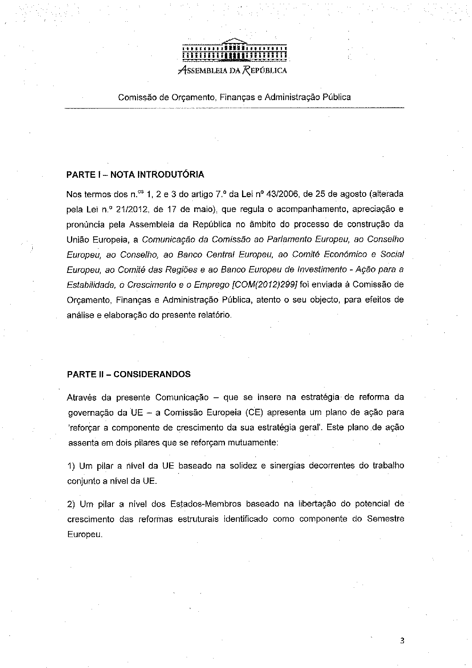
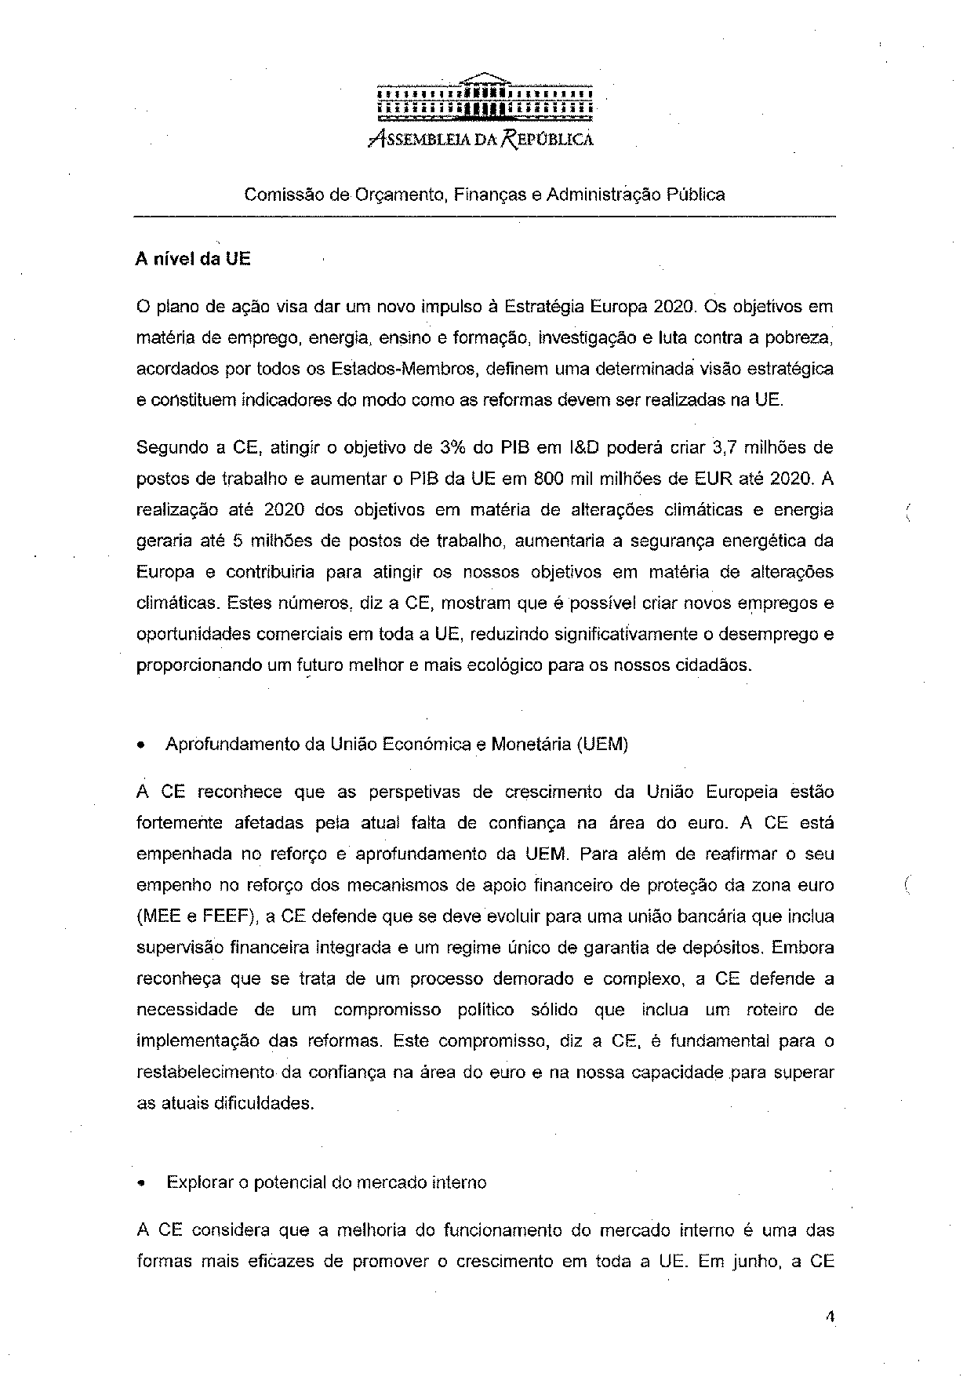
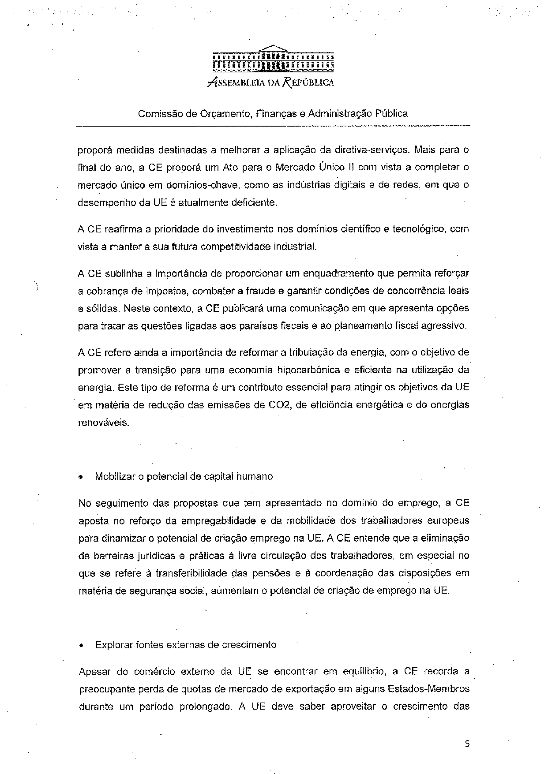
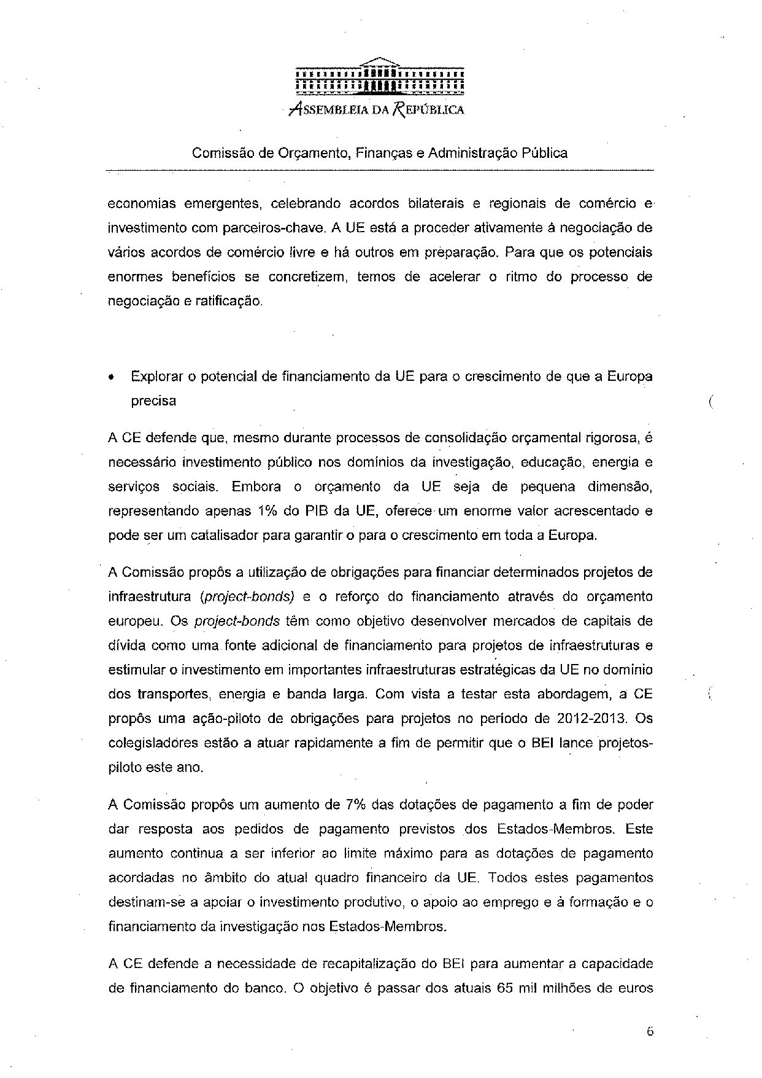
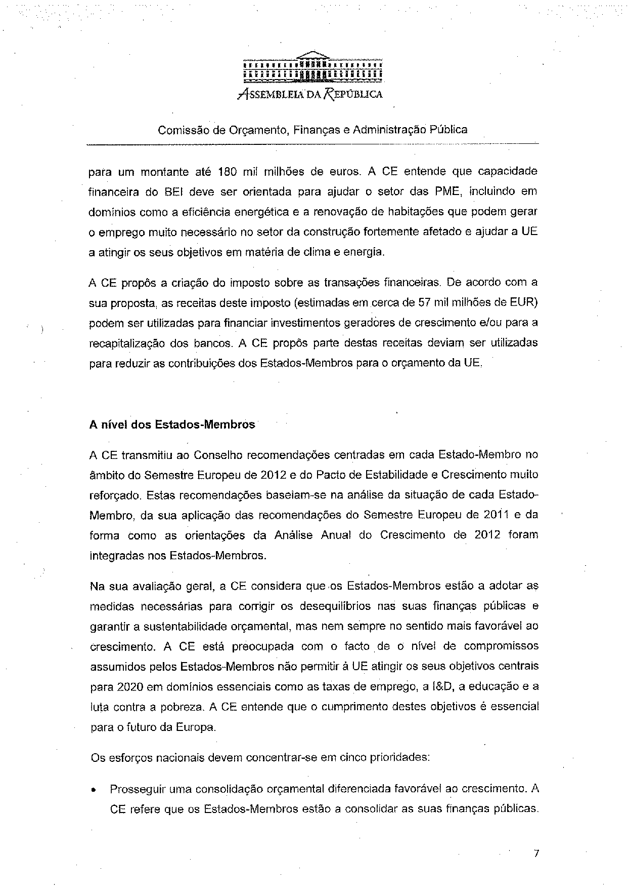
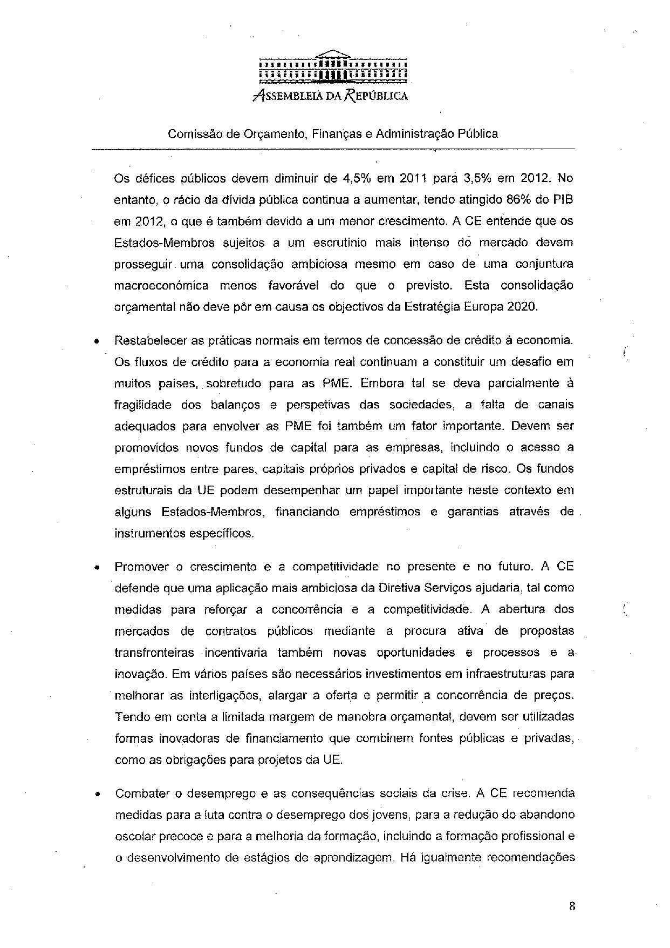
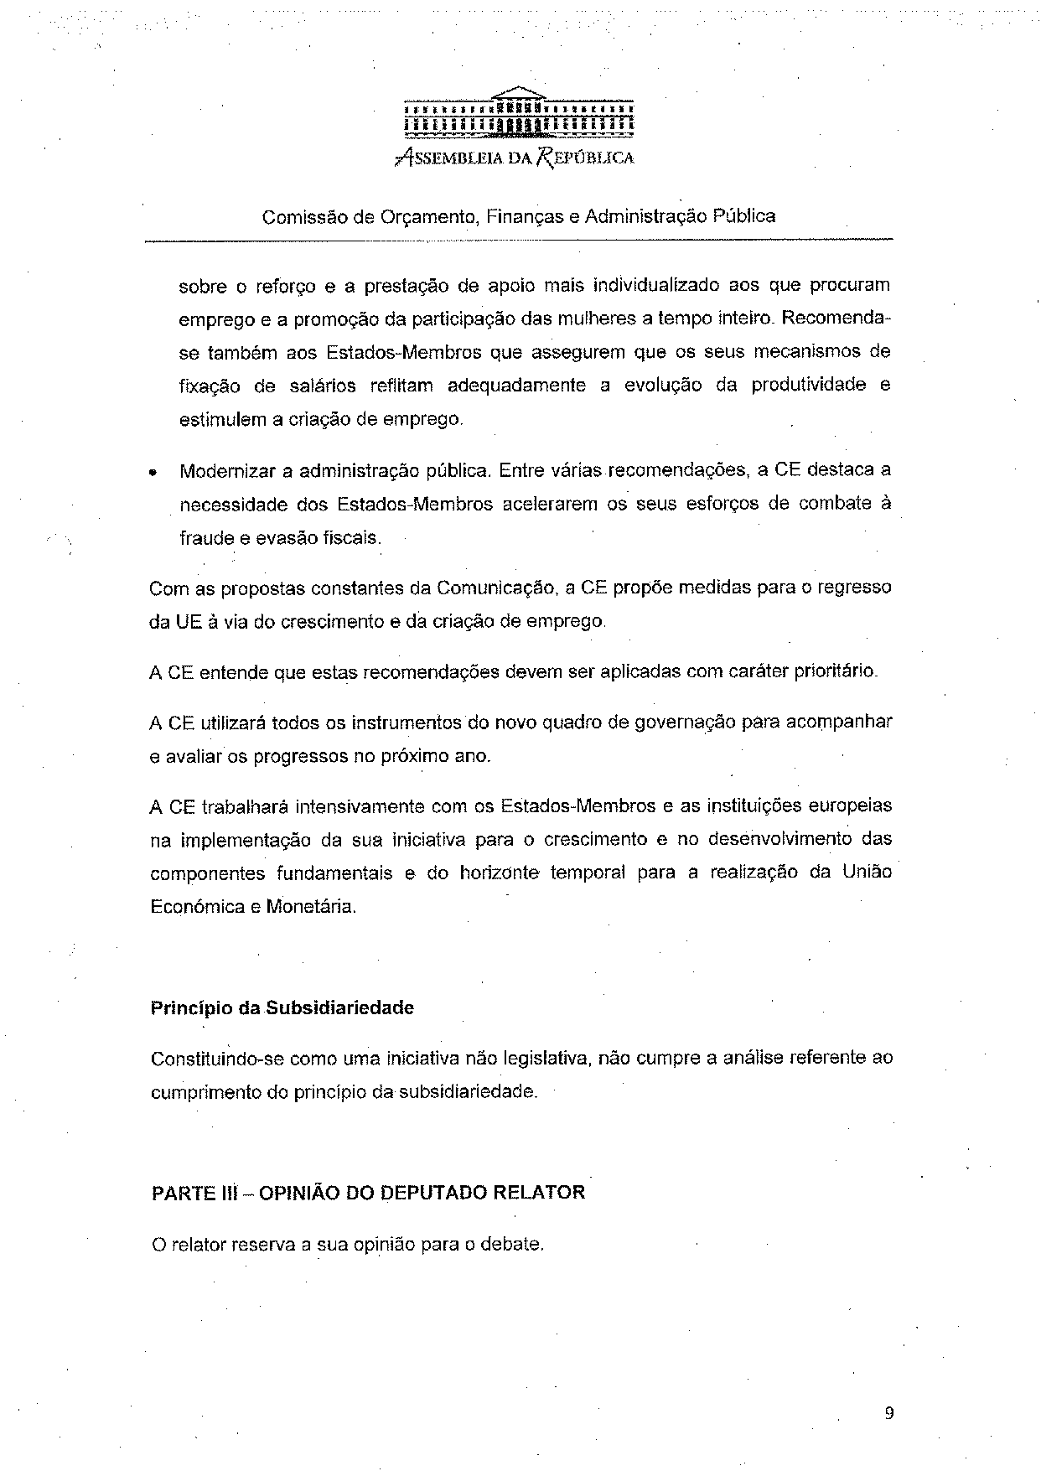
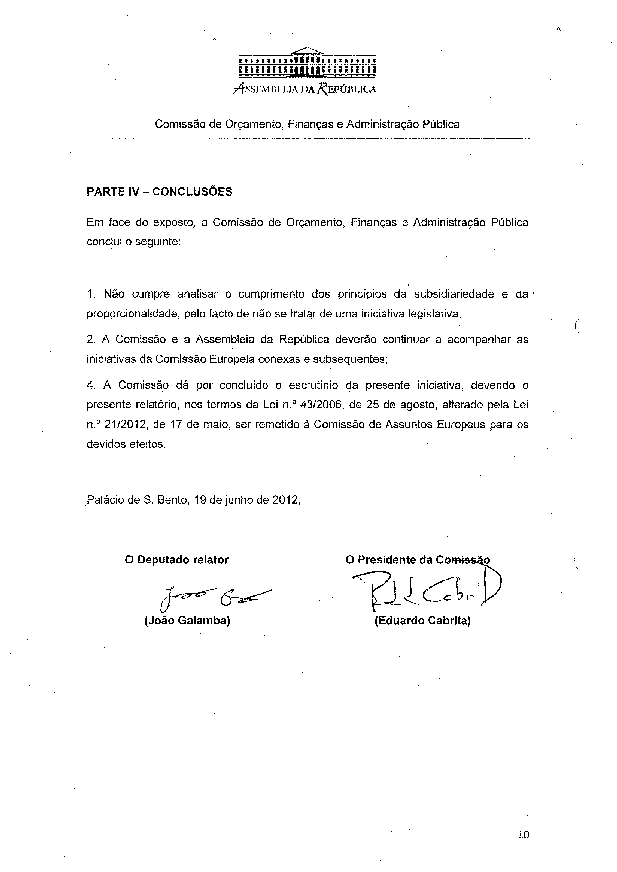

This opinion is available in English on the parliamentary EU information exchange site (IPEX) at the following address: http://www.ipex.eu/ipex/cms/home/Documents/pid/10

