 | 
COUNCIL OF  THE EUROPEAN UNION |  |  | Brussels, 9 July 2012
 |  |  | 12220/12
UEM 255
ECOFIN 675
SOC 635
COMPET 483
ENV 600
EDUC 239
RECH 313
ENER 340
INST 453
PARLNAT 290

COVER NOTE
from: | The President of the Portuguese Parliament
date of receipt: | 4 July 2012
to: | The President of the Council of the European Union
Subject: | Recommendation for a Council Recommendation on Portugal’s 2012 national reform programme and delivering a Council opinion on Portugal’s stability programme for 2012-2016  [doc . 10550/12 UEM 133 ECOFIN 468 SOC 451 COMPET 345 ENV 433 EDUC 142 RECH 194 ENER 220 - COM(2012) 324 final  - Opinion on the Application of the principles of Subsidiarity and Proportionality

Delegations will find attached the above mentioned opinion.

________________________

Encl.:

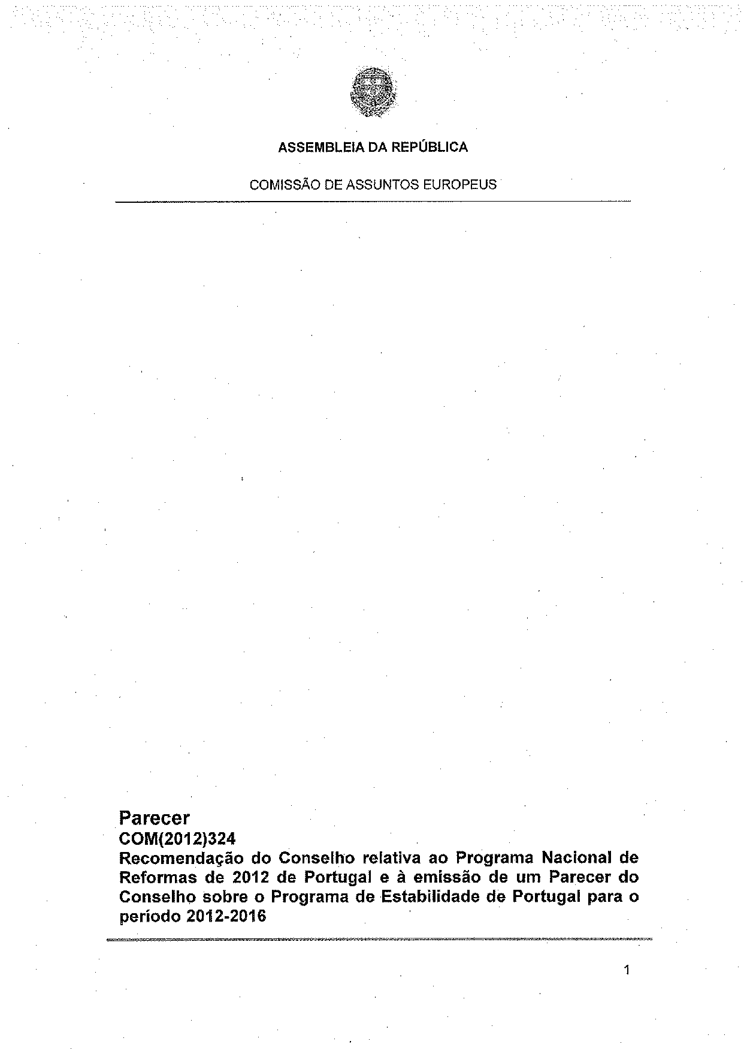
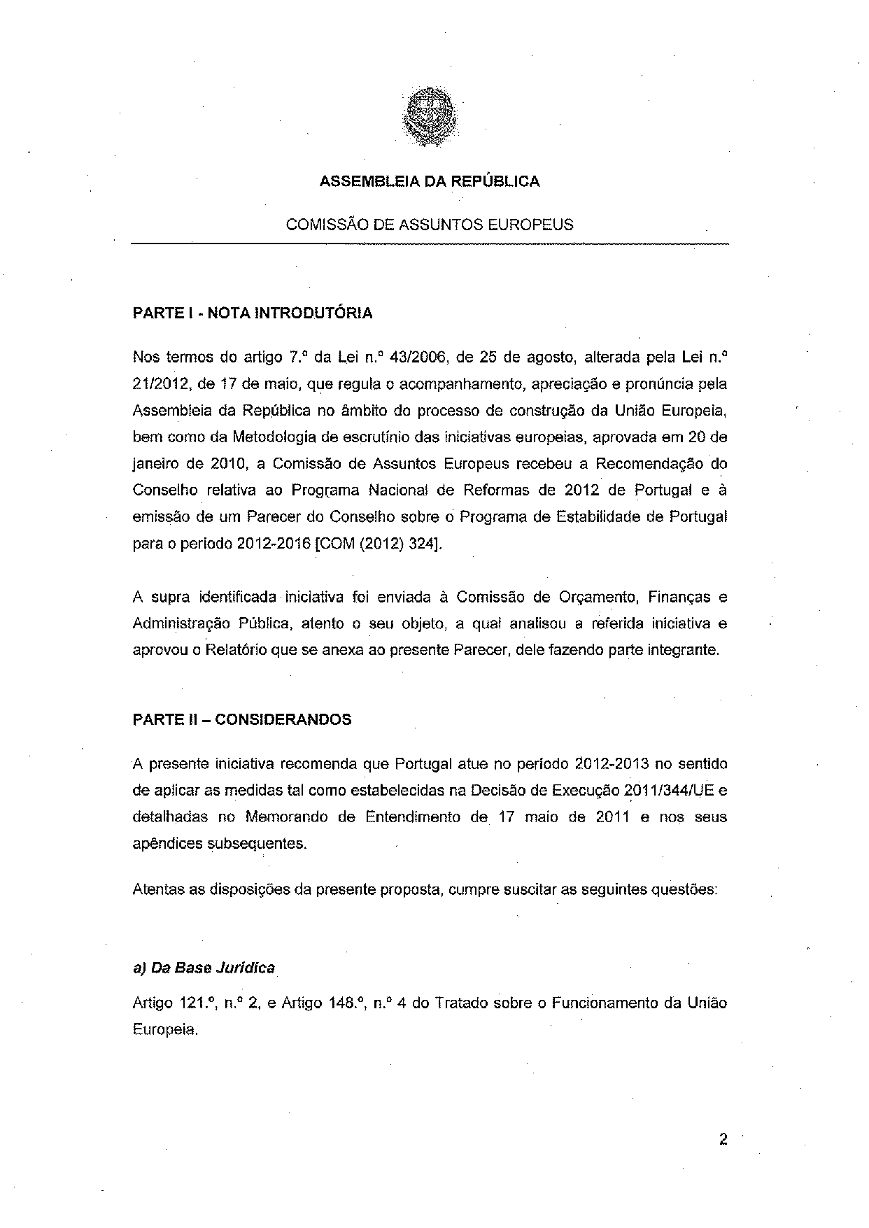
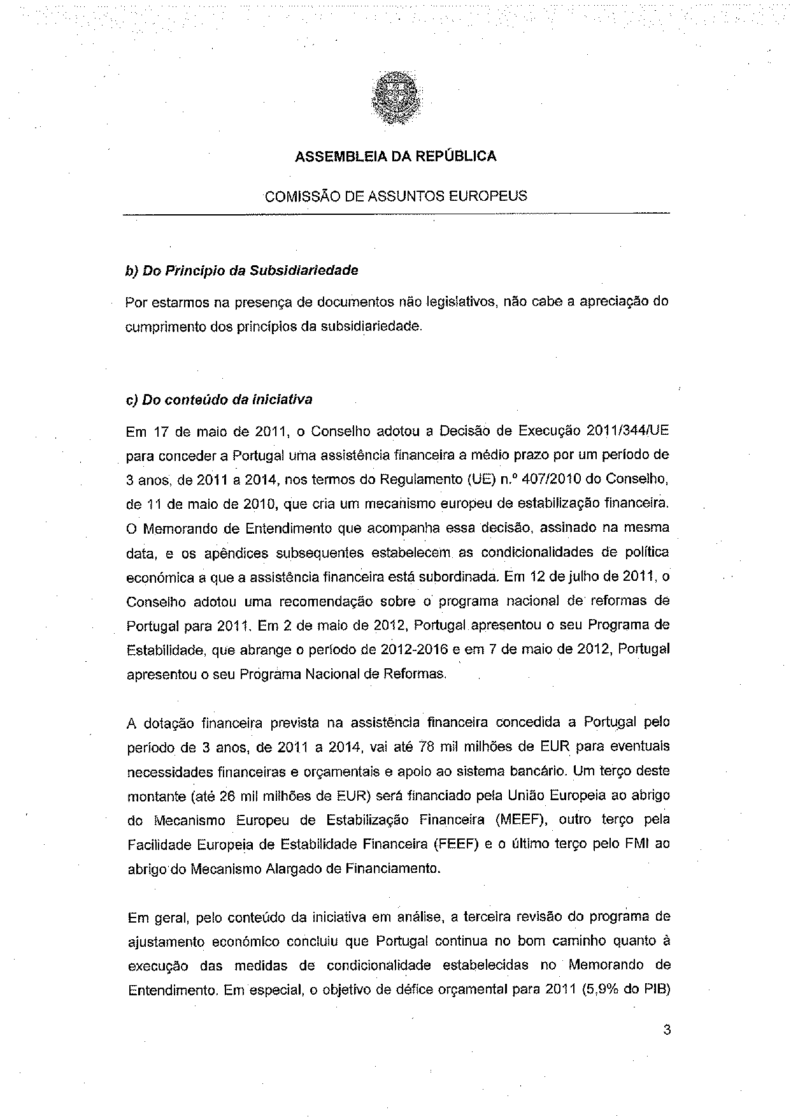
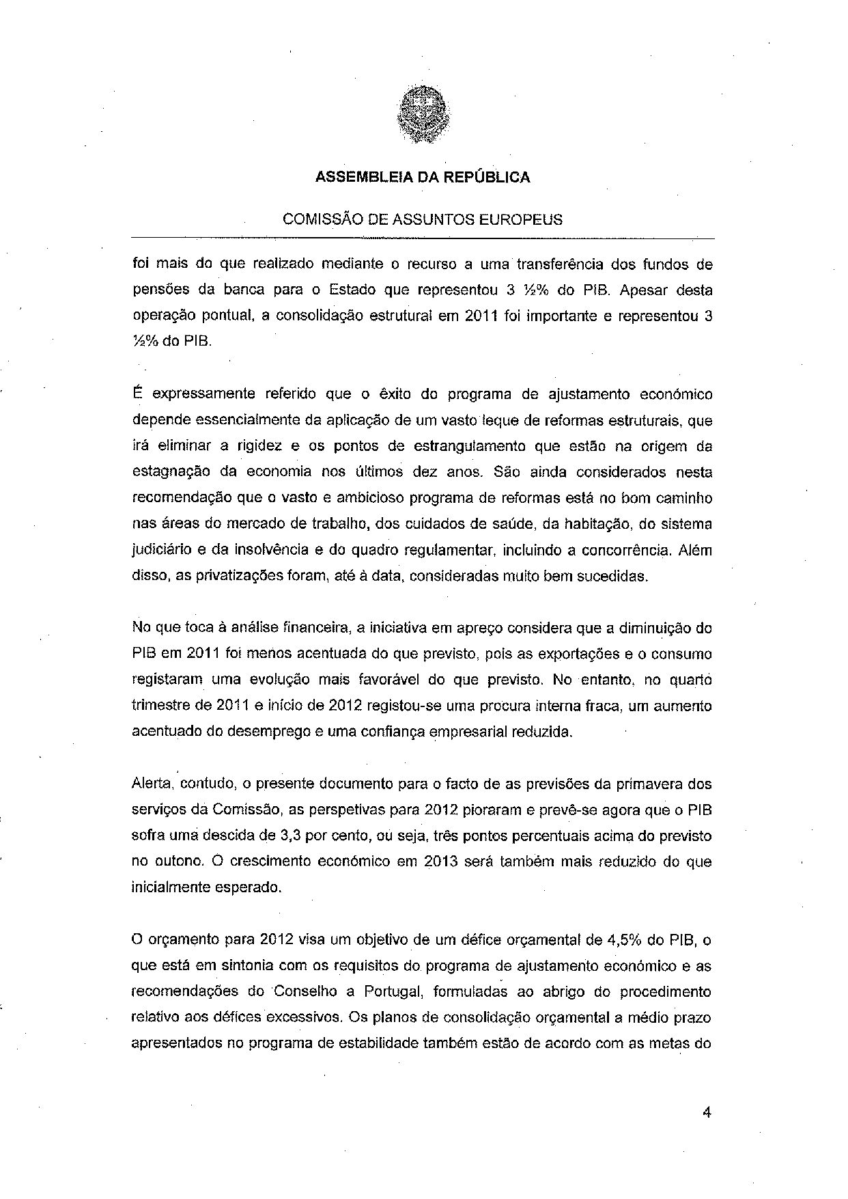
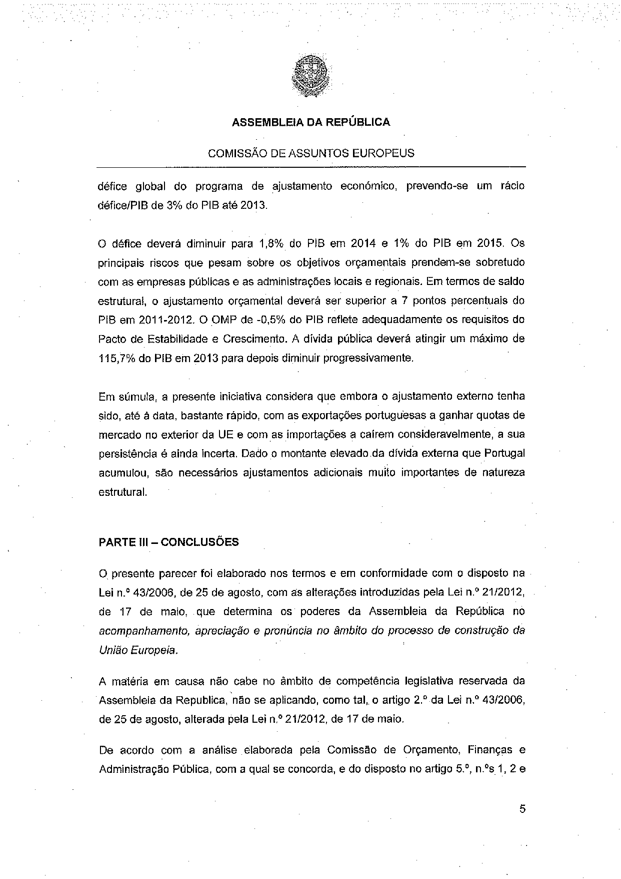
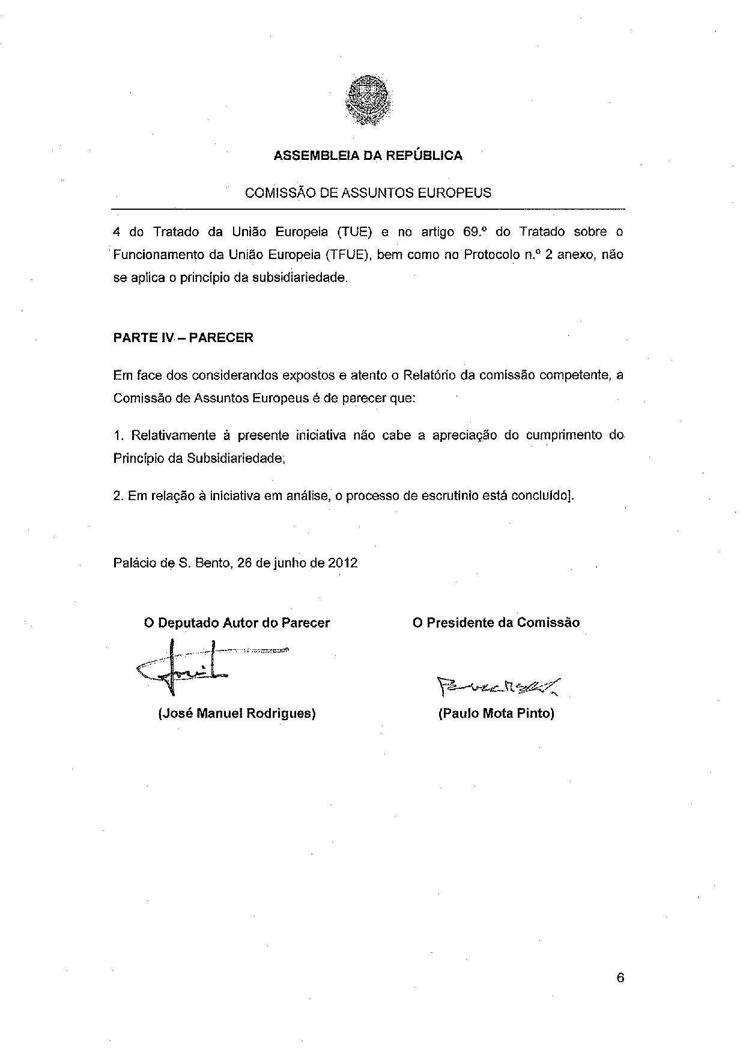
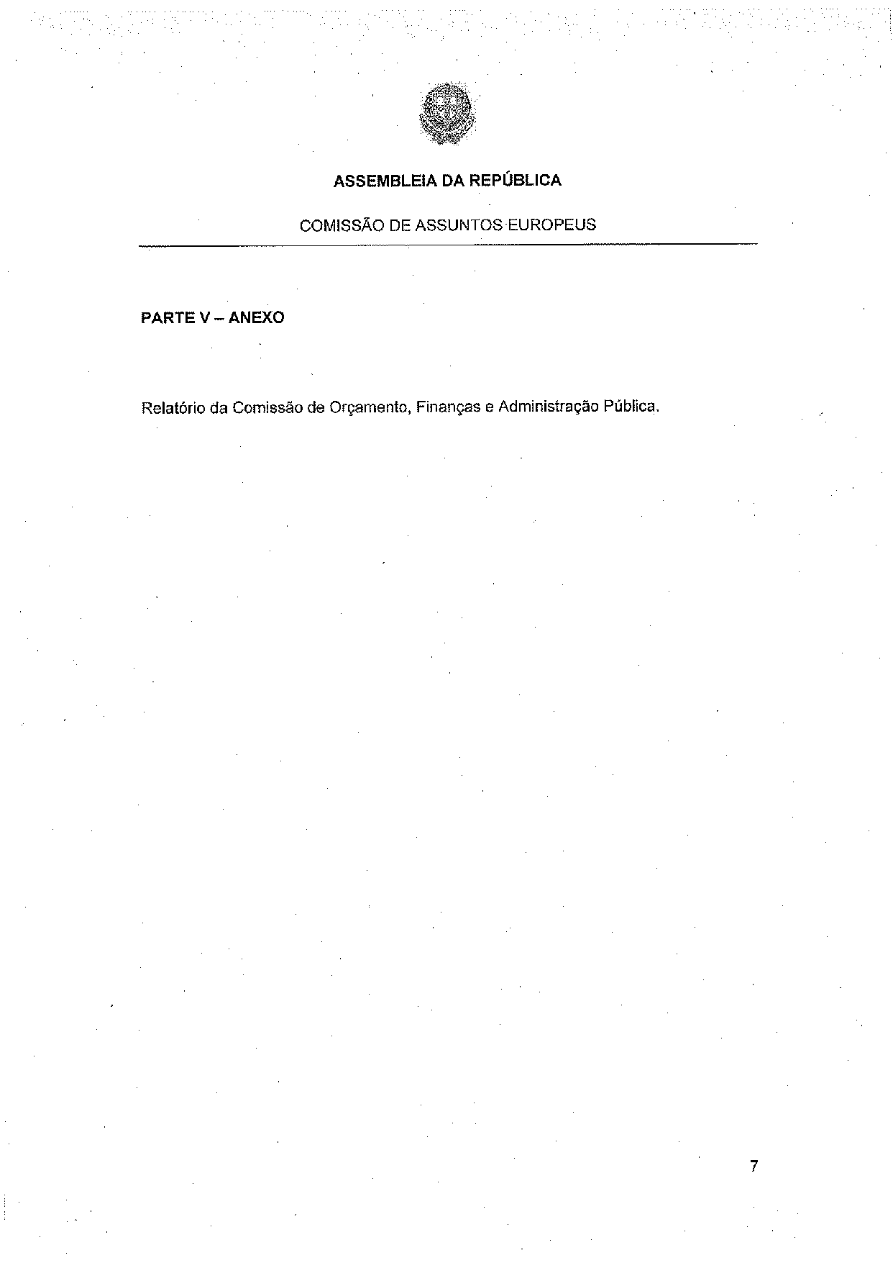
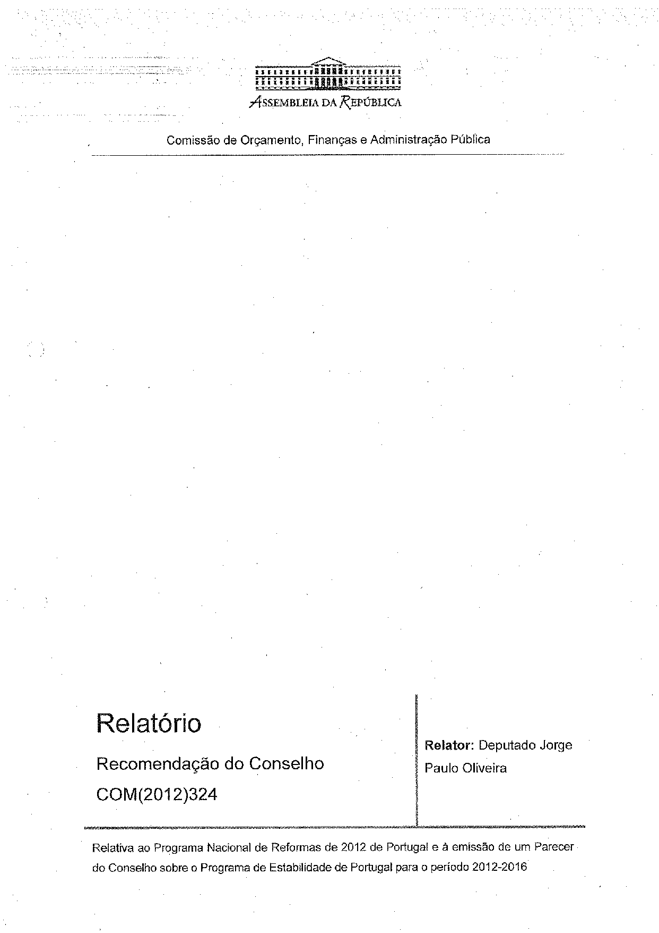
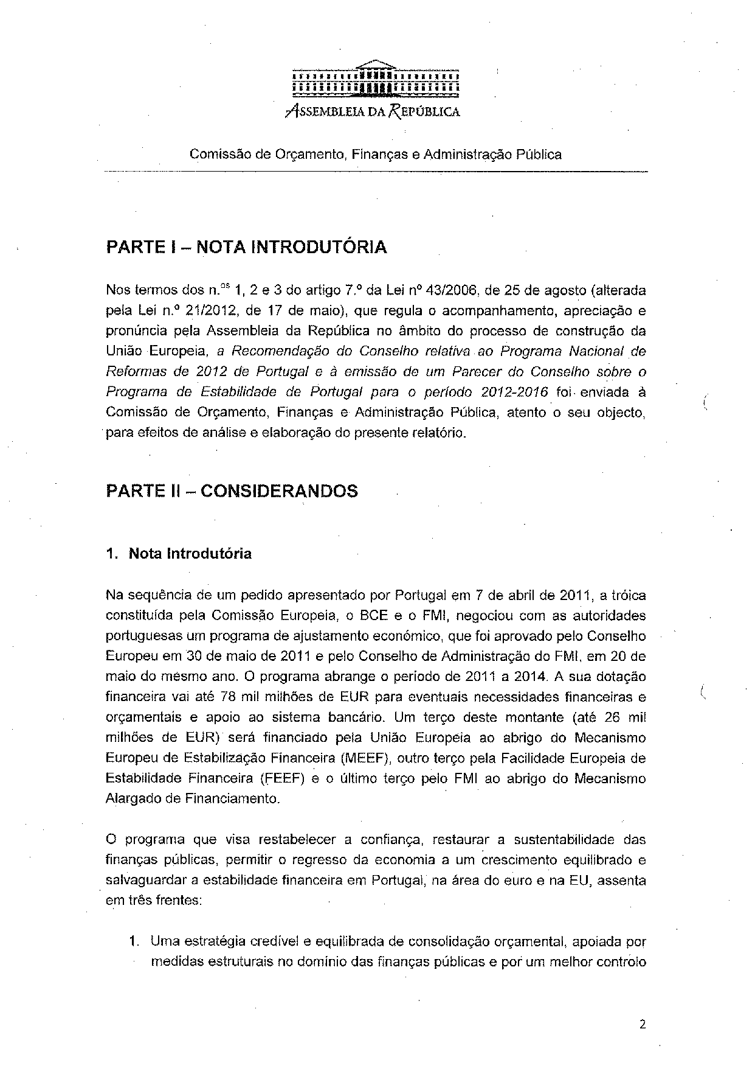
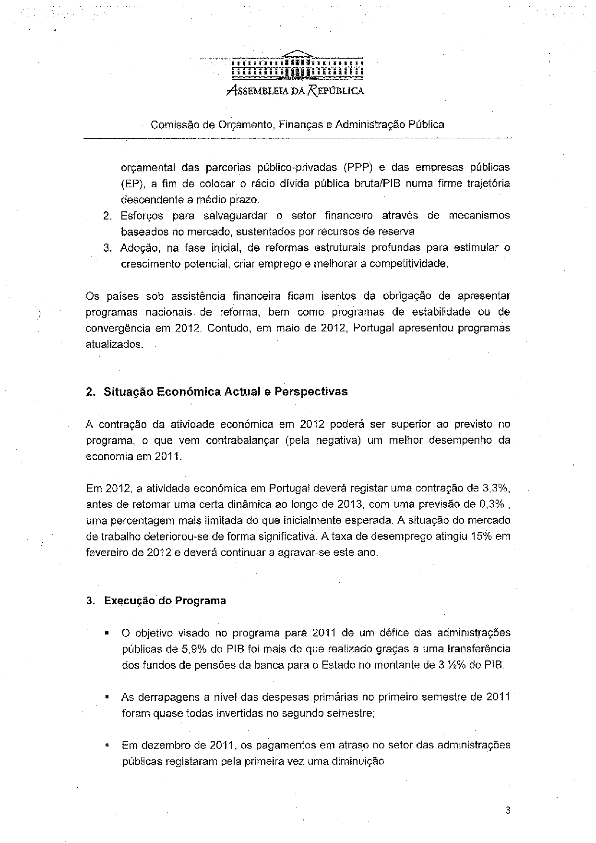
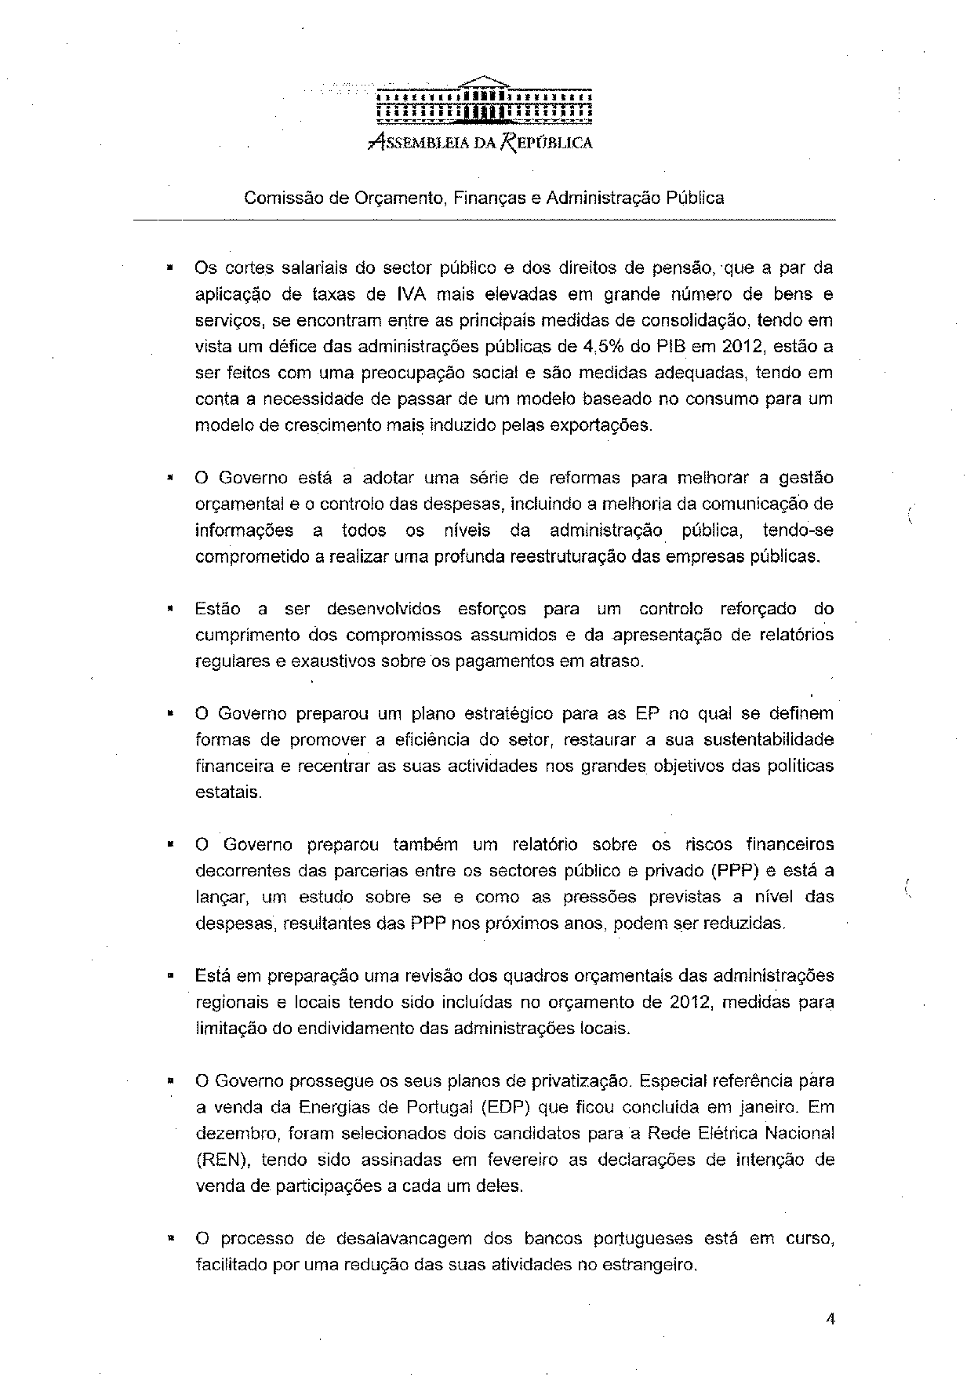
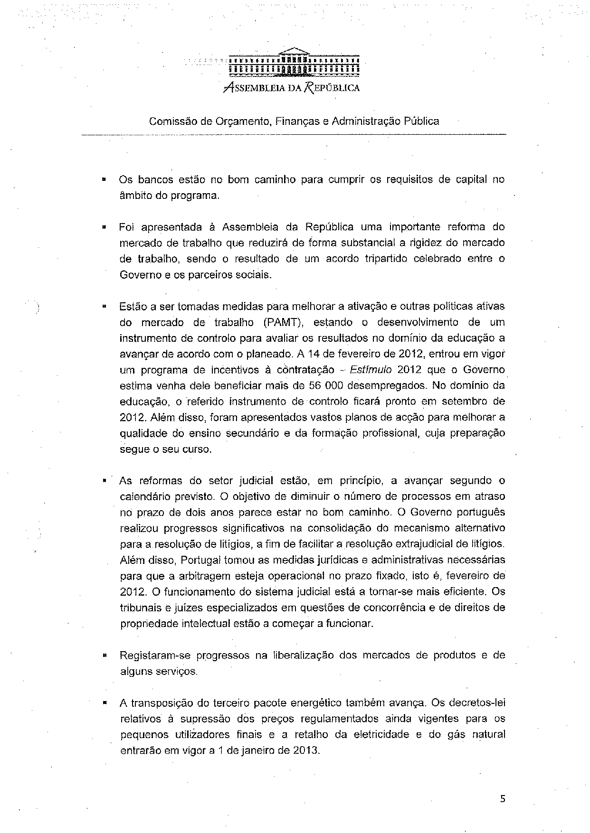
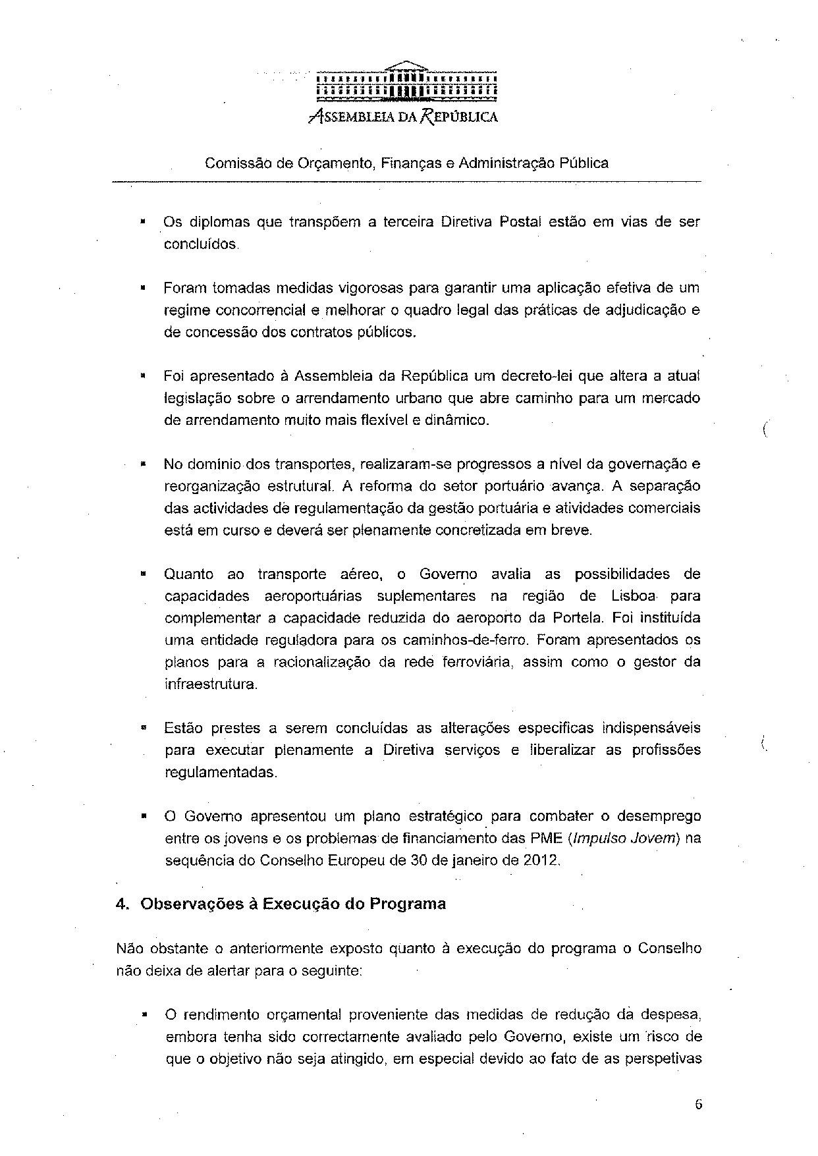
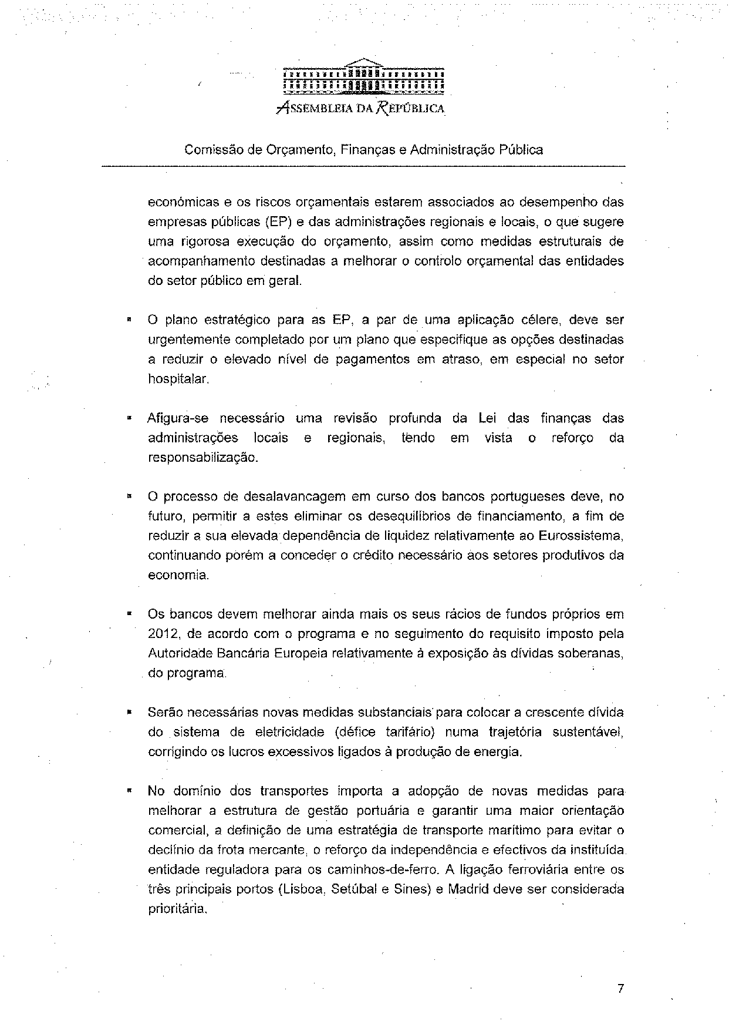
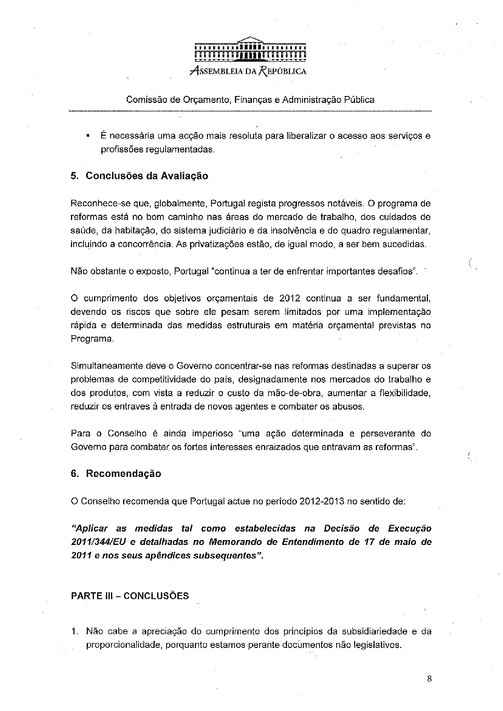
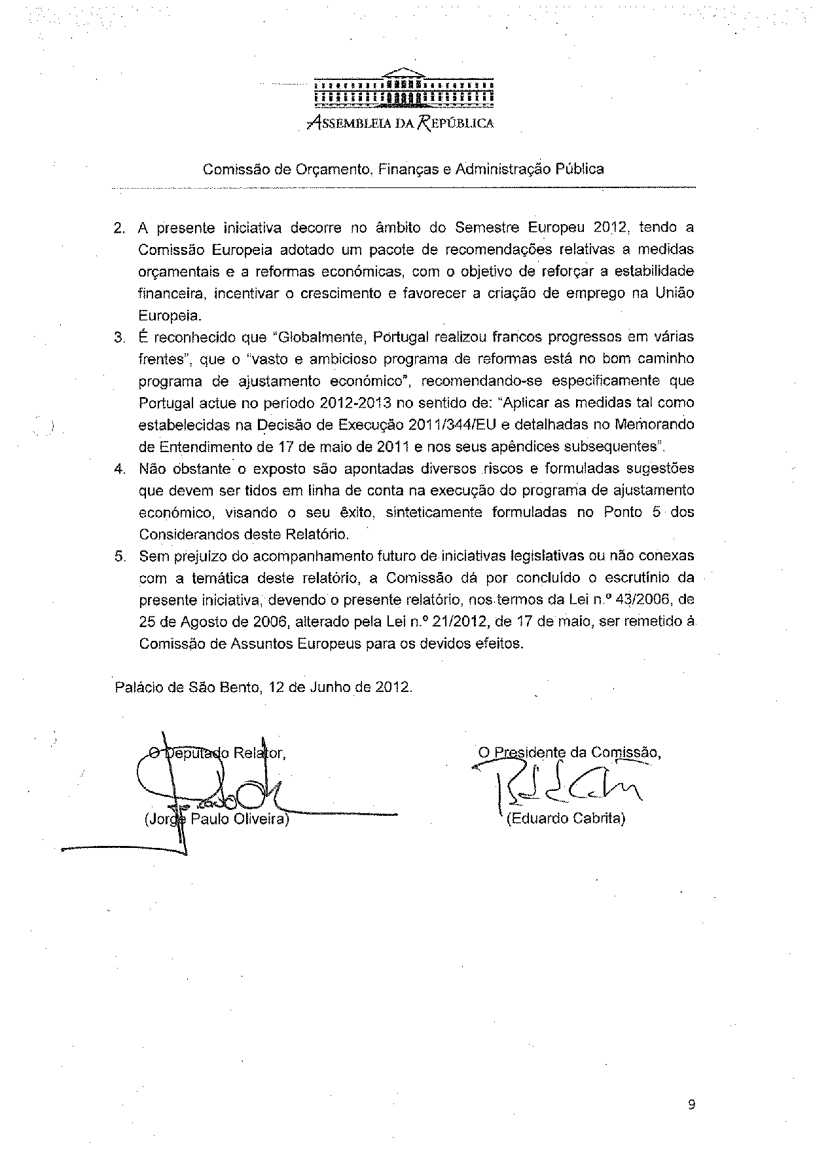

This opinion is available in English on the parliamentary EU information exchange site (IPEX) at the following address: http://www.ipex.eu/ipex/cms/home/Documents/pid/10

