 | 
COUNCIL OF  THE EUROPEAN UNION |  |  | Brussels, 9 July 2012
 |  |  | 12221/12
UEM 256
ECOFIN 676
SOC 636
COMPET 484
ENV 601
EDUC 240
RECH 314
ENER 341
INST 454
PARLNAT 291

COVER NOTE
from: | The President of the Portuguese Parliament
date of receipt: | 4 July 2012
to: | The President of the Council of the European Union
Subject: | Recommendation for a Council Recommendation on the implementation of the broad guidelines for the economic policies of the Member States whose currency is the euro  [doc . 10558/12 UEM 141 ECOFIN 476 SOC 459 COMPET 353 ENV 441  EDUC 150 RECH 202 ENER 228 - COM(2012) 301 final]  - Opinion on the Application of the principles of Subsidiarity and Proportionality

Delegations will find attached the above mentioned opinion.

________________________

Encl.:

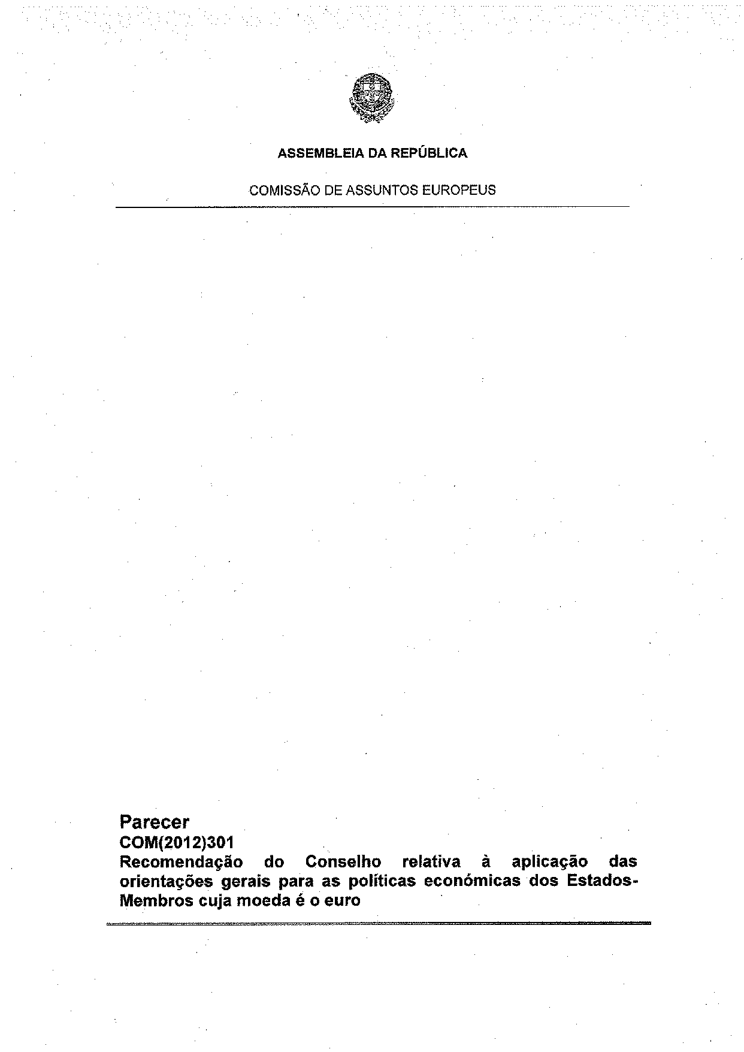
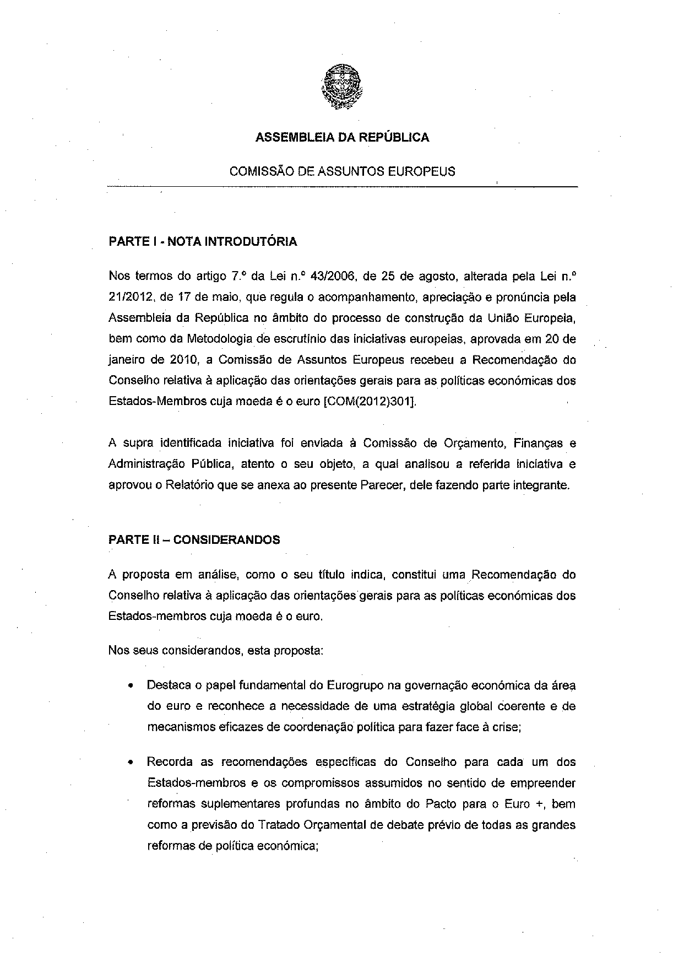
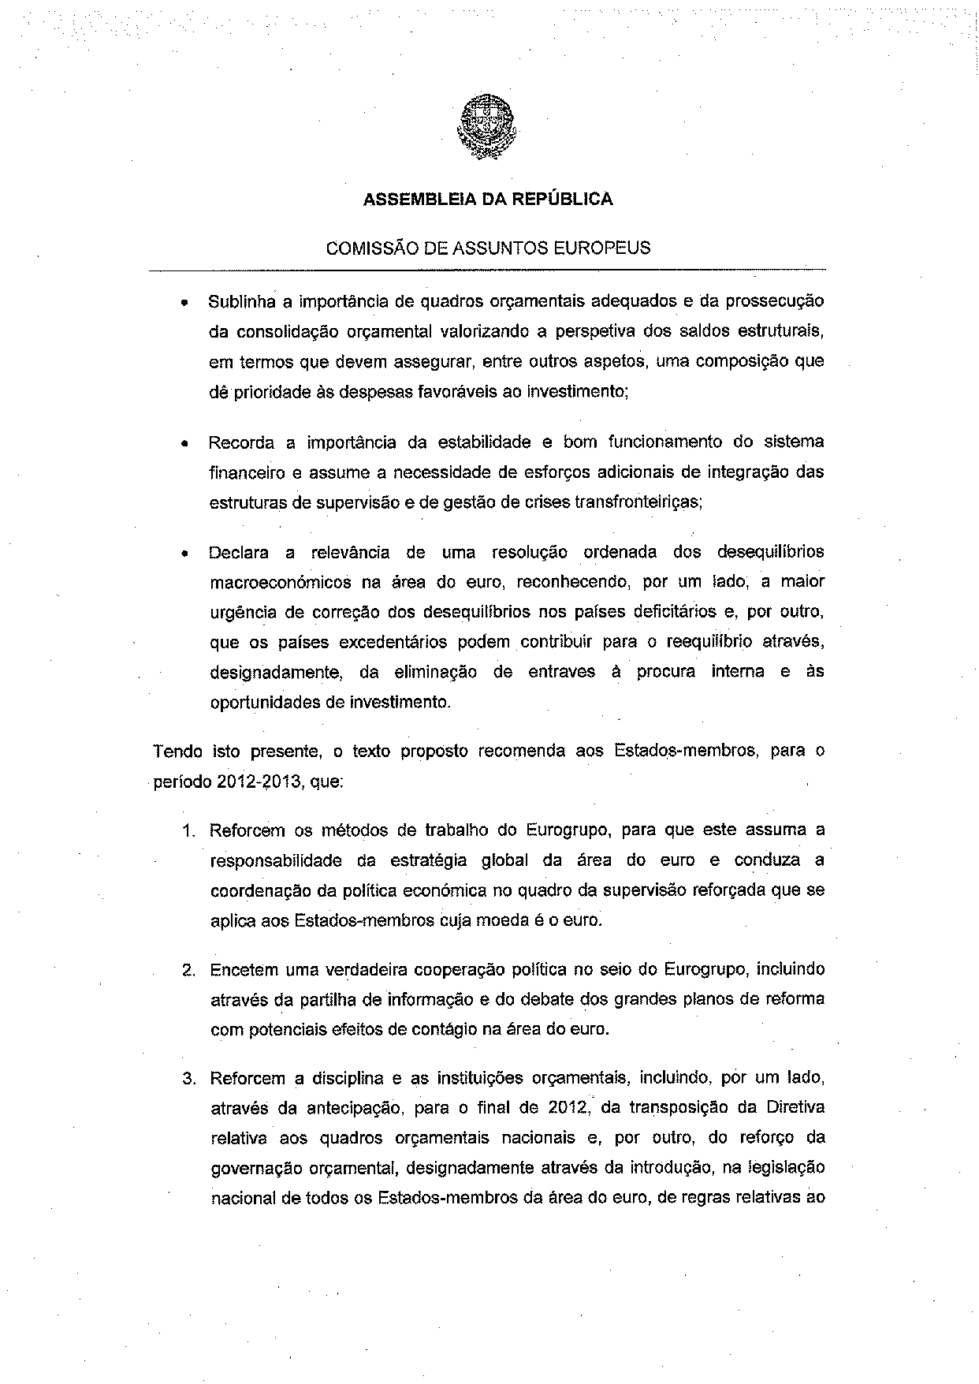
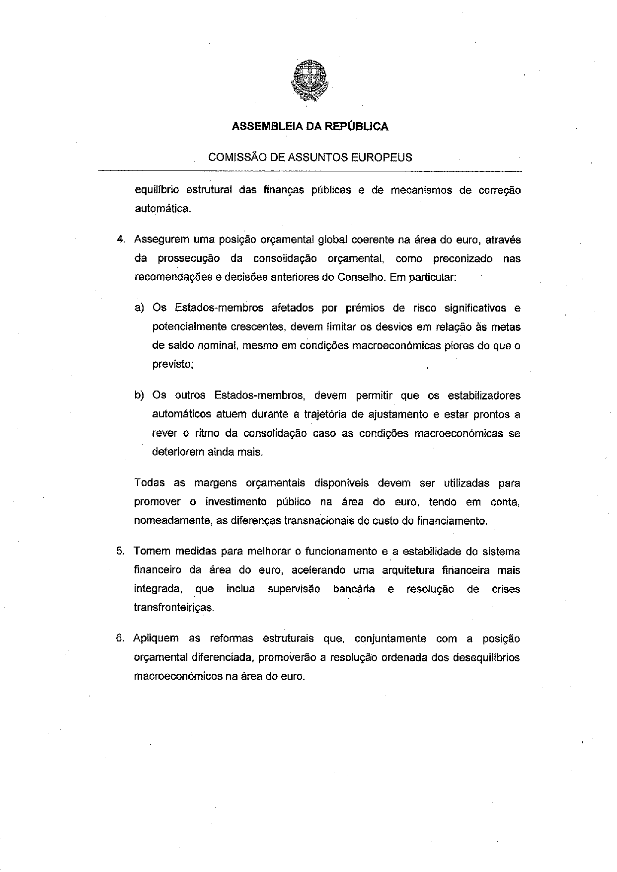
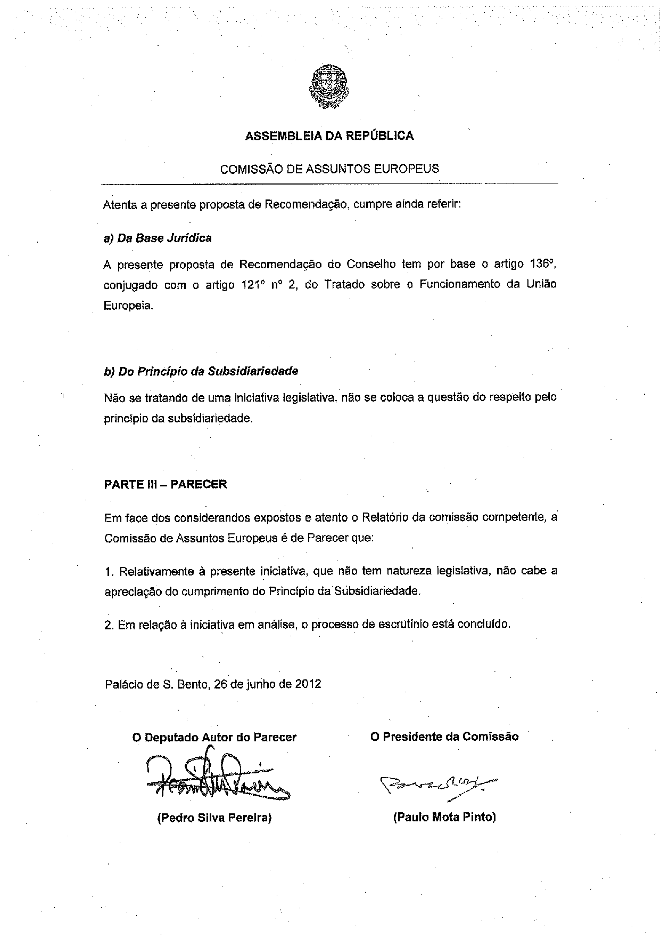
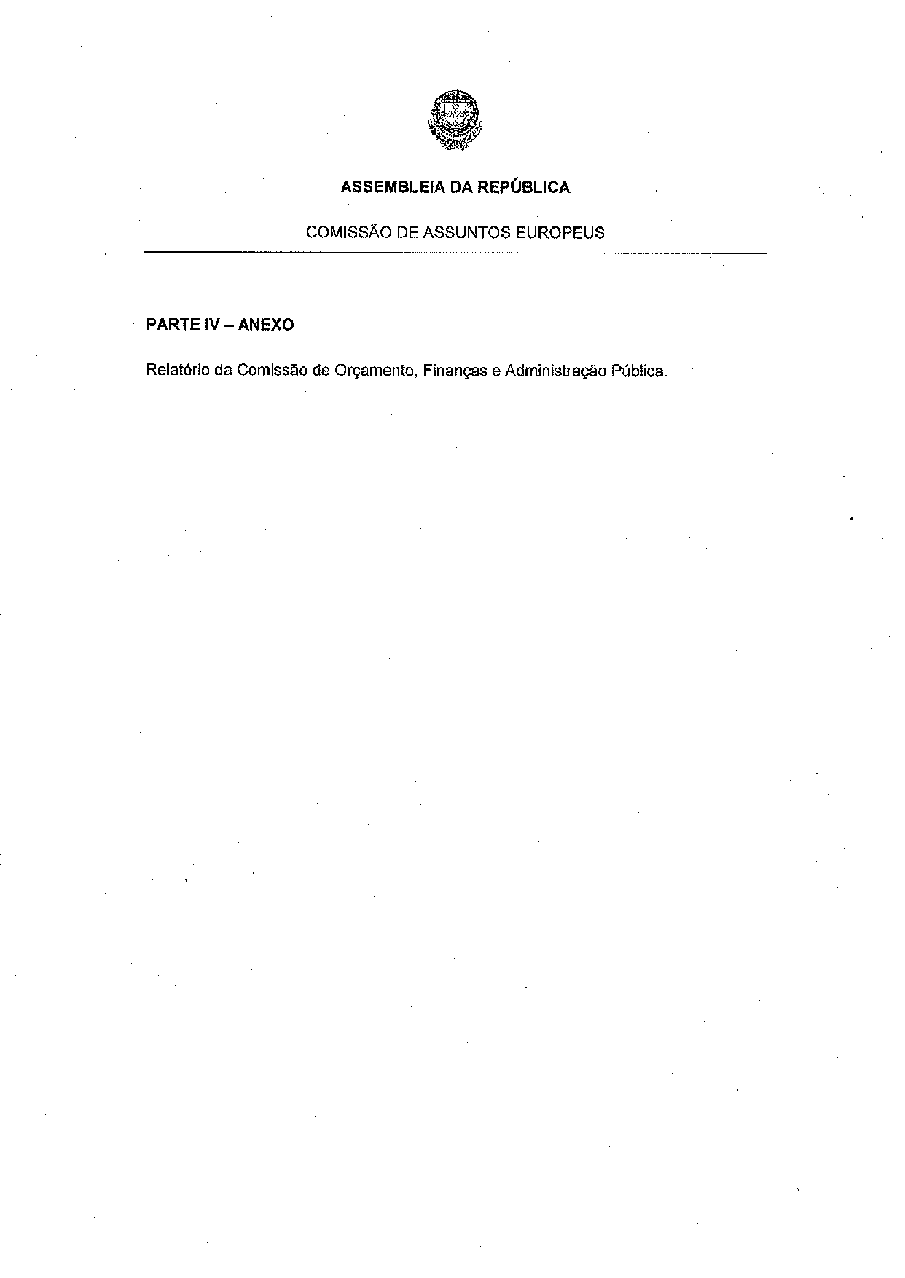
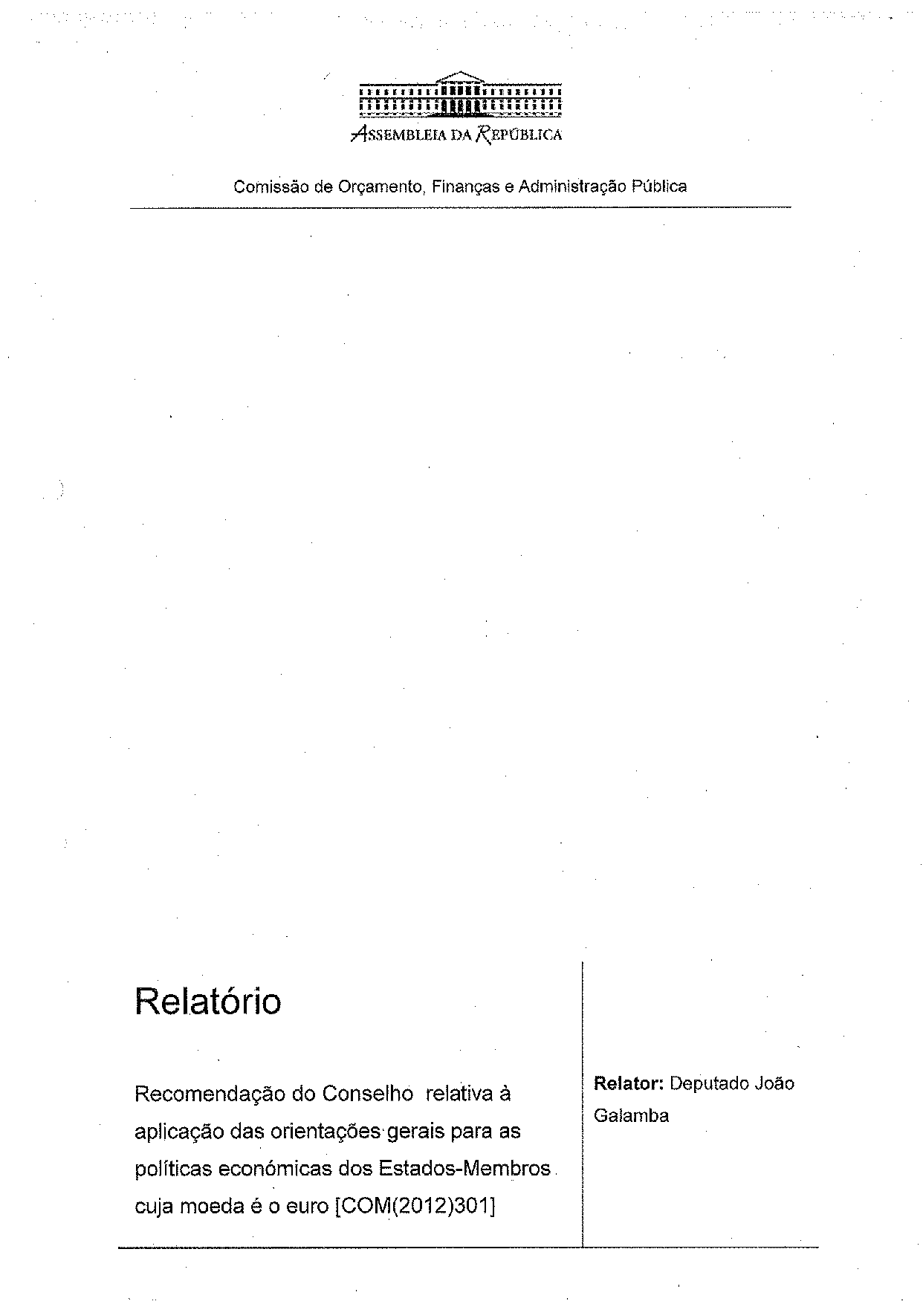
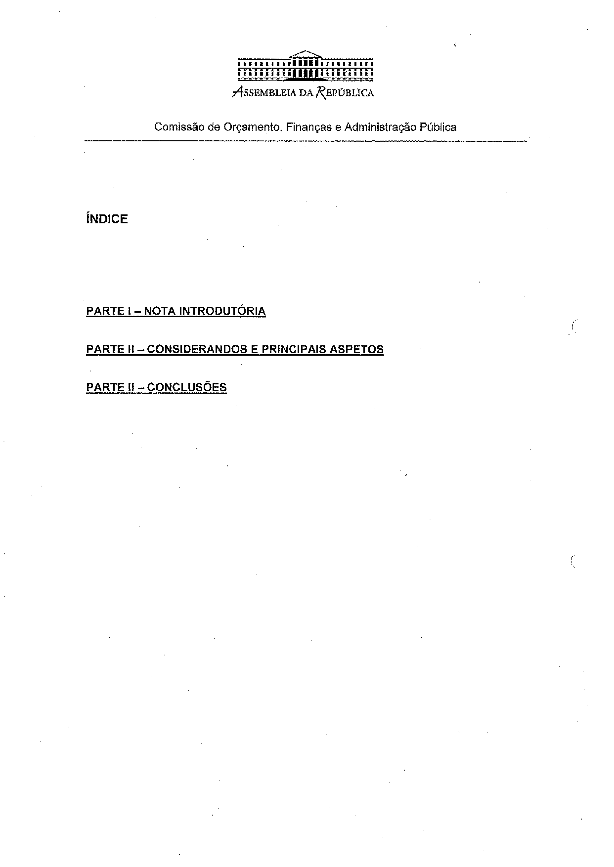
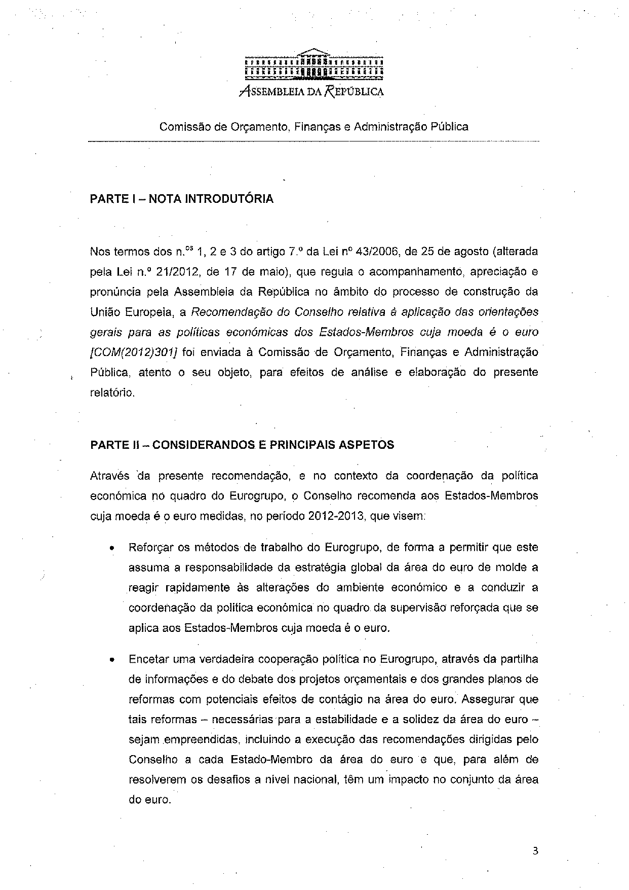
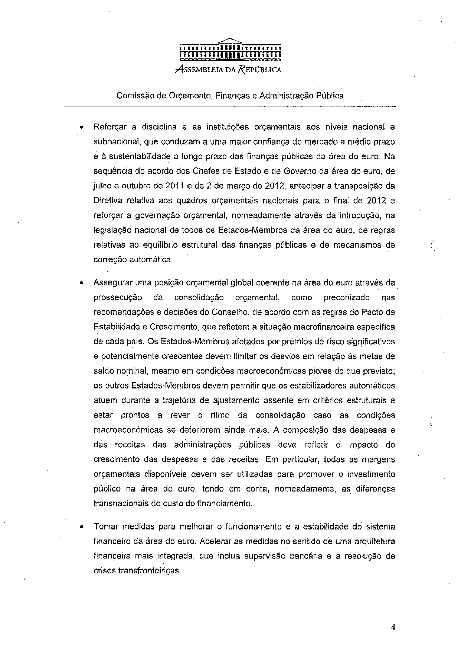
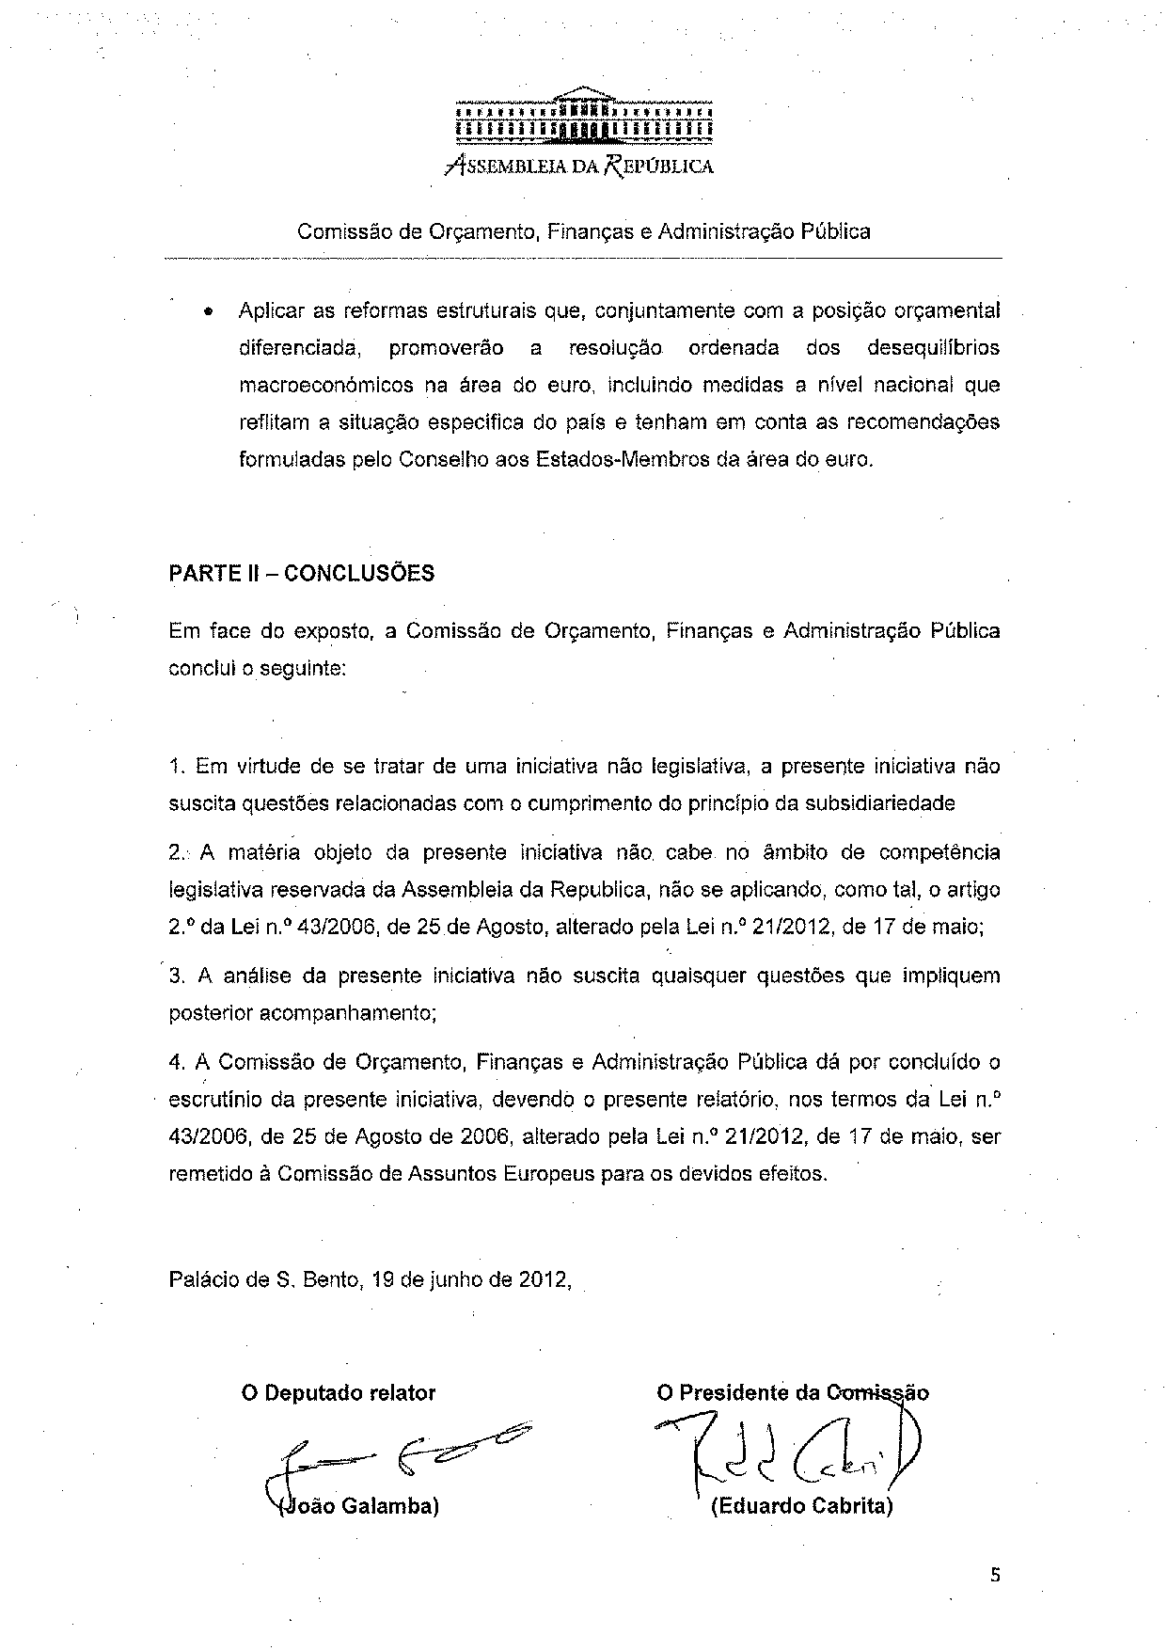

This opinion is available in English on the parliamentary EU information exchange site (IPEX) at the following address: http://www.ipex.eu/ipex/cms/home/Documents/pid/10

