COMMISSION STAFF WORKING DOCUMENT
Interim Evaluation of the European Marine Observation and Data Network
Accompanying the document
Green Paper
Marine Knowledge 2020: from seabed mapping to ocean forecasting
Contents
Executive Summary i
Rationale i
European Marine Observation and Data Network i
What was delivered ii
Relevance ii
Effectiveness and Efficiency ii
1. Purpose 1
2. Scope 1
3. What Was Requested 2
3.1. The portals 2
3.2. The projects 3
4. What was Delivered 3
4.1. Underlying technologies 4
4.2. Composition of thematic assembly groups 5
4.3. Metadata, Data and Data Products 5
5. Relevance 6
5.1. Benefits 6
5.2. Example 7
6. Management 8
6.1. Reports 8
6.2. Payments 9
7. Effectiveness 9
7.1. Specific contract to evaluate EMODnet 9
7.1.1. User-friendliness 10
7.1.2. Reusability of data 11
7.1.3. Data policy 11
7.2. Mutual Awareness Meetings 11
7.3. Marine Observation and Data Expert Group 11
7.4. Observations from Commission Services and EU Agencies 12
8. Efficiency 12
8.1. Implementation 13
8.2. Comparison with other initiatives 13
8.2.1. Research Projects 13
8.2.2. The Data Collection Framework 14
8.2.3. Global Monitoring for Environment and Security 14
8.3. Administrative Costs 14
9. Lessons Learned 15
Annex 1 Organisations Involved in ur-EMODnet 17

Executive Summary

Rationale
The oceans and seas that surround Europe offer new opportunities to meet the Europe 2020 goals. They can contribute towards the clean energy we need. They can deliver the protein we need for healthy diets. They can provide challenging and rewarding jobs.
To realise this potential, we need to make it easier for companies to invest. We need to lower costs, reduce risks and stimulate innovation. And we need to ensure that this expansion of the blue economy is sustainable. The resources are large but not infinite.
This is where marine knowledge comes in. Potential investors in a new venture need to know whether the ocean floor is sand or rock. They need to know what the ecosystem is like in order to assess any potential impact. They need to know the likelihood, frequency and severity of potentially damaging storms or tsunamis in order to gauge the risk.
It does not make sense for future investors to measure all these parameters themselves if somebody has already done it. But it can be very difficult to find out who holds these data. It can take much time and effort to negotiate access to them and it can be a nightmare to create a coherent picture of a particular area out of observations with different baselines, different units, different resolution and different formats.

European Marine Observation and Data Network
The aim of the European Marine Observation and Data Network (EMODnet) is to improve access to marine data and so reduce costs to users, stimulate innovation and reduce uncertainty in our understanding of the behaviour of the seas and oceans.
To test how this could be done a number of preparatory actions were started in the period 2008-2010. Consortia of marine data organisations, selected through calls for tender and implemented through procurement contracts, set up portals that provide access to marine data, metadata and data products for six themes for whole sea-basins. 53 different organisations participated in the projects; largely public bodies responsible for managing marine data on a national scale but supported by some small private companies with expertise in managing distributed data. All the metadata and data products and most of the data are made available to users free of charge and free of restriction of use. A total of €6,450,000 was committed.

What was delivered
This evaluation covers five portals – hydrography, geology, chemistry, biology and habitats. The contract for one of the portals, physical parameters, only began at the tail-end of 2010 so no conclusions can be drawn yet.
The portals provided access not only to the data themselves but also to data products. Thus, rather than being limited to information at a discrete set of measurement points, users were able to obtain information on parameters such as sediment type, water depth and habitat type at all points in the sea-basin. This did not only include the value of the parameter but also the confidence level (eg ± 20%). Users can live with uncertainty in measurements but they need to know what the uncertainty is.
The work of the groups was closely monitored by services of the Commission, the European Environment Agency and an independent Marine Observation and Data Expert Group. The effectiveness of the portals was tested by a contractor.

Relevance
An impact assessment has shown that once the present fragmented marine data infrastructure is rationalised, those involved in marine and maritime activities will gain €300 million in competiveness and another €200 million a year will be generated through innovative new products and services.
An Expert Group monitored the projects and hosted a number of meetings where public authorities and the marine industry expressed their needs for data. The offshore wind industry, cable laying companies and those in charge of protecting coastlines against erosion have all expressed strong support for the European Marine Observation and Data Network.

Effectiveness and Efficiency
The portals worked as expected. They allow users to obtain an overview of available data and data products and to download data for use. They were fit for purpose although some were more intuitive than others to use.
Data providers need to know what data is being used for, so some of the portals have user identification procedures. A single sign-in procedure for all EMODnet portals, also allowing access to GMES, should be a goal for the next generation of EMODnet.
There are some arguments in favour of merging the hydrography and geology groups. Although these are separate at a national level, this is partly for historic reasons and now both groups are using similar instruments and techniques for determining seabed properties. However this merging requires some further reflection and would be a longer term aim rather than an immediate priority. The experts and most users believe that a single portal for all parameters should be constructed that provides access to all the metadata, data and data products.
The deliverables represent good value for money. Public bodies spend over one a half billion euro a year in collecting marine data. For a proportionally small outlay, many of these previously inaccessible data have become available. The cost reflects not only the work done in processing the data to common standards but also gaining the agreement of data providers to release data.

1. Purpose
This report is an interim evaluation of preparatory actions carried out in the period 2008-2010 with the aim of improving access to marine data. It was produced by Commission services incorporating the results of independent evaluators in the framework of article 27(4) of the EU's Financial Regulation .

2. Scope
Following the Commission's 2007 Blue Paper for integrated maritime policy, the European Parliament proposed a budget for Preparatory Actions and Pilot Projects to assess the feasibility and desirability of future legislative proposals. Accordingly the EU budget incorporated a total of €14.7 million for preparatory actions over the three years 2008-2010 and €6 million for pilot projects over the two years 2008-2009.
Of this budget, €6,450,000 was committed to projects for marine knowledge, the .long-term objectives of which were clarified in the Commission Communication "Marine Knowledge 2020" as being to: reduce costs to users of marine data for private industry, public authorities and researchers; stimulate competition and innovation; and reduce uncertainty in the behaviour of the seas and oceans. An impact assessment quantified the benefits that would accrue from achieving these objectives and the costs of EU measures that would deliver these benefits.
The preparatory action projects were intended to provide prototype components for a Marine Observation and Data Network (ur-EMODnet) that would not only test the underlying concept but also provide concrete products that would be useful in themselves. None of the projects has yet been completed so a complete evaluation is not yet feasible. However, a number of them have already delivered tangible results and it is proposed to begin work on follow-ups under a new programme to support the further development of an Integrated Maritime Policy.
The overall aim of this evaluation is to evaluate the preparatory actions in order that any follow-up actions take account of the lessons learned. The evaluation takes account of: relevance (do the projects have contributed towards meeting the objectives set out in "Marine Knowledge 2020"?), management (were deliverables timely?), effectiveness (what worked well and what did not?) and efficiency (were the actions implemented in the most cost-effective way?),

3. What Was Requested

3.1. The portals
"Marine Knowledge 2020" identified "thematic assembly groups" as key elements of a future operational European Marine Observation and Data Network. Each thematic assembly group is a consortium of organisations that assemble fragmented marine data and make them available through a single portal. Altogether 53 different organisations took part (see annex 1).
The aim is not to construct a giant database; the data themselves may remain in separate archives but they should be accessible through a single entry point or "portal". Each type of data requires a separate approach so six different portals have been set up:
        - hydrography – bathymetry (water depth), coastlines, underwater features (wrecks etc)
        - geology – sediments, strata, coastal erosion, geological hazards
        - physics – temperature, waves, currents, sea-level, light penetration
        - chemistry – concentrations of chemicals in water, sediments and biota
        - biology – abundance of living species
        - physical habitats – habitat classification based on physical parameters (water depth, light penetration, sediments etc)
The preparatory action funding was not sufficient to cover data from all European seas with these portals so each one covers a subset of the sea-basins. Each one includes the North Sea and at least two other basins. All European seas subject to the Marine Strategy Framework Directive, except Macaronesia, are included in at least one portal. The portals should provide access to:
        - data – raw observations or measurements
        - metadata – information about the data such as location and time of measurement, units, precision)
        - data products – products derived from the data; normally by interpolation in space and time. Data products include digital terrain models on regular grids or geological maps. The predicted habitat maps are also a product, developed through integration of other data sets. Thus users can obtain estimates of parameter values between measurement points.

3.2. The projects
Each thematic assessment group was set-up following an open call for tender.
Thematic group | bids | Main contractor | Start | Coverage
hydrography | 3 | MARIS b.v, Netherlands | 29/05/2009 | North Sea, Celtic Seas, the Western Mediterranean, the Ionian Sea and the Central Mediterranean;
hydrography | 2 | MARIS bv, Netherlands | 08/06/2010 | Eastern Mediterranean, Black Sea, Iberian Atlantic and Biscay
geology | 2 | NERC BGS, UK | 16/07/2009 | North Sea, Baltic and Celtic Seas
physics | 1 | ETT, Italy | 17/12/2010 | All European seas
chemistry | 2 | OGS, Italy | 04/06/2009 | North Sea, Black Sea and selected parts of Mediterranean
biology | 3 | VLIZ, Belgium | 15/05/2009 | North Sea, Bay of Biscay and the Iberian Coast
physical habitats | 2 | JNCC, UK | 18/02/2009 | North Sea, Celtic Seas, Baltic and Western Mediterranean
Each project lasts for 3 years with intermediate reports at the 12 and 18 month stage. The portals should be operational after 24 months when a "final" report is delivered. The last (third) year is devoted to maintenance of the portal. This means that portals are now operational for all thematic groups except that for physics for which the project only started in December 2010.

4. What was Delivered
The specifications for the calls for tender were almost identical and not designed to favour any particular technology. However there were some constraints:
    - the data, metadata and data products should respect European standards. The main framework for these standards is the INSPIRE Directive. This is a two-way process. Standards generally exist for the higher level standards that are common to all data (longitude, latitude, time) but more specialised data (e.g. concentration of caesium 137 found in the flesh of a common mussel) generally are not. It is a task of the thematic assembly group to define a standard and to ensure its acceptance.
    - metadata and data products should be free of charge and free for use for whatever purpose. Where possible this should also be true for data as well but this was not always possible due to licence restrictions by the data owners.

4.1. Underlying technologies
None of the projects started from scratch. All the thematic groups based their portal software to some extent on technologies and standards developed through EU projects – mostly from the EU Framework projects for research but one was based on work done under Interreg.
        - Three of the projects used the SeaDataNet standards to describe their metadata. This was developed through a series of EU Framework Programme projects starting with SEASEARCH in the Fifth Framework Programme and followed by SeaDataNet projects in the Sixth and Seventh Framework Programmes.
        - The biological group based their software on the European Ocean Biogeographic Information System "EurOBIS" which is an integrated data system developed by the Flanders Marine Institute (VLIZ) for the EU Network of Excellence "Marine Biodiversity and Ecosystem Functioning" (MarBEF) in 2004.
        - The geology group used software, methods and standards developed under the OneGeology Europe project which aims to provide access to European geological data. OneGeology Europe covers land data so this choice ensured continuity between land and sea.
        - The physics group made use of components developed within the Global Monitoring for Environment and Security (GMES) MyOcean project for the delivery of real-time observations as well as SeaDataNet for archived observations.
        - The physical habitats group differs from the other groups in that it delivers products (seabed maps) based on modelling several types of measurement. The group derived habitat type from measurements of parameters such as water depth, wave energy, sediment type, temperature and light penetration. The work was based on results from the Interreg MESH (North Sea and Celtic Sea) and BALANCE (Baltic) projects. The EMODnet group harmonised the classification between the two areas and extended the analysis to the Western Mediterranean, using the European EUNIS classification as the standard classification for the maps.

4.2. Composition of thematic assembly groups
The 53 organisations belonging to the thematic assembly groups were largely from the public sector. Some observations concerning the composition are;
        - Two thematic groups (physics and hydrography) were led by small private companies.
        - The geology group was the most homogeneous. The partnership consisted of the national organisations of each country bordering the sea-basins concerned that are responsible for geological surveys.
        - The chemistry group was largely made of research institutes and national oceanographic data centres (see annex 1). They readily shared data but were unable to obtain all the data held by environmental agencies – particularly round the Black Sea.
        - National hydrographic agencies were conspicuously absent from the hydrographic group. The only exception was the French Service Hydrographique et Océanographique de la Marine (SHOM). This heterogeneity of the hydrographic group is partly due to a reticence of hydrographic agencies to provide detailed data and partly due to the fact that many other types of organisations survey seabeds. However national hydrographic agencies did provide data products to the groups and the International Hydrographic Organisation has recently signed a Memorandum of Understanding with the Commission that could open a structured dialogue on this matter.

4.3. Metadata, Data and Data Products
Three of the groups - hydrography, geology and physical habitats – managed to deliver data products that are immediately useful for data users. These were:
        - coverage of most European waters with a digital terrain model of one quarter of a minute resolution (approximately 500 metres). This is certainly not a fine enough resolution for many applications and the underlying survey data would allow finer resolution in some places but it is double the resolution of previous publicly available data.
        - sediment maps for selected European sea-basins at a scale of one to one million. This reflects efforts by the thematic group to reclassify maps of each country's waters using common criteria. Previously countries had used different grain sizes to distinguish the different categories of mud, sand, gravel or boulders.
        - Physical habitat maps covering a significant proportion of European seas with habitat maps. It is now possible to compare in a quantitative way the Baltic with the North Sea, to estimate what proportion of certain habitat types are covered by marine protected areas or determine which habitat types might be disturbed by bottom trawling
For the other types of data – physics, chemistry and biology, there has been more emphasis on collating data and metadata. The reasons for this are:
        - Chemical data are heterogeneous. Measurements are made in the water column, the sediment and biota. Furthermore the concentrations can vary greatly between measurement points that are located within metres of each other.
        - The challenge with biological measurements is to quantify the sampling effort. How do we compare the number of specimens of a certain species of invertebrate found in a benthic sample with those found in another area sampled with a different instrument? If a certain species is not recorded in a sample is it because it was not present or because nobody looked for it?
        - The thematic assembly group for physics focuses on data and metadata. The Global Monitoring for Environment and Security (GMES) MyOcean project is the prototype for a "marine core service". It already delivers hindcasts, nowcasts and forecasts for European seas for parameters such as temperature, current and salinity. The physics thematic assembly group will complement this by providing raw measurements that can feed into these MyOcean models. EMODnet also provides measurements in the near-coast regions where GMES does not reach.

5. Relevance

5.1. Benefits
An impact assessment has determined that Europe spends approximately €1.5 billion a year of public money on marine observations but that they are difficult to use. It is very difficult for business, especially small start-up enterprises, to find these data and to obtain permission to use them. And even when they do so, it costs them so much to put incompatible data from a multitude of bodies together, that they are unable to create value-added services or products at a price that the market can pay. This lack of competiveness costs the European economy approximately €300 million per year.
The loss of opportunity to develop innovative high added-value products costs the economy another €60 to €200 million per year. It is unrealistic to expect new services and products from EMODnet at this very early stage. However some enterprising companies are beginning to spot opportunities – for instance within the framework of the Irish SmartBay initiative.
These figures do not include the improvement in efficiency that would result from a reduced uncertainty in our understanding of the behaviour of the sea – for instance in coastal protection. Since the ocean circulation is the primary driver for seasonal variation in climate, a better understanding of the oceans can bring a better knowledge of what the future climate might bring.
Furthermore these estimates do not take into account the growing marine economy. They are based on 2010 figures.
Water and Marine Directors of the European Union, Candidate and EFTA Countrieshave indicated in Warsaw, 8-9 December 2011 that EMODnet would contribute to their future reporting for the Marine Strategy Framework Directive.

5.2. Example
The relevance and usefulness of the preparatory action projects is best understood through an example. Figure 1 shows a screenshot from the hydrography portal. This portal provides the highest resolution digital terrain model covering European seas that is currently available. A digital terrain model is a digital model or three dimensional representation of the seabed (Figure 2). The bathymetry is represented by a grid of values for the depth of water with the resolution defined as the length of the sides of each grid cell. The different colours indicate the different organisations that have provided data uses to create the digital terrain model. 20 different organisations provided data based on survey data from 113 organisations.
Previously users would have had to ask each of these data owners separately for the data and then process them to create the model. However, a digital terrain model is needed for nearly all analyses of the marine environment so each organisation would have separately needed to do the same processing. In practice they did not do so because the cost of creating the data layer and the time needed to do it would not have been justifiable. They would have had to make do with lower resolution data.
Thus the new data product reduces the cost to those who need digital terrain models; it creates new possibilities for innovation using products and services derived from the higher resolution data and increases the precision and hence reduces the uncertainty of all analyses that had previously used lower resolution data.
This screenshot also shows grey areas where the thematic assembly group were unable to obtain the necessary permissions for the data needed to create the digital terrain model or where no surveys had been done that would allow the quarter minute resolution model to be constructed. In these cases the thematic assembly group used lower resolution data.
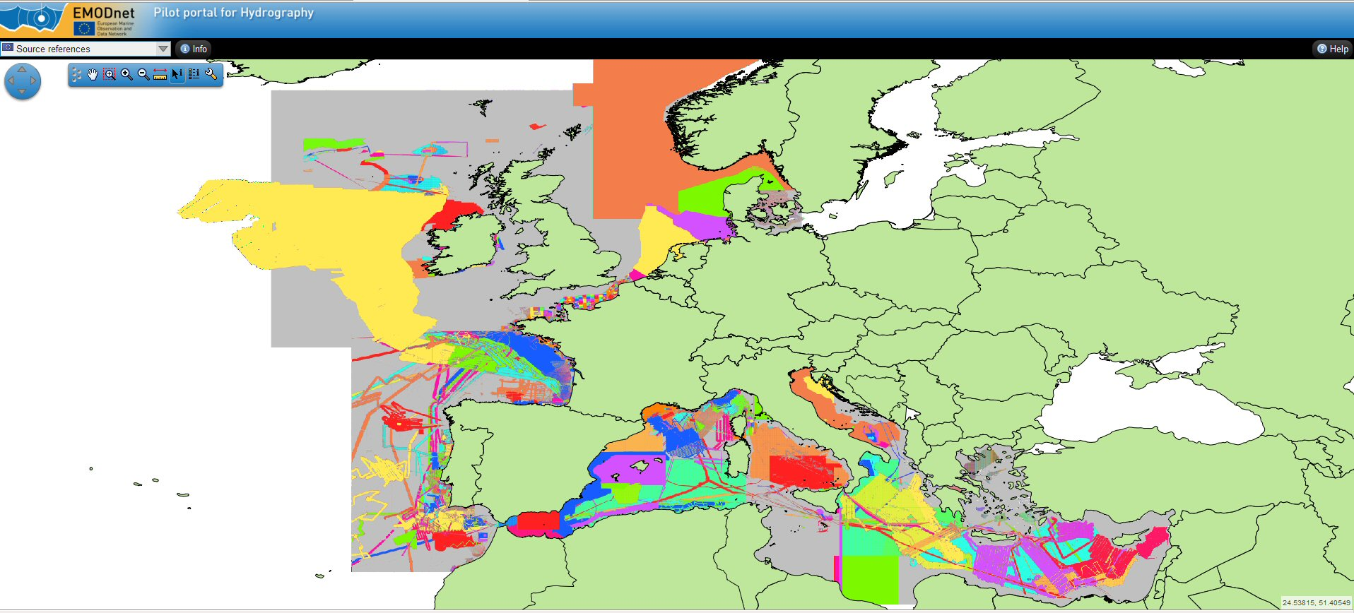  Figure 1 a screenshot from the hydrography portals. The different colours indicate the different organisations that have provided data to create a digital terrain model | 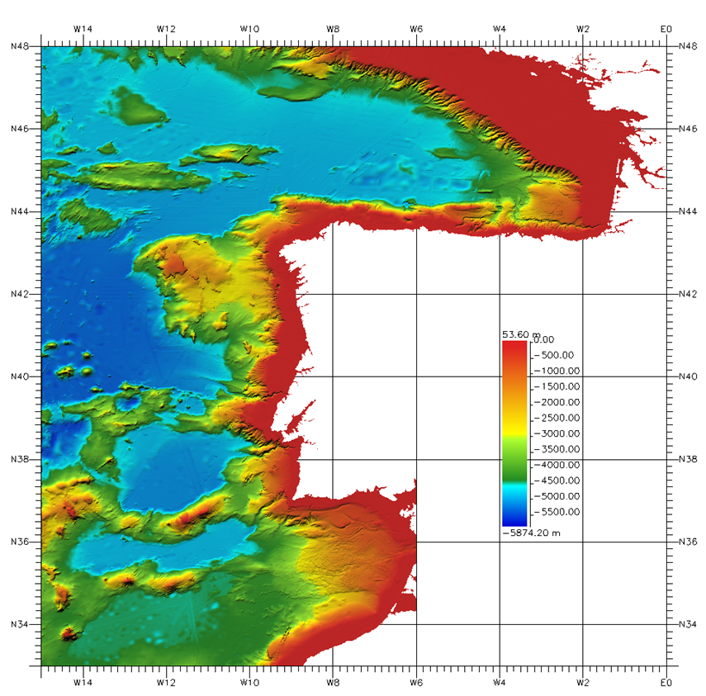  Figure 2 Digital terrain model of Bay of Biscay and Iberian coasts region
The portal also allows an evaluation of the accuracy and precision of the data. Users can interrogate a particular point and find out how many surveys contributed to the digital terrain model there and what the standard deviation is. They can also generate a map showing where the areas with the lowest accuracy are.
Another example is the sediment data layer produced by the thematic area group for geology (Figure 3). This is the first time that such a data layer has been produced for marine sediments. The first stages of planning a cabling or pipe-laying operation across the North Sea can now use a set of data that is consistent for the waters of all the coastal states. Furthermore the marine data is perfectly consistent with the land data which facilitates the task of coastal zone management.
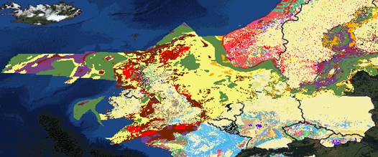 | 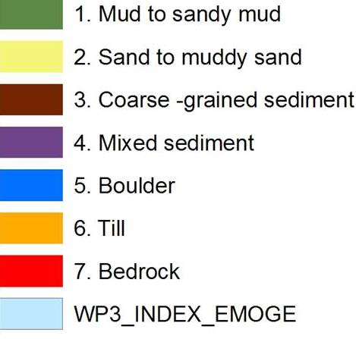
Figure 3 Sediment layers produced by the geology thematic assembly group (The land areas use the OneGeologyEurope classification)

6. Management

6.1. Reports
During the period of this evaluation five of the thematic groups delivered "final" reports although the contracts will run for another year in a "maintenance" phase. It would be inappropriate to judge the projects purely on the reports because the main deliverables were working portals. All the projects delivered portals are of acceptable quality. The evaluation of these portals is considered more carefully in section 7 "7. Effectiveness". Four of the reports were delivered within four working days of the deadline. Only one took longer - ten working days. The Commission had forty five days to evaluate them and all these were completed within this time. Three of the reports were accepted. Revisions were requested for the other two – primarily to make the reports more comprehensible to a general reader. The contractors provided modified versions of the reports within the stipulated 20 days.

6.2. Payments
The interval between the expected delivery of a report and the payment made to the contractor was analysed. Excluding the pre-financing payment for the physics portal, the average was two and half months. This pre-financing for the physics portal was delayed because of the complicated administrative procedures necessary to obtain a bank guarantee from an Italian bank. Contractors who submitted a report on time that was accepted first time and who submitted an invoice together with the report were paid within one or two months. Only one of the twenty payments was outside the Commissions' limit. Interest of €223.56 was paid to the contractor. Steps have been taken to ensure that this does not happen again.

7. Effectiveness
The effectiveness of the portals was checked through
    - a specific contract. The consultants, MRAG Ltd, were given the task of checking the operation of the portals for user-friendliness and fitness for purpose.
    - mutual awareness through common six-monthly meetings.
    - examination by peers. The independent 28-member Marine Observation and Data Expert Group attend the ur-EMODnet mutual awareness meetings and deliver opinions on progress.
    - assessment by Commission services and EU agencies.

7.1. Specific contract to evaluate EMODnet
A contract to evaluate the ur-EMODnet portals was awarded to MRAG Ltd in December 2011. Intermediate results were presented to the thematic assembly groups who had developed the portals, to the Marine Observation and Data Expert Group, to services of the Commission and to the European Environment Agency. Comments from these groups were taken into account in the final report that was accepted in August 2010. The evaluation aimed to answer three questions:
        - user-friendliness – How easy is it to navigate the portals and how much information do they provide about the underlying data?
        - fitness for purpose – Can the data be downloaded and processed easily?
        - data policy – Is it clear who owns the data and what they can be used for?

7.1.1. User-friendliness
Table 1 matrix comparing portals
portal | good first impression | portal intuitive to use | instructions were useful | data easy to find | portal had advanced features and functions | data was easy to access | data was comprehensive | data was in convenient format
biology | *** | ** | *** | ** | ** | *** | ** | ***
chemistry | *** | *** | *** | *** | *** | ** | *** | ***
geology | ** | ** | * | * | ** | ** | ** | **
hydrography | *** | *** | *** | *** | *** | ** | *** | ***
physical habitats | ** | ** | *** | ** | ** | *** | ** | ***
All of the portals were found to be intuitive to use, with all of them, apart from the physical habitats one, providing a searchable catalogue and a map interface for retrieving records. The continuity between the land and sea layers in the geology portal is certainly an advantage but it was hard to separate and analyse only the marine layers.
Difficulties in finding data were normally attributed to poor or non-standard metadata. In other words the same type of data was described differently in the distributed databases feeding information to the portal.
Data providers need to know what data is being used for so some of the portals have user identification procedures. However, lengthy or inhomogeneous procedures can discourage data users. There is as yet no single sign-in procedure for all EMODnet portals.
The data quality indicators were generally clear and useful for the data products assembled during the project. The information on quality for sets of the underlying data was sometimes harder to interpret if the set was composed of data from more than one provider.

7.1.2. Reusability of data
Most users will not be satisfied with viewing maps on the portal. Rather they will want to download data, process them and integrate them with other data using either their own software or commercial data processing, statistical, graphical platforms such as SAS, MATLAB or ARCGIS. A number of tests were run to see how easy it was to do this.
Bathymetric and geological data layers were downloaded from their respective portals and fed successfully into a geographical information system. Data downloaded from the biology portal allowed the number of observations of certain species of seabirds in a certain area to be determined. Physical habitat data enabled an estimate of the total area covered by different habitat types within a selected area. Data downloaded from the chemistry portal allowed an assessment of the spatial and temporal distribution of pollutants. The evaluation confirmed that the objective of trouble-free reusability had been achieved.

7.1.3. Data policy
Data accessed through the portals may be subject to intellectual property rights. Clarifying the data owner of data downloaded from the portal allows these rights to be respected. Analysis showed that intellectual property rights issues have clearly been taken into account in the design and operation of the portals.

7.2. Mutual Awareness Meetings
Representatives of the groups met together each six months to report progress in the presence of the Commission. This allowed different technologies to be compared, best practice to be determined and better cooperation across cross-thematic groups. It promoted interoperability by preventing the portals from diverging into completely separate independent platforms.

7.3. Marine Observation and Data Expert Group
The Marine Observation and Data Expert Group meets four times a year. At two of these meetings the work of the thematic assembly group is presented to them. Summaries of all meetings and copies of all presentations are publicly available through the EU maritime forum.
Other than detailed points that are largely covered in the assessment by MRAG, and in a summary of their meeting the Expert Group concluded that:
        - a main entry portal giving access to all the thematic assembly groups should be set up. The Commission plans to implement one with the 2012-2013 budget.
        - The preparatory actions are on the right track but they must be followed up. If the EU ceases to take an interest the momentum will be lost.
        - In the longer term consideration should be given to
              - merging the hydrography and geology groups. Both geologists and hydrographers make extensive use of multibeam echosounders to measure the bottom of the sea. Although most countries have a national hydrographic office and a national geological survey, there is considerable overlap in their surveying work. The Expert Group wondered whether it might be feasible to combine the hydrography and geology thematic assembly groups. There is considerable merit in the idea which should be considered seriously for the third post-2013 phase of the project.
              - deeper integration with the GMES and the Data Collection Framework for fisheries.

7.4. Observations from Commission Services and EU Agencies
The preparatory actions were implemented by the Directorate General for Maritime Affairs and Fisheries (MARE) and the project has been followed from the outset by other services of the Commission – mostly the Directorate Generals for Environment (ENV), Research and Innovation (RTD), Enterprise (ENTR) as well as the Joint Research Centre (JRC) and the European Environment Agency (EEA). Other services, such as the Directorates General for Information Society and Competition (INFSO and COMP) have assisted on matters relating to the benefits to competition of the re-use of public information. These services of the Commission have checked tender specifications, attended expert group meetings and monitored outputs of projects.
ENV and EEA have been particularly interested in the possibility of using EMODnet to help Member States report the state of Europe's seas as part of their obligations under the Marine Strategy Framework Directive and their continued presence in the monitoring process has assured that this is possible.

8. Efficiency
It is difficult to determine whether or not the same results could have been obtained for a cheaper price. The projects were implemented through procurement for fixed prices set by Commission services. Therefore, the Commission services have no knowledge of how much effort the contractors put into their work or how much profit or loss they made. However whether or not the EU obtained a good deal can be ascertained in other ways. In particular the following questions are relevant
    - was the implementation through procurement appropriate or would a grant have been better?
    - how well do the results of the project compare to projects with similar goals?
    - were the administrative costs of the projects reasonable?

8.1. Implementation
The Financial Regulation allows projects to be implemented in two basic ways – as a procurement or a grant. In the case of a procurement the Commission obtains a product or service it needs in return for payment, while in the case of a grant it makes a contribution either to a project carried out by an external organization or direct to that organization because its activities contribute to Community policy aims. However, in practice many projects can be implemented in either way. In this case procurements were chosen in order to give the EU ownership rights over the data products and thus facilitate the open access policy advocated not only in "Marine Knowledge 2020" but also in the Public Sector Information Directive.
A further argument in favour of procurement was that the Commission could specify exactly what should be delivered and payments were made on acceptance of these deliverables. With grants, on the other hand, payment is effectively made on the input - effort put in - and there is less control of the output. Should some legal entity emerge with a mission to deliver the type of services and products that are compatible with the objectives of "Marine Knowledge 2020" then a negotiated procedure could be considered.

8.2. Comparison with other initiatives
The European Marine Observation and Data Network is not the first or only initiative that aims to provide better dissemination of marine data. Indeed "Marine Knowledge 2020" emphasises that it is only one of a number of complementary EU efforts. One way of measuring the efficiency of the preparatory actions is to determine how the €6.45 million committed adds value to these other efforts.

8.2.1. Research Projects
There is no precise figure as to how much the EU spends on marine or maritime research because there is no one theme devoted to this issue. However a reasonable estimate is €367 million per year. A number of these projects such as SeaDataNet and GEOSEAS have provided underpinning technology for EMODnet.
The cost of the EMODnet work is reasonable. The OneGeologyEurope project is similar to EMODnet's geology lot. Both provide one to one million scale geological layers. OneGeologyEurope covers the land area of Europe for a cost to the EU of €2.7 million whilst EMODnet covers approximately one third of the sea area for €.0.925 million. The costs are comparable.

8.2.2. The Data Collection Framework
The Data Collection Framework adopted in 2008 obliges Member States to collect, manage and provide high quality fisheries data for the purpose of scientific advice. The EU provides co-financing of more than €40 million per year towards the activity The new framework obliges Member States to provide access to these data for fisheries management advice, scientific publication, public debate and stakeholder participation in policy development.
However nearly all fish stock management required data from more than one country and once assembled, the data cannot then be re-used for another purpose without the permission of all the data owners. There are no web-sites providing access to digital data on a sea-basin, fishing fleet or fish stock basis. Measures to improve access to the data, along the lines of EMOdnet, are being considered.

8.2.3. Global Monitoring for Environment and Security
The Global Monitoring for Environment and Security (GMES) initiative is a flagship of the EU's space policy. Between 2011 and 2013 the EU has allocated €1.3 billion to the initiative. Again much of the expenditure has been on the expensive business of satellite operation. However specific efforts have been made to provide data products for ocean observation. This has been achieved largely through the 39-month MyOcean project to which the EU contributed €33 million. A follow-up of a similar magnitude has now started.
Indeed the EMODnet physics thematic assembly group is directly linked to GMES. The same infrastructure is used to deliver real-time physical measurements and in-situ measurements assembled by EMODnet are used to calibrate and validate the GMES forecasts and satellite measurements. Furthermore EMODnet covers the near coastal regions that are not included in MyOcean.
MyOcean has a global coverage and its forecasting capability has no parallel in EMODnet. Nevertheless EMODnet adds value to what is being done within MyOcean at a cost that is not disproportionate.

8.3. Administrative Costs
The effort of the Commission in setting up and monitoring these projects up to the time that the last one has finished will be approximately two-person years for project management and one person year for financial management. This includes setting up the calls for tender, evaluating them, implementing the resulting projects, monitoring the output and reporting to budgetary authorities. It does not include dissemination of the results to stakeholders at various conferences and workshops. The administrative costs are therefore approximately 6% of the total costs of the project. This is proportionate.

9. Lessons Learned
The preparatory actions indicated that the basic architecture for marine data set out in "Marine Knowledge 2020" is appropriate. Leaving data and metadata in national or archives and receiving them automatically on demand is more efficient than asking the Member States to report to a central body.
The basic division of thematic assembly groups into hydrography, geology, physics, chemistry, biology and physical habitats was justified. Asking one group to look at all types of data would be setting too broad a task. Conversely splitting the groups further (eg physical parameters into a group for fixed buoys and another for ships) would risk incompatibilities in data standards. However further thought is needed as to whether the hydrography and geology groups could be considered for the third post-2013 phase of the initiative.
The data products produced by hydrography, geology and physical habitat groups are immediately useful whereas the users of the chemistry and biology portals require the raw data because it is extremely difficult within the limited budget available under the preparatory actions to create automatic algorithms for constructing distribution maps of concentration or abundance. It is too early to say whether this is the case for the physical portal because this project only started at the tail end of 2010.
There is now a better understanding of the data policies of the hundreds of data holders within the EU. Hydrographic offices are still reluctant to release their highest resolution data. However, a Memorandum of Understanding with the International Hydrographic Office has now been signed and this should enable a structured dialogue to take place as to how the data policies could be liberalised. Some environmental agencies are concerned lest "unofficial" interpretations of data be used to determine compliance with environmental standards. In other words, they do not want to provide ammunition for those who challenge the competent authority's opinion as to whether or not a certain standard has been met. However, on the whole most data holders see the benefits of the exercise and are keen to be associated with the initiative. Some organisations that were reluctant to join in the beginning have now asked to participate.
It is not yet possible to reach all the data with a single signing-in. Some data holders insist on a separate user authorisation procedure. The objective must be to arrive at a single sign –in for all data.
A study has shown that private companies collect even more data than public authorities but these data have not been included in EU initiatives so far. This is partly because the approach was to move one step at a time and partly because of concerns about increasing the administrative burden of these private companies. However since companies with licences to operate offshore are often already under an obligation in many cases to hand over data to public authorities, a more structured approach might simplify their work and reduce burden. This issue should be investigated further.
The initiative meshes well with other EU initiatives including Global Monitoring for Environment and Security (GMES), the Data Collection Framework in fisheries and potentially the Marine Framework Strategy Directive. An impact assessment suggests that it will contribute in a proportionate way to the competitiveness and innovativeness of the growing European offshore industry.
Annex 1 Organisations Involved in ur-EMODnet
country | organisation
Belgium | Flanders Marine Institute/Vlaams Instituut voor de Zee(VLIZ)
 | Royal Belgian Institute of Natural Sciences
 | University of Liege - GeoHydrodynamics and Environment Research (ULG)j
Bulgaria | Institute of Oceanology Bulgarian Academy of Science (IO-BAS)
Cyprus | University of Cyprus-Oceanography Centre (OC)
Denmark | Danish Environmental and Planning Agency (BLST)
 | Danish Hydraulic Institute (DHI)
 | Geological Survey of Denmark and Greenland
 | National Environmental Research Institute (NERI-MAR)
Estonia | Geological Survey of Estonia
Finland | Geological Survey of Finland,
France | Bureau de recherches géologiques et minières
 | Collecte Localisation Satellites (CLS)
 | Institut Français de Recherche pour l'Exploitation de la Mer (Ifremer)
 | Service Hydrographique et Oceanographique de la Marine (SHOM).
Georgia | Iv. Javakhishvili Tbilisi State University (TSU-DNA)
Germany | Alfred Wegener Institute for Polar and Marine Research (AWI)
 | Bundesamt für Seeschiffahrt und Hydrographie (BSH-DOD),
 | Federal Institute for Geosciences and Natural Resources
 | University of Bremen (UniHB)
Greece | Hellenic Centre for Marine Research (HCMR)
International | International Council for the Exploration of the Sea (ICES)
 | The Global Biodiversity Information Facility (GBIF)
 | UNEP/GRID-Arendal
Ireland | Geological Survey of Ireland
 | Marine Institute (MI)
Italy | ETT srl
 | Istituto Nazionale di Oceanografia e di Geofísica Sperimentale (OGS)
 | Istituto Superiore per la Protezione e la Ricerca Ambientale (ISPRA)
Latvia | Latvian Environment, Geology and Meteorology Agency
Lithuania | Lithuania institute of Geology and Geography
Netherlands | ATLIS
 | Deltares
 | Mariene Informatie Service 'MARIS' BV
 | NIOZ Royal Netherlands Institute for Sea Research (NIOZ)
 | Royal Netherlands Academy of Arts and Sciences/Koninklijke Nederlandse Akademie van Wetenschappen (KN A W); Netherlands Institute of Ecology; Centre for Estuarine and Marine Ecology (NIOO-CEME)
Norway | Geological Survey of Norway
 | Norwegian Marine Data Centre - Institute of Marine Research (IMR),
Poland | Polish Geological Institute
Romania | National Institute for Marine Research and Development "Grigore Antipa" (NIMRD)
Russian Federation | All Russian Research Institute of Hydro-meteorological Information - WDC B (RIHMI-WDC)
 | P.P. Shirshov Institute of Oceanology Russian Academy of Science (SIO-RAS)
Spain | Instituto Español de Oceanografía (IEO)
Sweden | Geological Survey of Sweden
 | Sveriges Meteorologiska Och Hydrologiska Institut (SMHI)
 | Swedish Environmental Protection Agency
Ukraine | Institute of Biology of the Southern Seas, National Academy of Sciences of Ukraine (IBSS NASU
 | Marine Hydro-physical Institute (MHI)
United Kingdom | Joint Nature Conservation Committee Support Co
 | NERC British Oceanographie Data Centre, Liverpool (BODC)
 | NERC, British Geological Survey, Edinburgh (BGS)
 | NERC, National Oceanography Centre Southampton (NOC)
United States | Rutgers University; Institute for Marine and Coastal Sciences (IMCS)

A strategy for smart, sustainable and inclusive growth COM(2010) 2020
All summaries of meetings and presentations made during them are accessible to everybody through the EU maritime forum https://webgate.ec.europa.eu/maritimeforum/category/161
http://ec.europa.eu/budget/library/documents/implement_control/fin_rules/syn_pub_rf_modex_en.pdf
COM(2007) 575 final
COM(2010) 461 final
SEC(2010) 998
COM(2010)494 final
2008/56/EC of of 17 June 2008
Macaronesia consists of five archipelagos,: Azores (Portugal), Canary Islands (Spain), Cape Verde (Cape Verde), Madeira, including Porto Santo Island and the Desertas Islands (Portugal), Savage Islands (Portugal), administratively part of the Madeira Autonomous Region
A complete list of main contractors is given in appendix 1. this does not include subcontractors of whom there are many.
Directive 2007/2/EC of the European Parliament and of the Council of 14 March 2007 establishing an Infrastructure for Spatial Information in the European Community (INSPIRE)
Interreg is an initiative that aims to stimulate cooperation between regions in the European Union. It started in 1989, and is financed under the European Regional Development Fund (ERDF). The current programme is Interreg IV, covering the period 2007–2013.
The Baltic, Black Sea and Macaronesia have not yet been covered
A digital terrain model is a digital model or three-dimensional representation of the topography of the sea floor
Regulation (EU) No 911/2010 of the European Parliament and of the council of 22 September 2010 on the European Earth monitoring programme (GMES) and its initial operations (2011 to 2013).
European Marine Observation and Data Network. Impact Assessment SEC(2010) 998 final
The value of the contract is €45,000
Details of the group and summaries of meetings can be found on the open-access part of the EU's Maritime Forum https://webgate.ec.europa.eu/maritimeforum/category/161
Study on Interim Evaluation of European Marine Observation and Data Network Final Report https://webgate.ec.europa.eu/maritimeforum/content/2180
Summaries of meetings are available on the opena-access part of the EU's maritime forum https://webgate.ec.europa.eu/maritimeforum/category/events/162
https://webgate.ec.europa.eu/maritimeforum/category/events/161
https://webgate.ec.europa.eu/maritimeforum/content/1947
Directive 2008/56/EC
Directive 2003/98/EC on the re-use of public sector information
This is an interim assessment. This money has not yet all been spent.
Analysis and inventory of FP7 marine-related proposals, European Commission ISBN 978-82-79-16288-6
Council Regulation (EC) N° 199/2008 of 25 February 2008
Marine Data Infrastructure Final Report submitted to DG Maritime Affairs & Fisheries by MRAG Ltd, November 2009
This has still to be defined further and set up in practice, including specific labelling of datasets as formally/officially used for Marine Strategy Framework Directive assessments.

