REPORT FROM THE COMMISSION TO THE EUROPEAN PARLIAMENT AND THE COUNCIL
Annual report to the European Parliament and the Council on the activities of the EURODAC Central Unit in 2011

1. Introduction

1.1. Scope
Council Regulation EC/2725/2000 of 11 December 2000, concerning the establishment of 'EURODAC' for the comparison of fingerprints for the effective application of the Dublin Convention (hereinafter referred to as 'EURODAC Regulation'), stipulates that the Commission shall submit to the European Parliament and the Council an annual report on the activities of the Central Unit. The present ninth annual report includes information on the management and the performance of the system in 2011. It assesses the output and the cost-effectiveness of EURODAC, as well as the quality of its Central Unit’s service.

1.2. Legal and policy developments
The Commission had adopted Recasts of the EURODAC Regulation in 2008 and 2009. These were followed by an Amended proposal of 11 October 2010 for a Regulation of the European Parliament and of the Council concerning the establishment of 'EURODAC' for the comparison of fingerprints for the effective application of Regulation (EC) No […/…] [establishing the criteria and mechanisms for determining the Member State responsible for examining an application for international protection lodged in one of the Member States by a third-country national or a stateless person], which was discussed by the co-legislators in early 2011. An orientation vote in the European Parliament's LIBE committee took place on 03.02.2011 at which the Rapporteur's draft report was adopted. Two Council preparatory body meetings took place to discuss the proposal.
The Polish Presidency noted to the Council on 21 October 2011 that "Work on the Eurodac Regulation is on hold. The overwhelming majority of delegations maintains its support for inserting a clause in the EURODAC Regulation enabling Member States to allow their law enforcement authorities' access to the EURODAC central database under strict conditions for the purposes of fighting terrorism and organised crime." The Commission had previously presented a proposal allowing for the possibility of access to EURODAC by law enforcement authorities, but this had lapsed with the entry into force of the Lisbon Treaty. As a consequence, negotiations on the 2010 proposal (that did not include law enforcement access) did not resume in 2011. However, given the overwhelming majority of Member States asking for it, it has since become clear that including law enforcement access for EURODAC is needed as part of a balanced deal on the negotiations of the Common European Asylum System package, with a view to completing the package by the end of 2012. Accordingly, the Commission has decided to table again a proposal permitting law enforcement access to EURODAC, presented on 30 May 2012.
THE EURODAC CENTRAL UNIT

1.3. Management of the system
Given the increasing amount of data to manage (some categories of transactions have to be stored for 10 years), the natural obsolescence of the technical platform (delivered in 2001) and the unpredictable trends of the EURODAC transaction volume, an upgrading of the EURODAC system has been carried out by the Commission. The IT project, called EURODAC PLUS, was aimed at a) replacing the obsolete IT infrastructure, b) increasing the overall system capacity and performance, c) ensuring a faster, more secure and more reliable data synchronisation between the Production System and the Business Continuity System. In 2011, the Final Acceptance Test (FAT) was successfully completed.
The EURODAC PLUS system was formally accepted in April 2011, after completion of the final acceptance test which consisted of 3 consecutive months of trouble free operations.
The old EURODAC IT infrastructure was decommissioned in November 2011.

1.4. Quality of service and cost-effectiveness
The Commission has taken the utmost care to deliver a high quality service to the Member States, who are the final end-users of the EURODAC Central Unit. Member States were fully informed about any service unavailability, which was on each occasion exclusively due to activities related to the upgrade of EURODAC (EURODAC PLUS). Although the EURODAC Central Unit in itself did not register any downtime in 2011, the scheduled migration from EURODAC to EURODAC PLUS and related data synchronisation between the systems required the interruption of incoming traffic and consequently the processing of incoming transactions for a period of 16 hours. Overall, in 2011 the EURODAC Central Unit was available 99.82% of the time.
The expenditure for maintaining and operating the Central Unit in 2011 was €1,040,703.82 and marked a decrease in the expenditure compared to previous years (€ 2.115.056,51 in 2010, €1,221,183.83 in 2009), which was, mainly due to the upgrade of the EURODAC system (EURODAC PLUS). The fixed price for the implementation of EURODAC PLUS is € 3,055,695.49: 20% (€ 611,139.10) was paid in 2009, 60% (€ 1,833,417.29) was paid in 2010. The remaining 20% (€ 611,139.10) was paid in 2011 and represented 58.72% of the whole year's expenditure.
Some savings were made by the efficient use of existing resources and infrastructures managed by the Commission, such as the use of the s-TESTA network. The Commission also provided (via the ISA Programme) the communication and security services for exchange of data between the Central and National Units. These costs, initially intended to be borne by each Member State in accordance with Article 21 (2) and (3) of the Regulation, were in the event covered by the Commission making use of the common available infrastructures.

1.5. Data protection and data security
Article 18 paragraph 2 of the EURODAC Regulation establishes a category of transactions which provides for the possibility to conduct so-called 'special searches' ("Category 9") on the request of the person whose data are stored in the central database in order to safeguard his/her rights as the data subject to access his/her own data.
As pointed out in previous annual reports, during the first years of operation of EURODAC, high volumes of 'special searches' triggered concerns about possible misuse of the purpose of this functionality by national administrations.
In 2011, a total of 226 such searches were conducted which represents a large increase in comparison with 2010 (66) and 2009 (42). However, the vast majority of these cases were conducted by Spain in May, June and August 2011 (10, 22 and 132 cases respectively), meaning that Spain accounted for 79% of all special searches.
In order to better monitor this phenomenon, the Commission has included in its proposal for the amendment of the EURODAC Regulation a requirement for Member States to send a copy of the data subject's request for access to the competent national supervisory authority.

2. Figures and findings
The annex attached to the present annual report contains tables with factual data produced by the Central Unit for the period 01.01.2011 – 31.12.2011. The EURODAC statistics are based on records of (1) fingerprints from all individuals aged 14 years or over who have made applications for asylum in the Member States ('category 1'), (2) fingerprints of persons who were apprehended when crossing a Member State's external border irregularly ('category 2'), or (3) persons who were found illegally present on the territory of a Member State (in case the competent authorities consider it necessary to check a potential prior asylum application) ('category 3').
EURODAC data on asylum applications are not comparable with those produced by Eurostat, which are based on monthly statistical data provided by the Ministries of Justice and of the Interior. There are a number of methodological reasons for the differences. First, the Eurostat data include all asylum applicants, i.e. of any age. Second, their data is collected with a distinction made between persons applying for asylum during the reference month (which may also include repeat applications) and persons applying for asylum for the first time.

2.1. Successful transactions
A 'successful transaction' is a transaction which has been correctly processed by the Central Unit, without rejection due to a data validation issue, fingerprint errors or insufficient quality.
In 2011, the Central Unit received a total of 412,303 successful transactions, which represents an increase of 37.7% compared with 2010 (299,459). This is in contrast with the trend from the previous year which had seen a decrease in the number of successful transactions. The biggest increases were in Malta (582.4%) and Italy (559.1%) and can be attributed to the Arab Spring.
The trend in the number of transactions of data of asylum seekers ('category 1') increased in 2011 to 275,857 (28%) requests compared with 2010 (215,463) and 2009 (236,936).
There was a change in trend regarding the number of persons who were apprehended in connection with an irregular crossing of an external border ('category 2'). After falling to 31,071 transactions in 2009, and further falling to 11,156 in 2010, the number of transactions increased significantly in 2011 to 57,693 (417.1%). Italy introduced by far the majority of these transactions (50,555 or 88%), followed at some distance by Spain (4,204 or 7%). By contrast, whereas Greece introduced the highest number of transactions in this category in 2009 (18,714) and again in 2010 (4,486), Greece introduced only 530 transactions in 2011 (-88%).
In 2011, 8 States (Switzerland, the Czech Republic, Estonia, Ireland, Luxembourg, Latvia, Norway, Portugal) did not send any 'category 2' transactions (5 of these States had also not sent any in 2010). As explained in the 2009 report, the issue of divergence between the number of category 2 data sent to EURODAC and other sources of statistics on the volume of irregular border crossings in the Member States, highlighted by the EURODAC statistics, is due to the definition in Article 8(1) of the EURODAC Regulation. This issue will be clarified in the framework of the on-going revision of the EURODAC Regulation.
The total number of 'category 3' transactions (data of persons apprehended when illegally present on the territory of a Member State) rose slightly by 8.1% in 2011 (to 78,753) compared with 2010 (72,840). Ireland remains the only Member State which did not send any 'category 3' transactions.
Even though 'category 3' searches are not obligatory under the EURODAC Regulation, the Commission encourages Member States to use this possibility before initiating return procedures under Directive 2008/115/EC of the European Parliament and of the Council of 16 December 2008 on common standards and procedures in Member States for returning illegally present third-country nationals. In the cases mentioned by the EURODAC Regulation, such a search could help establish whether the third country national has applied for asylum in another Member State where he/she should be returned in application of the Dublin Regulation. The largest number of 'category 3' transactions in 2011 was from Germany (22,851 or 29%), the UK (12,859 or 16%) and The Netherlands (11,154 or 14%). This is consistent with the trend in 2010.

2.2. 'Hits'

2.2.1. Multiple asylum applications ('Category 1 against category 1' hits)
From a total of 275,857 asylum applications recorded in EURODAC in 2011, 22.4% were recorded as 'multiple asylum applications' (i.e. second or more), which means that in 61,819 cases, the fingerprints of the same person had already been recorded as a 'category 1' transaction in the same or another Member State. In 2010, the same figure was 52,064 (24.2%). However, the practice of some Member States to fingerprint upon take back under the Dublin Regulation results in a distortion of the statistics on multiple applications: taking and transmitting again the fingerprints of the applicant upon arrival after a transfer under the Dublin Regulation falsely indicates that the applicant applied again for asylum. The Commission intends to solve this problem and, in its proposal for the amendment of the EURODAC Regulation, has introduced the requirement that transfers should not be registered as new asylum applications.
Table 3 of the Annex shows for each Member State the number of applications which corresponded to asylum applications previously registered in either another ('foreign hits') or in the same Member State ('local hits').
In 2011, a total of 38.6% of all multiple applications were local hits. In a number of Member States (Belgium, Bulgaria, Cyprus, the Czech Republic, Spain, Ireland, Italy, The Netherlands, Poland, the UK) this figure even exceeds 50%. The percentage of local hits in 2010 was 35%. Indicating cases where a person who has applied for asylum in a Member State makes a new application in the same Member State, local hits in fact reflect the notion of subsequent application under Article 32 of Council Directive 2005/85/EC of 1 December 2005 on minimum standards on procedures in Member States for granting and withdrawing refugee status.
Foreign hits give an indication of the secondary movements of asylum seekers in the EU. As in previous years, the statistics confirm that the secondary movements witnessed do not necessarily follow the 'logical' routes between neighbouring Member States. For instance, France continued to receive the highest number of foreign hits from asylum seekers who previously lodged an application in Poland (1,746). The same pattern can be observed in Germany where the highest number of foreign hits occurred against data from Sweden (1,314). The statistics show that foreign hits are not a one-way street from the countries with an external land border or those bordering the Mediterranean to the more northerly Member States. However, the statistics which indicate secondary flows to the countries with an external land border or those bordering the Mediterranean can to a large degree be attributed to the practice of some Member States to fingerprint upon take back under the Dublin Regulation.

2.2.2. "Category 1" against "category 2" hits
These hits give an indication of routes taken by persons who irregularly entered the territories of the Member States before applying for asylum. In 2011 most hits occurred against data sent by Italy; (4,268), Greece (1,805), Spain (555), Hungary (446) and Bulgaria (76). However, it is striking that with respect to Italy (85.9%) most of these hits were in fact local hits.
When comparing 2011 with 2010 a dramatic decrease from 73.4% to 21% in the cases of persons apprehended in connection with an irregular border-crossing, who later decide to lodge an asylum claim, can be observed. However, when comparing the absolute number of hits, there is a decrease from 11,939 in 2010 to 7,384 in 2011.
The majority of those who entered the EU illegally via Italy and moved on, travelled to Switzerland (2,288), Germany (688), or Sweden (363). Those who moved on after having entered illegally via Greece mainly went to Germany (323), the UK (195) or France (193). Of those entering via Spain (555) most moved on to either Switzerland (161), France (139), or Belgium (130), while those who moved on after having had their fingerprints taken in Hungary mainly moved on to the neighbouring countries of Austria (163) or Germany (66).

2.2.3. 'Category 3 against category 1' hits
These hits give indications as to where illegal migrants first applied for asylum before travelling to another Member State. It has to be borne in mind, however, that submitting 'category 3' transactions is not mandatory and that not all Member States use the possibility for this check systematically.
The available data indicate that the flows of persons apprehended when illegally present in another Member State from the one in which they claimed asylum mostly end up in a few Member States, in particular Germany (7,749), Switzerland (2,225), the Netherlands (3,418), France (2,255), Austria (1,739) and Norway (1,612).

2.3. Transaction delay
The EURODAC Regulation currently only provides a very vague deadline for the transmission of fingerprints, which can cause significant delays in practice. This is a crucial issue since a delay in transmission may lead to results contrary to the responsibility principles laid down in the Dublin Regulation. The issue of exaggerated delays between taking fingerprints and sending them to the EURODAC Central Unit was pointed out in previous annual reports and highlighted as a problem of implementation in the Evaluation Report.
Contrary to the previous years, 2011 saw an overall decrease in the average delay of transmissions, i.e. the time elapsed between the taking and sending of fingerprints to the Central Unit of EURODAC. Most of the Member States and Associated Countries delay in transmitting fingerprints to the EURODAC Central Unit is between 0 and 4 days. Exceptions to this average have been noticed mainly in the transmission of CAT2 fingerprints for the following Member States: Germany (4.67), Greece (12.03), Netherlands (8.83), Slovakia (6.4) and UK (5.75). The Commission must reiterate that a delayed transmission can result in the incorrect designation of a Member State by way of two different scenarios outlined in previous annual reports: 'wrong hits' and 'missed hits'.
Due to this general improvement in the average delay of transmission, the total number of hits missed because of a delay in the transmission of fingerprints declined from 362 in 2010 down to only 9 in 2011.
As in the previous year, it is noteworthy that the overwhelming majority of missed hits can be attributed to a delay in transmission by Greece, namely 6 (66.6%). The pattern regarding the distribution of wrong hits also followed the same pattern as in 2010 in that delays in the transmission by Denmark resulted in 28 wrong hits followed by Finland with 23 wrong hits out of a total of 89. On the basis of the above results, the Commission again urges the Member States to make all necessary efforts to send their data promptly in accordance with Articles 4 and 8 of the EURODAC Regulation.

2.4. Quality of transactions
In 2011, the average rate of rejected transactions for all Member States and Associated Countries decreased to 5.87%, down from 8.92% in 2010. The following Member States had a rejection rate of 10% or above: Estonia (21.65%), France (13.41%), Malta (13.31%), Portugal (15.42%), and the UK (11.08%). In total, 10 Member States had an above-average rejection rate.
The rejection rate did not depend on technology or weaknesses in the system. The causes of the rejection rate were mainly related to the low quality of the fingerprints images submitted by Member States, human error or the wrong configuration of the sending Member State’s equipment. On the other hand, in some cases these figures included several attempts to send the same fingerprints after they were rejected by the system for quality reasons. While acknowledging that some delay can be caused by the temporary impossibility of taking fingerprints (damaged fingertips or other health conditions hindering the prompt taking of fingerprints), the Commission reiterates the problem of generally high rejection rates already underlined in previous annual reports, and the Commission urges Member States to provide specific training of national EURODAC operators, as well as to configure their equipment correctly in order to reduce the rejection rate.

3. Conclusions
The EURODAC Central Unit provided satisfactory results throughout 2011 in terms of speed, output, security and cost-effectiveness.
In 2011, the overall volume of transactions increased by 37.7% (to 412,303), with increases in all 3 categories of transactions. The number of 'category 1' transactions increased by 28% (to 275,857), while the number of 'category 2' transactions grew by 17.1% (to 57,693) and the number of 'category 3' transactions increased by a more modest 8.1% (to 78,753).
The average rate of rejected transactions for all Member States decreased to 5.87% in 2011, from 8.92% in 2010.
There was a general improvement concerning delays in the transmission of data to the EURODAC Central Unit, although further improvements could still be made.
ANNEX
Table 1: EURODAC Central Unit, Database content status the 31/12/2011
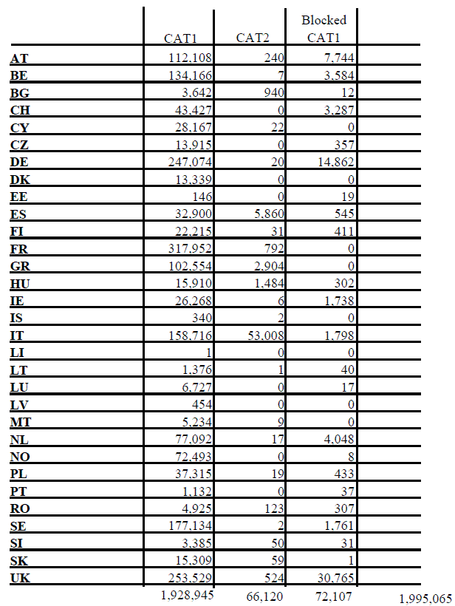
Table 2: Successful transactions to the EURODAC Central Unit, in 2011
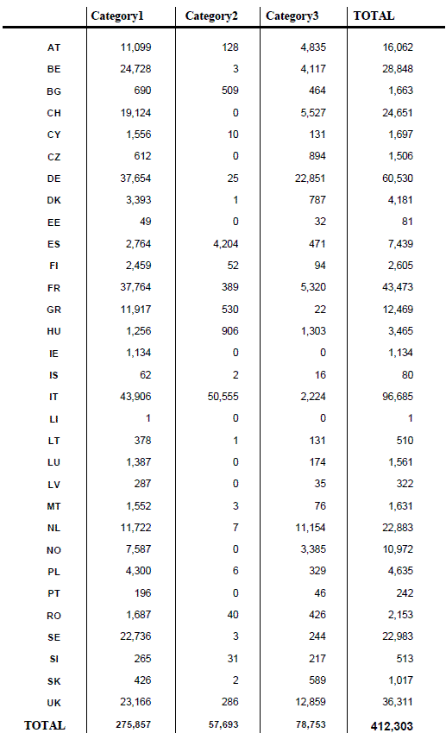
Table 3: Hit repartition – Category 1 against Category 1, in 2011
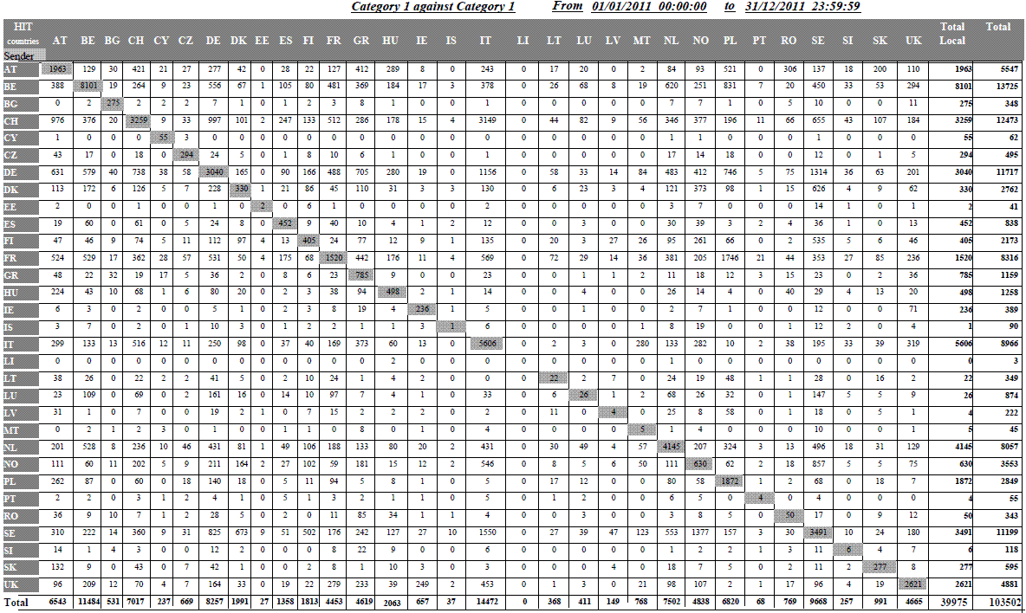
Table 4: Hit repartition – Category 1 against Category 2, in 2011
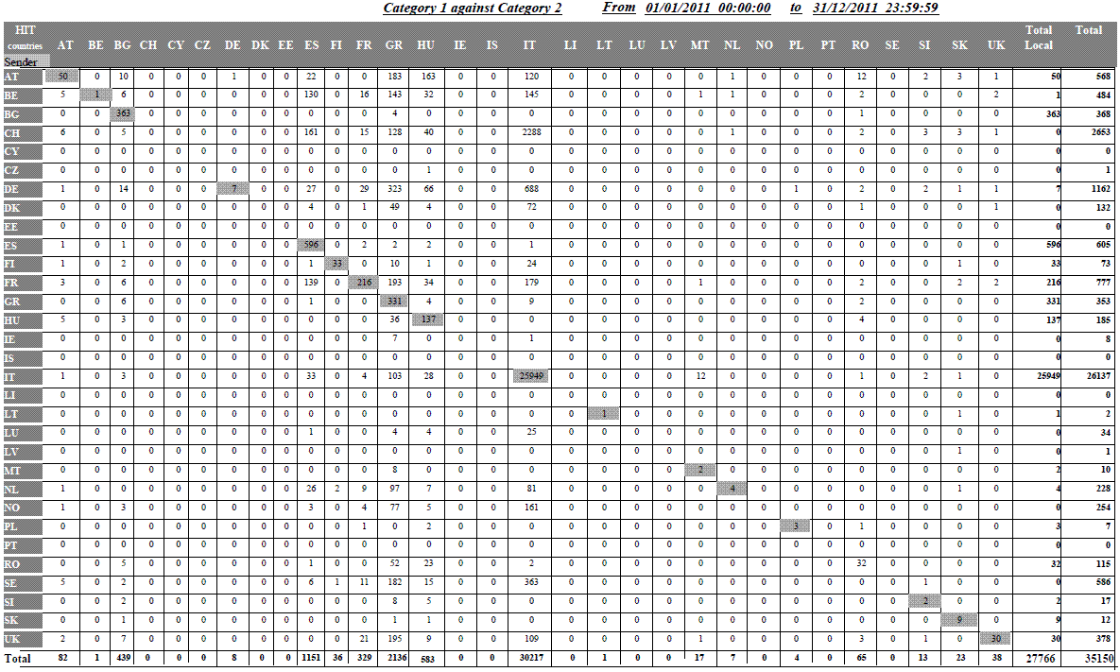
Table 5: Hit repartition – Category 3 against Category 1, in 2011
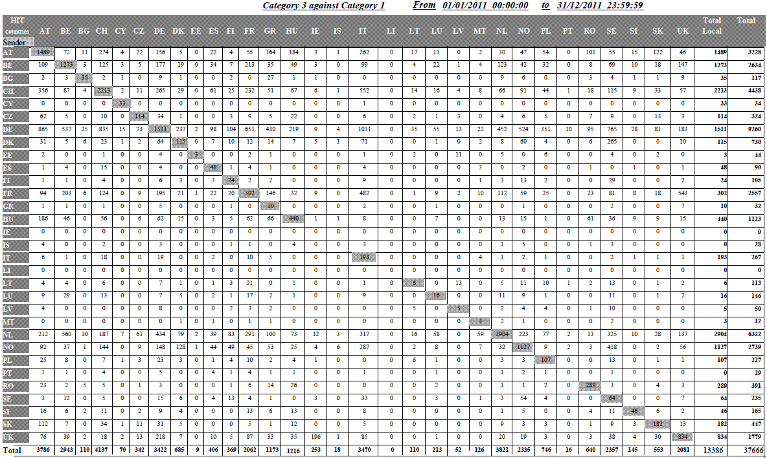
Table 6: Rejected transactions, percentage in 2011
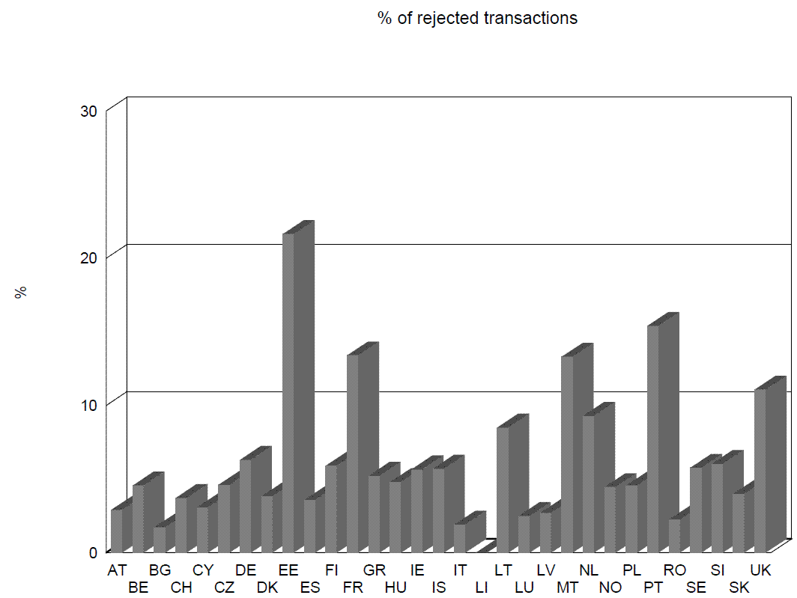
Table 7: Average time between the date of taking the fingerprints and their sending to the EURODAC Central Unit, in 2011
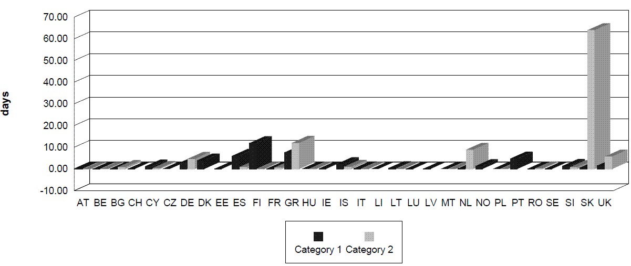
Table 8: Category 1 against Category 1 hit in wrong sense, in 2011
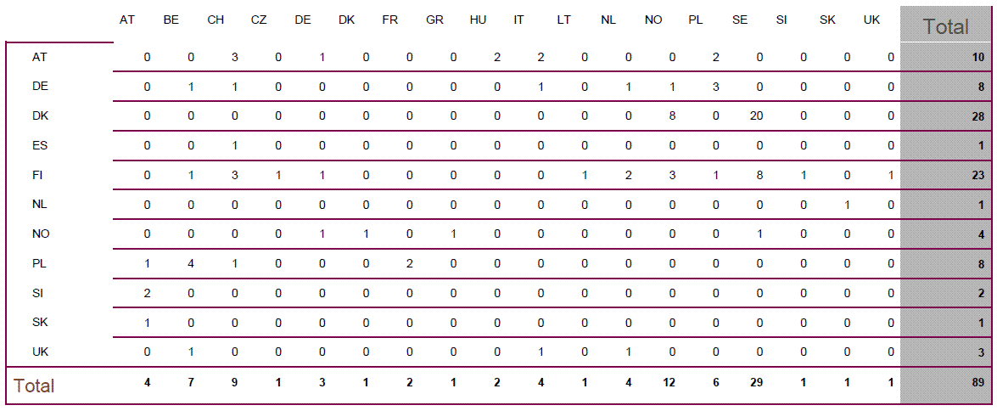
Table 9: Distribution of CAT1/CAT2 hits missed because a delay when sending the CAT2, in 2011
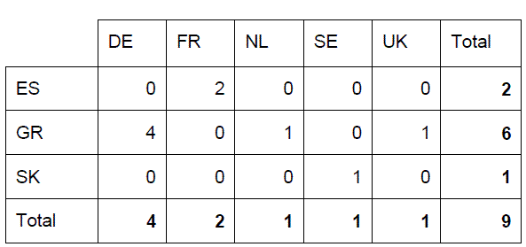
Table 10: Distribution of hits against blocked cases (art. 12 of the EC Regulation 2725/2000), in 2011
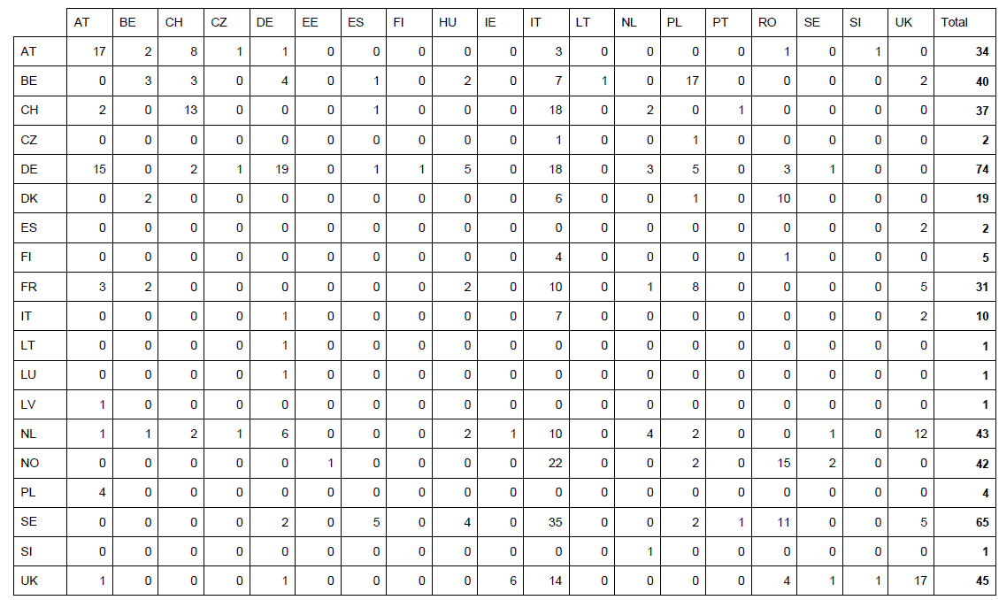
Table 11: Count of category 9 "special searches" per Member State, in 2011
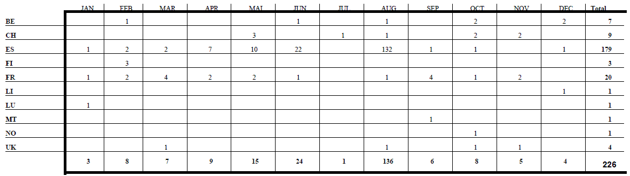

OJ L 316, 15.12.2000, p.1.
Article 24(1) EURODAC Regulation.
COM(2008) 825 final.
COM(2009) 342 final and COM(2009) 344 final.
COM(2010) 555 final.
See European Parliament document LIBE_PV(2011)0203_1.
"Common European Asylum Policy – State of Play". See Council Document 15843/11.
COM(2009) 344 final.
The EURODAC Regulation provides for the implementation of a Central Unit managed by the European Commission containing an Automated Fingerprint Identification System (AFIS) which shall receive data and transmit 'hit – no hit' replies to the national Units (National Access Points) in each Member State. The EURODAC Regulation and its Implementing Rules identify the responsibilities for the collection, transmission and comparison of the fingerprint data, the means through which the transmission can take place, the statistical tasks of the Central Unit and the standards that are used for the data transmission.
S-TESTA (secured Trans-European Services for Telematics between Administrations) network provides a generic infrastructure to serve the business needs and information exchange requirements between European and National administrations.
ISA (Interoperability Solution for European Public Administrations) is the new programme to improve electronic cooperation among public administrations in EU Member States. It is the follow-on of the previous programme IDA II (Interchange of Data between Administrations) and IDABC (Interoperable Delivery of European eGovernment Services to public Administrations, Businesses and Citizens).
Table 2 of the Annex details the successful transactions per Member State, with a breakdown by category, between 1 January 2011 and 31 December 2011.
'Each Member State shall, in accordance with the safeguards laid down in the European Convention on Human Rights and in the United Nations Convention on the Rights of the Child, promptly take the fingerprints of all fingers of every alien of at least 14 years of age who is apprehended by the competent control authorities in connection with the irregular crossing by land, sea or air of the border of that Member State having come from a third country and who is not turned back.'
OJ L 348 of 24.12.2008.
Article 11 '(…) As a general rule there are grounds for checking whether the alien has previously lodged an application for asylum in another Member State where: (a) the alien declares that he/she has lodged an application for asylum but without indicating the Member State in which he/she made the application; (b) the alien does not request asylum but objects to being returned to his/her country of origin by claiming that he/she would be in danger, or (c) the alien otherwise seeks to prevent his/her removal by refusing to cooperate in establishing his/her identity, in particular by showing no, or false, identity papers.'
The statistics concerning local hits shown in the tables may not necessarily correspond to the hit replies transmitted by the Central Unit and recorded by the Member States. The reason for this is that Member States do not always use the option, provided by Art. 4(4), which requests the Central Unit to search against their own data already stored in the Central database. However, even when Member States do not make use of this option, the Central Unit must, for technical reasons, always perform a comparison against all data (national and foreign) stored in the Central Unit. In these concrete cases, even if there is a match against national data, the Central Unit will simply reply 'no hit' because the Member State did not ask for the comparison of the data submitted against its own data.
OJ L 326 of 13.12.2005.
In the scenario of the so-called 'wrong hit', a third-country national lodges an asylum application in a Member State (A), whose authorities take his/her fingerprints. While those fingerprints are still waiting to be transmitted to the Central Unit (category 1 transaction), the same person could already present him/herself in another Member State (B) and ask again for asylum. If this Member State B sends the fingerprints first, the fingerprints sent by the Member State A would be registered in the Central database later then the fingerprints sent by Member State B and would thus result in a hit from the data sent by Member State B against the data sent by the Member State A. Member State B would thus be determined as being responsible instead of the Member State A where an asylum application had been lodged first.
In the scenario of the so-called 'missed hit', a third-country national is apprehended in connection with an irregular border crossing and his/her fingerprints are taken by the authorities of the Member State (A) he/she entered. While those fingerprints are still waiting to be transmitted to the Central Unit (category 2 transaction), the same person could already present him/herself in another Member State (B) and lodge an asylum application. At that occasion, his/her fingerprints are taken by the authorities of Member State (B). If this Member State (B) sends the fingerprints (category 1 transaction) first, the Central Unit would register a category 1 transaction first, and Member State (B) would handle the application instead of Member State A. Indeed, when a category 2 transaction arrives later on, a hit will be missed because category 2 data are not searchable.
A transaction may be rejected due to a data validation issue, fingerprint errors or insufficient quality (see also section 2.1. ibid).

