COMMISSION STAFF WORKING DOCUMENT
Accompanying the document
COMMUNICATION FROM THE COMMISSION
“Strategy for the sustainable competitiveness of the construction sector and its enterprises”

1. Introduction
The scope of this Staff Working Document (SWD) is to strengthen the factual basis underpinning the Communication ‘Strategy for the sustainable competitiveness of the construction sector and its enterprises’.
It provides information on the structure and the short-term trends of the entire ‘value chain’, including on-site construction enterprises (construction of buildings, infrastructure and specialised construction activities), the manufacturing industry (producers and suppliers of materials and construction products) and professional services (consulting firms, architecture and engineering, etc.).
‘Sustainable competitiveness’ is understood as the ability of businesses in the construction industry to achieve and maintain levels of economic performance required by the markets while coping with sustainable development goals. In other words, their economic performance should also contribute to the achievement of objectives in terms of quality of life, social welfare, resource efficiency and environmental protection. Hence, the SWD will also provide information about the environmental performance of construction enterprises.

2. Industry Characteristics
The construction industry is a major economic operator. Overall, it generates almost 10 % of GDP, provides 20 million direct jobs, mainly in micro and small enterprises, and contributes to more than 50 % in fixed capital formation of all economic agents. Due to its economic importance, the performance of the construction sector can have a significant influence on the whole economy.
Buildings account for 42 % of final energy consumption and 35 % of the CO₂ emissions in the EU-27. The manufacturing and transport of construction products is responsible for about 10 % of final energy consumption and about 50 % of all materials extracted from earth. The environmental performance of buildings varies significantly from one country to another.
The competitiveness of companies in the construction industry is therefore an important issue, not only for employment and for the European economy in general, but also to ensure the sustainability of the industry.
The range of different activities within each sub-sector gives contrasting results in terms of skills and adaptation to new regulations and market opportunities. Along the value chain, there are clearly three major sub-sectors differentiated by their structure, performance and the nature of the challenges they face.

2.1 On-site construction enterprises
This includes all businesses that construct buildings and infrastructure (bridges, roads, transportation networks, etc.) and carry out maintenance, renovation and demolition works.
The number of direct jobs linked to this sector was 15 million in 2008, representing 7 % of jobs in the EU and 30 % of industrial employment. Corporate concentration remains relatively low and a significant portion of the production value comes from micro-enterprises. Civil engineering works account for 22 % of total construction work, i.e. € 258 billion and about 3 million operatives.
As on-site construction is a major consumer of intermediate products and services, its growth has a significant impact on the development of other industry sectors (raw materials, chemicals, electric and electronic equipment, etc.).
Output has slowed down, especially in the construction and renovation of buildings. The production index has fallen by 19%, excluding seasonal variations, between January 2008 and November 2011 for all EU-27. Infrastructure work has also fallen, although to a lesser extent, as the index of production fell 7 % over the period between January 2008 and November 2011. Overall, the sector lost 13 % of its workforce between 2008 and 2010. Annex 1 gives more details on the impact of the crisis and the response of Member States.
A major share of on-site construction work in the EU, especially on infrastructure, arises from public procurement. Public procurement projects are often complex and extensive in nature and size, which may pose difficult challenges for SMEs.
To help implement the ‘Small Business Act’, the Code of Best Practices on SMEs encourages Member States to develop favourable conditions for subcontracting and partnership between SMEs (‘consortium’) within the framework of public procurement. Given the importance of public works for the construction activity, public procurement policy should be exemplary, a model of good practice for all fields.
As announced in the recast of Energy Performance of Buildings Directive, the introduction of Nearly Zero Energy Buildings (NZEB) is going to be a major challenge for the building industry in the next few years. The market has several years to adapt, but it needs to be supported by all market actors ranging from public bodies (which need to implement two years in advance), construction companies, designers, developers, etc. It will also require adaptation in areas such as financing structure, procurement, education and marketing.
On-site construction will increasingly face the need for skilled labour. Some surveys show that more than 7 enterprises out of 10 have already experienced difficulties in recruiting for several years. The huge swathe of skilled people due to retire by 2020, representing over two thirds of jobs in construction, industry and transportation, will also need to be replaced. The chronic shortage of skilled labour can be explained by the low attractiveness of the sector for young people and by the growing need for skills corresponding to specific qualifications, which education, training and the employment market often do not satisfy. The transition to a resource efficient and low carbon economy will also bring major structural changes in the construction sector, which will have to adapt and anticipate the needs for skills and competences in these areas. This is especially the case regarding preparations of the labour force to build Nearly Zero Energy Buildings, both new buildings and renovation.
The proportion of on-site construction workers who have completed higher education has increased over time but at a rather slow annual rate. This constitutes an obstacle to higher productivity and a better uptake of innovative technologies and business models. Moreover, due to disparities, in particular in the organisation of compulsory education systems, there are significant differences between the EU-27 countries in the level of basic skills of the workers recruited. These disparities, and the lack of a clear definition of basic requirements for jobs in on-site construction, pose a major obstacle to the mobility of skilled labour, as do other issues related to working conditions and wages.
These obstacles are reflected in the insufficient use of Information and Communication Technology (ICT) in the sector. Although the proportion of on-site construction enterprises with access to broadband internet has grown rapidly, the electronic management of orders and purchases and/or the direct exchange of information with suppliers and customers have grown more slowly. Only about one third of companies with more than ten employees use ICT to integrate its internal business processes and barely one tenth uses ICT to integrate external processes. In most micro-enterprises, ICT use is almost non-existent.
Spending on research and development (R & D) remains very low (0.05 % of turnover in 2007). This can be explained by the fact that the main interest of on-site construction enterprises is to integrate available external technological developments into their activities.
The number of ‘low-energy’ buildings is growing but has not yet reached a critical mass. Efforts to improve energy efficiency and integrate renewable energy sources are progressing slowly, for existing buildings and for new constructions. The initial extra costs of constructing a passive building vary between 15 to 20 % and seem to have a dissuasive effect on demand.
Regarding extensive renovations of buildings, the energy savings achieved are often relatively modest since investors often do not clearly perceive the added value of improved energy efficiency in the overall profitability of investment, especially for rental income. The ‘Strategy for a competitive, sustainable and secure energy’ , the ‘Roadmap for moving to a competitive low-carbon economy in 2050’ and the ‘Energy Efficiency Action Plan 2011’ therefore focus on the need for more action on buildings, especially on renovation.
Transport infrastructure has an enormous environmental impact, consumes substantial volumes of energy and raw materials and generates substantial volumes of waste. Infrastructure networks should bring a major contribution to making Europe more sustainable, by reducing the environmental impact, consumption of land and natural resources and energy and by making optimal use of scarce financial resources. In the urban environment, upgrading and retrofitting infrastructure will help provide a wide range of services, improve environmental and security issues, reduce disruption to traffic and drive down maintenance and reparation costs.
Finally, competition in the EU markets has improved through the application of public procurement directives and by most Member States adopting the European design and construction standards (Eurocodes). However, EU companies are not always on an equal footing, especially due to the social conditions in which they operate. Pressure from non-European companies, which are often subject to less stringent social and environmental requirements and sometimes receive state aid, is also growing in some EU markets, in particular for infrastructure works, with the risk that this puts European companies in an uncompetitive position. The situation on international markets is even more difficult. European businesses often face serious difficulties, both due to technical issues and due to the conditions of competition in some non-member countries, e.g. China, which limit the scope to access their markets.

2.2 Manufacturing construction products
In 2007, the construction products industry generated a turnover of €360 billion for an added value of € 115 billion and employed 2.5 million of workers. The seasonally-adjusted production index decreased by 24 % over the period from January 2008 to September 2011 for the entire industry in the EU-27.
The structure of this industry varies significantly depending on the areas concerned. SMEs are predominant, but the economic value of large enterprises is substantial in some industries, such as cement or plaster.
Beyond cyclical movements, the growth prospects are closely related to the on-site construction sector. Thus, the effects of the economic crisis on buildings and infrastructure projects were directly reflected in the sector of construction products, which also faces the challenges of rising costs of energy and raw materials and international trade.
The sector is, nevertheless, very innovative, particularly in terms of quality and performance of products placed on the market.
Spending on research and development in the construction products industry increased in 2007 to about 0.5 % of turnover. This low rate (1 to 2 %) can be explained by intensive manpower requirements compared with industry in general. In terms of patents, however, EU27 companies have been frontrunners with over a half of international patent applications related to new processes and new products submitted to the European Patent Office in 2006.
On-site construction and the manufacturing of construction products are characterised by a high consumption of inputs (such as metallic and non-metallic minerals, chemicals and wood) and the production of large quantities of waste. The construction products industry has sought in recent years to improve its environmental performance. Efforts have been made in the last decade to integrate the management of manufacturing, design of buildings and on-site works to reduce the amount of waste. The industry is developing more and more materials that are easier to collect and reuse and systems or ‘building solutions’ that facilitate the ‘deconstruction’ of the works and the re-use of materials. These efforts are in line with the new basic requirement listed in the Construction Products Regulation concerning a sustainable use of natural resources, and with the Raw Materials Initiative (RMI), by developing best practices in waste collection and treatment, especially in recovery/reuse of valuable materials from waste, and through support for research on economic incentives for recycling/recovery.
In addition to the drive to make progress in research and development, the dynamism of the sector is also due to the following factors: a gradual increase in competition on the internal market thanks to implementation of the Construction Products Directive (CPD), and the climate, environmental and energy efficiency objectives requiring continually higher performance levels of buildings constructed from these products.
However, the construction products industry still has to cope with a great diversity of standards, national approval schemes and quality marks, which often artificially increase the costs of the products placed on the market. Implementation of the Construction Products Regulation, as of July 2013, should help improve this situation significantly.
Meanwhile, the sector has gradually opened up to competition from outside the EU, exposing itself to severe competition with producers that have to follow less stringent social and environmental regulations.

2.3 Professional services in the construction sector
This area is also very diverse and includes architecture and engineering as well as regulators, surveyors and project coordinators. In 2007, it generated a turnover of € 620 billion, an added value of € 300 billion in 2007 and employed about 3 million people. Compared to the two other areas of the construction sector discussed above, the crisis has had less of an effect on the activity of professional services, although the production index for the period January 2008 to August 2011 shows stagnant activity in this sector.
In recent years, many mergers and acquisitions have taken place in the professional services sector, but micro-enterprises are still likely to dominate, according to medium-term projections.
The fragmentation of practices, regulations and cultural traditions at national, regional and local levels limits the mobility of professionals in this sub-sector, despite EU legislation on free movement of services and the mutual recognition of professional qualifications.
Eurocodes, European standards for design and construction, are an important platform at European level for engineering companies to access construction markets, including public procurement. Internationally, Eurocodes are also known to play an important role in opening new markets for European companies. Russia and some Asian countries, for instance Vietnam and Malaysia, are in the process of adopting them as tools for the design and construction of buildings and infrastructure. Underpinned by the right policy, Eurocodes could also play this role in African markets.
Although energy performance requirements are increasingly taken into account in project design, a more global approach encompassing sustainable development requirements is still only taken in specific cases. At national level, methods for making an integrated assessment of environmental performance and related certification tools are beginning to be applied in public procurement. However, these approaches are not harmonised and are insufficiently conducive to innovative solutions. Here too, European standardisation must play a role accompanied, where appropriate, by concerted efforts to develop a more systematic and harmonised framework to meet the economic, social and environmental criteria.
Costs resulting from failures in the construction process are relatively high; they represent a considerable risk to professional services and construction companies. Risk management is therefore a major concern for professional services. Liability and insurance policies vary significantly between Member States and are often associated with national quality marks, which in most cases is a major obstacle to the free movement of services on the internal market.

2.4 Structure and trends of the sector at national level
Annexes 2 to 4 describe the structure of the three sub-sectors analysed in the previous sections and trends in individual Member States.
In terms of size of enterprise, the three construction sub-sectors all have a comparatively high share of micro-enterprises compared to the average for manufacturing (NACE D). Although the small size of construction enterprises typically limits their internal capabilities and investment resources, it can offer opportunities for faster and more flexible business development. Member States in southern Europe tend to have the largest proportions of SMEs. Conversely, central and eastern European countries tend to have a higher share of large enterprises, although the trend is towards increasing shares of SMEs. Market concentration in both the on-site construction and the manufacturing of construction products tends to be higher in smaller Member States than in larger ones, presumably due to their market size and overall number of enterprises.
In terms of skills and education, most employees in on-site construction have at least an upper secondary education. There is a significant difference between the EU15 (61 % of total employment) and EU12 (84 % of total employment) averages, which in part reflects differences in the definition of mandatory educational systems. Annex 5 provides examples of the vocational education and training systems in place in some Member States. More than 60 % of employees in on-site construction in the southern European countries only have primary or lower secondary education. Over time, the share of employees in on-site construction with an upper and post-secondary non-tertiary education or a tertiary education have increased, although at a low annual rate in the EU27 from 2004-2008.
In all three subsectors, the share of turnover represented by business expenditure on research and development is significantly lower in the EU12 than in the EU15. Furthermore, in terms of innovation activity, there is a significant gap between enterprises in the EU15 and the EU12 in all three subsectors. Innovation activity in the EU-27 appears to be decreasing compared to 2004 levels, although this may simply reflect the initial impact of the financial crisis on enterprises involved in construction (note also the limited data coverage for 2004).
In terms of environmental performance, on-site construction and manufacturing of construction products generate large amounts of non-recyclable waste. In Greece, Romania and Slovenia, the shares of non-recyclable wastes are comparatively lower than in other EU countries, which is probably due to a higher reliance on more traditional construction materials and building methods. Efforts made so far to develop materials that are easier to re-cycle and reuse will only be fully reflected in improved waste statistics in 20 or 30 years. Enterprises in manufacturing materials in the EU12 appear to generate significantly more waste relative to output than enterprises in the EU15. This difference in waste efficiency (amount of waste generated per unit of production) may be due to differences in technology use driven by higher labour costs in the EU15.
Annex 1

Trends in on-site construction
The construction sector has been hit particularly hard by the financial and economic crisis. Figure 1 shows that the production index of on-site construction for both building and infrastructure works fell by 16 % between January 2008 and November 2011 across the EU-27.
Figure 1: Production index in the construction sector since the crisis
Source: Eurostat STS — News release 10/2012 – 18 January 2012.
Activity fell sharply in building works, in particular in the new residential segment, with a decline in the production index excluding seasonal variations of 19 % between January 2008 and November 2011 for all EU-27. Infrastructure works also experienced, although to a lesser extent, a downturn in activity as the index of production fell 7 % over the period between January 2008 and November 2011.
The situation varies enormously from one country to another. When comparing the quarterly production indexes, number of persons employed and building permits over the period from the first quarter of 2008 up to the third quarter of 2011, the most negative trends are seen in Bulgaria, Cyprus, Estonia, Greece, Hungary, Ireland, Portugal, Slovakia, Slovenia and Spain.
Figure 2: Change in the production index in on-site construction in individual Member States
However, in Austria, Belgium, Germany, Luxembourg, Poland and Sweden, at least one quarterly performance indicator showed an increase in activity. Countries with the highest decreases of the performance indexes since 2008 are those that had the highest growth rates up to 2008. Another reason for the different impacts of the crisis at national production levels could be the nature and impact of planned construction work as well as varying effects of national stimulus packages. Still, as Figure 7 shows, the on-site construction subsectors in all Member States (with the notable exceptions of Germany and possibly Belgium and Poland) were adversely affected by the financial crisis to some extent or other (both Germany and Poland fared comparatively poorly prior to 2008, however).

Responses to the crisis
Several Member States have adopted or announced specific programmes to promote private and public investment in infrastructure projects. For example, Germany’s second fiscal programme provides for € 17 billion in infrastructure investment. The French ‘plan de relance’ provides for € 4 billion in public infrastructure investment and € 1.9 billion for housing projects.
Some Member States have also adopted or announced additional measures in direct support of private housing demand and supply:
- Belgium: The government has announced reduced VAT rates (6 %) for new construction works up to a value of €50 000 in 2009.
- Ireland: Support for the housing market — Taxation measures with an estimated cost of € 180 million or 0.1 % of GDP, namely extension of the period of capital allowances for newly constructed buildings in order to increase the attractiveness of commercial buildings, a reduction of stamp duty applicable to non-residential property and an increase in mortgage interest relief for first-time homebuyers.
- Latvia: Lifted the obligatory 10 % down-payment rule when taking a mortgage loan (i.e. the LTV ratio was capped at 90 %) and reversed the fee increase for registering in the land registry.
- Netherlands: The guarantee fund for council housing ‘Waarborgfonds Sociale Woningbouw’ will be extended by (temporarily) increasing the maximum level of the guarantee in special circumstances. This enables housing corporations to (partly) take over projects from commercial parties and to let out houses.
- Spain: Draft bill on measures to stimulate the rental market and energy efficiency in buildings. Authorisation will be given to create Real Estate Investment Trusts which will have a favourable tax regime and whose main object will be to invest in property for rental purposes. The objective is to encourage the rental market in Spain. In 2008, through ICO, the State guarantees for securitising loans to SMEs were increased from 1 to 3 billion euro to promote rentals. Also, the ICO guarantee lines for securitisation of mortgage loans to buy social dwelling homes were increased from 3 to 5 billion euro. On VAT and personal income tax, there is improved tax treatment of building refurbishments that cost over 25 % more than the acquisition price (not including the land), effective as of January 2008. The goal is for more projects to be eligible for a more neutral beneficial tax scheme, improving input VAT recovery and stimulating the construction industry. The same applies to the rehabilitation credit allowed for the habitual dwelling under personal income tax.
- UK: Homeowners support package of £ 1.6 billion (0.13 % of GDP), including a new shared equity scheme to support first-time buyers, support to vulnerable homeowners at risk of repossession and a £ 400 million programme to support social housing supply. The government also decided to temporarily raise the tax-free threshold for the UK’s residential property transaction tax for one year from £ 125 000 to £ 175 000 (estimated to cost around £ 600 million in foregone revenues).
Annex 2

Individual Member State performance in on-site construction (NACE section F)
Figures 3 and 4 show the key performance indicators for on-site construction for each of the 27 Member States in 2007. Figure 3 shows how enterprises in the Nordic countries, Benelux, Ireland and the United Kingdom tend to generate a comparatively high turnover per person employed (although note that Irish figures only refer to enterprises with 20+ persons employed) compared to both the new Member States and the remaining EU15 Member States.
Figure 3: Turnover per person employed (2009 prices) and average enterprise sizes across Member States
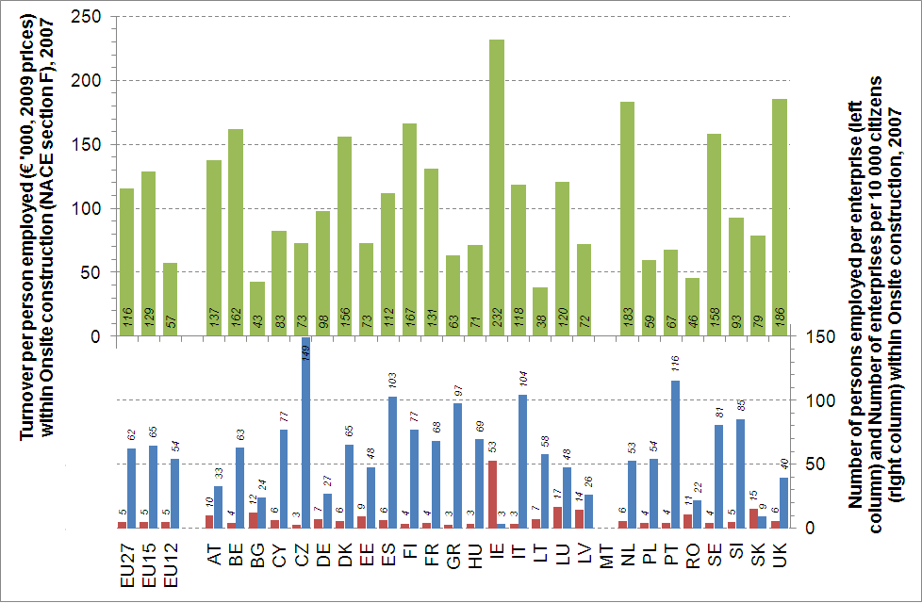
Source: Eurostat SBS (NACE Rev.1.1) and further calculation., Comparatively high Irish figures at least to some extent are due to the data not including enterprises in on-site construction with fewer than 20 persons employed, Data not available for Malta.
Figure 4: Wage-adjusted labour productivity and its components (2009 prices) across Member States
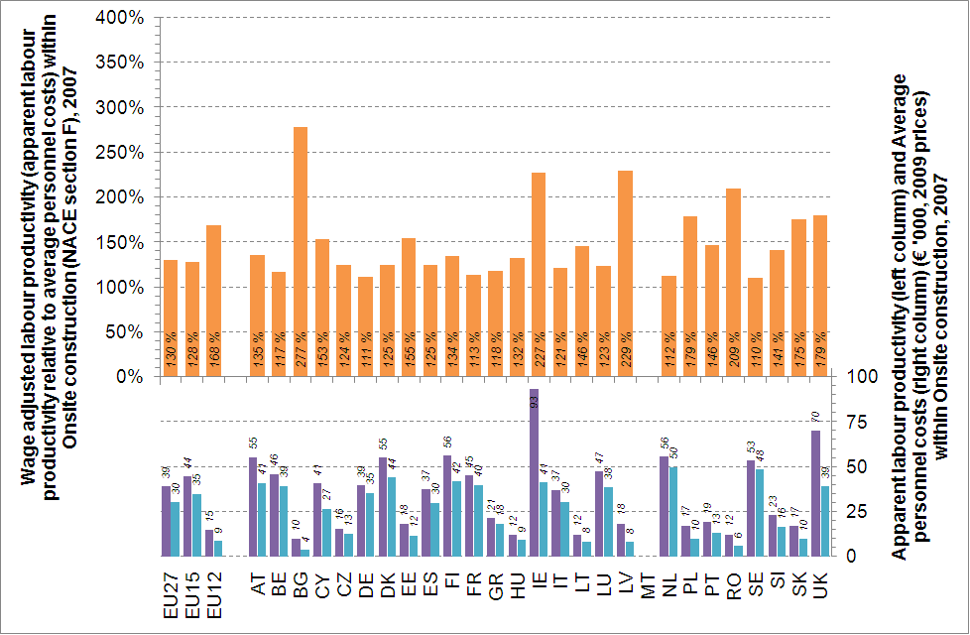
Source: Eurostat SBS (NACE Rev.1.1) and further calculations. Comparatively high Irish figures at least to some extent are due to data not including enterprises in on-site construction with fewer than 20 persons employed. Data not available for Malta.
The lowest turnover per person employed among the EU15 Member States is recorded in Greece and Portugal. The lowest turnover per person employed among the New Member States is recorded in Bulgaria, Lithuania and Romania, reflecting to some extent differences in purchasing power and productivity levels. Differences in purchasing power do not explain all the variation in turnover per person employed, however, and other factors are likely to include the quality of workforce and equipment and the frequency of undeclared work. The first graph also shows some interesting regional patterns regarding enterprise sizes. On the one hand, the southern European countries of Greece, Italy, Portugal and Spain all have a comparatively high number of enterprises relative to population size and a low average enterprise size (implying a comparatively high proportion of micro enterprises and/or comparatively small large enterprises). Only the Czech Republic registered a higher number of enterprises relative to its population size than these four countries in 2007. On the other hand, the countries with the largest average enterprise sizes tend to be new Member States. Thus, out of the five countries (not counting Ireland) where the average number of persons employed per enterprise exceeded 10 in 2007, four were Bulgaria, Latvia, Romania and Slovakia, and the fifth was Luxembourg — the smallest of the EU27 Member States besides Malta (for which no recent data is available) and the only country out of the five where the number of enterprises relative to population size was not correspondingly low.
The second graph shows how enterprises in the new Member States generally tend to record comparatively higher wage-adjusted labour productivity levels than enterprises in the EU15 Member States, led by enterprises in Bulgaria, Latvia and Romania, which generated more than two euros of value added for each euro paid in personnel costs in 2007. Seven of the 11 new Member States for which data are available recorded wage adjusted labour productivity levels above 150 % and only two, the Czech Republic and Hungary, recorded wage-adjusted labour productivity levels below the EU15 average of 128 %. Conversely, only Ireland and the United Kingdom among the EU15 Member States recorded wage-adjusted labour productivity levels above 150 %, driven by a comparatively high value added per person employed (for Ireland the effect of not reporting data for enterprises with less than 20 persons employed are unclear, but wage-adjusted labour productivity levels would appear to be relatively stable across enterprise size classes, even though it is lower among micro enterprises (see Figure 5). The lowest wage-adjusted labour productivity levels among the EU15 Member States in 2007 were recorded by Germany, France, the Netherlands and Sweden — in the latter two countries at least in part due to the highest average personnel costs of all Member States.
Figure 5: Wage-adjusted labour productivity and its components (2009 prices) across enterprise size classes
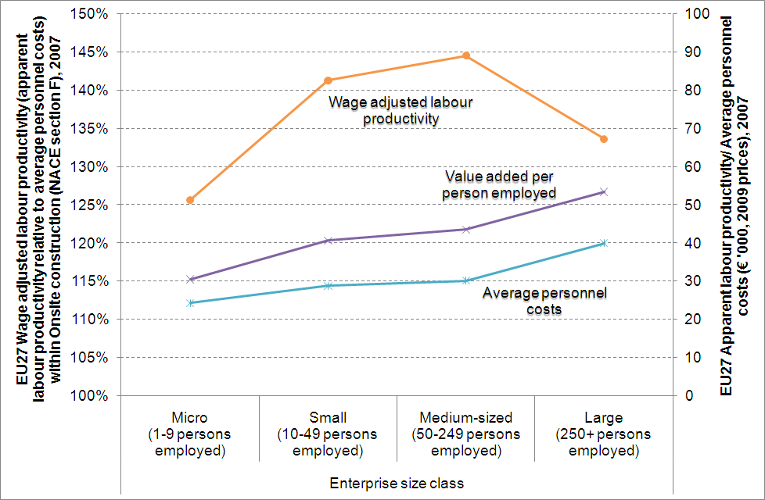
Source: Eurostat SBS (NACE Rev.1.1) and further calculations. EU27 averages do not include Ireland, Malta or Spain due to missing data.
Figure 6 shows that the majority of employees in on-site construction aged 18 to 69 has at least an upper secondary education and that this is the case for as many as 86 % in the EU12. However, the significant differences between the EU15 and EU12 averages at least partly reflect differences in the makeup of mandatory educational systems, and only about 10 % of the European labour force employed in on-site construction holds a university degree or other tertiary qualification.
The above averages mask some notable regional patterns. Specifically, more than three in five employees in on-site construction in the southern European countries including Greece, Italy, Malta, Portugal and Spain have just a primary or lower secondary educational background. Luxembourg is the only other Member State where this is the case. Also, the eight Member States with the lowest shares of employees in on-site construction with just a primary or lower secondary educational background form a tight geographical cluster in central Europe, namely in Austria, the Czech Republic, Germany, Hungary, Lithuania, Poland, Romania, and Slovakia. Finally, employees in northern Europe including the Nordic countries, Austria, Germany, the Netherlands, Ireland and the United Kingdom tend to have relatively more education and training, although it is unclear to what extent this is continuing vocational education and training or leisure interest classes. Only in Slovenia do employees in on-site construction participate in education and training at similar rates.
Figure 6: Educational attainment levels of employees in on-site construction (NACE section F), 2008
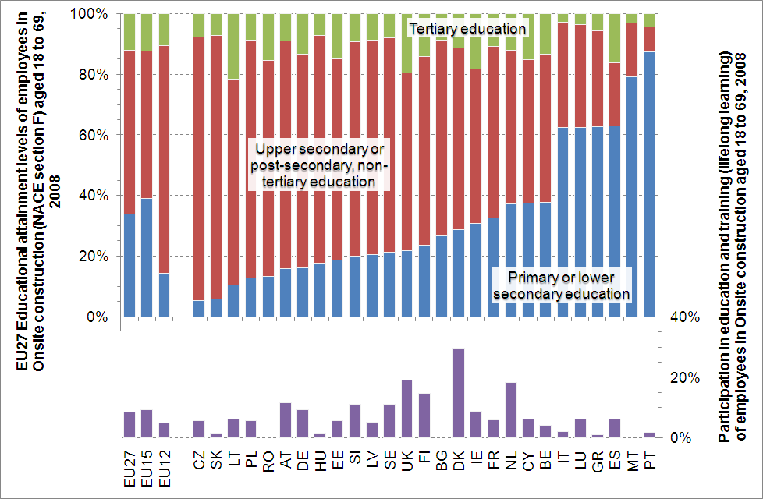
Source: Eurostat, Labour Force Survey (NACE Rev.1.1) and further calculations. See footnote for further comments on the EU12 average.
Over time, the shares of employees in on-site construction aged 18 to 69 with an upper secondary and post-secondary non-tertiary education or a tertiary education have steadily increased in the EU27 (not shown). The incremental changes probably reflect overall changes in the educational composition of the European labour force caused by inflows of better-educated young workers. But it is difficult to discern the impact of any concerted effort to improve educational levels in the limited time span of available data.

Developments since 2007
The most negative developments are found in Denmark, Estonia, Greece, Hungary, Ireland, Latvia, Lithuania, Luxembourg, Portugal, Spain and the United Kingdom, where the average quarterly change across available indicators (number of persons employed, new orders, production volume and/or gross wages and salaries depending on country) fell below zero (0 %) and the average quarterly change for at least one individual indicator exceeding a negative one (-1 %). On the other hand, Austria, Belgium, Finland, France, Germany, Poland, Romania, Slovakia and Sweden have fared relatively well in light of the crisis. In these countries the average quarterly change across available on-site construction indicators has stayed positive and the average quarterly change for at most one individual indicator is below zero (0 %). The countries with the highest decreases in construction activities since 2007 are those that had the highest growth rates up to 2007. Another reason for the different impacts of the crisis on development in national production levels could be the nature and impact of planned construction work and the varying effects of national stimulus packages. Still, as clear from Figure 7, the on-site construction subsectors in all Member States (with the notable exceptions of Germany and possibly Belgium and Poland) have been adversely affected by the financial crisis to some extent or other (both Germany and Poland fared comparatively poorly prior to 2007, however).
Figure 7: Average quarterly changes in on-site construction (NACE section F) across Member States 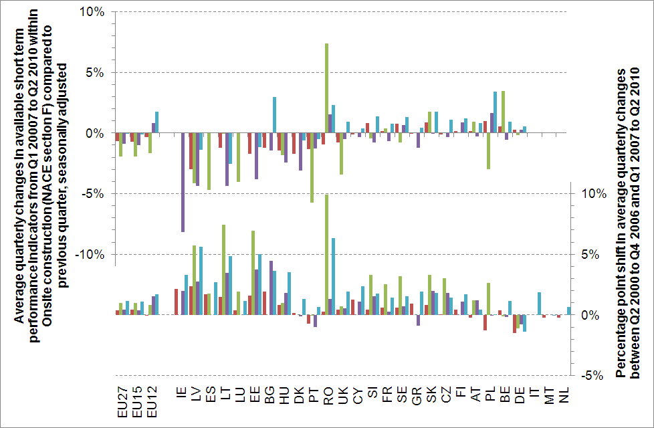
Source: Eurostat STS (NACE Rev.2). Performance indicators include the number of persons employed (far left red column), new orders (middle left green column), production volume (middle right purple column) and gross wages and salaries (far right blue column). Average quarterly growth in new orders based on data until Q4 2008 only to include new Member States. No current data available for Italy, Malta or the Netherlands. Countries ranked by swing in average quarterly changes between top and bottom rows.
Annex 3

Individual Member State performance in Manufacturing of construction materials
Figures 8 and 9 show the key performance indicators for manufacturing of construction materials for each of the 27 Member States in 2007. Figure 8 also shows how in manufacturing of construction materials, enterprises in the Nordic countries, Benelux, Ireland and the United Kingdom together with France tend to generate a comparatively higher turnover per person employed compared to both the new Member States and the remaining EU15 Member States.
Figure 8: Turnover per person employed (2009 prices) and average enterprise sizes across Member States
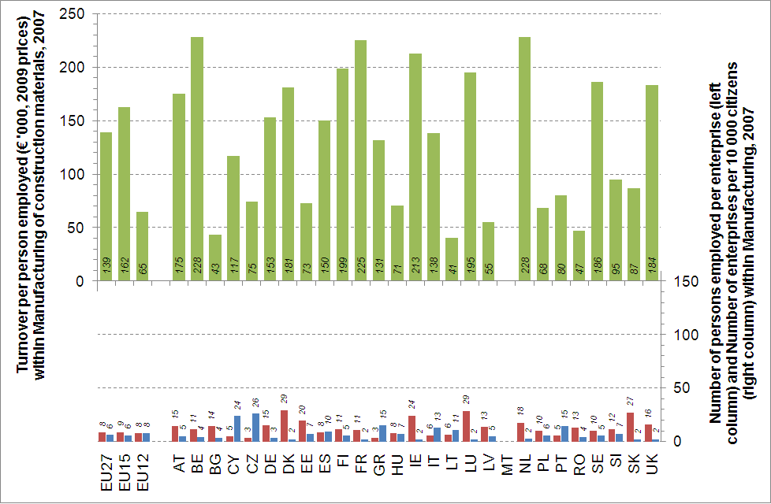
Source: Eurostat SBS (NACE Rev.1.1) and further calculations. Data not available for Malta.
Figure 9: Wage-adjusted labour productivity and its components (2009 prices) across Member States
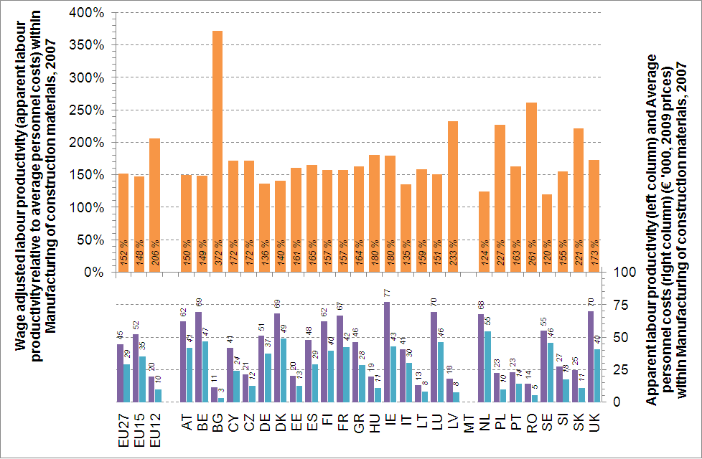
Source: Eurostat SBS (NACE Rev.1.1) and further calculations. Data not available for Malta.
The lowest turnover per person employed among the EU15 Member States was recorded in Portugal and the lowest turnover per person employed among the new Member States was recorded in Bulgaria, Lithuania and Romania, as it was for enterprises in on-site construction. When comparing average turnover per person employed between subsectors country by country, enterprises in manufacturing of construction materials tend to generate a significantly higher turnover than enterprises in on-site construction in the EU15 Member States, but this is not the case in the new Member States, even in percentage terms. This disparity suggests that manufacturing enterprises in the EU15 Member States are able to and do employ more modern technology and/or a better qualified workforce than manufacturing enterprises in the new Member States. Also in manufacturing of construction materials there is a regional pattern of comparatively high numbers of enterprises relative to population size and low average enterprise sizes in Southern Europe. The regional pattern noted in on-site construction of fewer, but larger enterprises in Eastern Europe is less apparent, however.
Figure 9 shows how manufacturing enterprises like on-site construction enterprises in the new Member States generally tend to record comparatively higher wage-adjusted labour productivity levels than enterprises in the EU15 Member States, led by enterprises in Bulgaria, Latvia, Poland, Romania and Slovakia, which generated more than two euros of value added for each euro paid in personnel costs in 2007. All of the 11 new Member States for which data are available recorded wage-adjusted labour productivity levels above 150 %, the lowest levels being recorded in Estonia, Lithuania and Slovenia. None recorded wage-adjusted labour productivity levels below the EU15 average. Conversely, seven of the EU15 Member States recorded wage-adjusted labour productivity levels below 150 %, namely Austria, Belgium, Denmark, Germany, Italy, the Netherlands and Sweden. Comparatively high average personnel costs are a major factor in several countries. Similarly to on-site construction, the highest wage-adjusted labour productivity levels among the EU15 Member States in 2007 were recorded by Ireland and the United Kingdom, although much closer to the EU15 average in this subsector. Country–by-country differences between manufacturing of construction materials and on-site construction are greater in the new Member States in value added per person employed and wage-adjusted labour productivity levels than in turnover per person employed, matching the differences observed between subsectors in the EU15 Member States. The generally higher wage-adjusted labour productivity levels in manufacturing of construction materials are largely driven by higher value added per person employed, given the similar average personnel costs in both subsectors in most countries.

Developments since 2007
The most negative developments have been recorded in Denmark, Estonia, Greece, Ireland, Italy, Latvia, Lithuania and Spain, where the average quarterly change across available indicators (number of persons employed, turnover, production volume and/or gross wages and salaries, with variations across countries, has shifted to below negative (-1 %) and the average quarterly change for at least one individual indicator exceeds -2 %. The average quarterly change across available indicators has been positive in only one country after 2007, Poland. An additional nine countries, Austria, Belgium, the Czech Republic, France, Germany, the Netherlands, Portugal, Sweden and the United Kingdom, have recorded average quarterly changes across available indicators between zero and minus one (-1 %) with average quarterly change on no individual indicator exceeding -2 % (see Figure 10). Compared to developments since 2007 in on-site construction, two groups of Member States seem to cluster at either end of the spectrum. Current performance levels in the Baltic States, Ireland, and Spain are consistently the most adversely affected by the financial crisis and performance levels in Austria, Belgium, Germany, Poland and Sweden are consistently among the least affected. Apart from the impact or lack of impact of construction projects planned before the crisis and stimulus packages, the manufacturing sector and the trading sector (see below) are always likely to be directly affected by developments in on-site construction.
Figure 10: Average quarterly changes in manufacturing of construction materials across Member States
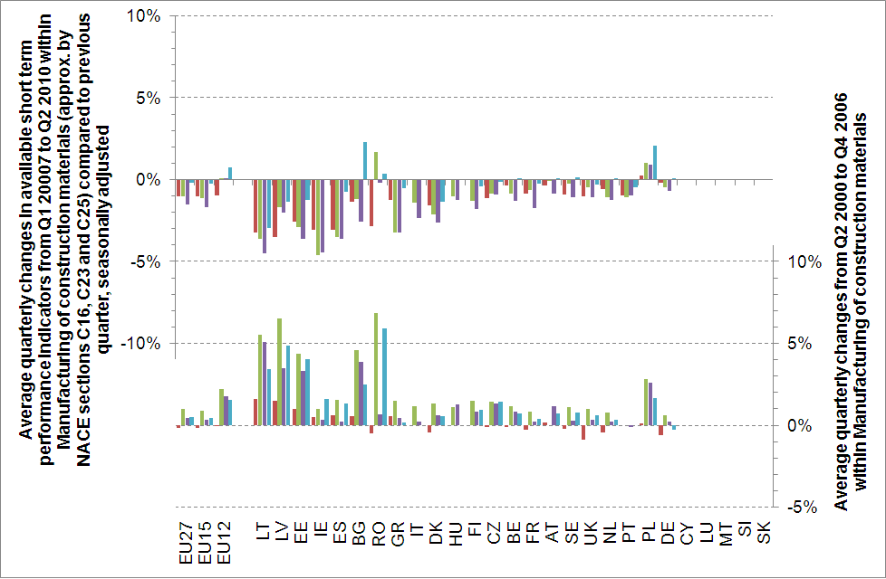
Source: Eurostat STS (NACE Rev.2). Performance indicators include number of persons employed (far left red column), turnover (middle left green column), production volume (middle right purple column) and gross wages and salaries (far right blue column). Average quarterly growth in number of persons employed in Ireland based on data until Q2 2009 only, due to missing data. No current data available for Cyprus, Luxembourg, Malta, Slovakia or Slovenia. Countries ranked by swing in average quarterly changes between top and bottom rows.
Annex 4

Individual Member State performance in Professional construction services
Figures 11 and 12 show the key performance indicators for professional construction services for each of the 27 Member States in 2007. Figure 11 shows how enterprises in the Nordic countries, Benelux, Ireland and the United Kingdom together with France and Slovenia tend to generate a comparatively higher turnover per person employed compared to the other Member States.
Figure 11: Turnover per person employed (2009 prices) and average enterprise sizes across Member States
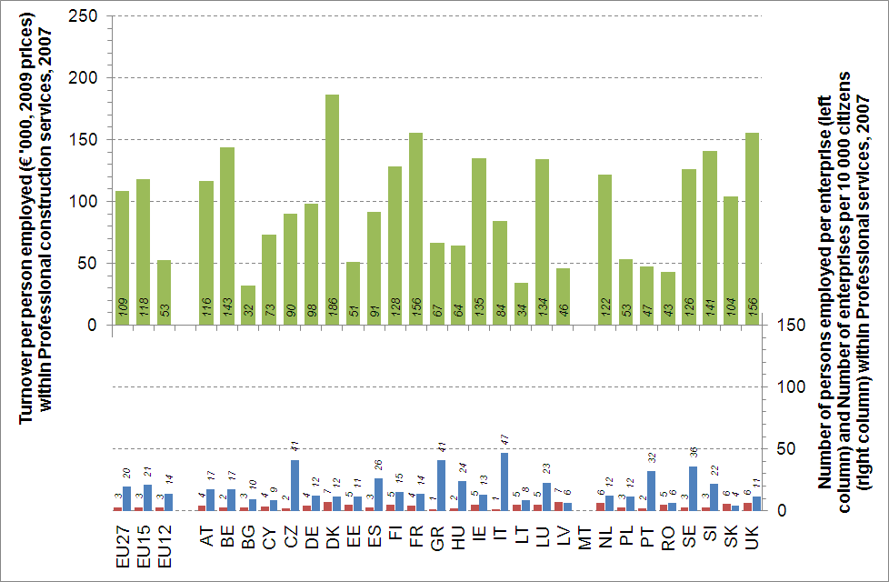
Source: Eurostat SBS (NACE Rev.1.1) and further calculations. Data not available for Malta.
Figure 12: Wage-adjusted labour productivity and its components (2009 prices) across Member States
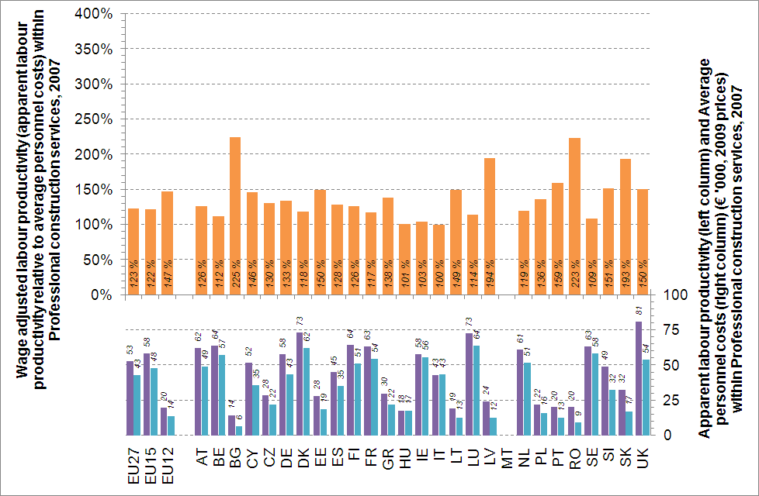
Source: Eurostat SBS (NACE Rev.1.1) and further calculations. Data not available for Malta.
The lowest turnover per person employed among the EU15 Member States is recorded in Portugal and the lowest turnover per person employed among the new Member States is recorded in Bulgaria and Lithuania, shortly followed by Latvia and Romania. These patterns resemble the patterns evident in the other two subsectors. When comparing average turnover per person employed across subsectors, the only countries in which turnover per person employed is highest in professional construction services are the Czech Republic, Denmark, Slovakia and Slovenia. Both the regional pattern of comparatively high numbers of enterprises relative to population size and low average enterprise sizes in southern Europe and the regional pattern of fewer, but larger enterprises in eastern Europe noted in on-site construction are apparent to a lesser extent in this subsector.
The latter graph shows how professional construction services enterprises in the New Member States generally tend to record comparatively higher wage-adjusted labour productivity levels than enterprises in the EU15 Member States. As in the other subsectors, wage-adjusted labour productivity levels in 2007 were highest in enterprises in Bulgaria, Latvia, Romania and Slovakia, which generated nearly two euros or more of value added for each euro paid in personnel costs. Compared to the other subsectors, however, there are some notable variations. Hungary and Ireland recorded two of the three lowest wage-adjusted labour productivity levels in professional construction services in 2007 and together with Italy were very close to generating less than one euro of value added for each euro paid in personnel costs. Equally, Portugal recorded the highest wage-adjusted labour productivity among the EU15 Member States at above 150 %, a feat only otherwise achieved by the United Kingdom. These discrepancies probably reflect the upward pressure on average personnel costs of differences in the stock of available labour force with the required skills base.

Developments since 2007
The most negative developments were seen in Estonia, Ireland, Latvia and Lithuania where the average quarterly change in turnover since 2007 has shifted to below -2 %, followed by Greece, Spain and Slovenia, where the average quarterly change in turnover since 2007 has shifted to below -1 %. On the other hand, the average quarterly change in turnover since 2007 remained positive in Austria, Bulgaria, Denmark, Finland, France, Germany, Hungary, Malta, the Netherlands, Poland, Romania, Sweden and the United Kingdom, that is, in at least 13 of the EU27 Member States. Hungary, Poland and Romania even recorded average quarterly changes above 2 %. Nevertheless, Figure 13 quite clearly shows that the professional construction services subsectors were also adversely affected, to some extent, by the financial crisis in most Member States, except in Poland and possibly Hungary, Malta and Sweden.
Figure 13: Average quarterly changes in professional construction services across Member States
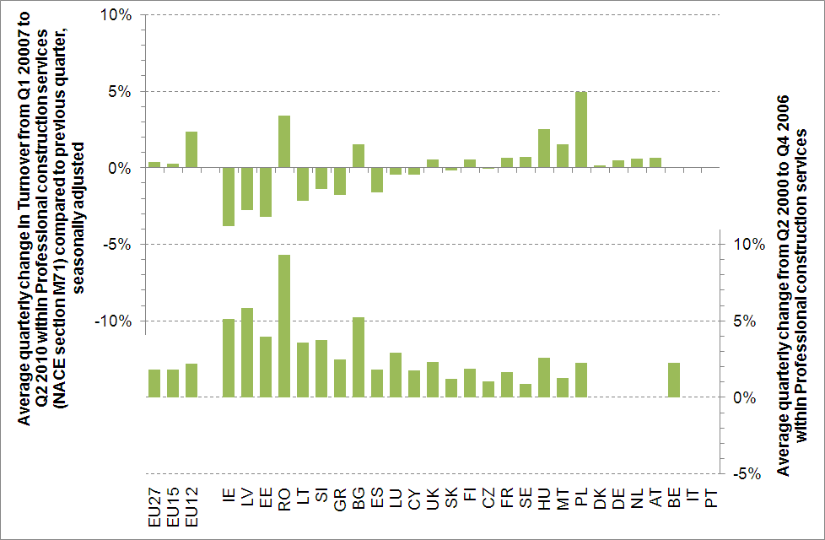
Source: Eurostat STS (NACE Rev.2). No current data available for Belgium, Italy and Portugal. Countries ranked by swing in average quarterly change between top and bottom rows.
Annex 5

The provision of education and training for the construction sector in individual Member States
Education and training systems across Europe vary widely in the degree of centralisation or decentralisation, the structure of training provision, the role of the social partners, financial structures, and curriculum content. Four education and training systems have been chosen to illustrate the type of systemic challenges in each of the systems.
- In Germany, the Vocational Education and Training system is decentralised and corporatist, as the construction sector is the joint responsibility of the federal government, the Länder (the federal states), the social partners, and enterprises. It is based on tripartite cooperation between government, employers, and trade unions, which updates the curricula in line with labour market needs. According to some stakeholders, the current system attempts to address too many and too narrow specialisations within the construction sector. This makes it more difficult for both enterprises and potential apprentices to navigate the system and to adapt to future job profiles and skill needs, which often transcend specific occupational profiles.
- In Italy, vocational training in the construction industry is carried out by a national vocational training system jointly managed by employers and employees’ federations, based on the national collective agreement for construction firms signed by ANCE (National Association of Construction Sector Workers) and the workers’ unions. A main challenge to the adaptability of the Italian VET system is to define and ensure comparable competence outcomes and quality levels across regions. As the vocational training system is not related to a national qualification framework, two workers may have the same vocational training qualifications but with quite different content.
- England has an employer-led on-site learning system where students mainly acquire competencies through company training. The VET-system is primarily regulated through voluntary agreements. Employers contribute to apprentices’ wages, while school training is funded by the state. A challenge in this system is the continued lack of suitable and sufficient places for apprentices, even though there is a levy/grant system for employers that take in apprentices. SMEs with annual payrolls below £ 73 000 are exempt from the levy, although they still qualify for grants, advice and support.
- The Bulgarian VET-system is centralised and characterised by school-based training and practice. Vocational construction education and training includes four years of general school training followed by the option of an additional year of specialisation. At the national level, VET is the responsibility of the relevant ministries. The main components of the curriculum are identical for all schools. A challenge of centralised systems like the Bulgarian is the rigidity in changing curricula.

Source: DG ENER.
Less than 10 employees — in 2007, micro enterprises represented 92 % of the total number of enterprises in on-site construction and accounted for 42 % of all persons employed and 31 % of the total turnover of the sector.
In 2007, on-site construction consumed € 750 billion of intermediate products and services from sectors other than construction (NACE section F), corresponding to nearly 44 % of the subsector’s turnover — Source: ECORYS, study on the sustainable competitiveness of the construction sector, client EC (2010).
Source: Eurostat.
Source: Eurostat.
Directive 2010/31/EU of the European Parliament and of the Council of 19 May 2010 on the energy performance of buildings.
For more details on the relevant provisions, please see Directive 2010/31/EU, Articles 2(2) and 9.
CEDEFOP ‘Skills, demand and Supply’ 2010 p. 93 http://www.cedefop.europa.eu/en/Files/3052_en.pdf
E.g. electronic management of orders and purchases.
E.g. exchange of information with suppliers and customers.
COM 2010 (639) final.
COM 2011 (112) final.
COM 2011 (109) final.
Study ECORYS — ‘FWC Sector Competitiveness Studies No B1/ENTR/06/054 — Sustainable Competitiveness of the construction sector’ — March 2011.
Ibid – For more information on the impact of the crisis on this sector, see ECORYS.
The experience relating to ‘Lean construction’ refers to this approach of integrated management.
E.g. Directive 2006/123/EC on services in the internal market and Directive 2005/36/EC on the recognition of professional qualifications, etc.
E.g. the work of CEN TC 350.
E.g. the SB Alliance.
EU-15 refers to the following group of countries of the EU-27: Austria, Belgium, Denmark, Finland, France, Germany, Greece, Ireland, Italy, Luxemburg, the Netherlands, Portugal, Spain, Sweden, United Kingdom. EU-12 refers to the following group of countries of the EU-27: Bulgaria, Cyprus, Czech Republic, Estonia, Hungary, Latvia, Lithuania, Malta, Poland, Romania, Slovakia, Slovenia.
See Eurostat Statistics on research and development.
See Eurostat Community Innovation Survey.
The reference year is 2005 (=100). Building permits refer to the useful floor area granted by the authorities.
The response of Member States to the Recovery plan is much diversified and needs a systematic analysis. A study ‘Lead Market Initiative – Assessing the impact of national recovery measures on construction in the EU-25’ is ongoing and would deliver results in November 2012.
According to Eurostat, the average share of employees in on-site construction aged 18 to 69 with primary or lower secondary educational background is 41 %. However, also according to Eurostat, no individual country among the EU12 except for Malta registers a share of employees in on-site construction aged 18 to 69 above 37 %. Moreover, the EU27 average according to Eurostat is lower than the EU15 average of 39 % implying that the average for EU12 equally should be lower.
The general availability of Eurostat STS data is very limited below the NACE section level. It is thus impossible to precisely detail developments within the various NACE divisions and subdivisions that make up the composite ‘Manufacturing of construction materials’ subsector as here defined. However, manufacturing of construction materials comprises significant shares of NACE sections C16, C23 and C25 and trends in these broader categories of economic activity thus cannot move entirely independently of activities within relevant NACE subcategories, or at least are highly unlikely to do so. Moreover, trends within each of these broader categories of economic activity are highly similar, suggesting an impact of the financial crisis common to most types of economic activity. Accordingly, aggregate developments within manufacturing of construction materials are approximated as the weighted average of changes within C16 (15 %), C23 (45 %) and C25 (40 %) based on relative sizes of divisions and subdivisions in terms of persons employed, turnover, value added and personnel costs.
See ‘Future Qualification and Skills Needs in the Construction Sector’, study carried out by Danish Technological Institute on behalf of the European Commission, DG Enterprise and Industry, July 2009.

