TABLE OF CONTENTS
Trans-regional actions in the areas of organised crime, trafficking, protection of critical infrastructure, threats to public health and the fight against terrorism (Article 4.1 IfS Regulation, priority 2) 4
Actions in the area of risk mitigation and preparedness relating to chemical, biological, radiological and nuclear (CBRN) materials and agents (Article 4.2 IfS Regulation) 11
Crisis Preparedness (Article 4.3 IfS Regulation) 16
Instrument for Stability, 2011 Overview of commitments, contracts and payments Article 4.1, 4.2 and 4.3
Instrument for Stability: Overview 2011 commitments and payments 22
IfS crisis response and preparedness 2011 decisions and commitments, status of contracts and disbursements 23
IfS crisis response and preparedness 2009 decisions and commitments, status of contracts and disbursements 25
IfS crisis response and preparedness 2008 decisions and commitments, status of contracts and disbursements 26
IfS crisis response and preparedness 2007 decisions and commitments, status of contracts and disbursements 27
IfS long-term component: 2011 commitments and payments by country, region and projects 28
IfS long-term component: 2010 commitments and payments by country, region and projects 29
IfS long-term component: 2009 commitments and payments by country, region and projects 30
IfS long-term component: 2008 commitments and payments by country, region and projects 31
IfS long-term component: 2007 commitments and payments by country, region and projects 32
IfS crisis preparedness: status and description of individual projects 33

COMMISSION STAFF WORKING DOCUMENT
Accompanying the document
REPORT FROM THE EUROPEAN COMMISSION TO THE EUROPEAN PARLIAMENT, THE COUNCIL, THE EUROPEAN ECONOMIC AND SOCIAL COMMITTEE AND THE COMMITTEE OF THE REGIONS
2011 Annual Report on the Instrument for Stability
Instrument for Stability Article 4.1 & 4.2
Building capacity to address specific global and transregional threats
Progress reports
Implementation of Instrument for Stability (IfS)

Trans-regional actions in the areas of organised crime, trafficking, protection of critical infrastructure, threats to public health and the fight against terrorism (Article 4.1 IfS Regulation, priority 2)
Title of IfS Decisions | Annual Action Programmes for Article 4.1 IfS (priority 2) adopted in 2007, 2008, 2009, 2010 and 2011
Type of measure | Trans-regional actions in the areas of organised crime, trafficking, protection of critical infrastructure, threats to public health and the fight against terrorism
Date of Adoption of IfS Decisions | AAP 2007 on 17/12/2007; AAP 2008 on 10/11/2008; AAP 2009 on 25/09/2009; AAP 2010 on 15/12/2010, AAP 2011 on 27/09/2011
Amount(s) | Committed: EUR 88,293,377; Contracted: EUR 59,092,310; Paid: EUR 24,601,304

1 Fighting organised crime on the cocaine route
Illicit drug trafficking, one of the major activities of organised crime worldwide, profits from insufficient international cooperation, regulatory inconsistencies, political obstacles and lack of governance over the global financial markets. Cocaine trafficking from Latin America via the Caribbean towards West Africa and on to Europe, for example, is facilitated by the lack of regional and interregional cooperation. Illicit trafficking in drugs is closely connected with other forms of organised crime. Cocaine trafficking across these regions is complemented by high volumes of illicit financial flows which are instrumental to the concealment, laundering and investment of the proceeds of crime.
A specific programme has been designed to support the fight against organised crime on the cocaine trafficking routes. The "Supporting the fight against organised crime on the cocaine route" programme addresses all regions along the routes from Latin America to Europe, with a special focus on West Africa, where the threat has appeared more recently and the gap in capacity is high. It encompasses the trans-regional dimension by creating cooperation links between West Africa, Latin America and the Caribbean. The aim of the programme is to strengthen the capacity for international cooperation between the law enforcement, prosecution and judicial authorities of the regions concerned. The programme was launched under the 2009 Annual Action Programme and all of its components were confirmed and extended in the 2010 and 2011 Annual Action Plan andcurrently consists of six components, with the aim to link them up progressively, thus contributing to create trans-regional synergies to tackle organised crime on the cocaine route.
Activities in more than 40 countries with a total budget of 19 million EUR are contributing to the following components / objectives:
To strengthen the anti-drug capacities at selected airports ("Airport Communication Programme" – commonly called AIRCOP I and II);
Meanwhile, implementation activities have been ongoing since early 2010 for the Airport Communication Project (AIRCOP), involving international airports in West Africa and Brazil and including work for the Establishment of Joint Airport Interdiction Task Forces (JAITF) and for their connection with international law enforcement databases and communication networks. Within the Airport Communication Project, the preparation of a very successful operation named COCAIR took place in 22 airports and resulted in considerable seizures of drugs, precursors, arms, capital and artworks. In Latin American and Caribbean countries a Memorandum of Understanding (MoU) between Ameripol and the National Police Directorates was signed and a MoU with the Ibero-American Association of Public Ministeries.
To strengthen cooperation in contrasting maritime trafficking in West Africa, Latin America and the Caribbean ("Seaport Cooperation Project" –SEACOP I and II);
Under the project activities were continued to be implemented in 2011, with a total contribution of EUR 2,999,180, for the support for the capacity of law enforcement, judicial and prosecuting authorities of Latin American and Caribbean countries. The first two Joint Airport Interdiction Task forces were inaugurated in Cape Verde and Senegal and the first trainings took place for the Joint Maritime Control Units in Cape Verde, Ghana and Senegal.
To contribute to strengthen cooperation of law enforcement, judicial and prosecuting authorities of Latin America and Caribbean countries and the EU in tackling transregional organised crime ("AMERIPOL I and II");
Under the AMERIPOL project, with a contribution of EUR3.5 million (decided in 2009 and 2010), activities taking place during 2011 that should be mentioned is the signature of the MoU by the Police authorities building the operational foundations of the National Ameripol Units (NAU) and commitments from the signatories to provide technical and human resources, and the signature of the Prosecutors’ MoU on implementation of training and capacity building for prosecutors. Furthermore gap analysis were finalized for Colombia, Bolivia, Brazil, Ecuador, Peru and Panama, Martinique, Venezuela, Barbados, Trinidad and Tobago and Argentina.
To support the fight against money laundering and financial crime in (1) Latin America and Caribbean countries ("GAFISUD I and II") and in (2) West Africa ("AML WA").
During 2011 support continued efforts were made in the fight against money laundering in Latin America and the Caribbean project, with a total contribution of EUR 1,897,500. For this last project, the Financial Action Task Force of South America against Money Laundering (GAFISUD) acts as implementing partner. The global objective of the project is to improve the coordinated action carried out by the GAFISUD countries to fight organized crime, i.a. covering asset laundering investigation, strengthening administrative and judicial cooperation, and law enforcement and fostering cooperation lines to fight asset laundering and formalizing agreements with countries and/or regional groups defined as the priority (GAFIC, GIABA). During 2011 Interpol carried out a study on the feasibilitty of creating a regional police information system to fight (organized) crime (including money laundering) and threats from terrorism which should facilitate the collection, centralization, management, sharing and analysis of police information on a national level in the 15 ECOWAS countries & Mauritania;
To contribute to the fight against the drug manufacture and trafficking by assisting the LAC region against the diversion of precursors from the licit trade (PRELAC II).
Several workshops held in 2011 attended by chemical substances and precursors control authorities and representatives of the chemical operators with the objective of confidence building between the different parties and promote dialogue as well as information exchange
To strengthen the transregional coordination, coherence and complementary effect among the various projects contained in the Cocaine Route Programme ("CORMS").
In 2011 the contract with the objective to strengthen the transregional coordination, coherence and complementary effect among the various projects contained in the Cocaine Route Programme ("CORMS"). was signed and mobilised.

2 Fighting organised crime on the heroin route
The "Fight against trafficking and organised crime on the heroin route" programme was set up to fight illicit trafficking to and from Afghanistan along the heroin trafficking routes. Traffickers take advantage of the lack of regional cooperation and weak law enforcement capacity. The same organised crime networks are suspected to be involved in the trafficking of human beings to the EU. Dealing with trafficking along the heroin routes therefore goes hand in hand with fighting organised crime in the Caucasus, the Black Sea Basin and the Western Balkans. A first major project to support the fight against trafficking to and from Afghanistan was launched in 2009. It focused on law enforcement cooperation between Central Asian countries, with a strong emphasis on Afghanistan, Pakistan and Iran, and involved the ten countries of the Economic Cooperation Organisation (ECO).

In 2011 progress on the programme included ongoing implementation activities for the project identified in the Annual Action Programme 2008 and identification studies for the Annual Action Programme 2011.
The project Fight against trafficking from/to Afghanistan has a budget of EUR 9.5 million and is structured in five components involving different partner organizations. Each component has further advanced in 2011:
- Global Secure Communication System are being set in place for exchange of information and intelligence. This accompanied by capacity building and sharing of best practice in Iran, Pakistan and Afghanistan;
- For "Developing a network of border control cooperation units at land/air/sea ports of entry for container control to stem the flow of drugs, precursors and other illegal trafficking", training programmes were prepared and a training handbook printed in English. Translation into Russian is in progress and translation into Dari and Pashtu is foreseen. Following the ports needs assessments that were conducted 5 Container Control Units (1 in Iran, Kazakhstan, Afghanistan and 2 in Azerbaijan) will be setup and a Container Communication system installed. A detailed action plan was created and the trainings started in 2011;
- A new contribution agreeement was signed with UNODC with the objective to strengthen the container control capacity of the countries and facilitate legal trade using the experience and lessons learned in the global CCP, to develop national and regional capacity to gather, collect and analyze essential data of trafficking of heroin in specialized border control units established in seaports and dry ports, to develop a functioning cooperation network in the area of specialized container profiling units in the Black Sea and Caspian Sea region (Armenia, Georgia, Moldova, Ukraine and possibly Turkey and Russia).
For the Annual Action Plan 2011 two preparatory study were carried out for identifying actions one on providing support for the fight against organised crime in general along the heroin routes in the Black Sea Basin and, ultimately, in the Western Balkans region, the other one specifically on trafficking in human beings.
3 Fight against the proliferation of small arms and light weapons
Small arms proliferation fuels and sustains conflicts, illicit trafficking, gang violence and urban criminality. The Instrument for Stability contributes to international efforts to fight the proliferation, accumulation and trafficking of small arms and light weapons.
In 2011, the European Union continued to promote the issue of Small Arms and Light Weapons (SALW) in all multilateral fora and in political dialogue with third countries. The EU has also addressed the destabilising effects of the proliferation and trafficking of SALW, firearms and explosive materials through continuing implementation of concrete projects with a trans-regional dimension.
In Central America, the EU continued supporting the Central American Small and Light Weapons Control Programme (CASAC), implemented by the Central American Integration System (SICA) under the umbrella of UNDP, in its efforts to fight the illicit trafficking of firearms and explosive materials in Central America and neighbouring countries. The project is implemented by UNDP; it has a budget of EUR 1 million and ended December 2011. The project pursued a double goal: 1) improve the security situation in the region and 2) contribute to the process of regional integration in line with the main objective of the EC’s Regional Strategy Paper on Central America 2007-2013. The contribution of the EU project to the CASAC initiative has shown so far a positive impact on establishing the foundation of a regional structure and long-term strategy to fight the illegal trafficking of arms in the region contributing to building knowledge, raising awareness, and and contributing to the Central American Security Strategy which was adopted in Guatemala on April 8, 2011. Preparations were made to sub delegate CASAC to the Nicaragua Delegation , allowing for a better coherence with other EU supported actions under the regional stratgey and ensuring close monitoring of this IFS long term action by the Delegation and to have a new agreement signed beginning 2012 (CASAC II).
In Africa, the EU continued supporting the Regional Centre on Small Arms (RECSA), located in Nairobi, in the fight against illicit accumulation and trafficking of firearms and explosive materials within the framework of the Africa-EU strategic partnership. The project implemented by RECSA has a budget of EUR 3.3 million and was foreseen by the Annual Action programme 2008. During 2011 it gained pace after having concluded a long consultation process by inter alia.: establishing National Focal Points (NFPs) and National Actions Plans (NAPs); having organised a first meeting of the Regional Police Chiefs Cooperation Organizations (RPCOs) sd; working on towards a strenghtened capacity and cooperation between national law enforcement agencies (police, border guards and customs) within and among countries. The project aims at complementing efforts at national and sub-regional levels, whilst taking into account specificities and needs in each region. Despite the encountered delays, the impact prospects of the project are positive. The project has shown a high degree of dynamism through consolidation of the regional priorities to the project activities and through alignment of priorities to the project’s expected results and rearrangement of the activities, to be implemented over the next two years.
Both programmes emphasize strengthening coordination at regional and sub-regional levels, in line with the activities of the regional organisations (SICA resp. RECSA).
The initiative implemented by UNODC (EUR 2.3 million) in countries in Central and West Africa, Latin America and the Caribbean affected by illegal trafficking in firearms and ammunition made a start in 2011. The initiative promotes the implementation of international agreements against the illicit manufacture and trafficking of small arms and light weapons, in combination with capacity building for law enforcement agencies in Latin America, the Caribbean and West Africa. The main activities include the adoption of an adequate institutional and legislative framework at national and regional level, capacity-building and training for development of required skills and capacities of actors involved in firearms control matters, assistance to States in improving their capacity to gather and analyze relevant information related to firearms and generate reliable empirical information and evidence on illicit trafficking in firearms and ammunition;
The development of a stolen and lost firearms database by Interpol (EUR 0.7 million). made good progress during 2011. The initiative will draw information from a number of pilot countries initially and from all 188 Interpol member countries eventually. The main objectives are to create a centralized tool for tracing and tracking of stolen and lost firearms, to provide a means to identify the trafficking routes of these firearms, to enable Interpol member countries access to insert, update and query a centralized international database for lost and stolen firearms and the consolidation of separate member-country data into one database. From a complimentarity point of view, the pilot phase is being implemented in the same countries (19 countries) as under the UNODC initiative.
4 Enhancing maritime security and safety along critical maritime routes
Maritime transport faces a number of multi-dimensional security issues. Piracy and armed robbery against ships are a serious and rising threat to maritime trading routes (representing by far the largest proportion of world trade by volume), humanitarian deliveries and regional stability. The "Critical Maritime Routes" programme was designed to support the fight against this particular form of organised crime by supporting the capacity of coastal states to ensure security and safety along critical maritime routes. It addresses the ‘hot spots’ of risks and threats crossed by major shipping lanes.
The programme focused initially on the Straits of Malacca and Singapore, where the safety of navigation is challenged by the archipelago structure of the Straits coupled with high-intensity naval traffic and shipments of hazardous and noxious materials, by armed robbery at sea and, to a lesser extent, by piracy incidents. Taking into account the sharp deterioration of the security situation in the Western Indian Ocean and the Gulf of Aden, the focus of the programme has shifted to include that area. Recently, the programme extended its reach to the Gulf of Guinea with a focus on piracy and armed robbery.
The IfS has been involved in the maritime security and safety dossier since 2008 as a long-term complement to other EU programmes under the European Development Fund (EDF), EUNAVFOR operation "ATALANTA" and other broader international efforts (foremost the IMO and national initiatives). IfS has been providing related technical and general support for fighting piracy and armed robbery in the above mentioned regions.
In 2011, progress on the programme included ongoing implementation activities for the projects identified in the Annual Action Programmes 2009, 2010 and 2011 and identification studies for the Annual Action Programme 2012.
In the Western Indian Ocean and the Gulf of Aden the programme supports the implementation of the Djibouti Code of Conduct (DCoC), under the aegis of the International Maritime Organization (IMO), through a consortium of EU Member States' Experts. The DCoC provides a framework for cooperation among coastal and user states for the repression of piracy and armed robbery against ships. The project for enhancing maritime security and safety through information sharing and capacity building started in September 2010 for an initial duration of 36 months with a budget of EUR 6 million gained pace during 2011. The project provides technical assistance for the setting up of a regional training centre in Djibouti and a regional maritime information sharing centre in Yemen, the Yemen centre was officially inaugurated in March 2011 though operations were re-located temporarily to Kenya due to political unrest. Establishment of Djibouti Regional Training Centre (DRTC) remains virtual, with trainings delivered in the framework of Djibouti Code of Conduct in coordination with IMO, but physical construction of DRTC started in September 2011.
Another action of the Critical Maritime Routes programme enables the national law enforcement agencies to combat maritime piracy and robbery on the high seas through effective pro-active investigations, by specifically providing them with the necessary training and equipment to conduct investigations and to identify and dismantle piracy networks and their supporters. The project, contracted in December 2010 with a budget of EUR 1.6 million and for a duration of 36 months, continued its implementation during 2011. The implementing partner is INTERPOL and the focus has been placed initially on Seychelles, Kenya, and, as far as feasible, Somalia (Somaliland and Puntland). As part of this initiative, investigations were carried out by Interpol on piracy organisers and financiers and tracking of financial flows in East Africa.
In the Straits of Malacca and Singapore, the programme supports existing cooperation by contributing to better safety of navigation. The ongoing action will continue until the end of 2012 and was allocated an indicative budget of EUR 0.5 million mainly focussing on co-operation among stakeholders towards enhancing safety and marine environment protection in the Straits of Malacca and Singapore and specifically supports the project "Capacity Building on Hazardous and Noxious Substances Preparedness and Response".
In the Gulf of Guinea, .EU Member States' Experts are currently preparing anti-piracy measures in the Gulf of Guinea.
In addition to the above mentioned projects, during 2011 the pilot project on piracy, maritime awareness and risks continued its implemented by the JRC. The initial scope, focusing on selected countries in the regional around the Horn of Africa (Djibouti, Yemen, Kenya, Tanzania, Seychelles), has been extended to the Gulf of Guinea region (Nigeria, Cameroon, Equatorial Guinea, Gabon, and São Tomé e Principe). The activities include identification and assessment of technical means and practices that can be used to contribute to maritime domain awareness, chiefly by supporting gathering and sharing of information. This IFS funded pilot project and its activities remain complementary to those under the Critical Maritime Routes programme, and the final workshop in Brussels which validate the operational opportunities of this technical tool and aims to promote further dissemination in DCoC countries.
5 Capacity building in regions afflicted by terrorism
The "Support for Preventing and Combating Terrorism" programme was devised under the Instrument for Stability to support capacity building in priority regions afflicted by terrorism, thereby contributing to the United Nations Counter-Terrorism Strategy and relevant UN Security Council resolutions. Particularly on counter-terrorism assistance, synergy with the Instrument for Stability crisis response component is relevant as weel for Pakistan and Sahel.
Implementation activities have been ongoing for the " Support the fight against terrorism in the African continent: Strengthening the African Centre for Study and Research on Terrorism (ACSRT) and the African Union Focal Points" project with a contribution of EUR 585,000. The activities implemented by ACSRT are following a very slow pace due to the low institutional capacity of the Centre, but finally, under the impuls of the newly appointed Director, 6 out of the 12 country audit and evaluation reports were received.
Several projects aim at preventing and combating terrorism, helping in implementing the UN counter-terrorism strategy by providing assistance to specific countries and regions. In 2011, a 6.7 million EUR contract for counter-terrorism in Sahel covering Mali, Mauritania and Niger has been signed and will, amongst others, setup the "Collège Sahélien de Sécurité" and improve the capacities to share information, anticipate terrorist acts and respond to terrorist acts on both operational and judicial level. A mission to Pakistan has determined the needs and definition of actions, to be implemented in the course of 2012, in improving the interface between the prosecution service and the police of the Punjab Province, in order to improve the Punjab criminal justice system as a whole in the management of terrorism cases and provision of a more reliable service to its citizens. In South East Asia the IfS engaged in a joint EU-UNODC initiative for supporting regional and national capacity to prevent and combat terrorism, in areas as strengthening investigation and prosecution services, radicalization and financing of terrorism.
6 The Expert Support Facility (ESF)
Due to the highly sensitive and technical nature of IfS actions in the areas of chemical, biological, radiological and nuclear risks mitigation and trans-regional threats to security, the identification of priorities and the design and implementation of programmes are most appropriately performed by experts from specialized organizations. Moreover, EU efforts in the areas of IfS will be complementary to the ongoing and planned activities of Member States. Therefore, close coordination and the participation of Member States' experts in implementing the programmes is important to ensure that synergies are maximised with the expertise available in national administrations. To this end, the Commission has established the Expert Support Facility under the IfS.
The overall objective of the ESF is to contribute to the aims of the long-term component of the IfS by guaranteeing the best use of human resources in terms of identified priorities and anticipated responses, while ensuring enhanced coordination with other bilateral or multilateral donors, in particular (but not exclusively) EU Member States. Through the ESF, experts from EU Member States Agencies, Departments, Ministries and specialist public or semi-public organisations make their specific knowledge and expertise available in order to provide more effective technical assistance to beneficiaries and to support the implementation and preparation of trans-regional and multi-purpose projects and programmes. Since 2008, approximately 100 multi-disciplinary experts from 17 different EU Member States covering 60 different organisations and institutions have carried out more than 100 fact-finding visits and missions to IfS relevant regions. The Framework Contract established in 2009 with 60 organisations in EU Member States provides for a structured and efficient procedure to mobilise the experts.
The current framework contract for ESF expires in September 2012. During 2011 consultations took place with Member States to discuss ways to continue mobilising EU MSs expertise beyond 2012, covering i.a. the options for reopening/reorganization of the ESF framework contract and the assessment of the which is foreseen before the end of validity of the framework contract. The outcome of this process was the agreement on the Commission moving forward with extending the ongoing framework contract with one year, until September 2013, which would allow for the conclusions of the assessment to be taken into account for the retendering of the framework contract.
7 New areas covered (cyber crime/cyber security, fight against the illicit market of falsified medicines)
Two new areas were explored during 2011 for possible inclusion in the AAP 2012.
Since cyber crime / cyber security is gaining importance as a cross-cutting issue within all trans-regional threats, as it abolishes distances, it ignores boundaries, and as such it facilitates and finances organized crime, the fight against cybercrime in third countries has been introduced as a new IfS priority area. In order to define EU external IfS actions foreseen for 2012, views and experiences of cyber experts in EU Member States, international organisations and US were collected at a DEVCO/EEAS led expert workshop that took place at the end of 2011.
Another new priority area for which IfS actions are foreseen is the fight against the illicit market of falsified medicines which represents a growing threat to global health security, affecting massively the poorest and most vulnerable populations. The way this new area of intervention should be addressed in 2012 has been discussed in close consultation with relevant stakeholders during a DEVCO/EEAS expert workshop that took place in December 2011.
Both workshops have been valuable in identifying the thematic and geographical scope of possible actions in these new areas under the IfS and identifying possible actions to be included in the 2012 Annual Action Plan.

Implementation of Instrument for Stability (IfS)

Actions in the area of risk mitigation and preparedness relating to chemical, biological, radiological and nuclear (CBRN) materials and agents
(Article 4.2 IfS Regulation)
Title of IfS Decisions | Annual Action Programmes for Article 4.2 IfS adopted in 2007, 2008, 2009,2010 and 2011
Type of measure | Risk mitigation and preparedness relating to chemical, biological radiological and nuclear (CBRN) materials and agents
Date of Adoption of IfS Decisions | AAP2007 (17/12/2007) – AAP2008 (05/12/2008), AAP2009 (30/11/2009) – AAP2010 (26/11/2010) ) – AAP2011 (04/10/2011)
Amount(s) | Committed: EUR 177000,000 Contracted: EUR 152,500,000  Paid: EUR 101,000,000

The long-term part of the Stability Instrument (Budget Headings 19.06.02.01 and 19.06.03)
Priority 1 (Article 4.2) - 19.060201 - Risk mitigation and preparedness relating to chemical, biological radiological and nuclear (CBRN) materials and agents.
The “Chemical Biological Radiological Nuclear (CBRN) risk mitigation (priority 1 of the Instrument for Stability) covers risks related to accidental, natural or malevalent CBRN related risks and aims at improving the safety and security culture by spreading best practices and raising the general level of security and safety awareness and culture.
On the basis of the Strategy 2007-2011 and the Indicative Programme 2009-2011 the fifth (2011) Annual Action Programme (EUR 48 million) was defined and adopted in October 2011.
It provides funding for the CBRN Centres of Excellence and for thematic actions to be implemented in the framework of the "Centres of Excellence" initiative; for Border Monitoring and figth agains Illicit Traficking of RN materials ; for Export Control Supports; for the contribution to the Multilateral Nuclear Assurances – Low enriched Uranium Fuel Bank managed by IAEA and for alternative employment of former soviet weapon scientists and engineers through support to ISTC/STCU (International Science and Technology Centre in Moscow / Science and Technology Centre in Ukraine in Kiev).
All activities defined in four previous (2007, 2008, 2009 and 2010) Annual Action Programmes for priority 1 were entirely contracted and are under implementation.
The geographical coverage has been extended to Mediterranean Basin, Middle East, South East Asia, Central Asia, South Caucasus and Africa. The total number of involved countries newly involved is now about 40.
1 CBRN Centers of Excellence (CoE)
The overall scope of the CBRN Centres of Excellence initiative is to strengthen the long-term national and regional capabilities of responsible authorities and administrative infrastructures, and develop a durable cooperation legacy in the fight against the CBRN threat. Effective response to CBRN risk depends on cooperation and coordination between all levels of government, response organisations and international partners. An effective strategy to deal with the CBRN risk management requires a very high level of co-operation and co-ordination among many different authorities within and among countries, therefore the CBRN CoE will rely on a integrated CBRN approach that incorporates all international, regional and national CBRN risk mitigation components into a common strategy. Different domains were covered separately till 2010 (e.g. export control of dual-use goods, illicit trafficking, redirection of former weapon scientists, bio-safety and bio-security culture). From 2010 onwards, the "Centres of Excellence" initiative should provide a single and integrated cooperation platform for actions in all these domains.
First phase of the CoE initiative, covered from the AAP 2009 is fully implemented. The objective is the conceptualization of the Centres of Excellence intended as a network of local, regional and international, including the definition of the guidelines and tools required.
The setting up of the EU CBRN Centres of Excellence (CoE) continued in 2010 and 2011, to enhance CBRN risk mitigation policies worldwide by developing tailored assistance packages based on the needs assessment developed in the concerned regions. As part of the of the second phase, the EU established CoE Secretariats in South-East Asia (Philippines), South East Europe/Southern Caucasus/Ukraine (Georgia), North Africa (Algeria), the "Atlantic façade" (Morocco) and Middle East (Jordan). The first five local CoE's Regional Secretariats became operative in late 2011. Contacts have furthermore been established with Central Asia, Gulf Cooperation Council countries and sub Saharan Africa. In parallel with the setup of the new Secretariats and the development of the key methodologies by UNICRI and JRC, 19 actions in five regions, for a total EUR 16.3 million have been selected and the implementation is scheduled to start in June 2012. They will constitute a major tool for capacity building and developing coherent regional policies and for strengthening the cooperation of national and regional capabilities in this domain.
2 Border Monitoring - fight against illicit traficking
The fight against illicit trafficking of CBRN materials and deceptive financial practices is implemented with actions in Central Asia and South East Asia and North Africa.
A coordination mechanism, the Border Monitoring Working Group (BMWG), has been set up between EU and US with the International Atomic Energy Agency (IAEA), to better coordinate activities on border control and on improvement of capabilities of the recipient countries for analysis of seized nuclear and radioactive materials. The dedicated BMWG meets twice per year since November 2005 to share information on donors' projects and coordinate border monitoring activities.
The actions planned both under the TACIS and the previous AAPs of IfS are still under implementation in various countries of Russia and Central Asia (e.g. actions to enhance the detection of radioactive and nuclear materials at identified borders crossing and/or nodal points in the Republic of Georgia, and at Southern borders of Tajikistan and Uzbekistan).
From the AAP 2011 the first two actions are already in contracting phase. Their purpose is to provide mobile detection equipment and training for the Saint Petersburg – Helsinki high speed train, as well as to provide an adequate CBRN protection during UEFA football championship EURO 2012 in Ukraine and Poland, in order to enhance detection capabilities, timely analysis of data and prompt response.
Based on the BMWG as well as an extension fact-finding mission in SE Asia and Democrat Republic of Congo, two additional activities are under preparation to cover these regions.
The first aims to enhance the detection at border crossings and support capacity building in the selected countries in South East Asia (Cambodia, Malaysia, the Philippines and Thailand) and involving the other countries of the ASEAN (Indonesia, Myanmar, Laos, Singapore, Vietnam) in regional initiatives as workshops, seminars and training, to deploy detection and response procedures and use properly the detection equipment supplied. Together with the international partners (in particular the IAEA and the US Second line of Defence program), the establishment of a dedicated network for experience and information sharing will be supported via regional seminars, workshops, advanced training sessions etc.
The second provides support the fight against illicit trafficking in the Democratic Republic of Congo by the provision of detection equipment (fix at borders and mobile for the retrieval of orphan sources), training (use of the detection equipment, methodology and national response plan) and capacity building (participation to the International Technical Working Group on Nuclear Forensics to integrate the international community in the view of experience sharing and networking).
In addition, a contract has been signed with IAEA to contribute to a new Nuclear Material Laboratory to be used by IAEA Safeguards Analytical Services in Seibersdorf, Austria (EUR 5 million in 2011).
3 Cooperation in Export Control of dual use goods
The EU Strategy against the proliferation of WMD articulates a clear commitment to strengthening export control polices and practices within EU borders and beyond, in co-ordination with partners. It identifies the need to set up a programme of assistance to States in need of technical knowledge in the field of export control.
Outreach to third countries in the area of export control of dual-use items is one of a number of tools and policies that the EU has developed in order to combat the proliferation of weapons of mass destruction (WMD) and their means of delivery. The German Federal Office of Economics and Export Control (BAFA) has been mandated by the EU Commission to implement an EU project with the aim of enhancing the effectiveness of the export control systems of third countries. While continuing to cooperate with the existing partner countries of the LTP 2008 and its predecessor programs and starting to work with new beneficiary countries, the new project has also expanded its scope.
The assistance and cooperation in export control of dual-use goods activities resulted in successful programme implementations with more than 28 States around the world that will be extended and reinforced. Cooperation with the US EXBS Export Control system has been reinforced.
The activities foreseen in 2011 aim at strengthening the export control systems of partner countries, with a strong link with the Regional Centres of Excellence activities, by aligning them to the standard of the international export control regimes and treaties and therefore meeting the requirements of the UNSCR 1540 (2004).
One particularly important new focal point in the current project is to establish a transition from a country oriented approach towards a more regional approach, among others through interaction with the Centres of Excellence (CoE).
4 Multilateral Nuclear Assurances
To support Multilateral Nuclear Assurances (MNA) initiatives, a contract has been signed with IAEA to contribute to the Low Enriched Uranium Bank for the Utilization of Nuclear Energy (EUR 20 million). The "LEU Bank", owned and managed by the IAEA, will supply countries introducing civil nuclear programmes with secure nuclear fuel, thus limiting the associated proliferation risks. As for the participant States this scheme will reduce the risks of fuel supply disruption due to the political reasons.
The concept of Multilateral approaches to the nuclear fuel cycle have been envisaged for decades. An IAEA-controlled nuclear fuel bank is essential to reducing global nuclear dangers because the same enrichment technology (e.g. centrifugation) can be used to produce both low enriched uranium for nuclear power reactors and high enriched uranium for nuclear weapons. Thus, multilateral approaches to the nuclear fuel cycle, in general, and creation of nuclear fuel bank, in particular, have potential to facilitate peaceful use of nuclear energy while providing the international community with additional assurance that the sensitive parts of the nuclear fuel cycle are not unduly disseminated and consequently are less vulnerable to misuse for non-peaceful purposes.
The specific objective to the IfS contribution to this project is to support, as a first step, the nuclear fuel bank option adopted by the IAEA, while ensuring compliance with basic criteria such as market compatibility, security of supply, consistence with existing international non-proliferation treaties and agreements and the absence of any negative proliferation impact.
5 Redirection of former weapon scientists
Support for retraining and alternative employment of former weapon scientists and engineers with origin in countries of the former Soviet Union has continued through the dedicated STCU and ISTC centres in Kiev and Moscow. In Iraq, actions continued by engaging former weapons scientists in comprehensive activities for the decommissioning, dismantling and decontamination of nuclear facilities.
The programmes under the Science Centres in Moscow and Kiev have provided a period of reasonable stability within the FSU countries to allow their governments to manage a significant change in the way WMD scientists and engineers adapted to post Soviet economic conditions. While in hindsight the proliferation threat from FSU WMD scientists absconding to work for states of concern or assisting terrorists to acquire proliferation sensitive expertise and materials was limited, the EU support for the Science Centres was instrumental in encouraging other donors to assist in scientist redirection work and develop good working relations between donors and partner countries. Without such support, Former Soviet Union countries ability to deal effectively with the challenge would have been a lot less certain. In 2011 it has been estimated by the Centres that about 3000 FWS have been engaged in peaceful research activities.
On the other hand 2009 G8 summit indicated that the focus of such work is moving away from “redirection” of scientists to the “engagement” of younger scientists. Therefore, a new strategy for the redirection/engagement activities is under development. It has been agreed that the former weapon scientist redirection needs extended to the engagement of scientists that have sensitive knowledge, including younger scientist that have not necessarily been involved in WMD development. This process was also accelerated by the Decree in August 2010 announcing the withdrawal of the Russian Federation from the ISTC Agreement.
During the transition process the funding of the Centres has been continuously reduced. Both Centres are being drastically restructured while the Parties (US, Canada and Japan for ISTC) are developing the new mission statement and mandate of the Centers.
The results of the first evaluation of the programme results were made available in July 2010. They covered three main areas: export control of dual–use goods, combating illicit trafficking of CBRN materials, and redirection of former WMD scientists' and engineers' knowledge to peaceful activities. For reasons of coherence and completeness, this evaluation covers the period 2004-2009 as the activities under the areas evaluated started before the IfS Regulation came into force. The evaluation results were taken into consideration in the definition of the new Strategy and Indicative programme 2012-2013. A second evaluation phase has been launched in 2011.

Instrument for Stability Article 4.3
Crisis Preparedness/Peace-building Partnership
Progress report
Implementation of Instrument for Stability (IfS)

Crisis Preparedness
(Article 4.3 IfS Regulation)
Title of IfS Decisions | Annual Action Programmes for Crisis Preparedness 2007-2011
Type of measure | Pre- and post-crisis capacity building
Date of Adoption of IfS Decisions | 21/12/2007, 31/03/2008, 30/06/2009, 31/03/2010 and 30/6/2011
Amount(s) | Committed: EUR 56.020.652; Contracted: EUR 45.520.652; Paid: EUR 25.882.634

The crisis preparedness component (Article 4.3) of the Instrument for Stability - also known as the Peace-building Partnership (PbP) – provides support for long-term measures aimed at fostering co-operation between the EU and a series of implementing partners. Between 2007 and 2011, 48 actions were contracted for a total of EUR 45.5 million. These actions focus on i) building the general capacity of non-state actors to respond to crises situations (46%); ii) co-operating with international organizations and regional organizations (37%); and iii) working with relevant Member State bodies on the training of police and civilian experts to participate in stabilization missions (17%).
In 2011, funding built on and continued supporting clusters of activities identified in the past. The 2011 Annual Action Programme, included eight actions grouped thematically under the following components: Capacity-building of non-state actors; Natural Resources and Conflict; PCNA/PDNA; Mediation and Dialogue; Women Peace and Security; Security Sector Reform. As in previous years, the Programme foresees engagement with three categories of partners as follows: 1) civil society; 2) international and regional organisations; 3) EU Member State bodies.
Examples of the results achieved by Peace-building Partnership actions during 2011 include:
i) Fostering dialogue on peace building with civil society organizations: to this end, a Civil Society Dialogue Network, managed by the European Peace-building Liaison Office (EPLO) for the benefit of all peace-building non-state actors, was launched in 2010 to provide input to the EU policy-makers on policy, strategic and programming aspects of the Peacebuilding Partnership, transversal thematic issues relating to peacebuilding and crisis-specific situations. Thirteen meetings were held in 2011 on peace-building related topics including conflict prevention and early warning, mediation and fragility, women, peace and security as well as country or region-specific conflicts (Mediterranean and North Africa region - MENA region, Ivory Coast).
ii) Capacity building of in-country non-state actors: twelve locally managed projects involving and led by civil society organizations started activities in six countries (Bolivia, Nicaragua, Pakistan, Timor Leste Yemen, Zimbabwe) covering the following areas: mediation and dialogue, situation of fragility and conflict, women peace and security and human security.
iii) Strengthening the mediation capacity of the international community: the EU supported the establishment of two positions within the Standby Team of Mediation Experts, established under the Mediation Support Unit (MSU) of the UN Department for Political Affairs: one expert on “natural resources and conflict”, the other on “mediation process design”. The mission of these experts - deployable anywhere in the word on 72-hours notice - was to quickly provide mediation expertise to mediation and peacekeeping missions led by the UN, Member States, as well as other international, regional and sub-regional organisations. During 2011, the two experts were deployed on 16 separate occasions to eight countries (Jordan, Kazakhstan, Kenya, Switzerland, Qatar and Belgium).
A project targeting the root causes of the post-election violence in Kenya in 2007 offers another example of effective PbP work in the area of mediation. The project’s activities strengthened the capacity of non-state actors to mitigate community conflicts by improving know-how on early warning informal mediation, field-based political analysis, policy oriented conflict research and policy dialogue. Groundwork was laid in the first year of the project and the second year has been characterized by the pursuit of community dialogue at grassroots level between beneficiaries, opinion leaders and state actors applying newly-gained knowledge in peace-building and conflict transformation. Focus was placed on utilizing the primary target groups’ newly gained knowledge in peace-building and conflict transformation. Key results included the establishment of the regional peace-building networks between the CSOs, the involvement of community leaders and provincial administration and one national and three provincial policy dialogue meetings. As a further example, the 'Preventing inter-community conflicts in East Africa' action yielded the following results, briefing and a roundtable on the Lou Nuer/Murle conflict in South Sudan was organised at the benefit of UN-DPKO, the EU Delegation, office of EU Special Representative for Sudan/South Sudan, Sudan Tribune newspaper, Embassy of Kenya, DFID / British Embassy, Members of Parliament, USAID; a traditional forum for resolving conflicts within the community, (NAAPO), was revitalized and a mechanism for women’s participation in the previously male-dominated mechanism was successfully established; two early-warning briefings in Kenya were delivered; tensions were reduced between Turkana and Pokot communities via a joint resolution to open the Nakwamoru-Lorokon road that had been barricaded for nine months due to a raid by Turkana warriors and raids were reduced both in number and scope in the target area. All the above projects contributed to global EU mediation efforts and helped turn the “Concept on Strengthening EU Mediation and Dialogue Capacities” into concrete actions to increase and develop the EU and the international community’s capacity to mediate and negotiate settlements of armed conflicts, political crisis and other disputes.
iv) Addressing the linkages between natural resources and conflict and how prudent use of natural resources may also play a role in preventing conflict and building peace: under an agreement with the UN Mediation Support Unit (MSU), experts were financed by the EU for the production of a Guidance Note on Extractive Resources and Conflict and extensive research pieces on the Nile River Basin as well as land conflicts involving indigenous populations in Chile and Panama. The experts also carried out training seminars in Brussels for EU staff on trans-boundary water-sharing issues (October 2011) and assisted DPA in the preparatory activities for national dialogues in the MENA region.
v) Improving international cooperation in the field of Post-conflict and Post-Disaster Needs Assessment (PCNA-PDNA): based on the EU-UN-WB partnership on PDNAs/PCNAs, the UN Development Operations Coordination Office (UNDOCO) developed web-based tools for experts undertaking assessment missions in the wake of natural or man-made disasters. The programme also developed joint training/information programmes through which some 170 staff from partner and other multilateral organisations received introductory training, with a further 73 experts following the in-depth programme. This created a critical mass of technical experts capable of rapidly analyzing the necessary international aid responses to give to natural and/or man-made disasters, allowing the EU to better play its international role in this regard.
vi) Addressing human rights in conflict contexts and in particular gender and youth issues: a full range of activities was delivered in 3 regions of Bosnia and Herzegovina under the project “Youth for Peace”, including the empowerment of youth organisations, the organization of training days on peace-building and community development and the construction of sport and children’s playgrounds and parks. Peace work was also included in Local Strategies for youth of 3 targeted municipalities and 5 publications were produced reaching over 5,000 project participants. The action “Political Participation of Women from Afghanistan, DR Congo and Liberia in Peace and Security Policy” saw women activists in DRC involved in investigating the cases of mass rapes in Fizi perpetrated by the regular army (FARDC) in early January 2011. Subsequently, Lieutenant-Colonel Mutware Daniel Kibibi became the first FARDC commander to be sentenced by a special mobile gender court for rape crimes and similar sentences were handed down near Kalehe and Maniema. Awareness-raising on UNSCR 1325 reached more than 1000 women through public information sessions resulting in an increase in women's political participation in the areas concerned: two women took up province-level ministerial posts; another two won seats in the national parliament and in virtually all territories with activities of DYFAP members, dozens of women gained posts in local governance structures.
In Afghanistan, a high-level meeting with president Karzai were held in 2011 to advocate gender-sensitive policies and women’s participation in decision-making bodies. The defeat of a government bill was secured to avoid the recognition of the decisions of informal courts (local shura), known to discriminate against women and to promote harmful practices. Furthermore the political participation of women was increased: Karzai nominated three candidate women ministers and women participated for the first time in the National Consultative Peace Jirga (334 women, 1334 men). Concerning the Jirga, the advocacy of the Afghan women’s movement succeeded in having the percentage of women increased from 12% to 20%. Moreover, the presence of nine women in the 70-strong High Peace Council overseeing the Afghanistan Peace and Reconciliation Programme was achieved and female civil society representatives participated in the 2011 Bonn Conference. Members of the Afghan Women’s Network (AWN) interviewed during the external evaluation of the project on political participation stated that the advocacy meetings in Europe (Brussels and Berlin), an activity of this project, contributed directly to this success.
This action is a concrete example of how the EU has contributed to advancing the implementation of UNSCR 1325, to the empowerment of women’s networks and organisations and to women’s participation in political processes in conflict affected contexts.
vii) Training civilian and police experts from EU Member States for participation in civilian stabilization missions: ENTRi (Europe’s New Training Initiative for Civilian Crisis Management), a consortium involving 13 participating EU partners was designed to strengthen the capacity, technical capability and skills of staff working in or preparing for deployment under civilian crisis management missions while simultaneously fostering interoperability and the harmonisation of partners’ approaches to training. Over its first year, the ENTRi consortium organised 17 courses (both pre-deployment and specialisations), in which 340 experts of 49 nationalities participated. 190 participants were nominated for participation by seconding institutions of EU’s Member States. Moreover, at the end of the year, a further action was funded providing for future training of EU police officers for deployment in civilian crisis management operations over the coming years, while also expanding its scope to include police officers from (a) non-EU countries contributing to CSDP missions and (b) African countries. To date, the European Union has provided significant complementary support for training efforts in these areas as successful civilian crisis management and stabilisation missions rely on the availability of well-prepared individuals which in turn depends on high quality training activities custom-designed for such purposes.
viii) Implementing co-operation with regional organisations on enhancing their early warning networks: an operational crisis response centre was established in 2011 at the Secretariat General of the League of Arab States (SGLAS) and an intensive training programme benefiting officials of SGLAS in crisis analysis and crisis response management is now being implemented. A platform of cooperation on the various on-going crises in the region between the EU and the SGLAS has been created. Through this and similar actions, the EU aims at strengthening regional and sub-regional organisations’ early-warning capabilities to better respond to or prevent conflict and to prepare for post-conflict and post-disaster recovery.
ix) Contributing to International Dialogue on Peace Building and State Building: since 2009, the EU has supported the International Dialogue on Peace Building and State Building, established in 2008 in Accra, in response to the need for a better and more focused effort to address the challenges of conflict and fragility. In 2011, the IfS supported the work of International Dialogue on Peace Building and State Building Secretariat and that of the four Dialogue working groups, as well as the organisation of international meetings such as in Monrovia in June. The Monrovia meeting agreed on final knowledge products and discussed a draft International Action Plan that was presented in December at the 4th High-Level Forum on Aid Effectiveness in Busan. The following December, the 4th High-Level Forum on Aid Effectiveness in Busan endorsed “the New Deal for Engagement in Fragile States”, a document that reflects a consensus on five Peace building and State building Goals, and commits to new ways of engaging in fragile and conflict-affected countries. More than 40 countries and organisations have signed up to the New Deal which is referred to in the Busan outcome document. New Deal implementation is currently on-going in a number of countries and is being used to inform key reforms of major multi-lateral partners, including the World Bank.
x) Supporting Aid Information Management Systems for Peacebuilding: through the project “Support to Aid Information Management Systems for Peacebuilding”, implemented by the UN Peacebuilding Support Office and UNDP, the EU worked towards two objectives : a) to enhance the reliability, quality and frequency of aid reporting to ensure that a satisfactorily high level of aid flows is captured in Aid Information Management Systems (AIMS); b) to present aid data relating specifically to peacebuilding in a “peacebuilding assistance dashboard” (PAD). Liberia and Central African Republic have been selected as pilot countries following an assessment process. Two fact-finding missions took place at the end of 2011 including consultations with government counterparts, the UN System, the EU Delegations and the wider donor community. The missions produced two mission reports/project concept notes as well as enabled the drafting of two Terms of Reference for Aid Information Experts to be deployed to the field, with a view to starting operations in spring 2012.
xi) Supporting conceptual and methodological aspects of designing and programming peace-building measures: support was given to an inter-agency project on peace-building design, monitoring and evaluation which included INGOS, local civil society and government agencies, in Nepal, Uganda and Democratic Republic of the Congo. This project built capacity of 21 organisations by identifying the theories of change underlying their projects, and assisted them to monitor and evaluate results and impact. A cross-project and country learning paper was produced for practitioners and policy-makers. The methodology and the step-by-step process for the pilots have been turned into a “How to” Guide on ‘light touch’ techniques for designing, monitoring and evaluating peace-building projects using theories of change. This project has been a catalyst to stimulate debate amongst both practitioners and policy-makers on how to ensure that peacebuilding efforts can better demonstrate and achieve their desired results. In particular, EU support for the production of the policy debate paper and the Guide will contribute to the field of peacebuilding by offering reflection on and tools for measuring the effectiveness of peacebuilding interventions.

Instrument for Stability, 2011
Overview of commitments, contracts and payments
Article 4.1, 4.2 and 4.3

Instrument for Stability: Overview 2011 commitments and payments
BUDGET HEADINGS 19.06.01.01 and 19.06.07 [Art. 3 and 4.3], 19.06.02.01 [Art. 4.2] and 19.06.03 [Art. 4.1]

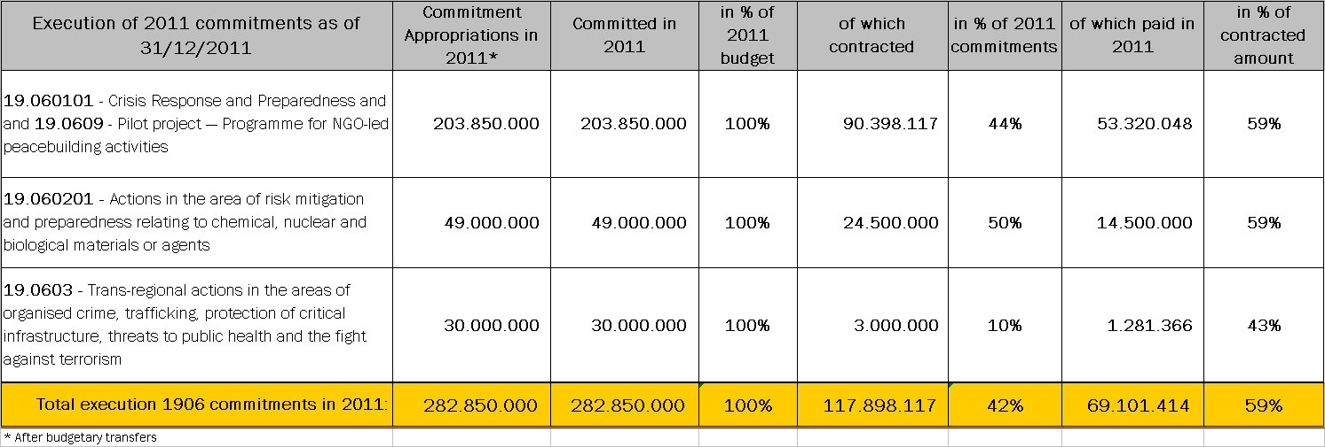

IfS crisis response and preparedness 2011
decisions and commitments, status of contracts and disbursements
(BUDGET HEADING 19.06.01, ARTICLE 3 AND 4.3 OF THE IFS REGULATION)

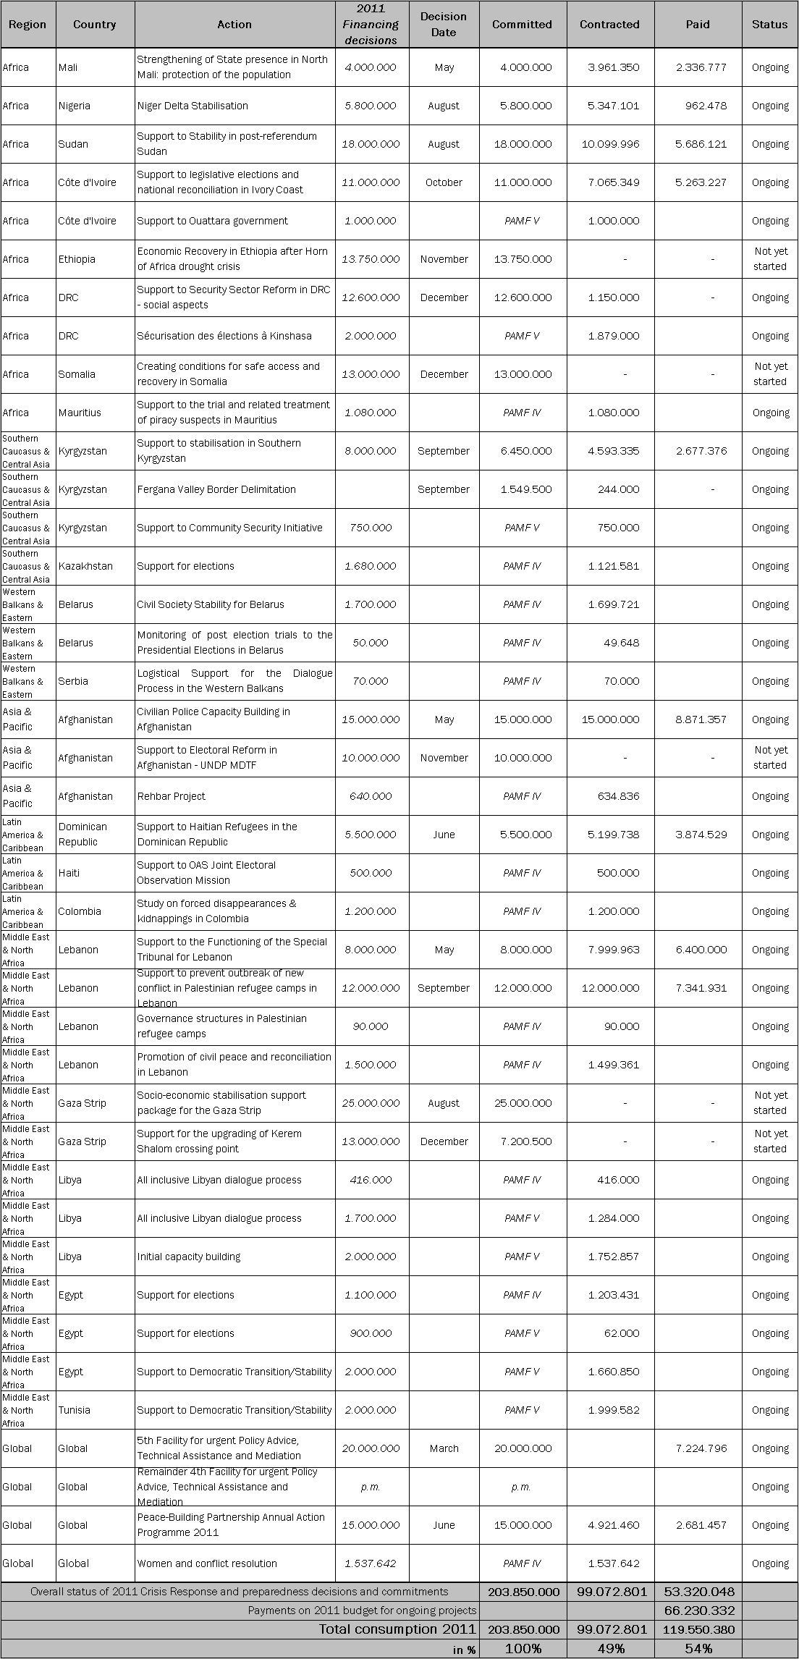
IFS crisis response and preparedness 2010
decisions and commitments, status of contracts and disbursements
(BUDGET HEADING 19.06.01, ARTICLE 3 AND 4.3 OF THE IFS REGULATION)

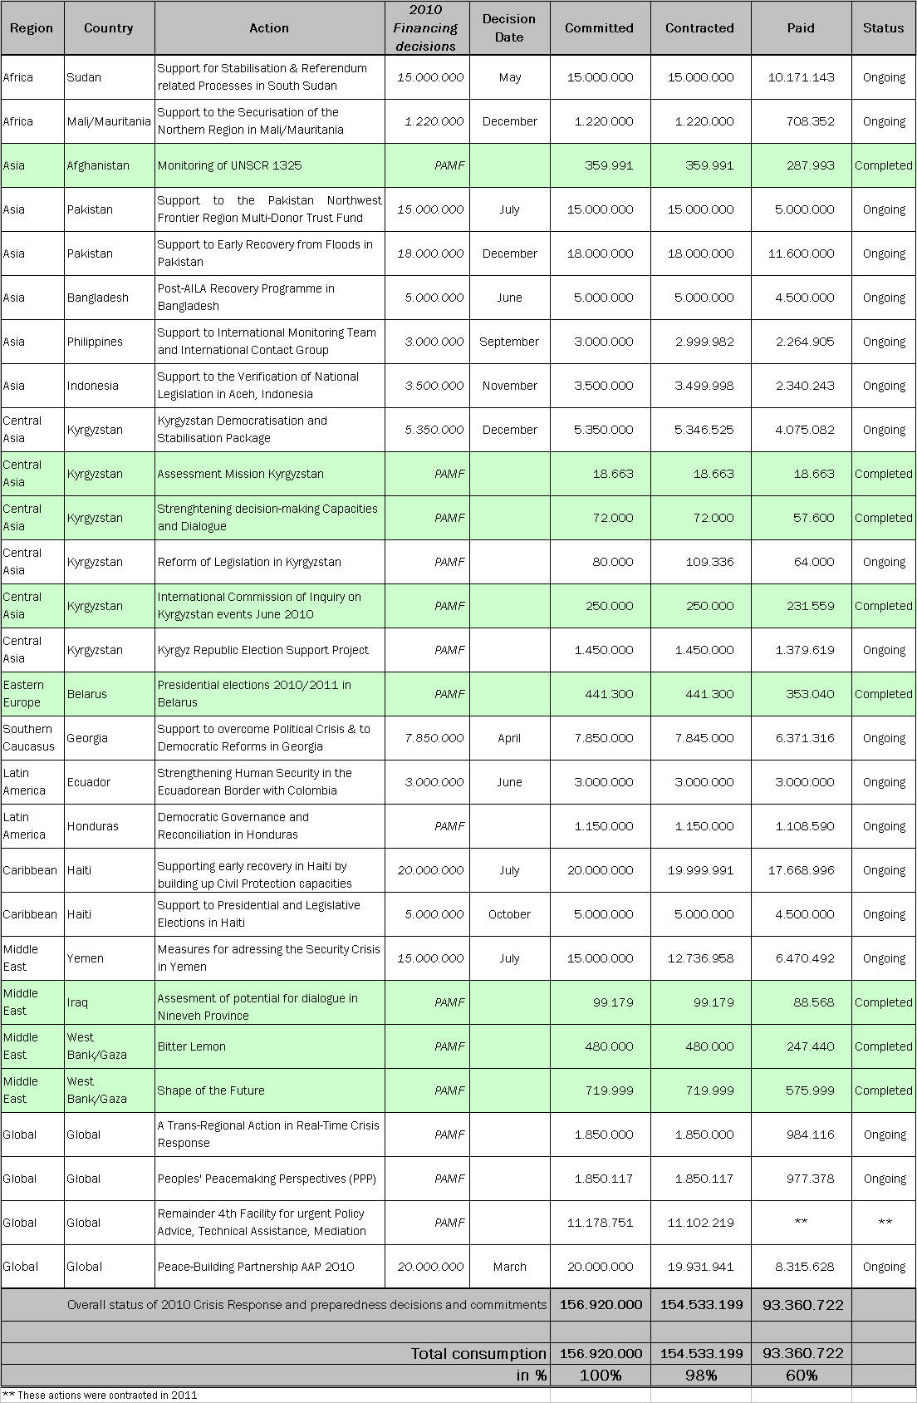
IfS crisis response and preparedness 2009
decisions and commitments, status of contracts and disbursements

(BUDGET HEADING 19.06.01, ARTICLE 3 AND 4.3 OF THE IFS REGULATION)

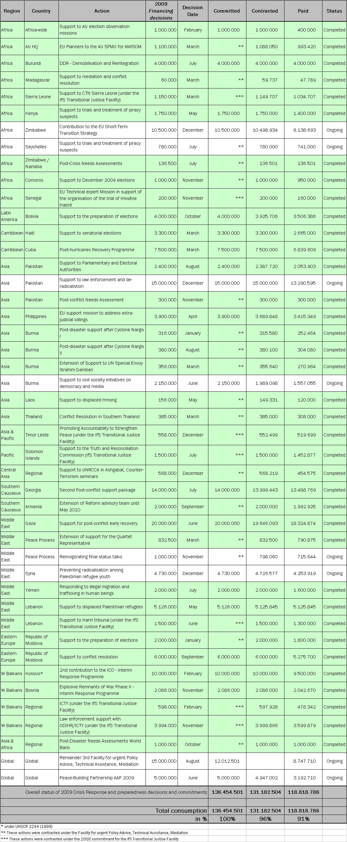
IfS crisis response and preparedness 2008
decisions and commitments, status of contracts and disbursements

(BUDGET HEADING 19.06.01, ARTICLE 3 AND 4.3 OF THE IFS REGULATION)

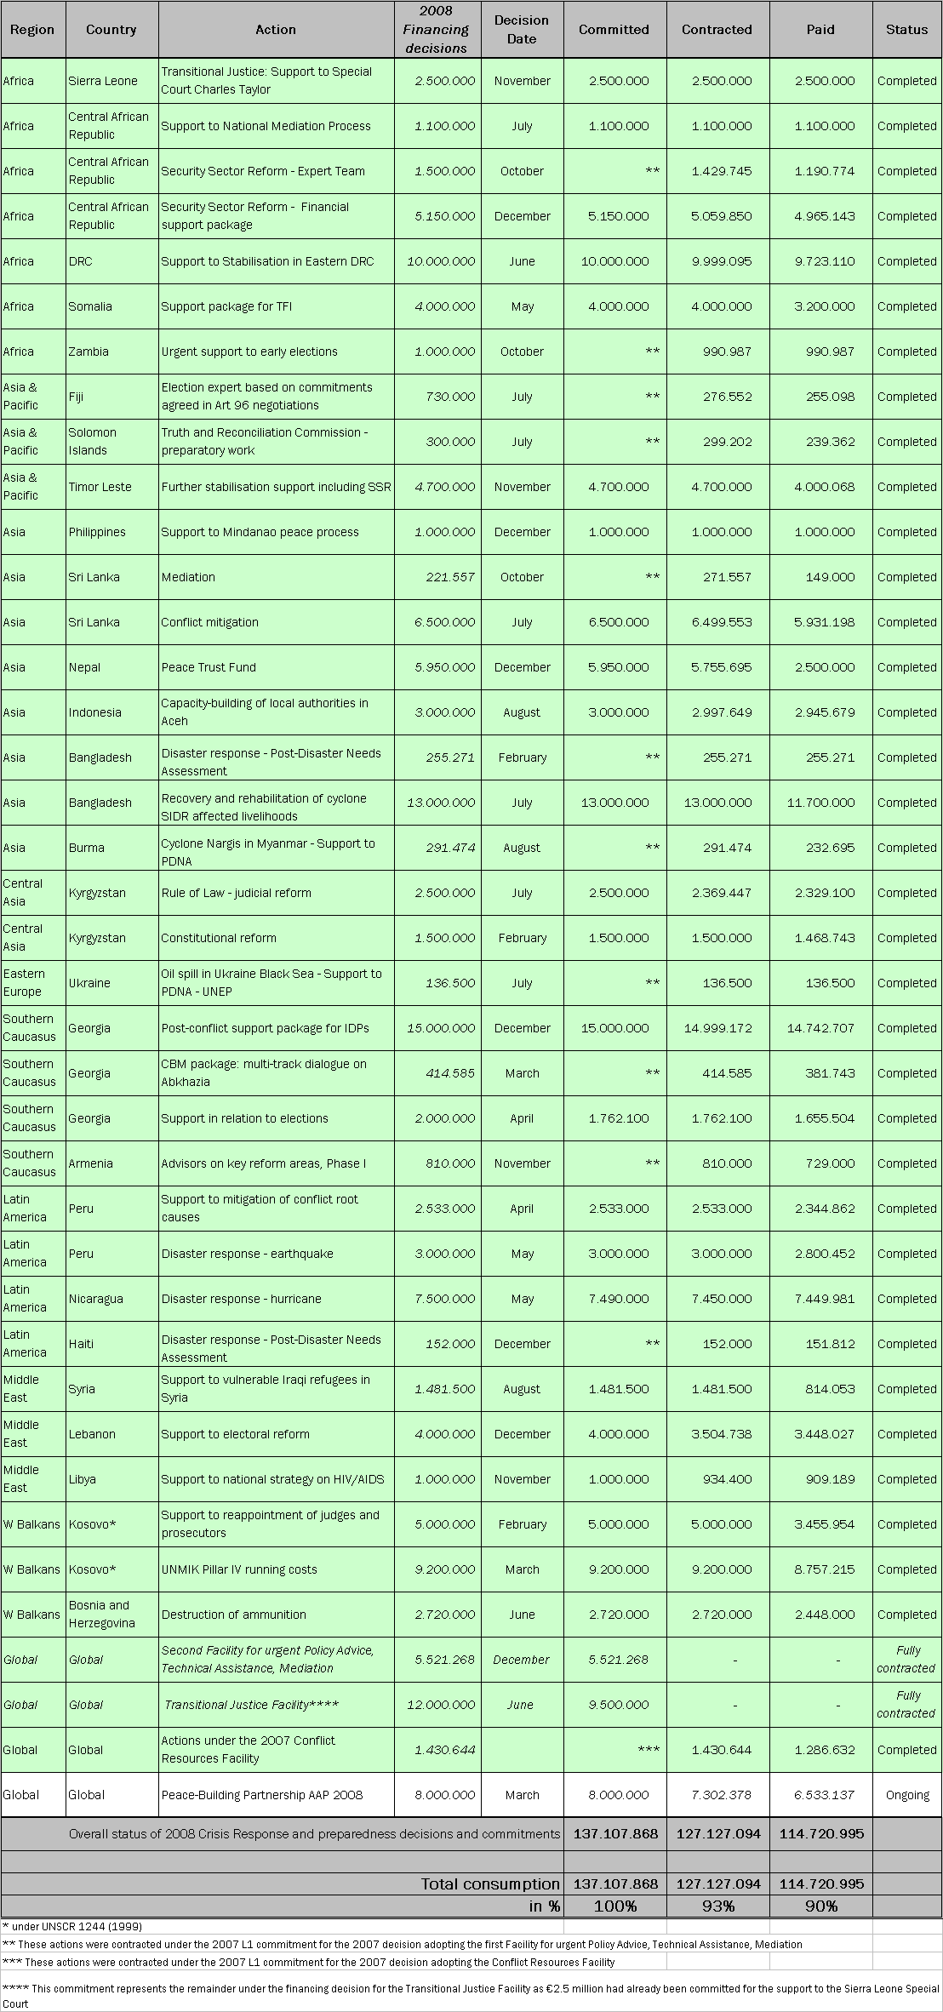
IfS crisis response and preparedness 2007
decisions and commitments, status of contracts and disbursements

(BUDGET HEADING 19.06.01, ARTICLE 3 AND 4.3 OF THE IFS REGULATION)

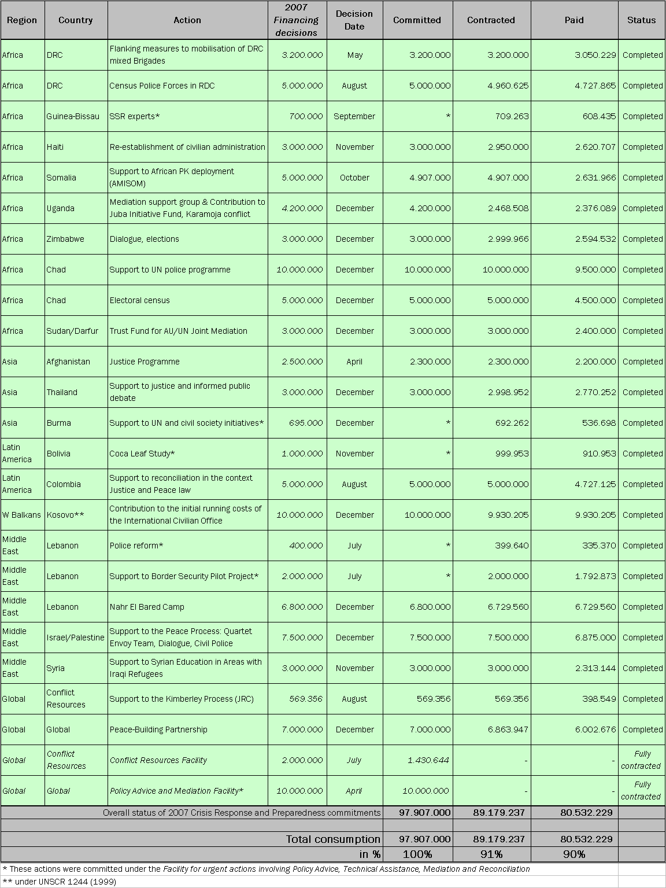

IfS long-term component: 2011 commitments and payments by country, region and projects
(BUDGET HEADINGS 19.06.02 ,19.06.03 and 19.06.07 ART. 4.2 AND 4.1 OF THE IFS REGULATION)

IfS long-term component: 2010 commitments and payments by country, region and projects
(BUDGET HEADINGS 19.06.02 AND 19.06.03, ART. 4.2 AND 4.1 OF THE IFS REGULATION)

IfS long-term component: 2009 commitments and payments by country, region and projects

(BUDGET HEADINGS 19.06.02 AND 19.06.03, ART. 4.2 AND 4.1 OF THE IFS REGULATION)

IfS long-term component: 2008 commitments and payments by country, region and projects

(BUDGET HEADINGS 19.06.02 AND 19.06.03, ART. 4.2 AND 4.1 OF THE IFS REGULATION)

IfS long-term component: 2007 commitments and payments by country, region and projects

(BUDGET HEADINGS 19.06.02 AND 19.06.03, ART. 4.2 AND 4.1 OF THE IFS REGULATION)

IfS crisis preparedness: status and description of individual projects
(BUDGET HEADING 19.06.01, Art. 4.3 OF THE IFS REGULATION, the Peacebuilding Partnership)
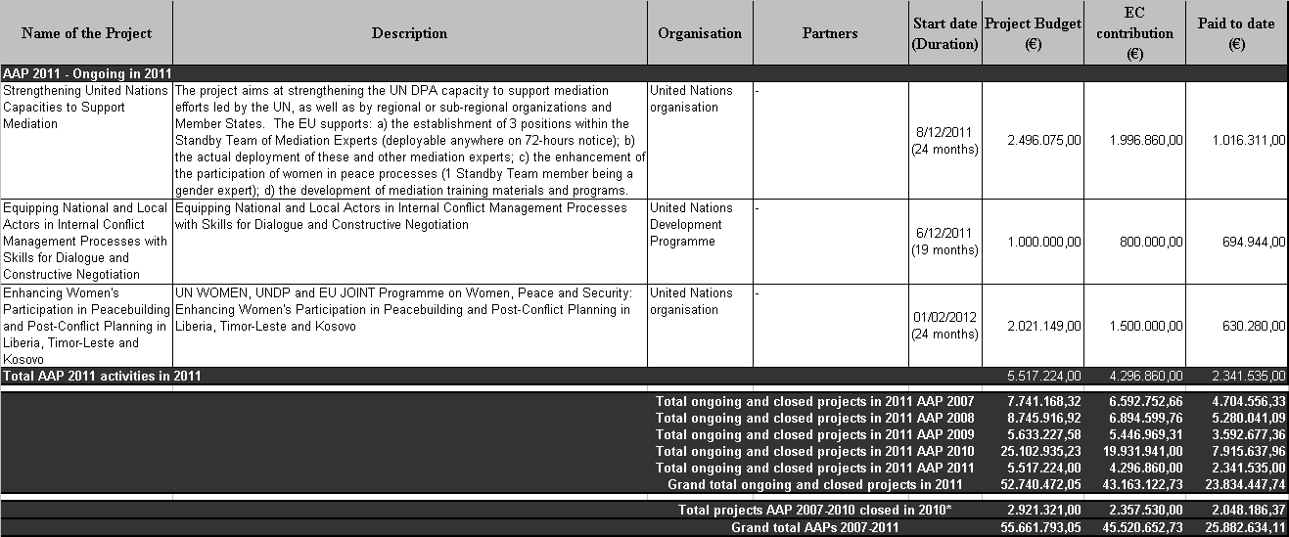

The European Peacebuilding Liaison Office (EPLO) is a platform of 30 NGOs, networks of NGOs and think-tanks active in the field of peacebuilding across 14 European countries.
The action “Strengthening non-state actors' capacities to prevent and resolve conflicts in areas affected by post election violence in Kenya” was managed by Konrad Adenauer Stiftung e. V.
This action was managed by Minority Rights Group International (MRG).
The Concept on Strengthening EU Mediation and Dialogue Capacities was adopted by the Council in November 2009.
This action was managed by Care International (municipalities involved)
Managed by the NGO Medica Mondiale e.V
The EUPST Action is managed by a specialised consortium of national public sector bodies led by the Arma Italiana dei Carabinieri.
This action, 'Strengthening Capacity to Design, Monitor and Evaluate Peacebuilding Programming', was managed by Care International.

